Milestone 2 Submission
Insurance Price Prediction
Submitted By
Group No. 4 [Batch: 2025-26]
Group Members
- Anup Kushwaha
- Govind Uttur
- Gunjan Kumar
- Arijit Sen

Mentor
Mr. Rajeev Kumar

Contents
Contents 2
Executive Summary 2
Introduction 4
Milestone 1 Handoff 5
Milestone 1 Recommendations Implemented 6
Raw versus Milestone 1 Engineered Features 6
Model Selection and Metrics of Interest 8
Model Reference Guide 8
Baseline and Standard Models 8
Advanced and Project-specific Models 9
Metric Reference Guide 9
Model Building and Evaluation 10
Dependent and Independent Variables 10
Leakage-safe Modeling Pipeline 10
Training and Holdout Results for All Models 10
Hyperparameter Tuning 11
Repeated Validation 12
Model Comparison and Selection 14
Final Model Decision 14
Selected Model Name Decoded 14
Prediction and Residual Diagnostics 15
Calibration and Quote-band Evaluation 15
Ordinal-style Quote-band Classification Challenger 16
Segment-level Error Review 17
Model Explainability 18
Business Insights and Recommendations 21
Streamlit Deployment 21
Appendix 24
Reader Glossary 24
Rubric Verification 25
Reproducibility 25
Key Saved Artifacts 25
Final Conclusion 26

Milestone 2: Modeling and Business Recommendations
Insurance Price Prediction | Model selection, validation, explainability, and deployment

Contents
- Executive Summary
- Introduction
- Milestone 1 Handoff
- Model Selection and Metrics of Interest
- Model Building and Evaluation
- Model Comparison and Selection
- Business Insights and Recommendations
- Appendix

Executive Summary
Milestone 2 converts the Milestone 1 analytical findings into a reproducible insurance-cost modeling workflow. The self-contained notebook starts from Insurance Data.csv, creates a target-price-band-stratified split, trains baseline and advanced models, validates the Milestone 1 engineered-feature proposal, tunes Histogram Gradient Boosting, performs repeated validation, selects the final model, evaluates quote-band post-processing, generates explainability outputs, and saves deployment artifacts.
result | value | meaning
Selected model | 50/50 LightGBM and Histogram Gradient Boosting blend | Output label: WeightedBlendLightGBMHistGradient
Test MAE | 2,385 | Average absolute cost error
Test RMSE | 2,972 | Large-error-sensitive cost metric
Test R2 | 0.9568 | Variance explained
RMSE improvement vs baseline | 79.2% | Relative to mean prediction

Technical interpretation: The selected 50/50 LightGBM and Histogram Gradient Boosting blend (WeightedBlendLightGBMHistGradient) achieved test MAE 2,385, RMSE 2,971.91, and R2 0.9568. Selection was based on repeated target-stratified validation.
Business interpretation: The model reduces holdout RMSE by 79.2% relative to predicting the mean premium, while retaining a controlled decision-support role.

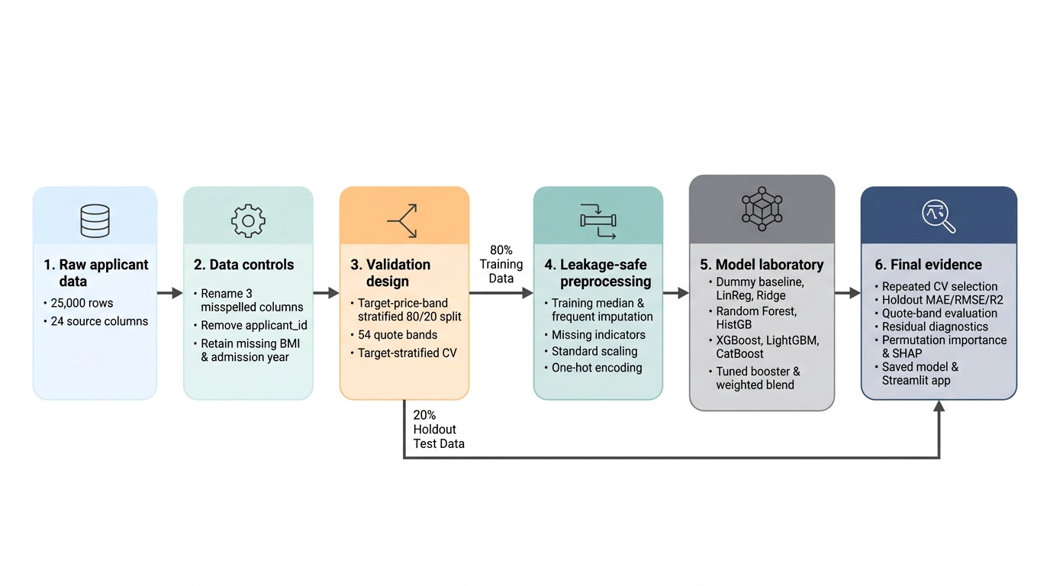
Milestone 2 end-to-end modeling workflow.
Technical interpretation: The workflow separates data controls, validation, preprocessing, training, selection, and final assessment.
Business interpretation: The diagram shows how raw applicant data becomes a reviewed quote estimate with reproducible evidence.

Introduction
The project predicts insurance_cost from health, lifestyle, demographic, medical-history, and insurance-history variables. The target is numeric but appears on 54 fixed historical quote bands separated by 1,234. Regression remains the primary formulation because business users need a continuous estimate, while quote-band rounding is evaluated as a separate deployment output.
- Input data: 25,000 applicant records and 24 source columns.
- Modeling target: insurance_cost.
- Identifier control: applicant_id is excluded before splitting and training.
- Validation: 80/20 target-band-stratified split with random_state 42.
- Selection: common cross-validation followed by repeated target-stratified validation.
- Deployment: raw continuous estimate, nearest valid quote band, and optional calibrated diagnostic.
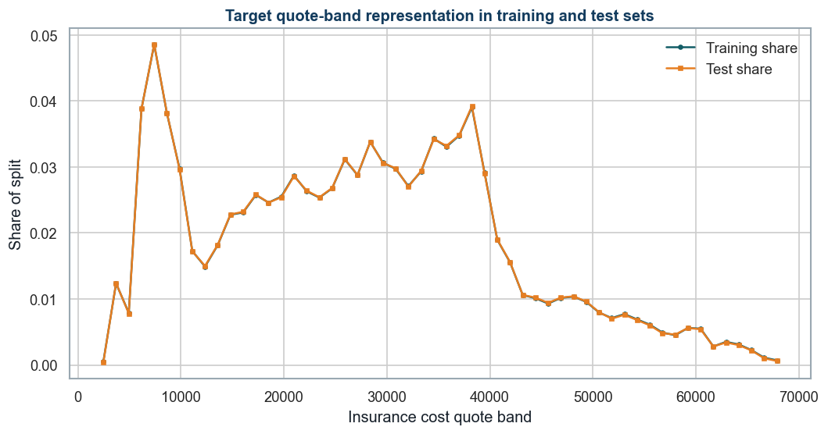
Target quote-band representation in the training and test partitions.
Technical interpretation: Both lines overlap closely across all 54 target levels. Each quote band is represented in training and test data.
Business interpretation: The evaluation includes routine and rare premium bands instead of measuring performance only on the most common prices.

Milestone 1 Handoff
The Milestone 2 notebook does not read Milestone 1 files at runtime. It recomputes the data profile, target-grid structure, missingness, identifier control, target-tail treatment, and marginal signal evidence directly from Insurance Data.csv before model development.
Milestone 1 evidence | Recomputed value | Modeling implication
Dataset rows | 25,000.0 | Recomputed from the supplied CSV
Source columns | 24.000 | Includes target and applicant_id
Independent applicant variables | 22.000 | Target and applicant_id excluded
Valid target quote bands | 54.000 | Discrete target levels
Target quote-band step | 1,234.0 | Modal difference between adjacent levels
BMI missing rows | 990.0 | Retained for pipeline treatment
Year_last_admitted missing rows | 11,881.0 | Retained as meaningful admission-history missingness
Unique applicant IDs | 25,000.0 | Identifier excluded before modeling
High-cost rows above IQR fence | 0.000 | Retained because they remain valid quote-band observations
High-cost rows deleted | 0.000 | No target-tail deletion

Technical interpretation: The handoff confirms 25,000 rows, 24 source columns, 22 usable applicant variables, 54 target bands separated by 1,234, 990 missing BMI values, 11,881 missing admission-year values, and no deletion of valid high-cost rows.
Business interpretation: Milestone 2 preserves the quote structure and incomplete applicant records while keeping applicant identity outside pricing.

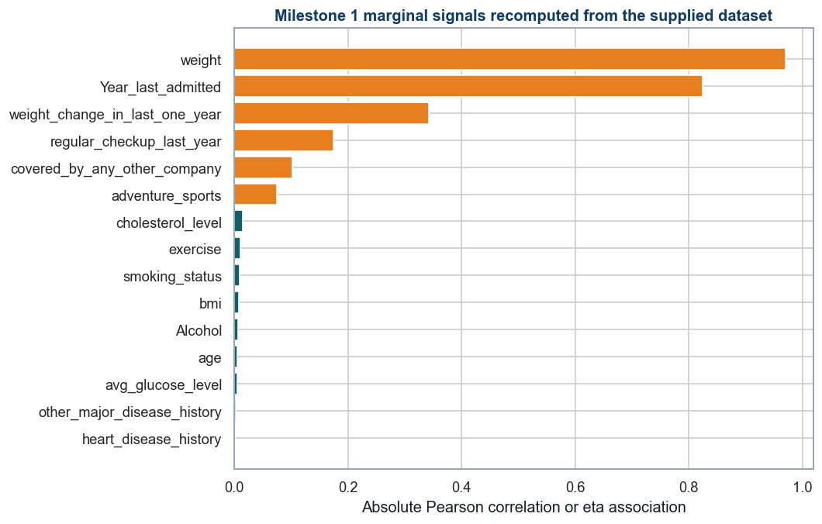
Milestone 1 marginal signal groups recomputed from Insurance Data.csv.
Technical interpretation: Weight, admission year, weight change, regular checkups, other-company coverage, and adventure sports remain the leading marginal signals. The listed lifestyle, medical, age, BMI, glucose, and cholesterol fields remain weak.
Business interpretation: Strong observed relationships guide model diagnostics, but neither strong nor weak marginal evidence is treated as a causal premium rule.

Milestone 1 Recommendations Implemented
Milestone 1 recommendation | Milestone 2 implementation | Notebook evidence
Use a target-band-aware split | Stratify the holdout and validation folds by the 54 quote bands | Sections 6, 10, and 13
Compare baseline and advanced models | Evaluate mean, linear, tree, boosting, and blend candidates | Sections 9 to 14
Evaluate continuous and quote-band outputs | Compare raw, calibrated, rounded, and calibrated-rounded variants | Section 15
Review residuals by premium segment | Report cost-decile and applicant-segment errors | Section 17
Explain the final model | Use permutation importance and a SHAP challenger explanation | Sections 18 and 19

Raw versus Milestone 1 Engineered Features
feature set | feature count | CV MAE mean | CV RMSE mean | CV RMSE std | selected for downstream modeling
Raw 22 features | 22.000 | 2,368.6 | 2,955.4 | 2.752 | Yes
Milestone 1 engineered 32 features | 32.000 | 2,359.1 | 2,948.5 | 6.745 | No

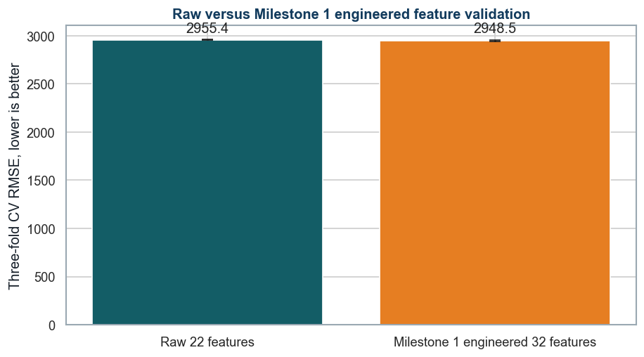
Same-fold validation comparison of raw and Milestone 1 engineered inputs.
Technical interpretation: The engineered set changes mean CV RMSE by 6.92 cost units, a relative gain below the predefined 0.5% requirement, and increases fold-to-fold variability.
Business interpretation: The final model retains the raw 22-feature strategy because the small average gain does not justify less stable validation and additional deployment logic.

Engineered features did not meet the predefined 0.5% RMSE improvement or stability threshold, so the raw feature set is retained for parsimony and portable deployment.

Model Selection and Metrics of Interest
The candidate set progresses from a simple mean baseline to linear, regularized, tree, ensemble, and external boosting methods. This establishes whether additional complexity produces measurable and stable improvement.

Model Reference Guide
The output name is the exact label used in notebook result tables. The reader-friendly explanation states how the model produces a prediction and why it was included.

Baseline and Standard Models
output name | how it works | role and caution
DummyRegressor | Predicts the training-set mean for every applicant. | Defines the minimum performance that a useful model must beat. Caution: Does not use applicant differences.
LinearRegression | Adds a learned contribution from each encoded input to form the prediction. | Provides a transparent additive benchmark. Caution: Cannot naturally represent thresholds and complex interactions.
Ridge | Uses linear regression with an L2 penalty that shrinks unstable coefficients. | Tests whether a more stable linear model improves generalization. Caution: Remains an additive linear model.
DecisionTreeRegressor | Builds if-then split rules that divide applicants into progressively similar groups. | Captures nonlinear thresholds and interactions. Caution: A single tree can overfit and change with the sample.
RandomForestRegressor | Averages many trees trained on resampled rows and randomized feature subsets. | Reduces the instability of one decision tree. Caution: Is larger and less directly interpretable than one tree.
GradientBoostingRegressor | Builds small trees sequentially, with each tree correcting earlier residual errors. | Tests a strong nonlinear boosting benchmark. Caution: Performance depends on learning rate, tree size, and iteration count.
HistGradientBoostingRegressor | Groups numeric values into bins before sequential tree boosting for efficient training. | Provides a fast sklearn boosting candidate for tabular data. Caution: Still requires controls for tree complexity and overfitting.

Advanced and Project-specific Models
output name | how it works | role and caution
RegularizedHistGradientBoosting | The same histogram algorithm with slower learning, leaf limits, and L2 regularization. | Tests a deliberately more constrained configuration. Caution: This is a project label, not a separate software library.
XGBRegressor | An optimized gradient-boosted tree implementation with sampling and regularization controls. | Adds a widely used advanced boosting benchmark. Caution: Requires careful tuning and optional accelerator configuration.
LightGBMRegressor | A histogram-based booster that grows the leaf with the largest expected loss reduction. | Provides efficient learning and strong nonlinear performance. Caution: Leaf-wise growth can overfit when leaf constraints are too loose.
CatBoostRegressor | A boosting implementation designed for stable training and strong categorical-data handling. | Adds a third external booster for comparison. Caution: In this notebook it receives the same one-hot encoded inputs for a fair pipeline comparison.
TunedHistGradientBoostingRegressor | The histogram model whose settings are chosen by RandomizedSearchCV on training folds. | Tests whether systematic tuning improves the base configuration. Caution: Tuning improves the search process but does not guarantee the final winner.
WeightedBlendLightGBMHistGradient | Averages the predictions from LightGBM and regularized Histogram Gradient Boosting. | Tests whether combining two strong but different boosters reduces validation error. Caution: Deployment must load and run both component pipelines.
HistGradientBoostingClassifier | Predicts probabilities for the 54 historical quote-band classes. | Challenges continuous regression with a discrete quote-band formulation. Caution: The multiclass loss does not itself enforce the numeric order of the bands.

Technical interpretation: The comparison covers a baseline, additive linear models, individual trees, bagged trees, sequential boosting, tuned boosting, a weighted blend, and a quote-band classifier.
Business interpretation: Each additional level of complexity must provide stable validation improvement that justifies its operating and governance cost.

Metric Reference Guide
metric | full meaning | interpretation
RMSE | Root mean squared error | Cost-unit error that gives extra weight to large misses
MAE | Mean absolute error | Average absolute error in cost units
R2 | Coefficient of determination | Share of target variance explained relative to the mean
MAPE | Mean absolute percentage error | Error as a percentage of actual cost
SMAPE | Symmetric absolute percentage error | Percentage error scaled by actual and predicted cost
Band accuracy | Exact or within-band rate | Share of outputs close to a valid quote band

Technical interpretation: RMSE ranks validation performance; MAE, R2, MAPE, and SMAPE prevent a one-metric conclusion. Band accuracy is assessed after continuous model selection.
Business interpretation: MAE and RMSE communicate monetary error, while quote-band distance connects the model to historical pricing operations.

Model Building and Evaluation

Dependent and Independent Variables
dataset role | column count | columns
Independent variables (X) | 22.000 | years_of_insurance_with_us, regular_checkup_last_year, adventure_sports, Occupation, visited_doctor_last_1_year, cholesterol_level, daily_avg_steps, age, heart_disease_history, other_major_disease_history, Gender, avg_glucose_level, bmi, smoking_status, Year_last_admitted, Location, weight, covered_by_any_other_company, Alcohol, exercise, weight_change_in_last_one_year, fat_percentage
Dependent variable (y) | 1.000 | insurance_cost
Excluded before splitting | 1.000 | applicant_id

Technical interpretation: The model uses 22 independent applicant variables to predict insurance_cost. applicant_id is removed before splitting because it has no generalizable pricing meaning.
Business interpretation: Pricing is based on applicant characteristics and history, not a unique record identifier.

Leakage-safe Modeling Pipeline
field group | action | reason
applicant_id | Removed before split | No generalizable pricing meaning
Numeric fields | Median imputation, missing indicators, scaling | Fitted inside each training fold
Categorical fields | Most-frequent imputation, one-hot encoding | Handles nominal and unseen levels
Target | No preprocessing transform | Keeps errors in cost units

Training and Holdout Results for All Models
model | train MAE | test MAE | train RMSE | test RMSE | train R2 | test R2
WeightedBlendLightGBMHistGradient | 2,204.6 | 2,385.2 | 2,745.3 | 2,971.9 | 0.9633 | 0.9568
TunedHistGradientBoostingRegressor | 2,280.9 | 2,394.4 | 2,840.1 | 2,979.1 | 0.9607 | 0.9566
LightGBMRegressor | 2,170.2 | 2,391.5 | 2,704.3 | 2,979.7 | 0.9644 | 0.9566
RegularizedHistGradientBoosting | 2,250.2 | 2,391.3 | 2,802.3 | 2,980.1 | 0.9618 | 0.9566
HistGradientBoostingRegressor | 2,263.0 | 2,393.6 | 2,817.8 | 2,982.5 | 0.9613 | 0.9565
XGBRegressor | 2,234.8 | 2,408.4 | 2,782.1 | 2,992.8 | 0.9623 | 0.9562
CatBoostRegressor | 2,264.8 | 2,416.3 | 2,818.4 | 3,001.4 | 0.9613 | 0.9559
GradientBoostingRegressor | 2,339.9 | 2,421.8 | 2,909.3 | 3,007.2 | 0.9588 | 0.9558
DecisionTreeRegressor | 2,179.5 | 2,492.4 | 2,753.8 | 3,162.4 | 0.9631 | 0.9511
Ridge | 2,681.8 | 2,760.4 | 3,332.0 | 3,416.7 | 0.9459 | 0.9429
LinearRegression | 2,682.0 | 2,760.7 | 3,332.0 | 3,416.8 | 0.9459 | 0.9429
RandomForestRegressor | 3,149.3 | 3,512.7 | 4,071.5 | 4,525.3 | 0.9193 | 0.8998
DummyRegressor | 11,825.2 | 11,805.0 | 14,329.6 | 14,298.5 | 0.0000 | -0.0000

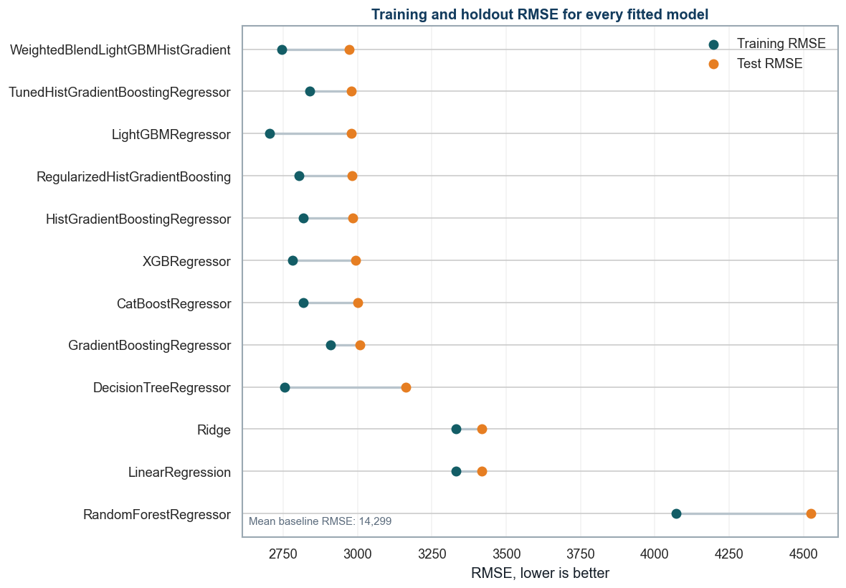
Training and holdout RMSE comparison for all fitted models; the mean baseline is reported separately on the figure.
Technical interpretation: The table and paired-point chart evaluate every baseline and advanced model on both training and holdout data. The selected blend has the lowest repeated cross-validation RMSE and also retains a controlled train-test gap.
Business interpretation: The final model materially improves pricing accuracy without relying on training performance alone.

Hyperparameter Tuning
technique | implementation | purpose
Randomized hyperparameter search | RandomizedSearchCV over eight reproducible candidates | Covers a broad search space without the cost of a full Cartesian grid
Learning-rate and iteration trade-off | learning_rate with max_iter | Tests slower learning with sufficient boosting iterations
Tree-complexity control | max_leaf_nodes and min_samples_leaf | Limits overly specific leaf rules and reduces variance
L2 regularization | l2_regularization | Penalizes overly aggressive fitted responses
Histogram resolution | max_bins | Balances numerical detail with speed and stability
Target-stratified cross-validation | The same three training-only folds for every candidate | Preserves all quote bands and prevents test-set tuning
Overfitting check | Training RMSE compared with cross-validation RMSE | Rejects parameter sets that improve fit without stable validation
Repeated validation and blending | Six repeated folds followed by a 50/50 advanced-model blend | Tests stability and whether complementary model errors can be reduced

parameter | selected value
model__min_samples_leaf | 50.000
model__max_leaf_nodes | 23.000
model__max_iter | 260.0
model__max_bins | 255.0
model__learning_rate | 0.030
model__l2_regularization | 0.150

Technical interpretation: RandomizedSearchCV tunes iteration count, learning rate, leaf count, minimum leaf support, regularization, and bin count using training-only target-stratified folds.
Business interpretation: The tuning record makes the selected configuration reproducible and reviewable instead of relying on undocumented manual choices.

Repeated Validation
model | repeated cv RMSE mean | repeated cv RMSE std | repeated cv MAE mean | repeated cv R2 mean
WeightedBlendLightGBMHistGradient | 2,949.6 | 13.803 | 2,363.9 | 0.9576
TunedHistGradientBoostingRegressor | 2,953.2 | 12.502 | 2,369.7 | 0.9575
HistGradientBoostingRegressor | 2,954.6 | 11.138 | 2,367.0 | 0.9575
RegularizedHistGradientBoosting | 2,954.9 | 11.554 | 2,368.6 | 0.9575
LightGBMRegressor | 2,965.7 | 16.605 | 2,375.3 | 0.9572
XGBRegressor | 2,969.8 | 16.297 | 2,384.7 | 0.9570

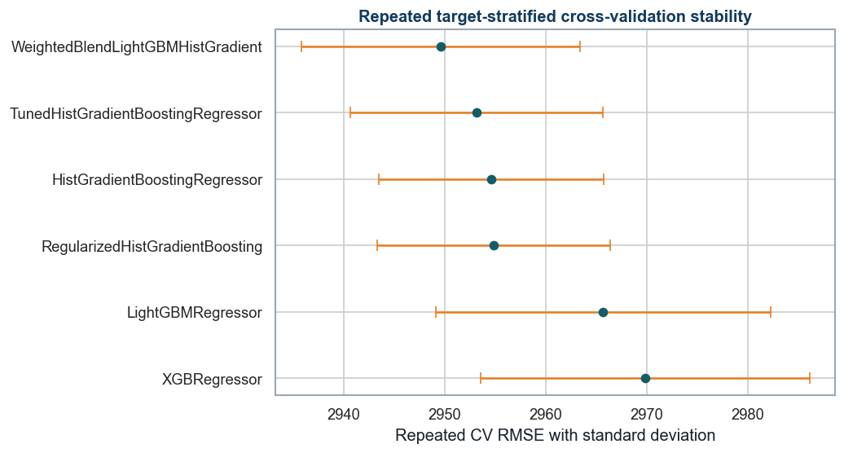
Repeated target-stratified validation mean RMSE and standard deviation.
Technical interpretation: The weighted LightGBM and Histogram Gradient blend has the lowest repeated validation RMSE among the leading candidates.
Business interpretation: The selected model is supported by multiple data partitions, reducing dependence on one favorable split.

Model Comparison and Selection

Repeated target-stratified cross-validation comparison for the leading model candidates.
Technical interpretation: The final model is chosen by repeated training-fold validation. Holdout metrics are reported for rubric comparison, but the selection code does not rank candidates by test performance.
Business interpretation: This explicit rule keeps model selection separate from the reported holdout comparison.

Final Model Decision

Selected Model Name Decoded
name part | meaning | use in final prediction
WeightedBlend | Predictions from more than one fitted model are combined. | An equal 50/50 arithmetic average is used.
LightGBM | Light Gradient Boosting Machine, an efficient histogram-based tree booster. | First component pipeline.
HistGradient | Regularized sklearn Histogram Gradient Boosting regressor. | Second component pipeline.
Complete output | WeightedBlendLightGBMHistGradient | One continuous estimate produced by averaging the two component estimates.

Both components receive the same raw applicant columns through their own leakage-safe preprocessing pipelines. The blend averages two predictions; it does not apply a separate pricing rule.
decision item | result
Selected model | WeightedBlendLightGBMHistGradient
Selection basis | Lowest repeated target-stratified CV RMSE
Repeated CV RMSE | 2,949.6
Repeated CV RMSE standard deviation | 13.803
Holdout MAE | 2,385.2
Holdout RMSE | 2,971.9
Holdout R2 | 0.957

WeightedBlendLightGBMHistGradient achieved the lowest repeated target-stratified CV RMSE (2949.56, standard deviation 13.80) among the leading candidates. Holdout metrics are reported for rubric comparison. The selection code uses only repeated training-fold cross-validation and does not rank candidates by test performance.

Prediction and Residual Diagnostics
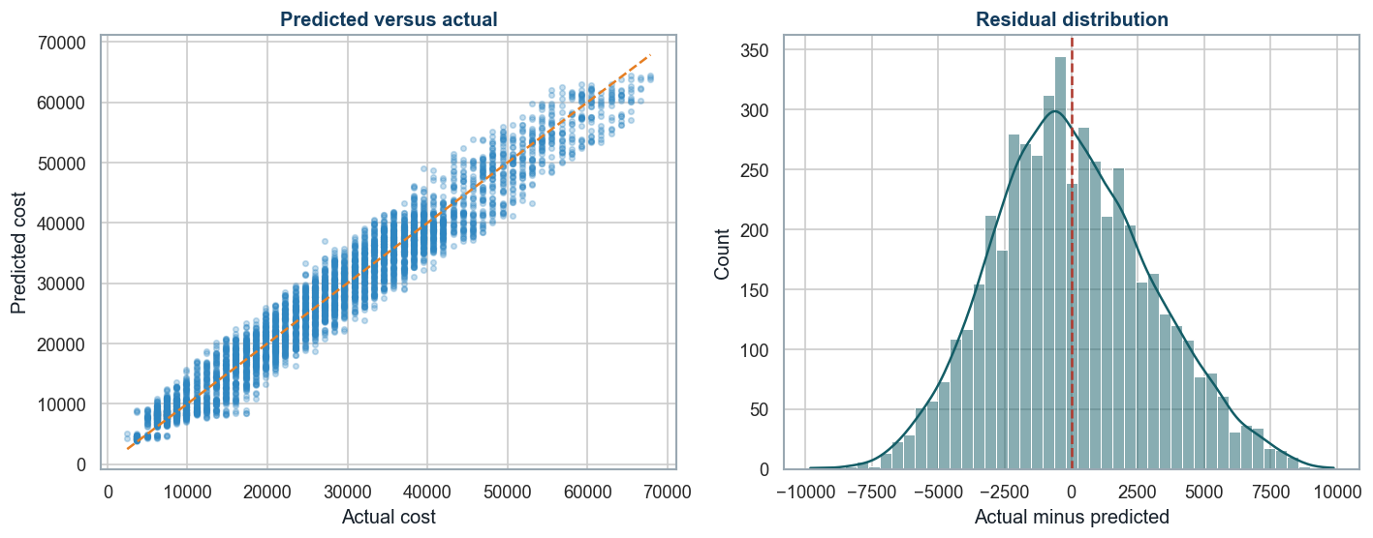
Holdout predicted-versus-actual alignment and residual distribution.
Technical interpretation: Predictions follow the actual-cost line closely. Residuals are centered near zero, with wider errors at some premium levels.
Business interpretation: High-cost or unusual cases need stronger manual review because a small number of large misses drives RMSE above MAE.

Calibration and Quote-band Evaluation
output label | plain-language meaning | role
raw_continuous | The selected regression model's original numeric cost estimate. | Primary analytical estimate
calibrated_continuous | The raw estimate after isotonic calibration. | Secondary diagnostic because MAE and RMSE did not improve
rounded_to_nearest_price_band | The raw estimate moved to the closest one of 54 valid quote bands. | Business quote-band display
calibrated_then_rounded | The calibrated estimate moved to the nearest valid quote band. | Comparison only

variant | MAE | RMSE | R2 | MAPE | SMAPE | within 2 band accuracy
raw_continuous | 2,385.2 | 2,971.9 | 0.9568 | 11.4579 | 11.1088 | 0.6972
calibrated_continuous | 2,398.9 | 2,995.8 | 0.9561 | 11.5089 | 11.1253 | 0.6916
rounded_to_nearest_price_band | 2,368.0 | 2,998.2 | 0.9560 | 11.3183 | 10.9523 | 0.6972
calibrated_then_rounded | 2,378.2 | 3,020.7 | 0.9554 | 11.3662 | 10.9323 | 0.6916

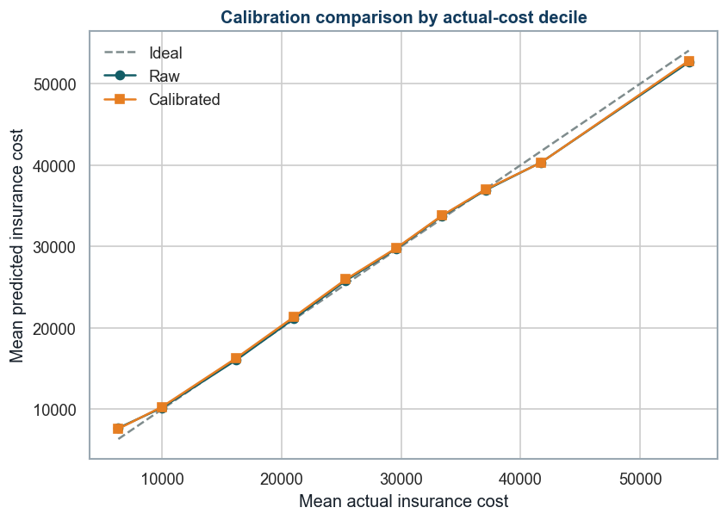
Raw and isotonic-calibrated predictions by actual-cost decile.
Technical interpretation: Calibration does not improve MAE or RMSE in this run. Nearest-band rounding lowers MAE but slightly increases RMSE.
Business interpretation: Use raw prediction for analytical cost estimation, rounded raw prediction for quote-band display, and calibrated cost only as a secondary diagnostic.

Ordinal-style Quote-band Classification Challenger
HistGradientBoostingClassifier predicts probabilities for all 54 historical quote-band classes. The hard-class output chooses the most likely band. The expected-value output multiplies every band cost by its probability and adds the results. The classes correspond to ordered prices, but the multiclass loss does not explicitly enforce their numeric order.
output label | plain-language meaning | role
ordinal_predicted_class | The single quote band with the highest classifier probability. | Hard-class challenger
ordinal_expected_value | Probability-weighted average of all quote-band costs. | Smoother classifier-based cost challenger

variant | MAE | RMSE | R2 | exact band accuracy | within 2 band accuracy
ordinal_predicted_class | 2,782.9 | 3,681.0 | 0.9337 | 0.1782 | 0.6298
ordinal_expected_value | 2,442.1 | 3,068.0 | 0.9540 | 0.1656 | 0.6848

Technical interpretation: The 54-class Histogram Gradient Boosting challenger is weaker than the selected regression model on monetary metrics. Its probability-weighted expected value performs better than hard class prediction but remains behind regression.
Business interpretation: The quote grid should remain a display and monitoring layer rather than replacing the stronger continuous regression model.

Segment-level Error Review
segment variable | segment value | records | MAE | RMSE | mean residual
Location | Nagpur | 351.0 | 2,507.7 | 3,078.9 | 33.931
Location | Surat | 289.0 | 2,500.7 | 3,144.7 | -45.594
Location | Bhubaneswar | 362.0 | 2,487.4 | 3,107.7 | 155.2
covered_by_any_other_company | Y | 1,566.0 | 2,480.9 | 3,094.7 | 156.5
Location | Mangalore | 359.0 | 2,467.4 | 3,124.0 | 276.8
Location | Pune | 347.0 | 2,462.7 | 2,998.7 | 191.3
Location | Guwahati | 338.0 | 2,444.3 | 3,019.6 | -65.548
Location | Delhi | 359.0 | 2,426.7 | 3,080.2 | -128.2
smoking_status | smokes | 788.0 | 2,418.3 | 3,027.7 | -13.163
smoking_status | never smoked | 1,809.0 | 2,398.1 | 2,983.5 | 61.395
Location | Jaipur | 346.0 | 2,395.7 | 2,955.3 | 213.7
Gender | Male | 3,246.0 | 2,390.9 | 2,976.1 | -9.228

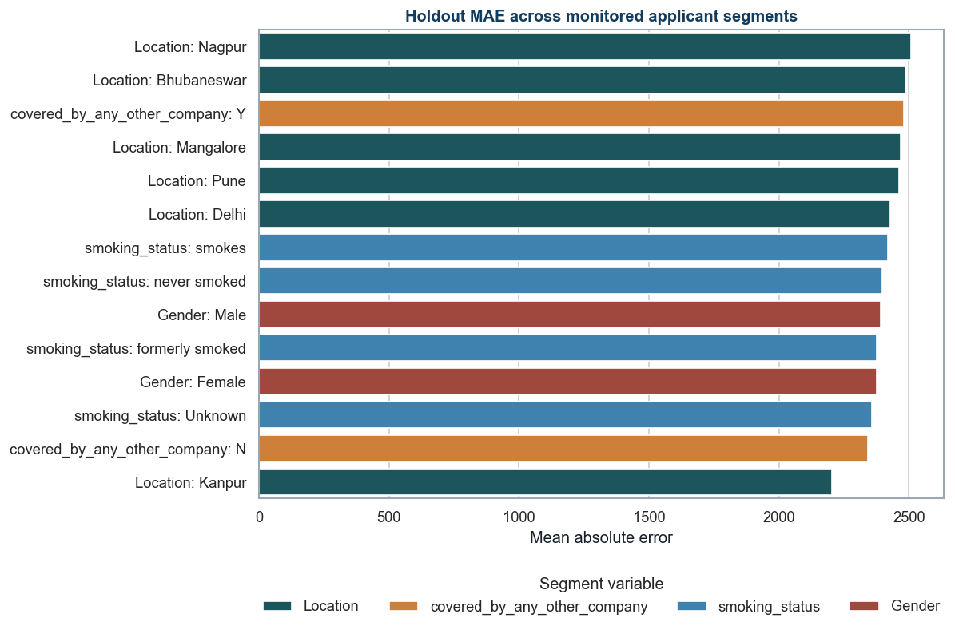
Holdout MAE for monitored applicant segments.
Technical interpretation: Segment errors are similar in magnitude but not identical. The table also reports mean residual to expose systematic overprediction or underprediction.
Business interpretation: Gender, location, coverage, and smoking variables require policy, fairness, and proxy-risk review before production use.

Model Explainability
feature | importance mean | importance std
weight | 15,951.9 | 180.4
Year_last_admitted | 301.5 | 17.380
covered_by_any_other_company | 158.4 | 18.427
regular_checkup_last_year | 112.6 | 13.681
weight_change_in_last_one_year | 51.345 | 5.781
years_of_insurance_with_us | 43.173 | 5.094
avg_glucose_level | 6.250 | 1.322
daily_avg_steps | 2.533 | 3.275
Location | 1.147 | 2.150
adventure_sports | 0.651 | 0.821
heart_disease_history | 0.410 | 0.737
Occupation | 0.214 | 0.450

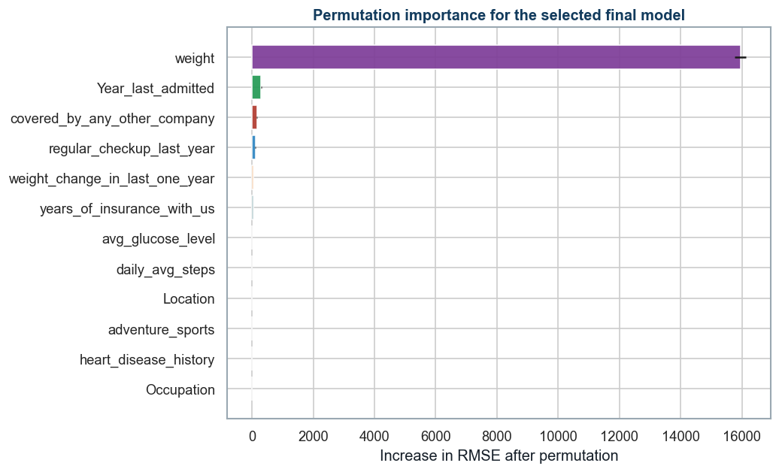
Permutation importance for the selected final pipeline.
Technical interpretation: Weight is the dominant raw input, followed by admission year, other-company coverage, regular checkups, and weight change.
Business interpretation: The strongest drivers should be checked against approved pricing policy and monitored for drift. Importance is association, not causation.

feature | mean abs shap
weight | 10,688.3
Year_last_admitted | 716.8
covered_by_any_other_company_N | 503.8
regular_checkup_last_year | 334.2
years_of_insurance_with_us | 255.9
weight_change_in_last_one_year | 197.4
missingindicator_Year_last_admitted | 144.8
daily_avg_steps | 61.302
covered_by_any_other_company_Y | 56.497
age | 53.538
avg_glucose_level | 52.575
bmi | 46.559

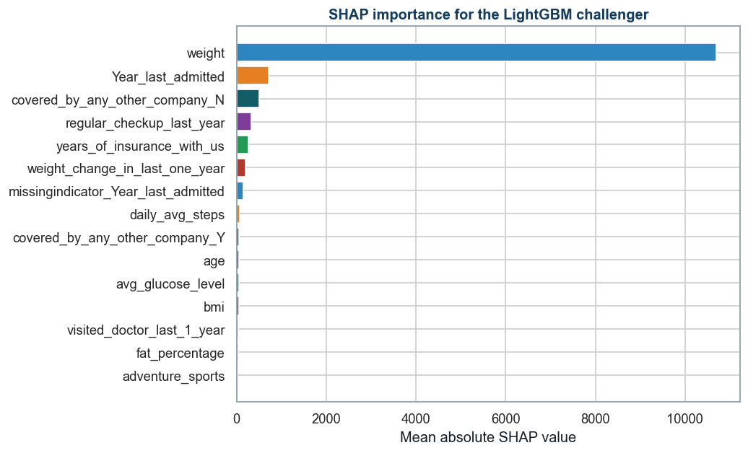
SHAP importance for the LightGBM challenger.
Technical interpretation: SHAP confirms the leading role of weight and admission history and adds transformed-category detail for the LightGBM model.
Business interpretation: SHAP supports portfolio and case explanation but does not establish that changing an input will cause a premium change.

Business Insights and Recommendations

Streamlit Deployment
Run the local application from the project root with: streamlit run app.py
The operational interface contains six workspaces: Quote Estimator, What-if Comparison, Batch Scoring, Model Insights, Monitoring and Fairness, and Methodology and Limitations.
The app allows comparison across 13 fitted regression models. WeightedBlendLightGBMHistGradient is labelled BEST and recommended because it has the lowest repeated target-stratified training-fold CV RMSE among the leading candidates. Choosing a challenger does not change the documented best-model decision.
- A synchronized desktop and mobile model selector lists every fitted regression model and keeps the best model clearly identified.
- Quote Estimator reports the raw estimate, nearest valid quote band, band distance, and review tier for any selected model. Out-of-fold portfolio percentile and empirical residual intervals are shown only for the recommended final blend.
- Applicant explanations use weighted component Tree SHAP for the complete fitted blend when the additivity check passes. Challenger models use a clearly labelled model-agnostic one-feature perturbation explanation.
- What-if Comparison stores a baseline, compares a second submitted scenario, and reports sequential input-change associations without presenting them as causal premium advice.
- Batch Scoring validates required columns, types, missing values, categories, and training ranges; invalid rows remain reviewable while valid rows are scored and exportable.
- Monitoring and Fairness reports holdout segment error, prediction distributions, quote-band distributions, and session-only PSI drift against a training reference profile.
- CSV and in-memory PDF exports retain an optional case reference but never send applicant_id into the fitted model.
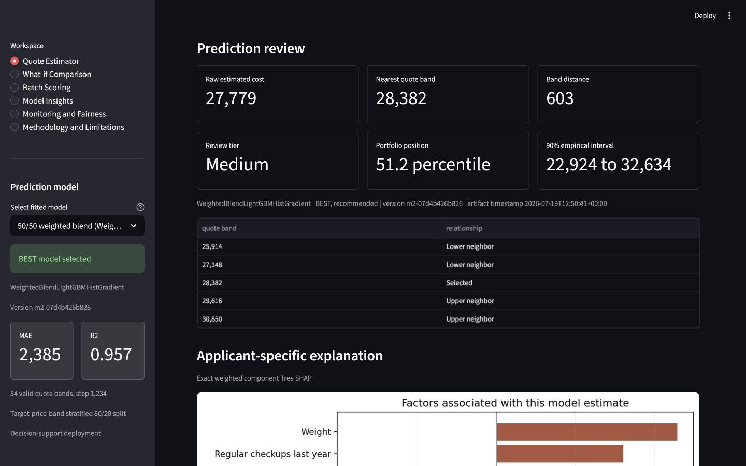
Streamlit quote review with the best model clearly labelled and alternative fitted models available for comparison.
Technical interpretation: The tested record shows the continuous estimate, nearest valid band, distance to that band, review tier, portfolio position, empirical interval, neighboring bands, and applicant-specific model contributions.
Business interpretation: The interface is decision support. Contributions are associations, uploaded batch monitoring is an offline demonstration, and final underwriting requires documented human, compliance, fairness, and security review.

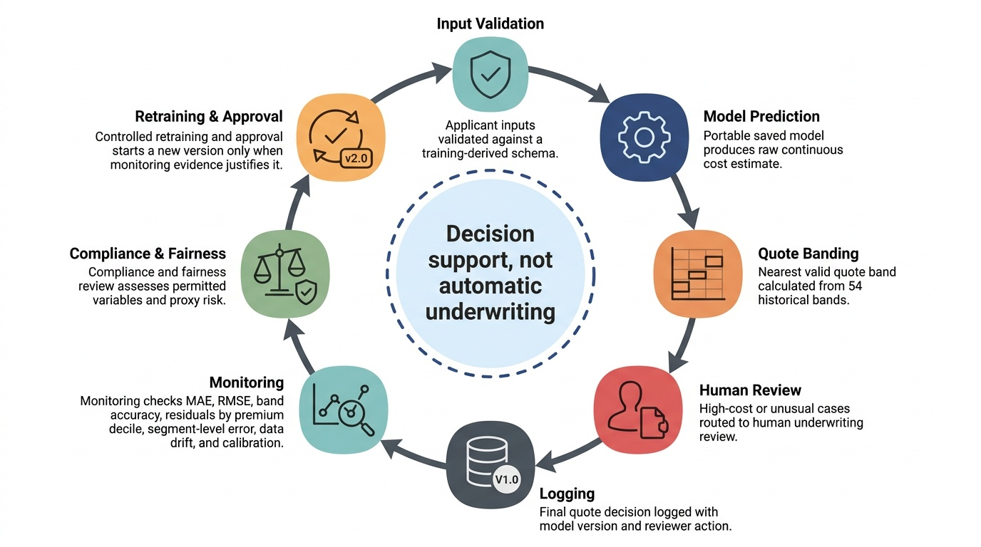
Responsible deployment and monitoring workflow.
Technical interpretation: The workflow separates prediction, quote-band display, human review, monitoring, compliance review, and controlled retraining.
Business interpretation: The model remains decision support, with a documented reviewer and model version attached to the final business action.

recommendation | evidence | action | measure
Two-value quote display | Target follows 54 fixed quote bands | Show raw estimate and nearest valid band | MAE, RMSE, exact and within-two-band accuracy
High-cost manual review | Large misses drive RMSE above MAE | Review highest predicted-cost and unusual cases | Review rate, corrected error, turnaround time
Driver and drift monitoring | Weight and admission history dominate importance | Compare input distributions and importance by release | Drift thresholds, segment error, calibration
Fairness and policy control | Segment errors vary and proxy risk exists | Review permitted variables with compliance specialists | Segment MAE, RMSE, residual and outcome gaps
Controlled model lifecycle | Notebook produces versioned artifacts and QA | Version data, model, schema, thresholds and approvals | Validation status, incidents, retraining decisions

- Use the model as pricing decision support, not automatic underwriting.
- Route extreme predicted premiums and unusual input combinations for manual review.
- Keep calibration secondary because it does not improve MAE or RMSE in this run.
- Review gender and location use with legal, compliance, and underwriting specialists.
- Revalidate after data drift, policy changes, model changes, or material segment-error movement.
Technical interpretation: The recommendations link model evidence to a named action and monitoring measure. They address accuracy, quote-band operations, explainability, fairness, and lifecycle control.
Business interpretation: The expected benefit is more consistent pricing review without removing human accountability or policy oversight.

Appendix

Reader Glossary
The following terms appear in the notebook, result tables, figures, or deployment recommendations.
term | plain-language meaning | use in this project
Supervised regression | Learning a numeric outcome from examples that contain both inputs and the known outcome. | The primary task predicts continuous insurance_cost.
Target quote band | One of the 54 discrete historical insurance_cost levels. | Used for stratification, rounding, and band-accuracy evaluation.
Stratification | Splitting data while preserving the relative frequency of defined groups. | Keeps all target quote bands represented in training, validation, and test partitions.
Holdout test set | Data kept outside fitting and tuning; its metrics are reported after fitting but are not used by the selection code. | The 20 percent test partition estimates final generalization performance.
Cross-validation (CV) | Repeatedly fitting on part of the training data and validating on the remaining fold. | Provides comparable training-only evidence for model ranking.
Repeated cross-validation | Running cross-validation across multiple shuffled fold assignments. | Checks whether the leading model remains accurate across partitions.
Standard deviation | The amount by which fold results vary around their mean. | A smaller validation value indicates more stable performance.
Data leakage | Information from validation or test data influencing model fitting. | Prevented by fitting preprocessing inside each training fold.
Pipeline | One saved object that applies preprocessing and then the model in a fixed order. | Ensures training and deployment use the same transformations.
Imputation | Replacing missing values using a rule learned from training data. | Uses medians for numeric inputs and the most frequent value for categories.
One-hot encoding | Converting each category into separate zero-or-one indicator columns. | Makes nominal fields usable by all compared estimators.
Standard scaling | Centering numeric inputs and scaling them by their training-set spread. | Supports stable linear-model fitting within the common pipeline.
Hyperparameter | A model setting chosen before fitting, such as learning rate or leaf count. | RandomizedSearchCV tests candidate Histogram Gradient Boosting settings.
Residual | Actual cost minus predicted cost. | Positive values indicate underprediction and negative values indicate overprediction.
Isotonic calibration | A monotonic post-model mapping learned from predictions and observed outcomes. | Tested as a secondary correction for systematic prediction bias.
Nearest-band rounding | Moving a continuous prediction to the closest valid historical quote band. | Produces the business-facing quote-band display.
Permutation importance | The increase in model error after one input column is randomly shuffled. | Explains the selected final pipeline at the raw-input level.
SHAP | Shapley Additive Explanations, an attribution method that assigns feature contributions to predictions. | Explains the LightGBM challenger after preprocessing.
Model drift | A change in input patterns or prediction relationships after deployment. | Triggers monitoring, review, and possible controlled retraining.
Smoke test | A small execution check that confirms a saved model loads and returns finite predictions. | Verifies the portable final_model.pkl artifact.

Rubric Verification
rubric block | report evidence | status | expected score
Model Selection and Metrics | Baseline and advanced families; MAE, RMSE, R2, MAPE, SMAPE, band metrics | Covered | 10/10
Model Building and Evaluation | Explicit X/y split, leakage-safe pipeline, baseline and advanced train/test metrics, tuning | Covered | 10/10
Model Comparison and Selection | Full train/test comparison, repeated CV, final reason, diagnostics, explainability | Covered | 10/10
Business Insights and Recommendations | Evidence, action, measure, governance, monitoring, further steps | Covered | 10/10

Rubric verification result: all four 10-mark blocks are explicitly covered. Expected score based on content coverage is 40/40, subject to evaluator judgment.

Reproducibility
- Place Insurance Data.csv in the project root.
- Open notebooks/02_milestone2_modeling.ipynb.
- Run all cells from top to bottom.
- The notebook creates model, table, figure, schema, app, and QA artifacts.
- The notebook imports no local project modeling script.
- Clean-room QA status: passed. Only 02_milestone2_modeling.ipynb and Insurance Data.csv were present before execution.
- The clean-room notebook produced zero error, warning, or stderr output blocks.
- The saved final model loads in a fresh Python process without a custom transformer.

Key Saved Artifacts
artifact | path
Notebook | notebooks/02_milestone2_modeling.ipynb
Notebook HTML | notebooks/02_milestone2_modeling.html
Milestone 1 handoff | outputs/tables/milestone1_handoff_summary.csv
Feature-set comparison | outputs/tables/milestone1_feature_set_comparison.csv
Final model | outputs/models/final_model.pkl
Model metrics | outputs/models/model_metrics.csv
Train/test evaluation | outputs/models/train_test_model_evaluation.csv
Final summary | outputs/models/final_model_summary.csv
Repeated CV | outputs/models/repeated_cv_metrics.csv
Quote-band evaluation | outputs/models/price_grid_evaluation.csv
Feature importance | outputs/models/feature_importance.csv
SHAP importance | outputs/models/shap_importance.csv
Deployment schema | outputs/models/app_schema.json
OOF interval metadata | outputs/models/prediction_interval_metadata.json
Portfolio reference | outputs/models/portfolio_prediction_reference.csv
Training drift profile | outputs/models/training_reference_profile.json
Local explanation reference | outputs/models/local_explanation_reference.json
App fairness summary | outputs/models/app_fairness_summary.csv
App version metadata | outputs/models/app_version_metadata.json
Streamlit app | app.py
QA summary | outputs/reports/milestone2_qa_summary.json

Final Conclusion
The selected 50/50 LightGBM and Histogram Gradient Boosting blend (WeightedBlendLightGBMHistGradient) is supported by the lowest repeated target-stratified CV RMSE and achieves holdout MAE 2,385, RMSE 2,971.91, and R2 0.9568. The continuous regression estimate remains the analytical output. The raw 22-feature strategy is retained because the Milestone 1 engineered challenger did not meet the predefined practical accuracy or stability rule. Nearest-band rounding remains the quote display, and calibration remains a secondary diagnostic. Production use requires underwriting validation, compliance and fairness review, monitoring, security testing, and documented human approval.

