Insurance Price Prediction

Submitted By
Group No. 4 [Batch: 2025-26]

Group Members
1. Anup Kushwaha
2. Govind Uttur
3. Gunjan Kumar
4. Arijit Sen

Mentor
Mr. Rajeev Kumar

Milestone 1 Submission
Insurance Price Prediction | Data Report, EDA, Preprocessing, and Insights

Contents
- Introduction
- Objectives, Problem Statement, and Sub-objectives
- Rubric Coverage Map
- Data Report
- Initial Exploratory Data Analysis
- Data Pre-processing
- Extensive Exploratory Data Analysis
- Appendix

Introduction
The insurance pricing problem is a supervised regression problem. The business objective is to estimate insurance_cost from health, lifestyle, habit, and demographic attributes so that pricing teams can understand risk drivers and support more consistent premium estimation.

Objectives, Problem Statement, and Sub-objectives
- Build a clean analytical dataset from the supplied Insurance Data.csv file.
- Identify data-quality issues including missing values, duplicate rows, inconsistent names, and outliers.
- Engineer interpretable predictors such as admission recency, BMI category, cholesterol midpoint, and disease-history flags.
- Use EDA to identify premium drivers and modeling risks before training predictive models.
- Prepare a reproducible pipeline for Milestone 2 model building and deployment.

Visual Summary and Image Plan
The workflow figure gives a one-page view of how Milestone 1 moves from raw data checks to a modeling-ready dataset. It complements the detailed EDA charts that follow and helps connect the target-grid finding, missingness treatment, and preprocessing choices.
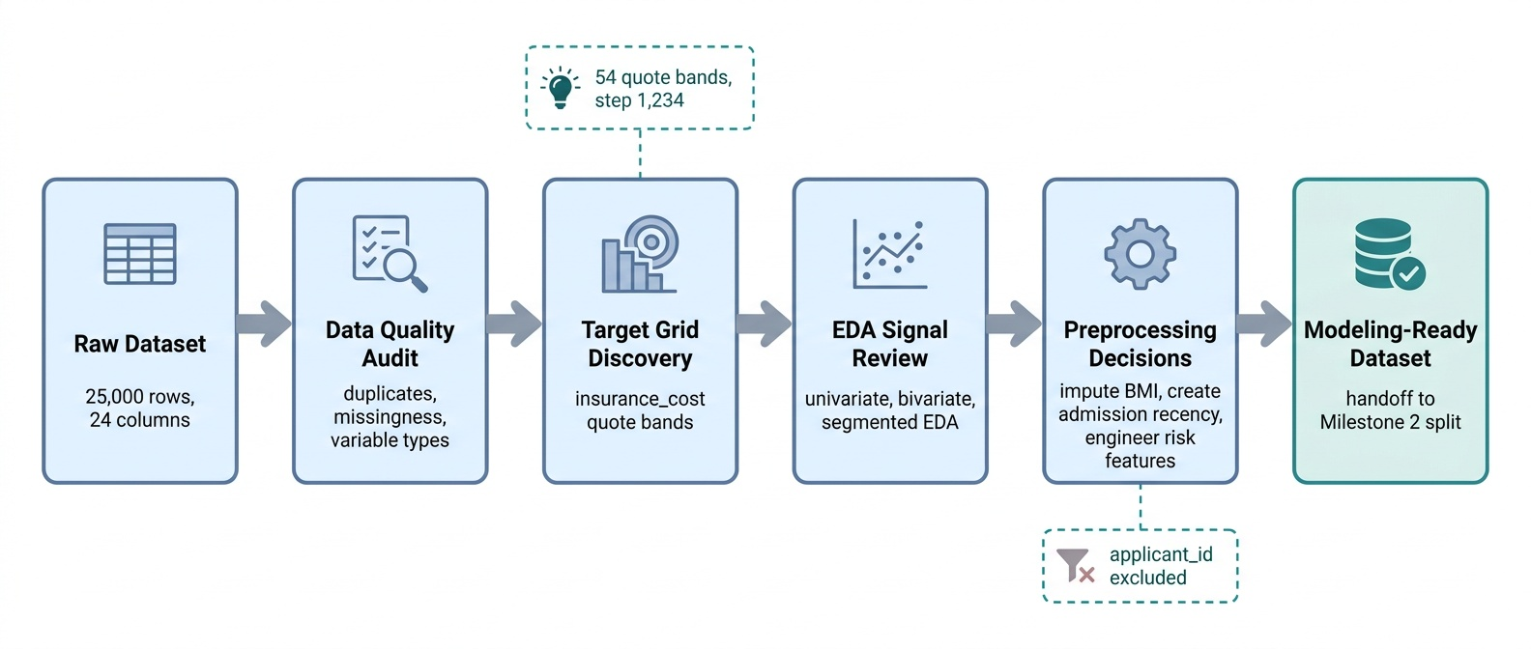
Figure 1. Milestone 1 data audit and EDA workflow for insurance price prediction.
Image candidate | Purpose in Milestone 1 | Status
Milestone 1 workflow overview | Summarizes the data audit, EDA, preprocessing, and handoff flow. | Added
Target quote-grid explainer | Clarifies why insurance_cost is evaluated as 54 quote bands. | Covered by target-grid chart
Missingness handling map | Shows why BMI and admission-year missingness are handled differently. | Covered by missingness charts
Preprocessing pipeline diagram | Shows ID exclusion, typo cleanup, imputation, and engineered features. | Optional for final deck
Signal-strength summary graphic | Highlights strong and weak observed EDA signals without overclaiming. | Covered by EDA sections
The report keeps the statistical plots as the main evidence and uses the generated workflow image only as an orientation aid.

Data Report
Metric | Value
Rows | 25,000.0
Columns | 24.000
Cells | 600,000.0
Duplicate rows | 0.000
Unique applicant_id | 25,000.0
Target mean | 27,147.4
Target median | 27,148.0
Target skew | 0.332

The dataset contains 25,000 unique applicants and 24 original columns. applicant_id is unique for every row and is retained only for auditability, not for modeling.

Target Pricing Grid
metric | value
target_unique_count | 54
target_grid_step | 1234
target_min | 2468
target_max | 67870
first_10_levels | 2468, 3702, 4936, 6170, 7404, 8638, 9872, 11106, 12340, 13574
last_10_levels | 56764, 57998, 59232, 60466, 61700, 62934, 64168, 65402, 66636, 67870

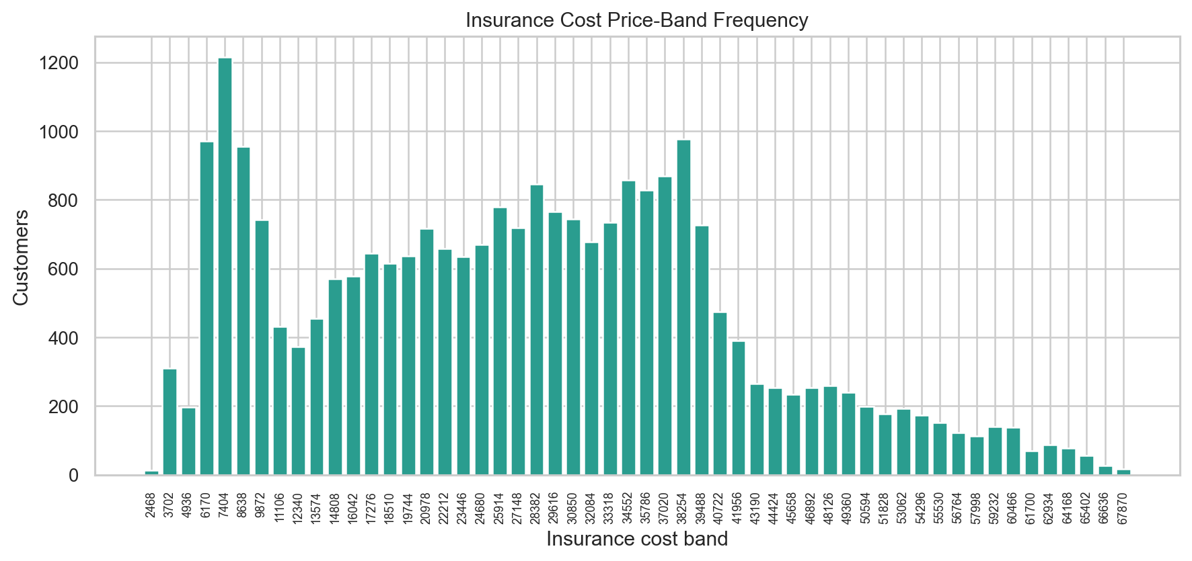
insurance_cost is a discrete business price grid rather than a truly continuous target.
Technical interpretation: The target has 54 unique quote bands with a fixed grid step of 1,234, so regression errors should be interpreted alongside quote-band rounding.
Business interpretation: The model should produce an analytical estimate and then map it to the nearest approved business quote band for presentation.

Missing Values
column | missing_count | missing_pct
Year_last_admitted | 11881 | 47.520
bmi | 990 | 3.960

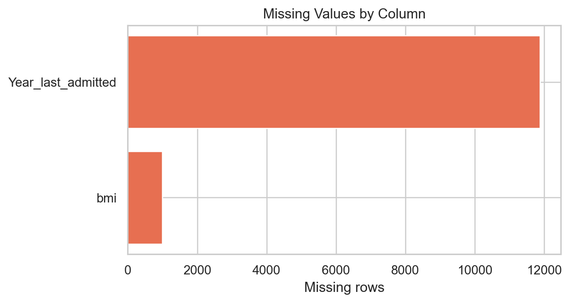
Only BMI and Year_last_admitted contain missing values.
Technical interpretation: BMI has limited missingness, while Year_last_admitted has structural missingness for applicants without known admission history.
Business interpretation: The missingness pattern should not be blanket-dropped; admission-year missingness carries customer history context.

Variable Types and Cleanup
column | clean_column | dtype | missing | unique_values
applicant_id | applicant_id | int64 | 0 | 25000
years_of_insurance_with_us | years_of_insurance_with_us | int64 | 0 | 9
regular_checkup_lasy_year | regular_checkup_last_year | int64 | 0 | 6
adventure_sports | adventure_sports | int64 | 0 | 2
Occupation | Occupation | str | 0 | 3
visited_doctor_last_1_year | visited_doctor_last_1_year | int64 | 0 | 12
cholesterol_level | cholesterol_level | str | 0 | 5
daily_avg_steps | daily_avg_steps | int64 | 0 | 4914
age | age | int64 | 0 | 59
heart_decs_history | heart_disease_history | int64 | 0 | 2
other_major_decs_history | other_major_disease_history | int64 | 0 | 2
Gender | Gender | str | 0 | 2
avg_glucose_level | avg_glucose_level | int64 | 0 | 221
bmi | bmi | float64 | 990 | 465
smoking_status | smoking_status | str | 0 | 4
Year_last_admitted | Year_last_admitted | float64 | 11881 | 29
Location | Location | str | 0 | 15
weight | weight | int64 | 0 | 45
covered_by_any_other_company | covered_by_any_other_company | str | 0 | 2
Alcohol | Alcohol | str | 0 | 3
exercise | exercise | str | 0 | 3
weight_change_in_last_one_year | weight_change_in_last_one_year | int64 | 0 | 7
fat_percentage | fat_percentage | int64 | 0 | 32
insurance_cost | insurance_cost | int64 | 0 | 54

clean_column | analysis_type | role | preprocessing_action
applicant_id | identifier | identifier | retain for audit only; drop from modeling
years_of_insurance_with_us | ordinal discrete numeric | predictor | validate type, preserve for EDA, and feed through modeling pipeline
regular_checkup_last_year | ordinal discrete numeric | predictor | normalize misspelled source name; preserve numeric/category meaning
adventure_sports | binary categorical | predictor | validate type, preserve for EDA, and feed through modeling pipeline
Occupation | nominal categorical | predictor | validate type, preserve for EDA, and feed through modeling pipeline
visited_doctor_last_1_year | ordinal discrete numeric | predictor | validate type, preserve for EDA, and feed through modeling pipeline
cholesterol_level | ordinal categorical | predictor | retain ordinal category and engineer cholesterol midpoint
daily_avg_steps | continuous numeric | predictor | validate type, preserve for EDA, and feed through modeling pipeline
age | continuous numeric | predictor | validate type, preserve for EDA, and feed through modeling pipeline
heart_disease_history | binary categorical | predictor | normalize misspelled source name; preserve numeric/category meaning
other_major_disease_history | binary categorical | predictor | normalize misspelled source name; preserve numeric/category meaning
Gender | nominal categorical | predictor | validate type, preserve for EDA, and feed through modeling pipeline
avg_glucose_level | continuous numeric | predictor | validate type, preserve for EDA, and feed through modeling pipeline
bmi | continuous numeric | predictor | create missingness flag; impute using train-fitted median logic
smoking_status | nominal categorical | predictor | validate type, preserve for EDA, and feed through modeling pipeline
Year_last_admitted | numeric with structural missingness | predictor | create admission flags/status and recency; keep missingness signal
Location | nominal categorical | predictor | validate type, preserve for EDA, and feed through modeling pipeline
weight | continuous numeric | predictor | validate type, preserve for EDA, and feed through modeling pipeline
covered_by_any_other_company | nominal categorical | predictor | validate type, preserve for EDA, and feed through modeling pipeline
Alcohol | nominal categorical | predictor | validate type, preserve for EDA, and feed through modeling pipeline
exercise | nominal categorical | predictor | validate type, preserve for EDA, and feed through modeling pipeline
weight_change_in_last_one_year | ordinal discrete numeric | predictor | validate type, preserve for EDA, and feed through modeling pipeline
fat_percentage | continuous numeric | predictor | validate type, preserve for EDA, and feed through modeling pipeline
insurance_cost | discrete numeric quote grid / regression target | target | retain as target; analyze as quote grid

original | cleaned_or_action | reason
regular_checkup_lasy_year | regular_checkup_last_year | column typo normalized
heart_decs_history | heart_disease_history | column typo normalized
other_major_decs_history | other_major_disease_history | column typo normalized
Occupation value: Salried | Salaried | category typo normalized
applicant_id | dropped from modeling | unique identifier, not predictive signal

Initial Exploratory Data Analysis
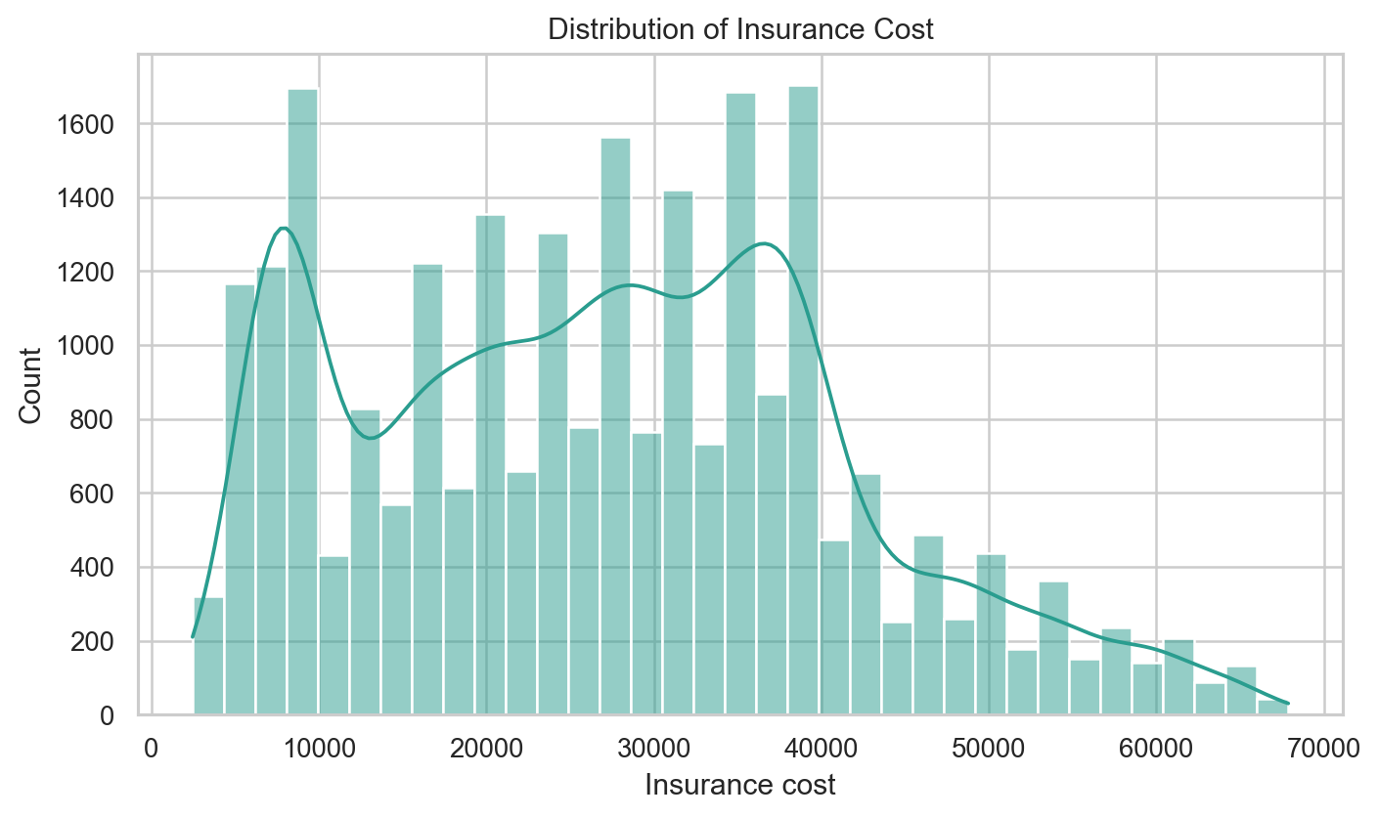
insurance_cost is mildly right-skewed, with most values between roughly 16k and 37k.
Technical interpretation: The target distribution is moderately concentrated with a mild right tail, and the center of the distribution is close to the median premium.
Business interpretation: Most customers fall in mid-range price bands, while high-cost cases require residual and manual-review attention.
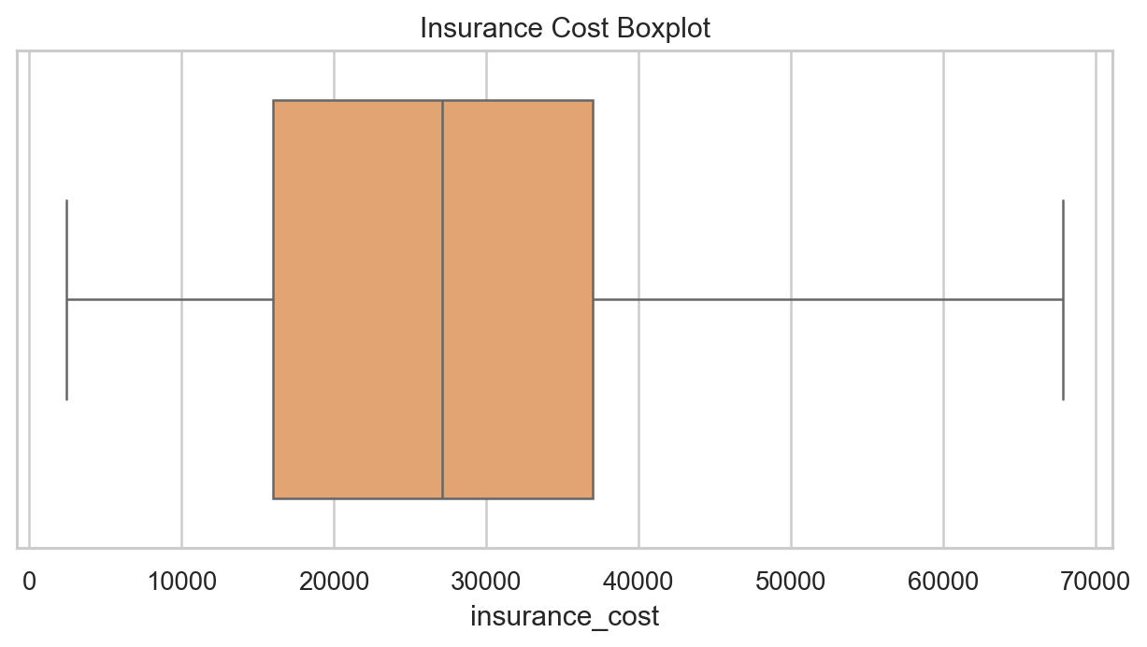
Target outliers are retained because they are valid high-cost pricing cases.
Technical interpretation: Upper-tail insurance_cost values are not data errors; they align with valid quote bands and should remain in model training.
Business interpretation: Removing high premiums would understate risk for customers who are expensive but legitimate pricing cases.
feature | correlation_with_insurance_cost
weight | 0.970
years_since_last_admitted | 0.490
regular_checkup_last_year | -0.174
visited_doctor_last_1_year | 0.009
fat_percentage | -0.008
bmi_for_analysis | -0.008
daily_avg_steps | -0.007
age | 0.005
avg_glucose_level | -0.005
cholesterol_midpoint | -0.001

- The target mean and median are nearly equal, while skew is modest at about 0.33.
- Weight is the dominant marginal pricing signal; a weight-only relationship explains much of the target variation.
- Other-company coverage, admission history, regular checkups, weight change, and adventure sports are stronger observed categorical or ordinal signals than smoking, alcohol, exercise, and disease-history flags.
- No duplicate applicant records were detected.
- Unknown smoking status is treated as a valid business category rather than a missing value.
- A complete univariate plot appendix is included for every original source variable, with technical and business interpretation for each plot.

Data Pre-processing
- Renamed misspelled columns: regular_checkup_lasy_year, heart_decs_history, and other_major_decs_history.
- Corrected Occupation value Salried to Salaried.
- Dropped applicant_id from the modeling feature set because it is a unique identifier.
- Created BMI and admission-year missingness flags before imputation so missingness can carry signal when relevant.
- Imputed BMI using median values by age band and gender for EDA. The sklearn modeling pipeline fits the same logic only on training data.
- Converted Year_last_admitted into was_admitted_before, admission_year_missing_flag, admission_status, and years_since_last_admitted using reference_year=2019. Missing admission years are not treated as ordinary numeric values.
- Created cholesterol_midpoint from ordinal cholesterol ranges.
- Engineered age_band, bmi_category, any_major_disease_history, weight_bmi_interaction, and steps_per_age.
- Capped extremely high BMI values for analysis at the 99.5th percentile while retaining target outliers.
column | q1 | q3 | iqr | lower_fence | upper_fence | outlier_count | outlier_pct
bmi | 26.100 | 35.600 | 9.500 | 11.850 | 49.850 | 549 | 2.290
weight | 64.000 | 78.000 | 14.000 | 43.000 | 99.000 | 0 | 0.000
avg_glucose_level | 113.0 | 222.0 | 109.0 | -50.500 | 385.5 | 0 | 0.000
daily_avg_steps | 4,543.0 | 5,730.0 | 1,187.0 | 2,762.5 | 7,510.5 | 952 | 3.810
fat_percentage | 21.000 | 36.000 | 15.000 | -1.500 | 58.500 | 0 | 0.000
insurance_cost | 16,042.0 | 37,020.0 | 20,978.0 | -15,425.0 | 68,487.0 | 0 | 0.000

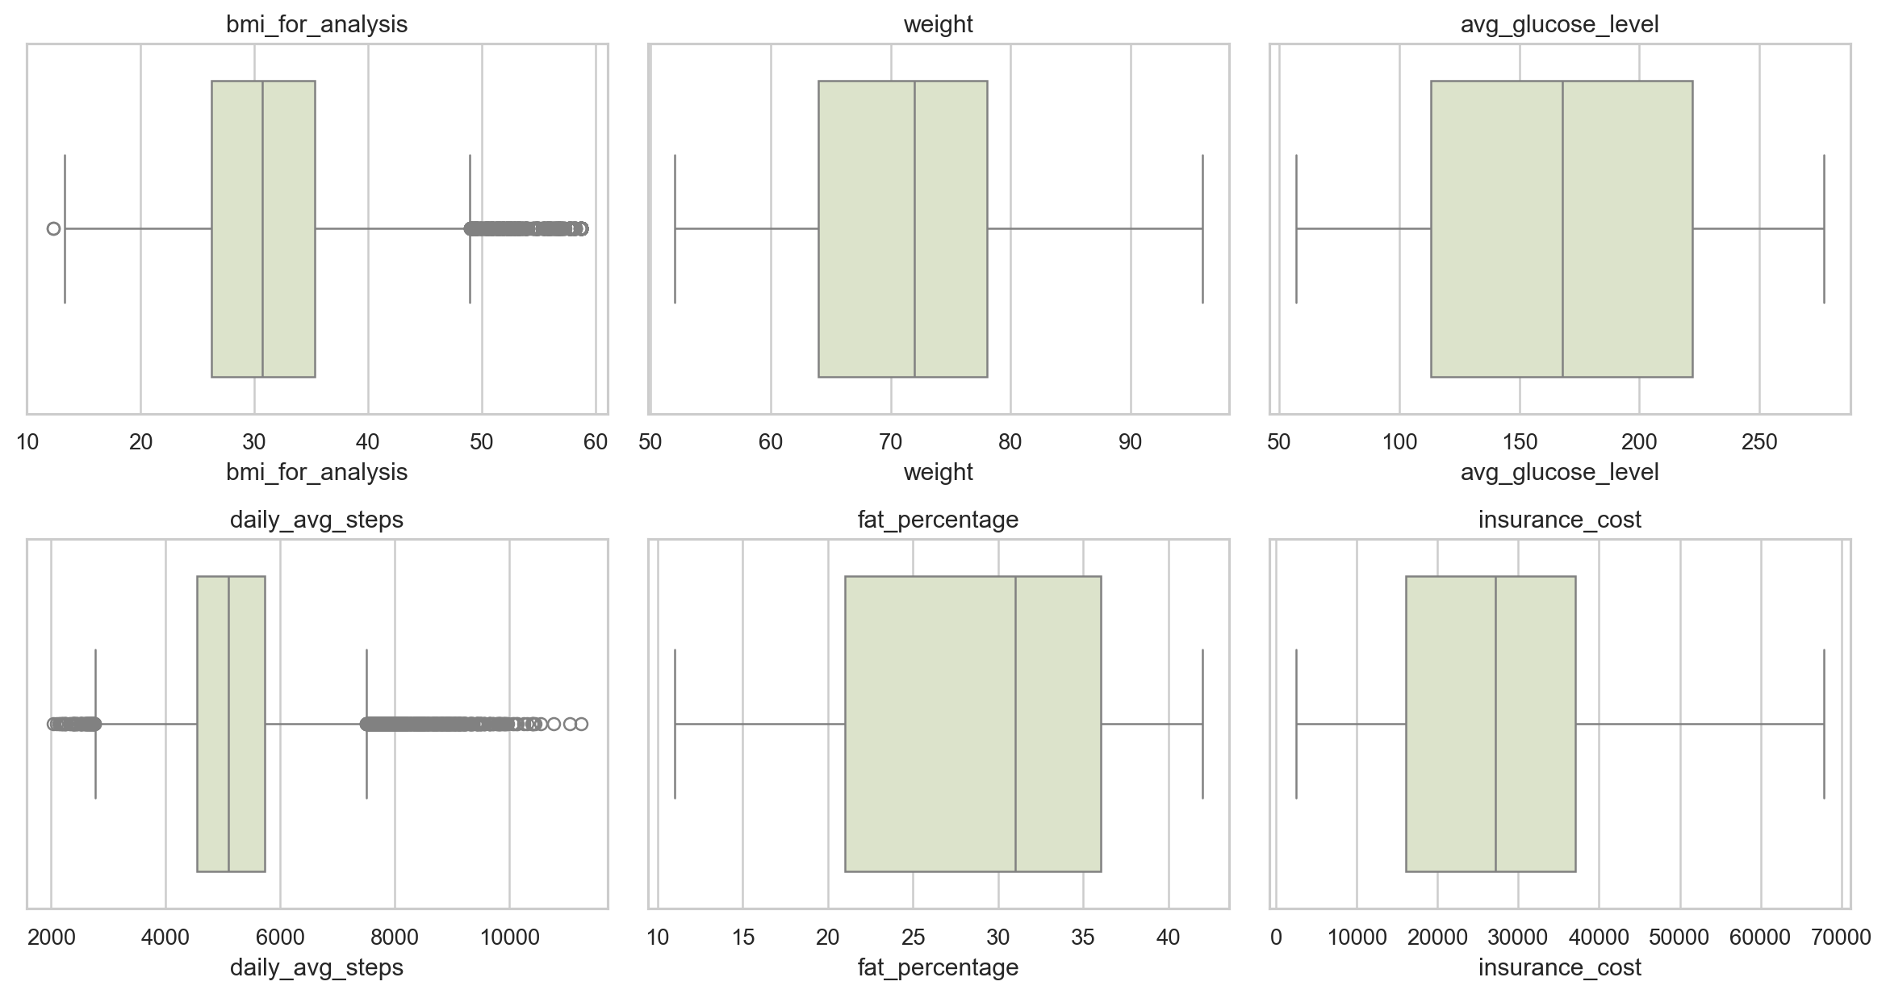
IQR outlier review for important numeric variables.
Technical interpretation: Numeric outlier checks show valid spread in cost, weight, glucose, steps, fat percentage, and BMI after analysis capping.
Business interpretation: The project keeps real applicant variation while only stabilizing extreme BMI values for analysis and modeling.

Extensive Exploratory Data Analysis
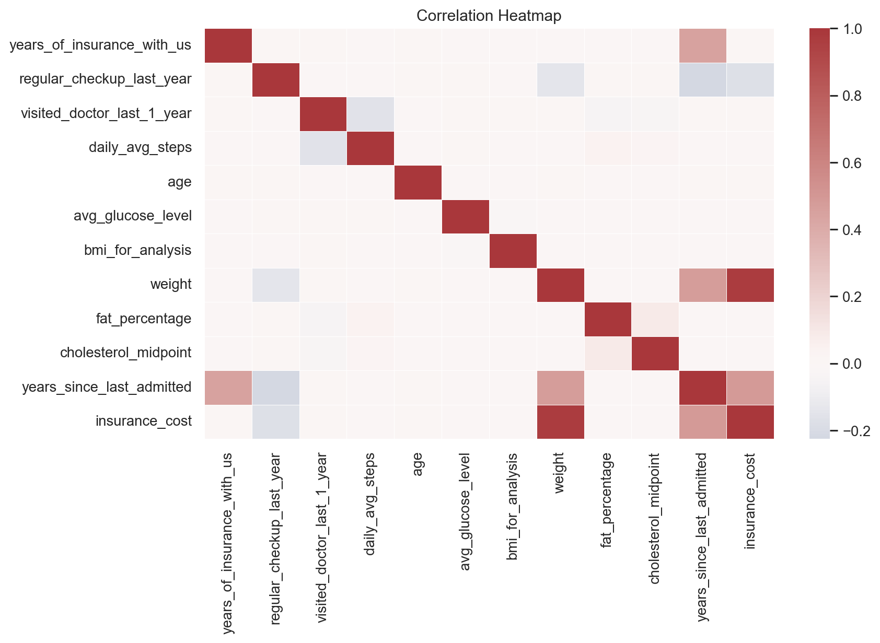
Correlation view across numeric and engineered variables.
Technical interpretation: The heatmap shows weight as the strongest marginal numeric relationship; many clinical and habit variables have weak standalone correlations.
Business interpretation: Pricing discussion should prioritize dominant observed drivers but retain weak variables for interaction and monitoring checks.
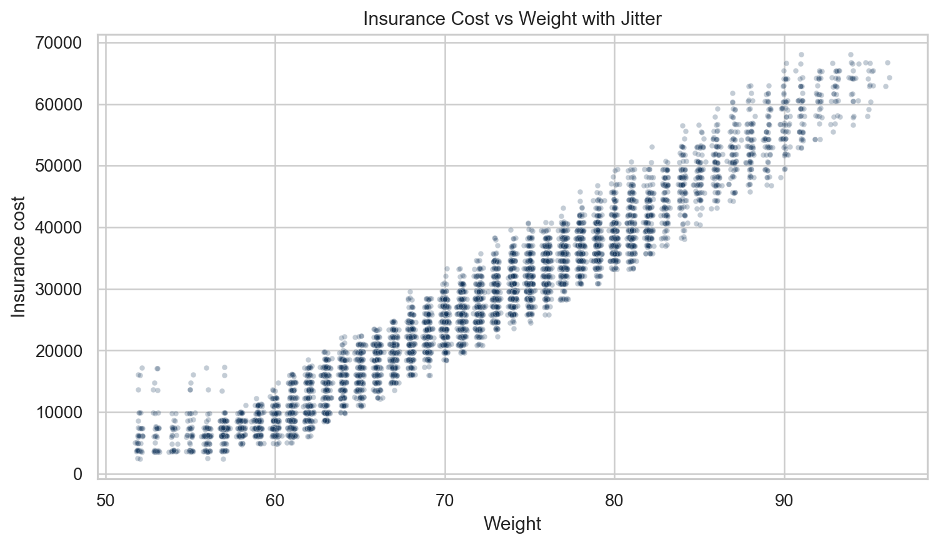
Weight dominates the target relationship and aligns closely with the discrete price bands.
Technical interpretation: The jittered scatter separates overlapping quote-grid points and reveals a clear upward cost pattern as weight increases.
Business interpretation: Weight is the most visible pricing driver in this dataset and must be validated against business policy before operational use.
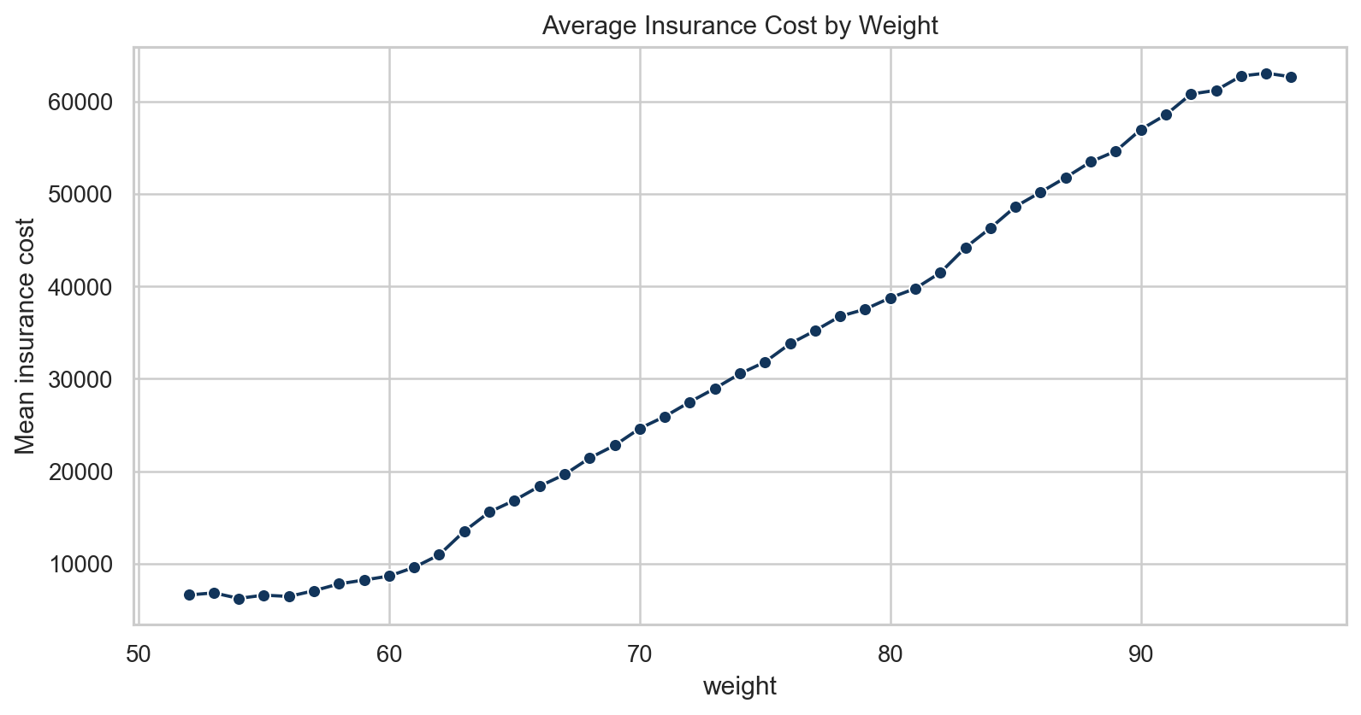
Average insurance cost rises sharply with weight.
Technical interpretation: Mean premium increases monotonically across much of the weight range, indicating a strong nonlinear pricing gradient.
Business interpretation: Applicants in higher weight ranges are likely to receive higher model estimates, so segment-level fairness and policy checks matter.
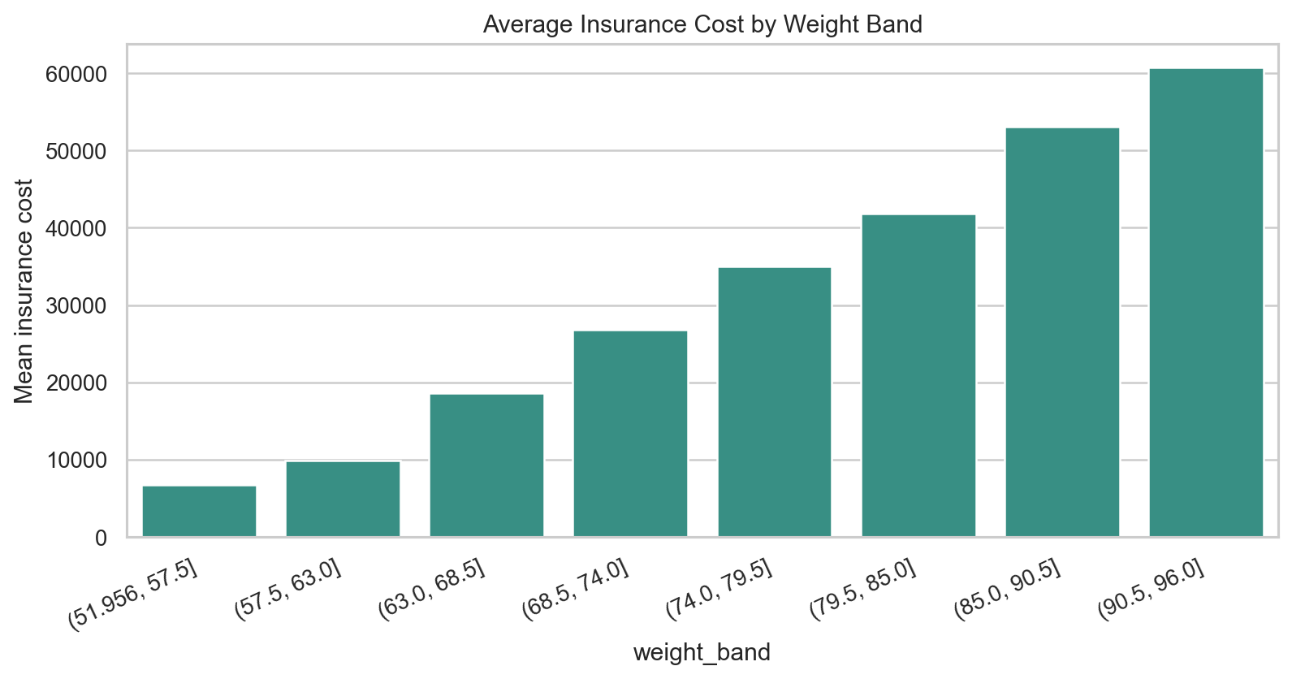
Weight-band summaries show the main pricing gradient.
Technical interpretation: Weight bands reduce point-level noise and confirm that the weight-cost relationship is not driven by only a few individual records.
Business interpretation: Business users can understand the model's main driver through banded summaries instead of raw scatter alone.
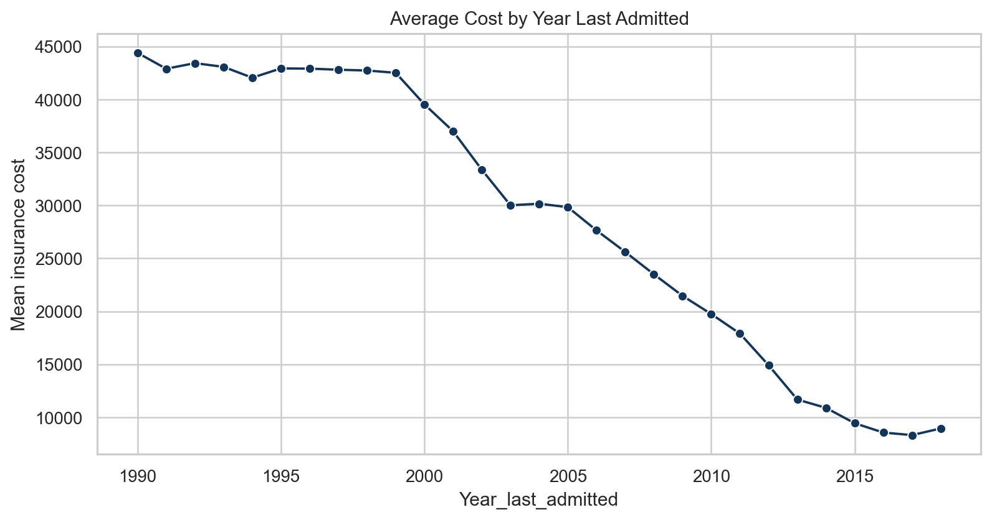
Admission year is an important risk-history signal among applicants with known admission history.
Technical interpretation: Admission year has an ordered association with average premium among applicants with a known admission date.
Business interpretation: Recent or known admissions may flag underwriting review needs, but the model should not treat missing years as ordinary zeros.
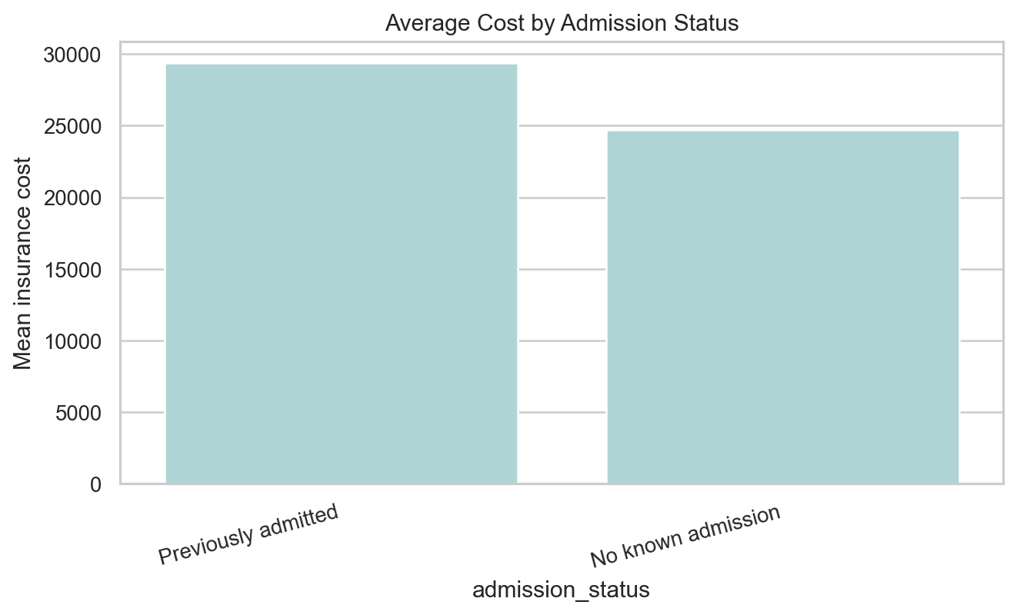
Missing or absent admission history is separated from known prior admission cases.
Technical interpretation: Admission status separates no known admission, missing year, and known admission history so the model can learn structural differences.
Business interpretation: This prevents applicants without admission records from being incorrectly grouped with applicants admitted in an arbitrary year.
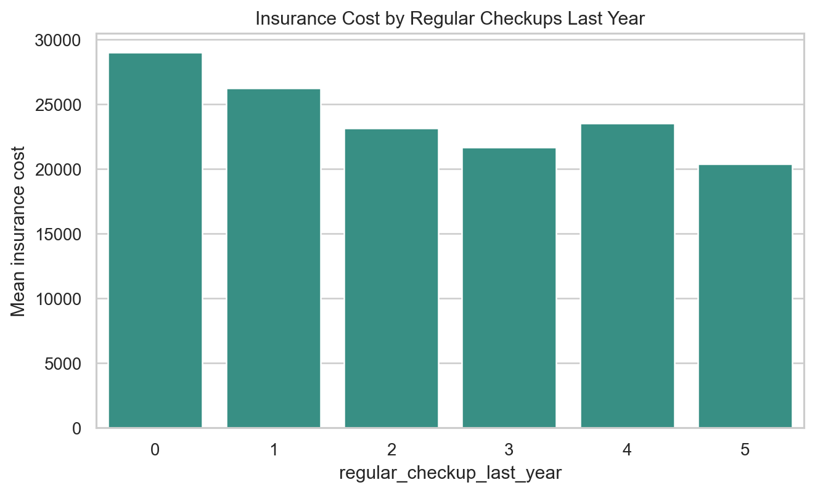
Regular-checkup counts show a stronger ordinal signal than many lifestyle flags.
Technical interpretation: Regular checkup count has a clearer ordinal target pattern than several binary habit flags.
Business interpretation: Preventive-care behavior may help segment applicants, though the relationship should be treated as association rather than causation.
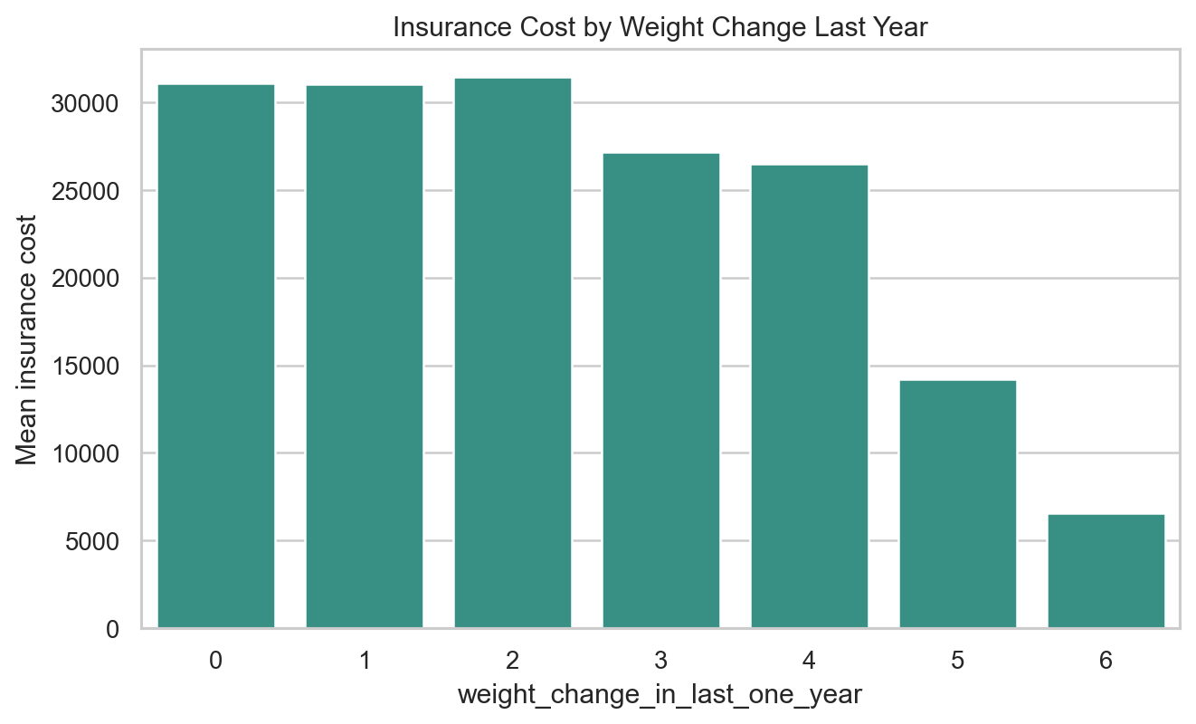
Weight-change categories show a strong observed pattern; this should be interpreted as association, not causation.
Technical interpretation: Weight-change categories produce a sizable target mean range, making them a useful engineered ordinal feature.
Business interpretation: Weight-change history can support risk segmentation, but business recommendations should avoid claiming it directly causes premium movement.
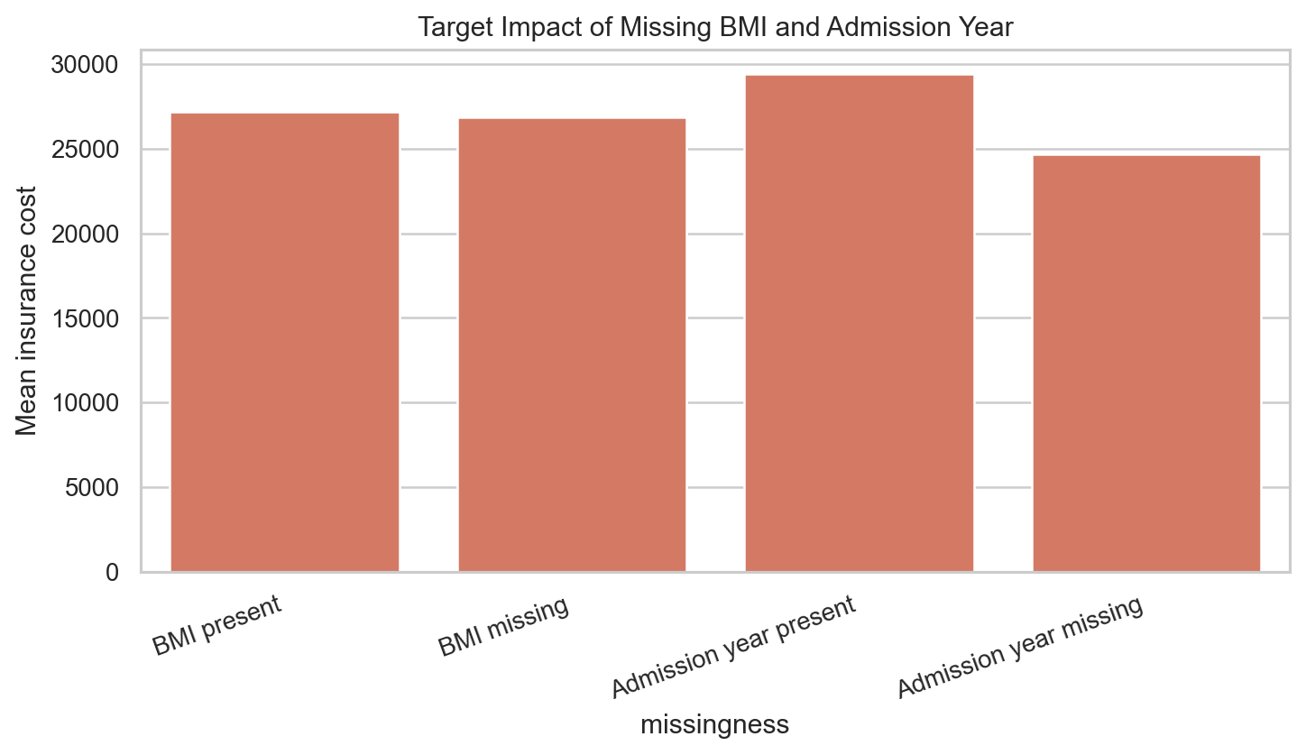
Missingness itself affects target means for BMI and admission year.
Technical interpretation: Target means differ between missing and present groups, which justifies explicit missingness flags before imputation.
Business interpretation: Retaining missingness indicators helps the deployment model handle incomplete applications more consistently.
feature | feature_type | target_mean_range | correlation_or_eta_squared | statistic_name | business_interpretation
weight | numeric | 46,308.6 | 0.970 | absolute_correlation | strong observed signal
Year_last_admitted | numeric_missing | 36,072.7 | 0.415 | eta_squared | strong observed signal
years_since_last_admitted | numeric_engineered | 30,329.2 | 0.490 | absolute_correlation | strong observed signal
weight_change_in_last_one_year | ordinal | 24,877.8 | 0.180 | eta_squared | strong observed signal
regular_checkup_last_year | ordinal | 8,606.3 | 0.034 | eta_squared | strong observed signal
adventure_sports | binary | 3,898.6 | 0.006 | eta_squared | strong observed signal
covered_by_any_other_company | categorical | 3,166.6 | 0.010 | eta_squared | strong observed signal
bmi_for_analysis | numeric | 1,072.6 | 0.008 | absolute_correlation | secondary signal; monitor with interactions
cholesterol_midpoint | numeric | 897.1 | 0.000 | eta_squared | weak marginal signal in this dataset
age | numeric | 792.7 | 0.005 | absolute_correlation | secondary signal; monitor with interactions
avg_glucose_level | numeric | 642.7 | 0.005 | absolute_correlation | secondary signal; monitor with interactions
exercise | categorical | 388.4 | 0.000 | eta_squared | weak marginal signal in this dataset
smoking_status | categorical | 312.3 | 0.000 | eta_squared | weak marginal signal in this dataset
Alcohol | categorical | 287.8 | 0.000 | eta_squared | weak marginal signal in this dataset
other_major_disease_history | binary | 109.2 | 0.000 | eta_squared | weak marginal signal in this dataset
heart_disease_history | binary | 28.040 | 0.000 | eta_squared | weak marginal signal in this dataset

- The strongest observed drivers are weight, admission recency/year, other-company coverage, regular checkups, weight change, and adventure sports.
- Smoking, alcohol, exercise, age, BMI, glucose, cholesterol, and disease-history variables show weak marginal effects in this dataset but remain useful for interaction checks, fairness review, and monitoring.
- BMI, weight, glucose, and fat percentage are related but not interchangeable; multicollinearity should be handled by regularization or tree ensembles rather than manually dropping fields too early.
- Other coverage and admission-history features may reflect customer risk profile and require careful business interpretation.

EDA Conclusion and Further Steps
- Conclusion: the dataset is complete enough for modeling after targeted BMI/admission-history treatment, and the target behaves like a discrete quote grid with clear pricing bands.
- Conclusion: weight is the dominant observed signal, while admission recency, coverage, regular checkups, weight change, and adventure sports provide the next strongest pricing context.
- Further step: carry the cleaned and engineered data into Milestone 2 with target-band stratified splitting, cross-validation, final model selection, explainability, and deployment checks.
- Further step: validate dominant drivers with business stakeholders before interpreting them as underwriting policy or causal effects.

Appendix

Complete Univariate Plot Appendix
original_column | clean_column | analysis_type | plot_type | missing_count | unique_count
applicant_id | applicant_id | identifier | identifier audit bar chart | 0 | 25000
years_of_insurance_with_us | years_of_insurance_with_us | ordinal discrete numeric | frequency bar chart | 0 | 9
regular_checkup_lasy_year | regular_checkup_last_year | ordinal discrete numeric | frequency bar chart | 0 | 6
adventure_sports | adventure_sports | binary categorical | frequency bar chart | 0 | 2
Occupation | Occupation | nominal categorical | frequency bar chart | 0 | 3
visited_doctor_last_1_year | visited_doctor_last_1_year | ordinal discrete numeric | frequency bar chart | 0 | 12
cholesterol_level | cholesterol_level | ordinal categorical | frequency bar chart | 0 | 5
daily_avg_steps | daily_avg_steps | continuous numeric | histogram and boxplot | 0 | 4914
age | age | continuous numeric | histogram and boxplot | 0 | 59
heart_decs_history | heart_disease_history | binary categorical | frequency bar chart | 0 | 2
other_major_decs_history | other_major_disease_history | binary categorical | frequency bar chart | 0 | 2
Gender | Gender | nominal categorical | frequency bar chart | 0 | 2
avg_glucose_level | avg_glucose_level | continuous numeric | histogram and boxplot | 0 | 221
bmi | bmi | continuous numeric | histogram and boxplot | 990 | 465
smoking_status | smoking_status | nominal categorical | frequency bar chart | 0 | 4
Year_last_admitted | Year_last_admitted | numeric with structural missingness | frequency bar chart | 11881 | 29
Location | Location | nominal categorical | frequency bar chart | 0 | 15
weight | weight | continuous numeric | histogram and boxplot | 0 | 45
covered_by_any_other_company | covered_by_any_other_company | nominal categorical | frequency bar chart | 0 | 2
Alcohol | Alcohol | nominal categorical | frequency bar chart | 0 | 3
exercise | exercise | nominal categorical | frequency bar chart | 0 | 3
weight_change_in_last_one_year | weight_change_in_last_one_year | ordinal discrete numeric | frequency bar chart | 0 | 7
fat_percentage | fat_percentage | continuous numeric | histogram and boxplot | 0 | 32
insurance_cost | insurance_cost | discrete numeric quote grid / regression target | target histogram with KDE | 0 | 54

Univariate plot: applicant_id
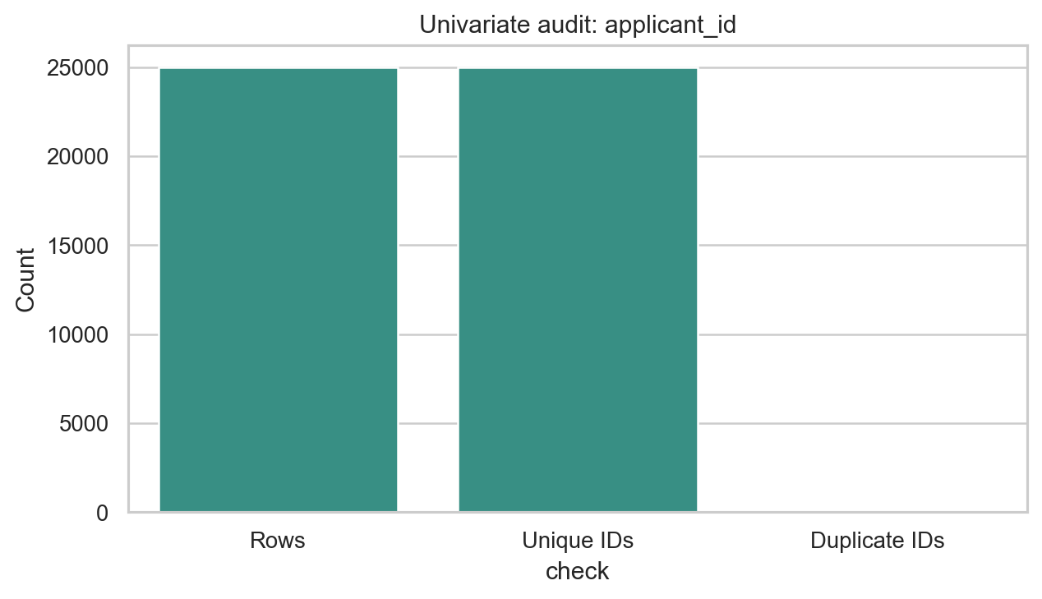
Univariate distribution or frequency for applicant_id.
Technical interpretation: `applicant_id` has 25,000 unique values across 25,000 rows and 0 duplicate ID values.
Business interpretation: The field is useful for audit traceability only and is excluded from modeling and app input because an identifier does not generalize to new applicants.

Univariate plot: years_of_insurance_with_us
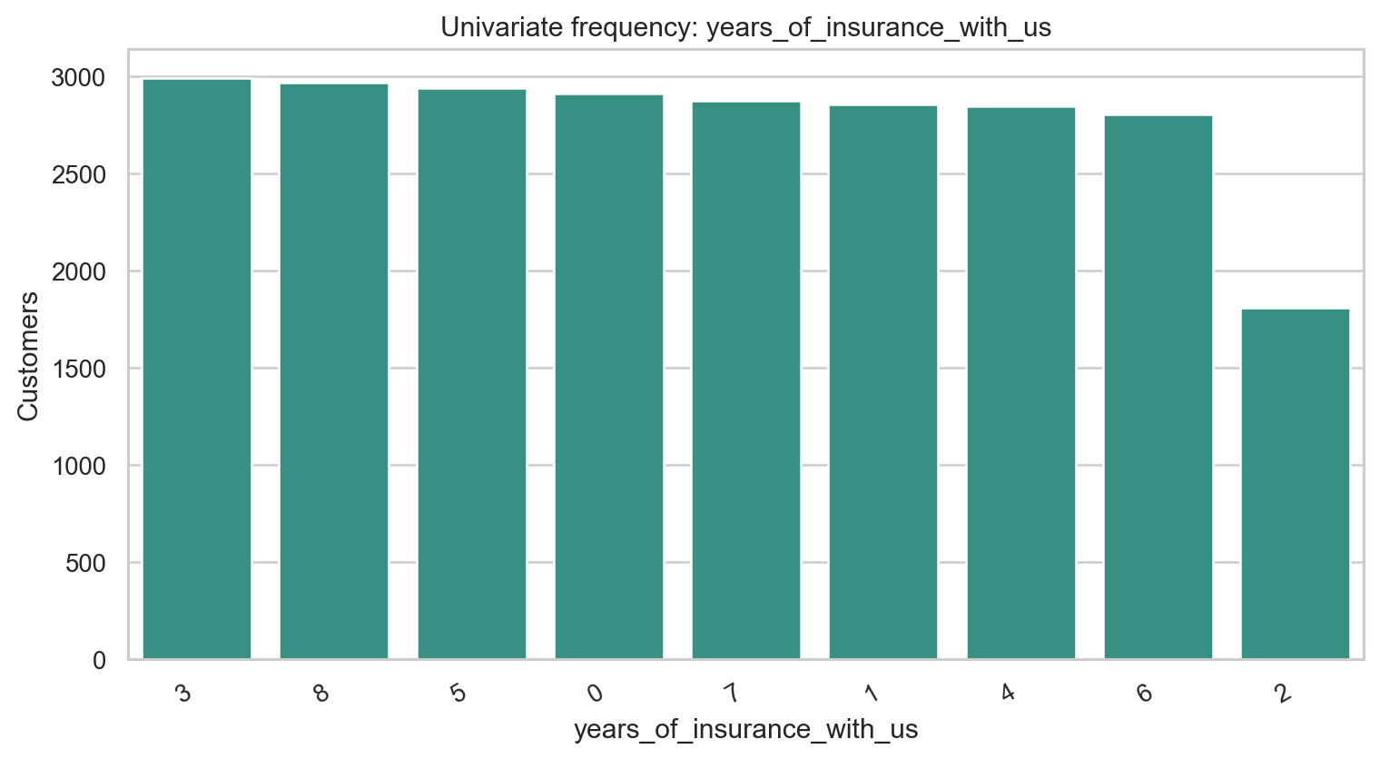
Univariate distribution or frequency for years_of_insurance_with_us.
Technical interpretation: `years_of_insurance_with_us` has 9 non-missing levels and 0 missing values; the most frequent level is `3` at 12.0% of rows.
Business interpretation: The frequency view checks whether `years_of_insurance_with_us` is balanced enough for EDA and downstream encoding; the preprocessing action is: validate type, preserve for EDA, and feed through modeling pipeline.

Univariate plot: regular_checkup_last_year
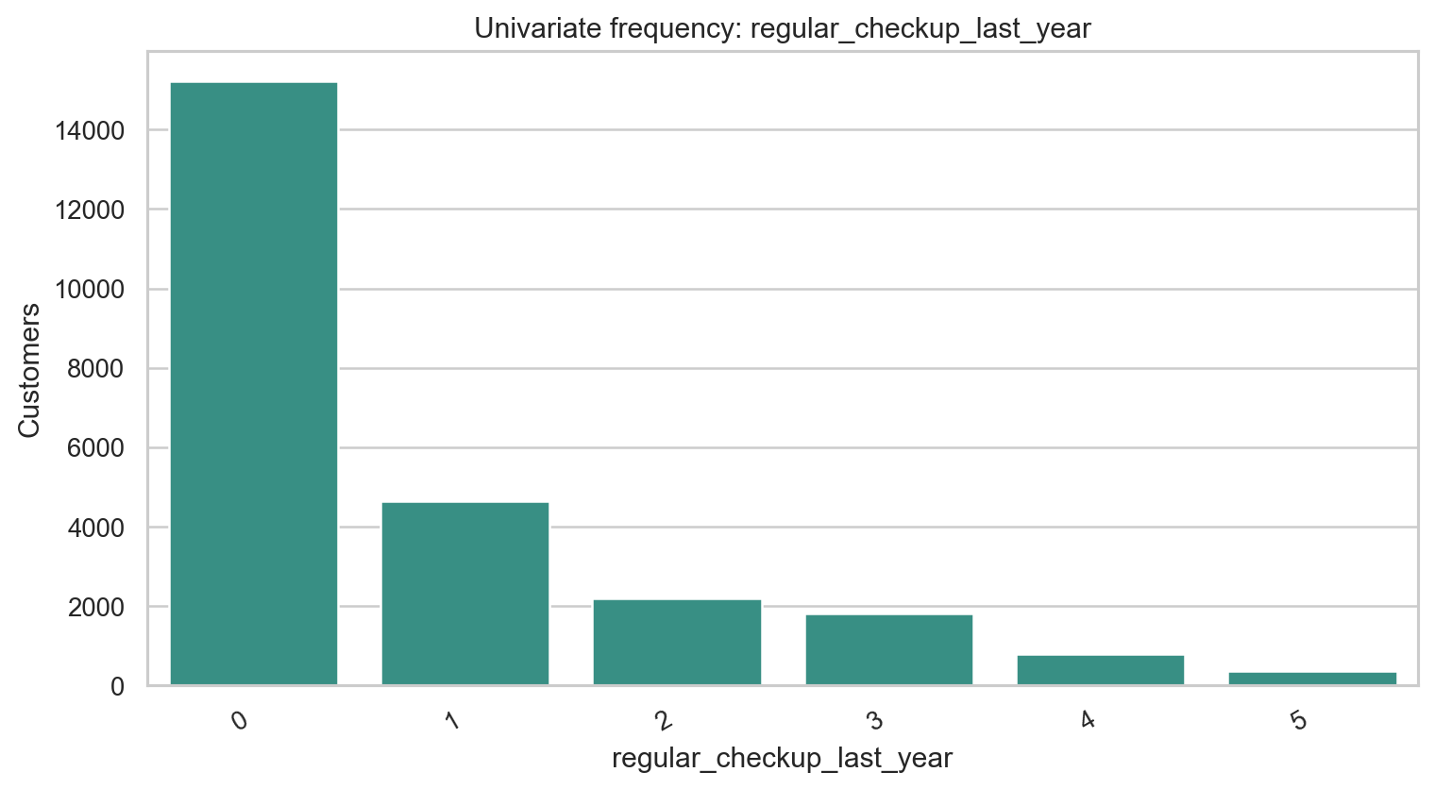
Univariate distribution or frequency for regular_checkup_last_year.
Technical interpretation: `regular_checkup_last_year` has 6 non-missing levels and 0 missing values; the most frequent level is `0` at 60.9% of rows.
Business interpretation: The frequency view checks whether `regular_checkup_last_year` is balanced enough for EDA and downstream encoding; the preprocessing action is: normalize misspelled source name; preserve numeric/category meaning.

Univariate plot: adventure_sports
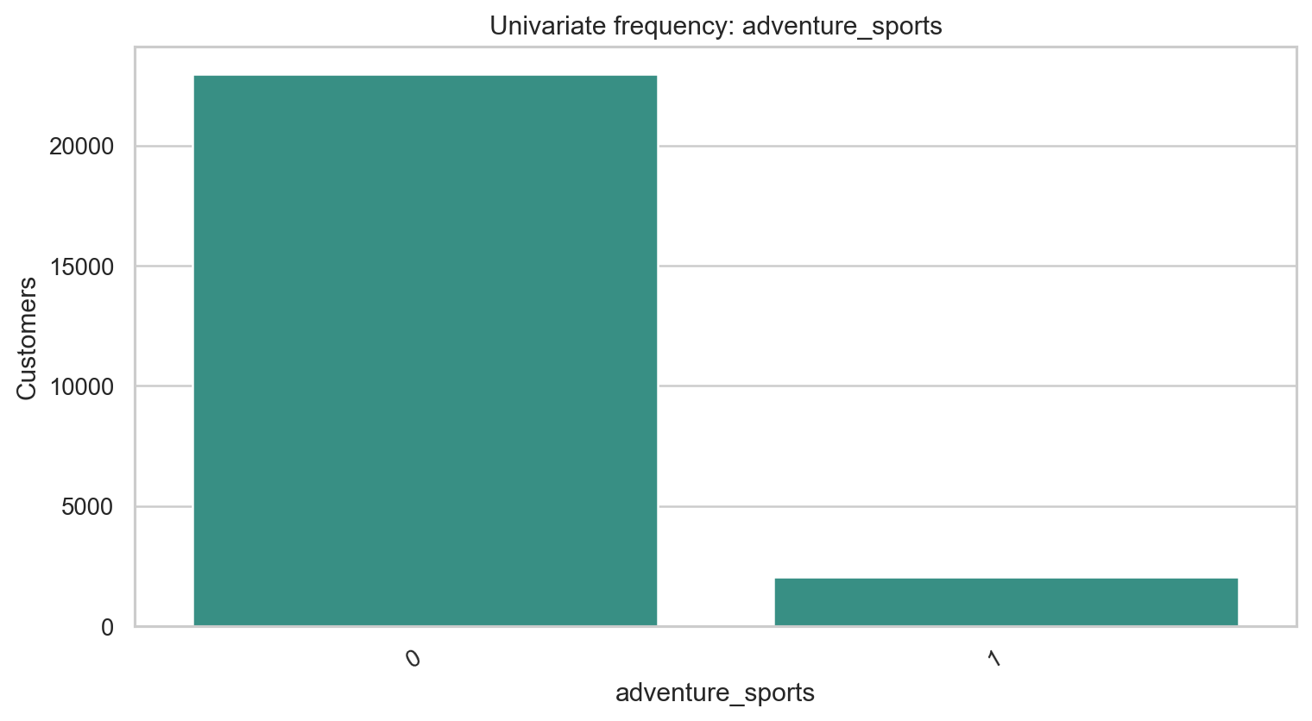
Univariate distribution or frequency for adventure_sports.
Technical interpretation: `adventure_sports` has 2 non-missing levels and 0 missing values; the most frequent level is `0` at 91.8% of rows.
Business interpretation: The frequency view checks whether `adventure_sports` is balanced enough for EDA and downstream encoding; the preprocessing action is: validate type, preserve for EDA, and feed through modeling pipeline.

Univariate plot: Occupation
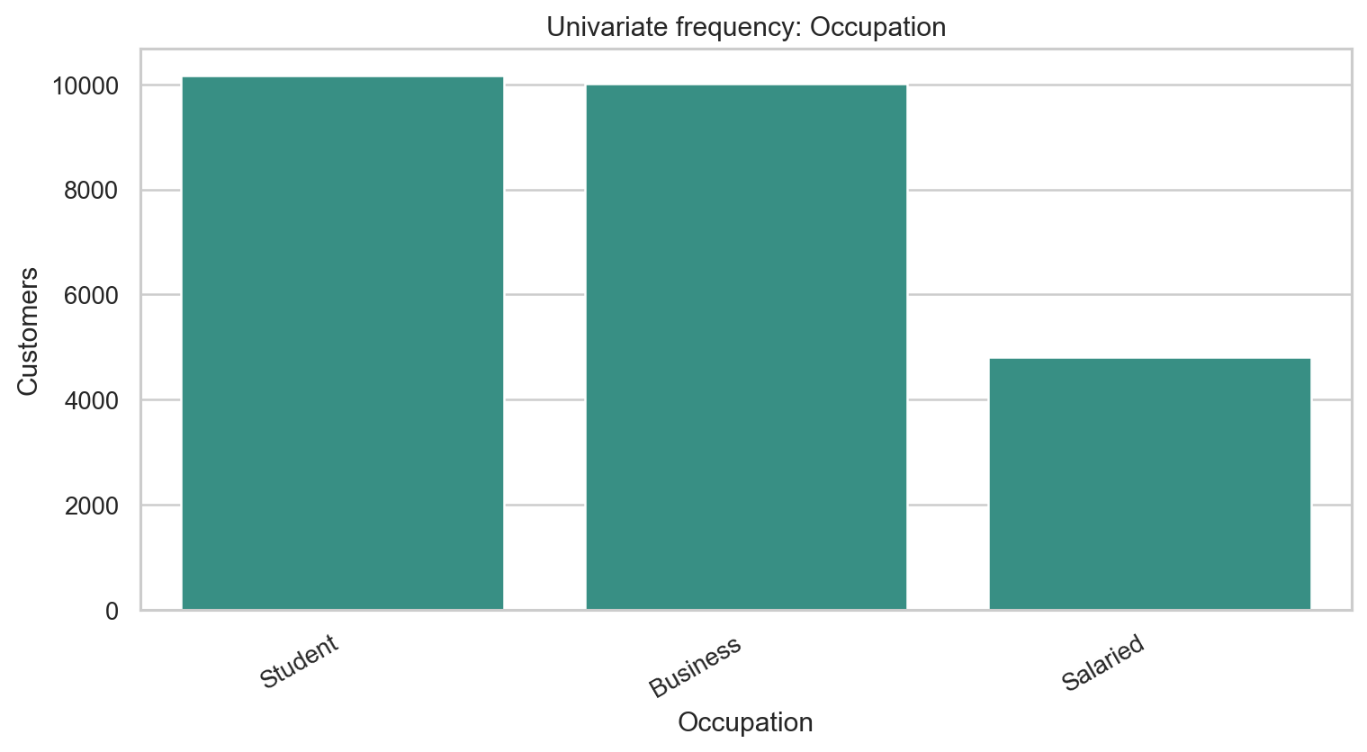
Univariate distribution or frequency for Occupation.
Technical interpretation: `Occupation` has 3 non-missing levels and 0 missing values; the most frequent level is `Student` at 40.7% of rows.
Business interpretation: The frequency view checks whether `Occupation` is balanced enough for EDA and downstream encoding; the preprocessing action is: validate type, preserve for EDA, and feed through modeling pipeline.

Univariate plot: visited_doctor_last_1_year
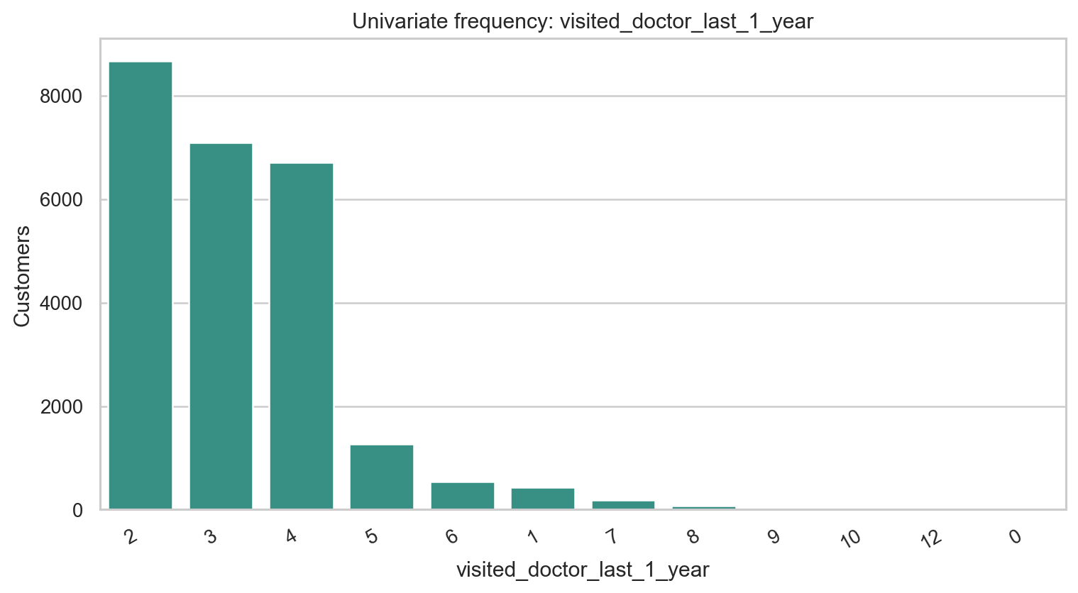
Univariate distribution or frequency for visited_doctor_last_1_year.
Technical interpretation: `visited_doctor_last_1_year` has 12 non-missing levels and 0 missing values; the most frequent level is `2` at 34.7% of rows.
Business interpretation: The frequency view checks whether `visited_doctor_last_1_year` is balanced enough for EDA and downstream encoding; the preprocessing action is: validate type, preserve for EDA, and feed through modeling pipeline.

Univariate plot: cholesterol_level
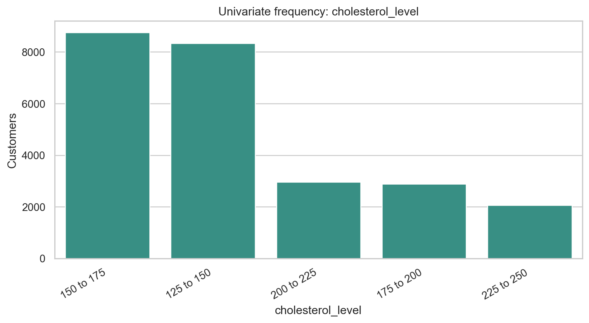
Univariate distribution or frequency for cholesterol_level.
Technical interpretation: `cholesterol_level` has 5 non-missing levels and 0 missing values; the most frequent level is `150 to 175` at 35.1% of rows.
Business interpretation: The frequency view checks whether `cholesterol_level` is balanced enough for EDA and downstream encoding; the preprocessing action is: retain ordinal category and engineer cholesterol midpoint.

Univariate plot: daily_avg_steps
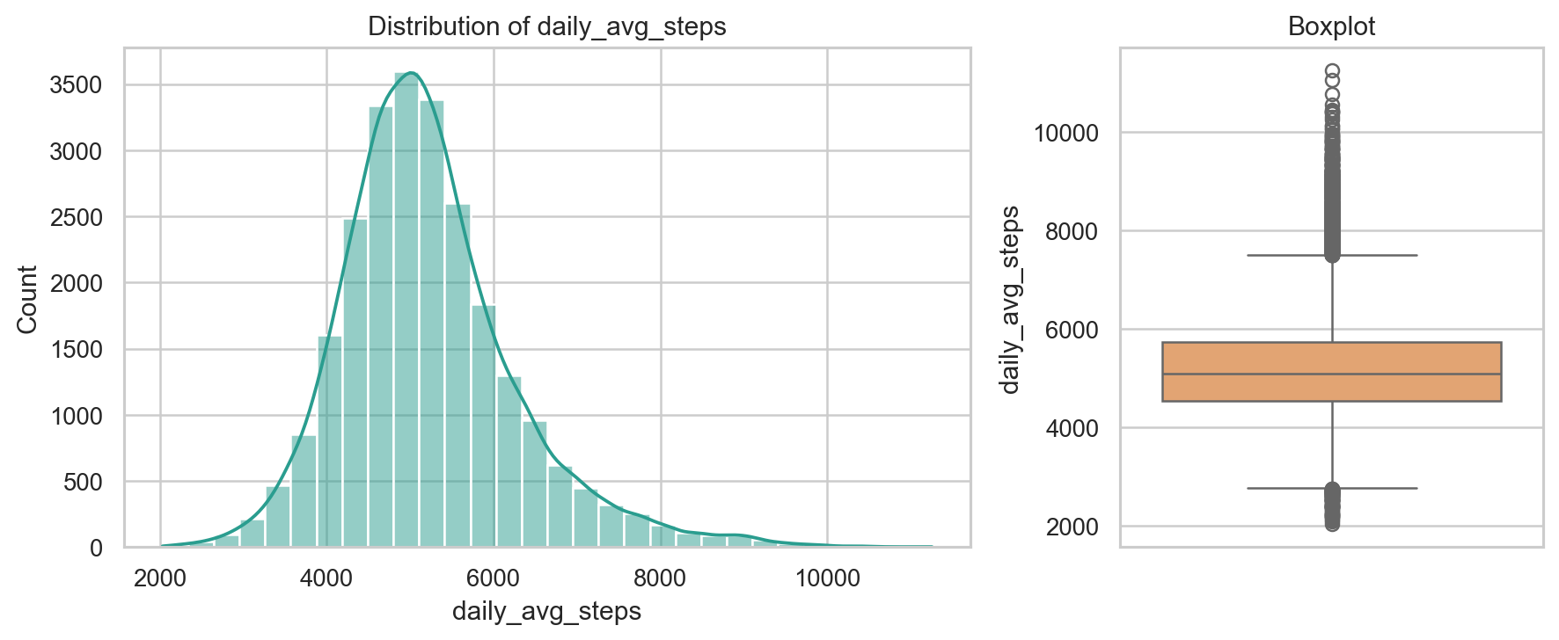
Univariate distribution or frequency for daily_avg_steps.
Technical interpretation: `daily_avg_steps` is numeric with 4,914 unique values, median 5,089.00, range 2,034.00 to 11,255.00, and 0 missing values.
Business interpretation: The distribution documents the applicant spread for `daily_avg_steps` before modeling; the preprocessing action is: validate type, preserve for EDA, and feed through modeling pipeline.

Univariate plot: age
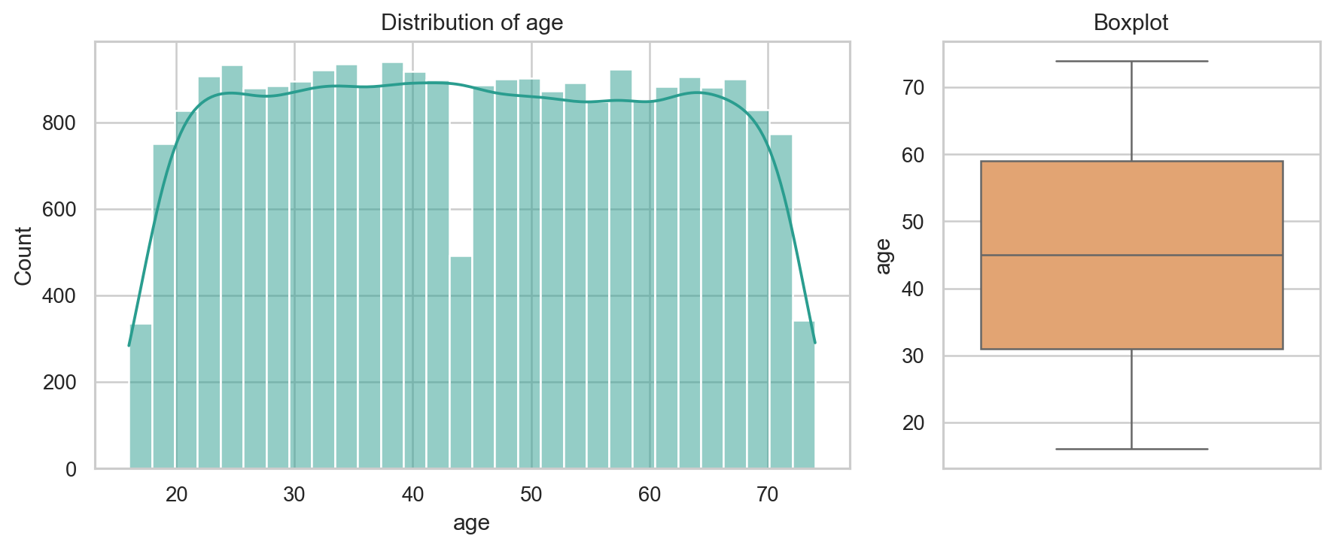
Univariate distribution or frequency for age.
Technical interpretation: `age` is numeric with 59 unique values, median 45.00, range 16.00 to 74.00, and 0 missing values.
Business interpretation: The distribution documents the applicant spread for `age` before modeling; the preprocessing action is: validate type, preserve for EDA, and feed through modeling pipeline.

Univariate plot: heart_disease_history
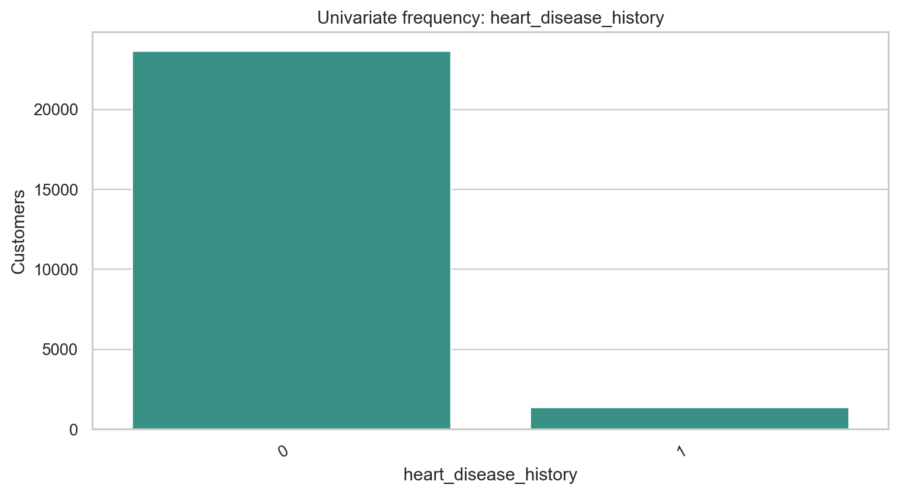
Univariate distribution or frequency for heart_disease_history.
Technical interpretation: `heart_disease_history` has 2 non-missing levels and 0 missing values; the most frequent level is `0` at 94.5% of rows.
Business interpretation: The frequency view checks whether `heart_disease_history` is balanced enough for EDA and downstream encoding; the preprocessing action is: normalize misspelled source name; preserve numeric/category meaning.

Univariate plot: other_major_disease_history
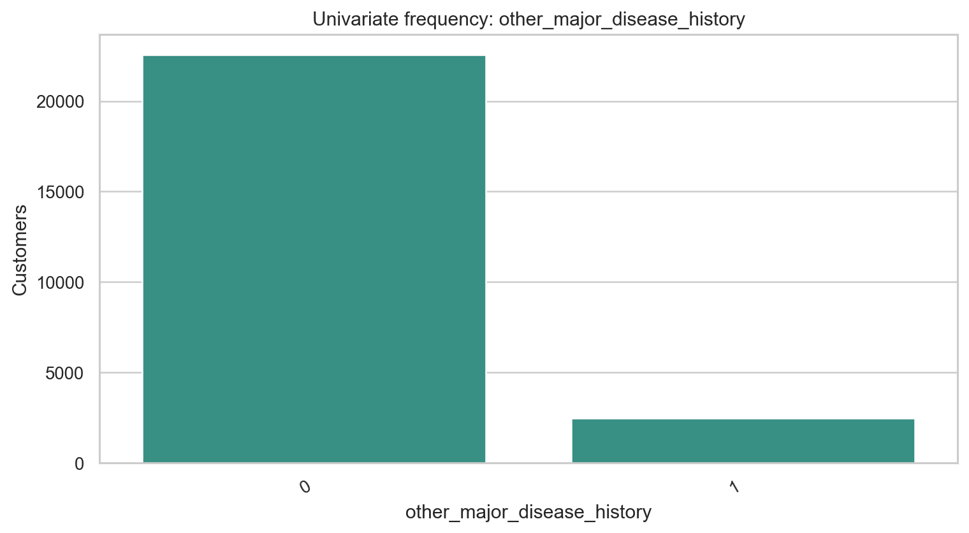
Univariate distribution or frequency for other_major_disease_history.
Technical interpretation: `other_major_disease_history` has 2 non-missing levels and 0 missing values; the most frequent level is `0` at 90.2% of rows.
Business interpretation: The frequency view checks whether `other_major_disease_history` is balanced enough for EDA and downstream encoding; the preprocessing action is: normalize misspelled source name; preserve numeric/category meaning.

Univariate plot: Gender
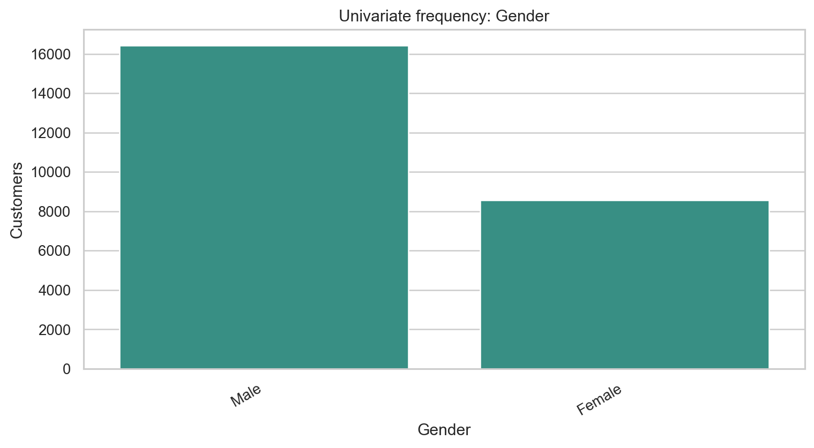
Univariate distribution or frequency for Gender.
Technical interpretation: `Gender` has 2 non-missing levels and 0 missing values; the most frequent level is `Male` at 65.7% of rows.
Business interpretation: The frequency view checks whether `Gender` is balanced enough for EDA and downstream encoding; the preprocessing action is: validate type, preserve for EDA, and feed through modeling pipeline.

Univariate plot: avg_glucose_level
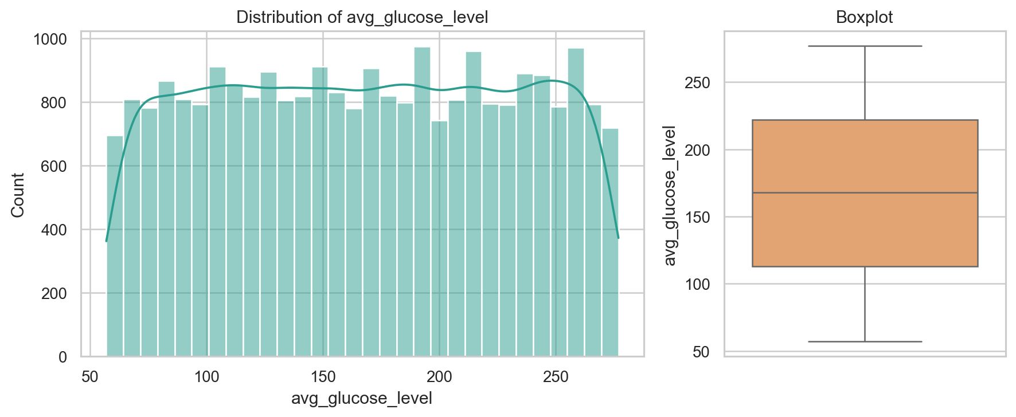
Univariate distribution or frequency for avg_glucose_level.
Technical interpretation: `avg_glucose_level` is numeric with 221 unique values, median 168.00, range 57.00 to 277.00, and 0 missing values.
Business interpretation: The distribution documents the applicant spread for `avg_glucose_level` before modeling; the preprocessing action is: validate type, preserve for EDA, and feed through modeling pipeline.

Univariate plot: bmi
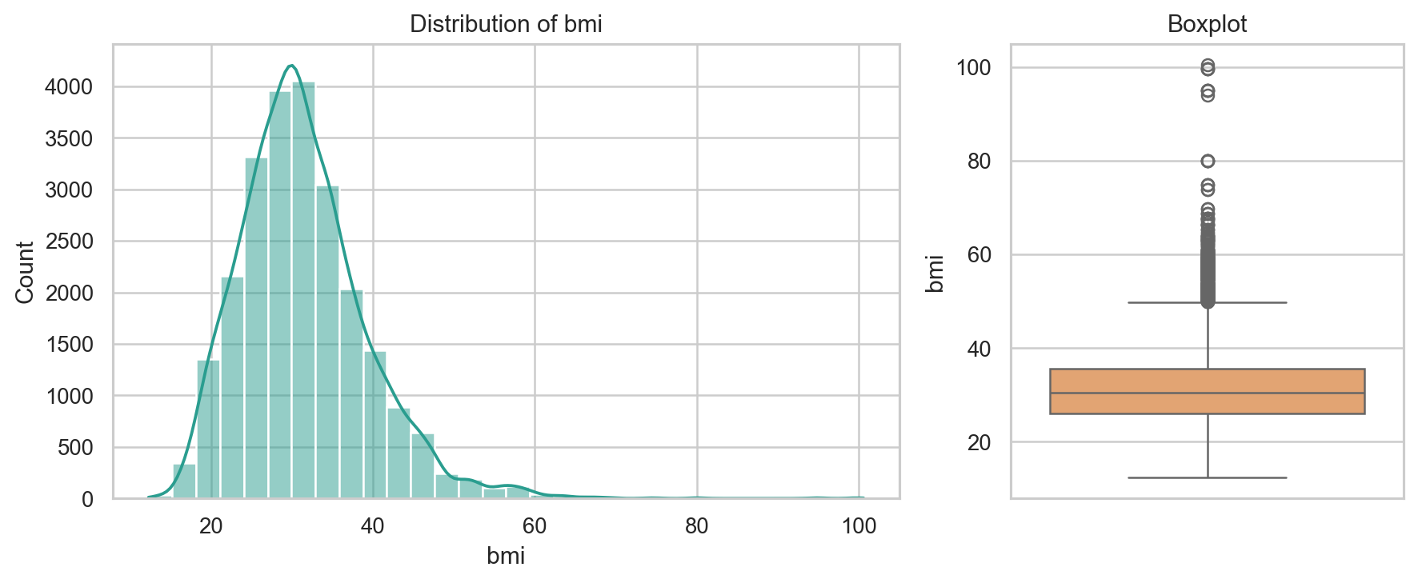
Univariate distribution or frequency for bmi.
Technical interpretation: `bmi` is numeric with 465 unique values, median 30.50, range 12.30 to 100.60, and 990 missing values.
Business interpretation: The distribution documents the applicant spread for `bmi` before modeling; the preprocessing action is: create missingness flag; impute using train-fitted median logic.

Univariate plot: smoking_status
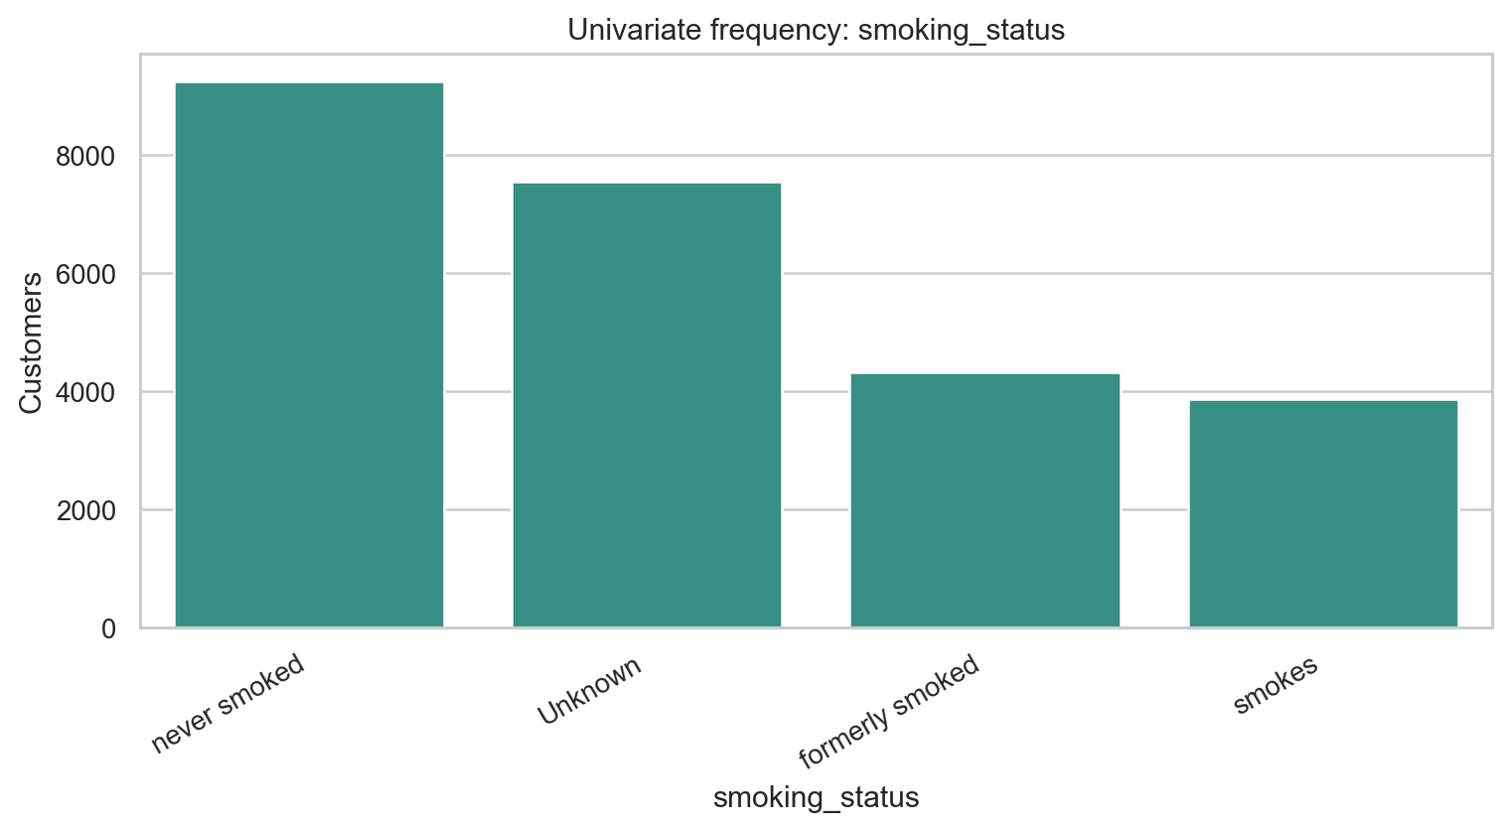
Univariate distribution or frequency for smoking_status.
Technical interpretation: `smoking_status` has 4 non-missing levels and 0 missing values; the most frequent level is `never smoked` at 37.0% of rows.
Business interpretation: The frequency view checks whether `smoking_status` is balanced enough for EDA and downstream encoding; the preprocessing action is: validate type, preserve for EDA, and feed through modeling pipeline.

Univariate plot: Year_last_admitted
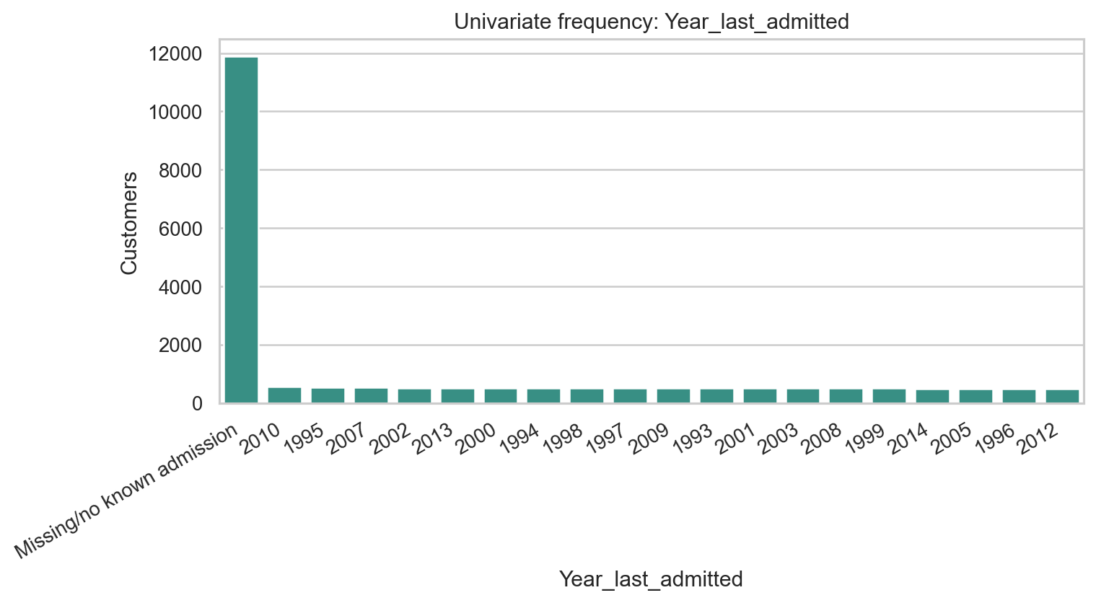
Univariate distribution or frequency for Year_last_admitted.
Technical interpretation: `Year_last_admitted` has 29 non-missing levels and 11,881 missing values; the most frequent level is `Missing/no known admission` at 47.5% of rows.
Business interpretation: The frequency view checks whether `Year_last_admitted` is balanced enough for EDA and downstream encoding; the preprocessing action is: create admission flags/status and recency; keep missingness signal.

Univariate plot: Location
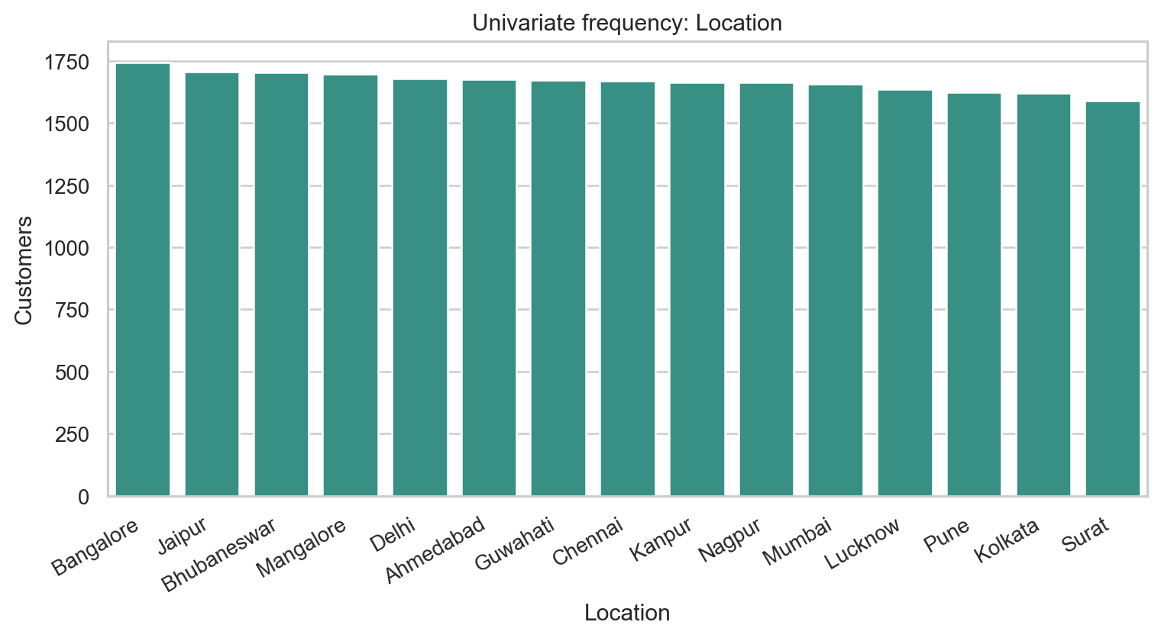
Univariate distribution or frequency for Location.
Technical interpretation: `Location` has 15 non-missing levels and 0 missing values; the most frequent level is `Bangalore` at 7.0% of rows.
Business interpretation: The frequency view checks whether `Location` is balanced enough for EDA and downstream encoding; the preprocessing action is: validate type, preserve for EDA, and feed through modeling pipeline.

Univariate plot: weight
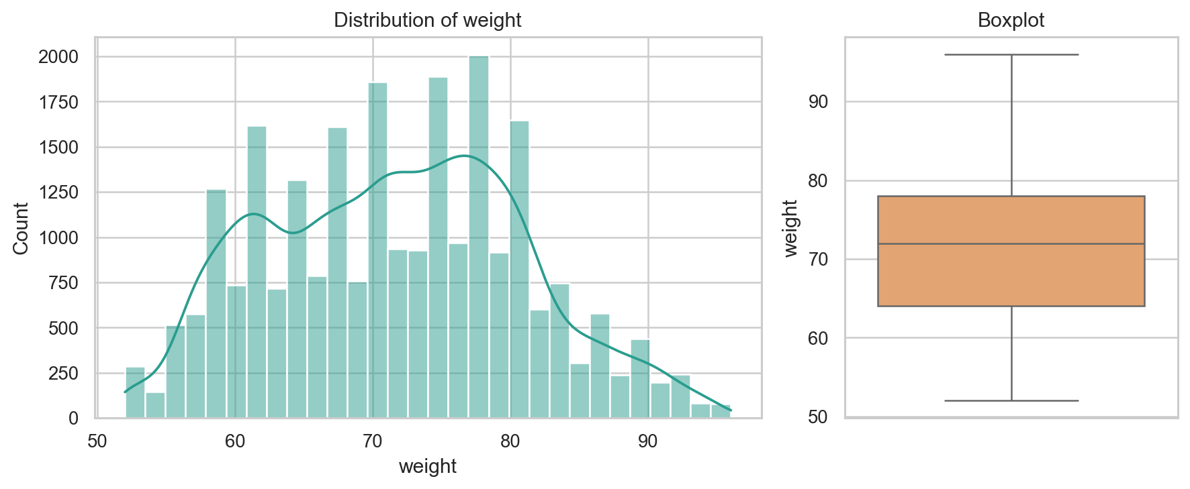
Univariate distribution or frequency for weight.
Technical interpretation: `weight` is numeric with 45 unique values, median 72.00, range 52.00 to 96.00, and 0 missing values.
Business interpretation: The distribution documents the applicant spread for `weight` before modeling; the preprocessing action is: validate type, preserve for EDA, and feed through modeling pipeline.

Univariate plot: covered_by_any_other_company
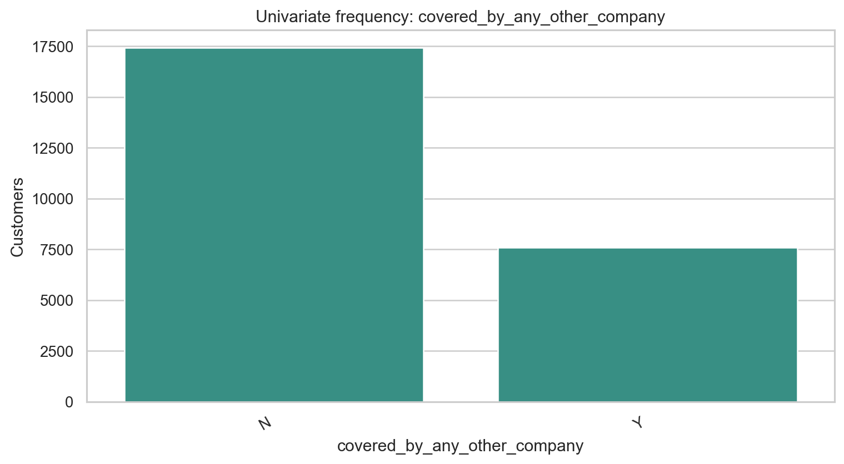
Univariate distribution or frequency for covered_by_any_other_company.
Technical interpretation: `covered_by_any_other_company` has 2 non-missing levels and 0 missing values; the most frequent level is `N` at 69.7% of rows.
Business interpretation: The frequency view checks whether `covered_by_any_other_company` is balanced enough for EDA and downstream encoding; the preprocessing action is: validate type, preserve for EDA, and feed through modeling pipeline.

Univariate plot: Alcohol
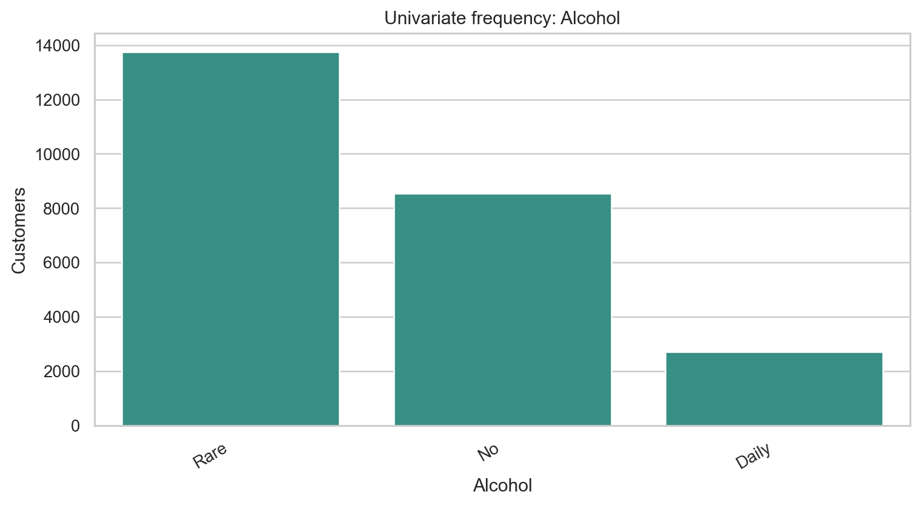
Univariate distribution or frequency for Alcohol.
Technical interpretation: `Alcohol` has 3 non-missing levels and 0 missing values; the most frequent level is `Rare` at 55.0% of rows.
Business interpretation: The frequency view checks whether `Alcohol` is balanced enough for EDA and downstream encoding; the preprocessing action is: validate type, preserve for EDA, and feed through modeling pipeline.

Univariate plot: exercise
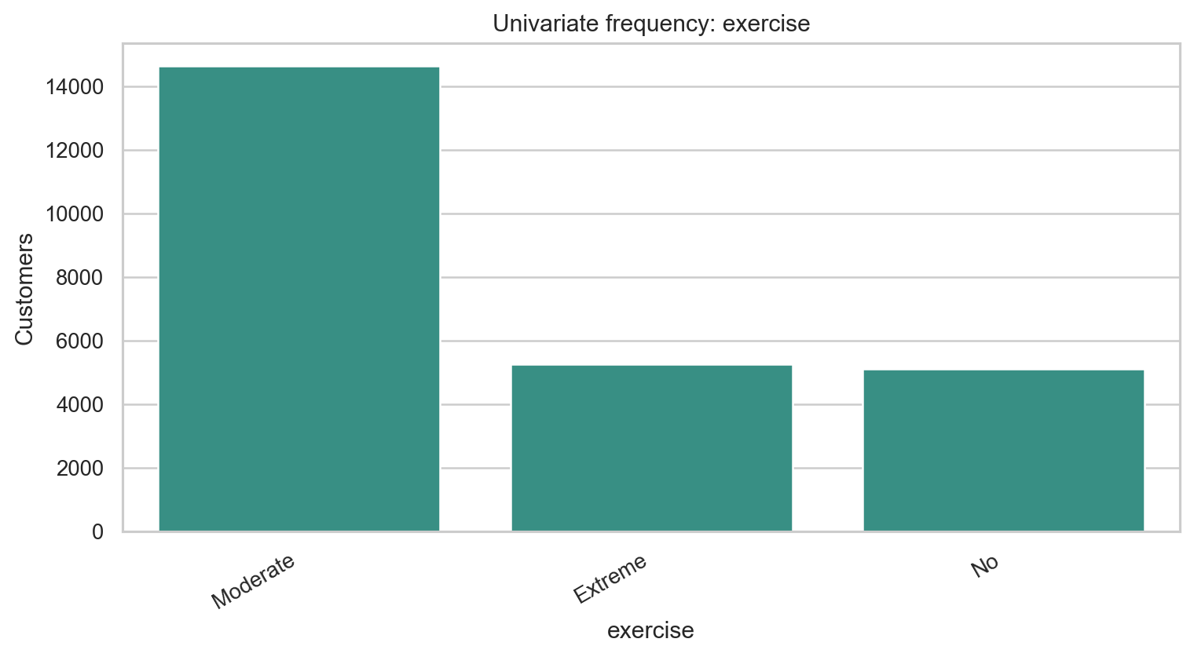
Univariate distribution or frequency for exercise.
Technical interpretation: `exercise` has 3 non-missing levels and 0 missing values; the most frequent level is `Moderate` at 58.6% of rows.
Business interpretation: The frequency view checks whether `exercise` is balanced enough for EDA and downstream encoding; the preprocessing action is: validate type, preserve for EDA, and feed through modeling pipeline.

Univariate plot: weight_change_in_last_one_year
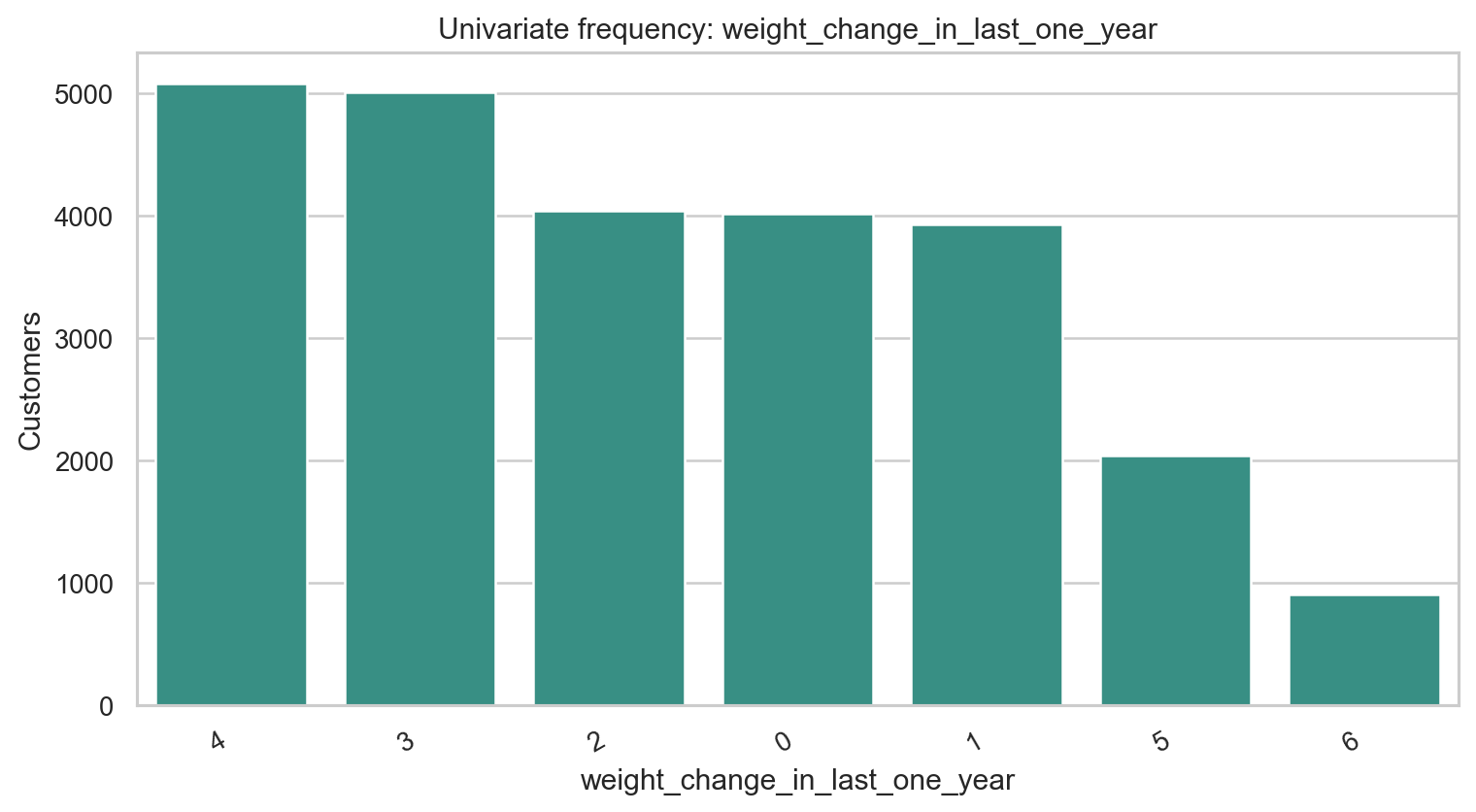
Univariate distribution or frequency for weight_change_in_last_one_year.
Technical interpretation: `weight_change_in_last_one_year` has 7 non-missing levels and 0 missing values; the most frequent level is `4` at 20.3% of rows.
Business interpretation: The frequency view checks whether `weight_change_in_last_one_year` is balanced enough for EDA and downstream encoding; the preprocessing action is: validate type, preserve for EDA, and feed through modeling pipeline.

Univariate plot: fat_percentage
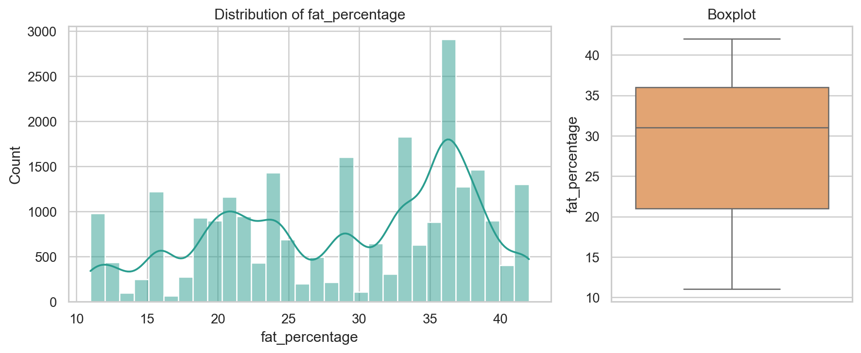
Univariate distribution or frequency for fat_percentage.
Technical interpretation: `fat_percentage` is numeric with 32 unique values, median 31.00, range 11.00 to 42.00, and 0 missing values.
Business interpretation: The distribution documents the applicant spread for `fat_percentage` before modeling; the preprocessing action is: validate type, preserve for EDA, and feed through modeling pipeline.

Univariate plot: insurance_cost
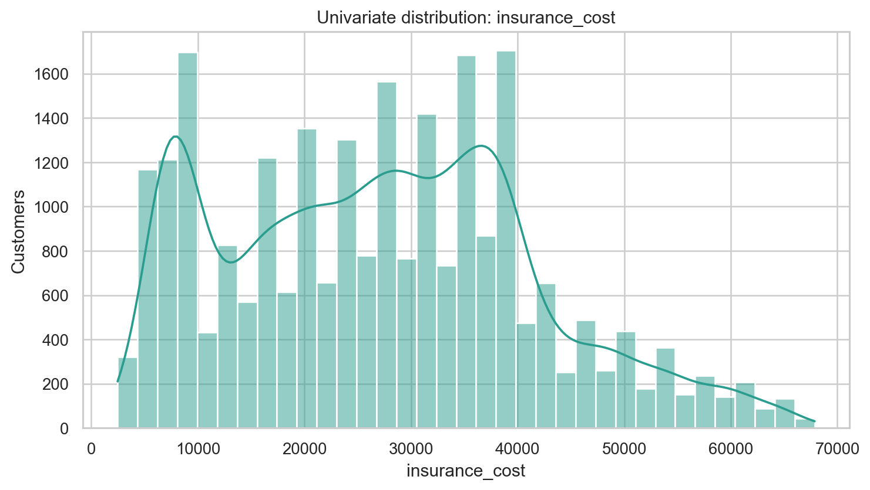
Univariate distribution or frequency for insurance_cost.
Technical interpretation: `insurance_cost` ranges from 2,468 to 67,870, has 54 unique quote bands, and a grid step of 1,234.
Business interpretation: This is the prediction target; it behaves like a fixed quote-band grid, so deployment should show both raw prediction and nearest valid quote band.

Selected Group Summaries

covered_by_any_other_company
covered_by_any_other_company | count | mean | median
Y | 7582 | 29,353.6 | 29,616.0
N | 17418 | 26,187.0 | 25,914.0

regular_checkup_last_year
regular_checkup_last_year | count | mean | median
0.000 | 15,215.0 | 29,002.8 | 29,616.0
1.000 | 4,644.0 | 26,214.8 | 24,680.0
4.000 | 777.0 | 23,530.2 | 24,680.0
2.000 | 2,198.0 | 23,143.4 | 22,212.0
3.000 | 1,818.0 | 21,681.2 | 22,212.0
5.000 | 348.0 | 20,396.5 | 20,361.0

weight_change_in_last_one_year
weight_change_in_last_one_year | count | mean | median
2.000 | 4,037.0 | 31,452.8 | 30,850.0
0.000 | 4,012.0 | 31,102.2 | 30,850.0
1.000 | 3,925.0 | 31,005.6 | 30,850.0
3.000 | 5,006.0 | 27,166.2 | 27,148.0
4.000 | 5,076.0 | 26,460.7 | 25,914.0
5.000 | 2,036.0 | 14,220.1 | 11,106.0
6.000 | 908.0 | 6,575.0 | 6,170.0

admission_status
admission_status | count | mean | median
Previously admitted | 13119 | 29,384.5 | 29,616.0
No known admission | 11881 | 24,677.2 | 23,446.0

smoking_status
smoking_status | count | mean | median
Unknown | 7555 | 27,343.5 | 27,148.0
never smoked | 9249 | 27,080.4 | 27,148.0
formerly smoked | 4329 | 27,052.2 | 27,148.0
smokes | 3867 | 27,031.2 | 27,148.0

exercise
exercise | count | mean | median
Moderate | 14638 | 27,273.4 | 27,148.0
Extreme | 5248 | 27,051.8 | 27,148.0
No | 5114 | 26,885.0 | 27,148.0

Alcohol
Alcohol | count | mean | median
No | 8541 | 27,253.5 | 27,148.0
Rare | 13752 | 27,117.3 | 27,148.0
Daily | 2707 | 26,965.7 | 27,148.0

bmi_category
bmi_category | count | mean | median
Underweight | 478 | 27,912.2 | 27,148.0
Normal | 4315 | 27,393.4 | 27,148.0
Overweight | 6629 | 27,242.6 | 27,148.0
Obese | 13578 | 26,995.9 | 27,148.0

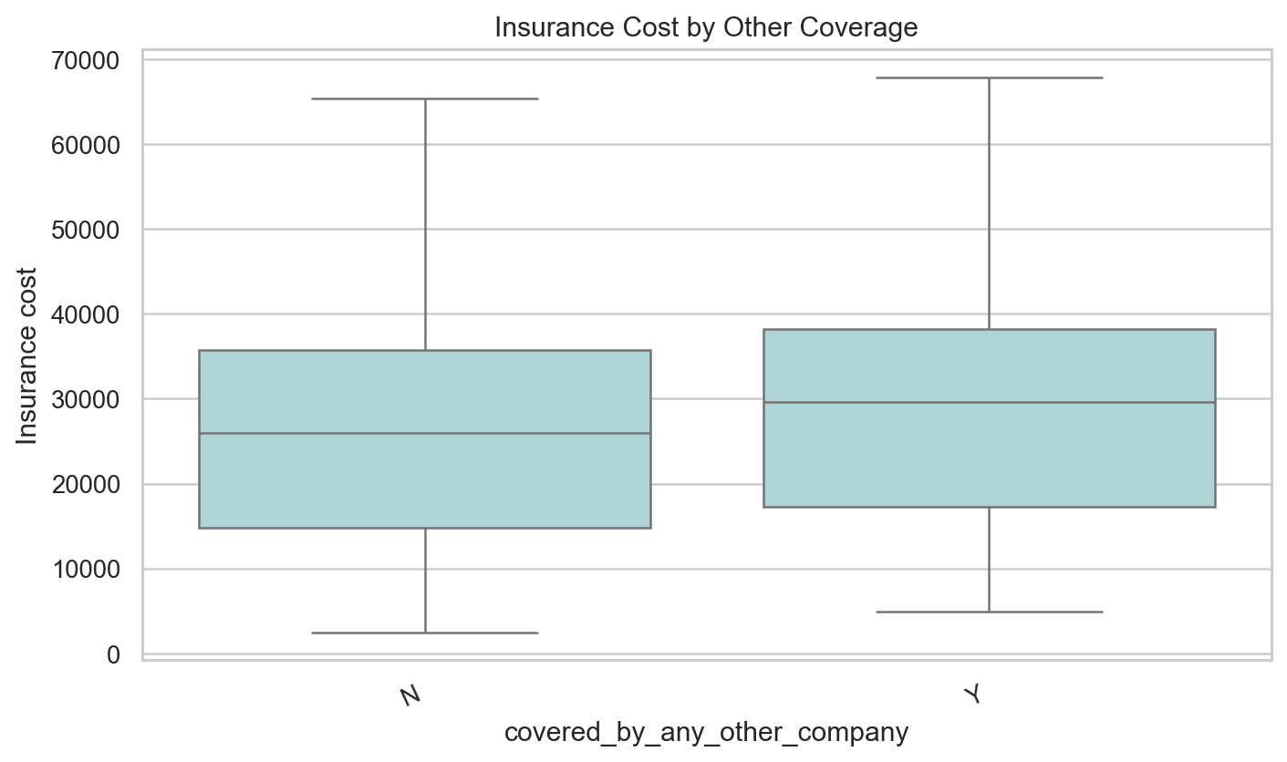
Insurance cost by other-company coverage.
Technical interpretation: Other-company coverage has a meaningful target difference and appears among the stronger non-weight EDA signals.
Business interpretation: Coverage status may proxy applicant history or insurance behavior, so it should be explained carefully in project material.
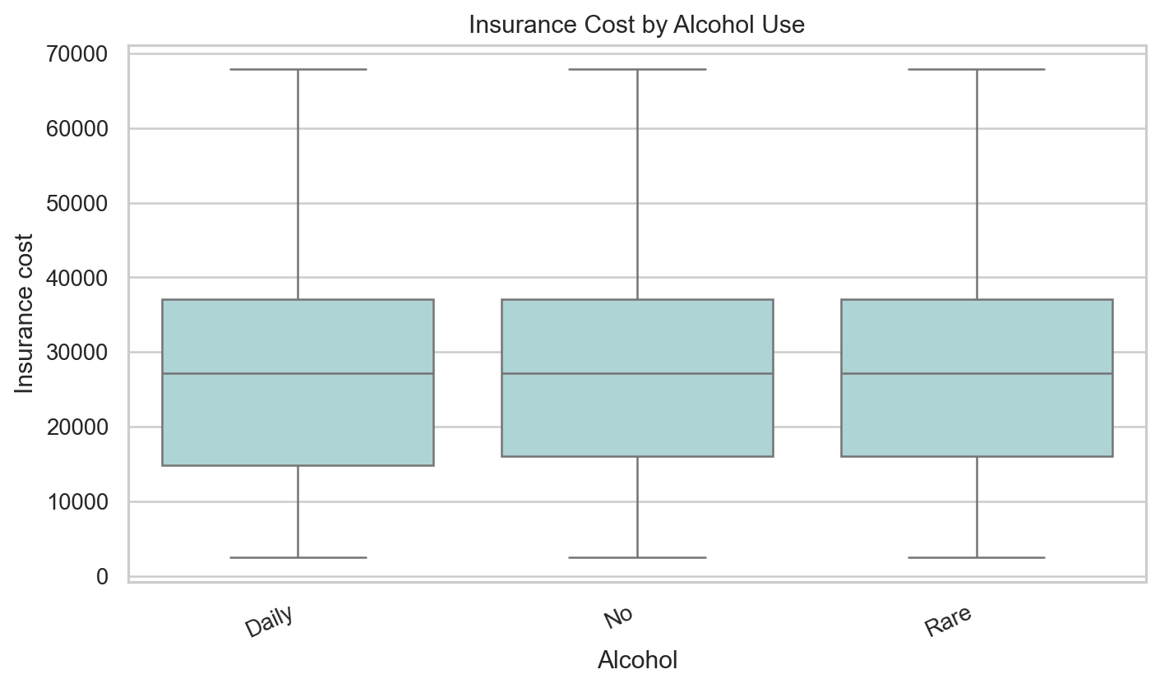
Insurance cost by alcohol consumption.
Technical interpretation: Alcohol categories show only weak marginal separation compared with weight and admission-related features.
Business interpretation: Alcohol should not be overstated as a standalone premium driver in this dataset.
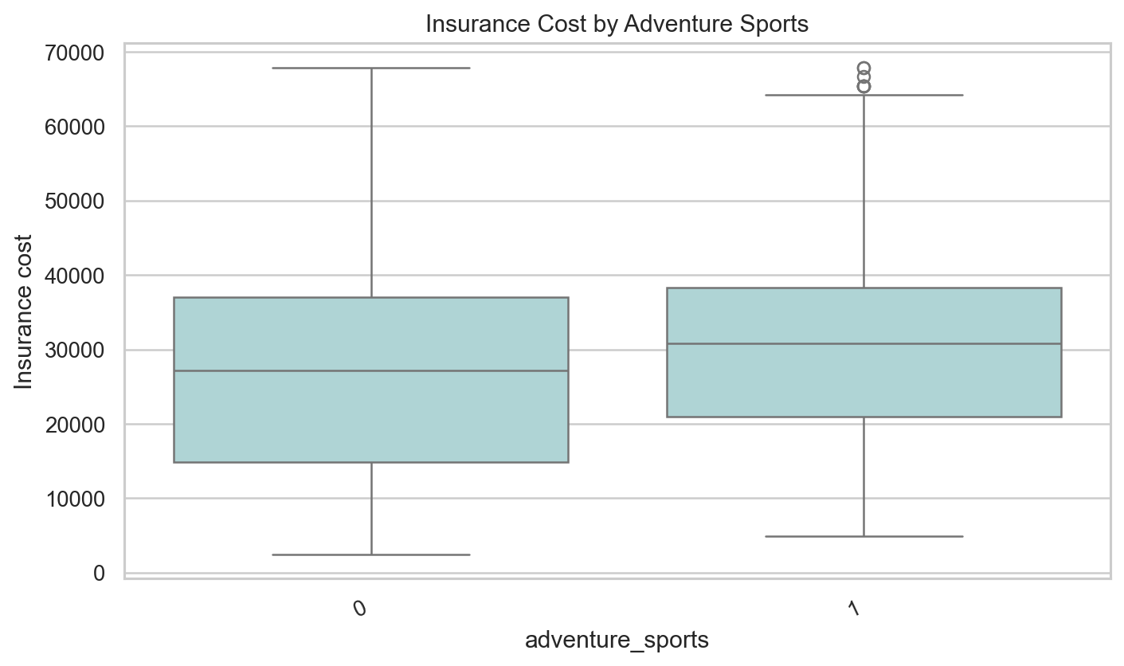
Insurance cost by adventure sports flag.
Technical interpretation: Adventure sports produces a clearer group difference than many other habit indicators and remains a useful risk flag.
Business interpretation: The business can use this feature for risk context, while still avoiding an automatic underwriting conclusion from one flag.
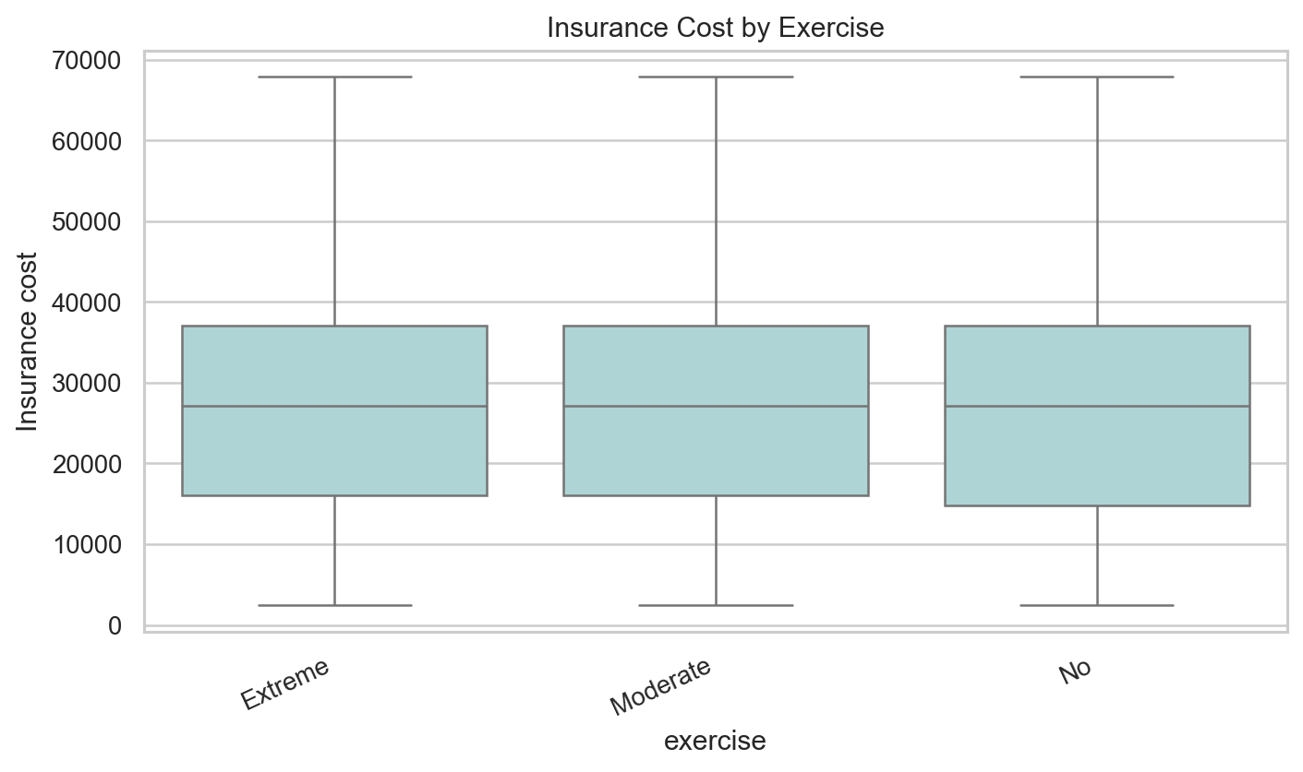
Insurance cost by exercise category.
Technical interpretation: Exercise has weak marginal separation and does not rank among the strongest standalone signals.
Business interpretation: Exercise is better framed as supporting context than as a major pricing driver.
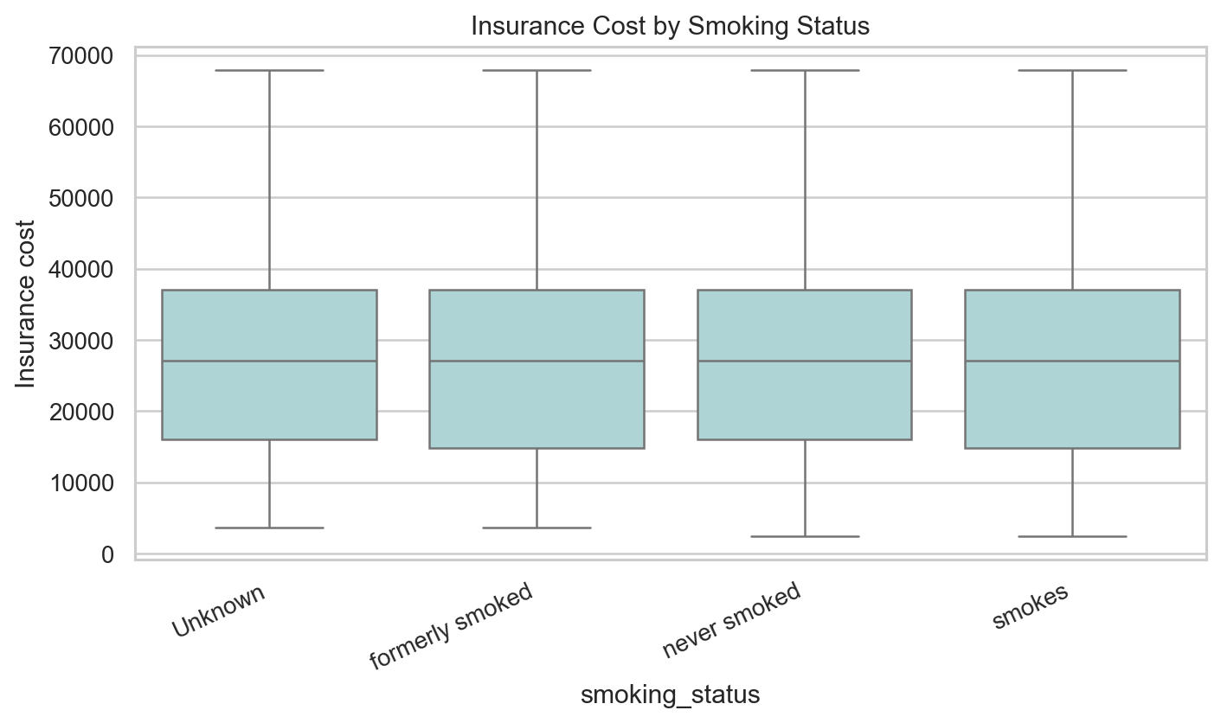
Insurance cost by smoking status.
Technical interpretation: Smoking status has weaker marginal separation than expected in this dataset and includes an explicit Unknown category.
Business interpretation: The report should be honest that smoking is not a leading standalone signal here, even if it remains business-relevant.
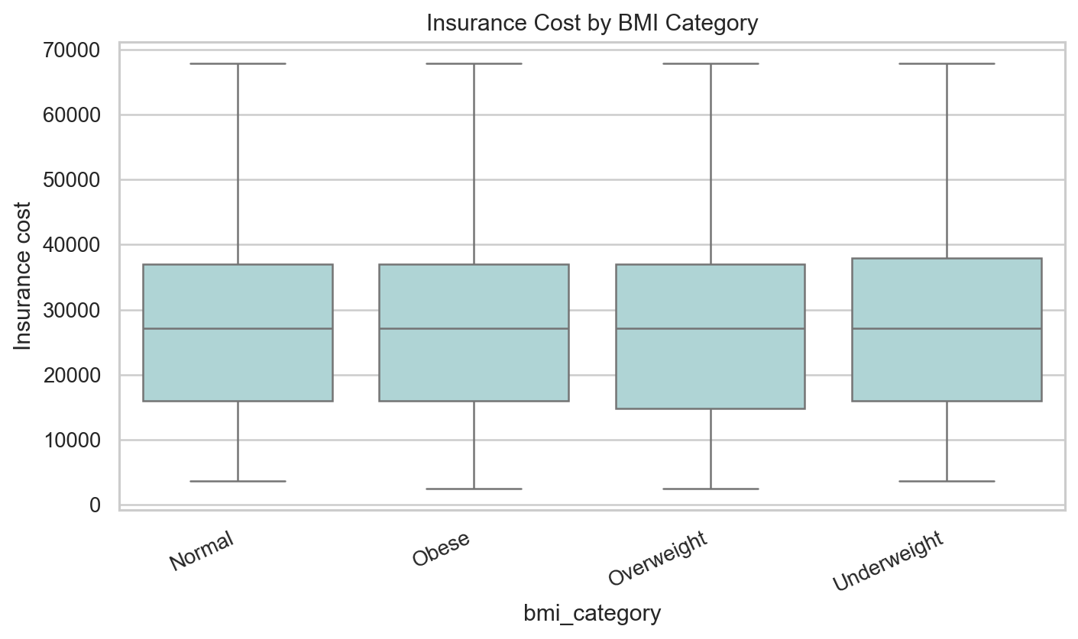
Insurance cost by BMI category.
Technical interpretation: BMI categories are useful for descriptive segmentation but are weaker than weight as a marginal cost signal.
Business interpretation: BMI remains useful for health context, yet weight is the dominant observed pricing gradient in the supplied data.
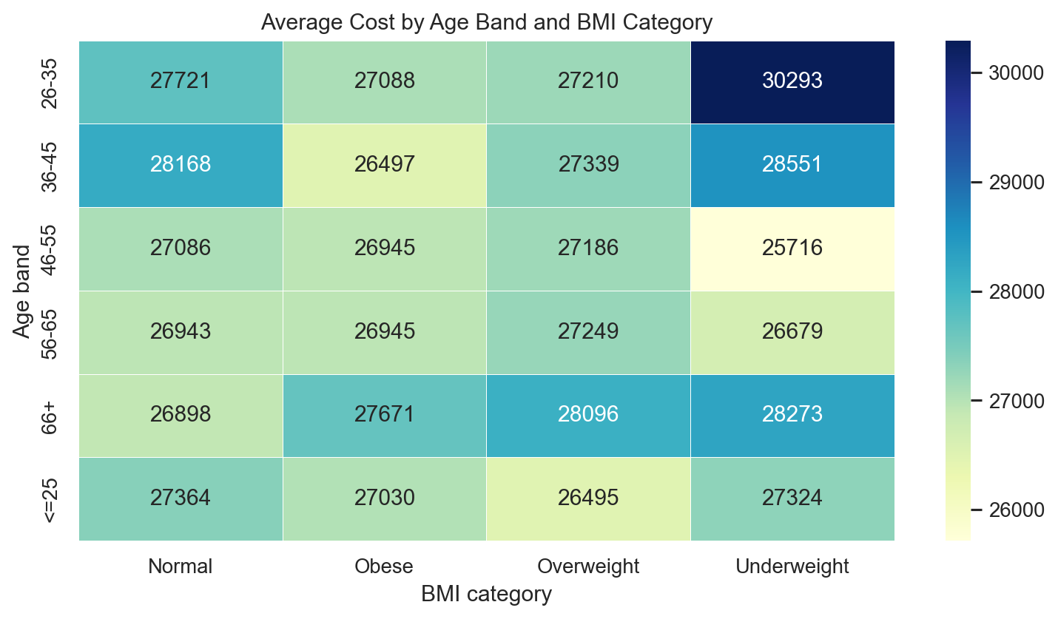
Average cost by age band and BMI category.
Technical interpretation: The age and BMI heatmap checks multivariate segmentation rather than relying on one variable at a time.
Business interpretation: Segment views help check whether weak marginal effects become meaningful when combined with other applicant characteristics.
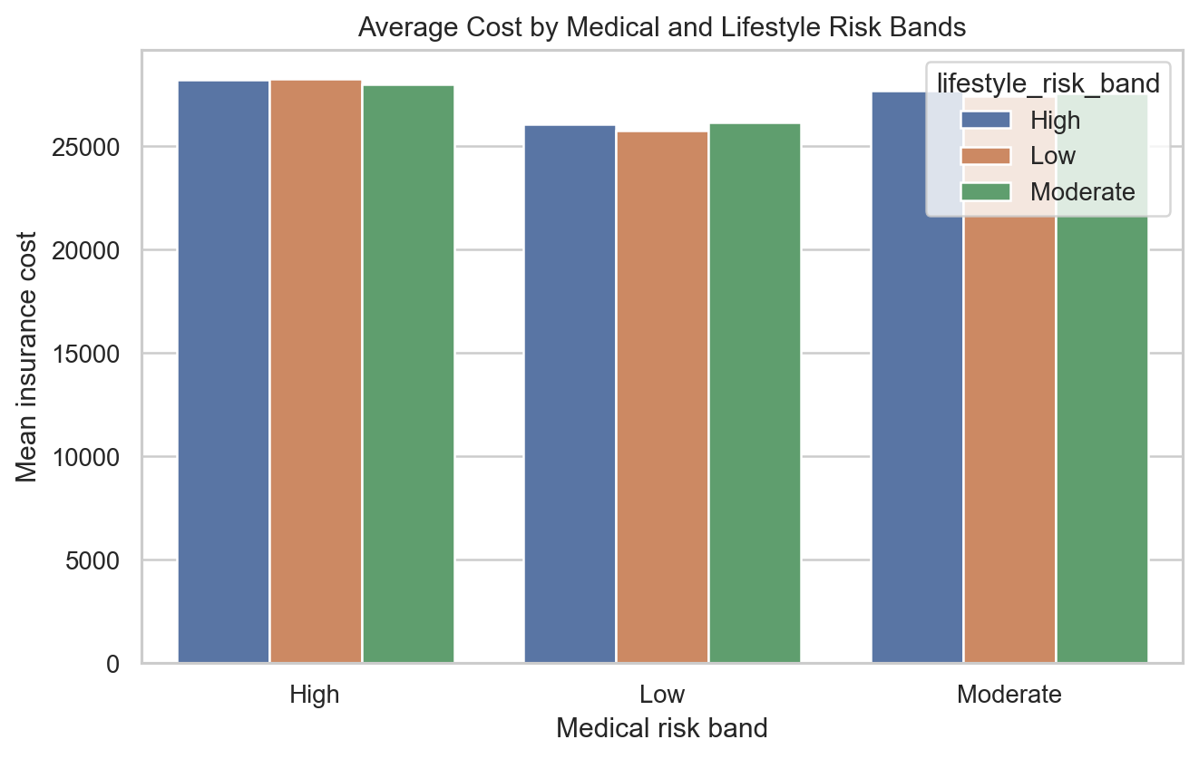
Average cost by medical and lifestyle risk bands.
Technical interpretation: Combined risk bands summarize engineered medical and lifestyle signals and show whether risk scoring adds segmentation value.
Business interpretation: This gives business stakeholders a higher-level explanation layer beyond individual raw fields.

