Milestone 2 Submission
Insurance Price Prediction

Submitted By
Group No. << n >> [Batch: << year >>]
Group Members: << Name >>, << Name >>, << Name >>, << Name >>
Mentor: << Name of mentor >>

Contents
1. Introduction
2. Model Selection and Metrics of Interest
3. Model Building and Evaluation
4. Model Comparison and Selection
5. Business Insights and Recommendations
6. Appendix

Introduction
This milestone builds on the cleaned data and engineered features from Milestone 1. The data is split into independent variables and the target insurance_cost using an 80/20 train-test split (random_state=42). A baseline model is established, a broad set of advanced models is trained and evaluated on both train and test sets, the strongest family is hyperparameter-tuned, the best model is selected, explained, and finally deployed via a FastAPI service, a React inference UI, and a Streamlit app.

Model Selection and Metrics of Interest
Baseline models:
- DummyRegressor (predicts the mean) - establishes the no-skill floor.
- LinearRegression - first interpretable real baseline.
Advanced models:
- Regularized linear: Ridge, Lasso, ElasticNet.
- Trees and ensembles: DecisionTree, RandomForest, ExtraTrees.
- Gradient boosting: GradientBoosting, HistGradientBoosting, XGBoost, LightGBM, CatBoost.
Metrics of interest (regression):
- MAE - average absolute pricing error in cost units (primary, business-readable).
- RMSE - penalises larger pricing errors more heavily.
- R2 - share of cost variance explained.
- MAPE / SMAPE - percentage-style errors for business communication.
- Cross-validated RMSE and the train-test RMSE gap - to check stability and overfitting.

Model Building and Evaluation
Every model is wrapped in the same leak-free scikit-learn Pipeline (feature engineering -> preprocessing -> estimator); preprocessing is fit only on the training fold. Each model is evaluated on both the train and test sets, with 5-fold cross-validation for stability. Hyperparameter tuning uses RandomizedSearchCV (25 iterations, 5-fold CV, optimising negative RMSE) on the strongest family, with a finer Optuna study and a log-target transform experiment explored in the notebooks. Gradient boosting with XGBoost and CatBoost is GPU-accelerated; LightGBM runs multi-core on CPU.
Model evaluation (sorted by test RMSE):
model | test_MAE | test_RMSE | test_R2 | train_R2 | cv_rmse_mean | train_test_RMSE_gap
LightGBM | 2,328.382 | 2,909.172 | 0.958 | 0.964 | 2,975.279 | 195.218
HistGradientBoosting | 2,334.436 | 2,911.705 | 0.958 | 0.962 | 2,969.155 | 112.246
CatBoost | 2,344.526 | 2,929.303 | 0.958 | 0.962 | 2,969.114 | 132.702
GradientBoosting | 2,367.703 | 2,944.151 | 0.957 | 0.958 | 2,979.133 | 4.291
RandomForest | 2,380.823 | 3,006.095 | 0.956 | 0.994 | 3,060.937 | 1,865.289
XGBoost | 2,427.640 | 3,034.263 | 0.955 | 0.978 | 3,122.070 | 906.180
ExtraTrees | 2,488.563 | 3,152.681 | 0.951 | 1.000 | 3,164.414 | 3,152.681
Lasso | 2,709.290 | 3,354.717 | 0.945 | 0.945 | 3,356.087 | 7.225
LinearRegression | 2,710.244 | 3,355.857 | 0.945 | 0.945 | 3,357.042 | 8.459
Ridge | 2,710.197 | 3,355.885 | 0.945 | 0.945 | 3,357.028 | 8.485
DecisionTree | 3,247.148 | 4,221.398 | 0.913 | 1.000 | 4,233.406 | 4,221.398
ElasticNet | 4,227.569 | 5,321.243 | 0.861 | 0.862 | 5,334.461 | -9.967
DummyRegressor | 11,762.003 | 14,273.629 | -0.000 | 0.000 | 14,338.912 | -62.196
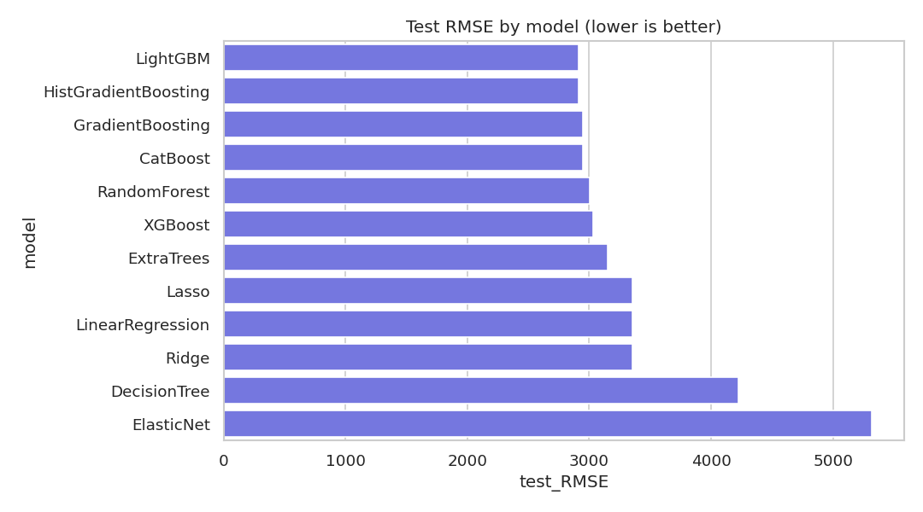
Figure: Test RMSE by model (lower is better).

Model Comparison and Selection
The gradient-boosting models clearly outperform the linear and single-tree models. LightGBM was selected as the final model: it achieves the lowest test RMSE and MAE with a strong R2, a stable cross-validation score, and a small train-test gap (low overfitting). RandomizedSearch tuning did not improve on the well-chosen defaults, so the default configuration was retained for simplicity and robustness.
Final model performance on the held-out test set:
- MAE: 2,328
- RMSE: 2,909
- R2: 0.9585
- MAPE: 11.3%
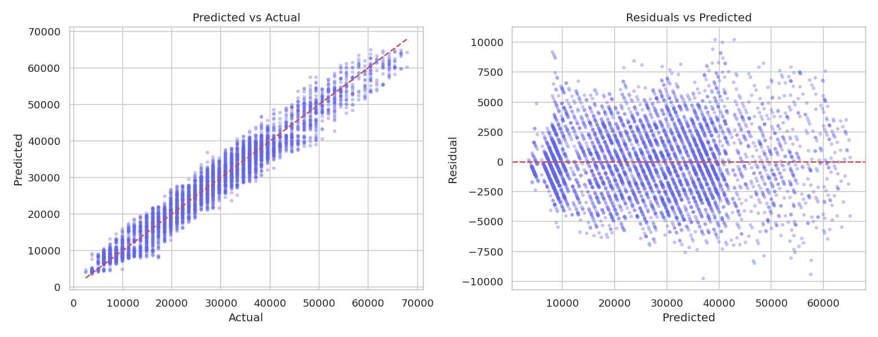
Figure: Predicted vs actual and residuals for the final model.

Business Insights and Recommendations
Model explainability (permutation importance in production, confirmed by SHAP in the notebook) identifies the key drivers of predicted insurance cost: weight is by far the dominant factor, followed by admission history (Year_last_admitted), coverage by another insurer, preventive checkups, and weight change.
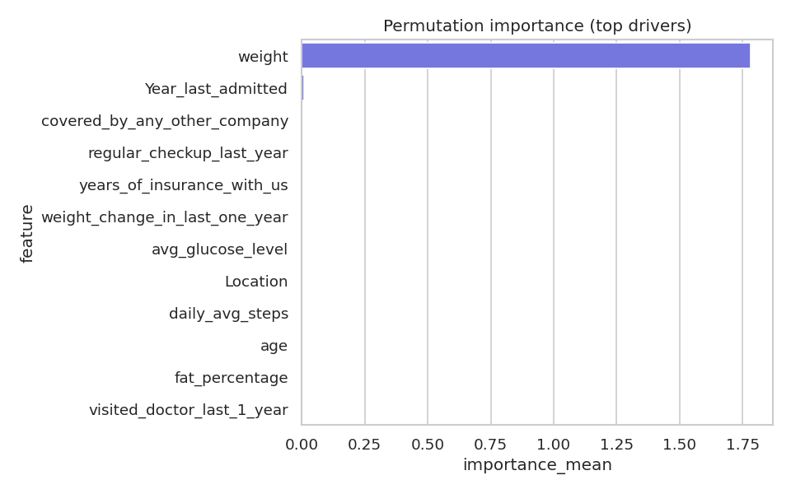
Figure: Permutation importance - top model drivers.
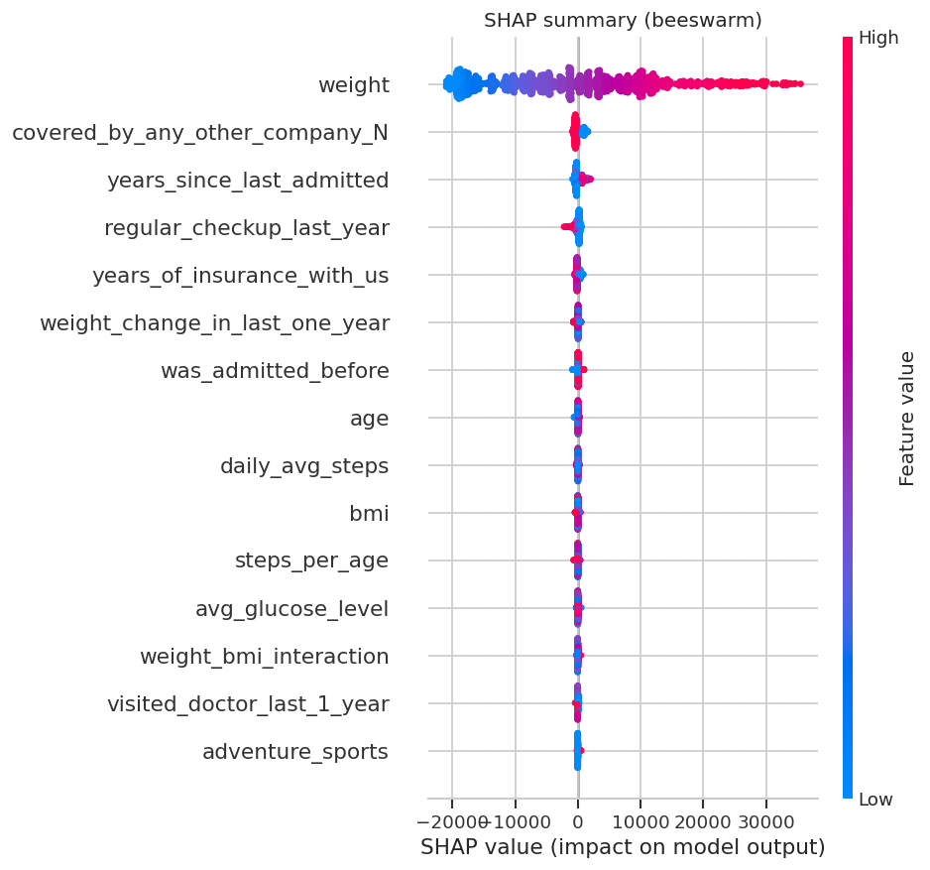
Figure: SHAP summary - per-feature contribution and direction.
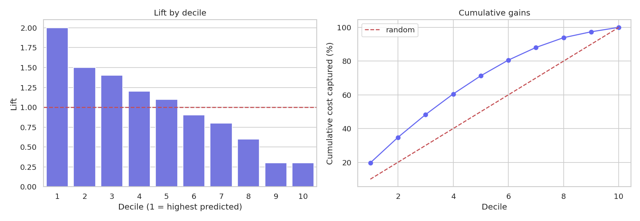
Figure: Lift and cumulative gains by predicted-cost decile.
Actionable recommendations (with measurable outcomes):
- Use the model as pricing decision-support, not automated underwriting - track quote turnaround time and underwriter override rate.
- Route extreme predictions (top decile) to manual review - measure reduction in mispriced high-cost policies.
- Target wellness programmes (weight management, preventive checkups, activity) at high-risk segments - track engagement and downstream claim reduction.
- Trigger documentation/preventive checks on prior-admission applicants - measure claim accuracy improvement.
- Apply fairness governance to Gender/Location and validate the dominance of weight for plausibility and leakage before production; monitor segment-level error and drift.

Appendix
Deployment: the final scikit-learn Pipeline is saved to models/final_model.pkl and served by a FastAPI API (api/main.py, endpoints /health, /schema, /predict), a React + TypeScript inference UI (frontend/), and a Streamlit app (streamlit_app.py). Predictions are mapped to Low / Medium / High risk bands using training-set tertiles (Low<19,744, High>34,552).
Reproducibility: run `uv run python -m insurance.train` to regenerate the model, metrics, and report tables. The full modeling workflow is in experiments/02-04, and the model comparison and importance tables are under reports/tables/.
Limitations: dataset provenance and real pricing rules are unknown; the dominance of weight must be validated for plausibility/leakage; all predictors must be available at quote time; fairness testing should be expanded before real-world deployment.

