Milestone 1 Submission
Insurance Price Prediction | Data Report, EDA, Preprocessing, and Insights

Contents
- Introduction
- Objectives, Problem Statement, and Sub-objectives
- Data Report
- Initial Exploratory Data Analysis
- Data Pre-processing
- Extensive Exploratory Data Analysis
- Appendix

Introduction
The insurance pricing problem is a supervised regression problem. The business objective is to estimate insurance_cost from health, lifestyle, habit, and demographic attributes so that pricing teams can understand risk drivers and support more consistent premium estimation.

Objectives, Problem Statement, and Sub-objectives
- Build a clean analytical dataset from the supplied Insurance Data.csv file.
- Identify data-quality issues including missing values, duplicate rows, inconsistent names, and outliers.
- Engineer interpretable predictors such as admission recency, BMI category, cholesterol midpoint, and disease-history flags.
- Use EDA to identify premium drivers and modeling risks before training predictive models.
- Prepare a reproducible pipeline for Milestone 2 model building and deployment.

Data Report
Metric | Value
Rows | 25,000.0
Columns | 24.000
Cells | 600,000.0
Duplicate rows | 0.000
Unique applicant_id | 25,000.0
Target mean | 27,147.4
Target median | 27,148.0
Target skew | 0.332

The dataset contains 25,000 unique applicants and 24 original columns. applicant_id is unique for every row and is retained only for auditability, not for modeling.

Missing Values
column | missing_count | missing_pct
Year_last_admitted | 11881 | 47.520
bmi | 990 | 3.960

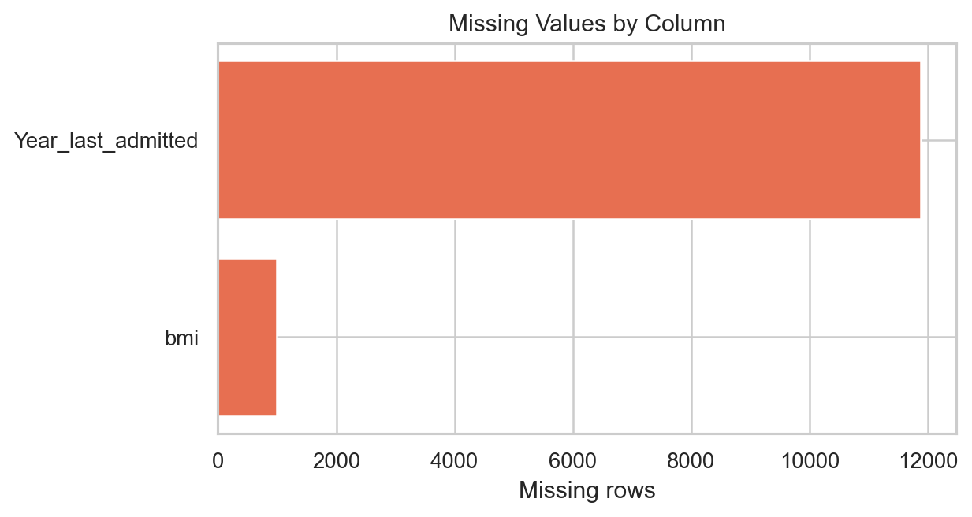
Only BMI and Year_last_admitted contain missing values.

Variable Types and Cleanup
column | clean_column | dtype | missing | unique_values
applicant_id | applicant_id | int64 | 0 | 25000
years_of_insurance_with_us | years_of_insurance_with_us | int64 | 0 | 9
regular_checkup_lasy_year | regular_checkup_last_year | int64 | 0 | 6
adventure_sports | adventure_sports | int64 | 0 | 2
Occupation | Occupation | str | 0 | 3
visited_doctor_last_1_year | visited_doctor_last_1_year | int64 | 0 | 12
cholesterol_level | cholesterol_level | str | 0 | 5
daily_avg_steps | daily_avg_steps | int64 | 0 | 4914
age | age | int64 | 0 | 59
heart_decs_history | heart_disease_history | int64 | 0 | 2
other_major_decs_history | other_major_disease_history | int64 | 0 | 2
Gender | Gender | str | 0 | 2
avg_glucose_level | avg_glucose_level | int64 | 0 | 221
bmi | bmi | float64 | 990 | 465
smoking_status | smoking_status | str | 0 | 4
Year_last_admitted | Year_last_admitted | float64 | 11881 | 29
Location | Location | str | 0 | 15
weight | weight | int64 | 0 | 45
covered_by_any_other_company | covered_by_any_other_company | str | 0 | 2
Alcohol | Alcohol | str | 0 | 3
exercise | exercise | str | 0 | 3
weight_change_in_last_one_year | weight_change_in_last_one_year | int64 | 0 | 7
fat_percentage | fat_percentage | int64 | 0 | 32
insurance_cost | insurance_cost | int64 | 0 | 54

original | cleaned_or_action | reason
regular_checkup_lasy_year | regular_checkup_last_year | column typo normalized
heart_decs_history | heart_disease_history | column typo normalized
other_major_decs_history | other_major_disease_history | column typo normalized
Occupation value: Salried | Salaried | category typo normalized
applicant_id | dropped from modeling | unique identifier, not predictive signal

Initial Exploratory Data Analysis
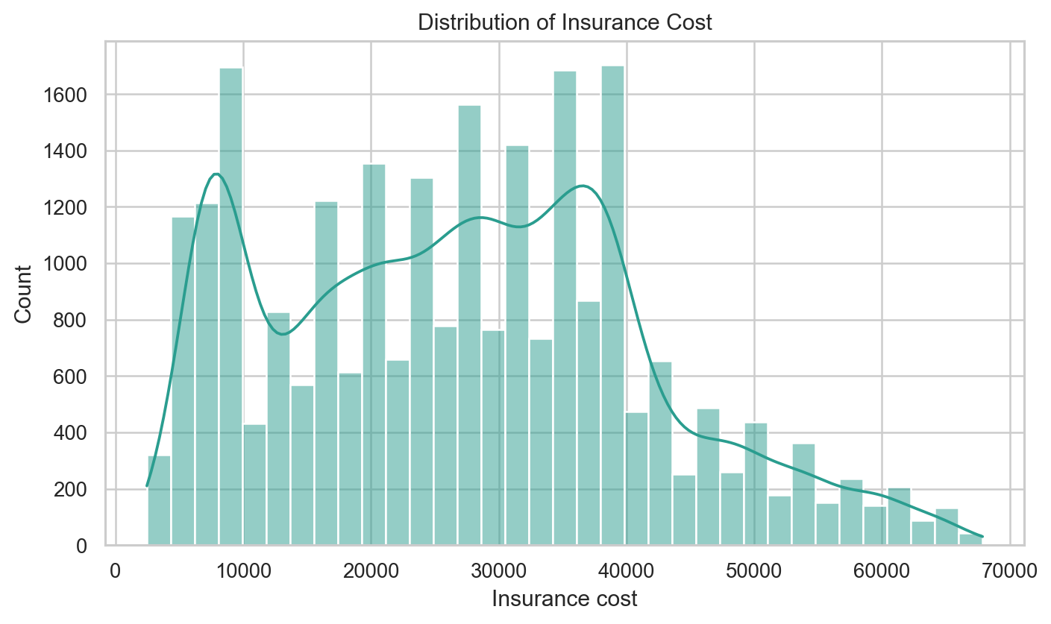
insurance_cost is mildly right-skewed, with most values between roughly 16k and 37k.
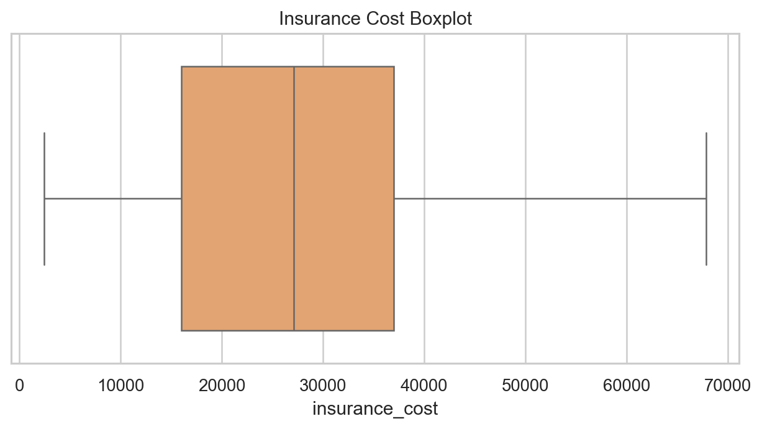
Target outliers are retained because they are valid high-cost pricing cases.
feature | correlation_with_insurance_cost
weight | 0.970
years_since_last_admitted | 0.490
regular_checkup_last_year | -0.174
visited_doctor_last_1_year | 0.009
fat_percentage | -0.008
bmi_for_analysis | -0.008
daily_avg_steps | -0.007
age | 0.005
avg_glucose_level | -0.005
cholesterol_midpoint | -0.001

- The target mean and median are nearly equal, while skew is modest at about 0.33.
- Categorical variables such as smoking_status, exercise, Alcohol, and other coverage show visible cost differences.
- No duplicate applicant records were detected.
- Unknown smoking status is treated as a valid business category rather than a missing value.

Data Pre-processing
- Renamed misspelled columns: regular_checkup_lasy_year, heart_decs_history, and other_major_decs_history.
- Corrected Occupation value Salried to Salaried.
- Dropped applicant_id from the modeling feature set because it is a unique identifier.
- Imputed BMI using median values by age band and gender for EDA. The sklearn modeling pipeline fits the same logic only on training data.
- Converted Year_last_admitted into was_admitted_before and years_since_last_admitted using reference_year=2019. Missing admission years are coded as no prior admission with recency 0.
- Created cholesterol_midpoint from ordinal cholesterol ranges.
- Engineered age_band, bmi_category, any_major_disease_history, weight_bmi_interaction, and steps_per_age.
- Capped extremely high BMI values for analysis at the 99.5th percentile while retaining target outliers.
column | q1 | q3 | iqr | lower_fence | upper_fence | outlier_count | outlier_pct
bmi | 26.100 | 35.600 | 9.500 | 11.850 | 49.850 | 549 | 2.290
weight | 64.000 | 78.000 | 14.000 | 43.000 | 99.000 | 0 | 0.000
avg_glucose_level | 113.0 | 222.0 | 109.0 | -50.500 | 385.5 | 0 | 0.000
daily_avg_steps | 4,543.0 | 5,730.0 | 1,187.0 | 2,762.5 | 7,510.5 | 952 | 3.810
fat_percentage | 21.000 | 36.000 | 15.000 | -1.500 | 58.500 | 0 | 0.000
insurance_cost | 16,042.0 | 37,020.0 | 20,978.0 | -15,425.0 | 68,487.0 | 0 | 0.000

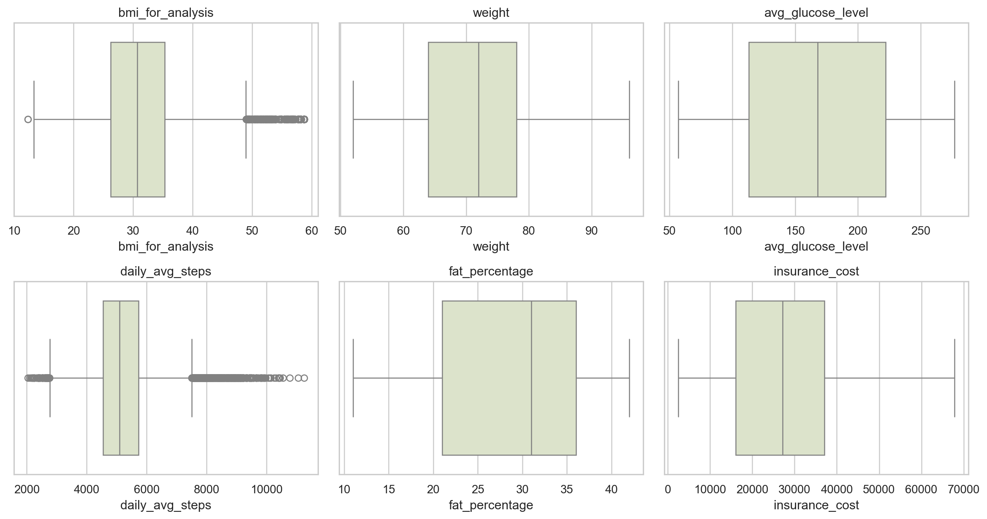
IQR outlier review for important numeric variables.

Extensive Exploratory Data Analysis
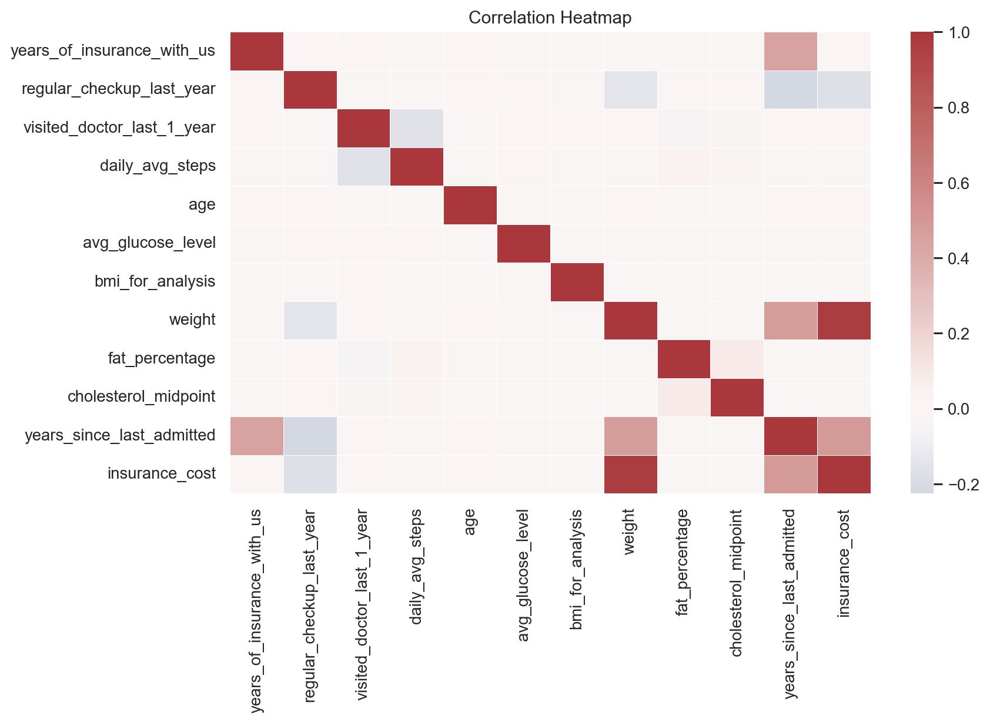
Correlation view across numeric and engineered variables.
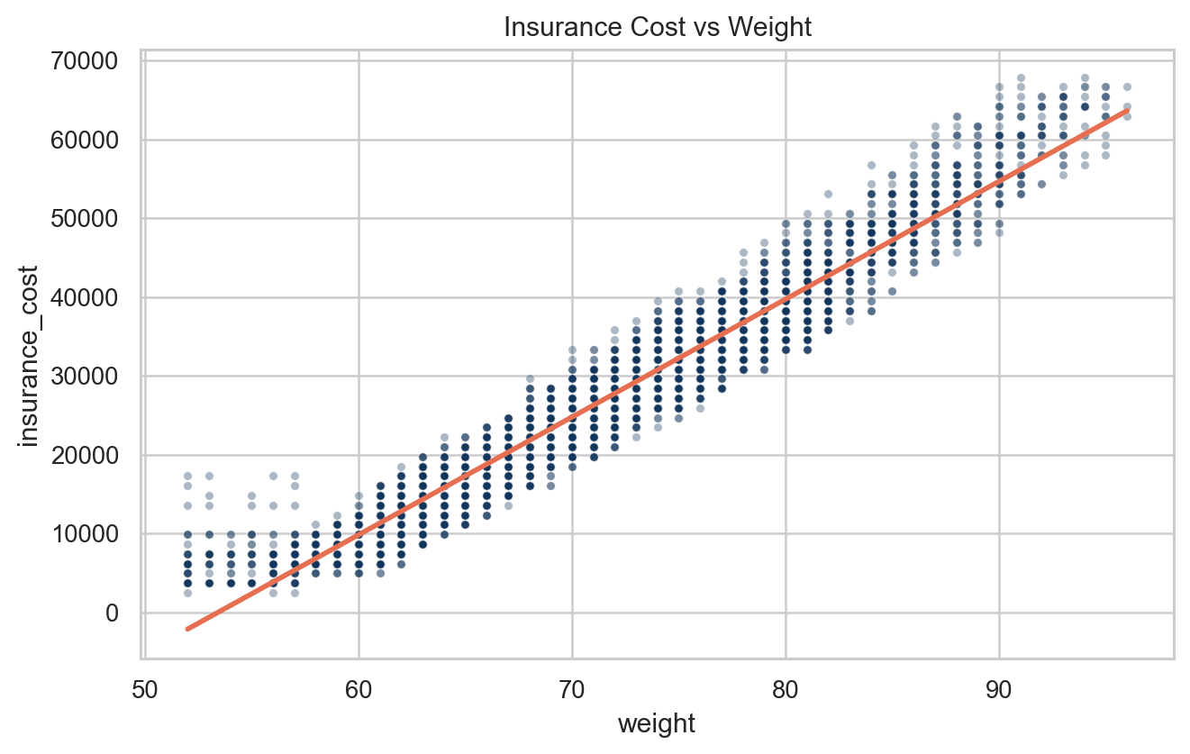
Cost generally rises with weight, though the relationship is not purely linear.
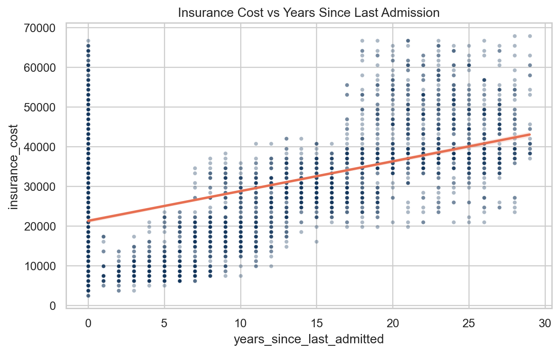
Admission recency provides a useful risk-history signal.
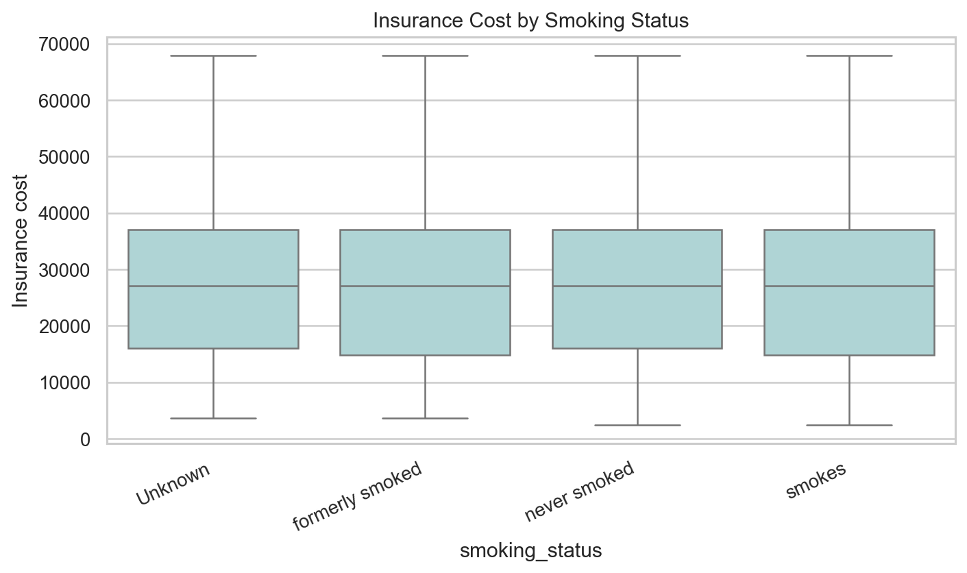
Smoking status segments differ in expected insurance cost.
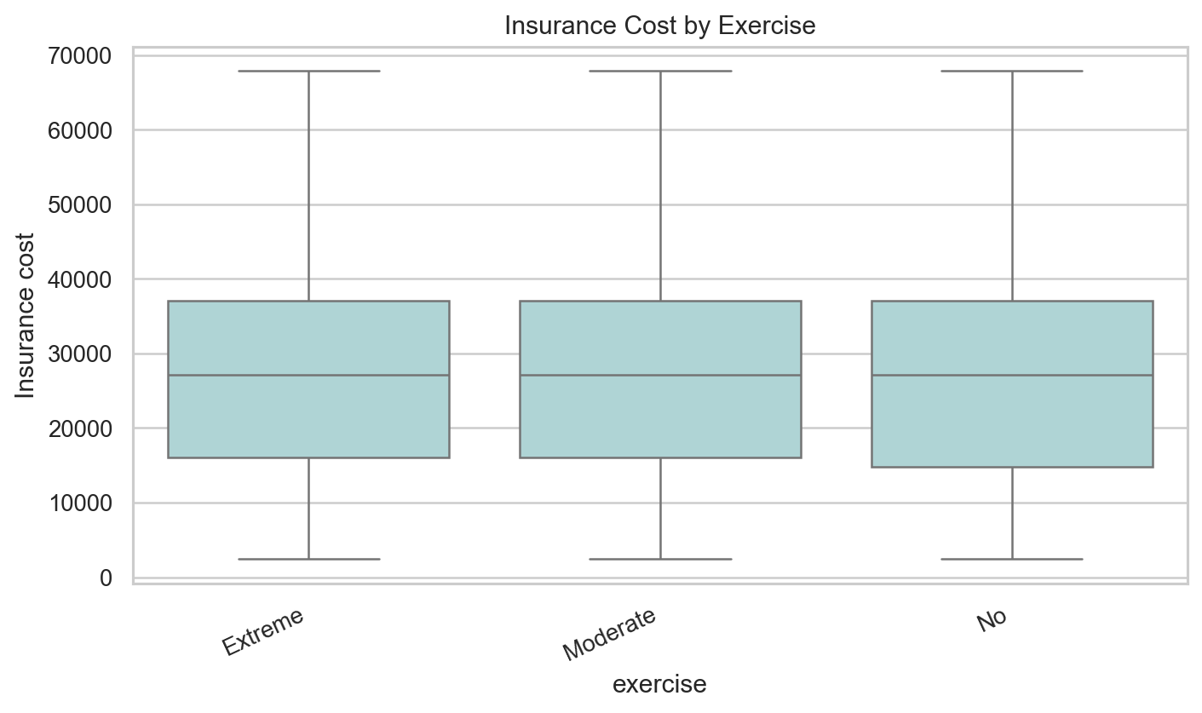
Exercise behavior is associated with different premium distributions.
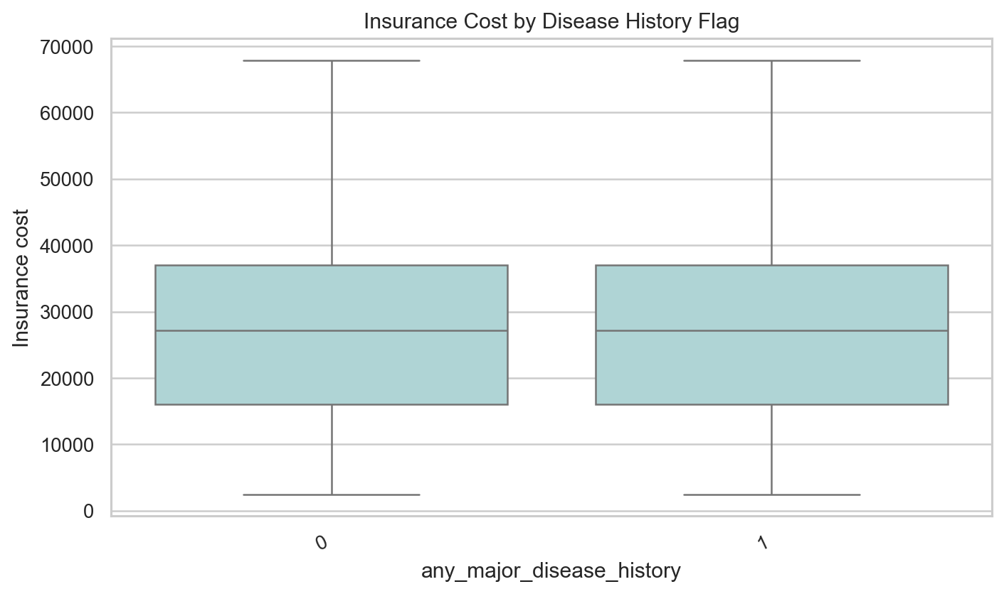
Disease-history flags are associated with higher premium levels.
- Higher-risk health behavior and history categories should be tested in nonlinear models, because group differences are not uniform across all applicants.
- BMI, weight, glucose, and fat percentage are related but not interchangeable; multicollinearity should be handled by regularization or tree ensembles rather than manually dropping fields too early.
- Other coverage and admission-history features may reflect customer risk profile and require careful business interpretation.

Appendix

Selected Group Summaries

smoking_status
smoking_status | count | mean | median
Unknown | 7555 | 27,343.5 | 27,148.0
never smoked | 9249 | 27,080.4 | 27,148.0
formerly smoked | 4329 | 27,052.2 | 27,148.0
smokes | 3867 | 27,031.2 | 27,148.0

exercise
exercise | count | mean | median
Moderate | 14638 | 27,273.4 | 27,148.0
Extreme | 5248 | 27,051.8 | 27,148.0
No | 5114 | 26,885.0 | 27,148.0

Alcohol
Alcohol | count | mean | median
No | 8541 | 27,253.5 | 27,148.0
Rare | 13752 | 27,117.3 | 27,148.0
Daily | 2707 | 26,965.7 | 27,148.0

bmi_category
bmi_category | count | mean | median
Underweight | 478 | 27,912.2 | 27,148.0
Normal | 4315 | 27,393.4 | 27,148.0
Overweight | 6629 | 27,242.6 | 27,148.0
Obese | 13578 | 26,995.9 | 27,148.0

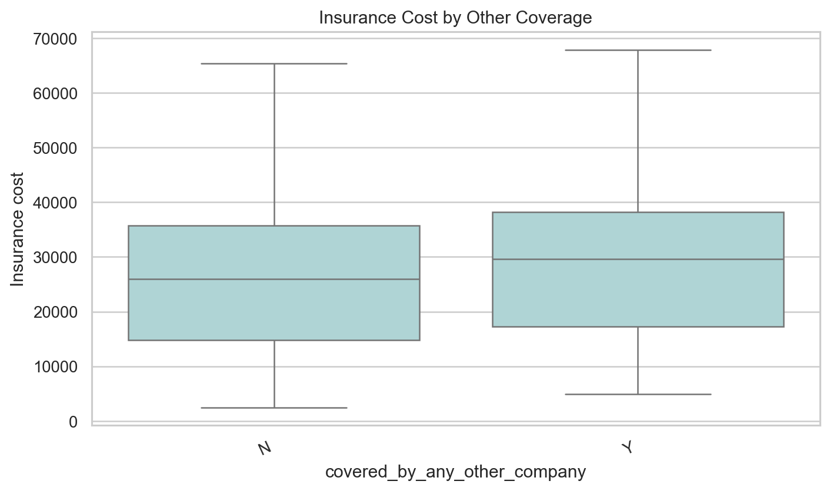
Insurance cost by other-company coverage.
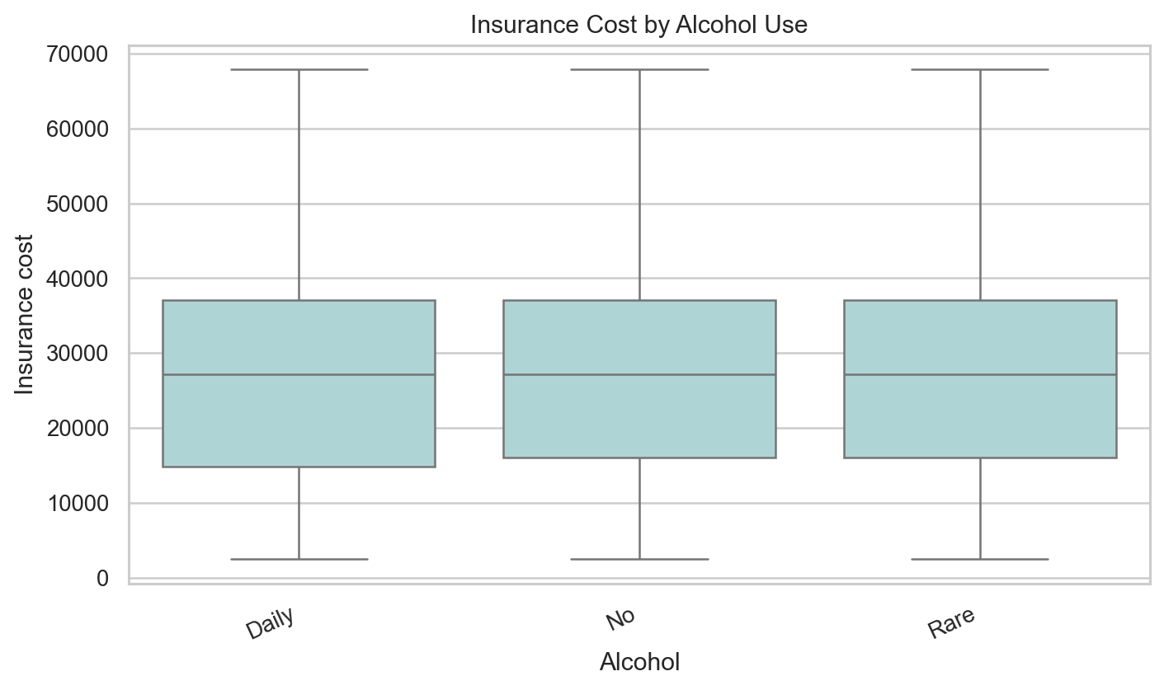
Insurance cost by alcohol consumption.
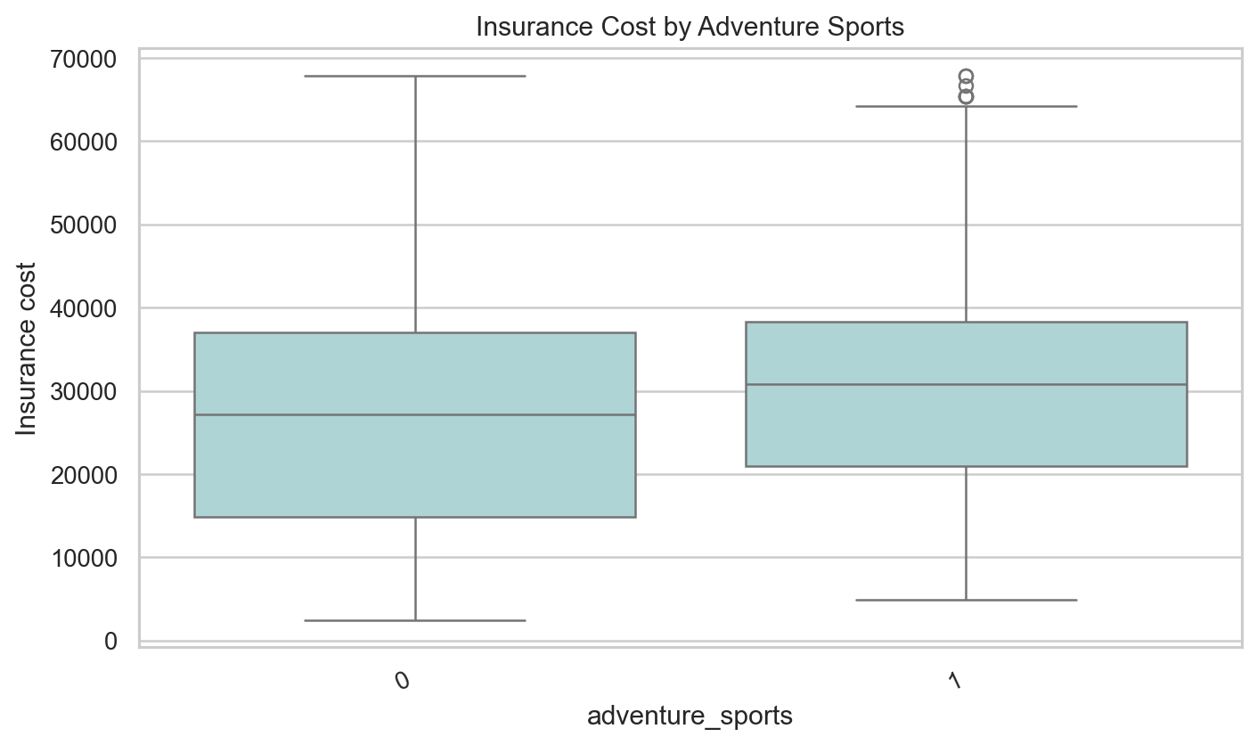
Insurance cost by adventure sports flag.

