Milestone 2 Submission
Insurance Price Prediction | Modeling, Tuning, Final Selection, Deployment, and Recommendations

Contents
- Introduction
- Model Selection and Metrics of Interest
- Model Building and Evaluation
- Model Comparison and Selection
- Business Insights and Recommendations
- Appendix

Introduction
Milestone 2 extends the cleaned analytical dataset into a trainable and deployable sklearn workflow. All imputation, one-hot encoding, scaling, and engineered features are fitted inside the training pipeline to avoid leakage.

Model Selection and Metrics of Interest
- Baseline: DummyRegressor establishes the value of predicting the average premium only.
- Linear family: Linear Regression, Ridge, Lasso, and ElasticNet test additive relationships and regularization.
- Tree family: Decision Tree, Random Forest, Extra Trees, Gradient Boosting, and Histogram Gradient Boosting test nonlinear interactions.
- External packages XGBoost, LightGBM, CatBoost, and SHAP were not available in the active environment, so HistGradientBoostingRegressor is used as the strongest sklearn boosting option.
- Primary metrics are MAE and RMSE because they are interpretable in insurance-cost units. R2 explains variance captured, and MAPE/SMAPE provide percentage-style business context.

Model Building and Evaluation
- Used an 80/20 train-test split with random_state=42.
- Used sklearn Pipeline and ColumnTransformer for feature engineering, imputation, scaling, and one-hot encoding.
- Used 5-fold cross-validation on training data for all model families.
- Tuned Histogram Gradient Boosting with RandomizedSearchCV over max_iter, learning_rate, max_leaf_nodes, min_samples_leaf, l2_regularization, and max_bins.
model | cv_rmse_mean | train_MAE | train_RMSE | train_R2 | test_MAE | test_RMSE | test_R2 | test_MAPE | train_test_RMSE_gap
HistGradientBoostingRegressor | 2,964.1 | 2,257.1 | 2,808.4 | 0.962 | 2,335.0 | 2,915.1 | 0.958 | 11.339 | 106.7
TunedHistGradientBoostingRegressor | 2,963.0 | 2,332.4 | 2,901.4 | 0.959 | 2,351.5 | 2,925.1 | 0.958 | 11.479 | 23.706
GradientBoostingRegressor | 2,977.6 | 2,345.4 | 2,917.9 | 0.959 | 2,365.8 | 2,939.6 | 0.958 | 11.570 | 21.712
DecisionTreeRegressor | 3,159.2 | 2,173.4 | 2,755.8 | 0.963 | 2,447.3 | 3,102.5 | 0.953 | 11.666 | 346.7
Lasso | 3,357.0 | 2,694.6 | 3,347.3 | 0.945 | 2,709.8 | 3,355.5 | 0.945 | 15.316 | 8.233
LinearRegression | 3,357.1 | 2,694.6 | 3,347.3 | 0.945 | 2,709.7 | 3,355.6 | 0.945 | 15.316 | 8.250
Ridge | 3,357.1 | 2,694.4 | 3,347.3 | 0.945 | 2,709.6 | 3,355.7 | 0.945 | 15.313 | 8.399
ElasticNet | 3,407.7 | 2,716.3 | 3,400.3 | 0.944 | 2,725.0 | 3,409.2 | 0.943 | 15.283 | 8.898
RandomForestRegressor | 4,443.7 | 2,951.6 | 3,799.2 | 0.930 | 3,287.8 | 4,265.8 | 0.911 | 19.062 | 466.6
ExtraTreesRegressor | 5,605.9 | 3,603.7 | 4,527.3 | 0.900 | 4,329.4 | 5,443.9 | 0.855 | 26.305 | 916.6
DummyRegressor | 14,336.2 | 11,836.1 | 14,335.8 | 0.000 | 11,762.0 | 14,273.6 | -0.000 | 79.868 | -62.196

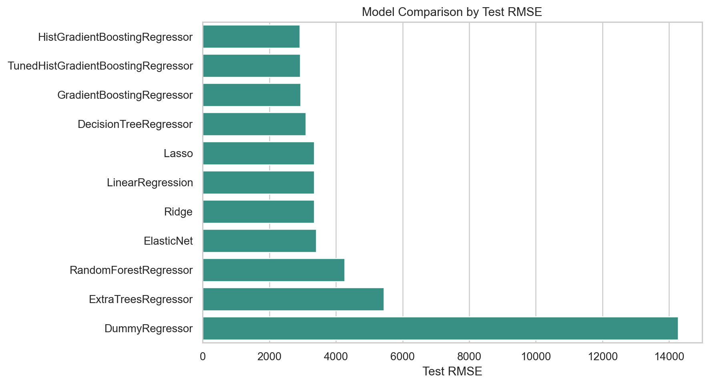
Model performance comparison by test RMSE.

Model Comparison and Selection
- Selected final model: HistGradientBoostingRegressor.
- Test MAE: 2,335. Test RMSE: 2,915. Test R2: 0.958.
- Selection prioritized low test RMSE and MAE, high R2, stable cross-validation RMSE, and a reasonable train-test gap.
- The final model is saved as outputs/models/final_model.pkl and is loaded directly by app.py.
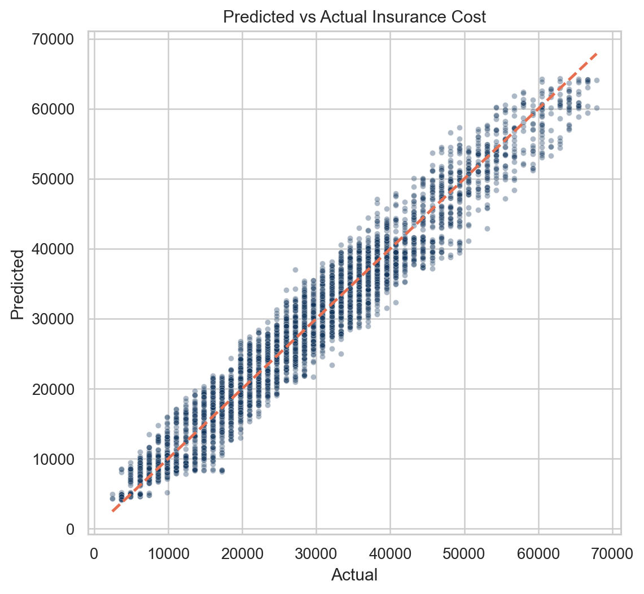
Predicted vs actual plot for the final model.
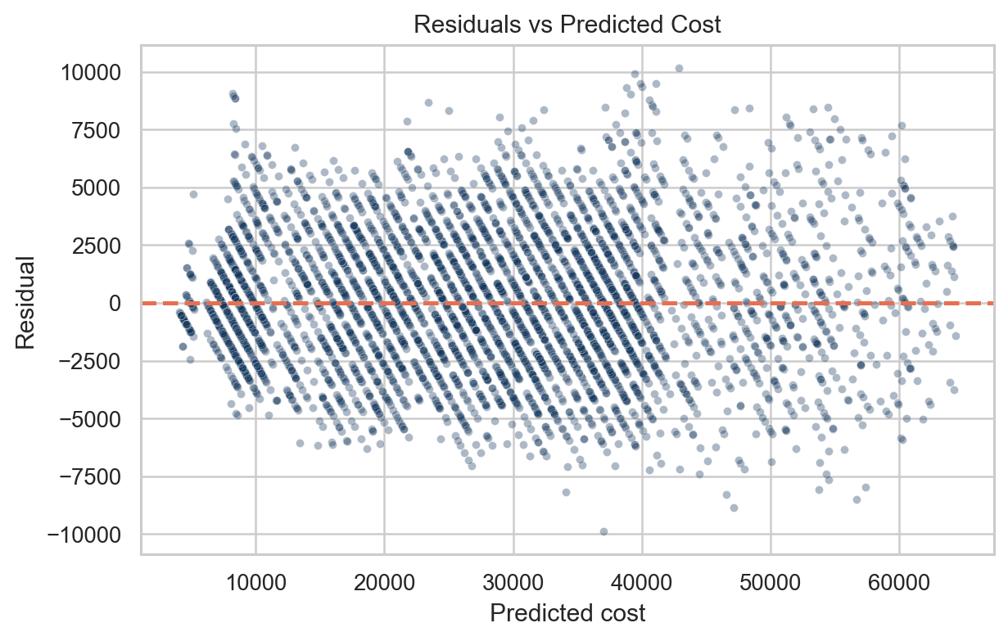
Residual plot for the final model.

Explainability
feature | importance_mean | importance_std
weight | 16,134.6 | 387.5
Year_last_admitted | 304.1 | 20.685
covered_by_any_other_company | 134.7 | 17.864
regular_checkup_last_year | 82.374 | 10.166
weight_change_in_last_one_year | 45.425 | 2.756
years_of_insurance_with_us | 29.933 | 5.840
bmi | 2.922 | 1.628
avg_glucose_level | 2.136 | 3.212
adventure_sports | 1.921 | 0.993
daily_avg_steps | 1.892 | 2.421
exercise | 0.969 | 0.779
fat_percentage | 0.848 | 1.449

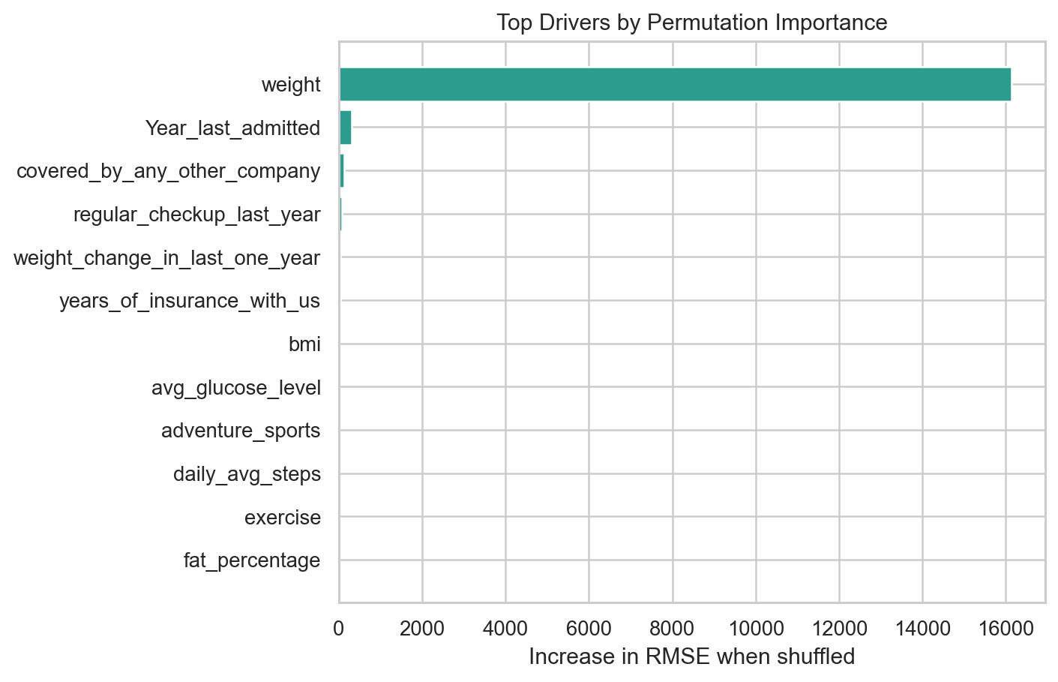
Permutation importance highlights the strongest model drivers.
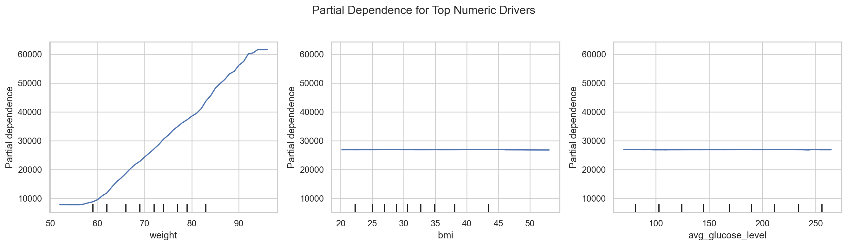
Partial dependence plots summarize directional feature effects.

Business Insights and Recommendations
- Use the final model as a pricing decision-support tool, not as an automatic underwriting decision.
- Prioritize wellness interventions for high-risk segments with poor exercise patterns, adverse BMI profile, elevated glucose, smoking exposure, or disease-history flags.
- Encourage preventive checkups and monitoring for applicants with prior admission history or high glucose because these features support risk differentiation.
- Route extreme predicted premiums or large model residual-like cases to manual review before final quote approval.
- Review Gender and Location usage with compliance teams because they may create fairness or proxy-discrimination concerns in real insurance pricing.
- Monitor prediction drift, segment-level error, and approval outcomes if the model is deployed beyond the capstone demo.

Appendix

Saved Artifacts
- outputs/models/final_model.pkl
- outputs/models/preprocessing_pipeline.pkl
- outputs/models/model_metrics.csv
- outputs/models/feature_importance.csv
- outputs/figures/*.png
- app.py
- notebooks/01_milestone1_eda.ipynb
- notebooks/02_milestone2_modeling.ipynb

Best Tuning Parameters
parameter | value
model__min_samples_leaf | 60.000
model__max_leaf_nodes | 15.000
model__max_iter | 460.0
model__max_bins | 128.0
model__learning_rate | 0.120
model__l2_regularization | 0.050

