
Dhruv Gosai(24CS002UG00604)
Submitted in partial fulfillment of the requirements for the degree
Bachelor of Computer Applications
October 2026

DEPARTMENT OF COMPUTER APPLICATIONS
Arjun Babani(24CS002UG001571)
By:
“Intership Tracker”
A Project Report on

Guided By:
Name of Guide

Certificate
This is to certify that the work presented in the BCA project report entitled “INTERNSHIP TRACKER”, submitted to the Department of Computer Applications, Christ College, Rajkot, in partial fulfilment of the requirements for the award of the Bachelor of Computer Applications, is an authentic record of the work carried out by Arjun Babani and Dhruv Gosai during the period from June 2026 to October 2026 under the supervision of Mr. Anand John.
We also certify that this work has not been submitted, either in part or full, for the award of any other degree elsewhere.

Signature of Arjun Babani: __________
Signature of Dhruv Gosai: __________

This is to certify that the above statement made by the candidate(s) is/are correct to the best of my knowledge.
Head | Guide
Dr. Shailendrasinh Jadeja | Mr . Anand John
Department of Computer Applications | Department of Computer Applications
Christ College, Rajkot | Christ College, Rajkot
Place: Rajkot
Date: __________

Acknowledgement
When we embarked on this project, it initially appeared to us as an onerous task. However, as we progressed, we realized that we were not alone in this journey. We wish to express our sincere gratitude to Rev. Fr. (Dr.) Jomon Thommana, Director, Christ Campus, and Dr. Yvonne Fernandes, Principal, Christ College, for their constant support and encouragement.
We are deeply thankful to Mr Anand John, our project guide, for their invaluable guidance, suggestions, and the freedom they provided us throughout this project. Without their mentorship, the completion of this project would not have been possible.
We also extend our heartfelt thanks to Mr Anand John, our friends for offering their unwavering support, encouragement, and assistance during the preparation of this project.
Our gratitude also goes to our group members, classmates, and well-wishers, whose generous help made this work considerably easier. Finally, our deepest thanks to our parents, who patiently bore with us through the challenges and supported us with a smile throughout our study period and beyond.

Babani Arjun
Gosai Dhruv
Christ College, Rajkot
October 2026

Objectives
Problem Definition
Feasibility Study
SDLC
DFD
10
E-R Diagram
Activity Diagram
Screenshots
Code Explanation
TABLE OF CONTENTS
Introduction
03
Name of Project
01
04
System Analysis
06
02
07
08
System Design
09
03
11
Data Dictionary
04
Implementation
15
05
16
Use Case and Process Diagram
11
Test Case
Result
Testing
15
06
16
Conclusion & Future Scope
07
Introduction
Introduction
An internship tracker is a web-based application designed to help students organize and manage their internship applications in one place. It allows users to record internship details such as the company name, job role, application date, application status, interview schedule, deadlines, and follow-up reminders. Instead of maintaining information manually in notebooks or spreadsheets, students can easily track the progress of all their applications through a single dashboard.
The main purpose of the internship tracker is to simplify the internship application process, improve organization, reduce missed deadlines, and help students monitor their progress efficiently. It provides a user-friendly and secure platform for managing internship-related information, making the internship search process more effective and less time-consuming.

Objectives
The project was built with the following goals in mind:--
- To give students a single place to log and manage every internship application they send out
- To track the lifecycle of each application through stages: Applied → Interview → Offer / Rejected
- To automatically flag applications that have been inactive for too long and need a follow-up
- To compare the performance of different resume versions based on actual response data
- To store and organize all company details, application dates, and interview schedules in a structured database
- To make the system accessible on both desktop and mobile browsers without any installation on the user's end

System Analysis
Problem Definition
Every semester, students apply to dozens of companies for internships — through linkedin, naukri, campus drives, referrals — and within a few weeks the details become a blur. which company is still pending? which resume did you send to whom? did you follow up with that hr from last week? most students handle this with a rough notebook entry or a basic excel sheet, both of which break down quickly once the number of applications crosses even ten or fifteen.
The lack of a proper system means students miss follow-up windows, forget interview dates, and lose track of which version of their resume actually got responses. this project addresses that exact problem — a dedicated web-based tracker built specifically for how a student's internship search actually works.

Feasibility Study
- Technical Feasibility:-
The project uses PHP for server-side logic, MySQL for structured data storage, and XAMPP as the local development server — all technologies covered in the BCA curriculum. Bootstrap 5 handles responsive design across devices. js renders the pipeline and analytics charts. The codebase follows a clean folder structure with shared includes, a PDO database layer, and session-based authentication, all of which are maintainable and extensible.
- Economical Feasibility:-
The entire project is built on zero-cost tools — PHP, MySQL, XAMPP, Bootstrap 5, and js are all free and open source. There are no licensing fees. Free hosting options such as Infinity Free also allow deployment without any cost, making this solution accessible to any student or educational institution.
- Operational Feasibility:-
The interface is designed to be used by students with no technical background. Registering, logging an application, and updating a status each take less than a minute. The system requires no training beyond reading the built-in user guide. It reduces time spent on manual record keeping and improves overall organization of the internship search process.

SDLC
SDLC Timeline for Student Project (June 15 – Oct 25)
1. Planning (June 15 – June 25) → 10 days
- Define project topic & objectives.
- Identify scope (what to include/exclude).
- Assign roles in the team.
- Decide tools/tech (language, DB, IDE).
2. Requirement Analysis (June 26 – July 5) → 10 days
- Collect requirements from guides/mentors.
- Prepare SRS (Software Requirement Specification).
- Finalize project modules & features.
3. System Design (July 6 – July 20) → 15 days
- Create ER diagrams, DFDs, UML diagrams.
- Design database schema.
- Sketch user interface (wireframes).
4. Implementation / Coding (July 21 – Sept 10) → ~50 days
- Divide modules among team members.
- Start coding (frontend + backend + DB).
- Conduct unit testing of each module.
5. Testing & Integration (Sept 11 – Sept 30) → 20 days
- Integrate all modules.
- Do system testing (functional, usability, security).
- Debug & fix errors.
- Prepare test report.

6. Deployment / Finalization (Oct 1 – Oct 10) → 10 days
- Deploy on system (or demo environment).
- Ensure all features work as expected.
- Take feedback from faculty/peers.
7. Documentation & Submission Prep (Oct 11 – Oct 25) → 15 days
- Complete final project report.
- Add diagrams, screenshots, testing results.
- Prepare PPT for viva/demo.
- Final review & submission.

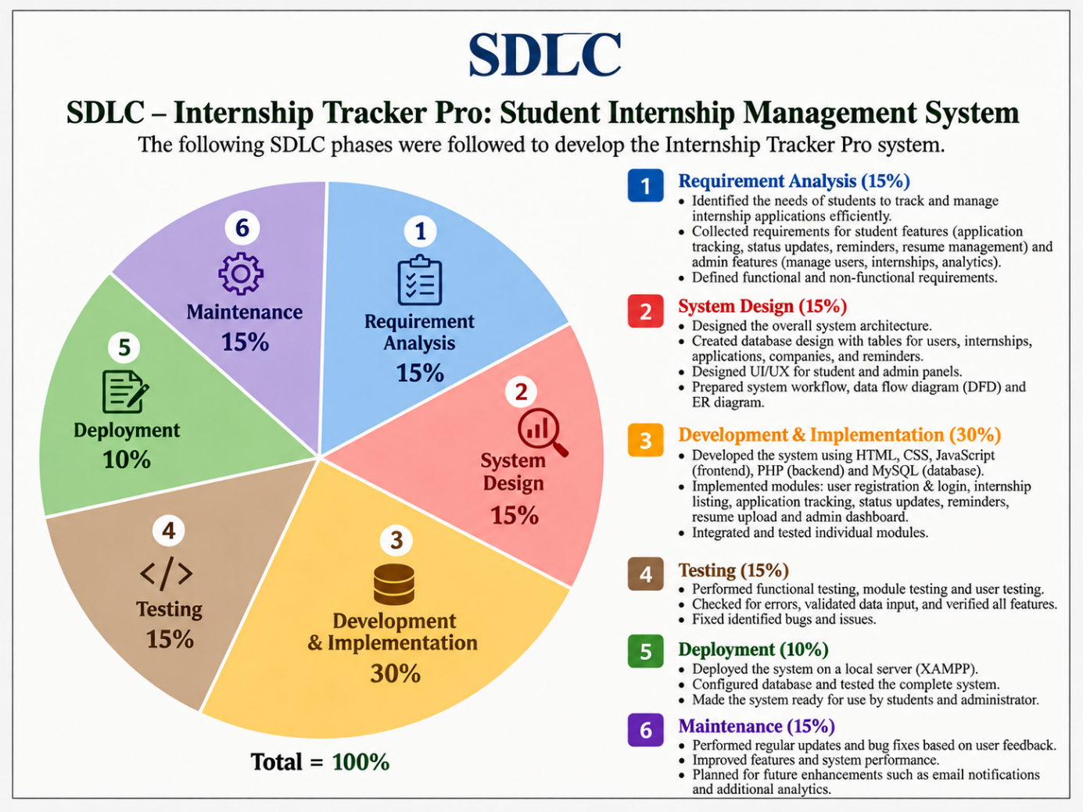

System Design
DFD
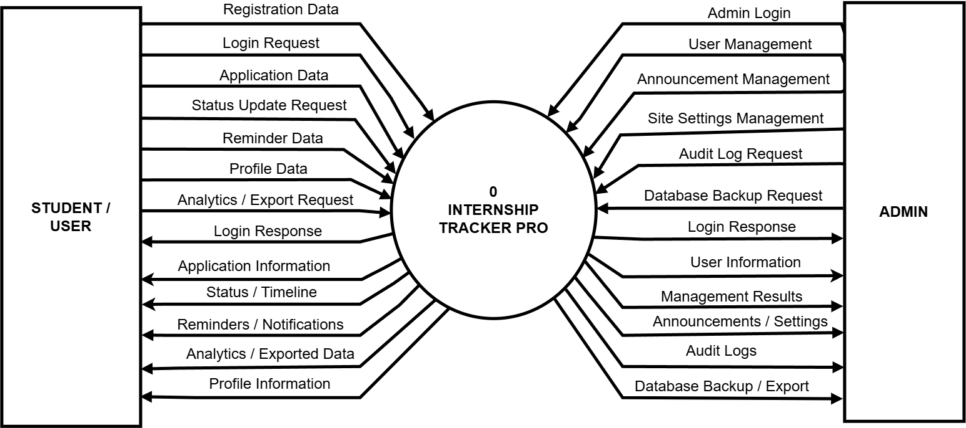
Level 0

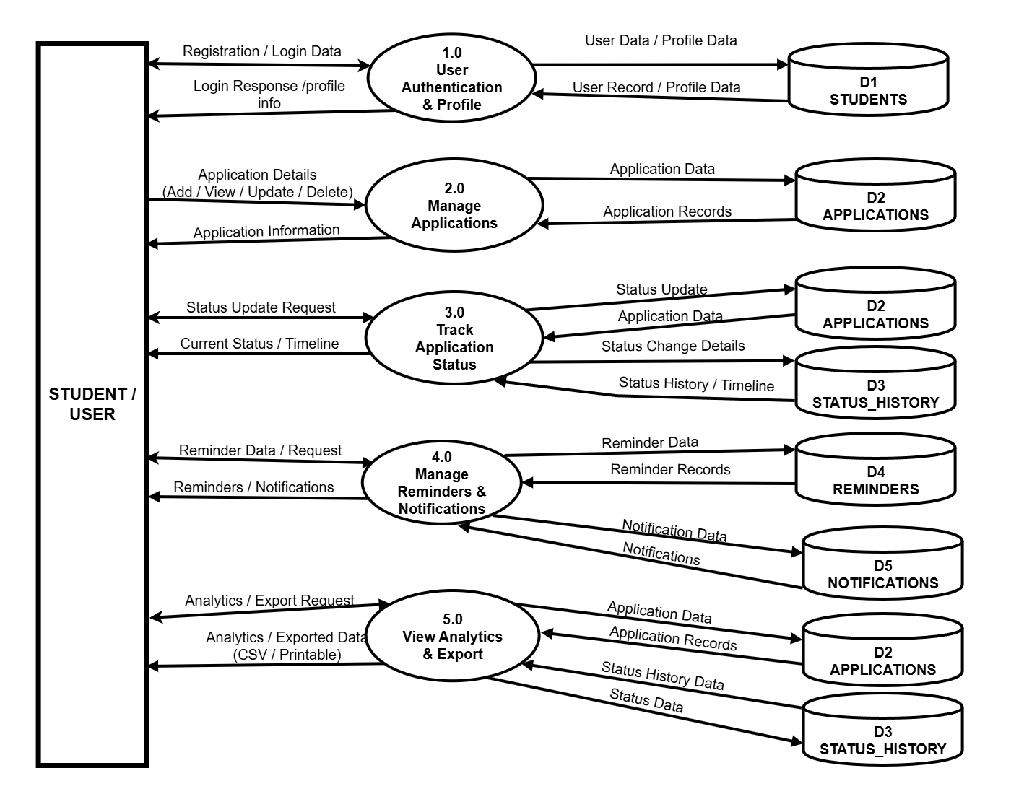
Level 1(user side)

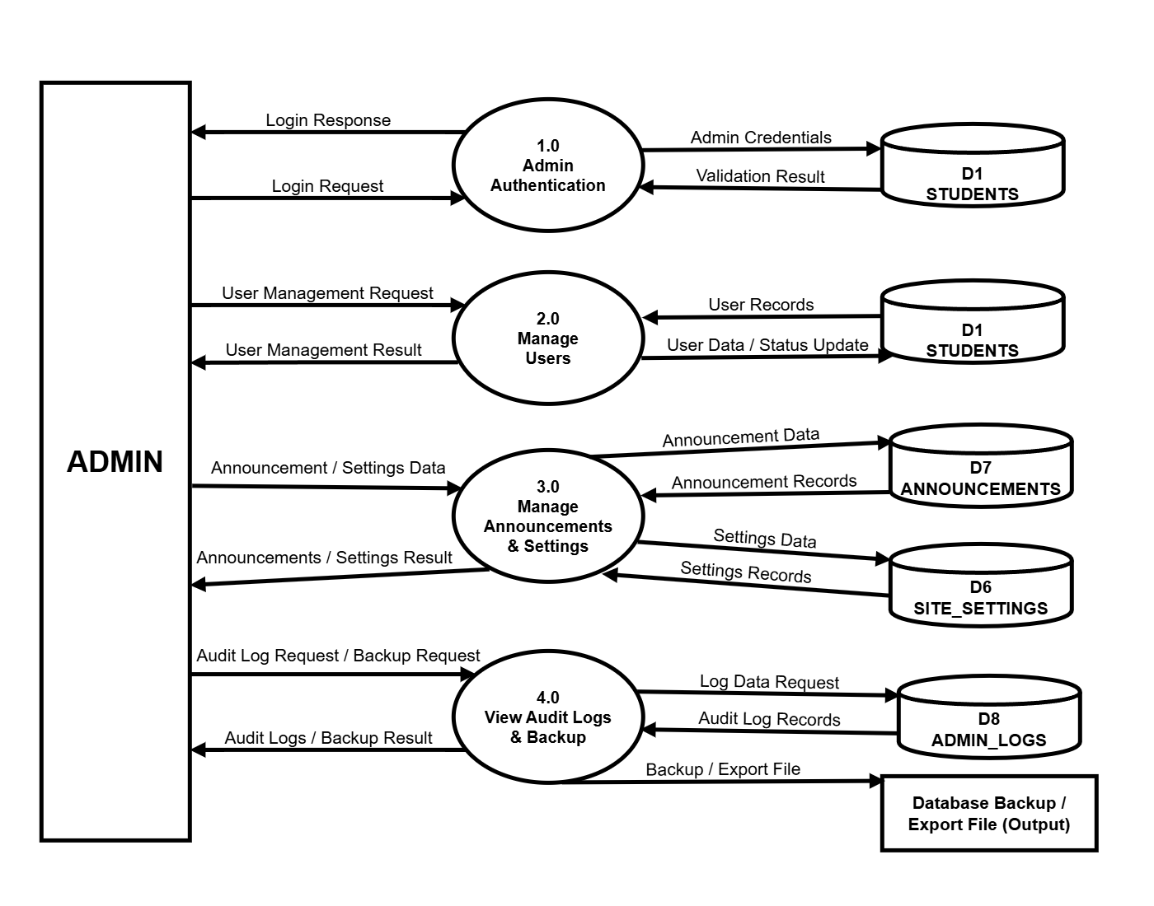
Level 1( admin side)

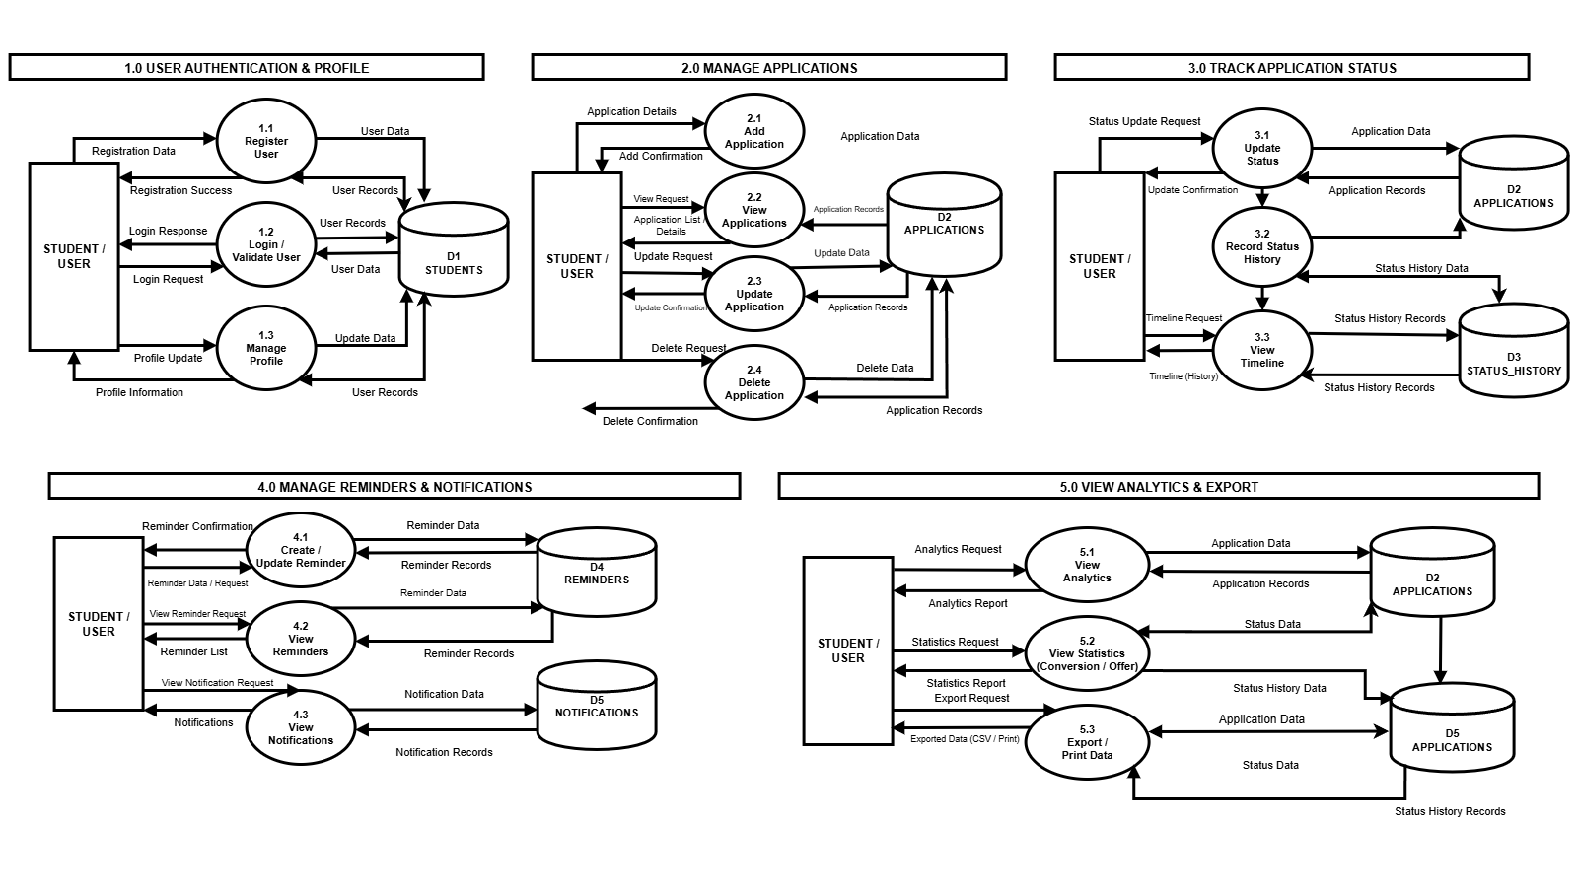
Level 2(user side)

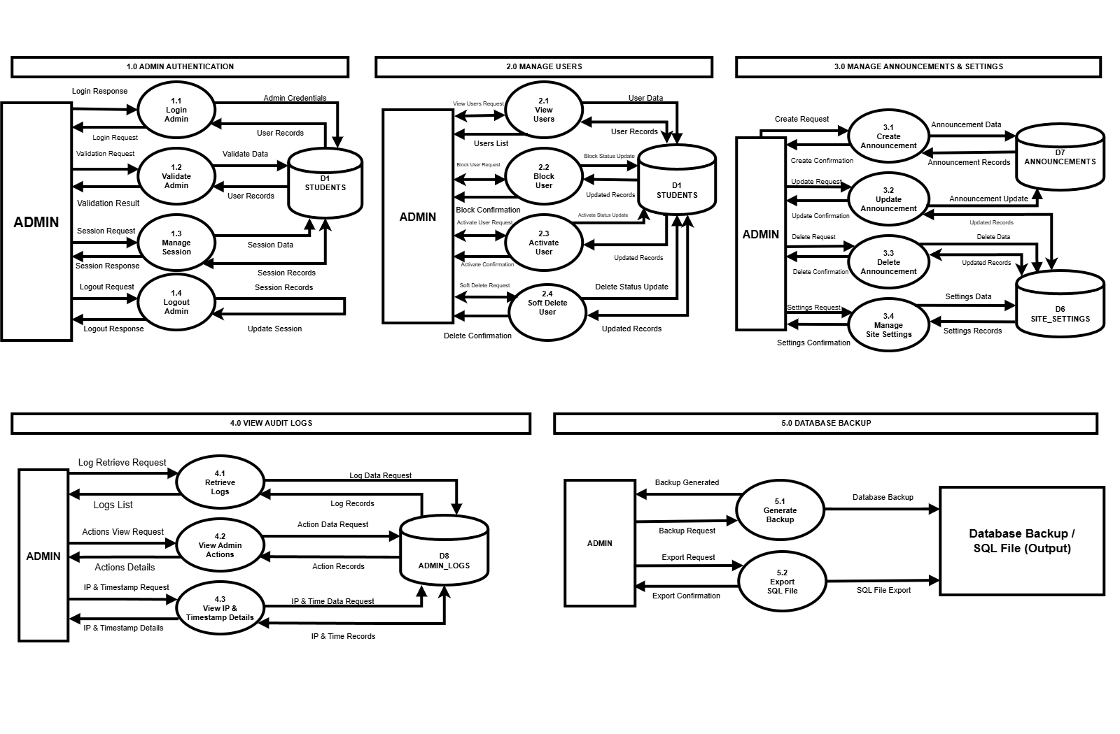
Level 2(admin side)

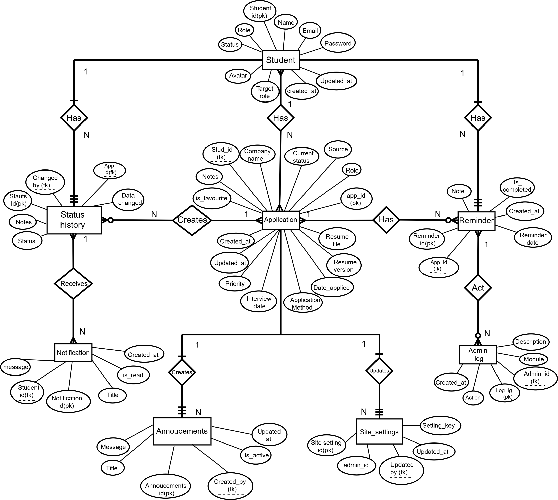
ER Diagram

Activity Diagram(user side)
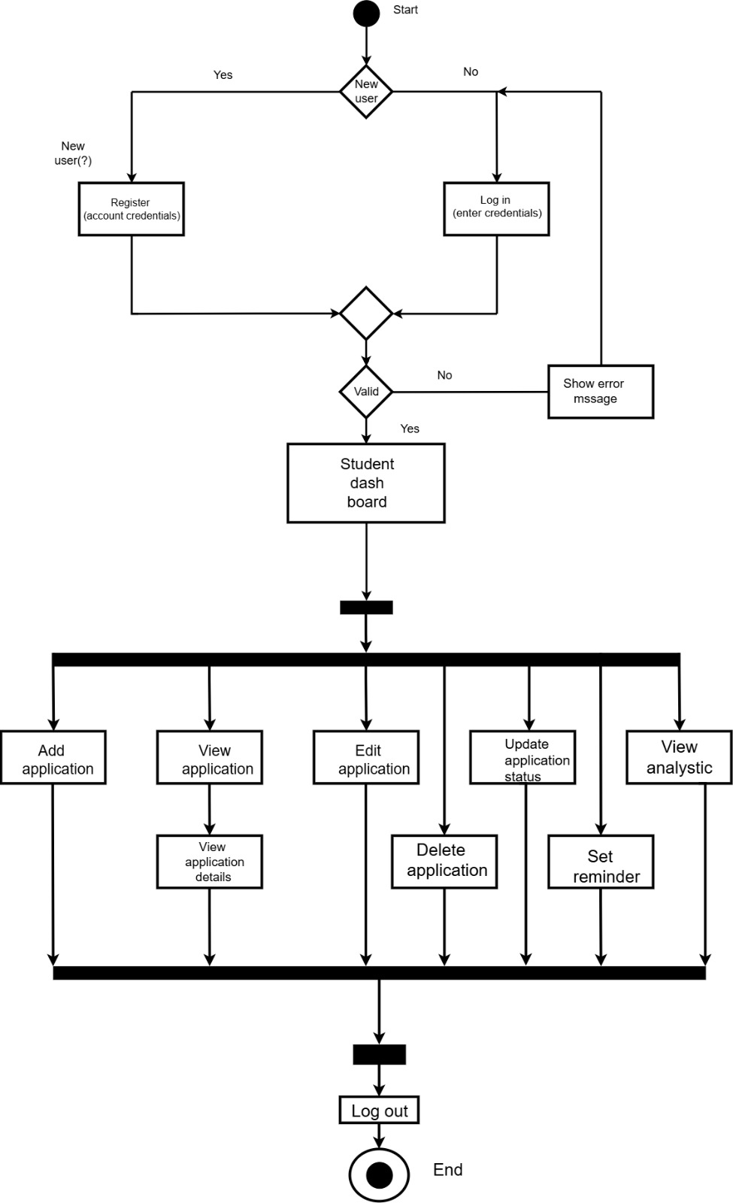

Activity Diagram(admin side)
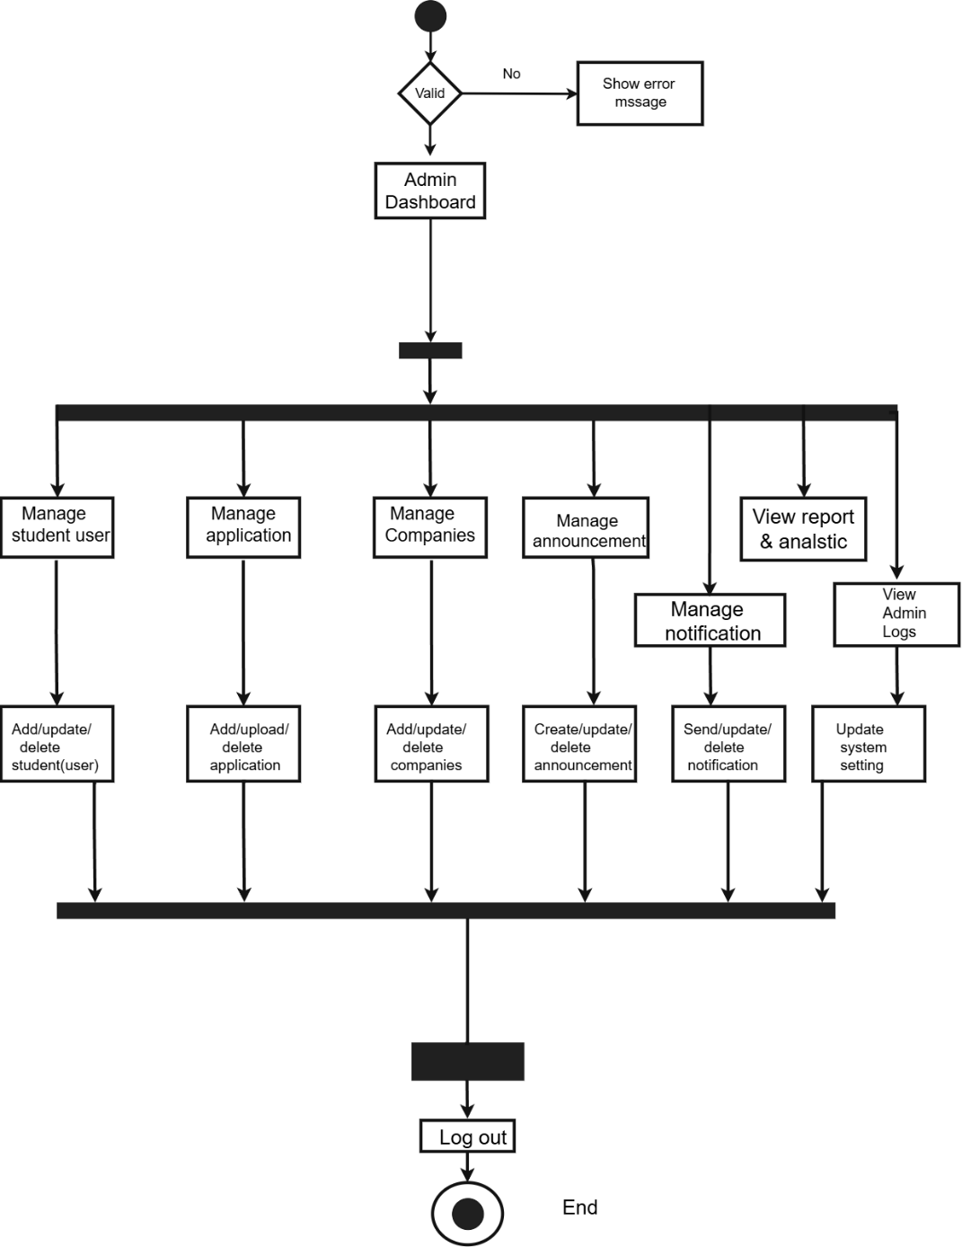
Use Case
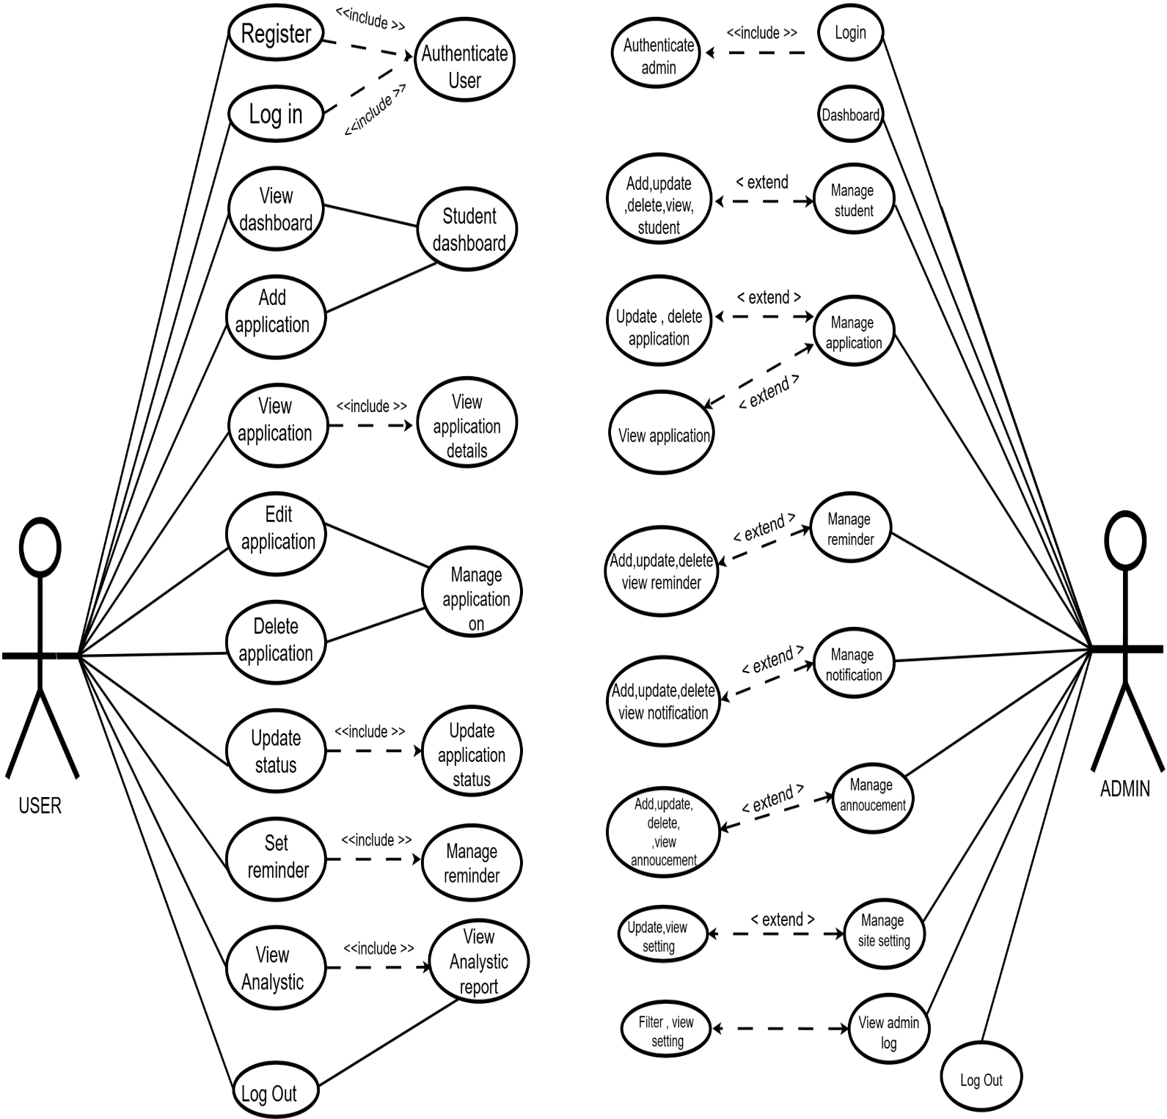

Process Flow
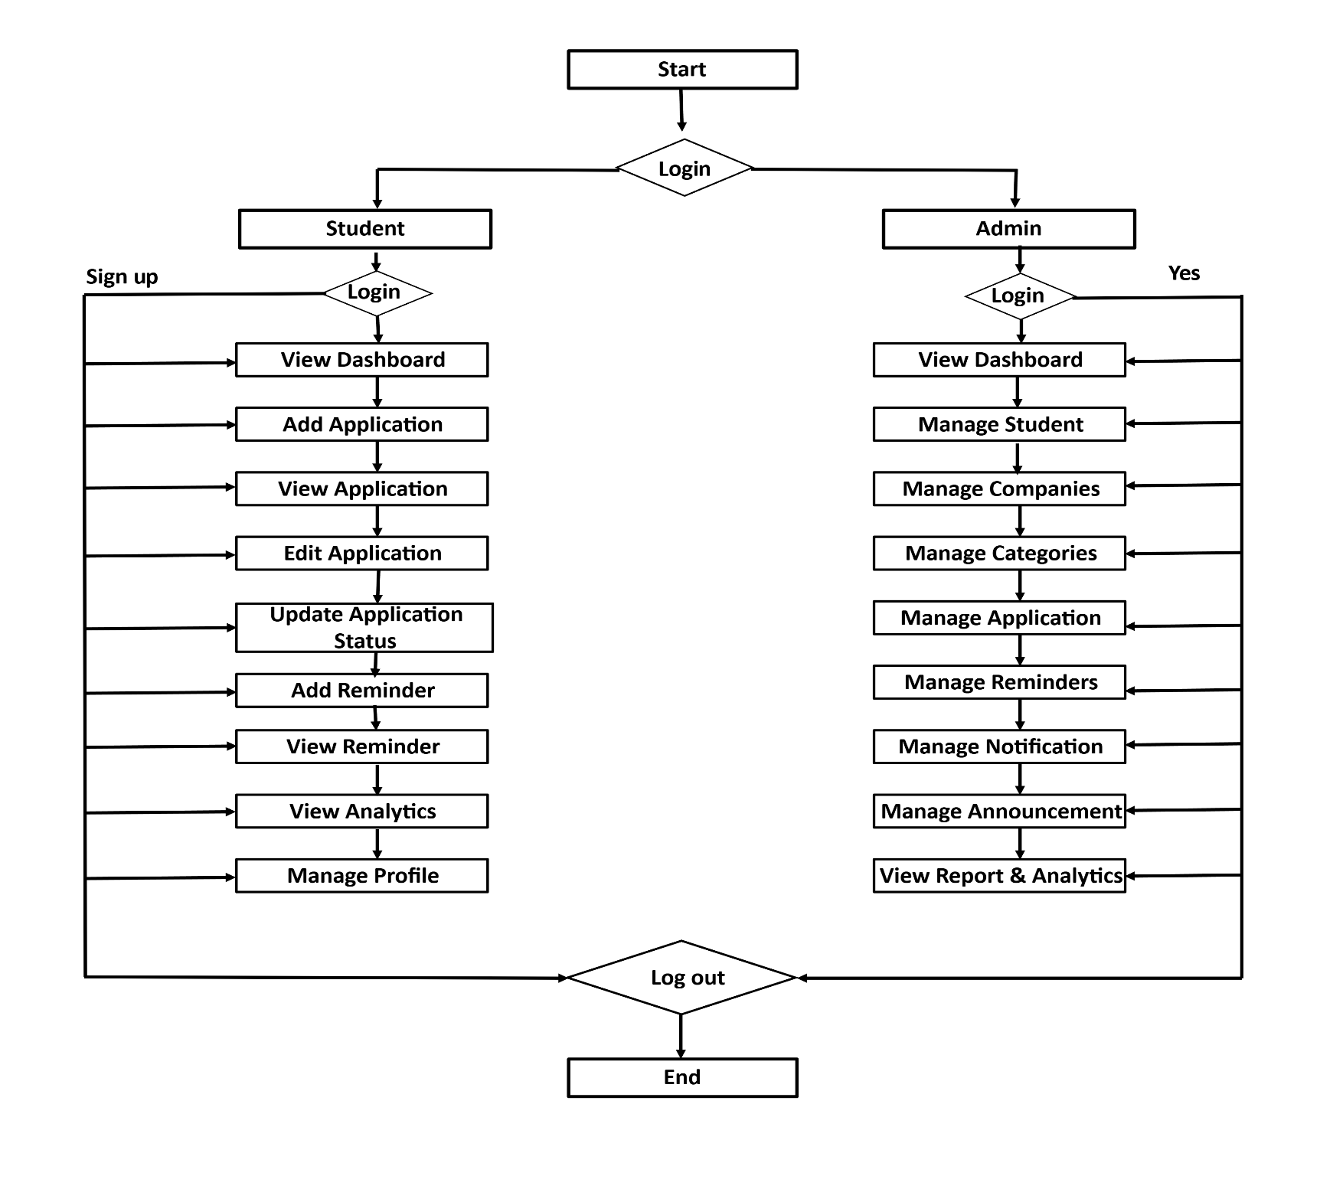

Data Dictionary
Table : student
Field Name | Data Type | Key | Description
id | INT(11) | PK | Identifier
name | VARCHAR(100) | - | Full name
email | VARCHAR(100) | Unique | Email address
password | VARCHAR(255) | - | Password
role | ENUM | - | User role
status | ENUM | - | Account status
avatar | VARCHAR(255) | - | Profile image
target_role | VARCHAR(100) | - | Target role
created_at | DATETIME | - | Creation time
updated_at | DATETIME | - | Update time

Table : application
Field Name | Data Type | Key | Description
id | INT(11) | PK | Identifier
student_id | INT(11) | FK | Student link
company_name | VARCHAR(150) | - | Company name
role | VARCHAR(150) | - | Applied role
source | VARCHAR(100) | - | Application source
application_method | VARCHAR(100) | - | Application method
date_applied | DATE | - | Application date
resume_version | VARCHAR(100) | - | Resume version
resume_file | VARCHAR(255) | - | Resume file
priority | ENUM | - | Priority level
interview_date | DATE | - | Interview date
current_status | VARCHAR(50) | - | Current status
notes | TEXT | - | Application notes
is_favorite | TINYINT(1) | - | Favorite flag
created_at | DATETIME | - | Creation time
updated_at | DATETIME | - | Update time

Table : status history
Field Name | Data Type | Key | Description
id | INT(11) | PK | Identifier
application_id | INT(11) | FK | Application link
status | VARCHAR(50) | - | New status
date_changed | DATETIME | - | Change time
changed_by | INT(11) | FK | Changed by
notes | TEXT | - | Status notes

Table : reminders
Field Name | Data Type | Key | Description
id | INT(11) | PK | Identifier
application_id | INT(11) | FK | Application link
reminder_date | DATETIME | - | Reminder time
note | TEXT | - | Reminder note
is_completed | TINYINT(1) | - | Completion status
created_at | DATETIME | - | Creation time

Table : notifications
Field Name | Data Type | Key | Description
id | INT(11) | PK | Identifier
user_id | INT(11) | FK | User link
title | VARCHAR(150) | - | Notification title
message | TEXT | - | Notification message
is_read | TINYINT(1) | - | Read status
created_at | DATETIME | - | Creation time

Table : announcements
Field Name | Data Type | Key | Description
id | INT(11) | PK | Identifier
title | VARCHAR(150) | - | Announcement title
message | TEXT | - | Announcement message
is_active | TINYINT(1) | - | Active status
created_by | INT(11) | FK | Created by
created_at | DATETIME | - | Creation time
updated_at | DATETIME | - | Update time

Table : site settings
Field Name | Data Type | Key | Description
id | INT(11) | PK | Identifier
setting_key | VARCHAR(100) | Unique | Setting name
setting_value | TEXT | - | Setting value
updated_at | DATETIME | - | Update time
updated_by | INT(11) | FK | Updated by

Table : admin logs
Field Name | Data Type | Key | Description
id | INT(11) | PK | Identifier
admin_id | INT(11) | FK | Admin link
action | VARCHAR(150) | - | Admin action
module | VARCHAR(100) | - | System module
description | TEXT | - | Action details
ip_address | VARCHAR(45) | - | IP address
created_at | DATETIME | - | Creation time

Implementation
Screenshot
Admin
Client

Code Explanation
login.pyt
djfksdjfkjsdkfjksdjfksdjfkjsdkjfks
fjlsdjfkjdskfjsdkljfksdl

login.pyt
djfksdjfkjsdkfjksdjfksdjfkjsdkjfks
fjlsdjfkjdskfjsdkljfksdl

Testing
Test Case
- TEST PLAN
The test plan is prepared to verify the major functions of Internship Tracker Pro. It covers Student and Admin operations and checks whether the completed system behaves as expected during normal use and common invalid-input situations.

The testing areas include authentication, application management, status tracking, interview and reminder functions, analytics, export and print functions, responsive design, Admin functions, and error handling.

- TESTING APPROACH
The test cases were prepared using the supplied Internship Tracker project source, database file, testing checklist, quick-start guide, installation guide, changelog, SRS/workflow documentation, and project content. Each test case contains an input, expected output, actual output, and final status.

Functional testing is organized into three groups: User Side Test Cases, Admin Side Test Cases, and System Level Test Cases. This keeps the testing section clear and directly related to the project modules.

- TESTING SUMMARY

Testing Area | Functionality Covered | Status
Authentication | Registration, login, logout and protected-page access | Successfully Executed
Application Management | Add, validate, upload, search,  filter, edit and delete applications | Successfully Executed
Status Tracking | Status update and status history/timeline | Successfully Executed
Interview & Reminders | Interview date, reminders and  follow-up | Successfully Executed
Analytics | Resume and application  response information | Successfully Executed
Export & Print | CSV export and print-friendly application view | Successfully Executed
Responsive Design | Mobile layout and navigation | Successfully Executed
Admin Functions | Users, settings, announcements, | Successfully Executed

 | backup and audit logs
Error Handling | 403, 404 and 500 error pages | Successfully Executed

- TESTING NOTES:
(1)The test-case tables follow the five-column format: Test Case ID, Input, Expected Output, Actual Output, and Status.
(2)The Actual Output column records the observed or documented result for each completed function.
(3)The stale-application test refers to the documented project rule because the supplied project documents describe the threshold differently.
(4)The testing results shown in the tables are based on the supplied project testing and functionality documentation.

- TEST CASES

User Side Test Cases :
Test Case ID | Input | Expected Output | Actual Output | Status
TC01 | Open login page | Login page loads | Login page  loaded successfully | Successfully Executed
TC02 | Register valid account | New student account is created | Account  created successfully | Successfully Executed
TC03 | Register with missing fields | Validation prevents submission | Validation displayed correctly | Successfully Executed
TC04 | Enter valid login details | User is authenticated and  dashboard opens | Dashboard opened  successfully | Successfully Executed
TC05 | Enter invalid login details | Login is rejected with an error | Invalid login handled  correctly | Successfully Executed

TC06 | Logout | Session is cleared and login page  opens | Logged out successfully | Successfully Executed
TC07 | Open protected page without  login | Access is blocked | Access blocked correctly | Successfully Executed
TC08 | Open student dashboard | Dashboard information loads | Dashboard loaded  successfully | Successfully Executed
TC09 | Add internship  application | Application is saved and listed | Application created  successfully | Successfully Executed
TC10 | Submit  incomplete application | Validation prevents invalid submission | Validation  working correctly | Successfully Executed
TC11 | Upload  supported resume | Resume is accepted and linked | Resume  uploaded successfully | Successfully Executed
TC12 | Search by  company or role | Matching  applications are displayed | Search results  displayed correctly | Successfully Executed
TC13 | Select status filter | Matching applications are displayed | Correct status data shown | Successfully Executed
TC14 | Edit application  details | Updated application is saved | Application updated  successfully | Successfully Executed
TC15 | Delete application | Application is removed after  confirmation | Application deleted  successfully | Successfully Executed
TC16 | Update  application status | New status is saved and displayed | Status  updated correctly | Successfully Executed
TC17 | View status history | Status changes appear in timeline | Timeline  displayed correctly | Successfully Executed
TC18 | Set interview date | Interview date is saved and displayed | Interview date saved successfully | Successfully Executed
TC19 | Create reminder | Reminder is saved and displayed | Reminder created | Successfully Executed
 |  |  | successfully
TC20 | Check  inactive application | Inactive application  is flagged by project rule | Follow-up  flag displayed correctly | Successfully Executed
TC21 | Open resume analytics | Resume/application response information is  displayed | Analytics loaded successfully | Successfully Executed
TC22 | Export  application data | CSV file is generated | CSV exported successfully | Successfully Executed
TC23 | Print  application summary | Print-friendly  summary is available | Print view  opened successfully | Successfully Executed
TC24 | Toggle dark/light mode | Theme changes correctly | Theme changed successfully | Successfully Executed
TC25 | Open system on mobile screen | Layout fits without horizontal overflow | Mobile layout displayed correctly | Successfully Executed
TC26 | Use keyboard navigation | Documented keyboard actions work | Keyboard navigation  working correctly | Successfully Executed

Admin Side Test Cases:
Test Case ID | Input | Expected Output | Actual Output | Status
TC27 | Open Admin dashboard | Admin dashboard loads | Admin dashboard loaded  successfully | Successfully Executed
TC28 | Manage student user | User access is updated correctly | User management working  correctly | Successfully Executed
TC29 | Update settings/announcement | Changes are saved | Changes saved successfully | Successfully Executed
TC30 | Generate database backup | SQL  backup/export is generated | Backup generated  successfully | Successfully Executed
TC31 | Perform Admin action | Action is recorded in  audit logs | Audit log recorded  successfully | Successfuly Executed

System Level Test Cases:
Test Case ID | Input | Expected Output | Actual Output | Status
TC32 | Open invalid/restricted page | Correct 403/404/500  page is displayed | Error page displayed correctly | Successfully Executed

- FINAL TESTING STATEMENT:
The system was tested across all major modules, and all documented test cases were successfully executed. The system performed as expected with no functional errors identified during testing.

Result
Test Case ID: TC_001
Test Case Name: Login with valid credentials
Module: User Authentication
Preconditions: User must be registered in the system.
Test Steps:
Open the application.
Go to the login page.
Enter valid username: testuser.
Enter valid password: Test@123.
Click on the "Login" button.
Expected Result: User should be logged in and redirected to the dashboard.
Actual Result: User successfully logged in and dashboard displayed.
Status: Pass ✅

Conclusion and Future Scope
1. Conclusion
The Internship Tracker Pro successfully fulfills the major functional, technical, and academic requirements of the project. The system provides a centralized platform for students to manage internship applications, track application statuses, maintain status history, schedule reminders, manage resume versions, and view application and resume analytics. It also provides CSV export and print-friendly application summaries for organized record management.

The system includes separate Student and Admin functionality. Students can manage their profiles and internship applications, while administrators can manage users, announcements, site settings, audit logs, and database backup/export operations. The project was developed using PHP 8, MySQL, HTML5, CSS3, JavaScript, and Bootstrap 5, with security measures such as password hashing, prepared statements, CSRF protection, XSS prevention, and session security. The documented test cases covering authentication, application management, status tracking, reminders, analytics, export, responsive design, Admin functions, and error handling were successfully executed.

Overall, Internship Tracker Pro demonstrates a complete web-based solution for organizing the internship application process and provides practical experience in software development, database management, security, testing, and system documentation.

Future Scope
* AI Resume Analysis: AI-based resume parsing and analysis can be integrated to extract information from resumes and provide more advanced resume performance insights.
* Automated Email Notifications: SMTP-based email notifications can be added for interview reminders, follow-ups, announcements, and important application updates.
* Mobile Push Notifications: Push notifications can be introduced so students can receive reminders and application updates directly on mobile devices.
* Advanced Analytics: Future versions can provide more detailed application trends, response rates, interview conversion rates, offer statistics, and resume-version comparisons.
* Enhanced Application Management: Additional features can be introduced for managing more detailed recruitment activities, interview preparation, deadlines, and follow-up actions.
* Scalability: The system can be optimized to support a larger number of students, applications, and administrative operations.
* Security Improvements: Additional security mechanisms can be implemented as the system grows, especially for user data, uploaded documents, authentication, and administrative operations.
* External Integration: Future versions can integrate with external career platforms, job portals, email services, or other APIs to reduce manual data entry and improve the internship tracking workflow.

