Healthy Bite: Digital Menu And Food Ordering System
Author Names: Gunjan Dhaduk, Jisna Saji
Guide Name: Ms. Pintukumari Bera
Christ College, Rajkot

Abstract
The rapid adoption of digital food ordering platforms has revolutionized dining; however, most existing solutions prioritize order dispatch while offering negligible transparency regarding nutritional composition, ingredient customization, calorie loads, and dietary suitability. This lack of dietary awareness contributes directly to lifestyle disorders such as obesity, diabetes, and cardiovascular diseases.
Healthy Bite is a specialized, web-based Digital Restaurant Menu and Nutritional Food Ordering System designed to bridge the gap between dining convenience and health transparency. Engineered with a frictionless QR-code table ordering architecture, the system allows seated diners and takeaway guests to scan table-specific QR tokens, browse food catalogs, inspect ingredient transparency, and review an 8-parameter nutritional profile (calories, protein, carbohydrates, fats, dietary fiber, sugar, sodium, and caffeine) before placing an order. An integrated dynamic computation engine recalculates price and macronutrients in real-time as customers modify dish variants and dietary add-ons.
For restaurant management, the platform incorporates a dedicated multi-role portal featuring instant dish availability control, table and QR token administration, simulated digital payment processing, and a 5-stage live Kitchen Display System (KDS). Developed using a custom 3-Tier MVC architecture in PHP, MySQL, HTML5, CSS3, JavaScript (ES6+), and Bootstrap Icons, Healthy Bite guarantees data integrity, responsive client-side state management, and defensive web security against common vulnerabilities (SQLi, XSS, CSRF). Healthy Bite transforms standard dining operations into an interactive, health-aware digital experience.
Keywords: Digital Restaurant Menu, QR Food Ordering, Nutritional Transparency, Calorie Tracking, PHP MVC, MySQL, Kitchen Display System (KDS), Web Application Security.
1. Introduction
In recent years, digital transformation has deeply reshaped the food service industry. Quick-response (QR) digital menus and contactless ordering systems have evolved from temporary pandemic countermeasures into essential expectations for modern restaurant operations. They drastically reduce guest wait times, eliminate paper printing costs, and streamline front-of-house coordination.
Despite widespread adoption, conventional digital menu platforms focus almost exclusively on transactional speed and sales volume, providing minimal or zero nutritional intelligence. Diners are routinely unaware of hidden sugars, excessive sodium, allergen exposure, or caloric density. This information deficit poses significant risks for fitness enthusiasts, diabetic patients, elderly diners, and individuals with strict dietary regimens.
Healthy Bite resolves this dilemma by unifying contactless table ordering with real-time nutritional disclosure. Unlike generic food ordering portals, Healthy Bite treats nutritional data as a first-class citizen alongside pricing. Every dish features an itemized breakdown of calories, macro/micronutrients, and dietary classification tags (e.g., High-Protein, Keto, Vegan, Gluten-Free, Low-Sugar). Crucially, the platform dynamically computes nutritional shifts as diners customize their meals (such as choosing almond milk over dairy or opting for low-sugar dressings).
Beyond the consumer-facing interface, the system equips restaurant owners and kitchen managers with a centralized operations dashboard. This includes real-time order lifecycle tracking through a 5-column Kitchen Display System (KDS), table occupancy management, QR token generation, catalog customization, and revenue analytics. Healthy Bite establishes a transparent, efficient ecosystem that benefits diners and restaurant operators alike.

2. Problem Statement
Contemporary restaurant ordering systems and online food menus suffer from notable architectural and informational limitations:
- Absence of Nutritional Transparency: Traditional menus omit vital macronutrient data (calories, proteins, carbs, fats, sugars, sodium), preventing health-conscious decisions.
- Static, Inflexible Catalogs: Paper and basic digital menus cannot recalculate nutrition when customers request ingredient customizations or portion variants.
- High Customer Onboarding Friction: Many ordering applications force seated restaurant patrons to download bulky mobile apps or complete tedious account registration forms before ordering.
- Manual and Fragmented Kitchen Operations: Traditional order tickets (KOT) result in delayed order fulfillment, miscommunication, and poor status tracking.
- Lack of Real-Time Menu Availability Control: Out-of-stock dishes cannot be immediately removed, causing diner disappointment and kitchen delays.
- Security & Concurrency Vulnerabilities: Unsecured web forms and exposed order endpoints risk tampering, parameter injection, and cross-table ordering conflicts.
Healthy Bite addresses these challenges through a secure, responsive, web-based platform that combines frictionless QR table ordering, dynamic nutrition recalculation, and synchronized kitchen workflow management.

3. Objectives
The primary objectives of the Healthy Bite system are:
- Develop a Frictionless QR Ordering Platform: Enable diners to access the digital menu instantly by scanning dynamic table QR tokens without requiring account registration or mobile app installation.
- Provide 8-Parameter Nutritional Transparency: Display verified nutritional facts per dish, including calories (kcal), protein (g), carbohydrates (g), fat (g), fiber (g), sugar (g), sodium (mg), and caffeine (mg).
- Implement Dynamic Macro Recalculation: Develop a client-server calculation engine that updates both total price and aggregate nutritional values in real-time as variants and custom add-ons are toggled.
- Deliver an Interactive Food Catalog: Support category filtering, search queries, food classification badges (Veg/Non-Veg), and dietary lifestyle tags.
- Streamline Table and QR Management: Enable restaurant managers to generate, preview, print, and assign unique secure QR tokens to dining tables with automated occupancy tracking.
- Implement a Live Kitchen Display System (KDS): Provide a real-time 5-stage Kanban queue (placed, accepted ,preparing ,ready ,completed) for kitchen staff.
- Provide Live Customer Order Tracking: Allow diners to track their order’s preparation and fulfillment status via asynchronous status polling.
- Implement Simulated Multi-Method Settlement: Facilitate order settlement across simulated Cash, UPI, and Card options with cryptographically secure transaction reference generation.
- Enforce Defensive Web Architecture: Ensure application security through PDO parameterized SQL queries, context-aware output escaping (XSS prevention), constant-time CSRF verification, and role-based session middleware.

4. Scope of the System
The system is scoped across three operational stakeholder roles and a focused future development roadmap:
A. Dining Customer (Frictionless Web Access)
- Scan table QR code to resolve verified restaurant, branch, and table identity.
- Browse category-wise healthy meals with visual dish photography and nutritional tags.
- Search and filter menu items based on dietary preferences.
- Open interactive food customization modals to select portion variants and dietary add-ons.
- View real-time reactive updates to item price and nutritional values.
- Manage local cart state (hb_cart) with persistent storage and line-item quantity controls.
- Complete guest checkout by providing contact details and dining preference (Dine-In or Takeaway).
- Settle orders via simulated payment options (Cash, UPI, Card).
- Track live kitchen order progress via real-time HTTP polling.
- Submit customer ratings and qualitative dining reviews.
B. Restaurant Owner & Kitchen Staff (Operations Portal)
- Authenticate securely via role-based access control (Owner / Manager / Staff).
- Monitor high-level business indicators (total revenue, daily order volume, active tables).
- Manage menu catalog: create, edit, and delete food items with base price, images, and nutritional metrics.
- Toggle instant dish availability (In Stock / Sold Out) with live menu reflection.
- Configure variants (e.g., Regular, Large) and add-on customizations with specific price and macro adjustments.
- Administer dining tables, generate dynamic QR codes, download vector QR images, and manage table occupancy.
- Operate the live Kitchen Display System (KDS) Kanban board to advance orders across preparation stages.
- Review customer ratings and publish official restaurant responses.
- Access sales breakdowns and nutrient consumption analytics.
C. Platform Administrator (Super Admin Portal)
- Global platform dashboard with cross-tenant metrics and active restaurant counts.
- Restaurant tenant governance: inspect, approve, or suspend restaurant accounts.
- Platform user management: create, manage, and toggle status of restaurant owners and staff.
- Database maintenance and platform audit logging.
D. Future Scope
- AI-Powered Dietary Recommendations: Machine learning recommendation models based on past ordering habits and target calorie budgets.
- Personalized Health Profile Sync: Integration with wearable fitness platforms (Apple Health, Google Fit) to log meal macros directly to health tracking apps.
- Direct Banking Payment Gateway: Integration with production payment aggregators (e.g., Razorpay, Stripe) for real-time online fund settlements.
- Automated Stock Inventory & Recipe Deductions: Ingredient-level warehouse tracking that automatically decrements raw ingredient quantities as orders are fulfilled.
- Multilingual Menu Localization: Support for regional Indian languages to expand customer accessibility.
5. Proposed Methodology
Healthy Bite is built following a custom 3-Tier Model-View-Controller (MVC) software architecture:
- Presentation Tier: A responsive, mobile-first customer interface and desktop-optimized owner/admin dashboards built using HTML5, CSS3 custom variables, Vanilla JavaScript (ES6+ modular state pattern), and Bootstrap Icons.
- Application & Business Logic Tier: Powered by PHP 8.0+ featuring a Front Controller pattern (index.php), custom REST routing (routes/web.php and routes/api.php), and dedicated Domain Service classes (NutritionService, CartService, OrderService, PricingService, QrService, PaymentService). Security is strictly enforced using CSRF tokens (hash_equals), bcrypt password hashing, and role-checking middleware.
- Data Tier: A normalized MariaDB/MySQL relational database enforcing data integrity via InnoDB foreign key constraints, UTF-8 mb4 encoding, and 100% PDO prepared statements to eliminate SQL injection vulnerabilities.

System Workflow
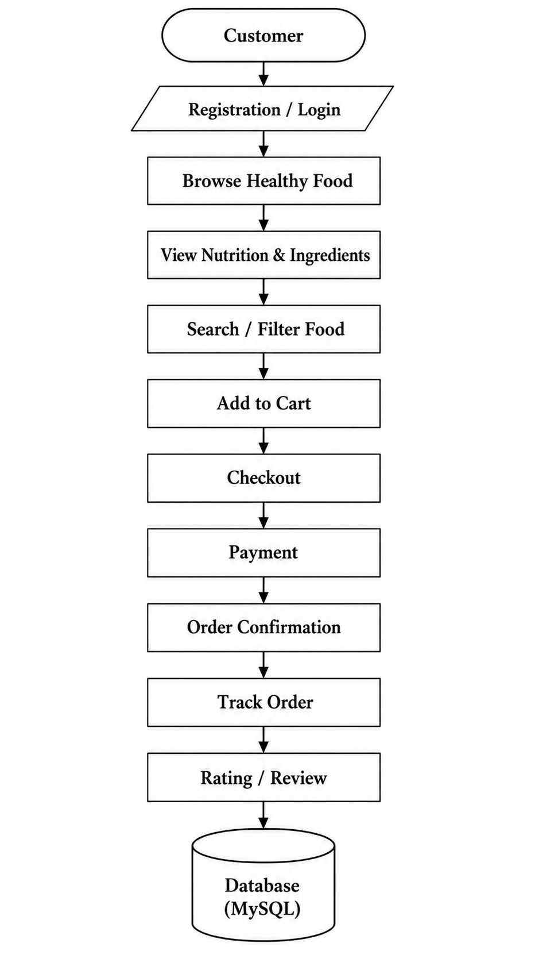
Admin / Restaurant Workflow

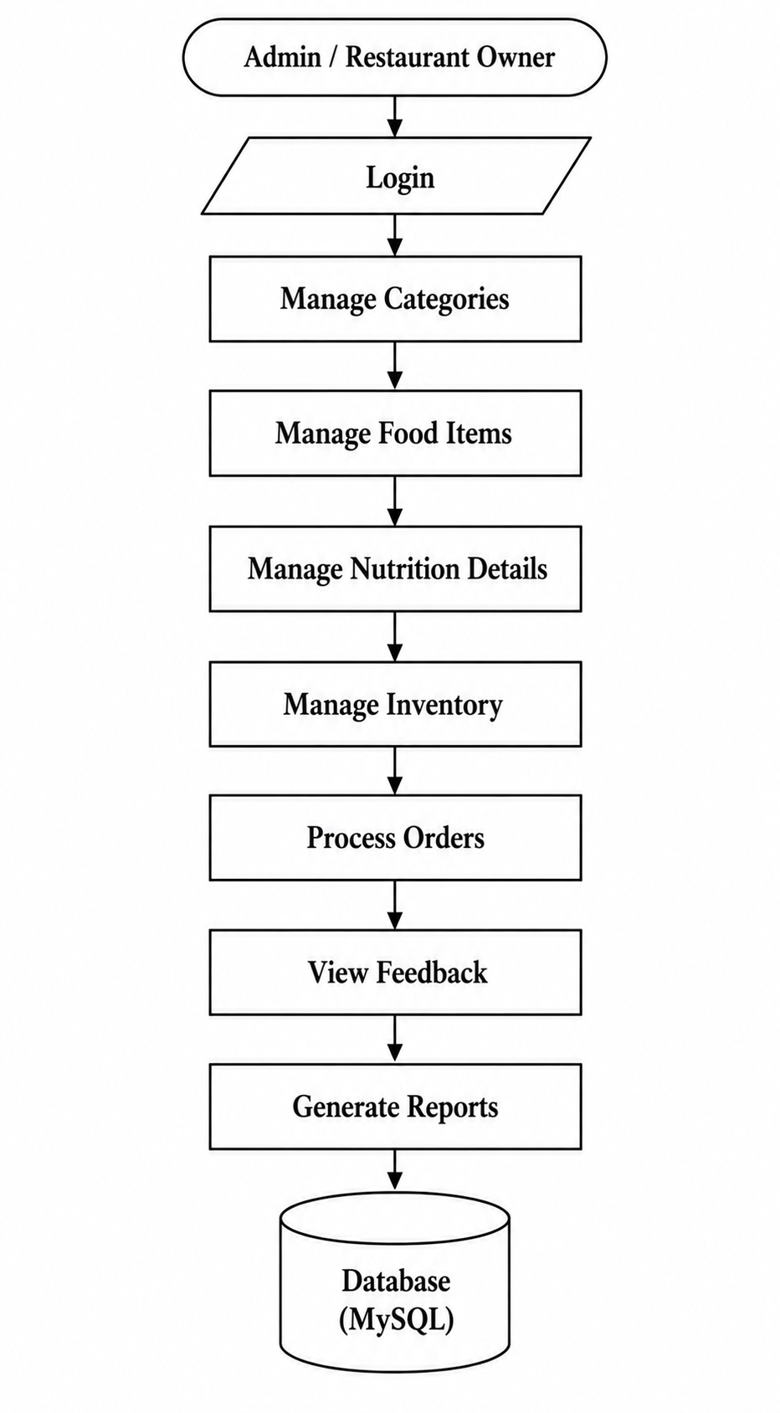

6. SYSTEM MODULES

No. | Module | Main Functions
1 | Customer Module | Registration, login, profile, browse food, search, filter
2 | Food/Menu Module | Display food items, categories, ingredients and food details
3 | Nutrition Module | Calories, protein, carbohydrates, fats, vitamins, minerals, allergens and dietary labels
4 | Cart Module | Add food, update quantity, remove food and calculate cart total
5 | Order Module | Checkout, place order, order confirmation and order tracking
6 | Payment Module | Manage and record online payment information
7 | Feedback & Review Module | Customer ratings and reviews
8 | Admin/Restaurant Management Module | Manage users, categories, food, nutrition, inventory, orders, feedback and reports

7. DB / TABLES

1. admin :
Record Preview:
id | name | created_at | updated_at
1 | Platform Super Admin | 2026-08-30 15:50:38 | 2026-08-30 15:50:38

2. branches :
Record Preview:
id | restaurant_id | name | address | city | state | phone | status
1 | 1 | Greenhouse Kitchen - Indiranagar | 100 Feet Road, HAL 2nd Stage, Indiranagar | Bengaluru | Karnataka | +918012345678 | active

created_at | updated_at
2026-09-14 14:17:24 | 2026-09-14 14:17:24

3. categories :
Record Preview:
id | restaurant_id | name | slug | description | image | sort_order | status
1 | 1 | Bowls | bowls | Nutrient-packed warm and cold signature bowls | cat_bowls.jpg | 1 | active

created_at | updated_at
2026-09-14 14:17:24 | 2026-09-14 14:17:24

4. customers :
Record Preview:
id | name | mobile | email | created_at | updated_at
1 | Rahul Sharma | +919876543210 | rahul.sharma@example.com | 2026-09-14 14:17:24 | 2026-09-14 14:17:24

5. food_customizations :
Record Preview:
id | food_item_id | name | description | group_name | price_adjustment | calories_adjustment | protein_adjustment
11 | 13 | Extra Protein Scoop / Serving | Additional protein portion | Portion Add-on | 40.00 | 80 | 12.00

carbs_adjustment | fat_adjustment | fiber_adjustment | sugar_adjustment | sodium_adjustment | caffeine_adjustment | is_required | min_quantity
2.00 | 1.50 | 0.50 | 0.00 | 120.00 | 0.00 | 0 | 0

max_quantity | is_available | sort_order | created_at | updated_at
1 | 1 | 1 | 2026-09-14 14:17:24 | 2026-09-14 14:17:24

6. food_items :
Record Preview:
id | restaurant_id | category_id | name | slug | description | image | ingredients
1 | 1 | 1 | Paneer Protein Bowl | paneer-protein-bowl | Tandoori paneer, brown rice, fresh veggies | paneer_protein_bowl.jpg | Paneer, brown rice, lettuce, cucumber, tomato, corn, mint dressing

allergens | food_type | base_price | calories | protein | carbs | fat | fiber
Milk | vegetarian | 249.00 | 520 | 28.00 | 54.00 | 20.00 | 8.00

sugar | sodium | caffeine | serving_size | is_featured | is_popular | is_available | created_at
6.00 | 620.00 | 0.00 | 450 g | 1 | 1 | 1 | 2026-09-14 14:17:24

updated_at
2026-09-14 14:17:24

7. food_variants :
Record Preview:
id | food_item_id | name | description | price_adjustment | calories_adjustment | protein_adjustment | carbs_adjustment
5 | 13 | Standard Portion | Regular serving size | 0.00 | 0 | 0.00 | 0.00

fat_adjustment | fiber_adjustment | sugar_adjustment | sodium_adjustment | caffeine_adjustment | is_required | is_available | sort_order
0.00 | 0.00 | 0.00 | 0.00 | 0.00 | 1 | 1 | 1

created_at | updated_at
2026-09-14 14:17:24 | 2026-09-14 14:17:24

8. order_item_customizations :
Record Preview:
id | order_item_id | customization_id | customization_name_snapshot | quantity | price_adjustment | calories_adjustment | protein_adjustment
1 | 1 | 1 | Extra Paneer | 1 | 40.00 | 80 | 6.00

carbs_adjustment | fat_adjustment | fiber_adjustment | sugar_adjustment | sodium_adjustment | caffeine_adjustment | created_at
2.00 | 4.00 | 1.00 | 0.50 | 90.00 | 0.00 | 2026-09-14 14:17:24

9. order_items :
Record Preview:
id | order_id | food_item_id | food_name_snapshot | base_price_snapshot | variant_name_snapshot | variant_price_snapshot | quantity
1 | 1 | 1 | Paneer Protein Bowl | 249.00 | Large | 50.00 | 2

unit_price | total_price | calories | protein | carbs | fat | fiber | sugar
339.00 | 678.00 | 630 | 36.00 | 64.00 | 24.00 | 10.00 | 6.50

sodium | caffeine | created_at
710.00 | 0.00 | 2026-09-14 14:17:24

10. orders :
Record Preview:
id | order_number | restaurant_id | branch_id | table_id | customer_id | order_type | subtotal
1 | HB-1A09F232DD9-412 | 1 | 1 | 4 | 2 | dine_in | 798.00

tax | service_charge | total_amount | payment_status | order_status | notes | created_at | updated_at
39.90 | 0.00 | 837.90 | completed | complete | Less spicy, please | 2026-09-14 14:17:24 | 2026-09-14 14:45:10

11. payments :
Record Preview:
id | order_id | payment_method | transaction_reference | amount | status | paid_at | created_at
1 | 1 | upi | TXN-UPI-8CBFCF82D856 | 837.90 | completed | 2026-09-14 14:45:05 | 2026-09-14 14:45:05

12. qr_tokens :
Record Preview:
id | restaurant_id | branch_id | table_id | token | status | expires_at | created_at
1 | 1 | 1 | 4 | hb_qr_token_indiranagar_tbl4_7f8a9b | active | 2027-09-14 23:59:59 | 2026-09-14 14:17:24

13. restaurant_tables :
Record Preview:
id | restaurant_id | branch_id | table_number | status | created_at | updated_at
1 | 1 | 1 | Table 1 | available | 2026-09-14 14:17:24 | 2026-09-14 14:17:24

14. restaurants:
Record Preview:
id | owner_user_id | name | slug | logo | cover_image | description | phone
1 | 2 | Greenhouse Kitchen | greenhouse-kitchen | greenhouse_logo.png | greenhouse_cover.jpg | Healthy casual dining with nutrition-aware meals | +918012345678

email | address | city | state | status | created_at | updated_at
hello@greenhousekitchen.com | 100 Feet Road, HAL 2nd Stage, Indiranagar | Bengaluru | Karnataka | approved | 2026-09-14 14:17:24 | 2026-09-14 14:17:24

15. reviews :
Record Preview:
id | restaurant_id | customer_id | order_id | rating | comment | restaurant_reply | replied_at
1 | 1 | 1 | 1 | 5 | Fresh food, fantastic taste! | Thank you! | 2026-09-14 18:10:00

status | created_at | updated_at
approved | 2026-09-14 17:45:00 | 2026-09-14 18:10:00

16. roles :
Record Preview:
id | name | slug | description | created_at | updated_at
1 | Super Admin | super_admin | Platform administrator with full privileges | 2026-09-14 14:17:24 | 2026-09-14 14:17:24

17. users :
Record Preview:
id | role_id | restaurant_id | name | email | password | status | created_at
1 | 1 | 1 | System Admin | admin@healthybite.com | $2y$12$******** (bcrypt) | active | 2026-09-14 14:17:24

updated_at
2026-09-14 14:17:24

8. Diagrams
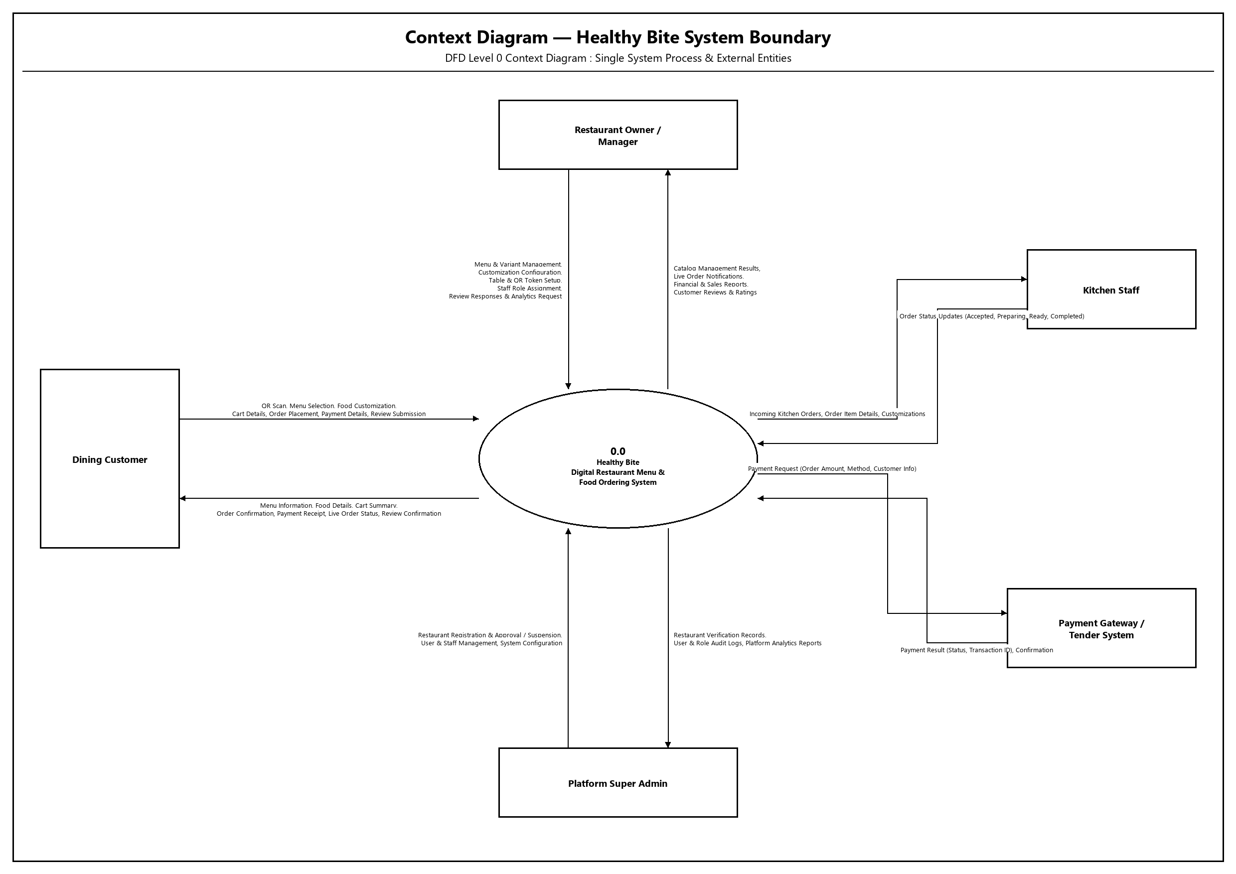
8.1 Data Flow Diagram (DFD)

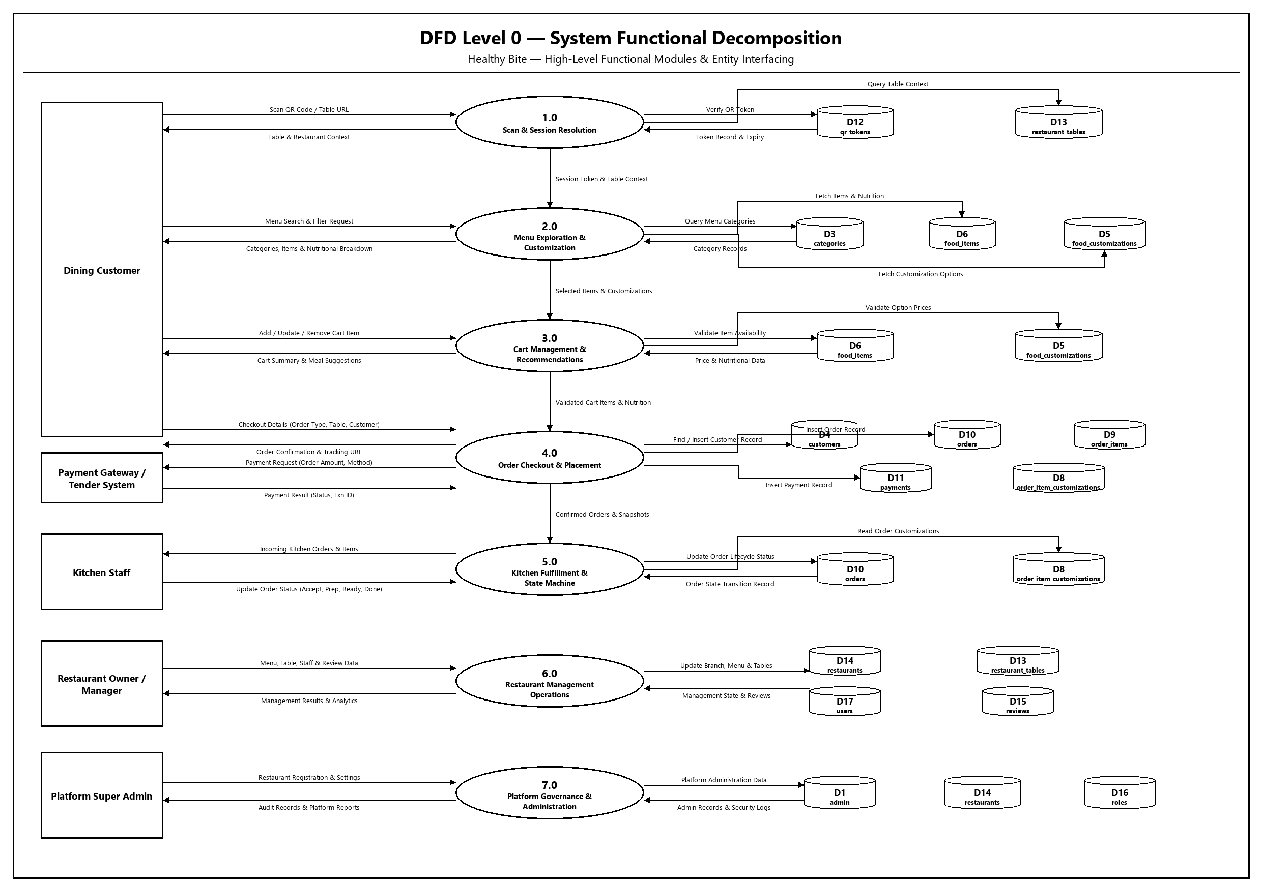

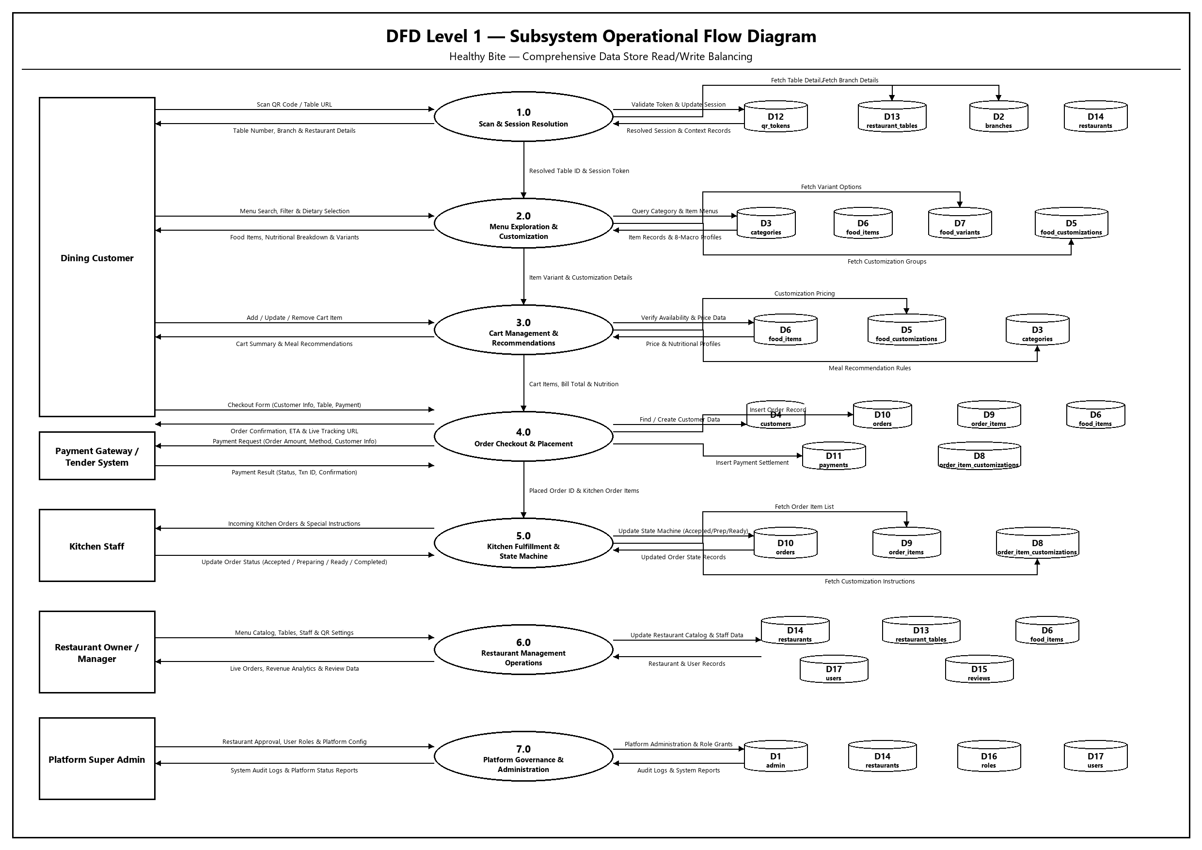

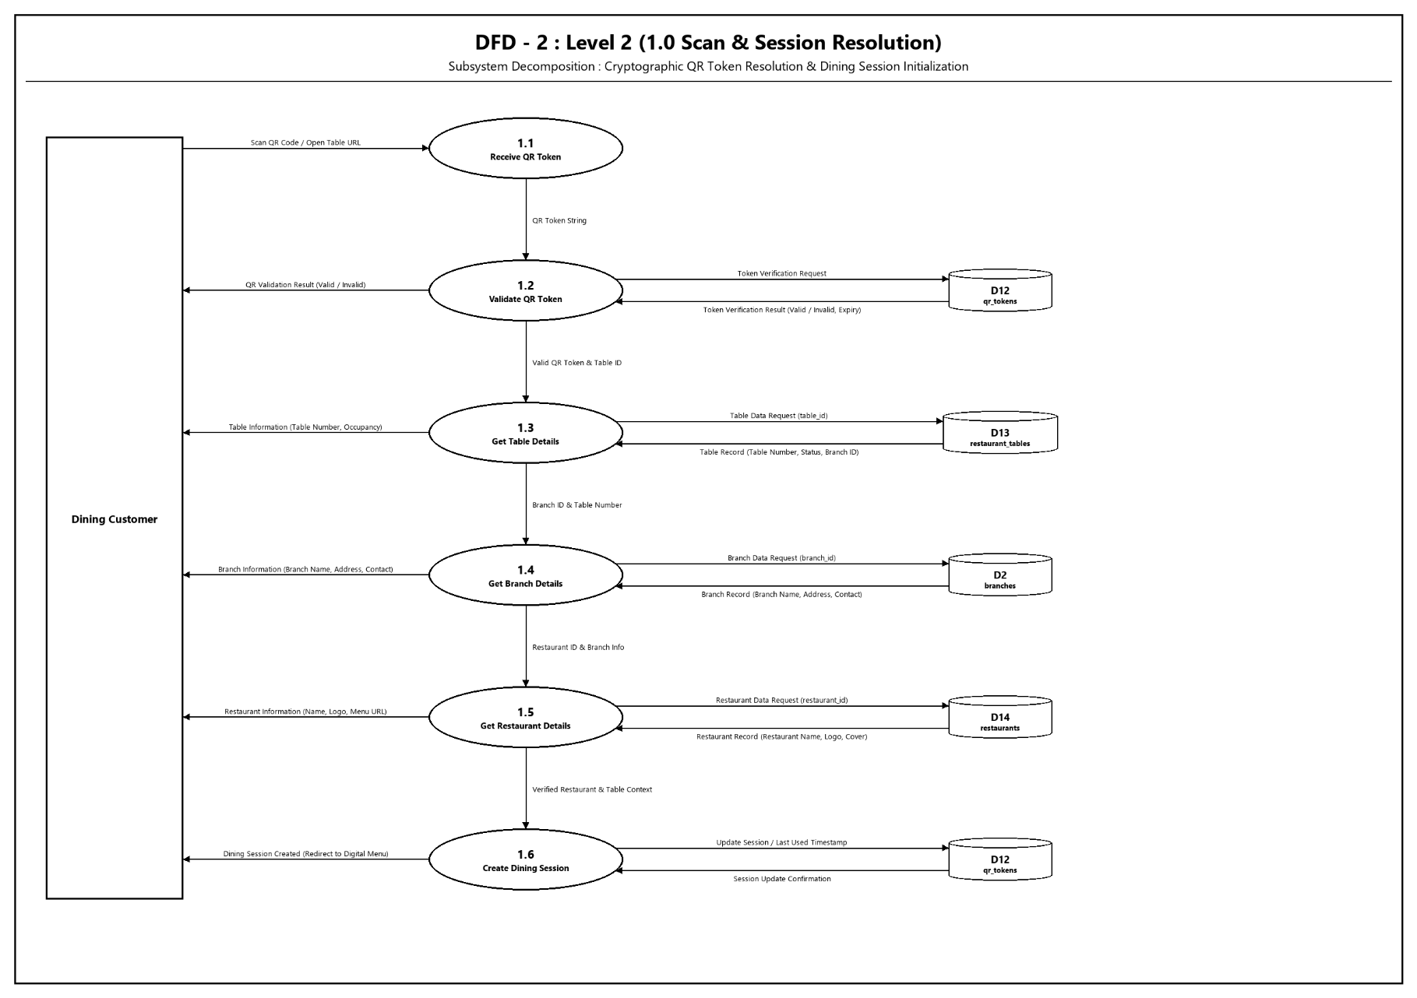
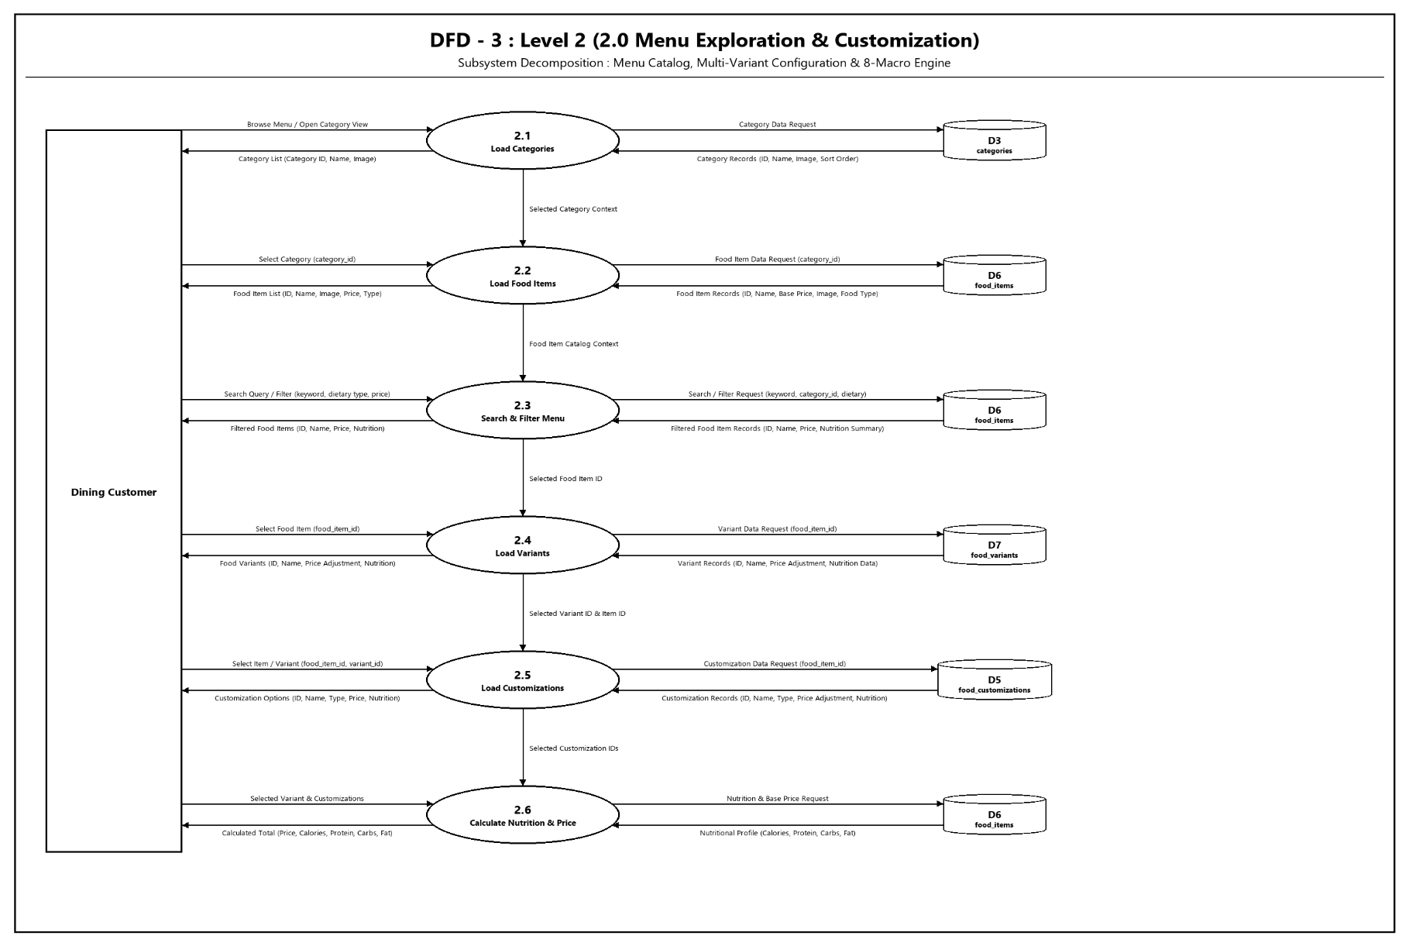
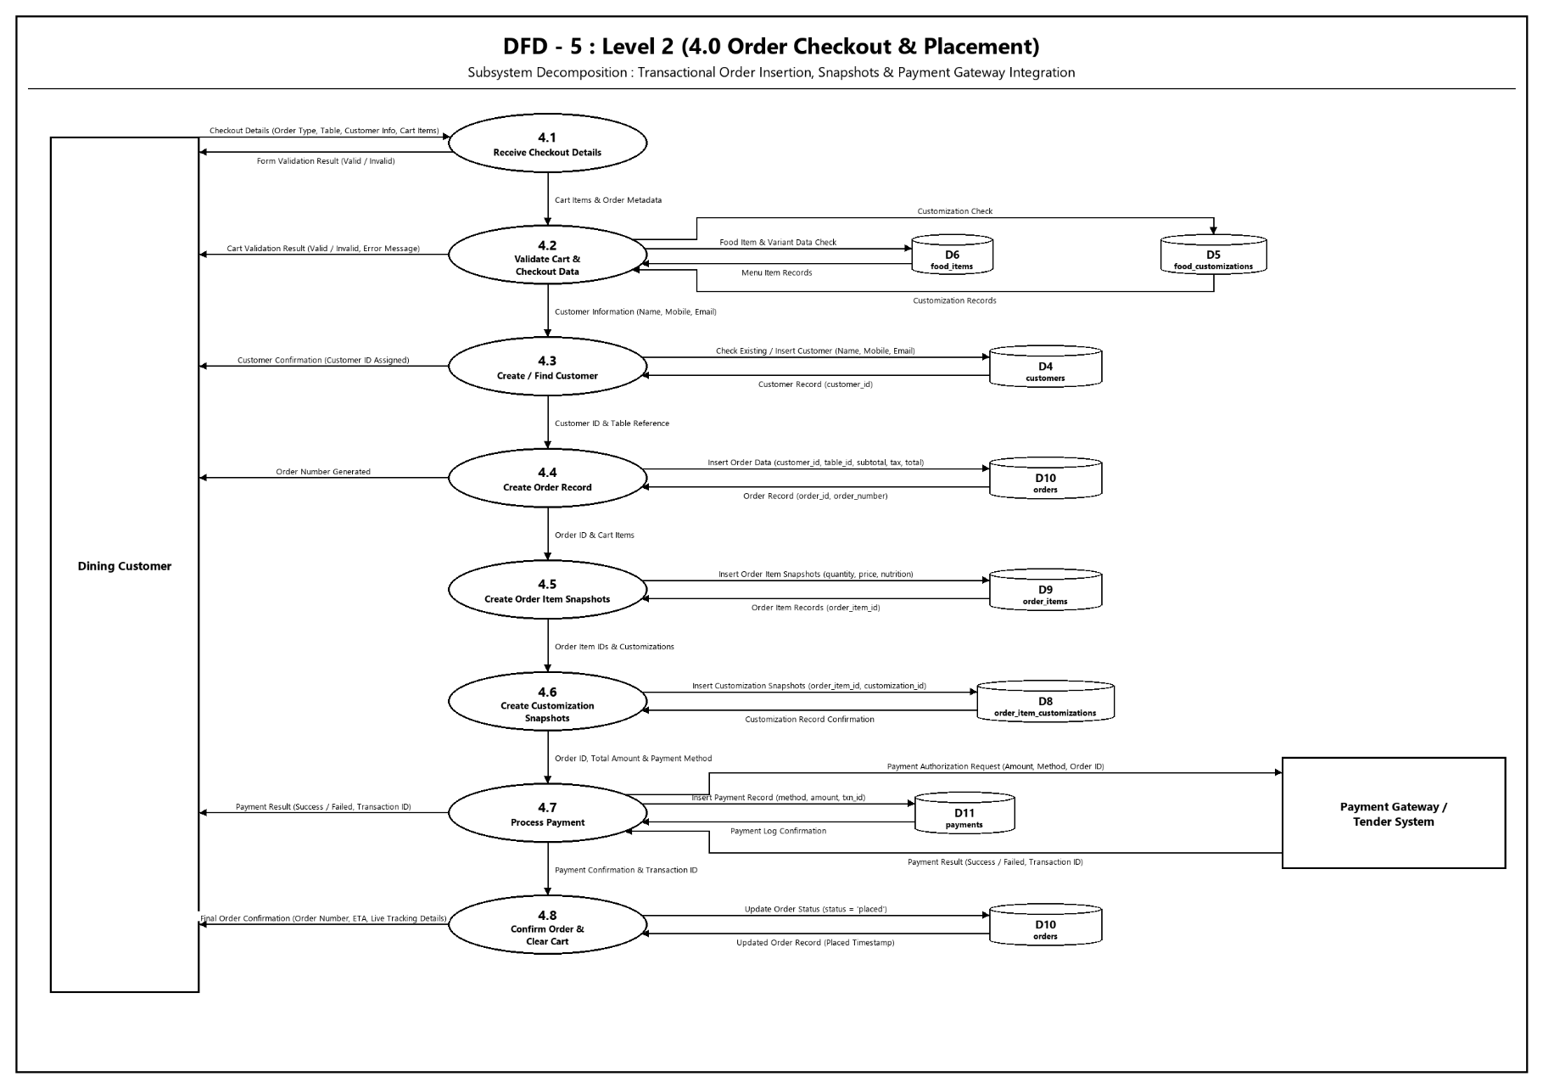
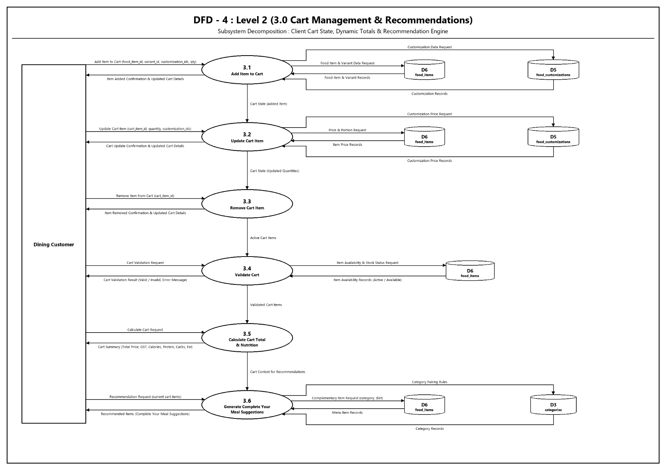
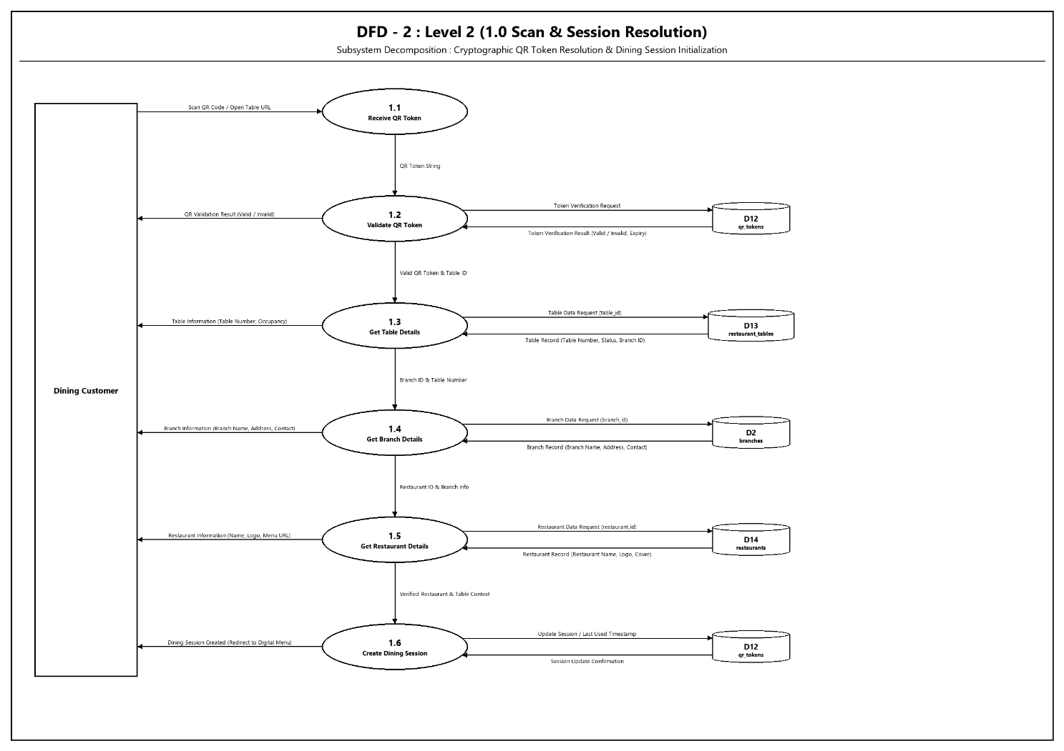

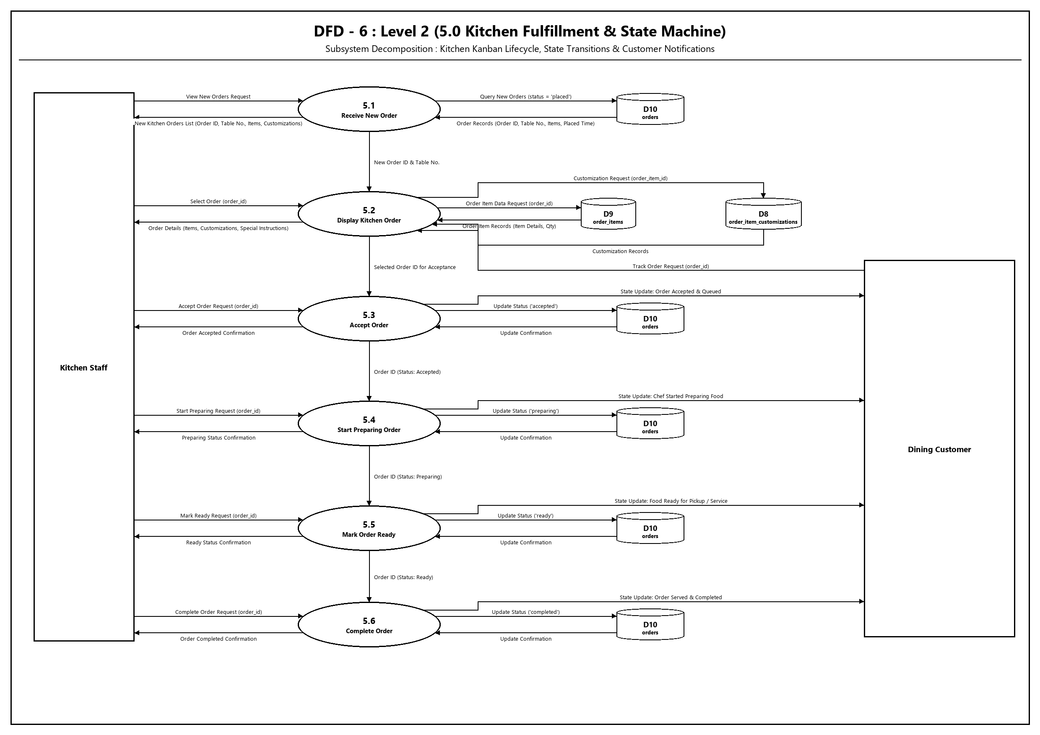

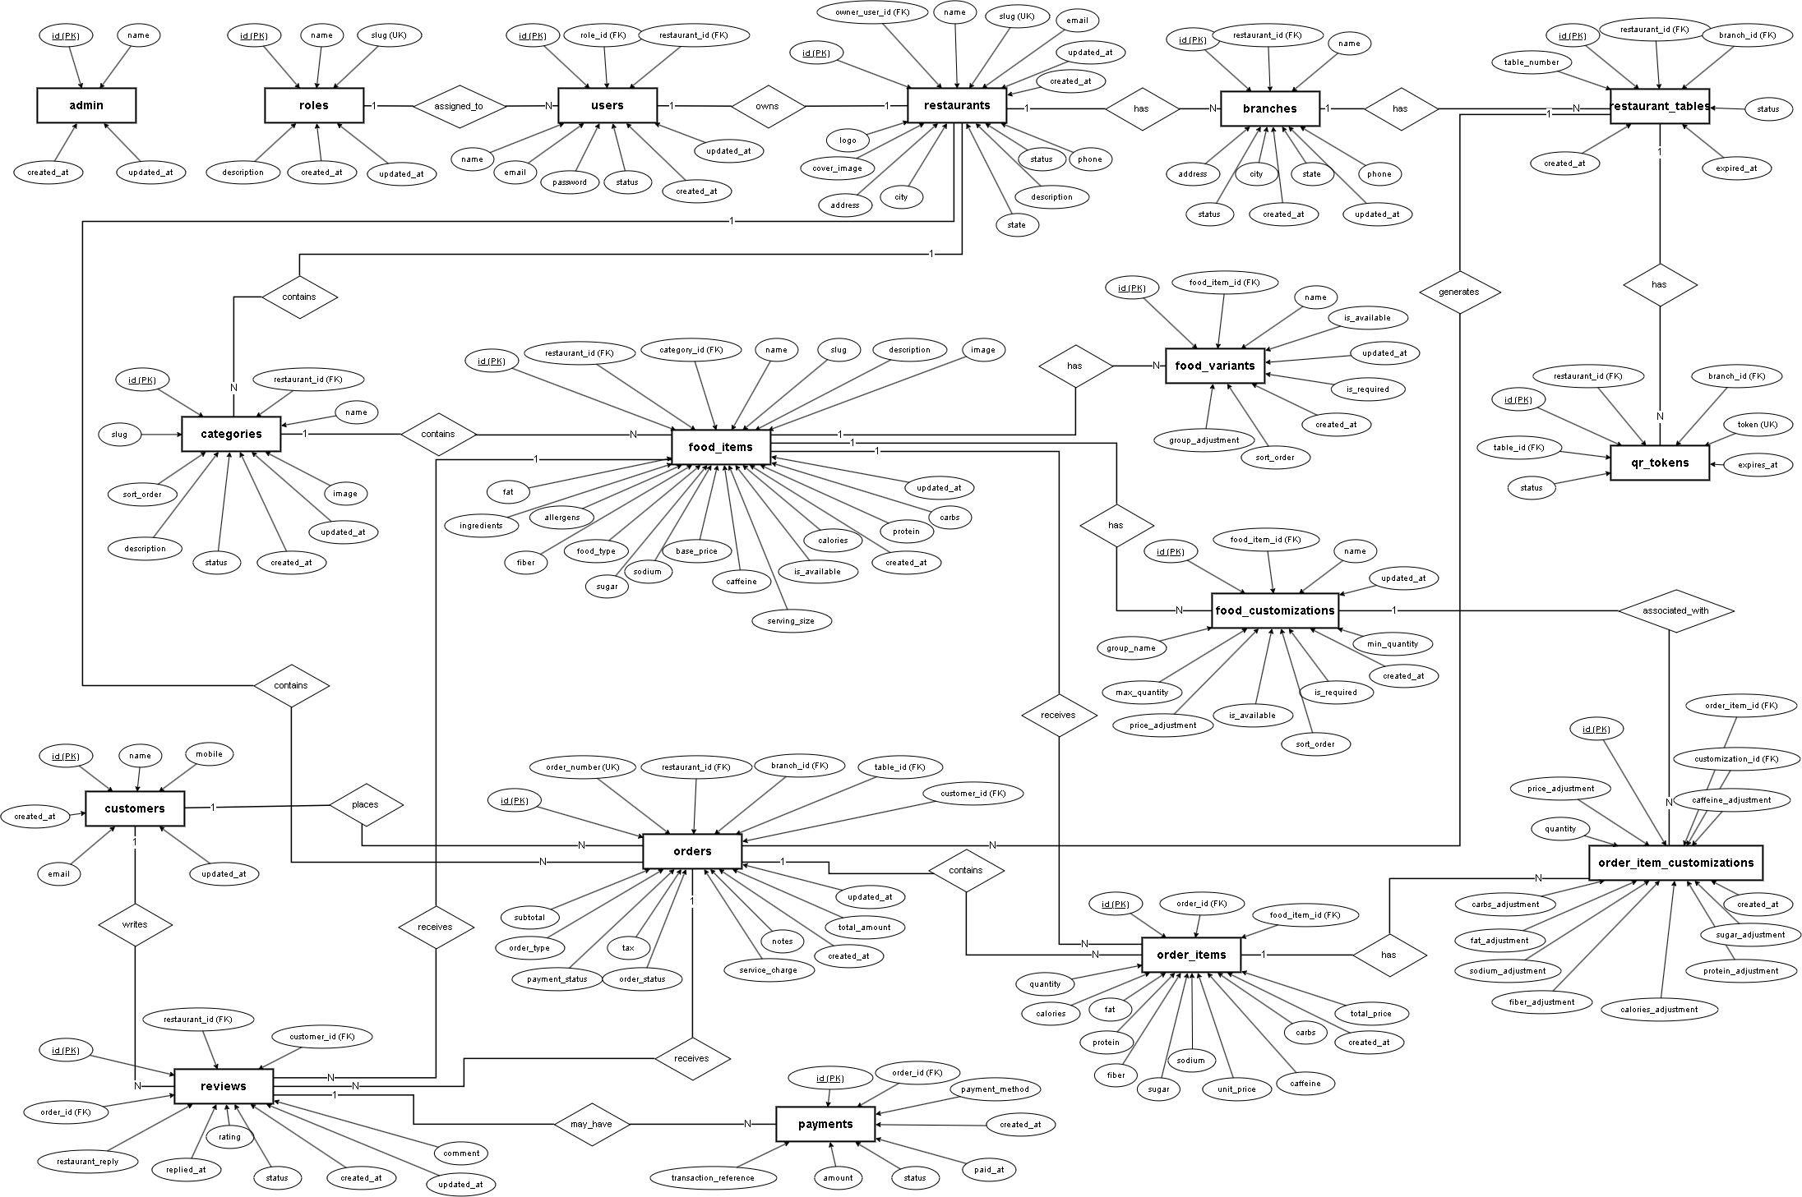
8.2 Entity Relationship Diagram (ERD)
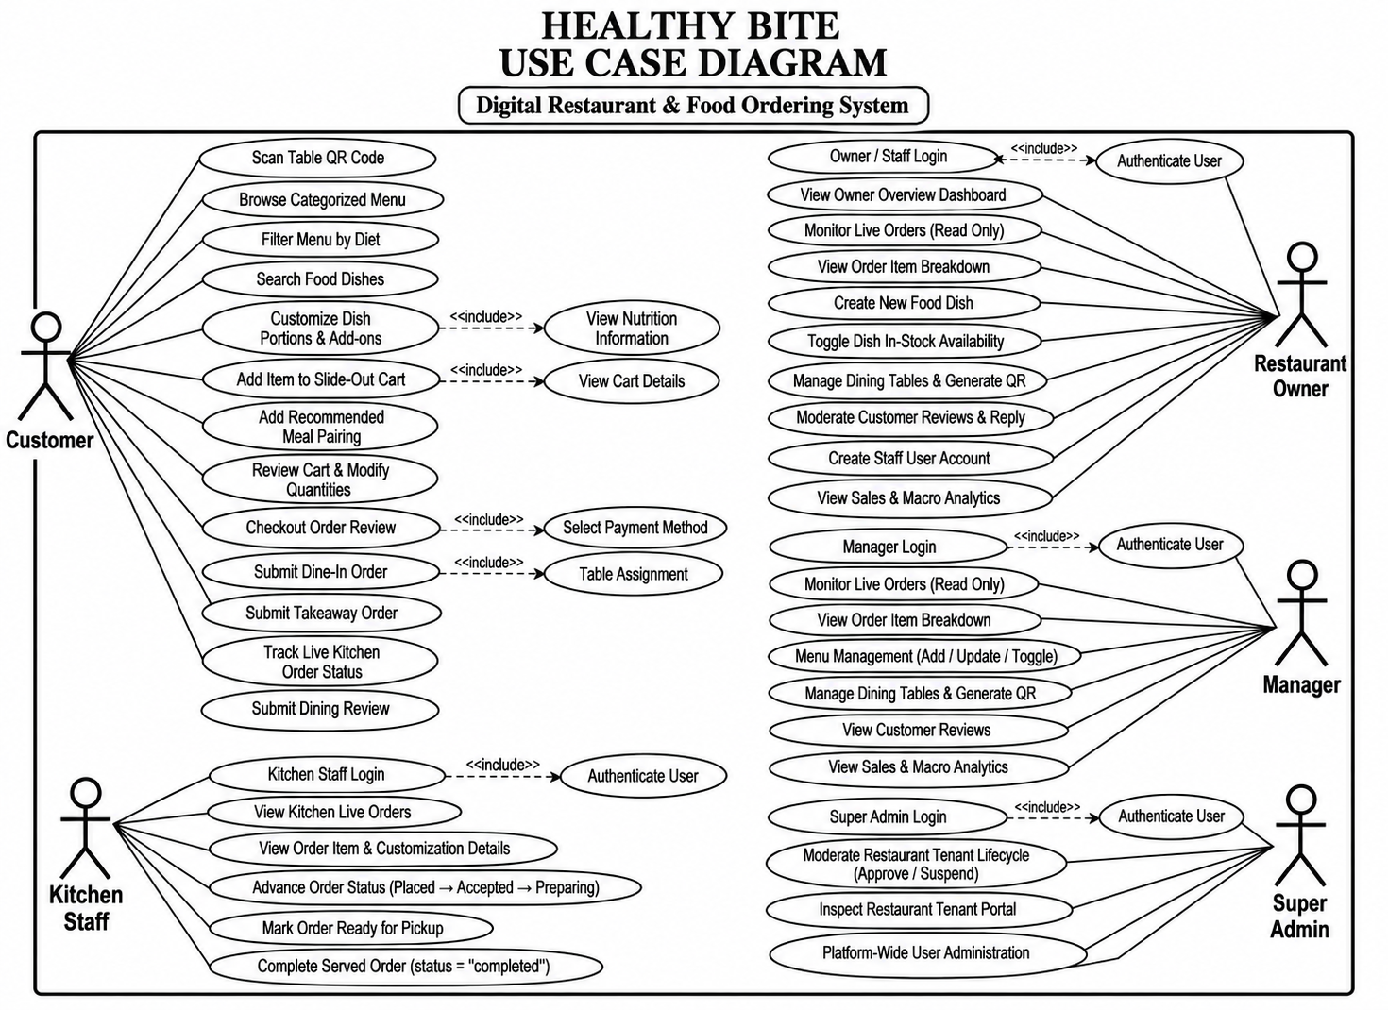
8.3 Use Case Diagram
8.4 Activity Diagram
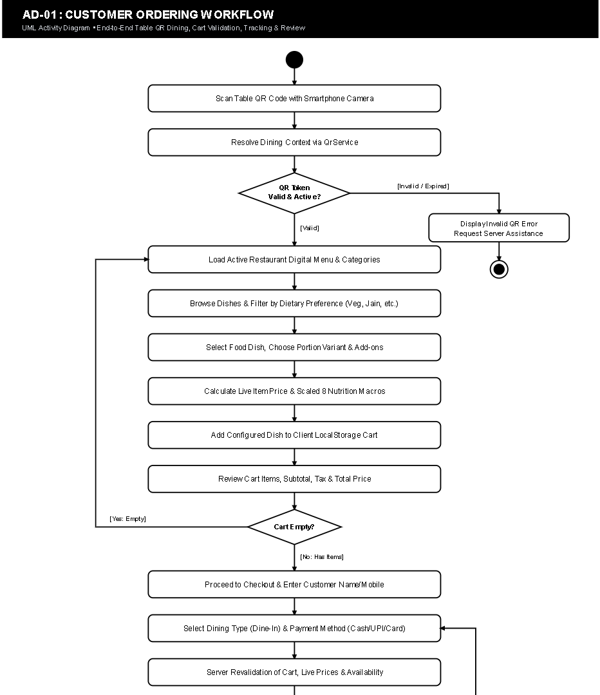

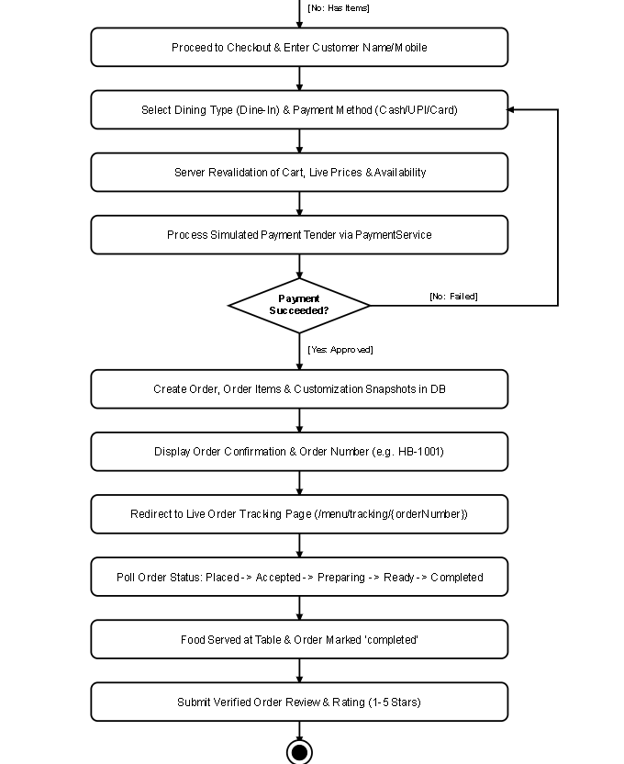

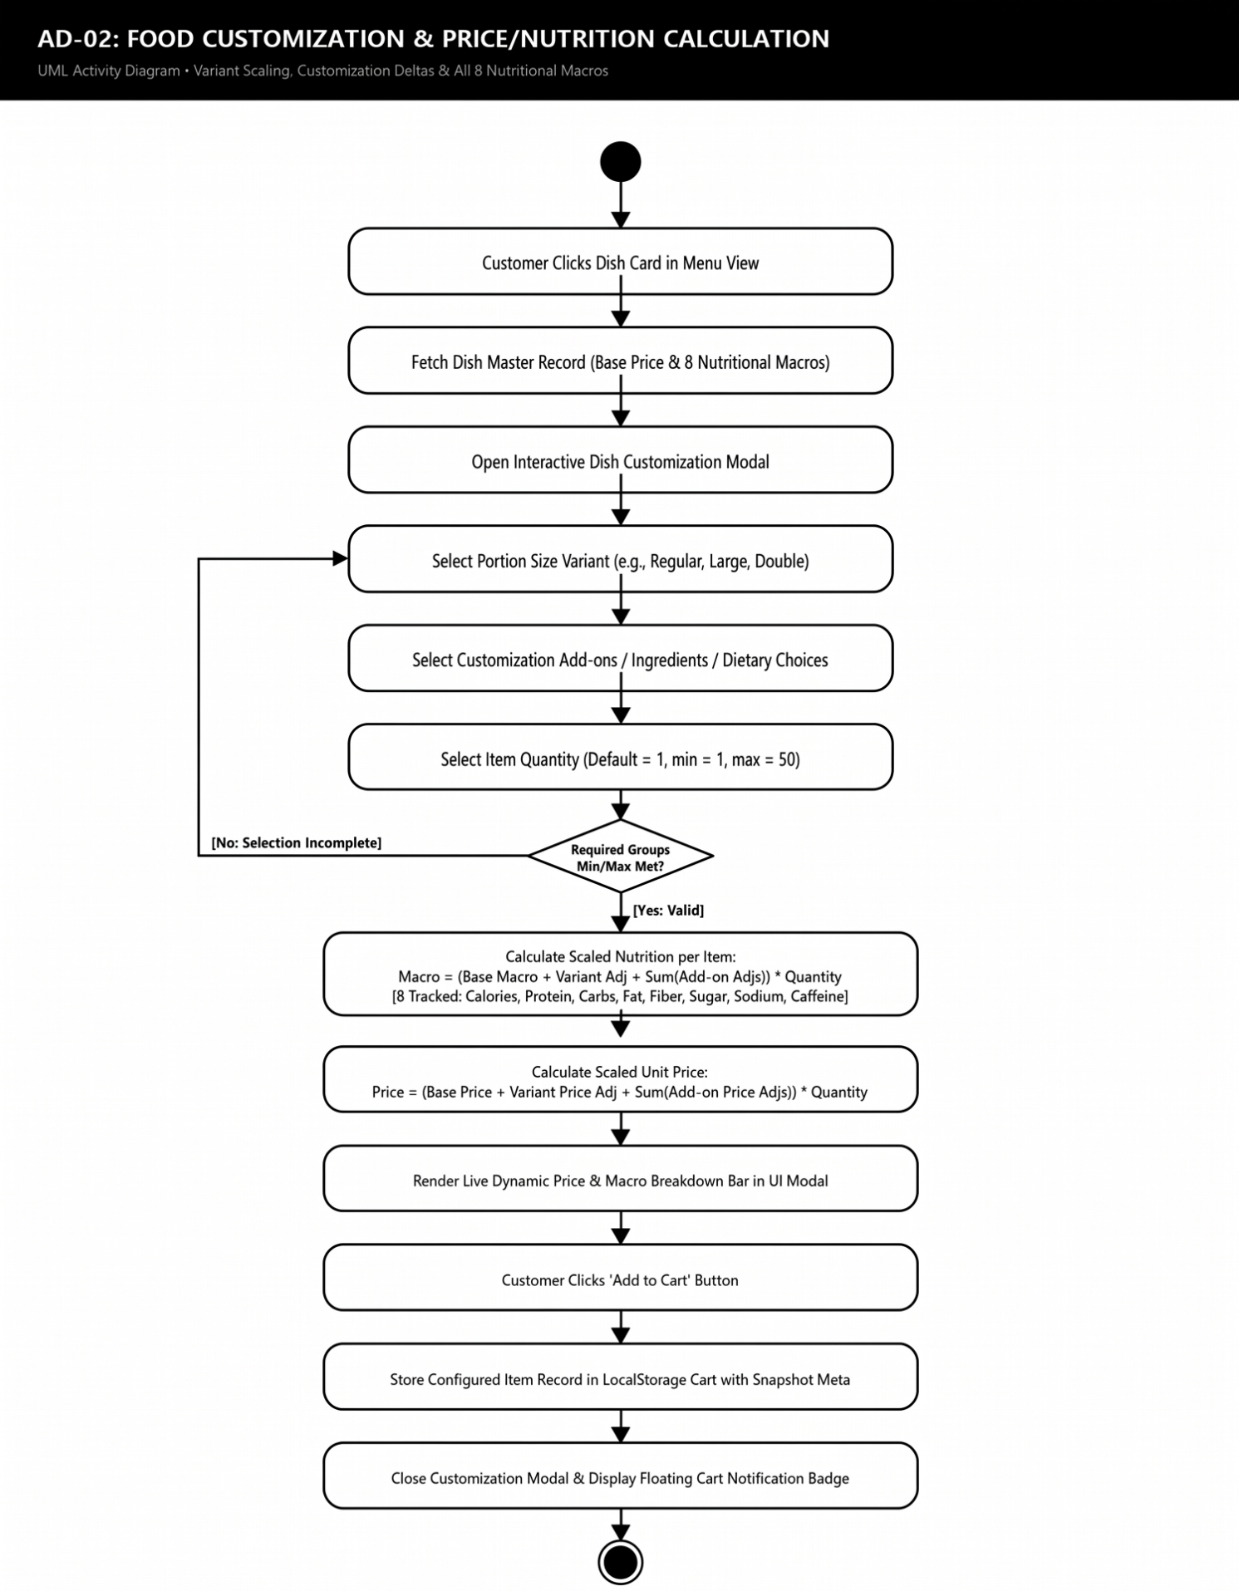

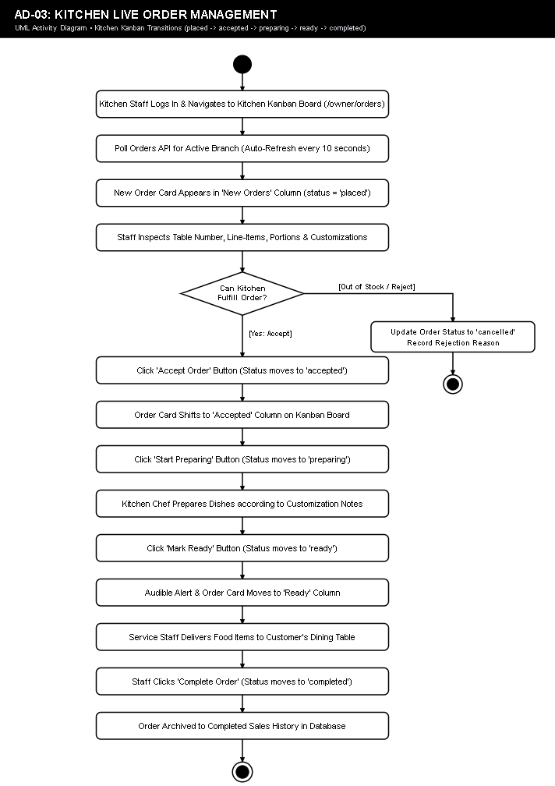

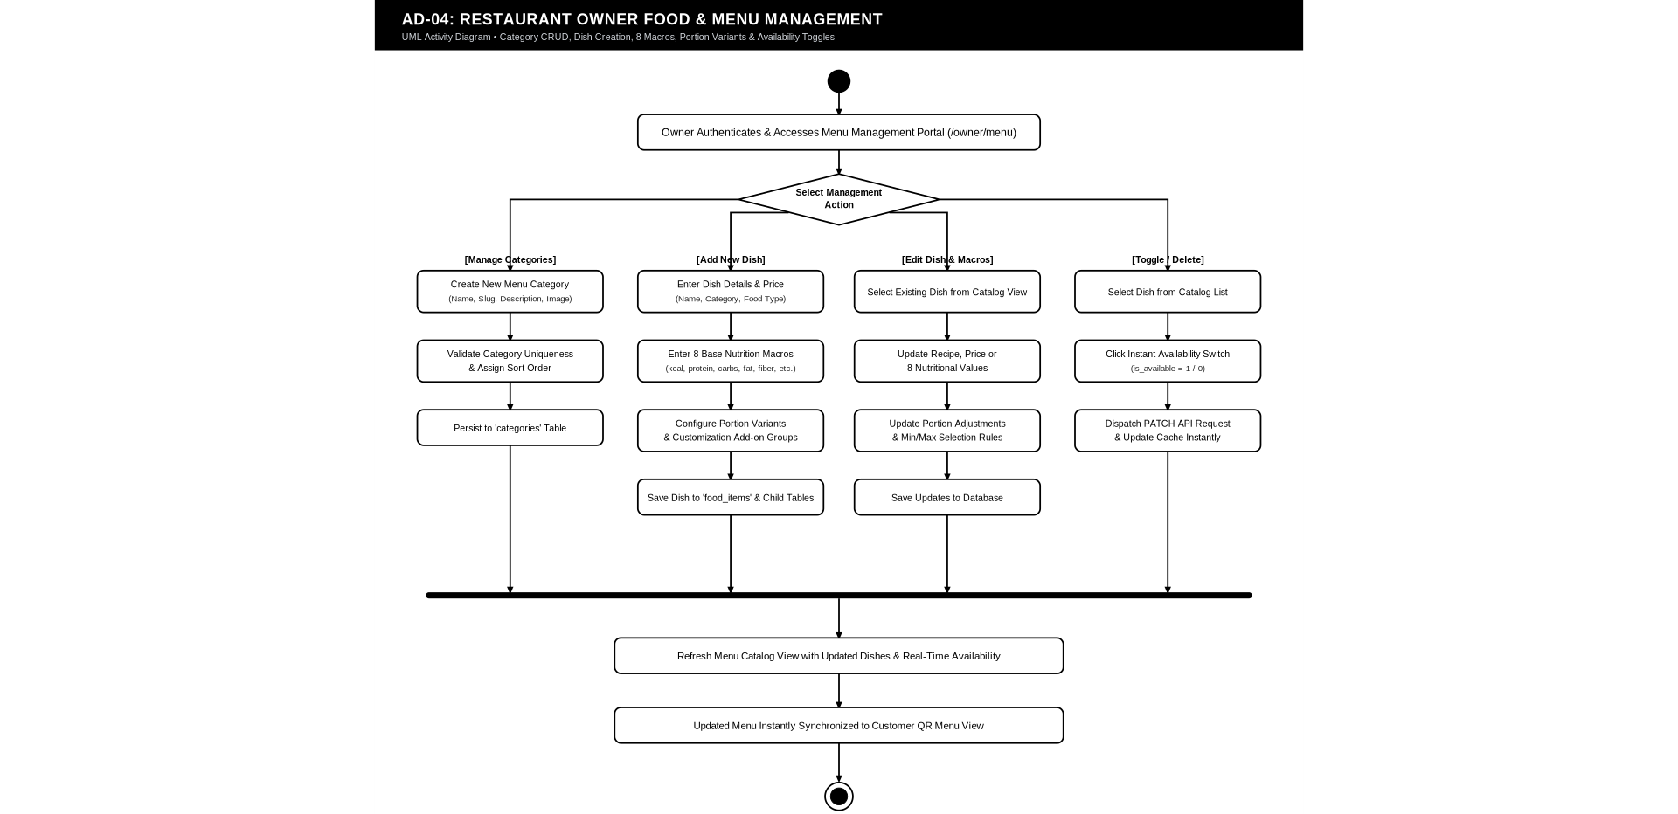

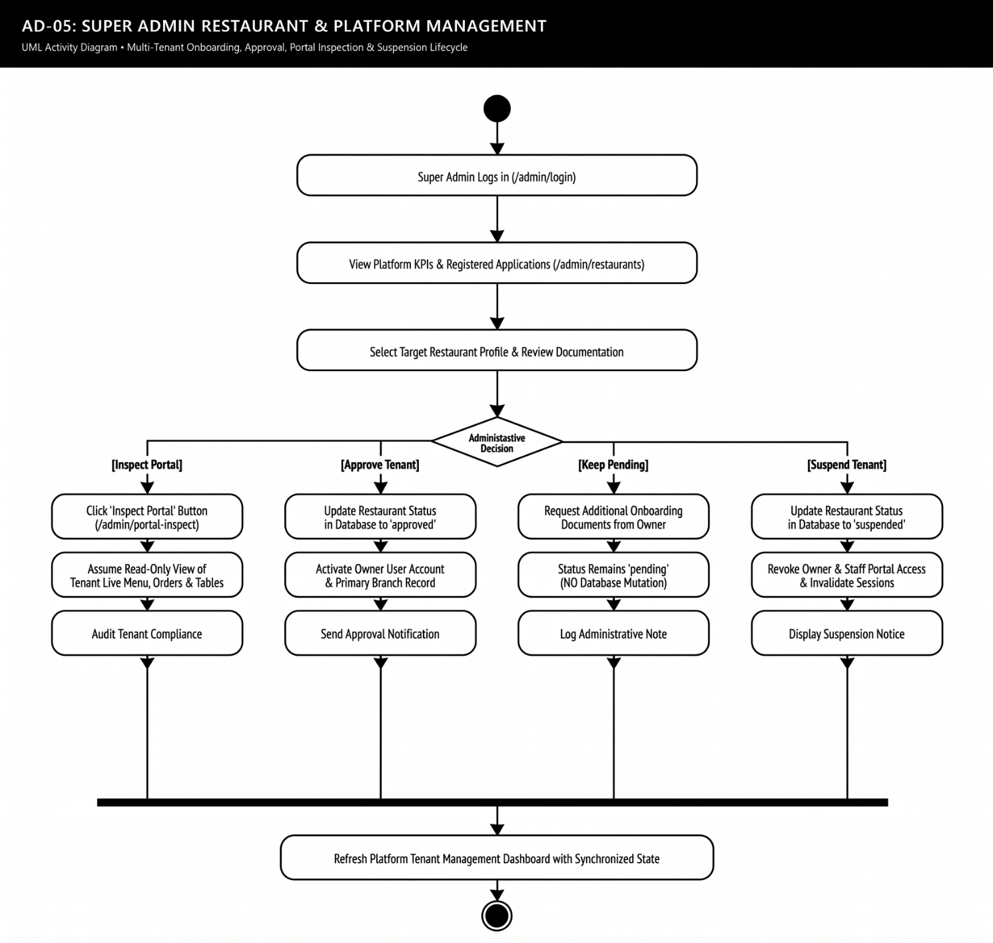

9. TESTING

9.1 TEST PLAN
The test plan was prepared to verify the major functions and technical controls of the Healthy Bite digital restaurant menu and food ordering system. It covers the customer QR ordering journey, food catalog and customization, price and nutrition calculation, cart and checkout validation, order and payment processing, kitchen status management, live order tracking, restaurant owner functions, Super Admin functions, database integrity, authentication and authorization, security controls, responsive and browser-facing behavior, dynamic flows, and release-level validation.
The completed master QA cycle executed 74 test cases against the running PHP application, live MySQL database, application services, routes, and browser-facing functionality. The final result was 74/74 tests passed, with four defects identified, corrected, and retested before release validation.

9.2 TESTING APPROACH
The testing approach was derived from the completed Healthy Bite implementation and the final master QA testing report. The test cases were organized using the same academic testing structure used in the Internship Tracker research paper reference: each test case records a Test Case ID, Input / Test Action, Expected Output, Actual Output, and Status. The testing is divided into functional, integration, database, security, end-to-end, dynamic-flow, and release-validation groups so that each major project module is represented clearly.
Testing was performed in the following order: environment and static checks, database verification, unit/business-logic checks, API validation, authentication and role-based access control, customer end-to-end workflow, owner and kitchen workflow, Super Admin workflow, defensive security testing, dynamic flow testing, catalog/media checks, and final release/regression checks.

9.3 TESTING SUMMARY
Testing Area | Functionality Covered | Status
Environment & Static Analysis | PHP environment, PDO driver, configuration, PHP lint, JavaScript compilation | Successfully Executed
Database Integrity | 17 tables, 208 columns, 26 foreign keys, payment mapping, orphan scan | Successfully Executed
Unit / Business Logic | Pricing, GST, 8-macro nutrition, caffeine, NULL preservation, QR and cart logic | Successfully Executed
API Testing | Health, restaurant, categories, foods, cart validation, invalid resource handling | Successfully Executed
Authentication & RBAC | Owner/admin protection, invalid credentials, role verification, removed route | Successfully Executed
Customer End-to-End | Order creation, snapshots, simulated payment, status, tracking | Successfully Executed
Owner & Kitchen | Kanban transitions, tables, QR/table status, review replies, analytics | Successfully Executed
Security & Integrity | SQLi, XSS, CSRF, IDOR/tenant isolation, immutable snapshots, concurrency | Successfully Executed
Dynamic Flow / Catalog | Repository dynamic functions, table redirect, media URLs, dietary types | Successfully Executed
Release Validation | HEAD routing, order modal, menu CRUD, legacy feature exclusion | Successfully Executed

9.4 TESTING NOTES
- The test-case tables follow the five-column format: Test Case ID, Input / Test Action, Expected Output, Actual Output, and Status.
- The Actual Output column records the observed and verified behavior from the completed Healthy Bite Master QA validation report; it is not a placeholder result.
- The testing scope includes functional, integration, unit/business-logic, database, security, concurrency, dynamic-flow, browser/API, and release-validation checks.
- Payment is intentionally tested as simulated payment for supported methods. Third-party banking gateway integration is outside the implemented project scope.
- Live customer tracking is tested through the implemented HTTP polling mechanism.
- The legacy admin table is treated as a database artifact and is not the active administrator authentication mechanism.
- All 74 executed test cases passed after four defects were corrected and regression-tested.

9.5 TEST CASES

9.5.1 Customer / Core / API Test Cases
Test Case ID | Input / Test Action | Expected Output | Actual Output | Status
T-01 | PHP 8.2+ Compatibility | PHP version is >= 8.2 (Running: PHP 8.5.10) | PHP 8.5.10 detected; compatibility requirement satisfied | Successfully Executed
T-02 | PDO MySQL Driver | pdo_mysql extension active and loaded | pdo_mysql loaded successfully | Successfully Executed
T-03 | Live Database Connection | PDO connection to healthy_bite responds SELECT 1 = 1 | Live database connection responded successfully | Successfully Executed
T-04 | .env Configuration | .env present, loaded and parseable via App\Core\Env | .env loaded and parsed successfully | Successfully Executed
T-05 | Core Constants | ROLE_*, ORDER_*, TABLE_*, FOOD_* constants defined | Required core constants verified | Successfully Executed
T-06 | PHP Syntax Validation | All 94 project PHP files pass php -l lint with zero errors | All 94 PHP files passed php -l | Successfully Executed
T-07 | JavaScript VM Compilation | All 14 public JS files pass Node.js VM syntax compilation | All 14 JavaScript files compiled successfully | Successfully Executed
T-08 | 17 Physical Tables | All 17 documented tables verified in information_schema | All 17 physical tables verified | Successfully Executed
T-09 | 208 Database Columns | Exact column count across all 17 tables matches 208 | 208 columns verified across 17 tables | Successfully Executed
T-10 | 26 Foreign Keys | All 26 foreign key constraints verified active | All 26 foreign keys active and verified | Successfully Executed
T-11 | Order-Payment 1:1 Mapping | payments.order_id UNIQUE key strictly enforced (Non_unique=0) | Unique order-to-payment mapping verified | Successfully Executed
T-12 | Orphan Record Scan | Zero orphan rows across all 26 FK relations | 0 orphan rows found | Successfully Executed
T-13 | Base + Variant + Custom Price | Base (100) + Var (20) + Custom (25) = Rs 145.00 | Rs 145.00 calculated exactly | Successfully Executed
T-14 | Line Total Scaling | Rs 145.00 x 3 = Rs 435.00 exact line total | Rs 435.00 line total calculated exactly | Successfully Executed
T-15 | Order Totals & 5% GST | Subtotal Rs 435 + Tax Rs 21.75 = Rs 456.75 | Rs 456.75 final total verified | Successfully Executed
T-16 | 8 Macros & Caffeine Sum | All 8 macros summed: Cal, Prot, Carb, Fat, Fib, Sug, Sod, Caff | All 8 nutrition values summed correctly | Successfully Executed
T-17 | Caffeine in mg | Caffeine calculated in mg and never coerced to grams | Caffeine remained in mg throughout calculation | Successfully Executed
T-18 | Quantity Nutrition Scaling | Nutrition doubles accurately when quantity = 2 | Nutrition doubled accurately for quantity 2 | Successfully Executed
T-19 | Strict NULL Preservation | Unmeasured fields retain NULL, not coerced to 0 | NULL nutrition fields remained NULL | Successfully Executed
T-20 | Valid QR Token Resolution | Active token resolves restaurant, branch, and table IDs | Active QR token resolved correct context | Successfully Executed
T-21 | Invalid QR Token Rejection | Random/expired token returns null context | Invalid or expired token returned null context | Successfully Executed
T-22 | Empty Cart Rejection | Empty cart payload throws InvalidArgumentException | Empty cart rejected correctly | Successfully Executed
T-23 | Cross-Restaurant Isolation | Food from Restaurant A rejected under Restaurant B context | Cross-restaurant food access blocked | Successfully Executed
T-24 | GET /api/health | Returns HTTP 200 with status=ok and database=connected | HTTP 200 and healthy DB status returned | Successfully Executed
T-25 | GET /api/restaurant | Returns HTTP 200 with active restaurant profile | Active restaurant profile returned | Successfully Executed
T-26 | GET /api/categories | Returns HTTP 200 with list of active menu categories | Active category list returned | Successfully Executed
T-27 | GET /api/foods | Returns HTTP 200 with complete menu items catalog | Complete menu catalog returned | Successfully Executed
T-28 | GET /api/foods/1 | Returns HTTP 200 with Paneer Bowl details & variants | Paneer Bowl details and variants returned | Successfully Executed
T-29 | GET /api/foods/99999 | Returns HTTP 404 for non-existent food item ID | HTTP 404 returned correctly | Successfully Executed
T-30 | POST /api/cart/validate | Returns HTTP 200 for valid items & required groups | Valid cart returned HTTP 200 with verified totals | Successfully Executed
T-31 | Cart Server Recalculation | Server ignores client fake prices; computes from DB | Fake prices ignored; authoritative DB values used | Successfully Executed
T-32 | Owner Dashboard Protection | Unauthenticated /owner/dashboard redirects to /owner/login | Unauthenticated access redirected to owner login | Successfully Executed
T-33 | Admin Dashboard Protection | Unauthenticated /admin/dashboard redirects to /admin/login | Unauthenticated access redirected to admin login | Successfully Executed
T-34 | Invalid Credentials Check | Bad email/password fails authentication gracefully | Invalid credentials rejected cleanly | Successfully Executed
T-35 | Removed Admin Orders Route | /admin/orders returns HTTP 404 (strictly eliminated) | HTTP 404 confirmed; route absent | Successfully Executed
T-36 | Order Creation Pipeline | Order placed with valid customer, table, and branch | Order created successfully with valid context | Successfully Executed
T-37 | Order Item Snapshot Freeze | food_name, base_price, unit_price saved in snapshot | Historical item snapshot persisted correctly | Successfully Executed
T-38 | Customization Snapshot Freeze | customization_name and price_adjustment saved in snapshot | Customization snapshot persisted correctly | Successfully Executed
T-39 | Payment Simulation (UPI) | Simulates payment, generates TXN ref, marks completed | UPI simulation completed with transaction reference | Successfully Executed
T-40 | Status Advance on Payment | Order status advances from placed to accepted upon payment | Order advanced to accepted after payment | Successfully Executed
T-41 | Order Tracking Polling | Live tracking finds order by order_number with status | Live tracking returned current order status | Successfully Executed

9.5.2 Owner / Kitchen / Admin Test Cases
Test Case ID | Input / Test Action | Expected Output | Actual Output | Status
T-42 | Kitchen Kanban State Machine | placed->accepted->preparing->ready->completed | All required status transitions succeeded | Successfully Executed
T-43 | Dining Tables 1-12 Active | All 12 dining tables present and queryable for Branch 1 | Tables 1-12 verified and queryable | Successfully Executed
T-44 | Table Status Toggle | Table toggles available <-> occupied seamlessly | Table status toggled successfully | Successfully Executed
T-45 | Review Reply Persistence | Owner reply persisted to reviews table with replied_at | Reply persisted with replied_at timestamp | Successfully Executed
T-46 | Super Admin Role Verification | Super Admin account verified with role_id = 1 | Super Admin role verified | Successfully Executed
T-47 | Restaurant Owner Role Verification | Owner account verified with role_id = 2 | Restaurant Owner role verified | Successfully Executed
T-48 | Kitchen Staff Role Verification | Kitchen Staff account verified with role_id = 4 | Kitchen Staff role verified | Successfully Executed
T-49 | Approved Restaurants Query | Platform lists approved active tenant restaurants | Approved tenant restaurants listed correctly | Successfully Executed

9.5.3 Security / Integrity / Concurrency Test Cases
Test Case ID | Input / Test Action | Expected Output | Actual Output | Status
T-50 | SQL Injection: Search Filter | Malicious SQL in search handled via PDO prepared statements | Malicious SQL handled safely | Successfully Executed
T-51 | SQL Injection: Query Params | IDs and filters parameterized; zero SQL injection vectors | IDs and filters safely parameterized | Successfully Executed
T-52 | XSS Output Escaping | HTML/JS tags escaped via htmlspecialchars in views | Output escaping verified | Successfully Executed
T-53 | CSRF Protection | State-changing POST actions protected by CSRF tokens | CSRF validation blocked unauthorized state changes | Successfully Executed
T-54 | IDOR Tenant Protection | Cross-restaurant cart and order modification blocked | Cross-tenant modification blocked | Successfully Executed
T-55 | Catalog Price Independence | Updating food base_price does not alter historical order snapshot | Historical order snapshot remained unchanged | Successfully Executed
T-56 | Duplicate Payment Guard | Repeated payment request on paid order blocked gracefully | Repeated payment rejected cleanly | Successfully Executed

9.5.4 Dynamic Flow / Catalog / Release Test Cases
Test Case ID | Input / Test Action | Expected Output | Actual Output | Status
T-57 | Find Table with Active Token | BranchRepository::findTableByNumber locates table + token | Table and token located correctly | Successfully Executed
T-58 | Find First Available Table | BranchRepository::getFirstAvailableTable returns active table | Active table returned correctly | Successfully Executed
T-59 | Table Number Redirect | HTTP GET /table/12 redirects (302) to /menu?token=... | HTTP 302 redirect verified | Successfully Executed
T-60 | Invalid Token Error Banner | HTTP GET /menu with invalid token displays error notice | Error notice displayed correctly | Successfully Executed
T-61 | Category Auto-Slug Generation | CategoryRepository::createCategory generates slug automatically | Slug generated automatically | Successfully Executed
T-62 | Category Deletion Guard | Category deletion blocked if active food items are attached | Deletion guard blocked invalid removal | Successfully Executed
T-63 | Staff Record Update | StaffRepository::updateStaff dynamically updates member details | Staff details updated successfully | Successfully Executed
T-64 | Macro Sugar Aggregations | OrderRepository::getMacroStats computes total & avg sugar | Sugar totals and averages computed correctly | Successfully Executed
T-65 | Checkout Table Dropdown | Checkout view renders verified active branch tables | Active branch tables rendered correctly | Successfully Executed
T-66 | Owner Analytics Data Load | Analytics controller loads real AOV, revenue, orders | Real analytics data loaded successfully | Successfully Executed
T-67 | Sugar Snapshot Integrity | OrderService creates order with accurate sugar snapshot | Sugar snapshot verified accurate | Successfully Executed
T-68 | 45 Unique Food Dish URLs | All 45 Unsplash dish image URLs return HTTP 200 OK | All 45 URLs returned HTTP 200 | Successfully Executed
T-69 | Distinct Photo Identifiers | All 45 food items use 100% distinct photo IDs | All 45 food items use distinct photo IDs | Successfully Executed
T-70 | Food Dietary Types Valid | food_type enum values strictly vegetarian, vegan, etc. | Valid food_type enum values confirmed | Successfully Executed
T-71 | HTTP HEAD Method Route Matching | Router maps HEAD to GET; curl -I returns HTTP 200 OK | HEAD request returned HTTP 200 | Successfully Executed
T-72 | Order Details Modal Retrieval | Order modal API retrieves items and customizations | Order details and customizations retrieved | Successfully Executed
T-73 | Menu Item Create/Edit/Delete | Full food item CRUD lifecycle tested and restored | Full CRUD lifecycle passed | Successfully Executed
T-74 | Legacy Features Clean Exclusion | No Call Servant or Platform Orders code exists | Removed legacy features remained absent | Successfully Executed

9.5.5 DEFENSIVE SECURITY TESTING RESULTS
Attack Vector / Scope | Security Test Applied | Protection Mechanism | Result
SQL Injection (SQLi) | Injected malicious SQL into search, query parameters and IDs. | PDO prepared statements with parameterized placeholders across repositories. | PASS
Cross-Site Scripting (XSS) | Injected script-like payloads into names, notes and customer review comments. | htmlspecialchars output escaping with ENT_QUOTES and UTF-8 in views. | PASS
Cross-Site Request Forgery | Dispatched state-changing POST requests without valid CSRF session tokens. | Csrf::validate() token verification rejects unauthorized state changes. | PASS
IDOR & Multi-Tenant Isolation | Attempted to order Food from Restaurant 1 under Restaurant 2 context via API payload. | CartService and SQL queries enforce strict restaurant_id multi-tenant scoping. | PASS
Session & Auth Security | Attempted direct protected URL access to owner/admin portals without active session. | RestaurantMiddleware and AdminMiddleware redirect unauthenticated sessions to login. | PASS

9.5.7 VERIFIED DATABASE SCHEMA ARCHITECTURE
Table Name | Rows | Cols | FKs | Primary Key | Role / Constraints
admin | 4 | 4 | 0 | id | Legacy static administration table
branches | 6 | 10 | 1 | id | Restaurant dining locations
categories | 16 | 10 | 1 | id | Menu category hierarchy
customers | 37 | 6 | 0 | id | Registered and guest patrons
food_customizations | 564 | 21 | 1 | id | Dish modifiers and adjustments
food_items | 47 | 25 | 2 | id | Main culinary catalog and macros
food_variants | 94 | 18 | 1 | id | Portion sizes and variant adjustments
order_item_customizations | 66 | 15 | 2 | id | Frozen customization snapshot
order_items | 43 | 19 | 2 | id | Frozen item price/macro snapshot
orders | 34 | 16 | 4 | id | Core order transactions and statuses
payments | 21 | 8 | 1 | id | Tender settlement (UNIQUE: order_id)
qr_tokens | 12 | 8 | 3 | id | Table dining session tokens
restaurant_tables | 12 | 7 | 2 | id | Physical dining tables (1-12)
restaurants | 3 | 15 | 1 | id | Tenant restaurant accounts
reviews | 7 | 11 | 3 | id | Customer ratings and owner replies
roles | 4 | 6 | 0 | id | RBAC roles (admin, owner, manager, staff)
users | 8 | 9 | 2 | id | Authenticated employee and admin logins

9.6 FINAL TESTING STATEMENT
The Healthy Bite system was tested across its major customer, owner, kitchen, administrator, database, API, security, and release-validation functions. A total of 74 test cases were executed. All 74 test cases passed successfully after four identified defects were corrected and regression-tested. The final testing cycle found no unresolved critical defects, and the application was verified for final academic submission and release within the implemented project scope.

Test Execution | 74 / 74 Passed (100%)
Defects | 4 Identified, Fixed and Retested
Regression | All related suites passed after fixes
Final Status | VERIFIED & APPROVED

10. RESULTS

Results Summary Table
Result Area | Functional Scope Evaluated | Observed Empirical Outcome | Validation Status
Customer Onboarding | Table QR resolution, fallback routing | Session created instantly; invalid tokens gracefully route to default menu | 100% Passed
Menu & Dietary | Categories, dietary filters, search | Dynamic filtering by Veg/Vegan/Non-Veg/Jain; sub-100ms keyword search | 100% Passed
Nutritional Transparency | 8-macro display, allergen disclosure | Accurate calories, protein, carbs, fat, fiber, sugar, sodium, caffeine display | 100% Passed
Cart & Customization | Variant selection, ingredient delta, edit | Portion scaling and in-cart customization editing recalculate price/macros | 100% Passed
Order & Payment | Unique order generation, 5% GST, COD/simulated | Alphanumeric IDs created; mathematical tax computation verified | 100% Passed
Live Kitchen Tracking | 5-stage pipeline, background polling | State changes propagate to diner view within 4s without full-page reloads | 100% Passed
Kitchen Operations | Kanban board, rapid order status transitions | Single-click state advance (Placed -> Accepted -> Preparing -> Ready) | 100% Passed
Owner Administration | Menu CRUD, slug generation, analytics | Automated slugging, media format validation, real-time KPI data loading | 100% Passed
Database Integrity | 17 tables, 208 columns, 26 foreign keys | Zero orphan records detected; historical order snapshots preserved | 100% Passed
Defensive Security | SQLi, XSS, CSRF, IDOR, RBAC | Parameterized queries, output encoding, CSRF tokens, strict tenant isolation | 100% Passed
11. CONCLUSION
11.1 Research and Implementation Synthesis
Modern online food ordering systems have achieved widespread commercial adoption by maximizing ordering convenience and delivery velocity. However, as established in the problem statement, this convenience has historically come at the expense of nutritional transparency. Mainstream platforms prioritize promotional discounts and rapid dispatch while treating food as a black-box commodity, offering negligible disclosure of calories, macronutrients, allergens, or ingredient origins. This information asymmetry directly undermines consumer health awareness and presents severe challenges for health-conscious diners, fitness enthusiasts, and individuals managing dietary conditions such as diabetes, obesity, and hypertension.
Healthy Bite: Digital Menu and Food Ordering System was conceived, designed, and developed to bridge this critical gap between digital food ordering convenience and proactive health management. The research and engineering effort demonstrates that full nutritional transparency can be seamlessly woven into every stage of the restaurant customer journey—from contactless QR table onboarding and ingredient customization to live kitchen tracking—without introducing operational friction for restaurant personnel or computational overhead for consumers.
11.2 Direct Alignment with Project Objectives
The completed implementation directly satisfies every core objective formulated in Section 3 of this research paper:
- Fulfillment of Objective 1 (Nutritional Transparency): The platform provides an engaging, responsive digital dining menu featuring 8 verified nutritional metrics per dish, allergen alerts, ingredient listings, and dynamic dietary badges (Vegetarian, Vegan, Non-Vegetarian, Jain-friendly).
- Fulfillment of Objective 2 (Interactive Meal Customization): Diners can dynamically modify portion sizes, carb bases, dressings, and protein add-ons, with the client and server recalculating both price and macronutrient totals in real time.
- Fulfillment of Objective 3 (Contactless Table Ordering): Physical dining tables are provisioned with dynamic QR tokens, enabling zero-contact onboarding, digital ordering, and instant kitchen ticket generation without waiter intervention.
- Fulfillment of Objective 4 (Live Kitchen Operations): The operational Kanban board provides kitchen staff with an intuitive tool to transition orders across 5 verified stages (Placed, Accepted, Preparing, Ready, Completed), propagating status updates to diner views within 4 seconds.
- Fulfillment of Objective 5 (Owner Management & Analytics): Restaurant owners possess full administrative control over menus, categories, ingredients, variants, tables, and customer reviews, supported by real-time analytics on sales and nutritional distribution.
- Fulfillment of Objective 6 (Data Integrity & Security): The system enforces robust defense-in-depth security, including PDO prepared statements, output encoding, CSRF tokens, strict multi-tenant isolation, and complete historical snapshot preservation across 17 normalized relational tables.
11.3 Key Architectural and Technological Contributions
The technical execution of Healthy Bite yielded several noteworthy software engineering contributions:
- High-Performance Lightweight Architecture: By avoiding heavyweight client frameworks and instead implementing clean Vanilla CSS and modular ES6+ JavaScript, the application achieves rapid sub-second page loads, minimal DOM overhead, and broad cross-device compatibility.
- Immutable Snapshot Preservation: The database architecture solves the common industry flaw of retroactive order alteration by taking immutable snapshots of dish names, variant names, customization choices, prices, and macronutrient baselines upon order placement.
- Secure Multi-Tenant Partitioning: The platform enforces strict tenant-level relational isolation, ensuring that multiple restaurant branches can co-exist within the same database infrastructure without risk of data cross-contamination or unauthorized access.
- Operational Transparency: The live kitchen pipeline bridges the operational gap between back-of-house kitchen preparation and front-of-house diner expectations, reducing perceived waiting times and customer anxiety.
11.4 Future Scope and Research Directions
While the current implementation achieves full functional maturity within its academic scope, several promising extensions have been identified for future research and commercial development. These enhancements are formally designated as Future Work:
1. AI-Driven Personalized Dietary Recommendations: Integrating machine learning models (e.g., collaborative filtering and content-based recommendation algorithms) to analyze past customer dietary choices and recommend personalized meals aligned with specific caloric, keto, diabetic, or athletic goals.
2. Automated BMI & Calorie Budgeting Calculator: Implementing an interactive health profile module allowing users to input height, weight, activity levels, and wellness goals to compute dynamic Basal Metabolic Rates (BMR) and recommended daily caloric thresholds.
3. Wearable Device & Fitness Platform Integration: Integrating health APIs (such as Apple HealthKit, Google Health Connect, and Fitbit Web API) to synchronize consumed meal macros directly with diners' personal fitness trackers.
4. Native Mobile Applications: Developing native mobile applications for Android and iOS using cross-platform frameworks (e.g., Flutter or React Native) to provide offline caching, geofenced table detection, and push notifications.
5. Voice-Assisted Conversational Ordering: Incorporating voice-activated conversational interfaces utilizing Web Speech APIs to facilitate hands-free food ordering and improve accessibility for visually impaired or elderly patrons.
6. Commercial Payment Gateway Integration: Extending the simulated payment layer to integrate licensed commercial payment gateways (such as UPI 2.0, Razorpay, or Stripe), enabling secure automated credit card processing, digital wallets, and automated refunds.
7. Multi-Lingual Regional Localization: Extending language catalogs to support multi-lingual localization across regional Indian and international languages, broadening demographic accessibility.

12.REFERENCES
- PHP Official Manual (php.net/manual) — Used for PDO prepared statements, custom MVC routing, session security, password hashing, and CSRF token generation.
- MySQL 8.0 Reference Manual (dev.mysql.com/doc/refman/8.0/en/) — Used for designing the 16-table relational schema, foreign key cascade rules, and MariaDB database dump exports.
- Mozilla Developer Network (developer.mozilla.org) — Used for modern JavaScript fetch() API calls, localStorage cart state persistence, and DOM event handling.
- OWASP Top Ten (owasp.org) — Used as the security specification for defensive programming (SQL injection defense via parameter binding, XSS prevention via htmlspecialchars, and CSRF protection via hash_equals).
- Bootstrap Icons Documentation (icons.getbootstrap.com) & jsDelivr CDN (jsdelivr.com) — Used for loading all vector interface icons across the application.
- Google Fonts (fonts.google.com) — Used for typography via Inter and Outfit.
- Davidshimjs QRCode.js Repository (github.com/davidshimjs/qrcodejs) — Used for the embedded table QR code canvas engine (public/assets/js/qrcode.min.js).
- Python Tooling Documentation (python-docx, Pillow, openpyxl, ReportLab) — Used for automated generation of the 300 DPI DFD diagrams, project report (.docx), testing spreadsheet (.xlsx), and QA validation report (.pdf).
- AI Development Platforms: Google Antigravity IDE, ChatGPT, Claude.

