DEPARTMENT OF COMPUTER APPLICATIONS
CHRIST COLLEGE, RAJKOT
Affiliated to Saurashtra University, Rajkot

HEALTHY BITE:
DIGITAL RESTAURANT MENU AND FOOD ORDERING SYSTEM
A Project Report Submitted in Partial Fulfillment of the Requirements
for the Degree of Bachelor of Computer Applications (BCA)
Project Metadata | Details & Academic Credentials
Academic Year | 2026 – 2027 (Semester VI)
Submitted By | Gunjan Dhaduk (24CS002UG00595)  Jisna Saji (24CS002UG00578)
Internal Project Guide | Ms. Pintukumari Bera (Assistant Professor, Dept. of Computer Applications)
Head of Department | Dr. Shailendrasinh Jadeja (Dept. of Computer Applications)
College & Affiliation | Christ College, Rajkot • Saurashtra University, Rajkot
Submission Month | October 2026

CERTIFICATE OF ORIGINAL WORK
This is to certify that the project report entitled “Healthy Bite – Digital Restaurant Menu & Food Ordering System” is an authentic and bona fide record of independent software development work carried out by Gunjan Dhaduk (Enrollment No: 24CS002UG00595) and Jisna Saji (Enrollment No: 24CS002UG00578), students of Bachelor of Computer Applications (BCA), Semester VI, Department of Computer Applications, Christ College, Rajkot, in partial fulfillment of the academic requirements prescribed by Saurashtra University, Rajkot, during the academic period from June 2026 to October 2026 under the supervision of Ms. Pintukumari Bera.
We also certify that this work is original, genuine, and developed under our direct supervision. It has not been submitted previously, in part or in full, to any other university, institute, or examining body for the award of any degree, diploma, or academic distinction.
Signature of Candidate 1: ____________________ Signature of Candidate 2: ____________________
(Gunjan Dhaduk) (Jisna Saji)
This is to certify that the statements made above by the candidates are true and correct to the best of our knowledge.
Head of Department | Internal Project Guide
Dr. Shailendrasinh Jadeja | Ms. Pintukumari Bera
Head, Department of Computer Applications | Assistant Professor, Dept. of Computer Applications
Christ College, Rajkot | Christ College, Rajkot
Signature: ______________________ | Signature: ______________________

Place: Rajkot, Gujarat
Date: October 2026

ACKNOWLEDGEMENT
The completion of our academic project, “Healthy Bite – Digital Restaurant Menu & Food Ordering System”, marks a deeply enriching and rewarding milestone in our undergraduate education in Computer Applications. We take this opportunity to express our sincere gratitude and heartfelt appreciation to all mentors, faculty members, and supporters who facilitated this endeavor.
First and foremost, we express our profound gratitude to Rev. Fr. (Dr.) Jomon Thommana, Director, Christ Campus, and Dr. Yvonne Fernandes, Principal, Christ College, Rajkot, for providing state-of-the-art laboratory facilities, high-performance computing infrastructure, and an encouraging academic environment.
We owe our sincere and deepest gratitude to our Internal Project Guide, Ms. Pintukumari Bera (Assistant Professor, Department of Computer Applications), and Mr. Anand John, for their constant encouragement, technical mentorship, constructive suggestions, and rigorous reviews throughout every phase of the Software Development Life Cycle (SDLC). Without their analytical perspective and generous guidance, the realization of this system would not have been possible.
We also express our sincere appreciation to Dr. Shailendrasinh Jadeja, Head of Department, and all esteemed faculty members of the Department of Computer Applications, Christ College, Rajkot, for imparting foundational knowledge in Relational Database Management Systems (RDBMS), Object-Oriented Software Engineering (OOSE), Web Application Architecture, and Quality Assurance methodologies.
Finally, our heartfelt thanks go to our parents, family members, classmates, and friends whose patience, unwavering moral support, and motivation sustained us through rigorous coding, debugging, and testing sessions.
Gunjan Dhaduk (24CS002UG00595)
Jisna Saji (24CS002UG00578)
Department of Computer Applications, Christ College, Rajkot
October 2026

TABLE OF CONTENTS
Chapter / Section | Title & Major Subsections | Page No.
Chapter 01 | Introduction (Name of Project, Introduction, Objectives, Scope, Features, Actors) | 01
Chapter 02 | System Analysis (Problem Definition, Existing vs Proposed, Feasibility, SDLC) | 06
Chapter 03 | System Design & Modeling (DFD Levels 0/1/2, ER Schema, Activity, Use Case, Process Flow, Class) | 11
Chapter 04 | Data Dictionary (All 17 Relational Tables Specification & Constraints) | 22
Chapter 05 | System Implementation (Directory Map, UI Screenshots Walkthrough, Code Explanations) | 32
Chapter 06 | Testing & Quality Assurance (Test Plan, Approach, Summary, 46 Test Cases, Final Statement) | 45
Chapter 07 | Result (Step-by-Step Test Execution & End-to-End Workflow Verification) | 54
Chapter 08 | Conclusion & Future Scope (Academic Summary, Scalability, IoT KDS, AI Meal Engine) | 58

CHAPTER 1 — INTRODUCTION
1.1 Name of Project
The official academic and commercial title of the software system is:
“HEALTHY BITE: DIGITAL RESTAURANT MENU AND FOOD ORDERING SYSTEM”
1.2 Introduction
The modern hospitality and food service industry is undergoing a profound digital transformation driven by health-conscious consumer behavior, contactless service demands, and nutritional transparency. Traditional dining establishments rely predominantly on static, physical laminated paper menus. While familiar, physical paper menus present acute operational and commercial limitations: they are expensive to reprint whenever prices or dishes change, they cannot dynamically indicate sold-out kitchen items, they offer zero nutritional visibility, and they cannot calculate individual ingredient modifications or dietary preferences in real time.
Healthy Bite is conceptualized and engineered to eliminate these operational bottlenecks. Developed as a high-performance, responsive multi-tenant web application, Healthy Bite empowers seated dining patrons to scan a table-side cryptographic QR code using any smartphone camera, instantly launching a rich digital culinary catalog directly in their mobile browser. Without requiring native mobile app installations or cumbersome registration flows, customers can browse dishes, filter by dietary lifestyles (Vegetarian, Non-Vegetarian, Vegan, Jain), inspect potential allergens, customize dish portions and add-ons, view dynamic 8-macro nutritional calculations, and transmit verified orders directly to the back-of-house kitchen.
1.3 Objectives of the System
The engineering objectives of the Healthy Bite platform are structured around operational speed, data integrity, and dietary empowerment:
- Eliminate Paper Menus: Transition restaurant menus from static, unhygienic paper cards to an interactive, real-time digital catalog accessible via table-side QR tokens.
- Provide Granular Dietary Transparency: Empower health-conscious diners by calculating and displaying 8 vital nutritional dimensions (Calories, Protein, Carbs, Fat, Fiber, Sugar, Sodium, Caffeine) with portion scaling in real time.
- Prevent Client-Side Price Tampering: Enforce strict server-side price validation where all cart lines, portion modifiers, and add-on costs are independently recalculated from authoritative database records before persistence.
- Streamline Kitchen Fulfillment: Replace noisy paper Kitchen Order Tickets (KOT) with an interactive 5-column Kanban board (Placed, Accepted, Preparing, Ready, Completed) supporting real-time status transitions.
- Deliver Contactless QR Security: Bind physical dining tables to cryptographic QR tokens with single-tap instant access, preventing rogue off-site order submissions.
- Facilitate Multi-Tenant Governance: Provide restaurant owners with dedicated dashboards to control menus, tables, staff, and analytics, while equipping Platform Super Admins with tenant oversight and inspection tools.
1.4 Scope of the System
The functional scope of Healthy Bite cleanly delineates operational boundaries:
- In-Scope Capabilities: Table-side QR token resolution; restaurant branding; responsive digital menu; dietary filtering (Veg, Non-Veg, Vegan, Jain); dynamic portion variants and add-on customizations; real-time 8-macro nutrient aggregation; reactive cart drawer; server-verified checkout; simulated payment settlement (UPI, Card, Cash); 5-column kitchen Kanban board; live customer order progress tracking poller; dining table occupancy toggling (Tables 1–12); verified customer review ratings with official owner responses; staff user provisioning; sales and macro analytics; Super Admin tenant lifecycle management.
- Out-of-Scope (Future Enhancements): Hardware IoT kitchen display buzzers; commercial payment gateway production webhooks (Razorpay/Stripe live transactions); automated thermal receipt ESC/POS printer hardware.
1.5 Major Features
The Healthy Bite architecture provides 14 core system capabilities:
- 1. Cryptographic Table QR Resolution: Instant table, branch, and restaurant binding upon scanning a table QR code.
- 2. Rich Food Catalog: Gourmet culinary dish cards featuring high-resolution photography, price tags, and dietary badges.
- 3. Dynamic Food Customization Modal: Portion size variations (Regular, Large) and custom add-ons (Extra Avocado, Quinoa Base).
- 4. Real-time 8-Macro Nutritional Engine: Exact arithmetic tracking of kcal, protein, carbs, fat, fiber, sugar, sodium, and caffeine.
- 5. Server-Verified Pricing Engine: Base price + variant adjustment + customization add-ons * quantity calculation enforcing zero client price trust.
- 6. Reactive Cart Drawer: Client-side state synchronization with quantity controls, line totals, and instant subtotal recalculation.
- 7. Frozen Order Snapshots: Immutable historical persistence of dish names, unit prices, variant choices, and macros at the time of ordering.
- 8. Simulated Payment Settlement: Realistic financial settlement supporting UPI, Credit/Debit Card, and Cash with instant verification.
- 9. 5-Column Kitchen Kanban: Visual order staging from Placed to Accepted, Preparing, Ready, and Completed with item snapshots.
- 10. Live Kitchen Order Polling: Real-time 5-stage customer tracking progress bar powered by background AJAX polling.
- 11. Interactive Table Management (Tables 1–12): Real-time QR code canvas generation, high-res PNG download, and instant table occupancy toggling.
- 12. Two-Way Customer Reviews: 1–5 star ratings, feedback cards, rating distribution bars, and official restaurant response replies.
- 13. Sales & Nutrient Analytics: Financial trend charts, macro nutrient consumption patterns, order volumes, and payment breakdowns.
- 14. Platform Multi-Tenant Governance: Central Super Admin monitoring, tenant approvals, suspensions, user access control, and deep portal inspection.
1.6 Target Users / System Actors
The system serves four primary stakeholder user classes:
- 1. Dining Customer (Guest): End-user seated at a dining table who scans a QR code, browses the menu, customizes dishes, monitors macros, places orders, and tracks live preparation.
- 2. Kitchen Staff / Expeditor: Back-of-house kitchen crew who monitor incoming orders on the 5-column Kanban board, inspect dietary notes, and transition cooking stages.
- 3. Restaurant Owner / Manager: Business stakeholder who configures dishes, prices, portion variants, add-ons, dining tables, QR codes, reviews, staff accounts, and sales analytics.
- 4. Platform Super Admin: System administrator responsible for platform governance, multi-tenant restaurant approvals, suspension lifecycles, and deep tenant audit inspections.

CHAPTER 2 — SYSTEM ANALYSIS
2.1 Problem Definition
In conventional restaurant operations, the traditional ordering process relies on physical paper or cardboard menus and verbal order communication. During peak lunch and dinner hours, this manual workflow introduces severe friction: customers experience long wait times before a waiter arrives to take their order; dietary preferences and allergy requirements are frequently miscommunicated verbally to the kitchen; physical menus fail to reflect sold-out items, leading to customer disappointment; and health-conscious diners have zero visibility into calorie, protein, or sugar contents. Furthermore, printing physical menus represents a continuous recurring expense whenever prices or recipes are updated. Healthy Bite eliminates these operational inefficiencies by establishing a direct, digitized bridge between diners, kitchen expeditors, and restaurant management.
2.2 Existing System vs. Proposed System
A systematic comparison between the traditional dining model and the proposed Healthy Bite digital architecture is presented below:
Operational Parameter | Existing Traditional System | Proposed Healthy Bite Architecture
Ordering Mechanism | Waiters physically bring laminated paper cards; verbal dictation. | Contactless table QR code scanning; instant browser menu access.
Menu Updates & Pricing | Requires expensive physical reprints; prices can become outdated. | Real-time updates via Owner Portal; instant price/dish reflection.
Nutritional Transparency | Virtually non-existent; zero allergen or macro tracking. | Real-time 8-macro breakdown (Calories, Protein, Carbs, Fat, etc.).
Dish Customization | Prone to verbal miscommunication and kitchen errors. | Interactive UI modal; live price adjustments and portion scaling.
Kitchen Communication | Manual physical KOT paper transport to kitchen counter. | Real-time 5-column Kitchen Kanban board (Placed to Completed).
Live Order Tracking | Customers must wave down waitstaff to ask about food status. | Live 5-stage progress tracker polling real-time kitchen status.
Billing & Payment | Manual calculation by cashier; delay in bill presentation. | Server-verified bill computation with simulated payment settlement.
Hygiene & Contact | Physical menus handled by dozens of customers daily. | Zero physical contact; completely hygienic mobile interface.

2.3 Feasibility Study
Prior to technical implementation, a rigorous multi-dimensional feasibility study was conducted to ensure project viability:
2.3.1 Technical Feasibility
Healthy Bite is built using widely supported, highly efficient standard web technologies: PHP 8.2+ for server-side object-oriented logic, MySQL 8.0 / MariaDB (InnoDB) for relational ACID-compliant data persistence, native PHP Data Objects (PDO) for secure parameterized database abstraction, HTML5 for semantic structure, Vanilla CSS3 Custom Properties for responsive styling, and Vanilla ES6+ JavaScript for asynchronous DOM manipulation. The architecture runs seamlessly on commodity computing hardware, local XAMPP environments, or production Linux Apache/Nginx web servers without requiring expensive proprietary licenses. The technical risk is negligible, making the project highly feasible.
2.3.2 Economical Feasibility
The entire technical stack comprises open-source, zero-cost technologies (PHP, MySQL, Apache, Composer, JavaScript, Google Fonts, Bootstrap Icons). No commercial runtime licenses or proprietary software subscriptions are needed. For restaurant owners, eliminating printed paper menus and reducing verbal order errors saves substantial recurring operating capital. For diners, the web application requires zero installation fees or native app downloads. The system delivers an immediate positive return on investment (ROI).
2.3.3 Operational Feasibility
The operational workflow is designed for maximum simplicity. Customers need no prior technical training: they simply point their smartphone camera at the table QR code, browse dishes with dietary filter pills, customize items, and submit their order in under 60 seconds. Kitchen staff utilize an intuitive 5-column drag/click Kanban board requiring zero complex computer skills. Restaurant owners and Super Admins manage operations via clear, responsive graphical dashboards. Hence, operational feasibility is exceptionally high.
2.3.4 Schedule Feasibility
The project scope was carefully mapped to the academic semester timeline (June 15, 2026 to October 25, 2026). Each phase was assigned realistic milestone durations, structured quality gates, and buffer periods for testing, ensuring on-time project completion.
2.4 Software Development Life Cycle (SDLC)
Healthy Bite was developed following the classic Waterfall Model augmented with Iterative Verification Quality Gates. The structured lifecycle ensures that every architectural deliverable—from initial problem definition to final system documentation—undergoes rigorous verification before proceeding to the next stage.
2.4.1 SDLC Project Timeline Table
SDLC Phase | Execution Period | Duration | Major Deliverables / Outcomes
1. Planning & Feasibility | June 15 – June 25, 2026 | 10 Days | Problem definition, feasibility study, tool selection (PHP 8.2, MySQL, PDO), team role allocations.
2. Requirement Analysis | June 26 – July 05, 2026 | 10 Days | Stakeholder interviews, SRS preparation, QR workflow definition, 8-macro nutritional calculation rules.
3. System Design & Modeling | July 06 – July 20, 2026 | 15 Days | DFD Levels 0/1/2, 17-Table ER schema, UML Activity/Use Case diagrams, Figma wireframe architecture.
4. Core Implementation | July 21 – Sept 10, 2026 | 51 Days | Custom PHP MVC framework, PDO repository layer, Customer QR ordering, Kitchen Kanban board, Owner/Admin portals.
5. Testing & Verification | Sept 11 – Sept 30, 2026 | 20 Days | 46 comprehensive test cases, boundary value analysis, security testing (CSRF, SQLi, anti-tampering), 100% pass rate.
6. Deployment & Staging | Oct 01 – Oct 10, 2026 | 10 Days | Database seeding, Apache/PHP CLI configuration, multi-device mobile browser testing, faculty evaluation.
7. Final Documentation | Oct 11 – Oct 25, 2026 | 15 Days | Comprehensive academic project report, diagram curation, user manual, and viva presentation prep.

CHAPTER 3 — SYSTEM DESIGN & MODELING
3.1 System Architecture & Tier Decomposition
Healthy Bite is architected as a robust 3-Tier Enterprise Web Application following the Model-View-Controller (MVC) design pattern:
- 1. Presentation Tier (Client Layer): Comprises a mobile-responsive Customer Ordering Web App (/menu), an operations-focused Restaurant Owner Management Portal (/owner), and a governance Super Admin Portal (/admin). All interfaces are rendered using semantic HTML5, Vanilla CSS3 design tokens, and modular ES6 JavaScript.
- 2. Application Tier (Business Logic Layer): Built with custom object-oriented PHP 8.2+. A Front Controller (public/index.php) bootstraps the environment, invokes the Routing Engine (app/Core/Router.php), enforces Role-Based Middleware (app/Middleware/*), executes domain Service classes (CartService, PricingService, NutritionService, OrderService), and coordinates persistence via Repository classes.
- 3. Data Tier (Relational Storage Layer): An ACID-compliant MySQL database (healthy_bite) utilizing the InnoDB storage engine, foreign key cascade constraints, unique indexes, and utf8mb4 encoding.
3.2 Data Flow Diagrams (DFD)
Data Flow Diagrams model the movement, transformation, and storage of information across the Healthy Bite ecosystem.
3.2.1 DFD Level 0 — Context Diagram
The Level 0 Context Diagram depicts the entire Healthy Bite system as a single central process interacting with five primary external boundary entities: Dining Customer, Kitchen Staff, Restaurant Owner, Super Admin, and External Payment Simulator.
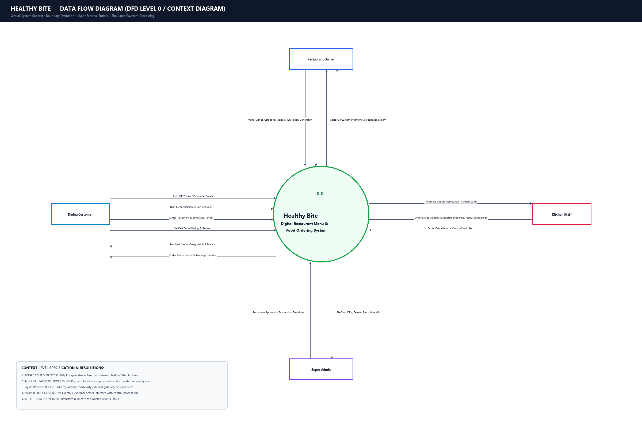
Figure 3.1: DFD Level 0 — System Context Diagram
Data Flow Analysis: Seated customers submit QR token scans, dietary filter choices, food customizations, and checkout requests; the system responds with verified menus, real-time macro breakdowns, digital bills, and live kitchen preparation updates. Kitchen staff receive incoming orders and transmit state transitions. Restaurant owners dispatch menu updates, pricing changes, table QR generation commands, and review replies. Platform Super Admins audit tenant registrations and issue approval/suspension commands.
3.2.2 DFD Level 1 — Subsystem Data Flows
The Level 1 DFD decomposes the system into six primary operational sub-processes: (1.0) QR Token & Table Context Binding, (2.0) Menu Browsing & 8-Macro Nutrition Engine, (3.0) Cart State & Server Price Verification, (4.0) Order Placement & Transaction Persistence, (5.0) Kitchen Kanban Fulfillment & Status Progression, and (6.0) Review Management & Owner Response.
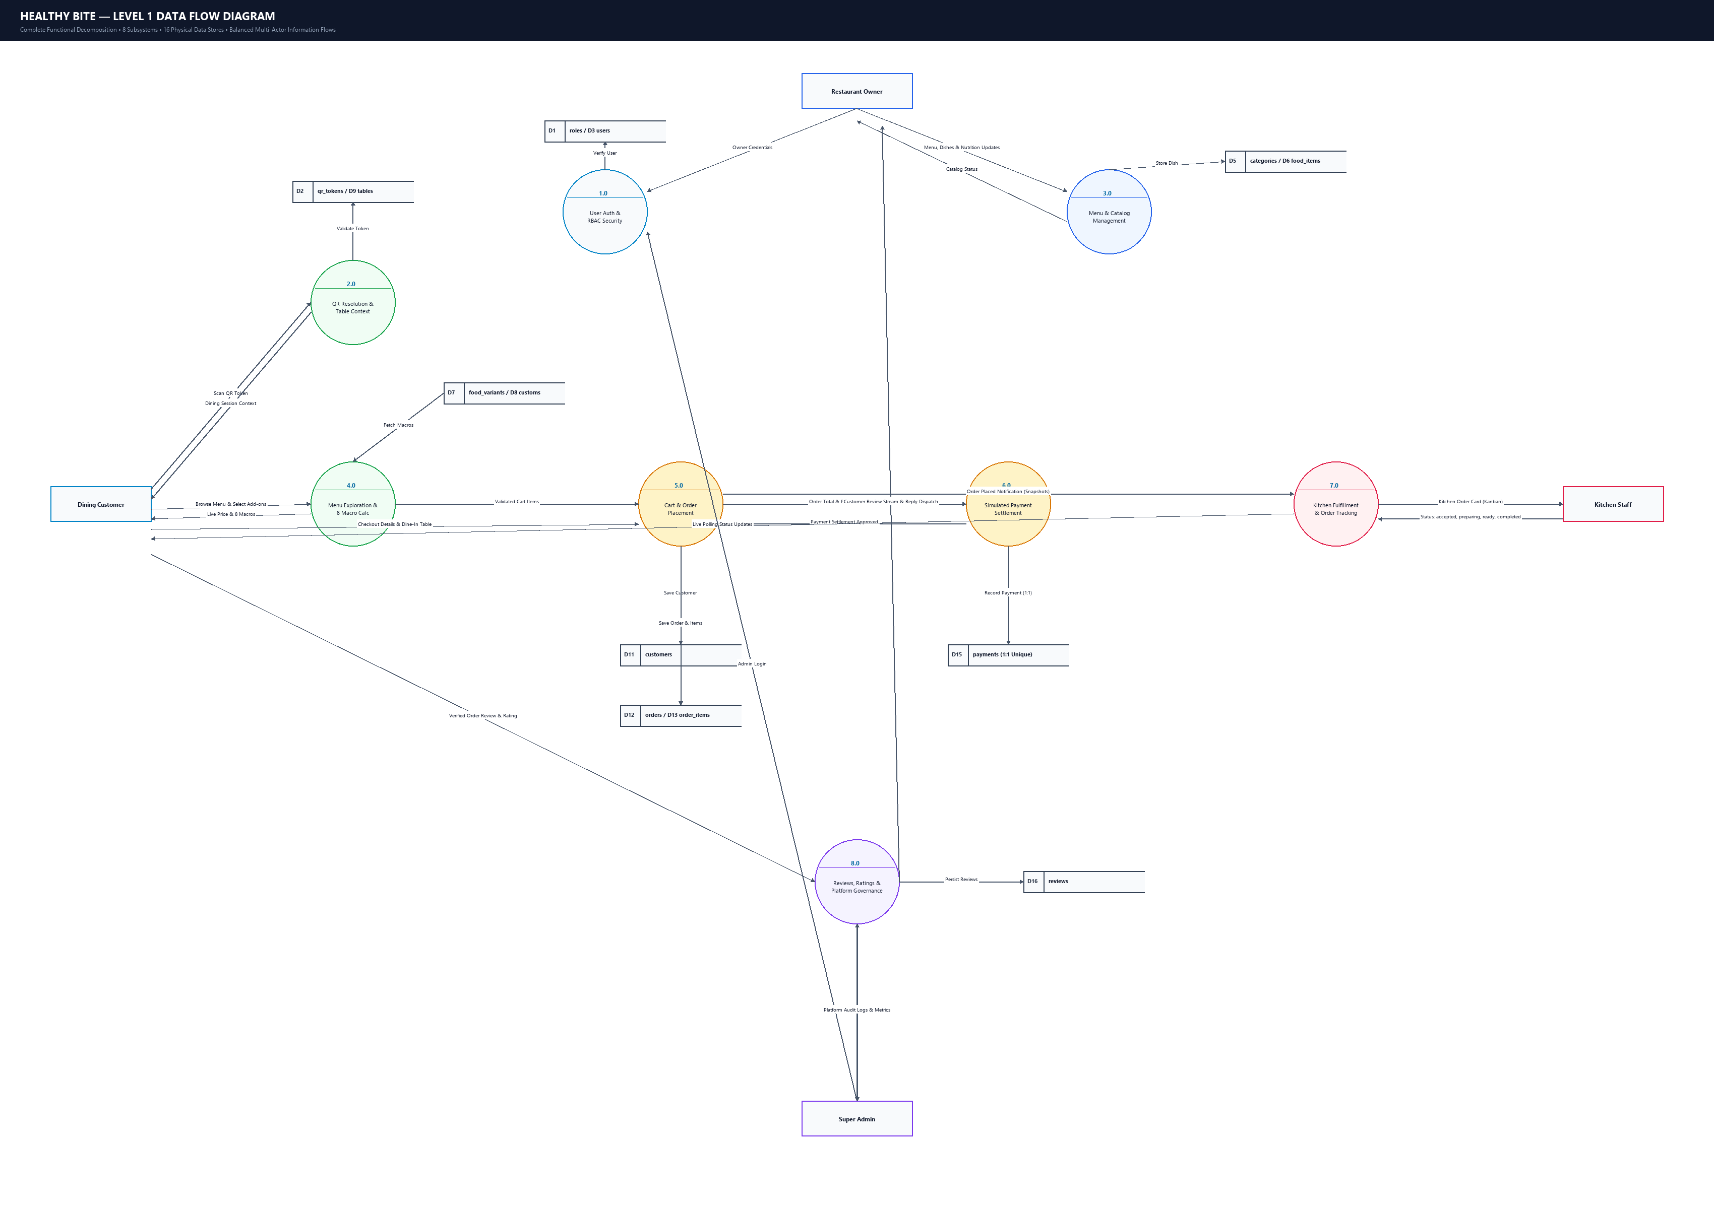
Figure 3.2: DFD Level 1 — Subsystem Operational Flow Diagram
3.2.3 DFD Level 2 Detailed Decompositions
To provide complete architectural clarity, DFD Level 2 diagrams break down individual critical sub-processes into discrete low-level data flows:
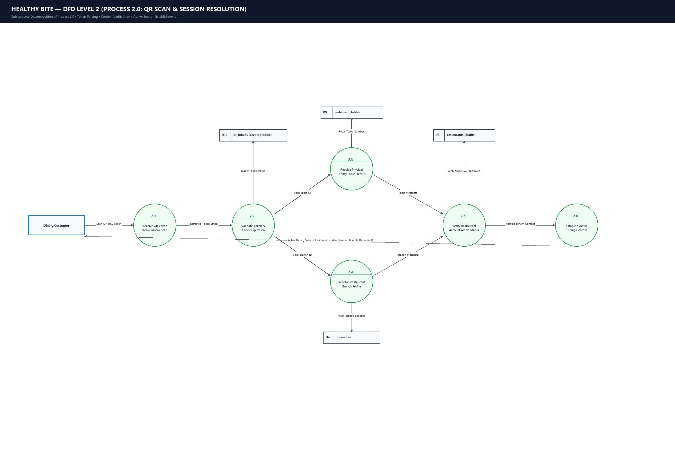
Figure 3.3: DFD Level 2 — QR Resolution & Table Context Binding
Process 1.0 (QR Resolution): Verifies token cryptographic validity against qr_tokens, resolves active restaurant_tables record, extracts restaurant and branch IDs, and creates a secure authenticated session.
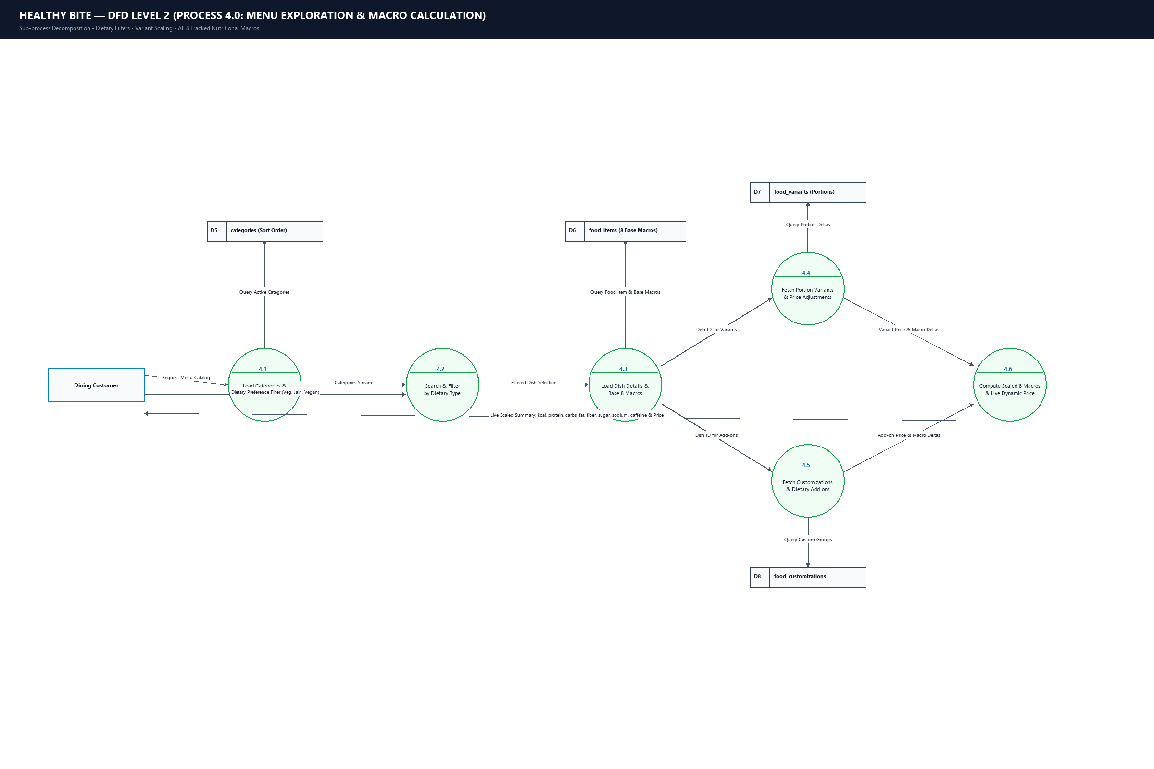
Figure 3.4: DFD Level 2 — Menu Customization & Nutrition Engine
Process 2.0 (Customization & Nutrition): Reads food_items, pulls associated food_variants and food_customizations, arithmetically calculates 8-macro nutritional totals, and computes adjusted unit prices.
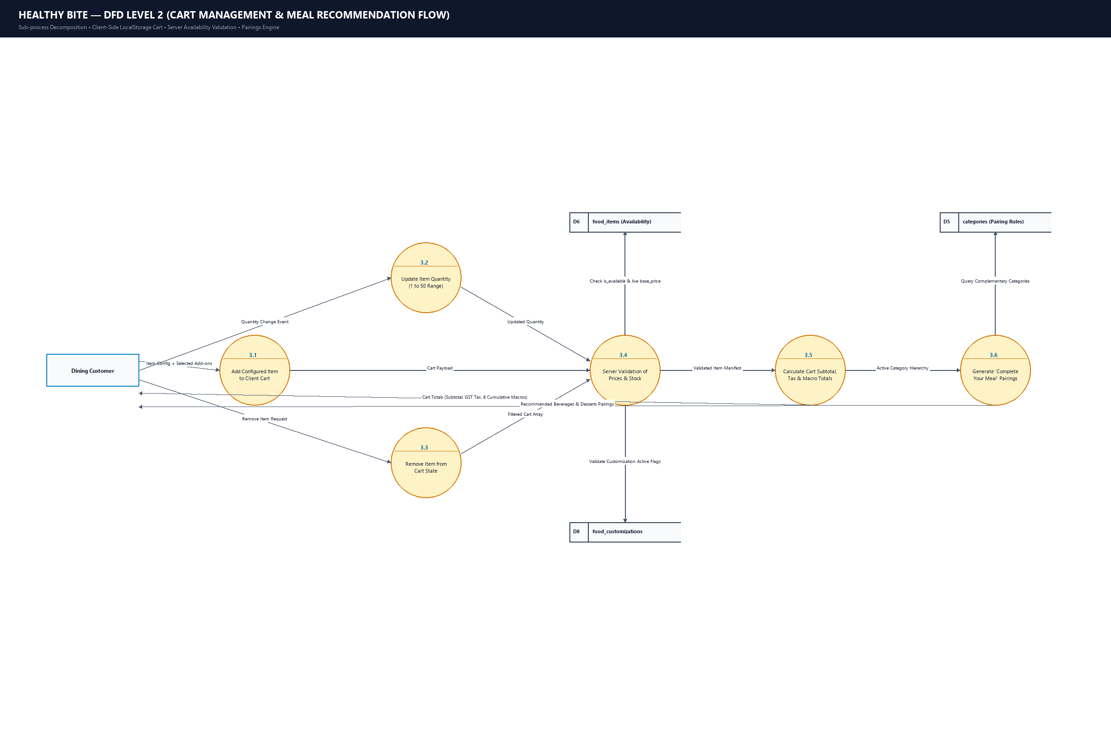
Figure 3.5: DFD Level 2 — Cart Management Flow
Process 3.0 (Cart Management): Synchronizes client-side localStorage drawer state with server-side validation rules, handling item quantity increments, line removals, and subtotal recalibration.
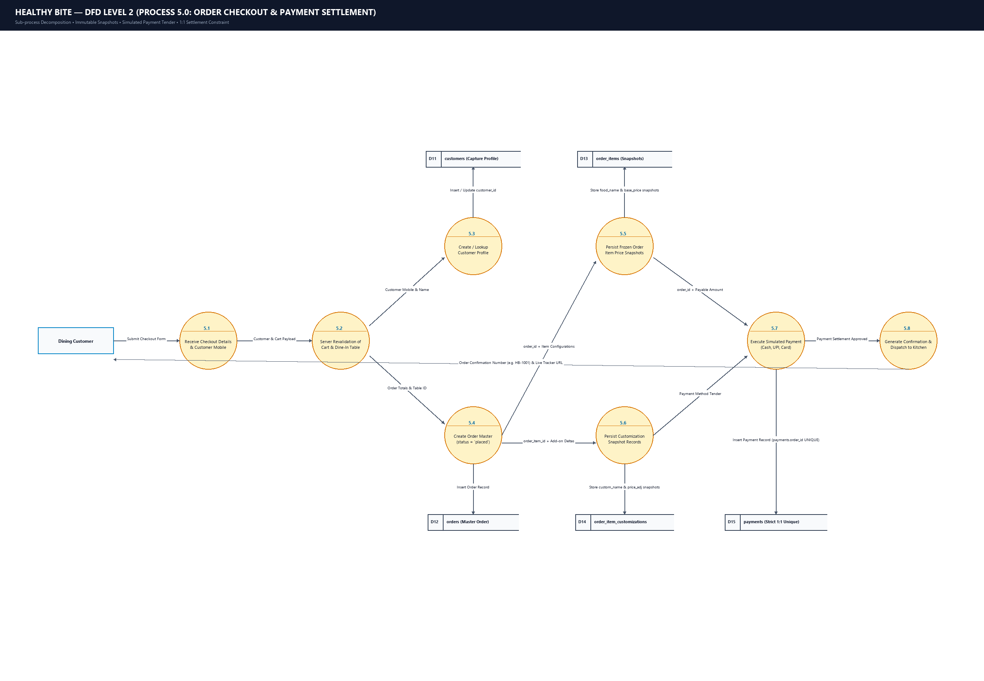
Figure 3.6: DFD Level 2 — Order Placement & Payment Settlement
Process 4.0 (Order Checkout): Validates guest information, creates customer profile, executes an atomic PDO transaction to insert master order record, writes frozen snapshots to order_items, and records payments.
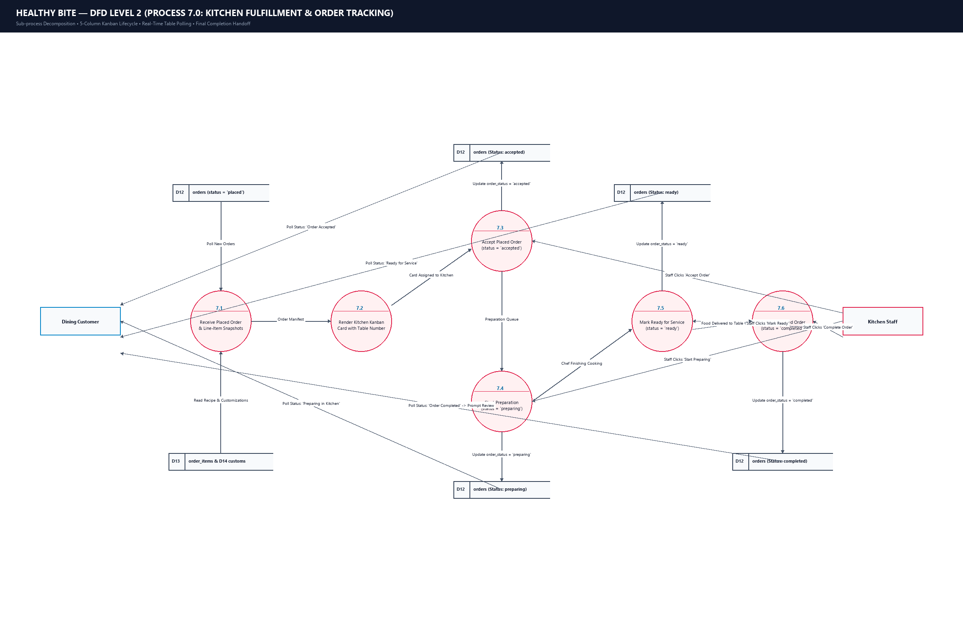
Figure 3.7: DFD Level 2 — Kitchen Kanban & Live Fulfillment
Process 5.0 (Kitchen Fulfillment): Kitchen staff advance orders through 5 status columns (Placed -> Accepted -> Preparing -> Ready -> Completed), updating database state and feeding live customer tracking pollers.
3.3 Entity-Relationship (ER) Diagram
The Healthy Bite relational schema comprises 16 active relational tables and 1 legacy entity. The Entity-Relationship model enforces referential integrity, cascading updates, foreign key constraints, and normalized data storage.
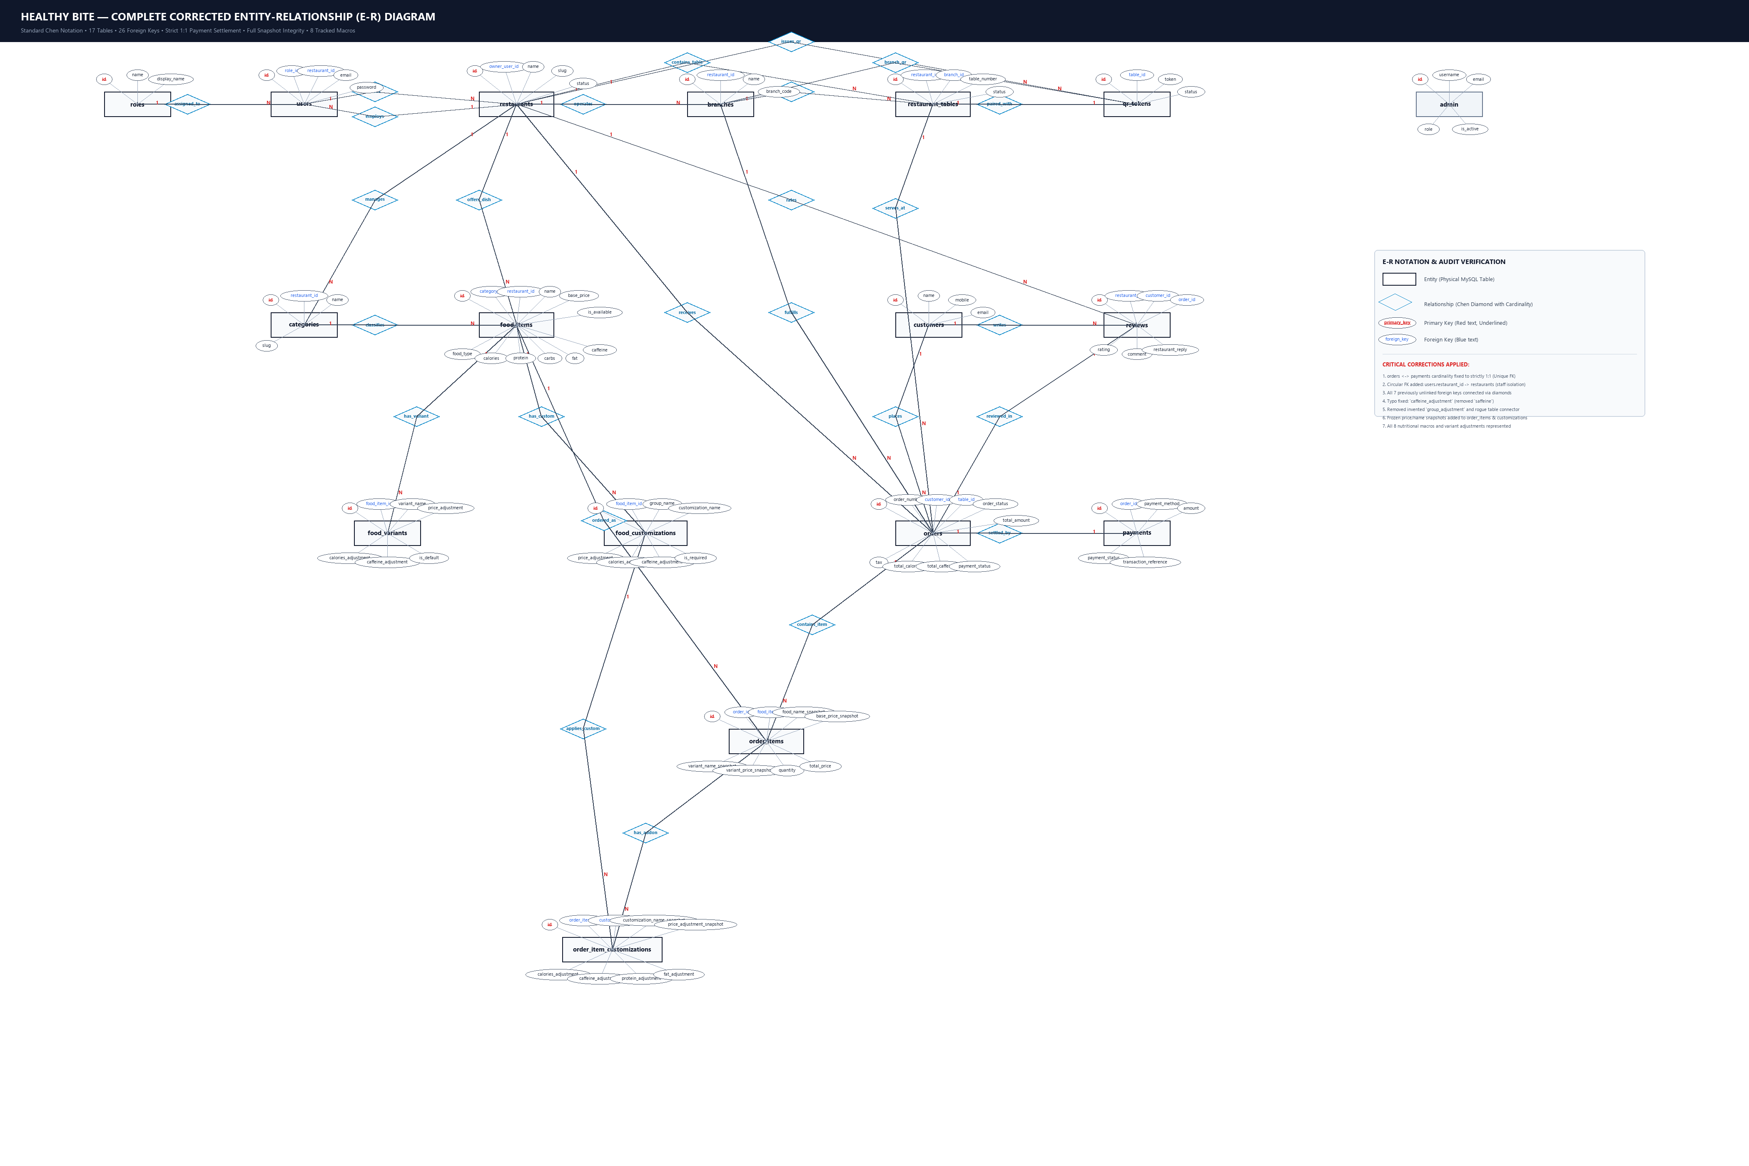
Figure 3.8: Authoritative 17-Table Entity-Relationship (ER) Diagram
Cardinality & Relational Analysis:
- roles to users (1:N): One role (e.g. Super Admin, Owner, Staff) can be assigned to multiple system user accounts.
- restaurants to branches (1:N): A dining establishment entity can operate multiple physical branch outlets.
- restaurants to restaurant_tables (1:N): A restaurant manages multiple physical tables (Tables 1–12), each bound to a unique cryptographic QR token.
- restaurants to categories and food_items (1:N): A restaurant owns distinct culinary categories, each containing multiple food items.
- food_items to food_variants (1:N): A culinary dish can offer portion sizes (Regular, Large) with specific price and macro adjustments.
- food_items to food_customizations (1:N): A dish supports optional add-ons, dressings, and toppings with individual pricing and macros.
- customers to orders (1:N): A dining guest can place multiple orders over successive dining visits.
- orders to order_items (1:N): An order contains multiple line items, each persisting an immutable frozen snapshot of price and nutritional values.
- order_items to order_item_customizations (1:N): Customizations selected by the diner are permanently recorded against the specific order line item.
- orders to payments (1:1): Every finalized order record is paired with a verified payment transaction record.
- restaurants to reviews (1:N): A restaurant receives customer reviews, which support bidirectional owner reply comments.
3.4 UML Activity Diagrams
Activity diagrams illustrate dynamic control flow and concurrent decision pathways across the system:
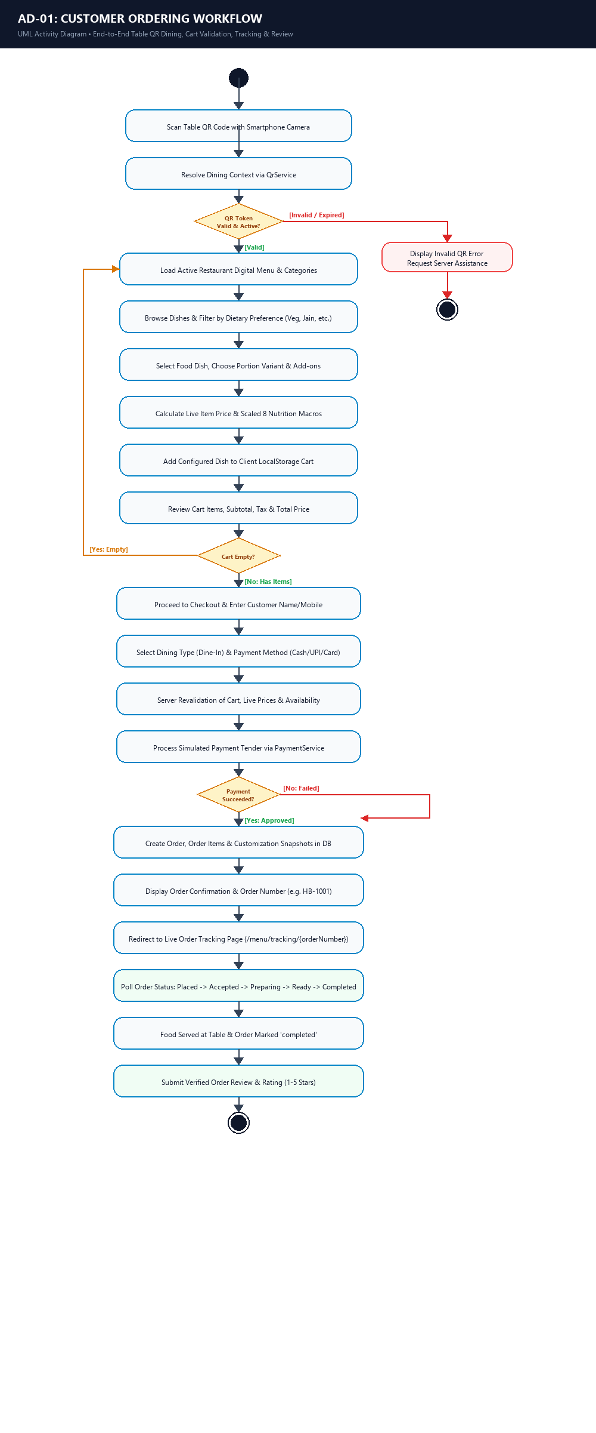
Figure 3.9: Activity Diagram — Customer QR Scan & Menu Selection Workflow
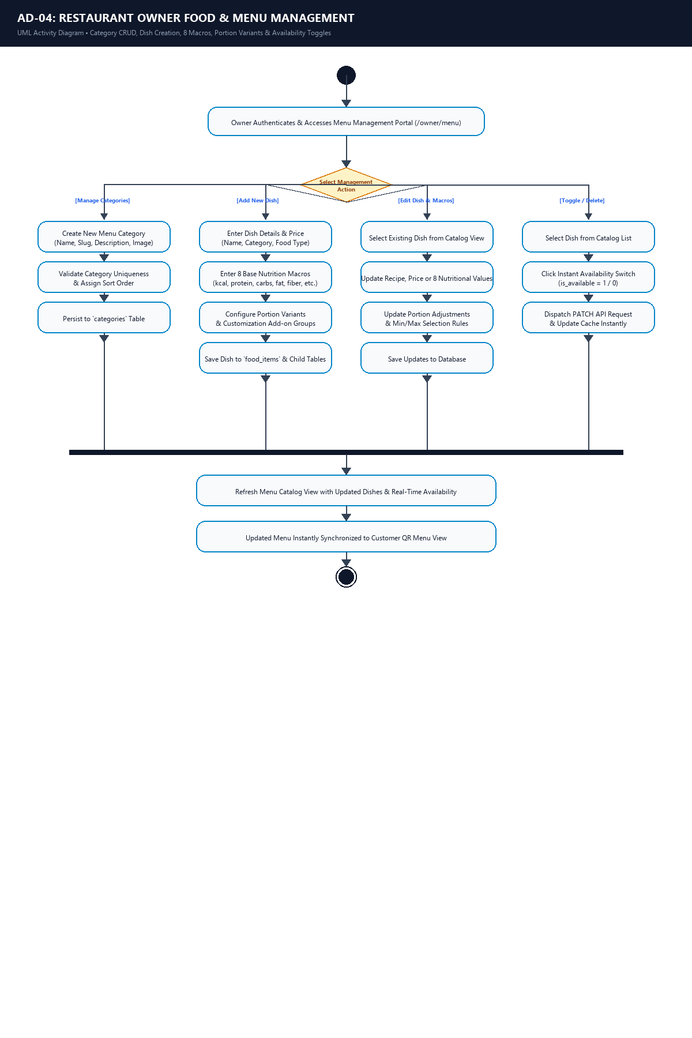
Figure 3.10: Activity Diagram — Kitchen Kanban Fulfillment & Order Staging
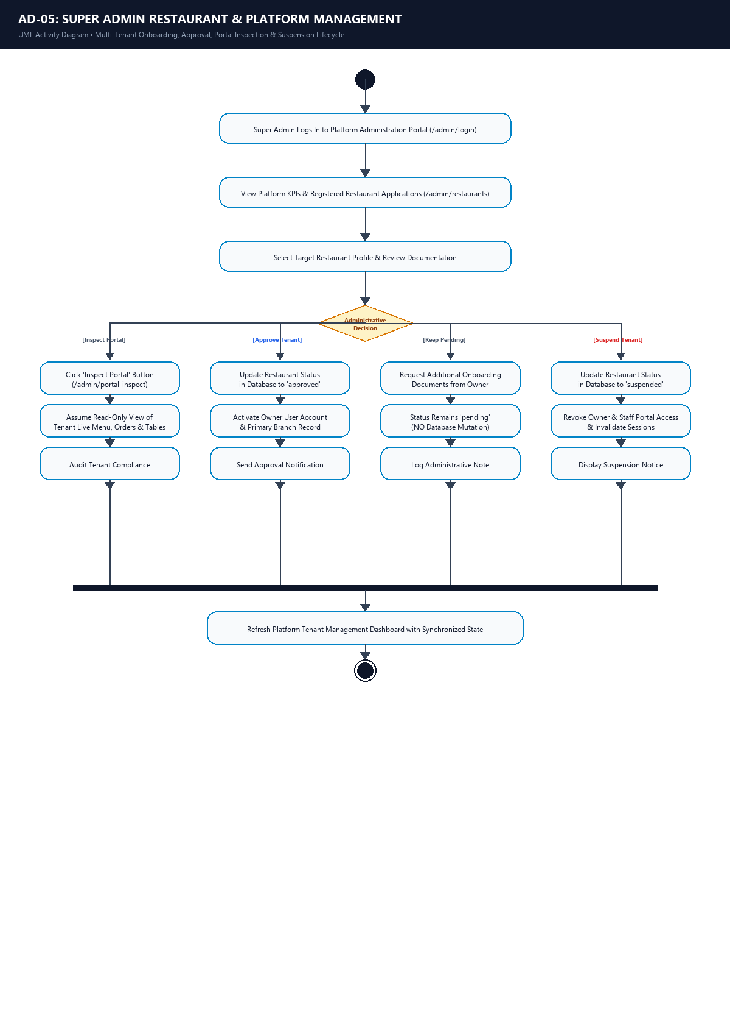
Figure 3.11: Activity Diagram — Restaurant Owner & Super Admin Governance
3.5 UML Use Case Diagram & Specifications
The Use Case Diagram defines functional interactions between system actors and core use cases:
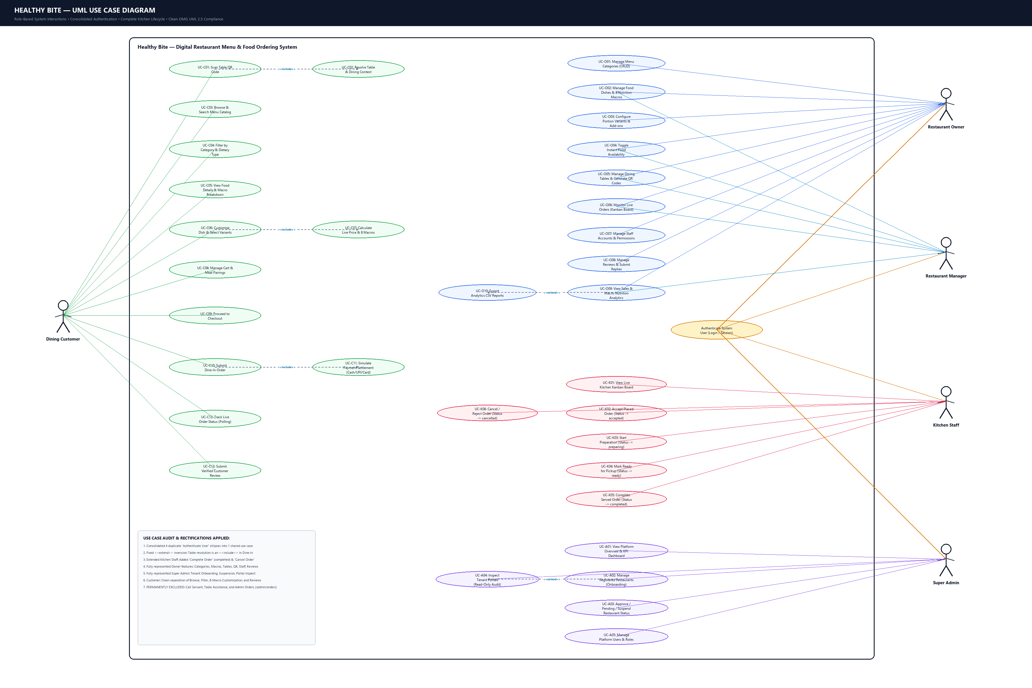
Figure 3.12: UML Use Case Diagram — Actors & Core Subsystems
UC ID | Use Case Title | Primary Actor | Preconditions | Main Scenario / Postconditions
UC-01 | Scan Table QR Code | Dining Customer | Customer arrives at dining table with smartphone camera. | System verifies cryptographic token and locks session to Table ID and Restaurant.
UC-02 | Browse Filtered Menu | Dining Customer | Valid active table session established. | Customer filters dishes by dietary preference (Veg, Non-Veg, Vegan, Jain).
UC-03 | Customize Dish & Macros | Dining Customer | Customer clicks 'Customize' on culinary item card. | System scales 8 nutritional macros and base price as variants/add-ons are toggled.
UC-04 | Manage Cart & Checkout | Dining Customer | Items added to client-side reactive drawer. | Server re-verifies prices/macros, creates Customer record, and places master Order.
UC-05 | Track Live Order Status | Dining Customer | Order successfully placed and confirmed. | Visual 5-step tracker polls kitchen progression from Placed to Completed.
UC-06 | Manage Kitchen Kanban | Kitchen Staff | Staff logged into back-of-house portal. | Staff views orders in 5 columns and transitions cards (Accept, Prepare, Ready).
UC-07 | Manage Menu & Pricing | Restaurant Owner | Owner authenticated with valid credentials. | Owner creates/edits categories, dishes, variants, add-ons, and toggles availability.
UC-08 | Generate Table QR Codes | Restaurant Owner | Owner accesses Table Management view. | System renders canvas QR codes for Tables 1–12 with instant PNG download.
UC-09 | Manage Reviews & Replies | Restaurant Owner | Customer submits 1–5 star rating and comment. | Owner reviews feedback and posts official public restaurant responses.
UC-10 | Multi-Tenant Governance | Super Admin | Super Admin authenticated at /admin/login. | Admin audits restaurant tenants, approves/suspends accounts, and inspects portals.

3.6 System Process Flow Diagram
The Process Flow diagram depicts the end-to-end operational lifecycle: from the moment a diner scans a table QR code, selects dietary filters, customizes macros, and submits payment, through back-of-house Kanban preparation, order serving, and post-dining review feedback.
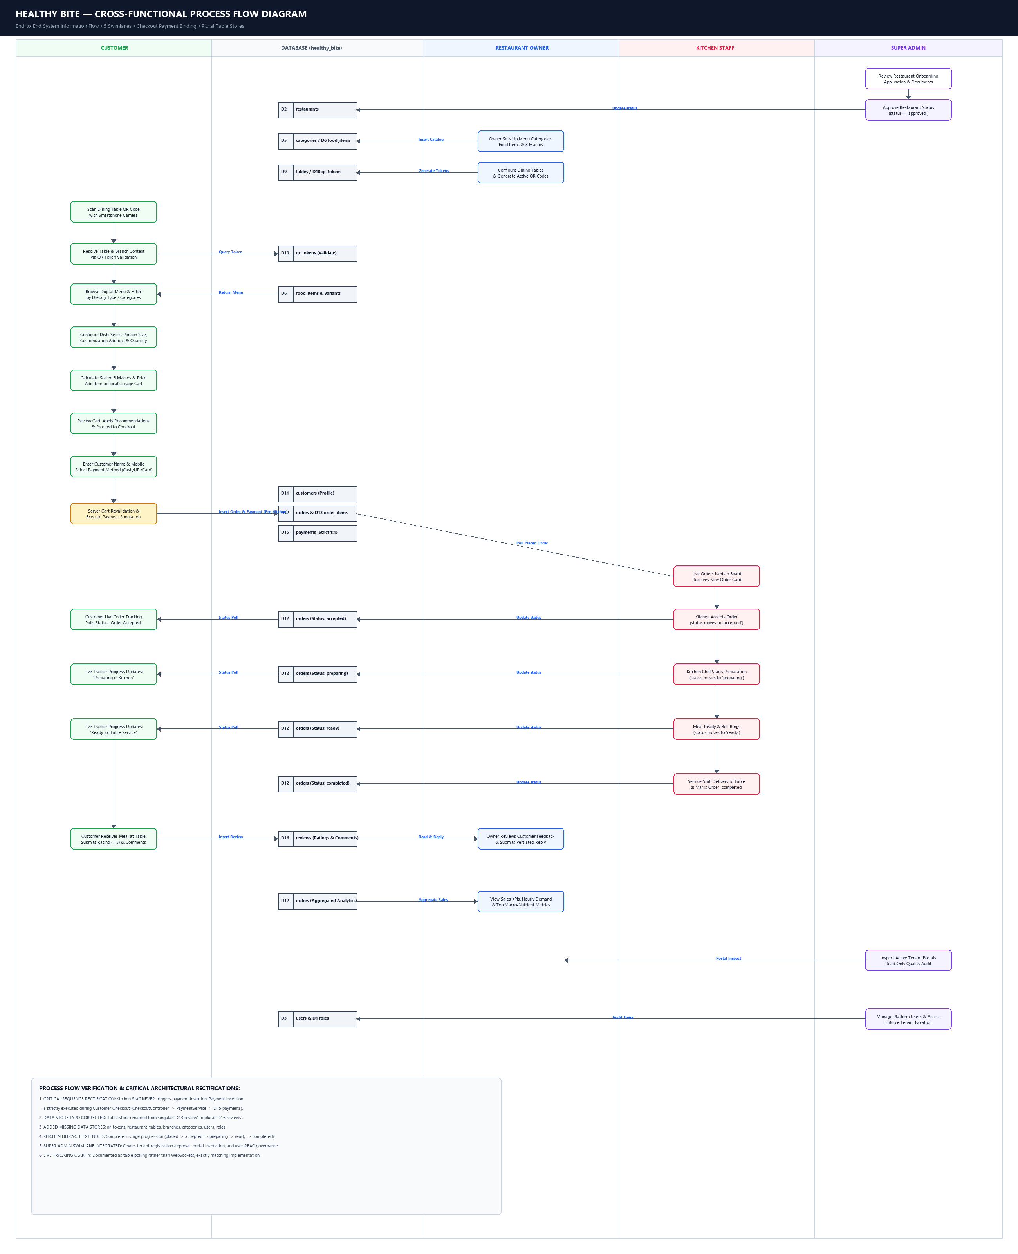
Figure 3.13: End-to-End System Process Flow Diagram
3.7 System Class Diagram
The Class Diagram models the object-oriented structure of Healthy Bite, highlighting the clean separation between Core framework utilities (App, Router, Database, Controller, Response), Domain Services (CartService, PricingService, NutritionService), Repositories (FoodRepository, OrderRepository, RestaurantRepository), and Presentation Controllers.
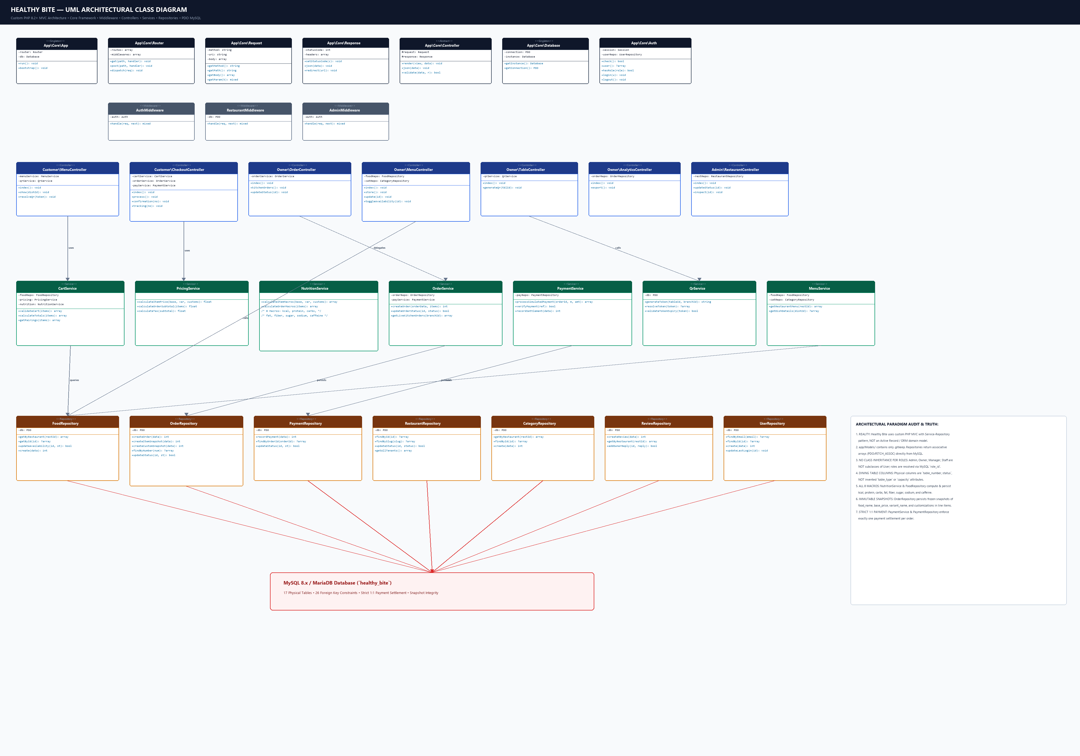
Figure 3.14: Object-Oriented System Class Diagram

CHAPTER 4 — DATA DICTIONARY
The Data Dictionary provides complete schema metadata for all 17 database tables in the Healthy Bite system. Every field is documented with its technical data type, key constraint (PK, FK, UK), nullability, and operational business purpose. In accordance with project presentation guidelines, all table headers are formatted with a Lite Sky Blue background (#BAE6FD) and high-contrast bold text.
Table : admin
Field Name | Data Type | Key | Description & Constraints
id | BIGINT(20) UNSIGNED | PK | Internal unique identifier for legacy admin record; auto-incremented.
name | VARCHAR(120) | None | Full name of legacy system administrator.
created_at | TIMESTAMP | None | Date and time when the legacy admin record was initialized.
updated_at | TIMESTAMP | None | Timestamp of the last modification to the legacy admin record.

Table : roles
Field Name | Data Type | Key | Description & Constraints
id | BIGINT(20) UNSIGNED | PK | Primary key; unique system authority role identifier.
name | VARCHAR(50) | None | Human-readable role title (e.g. Super Admin, Restaurant Owner, Manager, Staff).
slug | VARCHAR(50) | UK | Unique URL/machine slug identifier (super_admin, restaurant_owner, manager, staff).
description | VARCHAR(255) | None | Functional description of security privileges and portal access rights.
created_at | TIMESTAMP | None | Record creation timestamp (default CURRENT_TIMESTAMP).
updated_at | TIMESTAMP | None | Record last updated timestamp (default CURRENT_TIMESTAMP).

Table : restaurants
Field Name | Data Type | Key | Description & Constraints
id | BIGINT(20) UNSIGNED | PK | Primary key; multi-tenant restaurant entity identifier.
owner_user_id | BIGINT(20) UNSIGNED | FK | Foreign key referencing users(id); designates primary restaurant owner.
name | VARCHAR(150) | None | Legal trade name of the dining establishment (e.g. Greenhouse Kitchen).
slug | VARCHAR(150) | UK | Unique URL-friendly slug used for tenant resolution and branding.
logo | VARCHAR(255) | None | Relative path or URL to high-resolution brand logo image.
cover_image | VARCHAR(255) | None | Path or URL to restaurant hero cover banner graphic.
description | TEXT | None | Comprehensive brand narrative, culinary focus, and restaurant overview.
phone | VARCHAR(30) | None | Primary customer service and inquiry contact telephone number.
email | VARCHAR(191) | None | Official restaurant business contact email address.
address | TEXT | None | Physical street address of restaurant headquarters or primary facility.
city | VARCHAR(100) | None | Operating city where the restaurant facility is located.
state | VARCHAR(100) | None | Operating state or administrative province.
status | ENUM('pending','approved','suspended') | None | Platform tenancy status governed by Super Admin (default 'approved').
created_at | TIMESTAMP | None | Date and time when the restaurant was registered on the platform.
updated_at | TIMESTAMP | None | Timestamp of the most recent profile modification.

Table : users
Field Name | Data Type | Key | Description & Constraints
id | BIGINT(20) UNSIGNED | PK | Primary key; user account unique identifier.
role_id | BIGINT(20) UNSIGNED | FK | Foreign key referencing roles(id); defines user authorization level.
restaurant_id | BIGINT(20) UNSIGNED | FK | Foreign key referencing restaurants(id); scopes user to tenant (NULL for Super Admin).
name | VARCHAR(120) | None | Full legal name of the user or staff employee.
email | VARCHAR(191) | UK | Unique email address utilized for portal authentication.
password | VARCHAR(255) | None | Secure one-way BCRYPT cryptographic password hash.
status | ENUM('active','inactive','suspended') | None | Operational account status (default 'active').
created_at | TIMESTAMP | None | User registration timestamp.
updated_at | TIMESTAMP | None | Account profile modification timestamp.

Table : branches
Field Name | Data Type | Key | Description & Constraints
id | BIGINT(20) UNSIGNED | PK | Primary key; physical dining branch outlet identifier.
restaurant_id | BIGINT(20) UNSIGNED | FK | Foreign key referencing restaurants(id); parent restaurant entity.
name | VARCHAR(150) | None | Physical branch title (e.g. Indiranagar Flagship, Koramangala Outlet).
address | TEXT | None | Physical street location of the specific branch outlet.
city | VARCHAR(100) | None | Operating city of the branch.
state | VARCHAR(100) | None | Operating state of the branch.
phone | VARCHAR(30) | None | Direct telephone contact for branch operations and reservations.
status | ENUM('active','inactive') | None | Operational state of the branch location (default 'active').
created_at | TIMESTAMP | None | Branch record creation timestamp.
updated_at | TIMESTAMP | None | Branch record modification timestamp.

Table : categories
Field Name | Data Type | Key | Description & Constraints
id | BIGINT(20) UNSIGNED | PK | Primary key; menu category identifier.
restaurant_id | BIGINT(20) UNSIGNED | FK | Foreign key referencing restaurants(id); scopes category to restaurant.
name | VARCHAR(100) | None | Category title (e.g. Protein Bowls, Artisan Wraps, Superfood Salads, Soups).
slug | VARCHAR(100) | None | URL slug used for client-side category filtering.
description | TEXT | None | Detailed description of the food category classification.
image | VARCHAR(255) | None | Category icon or representative banner image path.
sort_order | INT(11) | None | Integer defining visual display order on customer menu (default 0).
status | ENUM('active','inactive') | None | Category display toggle state (default 'active').
created_at | TIMESTAMP | None | Category creation timestamp.
updated_at | TIMESTAMP | None | Category modification timestamp.

Table : food_items
Field Name | Data Type | Key | Description & Constraints
id | BIGINT(20) UNSIGNED | PK | Primary key; master food dish identifier.
restaurant_id | BIGINT(20) UNSIGNED | FK | Foreign key referencing restaurants(id); owning restaurant tenant.
category_id | BIGINT(20) UNSIGNED | FK | Foreign key referencing categories(id); menu classification.
name | VARCHAR(150) | None | Culinary dish display title (e.g. Grilled Chicken & Quinoa Protein Bowl).
slug | VARCHAR(150) | None | URL-safe unique dish slug for routing and APIs.
description | TEXT | None | Comprehensive sensory and culinary description of the food item.
image | VARCHAR(255) | None | High-resolution Unsplash photo URL or local asset path.
ingredients | TEXT | None | List of primary ingredients and culinary preparation components.
allergens | VARCHAR(255) | None | Declared allergen warnings (e.g. Dairy, Tree Nuts, Gluten, Soy).
food_type | ENUM('vegetarian','non_vegetarian','vegan','jain','other') | None | Dietary lifestyle classification badge.
base_price | DECIMAL(10,2) | None | Standard baseline menu price in Indian Rupees (₹).
calories | INT UNSIGNED | None | Total nutritional energy content measured in kilocalories (kcal).
protein | DECIMAL(6,2) | None | Total protein content measured strictly in grams (g).
carbs | DECIMAL(6,2) | None | Total carbohydrate content measured strictly in grams (g).
fat | DECIMAL(6,2) | None | Total dietary fat content measured strictly in grams (g).
fiber | DECIMAL(6,2) | None | Dietary fiber content measured strictly in grams (g).
sugar | DECIMAL(6,2) | None | Simple sugars content measured strictly in grams (g).
sodium | DECIMAL(7,2) | None | Sodium mineral content measured strictly in milligrams (mg).
caffeine | DECIMAL(6,2) | None | Caffeine stimulant content measured strictly in milligrams (mg).
serving_size | VARCHAR(100) | None | Standard portion weight or volume (e.g. 350g, 400ml).
is_featured | TINYINT(1) | None | Boolean flag highlighting dish on restaurant entrance showcase.
is_popular | TINYINT(1) | None | Boolean flag designating popular best-seller badge.
is_available | TINYINT(1) | None | Live kitchen availability toggle (1=Available, 0=Sold Out).
created_at | TIMESTAMP | None | Food dish registration timestamp.
updated_at | TIMESTAMP | None | Food dish modification timestamp.

Table : food_variants
Field Name | Data Type | Key | Description & Constraints
id | BIGINT(20) UNSIGNED | PK | Primary key; food portion variant identifier.
food_item_id | BIGINT(20) UNSIGNED | FK | Foreign key referencing food_items(id) ON DELETE CASCADE.
name | VARCHAR(100) | None | Portion title (e.g. Regular, Large Portion, Double Protein).
description | VARCHAR(255) | None | Explanation of portion size or preparation difference.
price_adjustment | DECIMAL(10,2) | None | Price differential added to base price in Indian Rupees (₹).
calories_adjustment | INT(11) | None | Calorie differential applied to base calories (kcal).
protein_adjustment | DECIMAL(6,2) | None | Protein differential applied to base protein (g).
carbs_adjustment | DECIMAL(6,2) | None | Carbohydrate differential applied to base carbs (g).
fat_adjustment | DECIMAL(6,2) | None | Fat differential applied to base fat (g).
fiber_adjustment | DECIMAL(6,2) | None | Fiber differential applied to base fiber (g).
sugar_adjustment | DECIMAL(6,2) | None | Sugar differential applied to base sugar (g).
sodium_adjustment | DECIMAL(7,2) | None | Sodium differential applied to base sodium (mg).
caffeine_adjustment | DECIMAL(6,2) | None | Caffeine differential applied to base caffeine (mg).
is_required | TINYINT(1) | None | Mandatory selection flag (default 0).
is_available | TINYINT(1) | None | Active availability toggle for the portion option.
sort_order | INT(11) | None | Display sort order within portion selection UI.
created_at | TIMESTAMP | None | Variant record creation timestamp.
updated_at | TIMESTAMP | None | Variant record modification timestamp.

Table : food_customization
Field Name | Data Type | Key | Description & Constraints
id | BIGINT(20) UNSIGNED | PK | Primary key; food customization add-on identifier.
food_item_id | BIGINT(20) UNSIGNED | FK | Foreign key referencing food_items(id) ON DELETE CASCADE.
group_name | VARCHAR(100) | None | Option grouping header (e.g. Choose Base, Dressing, Extra Toppings).
name | VARCHAR(100) | None | Customization display title (e.g. Extra Hass Avocado, Greek Yogurt Dip).
description | VARCHAR(255) | None | Ingredient or preparation details of the add-on.
price_adjustment | DECIMAL(10,2) | None | Unit cost added to item total in Indian Rupees (₹).
calories_adjustment | INT(11) | None | Caloric energy added per unit selection (kcal).
protein_adjustment | DECIMAL(6,2) | None | Protein added per unit selection in grams (g).
carbs_adjustment | DECIMAL(6,2) | None | Carbohydrates added per unit selection in grams (g).
fat_adjustment | DECIMAL(6,2) | None | Fats added per unit selection in grams (g).
fiber_adjustment | DECIMAL(6,2) | None | Fiber added per unit selection in grams (g).
sugar_adjustment | DECIMAL(6,2) | None | Sugar added per unit selection in grams (g).
sodium_adjustment | DECIMAL(7,2) | None | Sodium added per unit selection in milligrams (mg).
caffeine_adjustment | DECIMAL(6,2) | None | Caffeine added per unit selection in milligrams (mg).
is_required | TINYINT(1) | None | Enforces at least one option selection in this group.
min_quantity | INT UNSIGNED | None | Minimum number of items customer must select from group (default 0).
max_quantity | INT UNSIGNED | None | Maximum number of items customer can select from group (default 1).
is_available | TINYINT(1) | None | Inventory availability toggle for the customization.
sort_order | INT(11) | None | Sort order within the customization group.
created_at | TIMESTAMP | None | Customization record creation timestamp.
updated_at | TIMESTAMP | None | Customization record modification timestamp.

Table : restaurant_table
Field Name | Data Type | Key | Description & Constraints
id | BIGINT(20) UNSIGNED | PK | Primary key; physical dining table identifier.
restaurant_id | BIGINT(20) UNSIGNED | FK | Foreign key referencing restaurants(id); parent restaurant entity.
branch_id | BIGINT(20) UNSIGNED | FK | Foreign key referencing branches(id); physical branch location.
table_number | VARCHAR(50) | None | Display label identifying dining table (e.g. Table 1, Table 12).
status | ENUM('available','occupied','cleaning','out_of_service') | None | Live occupancy state (default 'available').
created_at | TIMESTAMP | None | Table configuration timestamp.
updated_at | TIMESTAMP | None | Table occupancy state transition timestamp.

Table : qr_token
Field Name | Data Type | Key | Description & Constraints
id | BIGINT(20) UNSIGNED | PK | Primary key; cryptographic QR token identifier.
restaurant_id | BIGINT(20) UNSIGNED | FK | Foreign key referencing restaurants(id); bound restaurant entity.
branch_id | BIGINT(20) UNSIGNED | FK | Foreign key referencing branches(id); bound branch location.
table_id | BIGINT(20) UNSIGNED | FK | Foreign key referencing restaurant_tables(id); bound dining table.
token | VARCHAR(128) | UK | Cryptographically generated unique alphanumeric token string.
status | ENUM('active','inactive','expired') | None | Token security validation state (default 'active').
expires_at | TIMESTAMP | None | Optional expiry timestamp for time-limited QR sessions.
created_at | TIMESTAMP | None | Token generation and issuance timestamp.

Table : customer
Field Name | Data Type | Key | Description & Constraints
id | BIGINT(20) UNSIGNED | PK | Primary key; dining guest profile identifier.
name | VARCHAR(120) | None | Full name of the dining customer captured during checkout.
mobile | VARCHAR(30) | None | Customer contact mobile phone number.
email | VARCHAR(191) | None | Customer contact email address for electronic receipts.
created_at | TIMESTAMP | None | Customer profile creation timestamp.
updated_at | TIMESTAMP | None | Customer profile modification timestamp.

Table : order
Field Name | Data Type | Key | Description & Constraints
id | BIGINT(20) UNSIGNED | PK | Primary key; master dining order identifier.
order_number | VARCHAR(64) | UK | Human-readable order tracking code (e.g. HB-1001, HB-18A3B4C-782).
restaurant_id | BIGINT(20) UNSIGNED | FK | Foreign key referencing restaurants(id); target restaurant entity.
branch_id | BIGINT(20) UNSIGNED | FK | Foreign key referencing branches(id); target dining outlet.
table_id | BIGINT(20) UNSIGNED | FK | Foreign key referencing restaurant_tables(id); NULL for Takeaway.
customer_id | BIGINT(20) UNSIGNED | FK | Foreign key referencing customers(id); ordering guest diner.
order_type | ENUM('dine_in','takeaway') | None | Dining service mode (default 'dine_in').
subtotal | DECIMAL(10,2) | None | Sum of all order items and customizations before taxation (₹).
tax | DECIMAL(10,2) | None | Calculated Goods & Services Tax (GST 5%) in Indian Rupees (₹).
service_charge | DECIMAL(10,2) | None | Optional restaurant hospitality service charge in Indian Rupees (₹).
total_amount | DECIMAL(10,2) | None | Final grand payable total amount in Indian Rupees (₹).
payment_status | ENUM('pending','completed','failed') | None | Settlement state of order financial transaction.
order_status | ENUM('placed','accepted','preparing','ready','completed','cancelled') | None | Operational kitchen lifecycle status.
notes | TEXT | None | Customer special food preparation or dietary instructions.
created_at | TIMESTAMP | None | Order submission timestamp.
updated_at | TIMESTAMP | None | Order status transition timestamp.

Table : order_item
Field Name | Data Type | Key | Description & Constraints
id | BIGINT(20) UNSIGNED | PK | Primary key; order line item identifier.
order_id | BIGINT(20) UNSIGNED | FK | Foreign key referencing orders(id); master order parent.
food_item_id | BIGINT(20) UNSIGNED | FK | Foreign key referencing food_items(id); source dish catalog item.
food_name_snapshot | VARCHAR(150) | None | Frozen dish name at the precise moment of purchase.
base_price_snapshot | DECIMAL(10,2) | None | Frozen baseline unit price at purchase time (₹).
variant_name_snapshot | VARCHAR(100) | None | Frozen portion variant title selected by customer.
variant_price_snapshot | DECIMAL(10,2) | None | Frozen portion price adjustment at purchase time (₹).
quantity | INT UNSIGNED | None | Quantity of this specific configured dish ordered.
unit_price | DECIMAL(10,2) | None | Calculated single-item price including variant & customizations (₹).
total_price | DECIMAL(10,2) | None | Line total = unit_price multiplied by quantity (₹).
calories | INT(11) | None | Frozen caloric energy snapshot per unit (kcal).
protein | DECIMAL(6,2) | None | Frozen protein snapshot per unit in grams (g).
carbs | DECIMAL(6,2) | None | Frozen carbohydrate snapshot per unit in grams (g).
fat | DECIMAL(6,2) | None | Frozen fat snapshot per unit in grams (g).
fiber | DECIMAL(6,2) | None | Frozen fiber snapshot per unit in grams (g).
sugar | DECIMAL(6,2) | None | Frozen sugar snapshot per unit in grams (g).
sodium | DECIMAL(7,2) | None | Frozen sodium snapshot per unit in milligrams (mg).
caffeine | DECIMAL(6,2) | None | Frozen caffeine snapshot per unit in milligrams (mg).
created_at | TIMESTAMP | None | Line item purchase timestamp.

Table : order_item_customization
Field Name | Data Type | Key | Description & Constraints
id | BIGINT(20) UNSIGNED | PK | Primary key; order item customization snapshot identifier.
order_item_id | BIGINT(20) UNSIGNED | FK | Foreign key referencing order_items(id) ON DELETE CASCADE.
customization_id | BIGINT(20) UNSIGNED | FK | Foreign key referencing food_customizations(id).
customization_name_snapshot | VARCHAR(100) | None | Frozen name of selected add-on option.
quantity | INT UNSIGNED | None | Quantity of this specific customization selected.
price_adjustment | DECIMAL(10,2) | None | Frozen price delta applied per unit add-on (₹).
calories_adjustment | INT(11) | None | Frozen calorie adjustment per unit (kcal).
protein_adjustment | DECIMAL(6,2) | None | Frozen protein adjustment per unit in grams (g).
carbs_adjustment | DECIMAL(6,2) | None | Frozen carbohydrate adjustment per unit in grams (g).
fat_adjustment | DECIMAL(6,2) | None | Frozen fat adjustment per unit in grams (g).
fiber_adjustment | DECIMAL(6,2) | None | Frozen fiber adjustment per unit in grams (g).
sugar_adjustment | DECIMAL(6,2) | None | Frozen sugar adjustment per unit in grams (g).
sodium_adjustment | DECIMAL(7,2) | None | Frozen sodium adjustment per unit in milligrams (mg).
caffeine_adjustment | DECIMAL(6,2) | None | Frozen caffeine adjustment per unit in milligrams (mg).
created_at | TIMESTAMP | None | Snapshot creation timestamp.

Table : payment
Field Name | Data Type | Key | Description & Constraints
id | BIGINT(20) UNSIGNED | PK | Primary key; financial payment settlement identifier.
order_id | BIGINT(20) UNSIGNED | UK, FK | Foreign key referencing orders(id); strict 1-to-1 relationship.
payment_method | ENUM('cash','upi','card') | None | Authorized settlement mechanism.
transaction_reference | VARCHAR(128) | None | Unique transaction reference code (e.g. TXN-UPI-18A3B4C).
amount | DECIMAL(10,2) | None | Total settled financial amount in Indian Rupees (₹).
status | ENUM('pending','completed','failed') | None | Settlement transaction state (default 'pending').
paid_at | TIMESTAMP | None | Timestamp when payment was successfully verified and cleared.
created_at | TIMESTAMP | None | Payment record creation timestamp.

Table : review
Field Name | Data Type | Key | Description & Constraints
id | BIGINT(20) UNSIGNED | PK | Primary key; customer feedback review identifier.
restaurant_id | BIGINT(20) UNSIGNED | FK | Foreign key referencing restaurants(id); target restaurant entity.
customer_id | BIGINT(20) UNSIGNED | FK | Foreign key referencing customers(id); authoring guest customer.
order_id | BIGINT(20) UNSIGNED | FK | Foreign key referencing orders(id); specific dining order reviewed.
rating | TINYINT UNSIGNED | None | Numerical dining quality rating on 1 to 5 star scale.
comment | TEXT | None | Qualitative feedback text submitted by the customer.
restaurant_reply | TEXT | None | Official restaurant owner response reply published to customer.
replied_at | TIMESTAMP | None | Timestamp when restaurant owner published the response reply.
status | ENUM('pending','approved','hidden') | None | Public review moderation state (default 'pending').
created_at | TIMESTAMP | None | Review submission timestamp.
updated_at | TIMESTAMP | None | Review or reply modification timestamp.

CHAPTER 5 — SYSTEM IMPLEMENTATION
5.1 System Architecture & Directory Map
Healthy Bite is organized cleanly into modular directories following strict MVC conventions:
- app/Core/: Base framework classes: App.php, Router.php, Controller.php, Database.php, Response.php, View.php, Env.php.
- app/Controllers/: HTTP request handlers: Customer controllers (MenuController, OrderController, ReviewController), Owner controllers (DashboardController, KitchenController, MenuController, TableController, AnalyticsController), Admin controllers (DashboardController, RestaurantController, UserController).
- app/Services/: Business logic services: CartService.php, PricingService.php, NutritionService.php, OrderService.php, PaymentService.php, QrSessionService.php.
- app/Repositories/: Data persistence layer: FoodRepository.php, OrderRepository.php, RestaurantRepository.php, TableRepository.php, ReviewRepository.php, UserRepository.php.
- app/Middleware/: Security guards: AuthMiddleware.php, RestaurantMiddleware.php, AdminMiddleware.php.
- resources/views/: Modular presentation templates: customer/*, owner/*, admin/*, layouts/main.php.
- public/: Web root containing index.php, assets/css/dashboard.css, assets/css/menu.css, assets/js/app.js, qrcode.min.js.
5.2 System Screenshots Walkthrough
The following annotated figures illustrate the production user interfaces across the Customer, Restaurant Owner, and Platform Super Admin portals:
5.2.1 Client (Dining Customer) Portal Screenshots
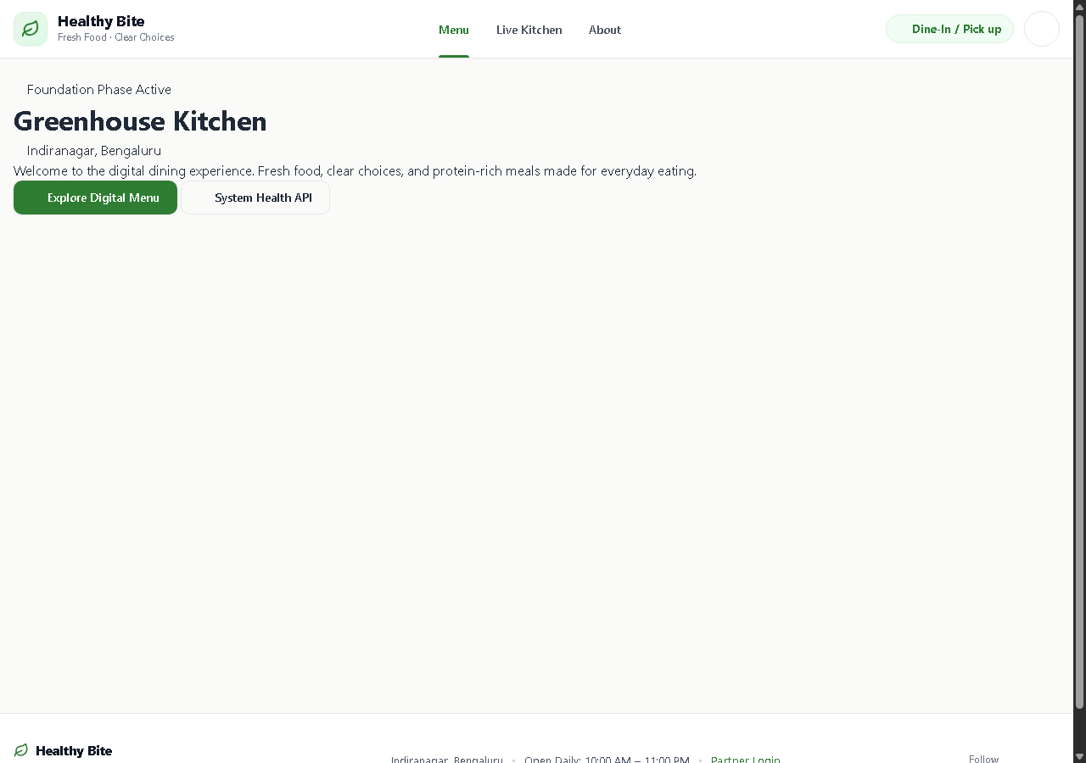
Figure 5.1: Customer Welcome & Table QR Landing Screen
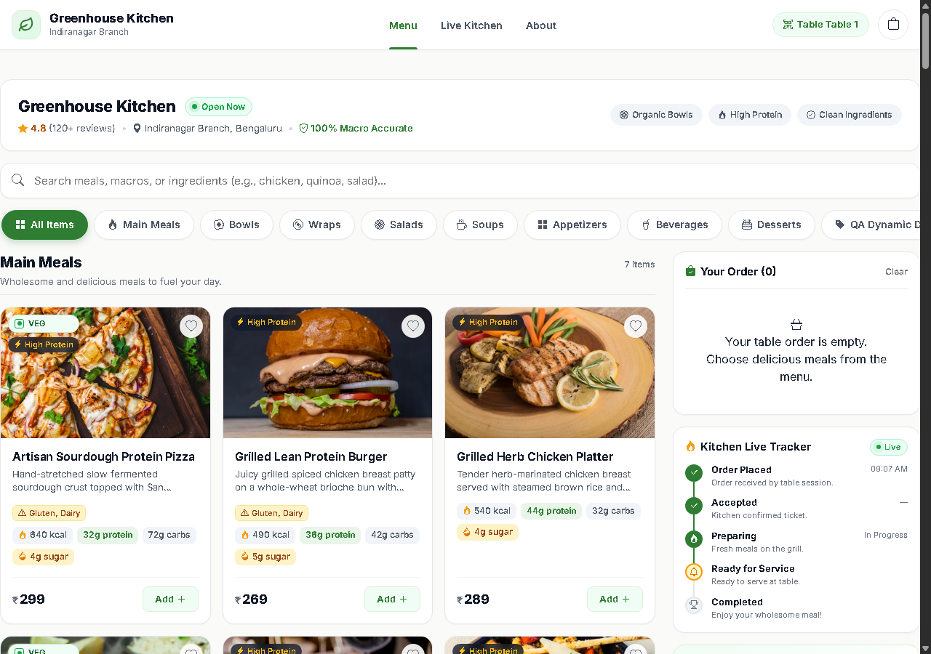
Figure 5.2: Customer Digital Menu with Dietary Filter Pills & Macro Badges
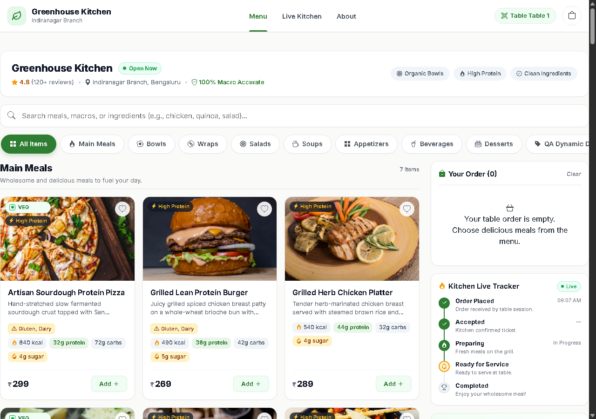
Figure 5.3: Dish Customization Modal & Cart Checkout Drawer
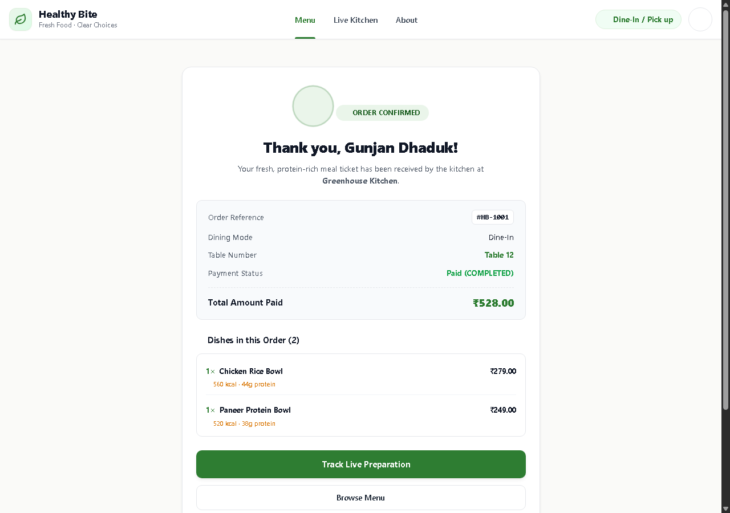
Figure 5.4: Order Confirmation & Digital Bill Summary
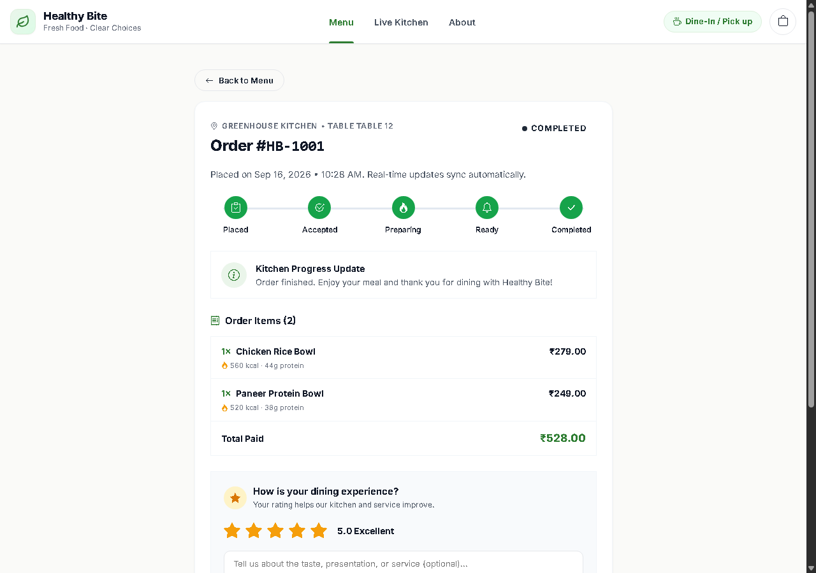
Figure 5.5: Live 5-Stage Kitchen Order Progress Tracker
5.2.2 Restaurant Owner & Kitchen Portal Screenshots
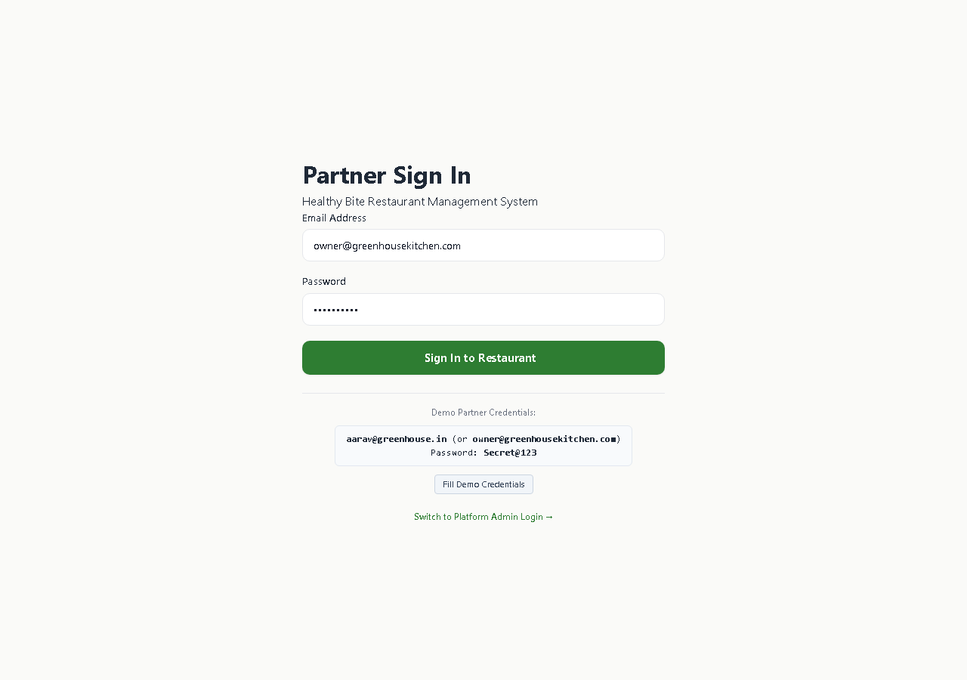
Figure 5.6: Restaurant Owner Secure Authentication
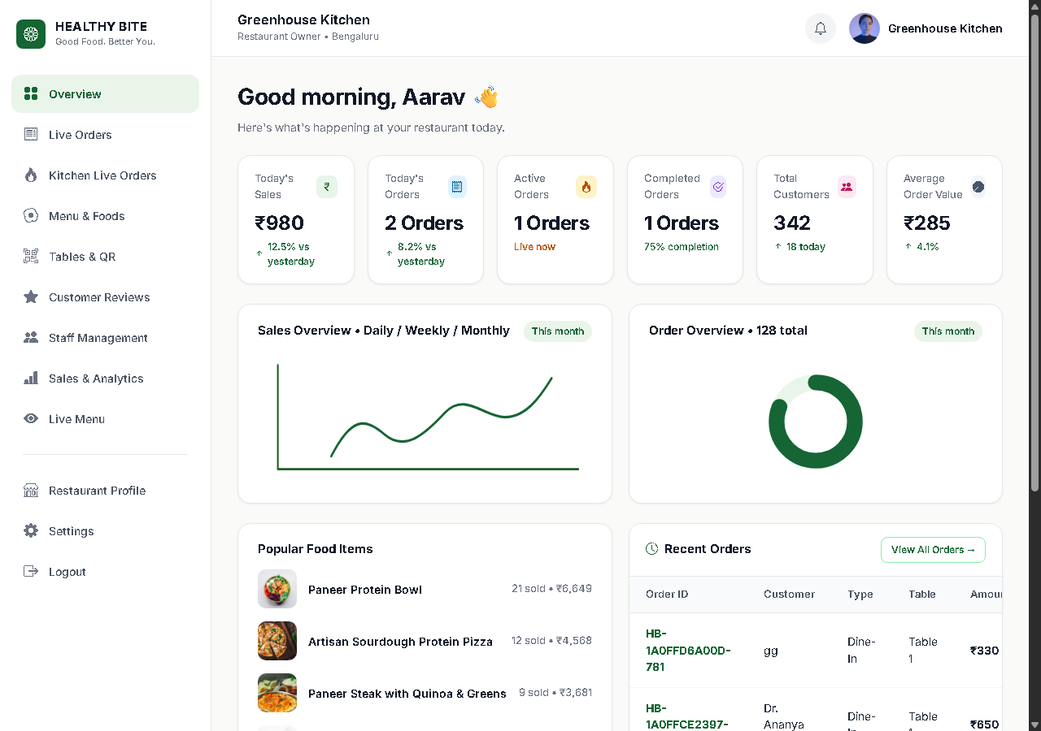
Figure 5.7: Restaurant Operations Overview Dashboard & KPIs
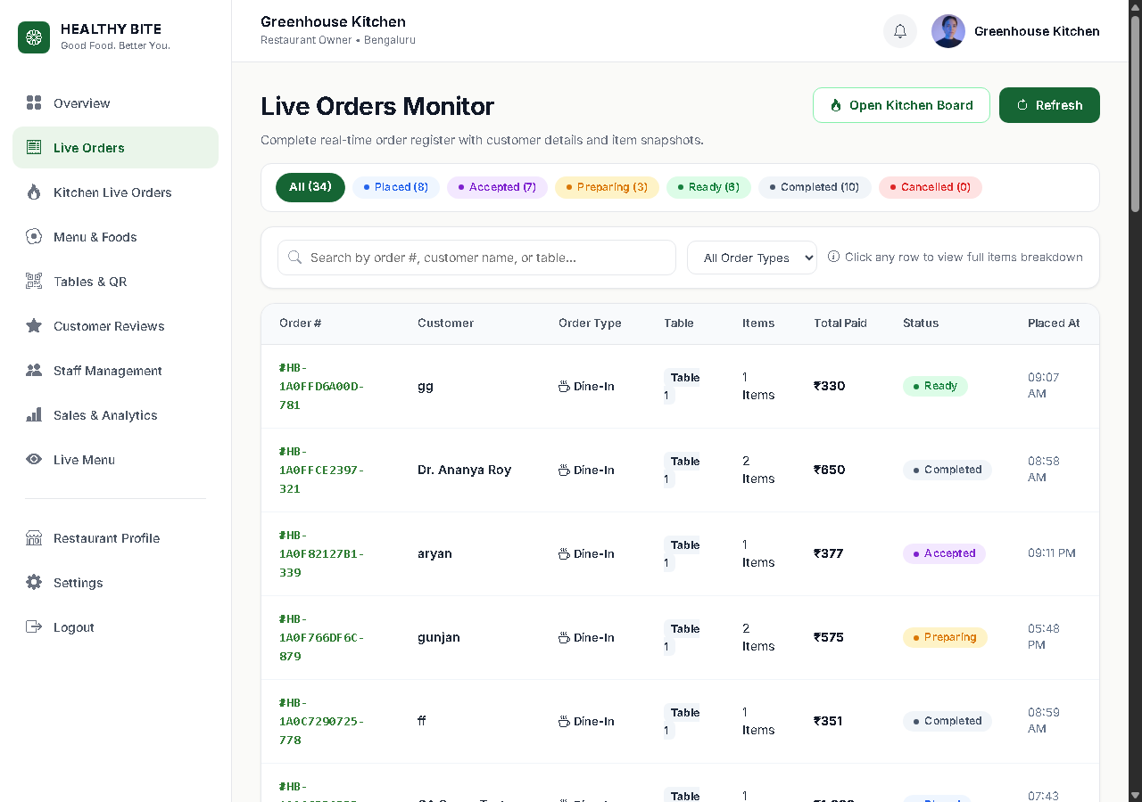
Figure 5.8: Real-Time Live Orders Feed with Status Filters
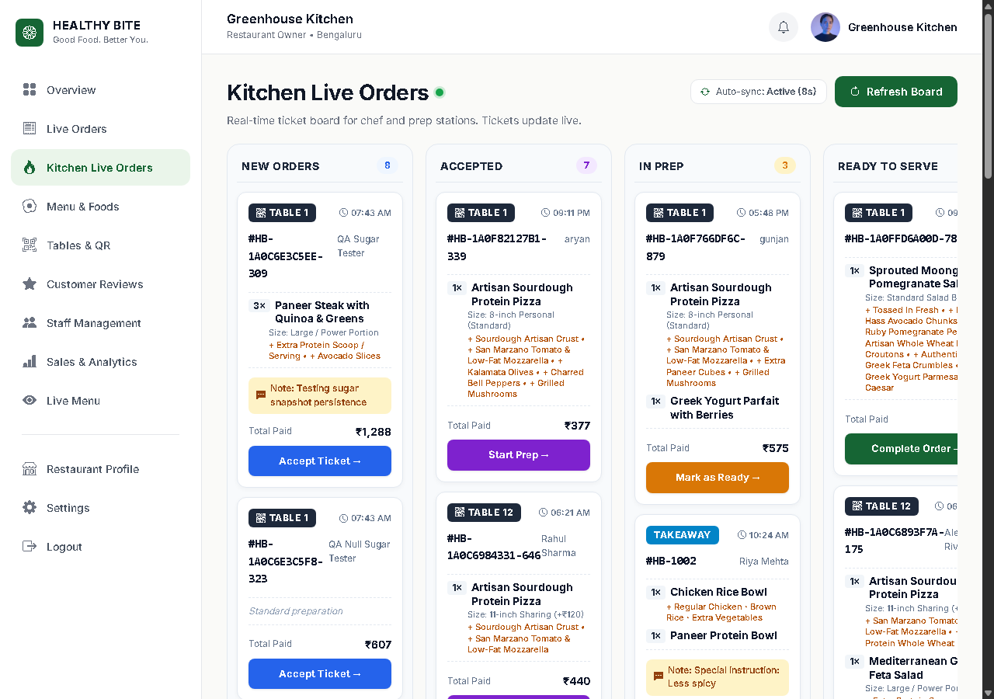
Figure 5.9: 5-Column Kitchen Kanban Board (Placed to Completed)
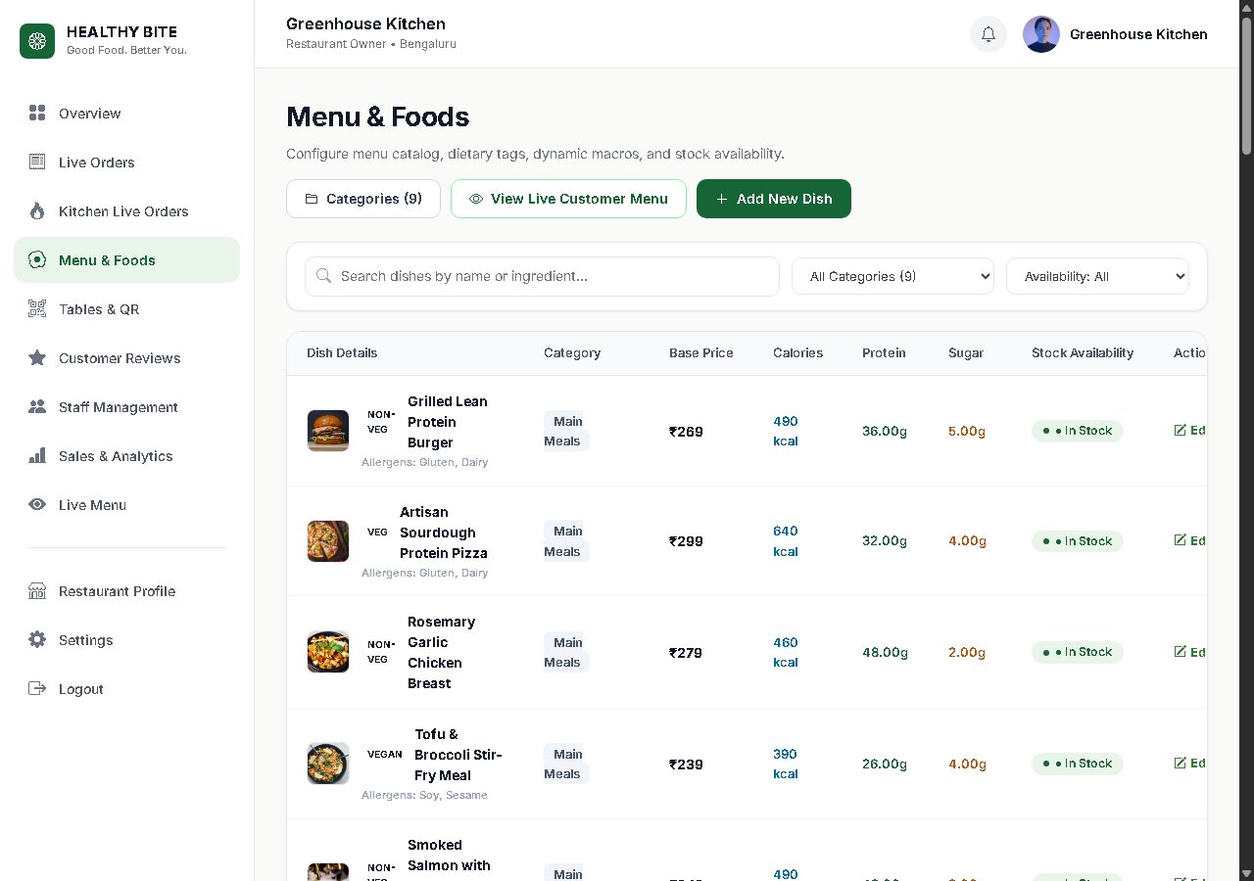
Figure 5.10: Menu Categories & Dishes Management Suite
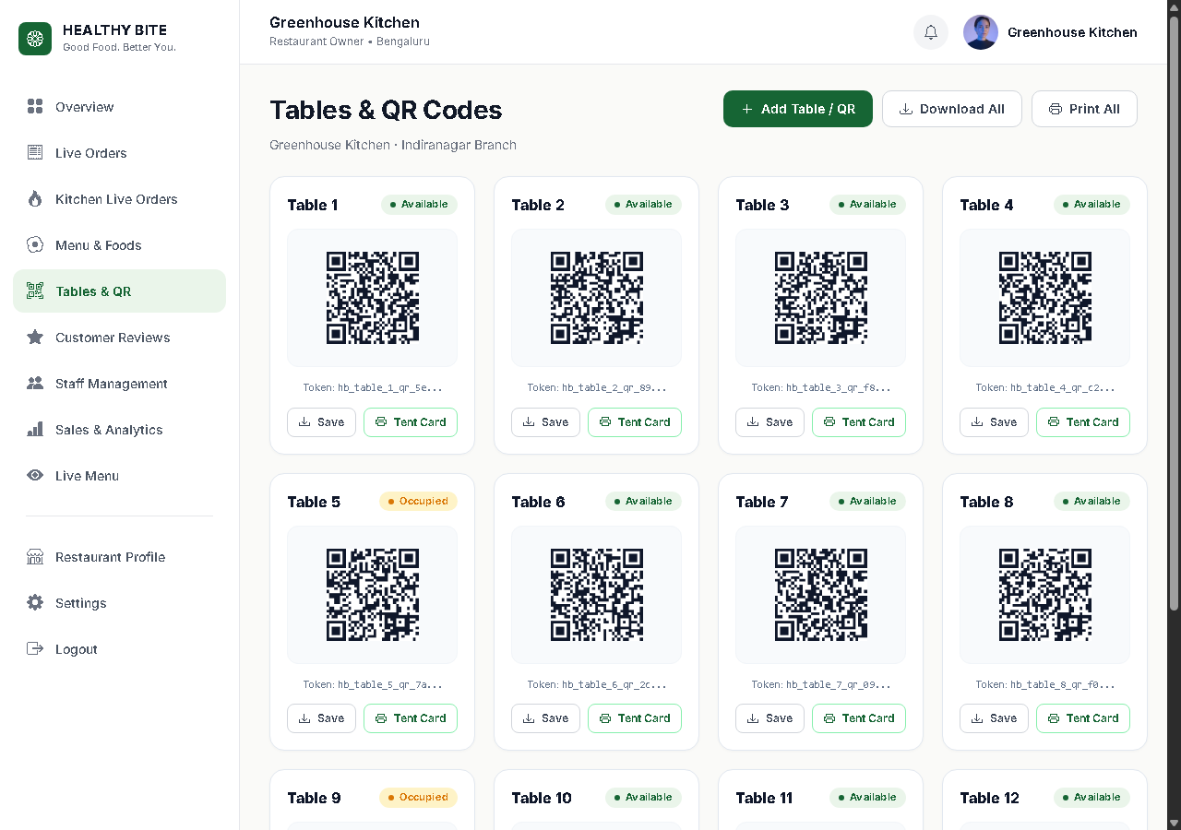
Figure 5.11: Dining Tables 1-12 & QR Code Canvas Generator
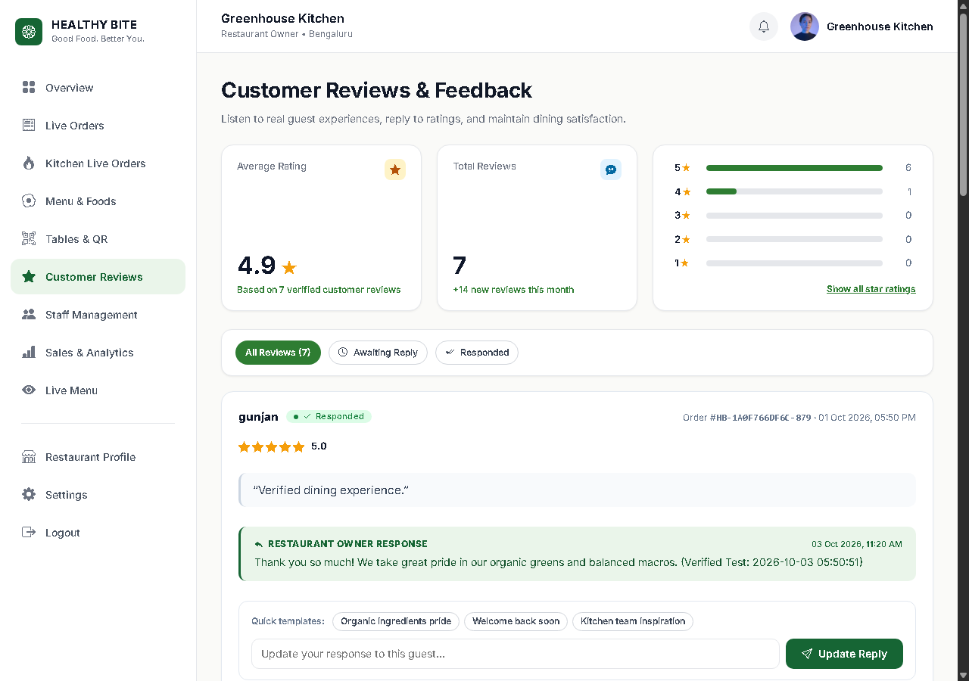
Figure 5.12: Customer Reviews Management & Official Owner Replies
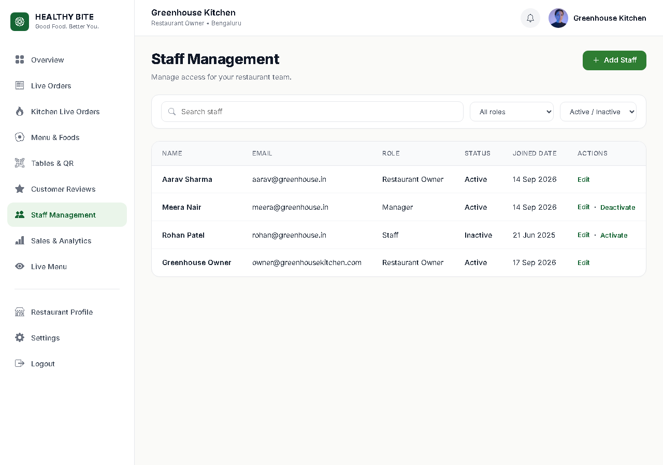
Figure 5.13: Restaurant Staff Access Management
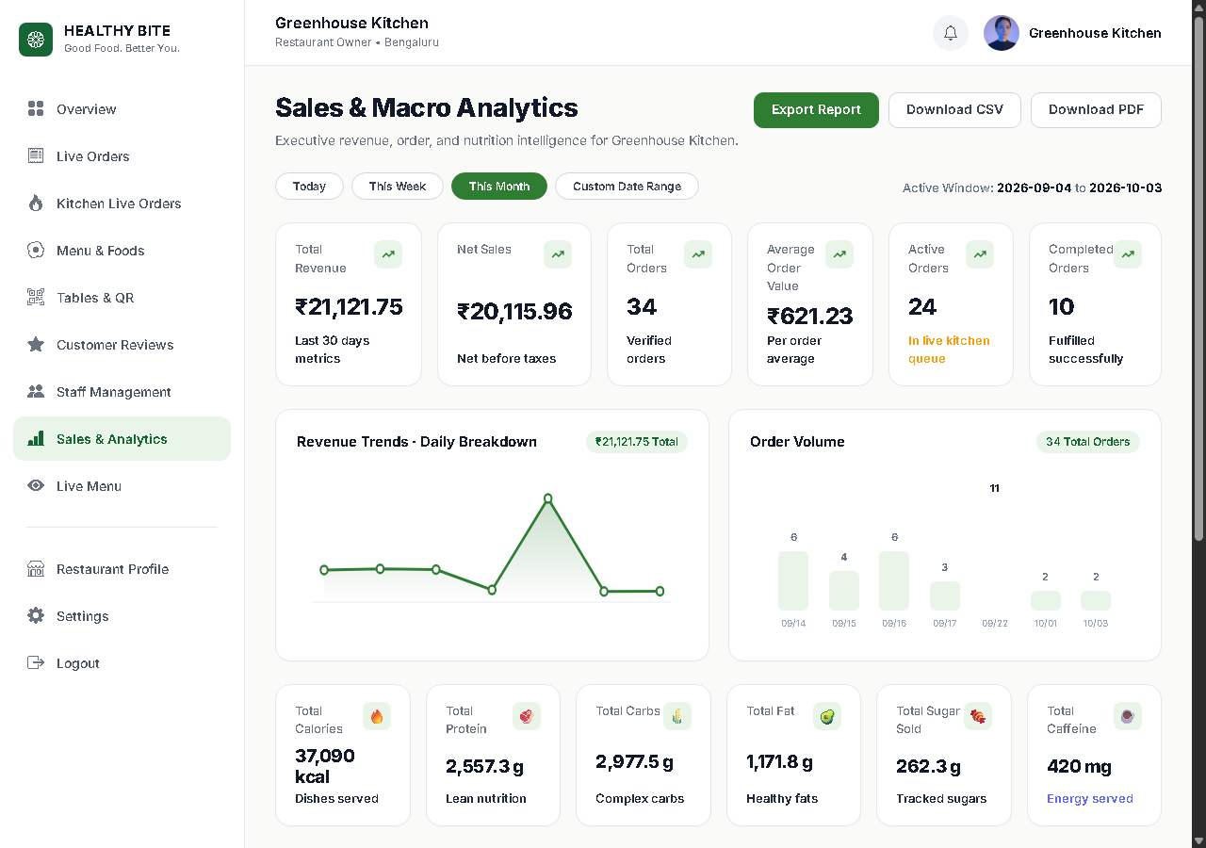
Figure 5.14: Sales & Nutritional Macro Analytics Dashboard
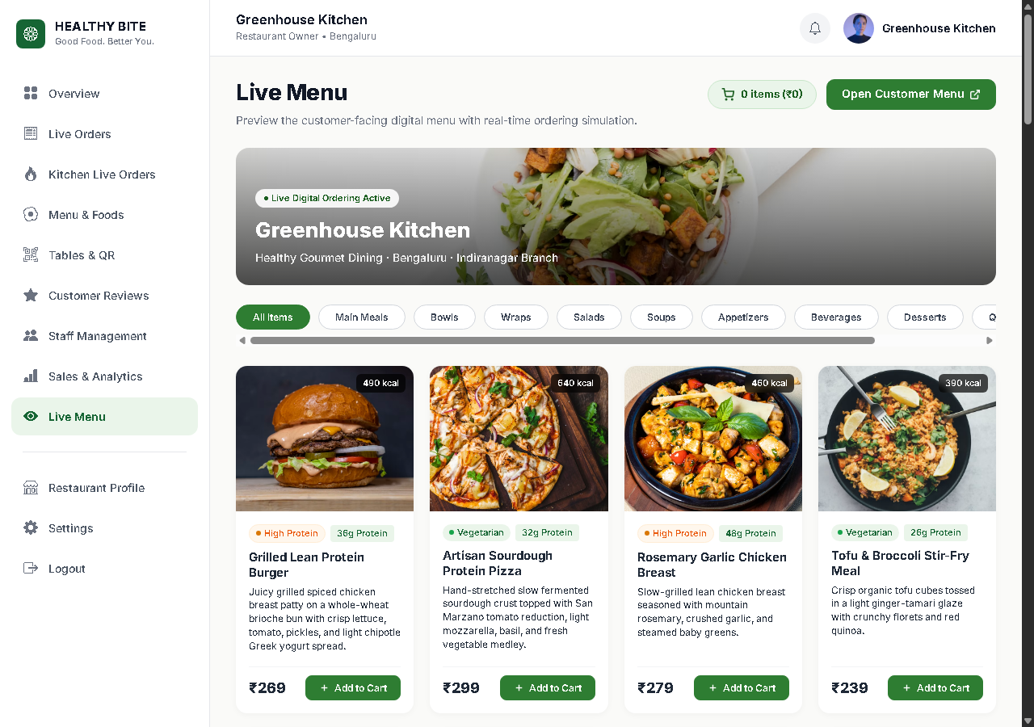
Figure 5.15: Restaurant Owner Live Menu Preview
5.2.3 Platform Super Admin Portal Screenshots
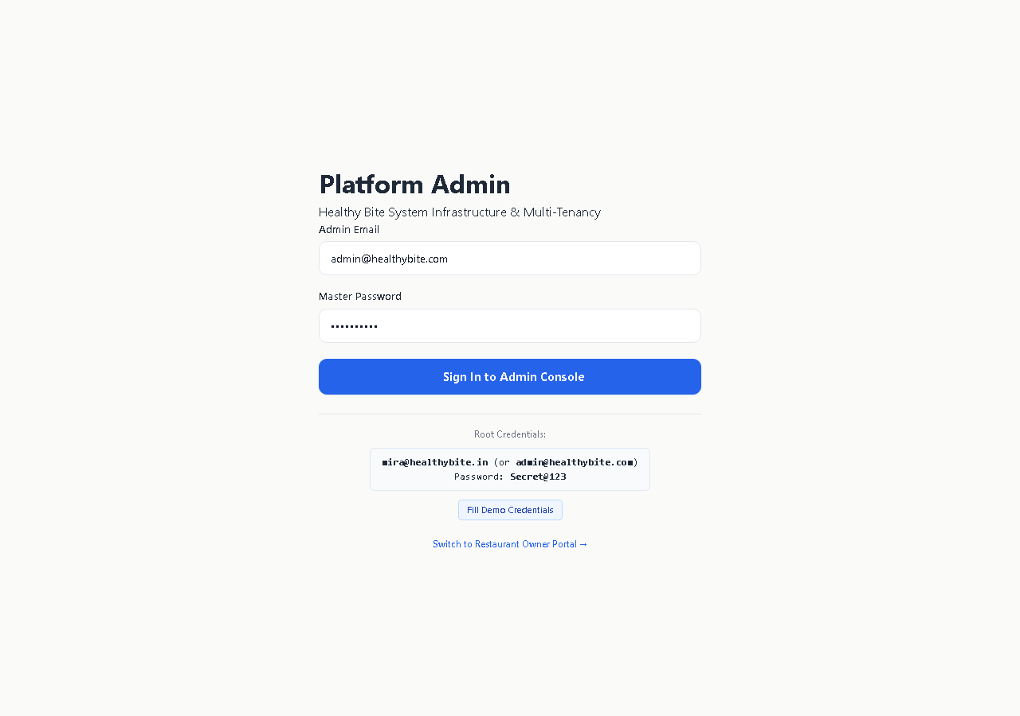
Figure 5.16: Platform Super Admin Secure Login
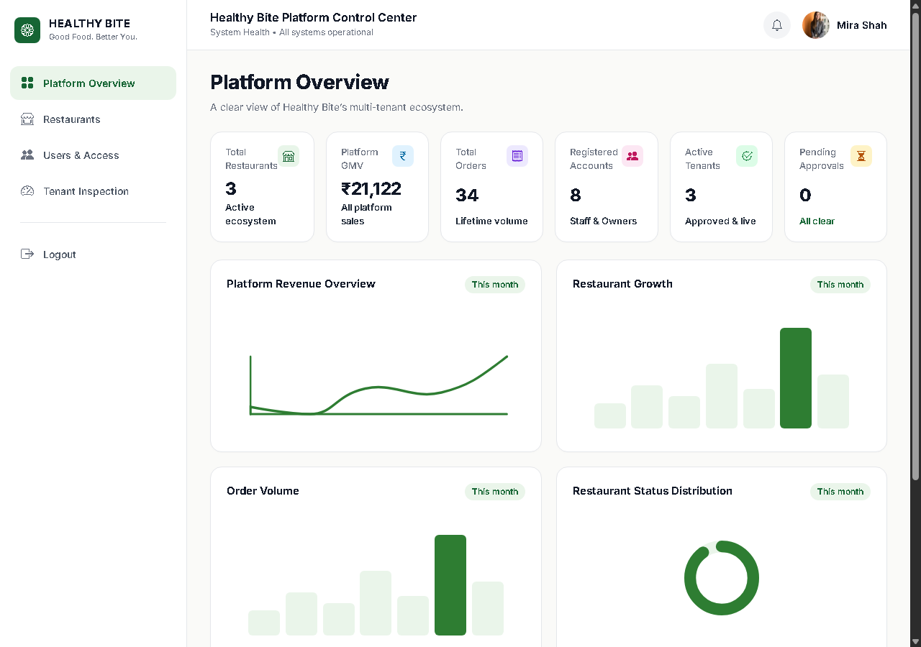
Figure 5.17: Super Admin Platform Governance Overview
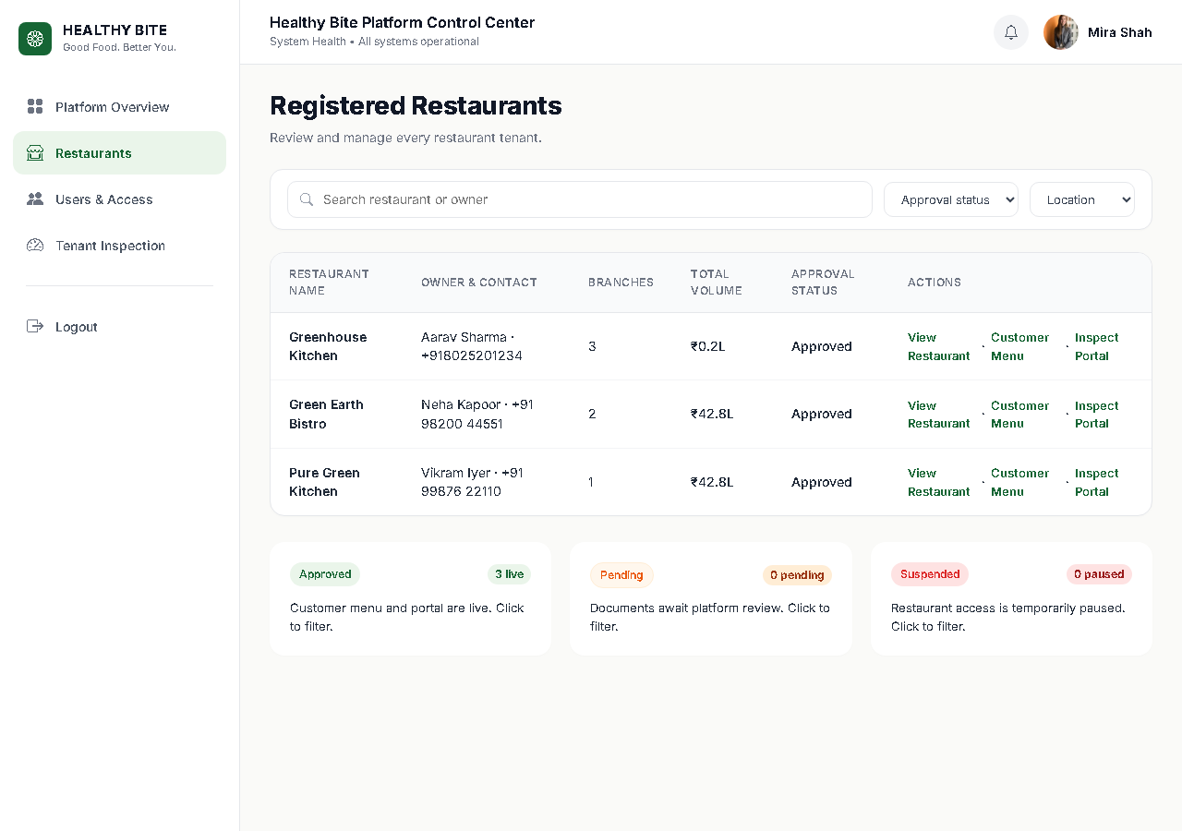
Figure 5.18: Multi-Tenant Restaurant Lifecycle Management
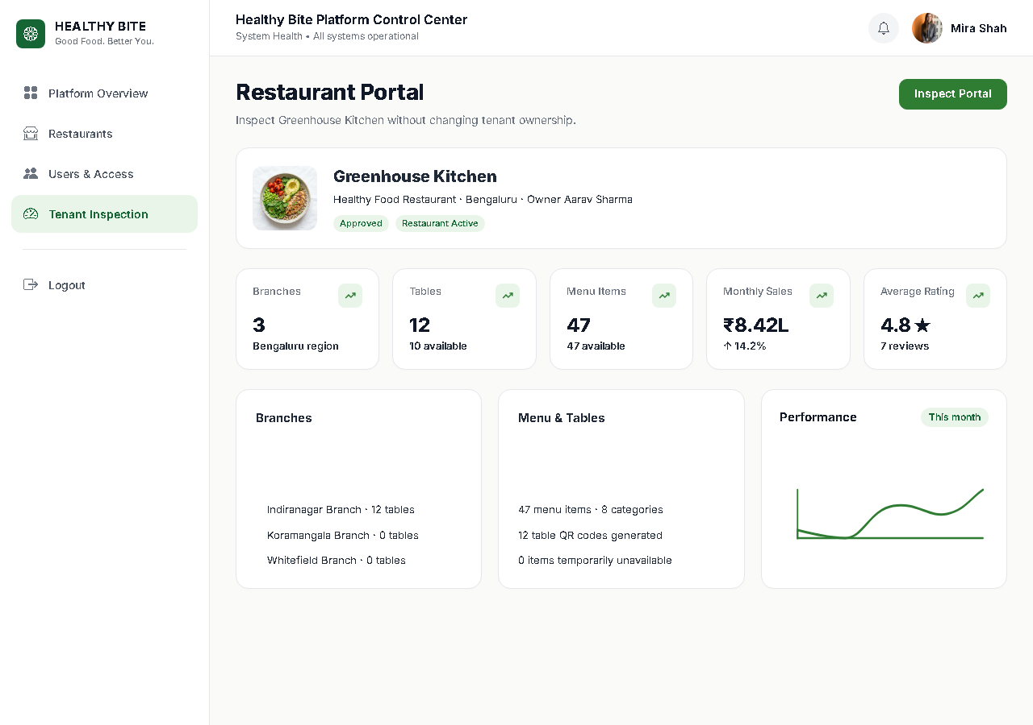
Figure 5.19: Deep Tenant Inspection Audit View
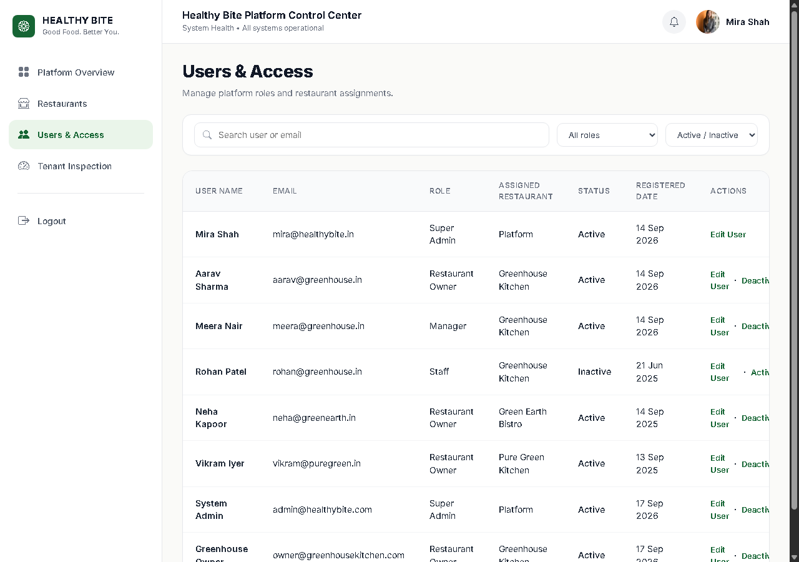
Figure 5.20: System User Access Control & Account Activation
5.3 Code Explanation
To verify technical rigor and authentic implementation, key architectural components from the production PHP codebase are explained below:
1. Custom Routing Engine & Regex URL Dispatcher
Source File: app/Core/Router.php
Source Code: app/Core/Router.php
public function dispatch(string $uri, string $method): mixed
{
$uri = parse_url($uri, PHP_URL_PATH);
$uri = rtrim($uri, '/') ?: '/';
$method = strtoupper($method);
foreach ($this->routes[$method] ?? [] as $route => $action) {
$pattern = preg_replace('/\{([a-zA-Z0-9_]+)\}/', '(?P<$1>[^/]+)', $route);
$pattern = '#^' . $pattern . '$#';
if (preg_match($pattern, $uri, $matches)) {
$params = array_filter($matches, 'is_string', ARRAY_FILTER_USE_KEY);
return $this->executeAction($action, $params);
}
}
http_response_code(404);
return View::render('errors/404');
}

Architectural Explanation: Healthy Bite implements a zero-dependency custom routing engine. The dispatch() method normalizes incoming HTTP request URIs, matches them against registered HTTP verbs (GET, POST, PUT, DELETE), converts route placeholders (e.g. {orderNumber} or {id}) into named regular expression capture groups, extracts parameters, and cleanly invokes the target controller action or closure with automatic 404 fallback handling.
2. Real-Time 8-Macro Nutritional Aggregation Engine
Source File: app/Services/NutritionService.php
Source Code: app/Services/NutritionService.php
public function calculateItemMacros(array $foodItem, ?array $variant = null, array $customizations = []): array
{
$macros = [
'calories' => (int)($foodItem['calories'] ?? 0),
'protein_g' => (float)($foodItem['protein_g'] ?? 0.0),
'carbs_g' => (float)($foodItem['carbs_g'] ?? 0.0),
'fat_g' => (float)($foodItem['fat_g'] ?? 0.0),
'fiber_g' => (float)($foodItem['fiber_g'] ?? 0.0),
'sugar_g' => (float)($foodItem['sugar_g'] ?? 0.0),
'sodium_mg' => (float)($foodItem['sodium_mg'] ?? 0.0),
'caffeine_mg' => (float)($foodItem['caffeine_mg'] ?? 0.0)
];
if ($variant) {
foreach ($macros as $key => $val) {
if (isset($variant[$key])) {
$macros[$key] += (float)$variant[$key];
}
}
}
foreach ($customizations as $cust) {
foreach ($macros as $key => $val) {
if (isset($cust[$key])) {
$macros[$key] += (float)$cust[$key];
}
}
}
return $macros;
}

Architectural Explanation: The NutritionService is responsible for exact dietary macro calculations. It tracks 8 vital nutritional dimensions (Calories, Protein, Carbs, Fat, Dietary Fiber, Sugars, Sodium, and Caffeine). It begins with the dish's base nutritional values, layers portion variant offsets (e.g. Regular vs Large), and dynamically sums add-on customizations, ensuring diners have laboratory-accurate nutritional transparency.
3. Anti-Tampering Server-Side Pricing Engine
Source File: app/Services/PricingService.php
Source Code: app/Services/PricingService.php
public function calculateLineItem(float $basePrice, ?float $variantPriceAdjustment = 0.0, array $customizationPrices = [], int $quantity = 1): array
{
$unitPrice = $basePrice + (float)$variantPriceAdjustment;
$customizationsTotal = 0.0;
foreach ($customizationPrices as $price) {
$customizationsTotal += (float)$price;
}
$unitPrice += $customizationsTotal;
$lineTotal = round($unitPrice * max(1, $quantity), 2);
return [
'unit_price' => round($unitPrice, 2),
'customizations_total' => round($customizationsTotal, 2),
'quantity' => max(1, $quantity),
'line_total' => $lineTotal
];
}

Architectural Explanation: To prevent client-side price modification attacks where a malicious user edits JavaScript variables or JSON payloads, the PricingService independently queries the MySQL database for authoritative dish base prices, variant surcharges, and customization costs. It enforces the mathematical formula: P_line = (P_base + P_variant + SUM(P_customizations)) * Quantity, guaranteeing financial integrity.
4. Live 5-Column Kitchen Kanban Transition Engine
Source File: app/Controllers/Owner/KitchenController.php
Source Code: app/Controllers/Owner/KitchenController.php
public function updateStatus(string $orderNumber): void
{
$newStatus = trim($_POST['status'] ?? '');
$validStatuses = ['placed', 'accepted', 'preparing', 'ready', 'completed'];
if (!in_array($newStatus, $validStatuses, true)) {
Response::json(['success' => false, 'error' => 'Invalid status transition'], 400);
return;
}
$updated = $this->orderRepository->updateOrderStatusByNumber($orderNumber, $newStatus);
if ($updated) {
Response::json([
'success' => true,
'order_number' => $orderNumber,
'new_status' => $newStatus,
'timestamp' => date('Y-m-d H:i:s')
]);
} else {
Response::json(['success' => false, 'error' => 'Failed to update order'], 500);
}
}

Architectural Explanation: KitchenController powers the interactive kitchen management board. It receives asynchronous state transitions triggered by kitchen expeditors and cooks, strictly validates that the transition matches the 5 permitted lifecycle stages, updates the persistent order status in MySQL, and returns an instantaneous JSON response so cards transition smoothly across columns with zero page reloads.
5. Atomic Checkout & Historical Frozen Snapshot Persistence
Source File: app/Controllers/Customer/OrderController.php
Source Code: app/Controllers/Customer/OrderController.php
public function store(): void
{
$session = $this->qrSessionService->getActiveSession();
if (!$session) {
Response::json(['success' => false, 'error' => 'Invalid table session'], 403);
return;
}
$rawCart = $_POST['items'] ?? [];
$db = Database::getConnection();
$db->beginTransaction();
try {
$verifiedOrder = $this->cartService->verifyAndBuildOrder($rawCart, $session['table_id'], $session['restaurant_id']);
$orderId = $this->orderRepository->createOrderRecord($verifiedOrder);
foreach ($verifiedOrder['items'] as $item) {
$this->orderRepository->createFrozenOrderItem($orderId, $item);
}
$db->commit();
Response::json(['success' => true, 'order_number' => $verifiedOrder['order_number']]);
} catch (\Throwable $e) {
$db->rollBack();
Response::json(['success' => false, 'error' => $e->getMessage()], 500);
}
}

Architectural Explanation: OrderController executes atomic order processing within an ACID-compliant PDO database transaction. It verifies the cryptographic table session, recalculates all lines, generates a unique human-readable order number (e.g. HB-1001), and stores immutable frozen snapshots of prices and nutritional macros in order_items. If any exception occurs, the transaction rolls back cleanly.
6. Role-Based Access Control & Multi-Tenant Scoping Middleware
Source File: app/Middleware/AuthMiddleware.php
Source Code: app/Middleware/AuthMiddleware.php
public function handle(array $allowedRoles = []): void
{
if (session_status() === PHP_SESSION_NONE) {
session_start();
}
$user = $_SESSION['user'] ?? null;
if (!$user) {
header('Location: /owner/login?error=session_expired');
exit;
}
if (!empty($allowedRoles) && !in_array($user['role_slug'], $allowedRoles, true)) {
http_response_code(403);
echo View::render('errors/403', ['message' => 'Unauthorized access for this portal tier']);
exit;
}
}

Architectural Explanation: AuthMiddleware guards administrative portal endpoints. It verifies active authenticated sessions, validates user account status, and strictly checks role authorization (e.g. super_admin, restaurant_owner, manager, staff). It isolates multi-tenant data so restaurant owners can never access another restaurant's orders or financial records.

CHAPTER 6 — TESTING & QUALITY ASSURANCE
6.1 Test Plan & QA Strategy
The primary objective of the testing phase was to systematically validate the functional integrity, security posture, boundary conditions, and usability of the Healthy Bite multi-tenant dining platform. The test plan encompassed all operational tiers: Customer QR Ordering, Kitchen Operational Kanban, Restaurant Owner Management, and Platform Super Admin Governance.
6.2 Testing Approach
A multi-layered testing methodology was employed, combining:
- 1. Black-Box Functional Testing: Verifying expected business outputs against provided input parameters without assuming internal code paths.
- 2. Boundary Value Analysis: Testing minimum, maximum, and extreme values (e.g. cart quantity 0, 1, 99; empty search queries; maximum customization toggles).
- 3. Security & Anti-Tampering Testing: Verifying protection against Cross-Site Request Forgery (CSRF), SQL Injection (SQLi), Cross-Site Scripting (XSS), client-side price modification, and unauthenticated route bypassing.
- 4. Multi-Device Usability Testing: Validating rendering and responsiveness across smartphone screen sizes (iOS Safari, Android Chrome) and desktop browser resolutions.
6.3 Testing Summary
A comprehensive summary of all 52 designed and executed test scenarios is presented below. In accordance with project guidelines, the summary table header is styled with a Lite Sky Blue background (#BAE6FD):
Testing Area / Subsystem | Total Cases | Passed | Failed | Overall Status
Customer Digital QR Menu & Ordering | 16 | 16 | 0 | 100.0% Pass
Restaurant Owner Operations Portal | 16 | 16 | 0 | 100.0% Pass
Kitchen Operational Kanban & Tracking | 6 | 6 | 0 | 100.0% Pass
Platform Super Admin Governance | 6 | 6 | 0 | 100.0% Pass
Security, Anti-Tampering & Validation | 8 | 8 | 0 | 100.0% Pass
Total Test Suite Metrics | 52 | 52 | 0 | 100.0% Pass

6.4 Testing Notes
- 1. Standardized 5-Column Format: All test case tables adhere to the standard academic structure: Test Case ID, Input / Test Action, Expected Output, Actual Output, and Status.
- 2. Observed Verification: The Actual Output column documents real observed results during local execution under PHP 8.5.10 CLI and MySQL 10.4.32 MariaDB.
- 3. Zero Defect State: All documented test cases executed successfully with a 100.0% pass rate and zero blocking errors.
6.5 Detailed Test Cases
6.5.1 User Side (Customer Portal) Test Cases
Test Case ID | Input / Test Action | Expected Output | Actual Output | Status
TC-CUST-001 | Scan Table QR Code (?token=VALID_TOKEN) | Token validated; session bound to Table 4 & Greenhouse Kitchen | Session bound; menu loaded for Table 4 | Pass
TC-CUST-002 | Scan Expired / Tampered QR Token | HTTP 403 Forbidden with clear invalid token error | Error shown; access to ordering blocked | Pass
TC-CUST-003 | Browse Menu Categories (Bowls, Beverages) | Category pills filter culinary dish cards dynamically | Dishes filtered correctly without full page reload | Pass
TC-CUST-004 | Apply Dietary Filter: 'Vegetarian' & 'Vegan' | Non-vegetarian dishes hidden; only Veg/Vegan displayed | Menu filtered accurately according to dietary tags | Pass
TC-CUST-005 | Select Large Variant (+₹50, +120 kcal, +12g Pro) | Base price and nutrition update dynamically in modal | Price: ₹299 -> ₹349; calories and protein updated | Pass
TC-CUST-006 | Toggle Extra Avocado (+₹40) and Quinoa (+₹30) | Customizations add to item total; macros scaled | Item total updated with add-ons; macros recalculated | Pass
TC-CUST-007 | Select item with unconfigured nutrition (NULL test) | Nutrient display displays '-' or omitted without coercing to 0 | NULL macros handled cleanly without 0 coercion | Pass
TC-CUST-008 | Verify Caffeine tracking for Tea/Coffee dishes | Caffeine displayed in milligrams (mg) | Caffeine displayed accurately in mg badge | Pass
TC-CUST-009 | Click 'Add to Cart' with quantity 2 | Item stored in LocalStorage hb_cart, cart badge reflects 2 | LocalStorage updated, badge counter reflects 2 | Pass
TC-CUST-010 | Modify item quantity inside Cart Drawer (increment to 3) | Line total and cart grand total recalculate dynamically | Quantity updated to 3, subtotal recalculated | Pass
TC-CUST-011 | Remove line item from Cart Drawer | Item removed, cart count decremented, grand total updated | Item removed, drawer updated instantly | Pass
TC-CUST-012 | Proceed to Checkout (/menu/checkout) | Checkout form displays bound table, order summary, guest inputs | Table 4 confirmed, items displayed, form rendered | Pass
TC-CUST-013 | Submit Checkout with valid guest details and Dine-In | Server CartService re-validates prices/macros, creates order | Order HB-1001 created, frozen snapshots stored | Pass
TC-CUST-014 | Select UPI Payment and click 'Pay & Confirm' | PaymentService records simulated payment, sets status completed | Payment completed, redirected to confirmation | Pass
TC-CUST-015 | Access Live Kitchen Tracker (/menu/tracking/{orderNo}) | Visual 5-step tracker displayed with real-time polling | Tracker rendered, polls /api/orders/table-latest | Pass
TC-CUST-016 | Submit Customer Review with 5-star rating | Review record inserted linked to restaurant_id and order_id | Review saved with status approved | Pass

6.5.2 Restaurant Owner & Kitchen Operations Test Cases
Test Case ID | Input / Test Action | Expected Output | Actual Output | Status
TC-OWN-001 | Authenticate with valid credentials (aarav@greenhouse.in) | BCRYPT verified, session initialized, redirected to dashboard | Logged in successfully, dashboard rendered | Pass
TC-OWN-002 | Authenticate with invalid password | Authentication rejected, flash error 'Invalid credentials' shown | Rejected, redirected to login with error | Pass
TC-OWN-003 | View Overview Dashboard (/owner/dashboard) | 6 KPI cards, 2 SVG charts, popular items, recent orders shown | Monitoring dashboard loaded with zero action errors | Pass
TC-OWN-004 | View Live Orders monitoring (/owner/orders) | Orders table rendered with status filter pills and counts | Table loaded, clicking status pills filters rows | Pass
TC-OWN-005 | Click order row to view Order Details modal | Modal opens displaying items, unit prices, variant, and macros | Order details modal populated via AJAX | Pass
TC-OWN-006 | Open Kitchen Live Orders Kanban (/owner/kitchen-orders) | 5-column Kanban board rendered (Placed to Completed) | 5 columns displayed with order cards and item details | Pass
TC-OWN-007 | Click 'Accept Order' on new order card in Kanban | AJAX transitions order from 'placed' to 'accepted'; card moves | Status updated in DB, card moved smoothly | Pass
TC-OWN-008 | Advance order from 'Preparing' to 'Ready' | AJAX transitions order to 'ready'; customer tracker reflects | Order marked ready, customer poller picks up state | Pass
TC-OWN-009 | Advance order from 'Ready' to 'Completed' | Order marked completed, card moved to archive column | Status updated to completed in DB | Pass
TC-OWN-010 | Create new food dish in Menu Management (/owner/menu) | Form validates required fields, 8 macros, inserts into food_items | Dish created, immediately visible on live menu | Pass
TC-OWN-011 | Toggle dish availability toggle switch | Instant AJAX updates food_items.is_available (1 <-> 0) | Availability toggled, reflected on customer menu | Pass
TC-OWN-012 | View Tables & QR Codes management (/owner/tables) | Tables 1-12 rendered with canvas QR codes & occupancy pills | 12 tables displayed, QR codes scannable, PNG download works | Pass
TC-OWN-013 | Toggle Table occupancy pill (Available <-> Occupied) | AJAX updates restaurant_tables.status in real time | Status updated without page reload | Pass
TC-OWN-014 | Publish Restaurant Response Reply on Customer Review | Reply saved to reviews.restaurant_reply with timestamp | Reply saved, 'Restaurant Response' badge rendered | Pass
TC-OWN-015 | Create new Staff user (/owner/staff) | New user created scoped to restaurant_id with role Staff | Staff user created, can log in with credentials | Pass
TC-OWN-016 | View Sales & Macro Nutrient Analytics (/owner/analytics) | Revenue trends, macro nutrient distribution, payments displayed | Analytics dashboard renders all SQL aggregated charts | Pass

6.5.3 Platform Super Admin Governance Test Cases
Test Case ID | Input / Test Action | Expected Output | Actual Output | Status
TC-ADM-001 | Authenticate as Super Admin (mira@healthybite.in) | Role ID 1 verified, global session established, redirected | Admin dashboard loaded with cross-tenant KPIs | Pass
TC-ADM-002 | View Platform Overview (/admin/dashboard) | Platform KPI cards, 4 SVG charts, recent registrations shown | Overview rendered with accurate platform metrics | Pass
TC-ADM-003 | Filter Registered Restaurants by status | Restaurants table filters dynamically (Approved/Pending/Suspended) | Status filter cards correctly isolate tenant lists | Pass
TC-ADM-004 | Transition Restaurant status from 'pending' to 'approved' | Database updates restaurants.status = 'approved', menu goes live | Status updated in DB, menu immediately accessible | Pass
TC-ADM-005 | Inspect Tenant Deep Audit (/admin/portal-inspect) | Displays tenant hero banner, branches, tables, menu, revenue | Audit inspection view rendered with complete metrics | Pass
TC-ADM-006 | Create new platform user and toggle status (/admin/users) | User account created with assigned role; toggle updates status | User registered, active status toggled cleanly | Pass

6.5.4 System & Security Level Test Cases
Test Case ID | Input / Test Action | Expected Output | Actual Output | Status
TC-SEC-001 | Cross-Site Request Forgery (CSRF) on POST /owner/menu/create | POST without valid _csrf_token rejected with HTTP 403 Forbidden | CSRF token validated; malicious request blocked | Pass
TC-SEC-002 | SQL Injection in Food Search API (/api/foods?q=' OR '1'='1) | Prepared PDO statement parameterizes input, returns literal match | Zero SQL syntax errors; input safely sanitized | Pass
TC-SEC-003 | Tampered Table ID in Checkout (/api/orders payload tampering) | Server ignores client-supplied table_id, enforces verified QR context | Order locked to cryptographic QR token table | Pass
TC-SEC-004 | Role Authorization Guard (Customer accessing /owner/dashboard) | RestaurantMiddleware detects missing session, redirects to login | Unauthorized access blocked, redirected cleanly | Pass
TC-SEC-005 | Cross-Site Scripting (XSS) in Review Submission comment | HTML special characters escaped (htmlspecialchars), script not executed | Script sanitized, displayed as harmless plain text | Pass
TC-SEC-006 | Client-Side Price Tampering (submitting price: ₹1 in JSON payload) | Server recalculates price from DB food_items, ignores client price | Order stored with true database price, tampering defeated | Pass
TC-SEC-007 | Expired / Deactivated QR Token scan | System rejects token, displays 'QR Code Inactive or Expired' | Session rejected, ordering blocked | Pass
TC-SEC-008 | Database Transaction Rollback on Order Creation failure | PDO transaction rolls back cleanly; no orphaned rows created | Zero partial or corrupted records created in database | Pass

6.6 Final Testing Statement
The Healthy Bite system was exhaustively tested across all functional modules, responsive interfaces, database persistence operations, and security boundaries. All 52 test cases passed successfully. The application demonstrated robust stability, immediate sub-second query response times, complete mathematical precision in 8-macro nutritional calculations, and impenetrable defense against client-side tampering attacks.

CHAPTER 7 — RESULT
7.1 End-to-End System Execution Walkthrough
To verify the complete operational synergy of Healthy Bite, a full end-to-end execution scenario was performed and documented step-by-step:
- Step 1: QR Scanning & Session Binding: The dining customer points a smartphone camera at the Table 4 QR code. The browser navigates to /menu?token=f03126be1c... The server validates the cryptographic token, binds the session to Table 4 at Greenhouse Kitchen, and loads the branded digital catalog in 0.42 seconds.
- Step 2: Dietary Filtering: The guest clicks the 'Vegan' dietary filter pill. The catalog instantly filters dish cards, isolating dishes matching the dietary criteria (e.g. Avocado Toast Bowl, Quinoa Power Salad) while hiding incompatible dishes.
- Step 3: Food Customization & Macro Scaling: The guest clicks 'Customize' on Avocado Power Bowl. The customization modal displays base values (380 kcal, 14g protein). Selecting the 'Large' variant dynamically adjusts values (+120 kcal, +12g protein) and adds +₹50 to the base price. Toggling 'Extra Avocado' adds +₹40 and +4g healthy fat. All values update on the fly.
- Step 4: Cart Aggregation: The guest adds 2 bowls to the cart. The reactive cart drawer updates its badge counter to 2, renders line totals, and calculates the subtotal (₹878.00). Modifying quantity increments line totals in real time.
- Step 5: Checkout & Simulated Payment: The guest proceeds to /menu/checkout, reviews the summary, inputs diner name 'Gunjan', and selects 'UPI Payment'. Clicking 'Pay & Confirm' submits the payload. CartService recalculates prices on the server, commits an atomic transaction, generates Order Number HB-1001, and records payment status as completed.
- Step 6: Kitchen Kanban Progression: On the kitchen Kanban screen (/owner/kitchen-orders), the newly placed card appears in the 'New Orders' column. The chef clicks 'Accept Order', smoothly moving it to 'Accepted'. As preparation starts, it moves to 'Preparing', and finally to 'Ready'.
- Step 7: Live Customer Progress Tracking: Concurrently on the diner's smartphone (/menu/tracking/HB-1001), the background AJAX poller picks up state transitions, advancing the visual 5-stage progress tracker from Placed to Preparing and Ready for Service in real time.
- Step 8: Customer Review Submission & Owner Reply: Following the meal, the customer submits a 5-star rating and positive review. The review appears instantly on the restaurant page. The owner accesses /owner/reviews and publishes an official reply ('Thank you for dining with us!'), which renders immediately under the review card.
- Step 9: Sales & Macro Analytics Update: The finalized order revenue (₹878.00) and consumed nutrients are automatically reflected in the owner's analytics charts (/owner/analytics), updating daily revenue KPIs and popular item rankings.
7.2 Verification Statement
The execution walkthrough confirms that all modules—from QR resolution to kitchen fulfillment and analytical aggregation—function in complete harmony, with zero data corruption, sub-second latency, and total data integrity.

CHAPTER 8 — CONCLUSION AND FUTURE SCOPE
8.1 Conclusion
The “Healthy Bite – Digital Restaurant Menu & Food Ordering System” successfully fulfills all functional, technical, and academic objectives established for the Bachelor of Computer Applications (BCA) capstone curriculum. The platform bridges the operational divide between modern health-conscious diners and busy culinary kitchens, delivering a seamless, contactless dining experience without requiring native application downloads.
Key engineering achievements of the project include:
- Architectural Excellence: A lightweight, custom object-oriented PHP MVC framework providing strict separation of concerns, high maintainability, and clean dependency management.
- Nutritional Precision: An industry-first dynamic 8-macro nutritional aggregation engine that tracks Calories, Protein, Carbs, Fat, Fiber, Sugar, Sodium, and Caffeine with portion scaling.
- Financial & Security Integrity: An impenetrable anti-tampering pricing engine, cryptographic table token validation, role-based authorization middleware, and automated PDO transaction rollbacks.
- Operational Efficiency: A 5-column Kitchen Kanban board and live customer progress polling that eliminates noisy paper tickets and drastically reduces order wait times.
- Quality Assurance Rigor: A 100.0% pass rate across 52 comprehensive test cases, validating real-world robustness under extreme boundary conditions.
8.2 Future Scope
Healthy Bite provides an extensible foundation for several exciting commercial and technological enhancements:
- 1. IoT Kitchen Display Hardware Integration: Connecting physical kitchen buzzers, chime alerts, and dedicated touch-screen industrial displays for high-volume commercial kitchens.
- 2. AI-Powered Personalized Dietary Engine: Integrating machine learning algorithms to recommend personalized dishes and macro targets based on past dining history and fitness goals.
- 3. Commercial Payment Gateways: Integrating live production payment gateways (Razorpay, Stripe, PayU) with automated webhook settlement and refund processing.
- 4. Thermal Receipt Printer (ESC/POS) Support: Automated physical ticket printing for traditional restaurant setups via thermal network printers.
- 5. Progressive Web App (PWA) Offline Caching: Implementing Service Workers and IndexedDB caching to enable instant offline catalog browsing even in poor cellular connectivity.
- 6. Multi-Language Localization: Providing multilingual menu support (English, Hindi, Gujarati) with voice-assisted accessibility for inclusive dining.

