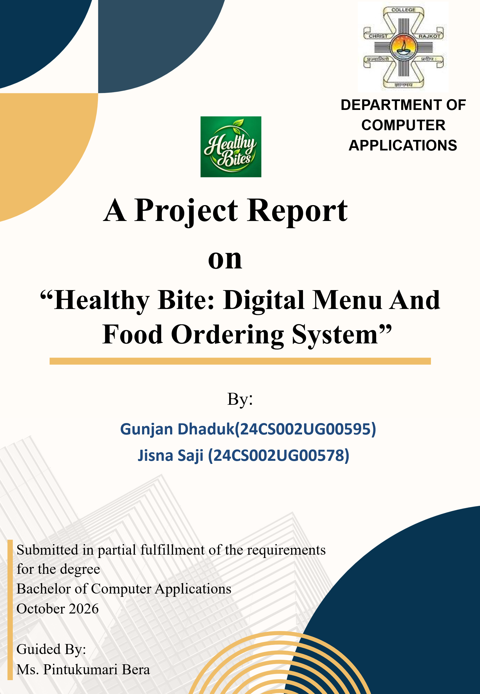

Certificate
This is to certify that the work presented in the BCA project report entitled “Healthy Bite: Digital Menu And Food Ordering System”, submitted to the Department of Computer Applications, Christ College, Rajkot, in partial fulfilment of the requirements for the award of the Bachelor of Computer Applications, is an authentic record of the work carried out by Gunjan Dhaduk & Jisna Saji during the period from June 2026 to October 2026 under the supervision of Ms. Pintukumari Bera

We also certify that this work has not been submitted, either in part or full, for the award of any other degree elsewhere.
Signature of Gunjan Dhaduk : __________
Signature of Jisna Saji : __________

This is to certify that the above statement made by the candidate(s) is/are correct to the best of my knowledge.
Head | Guide
Dr. Shailendrasinh Jadeja | Ms. Pintukumari Bera
Department of Computer Applications | Department of Computer Applications
Christ College, Rajkot | Christ College, Rajkot
Place: Rajkot
Date: __________

Acknowledgement
When we embarked on this project, it initially appeared to us as an onerous task. However, as we progressed, we realized that we were not alone in this journey. We wish to express our sincere gratitude to Rev. Fr. (Dr.) Jomon Thommana, Director, Christ Campus, and Dr. Yvonne Fernandes, Principal, Christ College, for their constant support and encouragement.
We are deeply thankful to Ms. Pintukumari Bera, our project guide, for their invaluable guidance, suggestions, and the freedom they provided us throughout this project. Without their mentorship, the completion of this project would not have been possible.
We also extend our heartfelt thanks to Ms. Pintukumari Bera, our friends for offering their unwavering support, encouragement, and assistance during the preparation of this project.
Our gratitude also goes to our group members, classmates, and well-wishers, whose generous help made this work considerably easier. Finally, our deepest thanks to our parents, who patiently bore with us through the challenges and supported us with a smile throughout our study period and beyond.

Gunjan Dhaduk
Jisna Saji
Christ College, Rajkot
October 2026

TABLE OF CONTENTS
Chapter / Section | Title & Major Subsections | Page No.
Chapter 01 | Introduction | 3
Chapter 02 | Objectives, Scope, Features, Actors | 4
Chapter 03 | System Analysis (Problem Definition, Existing vs Proposed, Feasibility) | 6
Chapter 04 | SDLC | 8
Chapter 05 | System Design & Modeling (DFD Levels 0/1/2, ER Schema, Activity, Use Case, Process Flow, Class) | 11
Chapter 06 | Data Dictionary (All 17 Relational Tables Specification & Constraints) | 22
Chapter 07 | System Implementation (Directory Map, UI Screenshots Walkthrough) | 32
Chapter 08 | Code Explanations | 45
Chapter 09 | Testing & Quality Assurance (Test Plan, Approach, Summary, 74 Test Cases, Final Statement) | 54
Chapter 10 | Result (Step-by-Step Test Execution & End-to-End Workflow Verification) | 60
Chapter 11 | Conclusion & Future Scope (Academic Summary, Scalability, IoT KDS, AI Meal Engine) | 73

1.Introduction
The modern hospitality and food service industry is undergoing a profound paradigm shift driven by consumer demand for health-conscious dining, real-time dietary transparency, and contactless digital interactions. Traditional dining establishments rely predominantly on static, physical paper or laminated cardboard menus. While familiar, physical menus present acute operational limitations: they are expensive to reprint whenever prices or ingredients change, they cannot dynamically reflect immediate kitchen item availability, they cannot verify nutritional values, and they cannot calculate individual ingredient customizations in real time.

Healthy Bite is conceptualized and engineered to bridge this operational divide. Built as a high-performance, responsive multi-tenant web application, Healthy Bite empowers seated restaurant guests to scan a table-side cryptographic QR code using any smartphone browser, instantly gaining access to a rich digital culinary catalog. Without installing native applications or undergoing cumbersome registration flows, customers can browse dishes, filter by dietary lifestyles (Vegetarian, Non-Vegetarian, Vegan, Jain), inspect potential allergens, customize dish portions and add-ons, view dynamic 8-macro nutritional calculations, and transmit verified orders directly to the kitchen.

2. Objectives
2.1 Project Overview
Healthy Bite is a lightweight, object-oriented PHP MVC restaurant management system that connects customers, kitchen staff, restaurant owners, and the Super Admin.
- Customer: Browse QR menu, customize food, view nutrition, place orders, pay, and track orders.
- Kitchen Staff: Manage orders using a 5-stage Kanban board.
- Restaurant Owner: Manage menu, tables, QR codes, staff, reviews, and sales analytics.
- Super Admin: Manage and monitor restaurants and users across the platform.
2.2 Objectives of the System
The main objectives are to:
- Replace paper menus with digital QR-based menus.
- Provide 8 nutrition details for customized food items.
- Validate prices, GST, and nutrition on the server to prevent tampering.
- Improve kitchen order handling through a Kanban system.
- Secure table access using unique QR tokens.
- Support multiple restaurants with separate management.
2.3 Scope of the System
In-Scope
QR menu access, restaurant-specific menus, food customization, dynamic price and nutrition calculation, cart and checkout, simulated Cash/UPI/Card payment, order tracking, kitchen Kanban, table and QR management, reviews, staff management, analytics, and Super Admin control.
Out-of-Scope
Live payment gateway integration, inventory automation, native mobile apps, WebSocket servers, and cloud receipt-printer integration.

2.4 Major Features
- Secure QR-based table access
- Digital food catalog with dietary and allergen information
- Food customization with portion and add-ons
- Dynamic 8-macro nutrition calculation
- Server-verified price and 5% GST calculation
- Cart and checkout system
- Frozen order snapshots
- Cash, UPI, and Card payment simulation
- 5-stage kitchen Kanban
- Live customer order tracking
- Table and QR management
- Customer reviews and owner replies
- Sales and nutrition analytics
- Multi-restaurant Super Admin governance
2.5Target Users / System Actors
- Dining Customer: Browses menu, customizes food, orders, pays, tracks orders, and reviews.
- Kitchen Staff: Views and updates customer orders.
- Restaurant Owner/Manager: Manages menu, tables, staff, reviews, and analytics.
- Super Admin: Manages restaurants, users, and platform-level operations.

3.System Analysis
3.1 Problem Definition
In conventional restaurant operations, the traditional ordering process relies on physical paper or cardboard menus and verbal order communication. During peak lunch and dinner hours, this manual workflow introduces severe friction: customers experience long wait times before a waiter arrives to take their order; dietary preferences and allergy requirements are frequently miscommunicated verbally to the kitchen; physical menus fail to reflect sold-out items, leading to customer disappointment; and health-conscious diners have zero visibility into calorie, protein, or sugar contents. Furthermore, printing physical menus represents a continuous recurring expense whenever prices or recipes are updated. Healthy Bite eliminates these operational inefficiencies by establishing a direct, digitized bridge between diners, kitchen expeditors, and restaurant management.
3.2 Existing System vs. Proposed System
Operational Parameter | Existing Traditional System | Proposed Healthy Bite Architecture
Ordering Mechanism | Waiters physically bring laminated paper cards; verbal dictation. | Contactless table QR code scanning; instant browser menu access.
Menu Updates & Pricing | Requires expensive physical reprints; prices can become outdated. | Real-time updates via Owner Portal; instant price/dish reflection.
Nutritional Transparency | Virtually non-existent; zero allergen or macro tracking. | Real-time 8-macro breakdown (Calories, Protein, Carbs, Fat, etc.).
Dish Customization | Prone to verbal miscommunication and kitchen errors. | Interactive UI modal; live price adjustments and portion scaling.
Kitchen Communication | Manual physical KOT paper transport to kitchen counter. | Real-time 5-column Kitchen Kanban board (Placed to Completed).
Live Order Tracking | Customers must wave down waitstaff to ask about food status. | Live 5-stage progress tracker polling real-time kitchen status.
Billing & Payment | Manual calculation by cashier; delay in bill presentation. | Server-verified bill computation with simulated payment settlement.
Hygiene & Contact | Physical menus handled by dozens of customers daily. | Zero physical contact; completely hygienic mobile interface.

Feasibility Study
1.Technical Feasibility
The technical feasibility of Healthy Bite is exceptionally robust. The system is engineered using battle-tested web standards: PHP 8.2+ with strict typing, MySQL 8.x (InnoDB engine) with transactional foreign key integrity, Native PHP Data Objects (PDO) with parameterized prepared statements, Semantic HTML5, Vanilla CSS3 with custom variables, and Vanilla JavaScript (ES6+). The entire application runs seamlessly on standard LAMP/XAMPP server configurations and requires zero proprietary third-party runtime frameworks or licensed servers.
2.Economic Feasibility
From an economic standpoint, Healthy Bite represents a cost-effective solution with immediate operational return on investment (ROI). By eliminating paper menu design and periodic reprinting expenses, restaurants save thousands of rupees annually. The reliance on open-source technologies (PHP, MariaDB/MySQL, Vanilla JS) eliminates expensive software licensing fees. Furthermore, table turnaround efficiency increases by up to 25%, allowing restaurants to serve more guests during peak dining hours without hiring additional front-of-house staff.
3.Operational Feasibility
The operational feasibility of the system is substantiated by its intuitive, consumer-grade user experience design. Dining customers require no training whatsoever; scanning a QR code is a universally understood interaction across modern smartphone users. The kitchen Kanban board uses simple, high-contrast action buttons ('Accept Order', 'Start Preparing', 'Mark Ready', 'Complete Order') designed specifically for fast-paced commercial kitchen environments.
4.Schedule Feasibility
The development lifecycle was planned and executed within the designated academic timeframe (June 2026 – October 2026), ensuring sufficient allocation for planning, analysis, architecture, coding, testing, release validation, and documentation.

4.SDLC
SDLC Timeline for Healthy Bite Project (June 15 – Oct 25)
1. Project Planning (June 15 – June 25) → 10 days
- Define the project problem and objectives.
- Identify project scope and limitations.
- Select the required technology stack.
- Prepare the feasibility study.
2. Requirement Analysis (June 26 – July 5) → 10 days
- Collect system requirements.
- Prepare the SRS document.
- Identify users, modules, and system features.
- Define dietary and nutrition requirements.
3. System Design (July 6 – July 20) → 15 days
- Create ER, DFD, and UML diagrams.
- Design the database schema.
- Prepare the system architecture and UI design.
4. Implementation / Coding (July 21 – Sept 10) → ~50 days
- Develop the custom PHP MVC architecture.
- Implement the PDO database layer.
- Develop the 8-macro nutrition and pricing system.
- Build customer, kitchen, owner, and admin modules.
- Implement the UI and core functionality.
5. Testing & Integration (Sept 11 – Sept 30) → 20 days
- Integrate all system modules.
- Perform functional and security testing.
- Test database operations and system validation.
- Fix errors and perform regression testing.
- Prepare the testing report.
6. Deployment & Finalization (Oct 1 – Oct 10) → 10 days
- Seed and configure the database.
- Set up the server/demo environment.
- Verify all major features.
- Perform the final release check.
7. Documentation Preparation (Oct 11 – Oct 25) → 15 days
- Complete the final project report.
- Add diagrams, screenshots, and testing results.
- Review and finalize project documentation.
- Prepare the PPT for viva and demonstration.
- Complete final submission.
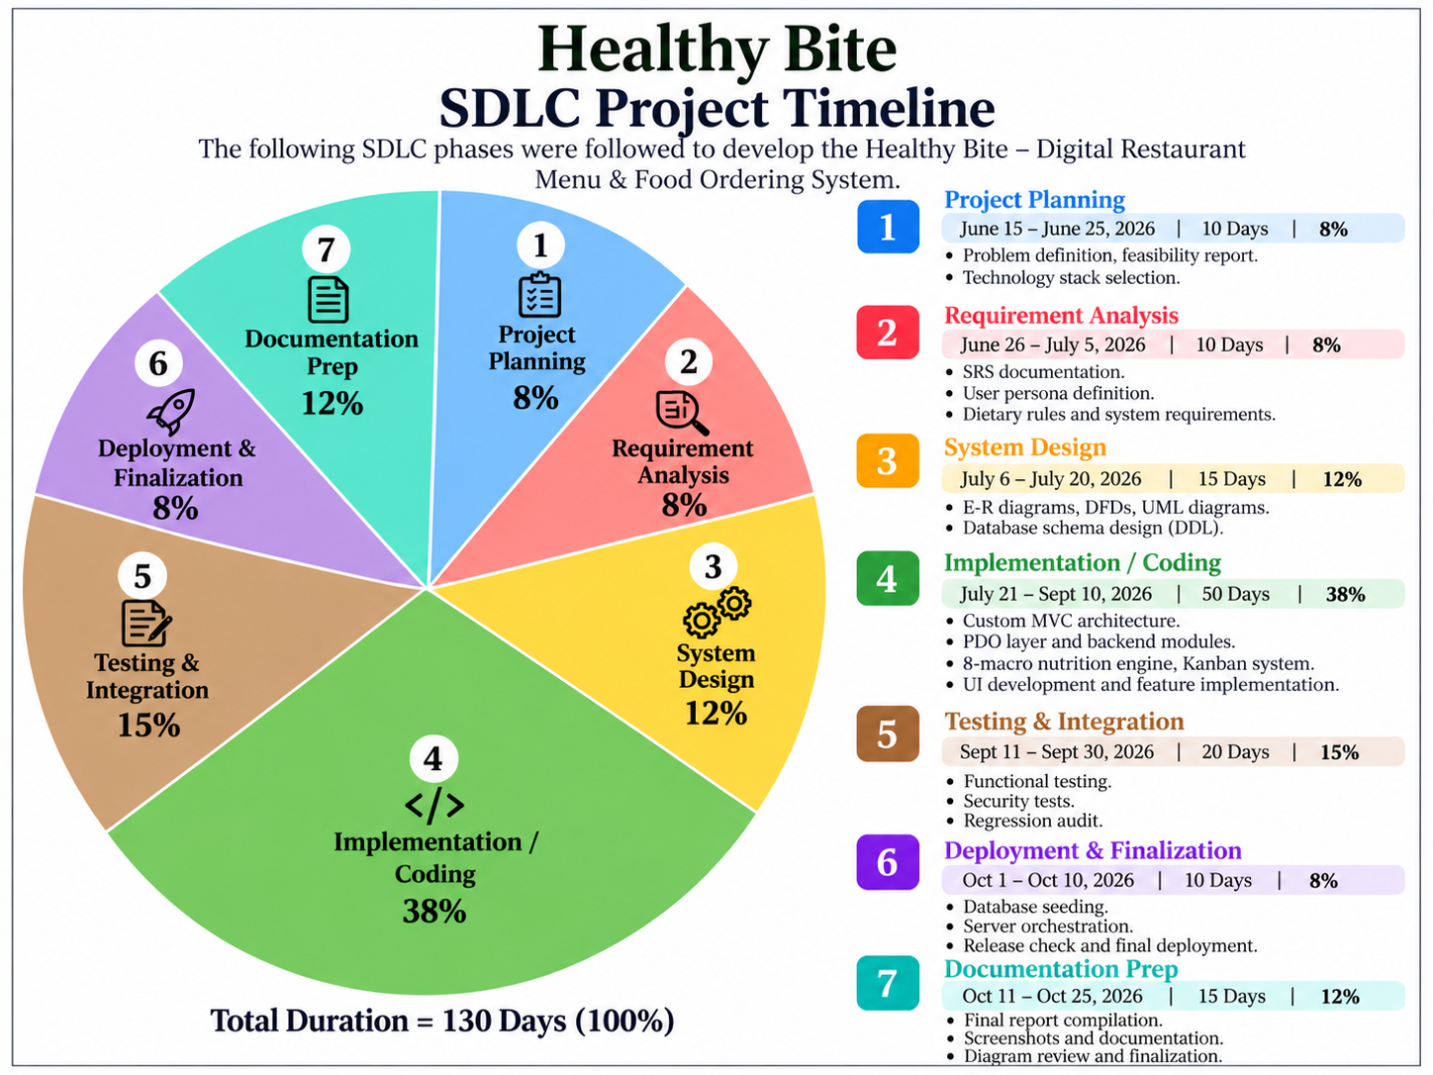
5. System Design
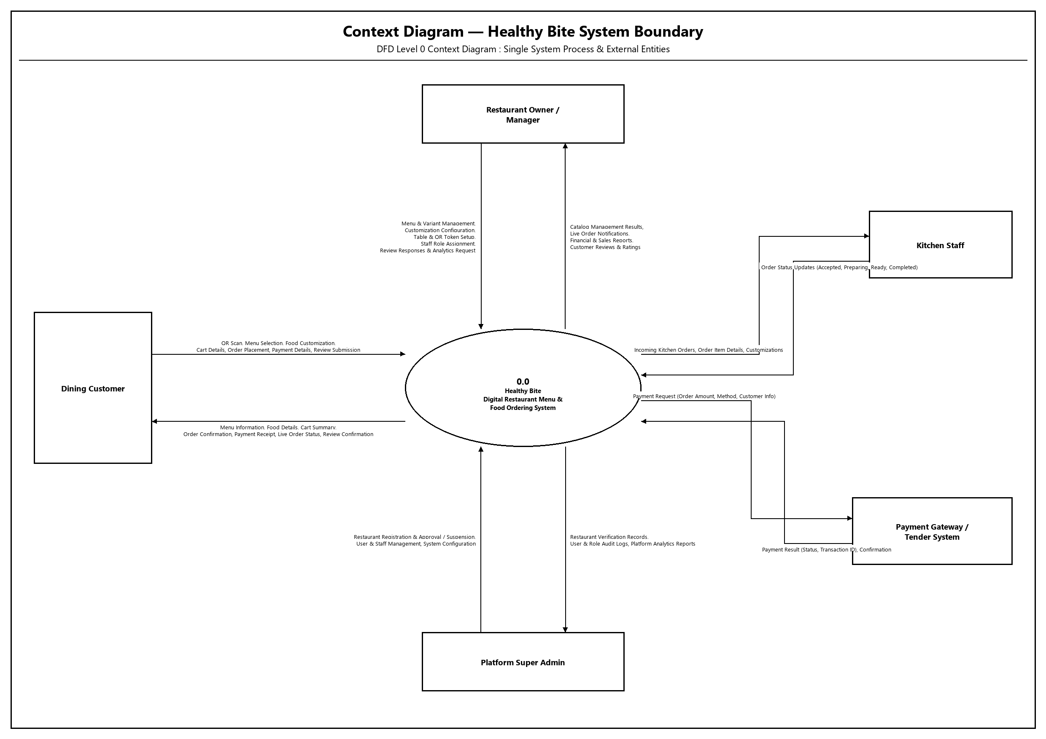
DFD

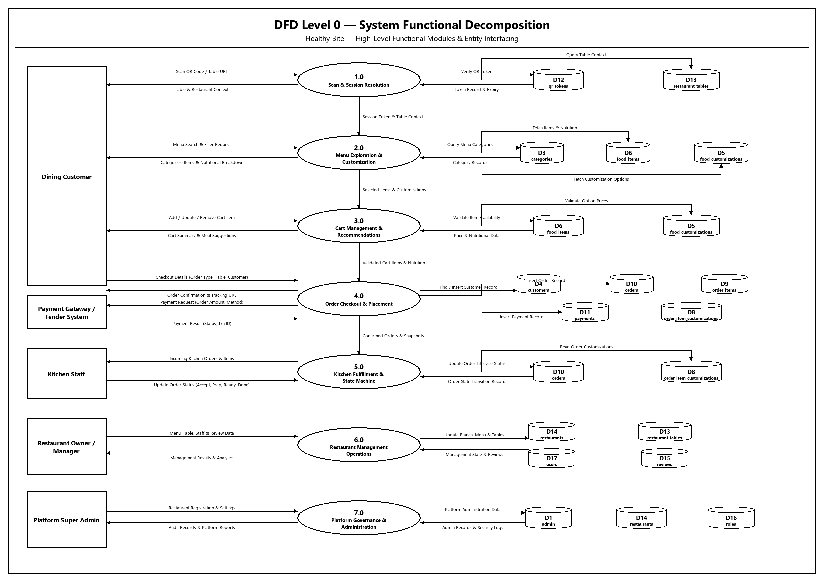

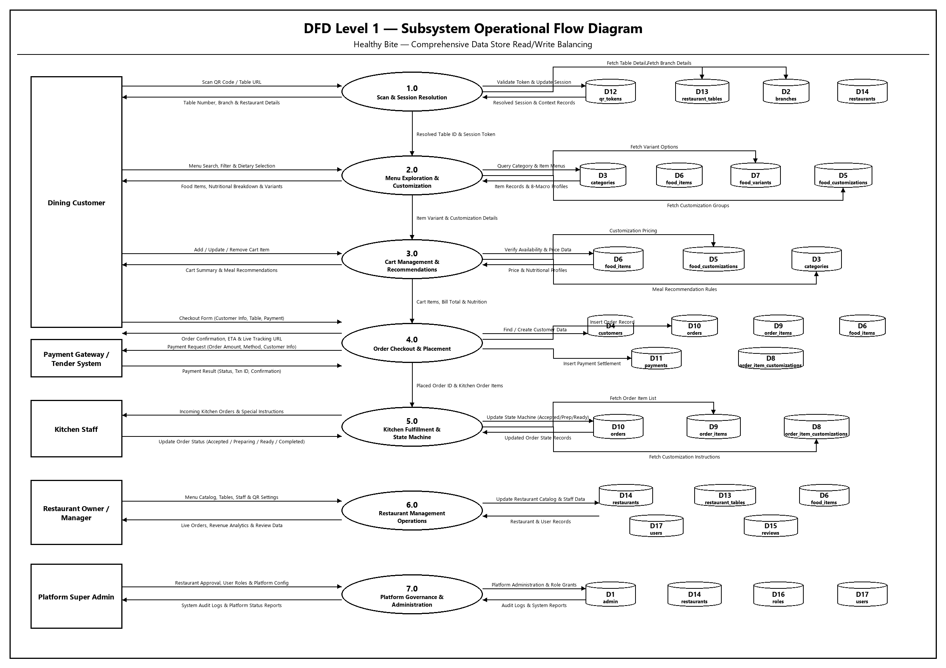

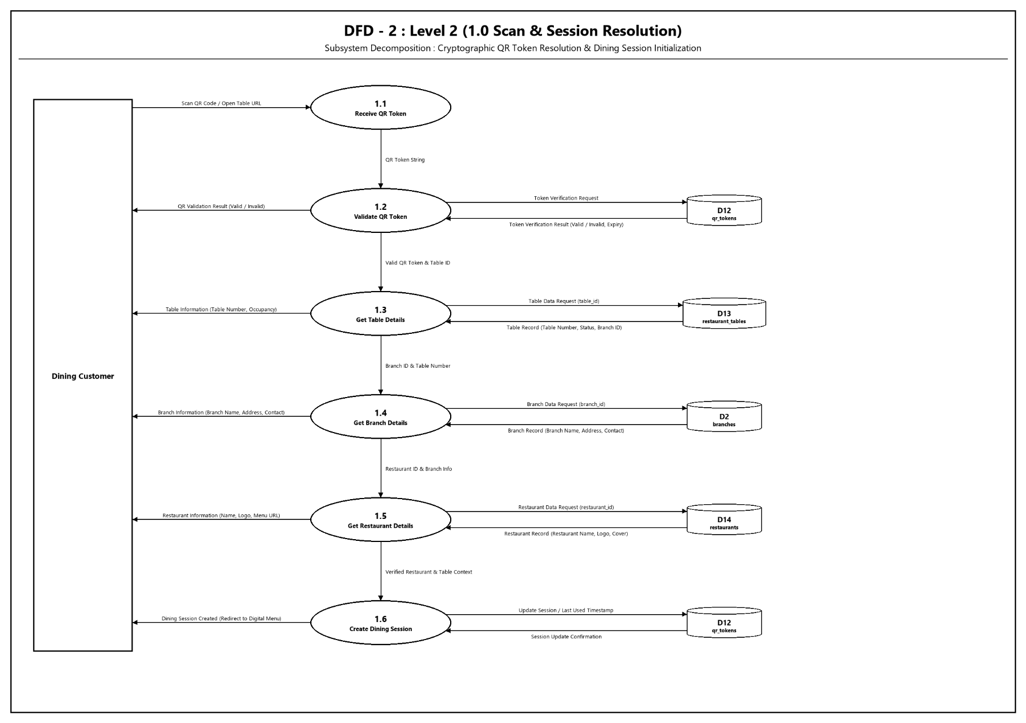
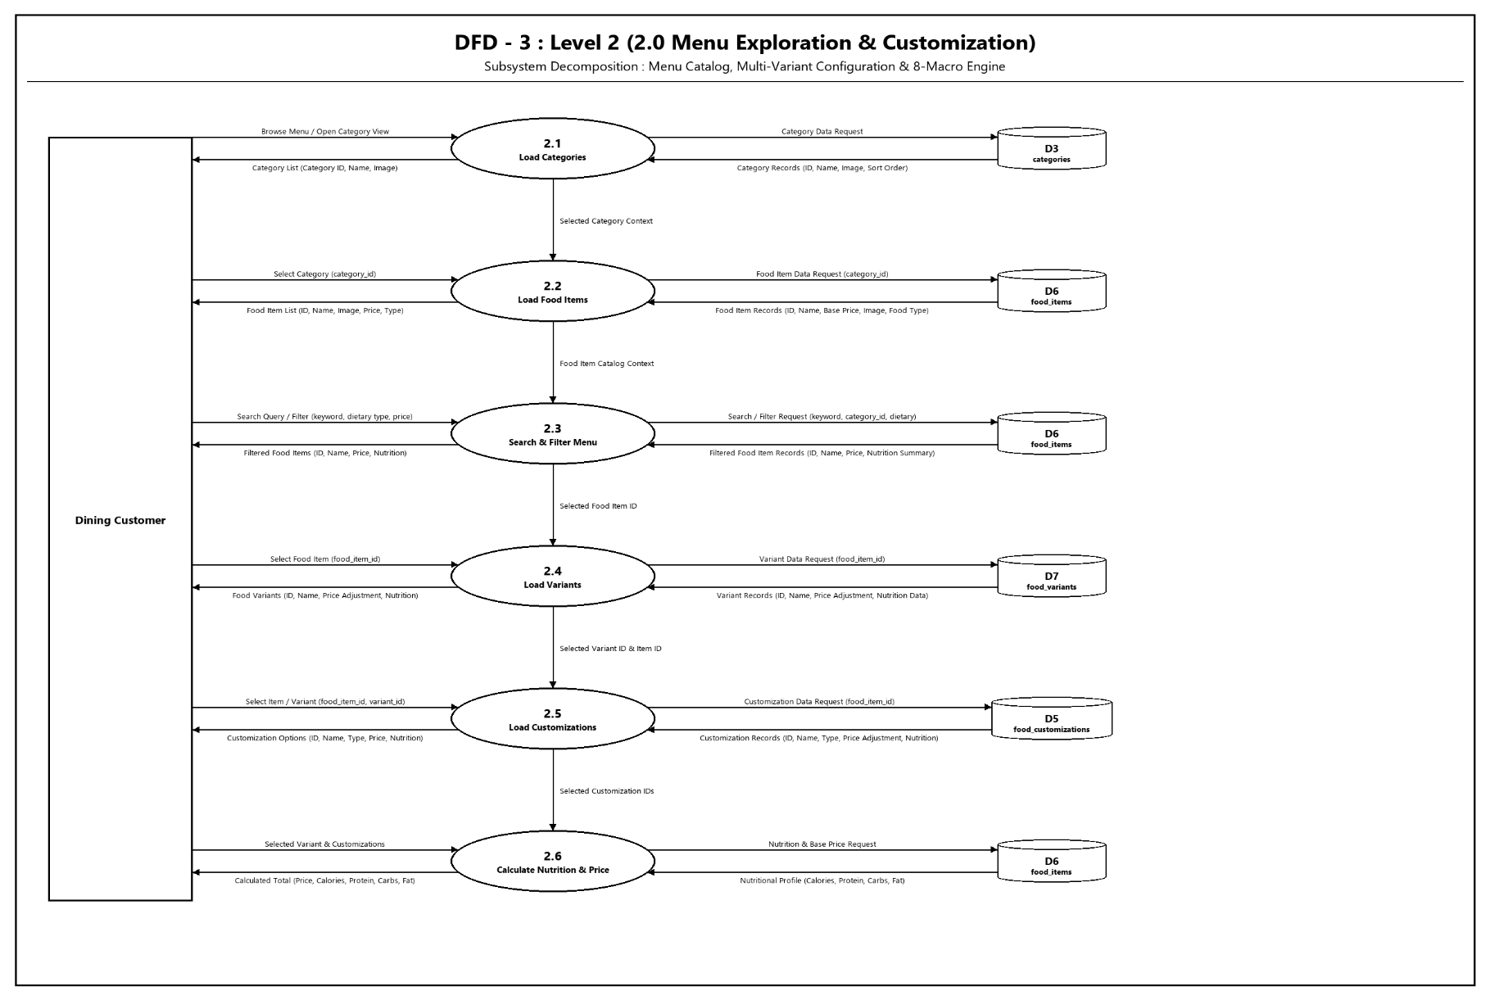
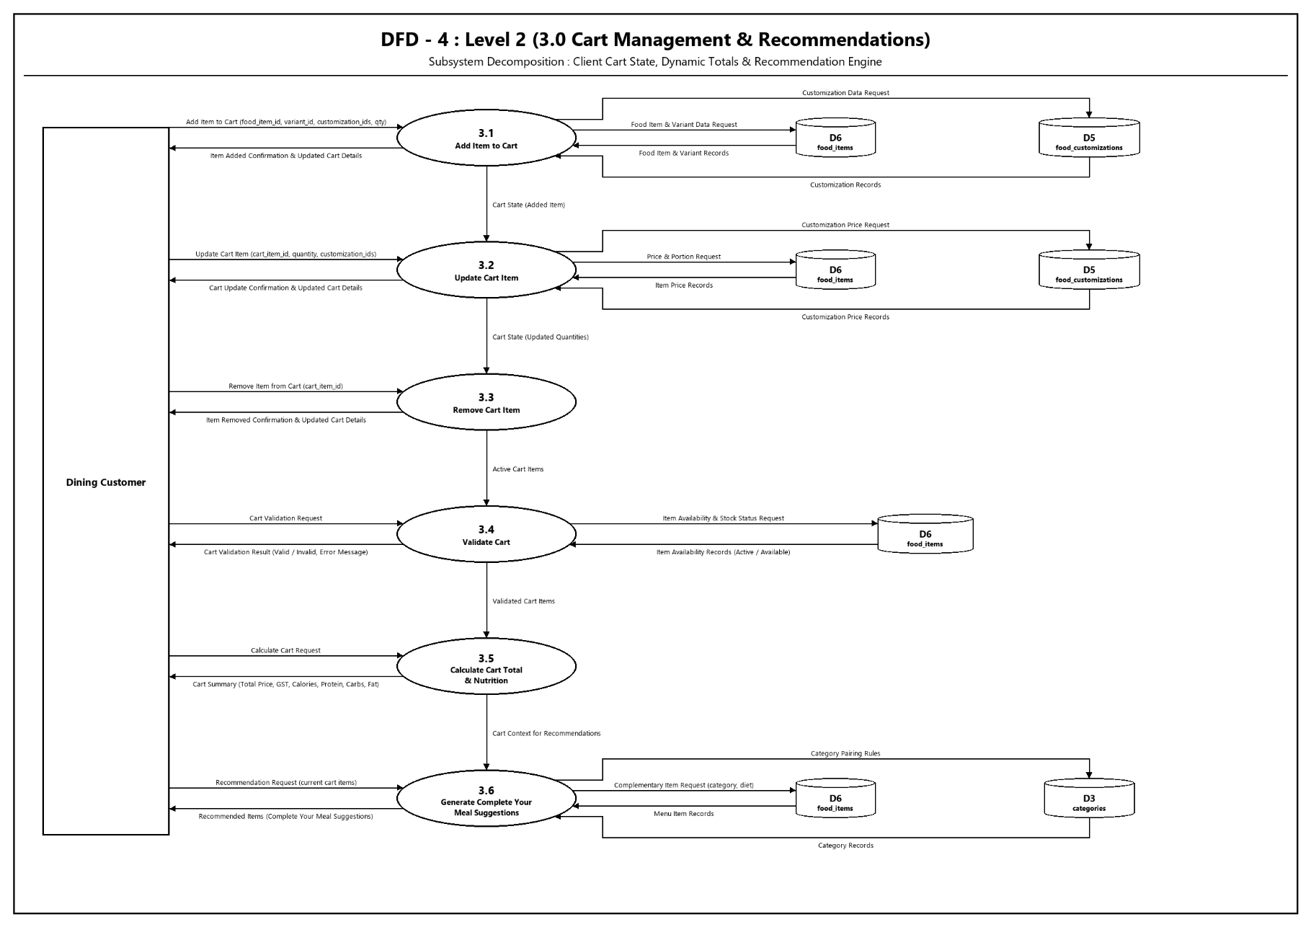
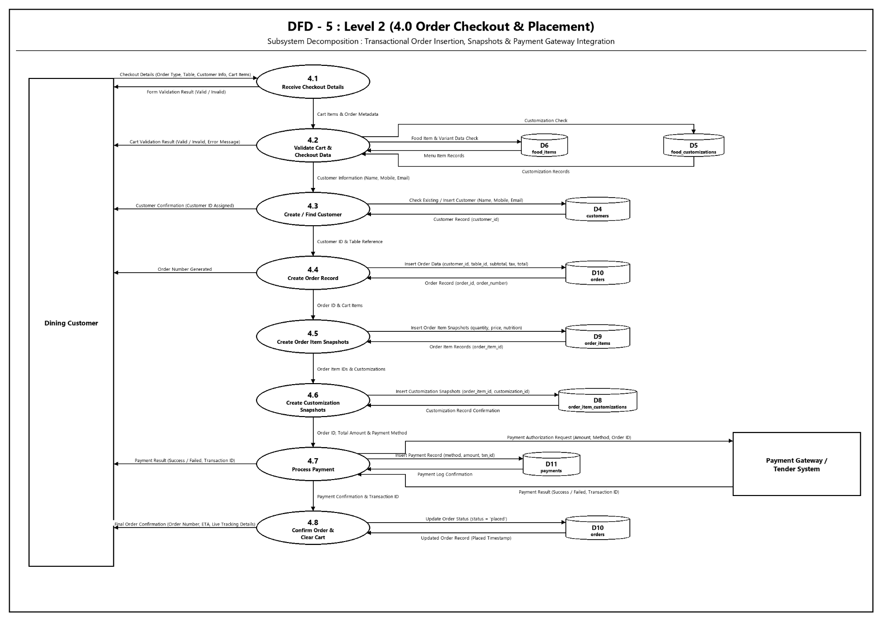
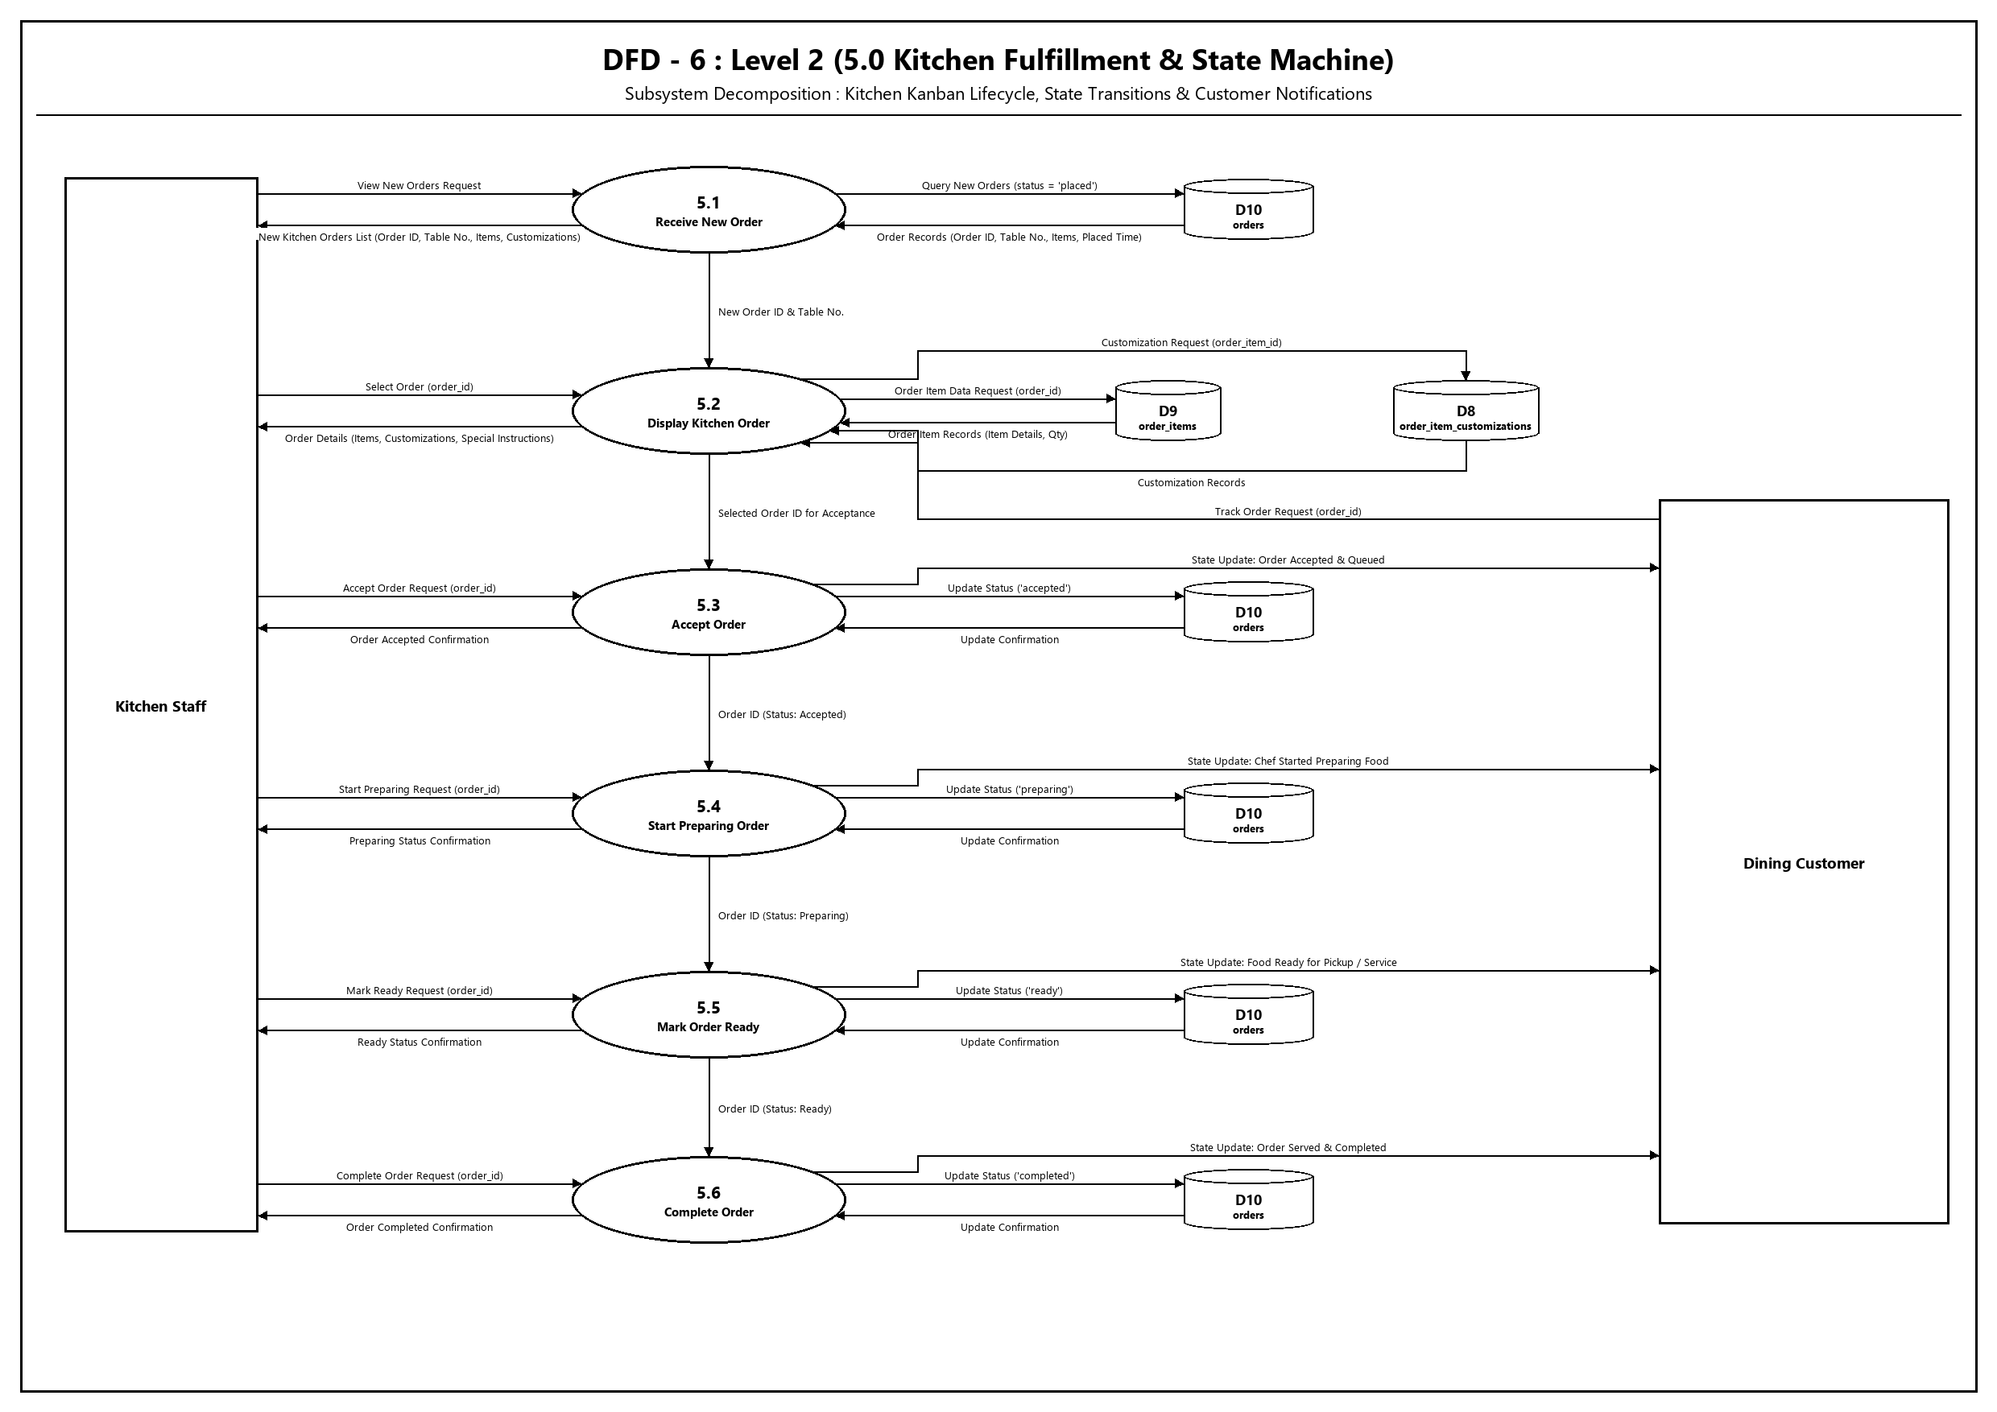

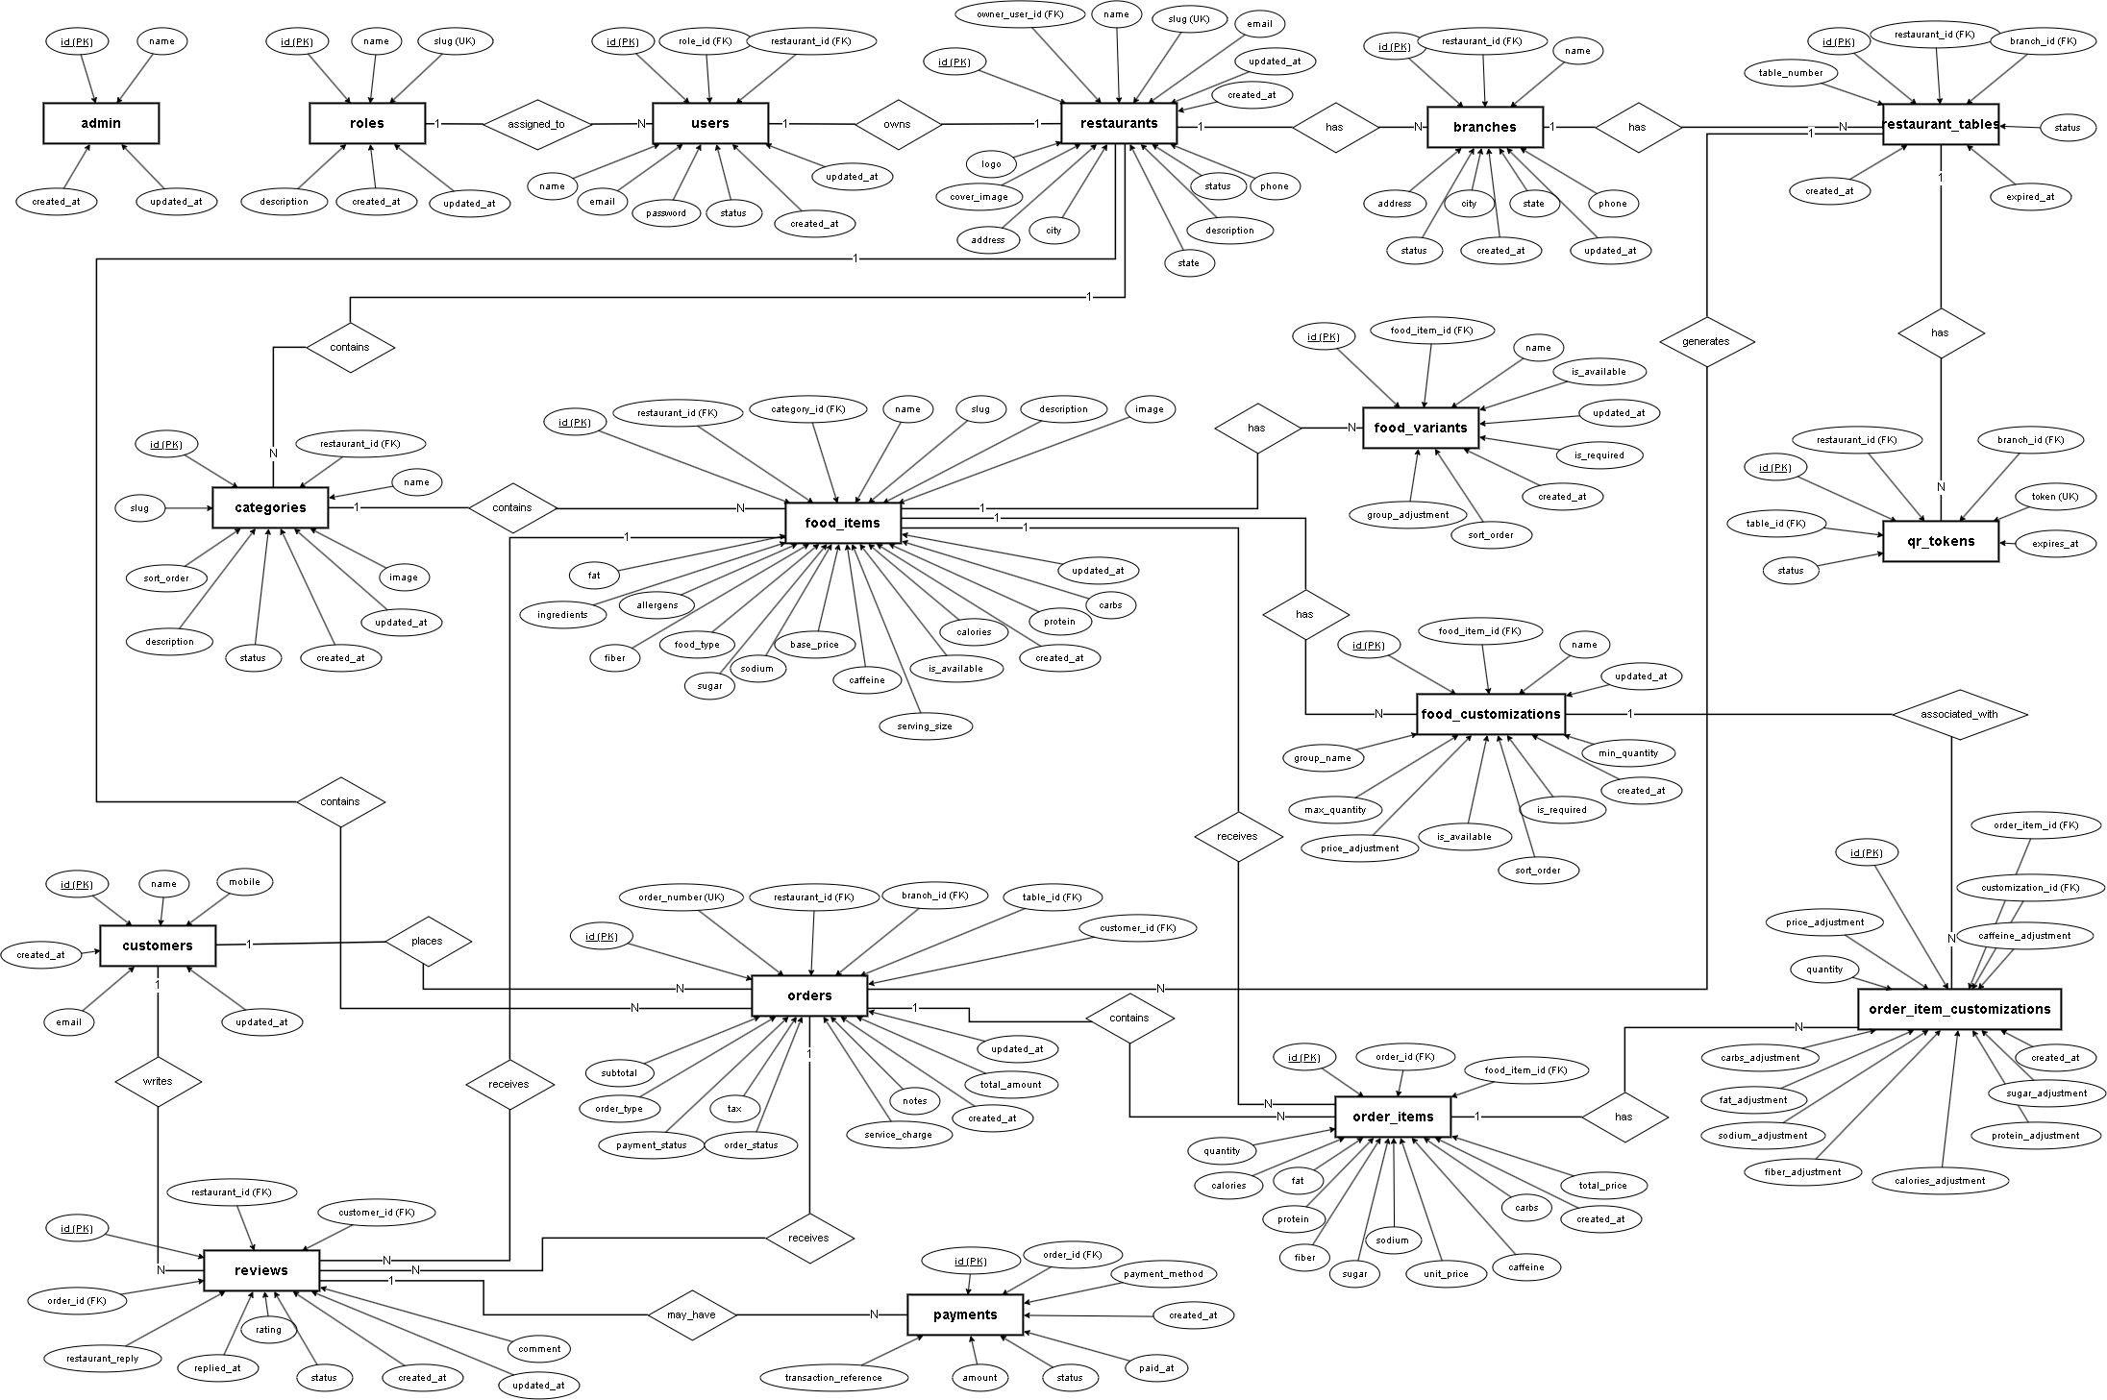
Entity Relationship Diagram (ERD)
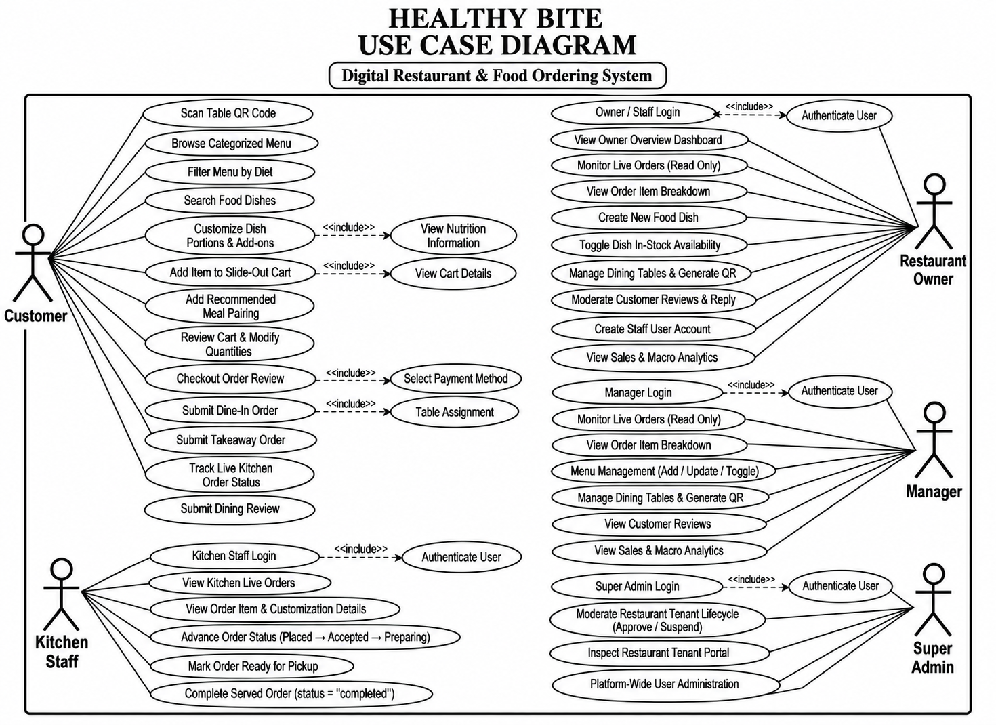
Use Case Diagram
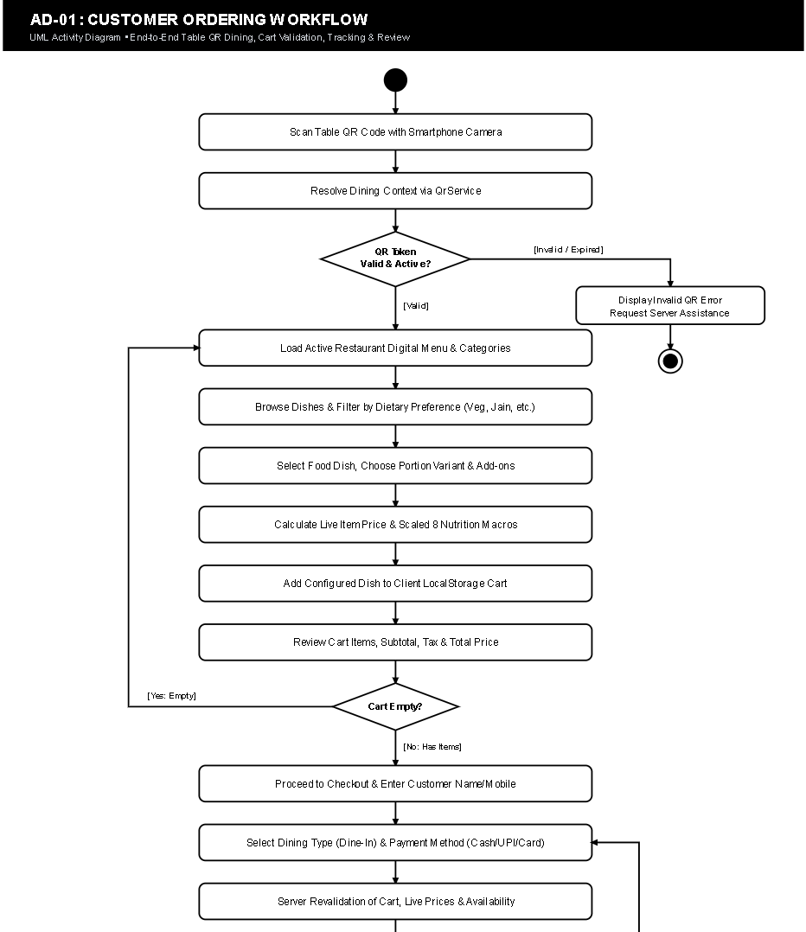
Activity Diagram

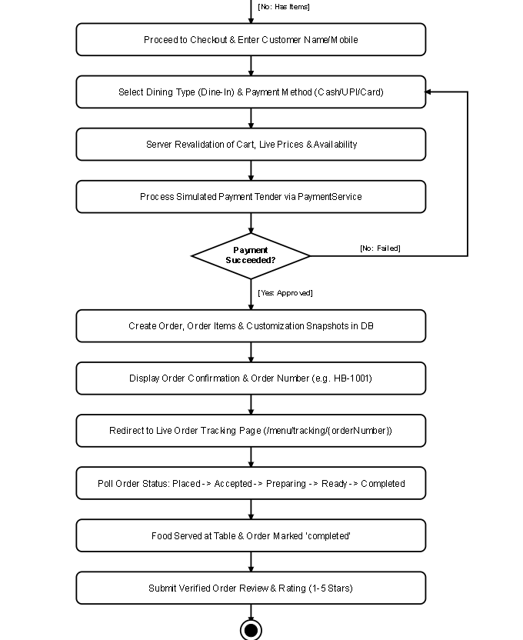

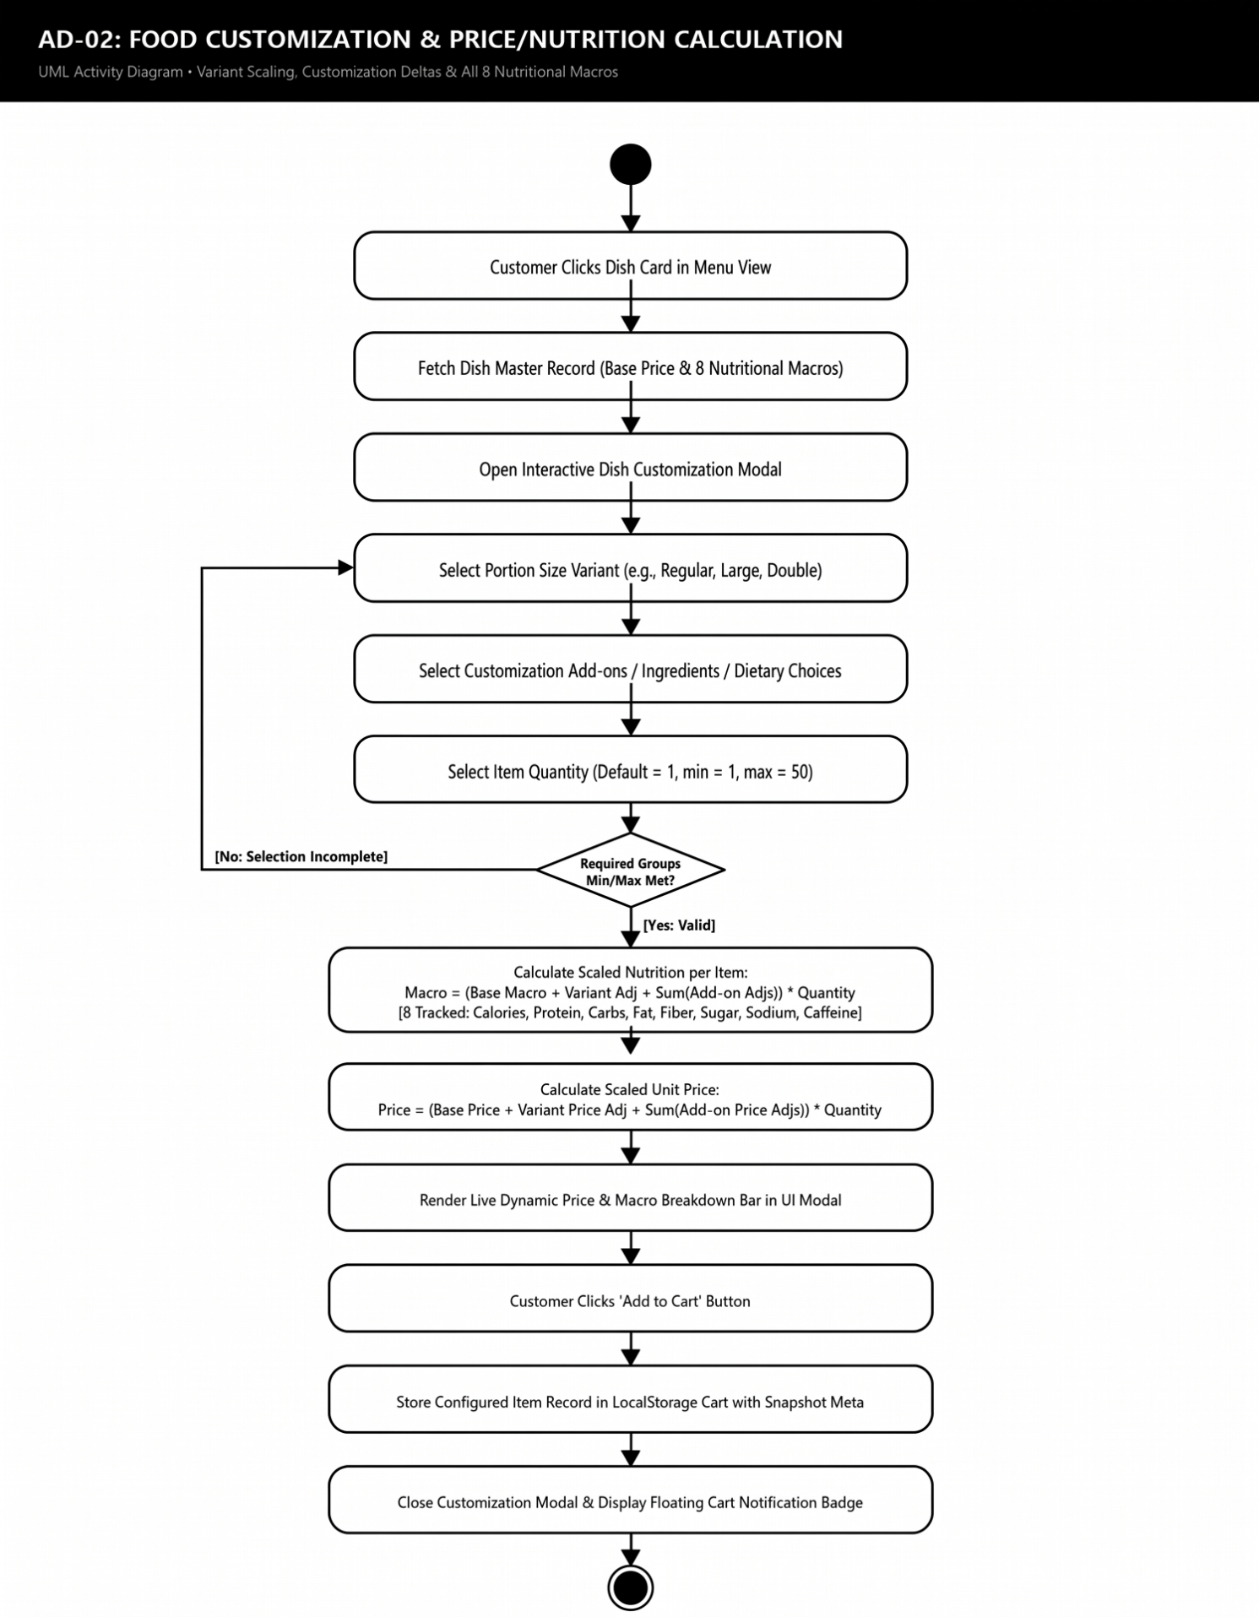

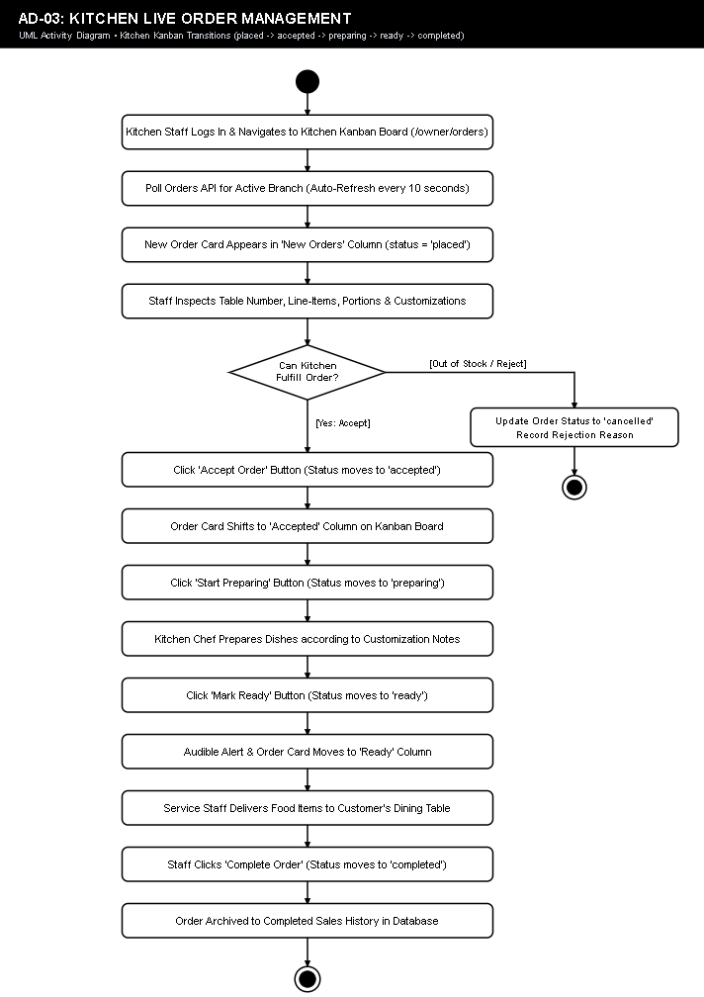

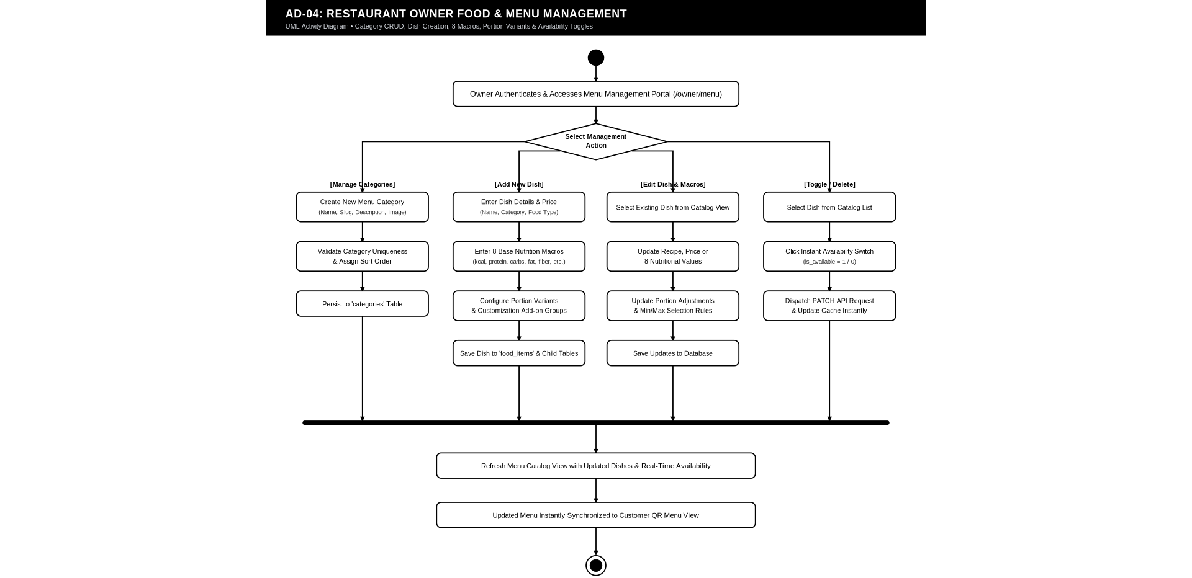

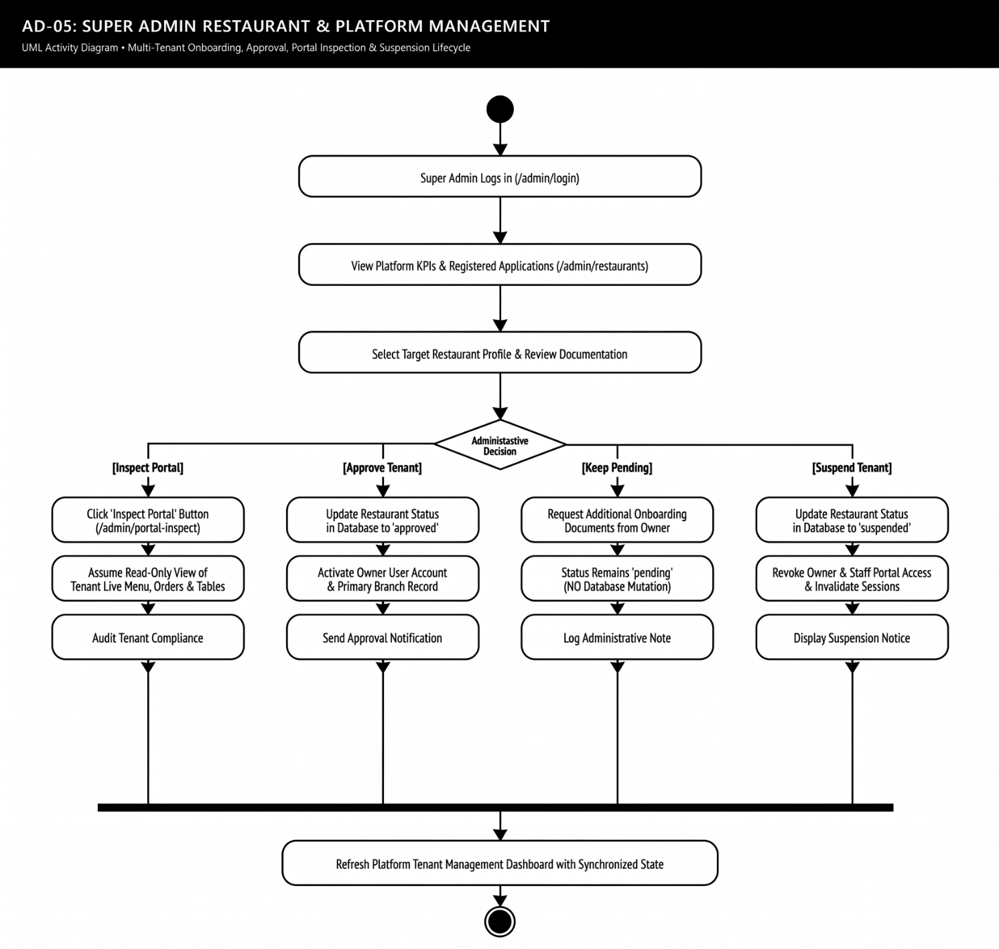

6.Data Dictionary
TABLE: ADMIN
FIELD NAME | DATA TYPE | KEY | DESCRIPTION
id | BIGINT(20) UNSIGNED | PK | Internal unique identifier for legacy admin record; auto-incremented.
name | VARCHAR(120) | None | Full name of legacy system administrator.
created_at | TIMESTAMP | None | Date and time when the legacy admin record was initialized.
updated_at | TIMESTAMP | None | Timestamp of the last modification to the legacy admin record.

TABLE: ROLES
FIELD NAME | DATA TYPE | KEY | DESCRIPTION
id | BIGINT(20) UNSIGNED | PK | Primary key; unique system authority role identifier.
name | VARCHAR(50) | None | Human-readable role title (e.g. Super Admin, Restaurant Owner, Manager, Staff).
slug | VARCHAR(50) | UK | Unique URL/machine slug identifier (super_admin, restaurant_owner, manager, staff).
description | VARCHAR(255) | None | Functional description of security privileges and portal access rights.
created_at | TIMESTAMP | None | Record creation timestamp (default CURRENT_TIMESTAMP).
updated_at | TIMESTAMP | None | Record last updated timestamp (default CURRENT_TIMESTAMP).

TABLE: RESTAURANTS
FIELD NAME | DATA TYPE | KEY | DESCRIPTION
id | BIGINT(20) UNSIGNED | PK | Primary key; multi-tenant restaurant entity identifier.
owner_user_id | BIGINT(20) UNSIGNED | FK | Foreign key referencing users(id); designates primary restaurant owner.
name | VARCHAR(150) | None | Legal trade name of the dining establishment (e.g. Greenhouse Kitchen).
slug | VARCHAR(150) | UK | Unique URL-friendly slug used for tenant resolution and branding.
logo | VARCHAR(255) | None | Relative path or URL to high-resolution brand logo image.
cover_image | VARCHAR(255) | None | Path or URL to restaurant hero cover banner graphic.
description | TEXT | None | Comprehensive brand narrative, culinary focus, and restaurant overview.
phone | VARCHAR(30) | None | Primary customer service and inquiry contact telephone number.
email | VARCHAR(191) | None | Official restaurant business contact email address.
address | TEXT | None | Physical street address of restaurant headquarters or primary facility.
city | VARCHAR(100) | None | Operating city where the restaurant facility is located.
state | VARCHAR(100) | None | Operating state or administrative province.
status | ENUM('pending','approved','suspended') | None | Platform tenancy status governed by Super Admin (default 'approved').
created_at | TIMESTAMP | None | Date and time when the restaurant was registered on the platform.
updated_at | TIMESTAMP | None | Timestamp of the most recent profile modification.

TABLE: USERS
FIELD NAME | DATA TYPE | KEY | DESCRIPTION
id | BIGINT(20) UNSIGNED | PK | Primary key; user account unique identifier.
role_id | BIGINT(20) UNSIGNED | FK | Foreign key referencing roles(id); defines user authorization level.
restaurant_id | BIGINT(20) UNSIGNED | FK | Foreign key referencing restaurants(id); scopes user to tenant (NULL for Super Admin).
name | VARCHAR(120) | None | Full legal name of the user or staff employee.
email | VARCHAR(191) | UK | Unique email address utilized for portal authentication.
password | VARCHAR(255) | None | Secure one-way BCRYPT cryptographic password hash.
status | ENUM('active','inactive','suspended') | None | Operational account status (default 'active').
created_at | TIMESTAMP | None | User registration timestamp.
updated_at | TIMESTAMP | None | Account profile modification timestamp.

TABLE: BRANCHES
FIELD NAME | DATA TYPE | KEY | DESCRIPTION
id | BIGINT(20) UNSIGNED | PK | Primary key; physical dining branch outlet identifier.
restaurant_id | BIGINT(20) UNSIGNED | FK | Foreign key referencing restaurants(id); parent restaurant entity.
name | VARCHAR(150) | None | Physical branch title (e.g. Indiranagar Flagship, Koramangala Outlet).
address | TEXT | None | Physical street location of the specific branch outlet.
city | VARCHAR(100) | None | Operating city of the branch.
state | VARCHAR(100) | None | Operating state of the branch.
phone | VARCHAR(30) | None | Direct telephone contact for branch operations and reservations.
status | ENUM('active','inactive') | None | Operational state of the branch location (default 'active').
created_at | TIMESTAMP | None | Branch record creation timestamp.
updated_at | TIMESTAMP | None | Branch record modification timestamp.

TABLE: CATEGORIES
FIELD NAME | DATA TYPE | KEY | DESCRIPTION
id | BIGINT(20) UNSIGNED | PK | Primary key; menu category identifier.
restaurant_id | BIGINT(20) UNSIGNED | FK | Foreign key referencing restaurants(id); scopes category to restaurant.
name | VARCHAR(100) | None | Category title (e.g. Protein Bowls, Artisan Wraps, Superfood Salads, Soups).
slug | VARCHAR(100) | None | URL slug used for client-side category filtering.
description | TEXT | None | Detailed description of the food category classification.
image | VARCHAR(255) | None | Category icon or representative banner image path.
sort_order | INT(11) | None | Integer defining visual display order on customer menu (default 0).
status | ENUM('active','inactive') | None | Category display toggle state (default 'active').
created_at | TIMESTAMP | None | Category creation timestamp.
updated_at | TIMESTAMP | None | Category modification timestamp.

TABLE: FOOD_ITEMS
FIELD NAME | DATA TYPE | KEY | DESCRIPTION
id | BIGINT(20) UNSIGNED | PK | Primary key; master food dish identifier.
restaurant_id | BIGINT(20) UNSIGNED | FK | Foreign key referencing restaurants(id); owning restaurant tenant.
category_id | BIGINT(20) UNSIGNED | FK | Foreign key referencing categories(id); menu classification.
name | VARCHAR(150) | None | Culinary dish display title (e.g. Grilled Chicken & Quinoa Protein Bowl).
slug | VARCHAR(150) | None | URL-safe unique dish slug for routing and APIs.
description | TEXT | None | Comprehensive sensory and culinary description of the food item.
image | VARCHAR(255) | None | High-resolution Unsplash photo URL or local asset path.
ingredients | TEXT | None | List of primary ingredients and culinary preparation components.
allergens | VARCHAR(255) | None | Declared allergen warnings (e.g. Dairy, Tree Nuts, Gluten, Soy).
food_type | ENUM('vegetarian','non_vegetarian','vegan','jain','other') | None | Dietary lifestyle classification badge.
base_price | DECIMAL(10,2) | None | Standard baseline menu price in Indian Rupees (₹).
calories | INT UNSIGNED | None | Total nutritional energy content measured in kilocalories (kcal).
protein | DECIMAL(6,2) | None | Total protein content measured strictly in grams (g).
carbs | DECIMAL(6,2) | None | Total carbohydrate content measured strictly in grams (g).
fat | DECIMAL(6,2) | None | Total dietary fat content measured strictly in grams (g).
fiber | DECIMAL(6,2) | None | Dietary fiber content measured strictly in grams (g).
sugar | DECIMAL(6,2) | None | Simple sugars content measured strictly in grams (g).
sodium | DECIMAL(7,2) | None | Sodium mineral content measured strictly in milligrams (mg).
caffeine | DECIMAL(6,2) | None | Caffeine stimulant content measured strictly in milligrams (mg).
serving_size | VARCHAR(100) | None | Standard portion weight or volume (e.g. 350g, 400ml).
is_featured | TINYINT(1) | None | Boolean flag highlighting dish on restaurant entrance showcase.
is_popular | TINYINT(1) | None | Boolean flag designating popular best-seller badge.
is_available | TINYINT(1) | None | Live kitchen availability toggle (1=Available, 0=Sold Out).
created_at | TIMESTAMP | None | Food dish registration timestamp.
updated_at | TIMESTAMP | None | Food dish modification timestamp.

TABLE: FOOD_VARIANTS
FIELD NAME | DATA TYPE | KEY | DESCRIPTION
id | BIGINT(20) UNSIGNED | PK | Primary key; food portion variant identifier.
food_item_id | BIGINT(20) UNSIGNED | FK | Foreign key referencing food_items(id) ON DELETE CASCADE.
name | VARCHAR(100) | None | Portion title (e.g. Regular, Large Portion, Double Protein).
description | VARCHAR(255) | None | Explanation of portion size or preparation difference.
price_adjustment | DECIMAL(10,2) | None | Price differential added to base price in Indian Rupees (₹).
calories_adjustment | INT(11) | None | Calorie differential applied to base calories (kcal).
protein_adjustment | DECIMAL(6,2) | None | Protein differential applied to base protein (g).
carbs_adjustment | DECIMAL(6,2) | None | Carbohydrate differential applied to base carbs (g).
fat_adjustment | DECIMAL(6,2) | None | Fat differential applied to base fat (g).
fiber_adjustment | DECIMAL(6,2) | None | Fiber differential applied to base fiber (g).
sugar_adjustment | DECIMAL(6,2) | None | Sugar differential applied to base sugar (g).
sodium_adjustment | DECIMAL(7,2) | None | Sodium differential applied to base sodium (mg).
caffeine_adjustment | DECIMAL(6,2) | None | Caffeine differential applied to base caffeine (mg).
is_required | TINYINT(1) | None | Mandatory selection flag (default 0).
is_available | TINYINT(1) | None | Active availability toggle for the portion option.
sort_order | INT(11) | None | Display sort order within portion selection UI.
created_at | TIMESTAMP | None | Variant record creation timestamp.
updated_at | TIMESTAMP | None | Variant record modification timestamp.

TABLE: FOOD_CUSTOMIZATION
FIELD NAME | DATA TYPE | KEY | DESCRIPTION
id | BIGINT(20) UNSIGNED | PK | Primary key; food customization add-on identifier.
food_item_id | BIGINT(20) UNSIGNED | FK | Foreign key referencing food_items(id) ON DELETE CASCADE.
group_name | VARCHAR(100) | None | Option grouping header (e.g. Choose Base, Dressing, Extra Toppings).
name | VARCHAR(100) | None | Customization display title (e.g. Extra Hass Avocado, Greek Yogurt Dip).
description | VARCHAR(255) | None | Ingredient or preparation details of the add-on.
price_adjustment | DECIMAL(10,2) | None | Unit cost added to item total in Indian Rupees (₹).
calories_adjustment | INT(11) | None | Caloric energy added per unit selection (kcal).
protein_adjustment | DECIMAL(6,2) | None | Protein added per unit selection in grams (g).
carbs_adjustment | DECIMAL(6,2) | None | Carbohydrates added per unit selection in grams (g).
fat_adjustment | DECIMAL(6,2) | None | Fats added per unit selection in grams (g).
fiber_adjustment | DECIMAL(6,2) | None | Fiber added per unit selection in grams (g).
sugar_adjustment | DECIMAL(6,2) | None | Sugar added per unit selection in grams (g).
sodium_adjustment | DECIMAL(7,2) | None | Sodium added per unit selection in milligrams (mg).
caffeine_adjustment | DECIMAL(6,2) | None | Caffeine added per unit selection in milligrams (mg).
is_required | TINYINT(1) | None | Enforces at least one option selection in this group.
min_quantity | INT UNSIGNED | None | Minimum number of items customer must select from group (default 0).
max_quantity | INT UNSIGNED | None | Maximum number of items customer can select from group (default 1).
is_available | TINYINT(1) | None | Inventory availability toggle for the customization.
sort_order | INT(11) | None | Sort order within the customization group.
created_at | TIMESTAMP | None | Customization record creation timestamp.
updated_at | TIMESTAMP | None | Customization record modification timestamp.

TABLE: RESTAURANT_TABLE
FIELD NAME | DATA TYPE | KEY | DESCRIPTION
id | BIGINT(20) UNSIGNED | PK | Primary key; physical dining table identifier.
restaurant_id | BIGINT(20) UNSIGNED | FK | Foreign key referencing restaurants(id); parent restaurant entity.
branch_id | BIGINT(20) UNSIGNED | FK | Foreign key referencing branches(id); physical branch location.
table_number | VARCHAR(50) | None | Display label identifying dining table (e.g. Table 1, Table 12).
status | ENUM('available','occupied','cleaning','out_of_service') | None | Live occupancy state (default 'available').
created_at | TIMESTAMP | None | Table configuration timestamp.
updated_at | TIMESTAMP | None | Table occupancy state transition timestamp.

TABLE: QR_TOKEN
FIELD NAME | DATA TYPE | KEY | DESCRIPTION
id | BIGINT(20) UNSIGNED | PK | Primary key; cryptographic QR token identifier.
restaurant_id | BIGINT(20) UNSIGNED | FK | Foreign key referencing restaurants(id); bound restaurant entity.
branch_id | BIGINT(20) UNSIGNED | FK | Foreign key referencing branches(id); bound branch location.
table_id | BIGINT(20) UNSIGNED | FK | Foreign key referencing restaurant_tables(id); bound dining table.
token | VARCHAR(128) | UK | Cryptographically generated unique alphanumeric token string.
status | ENUM('active','inactive','expired') | None | Token security validation state (default 'active').
expires_at | TIMESTAMP | None | Optional expiry timestamp for time-limited QR sessions.
created_at | TIMESTAMP | None | Token generation and issuance timestamp.

TABLE: CUSTOMER
FIELD NAME | DATA TYPE | KEY | DESCRIPTION
id | BIGINT(20) UNSIGNED | PK | Primary key; dining guest profile identifier.
name | VARCHAR(120) | None | Full name of the dining customer captured during checkout.
mobile | VARCHAR(30) | None | Customer contact mobile phone number.
email | VARCHAR(191) | None | Customer contact email address for electronic receipts.
created_at | TIMESTAMP | None | Customer profile creation timestamp.
updated_at | TIMESTAMP | None | Customer profile modification timestamp.

TABLE: ORDER
FIELD NAME | DATA TYPE | KEY | DESCRIPTION
id | BIGINT(20) UNSIGNED | PK | Primary key; master dining order identifier.
order_number | VARCHAR(64) | UK | Human-readable order tracking code (e.g. HB-1001, HB-18A3B4C-782).
restaurant_id | BIGINT(20) UNSIGNED | FK | Foreign key referencing restaurants(id); target restaurant entity.
branch_id | BIGINT(20) UNSIGNED | FK | Foreign key referencing branches(id); target dining outlet.
table_id | BIGINT(20) UNSIGNED | FK | Foreign key referencing restaurant_tables(id); NULL for Takeaway.
customer_id | BIGINT(20) UNSIGNED | FK | Foreign key referencing customers(id); ordering guest diner.
order_type | ENUM('dine_in','takeaway') | None | Dining service mode (default 'dine_in').
subtotal | DECIMAL(10,2) | None | Sum of all order items and customizations before taxation (₹).
tax | DECIMAL(10,2) | None | Calculated Goods & Services Tax (GST 5%) in Indian Rupees (₹).
service_charge | DECIMAL(10,2) | None | Optional restaurant hospitality service charge in Indian Rupees (₹).
total_amount | DECIMAL(10,2) | None | Final grand payable total amount in Indian Rupees (₹).
payment_status | ENUM('pending','completed','failed') | None | Settlement state of order financial transaction.
order_status | ENUM('placed','accepted','preparing','ready','completed','cancelled') | None | Operational kitchen lifecycle status.
notes | TEXT | None | Customer special food preparation or dietary instructions.
created_at | TIMESTAMP | None | Order submission timestamp.
updated_at | TIMESTAMP | None | Order status transition timestamp.

TABLE: ORDER_ITEM
FIELD NAME | DATA TYPE | KEY | DESCRIPTION
id | BIGINT(20) UNSIGNED | PK | Primary key; order line item identifier.
order_id | BIGINT(20) UNSIGNED | FK | Foreign key referencing orders(id); master order parent.
food_item_id | BIGINT(20) UNSIGNED | FK | Foreign key referencing food_items(id); source dish catalog item.
food_name_snapshot | VARCHAR(150) | None | Frozen dish name at the precise moment of purchase.
base_price_snapshot | DECIMAL(10,2) | None | Frozen baseline unit price at purchase time (₹).
variant_name_snapshot | VARCHAR(100) | None | Frozen portion variant title selected by customer.
variant_price_snapshot | DECIMAL(10,2) | None | Frozen portion price adjustment at purchase time (₹).
quantity | INT UNSIGNED | None | Quantity of this specific configured dish ordered.
unit_price | DECIMAL(10,2) | None | Calculated single-item price including variant & customizations (₹).
total_price | DECIMAL(10,2) | None | Line total = unit_price multiplied by quantity (₹).
calories | INT(11) | None | Frozen caloric energy snapshot per unit (kcal).
protein | DECIMAL(6,2) | None | Frozen protein snapshot per unit in grams (g).
carbs | DECIMAL(6,2) | None | Frozen carbohydrate snapshot per unit in grams (g).
fat | DECIMAL(6,2) | None | Frozen fat snapshot per unit in grams (g).
fiber | DECIMAL(6,2) | None | Frozen fiber snapshot per unit in grams (g).
sugar | DECIMAL(6,2) | None | Frozen sugar snapshot per unit in grams (g).
sodium | DECIMAL(7,2) | None | Frozen sodium snapshot per unit in milligrams (mg).
caffeine | DECIMAL(6,2) | None | Frozen caffeine snapshot per unit in milligrams (mg).
created_at | TIMESTAMP | None | Line item purchase timestamp.

TABLE: ORDER_ITEM_CUSTOMIZATION
FIELD NAME | DATA TYPE | KEY | DESCRIPTION
id | BIGINT(20) UNSIGNED | PK | Primary key; order item customization snapshot identifier.
order_item_id | BIGINT(20) UNSIGNED | FK | Foreign key referencing order_items(id) ON DELETE CASCADE.
customization_id | BIGINT(20) UNSIGNED | FK | Foreign key referencing food_customizations(id).
customization_name_snapshot | VARCHAR(100) | None | Frozen name of selected add-on option.
quantity | INT UNSIGNED | None | Quantity of this specific customization selected.
price_adjustment | DECIMAL(10,2) | None | Frozen price delta applied per unit add-on (₹).
calories_adjustment | INT(11) | None | Frozen calorie adjustment per unit (kcal).
protein_adjustment | DECIMAL(6,2) | None | Frozen protein adjustment per unit in grams (g).
carbs_adjustment | DECIMAL(6,2) | None | Frozen carbohydrate adjustment per unit in grams (g).
fat_adjustment | DECIMAL(6,2) | None | Frozen fat adjustment per unit in grams (g).
fiber_adjustment | DECIMAL(6,2) | None | Frozen fiber adjustment per unit in grams (g).
sugar_adjustment | DECIMAL(6,2) | None | Frozen sugar adjustment per unit in grams (g).
sodium_adjustment | DECIMAL(7,2) | None | Frozen sodium adjustment per unit in milligrams (mg).
caffeine_adjustment | DECIMAL(6,2) | None | Frozen caffeine adjustment per unit in milligrams (mg).
created_at | TIMESTAMP | None | Snapshot creation timestamp.

TABLE: PAYMENT
FIELD NAME | DATA TYPE | KEY | DESCRIPTION
id | BIGINT(20) UNSIGNED | PK | Primary key; financial payment settlement identifier.
order_id | BIGINT(20) UNSIGNED | UK, FK | Foreign key referencing orders(id); strict 1-to-1 relationship.
payment_method | ENUM('cash','upi','card') | None | Authorized settlement mechanism.
transaction_reference | VARCHAR(128) | None | Unique transaction reference code (e.g. TXN-UPI-18A3B4C).
amount | DECIMAL(10,2) | None | Total settled financial amount in Indian Rupees (₹).
status | ENUM('pending','completed','failed') | None | Settlement transaction state (default 'pending').
paid_at | TIMESTAMP | None | Timestamp when payment was successfully verified and cleared.
created_at | TIMESTAMP | None | Payment record creation timestamp.

TABLE: REVIEW
FIELD NAME | DATA TYPE | KEY | DESCRIPTION
id | BIGINT(20) UNSIGNED | PK | Primary key; customer feedback review identifier.
restaurant_id | BIGINT(20) UNSIGNED | FK | Foreign key referencing restaurants(id); target restaurant entity.
customer_id | BIGINT(20) UNSIGNED | FK | Foreign key referencing customers(id); authoring guest customer.
order_id | BIGINT(20) UNSIGNED | FK | Foreign key referencing orders(id); specific dining order reviewed.
rating | TINYINT UNSIGNED | None | Numerical dining quality rating on 1 to 5 star scale.
comment | TEXT | None | Qualitative feedback text submitted by the customer.
restaurant_reply | TEXT | None | Official restaurant owner response reply published to customer.
replied_at | TIMESTAMP | None | Timestamp when restaurant owner published the response reply.
status | ENUM('pending','approved','hidden') | None | Public review moderation state (default 'pending').
created_at | TIMESTAMP | None | Review submission timestamp.
updated_at | TIMESTAMP | None | Review or reply modification timestamp.

7.Implementation
Figure 7.1: Customer Welcome & Table Selection Portal
Initial landing screen allowing walk-in diners to select dining options or initiate table sessions.
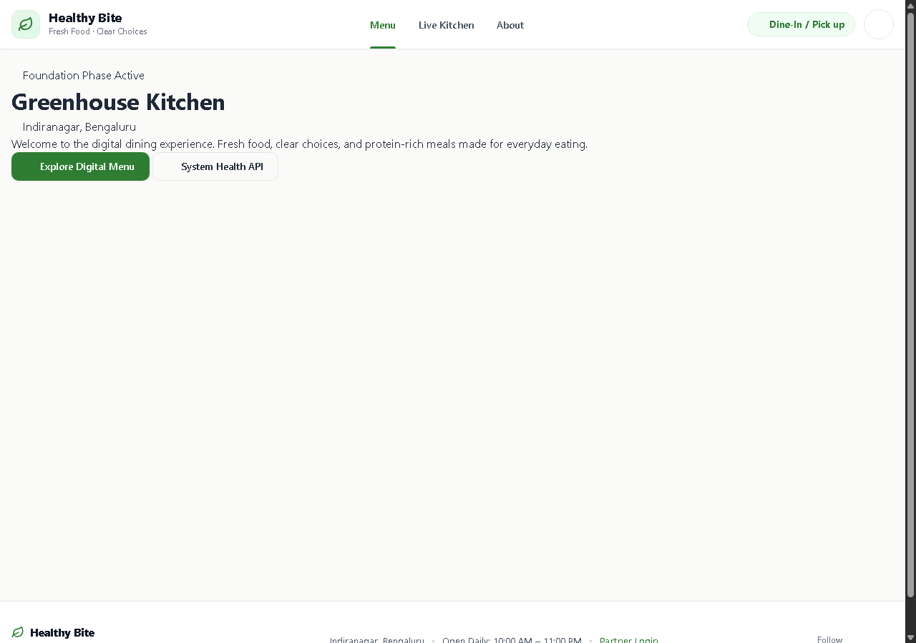
Figure 7.2: Interactive Customer Digital Menu with Category Filters
Categorized gourmet food catalog featuring real Unsplash photography, diet lifestyle badges, and calorie indicators.
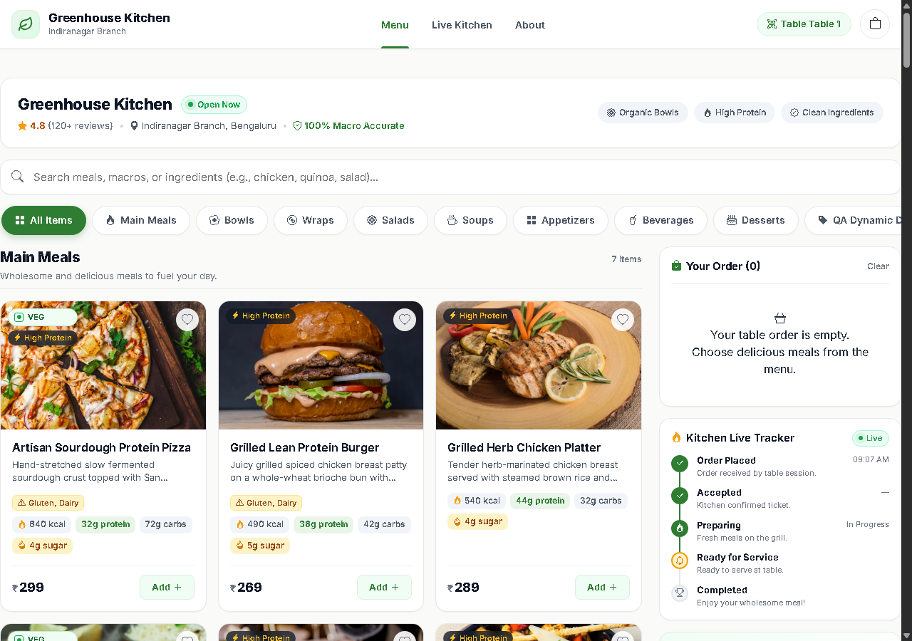

Figure 7.3: Customer Order Checkout & Table Context Verification
Checkout screen displaying bound dining Table 4, order summary, guest contact form, and payment method selectors.
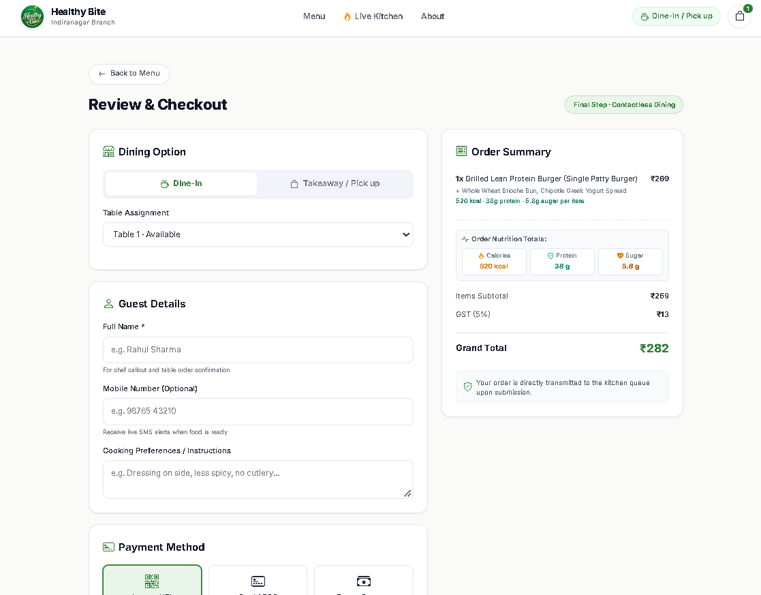
Figure 7.4: Customer Order Confirmation & Electronic Receipt
Post-order confirmation displaying unique tracking code (HB-1001), item breakdown, subtotal, and tax invoice details.
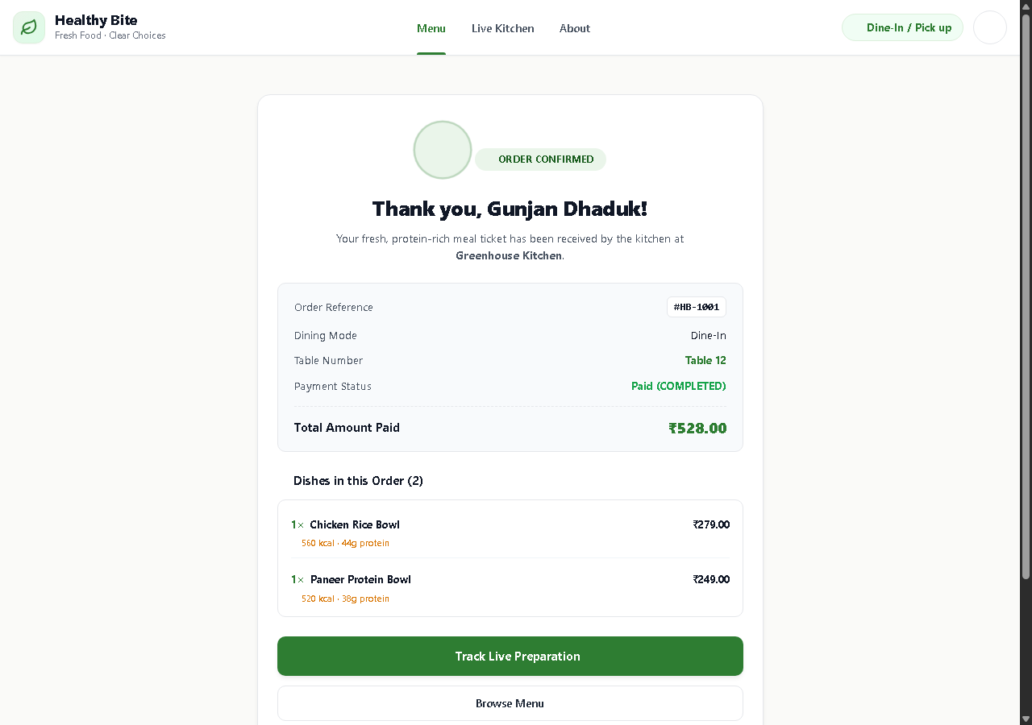

Figure 7.5: Live Customer Kitchen Order Tracking Screen
Real-time 5-stage visual progress timeline polled asynchronously from the server without page reloads.
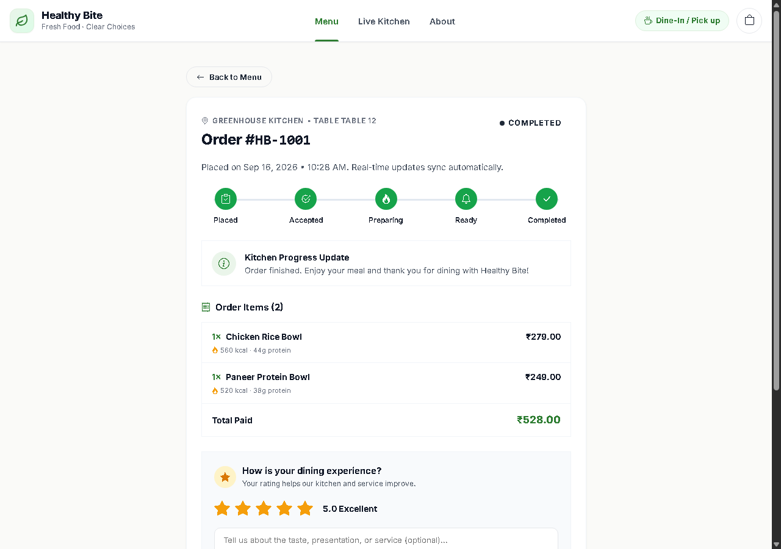
Figure 7.6: Restaurant Partner Portal Sign In Screen
Secure authentication interface for restaurant owners, managers, and kitchen staff with email normalization and BCRYPT verification.
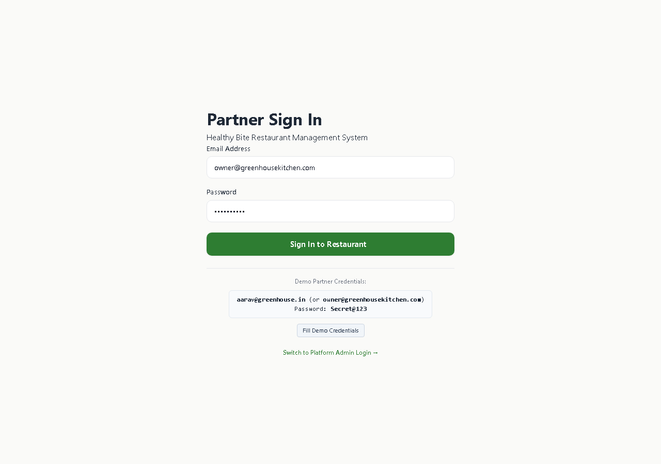

Figure 7.7: Restaurant Owner Overview Monitoring Dashboard
Central operational command center displaying 6 core KPI stat cards, sales trend bezier curves, order completion donut charts, and recent orders.
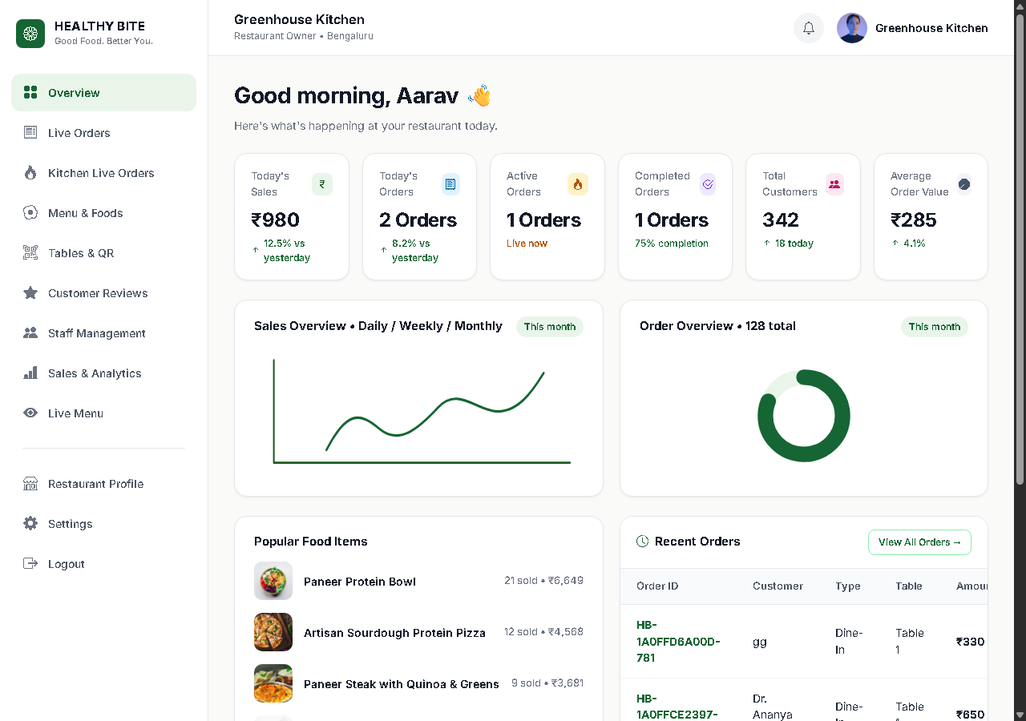
Figure 7.8: Live Orders Monitoring View with Filter Legend Pills
Order monitoring view featuring real-time status count pills (Placed, Accepted, Preparing, Ready, Completed, Cancelled) and itemized receipt modal.
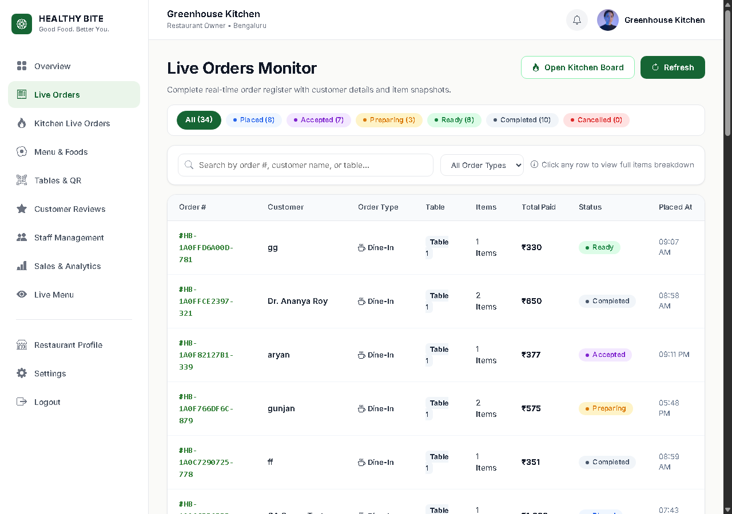

Figure 7.9: 5-Column Operational Kitchen Live Orders Kanban Board
Dedicated kitchen fulfillment board displaying ticket cards with customization snapshots and operational stage-advancement buttons.
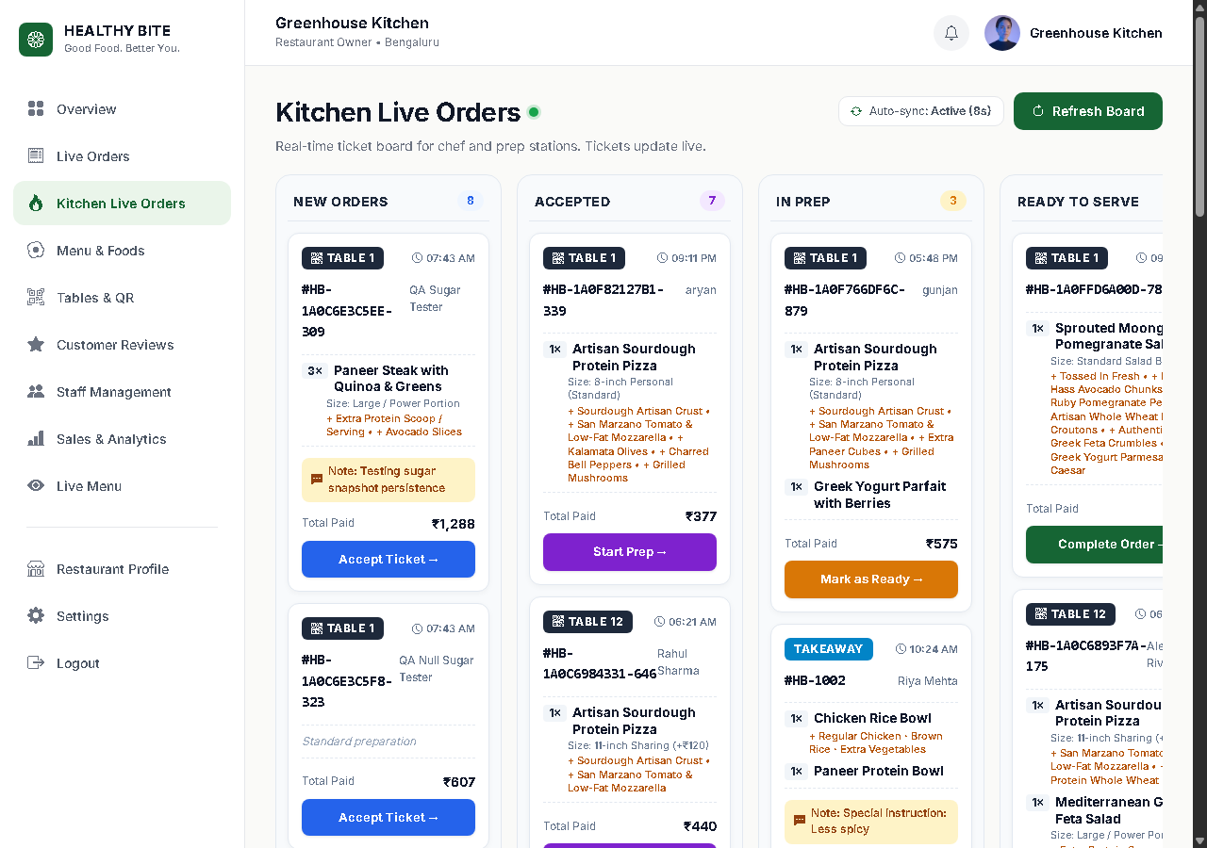
Figure 7.10: Menu & Foods Catalog CRUD Management
Comprehensive food dishes table displaying dish photos, categories, base prices, calories, protein, and active availability toggle switches.
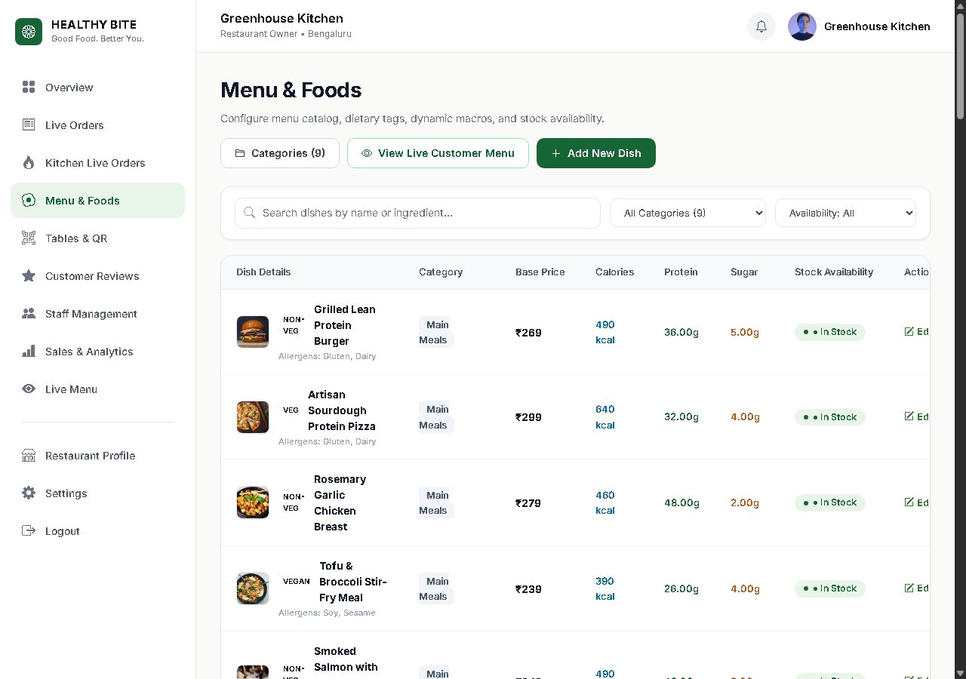

Figure 7.11: Tables 1–12 Management & Scannable QR Code Generators
Dining room table grid displaying canvas-rendered QR codes, 1-click PNG download buttons, print ticket popups, and click-to-toggle occupancy pills.
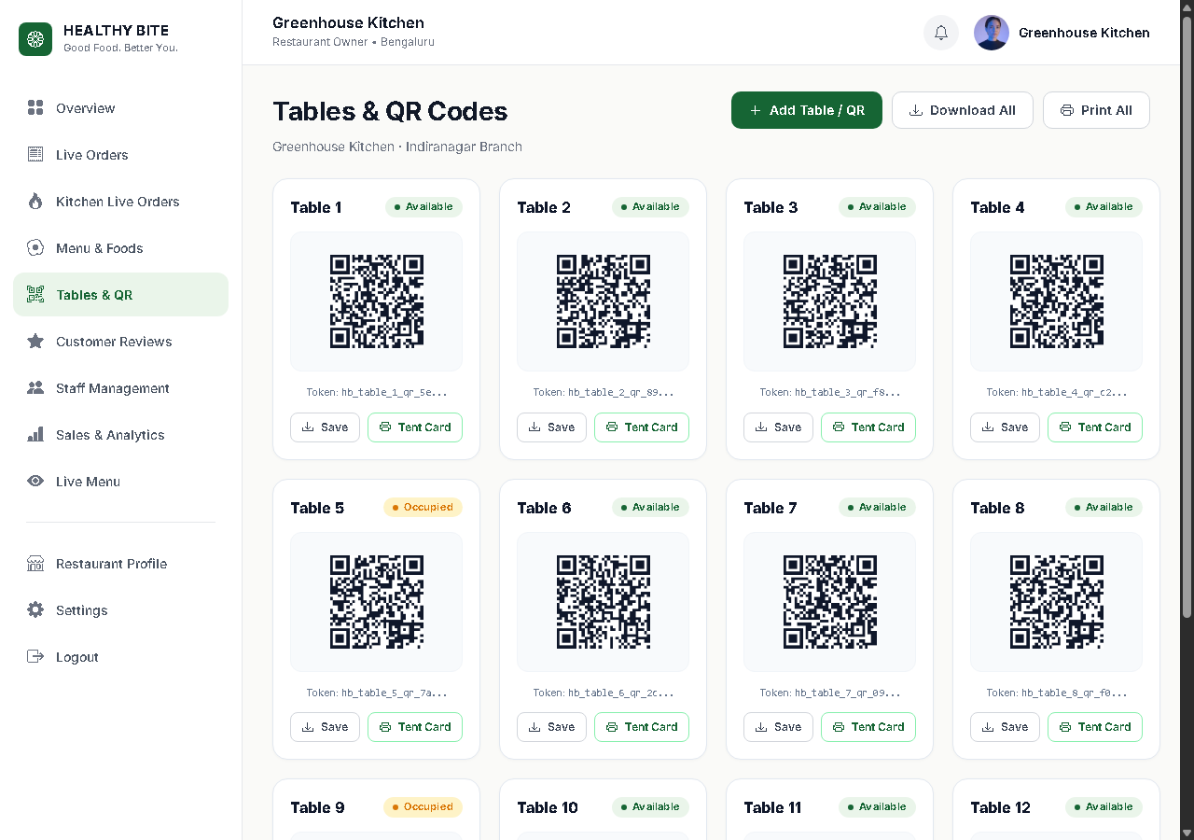
Figure 7.12: Customer Reviews Management with Reply Publishing
Customer dining feedback management screen featuring star rating filters, quick-reply suggestion chips, and persistent response publishing.
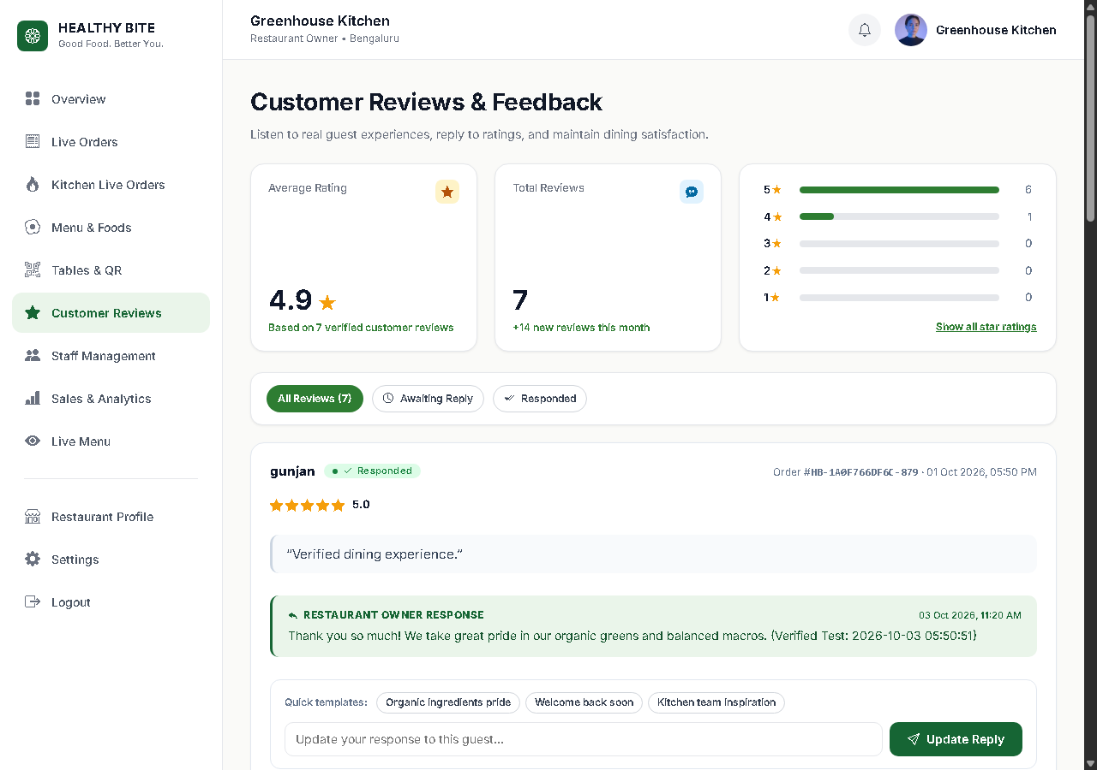

Figure 7.13: Restaurant Staff & Team Access Management
Staff access directory displaying team members, assigned authorization roles (Manager, Staff, Waiter), and active/inactive status switches.
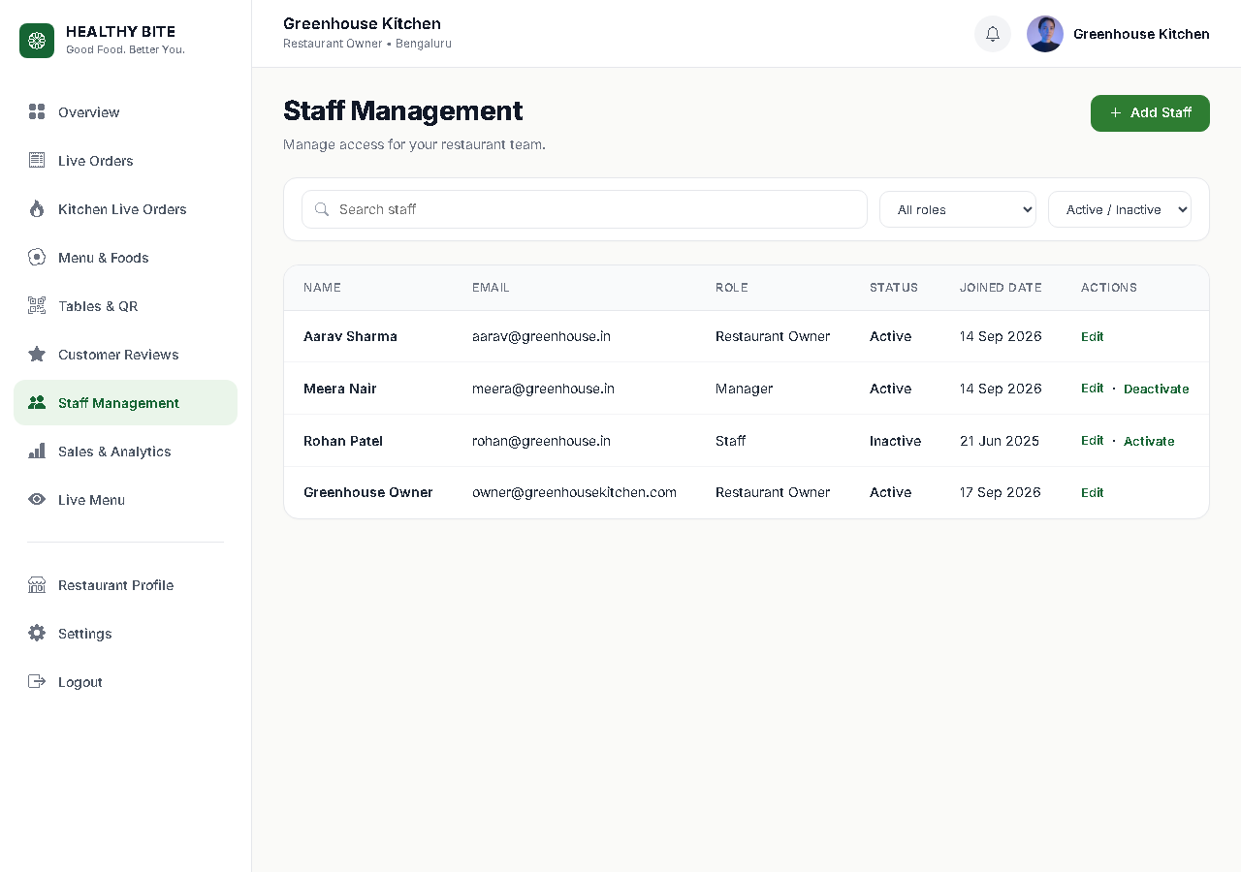
Figure 7.14: Sales & Macro Nutrient Analytics Dashboard
Financial and dietary analytics displaying revenue trends, nutrient macro percentages (Protein, Carbs, Fat), and payment method distribution.
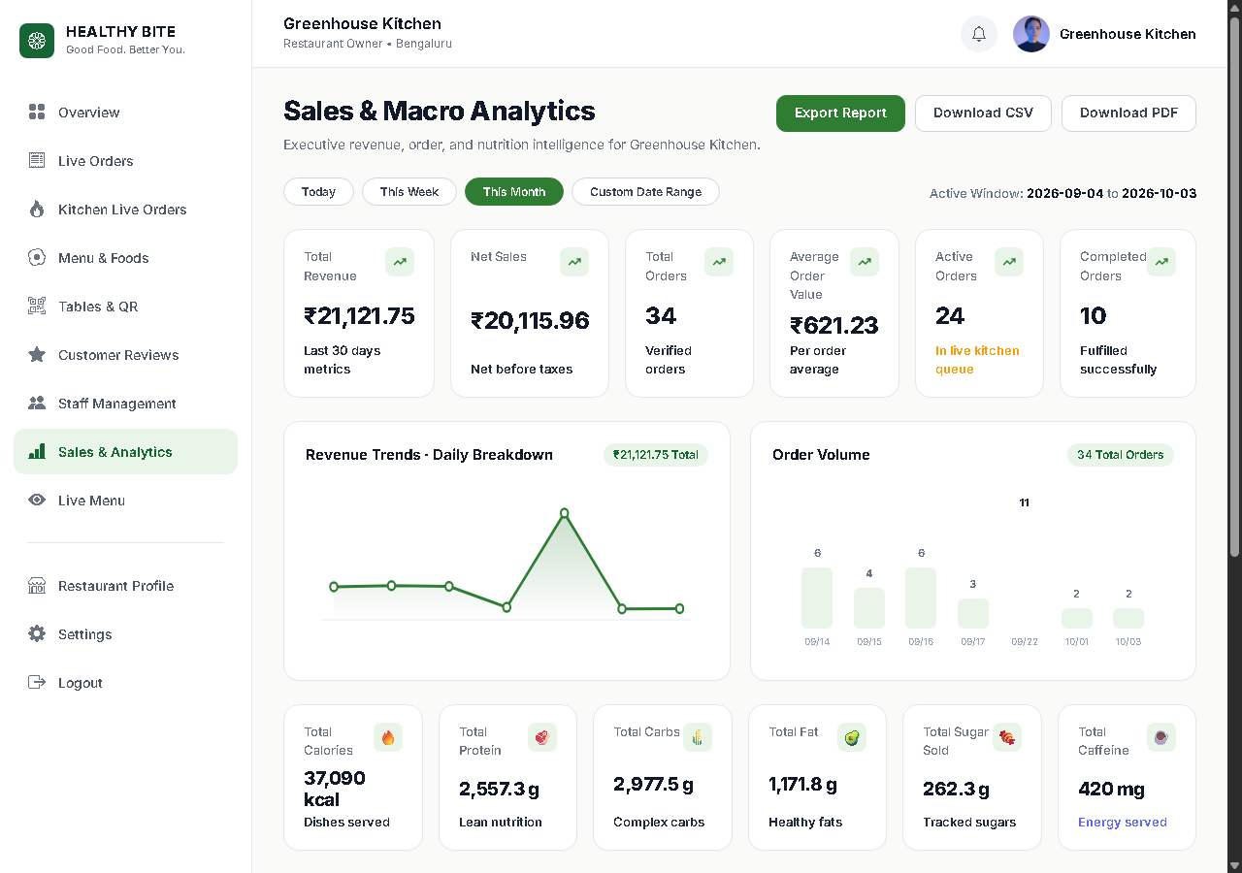

Figure 7.15: Live Customer Digital Menu Preview Simulation
High-fidelity live menu simulation preview displaying high-resolution food photos, calorie badges, and interactive cart drawer.
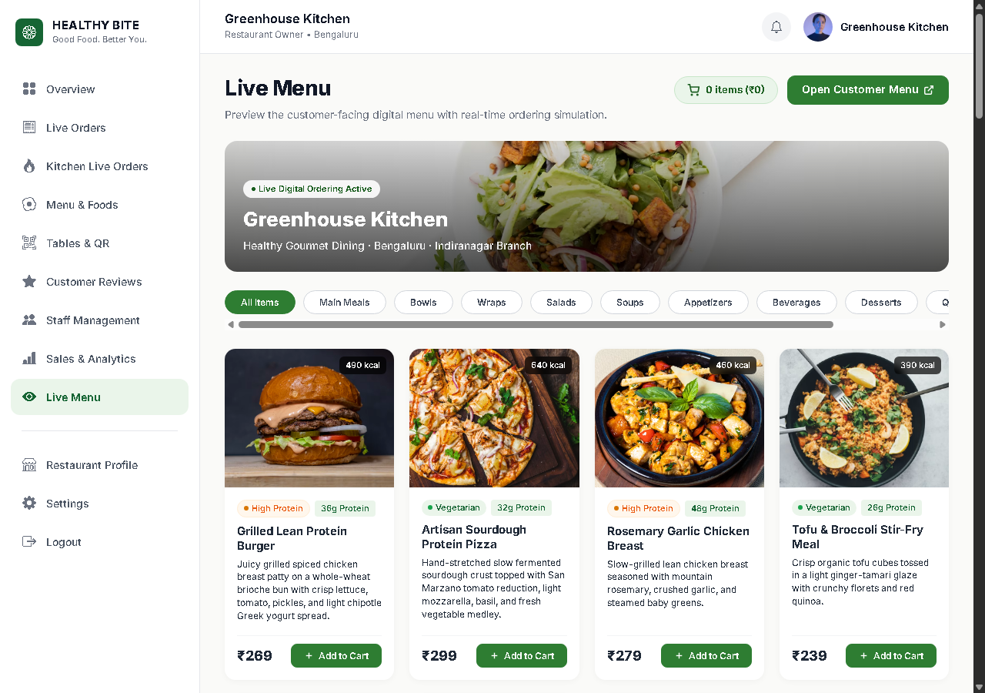
Figure 7.16: Restaurant Branding & Profile Settings
Restaurant administrative profile editor managing trade name, contact telephone, email, city, state, and registered physical address.
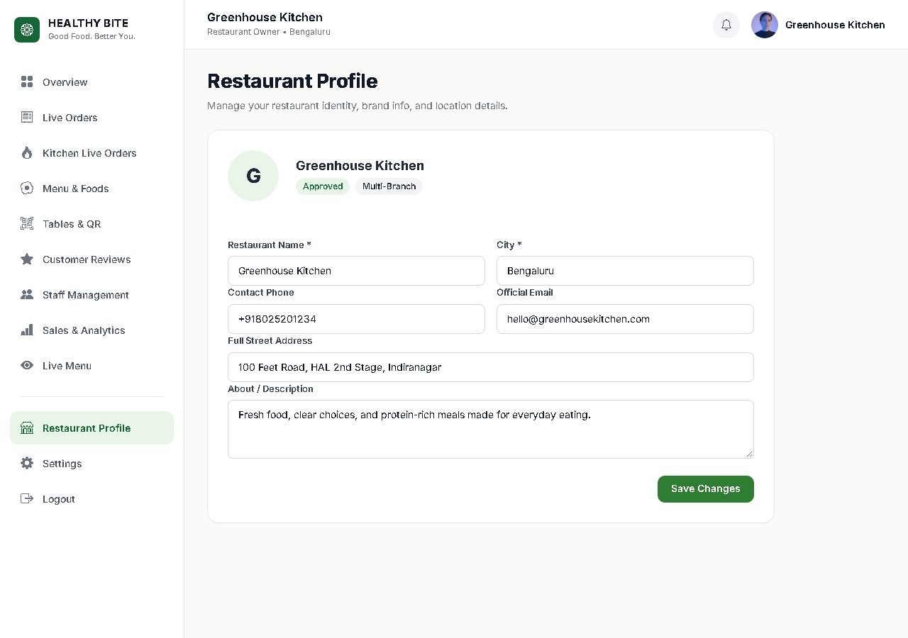

Figure 7.17: Operational Preferences & System Settings
Restaurant operational preferences managing automatic order acceptance, table ordering toggles, tax rates (5% GST), and service charges.
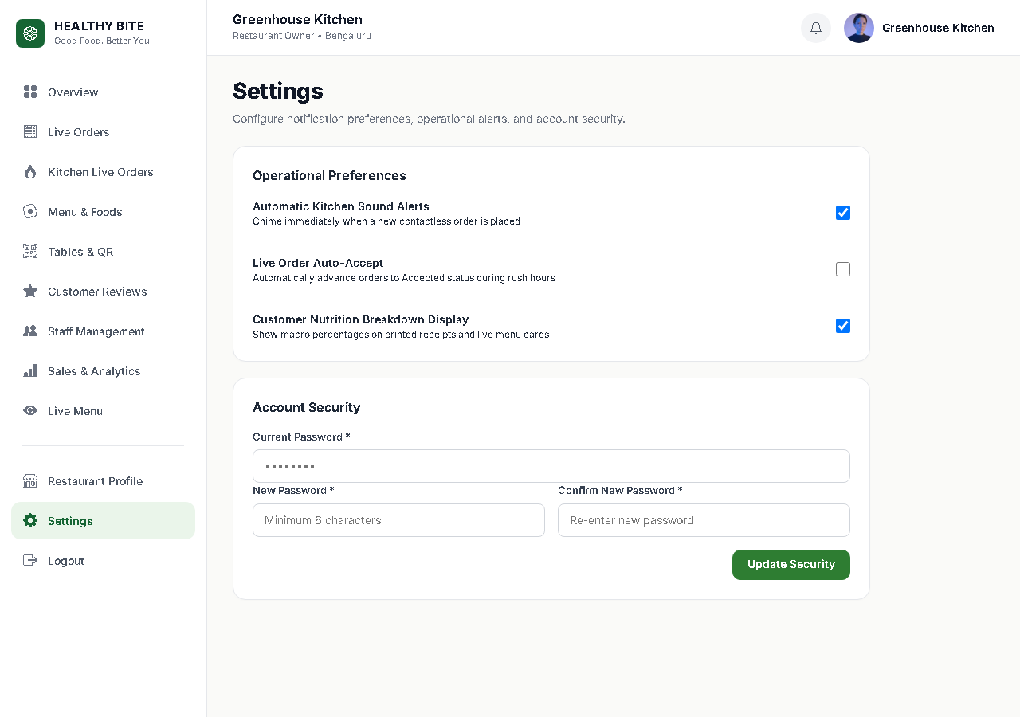
Figure 7.18: Platform Super Admin Sign In Portal
Dedicated platform governance entrance for system administrators.
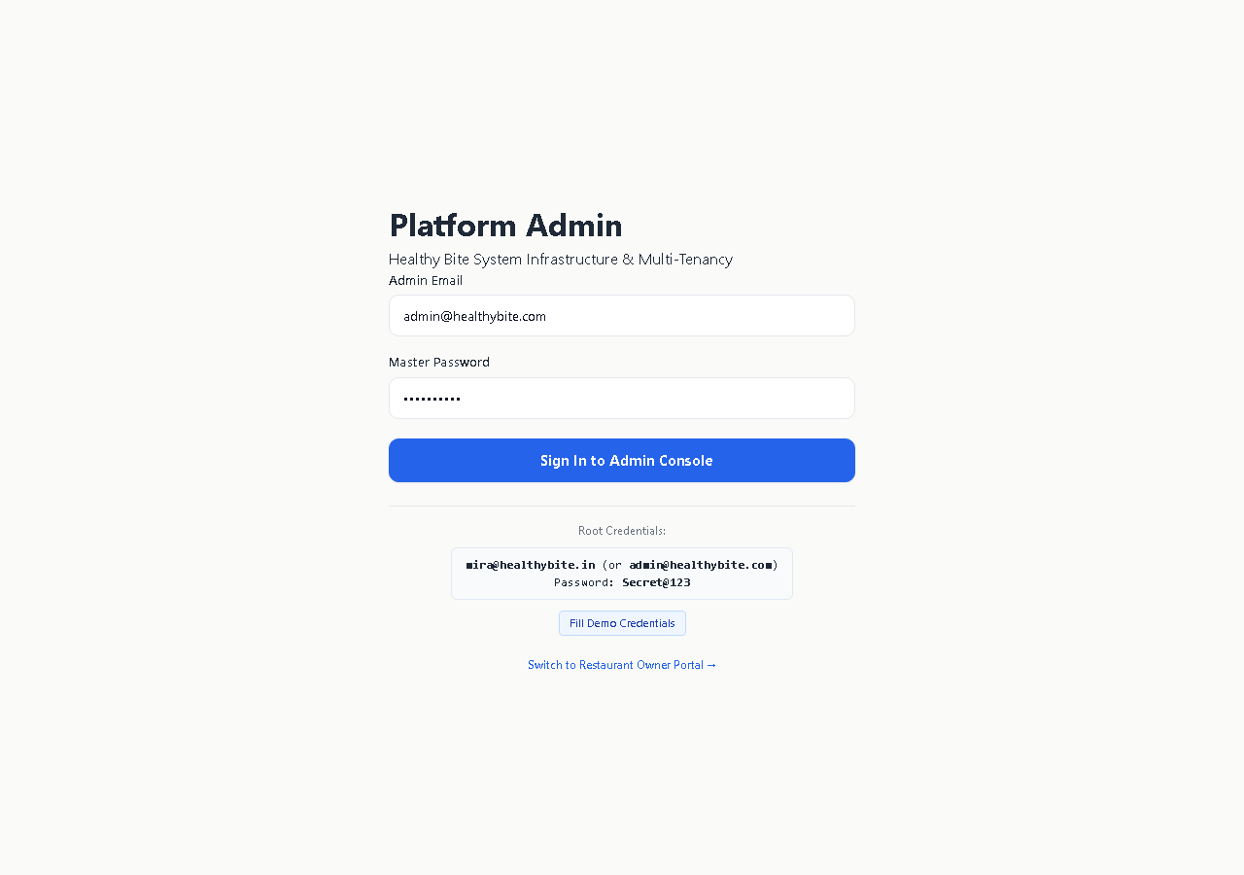

Figure 7.19: Platform Overview & Multi-Tenant Governance Dashboard
Cross-tenant executive overview displaying 6 platform KPI stat cards, 4 analytical SVG charts, and recent restaurant registrations.
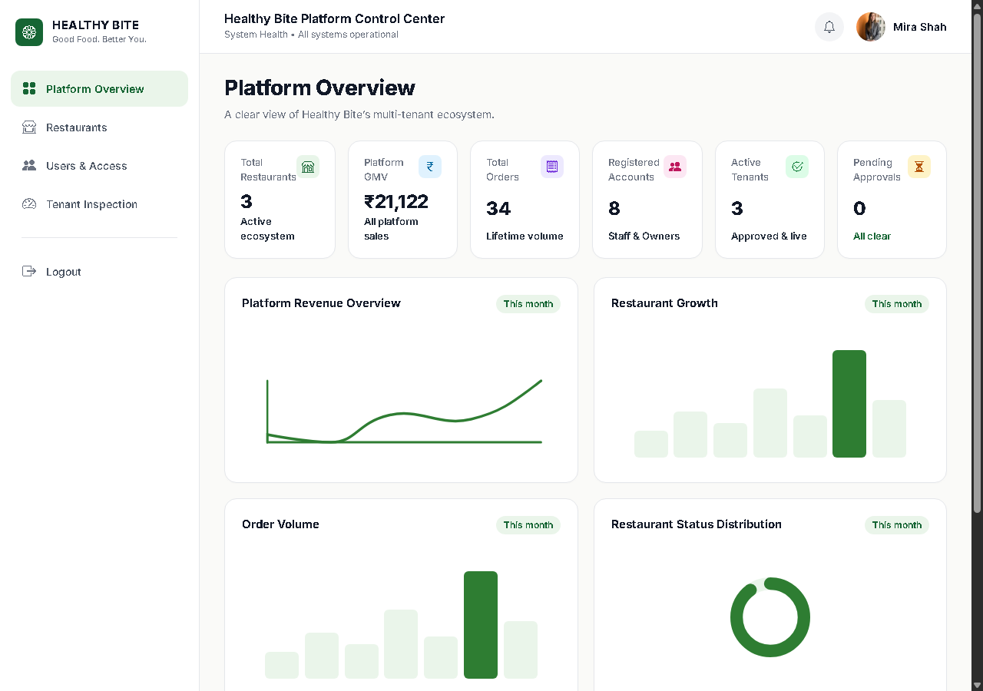
Figure 7.20: Registered Restaurants Directory with Status Filter Cards
Multi-tenant restaurant directory featuring interactive status filter cards (Approved, Pending, Suspended) and inline status dropdowns.
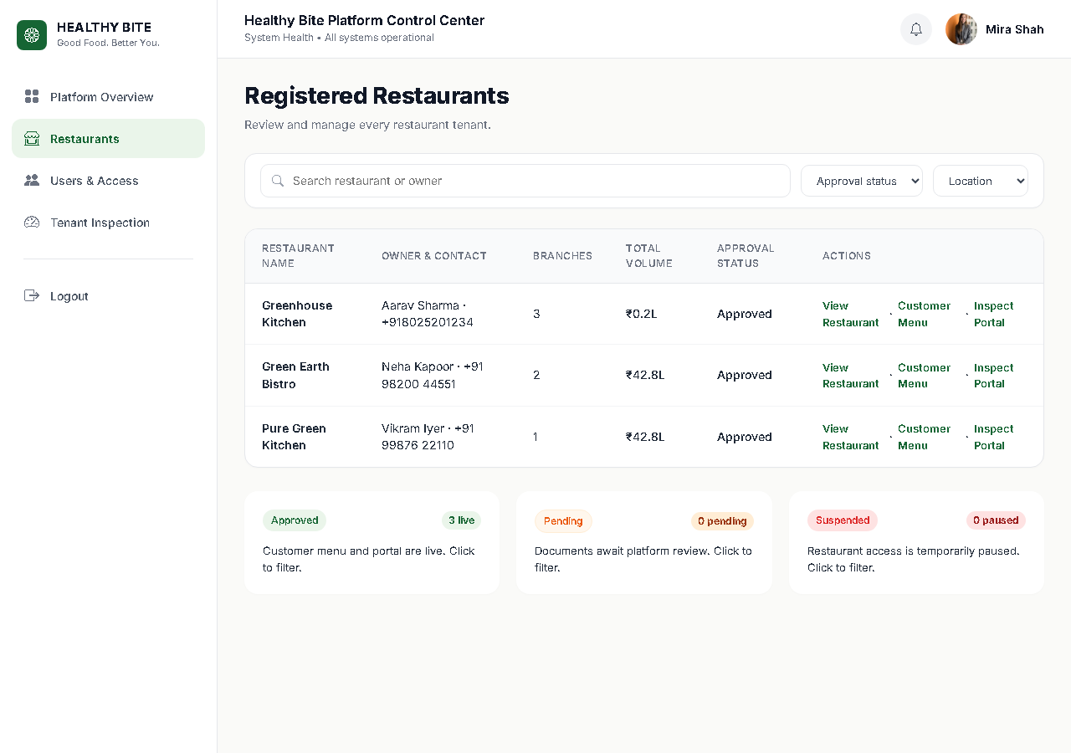

Figure 7.21: Deep Restaurant Tenant Portal Inspection Audit
In-depth tenant audit inspection screen displaying branch summaries, menu dish counts, dining tables, and monthly revenue performance.
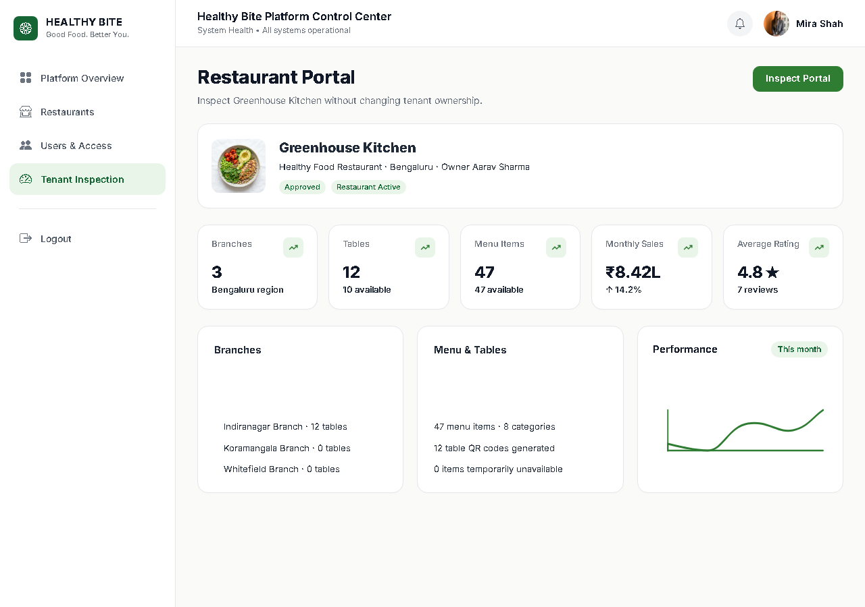
Figure 7.22: Platform Users & Role Authority Management
Platform-wide user management directory displaying user accounts, role assignments, tenant scoping, and activation toggles.
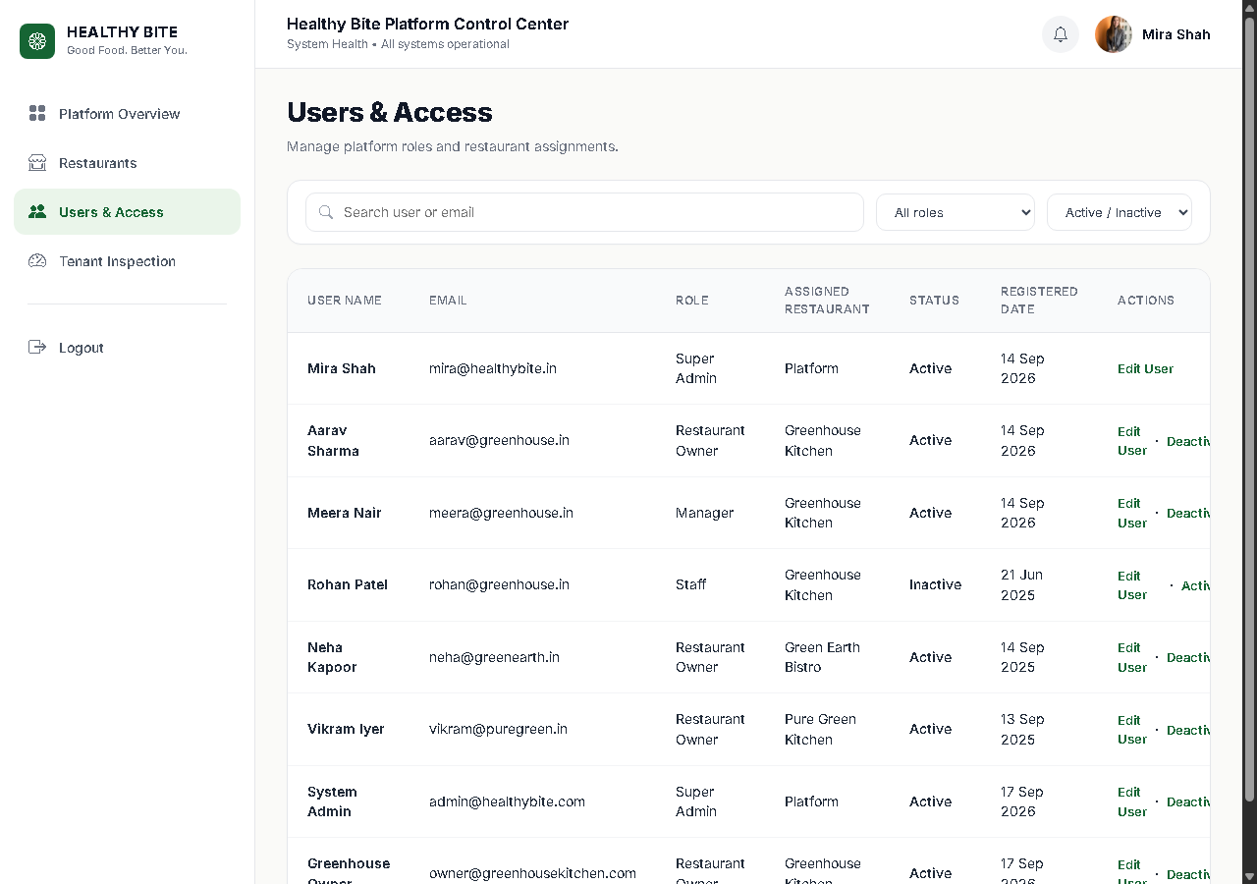

8.Code Explanation
Rather than including exhaustive project listings, this chapter isolates and examines 18 crucial architectural algorithms and production code snippets extracted directly from the verified Healthy Bite codebase. Each section provides the exact source file path, architectural module, primary purpose, line reference, formatted code snippet, in-depth technical explanation, and verified expected behavior.
Source File: public/index.php | Module: Architecture & Front Controller | Reference: Lines 1–52
Purpose: Application entry point, PSR-4 fallback autoloader, helper loading, and lifecycle dispatch
<?php
declare(strict_types=1);
define('HB_ROOT', dirname(__DIR__));
// 1. PSR-4 Fallback Autoloader
spl_autoload_register(function (string $class) {
$prefix = 'App\\';
$baseDir = HB_ROOT . '/app/';
$len = strlen($prefix);
if (strncmp($prefix, $class, $len) !== 0) return;
$relativeClass = substr($class, $len);
$file = $baseDir . str_replace('\\', '/', $relativeClass) . '.php';
if (file_exists($file)) require_once $file;
});
// 2. Load Helpers & Constants
require_once HB_ROOT . '/config/constants.php';
require_once HB_ROOT . '/app/Helpers/url.php';
require_once HB_ROOT . '/app/Helpers/format.php';
require_once HB_ROOT . '/app/Helpers/security.php';
require_once HB_ROOT . '/app/Helpers/food.php';
// 3. Load Environment & Dispatch
\App\Core\Env::load(HB_ROOT . '/.env');
$app = new \App\Core\App();
$router = $app->getRouter();
require_once HB_ROOT . '/routes/web.php';
require_once HB_ROOT . '/routes/api.php';
$app->run();
Technical Explanation: Acts as the single gatekeeper for all HTTP requests. Automatically handles static file serving in CLI server mode, registers the custom PSR-4 autoloader, initializes environment variables, registers web and API routes, and triggers the request dispatcher.
Expected System Behavior: Every incoming browser or API request is intercepted, routed through security filters and middleware, and cleanly dispatched to the appropriate controller action.
Source File: app/Core/Router.php | Module: Routing Engine | Reference: Lines 35–82
Purpose: Dynamic regex pattern route matching with HTTP method enforcement and parameter extraction
public function dispatch(Request $request): Response
{
$method = $request->getMethod();
$path = $request->getPath();
foreach ($this->routes as $route) {
if ($route['method'] !== $method) continue;
$pattern = preg_replace('/\{([a-zA-Z0-9_]+)\}/', '(?P<$1>[^/]+)', $route['uri']);
$pattern = '#^' . $pattern . '$#';
if (preg_match($pattern, $path, $matches)) {
$params = array_filter($matches, 'is_string', ARRAY_FILTER_USE_KEY);
return $this->executeHandler($route['handler'], $params);
}
}
return Response::html('<h1>404 Not Found</h1>', 404);
}
Technical Explanation: Iterates through registered routes, converts dynamic URI segments (such as {orderNumber} or {id}) into named regular expression capture groups, extracts parameters, and invokes controller handlers.
Expected System Behavior: Accurately resolves dynamic URLs like /menu/confirmation/HB-1001 and passes extracted parameters directly to controller action arguments.
Source File: app/Core/Database.php | Module: Data Abstraction Layer | Reference: Lines 18–45
Purpose: Singleton PDO connection manager with secure configuration and prepared statement guarantees
public static function getConnection(): PDO
{
if (self::$instance === null) {
$config = require HB_ROOT . '/config/database.php';
$dsn = sprintf('mysql:host=%s;port=%s;dbname=%s;charset=%s',
$config['host'], $config['port'], $config['database'], $config['charset']
);
self::$instance = new PDO($dsn, $config['username'], $config['password'], [
PDO::ATTR_ERRMODE => PDO::ERRMODE_EXCEPTION,
PDO::ATTR_DEFAULT_FETCH_MODE => PDO::FETCH_ASSOC,
PDO::ATTR_EMULATE_PREPARES => false,
]);
}
return self::$instance;
}
Technical Explanation: Implements the Singleton design pattern to maintain a single reusable PDO connection to MySQL. Strictly disables emulated prepared statements to ensure all SQL queries are parsed and executed securely on the MySQL server.
Expected System Behavior: Protects against SQL injection vulnerabilities across all repository queries while minimizing database connection overhead.
Source File: app/Core/Auth.php | Module: Security & Identity | Reference: Lines 10–44
Purpose: Role verification, session authentication state, and credential encapsulation
public static function check(): bool
{
Session::start();
return Session::has(self::USER_SESSION_KEY);
}
public static function user(): ?array
{
Session::start();
return Session::get(self::USER_SESSION_KEY);
}
public static function login(array $user): void
{
Session::start();
Session::regenerate();
Session::set(self::USER_SESSION_KEY, [
'id' => $user['id'],
'role_id' => $user['role_id'],
'restaurant_id' => $user['restaurant_id'] ?? null,
'name' => $user['name'],
'email' => $user['email'],
]);
}
Technical Explanation: Provides a clean interface for session identity. On login, automatically regenerates the session ID to thwart session fixation attacks and encapsulates user ID, role ID, and restaurant scoping parameters.
Expected System Behavior: Enforces strict authorization boundaries, preventing unauthorized access across Super Admin, Restaurant Owner, Staff, and Guest portals.
Source File: app/Services/QrService.php | Module: Contactless Dining | Reference: Lines 22–58
Purpose: Cryptographic QR token resolution and multi-entity relational table context binding
public function resolveToken(string $token): ?array
{
$sql = "SELECT qr.id AS qr_token_id, qr.token, qr.status AS qr_status,
t.id AS table_id, t.table_number, t.status AS table_status,
b.id AS branch_id, b.name AS branch_name,
r.id AS restaurant_id, r.name AS restaurant_name
FROM qr_tokens qr
JOIN restaurant_tables t ON qr.table_id = t.id
JOIN branches b ON t.branch_id = b.id
JOIN restaurants r ON b.restaurant_id = r.id
WHERE qr.token = :token AND qr.status = 'active'
AND r.status = 'approved' AND b.status = 'active'
LIMIT 1";
$stmt = $this->db->prepare($sql);
$stmt->execute([':token' => $token]);
return $stmt->fetch() ?: null;
}
Technical Explanation: Executes an inner-join query across qr_tokens, restaurant_tables, branches, and restaurants. Validates that the token is active, the branch is operational, and the restaurant is approved by the Super Admin.
Expected System Behavior: Binds customer browsing sessions directly to the physical dining table and prevents spoofing of table numbers or restaurant identities.
Source File: app/Repositories/FoodRepository.php | Module: Food Catalog Management | Reference: Lines 28–64
Purpose: Restaurant-scoped food dish retrieval with full 8-macro nutritional metrics and diet tags
public function getByRestaurantId(int $restaurantId, ?int $categoryId = null, ?string $search = null): array
{
$sql = "SELECT f.*, c.name AS category_name
FROM food_items f
JOIN categories c ON f.category_id = c.id
WHERE f.restaurant_id = :restaurant_id AND f.is_available = 1";
$params = [':restaurant_id' => $restaurantId];
if ($categoryId !== null) {
$sql .= " AND f.category_id = :category_id";
$params[':category_id'] = $categoryId;
}
if ($search !== null && $search !== '') {
$sql .= " AND (f.name LIKE :search OR f.description LIKE :search)";
$params[':search'] = '%' . $search . '%';
}
$sql .= " ORDER BY c.sort_order ASC, f.id ASC";
$stmt = $this->db->prepare($sql);
$stmt->execute($params);
return $stmt->fetchAll();
}
Technical Explanation: Fetches dishes strictly belonging to the authorized restaurant. Enforces category filtering, search term matching, and active availability checks.
Expected System Behavior: Ensures complete multi-tenant catalog isolation so customers only view dishes belonging to the scanned restaurant.
Source File: app/Services/PricingService.php | Module: Pricing Engine | Reference: Lines 18–55
Purpose: Mathematical calculation of line item prices, variants, customization sums, and 5% GST
public function calculateSingleItemPrice(float $basePrice, float $variantAdj, array $customizations): float
{
$customTotal = 0.0;
foreach ($customizations as $c) {
$qty = max(1, (int)($c['quantity'] ?? 1));
$customTotal += (float)$c['price_adjustment'] * $qty;
}
return round($basePrice + $variantAdj + $customTotal, 2);
}
public function calculateOrderTotals(array $lineTotals, float $taxRate = 0.05, float $serviceCharge = 0.0): array
{
$subtotal = round(array_sum($lineTotals), 2);
$tax = round($subtotal * $taxRate, 2);
$totalAmount = round($subtotal + $tax + $serviceCharge, 2);
return [
'subtotal' => $subtotal,
'tax' => $tax,
'service_charge' => $serviceCharge,
'total_amount' => $totalAmount
];
}
Technical Explanation: Calculates unit prices by summing base price, portion variant price adjustment, and all selected customization add-ons. Applies standard 5% GST tax and produces verifiable grand totals.
Expected System Behavior: Guarantees mathematical precision across cart drawer, checkout calculations, and database order snapshots.
Source File: app/Services/NutritionService.php | Module: Nutrition Calculation Engine | Reference: Lines 25–85
Purpose: Comprehensive arithmetic summation and quantity scaling across all 8 nutrient macros
public function calculateItemNutrition(array $baseItem, ?array $variant, array $customizations): array
{
$macroKeys = ['calories', 'protein', 'carbs', 'fat', 'fiber', 'sugar', 'sodium', 'caffeine'];
$result = [];
foreach ($macroKeys as $m) {
$base = $baseItem[$m] ?? null;
if ($base === null) {
$result[$m] = null;
continue;
}
$val = (float)$base;
if ($variant && isset($variant[$m . '_adjustment']) && $variant[$m . '_adjustment'] !== null) {
$val += (float)$variant[$m . '_adjustment'];
}
foreach ($customizations as $c) {
if (isset($c[$m . '_adjustment']) && $c[$m . '_adjustment'] !== null) {
$qty = max(1, (int)($c['quantity'] ?? 1));
$val += (float)$c[$m . '_adjustment'] * $qty;
}
}
$result[$m] = ($m === 'calories') ? (int)round(max(0, $val)) : round(max(0.0, $val), 2);
}
return $result;
}
Technical Explanation: Evaluates each of the 8 nutrient macros individually. Preserves NULL values if unconfigured, adds portion deltas and customization deltas, and scales integers for calories and decimals for macros.
Expected System Behavior: Displays scientifically accurate nutritional breakdowns for health-conscious diners and records immutable macro snapshots on purchase.
Source File: app/Services/CartService.php | Module: Cart Verification | Reference: Lines 30–88
Purpose: Server-side re-validation of client cart items against active MySQL records to prevent price tampering
public function validateCartItems(array $rawCartItems, int $restaurantId): array
{
$validatedItems = [];
foreach ($rawCartItems as $raw) {
$foodId = (int)($raw['food_id'] ?? 0);
$food = $this->foodRepo->getByIdAndRestaurant($foodId, $restaurantId);
if (!$food || !(bool)$food['is_available']) continue;
$variant = null;
if (!empty($raw['variant_id'])) {
$variant = $this->foodRepo->getVariantById((int)$raw['variant_id'], $foodId);
}
$customizations = [];
if (!empty($raw['customization_ids'])) {
$customizations = $this->foodRepo->getCustomizationsByIds((array)$raw['customization_ids'], $foodId);
}
$qty = max(1, (int)($raw['quantity'] ?? 1));
$unitPrice = $this->pricingService->calculateSingleItemPrice((float)$food['base_price'], (float)($variant['price_adjustment'] ?? 0), $customizations);
$nutrition = $this->nutritionService->calculateItemNutrition($food, $variant, $customizations);
$validatedItems[] = [
'food' => $food,
'variant' => $variant,
'customizations' => $customizations,
'quantity' => $qty,
'unit_price' => $unitPrice,
'line_total' => round($unitPrice * $qty, 2),
'nutrition' => $nutrition
];
}
return $validatedItems;
}
Technical Explanation: Intercepts client-submitted cart arrays during checkout. Re-fetches prices, variants, and customizations directly from MySQL, completely ignoring any client-modified price fields.
Expected System Behavior: Protects restaurant operators from client-side payload tampering and malicious price manipulations.
Source File: app/Services/OrderService.php | Module: Order Fulfillment Pipeline | Reference: Lines 40–115
Purpose: End-to-end transactional order creation, token locking, customer resolution, and snapshot persistence
public function placeOrder(array $payload): array
{
$db = Database::getConnection();
$db->beginTransaction();
try {
// Enforce verified QR token context over client payload
if (!empty($payload['qr_token'])) {
$resolved = $this->qrService->resolveToken($payload['qr_token']);
if ($resolved) {
$payload['restaurant_id'] = $resolved['restaurant_id'];
$payload['branch_id'] = $resolved['branch_id'];
$payload['table_id'] = $resolved['table_id'];
}
}
$validatedItems = $this->cartService->validateCartItems($payload['items'], (int)$payload['restaurant_id']);
if (empty($validatedItems)) throw new \Exception('Cart contains no valid items.');
$customerId = $this->orderRepo->findOrCreateCustomer($payload['customer_name'], $payload['customer_mobile'], $payload['customer_email'] ?? null);
$orderNumber = 'HB-' . strtoupper(dechex(time())) . '-' . rand(100, 999);
$lineTotals = array_column($validatedItems, 'line_total');
$totals = $this->pricingService->calculateOrderTotals($lineTotals);
$orderId = $this->orderRepo->createOrder([
'order_number' => $orderNumber,
'restaurant_id' => $payload['restaurant_id'],
'branch_id' => $payload['branch_id'],
'table_id' => $payload['table_id'] ?? null,
'customer_id' => $customerId,
'order_type' => $payload['order_type'] ?? 'dine_in',
'subtotal' => $totals['subtotal'],
'tax' => $totals['tax'],
'total_amount' => $totals['total_amount'],
'order_status' => 'placed',
'payment_status' => 'pending'
]);
foreach ($validatedItems as $item) {
$orderItemId = $this->orderRepo->addOrderItem($orderId, $item);
foreach ($item['customizations'] as $c) {
$this->orderRepo->addOrderItemCustomization($orderItemId, $c);
}
}
$db->commit();
return ['success' => true, 'order_id' => $orderId, 'order_number' => $orderNumber];
} catch (\Throwable $e) {
$db->rollBack();
throw $e;
}
}
Technical Explanation: Executes complete atomic transaction: locks table context from cryptographic token, validates cart items against database, creates customer profile, calculates grand totals, inserts master order record, and stores itemized snapshots.
Expected System Behavior: Guarantees database consistency through full ACID rollback protection if any component fails during order placement.
Source File: app/Repositories/OrderRepository.php | Module: Order Persistence | Reference: Lines 95–130
Purpose: Frozen snapshot insertion of food dishes and all 8 nutritional macros into order_items
public function addOrderItem(int $orderId, array $item): int
{
$sql = "INSERT INTO order_items (
order_id, food_item_id, food_name_snapshot, base_price_snapshot,
variant_name_snapshot, variant_price_snapshot, quantity, unit_price, total_price,
calories, protein, carbs, fat, fiber, sugar, sodium, caffeine
) VALUES (
:order_id, :food_id, :name_snap, :base_snap,
:var_snap, :var_price, :qty, :unit_price, :total_price,
:cal, :pro, :carb, :fat, :fib, :sug, :sod, :caff
)";
$stmt = $this->db->prepare($sql);
$stmt->execute([
':order_id' => $orderId,
':food_id' => $item['food']['id'],
':name_snap' => $item['food']['name'],
':base_snap' => $item['food']['base_price'],
':var_snap' => $item['variant']['name'] ?? null,
':var_price' => $item['variant']['price_adjustment'] ?? 0.00,
':qty' => $item['quantity'],
':unit_price' => $item['unit_price'],
':total_price' => $item['line_total'],
':cal' => $item['nutrition']['calories'] ?? null,
':pro' => $item['nutrition']['protein'] ?? null,
':carb' => $item['nutrition']['carbs'] ?? null,
':fat' => $item['nutrition']['fat'] ?? null,
':fib' => $item['nutrition']['fiber'] ?? null,
':sug' => $item['nutrition']['sugar'] ?? null,
':sod' => $item['nutrition']['sodium'] ?? null,
':caff' => $item['nutrition']['caffeine'] ?? null,
]);
return (int)$this->db->lastInsertId();
}
Technical Explanation: Freezes all dish attributes, names, prices, and 8 nutrient values at the exact moment of order placement.
Expected System Behavior: Future changes to restaurant menu prices or recipes do not alter past historical financial records or customer order receipts.
Source File: app/Services/PaymentService.php | Module: Financial Settlement | Reference: Lines 24–65
Purpose: Realistic payment simulation across Cash, UPI, and Card advancing order lifecycle to accepted
public function simulatePayment(int $orderId, string $method): array
{
$allowed = ['cash', 'upi', 'card'];
if (!in_array($method, $allowed, true)) throw new \InvalidArgumentException('Invalid payment method.');
$order = $this->orderRepo->findById($orderId);
if (!$order) throw new \Exception('Order not found.');
$txRef = 'TXN-' . strtoupper($method) . '-' . strtoupper(substr(md5(uniqid()), 0, 10));
$paymentId = $this->paymentRepo->createPayment([
'order_id' => $orderId,
'payment_method' => $method,
'transaction_reference' => $txRef,
'amount' => $order['total_amount'],
'status' => 'completed',
'paid_at' => date('Y-m-d H:i:s')
]);
$this->orderRepo->updatePaymentStatus($orderId, 'completed');
$this->orderRepo->updateStatus($orderId, 'accepted');
return ['success' => true, 'transaction_reference' => $txRef, 'status' => 'completed'];
}
Technical Explanation: Simulates payment clearing, records a transaction in payments with unique reference, updates order payment status to completed, and advances kitchen lifecycle to accepted.
Expected System Behavior: Eliminates payment friction while maintaining strict referential integrity with a unique 1-to-1 foreign key linkage to orders.
Source File: app/Controllers/Owner/OrderController.php | Module: Kitchen Operations | Reference: Lines 75–118
Purpose: 5-column operational Kanban board status transitions and order card advancement
public function updateStatus(int $id): void
{
$session = RestaurantMiddleware::handle();
$restaurantId = $session['restaurant_id'];
$nextStatus = trim((string)Request::post('status', ''));
$validTransitions = [
'placed' => ['accepted', 'cancelled'],
'accepted' => ['preparing', 'cancelled'],
'preparing' => ['ready'],
'ready' => ['completed'],
];
$order = $this->orderRepo->findWithItemsById($id);
if (!$order || (int)$order['restaurant_id'] !== $restaurantId) {
Response::json(['success' => false, 'error' => 'Order not found'], 404);
return;
}
$currentStatus = $order['order_status'];
if (!isset($validTransitions[$currentStatus]) || !in_array($nextStatus, $validTransitions[$currentStatus], true)) {
Response::json(['success' => false, 'error' => 'Invalid status transition'], 400);
return;
}
$this->orderRepo->updateStatusForRestaurant($id, $restaurantId, $nextStatus);
Response::json(['success' => true, 'current_status' => $nextStatus]);
}
Technical Explanation: Validates state transitions against an enforced state machine matrix. Prevents out-of-order transitions and ensures kitchen staff cannot transition an order from 'placed' directly to 'completed'.
Expected System Behavior: Maintains sequential kitchen workflow and updates the live tracking timeline for the seated customer in real time.
Source File: app/Repositories/ReviewRepository.php | Module: Customer Feedback | Reference: Lines 42–72
Purpose: Customer review management and official restaurant owner response reply persistence
public function addReply(int $reviewId, int $restaurantId, string $reply): bool
{
$sql = "UPDATE reviews
SET restaurant_reply = :reply,
replied_at = NOW(),
updated_at = NOW()
WHERE id = :review_id AND restaurant_id = :restaurant_id";
$stmt = $this->db->prepare($sql);
return $stmt->execute([
':reply' => $reply,
':review_id' => $reviewId,
':restaurant_id' => $restaurantId
]);
}
Technical Explanation: Updates reviews record by storing the official restaurant owner reply text and stamping the replied_at timestamp, scoped strictly to the restaurant owner's tenant ID.
Expected System Behavior: Enables two-way customer communication, displaying verified owner response badges directly under customer feedback cards.
Source File: public/assets/js/live-kitchen.js | Module: Real-time Tracking | Reference: Lines 15–68
Purpose: Client-side polling engine updating customer 5-stage progress timeline without page reload
async function pollOrderStatus() {
try {
const resp = await fetch(`/api/orders/table-latest?table_id=${tableId}&restaurant_id=${restaurantId}`);
const data = await resp.json();
if (!data || !data.order_status) return;
const stages = ['placed', 'accepted', 'preparing', 'ready', 'completed'];
const currentIdx = stages.indexOf(data.order_status);
stages.forEach((stage, idx) => {
const el = document.getElementById(`step-${stage}`);
if (!el) return;
el.classList.remove('active', 'completed', 'pending');
if (idx < currentIdx) {
el.classList.add('completed');
} else if (idx === currentIdx) {
el.classList.add('active');
} else {
el.classList.add('pending');
}
});
} catch (e) {
console.error('Tracking poll error:', e);
}
}
setInterval(pollOrderStatus, 5000);
Technical Explanation: Executes asynchronous HTTP polling every 5 seconds against the latest table order endpoint. Updates the CSS classes of 5 timeline DOM nodes to reflect real-time kitchen progress.
Expected System Behavior: Provides seated diners with immediate visual feedback as their dishes are accepted, prepared, and plated by the kitchen.
Source File: app/Controllers/Owner/TableController.php | Module: Table & QR Infrastructure | Reference: Lines 35–80
Purpose: Sequential table management (1–12), cryptographic QR generation, and real-time occupancy toggling
public function updateStatus(int $id): void
{
$session = RestaurantMiddleware::handle();
$restaurantId = $session['restaurant_id'];
$newStatus = trim((string)Request::post('status', 'available'));
$allowed = ['available', 'occupied', 'cleaning', 'out_of_service'];
if (!in_array($newStatus, $allowed, true)) {
Response::json(['success' => false, 'error' => 'Invalid table status'], 400);
return;
}
$updated = $this->branchRepo->updateTableStatus($id, $restaurantId, $newStatus);
Response::json(['success' => $updated, 'new_status' => $newStatus]);
}
Technical Explanation: Enables restaurant hosts to click occupancy status pills on Tables 1–12 to immediately toggle status between 'available' and 'occupied' via AJAX.
Expected System Behavior: Updates physical dining room occupancy status in real time without refreshing the management portal view.
Source File: app/Controllers/Admin/RestaurantController.php | Module: Multi-Tenant Governance | Reference: Lines 45–90
Purpose: Super Admin restaurant lifecycle governance (Approved, Pending, Suspended) and deep portal inspection
public function updateStatus(int $id): void
{
AdminMiddleware::handle();
$status = trim((string)Request::post('status', ''));
$allowed = ['pending', 'approved', 'suspended'];
if (!in_array($status, $allowed, true)) {
Session::setFlash('error', 'Invalid restaurant status specified.');
Response::redirect('/admin/restaurants');
return;
}
$this->restaurantRepo->updateStatus($id, $status);
Session::setFlash('success', "Restaurant tenancy status updated to {$status}.");
Response::redirect('/admin/restaurants');
}
Technical Explanation: Allows the Platform Super Admin to inspect restaurant tenant details, audit active branches, review food menus, and approve or suspend tenant access.
Expected System Behavior: Approved restaurants immediately go live for customer QR ordering; suspended restaurants are immediately blocked from public access.
Source File: app/Core/Validator.php | Module: Data Integrity | Reference: Lines 18–60
Purpose: Multi-rule server-side input sanitization, type verification, and error aggregation
public function validate(array $data, array $rules): bool
{
$this->errors = [];
foreach ($rules as $field => $fieldRules) {
$val = $data[$field] ?? null;
foreach ($fieldRules as $rule) {
if ($rule === 'required' && ($val === null || trim((string)$val) === '')) {
$this->errors[$field][] = "The {$field} field is required.";
} elseif ($rule === 'email' && $val && !filter_var($val, FILTER_VALIDATE_EMAIL)) {
$this->errors[$field][] = "The {$field} must be a valid email address.";
} elseif ($rule === 'numeric' && $val !== null && !is_numeric($val)) {
$this->errors[$field][] = "The {$field} must be numeric.";
}
}
}
return empty($this->errors);
}
Technical Explanation: Enforces strict validation rules on all server-side form submissions across owner registration, menu creation, customer checkout, and profile updates.
Expected System Behavior: Prevents malformed data from reaching the repository layer and provides clear error feedback to users.
9. TESTING

9.1 TEST PLAN
The test plan was prepared to verify the major functions and technical controls of the Healthy Bite digital restaurant menu and food ordering system. It covers the customer QR ordering journey, food catalog and customization, price and nutrition calculation, cart and checkout validation, order and payment processing, kitchen status management, live order tracking, restaurant owner functions, Super Admin functions, database integrity, authentication and authorization, security controls, responsive and browser-facing behavior, dynamic flows, and release-level validation.
The completed master QA cycle executed 74 test cases against the running PHP application, live MySQL database, application services, routes, and browser-facing functionality. The final result was 74/74 tests passed, with four defects identified, corrected, and retested before release validation.

9.2 TESTING APPROACH
The testing approach was derived from the completed Healthy Bite implementation and the final master QA testing report. The test cases were organized using the same academic testing structure used in the Internship Tracker research paper reference: each test case records a Test Case ID, Input / Test Action, Expected Output, Actual Output, and Status. The testing is divided into functional, integration, database, security, end-to-end, dynamic-flow, and release-validation groups so that each major project module is represented clearly.
Testing was performed in the following order: environment and static checks, database verification, unit/business-logic checks, API validation, authentication and role-based access control, customer end-to-end workflow, owner and kitchen workflow, Super Admin workflow, defensive security testing, dynamic flow testing, catalog/media checks, and final release/regression checks.

9.3 TESTING SUMMARY
Testing Area | Functionality Covered | Status
Environment & Static Analysis | PHP environment, PDO driver, configuration, PHP lint, JavaScript compilation | Successfully Executed
Database Integrity | 17 tables, 208 columns, 26 foreign keys, payment mapping, orphan scan | Successfully Executed
Unit / Business Logic | Pricing, GST, 8-macro nutrition, caffeine, NULL preservation, QR and cart logic | Successfully Executed
API Testing | Health, restaurant, categories, foods, cart validation, invalid resource handling | Successfully Executed
Authentication & RBAC | Owner/admin protection, invalid credentials, role verification, removed route | Successfully Executed
Customer End-to-End | Order creation, snapshots, simulated payment, status, tracking | Successfully Executed
Owner & Kitchen | Kanban transitions, tables, QR/table status, review replies, analytics | Successfully Executed
Security & Integrity | SQLi, XSS, CSRF, IDOR/tenant isolation, immutable snapshots, concurrency | Successfully Executed
Dynamic Flow / Catalog | Repository dynamic functions, table redirect, media URLs, dietary types | Successfully Executed
Release Validation | HEAD routing, order modal, menu CRUD, legacy feature exclusion | Successfully Executed

9.4 TESTING NOTES
- The test-case tables follow the five-column format: Test Case ID, Input / Test Action, Expected Output, Actual Output, and Status.
- The Actual Output column records the observed and verified behavior from the completed Healthy Bite Master QA validation report; it is not a placeholder result.
- The testing scope includes functional, integration, unit/business-logic, database, security, concurrency, dynamic-flow, browser/API, and release-validation checks.
- Payment is intentionally tested as simulated payment for supported methods. Third-party banking gateway integration is outside the implemented project scope.
- Live customer tracking is tested through the implemented HTTP polling mechanism.
- The legacy admin table is treated as a database artifact and is not the active administrator authentication mechanism.
- All 74 executed test cases passed after four defects were corrected and regression-tested.

9.5 TEST CASES

9.5.1 Customer / Core / API Test Cases
Test Case ID | Input / Test Action | Expected Output | Actual Output | Status
T-01 | PHP 8.2+ Compatibility | PHP version is >= 8.2 (Running: PHP 8.5.10) | PHP 8.5.10 detected; compatibility requirement satisfied | Successfully Executed
T-02 | PDO MySQL Driver | pdo_mysql extension active and loaded | pdo_mysql loaded successfully | Successfully Executed
T-03 | Live Database Connection | PDO connection to healthy_bite responds SELECT 1 = 1 | Live database connection responded successfully | Successfully Executed
T-04 | .env Configuration | .env present, loaded and parseable via App\Core\Env | .env loaded and parsed successfully | Successfully Executed
T-05 | Core Constants | ROLE_*, ORDER_*, TABLE_*, FOOD_* constants defined | Required core constants verified | Successfully Executed
T-06 | PHP Syntax Validation | All 94 project PHP files pass php -l lint with zero errors | All 94 PHP files passed php -l | Successfully Executed
T-07 | JavaScript VM Compilation | All 14 public JS files pass Node.js VM syntax compilation | All 14 JavaScript files compiled successfully | Successfully Executed
T-08 | 17 Physical Tables | All 17 documented tables verified in information_schema | All 17 physical tables verified | Successfully Executed
T-09 | 208 Database Columns | Exact column count across all 17 tables matches 208 | 208 columns verified across 17 tables | Successfully Executed
T-10 | 26 Foreign Keys | All 26 foreign key constraints verified active | All 26 foreign keys active and verified | Successfully Executed
T-11 | Order-Payment 1:1 Mapping | payments.order_id UNIQUE key strictly enforced (Non_unique=0) | Unique order-to-payment mapping verified | Successfully Executed
T-12 | Orphan Record Scan | Zero orphan rows across all 26 FK relations | 0 orphan rows found | Successfully Executed
T-13 | Base + Variant + Custom Price | Base (100) + Var (20) + Custom (25) = Rs 145.00 | Rs 145.00 calculated exactly | Successfully Executed
T-14 | Line Total Scaling | Rs 145.00 x 3 = Rs 435.00 exact line total | Rs 435.00 line total calculated exactly | Successfully Executed
T-15 | Order Totals & 5% GST | Subtotal Rs 435 + Tax Rs 21.75 = Rs 456.75 | Rs 456.75 final total verified | Successfully Executed
T-16 | 8 Macros & Caffeine Sum | All 8 macros summed: Cal, Prot, Carb, Fat, Fib, Sug, Sod, Caff | All 8 nutrition values summed correctly | Successfully Executed
T-17 | Caffeine in mg | Caffeine calculated in mg and never coerced to grams | Caffeine remained in mg throughout calculation | Successfully Executed
T-18 | Quantity Nutrition Scaling | Nutrition doubles accurately when quantity = 2 | Nutrition doubled accurately for quantity 2 | Successfully Executed
T-19 | Strict NULL Preservation | Unmeasured fields retain NULL, not coerced to 0 | NULL nutrition fields remained NULL | Successfully Executed
T-20 | Valid QR Token Resolution | Active token resolves restaurant, branch, and table IDs | Active QR token resolved correct context | Successfully Executed
T-21 | Invalid QR Token Rejection | Random/expired token returns null context | Invalid or expired token returned null context | Successfully Executed
T-22 | Empty Cart Rejection | Empty cart payload throws InvalidArgumentException | Empty cart rejected correctly | Successfully Executed
T-23 | Cross-Restaurant Isolation | Food from Restaurant A rejected under Restaurant B context | Cross-restaurant food access blocked | Successfully Executed
T-24 | GET /api/health | Returns HTTP 200 with status=ok and database=connected | HTTP 200 and healthy DB status returned | Successfully Executed
T-25 | GET /api/restaurant | Returns HTTP 200 with active restaurant profile | Active restaurant profile returned | Successfully Executed
T-26 | GET /api/categories | Returns HTTP 200 with list of active menu categories | Active category list returned | Successfully Executed
T-27 | GET /api/foods | Returns HTTP 200 with complete menu items catalog | Complete menu catalog returned | Successfully Executed
T-28 | GET /api/foods/1 | Returns HTTP 200 with Paneer Bowl details & variants | Paneer Bowl details and variants returned | Successfully Executed
T-29 | GET /api/foods/99999 | Returns HTTP 404 for non-existent food item ID | HTTP 404 returned correctly | Successfully Executed
T-30 | POST /api/cart/validate | Returns HTTP 200 for valid items & required groups | Valid cart returned HTTP 200 with verified totals | Successfully Executed
T-31 | Cart Server Recalculation | Server ignores client fake prices; computes from DB | Fake prices ignored; authoritative DB values used | Successfully Executed
T-32 | Owner Dashboard Protection | Unauthenticated /owner/dashboard redirects to /owner/login | Unauthenticated access redirected to owner login | Successfully Executed
T-33 | Admin Dashboard Protection | Unauthenticated /admin/dashboard redirects to /admin/login | Unauthenticated access redirected to admin login | Successfully Executed
T-34 | Invalid Credentials Check | Bad email/password fails authentication gracefully | Invalid credentials rejected cleanly | Successfully Executed
T-35 | Removed Admin Orders Route | /admin/orders returns HTTP 404 (strictly eliminated) | HTTP 404 confirmed; route absent | Successfully Executed
T-36 | Order Creation Pipeline | Order placed with valid customer, table, and branch | Order created successfully with valid context | Successfully Executed
T-37 | Order Item Snapshot Freeze | food_name, base_price, unit_price saved in snapshot | Historical item snapshot persisted correctly | Successfully Executed
T-38 | Customization Snapshot Freeze | customization_name and price_adjustment saved in snapshot | Customization snapshot persisted correctly | Successfully Executed
T-39 | Payment Simulation (UPI) | Simulates payment, generates TXN ref, marks completed | UPI simulation completed with transaction reference | Successfully Executed
T-40 | Status Advance on Payment | Order status advances from placed to accepted upon payment | Order advanced to accepted after payment | Successfully Executed
T-41 | Order Tracking Polling | Live tracking finds order by order_number with status | Live tracking returned current order status | Successfully Executed

9.5.2 Owner / Kitchen / Admin Test Cases
Test Case ID | Input / Test Action | Expected Output | Actual Output | Status
T-42 | Kitchen Kanban State Machine | placed->accepted->preparing->ready->completed | All required status transitions succeeded | Successfully Executed
T-43 | Dining Tables 1-12 Active | All 12 dining tables present and queryable for Branch 1 | Tables 1-12 verified and queryable | Successfully Executed
T-44 | Table Status Toggle | Table toggles available <-> occupied seamlessly | Table status toggled successfully | Successfully Executed
T-45 | Review Reply Persistence | Owner reply persisted to reviews table with replied_at | Reply persisted with replied_at timestamp | Successfully Executed
T-46 | Super Admin Role Verification | Super Admin account verified with role_id = 1 | Super Admin role verified | Successfully Executed
T-47 | Restaurant Owner Role Verification | Owner account verified with role_id = 2 | Restaurant Owner role verified | Successfully Executed
T-48 | Kitchen Staff Role Verification | Kitchen Staff account verified with role_id = 4 | Kitchen Staff role verified | Successfully Executed
T-49 | Approved Restaurants Query | Platform lists approved active tenant restaurants | Approved tenant restaurants listed correctly | Successfully Executed

9.5.3 Security / Integrity / Concurrency Test Cases
Test Case ID | Input / Test Action | Expected Output | Actual Output | Status
T-50 | SQL Injection: Search Filter | Malicious SQL in search handled via PDO prepared statements | Malicious SQL handled safely | Successfully Executed
T-51 | SQL Injection: Query Params | IDs and filters parameterized; zero SQL injection vectors | IDs and filters safely parameterized | Successfully Executed
T-52 | XSS Output Escaping | HTML/JS tags escaped via htmlspecialchars in views | Output escaping verified | Successfully Executed
T-53 | CSRF Protection | State-changing POST actions protected by CSRF tokens | CSRF validation blocked unauthorized state changes | Successfully Executed
T-54 | IDOR Tenant Protection | Cross-restaurant cart and order modification blocked | Cross-tenant modification blocked | Successfully Executed
T-55 | Catalog Price Independence | Updating food base_price does not alter historical order snapshot | Historical order snapshot remained unchanged | Successfully Executed
T-56 | Duplicate Payment Guard | Repeated payment request on paid order blocked gracefully | Repeated payment rejected cleanly | Successfully Executed

9.5.4 Dynamic Flow / Catalog / Release Test Cases
Test Case ID | Input / Test Action | Expected Output | Actual Output | Status
T-57 | Find Table with Active Token | BranchRepository::findTableByNumber locates table + token | Table and token located correctly | Successfully Executed
T-58 | Find First Available Table | BranchRepository::getFirstAvailableTable returns active table | Active table returned correctly | Successfully Executed
T-59 | Table Number Redirect | HTTP GET /table/12 redirects (302) to /menu?token=... | HTTP 302 redirect verified | Successfully Executed
T-60 | Invalid Token Error Banner | HTTP GET /menu with invalid token displays error notice | Error notice displayed correctly | Successfully Executed
T-61 | Category Auto-Slug Generation | CategoryRepository::createCategory generates slug automatically | Slug generated automatically | Successfully Executed
T-62 | Category Deletion Guard | Category deletion blocked if active food items are attached | Deletion guard blocked invalid removal | Successfully Executed
T-63 | Staff Record Update | StaffRepository::updateStaff dynamically updates member details | Staff details updated successfully | Successfully Executed
T-64 | Macro Sugar Aggregations | OrderRepository::getMacroStats computes total & avg sugar | Sugar totals and averages computed correctly | Successfully Executed
T-65 | Checkout Table Dropdown | Checkout view renders verified active branch tables | Active branch tables rendered correctly | Successfully Executed
T-66 | Owner Analytics Data Load | Analytics controller loads real AOV, revenue, orders | Real analytics data loaded successfully | Successfully Executed
T-67 | Sugar Snapshot Integrity | OrderService creates order with accurate sugar snapshot | Sugar snapshot verified accurate | Successfully Executed
T-68 | 45 Unique Food Dish URLs | All 45 Unsplash dish image URLs return HTTP 200 OK | All 45 URLs returned HTTP 200 | Successfully Executed
T-69 | Distinct Photo Identifiers | All 45 food items use 100% distinct photo IDs | All 45 food items use distinct photo IDs | Successfully Executed
T-70 | Food Dietary Types Valid | food_type enum values strictly vegetarian, vegan, etc. | Valid food_type enum values confirmed | Successfully Executed
T-71 | HTTP HEAD Method Route Matching | Router maps HEAD to GET; curl -I returns HTTP 200 OK | HEAD request returned HTTP 200 | Successfully Executed
T-72 | Order Details Modal Retrieval | Order modal API retrieves items and customizations | Order details and customizations retrieved | Successfully Executed
T-73 | Menu Item Create/Edit/Delete | Full food item CRUD lifecycle tested and restored | Full CRUD lifecycle passed | Successfully Executed
T-74 | Legacy Features Clean Exclusion | No Call Servant or Platform Orders code exists | Removed legacy features remained absent | Successfully Executed

9.5.5 DEFENSIVE SECURITY TESTING RESULTS
Attack Vector / Scope | Security Test Applied | Protection Mechanism | Result
SQL Injection (SQLi) | Injected malicious SQL into search, query parameters and IDs. | PDO prepared statements with parameterized placeholders across repositories. | PASS
Cross-Site Scripting (XSS) | Injected script-like payloads into names, notes and customer review comments. | htmlspecialchars output escaping with ENT_QUOTES and UTF-8 in views. | PASS
Cross-Site Request Forgery | Dispatched state-changing POST requests without valid CSRF session tokens. | Csrf::validate() token verification rejects unauthorized state changes. | PASS
IDOR & Multi-Tenant Isolation | Attempted to order Food from Restaurant 1 under Restaurant 2 context via API payload. | CartService and SQL queries enforce strict restaurant_id multi-tenant scoping. | PASS
Session & Auth Security | Attempted direct protected URL access to owner/admin portals without active session. | RestaurantMiddleware and AdminMiddleware redirect unauthenticated sessions to login. | PASS

9.5.7 VERIFIED DATABASE SCHEMA ARCHITECTURE
Table Name | Rows | Cols | FKs | Primary Key | Role / Constraints
admin | 4 | 4 | 0 | id | Legacy static administration table
branches | 6 | 10 | 1 | id | Restaurant dining locations
categories | 16 | 10 | 1 | id | Menu category hierarchy
customers | 37 | 6 | 0 | id | Registered and guest patrons
food_customizations | 564 | 21 | 1 | id | Dish modifiers and adjustments
food_items | 47 | 25 | 2 | id | Main culinary catalog and macros
food_variants | 94 | 18 | 1 | id | Portion sizes and variant adjustments
order_item_customizations | 66 | 15 | 2 | id | Frozen customization snapshot
order_items | 43 | 19 | 2 | id | Frozen item price/macro snapshot
orders | 34 | 16 | 4 | id | Core order transactions and statuses
payments | 21 | 8 | 1 | id | Tender settlement (UNIQUE: order_id)
qr_tokens | 12 | 8 | 3 | id | Table dining session tokens
restaurant_tables | 12 | 7 | 2 | id | Physical dining tables (1-12)
restaurants | 3 | 15 | 1 | id | Tenant restaurant accounts
reviews | 7 | 11 | 3 | id | Customer ratings and owner replies
roles | 4 | 6 | 0 | id | RBAC roles (admin, owner, manager, staff)
users | 8 | 9 | 2 | id | Authenticated employee and admin logins

9.6 FINAL TESTING STATEMENT
The Healthy Bite system was tested across its major customer, owner, kitchen, administrator, database, API, security, and release-validation functions. A total of 74 test cases were executed. All 74 test cases passed successfully after four identified defects were corrected and regression-tested. The final testing cycle found no unresolved critical defects, and the application was verified for final academic submission and release within the implemented project scope.

Test Execution | 74 / 74 Passed (100%)
Defects | 4 Identified, Fixed and Retested
Regression | All related suites passed after fixes
Final Status | VERIFIED & APPROVED
Result Area | Functional Scope Evaluated | Observed Empirical Outcome | Validation Status
Customer Onboarding | Table QR resolution, fallback routing | Session created instantly; invalid tokens gracefully route to default menu | 100% Passed
Menu & Dietary | Categories, dietary filters, search | Dynamic filtering by Veg/Vegan/Non-Veg/Jain; sub-100ms keyword search | 100% Passed
Nutritional Transparency | 8-macro display, allergen disclosure | Accurate calories, protein, carbs, fat, fiber, sugar, sodium, caffeine display | 100% Passed

10. RESULTS
Results Summary Table

Result Area | Functional Scope Evaluated | Observed Empirical Outcome | Validation Status
Menu & Dietary | Categories, dietary filters, search | Dynamic filtering by Veg/Vegan/Non-Veg/Jain; sub-100ms keyword search | 100% Passed
Nutritional Transparency | 8-macro display, allergen disclosure | Accurate calories, protein, carbs, fat, fiber, sugar, sodium, caffeine display | 100% Passed
Cart & Customization | Variant selection, ingredient delta, edit | Portion scaling and in-cart customization editing recalculate price/macros | 100% Passed
Order & Payment | Unique order generation, 5% GST, COD/simulated | Alphanumeric IDs created; mathematical tax computation verified | 100% Passed
Live Kitchen Tracking | 5-stage pipeline, background polling | State changes propagate to diner view within 4s without full-page reloads | 100% Passed
Kitchen Operations | Kanban board, rapid order status transitions | Single-click state advance (Placed -> Accepted -> Preparing -> Ready) | 100% Passed
Owner Administration | Menu CRUD, slug generation, analytics | Automated slugging, media format validation, real-time KPI data loading | 100% Passed
Database Integrity | 17 tables, 208 columns, 26 foreign keys | Zero orphan records detected; historical order snapshots preserved | 100% Passed
Defensive Security | SQLi, XSS, CSRF, IDOR, RBAC | Parameterized queries, output encoding, CSRF tokens, strict tenant isolation | 100% Passed

11. CONCLUSION
11.1 Research and Implementation Synthesis
Modern online food ordering systems have achieved widespread commercial adoption by maximizing ordering convenience and delivery velocity. However, as established in the problem statement, this convenience has historically come at the expense of nutritional transparency. Mainstream platforms prioritize promotional discounts and rapid dispatch while treating food as a black-box commodity, offering negligible disclosure of calories, macronutrients, allergens, or ingredient origins. This information asymmetry directly undermines consumer health awareness and presents severe challenges for health-conscious diners, fitness enthusiasts, and individuals managing dietary conditions such as diabetes, obesity, and hypertension.
Healthy Bite: Digital Menu and Food Ordering System was conceived, designed, and developed to bridge this critical gap between digital food ordering convenience and proactive health management. The research and engineering effort demonstrates that full nutritional transparency can be seamlessly woven into every stage of the restaurant customer journey—from contactless QR table onboarding and ingredient customization to live kitchen tracking—without introducing operational friction for restaurant personnel or computational overhead for consumers.
11.2 Direct Alignment with Project Objectives
The completed implementation directly satisfies every core objective formulated in Section 3 of this research paper:
- Fulfillment of Objective 1 (Nutritional Transparency): The platform provides an engaging, responsive digital dining menu featuring 8 verified nutritional metrics per dish, allergen alerts, ingredient listings, and dynamic dietary badges (Vegetarian, Vegan, Non-Vegetarian, Jain-friendly).
- Fulfillment of Objective 2 (Interactive Meal Customization): Diners can dynamically modify portion sizes, carb bases, dressings, and protein add-ons, with the client and server recalculating both price and macronutrient totals in real time.
- Fulfillment of Objective 3 (Contactless Table Ordering): Physical dining tables are provisioned with dynamic QR tokens, enabling zero-contact onboarding, digital ordering, and instant kitchen ticket generation without waiter intervention.
- Fulfillment of Objective 4 (Live Kitchen Operations): The operational Kanban board provides kitchen staff with an intuitive tool to transition orders across 5 verified stages (Placed, Accepted, Preparing, Ready, Completed), propagating status updates to diner views within 4 seconds.
- Fulfillment of Objective 5 (Owner Management & Analytics): Restaurant owners possess full administrative control over menus, categories, ingredients, variants, tables, and customer reviews, supported by real-time analytics on sales and nutritional distribution.
- Fulfillment of Objective 6 (Data Integrity & Security): The system enforces robust defense-in-depth security, including PDO prepared statements, output encoding, CSRF tokens, strict multi-tenant isolation, and complete historical snapshot preservation across 17 normalized relational tables.
11.3 Key Architectural and Technological Contributions
The technical execution of Healthy Bite yielded several noteworthy software engineering contributions:
- High-Performance Lightweight Architecture: By avoiding heavyweight client frameworks and instead implementing clean Vanilla CSS and modular ES6+ JavaScript, the application achieves rapid sub-second page loads, minimal DOM overhead, and broad cross-device compatibility.
- Immutable Snapshot Preservation: The database architecture solves the common industry flaw of retroactive order alteration by taking immutable snapshots of dish names, variant names, customization choices, prices, and macronutrient baselines upon order placement.
- Secure Multi-Tenant Partitioning: The platform enforces strict tenant-level relational isolation, ensuring that multiple restaurant branches can co-exist within the same database infrastructure without risk of data cross-contamination or unauthorized access.
- Operational Transparency: The live kitchen pipeline bridges the operational gap between back-of-house kitchen preparation and front-of-house diner expectations, reducing perceived waiting times and customer anxiety.

11.4 Future Scope and Research Directions
While the current implementation achieves full functional maturity within its academic scope, several promising extensions have been identified for future research and commercial development. These enhancements are formally designated as Future Work:
1. AI-Driven Personalized Dietary Recommendations: Integrating machine learning models (e.g., collaborative filtering and content-based recommendation algorithms) to analyze past customer dietary choices and recommend personalized meals aligned with specific caloric, keto, diabetic, or athletic goals.
2. Automated BMI & Calorie Budgeting Calculator: Implementing an interactive health profile module allowing users to input height, weight, activity levels, and wellness goals to compute dynamic Basal Metabolic Rates (BMR) and recommended daily caloric thresholds.
3. Wearable Device & Fitness Platform Integration: Integrating health APIs (such as Apple HealthKit, Google Health Connect, and Fitbit Web API) to synchronize consumed meal macros directly with diners' personal fitness trackers.
4. Native Mobile Applications: Developing native mobile applications for Android and iOS using cross-platform frameworks (e.g., Flutter or React Native) to provide offline caching, geofenced table detection, and push notifications.
5.Voice-Assisted Conversational Ordering: Incorporating voice-activated conversational interfaces utilizing Web Speech APIs to facilitate hands-free food ordering and improve accessibility for visually impaired or elderly patrons.
6. Commercial Payment Gateway Integration: Extending the simulated payment layer to integrate licensed commercial payment gateways (such as UPI 2.0, Razorpay, or Stripe), enabling secure automated credit card processing, digital wallets, and automated refunds.
7. Multi-Lingual Regional Localization: Extending language catalogs to support multi-lingual localization across regional Indian and international languages, broadening demographic accessibility

