1:write a program to test Hello World.

public class Test1 {

public static void main(String[] args){

// Scanner sc= new Scanner(System.in);

// int n;

// n=sc.nextInt();

// System.out.println(n);

System.out.println("hello world");

// sc.close();

}

}

Output:



2:Write a program to addition of two numbers .

import java.util.Scanner;

public class Test1 {

public static void main(String[] args){

Scanner sc= new Scanner(System.in);

int n;

System.out.println("Enter two numbers :");

n=sc.nextInt();

int n2=sc.nextInt();

int n3=n+n2;

System.out.println("The summation of two number is "+n3);

//System.out.println("hello world");

sc.close();

}

}

Output:

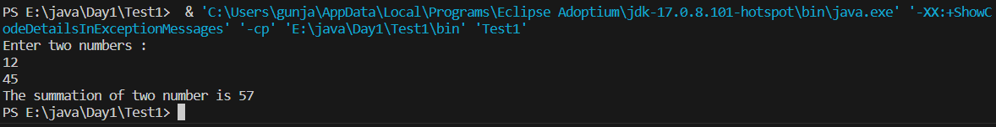

3:Write a program to swap two numbers.

import java.util.Scanner;

public class Prac2 {

public static void main(String[] args){

int num1, num2;

Scanner sc=new Scanner(System.in);

System.out.println("Enter the two numbers :");

num1=sc.nextInt();

num2=sc.nextInt();

int temp;

temp=num1;

num1=num2;

num2=temp;

System.out.println(" after swapping two numbers are :");

System.out.println("num1 :"+num1);

System.out.println("num2 :"+num2);

sc.close();

}

}

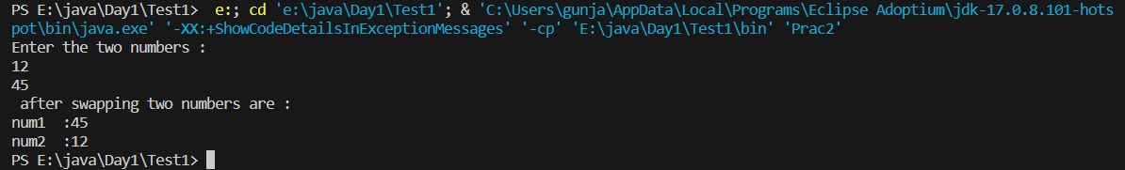

4. Write a program to accept an integer and check if it is even or odd.

import java.util.Scanner;

public class prac3 {

public static void main(String[] args){

Scanner sc= new Scanner(System.in);

int num1;

System.out.println("Enter a number :");

num1=sc.nextInt();

if(num1%2==0){

System.out.println("Even number ");

}

else{

System.out.println("Odd number ");

}

sc.close();

}

}

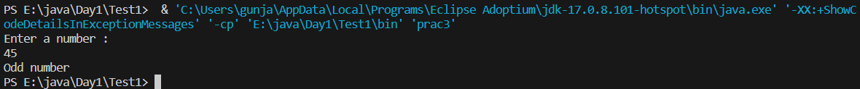

5. Write a program to accept a number and check if it is divisible by 5 and 7.

import java.util.Scanner;

public class prac5 {

public static void main(String[] args){

Scanner sc=new Scanner(System.in);

int num;

System.out.println("Enter a number :");

num=sc.nextInt();

if(num %5==0 && num%7==0){

System.out.println("The number is divisible by both 7 and 5");

}

else{

System.out.println("The number is not divisible by 5 and 7");

}

sc.close();

}

}

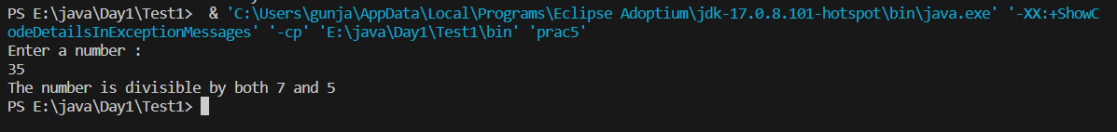

6. Write a program, which accepts annual basic salary of an employee and calculates and displays the

Income tax as per the following rules.

Basic: < 1, 50,000 Tax = 0

1, 50,000 to 3,00,000 Tax = 20%

> 3,00,000 Tax = 30%

import java.util.Scanner;

public class prac6 {

public static void main(String[] args){

Scanner sc= new Scanner(System.in);

int sal;

double tax;

System.out.println("Enter your salary :");

sal=sc.nextInt();

if(sal>300000){

tax=sal*30/100;

}

else if(sal>150000 && sal<300000){

tax=20*sal/100;

}

else{

tax=0;

}

System.out.println(tax);

}

}

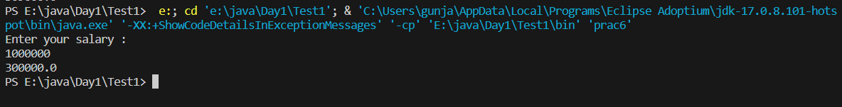

7. Accept a lowercase character from the user and check whether the character is a vowel or consonant.

(Hint: a, e, i, o, u are vowels)

import java.util.Scanner;

public class prac7 {

public static void main(String[] args){

Scanner sc=new Scanner(System.in);

char c;

System.out.println("Enter a character :");

c=sc.next().charAt(0);

if(c=='a' || c=='e'|| c=='i'|| c=='o' || c=='u'){

System.out.println("The character is vowel ");

}

else{

System.out.println("The character is consonent");

}

}

}

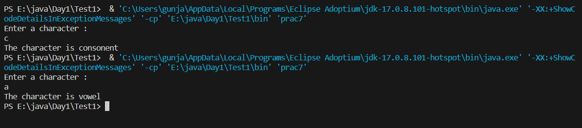

8. Write a program to input angles of a triangle and check whether triangle is valid or not.

import java.util.Scanner;

public class prac8 {

public static void main(String[] args){

Scanner sc=new Scanner(System.in);

int ang1, ang2, ang3;

System.out.println("Enter the angles :");

ang1=sc.nextInt();

ang2=sc.nextInt();

ang3=sc.nextInt();

if(ang1+ang2+ang3==180){

System.out.println("it is a triangle ");

}

else{

System.out.println(" it is not triangle ");

}

}

}

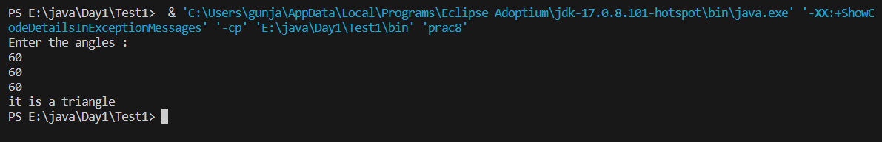

9:Write a program to find factorial of a given number. ex:no5 fact=5*4*3*2*1=120

import java.util.Scanner;

public class prac8{

public static void main(String[] args){

Scanner sc= new Scanner(System.in);

int num;

System.out.println("ENter a number ");

num= sc.nextInt();

int fact=1;

for(int i=2;i<=num;i++){

fact=fact*i;

// fact++;

}

System.out.println("The factorial of number is "+fact);

sc.close();

}

}

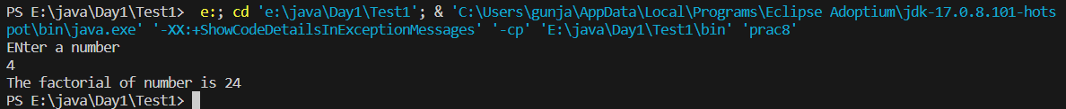

10:Write a program to find m to the power n. m=3 and n=4 so 3*3*3*3

import java.util.Scanner;

public class prac9 {

public static void main(String[] args){

Scanner sc= new Scanner(System.in);

int n, n2;

System.out.println("Enter two number :");

n=sc.nextInt();

n2= sc.nextInt();

int temp=1;

for(int i=0;i<n;i++){

temp=temp*n2;

}

System.out.println("the power "+n+" to the number "+n2+" = "+temp);

}

}

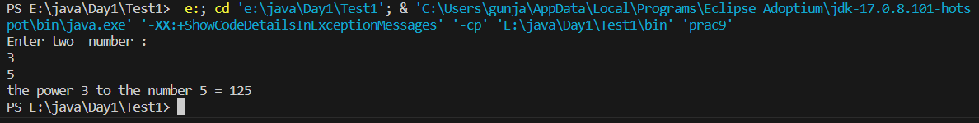

11:Check if number is a prime number or not.:

import java.util.Scanner;

public class prac11 {

public static void main(String[] args){

Scanner sc= new Scanner(System.in);

int num;

System.out.println("Enter a number :");

num= sc.nextInt();

boolean flag=false;

for(int i=2;i<num;i++){

if(num%i==0){

flag=false;

break;

}

else{

flag=true;

}

}

if(flag==true){

System.out.println("THe number is prime ");

}

else{

System.out.println("THe number is not prime ");

}

sc.close();

}

}

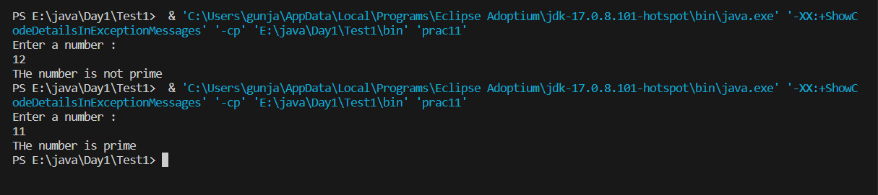

12:Sum of series :

1+2+3+….+n

import java.util.Scanner;

public class prac12 {

public static void main(String[] args){

Scanner sc= new Scanner(System.in);

System.out.println("Enter a number :");

int num=sc.nextInt();

int sum=0;

for(int i=1;i<=num;i++){

sum+=i;

}

System.out.println("THe summation of numbers are :"+sum);

}

}

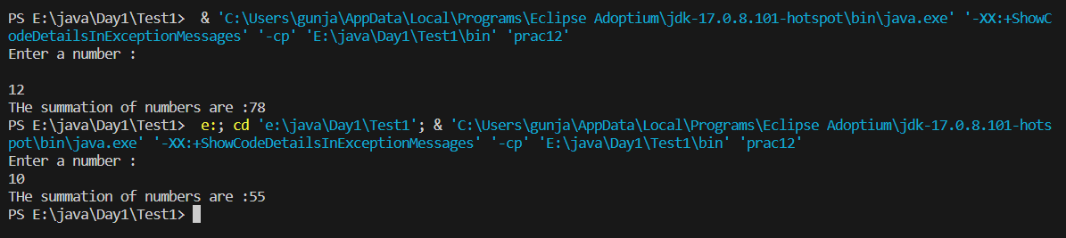

13:Check whether the number is palindrome or not?

import java.util.Scanner;

public class prac13 {

public static void main(String [] args){

Scanner sc=new Scanner(System.in);

System.out.println("Enter a number :");

int num=sc.nextInt();

int rem=0;

int sum=0;

int n=num;

while(num!=0){

rem=num%10;

sum=sum*10+ rem;

num=num/10;

}

if(n==sum){

System.out.println("it is palindrome ");

}

else{

System.out.println("it is not palindrome");

}

}

}

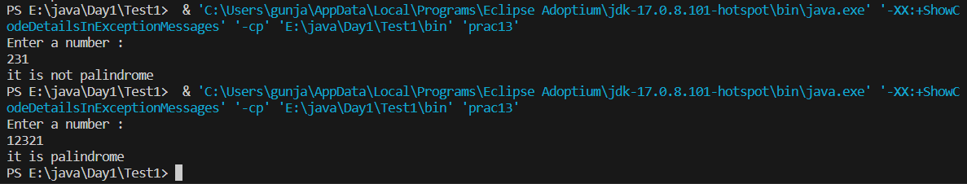

14:Write a program to find sum of all even and odd numbers between 1 to n.

import java.util.Scanner;

public class prac14 {

public static void main(String[] args){

Scanner sc= new Scanner(System.in);

int num;

System.out.println("ENter a number ");

num=sc.nextInt();

int sum1=0, sum2=0;

for(int i=1;i<=num;i++){

if(i%2==0){

sum2=sum2+i;

}

else{

sum1=sum1+i;

}

}

System.out.println("the summation of even is :" + sum2 + " The summation of odd is "+ sum1);

sc.close();

}

}

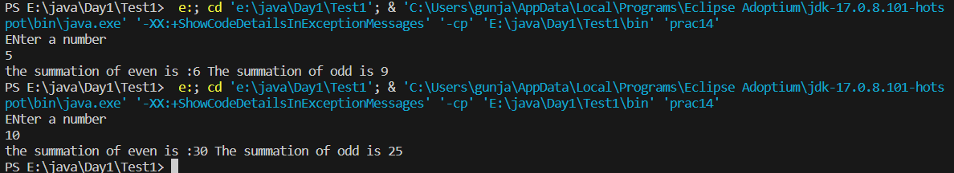

15: Write a program to enter a number and print its reverse.

import java.util.Scanner;

public class prac15{

public static void main(String[] args){

Scanner sc=new Scanner(System.in);

System.out.println("Enter a number :");

int num=sc.nextInt();

int rem=0;

int sum=0;

int n=num;

while(num!=0){

rem=num%10;

sum=sum*10+ rem;

num=num/10;

}

System.out.println("The reverse of number is "+ sum);

}

}

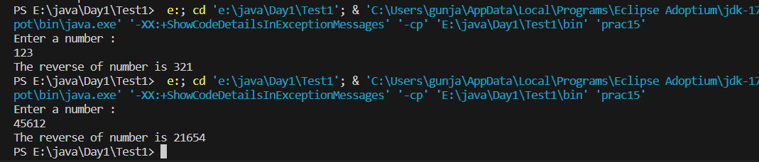

16:Write a program to print all Prime numbers between 1 to n.

import java.util.Scanner;

public class prac11 {

public static void isPrime( int n){

boolean flag=true;

for(int i=2;i<n;i++){

if(n%i==0){

flag=false;

break;

}

else{

flag=true;

}

}

if(flag==true){

System.out.println("THe number "+n+ " is prime ");

}

else{

System.out.println("THe number "+n +" is not prime ");

}

}

public static void main(String[] args){

Scanner sc= new Scanner(System.in);

int num;

System.out.println("Enter a number :");

num= sc.nextInt();

//boolean flag=false;

for(int i=2;i<num;i++){

isPrime(i);

}

sc.close();

}

}

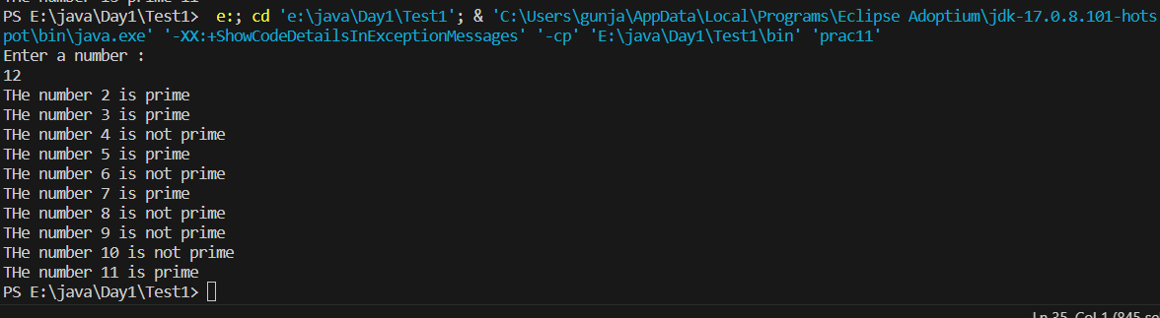

17:Write a program to check entered number is Armstrong number or not.

import java.util.Scanner;

public class prac17 {

public static void main(String[] args)

{

Scanner sc= new Scanner(System.in);

double count=0;

int num;

System.out.println("Enter a number :");

num=sc.nextInt();

int n=num;

int num1=num;

while(n!=0){

count++;

n=n/10;

}

// System.out.println(n);

int rem;

double sum=0;

while(num!=0){

rem=num%10;

sum=sum+ Math.pow(rem,count);

num=num/10;

}

if(num1==sum){

System.out.println("It is armstrong number ");

}

else{

System.out.println("It is not armstrong number ");

}

//System.out.println(sum);

}

}

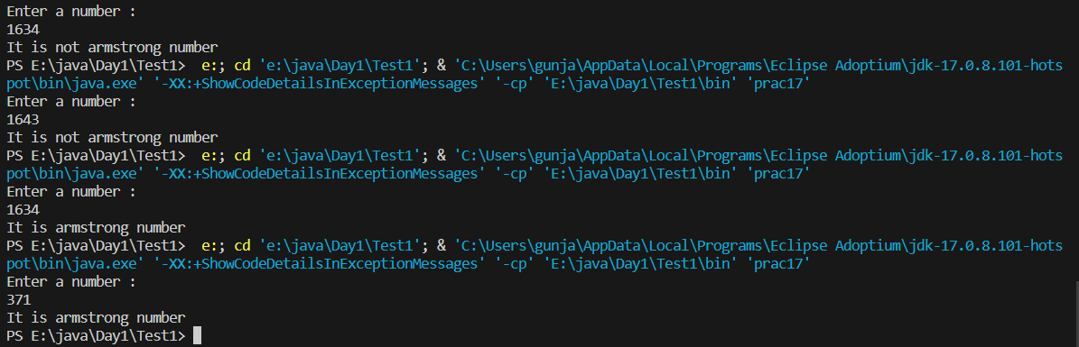

18:Write a program to find greatest of three numbers using nested if-else.

import java.util.Scanner;

public class prac18 {

public static void main(String[] args){

Scanner sc= new Scanner(System.in);

int num1, num2, num3;

System.out.println("ENter three number :");

num1= sc.nextInt();

num2=sc.nextInt();

num3= sc.nextInt();

if( num1 >num2 && num1 >num3){

System.out.println("The number 1 is greater ");

}

else if(num2 >num1 && num2 >num2){

System.out.println("The number 2 is greater ");

}

else{

System.out.println("The number 3 is greater ");

}

}

}

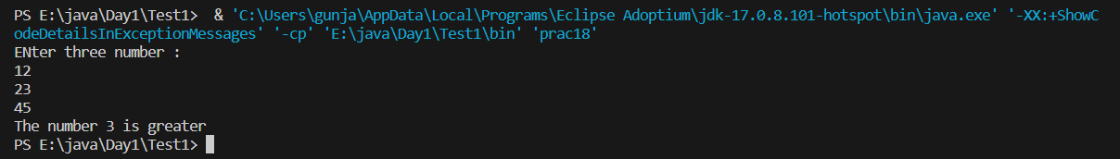

19:Create menu driven program for Pizza Shop.And display total amount,

20:Accept a single digit from the user and display it in words. For example, if digit entered is 9, display Nine.

import java.util.Scanner;

public class prac20 {

public static void main(String[] args){

Scanner sc= new Scanner(System.in);

int num;

System.out.println("Enter a number :");

num=sc.nextInt();

switch(num){

case 1: System.out.println("One");

break;

case 2: System.out.println("Two");

break;

case 3: System.out.println("Three");

break;

case 4: System.out.println("Four");

break;

case 5: System.out.println("Five");

break;

case 6: System.out.println("Six");

break;

case 7: System.out.println("Seven");

break;

case 8: System.out.println("Eight");

break;

case 9: System.out.println("Nine");

break;

default: System.exit(0);

break;

}

sc.close();

}

}

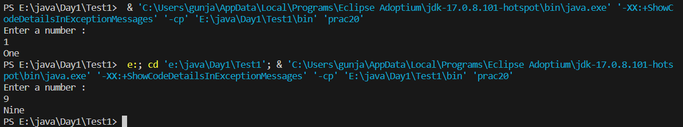

21. Write a program, which accepts two integers and an operator as a character (+ - * / ), performs the

corresponding operation and displays the result.

import java.util.Scanner;

public class prac21 {

public static void main(String[] args){

Scanner sc= new Scanner(System.in);

int num1, num2;

int a;

char ch;

while(true){

System.out.println("Enter your choice \n+ for addition \n- for subtraction\n* for multiplication\n/ for divide\nany for exit: ");

ch=sc.next().charAt(0);

switch(ch){

case '+': System.out.println("Enter 2 numbers :");

num1=sc.nextInt();

num2=sc.nextInt();

a=num1+num2;

System.out.println("The summation is :"+a);

break;

case '-':System.out.println("Enter 2 numbers :");

num1=sc.nextInt();

num2=sc.nextInt();

a=num1-num2;

System.out.println("The subtraction is :"+a);

break;

case '*':

System.out.println("Enter 2 numbers :");

num1=sc.nextInt();

num2=sc.nextInt();

a=num1+num2;

System.out.println("The multiplication of number is :"+a);

break;

case '/':

System.out.println("Enter 2 numbers :");

num1=sc.nextInt();

num2=sc.nextInt();

a=num1/num2;

System.out.println("The divide of 2 number is :"+a);

break;

default: System.exit(0);

break;

}

}

}

}

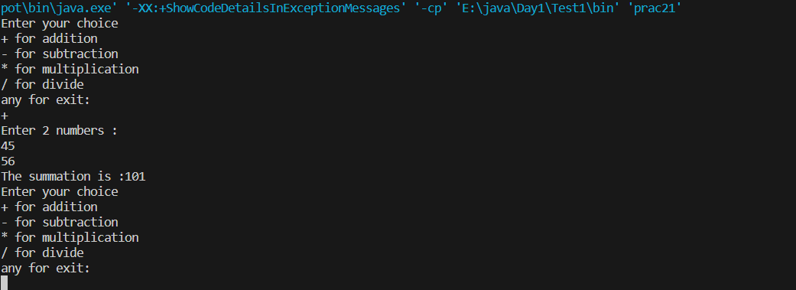

import java.util.Scanner;

public class Prac1{

public static void main(String[] args){

Scanner sc= new Scanner(System.in);

int sum=0;

int n;

do{

System.out.println("Enter the number");

n=sc.nextInt();

if(n>=0){

sum=sum+n;

}

else{

System.out.println("Enter a positive number");

System.out.println("Sum is:"+sum);

System.exit(0);

}

}

while(true);

}

}

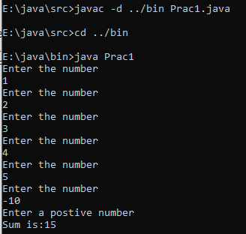

import java.util.Scanner;

public class Prac3{

public static void main(String[] args){

Scanner sc= new Scanner(System.in);

int n;

System.out.println("Enter a number ");

n=sc.nextInt();

char c;

System.out.println("ENter a character ");

c=sc.next().charAt(0);

for(int i=0;i<=n;i++){

System.out.print((c++)+" ");

}

}

}

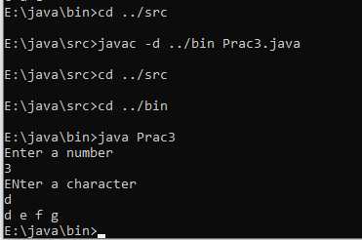

import java.util.Scanner;

public class Prac5{

public static void main(String[] args){

Scanner sc= new Scanner(System.in);

int num;

System.out.println("ENter a number ");

num=sc.nextInt();

for(int i=2;i<num;i++){

if(num%i==0){

System.out.println("The Factor of "+num+" is "+i);

}

}

}

}

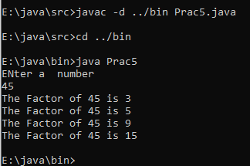

import java.util.Scanner;

public class Prac6{

public static void main(String[] args){

Scanner sc= new Scanner(System.in);

int num1, num2;

System.out.println("Enter the number numbers: ");

num1=sc.nextInt();

num2=sc.nextInt();

int result;

if(num1>num2)

result=num2;

else result=num1;

while(result>0){

if(num1%result==0 && num2%result==0){

break;

}

result--;

}

System.out.println("The Gcd of number "+num1 +" and " + num2 +" is " +result);

}

}

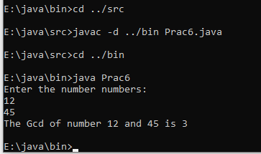

import java.util.Scanner;

public class Prac7{

public static void main(String[] args){

Scanner sc= new Scanner(System.in);

int radius;

int length,breadth;

int base, height;

float area;

char ch;

while(true){

System.out.println(" a) Compute area of circle\nb) Compute area of rectangle\nc) Compute area of triangle\nd) Exit ");

ch=sc.next().charAt(0);

switch(ch){

case 'a':

System.out.println("Enter the radius of circle ");

radius=sc.nextInt();

area=(float)3.14*radius*radius;

System.out.println("The radius of circle is " +area);

break;

case 'b':

System.out.println("Enter the length and breadth of reactangle: ");

length=sc.nextInt();

breadth=sc.nextInt();

area=length*breadth;

System.out.println("The radius of circle is " +area);

break;

case 'c':

System.out.println("Enter the base and height of triangle : ");

base=sc.nextInt();

height=sc.nextInt();

area=(float)0.5*base * height;

System.out.println("The radius of circle is " +area);

break;

case 'd':

System.exit(0);

break;

default:

break;

}

}

}

}

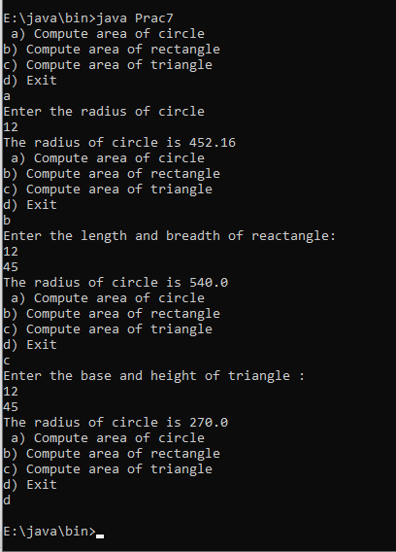

import java.util.Scanner;

import java.util.Arrays;

public class Prac8{

public static void main(String[] args){

Scanner sc= new Scanner(System.in);

int[] arr= new int[5];

int sum=0;

int n;

int index=0;

int j;

char ch;

while(true){

System.out.println("\na:Show Array\nb:Sum of Elments \nc:search element\nd:doubleArrayElement\ne:Enter array elements\nf:Sort Array ");

ch=sc.next().charAt(0);

switch(ch){

case 'a':

System.out.println("Printing the element of array ");

for(int i:arr){

System.out.print(i + " ");

}

break;

case 'b':

System.out.println("The sum of elements of array is ");

for(int i:arr)

{

sum+=i;;

}

System.out.print(sum+" ");

break;

case 'c':

System.out.println("ENter the element to be searched : ");

n=sc.nextInt();

for(int i:arr){

if(n==i){

System.out.println("The number is found ");

}

}

break;

case 'd':

System.out.println("Doubling the array elements ");

for(int i=0;i<arr.length;i++)

{

arr[i]=arr[i]*2;

}

break;

case 'e':

System.out.println("Enter the elements into array :");

j=sc.nextInt();

arr[index]=j;

index++;

break;

case 'f':

System.out.println("Sorting elements ");

Arrays.sort(arr);

break;

default:

System.exit(0);

}

}

}

}

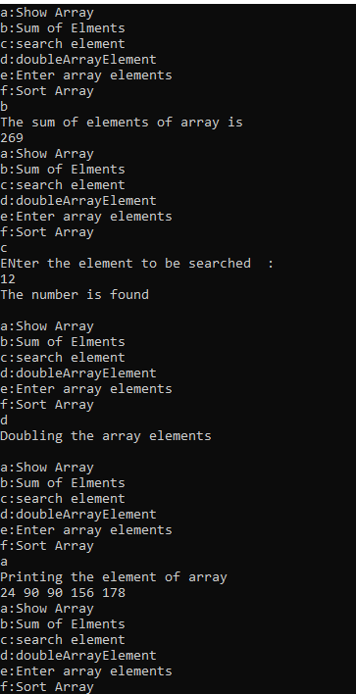

public class Tester{

public static void main(String[] args){

MathOperation.add(5,6);

MathOperation.add(5,6,5,4,4,5);

}

}

import java.util.Scanner;

public class MathOperation{

public static void add(int a, int b){

System.out.println("The addition of number is :"+(a+b));

}

public static void add(int... a){

int sum=0;

for(int i:a){

sum+=i;

}

System.out.println("Using VARARGS sum is "+sum);

}

}



3.1

package Day3;

import java.util.Scanner;

public class Student {

int rollno;

int marks1;

int marks2;

int marks3;

float percentage;

Scanner sc= new Scanner(System.in);

public void acceptInfo() {

System.out.println("Enter the rollno of student");

rollno=sc.nextInt();

System.out.println("Enter the marks of student");

marks1=sc.nextInt();

marks2=sc.nextInt();

marks3=sc.nextInt();

}

public void displayInfo() {

System.out.println("The rollno of student is "+rollno);

System.out.println("The marks of students are "+ marks1+" "+ marks2+" "+marks3);

System.out.println("The total marks of student is "+(marks1+marks2+marks3));

percentage=(float)(marks1+marks2+marks3)/3;

System.out.println("The total percentage of student is "+percentage);

if(percentage>80) {

System.out.println("Grade A");

}

else if(percentage>60 && percentage<80) {

System.out.println("Grade B");

}

else {

System.out.println("Fail");

}

}

public static void main(String[] args) {

Student s= new Student();

s.acceptInfo();

s.displayInfo();

}

}

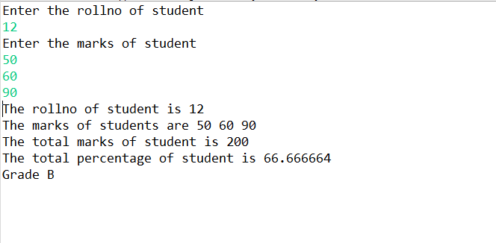

package Day3;

public class Person {

private String name;

private int age;

private String city;

public Person() {

name="Gunjan";

age=12;

city="nagpur";

}

public Person(String name,int age, String city) {

this.name=name;

this.age=age;

this.city=city;

}

public int getAge() {

return age;

}

public String getName() {

return name;

}

public String getCity() {

return city;

}

public void setName(String name) {

this.name=name;

}

public void setAge(int age) {

this.age=age;

}

public void setCity(String city) {

this.city=city;

}

public void display() {

System.out.println("The name of person is :"+ name);

System.out.println("The age of person is : "+age);

System.out.println("The city of person is :"+city);

}

public static void main(String[] args) {

Person p= new Person();

p.setName("Gunjan");

p.setCity("Pune");

p.setAge(20);

p.setAge(22);

p.setCity("Mumbai");

p.display();

}

}

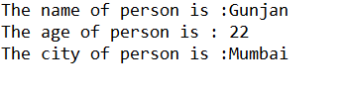

package Day3;

public class Date {

private int day;

private int month;

private int year;

public Date() {

day=01;

month=05;

year=2001;

}

public Date(int day, int month, int year) {

this.day=day;

this.month=month;

this.year=year;

}

public int getDay() {

return day;

}

public int getMonth() {

return month;

}

public int getYear() {

return year;

}

public void setDay(int day) {

this.day=day;

}

public void setMonth(int month) {

this.month=month;

}

public void setYear(int year) {

this.year=year;

}

public void display() {

System.out.println("The date is :"+day+"/"+month+"/"+year);

}

public static void main(String[] args) {

Date d= new Date();

d.display();

d.setDay(01);

d.setMonth(12);

d.setYear(2001);

d.display();

}

}

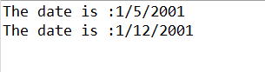

package Day3;

public class Book {

private String bName;

private int id;

private String author;

private double price;

public Book() {

bName="Facebook";

id=05;

author="Mark Zucks";

price=269.69;

}

public Book(String name, int id, String author, double price) {

this.bName=name;

this.id=id;

this.author=author;

this.price=price;

}

public String getBname() {

return bName;

}

public int getId() {

return id;

}

public String getAuthor() {

return author;

}

public double getPrice() {

return price;

}

public void setBname(String name) {

this.bName=name;

}

public void setId(int id) {

this.id=id;

}

public void setAuthor(String auth) {

this.author=auth;

}

public void setPrice(double price) {

this.price=price;

}

public void display() {

System.out.println("The name of book is "+bName);

System.out.println("The id of book is "+ id);

System.out.println("The author of book is "+author);

System.out.println("The price of book is "+price);

}

public static void main(String[] args) {

// TODO Auto-generated method stub

Book b= new Book();

b.display();

System.out.println("\n\n");

b.setPrice(1200.00);

b.setAuthor("Gunjan");

b.setBname("G63");

b.setId(63);

b.display();

}

}

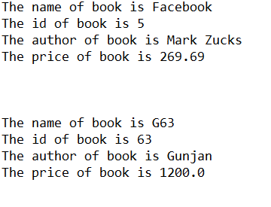

package Day3;

public class Point {

private int x;

private int y;

public Point() {

x=7;

y=9;

}

public Point(int x, int y) {

this.x=x;

this.y=y;

}

public int getX() {

return x;

}

public int getY() {

return y;

}

public void setX(int x) {

this.x=x;

}

public void setY(int y) {

this.x=x;

}

public void display() {

System.out.println("The value of x "+x);

System.out.println("The value of y "+ y);

}

public static void main(String[] args) {

Point p= new Point();

System.out.println("Default constructor");

p.display();

System.out.println("\n\nuser defined");

p.setX(6);

p.setY(9);

p.display();

}

}

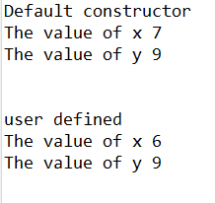

package Day3;

public class ComplexNumber {

private int real;

private int imaginary;

public ComplexNumber() {

real=7;

imaginary=9;

}

public ComplexNumber(int real, int imaginary) {

this.real=real;

this.imaginary=imaginary;

}

public int getX() {

return real;

}

public int getY() {

return imaginary;

}

public void setX(int real) {

this.real=real;

}

public void setY(int imaginary) {

this.real=real;

}

public void display() {

System.out.println("The value of complex number "+real+"+i"+imaginary);

}

public static void main(String[] args) {

// TODO Auto-generated method stub

ComplexNumber c= new ComplexNumber();

c.display();

System.out.println("\n\n");

c.setX(5);

c.setY(8);

c.display();

}

}

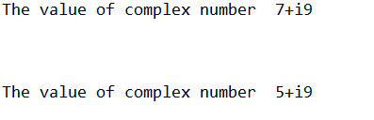

**Day4**

package com.code;

public class Point2D {

private int x, y;

public Point2D(int x, int y) {

this.x = x;

this.y = y;

}

public String toString() {

return x + " " + y;

}

}

package com.code;

import com.code.Point2D;

import java.util.Scanner;

public class tester {

public static void main(String[] args) {

// TODO Auto-generated method stub

Point2D[] arr = new Point2D[5];

Scanner sc = new Scanner(System.in);

int ch, index = 0;

do {

System.out.println("\n1)show all \n2)add new");

ch = sc.nextInt();

switch (ch) {

case 1:

for (Point2D p : arr) {

System.out.println(p);

}

break;

case 2:

if (index < arr.length) {

System.out.println("add new coordinates ");

Point2D obj = new Point2D(sc.nextInt(), sc.nextInt());

arr[index] = obj;

index++;

} else {

System.out.println("array is full");

}

break;

case 3:

System.exit(0);

}

} while (ch != 3);

}

}

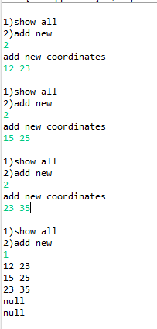

package com.node1;

public class Showroom {

private int id;

private String name;

private String color;

private double price;

private static int discount;

public static void showDiscount() {

}

public Showroom(int id, String name, String color, double price) {

this.id = id;

this.name = name;

this.color = color;

this.price = price;

}

public String getColor() {

return color;

}

public void setColor(String color) {

this.color = color;

}

public double getPrice() {

return price;

}

public void setPrice(double price) {

this.price = price;

}

public int getId() {

return id;

}

public String getName() {

return name;

}

@Override

public String toString() {

return "Showroom [id=" + id + ", name=" + name + ", color=" + color + ", price=" + price + ", discount="

+ discount + "]";

}

static {

// System.out.println(" discount");

discount = 2000;

}

}

package com.node1;

import java.util.Scanner;

public class Tester {

public static void main(String[] args) {

Scanner sc = new Scanner(System.in);

Showroom[] arr = new Showroom[10];

int ch, index = 0;

do {

System.out.println("\n1:show all \n2:add vehicle...\n3:edit color \n4:edit price \n5:remove ");

ch = sc.nextInt();

switch (ch) {

case 1:

for (Showroom s : arr) {

System.out.println(s);

}

break;

case 2:

if (index < arr.length) {

Showroom obj = new Showroom(sc.nextInt(), sc.next(), sc.next(), sc.nextDouble());

arr[index] = obj;

index++;

} else {

System.out.println("showroom is full");

}

break;

case 3:

int id;

System.out.println("Enter the id of your vehicle");

id = sc.nextInt();

for (Showroom s : arr) {

if (s != null) {

if (s.getId() == id) {

System.out.println("Enter new color for vehicle");

s.setColor(sc.next());

break;

}

}

else {

System.out.println("vehicle not exists");

}

}

break;

case 4:

int vid;

System.out.println("Enter the id of vehicle ");

vid = sc.nextInt();

for (Showroom s : arr) {

if (s != null) {

if (s.getId() == vid) {

System.out.println("Enter new price");

s.setPrice(sc.nextDouble());

break;

}

}

else {

System.out.println("vehicle does not exists");

}

}

break;

case 5:

System.out.println("Enter the id of vehicle");

vid = sc.nextInt();

for (int i = 0; i < arr.length; i++) {

if (arr[i] != null) {

if (arr[i].getId() == vid) {

System.out.println("vehicle removed");

arr[i] = null;

break;

}

}

else {

System.out.println("vehicle not found");

}

}

break;

}

} while (ch != 6);

}

}

