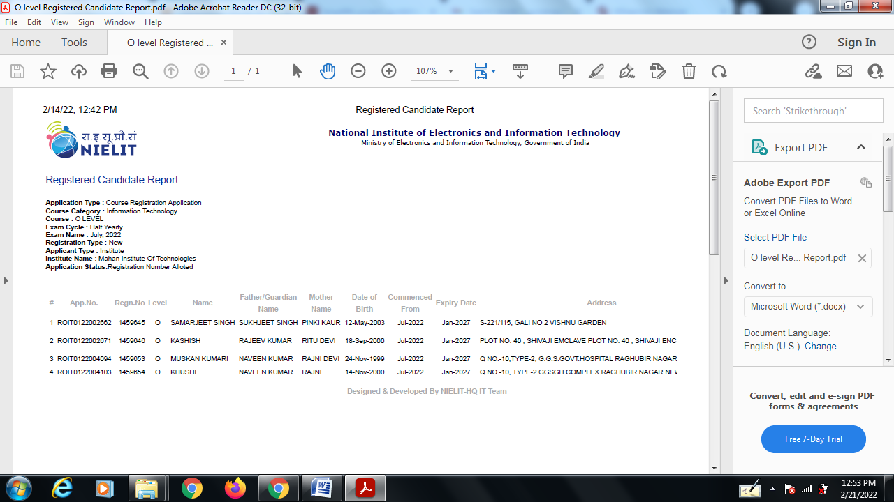

1. Jasleen – 8447122303- jasleenpal059@gmail.com
2. Kashish – 8527073668 – contactkashishverma18@gmail.com
3. Samarjeet – 9667894069 – ssamarjeet642@gmail.com
4. Aryan – 7838866763 – aryankapoor1302@gmail.com
5. Muskan - 8076206732 -[muskansweety1024@gmail.com](mailto:muskansweety1024@gmail.com)
6. Khushi – 8076206732 - khushigifty614@gmail.com