Report: Optimising NYC Taxi Operations
Include your visualizations, analysis, results, insights, and outcomes. Explain your methodology and approach to the tasks. Add your conclusions to the sections.

Data Preparation

  - Loading the dataset
    - Sample the data and combine the files
As the data is huge, just keeping 1% of sample data instead of 5%
Total Combined Rows: 379268
Here the logic used to sample 1% of data on hourly basis and stored combined data as parquet format.
- Loop through each parquet file present in `file_list`
- Read the parquet file into a pandas dataframe
- Filter dataframe records to keep only rows matching the year-month from the file name
- Extract all unique days from `tpep_pickup_datetime`
- Loop through each day separately
- For each day:
  - create a daily dataframe containing only that day's records
  - Extract all unique hours from that day
  - Loop through each hour separately
  - For each hour:
    - create an hourly dataframe containing only that hour’s records
    - Randomly sample 1% of records from that hourly dataframe
    - Append sampled hourly data into `combined_df`

Data Cleaning

Fixing Columns
    - Fix the index
Once all the unnecessary columns are dropped, this is how we would fix the index.
df.reset_index(drop=True)
    - Combine the two airport_fee columns
We have following fields with percentage of missing values:
airport_fee 92.176245
Airport_fee 11.236118
# Combine the two airport fee columns
df['Airport_fee'] = df['Airport_fee'].fillna(df['airport_fee'])
# Also if Airport_fee still has NaN, fill them with 0
df['Airport_fee'] = df['Airport_fee'].fillna(0)
# Drop other airport_fee column
df.drop(columns=['airport_fee'], inplace=True)

Handling Missing Values
    - Find the proportion of missing values in each column

Column Name | Missing %
VendorID | 0
tpep_pickup_datetime | 0
tpep_dropoff_datetime | 0
passenger_count | 3.412363
trip_distance | 0
RatecodeID | 3.412363
store_and_fwd_flag | 3.412363
PULocationID | 0
DOLocationID | 0
payment_type | 0
fare_amount | 0
extra | 0
mta_tax | 0
tip_amount | 0
tolls_amount | 0
improvement_surcharge | 0
total_amount | 0
congestion_surcharge | 3.412363
airport_fee | 92.176245
Airport_fee | 11.236118

    - Handling missing values in passenger_count
We have found quite a lot NaN values in 'passenger_count’ column and replaced them with 0 as below:

# There are almost 12942 records with missing values
print(df['passenger_count'].isna().sum())
# Fill the missing values (NaN) with 0
df['passenger_count'] = df['passenger_count'].fillna(0)
    - Handle missing values in RatecodeID
We have found quite a lot NaN values in 'RatecodeID’ column and replaced them with 1 as below:
# There are almost 12942 records with missing values
print(df['RatecodeID'].isna().sum())
# Fill the missing values (NaN) with 0
df['RatecodeID'] = df['RatecodeID'].fillna(1)
Where 1= Standard rate for RatecodeID
    - Impute NaN in congestion_surcharge
We have found quite a lot NaN values in ‘congestion_surcharge’ column and replaced them with 0 as below:
# There are almost 12942 records with missing values
print(df['congestion_surcharge'].isna().sum())

# Fill the missing values (NaN) with 0
df['congestion_surcharge'] = df['congestion_surcharge'].fillna(0)

Handling Outliers and Standardising Values
    - Check outliers in payment type, trip distance and tip amount columns
payment type:
# Valid values for payment_type: 1= Credit card, 2= Cash, 3= No charge, 4= Dispute, 5= Unknown, 6= Voided trip
df['payment_type'].unique()
# Keep only valid payment_type values from 1 to 6
df = df[ df['payment_type'].isin([1, 2, 3, 4, 5, 6]) ]
trip distance:
# Assumption here:
# Trips with extremely large distance (>250 miles) # but unusually low fare (<100) seems invalid.
# find out trips having trip_distance > 250
df['trip_distance'] > 250
# Before removing these records, let's also check fare_amount along with trip_distance
print(len(df[ (df['trip_distance'] > 250) & (df['fare_amount'] < 100) ]))
# Keep only valid trip_distance values
df = df[ ~(df['trip_distance'] > 250) & (df['fare_amount'] < 100) ]
# Entries where trip_distance and fare_amount are 0 but the pickup and dropoff zones are different
diff_zones_df = df[ (df['trip_distance'] == 0) & (df['fare_amount'] == 0)
& (df['PULocationID'] != df['DOLocationID']) ]
tip amount:
# Check for tip_amount is negative or very high and more than fare_amount
print(df[ (df['tip_amount'] < 0) | (df['tip_amount'] > 100) & (df['fare_amount'] < df['tip_amount']) ])
# For negative cap it to 0 and for higher value than 100 keep to 10% of fare amount
df.loc[ (df['tip_amount'] > 100) & (df['fare_amount'] < df['tip_amount']), 'tip_amount'] = df['fare_amount']*0.1

Exploratory Data Analysis

General EDA: Finding Patterns and Trends
    - Classify variables into categorical and numerical
Column Name | Classification | Remarks
VendorID | Categorical | It has got only 2 unique values
tpep_pickup_datetime | Datetime type | Neither Numerical nor Categorical
tpep_dropoff_datetime | Datetime type | Neither Numerical nor Categorical
passenger_count | Numerical
trip_distance | Numerical
RatecodeID | Categorical | It has got only 6 unique values
store_and_fwd_flag | Categorical | Y or N
PULocationID | Categorical | Though values are Numerical but only 250~260 distinct values
DOLocationID | Categorical | Though values are Numerical but only 250~260 distinct values
payment_type | Categorical | It has got only 6 unique values
fare_amount | Numerical
extra | Numerical
mta_tax | Numerical
tip_amount | Numerical
tolls_amount | Numerical
improvement_surcharge | Numerical
total_amount | Numerical
congestion_surcharge | Numerical
Airport_fee | Numerical

    - Analyse the distribution of taxi pickups by hours, days of the week, and months
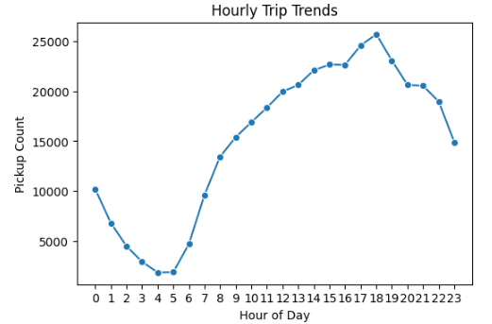
Hourly Trip Findings:
After 6 AM, trips increase rapidly. Trips decline sharply after midnight and reach the minimum around: 4 AM to 5 AM

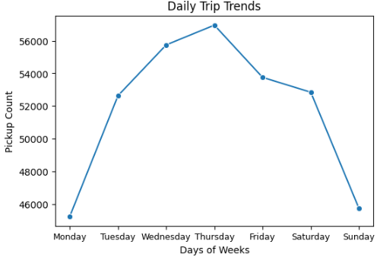
Daily Trip Findings:
Monday has the lowest trip demand. Thursday is the busiest day and then trip demand drops slightly from Thursday.
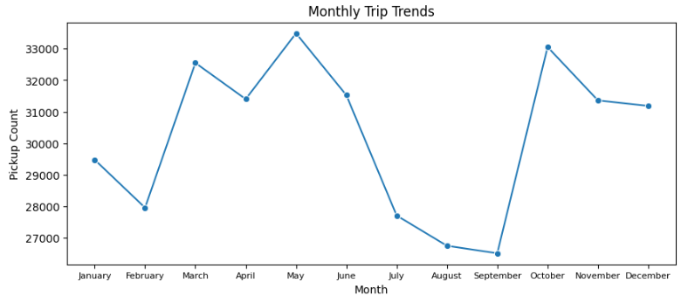
Monthly Trip Findings:
Demand rises strongly from February to May wherein May showing the highest pickup count and then demand drops after June. September shows the lowest demand and October shows a sharp increase again.

    - Filter out the zero/negative values in fares, distance and tips
For the following parameters
lst = ['fare_amount', 'tip_amount', 'total_amount', 'trip_distance']
# Output:
# Negative values found in total_amount: 15
# Zero values found in fare_amount: 115
# Zero values found in tip_amount: 79136
# Zero values found in total_amount: 45
# Zero values found in trip_distance: 4145
# Create a df with non zero entries for the selected parameters.
non_zero_df = df[ (df[cols] != 0).any(axis=1) ].copy()
# Output:
# Actual Dataframe count with zero entries: 362948
# Copy of Dataframe count with non-zero entries: 362916
    - Analyse the monthly revenue trends
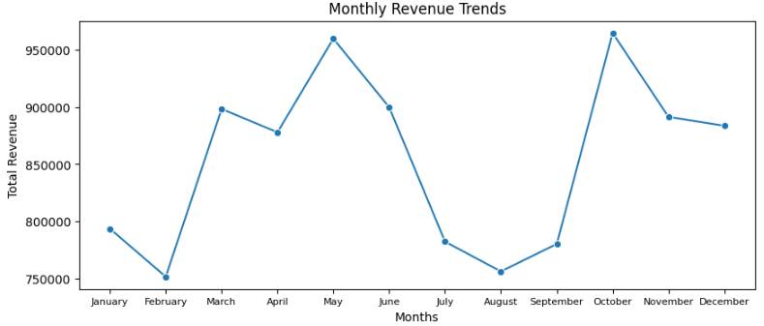
Monthly Revenue Findings:
As the demand raises so the revenue rises strongly from February to May wherein May showing the highest revenue count and then it drops after June. September shows the lowest revenue and October shows a sharp increase again.

    - Find the proportion of each quarter’s revenue in the yearly revenue
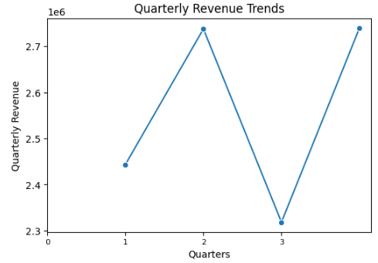
Quarterly Revenue Findings: The revenue rises from quarter 1 to quarter 2 and shows sudden drop of revenue in quarter 3 and then rises sharply in quarter 4.

    - Analyse and visualise the relationship between distance and fare
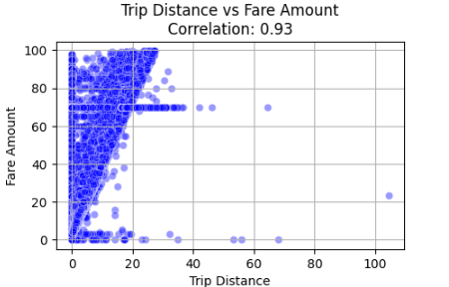
Analysis shows a very strong positive correlation. As trip distance increases, fare amount generally increases proportionally. Most trips are concentrated around: 0-20 miles.

    - Analyse the relationship between fare/tips and trips/passengers
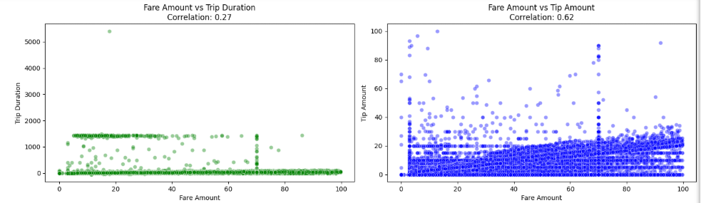
In the 1st graph analysis shows Correlation is low (0.27), which means fare is not strongly dependent on trip duration alone. Many trips have low duration but varying fares, suggesting distance contributes more to pricing.
Above in the 2nd graph analysis shows Moderate positive correlation (0.62) which means higher fares generally receive higher tips. Most tips increase proportionally with fare amount.

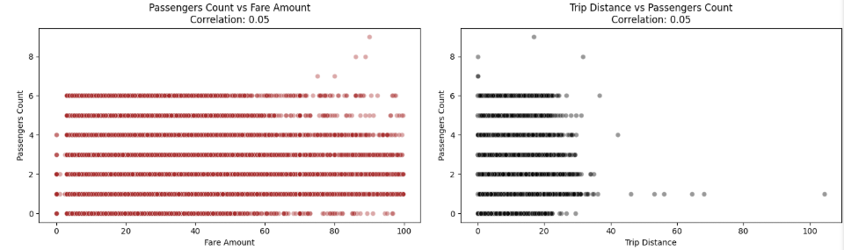
In the 3rd graph analysis shows that correlation is extremely low (0.05), indicating passenger count has almost no impact on fare amount. Fare is usually determined by distance, duration, and other charges rather than number of passengers.
Similarly in the 4th graph analysis shows that correlation is very weak (0.05), meaning trip distance is independent of passenger count.

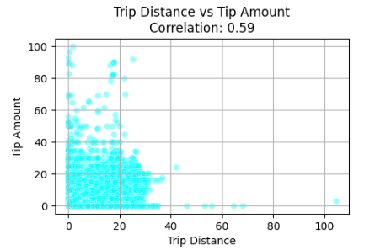

In this last graph, analysis shows moderate positive correlation (0.59) indicates longer trips generally tend to receive higher tips. Most trips are concentrated within 0–25 miles and tips below 20. Several high-tip outliers exist even for shorter trips.

    - Analyse the distribution of different payment types
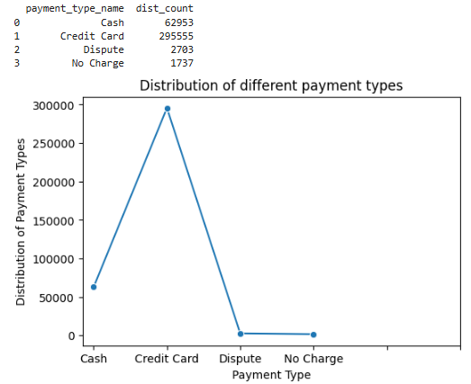
In the above graph, analysis shows that Credit Card is the dominant payment method with a high number of trips (~295K), indicating strong preference for card-based transactions. “Dispute” and “No Charge” categories are quite rare, suggesting most transactions are completed successfully without issues.
    - Load the taxi zones shapefile and display it
zones = gpd.read_file('trip_zones/taxi_zones.shp')
zones.head()
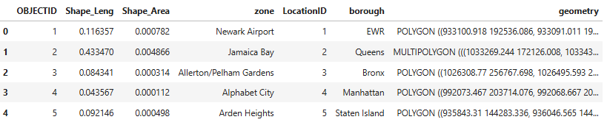

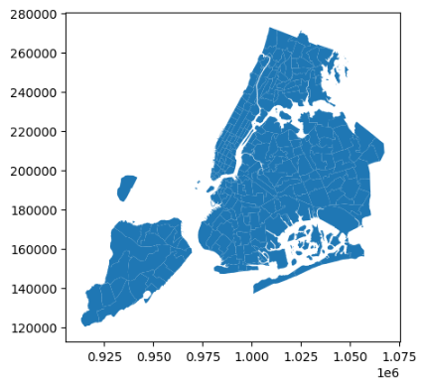
    - Merge the zone data with trips data
merged_df = non_zero_df.merge(
zones,
left_on='PULocationID',
right_on='LocationID',
how='inner'
)
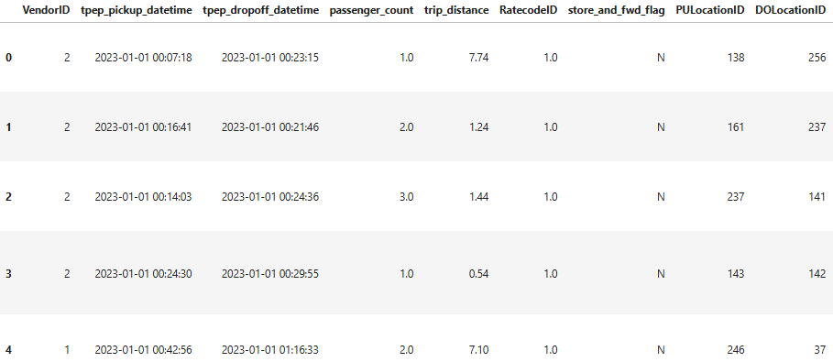

    - Find the number of trips for each zone/location ID
trip_counts_by_loc = ( merged_df.groupby('LocationID').size().reset_index(name='trip_count') )
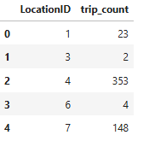
    - Add the number of trips for each zone to the zones dataframe
zones = zones.merge( trip_counts_by_loc[ ['LocationID', 'trip_count'] ], on='LocationID', how='left' )
# For given location id, fill missing values with 0
zones['trip_count'] = ( zones['trip_count'].fillna(0) )
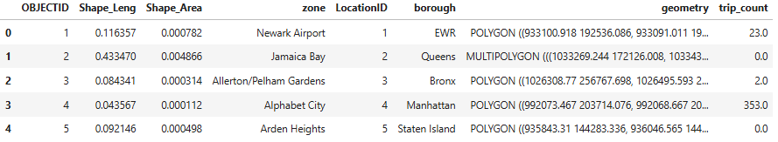

    - Plot a map of the zones showing number of trips
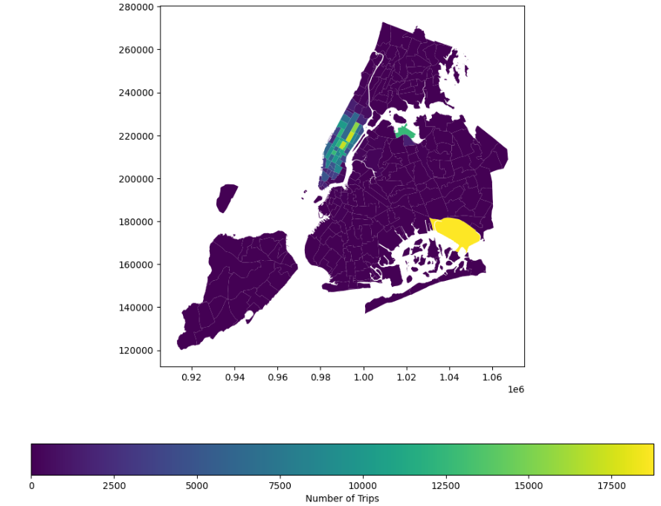
    - Conclude with results
- Manhattan is the area where highest number of trip volume observed.
- One isolated high-density zone (The one in yellow color) in Queens.
- Outer boroughs shows very low trip counts.

Detailed EDA: Insights and Strategies
    - Identify slow routes by comparing average speeds on different routes
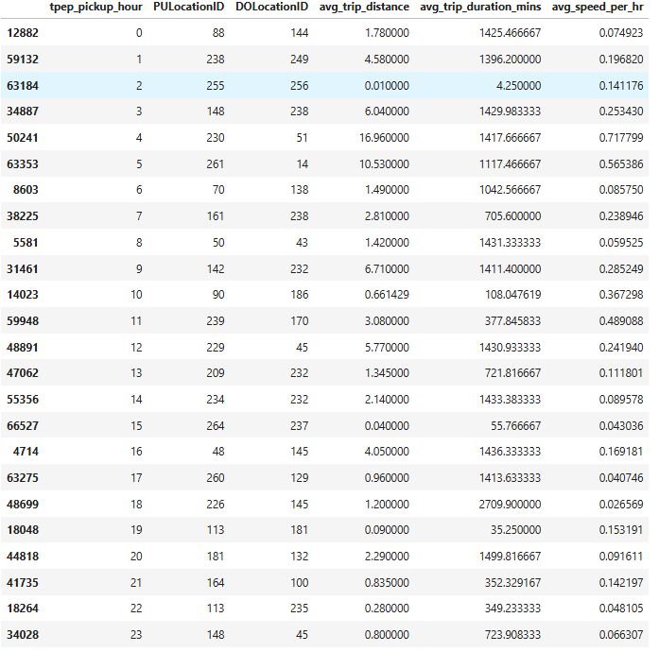

    - Calculate the hourly number of trips and identify the busy hours
From the following graph, analysis shows that the busiest hours are during the late afternoon and evening, around 2 PM to 5 PM, where trip counts stay at peak. A sharp rise in trips is also noted around 5 AM to 6 AM where trip count reaches the maximum.
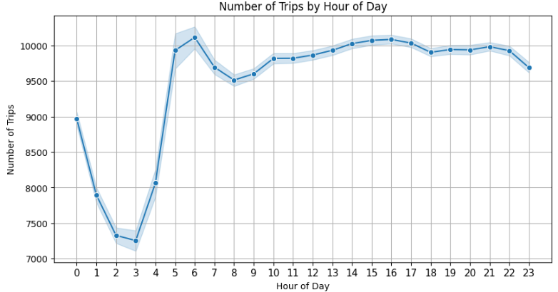
    - Scale up the number of trips from above to find the actual number of trips
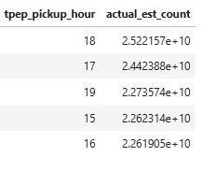

    - Compare hourly traffic on weekdays and weekends
In below graph, the analysis shows that all weekdays show a very similar traffic pattern, indicating consistent commutation. Traffic is lowest during the early morning hours (2 AM – 5 AM) and rises sharply after 6 AM. Trip counts continue increasing throughout the day and peak around 5 PM – 6 PM. Thursday appears to be the busiest weekday overall and Monday consistently has the lowest traffic volume.
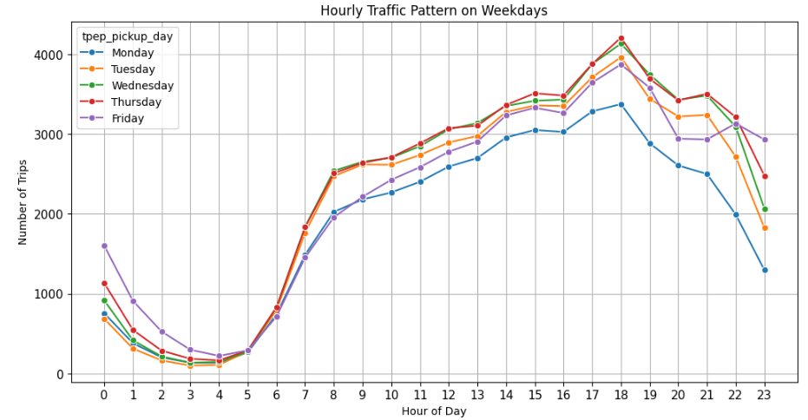

In below graph, the analysis shows that Saturday peaks around 5 PM – 6 PM, suggesting strong weekend movement whereas Sunday traffic begins declining earlier in the evening. Overall on weekends, traffic drops sharply between 2 AM – 5 AM and then starts rising from 6 AM.
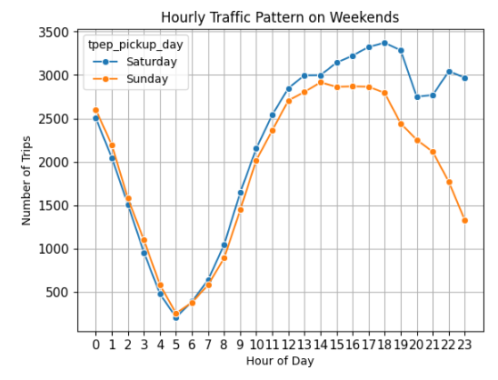
    - Identify the top 10 zones with high hourly pickups and drops
Top 10 zones with high hourly pickups:
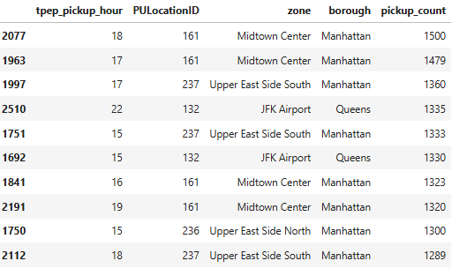

Top 10 zones with high hourly drop-offs:
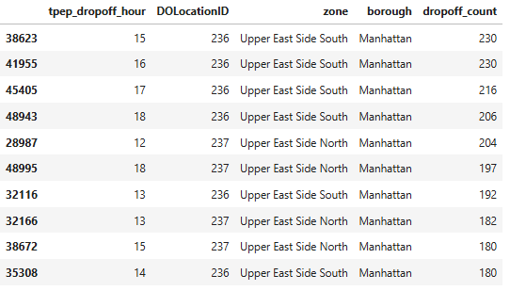

    - Find the ratio of pickups and dropoffs in each zone
Top 10 zones with high pickups ratio
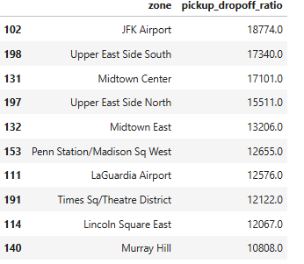

# Bottom 10 zones with high pickups ratio
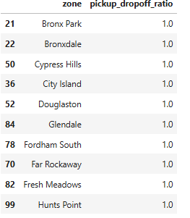

    - Identify the top zones with high traffic during night hours
# Top 10 pickup zones for night hours
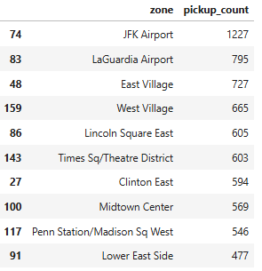

# Top 10 drop-off zones for night hours
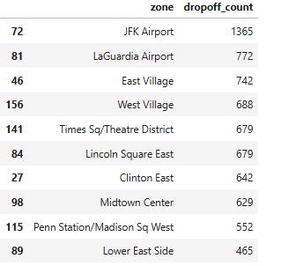

    - Find the revenue share for nighttime and daytime hours
Night hours: 11 pm to 5 pm
Day hours: 6 am to 10 pm
Total night revenue 1225387.28
Total day revenue 10133545.52

    - For the different passenger counts, find the average fare per mile per passenger
# Calculate fare per mile
filtered_df['fare_per_mile'] = ( filtered_df['fare_amount'] / filtered_df['trip_distance'] )
filtered_df['fare_per_mile_per_passenger'] = ( filtered_df['fare_per_mile'] / filtered_df['passenger_count'] )
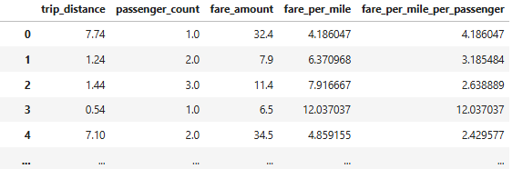

    - Find the average fare per mile by hours of the day and by days of the week
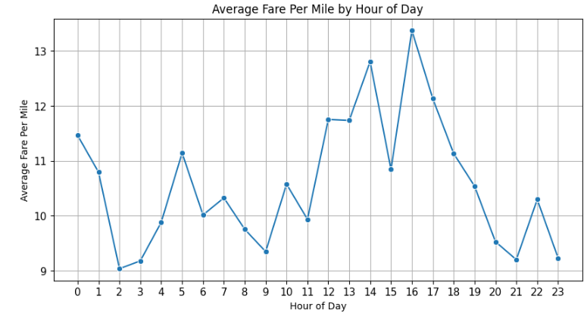
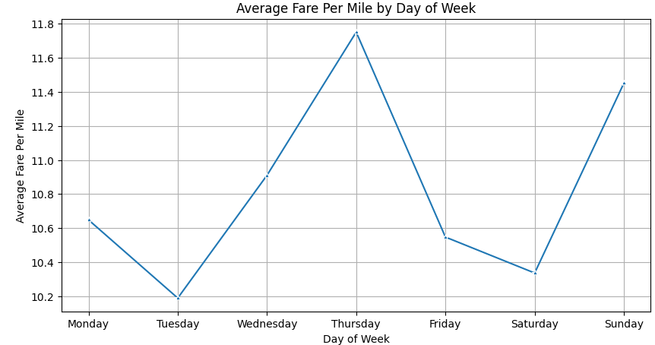

    - Analyse the average fare per mile for the different vendors
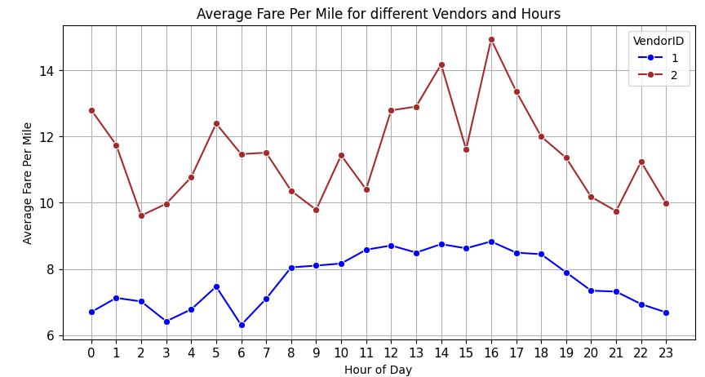
    - Compare the fare rates of different vendors in a distance-tiered fashion
    - Analyse the tip percentages
    - Analyse the trends in passenger count
    - Analyse the variation of passenger counts across zones
    - Analyse the pickup/dropoff zones or times when extra charges are applied more frequently.

Conclusions

Final Insights and Recommendations

    - Recommendations to optimize routing and dispatching based on demand patterns and operational inefficiencies.

    - Suggestions on strategically positioning cabs across different zones to make best use of insights uncovered by analyzing trip trends across time, days and months.

    - Propose data-driven adjustments to the pricing strategy to maximize revenue while maintaining competitive rates with other vendors.

