1.How are inline and block elements different from each other.

An inline element does not start on a new line.An inline element only takes up as much width as necessary.

This is a <span> element inside a paragraph.

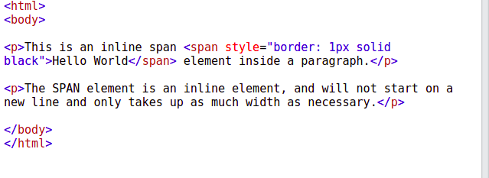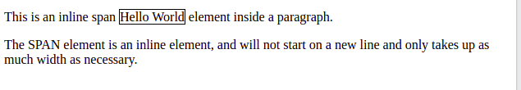

A block-level element always starts on a new line. A block-level element always takes up the full width available.A block level element has a top and a bottom margin, whereas an inline element does not.

The <div> element is a block-level element.

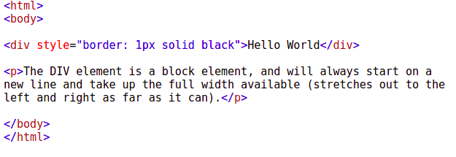

Output:-

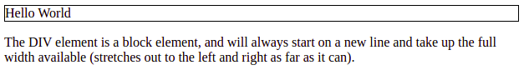

2.Explain the difference between visibility:hidden and display:none

The visibility: hidden property hides an element, but affects the layout i.e. takes up space.

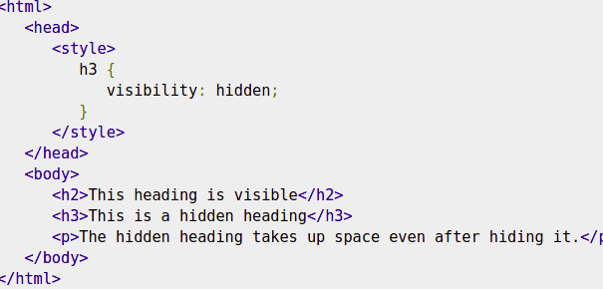

Output:-

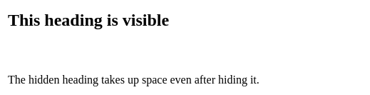

The display: none property is used to hide elements without deleting them. It does not take up any space.

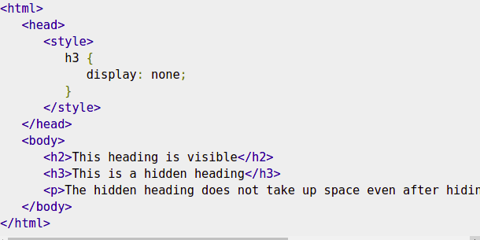

Output:-

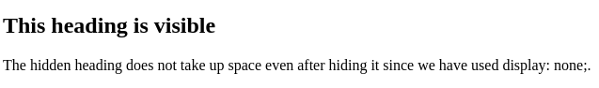

3.Explain the clear and float properties.

The CSS clear property specifies what elements can float beside the cleared element and on which side.The clear property specifies what should happen with the element that is next to a floating element.

The clear property can have one of the following values:

* none - The element is not pushed below left or right floated elements. This is default
* left - The element is pushed below left floated elements
* right - The element is pushed below right floated elements
* both - The element is pushed below both left and right floated elements
* inherit - The element inherits the clear value from its parent

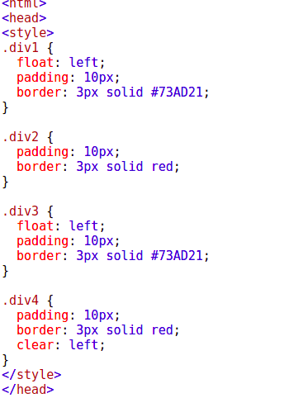

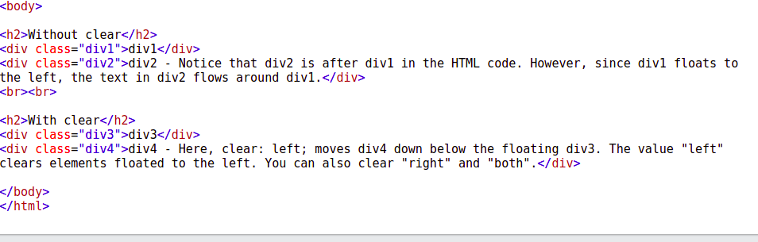

Output:-

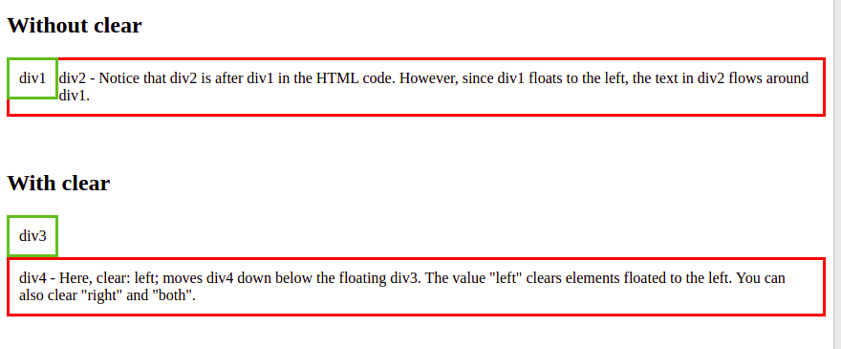

The CSS float property specifies how an element should float.

The float property can have one of the following values:

* left - The element floats to the left of its container
* right - The element floats to the right of its container
* none - The element does not float (will be displayed just where it occurs in the text). This is default
* inherit - The element inherits the float value of its parent

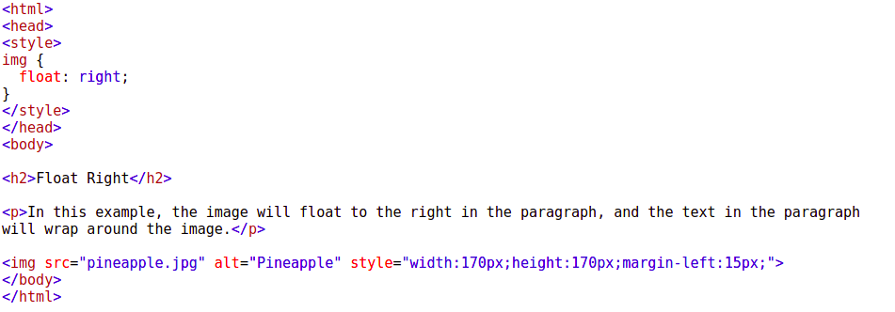

Output:-

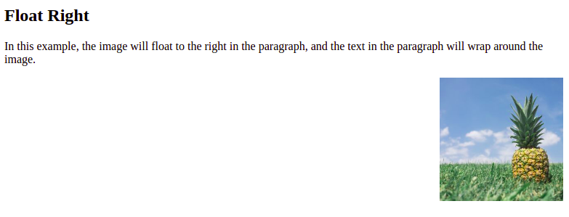

4.Explain difference between absolute, relative,fixed and static.

The position property specifies the type of positioning method used for an element.There are five different position values:

* static

Static positioned elements are not affected by the top, bottom, left, and right properties.

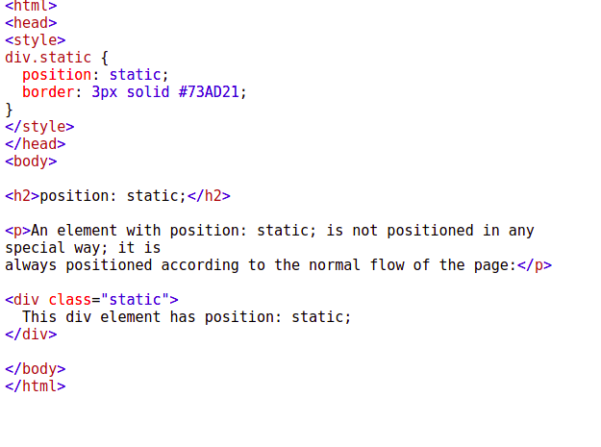

Output:-

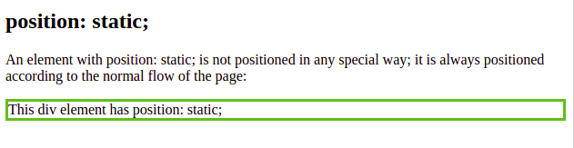

* Relative

An element with position: relative; is positioned relative to its normal position.

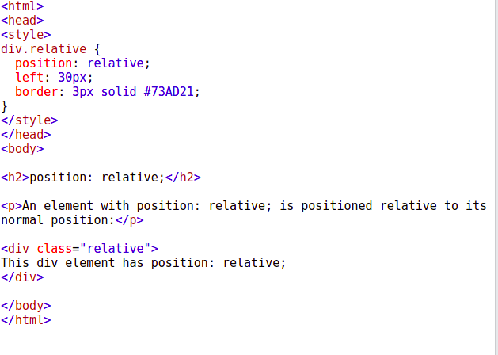

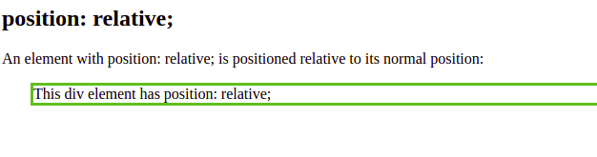

* fixed

An element with position: fixed; is positioned relative to the viewport, which means it always stays in the same place even if the page is scrolled. The top, right, bottom, and left properties are used to position the element.

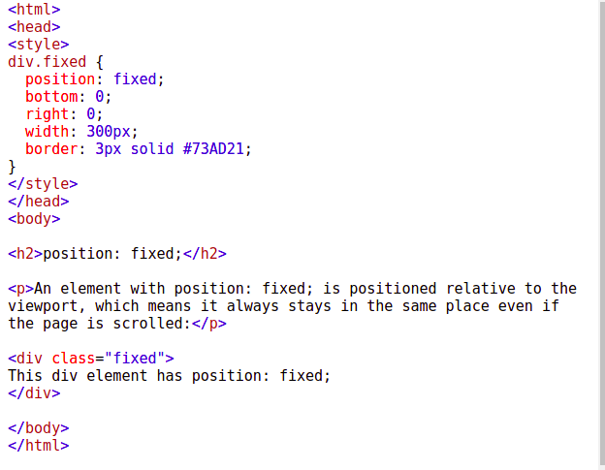

Output:-

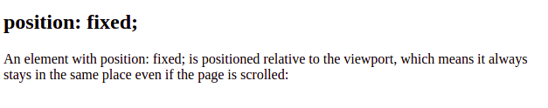

* absolute

An element with position: absolute; is positioned relative to the nearest positioned ancestor

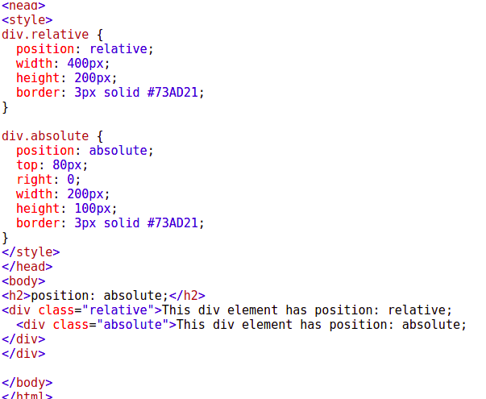

Output:-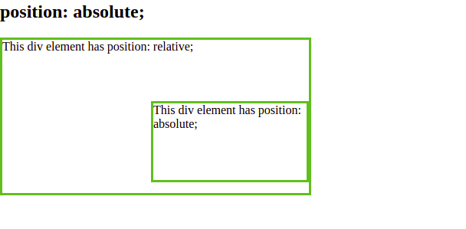

5. Write the HTML code to create a table in which there are 4 columns( ID , Employee Name, Designation, Department) and at least 6 rows. Also do some styling to it.

<html>

<head>

<style>

#employes{

font-family: Arial, Helvetica, sans-serif;

border-collapse: collapse;

width: 100%;

}

#employes td, #employes th {

border: 1px solid #ddd;

padding: 8px;

}

#employes tr:nth-child(even){background-color: #f2f2f2;}

#employes tr:hover {background-color: #ddd;}

#employes th {

padding-top: 12px;

padding-bottom: 12px;

text-align: left;

background-color: #04AA6D;

color: white;

}

</style>

</head>

<body>

<table id="employes">

<tr>

<th>ID</th>

<th>Name</th>

<th>Designation</th>

<th>Department</th>

</tr>

<tr>

<td>1</td>

<td>Maria Anders</td>

<td>Engineer</td>

<td>IT</td>

</tr>

<tr>

<td>2</td>

<td>Christina Berglund</td>

<td>SDO</td>

<td>Engineer</td>

</tr>

<tr>

<td>3</td>

<td>Francisco Chang</td>

<td>Teacher</td>

<td>Maths</td>

</tr>

<tr>

<td>4</td>

<td>Roland Mendel</td>

<td>Tech Lead</td>

<td>IT</td>

</tr>

<tr>

<td>5</td>

<td>Helen Bennett</td>

<td>lecturer</td>

<td>Physics</td>

</tr>

<tr>

<td>6</td>

<td>Philip Cramer</td>

<td>Clerk</td>

<td>Electrical</td>

</tr>

</table>

</body>

</html>

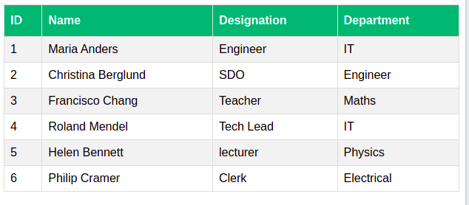

6.Why do we use meta tags?

The metadata means information about data. The <meta> tag in HTML provides information about HTML Document or in simple words, it provides important information about a document. These tags are basically used to add name/value pairs to describe properties of HTML documents, such as expiry date, author name, list of keywords, document author, etc.

Syntax

<meta attribute-name="value">

Attributes:

* [name](https://www.geeksforgeeks.org/html-meta-name-attribute/): This attribute is used to define the name of the property.
* [http-equiv](https://www.geeksforgeeks.org/html-meta-http-equiv-attribute/): This attribute is used to get the HTTP response message header.
* [content](https://www.geeksforgeeks.org/html-meta-content-attribute/): This attribute is used to specify properties value.
* [charset](https://www.geeksforgeeks.org/html-meta-charset-attribute/#:~:text=HTML%20%7C%20charset%20Attribute,-Last%20Updated%20%3A%2029&text=The%20HTML%20charset%20Attribute%20is,lang%20attribute%20of%20any%20element.): This attribute is used to specify a character encoding for an HTML file.

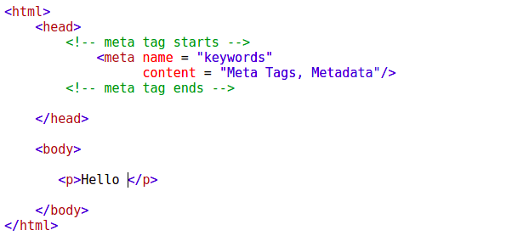

7. Explain box model.

The CSS box model is essentially a box that wraps around every HTML element. It consists of: margins, borders, padding, and the actual content.

Explanation of the different parts:

* Content - The content of the box, where text and images appear
* Padding - Clears an area around the content. The padding is transparent
* Border - A border that goes around the padding and content
* Margin - Clears an area outside the border. The margin is transparent

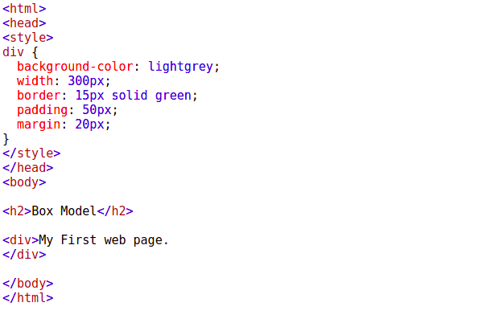

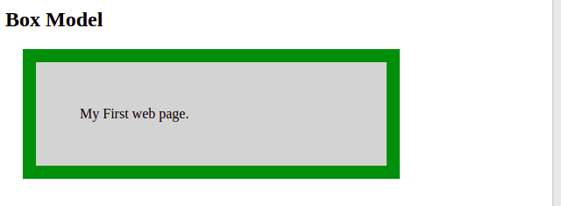

8. What are the different types of CSS Selectors?

CSS selectors are used to "find" (or select) the HTML elements you want to style.

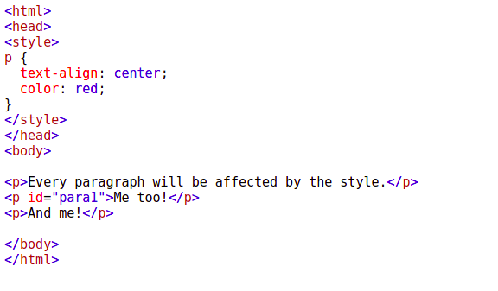

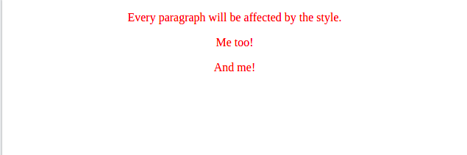

9. Define Doctype.

The HTML document type declaration, also known as DOCTYPE , is the first line of code required in every HTML or XHTML document. The DOCTYPE declaration is an instruction to the web browser about what version of HTML the page is written in. This ensures that the web page is parsed the same way by different web browsers.

In HTML 5, the declaration is simple:

<!DOCTYPE html>

10. Explain 5 HTML5 semantic tags.

**<header>**

The <header> element is generally found at the top of a document, a section, or an article and usually contains the main heading and some navigation and search tools.

#### **<footer>**

If there is a <header> there must be a <footer>. A <footer> is generally found at the bottom of a document, a section, or an article. Just like the <header> the content is generally metainformation, such as author details, legal information, and/or links to related information. It is also valid to include <section> elements within a footer.

**<hgroup>**

The <hgroup> element should be used where you want a main heading with one or more subheadings.

**<aside>**

The <aside> element is intended for content that is not part of the flow of the text in which it appears, however still related in some way. This of <aside> as a sidebar to your main content.

**<time>**

The <time> element allows an unambiguous ISO 8601 date to be attached to a human-readable version of that date.

11.Create HTML for web-page.jpg (check resources, highest weightage for answers)

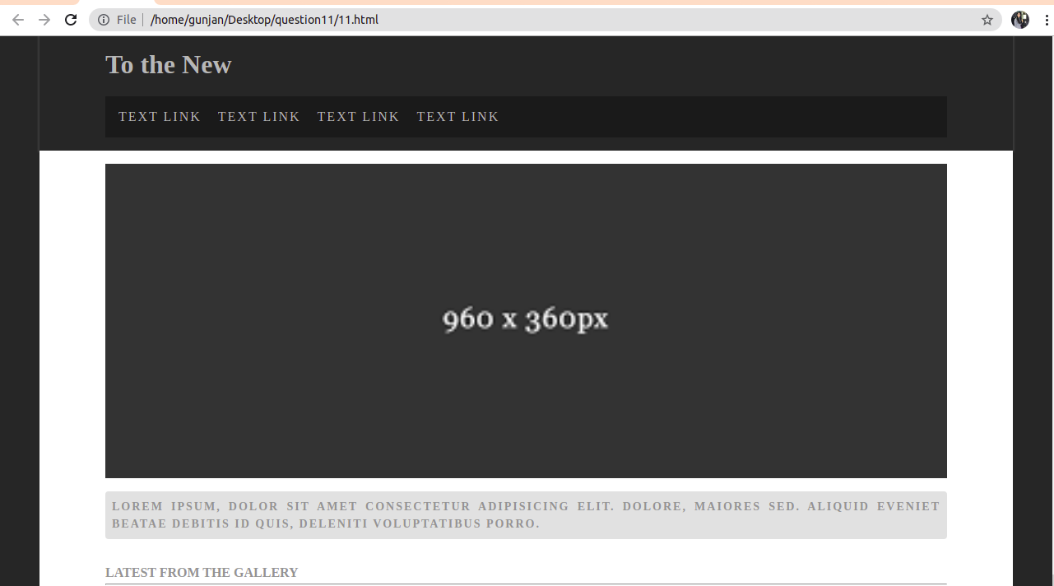

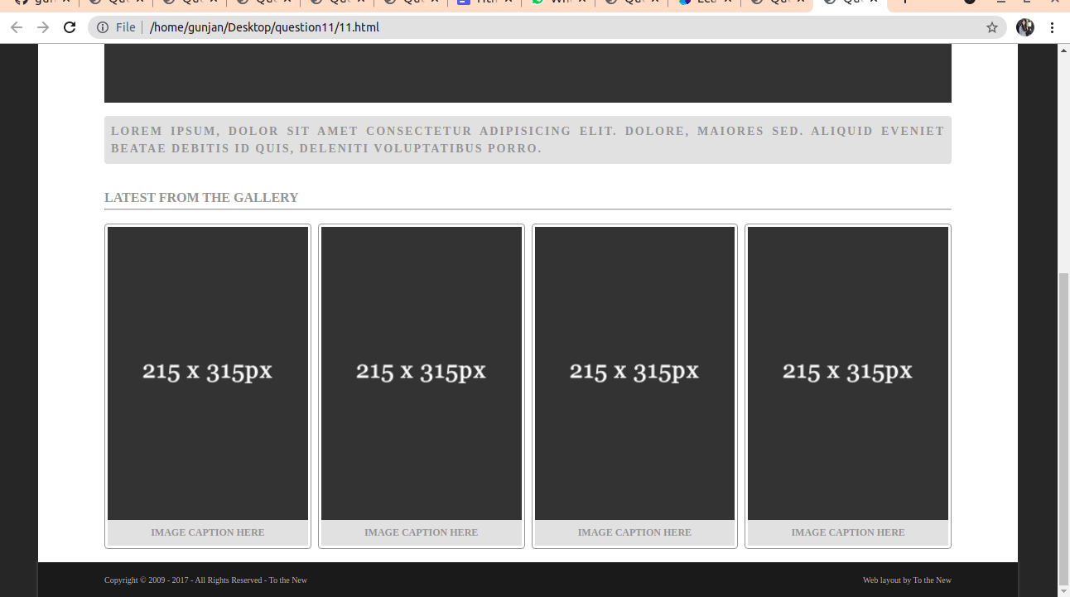

12.Create HTML for form.png (check resources, highest weightage for answers)

