**Introduction:**

A CSR is an essential component of the issuance of a digital certificate. It supplies enough information to a CA to confirm the user’s profile and issue a signed certificate that allows for safe communication between client and server. By understanding a CSR’s purpose, content, and generation process, a smooth and secure certificate issuance experience can be guaranteed.

**What is CSR?**

A CSR (Certificate Signing Request) is an encoded file that specifies the public key and some information about you that uniquely identifies your company and domain name. Using this information, a Certificate Authority (CA) produces an SSL/TLS certificate for your website to enable encrypted traffic to your site.

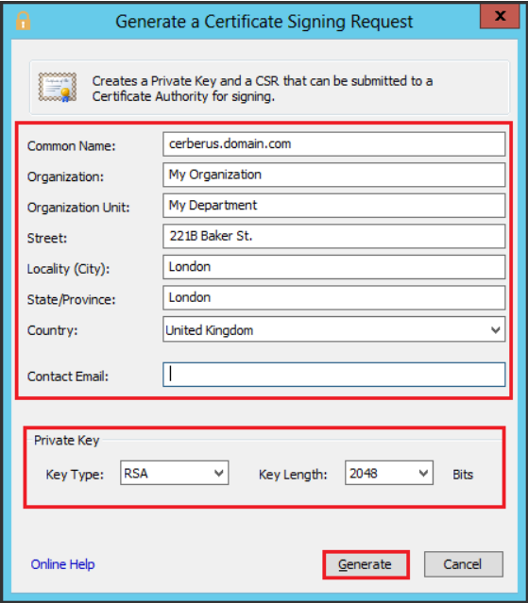

https://www.digicert.com/kb/csr-creation-ssl-installation-cerberus-instructions.htm

**What information is contained within a CSR?**

When you create a Certificate Signing request, you must fill in the information below.

|  |  |  |
| --- | --- | --- |
| Common Name (CN) | It is a fully qualified domain name (FQDN) of the web server. The name should be matched with the name you enter in the browser otherwise; the browser will show a name mismatch error. | www.example.com  shop.example.com  *.example.com |
| Organization (O) | It refers to full name of your organization that should include the suffix like. LTD, .Corp, Inc., LLC. Abbreviated names are not allowed. | Business Name LLC |
| Organizational Unit (OU) | It represents organization’s unit that handles the certificate. | IT Department |
| City/Locality  (L) | Mention the name of a city where your organization is placed. | Forest Hills |
| State/County/Region (S) | Mention the name of the state or region where your organization is placed. | New York |
| Country (C) | Mention the ISO code for the country where your organization is placed. | US |
| Email address | Provide a valid email address of an organization for the purpose of contact. | admin@example.com |
| Public Key | The public key will be used to sign the certificate. | Created automatically |

The CSR certificate should contain all information about your business, such as the name of your business and your city, state, and country. You also have your email address, domain name, and any other domain name you want to secure your SSL/TLS certificate with. We will forever use this information to verify your identity when creating this certificate.

**Use of a Public key**

A public key is simply a cryptography value for encrypting data. The CSR includes your public key, which the CA will fetch and use to generate your certificate and validate your signature in your CSR.

A cryptographic algorithm such as RSA is used to generate public keys. RSA is widely used for both public and private keys. The length of the key, in bits, says how strong the encryption is. The longer the key, the more secure it is. The most common private key length is RSA 2048, but it is also possible to choose RSA 3072 or RSA 4096.

**Type of Keys and its length**

The CSR should include the key type (RSA or DSA) and the length of the key being used. The most common key sizes are 2048-bit and 4096-bit. A private key is used to decode information encrypted with a public key. RSA key length has been changing due to increases in computation power and technology enhancements.

**How to Create Certificate Signing Request?**

To generate a CSR, there are a few steps. First, you need to create a private key. A private key is just a password used to encrypt information. Keep this key safe because it can be used to decrypt traffic to your website.

**Private Key Generation**

A public key is derived from mathematical operations performed on a private key. In combination, they are joined and defined as a “key pair.” A private key contains data necessary for decoding information encrypted by the public key, and vice versa; the public key permits the check of electronic signatures made by the private key.

Users use most web server and runtime environments, such as IIS, OpenSSL, and cPanel. An ideal private key, with a bit size of 2048 bits, will be created, and this special key is used to create the private key.

**CSR Generation**

Once the private key has been created, it can be used to produce a CSR file. As we discussed above, it includes the domain name, locality, city, state, email address, organization, etc.; it is usually encoded in Base-64. Additionally, OpenSSL, IIS, cPanel, and other servers allow you to generate a CSR file using their command-line tool.

**CSR Submission**

Once a CSR is created, it is essential to remember a few key points: Eventually, the CSR should be sent to a CA for validation. When you have created your CSR request, the Certificate Authority (CA) will issue an SSL certificate for your website after performing all required processes.

**CSR Used for Certificate Process**

Once you have the CSR, you need to give it to the SSL certificate provider. After filling out all required details on the configuration page, you need to approve domain ownership. In case of further validation, the certificate authority checks the business registration and related documents along with phone verification. Otherwise, the CA issues an SSL certificate. The server type and the software used will determine how you install it.

**What does a Certificate Signing Request (CSR) code look like?**

Base64-formatted PEM format using lines “—–BEGIN CERTIFICATE REQUEST—–” through “—–END CERTIFICATE REQUEST—–” is adequate for CSR. If you have created a Certificate Signing Request on your server and the file generated is available below, then keep that file in a text editor.

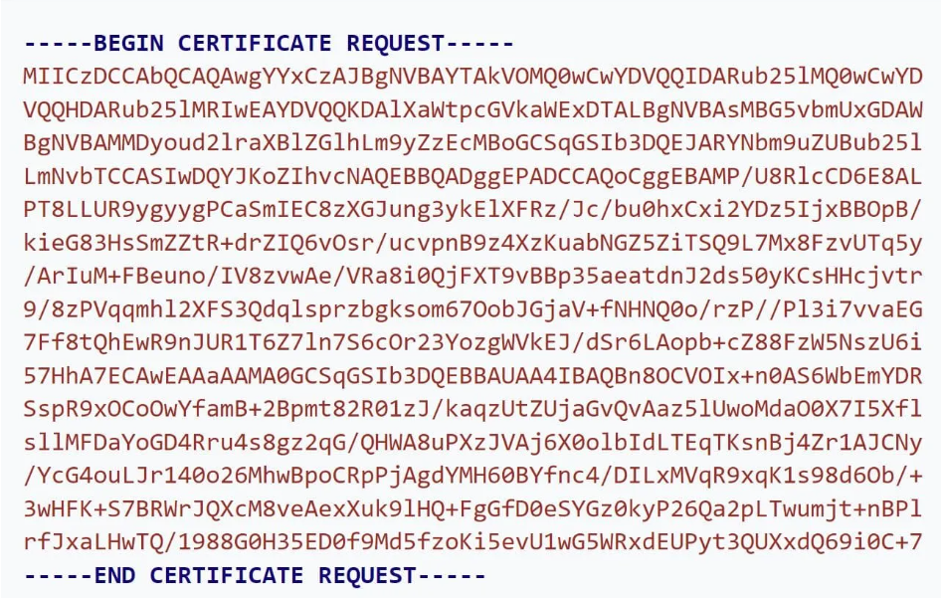

[What is a Certificate Signing Request (CSR)?](https://www.keyfactor.com/blog/what-is-a-certificate-signing-request-csr/)

**About Base-64**:

A standard encoding type is used to represent binary data in ASCII text, and this is called Base-64. It consumes binary data into a form that can be read and sent on the Internet. When you create a CSR, it will need to be encoded into Base64 because the CA needs to process it.

**About ASCII:** Binary data is represented in ASCII text with a standard encoding type, and its name is Base-64. All the characters in the alphabet are assigned a unique number.

**Conclusion:**

We hope that the above information will help you understand the concept of CSR when you wish to buy an SSL certificate. SSL certificates need to be set up on CSR files on your website. They contain the information that can be used to create the certificate, which will then be submitted to a CA to obtain a certificate. However, once you have your certificate, you have to install it on your server.

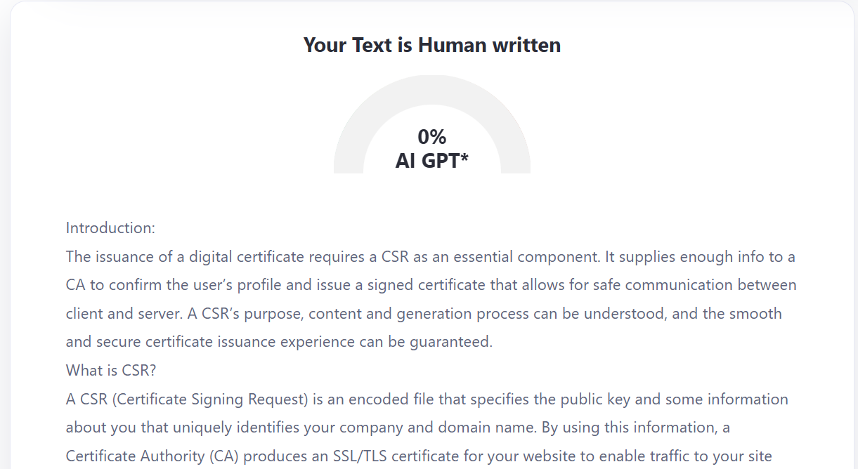

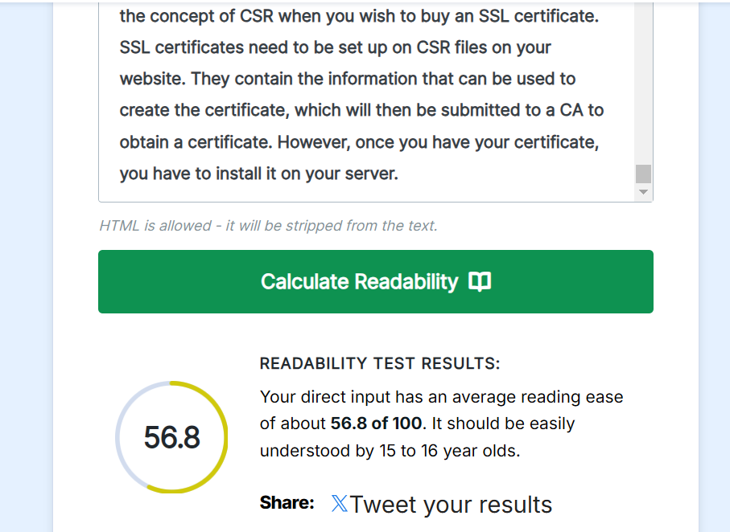

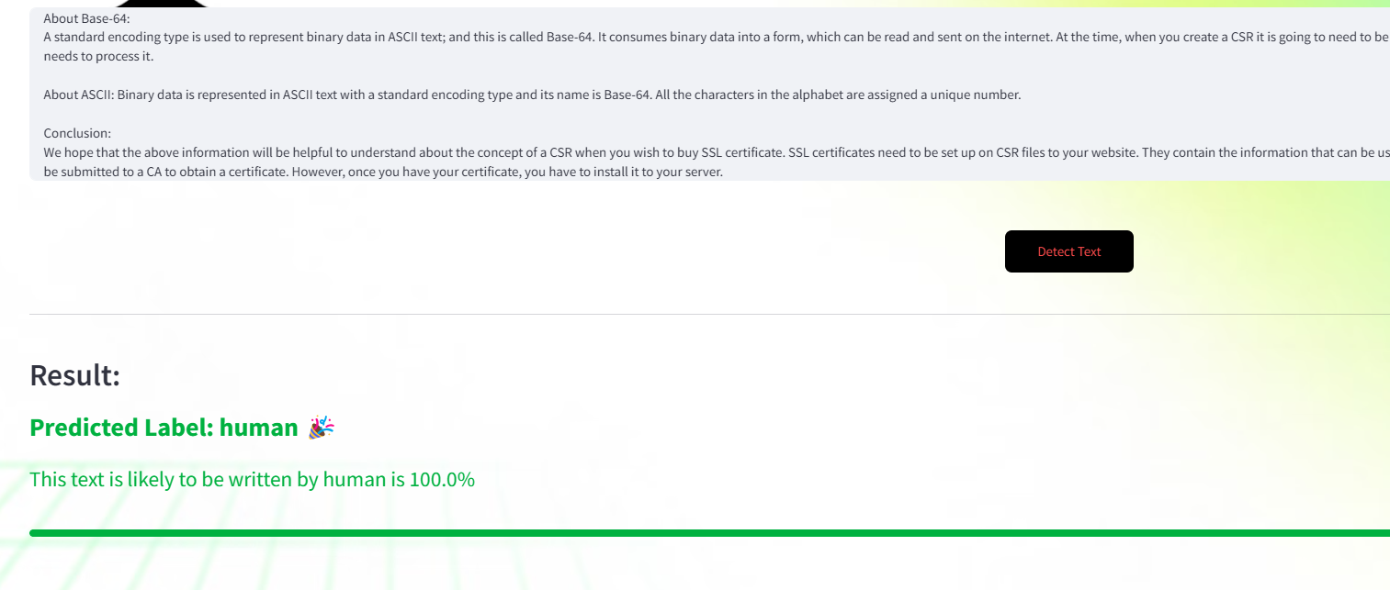

<https://aidetector.streamlit.app/>

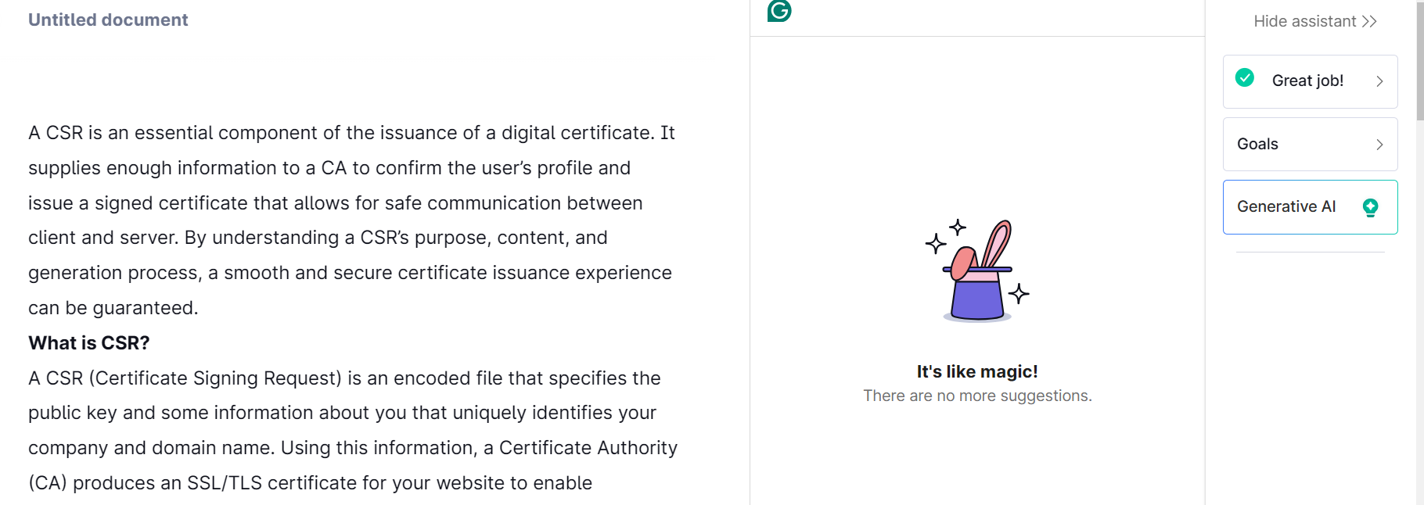

Grammarly.com