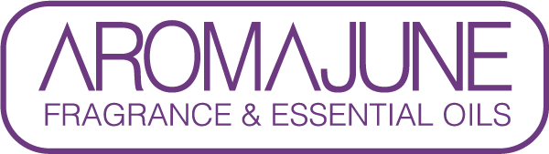

SPECIFICATION

{{DATE}}

1. NAME OF PRODUCT : {{PRODUCT}}

2. COLOR : {{COLOR}}

3. APPEARANCE : LIQUID

4. SPECIFIC GRAVITY (at 20℃) : {{SG}}

5. REFRACTIVE INDEX (at 20℃) : {{RI}}

6. * Shelf life : 2 years under the cool, dark and dry place.

We confirm that our products have not been the subject of animal testing for explicitly cosmetic purpose by or on behalf of AROMAJUNE and do not use raw materials of animal nature



