Experiment No: 10

Aim: Load and display JSON data using fetch() and jQuery $.getJSON(); render results dynamically in a table. Software/Tools Required: Visual Studio Code, Web Browser, Active Internet Connection (for API & CDN).
Theory: 1. JSON (JavaScript Object Notation) JSON is a lightweight data-interchange format that is easy for humans to read and write, and easy for machines to parse and generate. It is the standard format for transferring data between a server and a web application.
2. The fetch() API (Vanilla JavaScript) The fetch() method is a modern, built-in JavaScript Promise-based API used to make asynchronous network requests. It provides a cleaner and more flexible alternative to the older XMLHttpRequest. In this experiment, it is used to send a GET request to a REST API, parse the returned JSON stream, and pass the object array to the rendering function.
3. jQuery $.getJSON() jQuery is a fast, small, and feature-rich JavaScript library. The $.getJSON() method is a shorthand Ajax function specifically designed to load JSON-encoded data from a server using a GET HTTP request. It abstracts away the need to manually parse the response, automatically passing the JSON object to its success callback function.
4. Dynamic DOM Rendering Once the JSON data (an array of user objects) is retrieved, JavaScript is used to iterate over the array using the forEach() or map() method. During iteration, HTML table rows (<tr>) and data cells (<td>) are dynamically constructed as template literals and injected into the table's <tbody> using the innerHTML property.

Output:
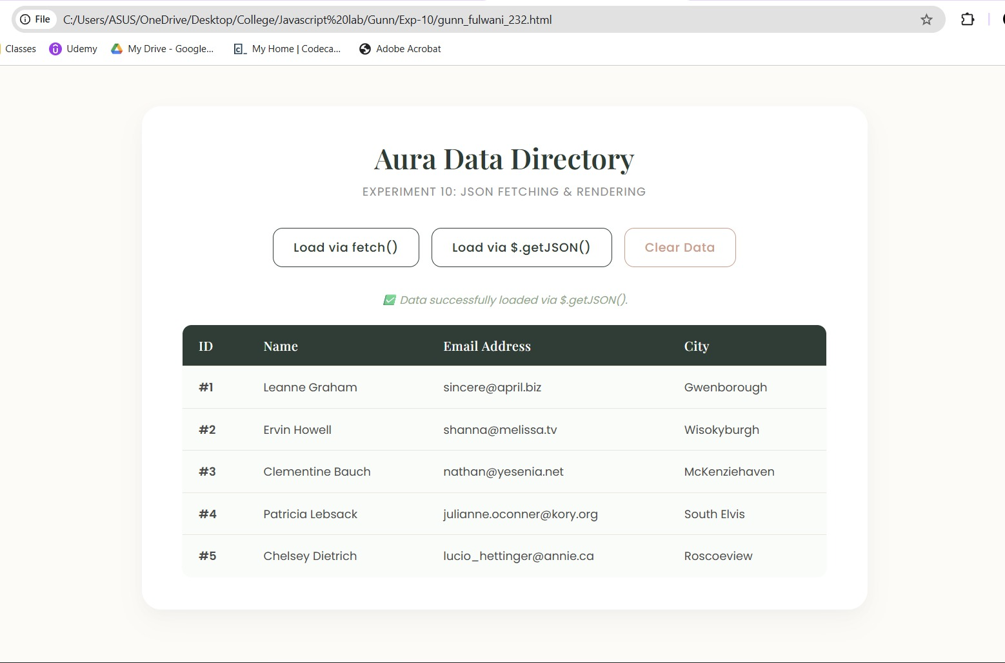
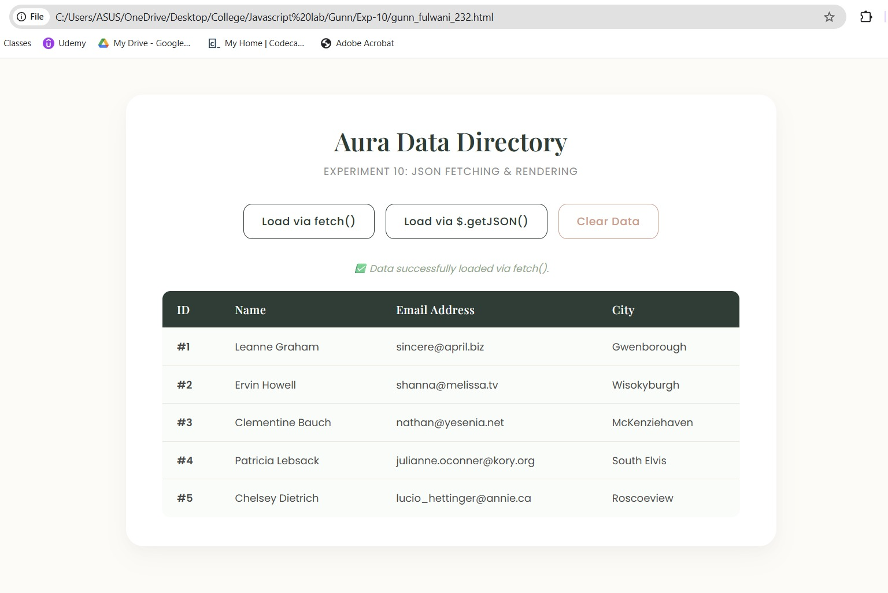
Result/Conclusion: The experiment was successfully completed. A minimalist, responsive web interface was engineered to demonstrate asynchronous data fetching. The application successfully utilized both the modern Vanilla JavaScript fetch() API and the jQuery $.getJSON() method to request data from a public JSON API. The retrieved JSON data was seamlessly parsed and dynamically rendered into an HTML table using DOM manipulation techniques, thereby highlighting the practical differences and syntax of both Ajax approaches.

