Experiment No: 9
Aim: Implement localStorage and sessionStorage to save user preferences like theme settings. Software/Tools Required: Visual Studio Code (or any text editor), Web Browser.
Theory: 1. Introduction to Web Storage API The Web Storage API provides mechanisms by which browsers can store key/value pairs securely in the user's browser, offering a much more intuitive and spacious alternative to cookies. Data is saved as strings.
2. localStorage vs. sessionStorage
- localStorage: Stores data with no expiration date. The data persists even when the browser is closed and reopened. In this experiment, it is used to save the user's visual theme preference (e.g., Default, Sage, or Dark mode) so the aesthetic remains consistent across multiple visits.
- sessionStorage: Maintains a separate storage area for each given origin that's available for the duration of the page session (as long as the browser tab is open). Once the tab is closed, the data is erased. Here, it is used to store a temporary "Current Focus" or session goal.
3. Core Methods Both storage objects share the exact same methods:
- setItem(key, value): Adds a key and its corresponding string value to the storage.
- getItem(key): Retrieves the value associated with the specified key.
- removeItem(key): Deletes a specific key/value pair.
- clear(): Empties all keys out of the storage.

Output:
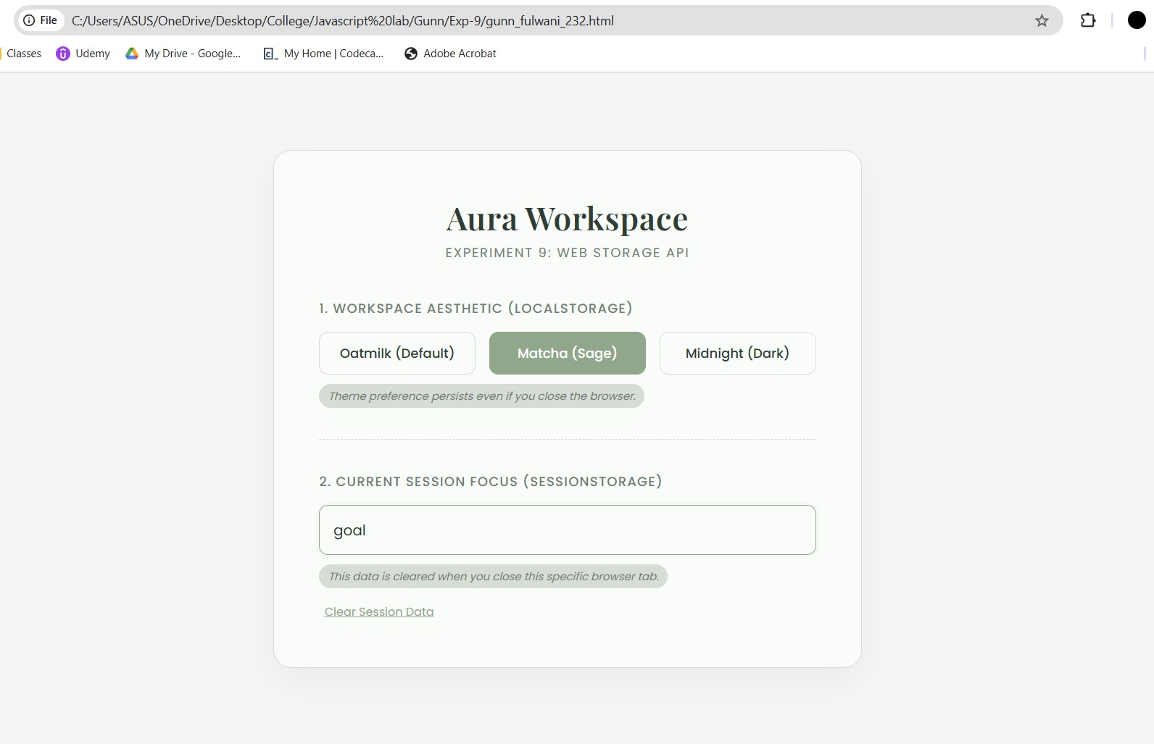
Result/Conclusion: The experiment was successfully completed. A dynamic web application was engineered to demonstrate client-side data persistence. By utilizing localStorage, the application successfully saved and retrieved global user preferences (Theme Settings) across page reloads. Furthermore, sessionStorage was effectively implemented to handle volatile, session-specific data, clearly demonstrating the functional differences and use-cases of the Web Storage API.

