Experiment No: 5
Title: Apply array methods and object handling; create a cart total calculator with discount logic using JavaScript.
Software/Tools Required: Visual Studio Code, Web Browser.
Theory:
1. Object Handling in JavaScript An object in JavaScript is a standalone entity, with properties and types. It is similar to a real-life object. In an e-commerce context, a single product can be represented as an object containing properties like id, name, price, and quantity.
2. Arrays of Objects To manage multiple items in a shopping cart, we use an Array containing multiple Objects. This allows us to store complex, structured data in a single variable and iterate over it efficiently.
3. Array Iteration and Manipulation Methods Modern JavaScript provides powerful built-in array methods that make data processing declarative and clean:
- forEach(): This method executes a provided function once for each array element. It is used in this experiment to iterate through the cart items and dynamically generate HTML elements to display them on the screen.
- map(): This method creates a new array populated with the results of calling a provided function on every element in the calling array. It can be used to extract just the prices of the items.
- reduce(): This method executes a user-supplied "reducer" callback function on each element of the array, passing in the return value from the calculation on the preceding element. It is perfect for calculating the total bill (e.g., accumulating price * quantity for all items).
- filter(): This method creates a shallow copy of a portion of a given array, filtered down to just the elements that pass the test implemented by the provided function. It is used here to find items eligible for specific category discounts.
4. Discount Logic and State Management The application uses DOM manipulation to read a user-entered promo code. If the code matches predefined strings (e.g., "FESTIVE20"), the script calculates the percentage off the subtotal derived from the reduce() method, updates the final total, and manipulates the DOM to render the new discounted price.

Output:
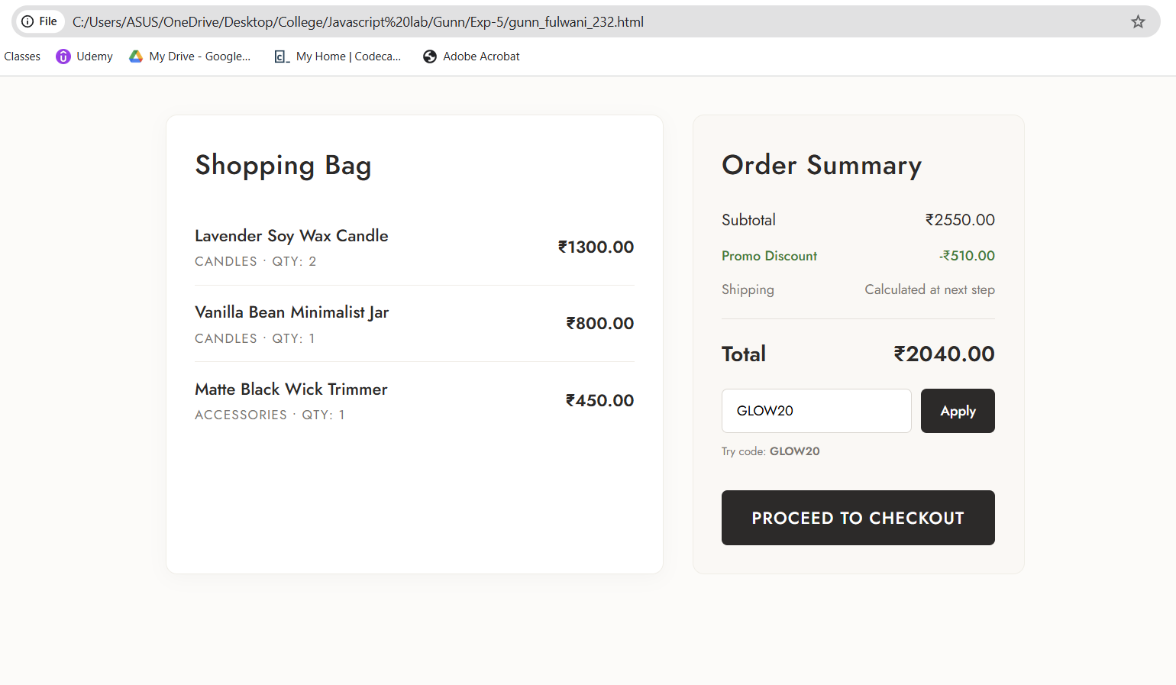

Result/Conclusion: The experiment was successfully completed. A dynamic e-commerce cart calculator was built using JavaScript. Complex data was effectively managed using an array of objects. Essential ES6 array methods, including forEach(), reduce(), and filter(), were applied to render the UI, compute sub-totals, and process discount logic, demonstrating a strong understanding of JavaScript data structures and DOM manipulation.

