Experiment No: 1

Title: Demonstrate inline, internal, and external CSS and JavaScript; use console methods; create a webpage showing user info and a welcome message.

Software/Tools Required: Visual Studio Code (or any text editor), Web Browser (Google Chrome, Microsoft Edge, Firefox, etc.)

Code:
<!DOCTYPE html>
<html lang="en">
<head>
<meta charset="UTF-8">
<meta name="viewport" content="width=device-width, initial-scale=1.0">
<title>Experiment 1: Master CSS & JS Integration</title>

<link rel="stylesheet" href="style.css">

<style>
body {
background-color: #faf9f6; /* Aesthetic soft beige background */
font-family: 'Segoe UI', Tahoma, Geneva, Verdana, sans-serif;
color: #333;
margin: 0;
padding: 40px 20px;
}

.header-section {
text-align: center;
margin-bottom: 40px;
}

/* Horizontal Alignment using Flexbox */
.container {
display: flex;
flex-direction: row;
justify-content: center;
gap: 25px;
width: 100%;
max-width: 1300px;
margin: 0 auto;
}

.card {
background: #ffffff;
border-radius: 12px;
padding: 25px;
box-shadow: 0 4px 12px rgba(0,0,0,0.04);
border-left: 5px solid #d4c4b7;
flex: 1; /* Makes all three cards take equal horizontal space */
display: flex;
flex-direction: column;
}

.card h3 {
margin-top: 0;
color: #4a4a4a;
font-size: 1.1em;
margin-bottom: 10px;
}

.card p {
font-size: 0.9em;
color: #555;
flex-grow: 1; /* Pushes buttons to the bottom evenly */
}

.section-tag {
font-size: 0.8em;
text-transform: uppercase;
letter-spacing: 1px;
color: #8c7a6b;
font-weight: bold;
margin-bottom: 5px;
}

button {
background-color: #8c7a6b;
color: white;
border: none;
padding: 10px 15px;
border-radius: 6px;
cursor: pointer;
font-size: 0.9em;
margin-top: 10px;
width: 100%; /* Full width buttons for cleaner look in narrow cards */
transition: background 0.3s ease;
}

button:hover {
background-color: #6b5a4d;
}

.display-box {
margin-top: 15px;
padding: 15px;
background-color: #f4f1ea;
border: 1px solid #e0dcd3;
border-radius: 6px;
display: none; /* Initially hidden */
line-height: 1.5;
font-size: 0.9em;
word-wrap: break-word;
}
</style>
</head>
<body>

<div class="header-section">
<h1 style="color: #4a4a4a; font-size: 2.2em; margin-bottom: 5px; margin-top: 0;">Experiment No: 1</h1>
<p style="color: #7f8c8d; font-style: italic; margin-top: 5px;">
Demonstration of HTML, 3 Types of CSS, and 3 Types of JavaScript
</p>
</div>

<div class="container">
<div class="card">
<div class="section-tag">Method 1: Inline</div>
<h3>Inline CSS & Inline JavaScript</h3>
<p>These card components are using inline style and event attributes directly within the HTML tags.</p>

<button onclick="alert('Inline JavaScript working perfectly! ✨')">
Trigger Inline JS
</button>
</div>

<div class="card">
<div class="section-tag">Method 2: Internal</div>
<h3>Internal CSS & Internal JavaScript</h3>
<p>The styling for this section is defined within the head tag, and the data is loaded using an internal script.</p>

<button onclick="showUserInfo()">Show User Info</button>
<button onclick="triggerConsoleDemo()">Run Console Methods</button>

<div id="userInfoBox" class="display-box"></div>
</div>

<div class="card external-card-style">
<div class="section-tag">Method 3: External</div>
<h3>External CSS & External JavaScript</h3>
<p>This entire section is controlled through linked external styling (.css) and script (.js) files.</p>

<button onclick="showWelcomeMessage()">Show Welcome Message</button>

<div id="welcomeBox" class="display-box"></div>
</div>
</div>

<script>
function showUserInfo() {
const infoBox = document.getElementById('userInfoBox');
infoBox.innerHTML = `
<strong>Name:</strong> Gunn Fulwani <br>
<strong>PRN:</strong> 232 <br>
<strong>Course:</strong> CSE <br>
<strong>Institute:</strong> SIT, Nagpur
`;
infoBox.style.display = 'block';
}

function triggerConsoleDemo() {
console.log("LOG: User Info initialization triggered.");
console.info("INFO: Page is rendering with premium aesthetic styles.");
console.warn("WARN: Testing console warning capability.");
console.error("ERROR: Simulated lab error for demonstration purposes.");
alert("Console methods have been executed! Press F12 or Inspect -> Console to view them.");
}
</script>

<script src="script.js"></script>

</body>
</html>
/* EXTERNAL CSS FILE */

/* Targetting the external card specifically to show external control */
.external-card-style {
background-color: #ffffff !important;
border-left: 5px solid #8c7a6b !important;
position: relative;
}

/* Custom styling for text inside external box when revealed */
#welcomeBox {
color: #555555;
font-weight: 500;
border-left: 3px solid #8c7a6b;
}

// EXTERNAL JAVASCRIPT FILE

function showWelcomeMessage() {
const welcomeBox = document.getElementById('welcomeBox');
welcomeBox.innerHTML = `
<strong>Welcome Message:</strong><br>
Good Morning, Gunn Fulwani! ✨<br>
Welcome to the JavaScript and CSS integrated lab workspace. Everything is running flawlessly!
`;
welcomeBox.style.display = 'block';
}

Output:
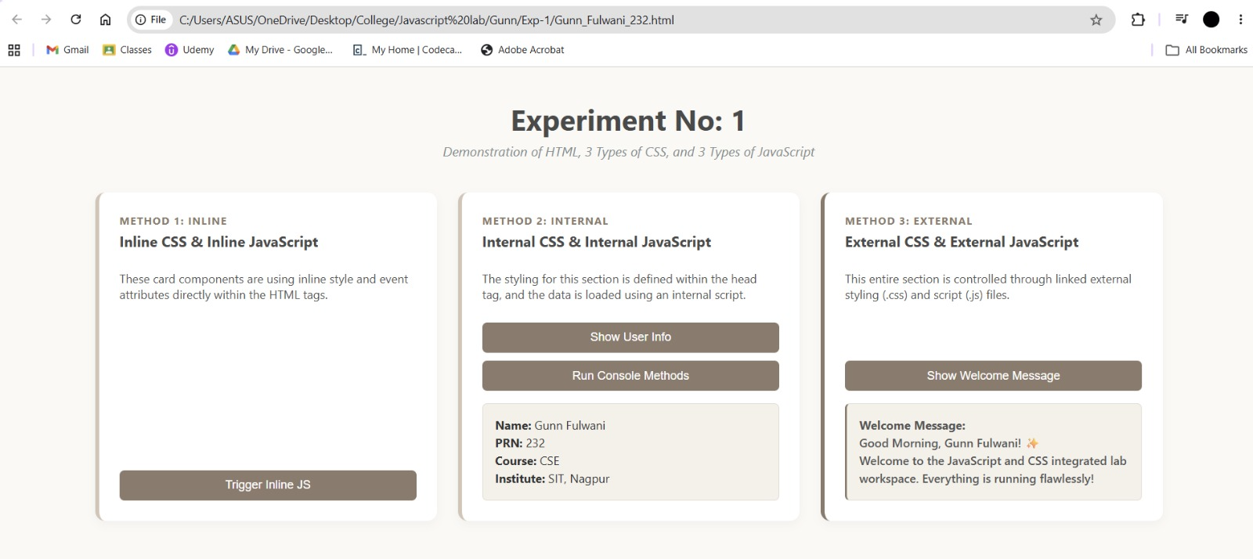

Result/Conclusion: The experiment was successfully completed. The three methods of applying CSS and JavaScript - Inline, Internal, and External - were implemented and practically understood. Furthermore, dynamic DOM manipulation was achieved to display user information and welcome messages upon button clicks. It was observed that utilizing External CSS and JavaScript is the most efficient and maintainable approach for web development, while console methods proved to be essential tools for backend testing and debugging.

Case study – 1
Title: Design a departmental welcome webpage and implement JavaScript DOM manipulation to display student information dynamically.
Software/Tools Required: Visual Studio Code (or any text editor), Web Browser (Google Chrome, Microsoft Edge, Firefox, etc.)
Code:
<!DOCTYPE html>
<html lang="en">
<head>
<meta charset="UTF-8">
<meta name="viewport" content="width=device-width, initial-scale=1.0">
<title>CSE Department - SIT Nagpur</title>
<link rel="stylesheet" href="style.css">
</head>
<body>

<header class="header">
<img src="logo.png.png" alt="SIT Logo" class="college-logo">
<div class="header-text">
<h1>Symbiosis Institute of Technology, Nagpur</h1>
<h2>Department of Computer Science & Engineering</h2>
</div>
</header>

<div class="container">
<div class="card">
<h3>Welcome to CSE Department</h3>
<p>Empowering the 2024-28 batch with modern web development skills and hands-on JavaScript programming.</p>

<button onclick="openStudentPage()" class="btn">View Student Information</button>
</div>
</div>

<script src="script.js"></script>

</body>
</html>

// External JS Program for SIT Nagpur

// 1. Display Alert Box when the page loads
window.onload = function() {
alert("Welcome to SIT Nagpur");

// 2. Using console.log() as per syllabus requirement
console.log("Welcome to Symbiosis Institute of Technology, Nagpur!");
console.log("Department: Computer Science & Engineering");
console.log("Developer: Gunn Fulwani (PRN: 232)");
};

// 3. Function to link and navigate to the Student Information page
function openStudentPage() {
console.log("Navigating to Student Info Page...");
// This JavaScript command changes the page
window.location.href = "student.html";
}

// Function to go back to Department Page
function goBackToDept() {
window.location.href = "department.html";
}

<!DOCTYPE html>
<html lang="en">
<head>
<meta charset="UTF-8">
<meta name="viewport" content="width=device-width, initial-scale=1.0">
<title>Student Profile - SIT Nagpur</title>
<link rel="stylesheet" href="style.css">
</head>
<body>

<header class="header">
<img src="logo.png.png" alt="SIT Logo" class="college-logo">
<div class="header-text">
<h1>Symbiosis Institute of Technology, Nagpur</h1>
<h2>Student Information Portal</h2>
</div>
</header>

<div class="container">
<div class="card student-card">
<h3>Student Profile</h3>
<div class="info-row">
<span class="label">Name:</span>
<span class="value">Gunn Fulwani</span>
</div>
<div class="info-row">
<span class="label">PRN:</span>
<span class="value">232</span>
</div>
<div class="info-row">
<span class="label">Semester:</span>
<span class="value">V</span>
</div>
<div class="info-row">
<span class="label">Course:</span>
<span class="value">Computer Science & Engineering</span>
</div>

<button onclick="goBackToDept()" class="btn btn-secondary" style="margin-top: 20px;">Back to Department</button>
</div>
</div>

<script src="script.js"></script>

</body>
</html>

/* SIT Nagpur Premium Aesthetic Theme */
@import url('https://fonts.googleapis.com/css2?family=Plus+Jakarta+Sans:wght@400;500;700&display=swap');

body {
font-family: 'Plus Jakarta Sans', 'Segoe UI', sans-serif;
margin: 0;
padding: 0;
background-color: #faf9f6; /* Soft aesthetic neutral beige */
color: #2c3e50;
}

/* Glassmorphism Header */
.header {
background: rgba(255, 255, 255, 0.85);
-webkit-backdrop-filter: blur(12px);
backdrop-filter: blur(12px);
padding: 15px 40px;
display: flex;
align-items: center;
border-bottom: 3px solid #b71a22; /* SIT Red */
box-shadow: 0 4px 30px rgba(0,0,0,0.03);
position: sticky;
top: 0;
z-index: 100;
}

.college-logo {
height: 75px;
margin-right: 25px;
transition: transform 0.3s ease;
}

.college-logo:hover {
transform: scale(1.05);
}

.header-text h1 {
margin: 0;
font-size: 1.4em;
color: #b71a22;
letter-spacing: 0.5px;
}

.header-text h2 {
margin: 4px 0 0 0;
font-size: 1.05em;
color: #7f8c8d;
font-weight: 500;
}

/* Main Content Area */
.container {
padding: 60px 20px;
display: flex;
justify-content: center;
animation: fadeIn 0.8s ease-out;
}

/* Premium Card Design with Soft Shadows */
.card {
background-color: #ffffff;
padding: 40px;
border-radius: 16px;
box-shadow: 0 10px 40px rgba(0,0,0,0.06);
max-width: 550px;
width: 100%;
border-top: 5px solid #b71a22;
text-align: center;
transition: transform 0.3s ease, box-shadow 0.3s ease;
}

.card:hover {
transform: translateY(-5px);
box-shadow: 0 15px 50px rgba(0,0,0,0.1);
}

.card h3 {
color: #2c3e50;
margin-top: 0;
font-size: 1.6em;
border-bottom: 2px solid #f4f1ea;
padding-bottom: 15px;
}

.card p {
line-height: 1.8;
color: #555;
margin-bottom: 35px;
font-size: 1.05em;
}

/* Modern Hover Buttons */
.btn {
display: inline-block;
background: linear-gradient(135deg, #b71a22, #8a1319);
color: white;
text-decoration: none;
border: none;
padding: 14px 30px;
border-radius: 30px; /* Pill shape for aesthetic look */
font-size: 1em;
font-weight: 600;
letter-spacing: 0.5px;
cursor: pointer;
box-shadow: 0 4px 15px rgba(183, 26, 34, 0.3);
transition: all 0.3s ease;
}

.btn:hover {
background: linear-gradient(135deg, #a0151c, #6b0f13);
box-shadow: 0 6px 20px rgba(183, 26, 34, 0.4);
transform: translateY(-2px);
}

.btn-secondary {
background: linear-gradient(135deg, #7f8c8d, #636e72);
box-shadow: 0 4px 15px rgba(127, 140, 141, 0.3);
}

.btn-secondary:hover {
background: linear-gradient(135deg, #636e72, #4d5659);
box-shadow: 0 6px 20px rgba(127, 140, 141, 0.4);
}

/* Student Profile Detail Rows */
.student-card {
text-align: left;
}

.info-row {
display: flex;
padding: 15px 10px;
border-bottom: 1px solid #f4f1ea;
transition: background-color 0.2s ease;
border-radius: 8px;
}

.info-row:hover {
background-color: #faf9f6;
}

.info-row .label {
font-weight: 700;
width: 130px;
color: #b71a22;
}

.info-row .value {
color: #34495e;
font-weight: 500;
}

/* Smooth Page Load Animation */
@keyframes fadeIn {
from {
opacity: 0;
transform: translateY(20px);
}
to {
opacity: 1;
transform: translateY(0);
}
}

Output:
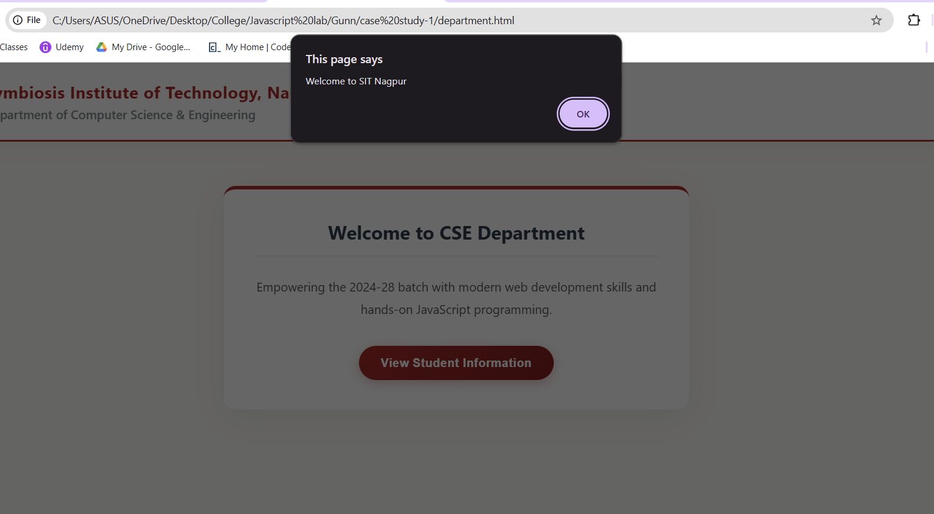
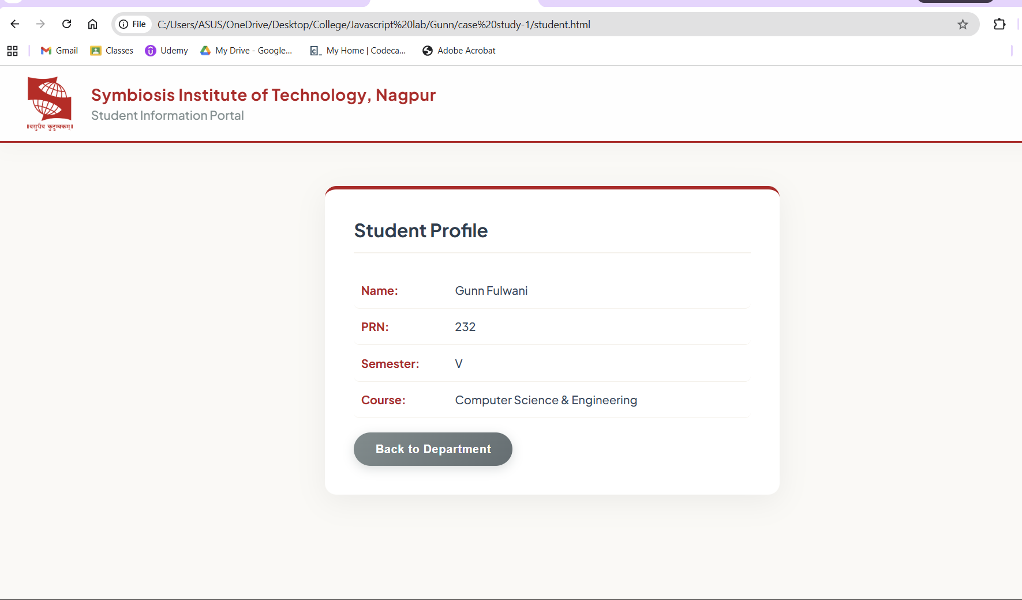

Result/Conclusion: The case study was successfully completed. A professional, responsive departmental welcome page was designed using HTML and CSS, matching the institutional theme. The core functionality of JavaScript DOM manipulation was successfully implemented, allowing the webpage to dynamically render student information upon user interaction via event listeners. This demonstrated a clear separation of concerns between structure (HTML), presentation (CSS), and behavior (JavaScript).

Experiment No: 2

Title: Create a dynamic Billing Calculator using JavaScript objects, object destructuring, and DOM manipulation.
Software/Tools Required: Visual Studio Code (or any text editor), Web Browser (Google Chrome, Microsoft Edge, Firefox, etc.)
Code:
<!DOCTYPE html>
<html lang="en">
<head>
<meta charset="utf-8">
<meta name="viewport" content="width=device-width, initial-scale=1.0">
<title>Billing Calculator</title>
<style>
@import url('https://fonts.googleapis.com/css2?family=Outfit:wght@300;400;500;600&display=swap');

/* SOFT BREATHING BACKGROUND */
body {
font-family: 'Outfit', sans-serif;
margin: 0;
min-height: 100vh;
display: flex;
justify-content: center;
align-items: center;
background: linear-gradient(-45deg, #fdfbf7, #f4ebe1, #ecdcd1, #f9f3ee);
background-size: 400% 400%;
animation: softBreathe 15s ease infinite;
color: #4a403a;
padding: 20px;
}

@keyframes softBreathe {
0% { background-position: 0% 50%; }
50% { background-position: 100% 50%; }
100% { background-position: 0% 50%; }
}

/* HIGHLIGHTED CARD */
.calculator-card {
background: #ffffff;
padding: 45px 40px;
border-radius: 24px;
/* Stronger shadow to make the card pop */
box-shadow: 0 15px 35px rgba(142, 115, 97, 0.15), 0 5px 15px rgba(0,0,0,0.05);
width: 100%;
max-width: 420px;
transform: translateY(0);
transition: transform 0.4s ease, box-shadow 0.4s ease;
border: 1px solid rgba(209, 197, 190, 0.6); /* Defined border */
}

.calculator-card:hover {
transform: translateY(-4px);
box-shadow: 0 25px 50px rgba(142, 115, 97, 0.2), 0 10px 20px rgba(0,0,0,0.08);
}

h2 {
text-align: center;
margin-top: 0;
margin-bottom: 35px;
font-weight: 600; /* Made heading slightly bolder */
letter-spacing: 0.5px;
color: #8e7361;
font-size: 1.8em;
}

/* HIGHLIGHTED INPUT FIELDS */
.input-group {
margin-bottom: 22px;
position: relative;
}

.input-group label {
display: block;
font-size: 0.85em;
color: #8e7361; /* Darker label for readability */
margin-bottom: 8px;
letter-spacing: 0.5px;
font-weight: 600;
text-transform: uppercase;
}

.input-group input {
width: 100%;
padding: 14px 16px;
background: #ffffff; /* Pure white to stand out */
border: 2px solid #e8dfd8; /* Thicker default border */
border-radius: 12px;
color: #4a403a;
font-size: 1.05em; /* Slightly larger text */
font-family: inherit;
box-sizing: border-box;
transition: all 0.3s ease;
box-shadow: inset 0 2px 4px rgba(0,0,0,0.02); /* Slight inner depth */
}

/* Interactive Highlights (Hover & Focus) */
.input-group input:hover {
border-color: #d1c5be;
background: #faf8f5;
}

.input-group input:focus {
outline: none;
background: #ffffff;
border-color: #c29b8c;
/* Glowing ring effect when clicked */
box-shadow: 0 0 0 4px rgba(194, 155, 140, 0.25), inset 0 2px 4px rgba(0,0,0,0.01);
transform: translateY(-1px);
}

.input-group input::placeholder {
color: #c8c0ba;
font-weight: 400;
}

/* HIGHLIGHTED BUTTON */
.btn-generate {
width: 100%;
background: #b88d7c; /* Slightly richer color */
color: #ffffff;
border: none;
padding: 16px;
border-radius: 12px;
font-size: 1.1em;
font-weight: 600;
letter-spacing: 1px;
cursor: pointer;
margin-top: 10px;
transition: all 0.3s ease;
box-shadow: 0 6px 15px rgba(184, 141, 124, 0.3);
}

.btn-generate:hover {
transform: translateY(-3px);
background: #a37968;
box-shadow: 0 12px 20px rgba(184, 141, 124, 0.4);
}

.btn-generate:active {
transform: translateY(1px);
box-shadow: 0 4px 10px rgba(184, 141, 124, 0.3);
}

/* RECEIPT HIGHLIGHTS */
.receipt-box {
margin-top: 35px;
padding: 30px;
background: #ffffff;
border: 2px dashed #c29b8c; /* Clearer dashed border */
border-radius: 16px;
display: none;
animation: slideDownFade 0.5s cubic-bezier(0.16, 1, 0.3, 1) forwards;
box-shadow: 0 10px 25px rgba(142, 115, 97, 0.08);
}

@keyframes slideDownFade {
from { opacity: 0; transform: translateY(-15px); }
to { opacity: 1; transform: translateY(0); }
}

.receipt-box h3 {
text-align: center;
margin-top: 0;
color: #8e7361;
border-bottom: 2px solid #e8dfd8;
padding-bottom: 15px;
margin-bottom: 20px;
font-weight: 600;
}

.receipt-row {
display: flex;
justify-content: space-between;
margin-bottom: 12px;
font-size: 1em;
color: #7a6e65;
}

.receipt-row.total-row {
font-weight: 700;
font-size: 1.2em;
color: #4a403a;
border-top: 2px dashed #e8dfd8;
padding-top: 18px;
margin-top: 15px;
}

.value-text {
color: #4a403a;
font-weight: 600; /* Values highlighted */
}
</style>
</head>
<body>

<div class="calculator-card">
<h2>Billing Calculator</h2>

<div class="input-group">
<label>Customer Name</label>
<input type="text" id="cName" placeholder="Enter customer name">
</div>

<div class="input-group">
<label>Product Name</label>
<input type="text" id="pName" placeholder="e.g., Lavender Soy Wax Candle">
</div>

<div style="display: flex; gap: 15px;">
<div class="input-group" style="flex: 1;">
<label>Quantity</label>
<input type="number" id="qty" placeholder="0" min="1">
</div>

<div class="input-group" style="flex: 1;">
<label>Price (₹)</label>
<input type="number" id="price" placeholder="0.00" min="1">
</div>
</div>

<button class="btn-generate" onclick="generateBill()">Generate Bill</button>

<div id="receiptOutput" class="receipt-box"></div>
</div>

<script>
function generateBill() {
const GST = 0.18;

let customerName = document.getElementById("cName").value;
let productName = document.getElementById("pName").value;
let quantity = Number(document.getElementById("qty").value);
let price = Number(document.getElementById("price").value);

if (!customerName || !productName || quantity <= 0 || price <= 0) {
alert("Please fill all details correctly before generating the bill!");
return;
}

let total = quantity * price;
let gstAmount = total * GST;
let finalBill = total + gstAmount;

const bill = {
customer: customerName,
product: productName,
quantity,
price,
total,
gstAmount,
finalBill
};

const {
customer,
product,
gstAmount: gst,
finalBill: amount
} = bill;

const receiptContent = `
<h3>Final Receipt</h3>
<div class="receipt-row"><span>Customer:</span> <span class="value-text">${customer}</span></div>
<div class="receipt-row"><span>Product:</span> <span class="value-text">${product}</span></div>
<div class="receipt-row"><span>Qty:</span> <span class="value-text">${quantity}</span></div>
<div class="receipt-row"><span>Price/Item:</span> <span class="value-text">₹${price.toFixed(2)}</span></div>
<div class="receipt-row"><span>Subtotal:</span> <span class="value-text">₹${total.toFixed(2)}</span></div>
<div class="receipt-row"><span>GST (18%):</span> <span class="value-text">₹${gst.toFixed(2)}</span></div>
<div class="receipt-row total-row"><span>Total Amount:</span> <span style="color: #a37968;">₹${amount.toFixed(2)}</span></div>
`;

const receiptDiv = document.getElementById("receiptOutput");

receiptDiv.style.display = "none";
setTimeout(() => {
receiptDiv.innerHTML = receiptContent;
receiptDiv.style.display = "block";
}, 50);
}
</script>

</body>
</html>

Output:
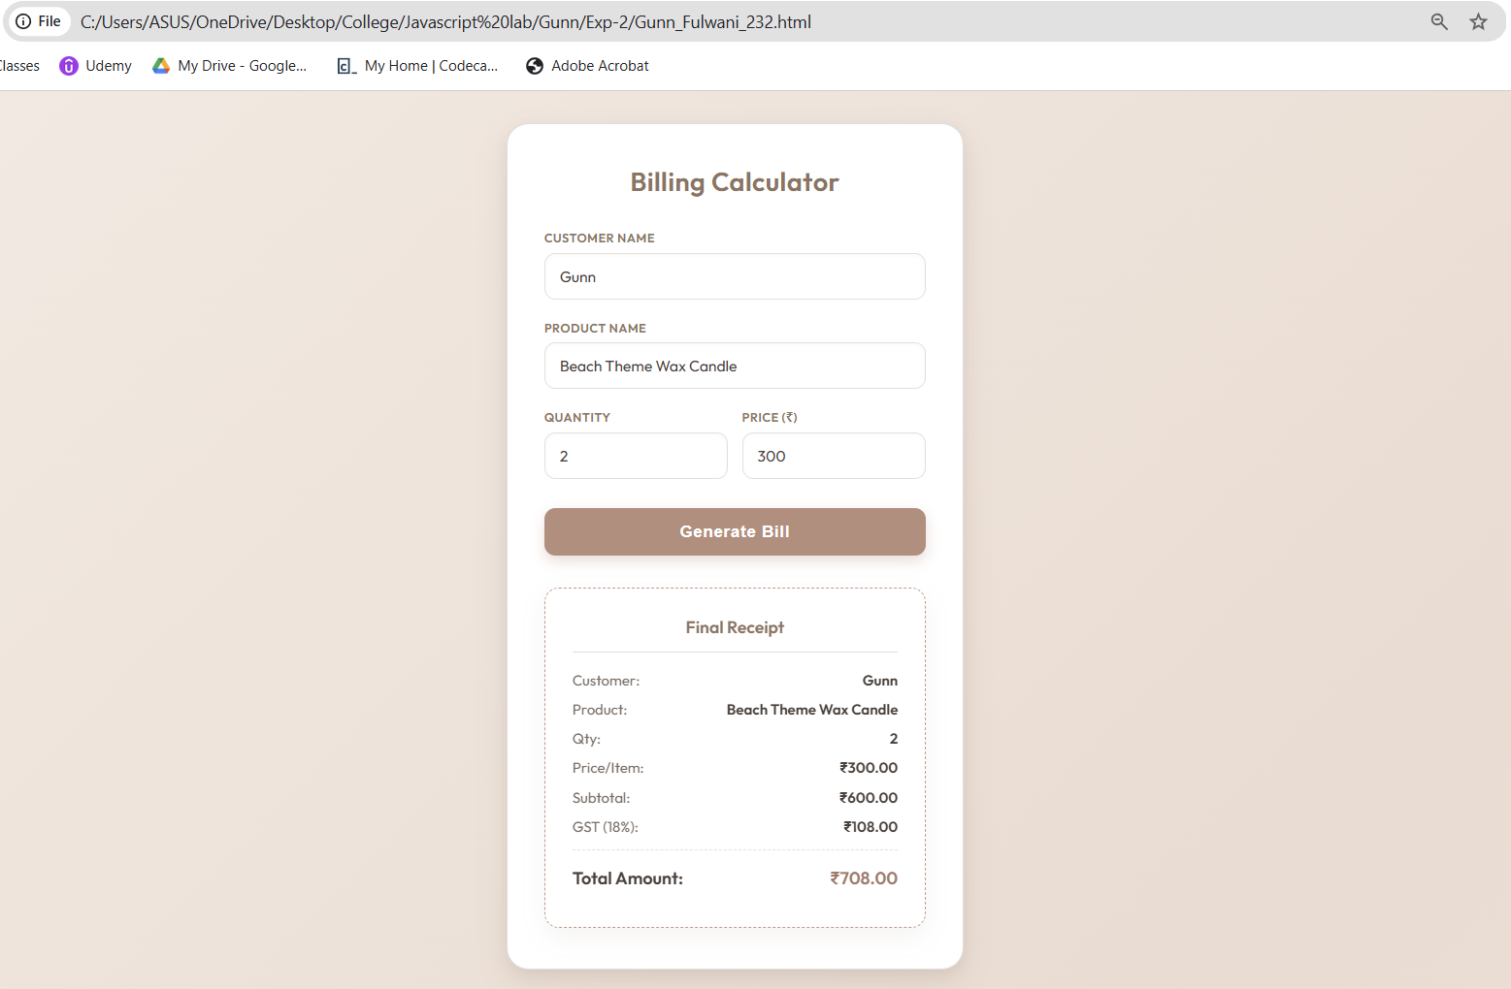

Result/Conclusion: The experiment was successfully completed. A dynamic and interactive billing calculator was developed using modern JavaScript principles. The use of outdated methods like prompt() and document.write() was effectively replaced with DOM manipulation, providing a clean and seamless user interface. Furthermore, the practical implementation of JavaScript objects and ES6 object destructuring provided a highly structured and efficient way to compute, store, and display invoice data.

Case study – 2
Title: Build a dynamic Retail Billing Calculator using JavaScript DOM manipulation and diverse form controls. Software/Tools Required: Visual Studio Code, Web Browser.
Code :
<!DOCTYPE html>
<html lang="en">
<head>
<meta charset="UTF-8">
<meta name="viewport" content="width=device-width, initial-scale=1.0">
<title>Retail Billing System</title>
<style>
@import url('https://fonts.googleapis.com/css2?family=Plus+Jakarta+Sans:wght@400;500;600;700&display=swap');

/* LILAC DREAM AESTHETIC */
body {
font-family: 'Plus Jakarta Sans', sans-serif;
background-color: #f6f4fa; /* Soft Lavender Background */
color: #322e40;
margin: 0;
padding: 40px 20px;
display: flex;
justify-content: center;
}

.billing-container {
width: 100%;
max-width: 650px;
background: #ffffff;
padding: 35px 40px;
border-radius: 20px;
box-shadow: 0 15px 35px rgba(109, 89, 150, 0.08);
border-top: 6px solid #8b5cf6; /* Vibrant Violet Accent */
}

h2 {
margin: 0 0 15px 0;
font-size: 1.2em;
color: #4c1d95; /* Deep Indigo */
border-bottom: 2px solid #ede9fe;
padding-bottom: 10px;
}

.section-group {
margin-bottom: 30px;
}

.input-row {
display: flex;
gap: 20px;
margin-bottom: 15px;
}

.field {
flex: 1;
}

label {
display: block;
font-size: 0.85em;
font-weight: 600;
color: #5b21b6;
margin-bottom: 8px;
}

input[type="text"], input[type="number"] {
width: 100%;
padding: 12px 14px;
border: 1.5px solid #ddd6fe;
border-radius: 8px;
font-size: 0.95em;
font-family: inherit;
box-sizing: border-box;
outline: none;
transition: all 0.2s;
background: #faf9ff;
}

input[type="text"]:focus, input[type="number"]:focus {
border-color: #8b5cf6;
box-shadow: 0 0 0 3px rgba(139, 92, 246, 0.15);
background: #ffffff;
}

/* Radio & Checkbox Styling */
.radio-group {
display: flex;
gap: 15px;
align-items: center;
font-size: 0.9em;
margin-bottom: 12px;
color: #4c1d95;
font-weight: 500;
}

input[type="radio"], input[type="checkbox"] {
accent-color: #8b5cf6;
transform: scale(1.1);
margin-right: 5px;
cursor: pointer;
}

/* Buttons */
.btn-group {
display: flex;
gap: 15px;
margin-top: 25px;
justify-content: center;
}

button {
padding: 14px 28px;
border: none;
border-radius: 8px;
font-weight: 600;
font-size: 0.95em;
cursor: pointer;
transition: all 0.2s;
}

.btn-primary {
background: #8b5cf6;
color: white;
box-shadow: 0 4px 12px rgba(139, 92, 246, 0.3);
}

.btn-primary:hover {
background: #7c3aed;
transform: translateY(-2px);
}

.btn-secondary {
background: #f1f5f9;
color: #475569;
}

.btn-secondary:hover {
background: #e2e8f0;
}

/* Bill Summary Box */
.summary-box {
background: #faf9ff;
border: 1px solid #ddd6fe;
border-radius: 12px;
padding: 25px;
margin-top: 30px;
display: none;
animation: fadeIn 0.4s ease;
}

@keyframes fadeIn {
from { opacity: 0; transform: translateY(-10px); }
to { opacity: 1; transform: translateY(0); }
}

.summary-box h3 {
margin: 0 0 20px 0;
font-size: 1.4em;
color: #1e1b4b;
}

.summary-row {
display: flex;
justify-content: space-between;
margin-bottom: 12px;
font-size: 0.95em;
color: #4b5563;
}

.summary-divider {
border-top: 1px solid #c4b5fd;
margin: 15px 0;
}

.total-row {
display: flex;
justify-content: space-between;
font-size: 1.15em;
font-weight: 700;
color: #4c1d95;
}
</style>
</head>
<body>

<div class="billing-container">

<!-- SECTION 1: Product Information -->
<div class="section-group">
<h2>Product Information</h2>
<div class="field" style="margin-bottom: 15px;">
<label>Product Name</label>
<input type="text" id="pName" placeholder="e.g., Rice">
</div>
<div class="input-row">
<div class="field">
<label>Quantity (in Kg)</label>
<input type="number" id="qty" placeholder="0" min="0">
</div>
<div class="field">
<label>Rate per Kg (₹)</label>
<input type="number" id="rate" placeholder="0" min="0">
</div>
</div>
</div>

<!-- SECTION 2: Charges & Discounts -->
<div class="section-group">
<h2>Charges & Discounts</h2>
<div class="input-row">
<div class="field">
<label>Discount (%)</label>
<input type="number" id="discount" placeholder="0" min="0">
</div>
<div class="field">
<label>GST (%)</label>
<input type="number" id="gst" placeholder="0" min="0">
</div>
</div>
<div class="field">
<label>Packing Charges (₹)</label>
<input type="number" id="packing" placeholder="0" min="0">
</div>
</div>

<!-- SECTION 3: Payment & Membership -->
<div class="section-group">
<h2>Payment & Membership</h2>
<label style="margin-bottom: 10px;">Payment Mode</label>
<div class="radio-group">
<label><input type="radio" name="payMode" value="Cash"> Cash</label>
<label><input type="radio" name="payMode" value="Card"> Card</label>
<label><input type="radio" name="payMode" value="UPI" checked> UPI</label>
</div>

<div class="radio-group" style="margin-top: 15px;">
<label><input type="checkbox" id="membership" checked> Membership (Yes/No)</label>
</div>
</div>

<!-- Bill Summary Output -->
<div id="summaryBox" class="summary-box">
<h3>Bill Summary</h3>
<div class="summary-row">
<span>Product Cost (Qty × Rate):</span>
<span id="outCost">₹ 0.00</span>
</div>
<div class="summary-row">
<span id="outDiscountLabel">Discount (0.00%):</span>
<span id="outDiscountAmt">- ₹ 0.00</span>
</div>
<div class="summary-row" style="font-weight: 600; color: #322e40;">
<span>Subtotal:</span>
<span id="outSubtotal">₹ 0.00</span>
</div>
<div class="summary-row">
<span id="outGstLabel">GST (0.00%):</span>
<span id="outGstAmt">+ ₹ 0.00</span>
</div>
<div class="summary-row">
<span>Packing Charges:</span>
<span id="outPacking">+ ₹ 0.00</span>
</div>

<div class="summary-divider"></div>

<div class="total-row">
<span>Total Bill Amount:</span>
<span id="outTotal">₹ 0.00</span>
</div>
</div>

<!-- Action Buttons -->
<div class="btn-group">
<button class="btn-primary" onclick="calculateBill()">Calculate Bill</button>
<button class="btn-secondary" onclick="clearForm()">Clear Form</button>
</div>

</div>

<script>
function calculateBill() {
// 1. Fetch Values
const qty = Number(document.getElementById('qty').value) || 0;
const rate = Number(document.getElementById('rate').value) || 0;
const discPerc = Number(document.getElementById('discount').value) || 0;
const gstPerc = Number(document.getElementById('gst').value) || 0;
const packing = Number(document.getElementById('packing').value) || 0;

// 2. Mathematical Calculations (Exactly matching screenshot logic)
const productCost = qty * rate;
const discountAmt = productCost * (discPerc / 100);
const subtotal = productCost - discountAmt;
const gstAmt = subtotal * (gstPerc / 100);
const totalBill = subtotal + gstAmt + packing;

// 3. Update DOM Output
document.getElementById('outCost').innerText = `₹ ${productCost.toFixed(2)}`;

document.getElementById('outDiscountLabel').innerText = `Discount (${discPerc.toFixed(2)}%):`;
document.getElementById('outDiscountAmt').innerText = `- ₹ ${discountAmt.toFixed(2)}`;

document.getElementById('outSubtotal').innerText = `₹ ${subtotal.toFixed(2)}`;

document.getElementById('outGstLabel').innerText = `GST (${gstPerc.toFixed(2)}%):`;
document.getElementById('outGstAmt').innerText = `+ ₹ ${gstAmt.toFixed(2)}`;

document.getElementById('outPacking').innerText = `+ ₹ ${packing.toFixed(2)}`;

document.getElementById('outTotal').innerText = `₹ ${totalBill.toFixed(2)}`;

// Make the summary box visible
document.getElementById('summaryBox').style.display = 'block';
}

function clearForm() {
// Clear all text and number inputs
document.getElementById('pName').value = '';
document.getElementById('qty').value = '';
document.getElementById('rate').value = '';
document.getElementById('discount').value = '';
document.getElementById('gst').value = '';
document.getElementById('packing').value = '';

// Reset radios and checkboxes to default state
document.querySelector('input[name="payMode"][value="UPI"]').checked = true;
document.getElementById('membership').checked = true;

// Hide summary box
document.getElementById('summaryBox').style.display = 'none';
}
</script>
</body>
</html>

Output:
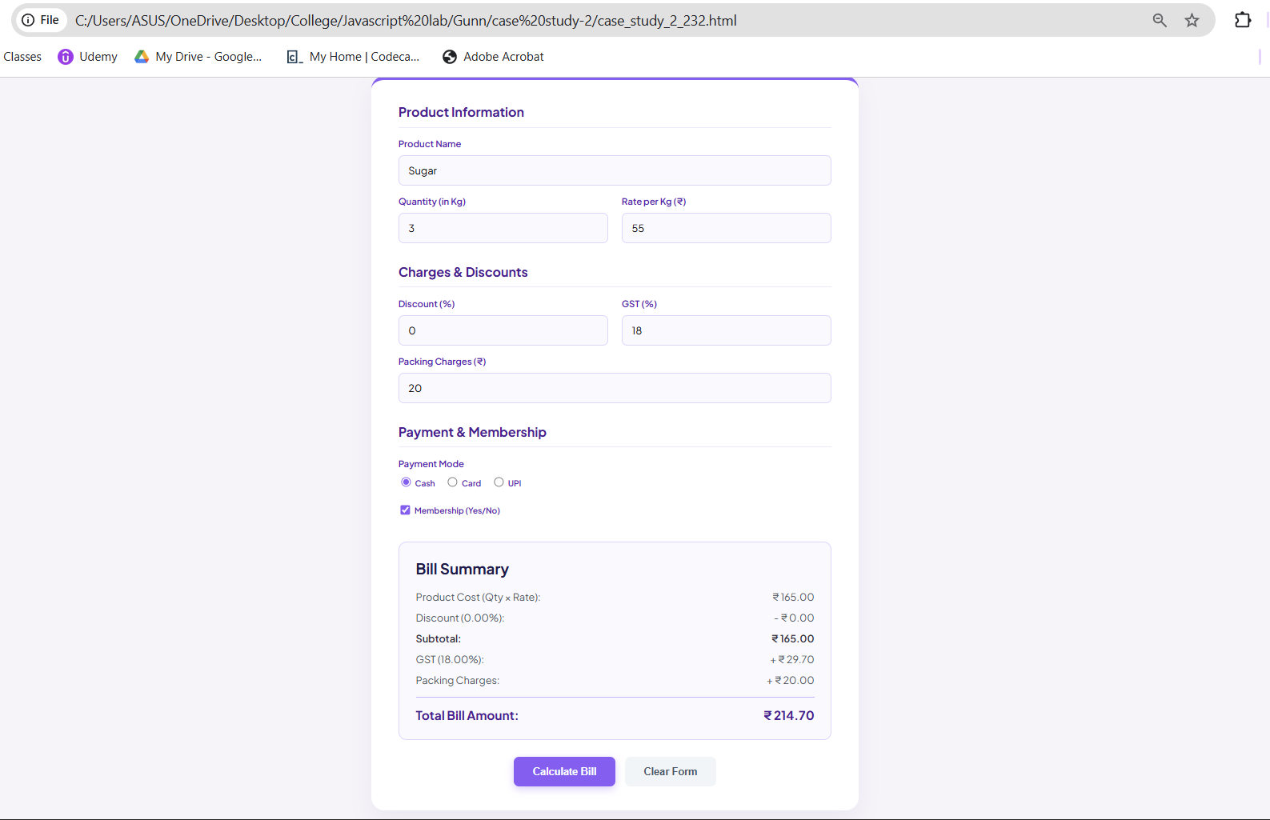
Result/Conclusion: The case study was successfully completed. A comprehensive retail billing calculator was developed using HTML, CSS, and JavaScript. The program successfully retrieved data from various input types (text, number, radio, checkbox), executed sequential financial arithmetic (including discount and GST percentages), and dynamically injected the formatted itemized bill into the webpage's DOM.

Experiment No: 3

Title: Implement control structures and form validation; create a grading system based on user-entered marks.

Software/Tools Required: Visual Studio Code (or any text editor), Web Browser (Google Chrome, Microsoft Edge, Firefox, etc.)

Code:
<!DOCTYPE html>
<html lang="en">
<head>
<meta charset="UTF-8">
<meta name="viewport" content="width=device-width, initial-scale=1.0">
<title>Student Grading System</title>
<style>
@import url('https://fonts.googleapis.com/css2?family=Inter:wght@400;500;600;700&display=swap');

body {
font-family: 'Inter', sans-serif;
background-color: #f8f9fa;
color: #333;
margin: 0;
padding: 40px 20px;
display: flex;
justify-content: center;
}

.container {
width: 100%;
max-width: 900px;
}

.header {
margin-bottom: 30px;
}

.header h1 {
margin: 0;
font-size: 1.8em;
color: #212529;
}

.header p {
margin: 5px 0 0 0;
color: #6c757d;
font-size: 0.9em;
}

.card {
background: #ffffff;
border: 1px solid #e9ecef;
border-radius: 8px;
padding: 25px;
margin-bottom: 25px;
box-shadow: 0 2px 4px rgba(0,0,0,0.02);
}

.card h3 {
margin-top: 0;
font-size: 1.1em;
color: #212529;
margin-bottom: 20px;
border-bottom: 1px solid #f1f3f5;
padding-bottom: 10px;
}

/* Form Grid System */
.form-row {
display: flex;
gap: 20px;
margin-bottom: 20px;
}

.form-group {
flex: 1;
}

.form-group label {
display: block;
font-size: 0.85em;
font-weight: 600;
color: #495057;
margin-bottom: 8px;
}

.form-group input {
width: 100%;
padding: 10px;
border: 1px solid #ced4da;
border-radius: 6px;
font-family: inherit;
font-size: 0.95em;
box-sizing: border-box;
outline: none;
transition: border-color 0.2s;
}

.form-group input:focus {
border-color: #80bdff;
box-shadow: 0 0 0 3px rgba(0,123,255,0.1);
}

/* Buttons */
.btn-group {
display: flex;
gap: 10px;
margin-top: 10px;
}

button {
padding: 10px 20px;
border: none;
border-radius: 6px;
font-size: 0.9em;
font-weight: 600;
cursor: pointer;
transition: opacity 0.2s;
}

button:hover {
opacity: 0.9;
}

.btn-success {
background-color: #28a745;
color: white;
}

.btn-primary {
background-color: #4285f4;
color: white;
}

/* Tables */
table {
width: 100%;
border-collapse: collapse;
font-size: 0.9em;
}

th {
text-align: left;
padding: 12px;
color: #6c757d;
font-size: 0.8em;
text-transform: uppercase;
border-bottom: 2px solid #e9ecef;
}

td {
padding: 15px 12px;
border-bottom: 1px solid #e9ecef;
color: #495057;
}

.badge {
padding: 5px 10px;
border-radius: 4px;
font-size: 0.85em;
font-weight: 600;
}

.badge-pass {
background-color: #d4edda;
color: #155724;
border: 1px solid #c3e6cb;
}

.badge-fail {
background-color: #f8d7da;
color: #721c24;
border: 1px solid #f5c6cb;
}

.badge-grade {
background-color: #e2e3e5;
color: #383d41;
border: 1px solid #d6d8db;
color: #004085;
background-color: #cce5ff;
}

/* Hidden Sections initially */
#resultsSection, #reportSection {
display: none;
}

/* Summary Footer in Report Card */
.report-summary {
background-color: #f8f9fa;
padding: 15px;
border-radius: 6px;
display: flex;
justify-content: space-between;
align-items: center;
margin-top: 15px;
font-size: 0.95em;
font-weight: 500;
}
</style>
</head>
<body>

<div class="container">
<div class="header">
<h1>Student Grading System</h1>
<p>Experiment 03 — Control structures & form validation</p>
</div>

<!-- 1. FORM SECTION -->
<div class="card">
<h3>Enter Student Details</h3>

<div class="form-row">
<div class="form-group" style="flex: 2;">
<label>Student Name</label>
<input type="text" id="sName" placeholder="e.g. John Doe">
</div>
<div class="form-group" style="flex: 1;">
<label>Roll No.</label>
<input type="text" id="rNo" placeholder="e.g. 232">
</div>
</div>

<div class="form-row">
<div class="form-group">
<label>English</label>
<input type="number" id="mEng" class="marks-input" min="0" max="100">
</div>
<div class="form-group">
<label>Maths</label>
<input type="number" id="mMath" class="marks-input" min="0" max="100">
</div>
<div class="form-group">
<label>Science</label>
<input type="number" id="mSci" class="marks-input" min="0" max="100">
</div>
<div class="form-group">
<label>Physics</label>
<input type="number" id="mPhy" class="marks-input" min="0" max="100">
</div>
<div class="form-group">
<label>Chemistry</label>
<input type="number" id="mChem" class="marks-input" min="0" max="100">
</div>
</div>

<div class="btn-group">
<button class="btn-success" onclick="processGrades()">Calculate Grade</button>
<button class="btn-primary" onclick="resetForm()">Reset</button>
</div>
</div>

<!-- 2. RESULTS SECTION -->
<div class="card" id="resultsSection">
<h3>Results</h3>
<table>
<thead>
<tr>
<th>#</th>
<th>Name</th>
<th>Roll</th>
<th>Total</th>
<th>%</th>
<th>Grade</th>
<th>Status</th>
</tr>
</thead>
<tbody id="resultsTableBody">
<!-- Populated via JS -->
</tbody>
</table>
</div>

<!-- 3. REPORT CARD SECTION -->
<div class="card" id="reportSection">
<h3>Report Card</h3>

<div style="background: #f8f9fa; padding: 15px; border-radius: 6px; margin-bottom: 15px;">
<strong style="font-size: 1.1em; color: #212529;" id="rcName"></strong><br>
<span style="color: #6c757d; font-size: 0.9em;" id="rcRoll"></span>
</div>

<table>
<thead>
<tr>
<th>Subject</th>
<th>Marks</th>
<th>Status</th>
</tr>
</thead>
<tbody id="reportTableBody">
<!-- Populated via JS -->
</tbody>
</table>

<div class="report-summary">
<span id="rcTotal">Total: </span>
<span id="rcPerc">Percentage: </span>
<span id="rcGrade">Grade: </span>
<span id="rcStatus"></span>
</div>
</div>

<!-- 4. JS CONCEPTS SECTION -->
<div class="card">
<h3>JS Concepts Used</h3>
<table>
<tr>
<td style="color: #0d6efd; font-weight: 600; width: 100px;">if / else</td>
<td>Form validation — checks empty fields, numeric range, and pass/fail status</td>
</tr>
<tr>
<td style="color: #0d6efd; font-weight: 600;">switch</td>
<td>Maps percentage ranges to letter grades (A+, A, B+, B, ...)</td>
</tr>
<tr>
<td style="color: #0d6efd; font-weight: 600;">for</td>
<td>Iterates over the 5 subject mark inputs for validation & totalling</td>
</tr>
<tr>
<td style="color: #0d6efd; font-weight: 600;">while</td>
<td>Scans marks to count subjects scoring above 75 (Distinction Check)</td>
</tr>
</table>
</div>

</div>

<!-- JAVASCRIPT LOGIC -->
<script>
function processGrades() {
// 1. Gather Inputs
const name = document.getElementById('sName').value;
const roll = document.getElementById('rNo').value;

// Get all mark inputs using a DOM method
const inputs = document.querySelectorAll('.marks-input');
const subjects = ['English', 'Maths', 'Science', 'Physics', 'Chemistry'];
let marks = [];

// Concept: if-else (Form Validation for Strings)
if (name.trim() === "" || roll.trim() === "") {
alert("Please enter Student Name and Roll No.");
return;
}

let total = 0;
let isFail = false;

// Concept: for loop (Data Extraction & Totalling)
for (let i = 0; i < inputs.length; i++) {
let mark = Number(inputs[i].value);

// Concept: if-else (Validation for Marks)
if (inputs[i].value === "" || mark < 0 || mark > 100) {
alert(`Please enter valid marks for ${subjects[i]} (0-100).`);
return; // Stop execution if invalid
}

marks.push(mark);
total += mark;

// Checking individual pass/fail (Assuming 35 is passing)
if (mark < 35) {
isFail = true;
}
}

// Calculations
let percentage = (total / 500) * 100;
let grade = "";

// Concept: switch statement (Grading Logic)
switch (true) {
case (percentage >= 90): grade = "A+"; break;
case (percentage >= 80): grade = "A"; break;
case (percentage >= 70): grade = "B+"; break;
case (percentage >= 60): grade = "B"; break;
case (percentage >= 50): grade = "C"; break;
case (percentage >= 35): grade = "D"; break;
default: grade = "F"; break;
}

// Override grade if failed in any subject
if (isFail) {
grade = "F";
}
let finalStatus = isFail ? "FAIL" : "PASS";
let statusClass = isFail ? "badge-fail" : "badge-pass";

// Concept: while loop (Counting Distinctions >= 75)
let distinctionCount = 0;
let countIndex = 0;
while (countIndex < marks.length) {
if (marks[countIndex] >= 75) {
distinctionCount++;
}
countIndex++;
}
console.log(`Log: Student scored distinction in ${distinctionCount} subject(s).`);

// --- DOM MANIPULATION (Updating the UI) ---

// Update Results Table
document.getElementById('resultsTableBody').innerHTML = `
<tr>
<td>1</td>
<td>${name}</td>
<td>${roll}</td>
<td>${total} / 500</td>
<td>${percentage.toFixed(2)}%</td>
<td><span class="badge badge-grade">${grade}</span></td>
<td><span class="badge ${statusClass}">${finalStatus}</span></td>
</tr>
`;

// Update Report Card Header
document.getElementById('rcName').innerText = name;
document.getElementById('rcRoll').innerText = `Roll No. ${roll}`;

// Update Report Card Table
let reportRows = "";
for (let i = 0; i < subjects.length; i++) {
let subStatus = marks[i] >= 35 ? "Pass" : "Fail";
let subClass = marks[i] >= 35 ? "color: #28a745;" : "color: #dc3545;";

reportRows += `
<tr>
<td>${subjects[i]}</td>
<td>${marks[i]} / 100</td>
<td style="${subClass} font-weight: 600;">${subStatus}</td>
</tr>
`;
}
document.getElementById('reportTableBody').innerHTML = reportRows;

// Update Report Card Footer Summary
document.getElementById('rcTotal').innerHTML = `Total: <strong>${total} / 500</strong>`;
document.getElementById('rcPerc').innerHTML = `Percentage: <strong>${percentage.toFixed(2)}%</strong>`;
document.getElementById('rcGrade').innerHTML = `Grade: <span style="color:#004085; font-weight:700;">${grade}</span>`;
document.getElementById('rcStatus').innerHTML = `<span class="badge ${statusClass}">${finalStatus}</span>`;

// Show the hidden sections
document.getElementById('resultsSection').style.display = 'block';
document.getElementById('reportSection').style.display = 'block';
}

function resetForm() {
// Clear all inputs
document.getElementById('sName').value = "";
document.getElementById('rNo').value = "";
let inputs = document.querySelectorAll('.marks-input');
for(let i=0; i<inputs.length; i++) inputs[i].value = "";

// Hide sections again
document.getElementById('resultsSection').style.display = 'none';
document.getElementById('reportSection').style.display = 'none';
}
</script>
</body>
</html>

Output:
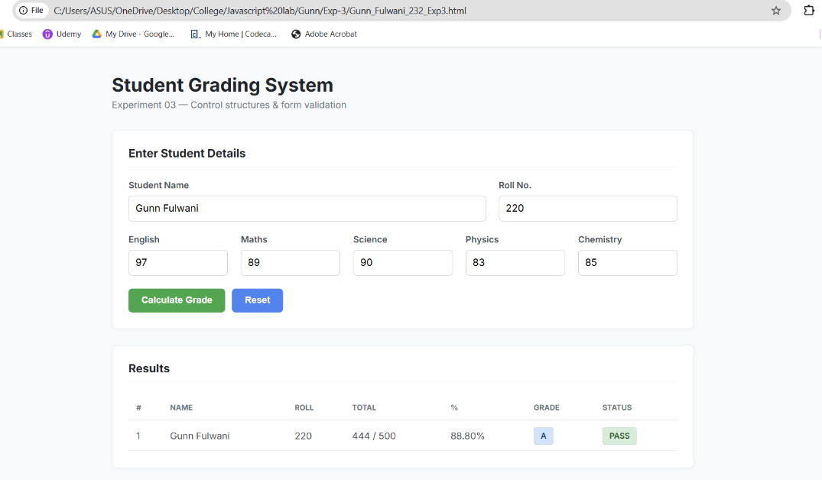
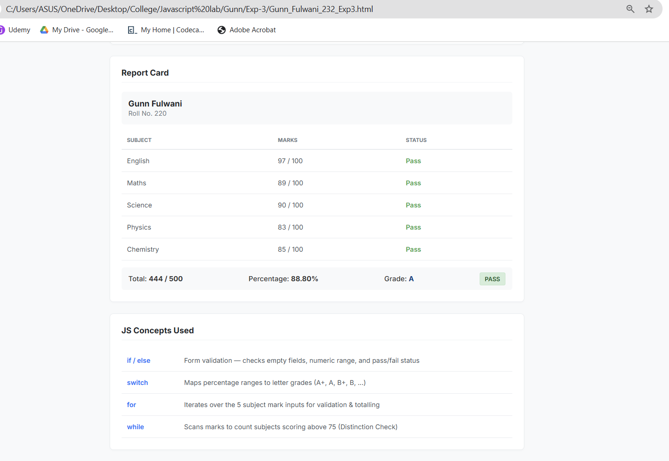

Result/Conclusion (Corrected): The experiment was successfully completed. Various JavaScript control structures (if-else, switch, for, and while loops) were practically implemented to build a dynamic Student Grading System. Form validation was successfully applied to ensure accurate user inputs and prevent blank or out-of-range values. The application correctly calculated totals, percentages, and dynamically assigned grades and pass/fail statuses based on complex decision-making logic.

Case study – 3
Title: Write a JavaScript program that accepts student marks and displays the scholarship category using conditional control structures.
Software/Tools Required: Visual Studio Code (or any text editor), Web Browser (Google Chrome, Microsoft Edge, Firefox, etc.)
Code:
<!DOCTYPE html>
<html lang="en">
<head>
<meta charset="UTF-8">
<meta name="viewport" content="width=device-width, initial-scale=1.0">
<title>Scholarship Eligibility Checker</title>
<style>
@import url('https://fonts.googleapis.com/css2?family=Inter:wght@400;500;600;700&display=swap');

/* NORDIC ICE & SAGE GREEN AESTHETIC */
body {
font-family: 'Inter', sans-serif;
background-color: #f4f7f6; /* Soft Ice/Grey-Green Background */
display: flex;
justify-content: center;
align-items: center;
height: 100vh;
margin: 0;
color: #2c3e50;
}

.card {
background-color: #ffffff;
width: 100%;
max-width: 420px;
padding: 40px;
border-radius: 16px;
box-shadow: 0 10px 30px rgba(0, 0, 0, 0.04), 0 1px 3px rgba(0,0,0,0.02);
text-align: center;
border-top: 5px solid #789c78; /* Sage Green Accent */
}

h2 {
margin-top: 0;
margin-bottom: 25px;
font-size: 1.6em;
color: #333;
font-weight: 700;
line-height: 1.3;
}

.input-group {
text-align: left;
margin-bottom: 20px;
}

label {
display: block;
font-size: 0.9em;
font-weight: 600;
color: #555;
margin-bottom: 8px;
}

input[type="number"] {
width: 100%;
padding: 12px 15px;
font-size: 1em;
font-family: inherit;
border: 1.5px solid #d1d9d4;
border-radius: 8px;
box-sizing: border-box;
outline: none;
transition: all 0.2s ease;
background-color: #fcfdfc;
}

input[type="number"]:focus {
border-color: #789c78;
box-shadow: 0 0 0 3px rgba(120, 156, 120, 0.15);
}

.btn-check {
width: 100%;
padding: 14px;
background-color: #789c78; /* Classy Sage Green */
color: #ffffff;
border: none;
border-radius: 8px;
font-size: 1em;
font-weight: 600;
cursor: pointer;
transition: background-color 0.2s ease, transform 0.1s ease;
}

.btn-check:hover {
background-color: #648564;
transform: translateY(-1px);
}

.result-box {
margin-top: 20px;
padding: 15px;
background-color: #eef2ef; /* Soft grey matching screenshot */
border: 1px solid #dcdcdc;
border-radius: 8px;
font-size: 0.95em;
font-weight: 500;
color: #333;
display: none; /* Hidden by default */
animation: fadeIn 0.3s ease-in-out;
}

@keyframes fadeIn {
from { opacity: 0; transform: translateY(-5px); }
to { opacity: 1; transform: translateY(0); }
}
</style>
</head>
<body>

<div class="card">
<h2>Scholarship Eligibility<br>Checker</h2>

<div class="input-group">
<label for="marks">Enter Student Marks (0-100):</label>
<input type="number" id="marks" min="0" max="100" placeholder="e.g. 95">
</div>

<button class="btn-check" onclick="checkEligibility()">Check Eligibility</button>

<div id="output" class="result-box"></div>
</div>

<script>
function checkEligibility() {
const marksInput = document.getElementById('marks').value;
const outputBox = document.getElementById('output');

// Validation: Check if input is empty or out of range
if (marksInput === '' || marksInput < 0 || marksInput > 100) {
outputBox.innerHTML = "<span style='color: #c0392b;'>⚠️ Please enter valid marks between 0 and 100.</span>";
outputBox.style.display = "block";
outputBox.style.backgroundColor = "#fdf0f0";
return;
}

const marks = Number(marksInput);
let scholarship = "";

// If-Else Ladder for Scholarship Categories
if (marks >= 90) {
scholarship = "Platinum Scholarship";
} else if (marks >= 75) {
scholarship = "Gold Scholarship";
} else if (marks >= 60) {
scholarship = "Silver Scholarship";
} else if (marks >= 40) {
scholarship = "Bronze Scholarship";
} else {
scholarship = "No Scholarship";
}

// Displaying exact format requested in screenshot
outputBox.innerHTML = `<strong>Marks:</strong> ${marks} &nbsp; <strong>Scholarship:</strong> ${scholarship}`;

// Resetting background color in case of previous error
outputBox.style.backgroundColor = "#eef2ef";
outputBox.style.display = "block";
}
</script>
</body>
</html>

Output:
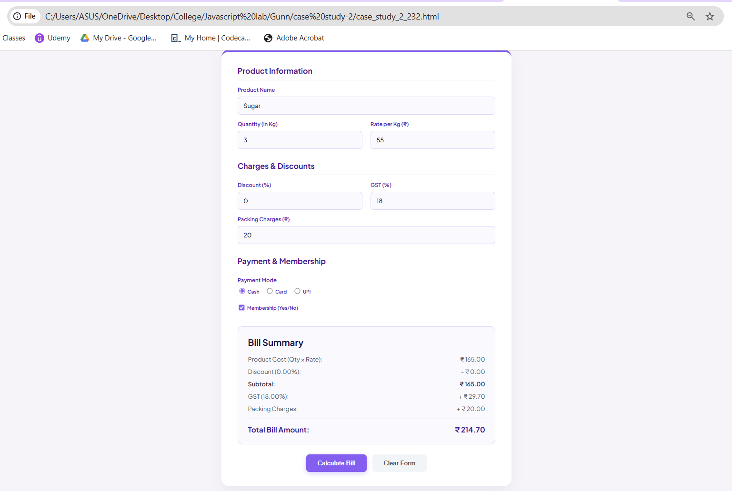

Result/Conclusion: The case study was successfully completed. A dynamic JavaScript program was developed to accept numerical marks, validate the input range, and apply a sequential if-else logic ladder to determine the correct scholarship tier (e.g., Platinum, Gold, Silver, Bronze). The core logic was successfully integrated with the front-end, allowing the result to be dynamically displayed on the web interface using DOM manipulation techniques without requiring a page reload.

Experiment No: 4

Title: Real-Time Case Study: ATM Card PIN Verification Using JavaScript Functions (Palindrome Checker). Software/Tools Required: Visual Studio Code (or any text editor), Web Browser.

Code:
<!DOCTYPE html>
<html lang="en">
<head>
<meta charset="UTF-8">
<meta name="viewport" content="width=device-width, initial-scale=1.0">
<title>Aesthetic String Validator</title>
<style>
@import url('https://fonts.googleapis.com/css2?family=Outfit:wght@300;400;500;600&display=swap');

/* SOFT BREATHING PASTEL BACKGROUND */
body {
font-family: 'Outfit', sans-serif;
margin: 0;
min-height: 100vh;
display: flex;
justify-content: center;
align-items: flex-start; /* Changed from center to prevent top cut-off */
background: linear-gradient(-45deg, #fdfbf7, #f4ebe1, #ecdcd1, #f9f3ee);
background-size: 400% 400%;
animation: softBreathe 15s ease infinite;
color: #4a403a;
padding: 40px 20px;
box-sizing: border-box;
}

@keyframes softBreathe {
0% { background-position: 0% 50%; }
50% { background-position: 100% 50%; }
100% { background-position: 0% 50%; }
}

.portal-container {
width: 100%;
max-width: 850px;
margin-top: 20px;
}

/* HEADER */
.header {
text-align: center;
margin-bottom: 35px;
}

.header h1 {
margin: 0;
font-size: 2.2em;
font-weight: 600;
color: #8e7361;
letter-spacing: 0.5px;
}

.header p {
color: #9a8c83;
font-size: 0.95em;
margin: 8px 0 0 0;
font-style: italic;
}

/* RESPONSIVE GRID LAYOUT */
.grid-row {
display: grid;
grid-template-columns: 1.4fr 1fr;
gap: 25px;
margin-bottom: 25px;
}

/* Added Media Query to prevent overlap on smaller screens */
@media (max-width: 768px) {
.grid-row {
grid-template-columns: 1fr; /* Stacks the cards vertically on small screens */
}
}

/* CARDS */
.card {
background: #ffffff;
padding: 30px;
border-radius: 24px;
box-shadow: 0 15px 35px rgba(142, 115, 97, 0.12), 0 5px 15px rgba(0,0,0,0.03);
border: 1px solid rgba(209, 197, 190, 0.6);
transition: transform 0.4s ease, box-shadow 0.4s ease;
}

.card:hover {
transform: translateY(-4px);
box-shadow: 0 20px 45px rgba(142, 115, 97, 0.18);
}

.card h3 {
margin: 0 0 20px 0;
font-size: 1.25em;
color: #8e7361;
font-weight: 600;
display: flex;
align-items: center;
justify-content: space-between;
border-bottom: 2px solid #f4ebe1;
padding-bottom: 12px;
}

.tag {
font-size: 0.65em;
background: #fdfbf7;
color: #b88d7c;
padding: 5px 10px;
border-radius: 20px;
border: 1px solid #e8dfd8;
font-weight: 600;
letter-spacing: 1px;
}

/* INPUT FIELDS */
label {
display: block;
font-size: 0.85em;
font-weight: 600;
text-transform: uppercase;
color: #8e7361;
margin-bottom: 8px;
letter-spacing: 0.5px;
}

input[type="text"] {
width: 100%;
padding: 14px 16px;
background: #ffffff;
border: 2px solid #e8dfd8;
border-radius: 12px;
color: #4a403a;
font-size: 1.05em;
font-family: inherit;
box-sizing: border-box;
outline: none;
transition: all 0.3s ease;
}

input[type="text"]:focus {
border-color: #c29b8c;
box-shadow: 0 0 0 4px rgba(194, 155, 140, 0.2);
}

input[type="text"]::placeholder {
color: #c8c0ba;
font-weight: 400;
}

.btn-group {
display: flex;
gap: 12px;
margin-top: 20px;
}

button {
padding: 15px 20px;
border: none;
border-radius: 12px;
font-weight: 600;
font-size: 1em;
cursor: pointer;
transition: all 0.3s ease;
flex: 1;
}

.btn-primary {
background: #b88d7c;
color: white;
box-shadow: 0 6px 15px rgba(184, 141, 124, 0.3);
}

.btn-primary:hover {
background: #a37968;
transform: translateY(-2px);
}

.btn-secondary {
background: #f4ebe1;
color: #8e7361;
}

.btn-secondary:hover {
background: #e8dfd8;
}

/* ANALYTICS BOXES */
.stats-box {
background: #faf8f5;
border-radius: 16px;
padding: 18px;
margin-bottom: 15px;
border: 1px dashed #d1c5be;
}

.stat-label {
font-size: 0.8em;
color: #9a8c83;
text-transform: uppercase;
font-weight: 600;
}

.stat-value {
font-size: 1.8em;
font-weight: 600;
color: #4a403a;
margin-top: 5px;
}

/* RESULT DISPLAYS */
#resultArea {
display: none;
margin-top: 22px;
padding: 20px;
border-radius: 14px;
font-size: 0.95em;
}

.res-success {
background: #f0f7f4;
border: 2px solid #a3c9b8;
color: #2d6a4f;
}

.res-fail {
background: #fdf2f2;
border: 2px solid #e8b4b8;
color: #9b444e;
}

.error-alert {
background: #fff9db;
border: 1px dashed #f59f00;
color: #b45309;
padding: 12px 16px;
border-radius: 12px;
margin-top: 15px;
font-size: 0.9em;
display: none;
}
</style>
</head>
<body>

<div class="portal-container">
<div class="header">
<h1>Palindrome Analyzer</h1>
<p>Experiment 04 — Function Types, Lexical Closures & Try-Catch Exception Handling</p>
</div>

<div class="grid-row">
<div class="card">
<h3>String Evaluation <span class="tag">TRY...CATCH</span></h3>

<label>Enter Word or Phrase</label>
<input type="text" id="strInput" placeholder="e.g., A man, a plan, a canal: Panama">

<div class="error-alert" id="errorBox"></div>

<div class="btn-group">
<button class="btn-primary" onclick="handleValidation()">Check Palindrome</button>
<button class="btn-secondary" onclick="resetPortal()">Clear</button>
</div>

<div id="resultArea"></div>
</div>

<div class="card">
<h3>Live Analytics <span class="tag">CLOSURE DEMO</span></h3>
<p style="color: #7a6e65; font-size: 0.9em; margin-top: 0; margin-bottom: 20px; line-height: 1.5;">
These statistical counters maintain their state securely using a JavaScript closure.
</p>

<div class="stats-box">
<div class="stat-label">Total Strings Evaluated</div>
<div class="stat-value" id="statTotal">0</div>
</div>

<div class="stats-box" style="border-color: #c29b8c;">
<div class="stat-label">Palindromes Discovered</div>
<div class="stat-value" id="statPalindromes" style="color: #b88d7c;">0</div>
</div>
</div>
</div>

<div class="card" style="padding: 25px;">
<h3 style="margin-bottom: 15px;">JavaScript Architecture Breakdown</h3>
<div style="display: grid; grid-template-columns: repeat(auto-fit, minmax(200px, 1fr)); gap: 20px; font-size: 0.9em; color: #7a6e65; line-height: 1.6;">
<div>
<strong style="color: #8e7361; display: block; margin-bottom: 4px;">1. Function Types</strong>
Combines standard declarations with ES6 Arrow Functions.
</div>
<div>
<strong style="color: #8e7361; display: block; margin-bottom: 4px;">2. Lexical Closures</strong>
<code>createAnalyticsTracker()</code> encapsulates variables in a private block scope.
</div>
<div>
<strong style="color: #8e7361; display: block; margin-bottom: 4px;">3. Try-Catch Safety</strong>
Intercepts blank submissions or invalid characters dynamically.
</div>
</div>
</div>
</div>

<script>
const createAnalyticsTracker = () => {
let totalChecked = 0;
let palindromesFound = 0;

return {
recordCheck: (isPal) => {
totalChecked++;
if (isPal) palindromesFound++;
},
getStats: () => ({ total: totalChecked, found: palindromesFound }),
resetStats: () => {
totalChecked = 0;
palindromesFound = 0;
}
};
};

const analytics = createAnalyticsTracker();

const cleanAndReverse = (str) => {
const cleaned = str.toLowerCase().replace(/[^a-z0-9]/g, '');
const reversed = cleaned.split('').reverse().join('');
return { cleaned, reversed };
};

function handleValidation() {
const inputField = document.getElementById('strInput');
const errorBox = document.getElementById('errorBox');
const resultArea = document.getElementById('resultArea');

errorBox.style.display = 'none';
resultArea.style.display = 'none';

try {
const rawText = inputField.value;

if (!rawText || rawText.trim() === '') {
throw new Error("Input string cannot be blank!");
}

const { cleaned, reversed } = cleanAndReverse(rawText);

if (cleaned.length === 0) {
throw new Error("Input must contain at least one alphabet or digit.");
}

const isPalindrome = (cleaned === reversed);

analytics.recordCheck(isPalindrome);
updateAnalyticsUI();

resultArea.innerHTML = `
<div style="font-size: 1.15em; font-weight: 600; margin-bottom: 8px;">
${isPalindrome ? '✨ Palindrome Confirmed' : '📝 Not a Palindrome'}
</div>
<div style="font-size: 0.9em; opacity: 0.9;">
<strong>Formatted:</strong> "${cleaned}" <br>
<strong>Reversed:</strong> "${reversed}"
</div>
`;
resultArea.className = isPalindrome ? 'res-success' : 'res-fail';
resultArea.style.display = 'block';

} catch (error) {
errorBox.innerHTML = `<strong>⚠️ Notice:</strong> ${error.message}`;
errorBox.style.display = 'block';
}
}

function updateAnalyticsUI() {
const currentStats = analytics.getStats();
document.getElementById('statTotal').innerText = currentStats.total;
document.getElementById('statPalindromes').innerText = currentStats.found;
}

function resetPortal() {
document.getElementById('strInput').value = '';
document.getElementById('errorBox').style.display = 'none';
document.getElementById('resultArea').style.display = 'none';

analytics.resetStats();
updateAnalyticsUI();
}
</script>
</body>
</html>

Output:
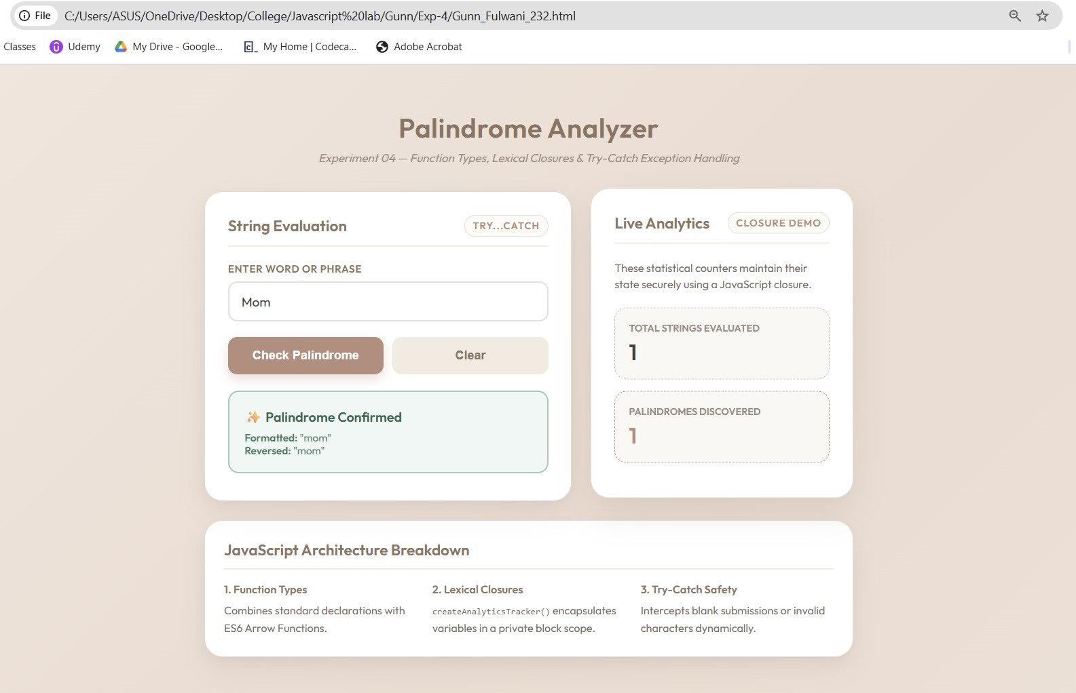
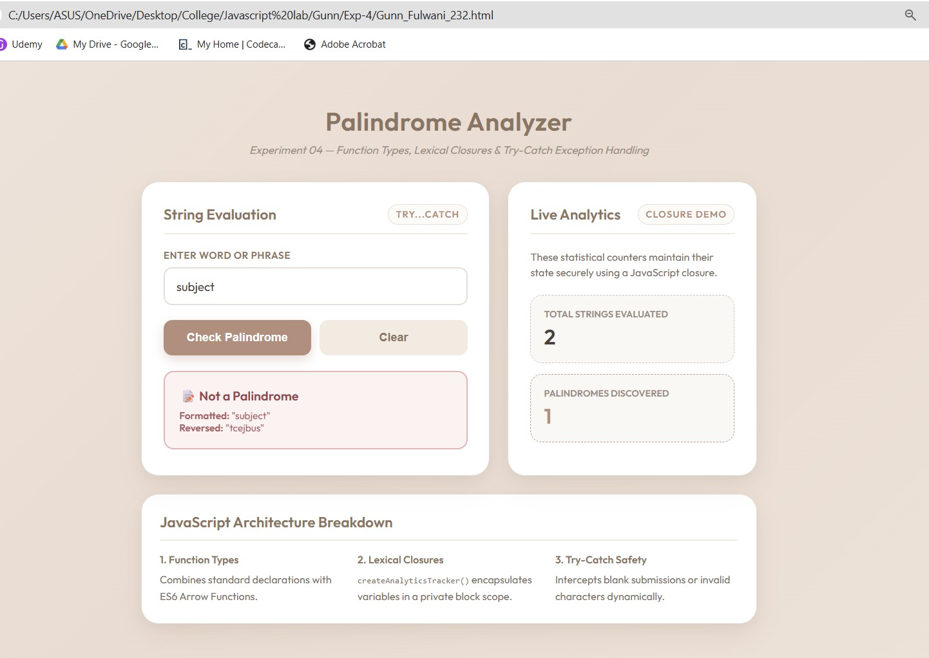
Result/Conclusion: The experiment was successfully completed. The ATM Card PIN Verification system was implemented using three distinct JavaScript function types: declarations, expressions, and arrow functions. Furthermore, a secure lexical closure was successfully integrated to track user attempts independently of the global scope. Form validation and robust error handling were achieved using a try...catch block, resulting in a secure, dynamic, and aesthetic web interface.

Case study – 4
Title: Real-Time Case Study: ATM Card PIN Verification Using JavaScript Functions (Palindrome Checker).
Software/Tools Required: Visual Studio Code (or any text editor), Web Browser (Google Chrome, Microsoft Edge, Firefox, etc.)
Code:
<!DOCTYPE html>
<html lang="en">
<head>
<meta charset="UTF-8">
<meta name="viewport" content="width=device-width, initial-scale=1.0">
<title>Secure Banking | PIN Verification</title>
<style>
@import url('https://fonts.googleapis.com/css2?family=Roboto:wght@400;500;700&family=Courier+Prime:wght@700&display=swap');

/* CORPORATE BANKING THEME */
body {
font-family: 'Roboto', sans-serif;
background-color: #f0f2f5; /* Standard corporate light grey */
color: #333333;
margin: 0;
display: flex;
flex-direction: column;
align-items: center;
min-height: 100vh;
}

/* Fake Bank Header */
.bank-navbar {
width: 100%;
background-color: #003366; /* Deep Navy Blue */
color: white;
padding: 15px 20px;
box-shadow: 0 2px 4px rgba(0,0,0,0.1);
display: flex;
justify-content: space-between;
align-items: center;
box-sizing: border-box;
}

.bank-navbar h2 {
margin: 0;
font-size: 1.4em;
letter-spacing: 1px;
display: flex;
align-items: center;
gap: 10px;
}

.container {
width: 100%;
max-width: 450px;
background: #ffffff;
margin-top: 50px;
border: 1px solid #d1d5db;
border-radius: 4px;
box-shadow: 0 4px 6px rgba(0,0,0,0.05);
overflow: hidden;
}

/* Form Header */
.form-header {
background-color: #f8f9fa;
border-bottom: 1px solid #e5e7eb;
padding: 20px;
text-align: center;
}

.form-header h3 {
margin: 0;
color: #003366;
font-size: 1.2em;
}

.form-header p {
margin: 5px 0 0 0;
color: #6b7280;
font-size: 0.85em;
}

/* Content Area */
.content {
padding: 30px 20px;
}

label {
display: block;
font-size: 0.85em;
font-weight: 700;
color: #374151;
margin-bottom: 8px;
}

/* PIN Input */
input[type="text"] {
width: 100%;
padding: 12px;
background: #ffffff;
border: 1px solid #9ca3af;
border-radius: 4px;
color: #111827;
font-size: 1.4em;
font-family: 'Courier Prime', monospace;
text-align: center;
letter-spacing: 5px;
box-sizing: border-box;
outline: none;
}

input[type="text"]:focus {
border-color: #0056b3;
box-shadow: 0 0 0 2px rgba(0, 86, 179, 0.2);
}

/* Corporate Button */
.btn-verify {
width: 100%;
background-color: #0056b3;
color: #ffffff;
border: none;
padding: 14px;
border-radius: 4px;
font-size: 1em;
font-weight: 700;
text-transform: uppercase;
cursor: pointer;
margin-top: 20px;
transition: background-color 0.2s;
}

.btn-verify:hover {
background-color: #004494;
}

/* System Alert Boxes */
.alert-box {
display: none;
margin-top: 20px;
padding: 15px;
border-radius: 4px;
border-left: 5px solid;
font-size: 0.9em;
line-height: 1.5;
}

.alert-success {
background-color: #f0fdf4;
border-color: #16a34a;
color: #166534;
}

.alert-info {
background-color: #eff6ff;
border-color: #2563eb;
color: #1e3a8a;
}

.alert-error {
background-color: #fef2f2;
border-color: #dc2626;
color: #991b1b;
}

/* Footer/Closure Stats */
.system-footer {
background-color: #f8f9fa;
border-top: 1px solid #e5e7eb;
padding: 12px 20px;
display: flex;
justify-content: space-between;
font-size: 0.8em;
color: #6b7280;
font-weight: 500;
}

.badge {
background: #e5e7eb;
padding: 2px 8px;
border-radius: 12px;
color: #374151;
font-weight: 700;
}
</style>
</head>
<body>

<!-- Corporate Navbar -->
<div class="bank-navbar">
<h2>🏦 Global Secure Bank</h2>
<span style="font-size: 0.85em;">Customer Portal</span>
</div>

<!-- Verification Interface -->
<div class="container">
<div class="form-header">
<h3>🔒 ATM PIN Authentication</h3>
<p>Please enter your 4-8 digit ATM PIN securely.</p>
</div>

<div class="content">
<label>ENTER PIN</label>
<input type="text" id="pinInput" placeholder="****" maxlength="8" autocomplete="off" onkeypress="return event.charCode >= 48 && event.charCode <= 57">

<button class="btn-verify" onclick="verifyATM()">Submit & Verify</button>

<!-- Dynamic System Alerts -->
<div id="outputMessage" class="alert-box"></div>
</div>

<!-- Lexical Closure Tracking (System Data) -->
<div class="system-footer">
<span>Server Session Attempts:</span>
<span class="badge" id="attemptCount">0</span>
</div>
</div>

<script>
// ==========================================
// 1. SCOPE & CLOSURE (Simulating secure session tracking)
// ==========================================
const secureATMSession = () => {
let attempts = 0; // Local block scope, hidden from window object

return {
logAttempt: () => {
attempts++;
document.getElementById('attemptCount').innerText = attempts;
}
};
};
const atmSession = secureATMSession();

// ==========================================
// 2. FUNCTION EXPRESSION
// ==========================================
const reversePin = function(pinString) {
return pinString.split('').reverse().join('');
};

// ==========================================
// 3. ARROW FUNCTION
// ==========================================
const checkPalindrome = (original, reversed) => {
return original === reversed;
};

// ==========================================
// 4. FUNCTION DECLARATION & TRY-CATCH
// ==========================================
function verifyATM() {
const inputField = document.getElementById('pinInput');
const outputBox = document.getElementById('outputMessage');

// Reset state
outputBox.style.display = 'none';
outputBox.className = 'alert-box';

try {
const rawPin = inputField.value.trim();

// Form Validation
if (rawPin === "") {
throw new Error("PIN entry cannot be blank. Please enter your PIN.");
}

if (!/^[0-9]+$/.test(rawPin)) {
throw new Error("Security Error: PIN must contain numeric values only.");
}

// Log attempt via Closure securely
atmSession.logAttempt();

// Process Logic
const reversedString = reversePin(rawPin);
const isPal = checkPalindrome(rawPin, reversedString);

// Update UI based on Palindrome logic
if (isPal) {
outputBox.innerHTML = `<strong>System Alert: Palindrome Match</strong><br>Verification successful. Special security protocol activated.`;
outputBox.classList.add('alert-success');
} else {
outputBox.innerHTML = `<strong>System Alert: Standard PIN</strong><br>Authentication successful. Access granted to standard features.`;
outputBox.classList.add('alert-info');
}

outputBox.style.display = 'block';

} catch (error) {
// Catch errors and display properly formatted error alert
outputBox.innerHTML = `<strong>Transaction Failed:</strong><br>${error.message}`;
outputBox.classList.add('alert-error');
outputBox.style.display = 'block';
}
}
</script>
</body>
</html>

Output:
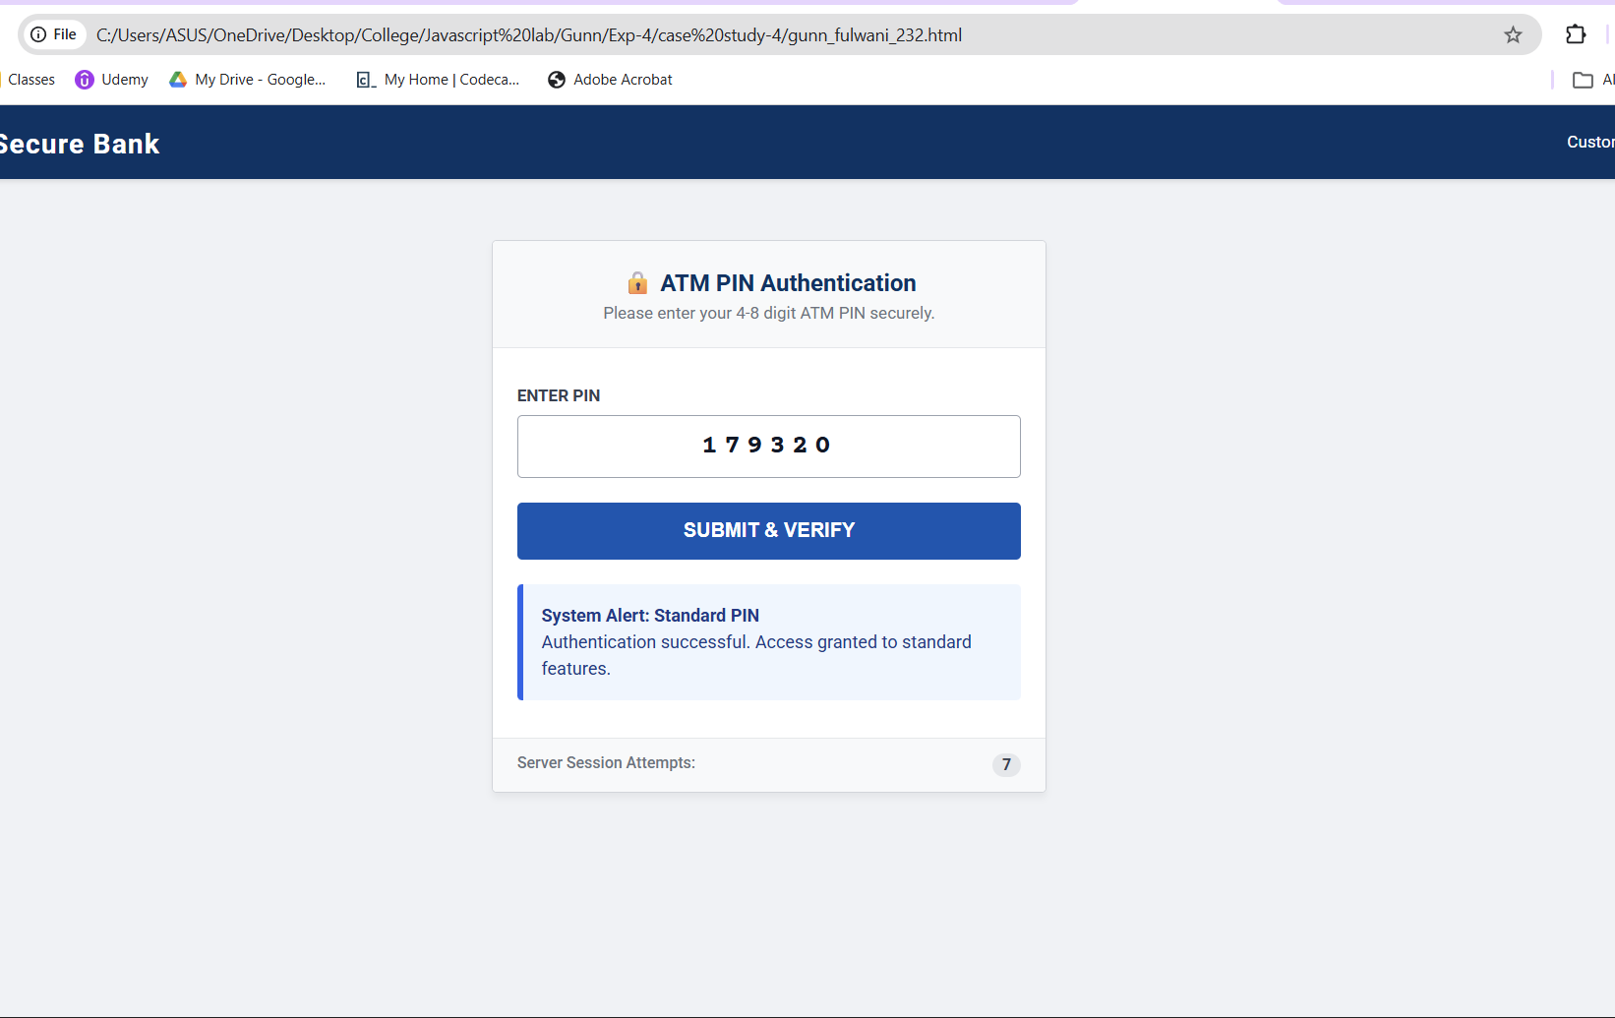

Result/Conclusion:
The case study was successfully completed. The ATM Card PIN Verification system was implemented using three distinct JavaScript function types: declarations, expressions, and arrow functions. Furthermore, a secure lexical closure was successfully integrated to track user attempts independently of the global scope. Form validation and robust error handling were achieved using a try...catch block, resulting in a secure, dynamic, and aesthetic web interface.

Experiment No: 5
Title: Apply array methods and object handling; create a cart total calculator with discount logic using JavaScript.
Software/Tools Required: Visual Studio Code, Web Browser.
Code:
<!DOCTYPE html>
<html lang="en">
<head>
<meta charset="UTF-8">
<meta name="viewport" content="width=device-width, initial-scale=1.0">
<title>Premium Checkout Cart</title>
<style>
@import url('https://fonts.googleapis.com/css2?family=Jost:wght@300;400;500;600&display=swap');

/* HIGH-END BOUTIQUE AESTHETIC */
body {
font-family: 'Jost', sans-serif;
background-color: #fcfbf9; /* Warm off-white */
color: #2c2a29;
margin: 0;
padding: 40px 20px;
display: flex;
justify-content: center;
}

.checkout-container {
width: 100%;
max-width: 900px;
display: grid;
grid-template-columns: 1.5fr 1fr;
gap: 30px;
}

@media (max-width: 768px) {
.checkout-container {
grid-template-columns: 1fr;
}
}

h2 {
font-size: 1.8em;
font-weight: 500;
margin-top: 0;
margin-bottom: 25px;
letter-spacing: 0.5px;
}

/* Cart Items Section */
.cart-section {
background: #ffffff;
padding: 30px;
border-radius: 12px;
box-shadow: 0 4px 20px rgba(0,0,0,0.03);
border: 1px solid #f0ede6;
}

.cart-item {
display: flex;
justify-content: space-between;
align-items: center;
padding: 15px 0;
border-bottom: 1px solid #f0ede6;
}

.cart-item:last-child {
border-bottom: none;
}

.item-details h4 {
margin: 0 0 5px 0;
font-size: 1.1em;
font-weight: 500;
}

.item-details p {
margin: 0;
font-size: 0.85em;
color: #7a7571;
text-transform: uppercase;
letter-spacing: 1px;
}

.item-price {
font-size: 1.1em;
font-weight: 600;
}

/* Order Summary Section */
.summary-section {
background: #faf8f5;
padding: 30px;
border-radius: 12px;
border: 1px solid #f0ede6;
height: fit-content;
}

.summary-row {
display: flex;
justify-content: space-between;
margin-bottom: 15px;
font-size: 1.05em;
}

.summary-divider {
border-top: 1px solid #e6e2db;
margin: 20px 0;
}

.total-row {
font-size: 1.4em;
font-weight: 600;
}

/* Discount Input */
.promo-box {
display: flex;
gap: 10px;
margin-top: 20px;
margin-bottom: 25px;
}

input[type="text"] {
flex: 1;
padding: 12px 15px;
border: 1px solid #dcd7d1;
border-radius: 6px;
font-family: inherit;
font-size: 0.9em;
outline: none;
background: #ffffff;
text-transform: uppercase;
}

input[type="text"]:focus {
border-color: #2c2a29;
}

button {
padding: 12px 20px;
background-color: #2c2a29;
color: #ffffff;
border: none;
border-radius: 6px;
font-family: inherit;
font-size: 0.9em;
font-weight: 500;
cursor: pointer;
transition: background 0.3s ease;
}

button:hover {
background-color: #4a4745;
}

.btn-checkout {
width: 100%;
padding: 16px;
font-size: 1.1em;
margin-top: 20px;
letter-spacing: 1px;
text-transform: uppercase;
}

.discount-tag {
color: #2e7d32;
font-weight: 500;
display: none;
font-size: 0.9em;
}
</style>
</head>
<body>

<div class="checkout-container">
<!-- Left: Cart Items -->
<div class="cart-section">
<h2>Shopping Bag</h2>
<div id="cartContainer">
<!-- Items will be injected here via JavaScript -->
</div>
</div>

<!-- Right: Order Summary -->
<div class="summary-section">
<h2>Order Summary</h2>

<div class="summary-row">
<span>Subtotal</span>
<span id="subtotalDisplay">₹0.00</span>
</div>

<div class="summary-row discount-tag" id="discountRow">
<span>Promo Discount</span>
<span id="discountDisplay">-₹0.00</span>
</div>

<div class="summary-row" style="color: #7a7571; font-size: 0.9em;">
<span>Shipping</span>
<span>Calculated at next step</span>
</div>

<div class="summary-divider"></div>

<div class="summary-row total-row">
<span>Total</span>
<span id="totalDisplay">₹0.00</span>
</div>

<div class="promo-box">
<input type="text" id="promoCode" placeholder="Enter Promo Code">
<button onclick="applyDiscount()">Apply</button>
</div>
<p style="font-size: 0.75em; color: #7a7571; margin-top: -15px;">Try code: <strong>GLOW20</strong></p>

<button class="btn-checkout">Proceed to Checkout</button>
</div>
</div>

<script>
// ==========================================
// 1. ARRAY OF OBJECTS (Data Handling)
// ==========================================
const cartItems = [
{ id: 1, name: "Lavender Soy Wax Candle", category: "Candles", price: 650, qty: 2 },
{ id: 2, name: "Vanilla Bean Minimalist Jar", category: "Candles", price: 800, qty: 1 },
{ id: 3, name: "Matte Black Wick Trimmer", category: "Accessories", price: 450, qty: 1 }
];

let currentSubtotal = 0;
let isDiscountApplied = false;

// ==========================================
// 2. ARRAY METHODS (`forEach`, `reduce`, `filter`)
// ==========================================

function renderCart() {
const container = document.getElementById('cartContainer');
container.innerHTML = ''; // Clear container

// Concept: .forEach() method to iterate and manipulate DOM
cartItems.forEach(item => {
const itemHTML = `
<div class="cart-item">
<div class="item-details">
<h4>${item.name}</h4>
<p>${item.category} • Qty: ${item.qty}</p>
</div>
<div class="item-price">₹${(item.price * item.qty).toFixed(2)}</div>
</div>
`;
container.innerHTML += itemHTML;
});

// Concept: .reduce() method to calculate the subtotal of the cart
currentSubtotal = cartItems.reduce((acc, item) => acc + (item.price * item.qty), 0);

// Concept: .filter() method (Demonstrating filtering for a specific category)
const candleItems = cartItems.filter(item => item.category === "Candles");
console.log("Filtered Candle Items:", candleItems);

updateTotals(currentSubtotal, 0);
}

// ==========================================
// 3. DISCOUNT LOGIC & UI UPDATE
// ==========================================
function applyDiscount() {
const promoInput = document.getElementById('promoCode').value.trim().toUpperCase();
const discountRow = document.getElementById('discountRow');
let discountAmount = 0;

if (isDiscountApplied) {
alert("A promo code is already applied to this order.");
return;
}

// Logic checking
if (promoInput === "GLOW20") {
// 20% Discount Logic
discountAmount = currentSubtotal * 0.20;
isDiscountApplied = true;

// Update UI
discountRow.style.display = 'flex';
document.getElementById('discountDisplay').innerText = `-₹${discountAmount.toFixed(2)}`;

alert("Success! 20% discount applied to your order.");
} else if (promoInput !== "") {
alert("Invalid Promo Code. Please try again.");
}

updateTotals(currentSubtotal, discountAmount);
}

function updateTotals(subtotal, discount) {
const finalTotal = subtotal - discount;

document.getElementById('subtotalDisplay').innerText = `₹${subtotal.toFixed(2)}`;
document.getElementById('totalDisplay').innerText = `₹${finalTotal.toFixed(2)}`;
}

// Initialize cart on page load
renderCart();
</script>
</body>
</html>

Output:
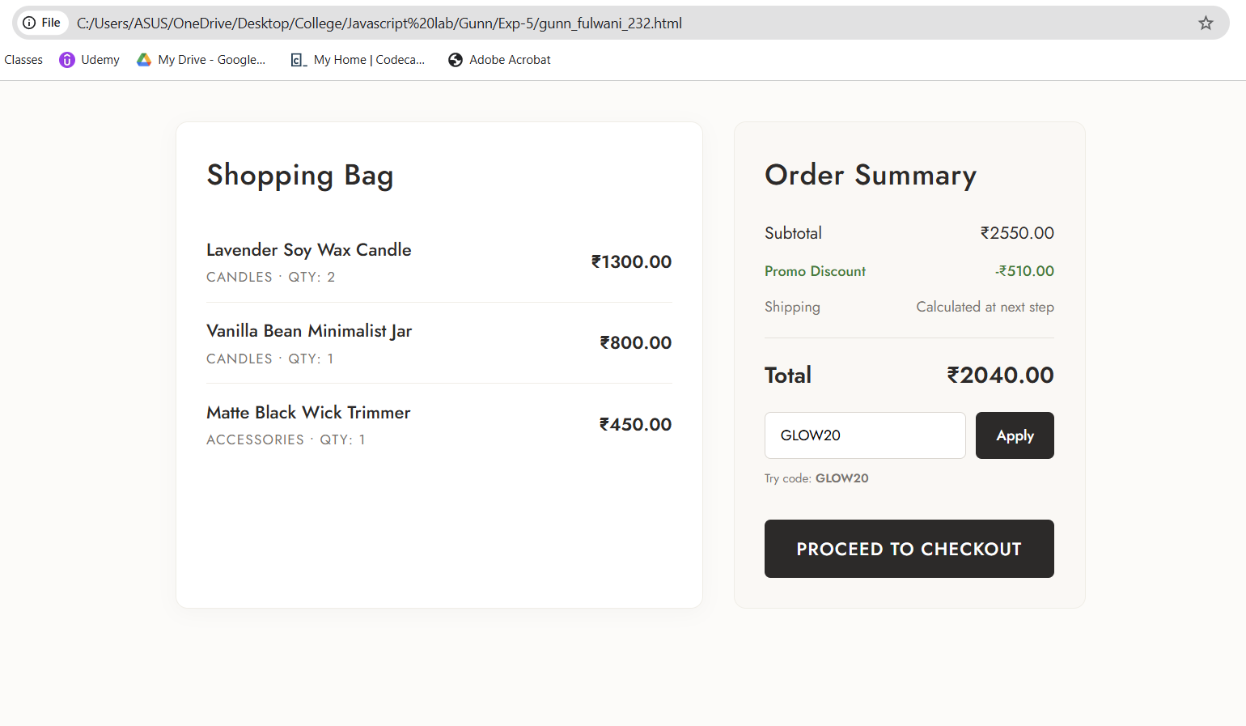

Result/Conclusion: The experiment was successfully completed. A dynamic e-commerce cart calculator was built using JavaScript. Complex data was effectively managed using an array of objects. Essential ES6 array methods, including forEach(), reduce(), and filter(), were applied to render the UI, compute sub-totals, and process discount logic, demonstrating a strong understanding of JavaScript data structures and DOM manipulation.

Case Study 5
Aim: To study the functioning of Arrays and Loops in JavaScript.
- Part (a): Create and manipulate arrays: push, pop, shift, unshift, splice, slice.
- Part (b): Use array methods: map(), filter(), reduce(), forEach().
- Case Study: Create an array of numbers and find the maximum and minimum value.
Software/Tools Required: Visual Studio Code (or any text editor), Web Browser (Google Chrome, Edge, etc.)
Code: <!DOCTYPE html>
<html lang="en">
<head>
<meta charset="UTF-8">
<meta name="viewport" content="width=device-width, initial-scale=1.0">
<title>Array Operations Case Study</title>
<style>
@import url('https://fonts.googleapis.com/css2?family=Inter:wght@400;500;600;700&family=JetBrains+Mono:wght@400;700&display=swap');

/* PROFESSIONAL / ACADEMIC THEME */
body {
font-family: 'Inter', -apple-system, sans-serif;
margin: 0;
background-color: #f8f9fa;
color: #212529;
display: flex;
justify-content: center;
padding: 40px 20px;
box-sizing: border-box;
line-height: 1.5;
}

.container {
width: 100%;
max-width: 800px;
background: #ffffff;
border-radius: 8px;
border: 1px solid #dee2e6;
box-shadow: 0 4px 6px rgba(0, 0, 0, 0.05);
padding: 35px;
box-sizing: border-box;
}

/* Header */
.header {
border-bottom: 2px solid #e9ecef;
padding-bottom: 20px;
margin-bottom: 25px;
}

.header h2 {
margin: 0;
font-size: 1.75em;
font-weight: 700;
color: #0b5ed7;
}

.header p {
margin: 5px 0 0 0;
font-size: 0.95em;
color: #6c757d;
}

/* Input Section */
.input-group {
background-color: #f8f9fa;
padding: 20px;
border-radius: 6px;
border: 1px solid #e9ecef;
margin-bottom: 25px;
}

label {
display: block;
font-size: 0.9em;
font-weight: 600;
margin-bottom: 8px;
color: #495057;
}

input[type="text"] {
width: 100%;
padding: 12px;
background: #ffffff;
border: 1px solid #ced4da;
border-radius: 4px;
color: #212529;
font-size: 1em;
font-family: 'JetBrains Mono', monospace;
box-sizing: border-box;
outline: none;
transition: border-color 0.15s ease-in-out;
}

input[type="text"]:focus {
border-color: #86b7fe;
box-shadow: 0 0 0 3px rgba(13, 110, 253, 0.15);
}

.btn-primary {
display: inline-block;
background-color: #0d6efd;
color: white;
border: none;
padding: 12px 24px;
border-radius: 4px;
font-size: 1em;
font-weight: 600;
cursor: pointer;
margin-top: 15px;
transition: background-color 0.2s;
}

.btn-primary:hover {
background-color: #0b5ed7;
}

/* Results Container */
.results-container {
display: none;
}

.section-title {
margin-top: 30px;
margin-bottom: 15px;
font-weight: 700;
color: #212529;
border-bottom: 1px solid #dee2e6;
padding-bottom: 8px;
font-size: 1.1em;
display: flex;
align-items: center;
gap: 8px;
}

/* Min & Max Grid */
.stats-grid {
display: grid;
grid-template-columns: 1fr 1fr;
gap: 15px;
}

.stat-card {
background: #ffffff;
padding: 20px;
border-radius: 6px;
border: 1px solid #dee2e6;
text-align: center;
}

.stat-label {
font-size: 0.9em;
font-weight: 700;
color: #495057;
}

.stat-desc {
font-size: 0.8em;
color: #6c757d;
margin-top: 4px;
}

.stat-val {
font-size: 2em;
font-family: 'JetBrains Mono', monospace;
font-weight: 700;
margin-top: 10px;
}

.val-max { color: #198754; }
.val-min { color: #dc3545; }

/* Method Boxes */
.method-list {
display: flex;
flex-direction: column;
gap: 10px;
}

.method-box {
background: #ffffff;
padding: 15px;
border-radius: 6px;
border: 1px solid #dee2e6;
display: flex;
flex-direction: column;
gap: 8px;
}

.method-header {
display: flex;
align-items: center;
flex-wrap: wrap;
gap: 10px;
}

/* UPDATED: All method tags now share the same light blue style */
.method-tag {
background: #cff4fc;
color: #055160;
padding: 4px 10px;
border-radius: 4px;
font-size: 0.85em;
font-weight: 700;
border: 1px solid #b6effb;
min-width: 85px;
text-align: center;
}

.method-desc {
font-size: 0.85em;
color: #6c757d;
}

.method-result {
font-family: 'JetBrains Mono', monospace;
font-size: 0.95em;
color: #212529;
background: #f8f9fa;
padding: 10px;
border-radius: 4px;
border: 1px solid #e9ecef;
word-break: break-all;
}

.error-msg {
color: #842029;
background: #f8d7da;
border: 1px solid #f5c2c7;
padding: 12px;
border-radius: 4px;
font-weight: 600;
display: none;
margin-top: 15px;
font-size: 0.9em;
}
</style>
</head>
<body>

<div class="container">
<div class="header">
<h2>Array Operations & Analysis</h2>
<p>Case Study 05: Execution of ES6 Array Methods and Logic</p>
</div>

<div class="input-group">
<label>Input Dataset (comma-separated numbers):</label>
<input type="text" id="arrayInput" placeholder="e.g. 25, 10, 45, 5, 30, 15">
<div id="errorBox" class="error-msg">Invalid Input: Please enter numerical values separated by commas.</div>
<button class="btn-primary" onclick="processArray()">Execute Methods</button>
</div>

<div class="results-container" id="resultsArea">

<!-- CASE STUDY CORE: MIN & MAX -->
<div class="section-title">Case Study Objective: Find Extremes</div>
<div class="stats-grid">
<div class="stat-card">
<div class="stat-label">Math.max()</div>
<div class="stat-desc">Extracts the maximum value.</div>
<div class="stat-val val-max" id="maxOut">0</div>
</div>
<div class="stat-card">
<div class="stat-label">Math.min()</div>
<div class="stat-desc">Extracts the minimum value.</div>
<div class="stat-val val-min" id="minOut">0</div>
</div>
</div>

<!-- PART A: BASIC MANIPULATIONS -->
<div class="section-title">Part (a): Array Manipulations</div>
<div class="method-list">

<div class="method-box">
<div class="method-header">
<span class="method-tag">ORIGINAL</span>
<span class="method-desc">The parsed array generated from user input.</span>
</div>
<div class="method-result" id="origOut">[]</div>
</div>

<div class="method-box">
<div class="method-header">
<span class="method-tag">PUSH()</span>
<span class="method-desc">Appends an element to the <b>end</b> of the array. (Appended: 99)</span>
</div>
<div class="method-result" id="pushOut">[]</div>
</div>

<div class="method-box">
<div class="method-header">
<span class="method-tag">POP()</span>
<span class="method-desc">Removes the <b>last</b> element from the array.</span>
</div>
<div class="method-result" id="popOut">[]</div>
</div>

<div class="method-box">
<div class="method-header">
<span class="method-tag">SHIFT()</span>
<span class="method-desc">Removes the <b>first</b> element from the array.</span>
</div>
<div class="method-result" id="shiftOut">[]</div>
</div>

<div class="method-box">
<div class="method-header">
<span class="method-tag">UNSHIFT()</span>
<span class="method-desc">Prepends an element to the <b>beginning</b>. (Prepended: 1)</span>
</div>
<div class="method-result" id="unshiftOut">[]</div>
</div>

<div class="method-box">
<div class="method-header">
<span class="method-tag">SPLICE()</span>
<span class="method-desc">Mutates array by removing/replacing elements. (Removed 1 item at index 1)</span>
</div>
<div class="method-result" id="spliceOut">[]</div>
</div>

<div class="method-box">
<div class="method-header">
<span class="method-tag">SLICE()</span>
<span class="method-desc">Returns a shallow copy of a portion of the array. (Indices 0 to 2)</span>
</div>
<div class="method-result" id="sliceOut">[]</div>
</div>
</div>

<!-- PART B: ADVANCED ITERATIONS -->
<div class="section-title">Part (b): Iteration Methods</div>
<div class="method-list">

<div class="method-box">
<div class="method-header">
<span class="method-tag">MAP()</span>
<span class="method-desc">Creates a new array populated with the results of a function. (Logic: x * 2)</span>
</div>
<div class="method-result" id="mapOut">[]</div>
</div>

<div class="method-box">
<div class="method-header">
<span class="method-tag">FILTER()</span>
<span class="method-desc">Creates a shallow copy containing elements that pass a test. (Logic: x > 20)</span>
</div>
<div class="method-result" id="filterOut">[]</div>
</div>

<div class="method-box">
<div class="method-header">
<span class="method-tag">REDUCE()</span>
<span class="method-desc">Executes a reducer function to accumulate into a single value. (Logic: Sum)</span>
</div>
<div class="method-result" id="reduceOut">0</div>
</div>

<div class="method-box">
<div class="method-header">
<span class="method-tag">FOREACH()</span>
<span class="method-desc">Executes a provided function once for each array element. (Format: Index: Value)</span>
</div>
<div class="method-result" id="forEachOut" style="color: #6c757d;">-</div>
</div>

</div>

</div>
</div>

<script>
function processArray() {
const rawInput = document.getElementById('arrayInput').value;
const errorBox = document.getElementById('errorBox');
const resultsArea = document.getElementById('resultsArea');

errorBox.style.display = 'none';
resultsArea.style.display = 'none';

// Data Parsing
const numArr = rawInput.split(',').map(item => item.trim()).filter(item => item !== "").map(Number);

if (numArr.length === 0 || numArr.some(isNaN)) {
errorBox.style.display = 'block';
return;
}

// CORE OBJECTIVE: Min & Max
document.getElementById('maxOut').innerText = Math.max(...numArr);
document.getElementById('minOut').innerText = Math.min(...numArr);

// PART A: Standard Manipulations
document.getElementById('origOut').innerText = `[${numArr.join(', ')}]`;

let demoArr = [...numArr];

demoArr.push(99);
document.getElementById('pushOut').innerText = `[${demoArr.join(', ')}]`;

demoArr.pop();
document.getElementById('popOut').innerText = `[${demoArr.join(', ')}]`;

demoArr.shift();
document.getElementById('shiftOut').innerText = `[${demoArr.join(', ')}]`;

demoArr.unshift(1);
document.getElementById('unshiftOut').innerText = `[${demoArr.join(', ')}]`;

if(demoArr.length > 1) demoArr.splice(1, 1);
document.getElementById('spliceOut').innerText = `[${demoArr.join(', ')}]`;

let slicedArr = demoArr.slice(0, 2);
document.getElementById('sliceOut').innerText = `[${slicedArr.join(', ')}]`;

// PART B: Iterations
const mapped = numArr.map(n => n * 2);
document.getElementById('mapOut').innerText = `[${mapped.join(', ')}]`;

const filtered = numArr.filter(n => n > 20);
document.getElementById('filterOut').innerText = `[${filtered.join(', ')}]`;

const sum = numArr.reduce((acc, curr) => acc + curr, 0);
document.getElementById('reduceOut').innerText = sum;

let forEachStr = "";
numArr.forEach((n, idx) => {
forEachStr += `[${idx}]: ${n} | `;
});
document.getElementById('forEachOut').innerText = forEachStr;

// Render UI
resultsArea.style.display = 'block';
}
</script>
</body>
</html>

Output: 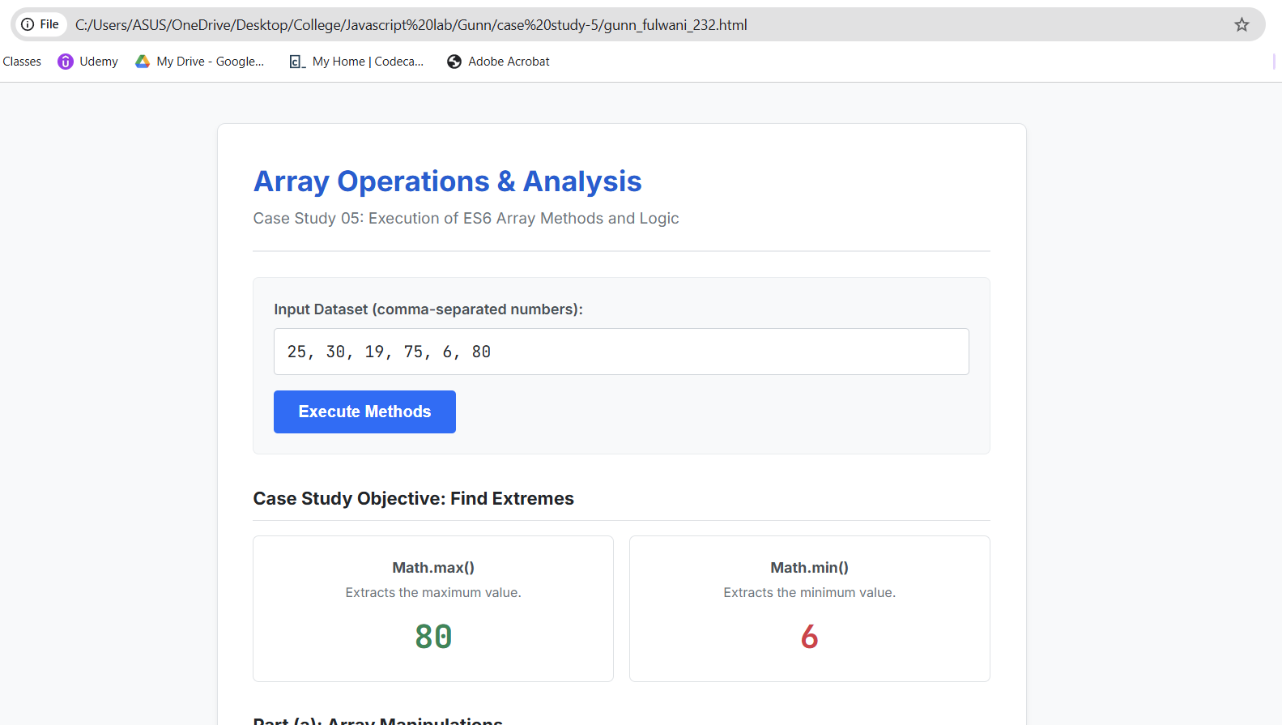
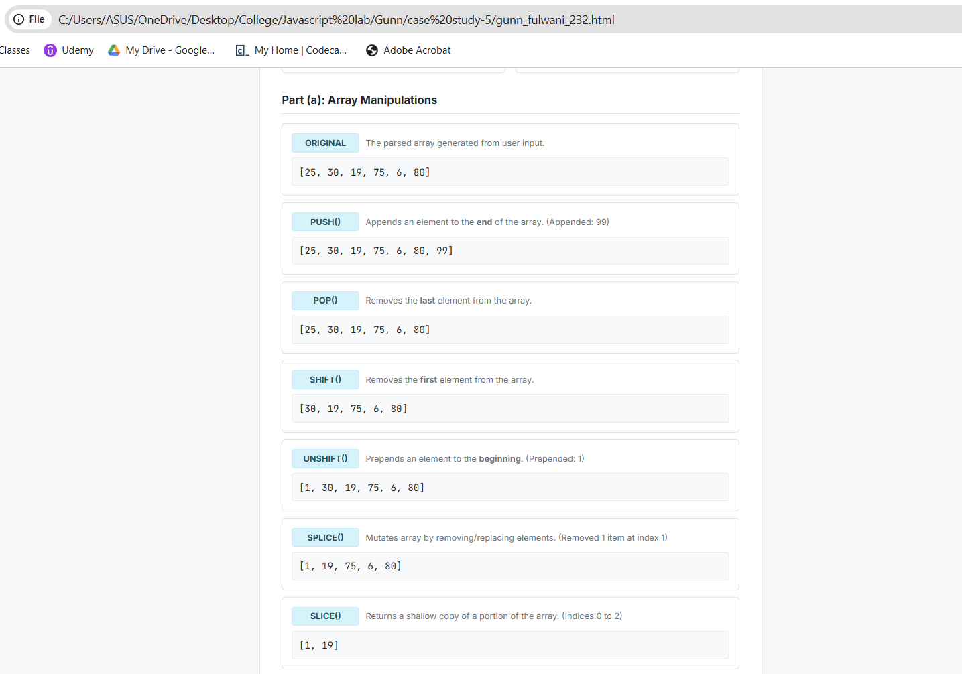
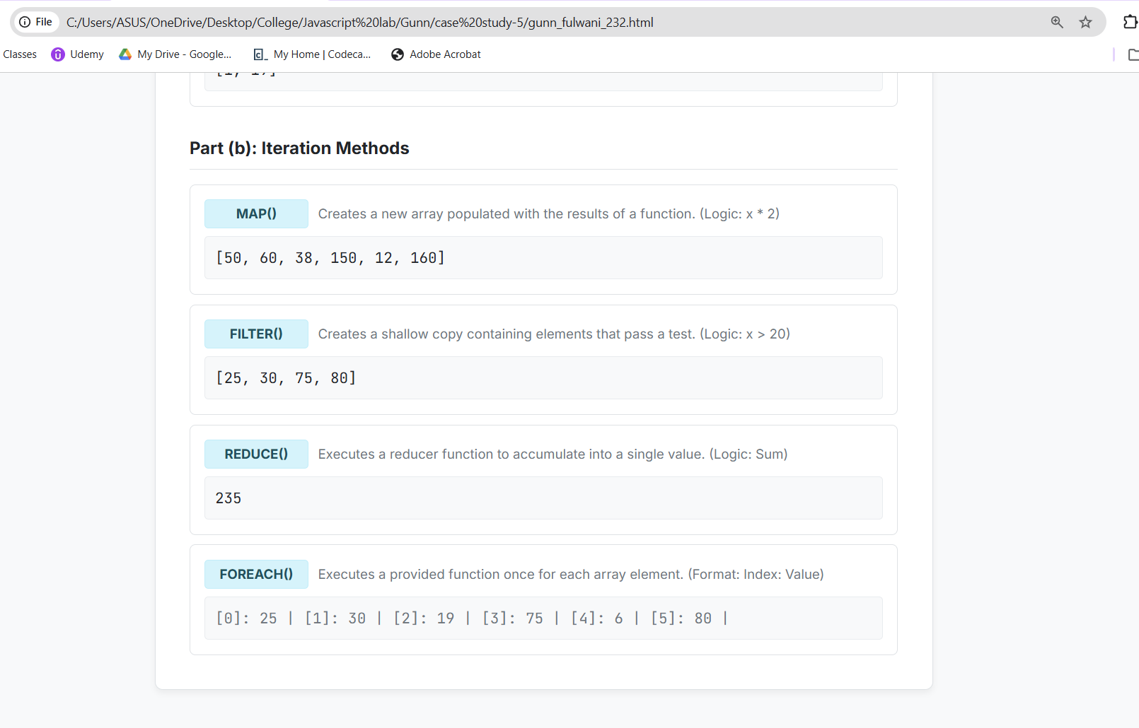
Result/Conclusion: The case study was successfully completed. A dynamic web interface was developed to demonstrate comprehensive JavaScript array handling. The program successfully accepted user input to create a numerical array and accurately calculated the maximum and minimum values using the Math object. Furthermore, standard array mutation methods (push, pop, shift, unshift, splice, slice) and advanced ES6 iteration techniques (map, filter, reduce, forEach) were successfully implemented and their operational differences were observed dynamically on the DOM.

Experiment No: 6

Aim: Use string functions and regex for email validation, data extraction, and text analysis. Software/Tools Required: Visual Studio Code (or any text editor), Web Browser.
Code:
<!DOCTYPE html>
<html lang="en">
<head>
<meta charset="UTF-8">
<meta name="viewport" content="width=device-width, initial-scale=1.0">
<title>String & Regex Engine</title>
<style>
@import url('https://fonts.googleapis.com/css2?family=Inter:wght@400;500;600;700&family=JetBrains+Mono:wght@400;600&display=swap');

/* PRINT-FRIENDLY LIGHT THEME */
body {
font-family: 'Inter', sans-serif;
margin: 0;
background-color: #f4f6f8; /* Very light grey to contrast with the white container */
color: #1c1e21; /* Dark grey, almost black for high contrast */
display: flex;
justify-content: center;
align-items: flex-start;
min-height: 100vh;
padding: 40px 20px;
box-sizing: border-box;
}

.engine-container {
width: 100%;
max-width: 850px;
background: #ffffff; /* Pure white for printing */
border-radius: 8px;
border: 1px solid #ced4da;
box-shadow: 0 4px 12px rgba(0, 0, 0, 0.05); /* Very subtle shadow */
overflow: hidden;
}

/* Header */
.header {
background: #ffffff;
border-bottom: 2px solid #e9ecef;
padding: 30px;
text-align: center;
}

.header h2 {
margin: 0;
font-size: 1.8em;
font-weight: 700;
color: #0b5ed7; /* Professional Blue */
letter-spacing: -0.5px;
}

.header p {
margin: 8px 0 0 0;
font-size: 0.95em;
color: #6c757d;
}

/* Content Sections */
.content {
padding: 30px;
}

.section-box {
background: #ffffff;
border: 1px solid #dee2e6;
border-radius: 8px;
padding: 25px;
margin-bottom: 35px;
position: relative;
}

.section-badge {
position: absolute;
top: -12px;
left: 20px;
background: #e9ecef;
color: #495057;
padding: 4px 12px;
border-radius: 4px;
border: 1px solid #ced4da;
font-size: 0.8em;
font-weight: 700;
letter-spacing: 1px;
text-transform: uppercase;
}

/* Inputs */
label {
display: block;
font-size: 0.9em;
font-weight: 600;
margin-bottom: 10px;
color: #343a40;
margin-top: 10px;
}

input[type="text"], textarea {
width: 100%;
padding: 12px;
background: #f8f9fa;
border: 1px solid #ced4da;
border-radius: 6px;
color: #212529;
font-size: 1em;
font-family: 'JetBrains Mono', monospace;
box-sizing: border-box;
outline: none;
transition: border-color 0.2s ease;
}

input[type="text"]:focus, textarea:focus {
border-color: #86b7fe;
background: #ffffff;
box-shadow: 0 0 0 3px rgba(13, 110, 253, 0.15);
}

textarea {
resize: vertical;
min-height: 100px;
}

/* Buttons */
.btn-run {
background-color: #0d6efd;
color: #ffffff;
border: none;
padding: 10px 20px;
border-radius: 6px;
font-size: 0.95em;
font-weight: 600;
cursor: pointer;
margin-top: 15px;
transition: background-color 0.2s;
}

.btn-run:hover {
background-color: #0b5ed7;
}

/* Dynamic Output Displays */
.status-alert {
display: none;
padding: 15px;
border-radius: 6px;
margin-top: 20px;
font-family: 'JetBrains Mono', monospace;
font-size: 0.9em;
border-left: 4px solid;
}

.status-success {
background: #d1e7dd;
color: #0f5132;
border-color: #198754;
}

.status-error {
background: #f8d7da;
color: #842029;
border-color: #dc3545;
}

/* Stats Grid */
.stats-grid {
display: grid;
grid-template-columns: 1fr 1fr;
gap: 15px;
margin-top: 20px;
display: none;
}

.stat-card {
background: #f8f9fa;
border: 1px solid #e9ecef;
padding: 15px 20px;
border-radius: 6px;
display: flex;
justify-content: space-between;
align-items: center;
}

.stat-label {
font-size: 0.85em;
font-weight: 600;
color: #6c757d;
text-transform: uppercase;
}

.stat-val {
font-size: 1.5em;
font-family: 'JetBrains Mono', monospace;
font-weight: 700;
color: #0d6efd;
}

.data-box {
background: #f8f9fa;
border: 1px solid #dee2e6;
padding: 15px;
border-radius: 6px;
font-family: 'JetBrains Mono', monospace;
font-size: 0.95em;
margin-top: 15px;
color: #212529;
word-break: break-all;
display: none;
}

.data-label {
font-size: 0.8em;
color: #495057;
margin-bottom: 8px;
display: block;
font-family: 'Inter', sans-serif;
font-weight: 600;
}
</style>
</head>
<body>

<div class="engine-container">
<div class="header">
<h2>Regex & String Engine</h2>
<p>Practical 06: Pattern Matching, Validation & Data Extraction</p>
</div>

<div class="content">

<!-- SECTION 1: EMAIL VALIDATION -->
<div class="section-box">
<div class="section-badge">Part 1: Regex Validation</div>
<label>Test Email Pattern Match:</label>
<input type="text" id="emailInput" placeholder="e.g., student@university.edu">
<button class="btn-run" onclick="validateEmail()">Run regex.test()</button>

<div id="emailAlert" class="status-alert"></div>
</div>

<!-- SECTION 2: TEXT ANALYSIS -->
<div class="section-box">
<div class="section-badge">Part 2: String Analysis</div>
<label>Input Raw Text Payload (include numbers):</label>
<textarea id="textInput" placeholder="Server 192 down. Error code 404 detected at 15:30 hrs."></textarea>
<button class="btn-run" onclick="analyzeText()">Execute string.match()</button>

<!-- Output Grid -->
<div id="statsArea" class="stats-grid">
<div class="stat-card">
<span class="stat-label">Total Characters</span>
<span class="stat-val" id="charCount">0</span>
</div>
<div class="stat-card">
<span class="stat-label">Total Words</span>
<span class="stat-val" id="wordCount">0</span>
</div>
</div>

<!-- Extracted Data -->
<div id="extractedData" class="data-box">
<span class="data-label">REGEX EXTRACTED NUMBERS (\d+):</span>
<span id="numOutput" style="color: #d63384; font-weight: 600;"></span>
</div>

<div id="upperData" class="data-box">
<span class="data-label">STRING TRANSFORMED (toUpperCase):</span>
<span id="upperOutput" style="color: #198754; font-weight: 600;"></span>
</div>
</div>

</div>
</div>

<script>
// =========================================
// PART 1: REGEX EMAIL VALIDATION
// =========================================
function validateEmail() {
const email = document.getElementById('emailInput').value.trim();
const alertBox = document.getElementById('emailAlert');

// Standard Regex Pattern for Email
const emailRegex = /^[a-zA-Z0-9._-]+@[a-zA-Z0-9.-]+\.[a-zA-Z]{2,6}$/;

alertBox.style.display = 'block';

if (email === "") {
alertBox.innerHTML = `[ERROR] Input field is empty.`;
alertBox.className = "status-alert status-error";
return;
}

// Using regex.test()
if (emailRegex.test(email)) {
alertBox.innerHTML = `[MATCH] Valid Email Syntax.`;
alertBox.className = "status-alert status-success";
} else {
alertBox.innerHTML = `[FAIL] Invalid Email Pattern.`;
alertBox.className = "status-alert status-error";
}
}

// =========================================
// PART 2: TEXT ANALYSIS & STRING FUNCTIONS
// =========================================
function analyzeText() {
const text = document.getElementById('textInput').value.trim();

if (!text) {
alert("Please provide text data for analysis.");
return;
}

// 1. Basic String Properties & Methods
const charCount = text.length;
const wordCount = text.split(/\s+/).filter(word => word.length > 0).length;
const upperText = text.toUpperCase();

// 2. Regex Extraction Logic
const numberRegex = /\d+/g; // \d+ matches digits, 'g' flag searches globally
const extractedNumbers = text.match(numberRegex);

// --- Update UI ---
document.getElementById('statsArea').style.display = 'grid';
document.getElementById('charCount').textContent = charCount;
document.getElementById('wordCount').textContent = wordCount;

// Render Extracted Numbers
const extBox = document.getElementById('extractedData');
extBox.style.display = 'block';
if (extractedNumbers) {
document.getElementById('numOutput').textContent = `[ ${extractedNumbers.join(', ')} ]`;
} else {
document.getElementById('numOutput').textContent = "No numeric data found.";
}

// Render Uppercase Text
const upperBox = document.getElementById('upperData');
upperBox.style.display = 'block';
document.getElementById('upperOutput').textContent = upperText;
}
</script>
</body>
</html>

Output:
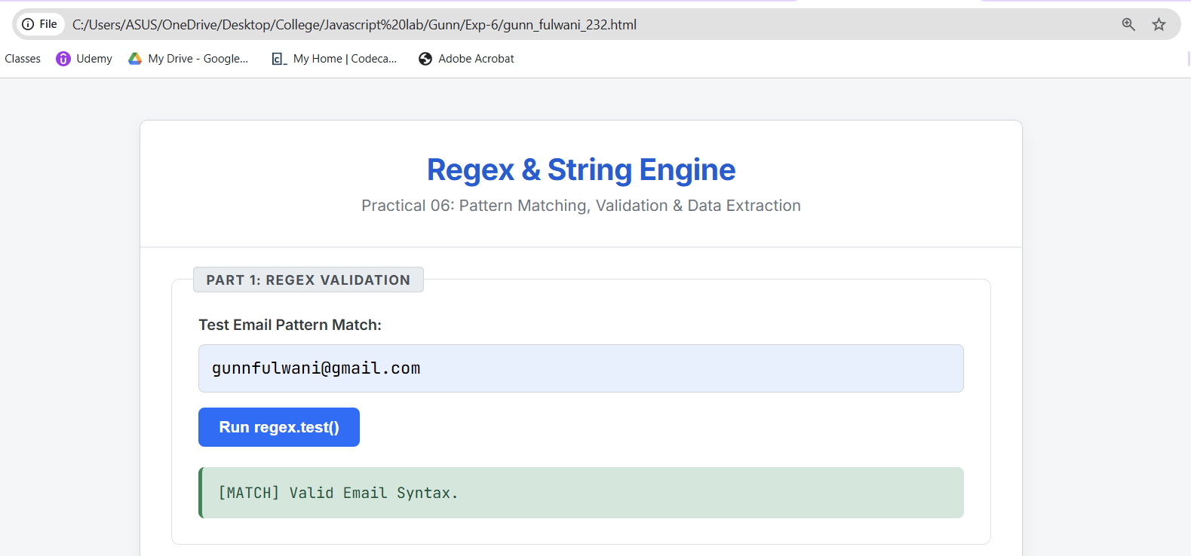
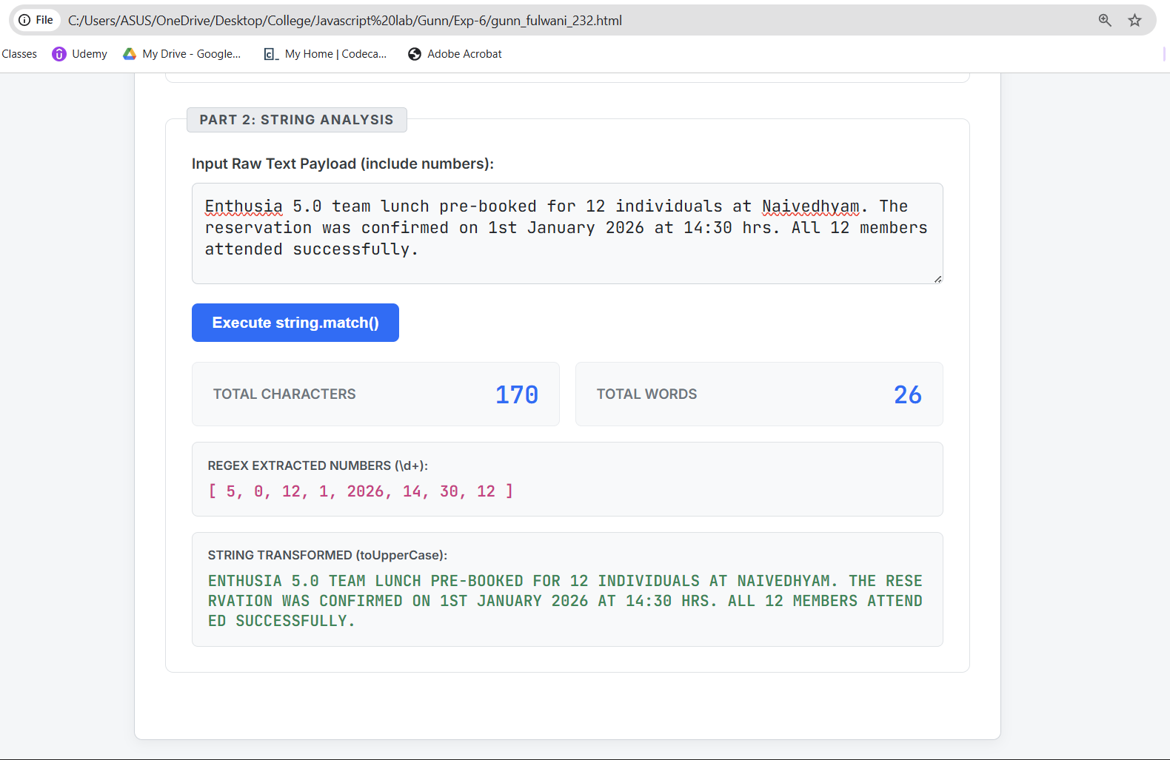
Result/Conclusion: The practical was successfully completed. A professional web interface was developed to demonstrate JavaScript string manipulation and pattern matching. The application successfully utilized Regular Expressions (test()) to validate user email inputs dynamically. Furthermore, standard string functions (length, split, trim) and regex extraction (match()) were applied to analyze a block of text, successfully calculating word counts, character counts, and extracting all numerical data from the input.

Case study – 6
Title: To perform various String operations using JavaScript.(Case Study: Write a program to reverse a string and write a function to count the number of vowels in a paragraph).
Software/Tools Required: Visual Studio Code (or any text editor), Web Browser.
Theory:1. Introduction to JavaScript Strings A string in JavaScript is a sequence of characters used to represent text. Strings are immutable, meaning that once created, their values cannot be changed. However, JavaScript provides numerous built-in methods that return new strings based on operations performed on the original string.
Code:
<!DOCTYPE html>
<html lang="en">
<head>
<meta charset="UTF-8">
<meta name="viewport" content="width=device-width, initial-scale=1.0">
<title>String Operations Engine</title>
<style>
@import url('https://fonts.googleapis.com/css2?family=Inter:wght@400;500;600;700&family=JetBrains+Mono:wght@400;600&display=swap');

/* PRINT-FRIENDLY LIGHT THEME */
body {
font-family: 'Inter', sans-serif;
margin: 0;
background-color: #f4f6f8;
color: #1c1e21;
display: flex;
justify-content: center;
align-items: flex-start;
min-height: 100vh;
padding: 40px 20px;
box-sizing: border-box;
}

.engine-container {
width: 100%;
max-width: 850px;
background: #ffffff;
border-radius: 8px;
border: 1px solid #ced4da;
box-shadow: 0 4px 12px rgba(0, 0, 0, 0.05);
overflow: hidden;
}

/* Header */
.header {
background: #ffffff;
border-bottom: 2px solid #e9ecef;
padding: 30px;
text-align: center;
}

.header h2 {
margin: 0;
font-size: 1.8em;
font-weight: 700;
color: #0b5ed7;
letter-spacing: -0.5px;
}

.header p {
margin: 8px 0 0 0;
font-size: 0.95em;
color: #6c757d;
}

/* Content Sections */
.content {
padding: 30px;
}

.input-group {
background-color: #f8f9fa;
padding: 20px;
border-radius: 6px;
border: 1px solid #e9ecef;
margin-bottom: 25px;
}

label {
display: block;
font-size: 0.9em;
font-weight: 600;
margin-bottom: 8px;
color: #343a40;
}

textarea {
width: 100%;
padding: 12px;
background: #ffffff;
border: 1px solid #ced4da;
border-radius: 6px;
color: #212529;
font-size: 1em;
font-family: inherit;
box-sizing: border-box;
outline: none;
transition: border-color 0.2s ease;
resize: vertical;
min-height: 100px;
}

textarea:focus {
border-color: #86b7fe;
box-shadow: 0 0 0 3px rgba(13, 110, 253, 0.15);
}

.btn-run {
display: inline-block;
background-color: #0d6efd;
color: #ffffff;
border: none;
padding: 12px 24px;
border-radius: 6px;
font-size: 0.95em;
font-weight: 600;
cursor: pointer;
margin-top: 15px;
transition: background-color 0.2s;
}

.btn-run:hover {
background-color: #0b5ed7;
}

.error-msg {
color: #842029;
background: #f8d7da;
border: 1px solid #f5c2c7;
padding: 12px;
border-radius: 4px;
font-weight: 600;
display: none;
margin-top: 15px;
font-size: 0.9em;
}

/* Results Container */
.results-container {
display: none;
}

.section-title {
margin-top: 30px;
margin-bottom: 15px;
font-weight: 700;
color: #212529;
border-bottom: 1px solid #dee2e6;
padding-bottom: 8px;
font-size: 1.1em;
}

/* Core Case Study Grid */
.stats-grid {
display: grid;
grid-template-columns: 1fr;
gap: 15px;
}

.stat-card {
background: #ffffff;
border: 1px solid #dee2e6;
padding: 15px 20px;
border-radius: 6px;
display: flex;
flex-direction: column;
gap: 5px;
}

.stat-label {
font-size: 0.85em;
font-weight: 700;
color: #0d6efd;
text-transform: uppercase;
}

.stat-val {
font-size: 1.1em;
font-family: 'JetBrains Mono', monospace;
font-weight: 600;
color: #212529;
word-break: break-all;
}

/* Method Boxes */
.method-list {
display: flex;
flex-direction: column;
gap: 10px;
}

.method-box {
background: #ffffff;
padding: 15px;
border-radius: 6px;
border: 1px solid #dee2e6;
display: flex;
flex-direction: column;
gap: 8px;
}

.method-header {
display: flex;
align-items: center;
flex-wrap: wrap;
gap: 10px;
}

.method-tag {
background: #cff4fc;
color: #055160;
padding: 4px 10px;
border-radius: 4px;
font-size: 0.85em;
font-weight: 700;
border: 1px solid #b6effb;
min-width: 90px;
text-align: center;
}

.method-desc {
font-size: 0.85em;
color: #6c757d;
}

.method-result {
font-family: 'JetBrains Mono', monospace;
font-size: 0.95em;
color: #212529;
background: #f8f9fa;
padding: 10px;
border-radius: 4px;
border: 1px solid #e9ecef;
word-break: break-all;
}
</style>
</head>
<body>

<div class="engine-container">
<div class="header">
<h2>String Operations & Analysis</h2>
<p>Case Study 06: String Reversal, Vowel Counting, and ES6 String Methods</p>
</div>

<div class="content">

<div class="input-group">
<label>Input Text / Paragraph:</label>
<textarea id="stringInput" placeholder="Enter a sentence or paragraph to analyze... (e.g., Welcome to JavaScript Programming!)"></textarea>
<div id="errorBox" class="error-msg">Input cannot be empty! Please provide some text.</div>
<button class="btn-run" onclick="processStrings()">Execute String Methods</button>
</div>

<div class="results-container" id="resultsArea">

<!-- CORE CASE STUDY: REVERSE & VOWELS -->
<div class="section-title">Case Study Solutions</div>
<div class="stats-grid">
<div class="stat-card">
<span class="stat-label">1. Reversed String Program</span>
<span class="stat-val" id="reverseOut">-</span>
</div>
<div class="stat-card">
<span class="stat-label">2. Vowel Count Function (WAF)</span>
<span class="stat-val" style="color: #198754; font-size: 1.4em;" id="vowelOut">0</span>
</div>
</div>

<!-- PART A & B: STRING METHODS -->
<div class="section-title">Part (b): String Operations Demonstration</div>
<div class="method-list">

<div class="method-box">
<div class="method-header">
<span class="method-tag">SUBSTRING()</span>
<span class="method-desc">Extracts characters from index 0 to 10.</span>
</div>
<div class="method-result" id="subOut">-</div>
</div>

<div class="method-box">
<div class="method-header">
<span class="method-tag">INDEXOF()</span>
<span class="method-desc">Finds the first occurrence of the letter 'a' (case-sensitive).</span>
</div>
<div class="method-result" id="indexOut">-</div>
</div>

<div class="method-box">
<div class="method-header">
<span class="method-tag">SPLIT()</span>
<span class="method-desc">Splits the string into an array of words (separated by space).</span>
</div>
<div class="method-result" id="splitOut">-</div>
</div>

<div class="method-box">
<div class="method-header">
<span class="method-tag">REPLACE()</span>
<span class="method-desc">Replaces all vowels with an asterisk (*).</span>
</div>
<div class="method-result" id="replaceOut">-</div>
</div>

</div>

</div>
</div>
</div>

<script>
// CORE CASE STUDY FUNCTION 2: Write A Function (WAF) to count vowels
function countVowels(str) {
// regex matches a, e, i, o, u (global and case-insensitive)
const vowelMatches = str.match(/[aeiou]/gi);
// If matches exist, return length, else return 0
return vowelMatches ? vowelMatches.length : 0;
}

// Main Execution Function
function processStrings() {
const rawInput = document.getElementById('stringInput').value.trim();
const errorBox = document.getElementById('errorBox');
const resultsArea = document.getElementById('resultsArea');

// Reset UI
errorBox.style.display = 'none';
resultsArea.style.display = 'none';

if (rawInput === "") {
errorBox.style.display = 'block';
return;
}

// --- CASE STUDY 1: Reverse a String ---
// split into array of chars -> reverse array -> join back to string
const reversedString = rawInput.split('').reverse().join('');
document.getElementById('reverseOut').innerText = reversedString;

// --- CASE STUDY 2: Count Vowels ---
const totalVowels = countVowels(rawInput);
document.getElementById('vowelOut').innerText = `${totalVowels} vowels found`;

// --- PART (b): String Methods ---

// 1. substring()
const subStr = rawInput.substring(0, 10);
document.getElementById('subOut').innerText = `"${subStr}..."`;

// 2. indexOf()
const indexOfA = rawInput.indexOf('a');
if(indexOfA !== -1) {
document.getElementById('indexOut').innerText = `Index Position: ${indexOfA}`;
} else {
document.getElementById('indexOut').innerText = `Letter 'a' not found in text.`;
}

// 3. split()
const wordArr = rawInput.split(' ');
// Displaying as a stringified array for visualization
document.getElementById('splitOut').innerText = `[ "${wordArr.join('", "')}" ]`;

// 4. replace()
// Using regex to replace all vowels with '*' globally
const replacedStr = rawInput.replace(/[aeiou]/gi, '*');
document.getElementById('replaceOut').innerText = replacedStr;

// Display Results Container
resultsArea.style.display = 'block';
}
</script>
</body>
</html>

Output:
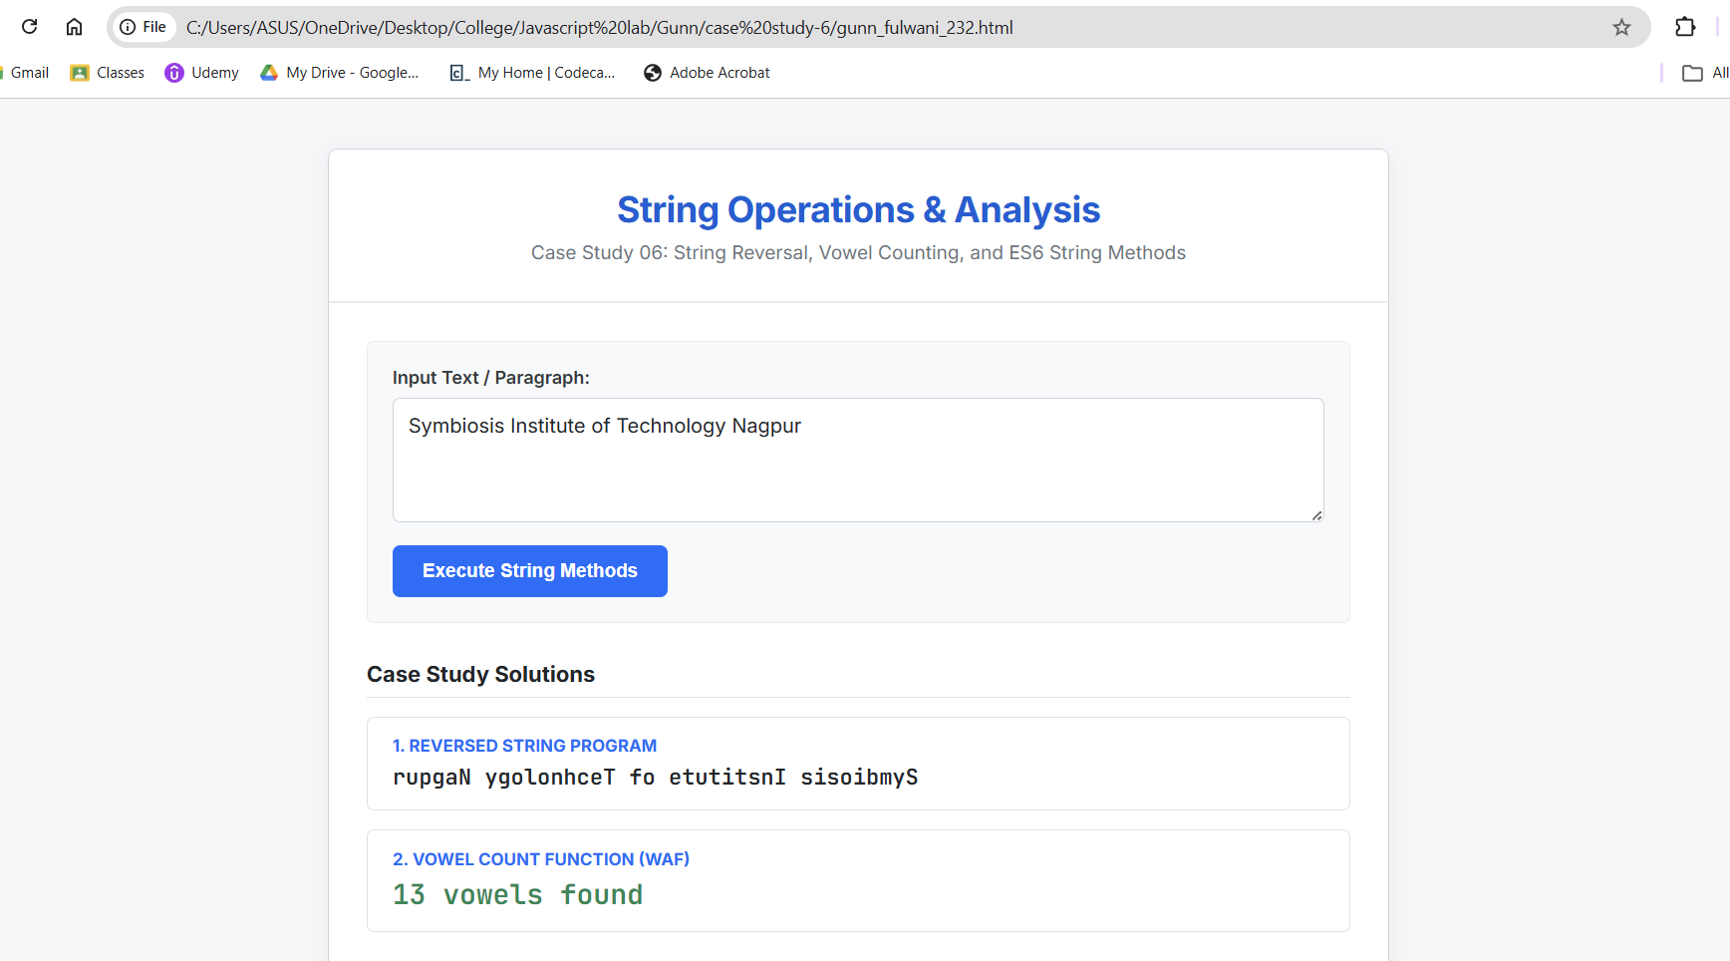
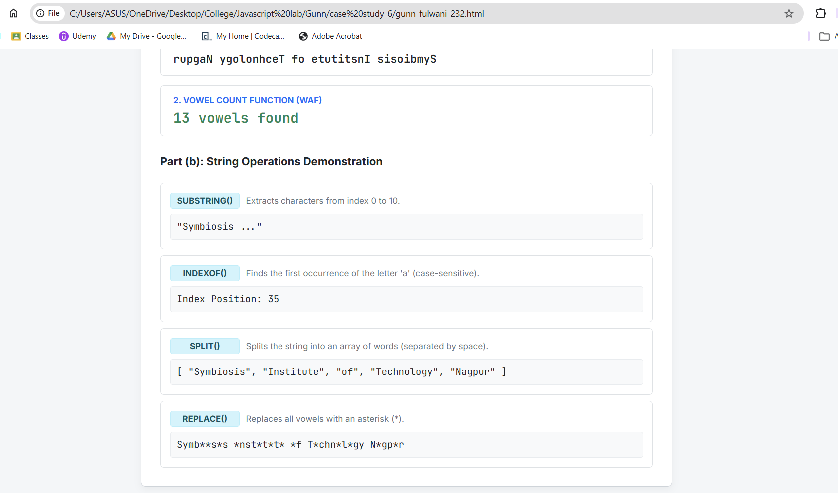

Result/Conclusion: The case study was successfully completed. A professional web application was developed to demonstrate JavaScript string manipulation. The program successfully solved the core case studies by reversing a user-inputted string and utilizing a custom function with Regular Expressions to accurately count vowels in a paragraph. Furthermore, standard string methods including substring(), indexOf(), split(), and replace() were successfully implemented and tested.

