AUTOMATED APPLICATION DEPLOYMENT
IN AWS CLOUD
JAVA, MAVEN <<>> RDS
EMPLOYEE MANAGEMENT SYSTEM USING TERRAFORM

- Project Overview : This project implements a 2-tier architecture on AWS using Terraform to automate the deployment of a Java Spring Boot application on EC2 and a PostgreSQL database on RDS. It functions as an Employee Management System where users can add and view employee details through a web interface connected to backend APIs. The project demonstrates skills in cloud deployment, infrastructure automation, and full-stack application integration.

- Architecture Diagram :

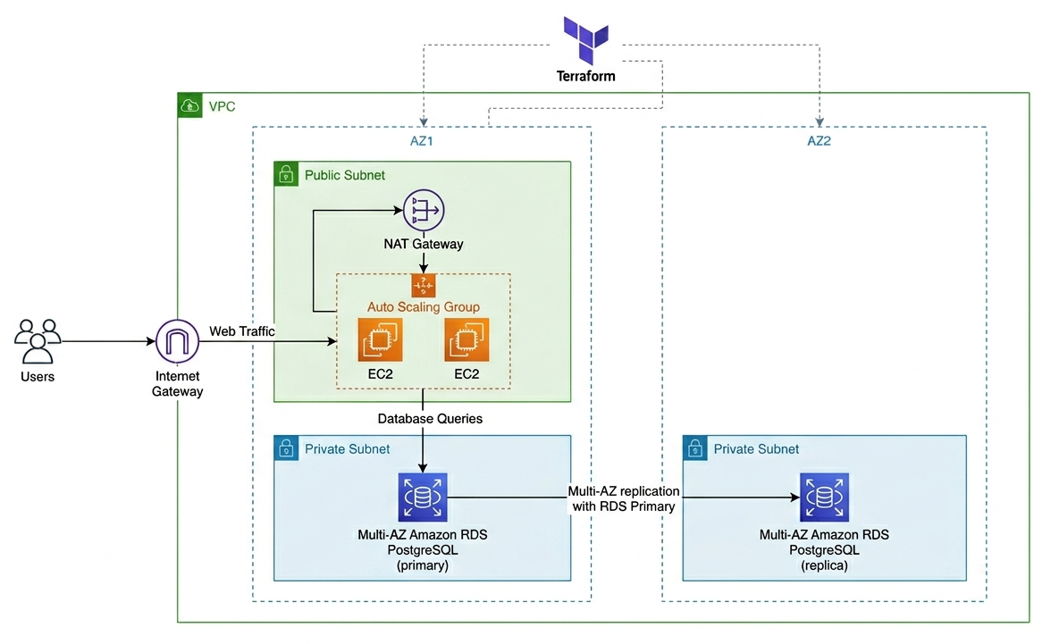

- Logic Work Flow :

+------------------------+ +----------------------------------------------+ +--------------------------------------+
| Web (Frontend) | ---> | EC2 (Java + Spring Boot + Maven) | ---> | RDS (PostgreSQL Database) |
+------------------------+ +----------------------------------------------+ +--------------------------------------+

(POST - Add Employee Data)

+------------------------+ +----------------------------------------------+ +--------------------------------------+
| Web (Frontend) | <--- | EC2 (Java + Spring Boot + Maven | <--- | RDS (PostgreSQL Database) |
+------------------------+ +----------------------------------------------+ +-------------------------------------+

(GET - Retrieve Employee Data)

- Technologies Used : Terraform for automate
AWS : VPC, Subnets, Route Table, Internet Gateway, Security Groups, EC2, RDS Database

- Project Terraform Structure :

project/
├── terraform/ → (provider.tf, variables.tf, main.tf, ec2.tf, rds.tf, security.tf, sg.tf, outputs.tf), index.html,
└── java/ → (EmployeeApiApplication.java, Employee.java, EmployeeController.java, EmployeeRepository.java, application.properties, pom.xml)

- Terraform Files :

- Java Files :

- Web HTML page :

- Terraform Commands :
terraform init : for Initialize and connect to Cloud
terraform validate : for checking errors
terraform plan : to check preview of infra
terraform apply : for creating infra in cloud
terraform apply –auto-approve : Avoid manual approve

- Changes Need to do :
- In Provider.tf file you need to enter or change Access Key and Secret Key for connecting terraform and AWS connect
- In Variables.tf provide name as your wish for ec2 instance name, Database name, Password and User
- In provider.tf file there is backend block its optional, if you want to store state file in storage account and not in local pc use it
- User_data.tf is optional if you want you can use it for installing update, java and maven

- EC2 and RDS Setup :
- EC2 instance is provisioned to host the Java Spring Boot application with required dependencies (Java, Maven).
- RDS PostgreSQL instance is created and securely connected to EC2 for storing and retrieving application data.

- Deployment Steps :
- Initialize, download plugins, and connect Terraform to AWS using terraform init
- Validate the configuration using terraform validate.
- For checking and preview terraform plan
- Create infrastructure using terraform apply to create EC2 and RDS resources
- Access the application using the EC2 public IP in web after successful deployment.

- Challenges and Solutions :

- Environment Variables Issue :
- Problem: Database credentials were not properly passed to the application, causing connection failures.
- spring.datasource.url=jdbc:postgresql://${DB_HOST}:5432/${DB_NAME}

- Solution: Export environment variables correctly in EC2 before running the application.
"echo 'DB_HOST=${aws_db_instance.db.address}' | sudo tee /etc/environment",
"echo 'DB_PORT=5432' | sudo tee -a /etc/environment",
"echo 'DB_NAME=${var.db_name}' | sudo tee -a /etc/environment",
"echo 'DB_USER=${var.db_user}' | sudo tee -a /etc/environment",
"echo 'DB_PASSWORD=${var.db_password}' | sudo tee -a /etc/environment",

- Web API Input Issue
- Problem: Only name field was sent from frontend, other fields missing in request.
- body: JSON.stringify({ name: name })

- Solution: Send all required fields from frontend.
body: JSON.stringify({
name, department, email, salary
})

- onclick Issue
- Problem: Button click was not triggering function due to incorrect binding.
- <button>Add</button>

- Solution: Properly attach function using onclick.
- <button onclick="addEmployee()">Add</button>

- Database Retrieval Issue
- Problem: Data was not displayed due to incorrect template string usage.
`<li>${e.name}</li>`
- Solution: Correct JavaScript template syntax.
`<li>$${e.name}</li>`

Results / Output
- Browse IP:8080 in web browser

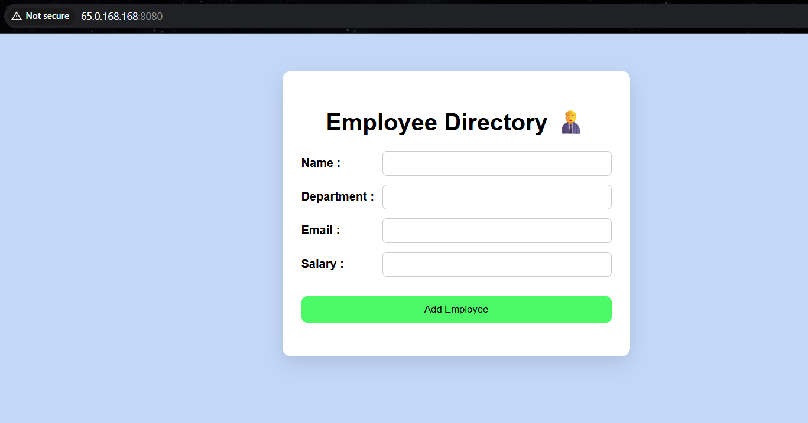

- Now provide and git Add Employee Button

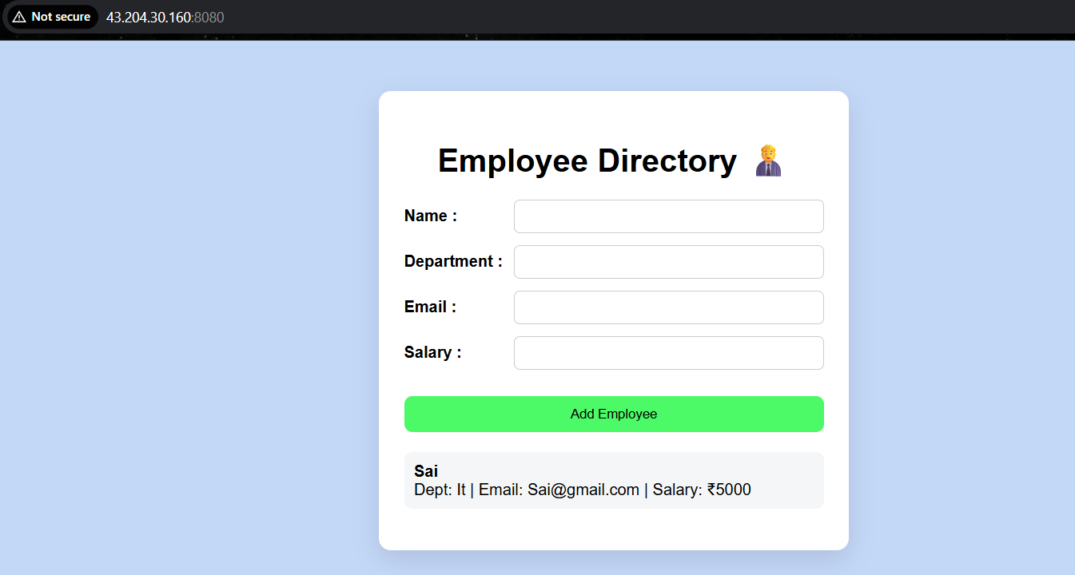

- Now Browse in web browser
IP:8080/api/employees

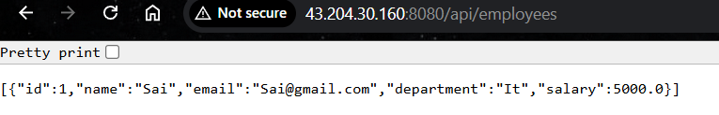

- Same output from EC2 :

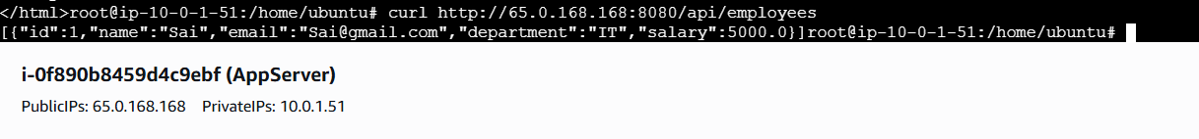

- Outcome :
- Successfully deployed a 2-tier application on AWS using Terraform automation.
- Integrated Java Spring Boot backend with PostgreSQL RDS database.
- Built a functional Employee Management System with frontend and API communication.
- Achieved end-to-end data flow from web interface to database and back.

- Learnings :
- Gained hands-on experience with Terraform and Infrastructure as Code (IaC).
- Learned AWS services integration (EC2, RDS, Security Groups).
- Improved understanding of backend–database connectivity and API handling.
- Understood debugging of real-time issues in deployment and frontend integration.

- Document created and made by : Saibaba Kola

