

A SUMMER INTERNSHIP REPORT
ON
TENDER MANAGEMENT

2-Month Summer Internship Report
submitted towards the partial fulfillment of the degree

BACHELOR OF TECHNOLOGY

By

GUNNAM JAHNAVI
23CS002806

Submitted to

Department of Computing and Informatics,
School of Engineering & Sciences,
Sir Padampat Singhania University,
Udaipur, 313601, Rajasthan, India
DECLARATION
I, Gunnam Jahnavi, student of B.Tech. (CSE), hereby declare that the 2-Month Summer Internship project report titled “Tender Management”, submitted by me to the Department of Computing and Informatics, School of Engineering & Sciences, Sir Padampat Singhania University, Udaipur, Rajasthan, towards the partial fulfillment of the requirements for the award of the degree of Bachelor of Technology, is an original record of the work carried out during my internship at Larsen & Toubro. The work embodied in this report has not previously formed the basis for the award of any degree, diploma, certificate, or other similar title or recognition.

Name and Signature of Student:
Gunnam Jahnavi
Place: Udaipur
Date: ______________

CERTIFICATE
This is to certify that the 2-Month Summer Internship project entitled “Tender Management”, being submitted by Gunnam Jahnavi, submitted towards the partial fulfillment of the requirements for the award of the degree of Bachelor of Technology, has been carried out under my supervision and guidance.
The matter embodied in this report has not been submitted, in part or in full, to any other university or institute for the award of any degree, diploma or certificate.

Jim JR
Manager, Digital Teams, RBF SBG Transportation IC
Larsen & Toubro
https://www.larsentoubro.com

Sunit Kumar Meena
Assistant Professor
Department of Computing and Informatics,
Sir Padampat Singhania University, Udaipur

Dr. Amit Kumar Goel
Professor and Dean
Department of Computing and Informatics,
School of Engineering & Sciences,
Sir Padampat Singhania University,
Udaipur, 313601, Rajasthan, India

COLORED COPY OF INTERNSHIP CERTIFICATE
Reserved for the colored copy of the internship certificate issued by Larsen & Toubro. The scanned certificate may be inserted in this area before final submission without changing the chapter sequence.

Attach Colored Internship Certificate Here

ACKNOWLEDGEMENT
I would like to express my sincere gratitude to my external guide, Mr. Jim JR, Manager, Digital Teams, RBF SBG Transportation IC, Larsen & Toubro, for giving me the opportunity to work on the Tender Management system as an AI Full Stack Intern and for providing patient guidance, practical insights, and encouragement throughout the internship. His explanations of real tendering workflows shaped the role model and lifecycle rules at the heart of this project.
I am deeply thankful to my internal guide, Mr. Sunit Kumar Meena, Assistant Professor, Department of Computing and Informatics, Sir Padampat Singhania University, Udaipur, for his continuous guidance, constructive feedback, and academic support during the preparation and completion of this internship work. I also extend my sincere thanks to Dr. Amit Kumar Goel, Professor and Dean, Department of Computing and Informatics, School of Engineering & Sciences, Sir Padampat Singhania University, for providing the institutional support and academic environment required to complete this internship successfully.
I gratefully acknowledge Larsen & Toubro for providing an opportunity to gain practical exposure to full-stack web engineering, role-based system design, and collaborative software delivery in a work-from-office environment. This project would not have been possible without the cooperation and constant support of my team members, whose technical discussions and shared ideas helped at every stage.
Finally, I would like to thank all faculty members, colleagues, friends, and my family for their motivation, patience, and encouragement throughout the internship period.

Gunnam Jahnavi
(23CS002806)

CONTENTS
DECLARATION i
CERTIFICATE ii
COLORED COPY OF INTERNSHIP CERTIFICATE iv
ACKNOWLEDGEMENT v
CONTENTS vii
LIST OF TABLES viii
LIST OF FIGURES x
LIST OF ABBREVIATIONS xi
ABSTRACT 1
CHAPTER 1 INTRODUCTION 3
CHAPTER 2 LITERATURE REVIEW 11
CHAPTER 3 ORGANIZATION / TOOLS & TECHNOLOGY OVERVIEW 17
CHAPTER 4 METHODOLOGY / SYSTEM DESIGN 23
CHAPTER 5 IMPLEMENTATION 35
CHAPTER 6 RESULTS AND DISCUSSION 44
CHAPTER 7 TESTING 48
CHAPTER 8 CONCLUSION AND FUTURE SCOPE OF WORK 51
REFERENCES 56
ANNEXURE-I MONTHLY ATTENDANCE REPORT 58
ANNEXURE-II FEEDBACK FORM FROM SUPERVISOR 59

LIST OF TABLES
Table 1.1: Primary users and their needs 6
Table 1.2: Summary of included project scope 8
Table 1.3: Internship and project overview 9
Table 2.1: Fragmented and integrated tender administration 15
Table 3.1: Key technologies and their roles 20
Table 3.2: Backend route domains and endpoint counts 21
Table 4.1: Development phases and representative outputs 23
Table 4.2: Role-based access control matrix 28
Table 4.3: Default bid pipeline stages 29
Table 4.4: Design decisions and trade-offs 33
Table 5.1: Authentication, user and experience endpoints 39
Table 5.2: Project and category endpoints 40
Table 5.3: Team and task endpoints 41
Table 5.4: Notification and analytics endpoints 42
Table 5.5: Frontend pages and reusable components 42
Table 6.1: Outcome against project objectives 45
Table 7.1: Authentication and RBAC validation cases 48
Table 7.2: Workflow and boundary validation cases 49
Table 7.3: Known prototype limitations 50
Table 8.1: Final project outcomes 52
Table 8.2: Prioritized future-development roadmap 54

LIST OF FIGURES
Figure 1.1: High-level project context and stakeholder interaction 5
Figure 2.1: From fragmented tracking to a unified tender platform 12
Figure 3.1: Layered technology stack of Tender Manager 18
Figure 4.1: Iterative feature-oriented development cycle 23
Figure 4.2: Principal actors and high-level use cases 26
Figure 4.3: Overall client-server architecture 27
Figure 4.4: Tender lifecycle state flow 31
Figure 4.5: High-level entity relationship model 32
Figure 4.6: Load-balanced deployment topology 33
Figure 5.1: Principal source organisation 35
Figure 5.2: Experience synchronisation engine 38
Figure 6.1: Integrated functional outcomes by role 44
Figure 8.1: Proposed future development roadmap 54

LIST OF ABBREVIATIONS
ABBREVIATION DESCRIPTION
API Application Programming Interface
CORS Cross-Origin Resource Sharing
CRUD Create, Read, Update, and Delete
CSS Cascading Style Sheets
HOD Head of Department
HTTP Hypertext Transfer Protocol
JSON JavaScript Object Notation
JWT JSON Web Token
L&T Larsen & Toubro
RBAC Role-Based Access Control
REST Representational State Transfer
SPA Single-Page Application
SQL Structured Query Language
SSMS SQL Server Management Studio
UI User Interface
URL Uniform Resource Locator
ABSTRACT
This report presents the design, implementation, and validation of Tender Management, a full-stack web application developed during a two-month summer internship at Larsen & Toubro as an AI Full Stack Intern. The application digitises the complete lifecycle of infrastructure tenders within an organization: intake and coding of new tenders, assignment of senior leadership, formation of execution teams, stage-by-stage bid preparation, task execution with performance review, completion, and finally the recording of the tender outcome as a success or a ranked failure. The central motivation is that tender-related information in many organizations still moves through spreadsheets, messages, and verbal status checks, which fragments ownership, hides workload, and makes accumulated experience difficult to reuse.
The system is organised around five operational roles - Creator, Head of Department (HOD), Senior Lead, Team Lead, and Member - together with a read-only Viewer role, each served by a dedicated, role-gated dashboard. The frontend is a React 19 single-page application built with Vite and Tailwind CSS, offering task Kanban, Gantt and calendar visualisations, an analytics suite rendered with Recharts, and profile pages that convert completed work into structured experience and leadership records. The backend is an Express REST API protected by JSON Web Token authentication and role-based middleware, exposing thirty-eight endpoints over thirteen logical collections. Business rules implemented include automatic tender coding (LT-YYYY-NNN), category-based HOD scoping, a customizable nine-stage bid pipeline whose completion gates project completion, a maximum of five active projects per person during team formation, and a mandatory one-to-five-star performance review when a Team Lead closes a task.
A distinctive element of the implementation is an experience synchronisation engine that reconciles employee experience and leadership history whenever teams, statuses, or outcomes change, keeping profiles, team-formation recommendations, and analytics consistent. The report describes the literature that informed the design, the technology stack, the methodology, the system design, the implementation modules, the results obtained, and the validation performed. The current prototype intentionally stores data in a typed in-memory store to enable rapid iteration; the report records this, together with demonstration-grade seed credentials and a few orphaned artefacts, as known technical debt. The internship concluded that role-focused workflows, explicit business rules, and automated experience capture materially improve tender visibility and organisational learning, and it identifies SQL Server persistence, production authentication hardening, and automated testing as the principal directions for future work.
CHAPTER 1
INTRODUCTION
1.1 Background
From 1 June to 31 July 2026, I completed a two-month, work-from-office summer internship with Larsen & Toubro (L&T) as an AI Full Stack Intern within the Digital Teams of the RBF SBG Transportation IC. L&T is one of India's largest engineering and construction conglomerates, with established business interests in infrastructure, transportation, energy, and technology services [1]. The internship placed me in a team whose mandate is to digitise the workflows that surround infrastructure bidding, and the central deliverable of the internship was the Tender Management system, a full-stack web application that tracks a tender from the moment it is picked up for bidding until the outcome of the bid is recorded.
1.1.1 Host Organization Context
L&T's transportation and infrastructure businesses prepare and submit large numbers of competitive bids each year. Every bid involves a chain of decisions and documents - go/no-go decisions, team allocation, executive summaries, site visits, pre-bid queries, value engineering, bid preparation, internal review, and final submission - and every bid draws on people whose suitability depends on the categories of work they have executed before. Because these activities were historically coordinated through spreadsheets, email threads, and verbal status checks, the organization required a single platform that makes ownership, workload, and accumulated experience visible. The Tender Management system is a response to that need.
1.1.2 Tender Management Context
A tender management platform has to serve several kinds of users at once. Creators initiate tenders and manage the user base; Heads of Department provide category-scoped oversight; Senior Leads exercise operational leadership; Team Leads run daily execution; and Members execute the assigned work. Each role asks different questions of the same records, and the project reflects that through five role-focused dashboards inside one application, together with a read-only Viewer role for audit-style visibility.
1.1.3 Problem Statement
When tender information is split across disconnected tools, the same details are entered more than once, status becomes stale, workload is invisible, and the experience earned on one project cannot be consulted when forming the next team. Administrators lack a consolidated view of the bid pipeline, and win/loss outcomes are not analysed. The project set out to reduce this fragmentation by connecting intake, leadership assignment, team formation, pipeline execution, task review, completion, and outcome recording in one system with explicit business rules.
1.1.4 Project Overview
Tender Management is a full-stack web application. Its React-based frontend contains five role dashboards and five shared pages, reusable modals and view components, and an analytics suite. The backend is a single Express application exposing thirty-eight REST endpoints guarded by JSON Web Token (JWT) authentication and role-based middleware, operating over thirteen logical data collections. Figure 1.1 shows the high-level context and stakeholder interaction.
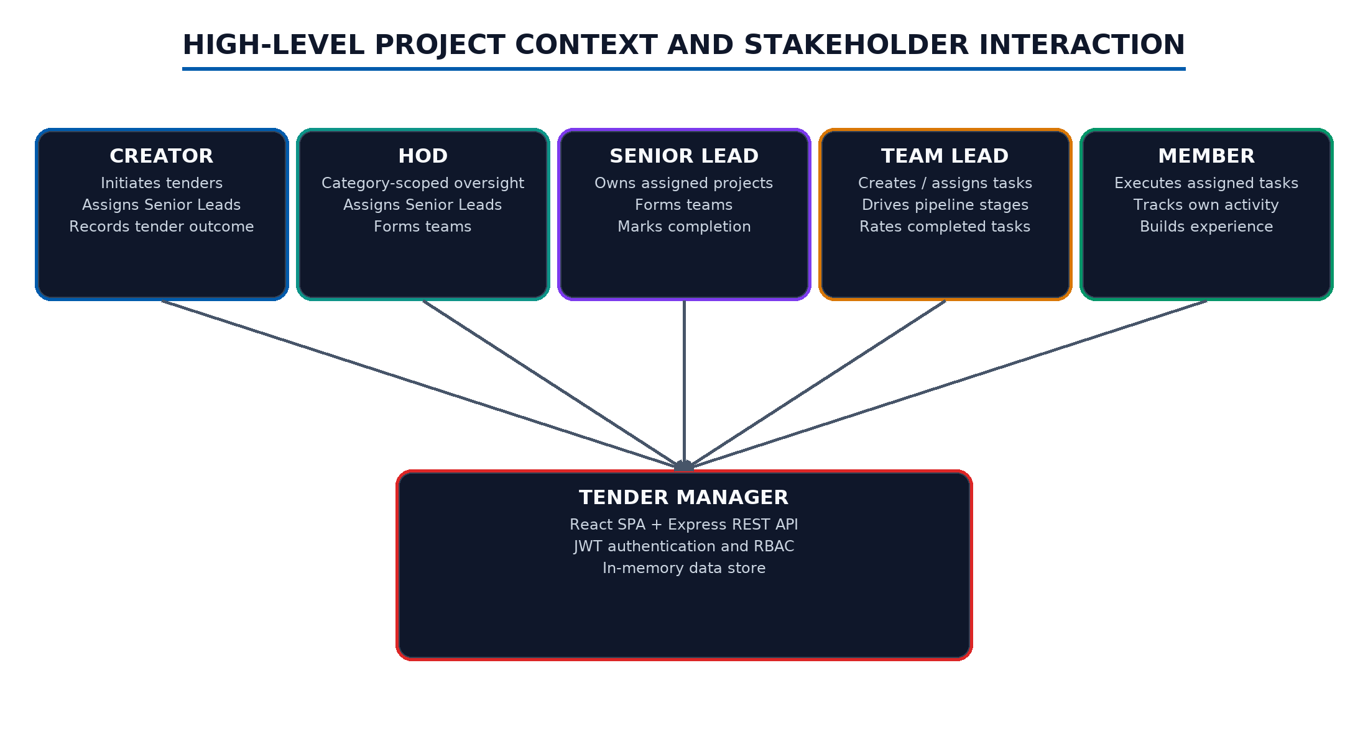
Figure 1.1: High-level project context and stakeholder interaction
1.1.5 Internship Context and Role
As an AI Full Stack Intern working from the office, I participated in requirement discussions with the team, analysed the tendering workflow, and designed and implemented the application end to end, including the role and permission model, the pipeline and status rules, the task and review mechanics, the experience synchronisation logic, the analytics endpoints, and the containerised deployment. The work was reviewed iteratively by my external guide, and the report that follows records the completed system exactly as implemented.
1.1.6 Principal Users and Their Needs
The five operational roles shaped the interface from the start. Each dashboard exposes only the actions its role owns, while shared pages provide the common project directory, calendar, analytics, and profile views.
Table 1.1: Primary users and their needs
User group | Main need | Examples in the system
Creator | Initiate and govern tenders | Project creation, categories, user creation, bid drop, tender outcome
HOD | Category-scoped oversight | Lead assignment, team formation, stage control, report export
Senior Lead | Operational leadership of own projects | Team formation, completion, task oversight
Team Lead | Daily execution control | Task CRUD, Kanban board, stage toggling, task reviews
Member | Execute assigned work | Task status updates, activity feed, completed-project archive
Viewer | Read-only visibility | Projects, employees, analytics without mutation rights

1.2 Objectives and Scope of Work
The project objective was to implement an integrated tender lifecycle prototype that supports the core bidding activities of an infrastructure organization. The internship also aimed to build practical experience in product analysis, full-stack engineering, role-based security, and delivery.
1.2.1 Primary Project Objectives
• Bring Creator, HOD, Senior Lead, Team Lead, and Member workflows into one product with role-focused navigation.
• Support the tender lifecycle: intake with automatic coding, leadership assignment, team formation with workload limits, a customizable bid pipeline, task execution with review, completion, and outcome recording.
• Convert completed work automatically into structured experience and leadership records that inform future team formation.
• Provide Kanban, Gantt, and calendar visualisations plus analytics for win/loss and performance.
• Deliver a reproducible deployment through container definitions and a load-balanced topology.
1.2.2 Functional Objectives by Role
The Creator dashboard manages projects, categories, and users, and assigns Senior Leads. The HOD dashboard provides category-scoped assignment, team formation, stage control, and a JSON report export. The Senior Lead dashboard owns assigned projects, forms teams with experience-aware recommendations, and marks completion. The Team Lead dashboard drives tasks through templates, priorities, stage association, drag-and-drop Kanban movement, and mandatory star-rated reviews. The Member dashboard presents a personal task feed with filters, an activity trail, and an archive of completed projects.
1.2.3 Technical Objectives
The technical objective was to separate presentation, API routing, business rules, and data while keeping the prototype fast to iterate. On the frontend, role-gated routing, a shared layout with a notification bell, and reusable view components organise the feature set. On the backend, authentication and role middleware protect a route layer that applies validation and business rules before mutating the data store.
1.2.4 Personal Objectives and Responsibilities
My personal goals were to deepen my React and Express engineering skills, understand end-to-end data flow from UI action to persisted state and back, and learn to encode organisational rules - such as HOD category scoping and workload caps - as enforceable server-side logic rather than as informal convention.
1.2.5 Scope Included in the Completed Project
The implemented scope covers the main tender lifecycle rather than every capability of a production e-procurement suite. Table 1.2 summarises the included areas.
Table 1.2: Summary of included project scope
Area | Included work
Tender intake | Project creation with custom pipelines, automatic LT-YYYY-NNN coding, automatic HOD assignment by category
Leadership and teams | Senior Lead assignment; team formation and update with a maximum of five active projects per person
Execution | Tasks with templates, stages, priorities and dates; Kanban, Gantt and calendar views
Completion and outcome | Stage-gated completion; Success/Fail outcome recording with ranking and remarks
People and analytics | Performance reviews, experience and leadership records, tender and performance analytics
Platform | JWT authentication with RBAC, notifications, profile pages, Docker and nginx load-balanced deployment

1.2.6 Scope Boundaries and Exclusions
The current build intentionally stores data in a typed in-memory store, so state resets on restart; a SQL Server-backed persistence layer managed through SQL Server Management Studio (SSMS) is the stated production direction and is recorded as future work. Seed credentials are demonstration-grade, passwords are stored in plaintext in the seed file, and the companion documentation lists a few demo accounts that differ from the seed data. The milestones collection is declared but not yet populated, the Viewer role exists in code and UI without a seeded account, and one legacy calendar component remains unreferenced. These items are documented honestly as prototype artifacts, not presented as completed production features.
1.2.7 Internship and Project Summary
Table 1.3: Internship and project overview
Attribute | Recorded detail
Internship period and mode | 1 June 2026 to 31 July 2026; work from office at Larsen & Toubro
Organization and role | Larsen & Toubro; AI Full Stack Intern, Digital Teams, RBF SBG Transportation IC
Primary individual contribution | Full-stack analysis, design and implementation of the Tender Management web application
Project users | Creator, HOD, Senior Lead, Team Lead, Member, plus read-only Viewer
Core outcome | Role-based tender lifecycle platform with 38 REST endpoints, 5 dashboards and 13 data collections

The project therefore combines product design and full-stack implementation. The chapters that follow describe the ideas behind the platform, the technology choices, the system design, the implemented workflows, the results obtained, and the validation performed.
CHAPTER 2
LITERATURE REVIEW
2.1 Introduction to the Literature Review
Tender Management draws on research and practice in access control, web architecture, authentication, component-based user interfaces, task visualisation, and analytics. This review focuses on the ideas that influenced the project's design and on the limits those ideas make visible.
2.2 Evolution of Tender and Project Tracking Systems
Organisational tracking systems have grown from static records into platforms that coordinate structures, assignments, execution, evaluation, and reporting. In construction and infrastructure, the bid pipeline is a particularly strong example: a tender moves through named stages, each with its own owners and artefacts, and the value of a platform lies in making the stage state, the owners, and the deadlines visible to every stakeholder at once. Figure 2.1 contrasts the fragmented practice the project replaces with the unified platform it delivers.
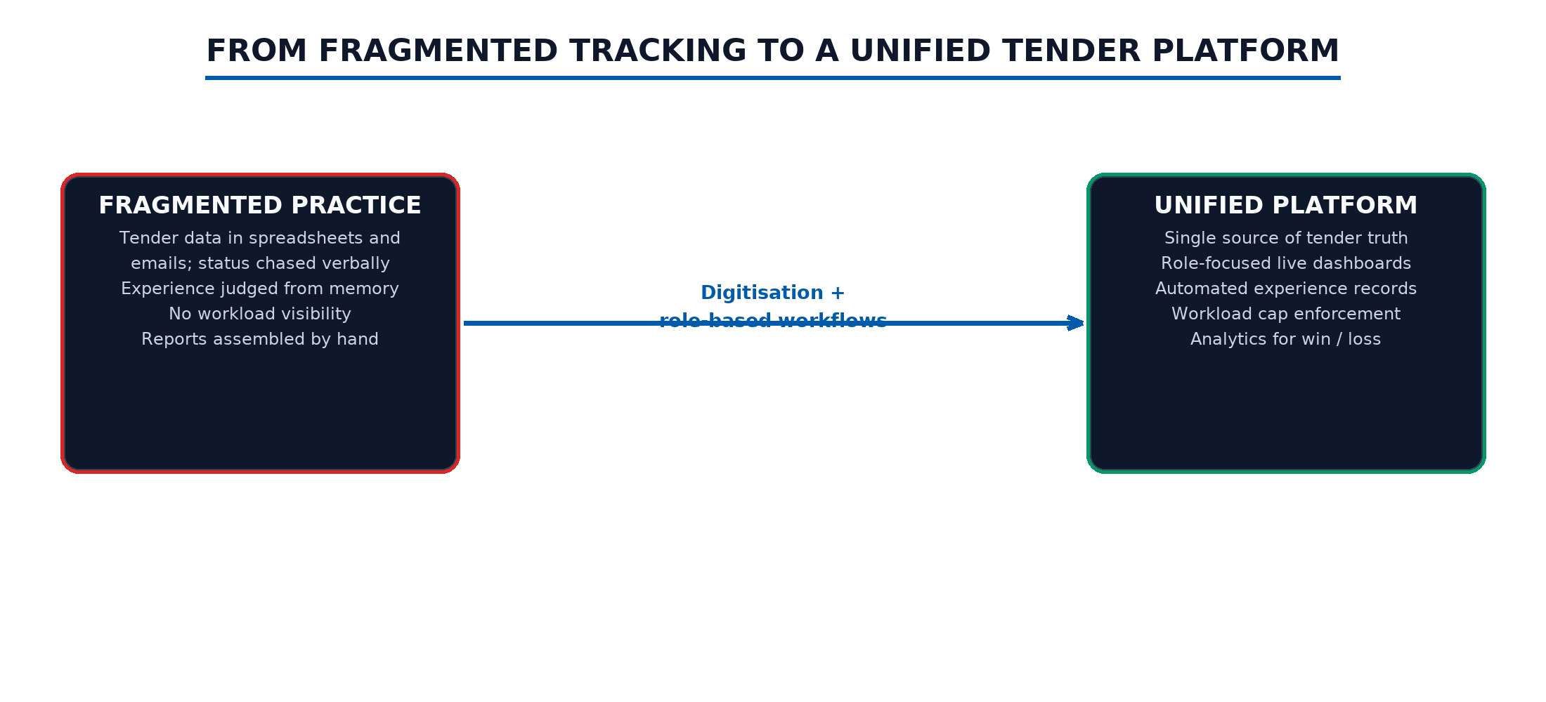
Figure 2.1: From fragmented tracking to a unified tender platform
2.3 Role-Based Access Control
A system shared by five roles must decide, for every operation, who may perform it. Role-Based Access Control (RBAC) formalises this by granting permissions to roles rather than to individuals, so that organisational policy is expressed once and enforced uniformly [2]. Tender Management applies RBAC at two layers: server-side middleware rejects operations outside a caller's role, and client-side route registration hides interfaces a role cannot use. The review confirms that RBAC is a usability and organisation mechanism; it must always be backed by server-side enforcement, which the project does.
2.4 Token-Based Authentication
Stateless sessions let a browser prove its identity on every request without server-side session storage. JSON Web Tokens define a compact signed format carrying claims such as user identity and role, with expiry [3]. Security guidance emphasises signature and algorithm validation, expiry checks, strong keys, and safe transport [4]. The project issues an eight-hour Bearer token containing identity and role claims, validates it on every protected route, and keeps role checks server-side; the review also notes that production deployments must move from a fallback secret to an environment-managed key and hash stored credentials.
2.5 Component-Based Frontend Development
React's component model supports building an interface from reusable parts [5]. In Tender Management, shared panels, status pills, modals, and a stepper for the bid pipeline reduce repeated work and keep the five dashboards visually related. Domain components such as the project detail modal and the experience modal sit above general primitives. Reuse is most useful when a component has a clear job; the project's stepper, reused across four dashboards in read-only and interactive modes, is a good example.
2.6 Build Tooling and Single-Page Routing
Modern build tools such as Vite shorten the loop between edit and feedback and, in middleware mode, allow a single development server to host both the API and the interface [6]. Client-side routers then map URLs to screens inside one document, which suits role-gated dashboards because route availability can react to the signed-in identity [5]. The project uses Vite middleware inside Express during development and a static bundle in production, with role-conditional route registration on the client.
2.7 Utility-First Styling
Utility-first CSS keeps styling decisions local to the markup and supports design tokens for a consistent palette [7]. The project defines corporate tokens - a primary blue, a dark navy, warning amber - and applies them consistently across dashboards, pills, and charts, which keeps a large surface visually coherent without a separate stylesheet per page.
2.8 REST and Client-Server Separation
Representational State Transfer (REST) separates the browser from server implementation through resource-oriented endpoints, stateless requests, and layered systems [8]. Tender Management exposes resource-style routes for users, projects, teams, tasks, notifications, and analytics, with a shared fetch convention on the client that applies the Bearer header and parses errors uniformly. Stable request and response contracts remain the main maintenance asset of such a design.
2.9 Node.js Service Layer
Express provides a minimal, middleware-oriented host for REST services [9]. The project chains a JSON body parser, an authentication middleware, and a role middleware before route handlers, which keeps permission logic out of business code. The review notes that as route counts grow, monolithic route files benefit from decomposition into domain routers - a consolidation item recorded for future work.
2.10 Task Visualisation: Kanban and Gantt
Kanban systems make work-in-progress visible by placing tasks on boards whose columns represent states, and they use explicit limits to expose overload [10]. Gantt-style timelines complement boards by showing task duration and overlap against a calendar axis, which remains a standard technique in project control literature [11]. Tender Management implements both natively: a drag-and-drop Kanban for task states and a proportional-bar Gantt derived from task start and end dates, plus month calendars that merge pipeline deadlines with task due dates.
2.11 Dashboards and Analytics
Declarative chart libraries such as Recharts let applications render trends, mixes, and comparisons directly from data arrays [12]. The project derives three analytics dashboards - executive overview, tender outcomes, and user performance - from shared records. The literature cautions that metric definitions must be explicit; the project therefore computes success rates, failure-rank distributions, and average ratings in one backend place so every dashboard reads the same definitions.
2.12 Synthesis and Research Gap
The reviewed approaches agree on a practical balance: role-focused workflows make a shared system usable; middleware-enforced RBAC and signed tokens make it safe to expose; reusable components and stable contracts make it maintainable; and boards, timelines, and charts make its state legible. The gap addressed by this project is the connection of those ideas to the specific rules of infrastructure tendering - category-scoped departmental authority, a stage-gated bid pipeline, workload caps during team formation, and the automatic conversion of completed work into reusable experience records.
Table 2.1: Fragmented and integrated tender administration
Dimension | Fragmented approach | Integrated platform approach
Tender records | Spreadsheets and email attachments | Single coded project directory with stakeholders
Status | Verbal or chat updates | Live pipeline stepper visible to all stakeholders
Workload | Unknown until overload occurs | Active-project counts and a five-project cap
Experience | Recalled from memory | Structured experience and leadership records
Outcomes | Rarely analysed | Win/loss analytics with failure ranking

CHAPTER 3
ORGANIZATION / TOOLS & TECHNOLOGY OVERVIEW
3.1 Chapter Introduction
This chapter describes the host organization, the internship environment, and every significant technology used during the project, together with the reason each was chosen and the boundary it currently exhibits.
3.2 Organization Overview: Larsen & Toubro
Larsen & Toubro is a multinational conglomerate headquartered in Mumbai, India, active in infrastructure, energy, and technology [1]. The internship was hosted by the Digital Teams of the RBF SBG Transportation IC, which builds digital tools for the transportation businesses. The work-from-office mode allowed daily clarification of tendering rules that would be difficult to capture remotely.
3.3 Internship Environment and Team Role
The team worked iteratively around feature areas - dashboards, pipeline, tasks, analytics, deployment - with review conversations replacing formal ceremony. My role covered the full stack: I translated workflow rules into routes and screens, implemented the business logic, and prepared the containerised delivery.
3.4 Overall Technology Architecture
The stack is deliberately compact: one React single-page application, one Express API, one typed in-memory store, and container-based delivery. Figure 3.1 shows the layers.
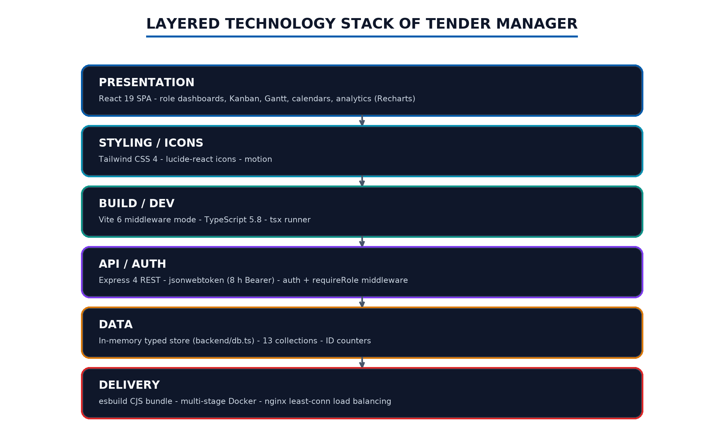
Figure 3.1: Layered technology stack of Tender Manager
3.5 Frontend Framework and Build Environment
3.5.1 React 19
React 19 provides the component runtime and hooks used for all state handling [5]. Functional components with local state keep each dashboard self-contained, while the router re-renders the tree when the signed-in identity changes.
3.5.2 Vite 6 in Middleware Mode
Vite 6 serves the frontend during development through Express middleware and proxies /api and /auth to the backend, so one port hosts the whole system [6]. For production, Vite builds a static bundle that the same Express server serves, removing any cross-origin complexity.
3.5.3 TypeScript 5.8
TypeScript adds static typing across both tiers [13]. The project uses pragmatic typing - strict where structures are stable and permissive where the schema evolves - which kept iteration fast while catching most integration mistakes early.
3.6 Styling and User Interface Technologies
Tailwind CSS 4 with an @theme block supplies the corporate palette and typography; lucide-react supplies consistent iconography; and the motion library is available for transitions. Custom utility classes in a global stylesheet define panels, data tables, and status pills used uniformly by every page.
3.7 Visualization Libraries
Recharts renders the analytics dashboards and the HOD statistics panel [12]. The Kanban board, Gantt chart, and calendars are implemented natively with HTML5 drag events and proportional layout, avoiding heavy chart dependencies for operational views.
3.8 Backend Runtime and Framework
The backend runs on Node.js (node:22-alpine in containers) with Express 4 [9]. The tsx runner executes TypeScript directly in development, and esbuild bundles the server into a CommonJS artifact for production. jsonwebtoken signs and verifies the Bearer tokens; cors and dotenv complete the runtime perimeter.
3.9 Data Layer
The data layer is a typed in-memory object holding thirteen collections and nine identifier counters. This choice gives the prototype zero configuration, instant resets for demonstrations, and a schema that maps cleanly onto relational tables. The organization's production direction is a SQL Server database administered through SQL Server Management Studio (SSMS); the current store therefore doubles as a precise specification of that future schema.
3.10 Containerization and Delivery
A multi-stage Dockerfile builds the bundle and runs it on a minimal image with health and readiness probes; a compose file runs three replicas behind an nginx least-connection load balancer [14], [15]. This topology demonstrates horizontal scaling and health-gated routing for the API and static assets.
3.11 Technology Selection Rationale
The stack was chosen to support a broad interface, explicit business rules, and a practical deployment path. Its trade-offs are recognised: the in-memory store does not persist, one route file concentrates logic, and demonstration credentials are not production security. Recognising those limits is part of an accurate technology review.
Table 3.1: Key technologies and their roles
Technology | Version line | Role in the project
React | 19 | Component runtime for all dashboards and pages
Vite | 6 | Dev middleware, proxy, production bundling
TypeScript | 5.8 | Static typing across frontend and backend
Tailwind CSS | 4 | Utility styling with corporate design tokens
lucide-react | 0.546 | Iconography
recharts | 3.8 | Analytics and statistics charts
react-router-dom | 7 | Role-gated client routing
Express | 4 | REST API host and middleware chain
jsonwebtoken | 9 | Eight-hour Bearer token sessions
tsx / esbuild | 4.21 / 0.25 | Development runner and production bundling
Docker + nginx | node:22-alpine / 1.27 | Multi-stage image and least-conn load balancing

Table 3.2: Backend route domains and endpoint counts
Domain | Endpoints | Representative routes
Authentication | 1 | POST /auth/login
Users and profile | 7 | GET /api/users, GET /api/profile, experiences, leadership, create, delete, activity
Categories | 2 | GET and POST /api/categories
Projects | 13 | create, patch, update-status, bid-drop, complete, stages, tender-outcome
Teams | 4 | get, create, update, remove-member
Tasks | 6 | get, create, status, edit, delete, completed-projects
Notifications | 3 | get, read, read-all
Analytics | 2 | tender-outcomes, performance

3.12 Chapter Summary
A compact, typed stack supports a broad prototype: one SPA, one API, one store, and container delivery. The next chapter turns this stack into a design.
CHAPTER 4
METHODOLOGY / SYSTEM DESIGN
4.1 Chapter Introduction
The design had to connect five user groups, a stage-gated lifecycle, workload rules, and several visualisations. The following sections describe the development approach and the principal decisions.
4.2 Development Methodology
The team used an iterative, feature-oriented approach. Work was grouped around areas such as dashboards, pipeline, tasks, experience, and deployment; for each area the user task was clarified, a screen and data flow were built, the available endpoints were connected, and the integrated result was reviewed. Figure 4.1 shows the cycle.
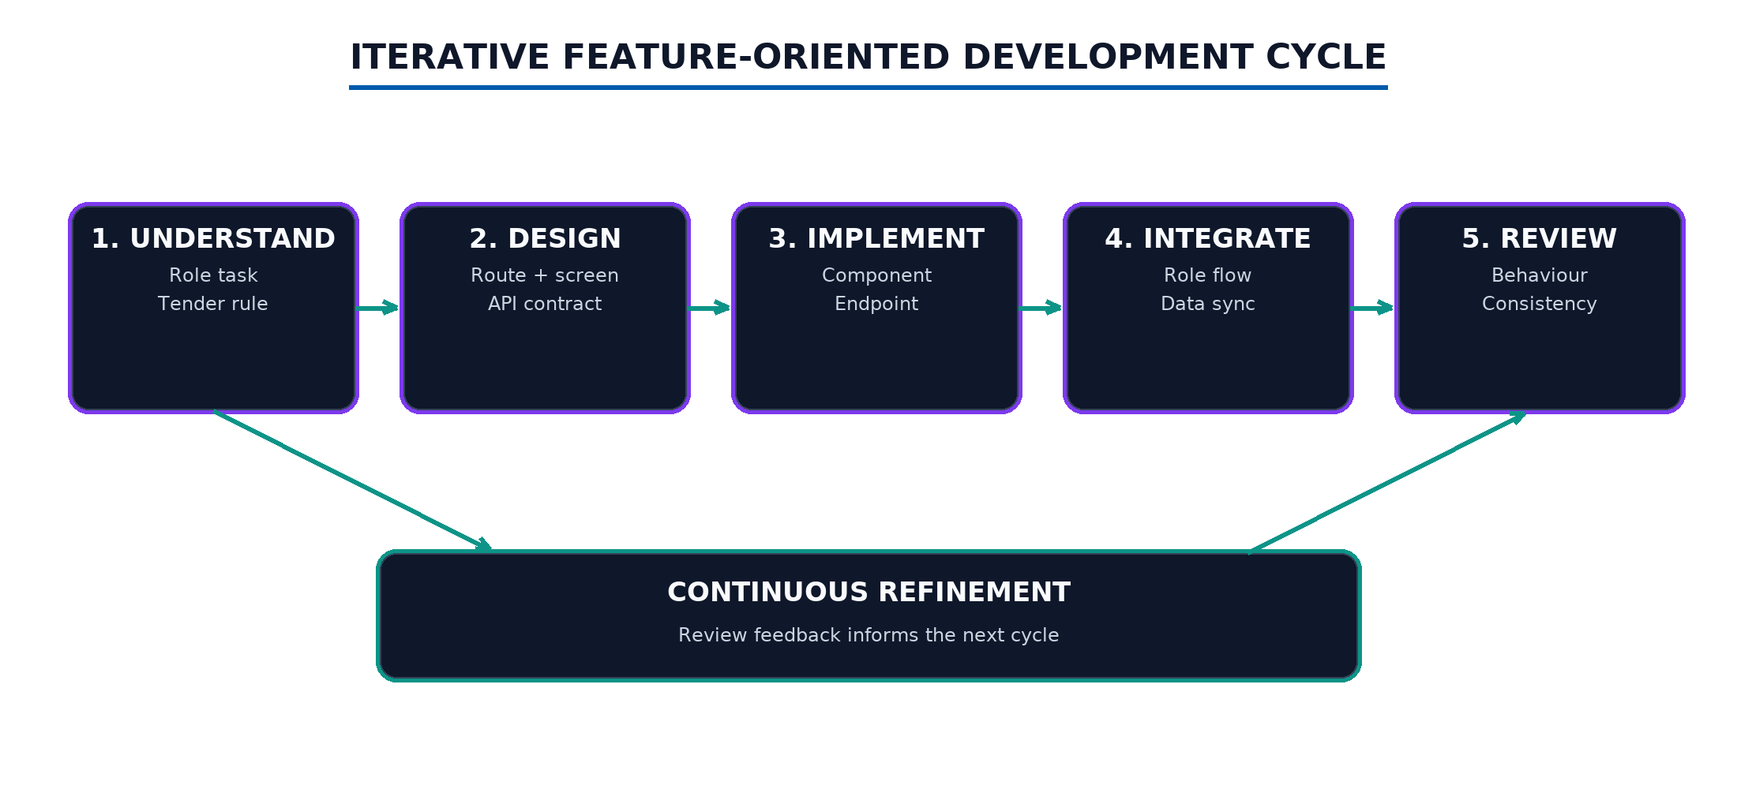
Figure 4.1: Iterative feature-oriented development cycle
Table 4.1: Development phases and representative outputs
Phase | Representative output
Foundation | Login, layout, notification bell, role-gated router
Lifecycle | Project creation, lead assignment, team formation, stages
Execution | Tasks, Kanban drag-and-drop, review modal, calendars, Gantt
People | Experience sync, profiles, employees directory, analytics
Delivery | Docker image, load-balanced compose, health probes

4.3 Requirements Analysis
4.3.1 Functional Requirements
• Provide separate dashboards for Creator, HOD, Senior Lead, Team Lead, and Member with role-relevant navigation, plus a Viewer read-only mode.
• Create tenders with category, value, geography, dates, description, and a customizable stage pipeline; assign codes automatically.
• Assign Senior Leads, form teams with a Team Lead and members, and enforce a five-active-project workload cap.
• Track tasks with stage association, priority, dates, and drag-and-drop status changes; require a star rating when a Team Lead completes a task.
• Gate project completion on pipeline completion; record Success/Fail outcomes with ranking and remarks.
• Maintain notifications, activity trails, experience and leadership records, and analytics.
4.3.2 Non-Functional Requirements
Usability, maintainability, responsiveness, data integrity, and security were considered during design. Role-specific dashboards and consistent controls address usability; middleware-enforced rules address integrity and security; the container topology addresses deployability. Production-grade persistence, observability, and accessibility testing remain future work.
4.4 Actors and Use-Case Model
The principal actors are the five operational roles; the Viewer observes without mutation. Figure 4.2 maps actors to their high-level use cases and to the cross-cutting system behaviours - notifications, experience synchronisation, workload guard, and analytics.
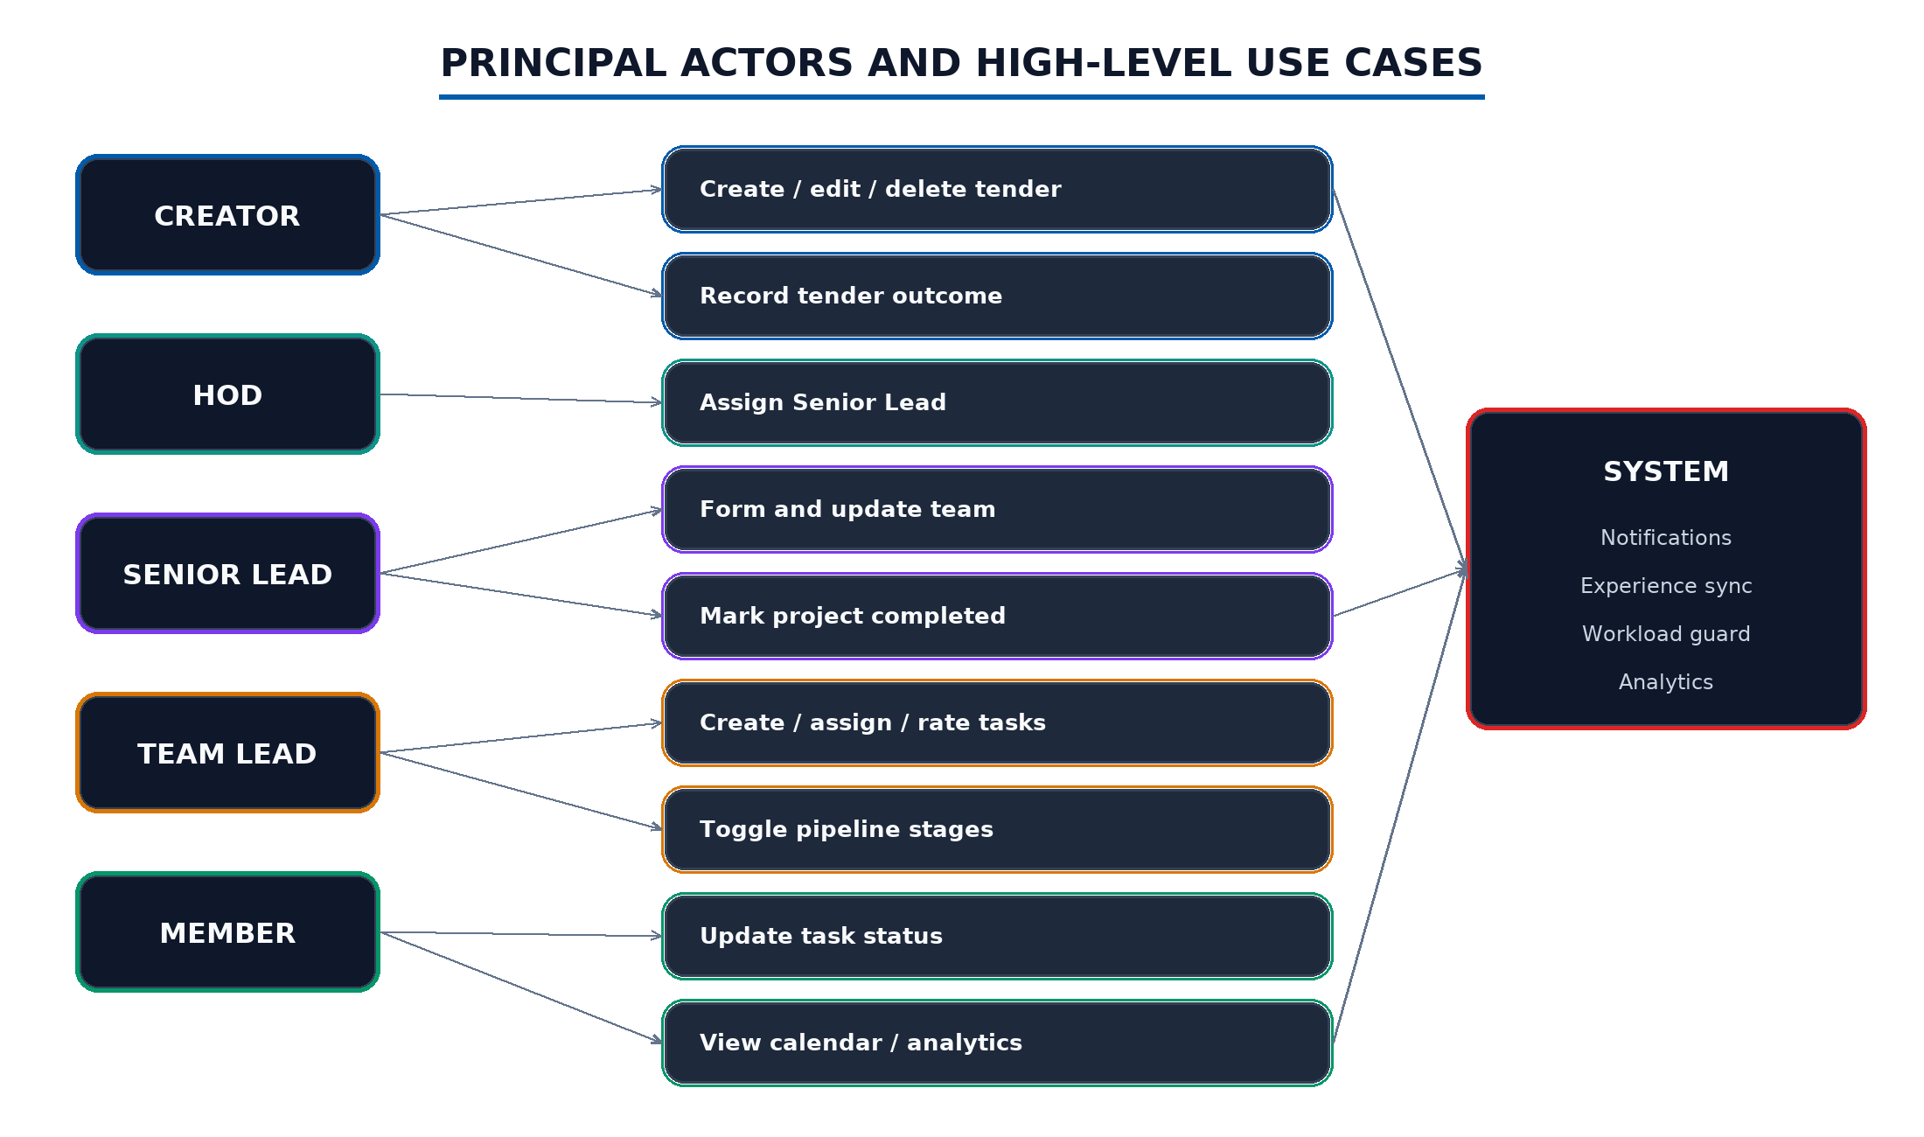
Figure 4.2: Principal actors and high-level use cases
4.5 Overall System Architecture
The browser sends every request to one origin. Express serves the interface and the API from the same process; the authentication middleware verifies the Bearer token, the role middleware filters by role, and handlers apply business rules before mutating the store. In development the Vite middleware provides hot reloading; in production the static bundle is served. Figure 4.3 gives the architecture.
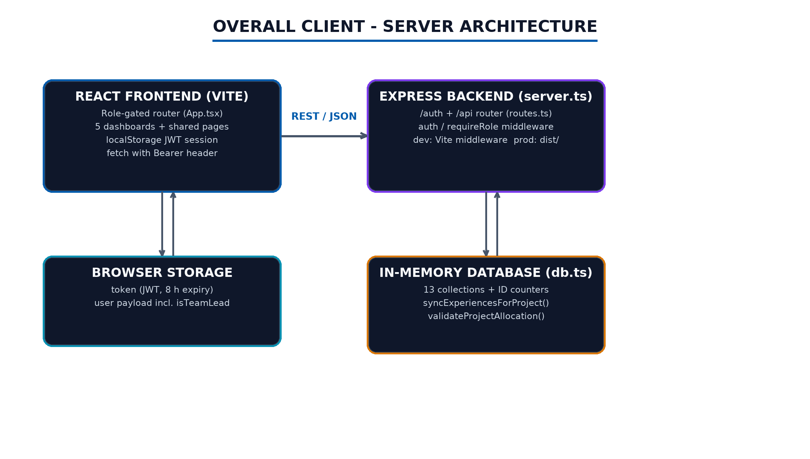
Figure 4.3: Overall client-server architecture
4.6 Frontend Design
The router registers dashboard routes conditionally on the signed-in role, and the Layout supplies the sidebar, the notification bell with five-second polling, and the user menu. Dashboards compose reusable pieces: the status stepper appears in four dashboards and the detail modal; the Kanban, Gantt, and calendar views are shared between the Team Lead and Member workspaces; and the experience modal serves both the employees directory and the profile page.
4.7 Backend Design
The backend chains express.json, an auth middleware that verifies the JWT and injects the caller, and a requireRole factory for role gates. Handlers then apply validation helpers - pipeline normalisation, status validation, allocation checks, stage-completion checks - before mutating collections. Helper functions such as canHodManageProject encode organisational policy in one place.
4.8 Role-Based Access Control Design
Table 4.2 summarises the enforced matrix. HOD authority is scoped by category: one HOD owns Bridges and the other owns all remaining categories, a rule applied consistently to lead assignment, status changes, stage toggles, and completion.
Table 4.2: Role-based access control matrix
Capability | Creator | HOD | Senior Lead | Team Lead | Member
Create / edit / delete project | Yes | No | No | No | No
Assign Senior Lead | Yes | Scoped | No | No | No
Form / update team | No | Scoped | Own projects | No | No
Toggle pipeline stage | Yes | Scoped | No | Own team | No
Update project status | Yes | Scoped | Own | Own | No
Bid drop / revert | Yes | No | No | No | No
Record tender outcome | Yes | No | No | No | No
Create / edit / delete tasks | No | No | Own | Own | No
Complete task with rating | No | No | No | Required | Self status
Manage users | Yes | Yes | No | No | No

4.9 Pipeline and Status Design
Each project carries an ordered list of stages with optional deadlines; the default nine stages mirror the organization's bid process. Completion of every stage gates the Completed status, and toggling the final stage auto-completes the project. Bid Dropped is a separate, Creator-only, reversible state excluded from active views.
Table 4.3: Default bid pipeline stages
# | Stage | Purpose
1 | Go Decision | Commit to pursuing the tender
2 | Team Allocated | Confirm the execution team
3 | Exec Summary | Prepare the executive summary
4 | Site Visit | Inspect the site and conditions
5 | Pre-Bid Queries | Raise and consolidate queries
6 | Value Engg. | Optimise design and cost
7 | Bid Preparation | Assemble the bid documents
8 | Internal Review | Review before submission
9 | Bid Submitted | Record submission

4.10 Tender Lifecycle Flow
Figure 4.4 traces the state flow from creation through outcome, including the reversible bid-drop branch and the experience credit on completion.
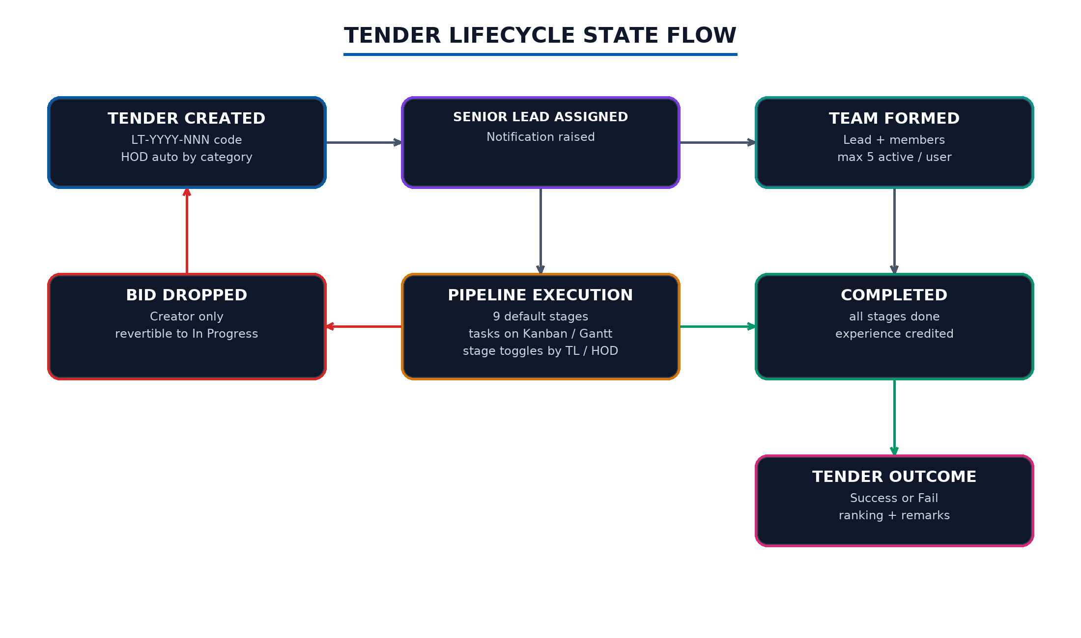
Figure 4.4: Tender lifecycle state flow
4.11 Database Design
The store contains thirteen collections. Users hold identity and role; projects hold lifecycle state and stakeholder identifiers; teams map a project to a Team Lead and members; tasks carry execution detail and review fields; and the people-analytics collections - performance reviews, employee experiences, leadership history, and the legacy experience history - are maintained by the synchronisation engine. Notifications and the activity feed record events; categories carry name and color; milestones is declared for future use. Figure 4.5 shows the relationships.
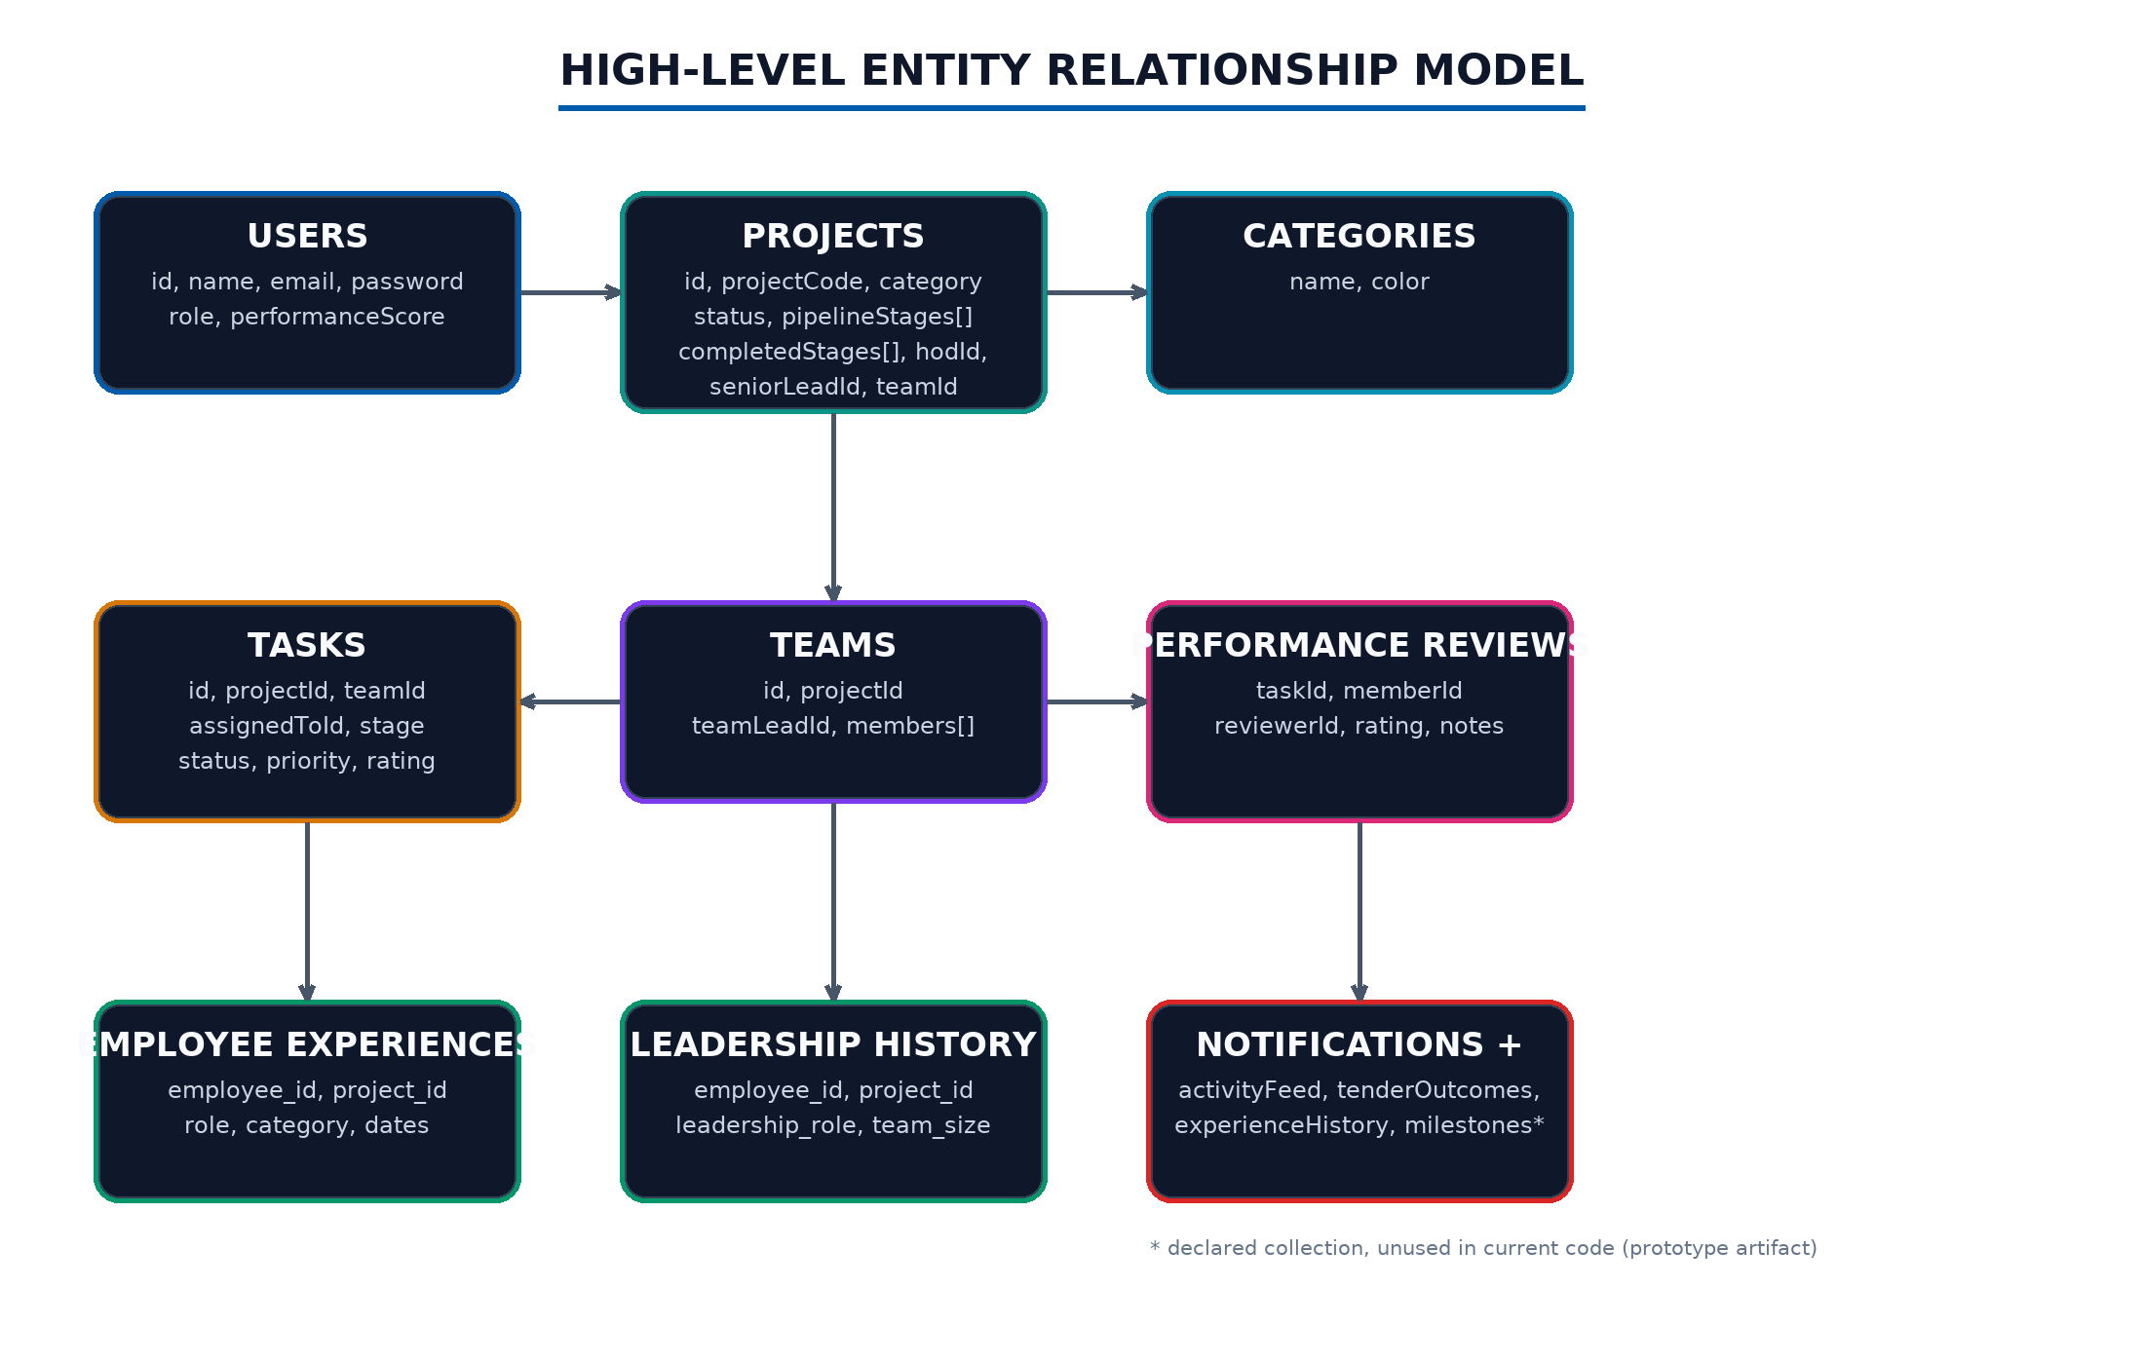
Figure 4.5: High-level entity relationship model
4.12 Notifications and Activity Design
Every significant transition - lead assignment, task assignment, task completion, status change, project completion - pushes a notification to the affected users, and task status changes append an activity entry for the actor. The layout polls for notifications so stakeholders see changes within seconds.
4.13 Experience and Leadership Credit Design
When a project completes or its tender succeeds, the synchronisation engine resolves participants - HOD, Senior Lead, Team Lead, and members - prunes records for participants no longer attached, upserts experience rows with category, role, and dates, upserts leadership rows with team size for leads, mirrors the legacy history, and raises completion notifications exactly once per user.
4.14 Deployment Architecture
The production image bundles the server and the static client; three replicas run behind nginx with least-connection balancing and health-gated membership, as shown in Figure 4.6. The design demonstrates horizontal scale-out; because each replica currently owns its own memory, shared persistence is the first production requirement, as discussed in Chapter 8.
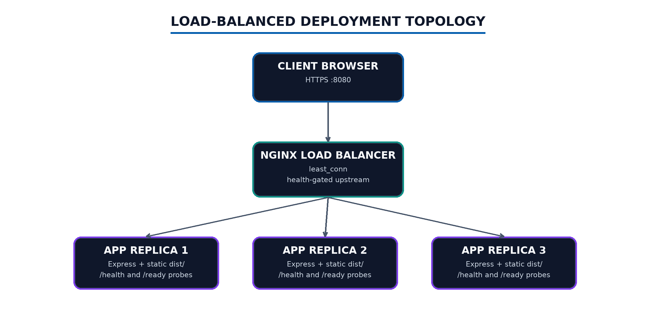
Figure 4.6: Load-balanced deployment topology
4.15 Key Design Decisions and Trade-offs
Table 4.4: Design decisions and trade-offs
Decision | Reason | Trade-off
Single in-memory store | Zero-config prototype, instant demos | No persistence; replicas diverge under load balancing
One route module | Logic traceable in one file | Needs decomposition as domains grow
Name-based HOD scoping | Matches current organization | Should generalise to a stored scope table
Plaintext seed credentials | Demo convenience | Must be hashed for production
Five-second notification polling | Simple, no infrastructure | Chatty; real-time push is future work

4.16 Chapter Summary
The design connects five roles to a stage-gated lifecycle through enforced RBAC, a reconciling experience engine, and a scalable delivery topology. Chapter 5 describes how the design was implemented.
CHAPTER 5
IMPLEMENTATION
5.1 Chapter Introduction
This chapter describes the implemented modules with reference to the source organisation, the principal algorithms, and the complete endpoint inventory.
5.2 Source Organisation
The repository separates backend and frontend at the root, with shared constants on the client and delivery assets at the top level. Figure 5.1 maps the principal sources.
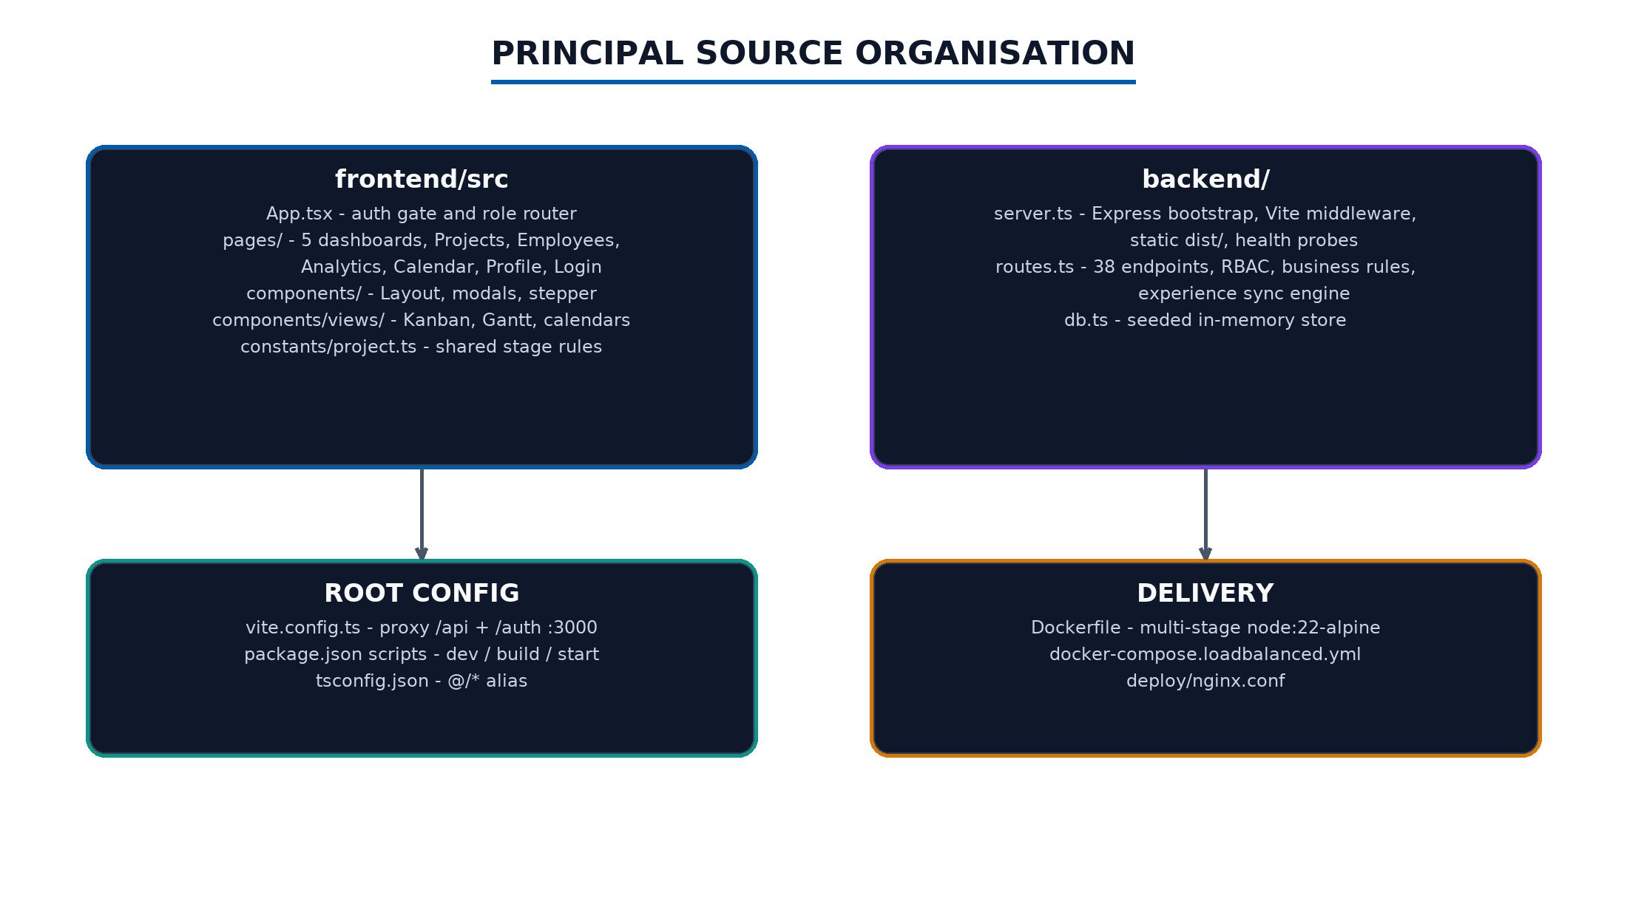
Figure 5.1: Principal source organisation
5.3 Authentication Implementation
POST /auth/login validates the email and password against the seed users, signs an eight-hour token carrying id, role, and name, and computes isTeamLead by checking whether the user leads any team whose project is not completed. The client stores the token and user payload in localStorage and attaches the Bearer header on every request; the auth middleware verifies the token and rejects missing or invalid signatures with 401.
5.4 Users, Profiles, and Experience Implementation
The users directory enriches each user with category-grouped experience, leadership history, and a live active-project count used by the workload guard and the recommendation score. Profile assembly combines completed experiences, leadership rows, average task rating, and project buckets. The experiences and leadership endpoints join back into projects and teams to render durations, team composition, and outcomes, with a prior-experience fallback for seeded history.
5.5 Project Implementation
Project creation validates the name, generates the LT-YYYY-NNN code, normalises the pipeline stages (defaulting to the nine-stage list), auto-assigns the HOD by category - Bridges to one HOD, all other categories to the other - and notifies an assigned Senior Lead. Editing applies field-level guards; status transitions validate the status vocabulary, enforce the all-stages rule for Completed, restrict Bid Dropped to the Creator, and raise stakeholder notifications. Deletion cascades teams, tasks, activity, and notifications.
5.6 Team Implementation
Team creation and update parse the lead and member identifiers, verify the caller's authority over the project, and run the allocation guard, which counts each candidate's active projects - excluding completed and bid-dropped ones - and rejects any assignment that would exceed five. Member removal protects the Team Lead identity until reassigned.
5.7 Task Implementation
Task creation is limited to the project's Team Lead or its Senior Lead, binds the task to the project's team and chosen stage, and notifies the assignee. Status updates are permitted to the Team Lead, senior management, or the assignee; when a Team Lead completes a task the handler requires a one-to-five rating and upserts a performance review that also stamps the task row. Status changes append activity entries and completion notifications.
5.8 Experience Synchronisation Engine
The engine is invoked from every mutation that can change participation or outcome: project creation, status updates, stage completion, team changes, lead assignment, bid revert, and successful outcomes. Figure 5.2 shows the trigger-resolution-reconcile-effect flow.
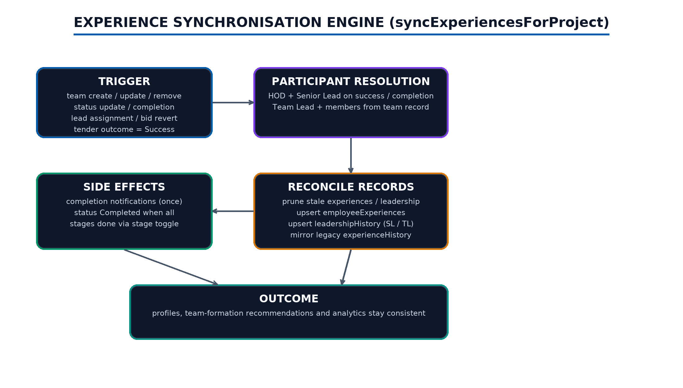
Figure 5.2: Experience synchronisation engine
5.9 Notifications and Analytics Implementation
Notification endpoints return the caller's feed and support single and bulk read. The tender analytics endpoint merges project-attached outcomes with the outcomes collection, scopes visibility by role, and computes participation, success and failure rates, rank distribution, and average failure position. The performance endpoint scopes reviews by role and produces member, task, project, and category aggregations with recent review details.
5.10 Frontend Implementation Highlights
The Kanban board implements native drag-and-drop with per-column drop handlers that route through the status endpoint; completing a task from the board opens the review modal so the rating rule cannot be bypassed. The Gantt view computes proportional offsets between the earliest start and latest end. The unified calendar merges project deadlines and task due dates, coloured by category, with role-aware task visibility. The Creator dashboard offers a pipeline editor with selection, deadlines, reordering, and custom stages.
5.11 API Endpoint Inventory
Table 5.1: Authentication, user and experience endpoints
Method and path | Gate | Purpose
POST /auth/login | Public | Issue JWT and isTeamLead flag
GET /api/users | auth | Directory with experience and workload
GET /api/profile | auth | Own profile, ratings, project buckets
GET /api/users/:id/experiences | auth | Category experience with project detail
GET /api/users/:id/leadership | auth | Leadership history with outcomes
POST /api/users/create | HOD, Creator | Create user with prior-experience seeding
DELETE /api/users/:id | HOD, Creator | Remove a user
GET /api/users/me/activity | auth | Own recent activity trail

Table 5.2: Project and category endpoints
Method and path | Gate | Purpose
GET /api/projects | auth | Populated directory, optional bid-drop exclusion
GET /api/projects/directory | auth | Sidebar directory alias
GET /api/categories | auth | List categories
POST /api/categories | Creator | Add category
POST /api/projects/create | Creator | Create with code and auto-HOD
PATCH /api/projects/:id | Creator | Edit fields and status with guards
POST /api/projects/:id/update-status | role checks | Transition status with notifications
DELETE /api/projects/:id | Creator | Cascade delete
POST /api/projects/:id/bid-drop | Creator | Drop the bid
POST /api/projects/:id/revert-bid-drop | Creator | Restore to In Progress
POST /api/projects/:id/assign-senior-lead | HOD, Creator | Assign lead
POST /api/projects/:id/complete | SL, HOD | Complete with stage gate
POST /api/projects/:id/complete-stage | TL, Creator, HOD | Mark a stage done
DELETE /api/projects/:id/complete-stage/:stage | TL, Creator, HOD | Un-mark a stage
POST /api/projects/:id/tender-outcome | Creator | Record Success/Fail

Table 5.3: Team and task endpoints
Method and path | Gate | Purpose
GET /api/teams | auth | List teams
POST /api/teams/create | SL, HOD | Form team with allocation guard
PATCH /api/teams/:id/update | SL, HOD | Update lead and members
POST /api/teams/:id/remove-member | SL, HOD | Remove a member
GET /api/tasks | auth | Role-scoped task list
POST /api/tasks/create | TL, SL | Create and assign task
PATCH /api/tasks/:id/status | role checks | Move task; rating gate for TL completion
PATCH /api/tasks/:id/edit | creator, SL | Edit task fields
DELETE /api/tasks/:id | creator, SL | Delete task
GET /api/tasks/completed-projects | auth | Archive grouped by completed project

Table 5.4: Notification and analytics endpoints
Method and path | Gate | Purpose
GET /api/notifications | auth | Caller's notification feed
PATCH /api/notifications/:id/read | auth | Mark one read
PATCH /api/notifications/read-all | auth | Mark all read
GET /api/analytics/tender-outcomes | auth | Role-scoped win/loss analytics
GET /api/analytics/performance | auth | Role-scoped performance analytics

Table 5.5: Frontend pages and reusable components
Module | Responsibility
Login | JWT sign-in with quick account picks
Layout | Sidebar, notification bell with 5 s polling, user menu
CreatorDashboard | Project, user and category creation; lead assignment
HodDashboard | Scoped assignment, teams, stages, JSON export
SeniorLeadDashboard | Own projects, team formation, completion
TeamLeadDashboard | Overview/Kanban/Calendar/Gantt tabs; task CRUD; review modal
MemberDashboard | Task feed with filters, activity, archive, views
Projects | Global directory with edit, bid-drop, outcome actions
Employees | Directory, workload bars, password gate, create/delete
Analytics | Executive, tender, and performance dashboards
Profile + modals | Experience, leadership, portfolio detail
Views | KanbanBoard drag-and-drop, GanttChart, UnifiedCalendar, TaskCalendar (legacy)

5.12 Chapter Summary
The implementation realises every design rule as enforceable code: codes, scopes, caps, gates, ratings, and reconciliation. Chapter 6 examines the results.
CHAPTER 6
RESULTS AND DISCUSSION
6.1 Chapter Introduction
This chapter presents what the completed system delivers against its objectives, demonstrates three representative end-to-end flows, and discusses observed behaviour and limitations.
6.2 Functional Outcomes by Role
All five dashboards operate over the shared data with role-correct visibility and mutation rights, as summarised in Figure 6.1.
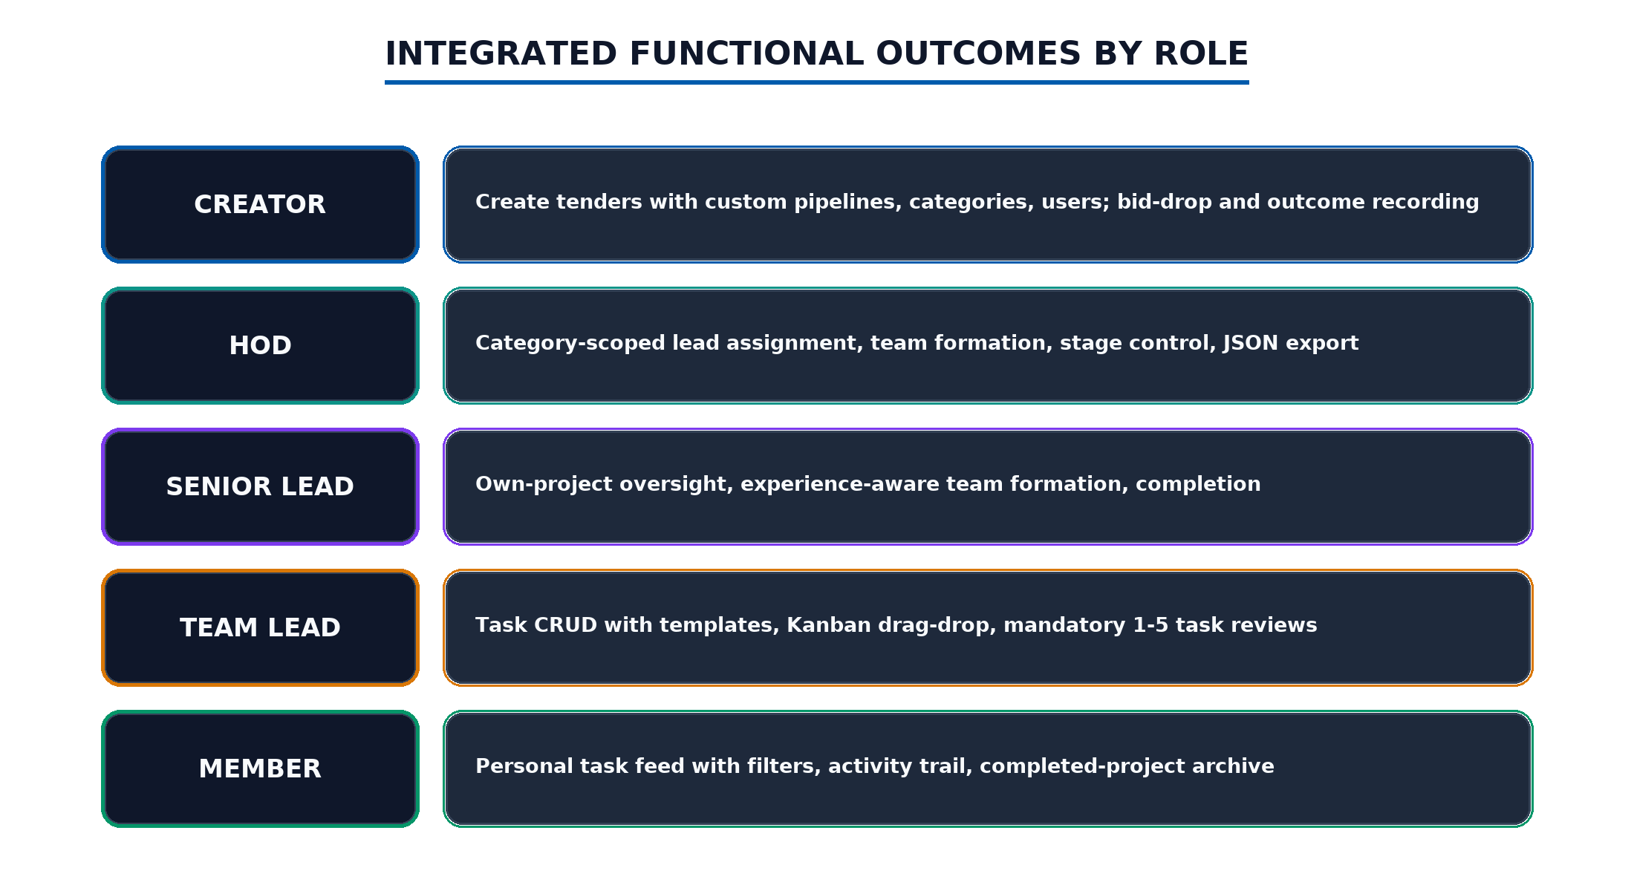
Figure 6.1: Integrated functional outcomes by role
6.3 Outcome Against Objectives
Table 6.1: Outcome against project objectives
Objective | Result
Unified role-focused platform | Five dashboards plus shared pages behind one router and layout
Lifecycle support | Intake, coding, assignment, teams, stages, tasks, completion, outcomes implemented
Experience reuse | Synchronisation engine keeps experience, leadership, and recommendations current
Visualisation | Kanban, Gantt, two calendars, and three analytics dashboards delivered
Workload control | Five-active-project cap enforced on team create and update
Deployment | Multi-stage image plus three-replica nginx topology validated

6.4 Representative End-to-End Flows
6.4.1 Creator Initiates a New Project
The Creator submits the creation form with a selected and ordered stage pipeline. The client pre-checks name duplication, the server re-validates, generates the next LT code, normalises stages, auto-assigns the HOD by category, stores the project as In Progress, and notifies the chosen Senior Lead. The dashboard refreshes and the new tender appears in the HOD's unassigned queue only for the HOD whose category scope matches.
6.4.2 Team Lead Moves a Task on the Kanban
Dragging a card between columns issues a status update. Moving a task to Completed opens the review modal; submitting without a valid rating is rejected by the server with an explanatory error, and with a rating the handler records the review, stamps the task, appends the activity entry, and notifies the assigner. The member's feed and the analytics aggregations reflect the change immediately.
6.4.3 Completion Distributes Experience
When the final pipeline stage is toggled, the project auto-completes. The synchronisation engine then writes experience rows for the HOD, Senior Lead, Team Lead, and members, leadership rows for the leads with team sizes, mirrors the legacy history, and raises one completion notification per participant. Profiles, the employees directory, and team-formation recommendations show the new records without further action.
6.5 Analytics Outcomes
The tender dashboard reports participation, success and failure rates, the distribution of failure rankings, and the average failure position, scoped per role. The performance dashboard ranks members by average review rating, surfaces each member's best category, and aggregates task, project, and category quality. Because every figure reads the same backend aggregations, the dashboards remain mutually consistent.
6.6 Limitations Observed
The in-memory store resets on restart and diverges across load-balanced replicas; seed passwords are plaintext; the documentation's demo account list differs from the seeded users; milestones and the Viewer role are present but unexercised; and notifications rely on polling. These are recorded as technical debt and guide the future work of Chapter 8.
6.7 Chapter Summary
The system delivers its intended lifecycle, people, and analytics outcomes with explicit, enforceable rules; its limitations are known, bounded, and documented.
CHAPTER 7
TESTING
7.1 Testing Strategy
Validation combined manual UI walkthroughs for each role with API-level checks of gates and business rules during development. Each endpoint was exercised with authorized, unauthorized, and out-of-role callers; each workflow was executed end to end in the interface; and boundary conditions were probed with invalid payloads. Because the internship environment is a prototype, automated suites were not introduced; their absence is recorded as future work.
7.2 Authentication and RBAC Validation
Table 7.1: Authentication and RBAC validation cases
Case | Expected | Observed
Login with unknown credentials | 401 Invalid credentials | Passed
Protected route without token | 401 Unauthorized | Passed
Member calls POST /api/projects/create | 403 Forbidden | Passed
Bridges project assigned by out-of-scope HOD | 403 scope error | Passed
Member reads /api/tasks | Only own-team tasks returned | Passed
Viewer reaches mutation endpoints | 403 Forbidden | Passed
Expired or tampered token | 401 Invalid token | Passed
HOD/Creator views passwords in directory | Permitted by design; others masked | Passed

7.3 Workflow and Boundary Validation
Table 7.2: Workflow and boundary validation cases
Case | Expected | Observed
Create duplicate project name | 400 name exists | Passed
New project code sequence | LT-2026-001, ...002 | Passed
Team create with a user at 5 active projects | 400 allocation message | Passed
Remove Team Lead via remove-member | 400 reassign first | Passed
TL completes task without rating | 400 rating required | Passed
Complete project with open stages | 400 stage gate | Passed
Toggle final stage | Auto-complete plus experience credit | Passed
Record outcome on non-completed project | 400 must be completed | Passed
Bid drop then calendar view | Project hidden from calendar scope | Passed
Delete project | Teams, tasks, activity cascade removed | Passed

7.4 Defects and Known Limitations
Table 7.3: Known prototype limitations
Item | Classification | Disposition
State resets on restart; replicas diverge | Persistence | SQL Server integration planned
Plaintext seed passwords | Security | Hashing and env-managed JWT secret planned
CREDENTIALS.md lists accounts absent from seed | Documentation | Reconciliation planned
milestones collection unused; TaskCalendar unreferenced | Dead artefacts | Wire or retire
Notification polling at 5 s | Efficiency | Push-based updates planned

7.5 Coverage Limitations
The validation covers authentication, RBAC, lifecycle rules, and the principal workflows, but component tests, browser automation, load testing, and accessibility audits remain absent. The load-balanced topology was exercised for routing and health behaviour, not for sustained concurrency.
7.6 Testing Conclusion
Testing confirmed that the principal pages, endpoints, business rules, and cross-role workflows behave as designed. The recorded limitations are infrastructure and hardening items rather than functional defects, and they define the first priorities of future work.
CHAPTER 8
CONCLUSION AND FUTURE SCOPE OF WORK
8.1 Conclusion
The internship produced a complete, role-based tender lifecycle platform for an infrastructure organization. Its main achievement is the connection between tender intake, leadership assignment, team formation with workload control, a stage-gated bid pipeline, reviewed task execution, completion, and outcome analytics - with every transition reconciled into reusable experience and leadership records.
8.1.1 Achievement of the Internship Objectives
The project met its core objectives: five role dashboards and a Viewer mode, the full lifecycle with automatic coding and HOD scoping, the five-project workload cap, the mandatory task review rule, the experience synchronisation engine, the Kanban/Gantt/calendar visualisations, the analytics dashboards, and the containerised, load-balanced delivery. Prototype boundaries - in-memory persistence, demonstration credentials, and polling notifications - were kept explicit and are not presented as production controls.
8.1.2 Personal and Professional Learning
The AI Full Stack Intern role strengthened my ability to convert organisational rules into enforceable server-side logic, to design role-focused interfaces that stay coherent across a large surface, and to trace data end to end from a drag on a board to a reconciled record and back into a chart. Working from the office at L&T made the domain concrete: every rule in the system came from a conversation about how tenders actually move.
Table 8.1: Final project outcomes
Outcome area | Result
Product | Integrated tender lifecycle workflows for five roles plus Viewer
Frontend | Five dashboards, five shared pages, four visualisation views, analytics
Backend | 38 REST endpoints with JWT auth and RBAC middleware
Data | 13 collections with a reconciling experience engine
Delivery | Multi-stage Docker image and three-replica nginx topology
Quality | Documented validation cases and bounded, recorded limitations

8.2 Future Scope of Work
Future work should preserve the connected workflow while replacing prototype shortcuts with production controls. Figure 8.1 and Table 8.2 prioritise the roadmap.
8.2.1 SQL Server Persistence
The principal next step is to replace the in-memory store with a SQL Server database administered through SSMS, using the mssql driver for Node.js, with the existing collections mapping directly onto relational tables and the counters onto identities [16], [17]. This also unifies state across load-balanced replicas.
8.2.2 Security Hardening
Hash stored credentials, move the JWT secret to environment-managed configuration, tighten CORS to the deployed origin, and add server-side rate limits and audit logging.
8.2.3 Real-Time Updates and Milestones
Replace polling with push-based notifications, activate the milestones collection as first-class calendar events, and generalise HOD scoping from name matching to a stored category-scope table.
8.2.4 Automated Testing and UX
Introduce API integration tests, browser automation for the principal workflows, accessibility review of dense dashboards, and retirement or wiring of legacy components.
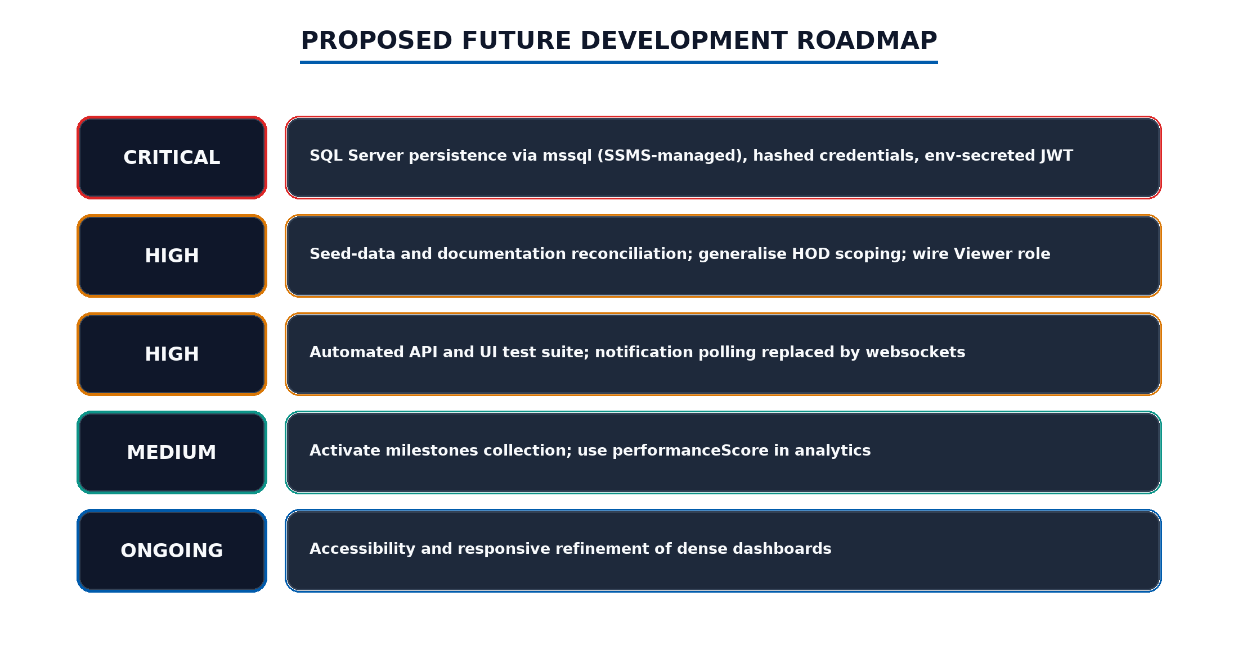
Figure 8.1: Proposed future development roadmap
Table 8.2: Prioritized future-development roadmap
Priority | Work item | Expected benefit
Critical | SQL Server persistence via mssql, hashed credentials | Durable, replica-consistent state
High | Seed and documentation reconciliation; Viewer seeding | Coherent demonstrations
High | Automated API and browser test suite | Repeatable confidence
Medium | Milestones activation; performanceScore utilisation | Richer planning and analytics
Ongoing | Accessibility and responsive refinement | Inclusive, validated experience

REFERENCES
[1] Larsen & Toubro Limited, “About L&T,” L&T. [Online]. Available: https://www.larsentoubro.com. [Accessed: Aug. 12, 2026].
[2] D. F. Ferraiolo and D. R. Kuhn, “Role-Based Access Controls,” in Proc. 15th NIST-NCSC National Computer Security Conference, Baltimore, MD, USA, 1992, pp. 554-563.
[3] M. Jones, J. Bradley, and N. Sakimura, “JSON Web Token (JWT),” IETF RFC 7519, May 2015. [Online]. Available: https://www.rfc-editor.org/rfc/rfc7519.
[4] OWASP Foundation, “JSON Web Token Cheat Sheet for Java,” OWASP Cheat Sheet Series. [Online]. Available: https://cheatsheetseries.owasp.org. [Accessed: Aug. 12, 2026].
[5] Meta Platforms, Inc., “React - The library for web and native user interfaces,” React Documentation. [Online]. Available: https://react.dev. [Accessed: Aug. 12, 2026].
[6] VoidZero Inc., “Vite Documentation,” Vite. [Online]. Available: https://vite.dev. [Accessed: Aug. 12, 2026].
[7] Tailwind Labs, “Tailwind CSS Documentation,” Tailwind CSS. [Online]. Available: https://tailwindcss.com. [Accessed: Aug. 12, 2026].
[8] R. T. Fielding, “Architectural Styles and the Design of Network-based Software Architectures,” Ph.D. dissertation, Dept. Information and Computer Science, Univ. of California, Irvine, CA, USA, 2000.
[9] OpenJS Foundation, “Express - Node.js web application framework,” Express Documentation. [Online]. Available: https://expressjs.com. [Accessed: Aug. 12, 2026].
[10] D. J. Anderson, Kanban: Successful Evolutionary Change for Your Technology Business. Sequim, WA, USA: Blue Hole Press, 2010.
[11] H. Kerzner, Project Management: A Systems Approach to Planning, Scheduling, and Controlling, 12th ed. Hoboken, NJ, USA: Wiley, 2017.
[12] Recharts Contributors, “Recharts - A composable charting library for React,” Recharts. [Online]. Available: https://recharts.org. [Accessed: Aug. 12, 2026].
[13] Microsoft, “TypeScript Documentation,” TypeScript. [Online]. Available: https://www.typescriptlang.org/docs. [Accessed: Aug. 12, 2026].
[14] Docker, Inc., “Docker Documentation,” Docker. [Online]. Available: https://docs.docker.com. [Accessed: Aug. 12, 2026].
[15] F5 Networks, “NGINX Documentation,” NGINX. [Online]. Available: https://nginx.org/en/docs/. [Accessed: Aug. 12, 2026].
[16] Microsoft, “SQL Server Documentation,” Microsoft Learn. [Online]. Available: https://learn.microsoft.com/en-us/sql/. [Accessed: Aug. 12, 2026].
[17] Tedious Contributors, “mssql - Microsoft SQL Server client for Node.js,” npm. [Online]. Available: https://www.npmjs.com/package/mssql. [Accessed: Aug. 12, 2026].

ANNEXURE - I
MONTHLY ATTENDANCE REPORT
Reserved for the signed or system-generated monthly attendance report covering the internship period from 1 June 2026 to 31 July 2026 at Larsen & Toubro. The final evidence may be inserted as an image or scanned document without changing the chapter sequence.

Attach Monthly Attendance Report Here

ANNEXURE - II
FEEDBACK FORM FROM SUPERVISOR
Reserved for the completed supervisor feedback form bearing the appropriate signature and organization stamp. The final scanned form may be inserted in this area before submission.

Attach Signed Supervisor Feedback Form Here

