
SKILL 1 – CLOUD INFRASTRUCTURE AND SERVICES (CDIS)
IAM User with Programmatic Access and Free Tier Billing Alert
I created the IAM user test without enabling console login.
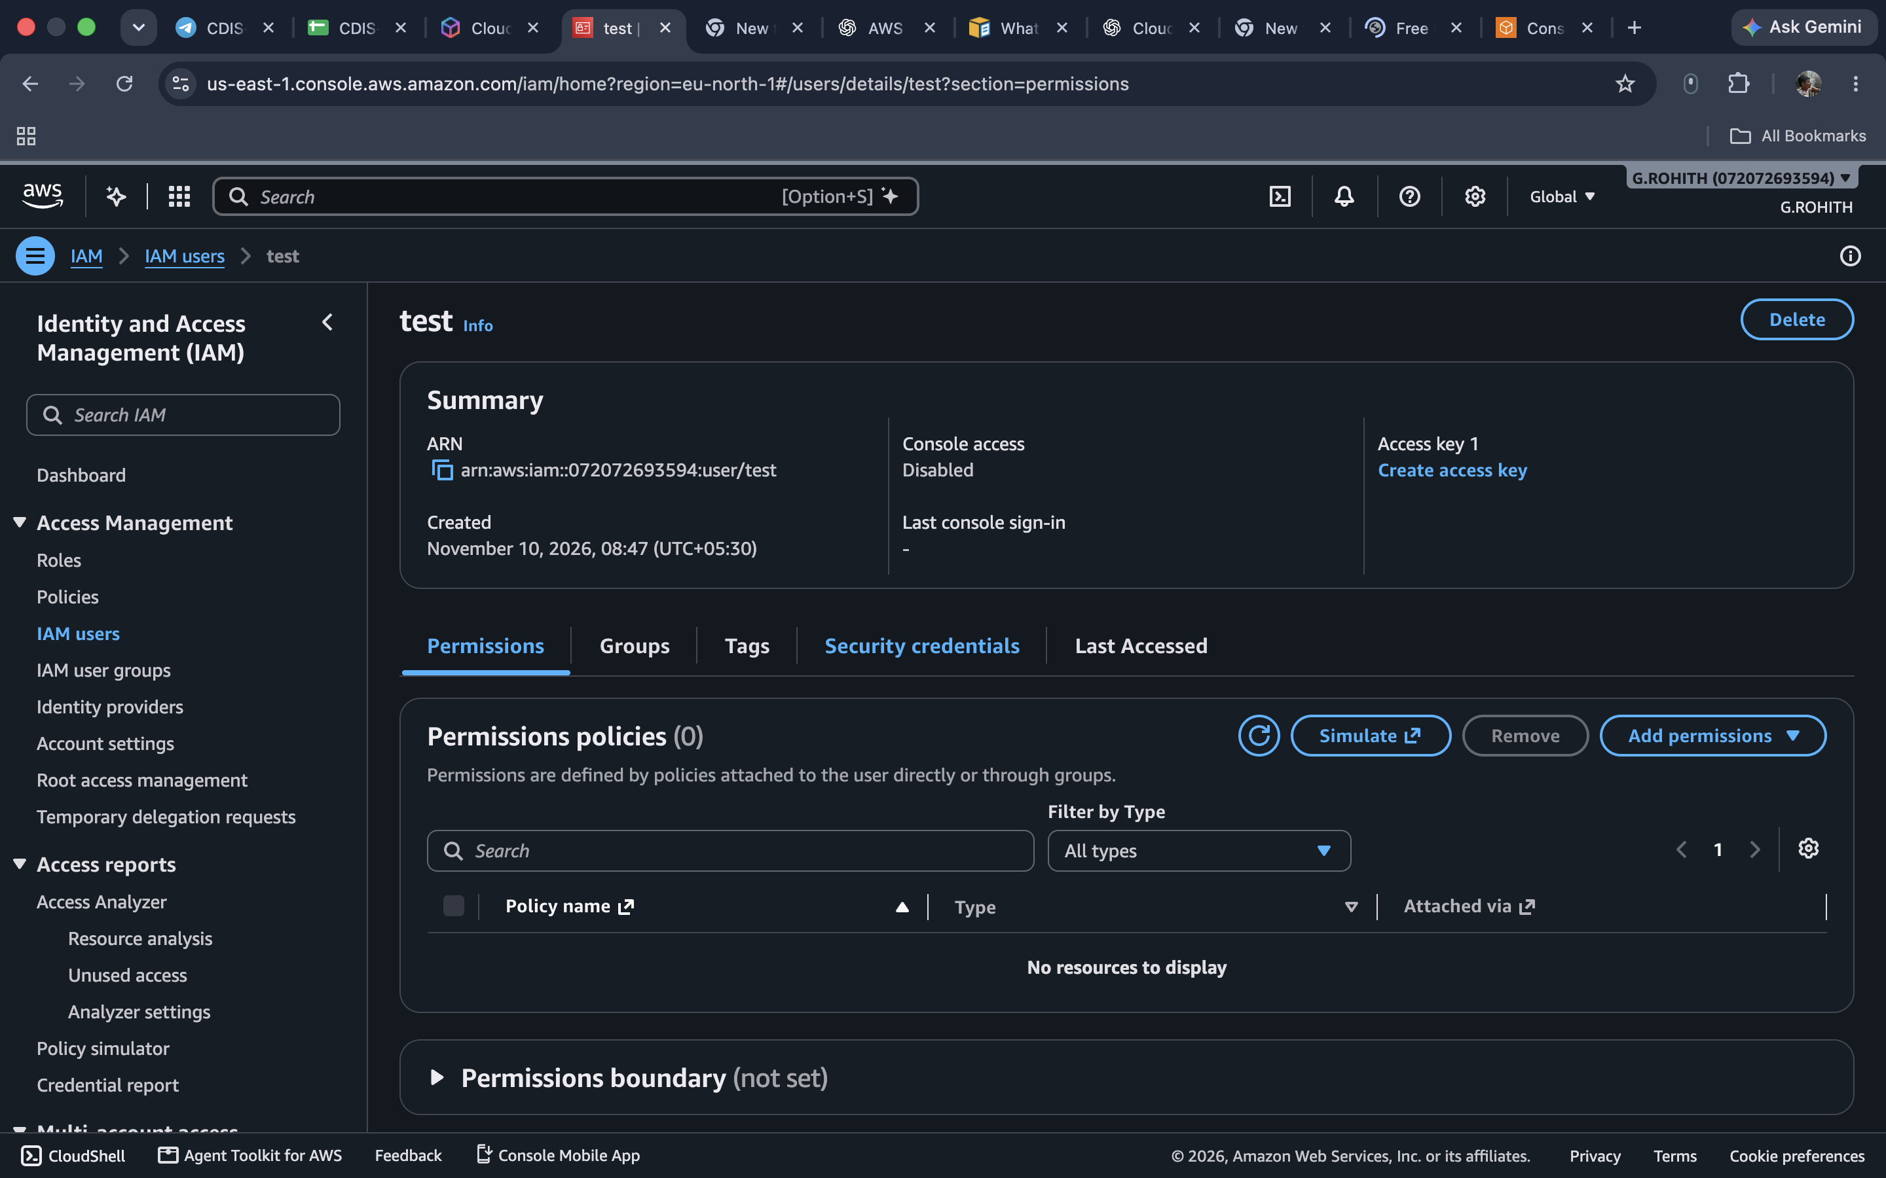
I checked the security credentials and confirmed that console access was disabled.
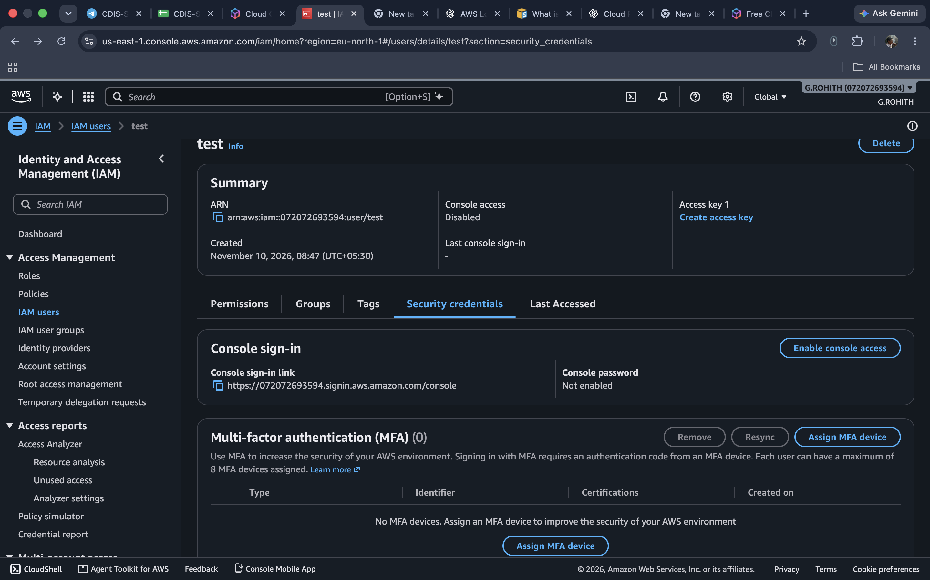
I opened Create access key and selected the use case for programmatic access.
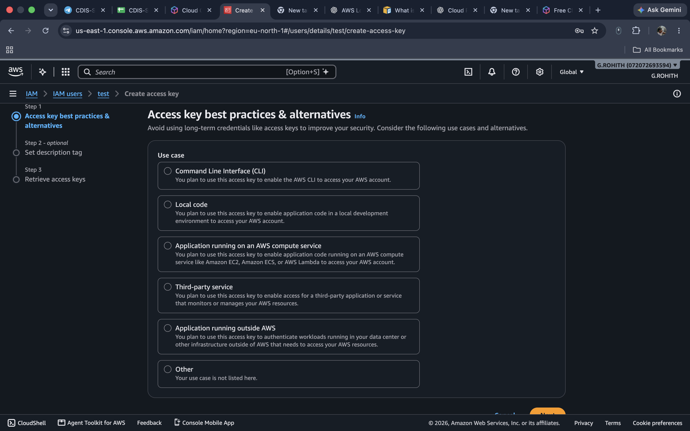
I created the access key and downloaded the CSV containing the access key ID and secret key.
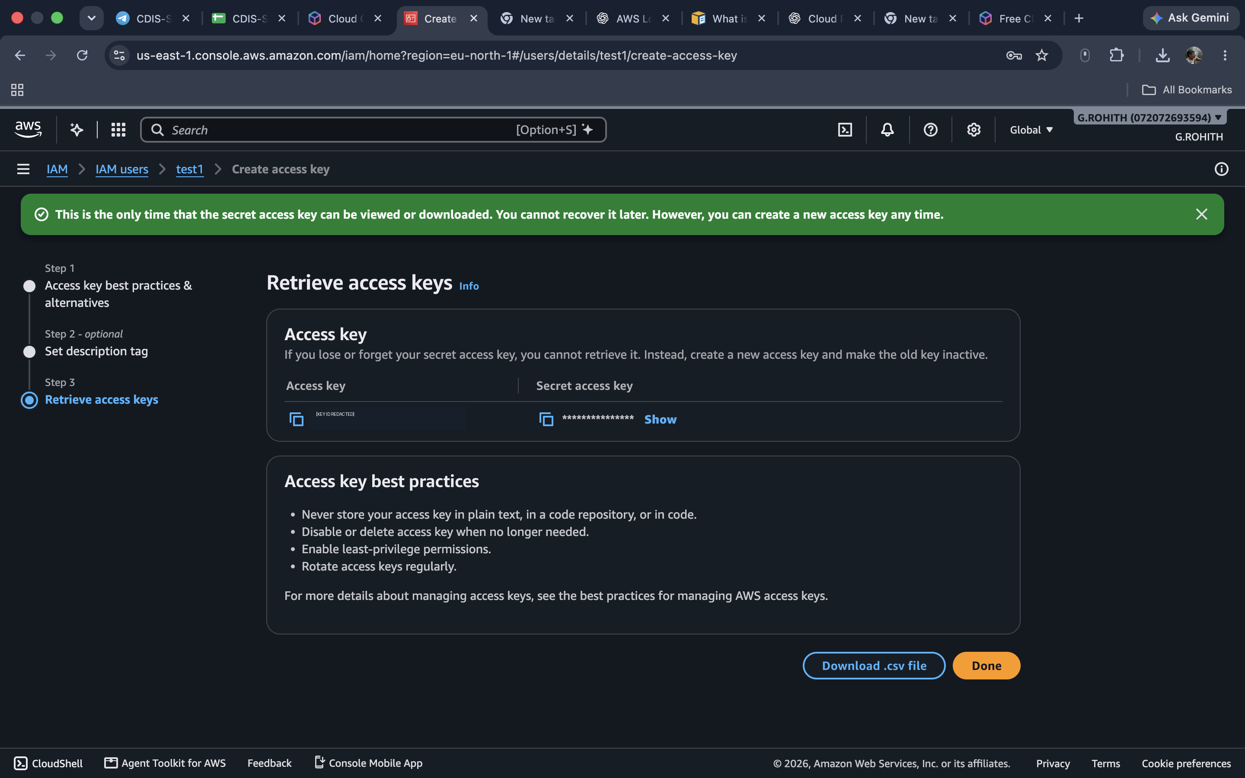
I opened Billing and Cost Management and selected Create budget.
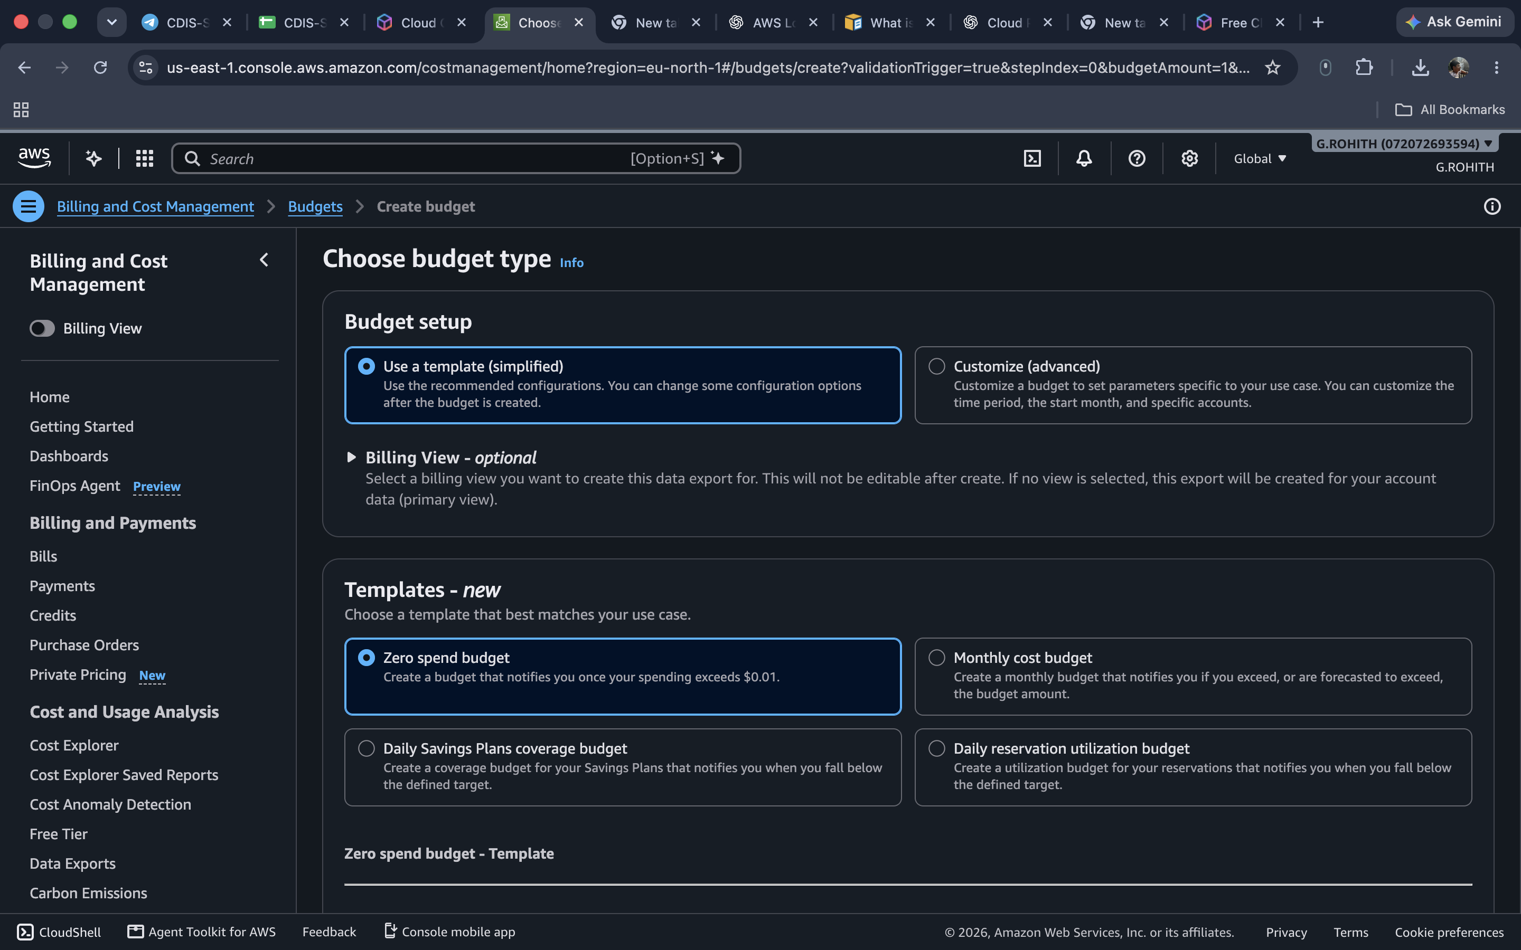
I selected the Zero spend budget option to set up a spending alert.
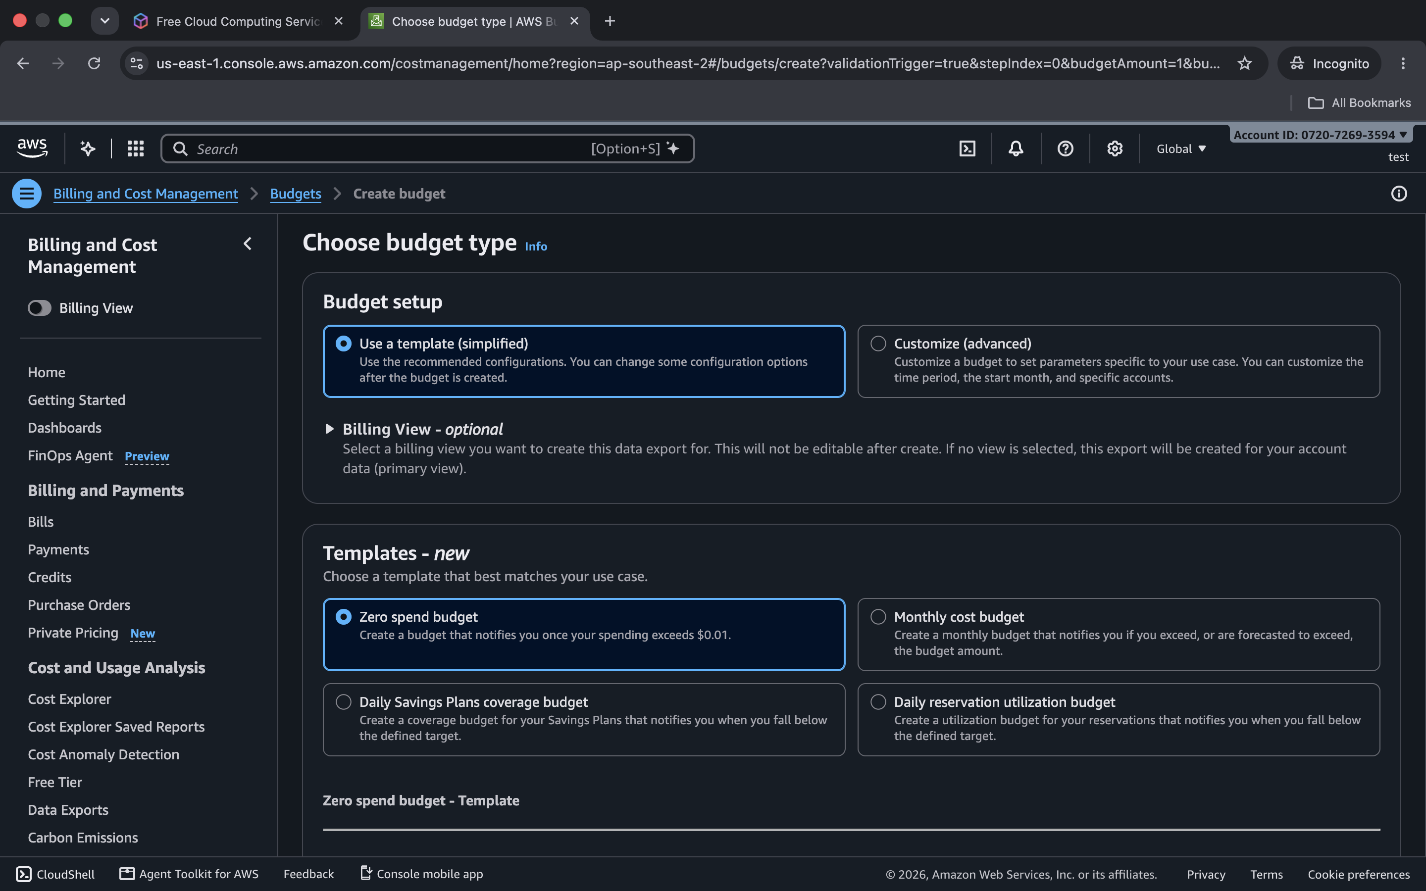
I got a permission error when opening billing from the IAM user account.
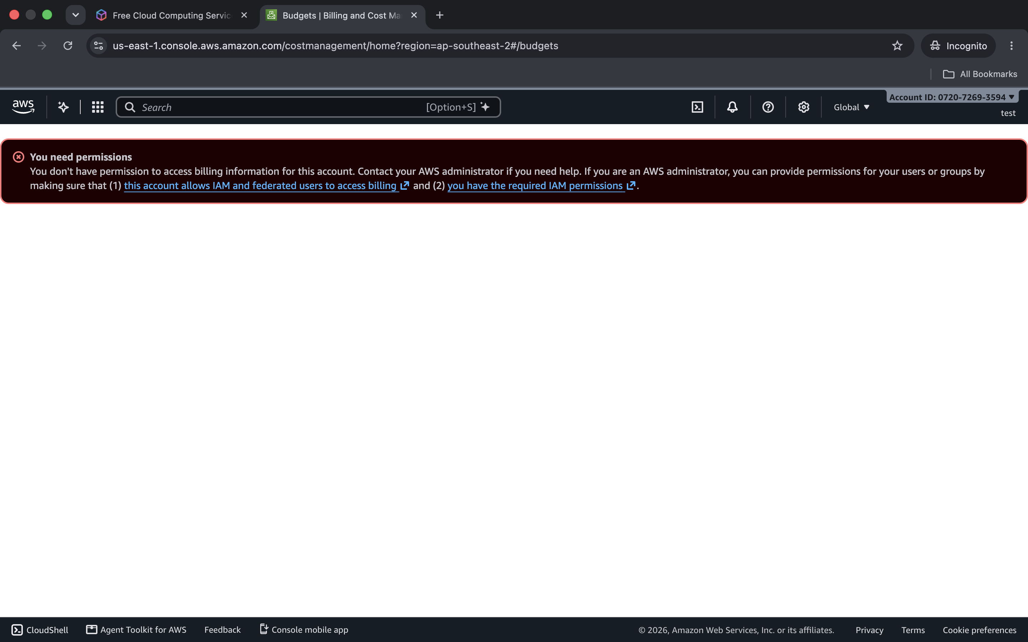
I opened the IAM permissions page to check the AWS Budgets policy.


