
Department of CSE

B.Tech. CSE Trimester -5

Roll Number: 2520030220
Name: G.ROHITH

Cloud Infrastructure and Services
25CS2206E

LAB RECORD
2026

Experiment - 2
AWS Account Security, EC2 Linux Instance and S3 Bucket Creation
PART A – Multi-Factor Authentication (MFA)
AIM: To protect the AWS account by using multi-factor authentication during sign-in.
Description:
Multi-factor authentication adds a second verification factor to the account sign-in process. The supplied screenshot shows an AWS sign-in requesting a passkey and macOS Touch ID.
Steps:
Step 1: Open the AWS sign-in page and enter the account credentials.
Step 2: When AWS requests additional verification, choose the registered passkey or security key.
Step 3: Complete the Touch ID verification on the Mac to proceed with sign-in. The screenshot documents the MFA challenge; it does not show the original MFA enrollment screens.
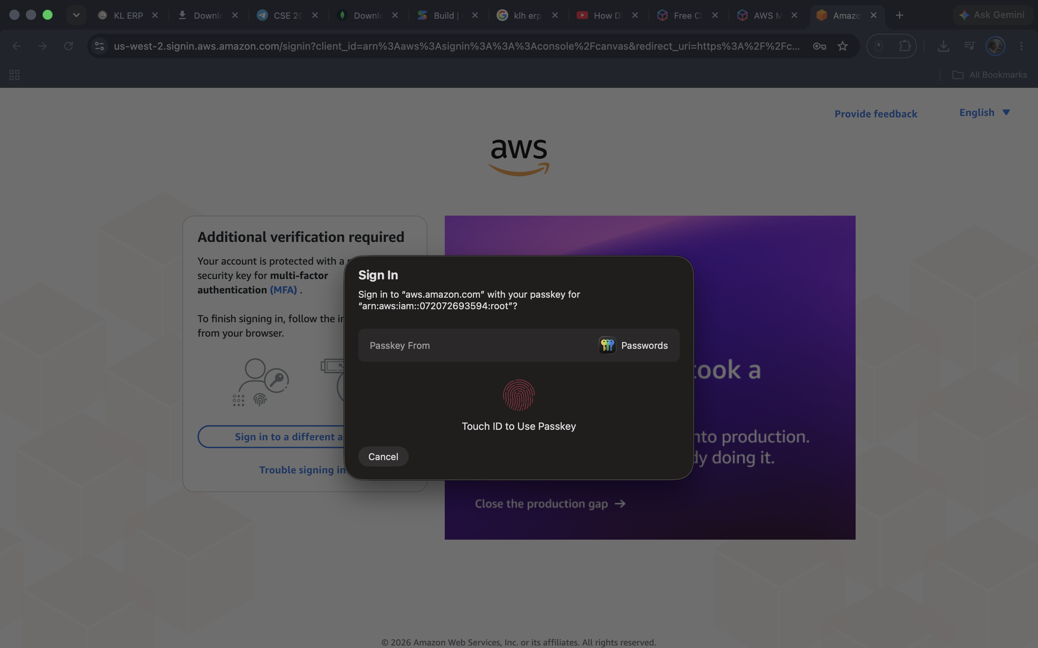
Figure A1: AWS additional verification screen requesting Touch ID for a passkey.
Output:
The account is shown requesting a second authentication factor (passkey/Touch ID). The provided screenshot does not independently confirm completion of the sign-in.

PART B – Launching an EC2 Instance and Using the Linux Terminal
AIM: To launch an Amazon EC2 virtual machine, connect to it through the browser and execute basic Linux commands.
Description:
Amazon EC2 provides virtual servers in the cloud. The screenshots show an Amazon Linux 2023 instance named MY_MACBOOK in the Europe (Stockholm) region and a browser-based EC2 Instance Connect terminal.
Steps:
Step 1: In the EC2 console, select Launch instance, choose an Amazon Linux image, configure the instance and launch it. The screenshot confirms that the launch was initiated successfully.
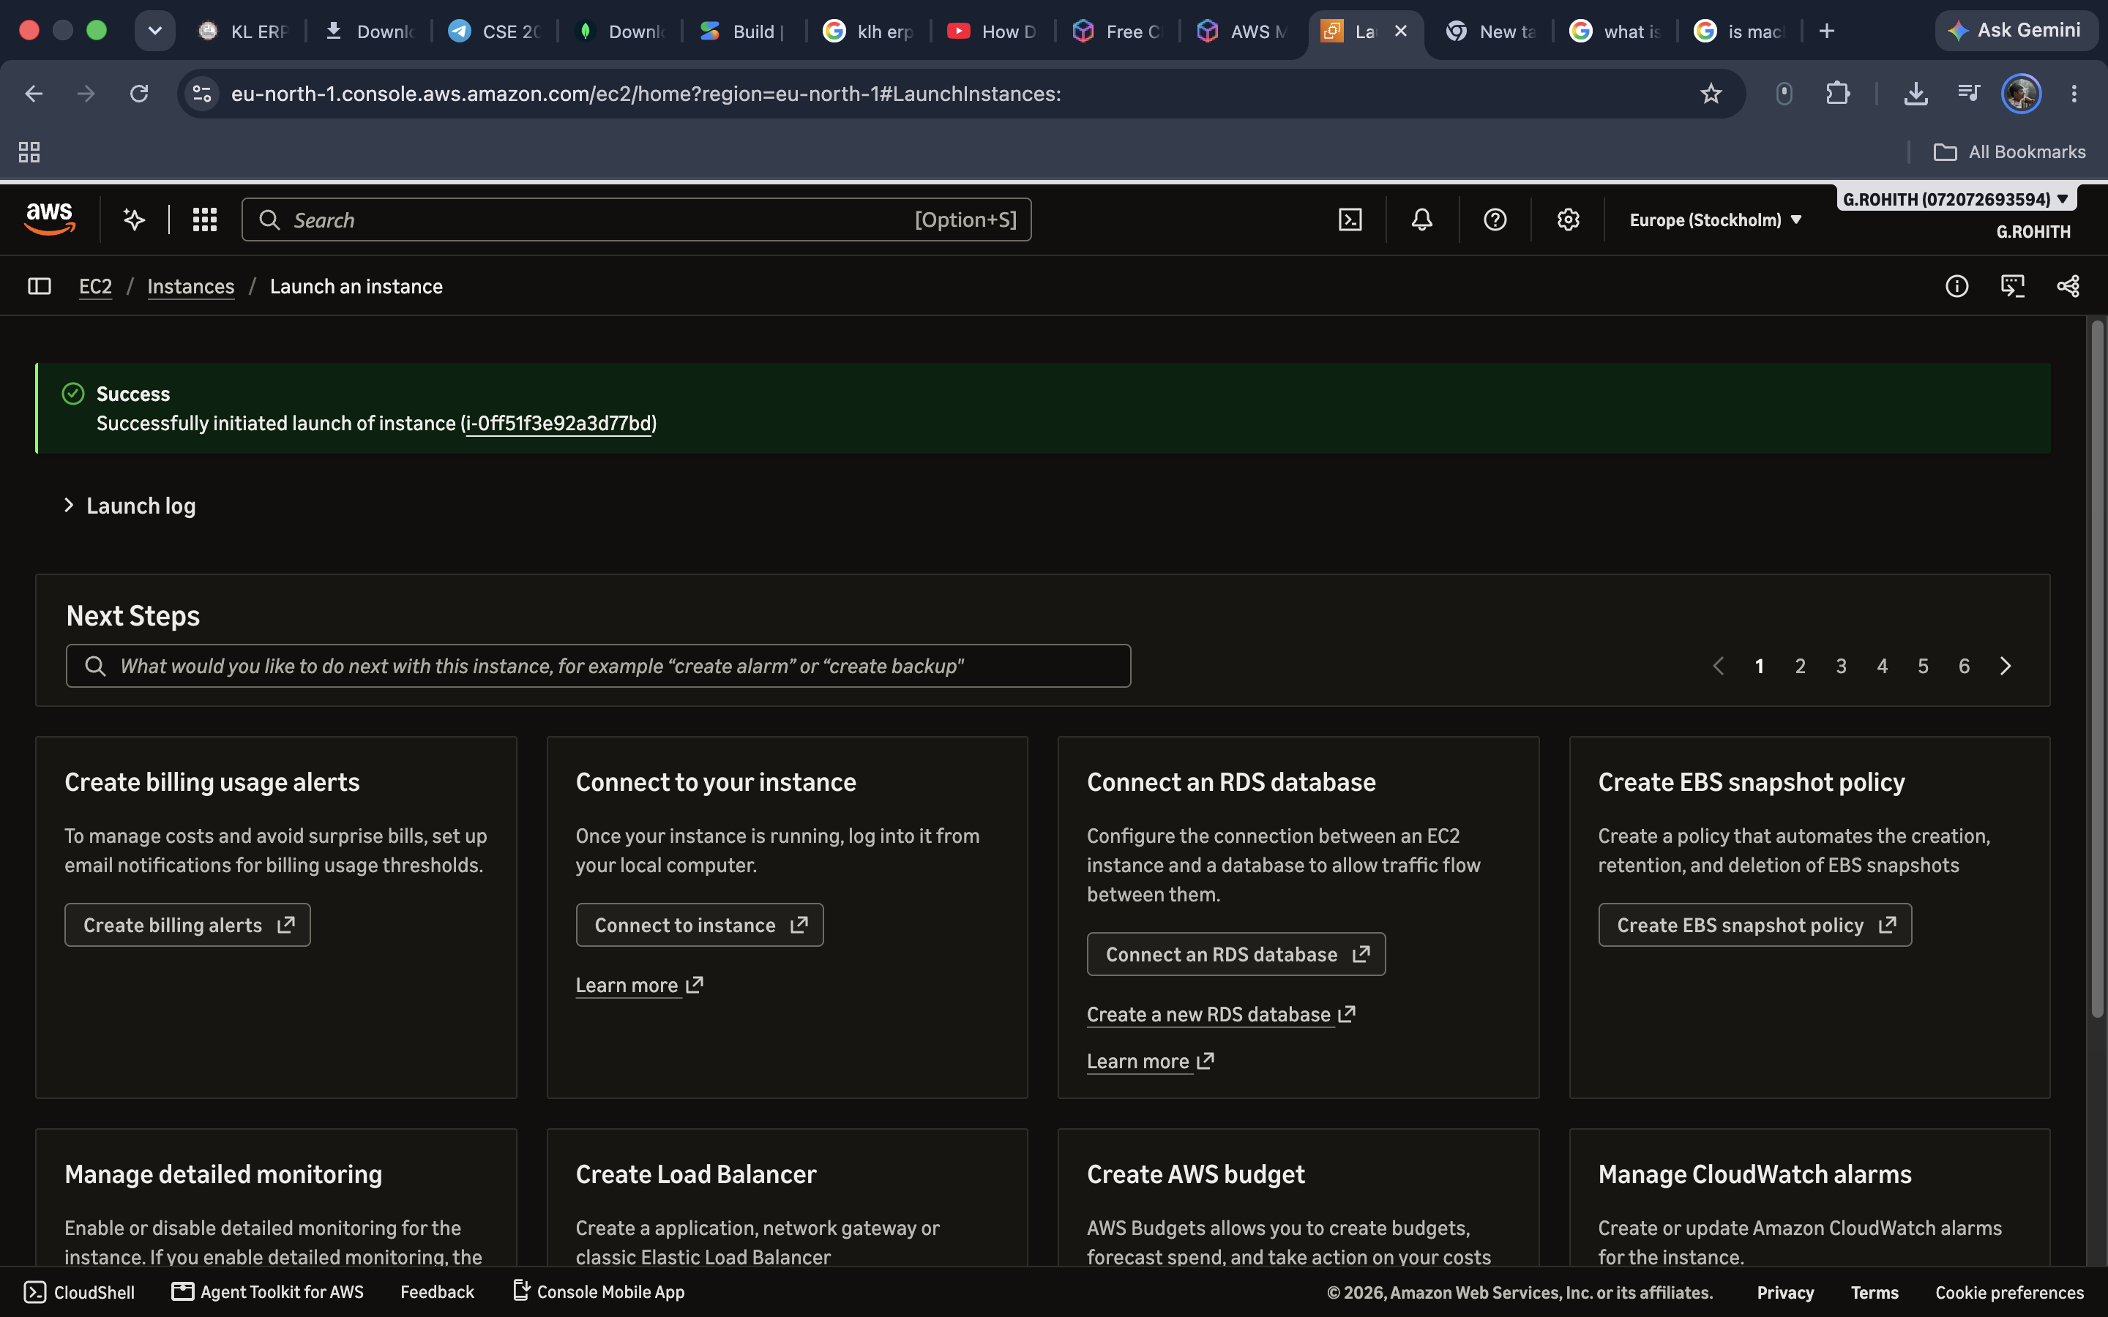
Figure B1: EC2 instance launch confirmation.
Step 2: Open Instances and select MY_MACBOOK. Verify that the instance status is Running.
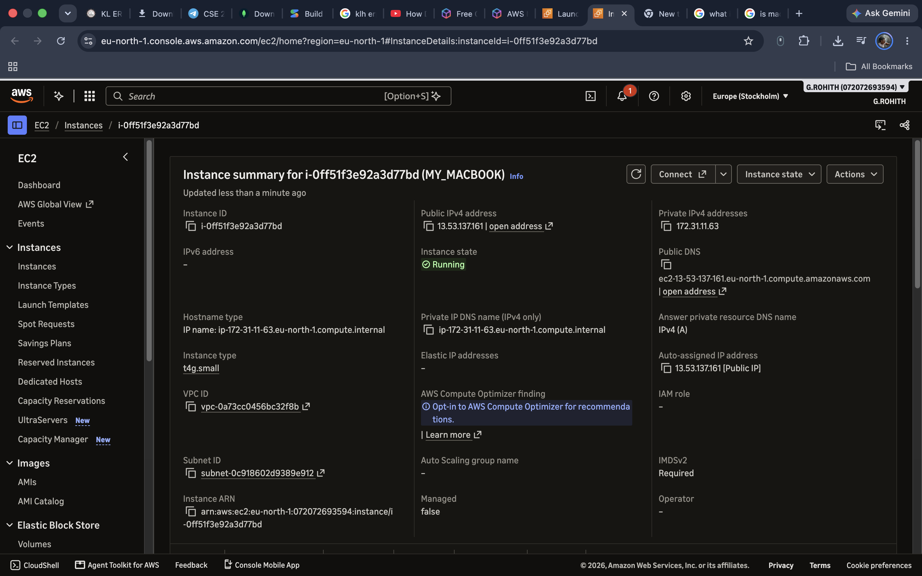
Figure B2: Instance summary showing the running EC2 instance.
Step 3: Click Connect. Under In web browser, select EC2 Instance Connect and verify the instance status checks.
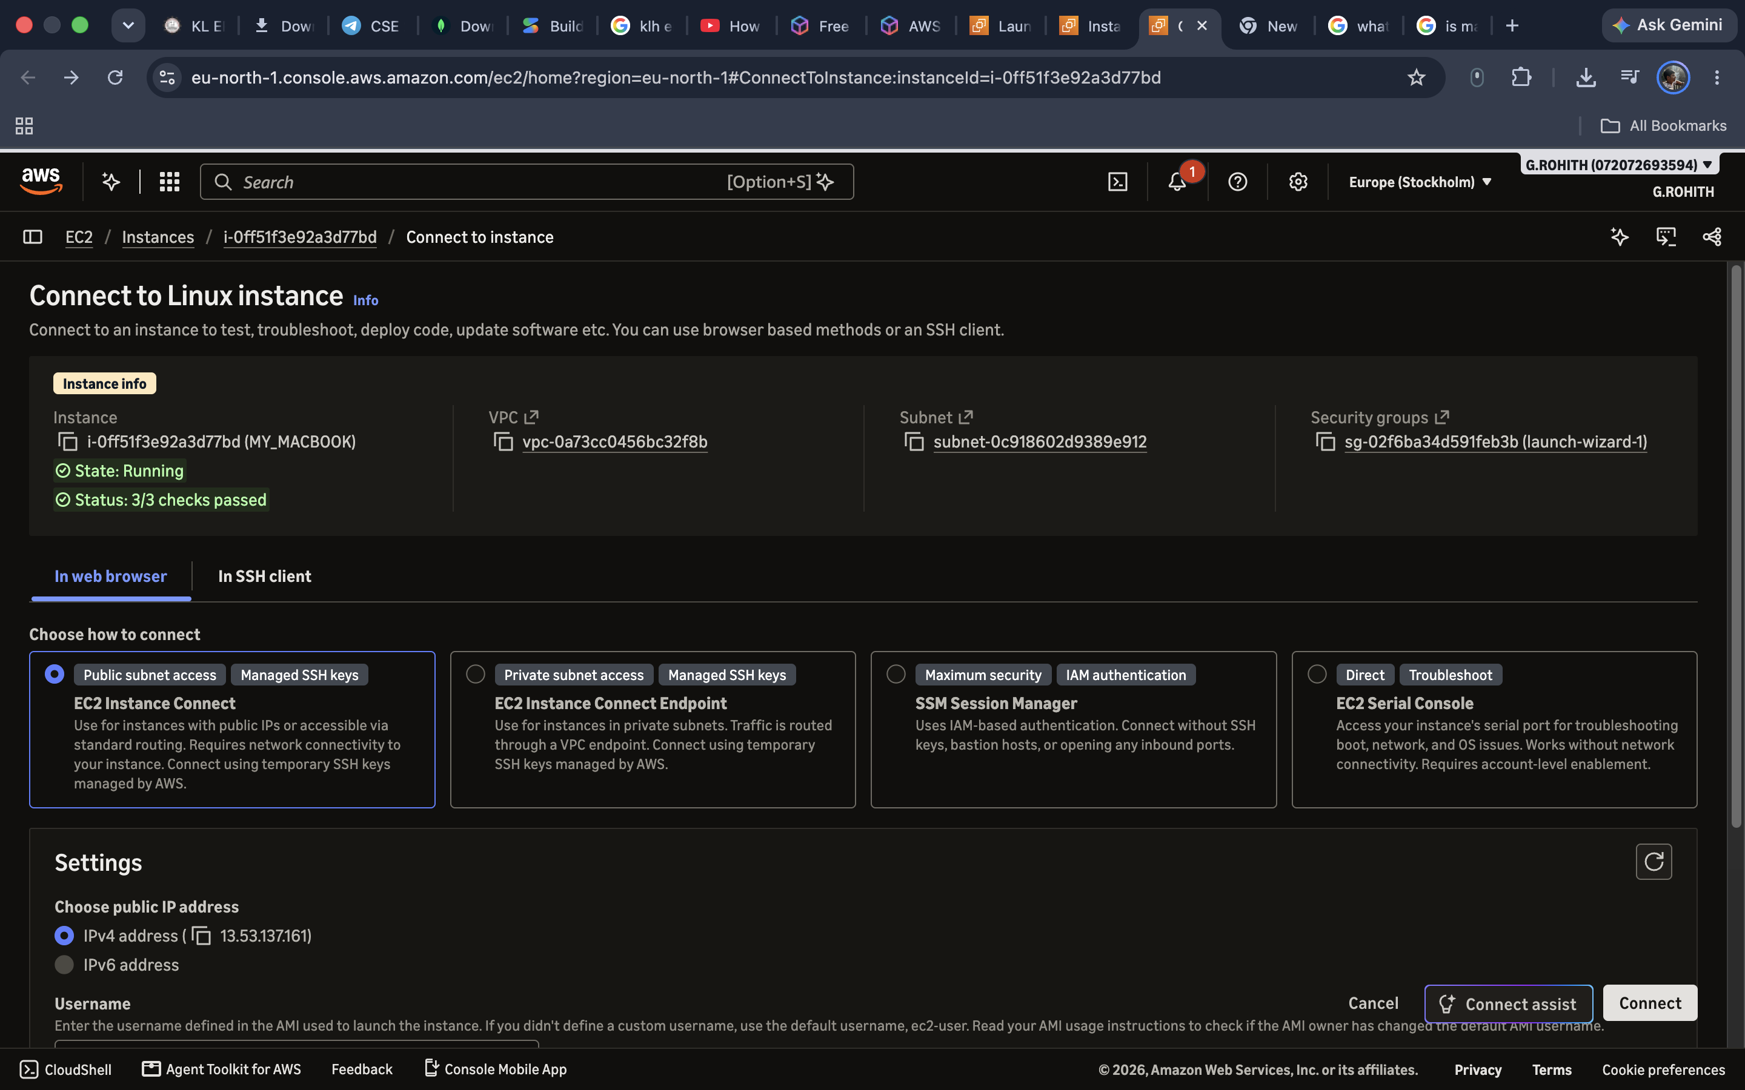
Figure B3: EC2 Instance Connect page.
Step 4: Click Connect to open the Amazon Linux 2023 terminal. Use lowercase ls to list files. The screenshot shows an initial uppercase LS error, followed by successful lowercase ls and mkdir commands.
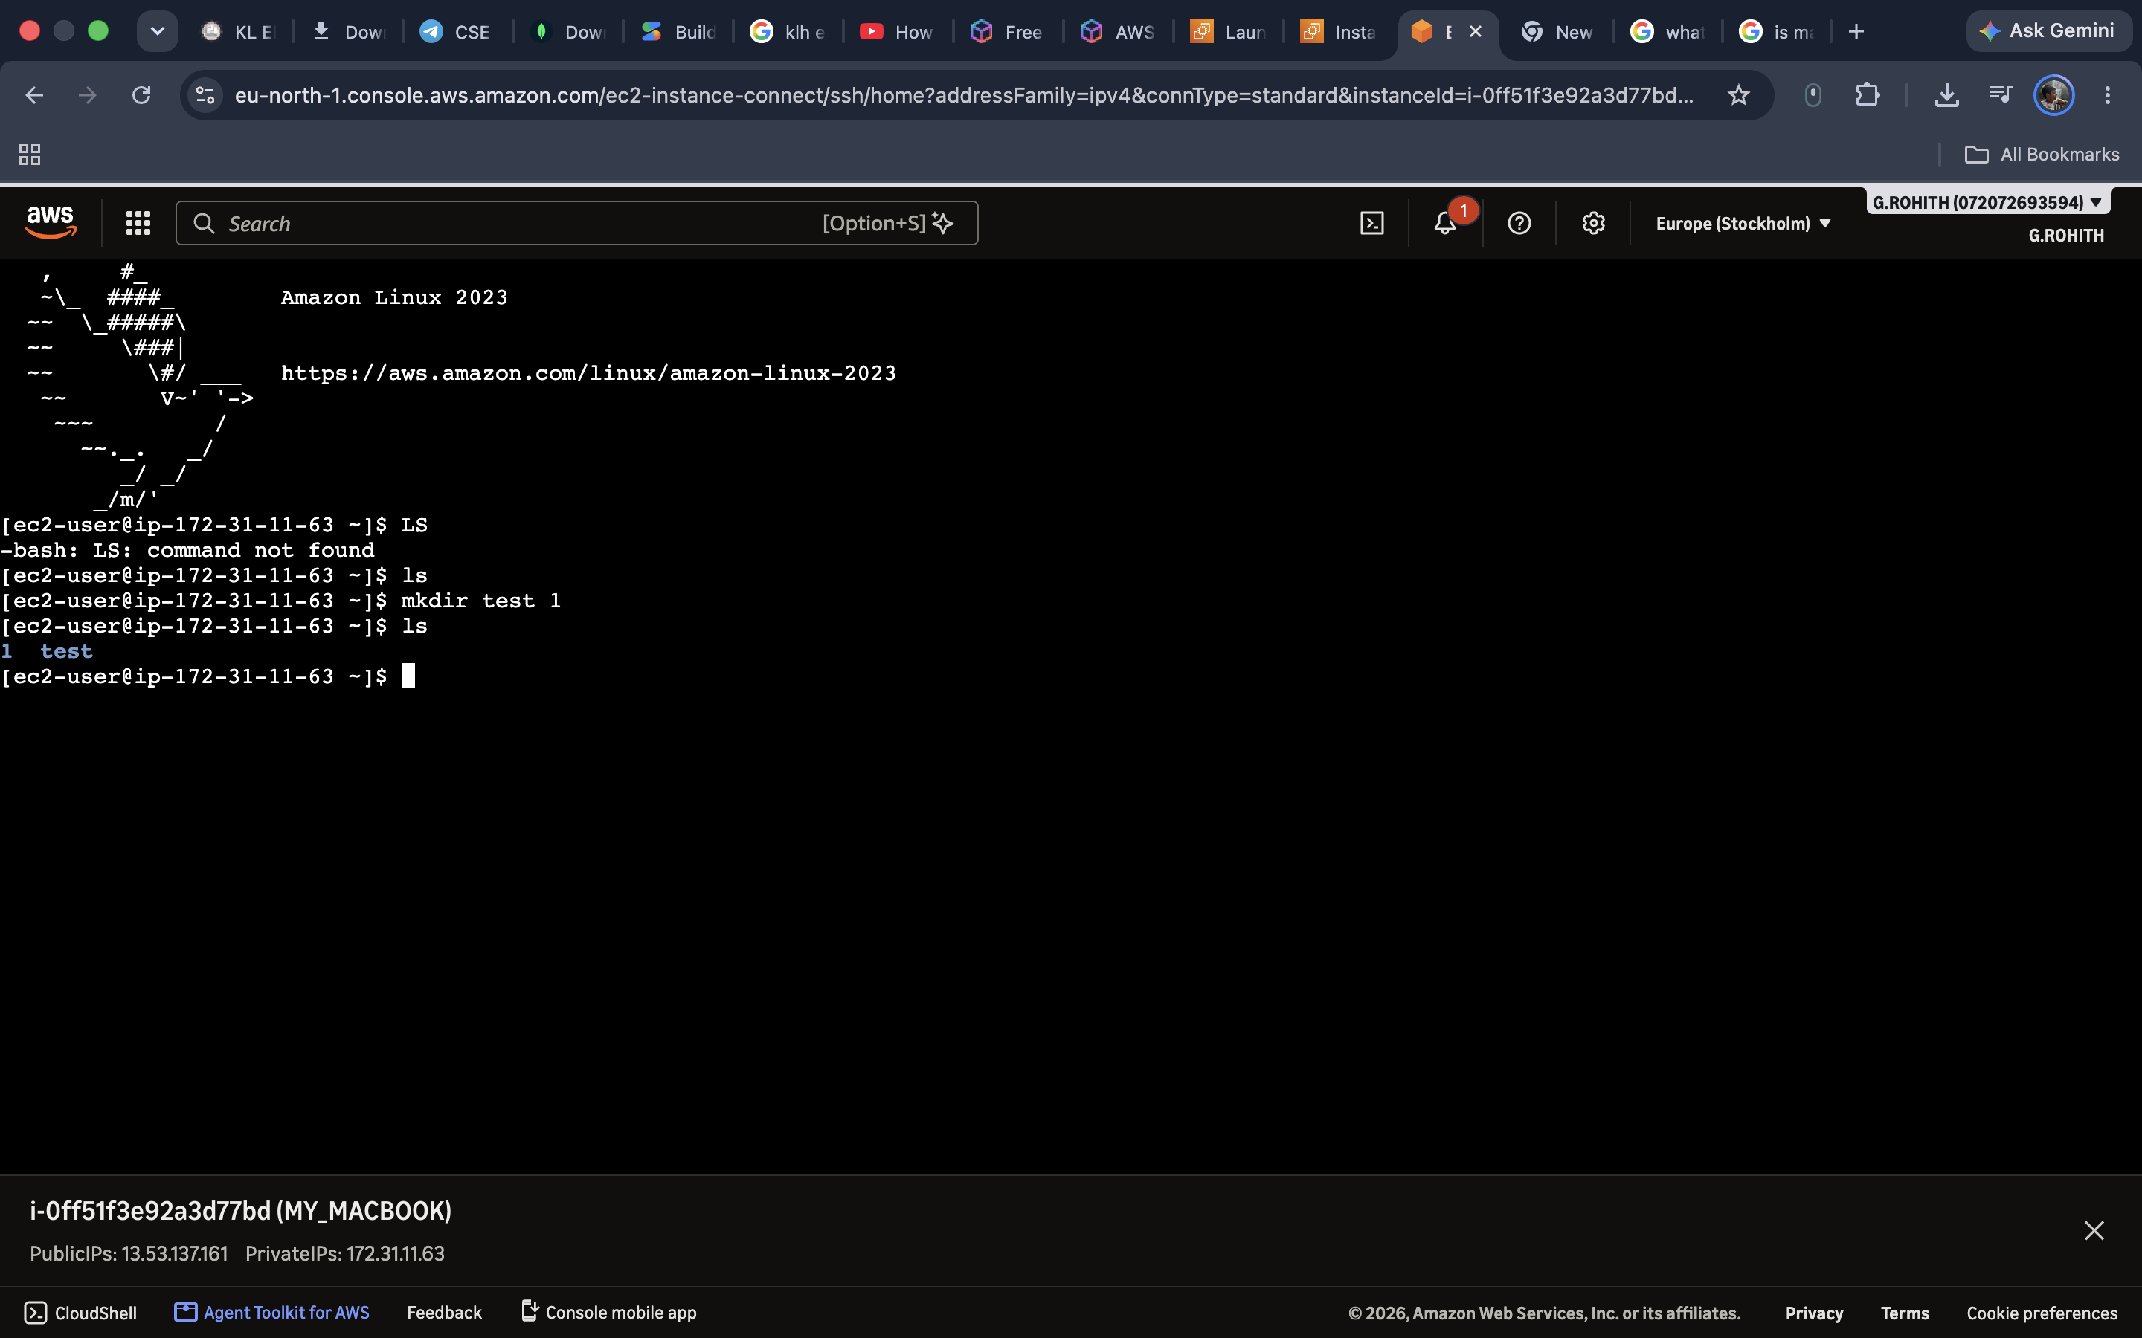
Figure B4: Linux terminal with ls and mkdir test 1 commands.
Step 5: Run cd test to enter the test directory, touch file1 to create a file, and ls to verify its presence. The screenshot also shows a mistyped s command that returns command not found.
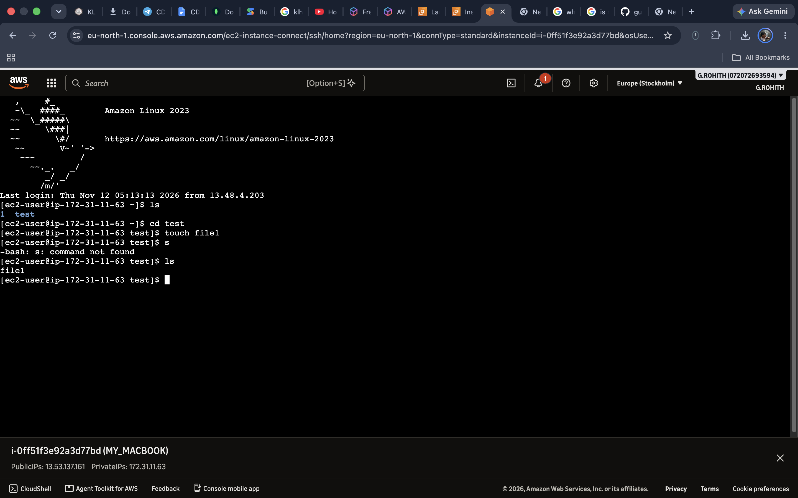
Figure B5: Terminal demonstrating cd test, touch file1 and ls.
Output:
The EC2 instance was launched and connected successfully. Linux commands were executed, and file1 was visible inside the test directory.

PART C – Creating an Amazon S3 Bucket
AIM: To create and inspect a general-purpose Amazon S3 bucket using the AWS Management Console.
Description:
Amazon Simple Storage Service (S3) provides object storage. A bucket is a container for objects. The screenshots show the bucket creation form, an S3 bucket listing, a successful creation notification and the properties of the new bucket.
Steps:
Step 1: Open Amazon S3, go to Buckets and select Create bucket.
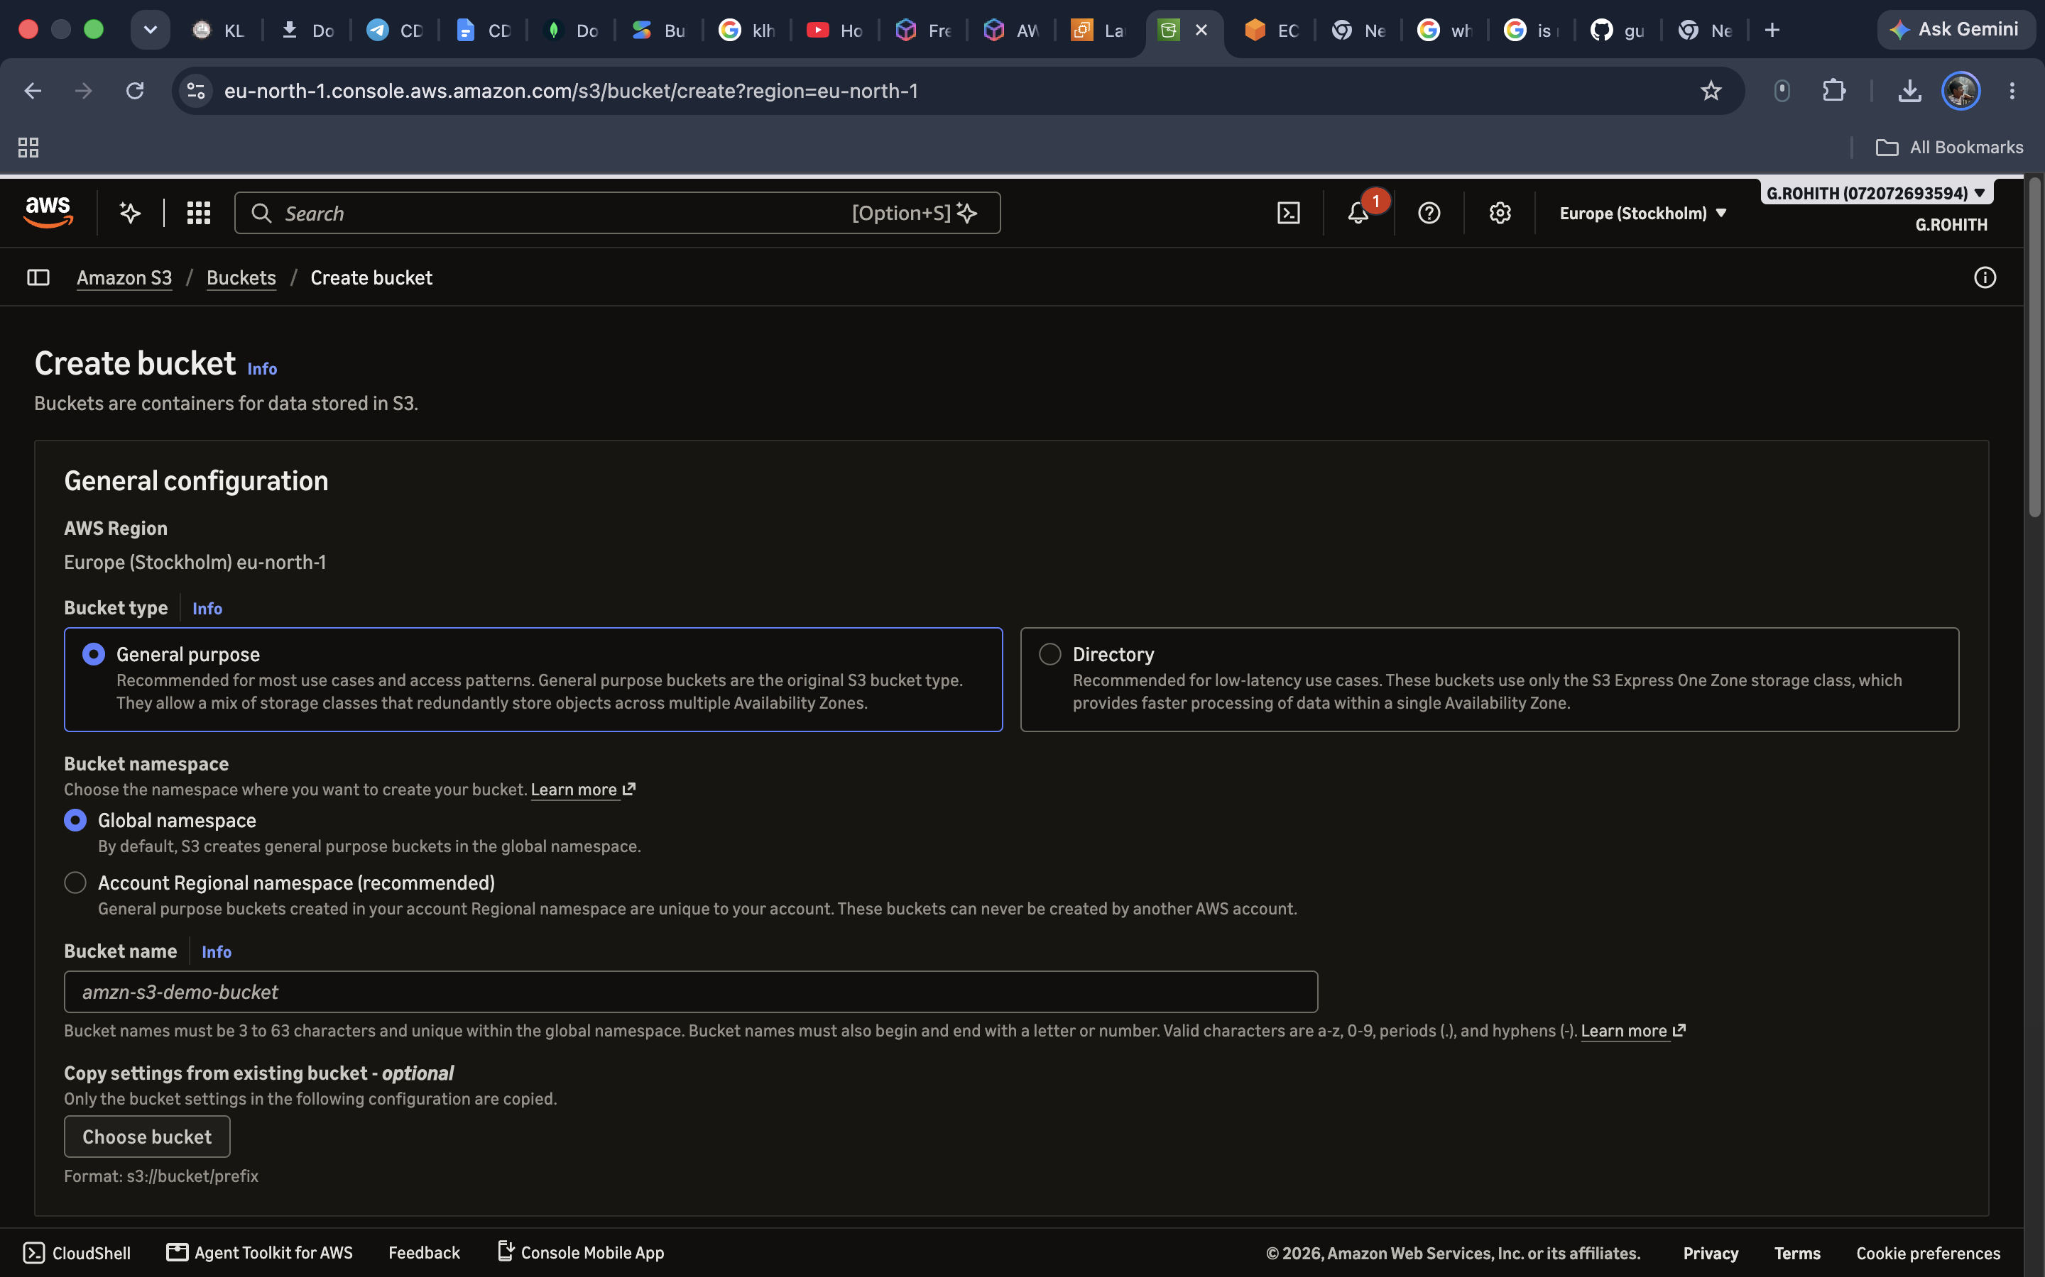
Figure C1: Create bucket page with general-purpose bucket settings.
Step 2: Select the AWS Region (Europe/Stockholm), choose General purpose and enter a unique bucket name. Review the remaining settings and select Create bucket.
Step 3: Return to the Buckets page to view the bucket list. The supplied listing also shows an existing bucket named gunnam-rohith.
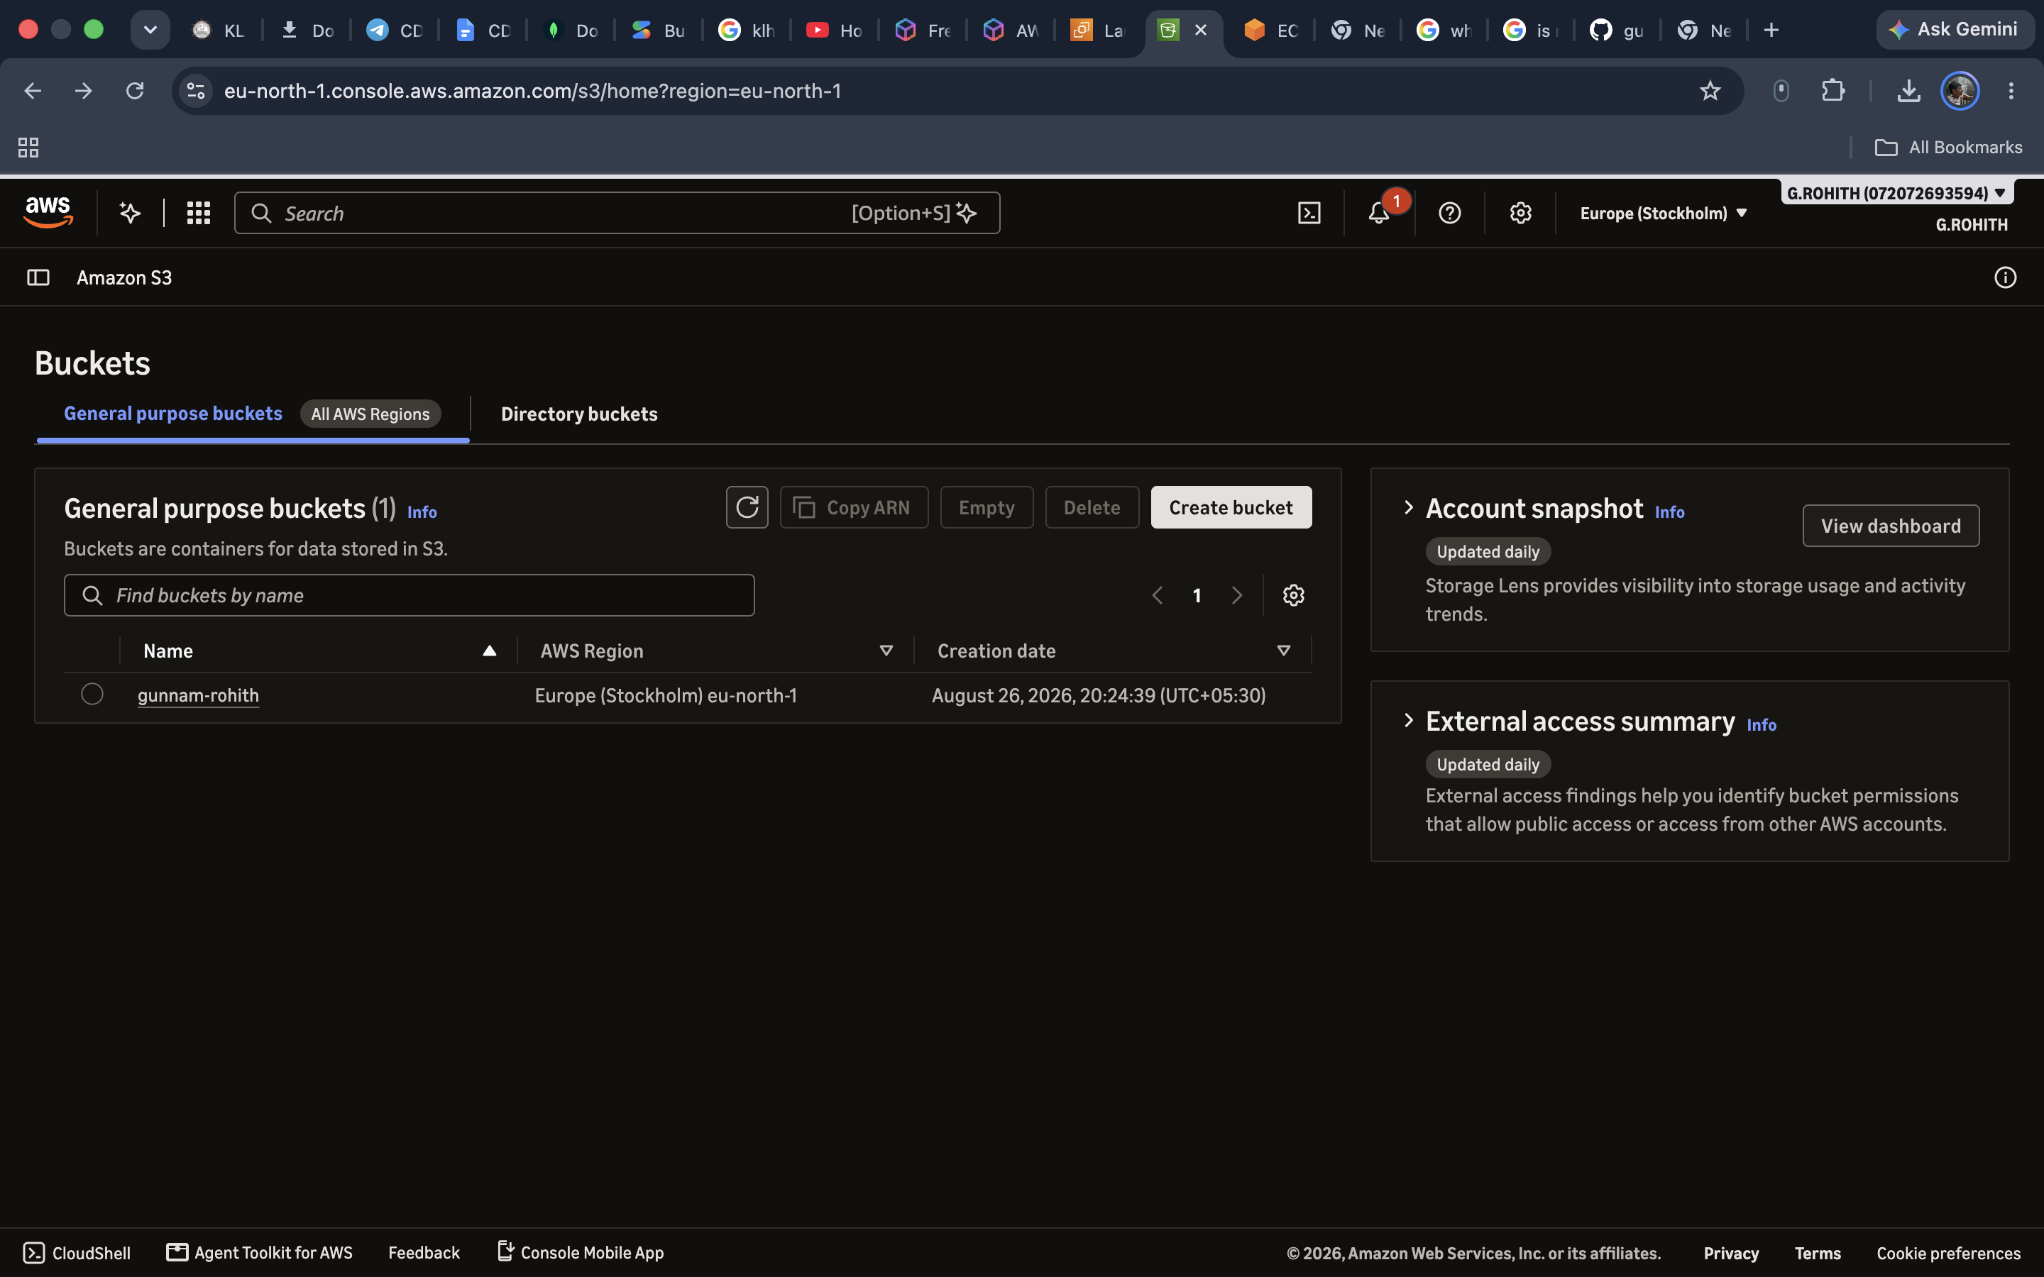
Figure C2: S3 bucket listing showing an existing bucket.
Step 4: Confirm the success message for the newly created bucket gunnamrohith and open its Objects tab. The bucket currently has zero objects.
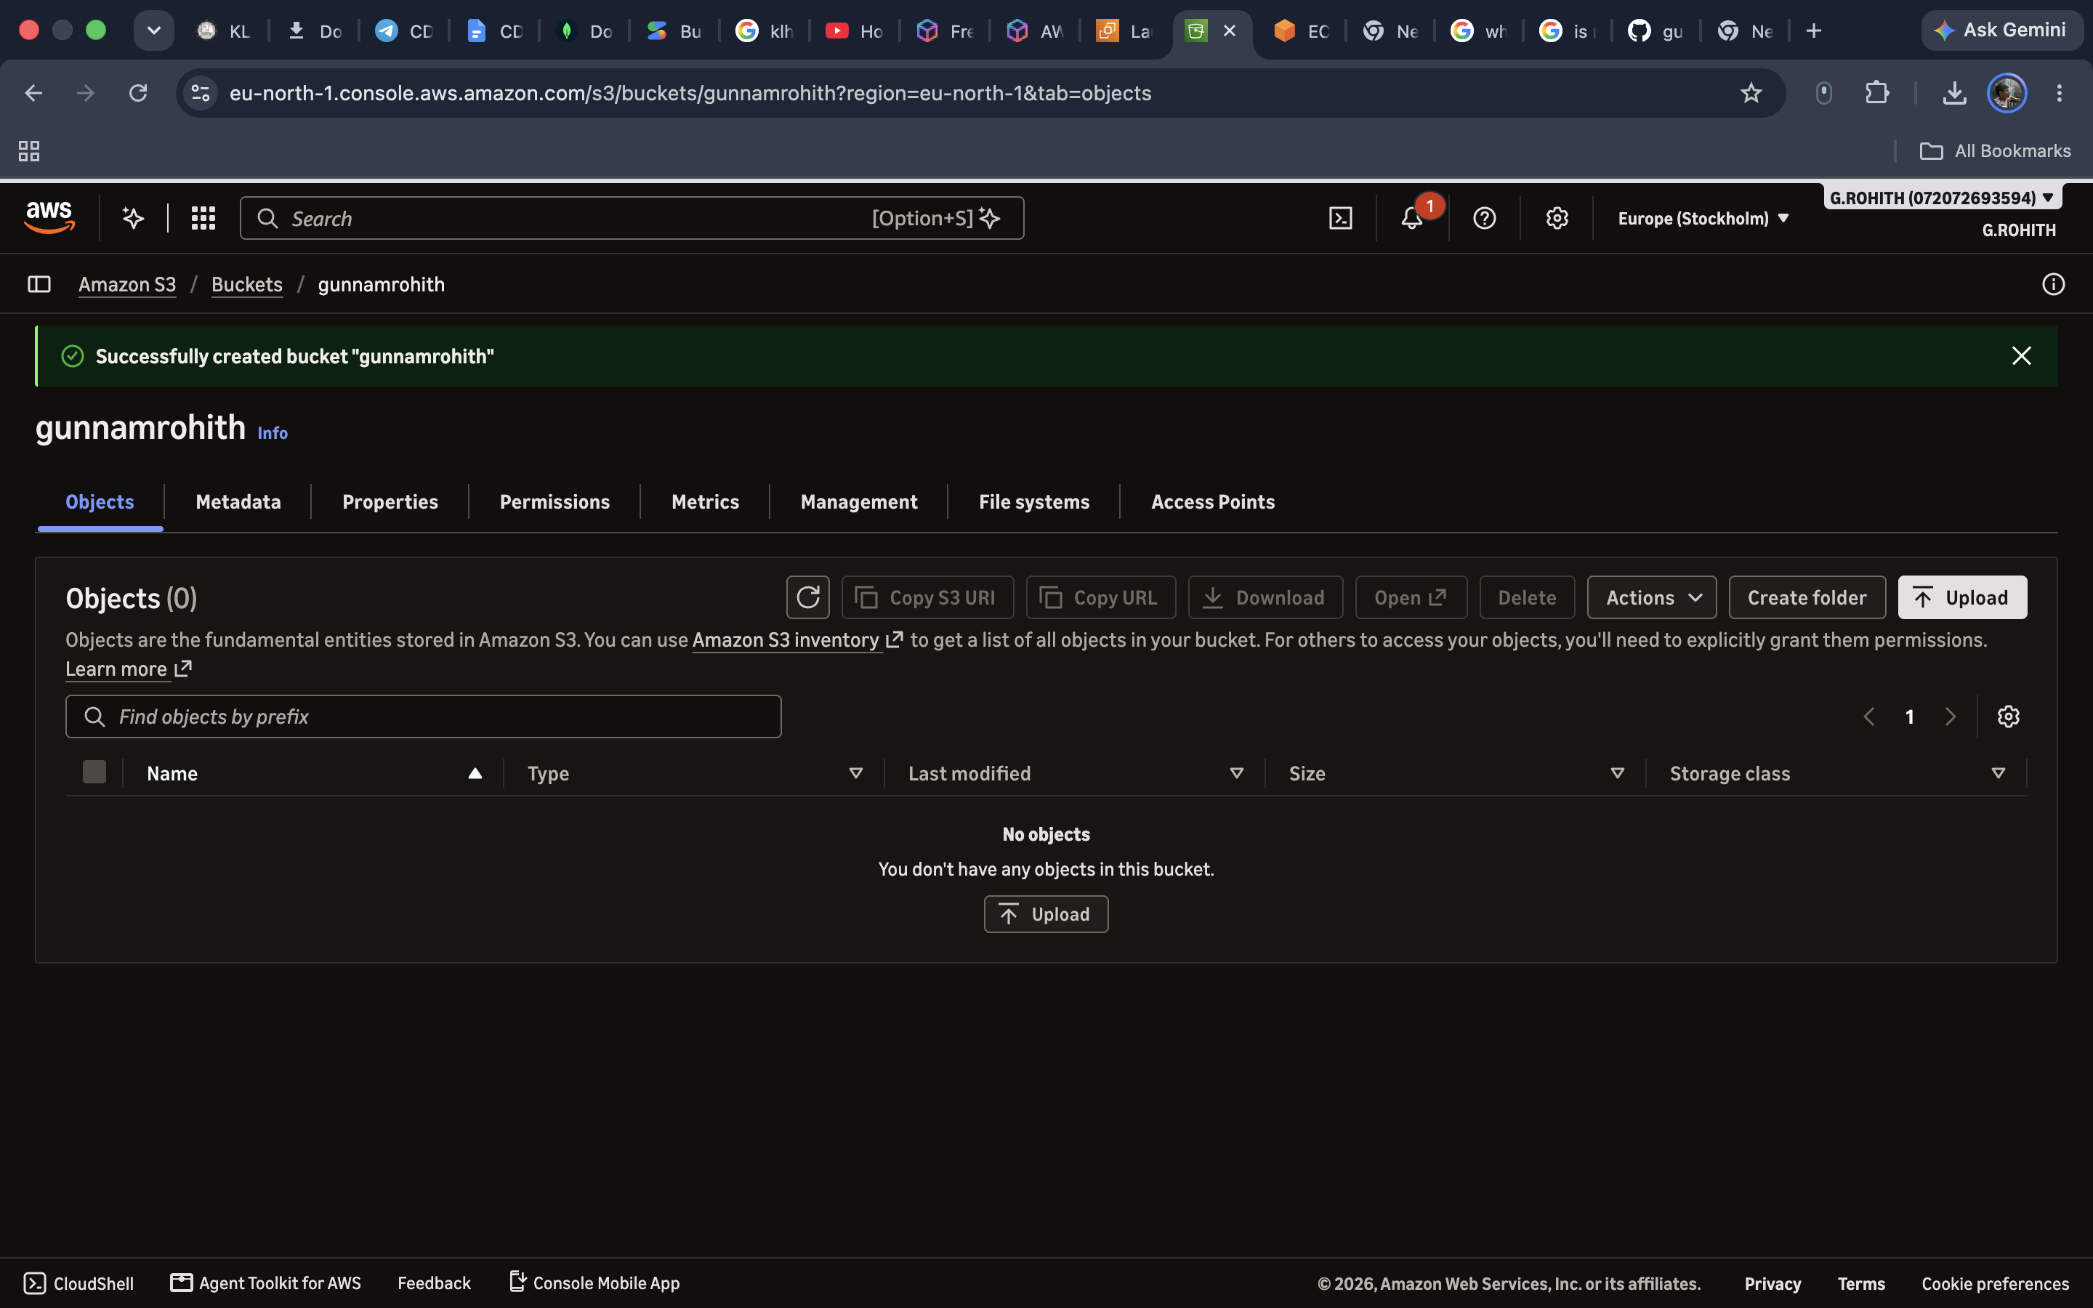
Figure C3: Successful creation of bucket gunnamrohith; empty Objects tab.
Step 5: Open the Properties tab to inspect the region, ARN and versioning configuration.
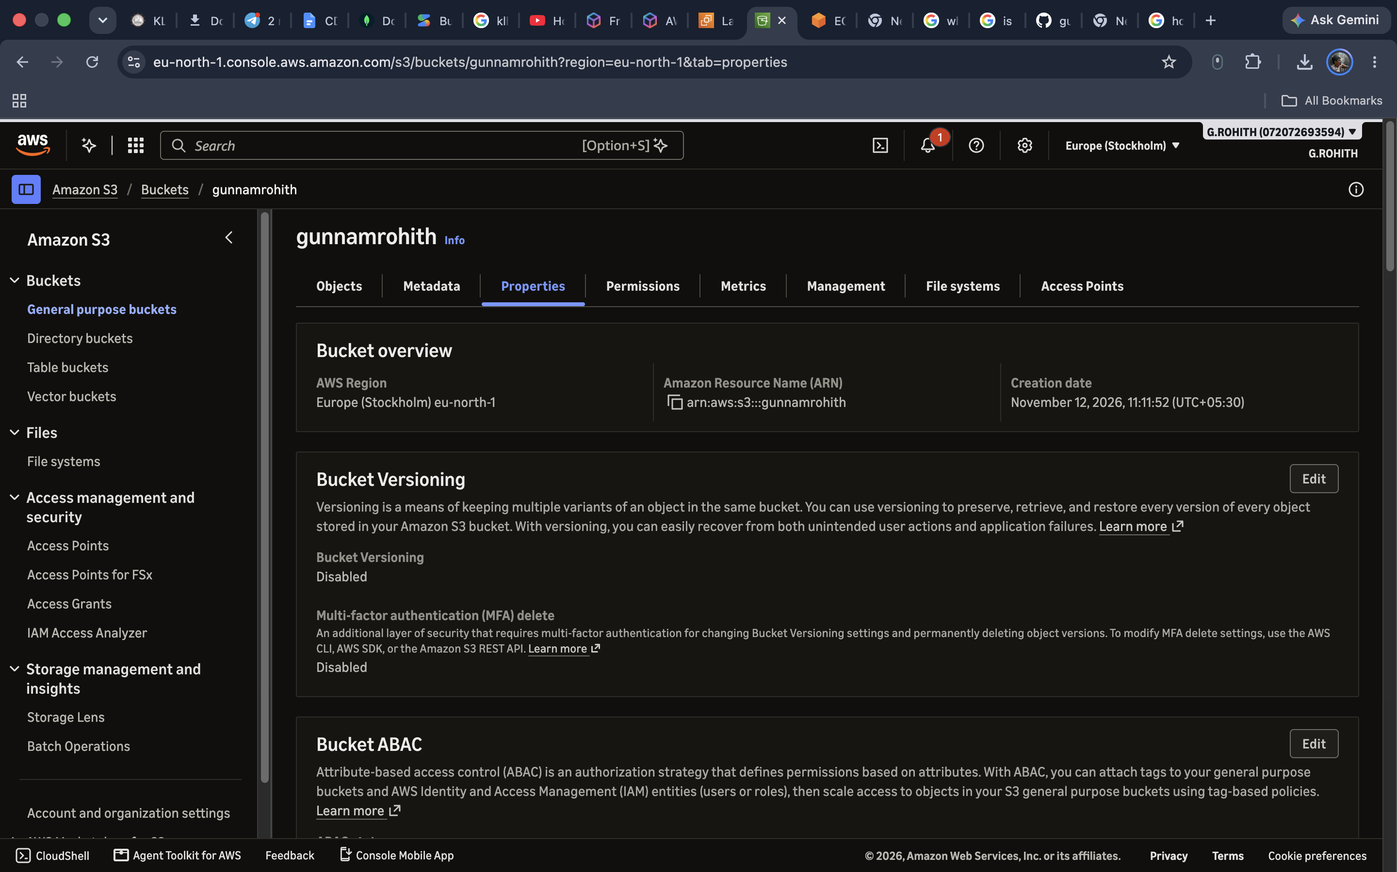
Figure C4: Bucket properties showing region and disabled versioning.
Output:
The S3 bucket gunnamrohith was created successfully in eu-north-1. Its Objects tab showed no uploaded objects, and bucket versioning was disabled.

