
Department of CSE

B.Tech. CSE Trimester -5

2520030220
G.ROHITH

Cloud Infrastructure and Services
25CS2206E

LAB RECORD
2026

Experiment -1
AIM: IAM User with Programmatic Access and Free Tier Billing Alert
Description:
Create an IAM user without console login, create a programmatic access key, and configure a zero spend budget alert in AWS. The screenshots document the completed steps and the billing permissions issue encountered.
Steps:
I created the IAM user test without enabling console login.
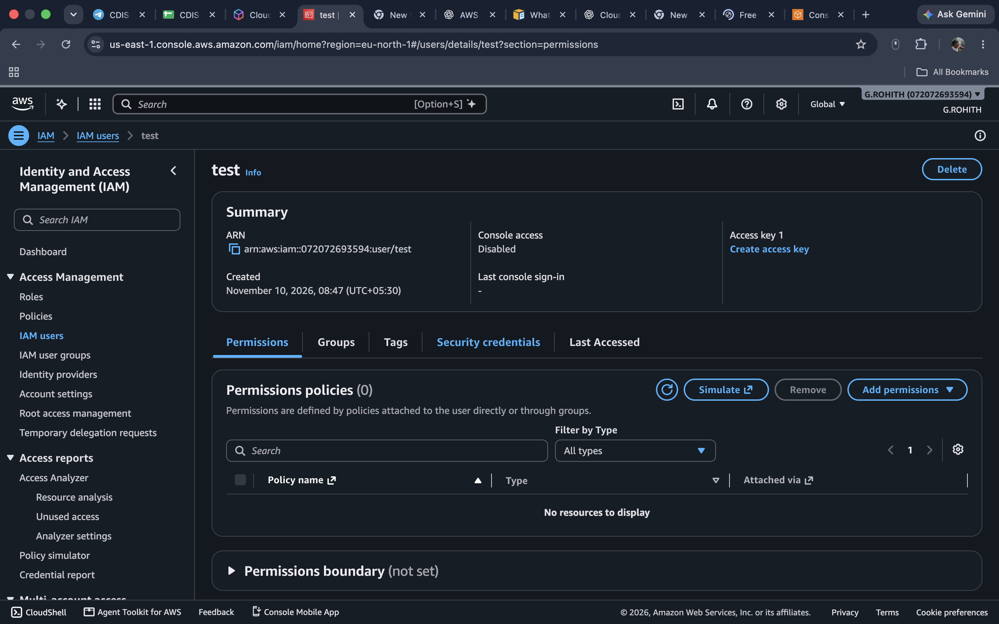
I checked the security credentials and confirmed that console access was disabled.
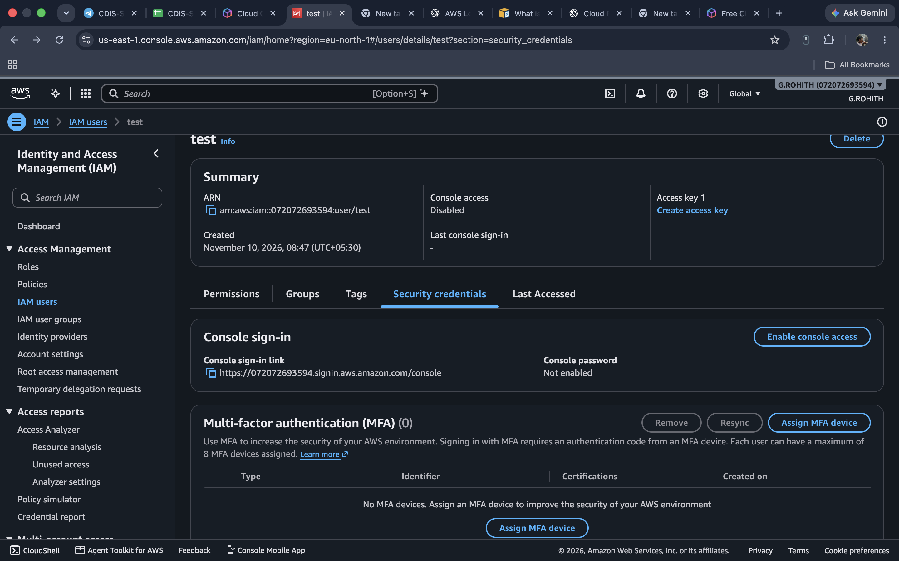
I opened Create access key and selected the use case for programmatic access.
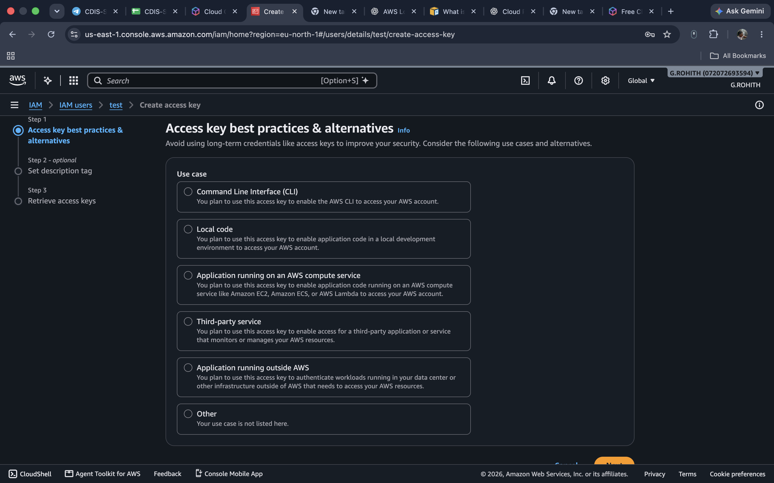
I created the access key and downloaded the CSV containing the access key ID and secret key.
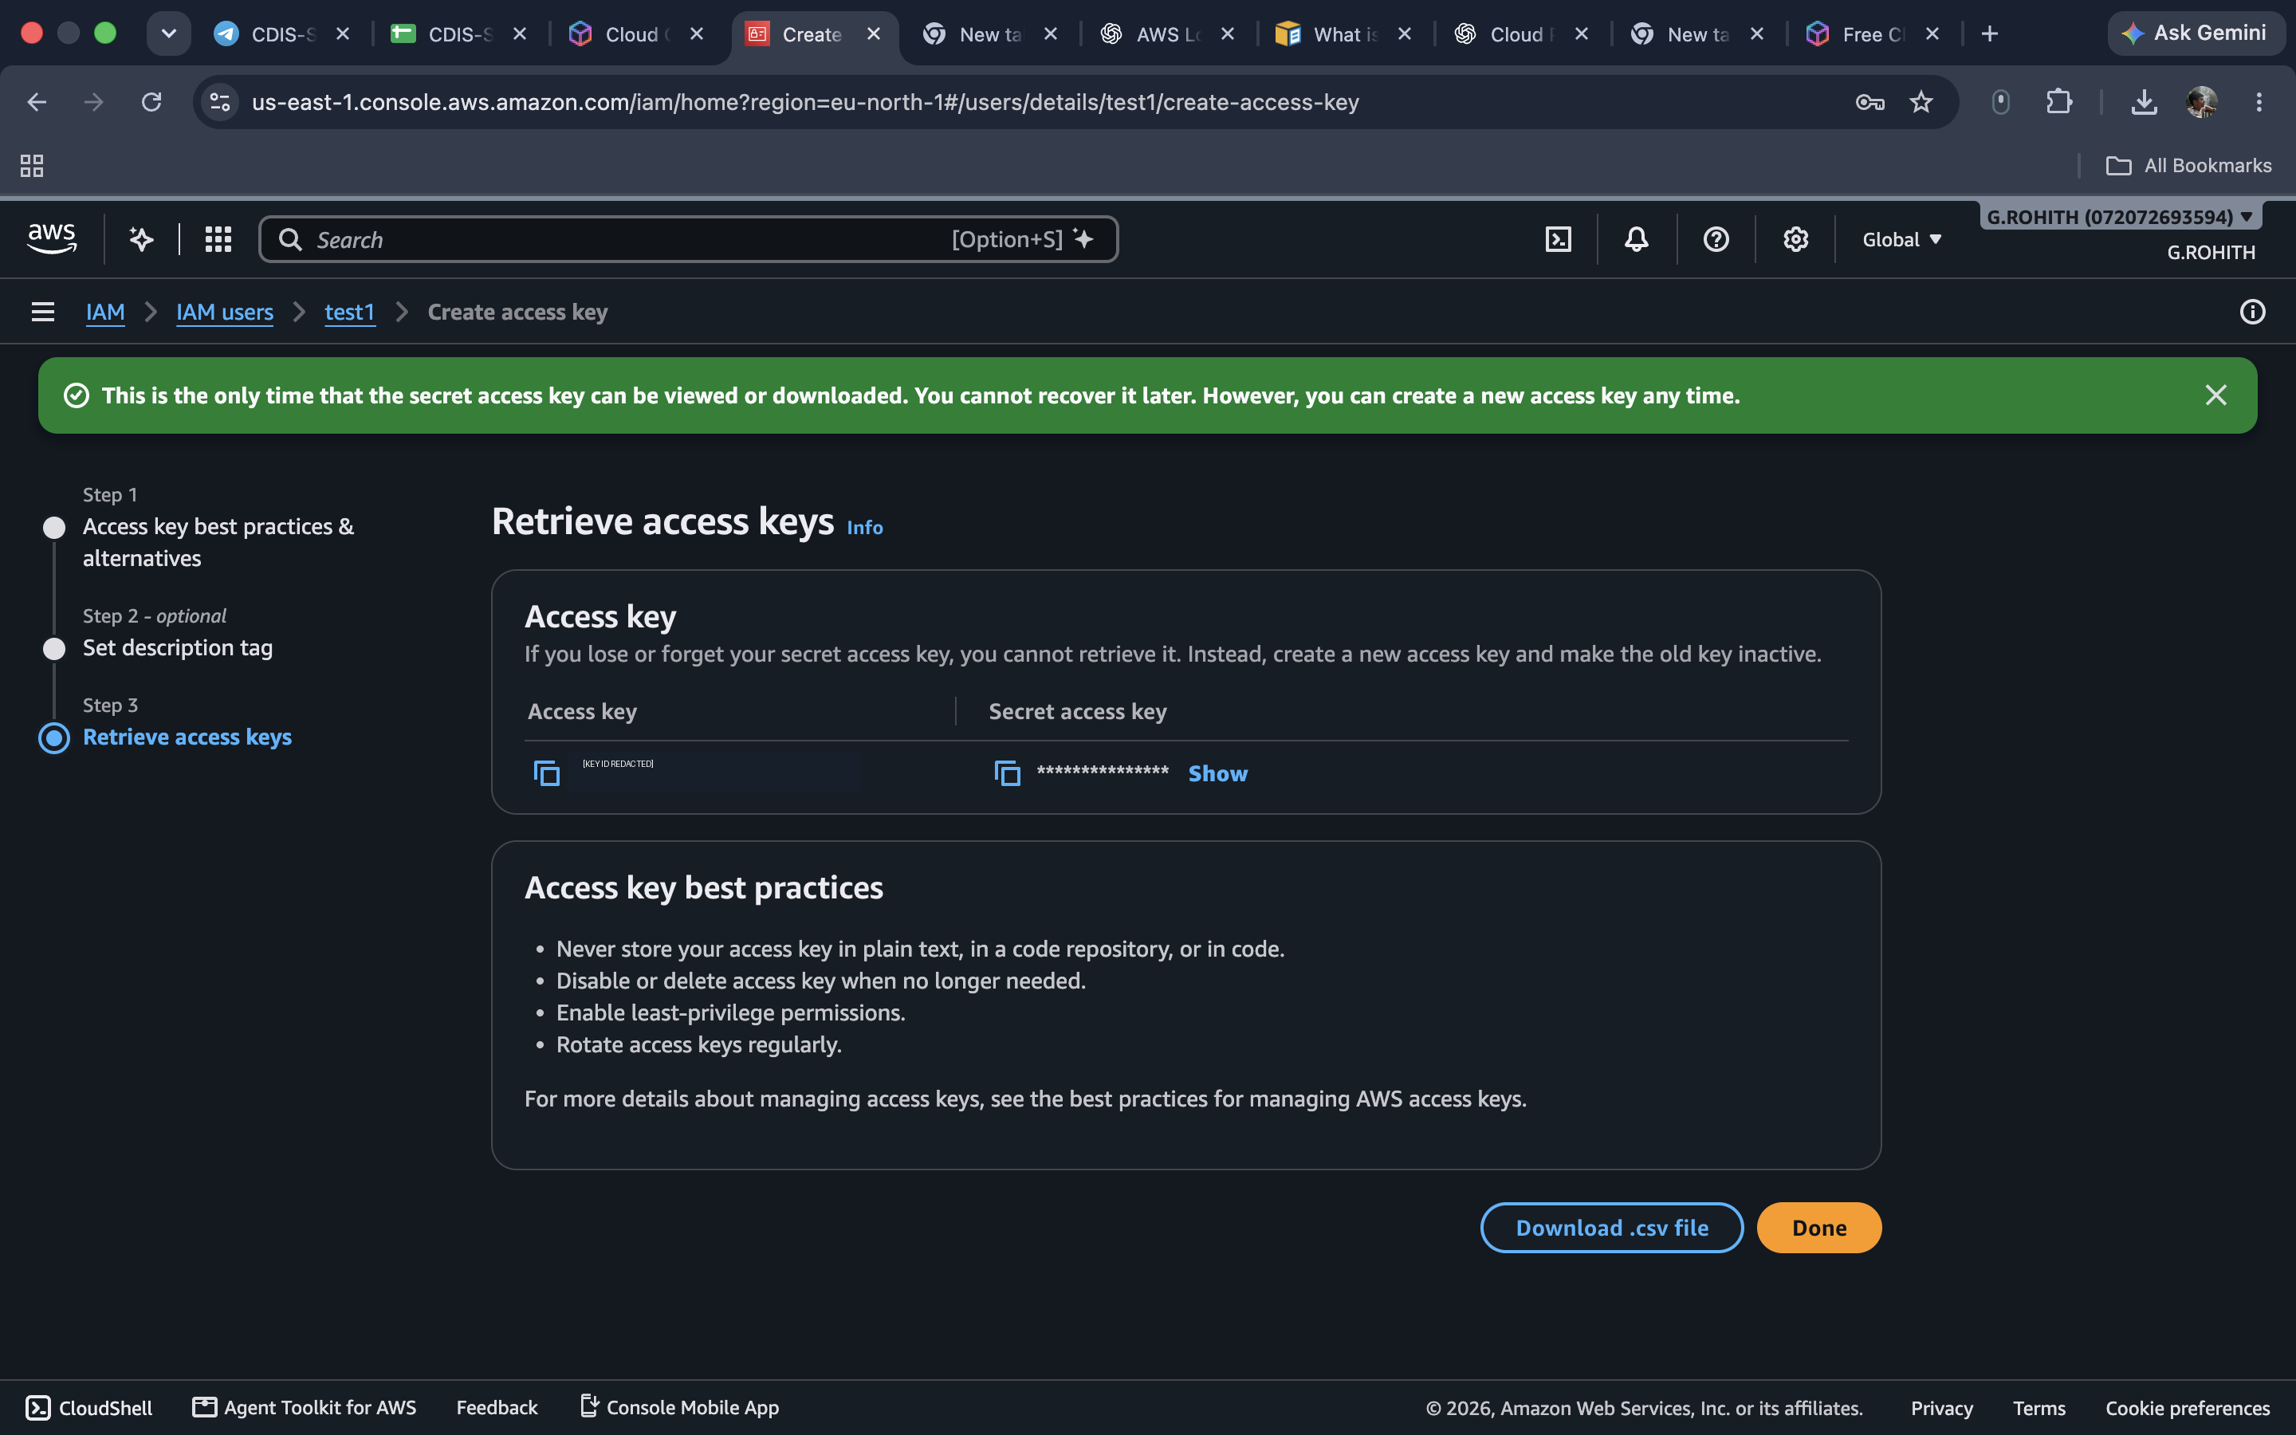
I opened Billing and Cost Management and selected Create budget.
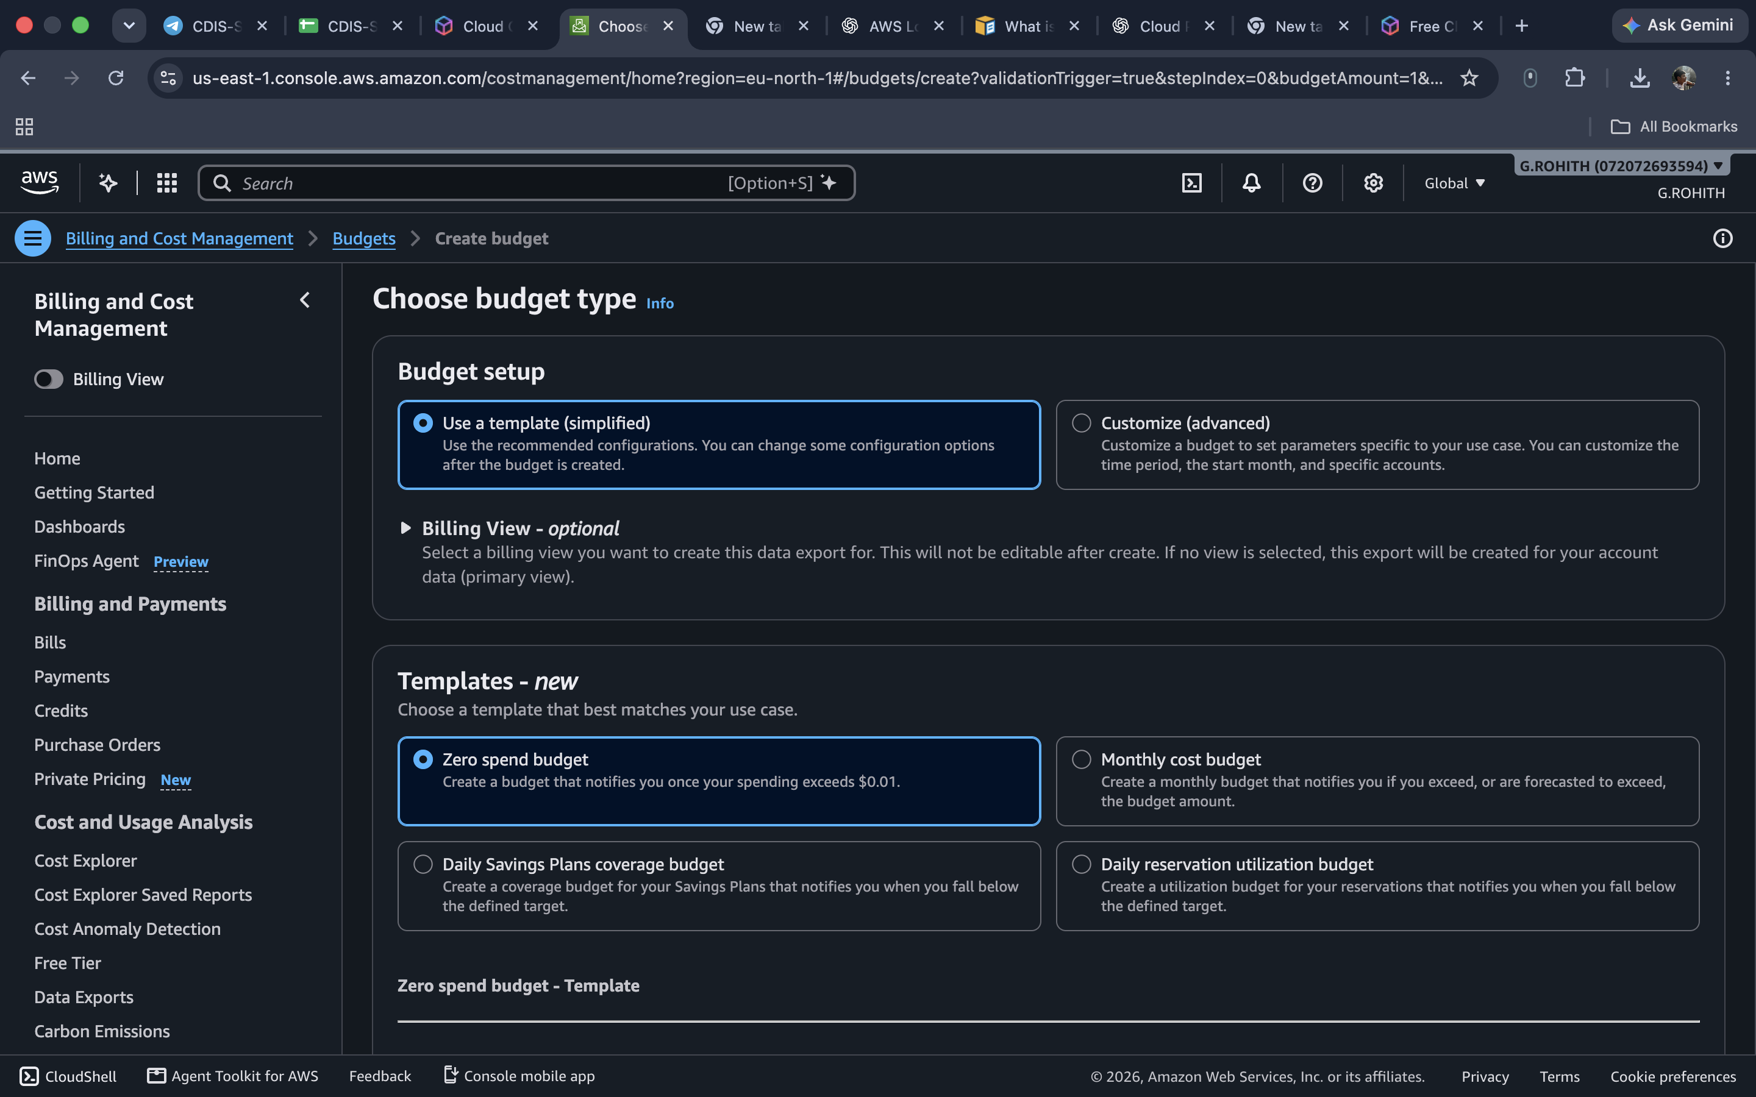
I selected the Zero spend budget option to set up a spending alert.
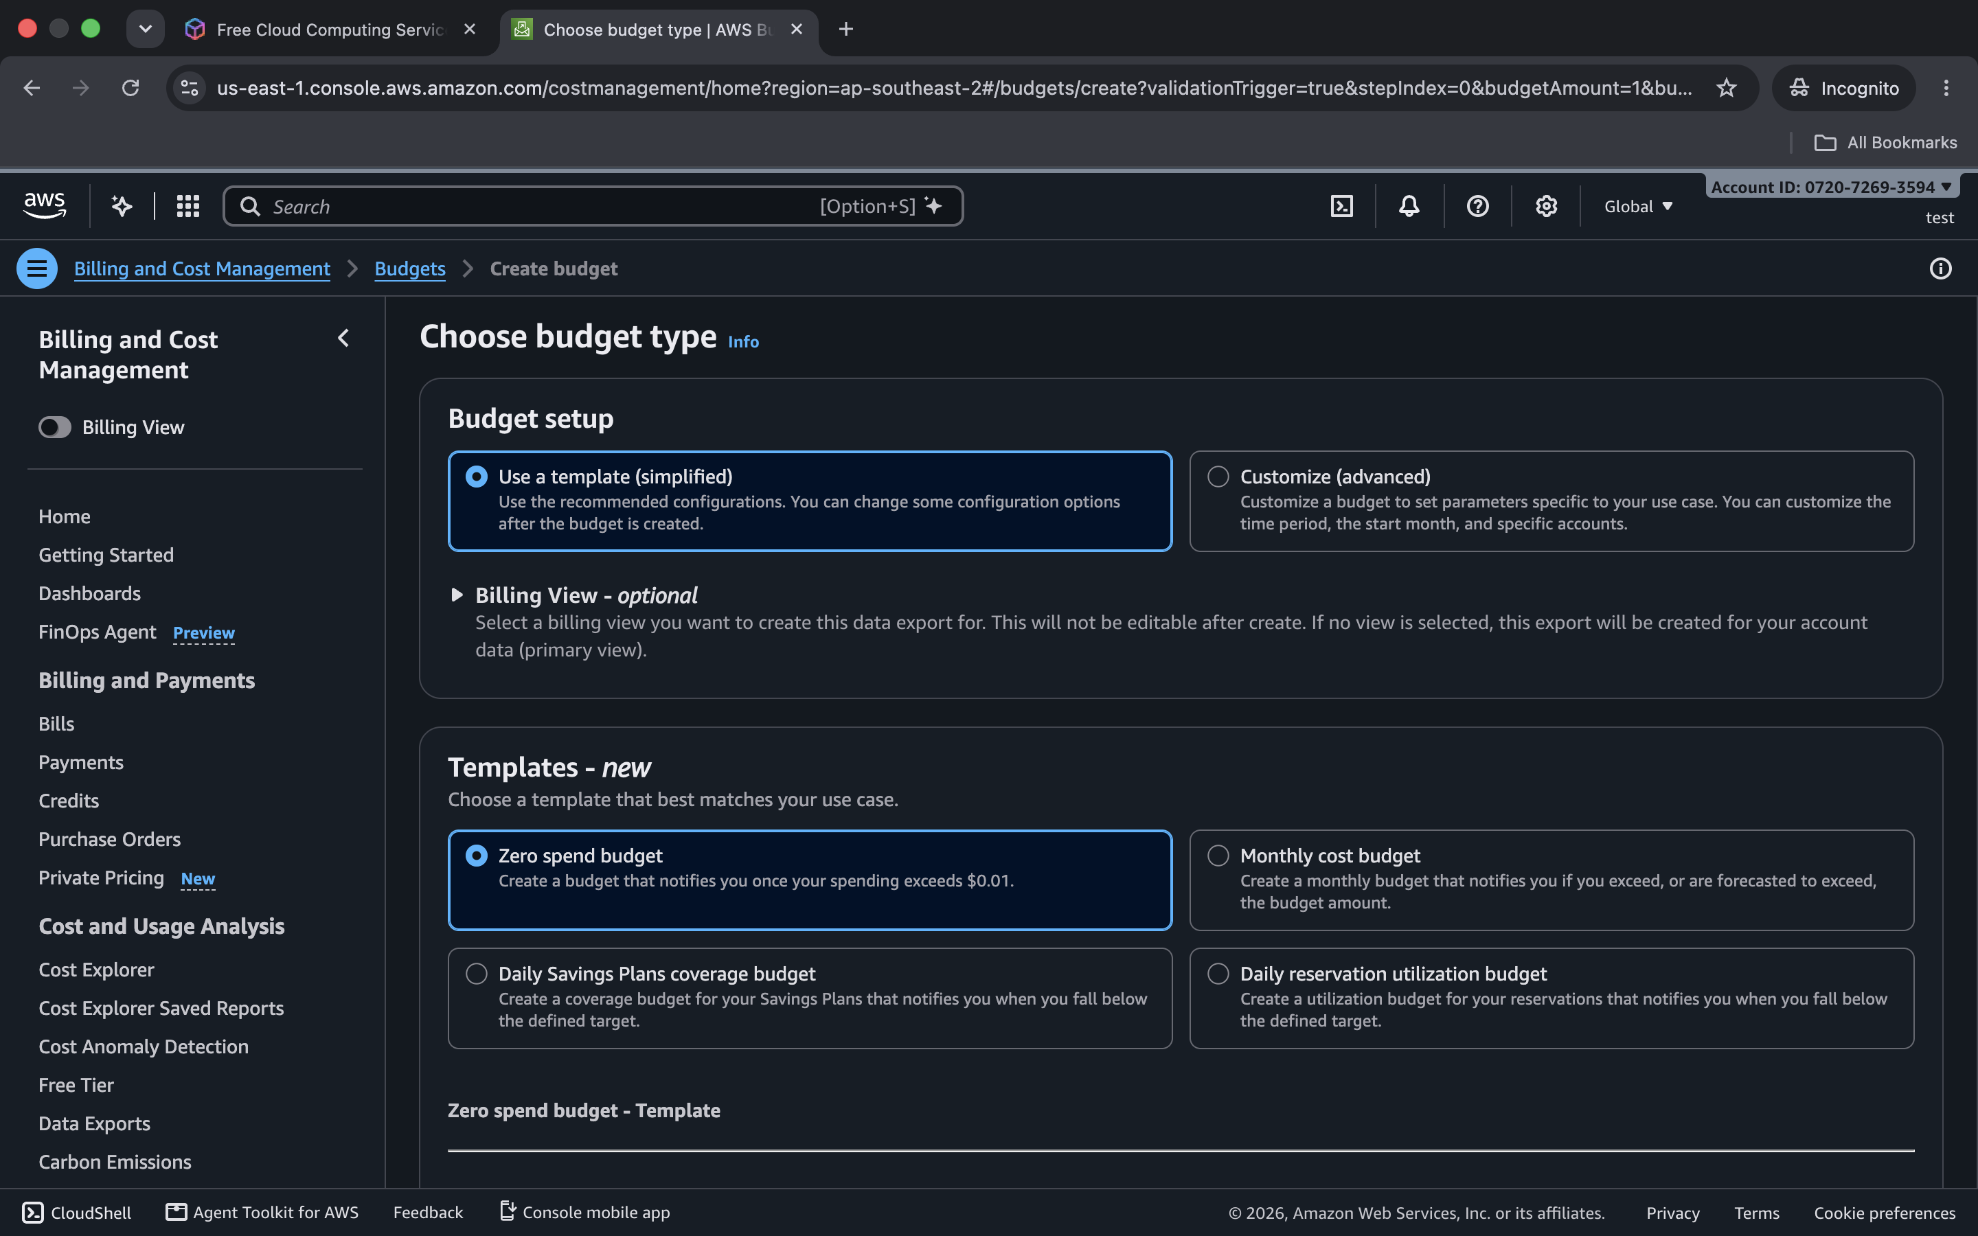
I got a permission error when opening billing from the IAM user account.
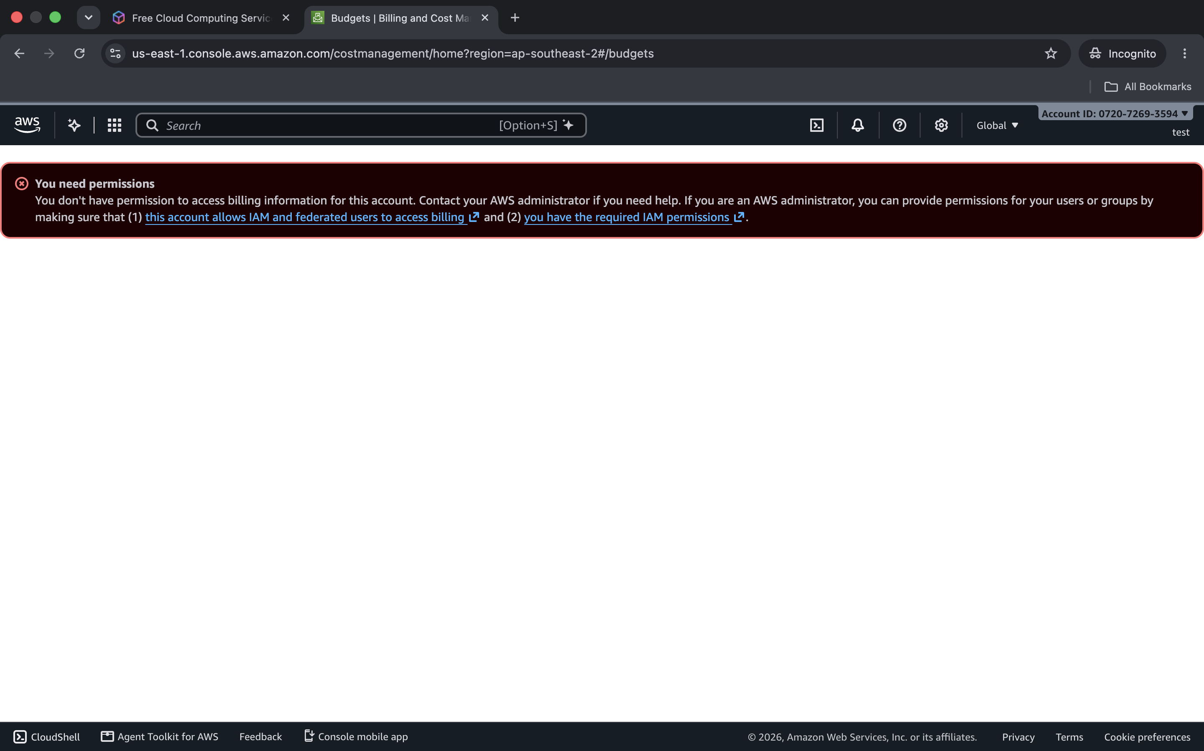
I opened the IAM permissions page to check the AWS Budgets policy.
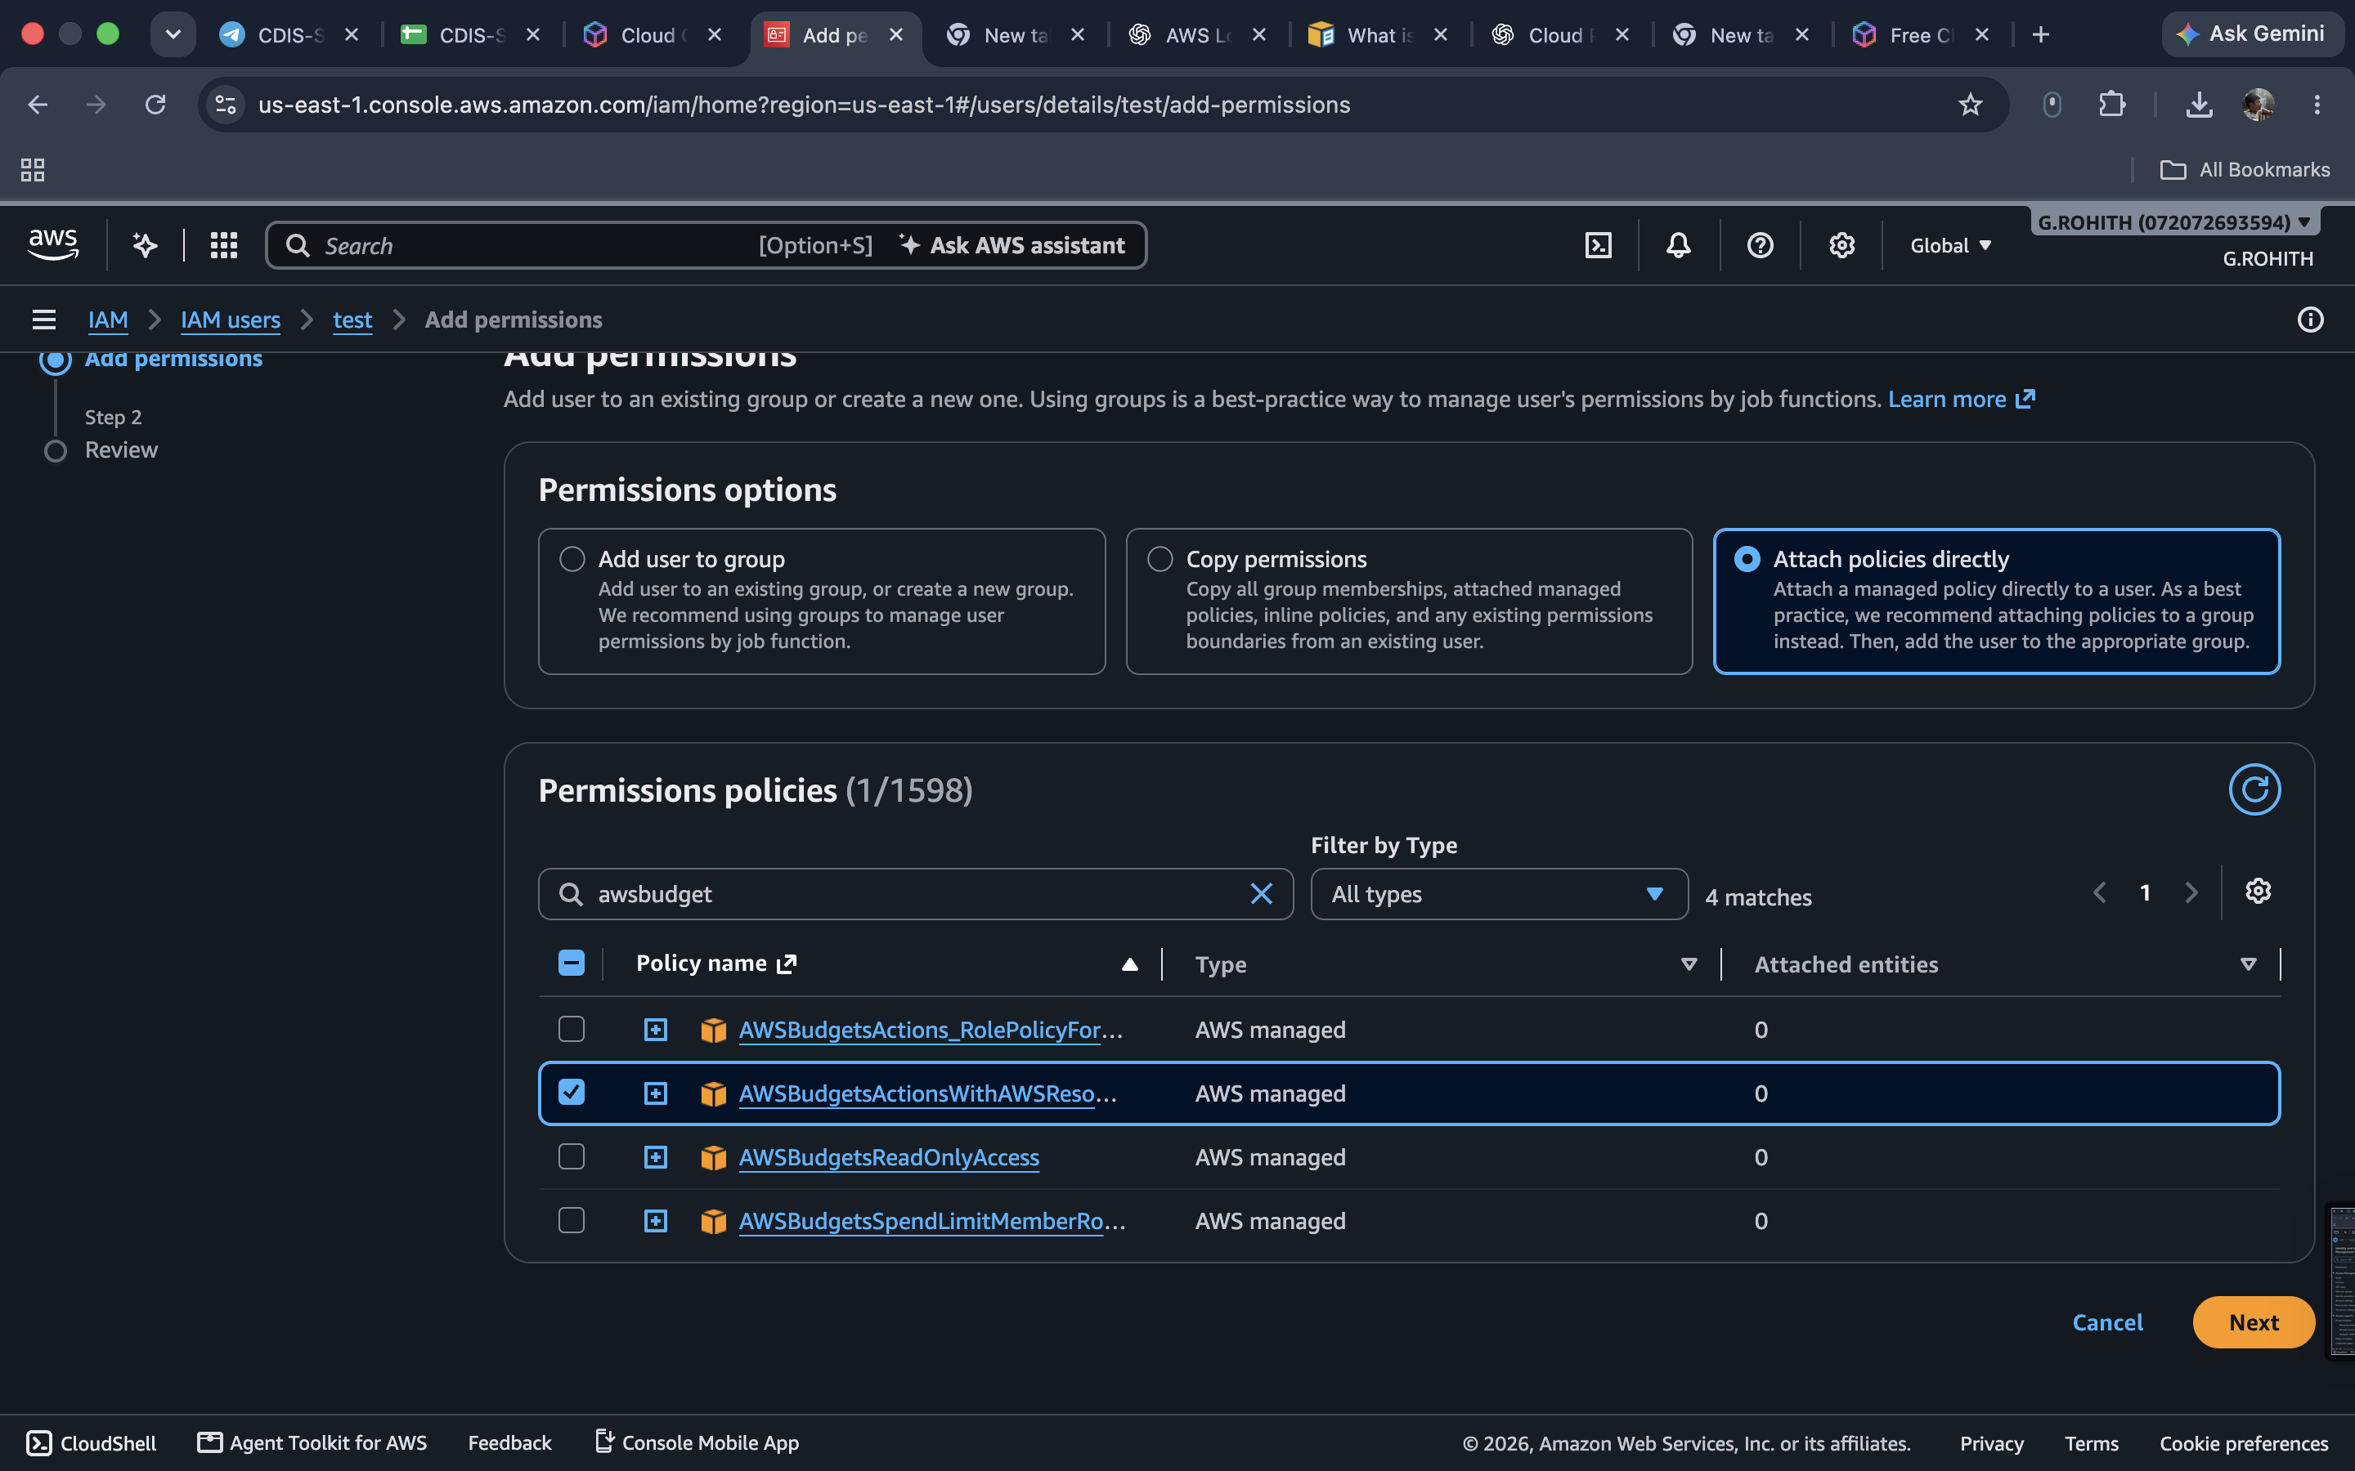
Output:
The IAM user was created without console login, and an access key was generated. The zero spend budget option was selected; billing access produced a permission error, after which the AWS Budgets policy was checked.

