HAVEN SOCIETY MANAGEMENT
PROJECT DESIGN DOCUMENT
Residential Society Operations and Community Management System

1. Project Overview
Society Management is a residential community system designed to manage flats, residents, visitors, staff, maintenance billing, payments, complaints, notices, amenities and amenity bookings. The relational database connects operational records through primary and foreign keys, while the React interface provides role-based access to the corresponding management modules.

2. Objectives
- Store and manage flat and resident information.
- Track visitor entry, exit, purpose and current status.
- Maintain staff records and operational responsibilities.
- Generate maintenance bills and record resident payments.
- Register complaints, publish notices and monitor resolution status.
- Manage amenities and resident booking schedules using relational integrity.

3. System Architecture
The overall logical flow of the system is:
Resident / Staff / Committee / Administrator
↓
React + Vite Web Application
↓
Context and Service Layer
↓
Backend API (integration point)
↓
MySQL society_management Database
↓
flats | residents | visitors | staff | maintenance_bills
payments | complaints | notices | amenities | amenity_bookings

4. Entity Relationship (ER) Design
The following ER diagram represents the society_management database. It shows the ten main tables and the foreign-key relationships that connect flats, residents, billing, complaints and amenity bookings.
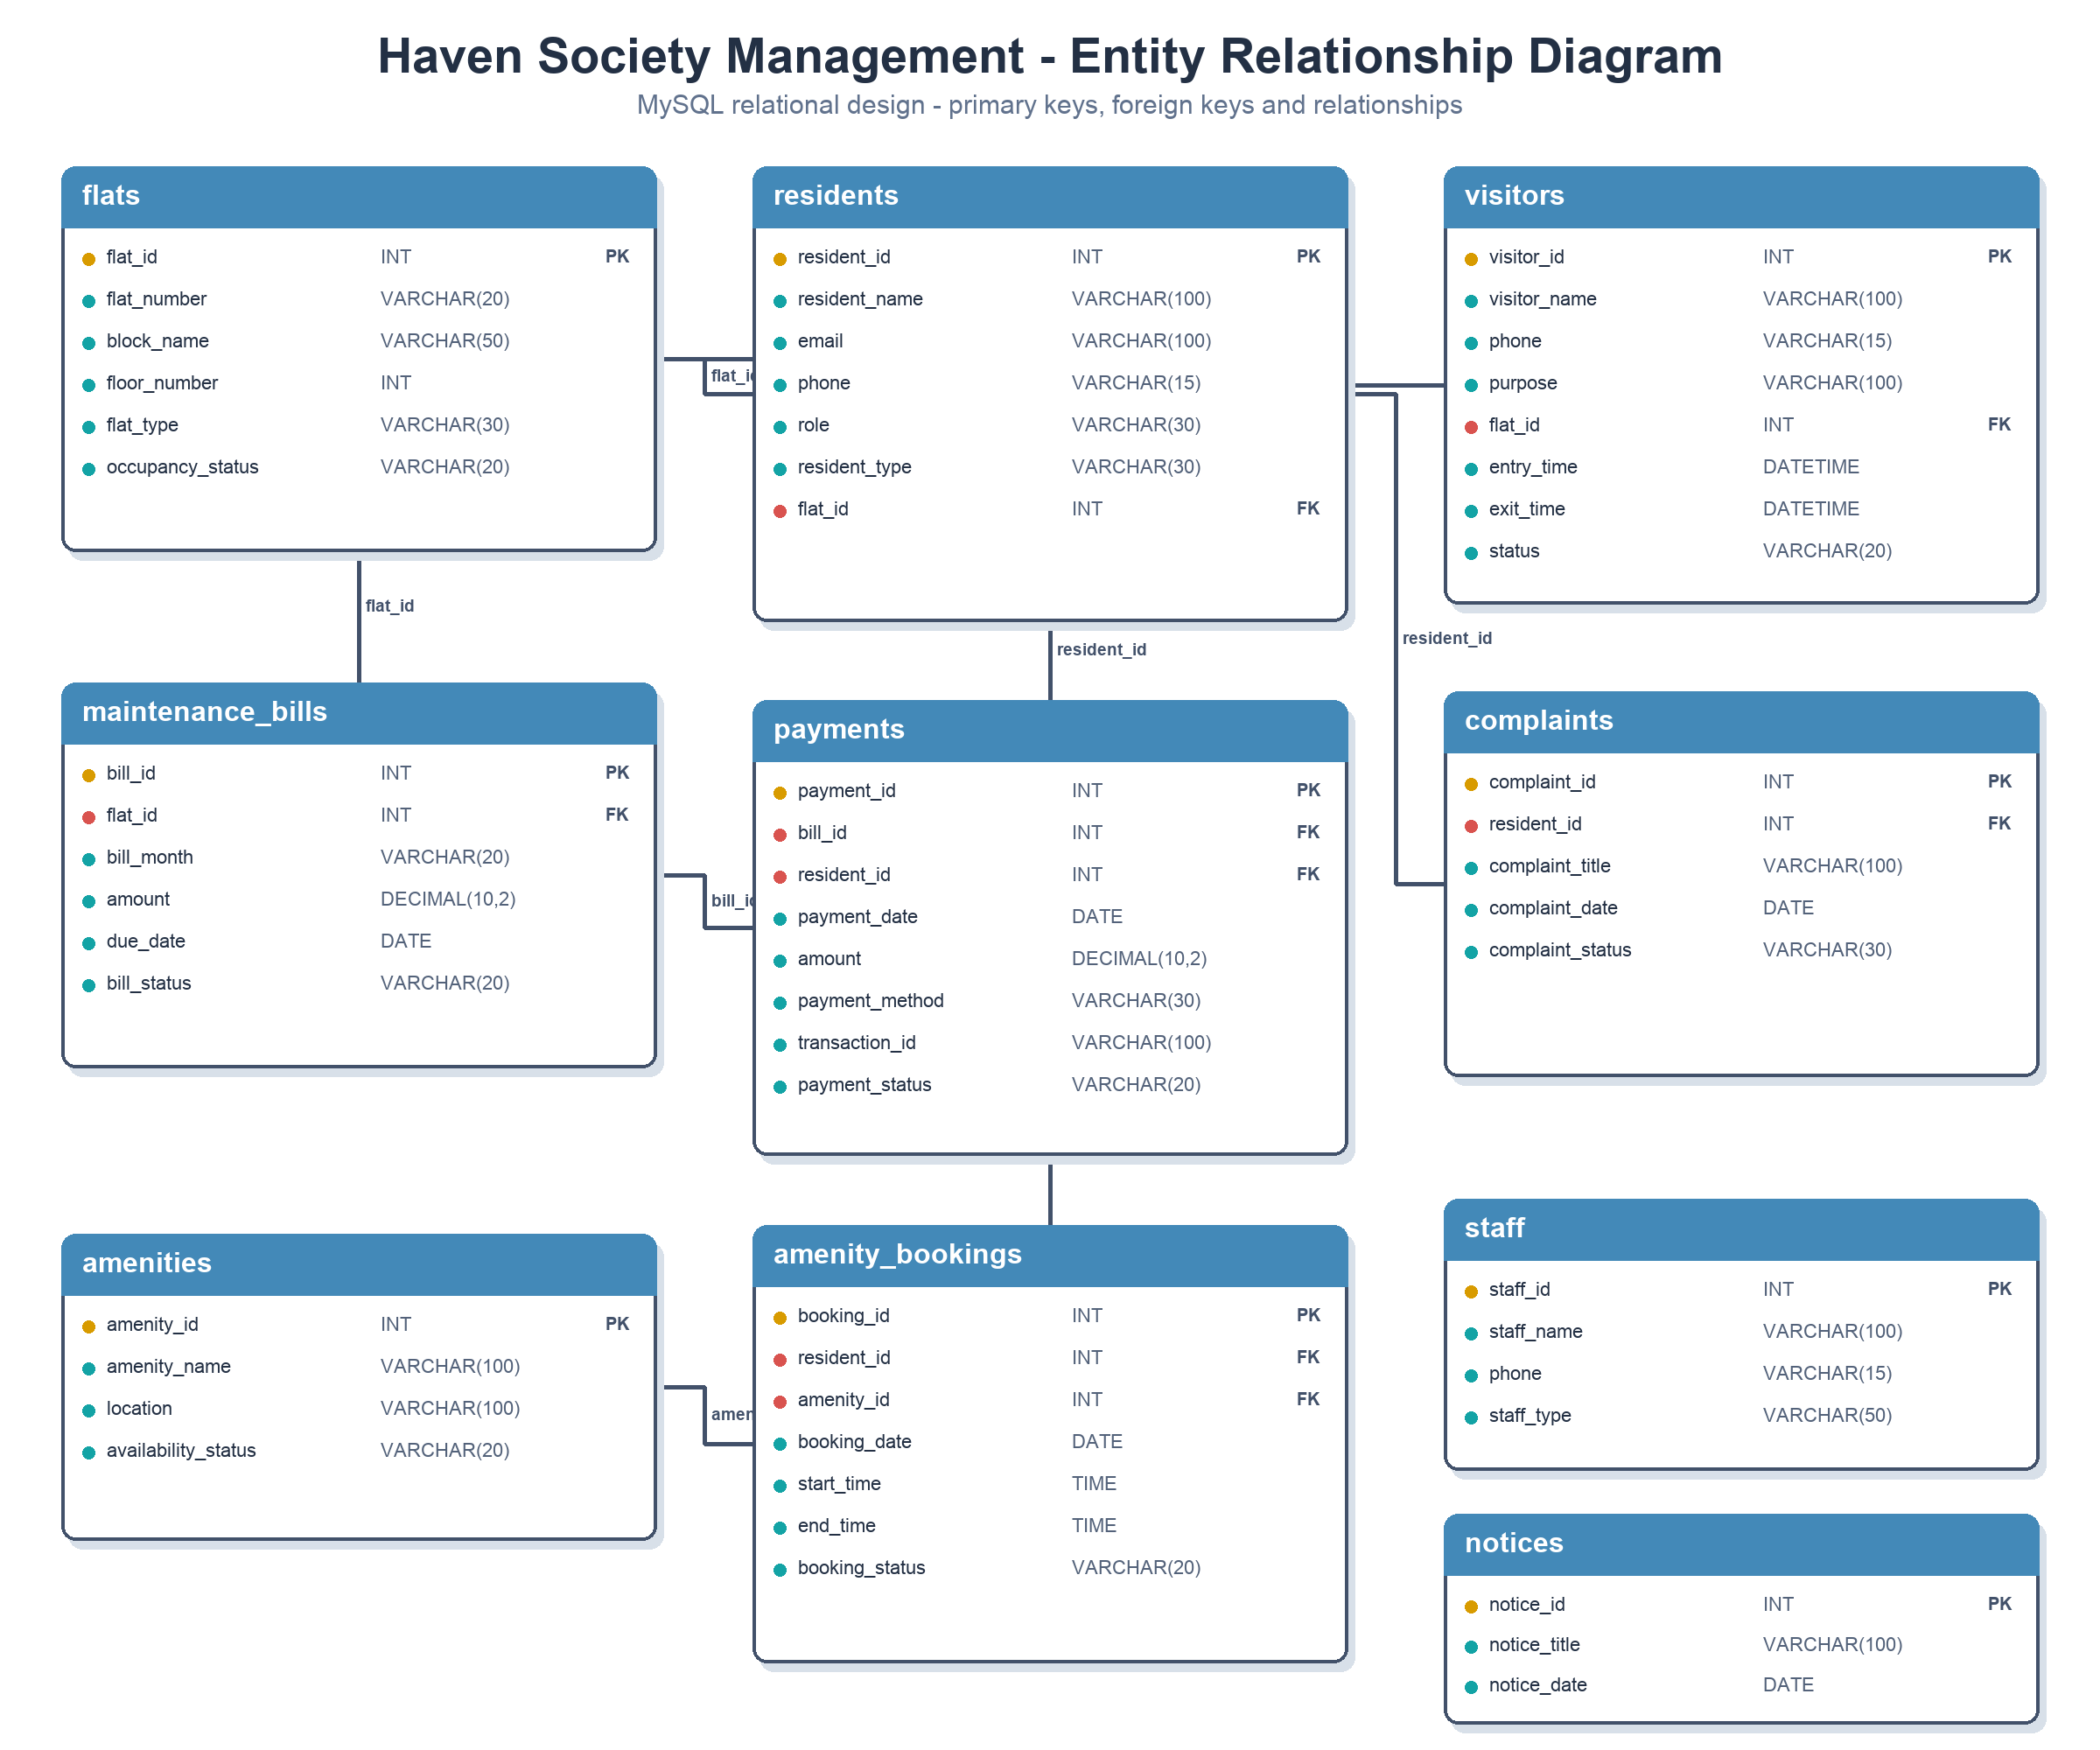

5. Database Tables

flats
Field | Data Type | Purpose / Relationship
flat_id | INT | Primary Key; AUTO_INCREMENT
flat_number | VARCHAR(20) | Flat number
block_name | VARCHAR(50) | Society block
floor_number | INT | Floor number
flat_type | VARCHAR(30) | Flat configuration
occupancy_status | VARCHAR(20) | Occupancy state

residents
Field | Data Type | Purpose / Relationship
resident_id | INT | Primary Key; AUTO_INCREMENT
resident_name | VARCHAR(100) | Resident name
email | VARCHAR(100) | Login/contact email
phone | VARCHAR(15) | Contact number
password | VARCHAR(100) | Authentication credential
role | VARCHAR(30) | Access role
resident_type | VARCHAR(30) | Owner or tenant
flat_id | INT | Foreign Key -> flats.flat_id

visitors
Field | Data Type | Purpose / Relationship
visitor_id | INT | Primary Key; AUTO_INCREMENT
visitor_name | VARCHAR(100) | Visitor name
phone | VARCHAR(15) | Contact number
purpose | VARCHAR(100) | Reason for visit
flat_id | INT | Foreign Key -> flats.flat_id
entry_time | DATETIME | Entry timestamp
exit_time | DATETIME | Exit timestamp
status | VARCHAR(20) | Visit status

staff
Field | Data Type | Purpose / Relationship
staff_id | INT | Primary Key; AUTO_INCREMENT
staff_name | VARCHAR(100) | Staff member name
phone | VARCHAR(15) | Contact number
staff_type | VARCHAR(50) | Work category
address | VARCHAR(200) | Residential address

maintenance_bills
Field | Data Type | Purpose / Relationship
bill_id | INT | Primary Key; AUTO_INCREMENT
flat_id | INT | Foreign Key -> flats.flat_id
bill_month | VARCHAR(20) | Billing month
amount | DECIMAL(10,2) | Amount payable
due_date | DATE | Payment due date
bill_status | VARCHAR(20) | Bill state

payments
Field | Data Type | Purpose / Relationship
payment_id | INT | Primary Key; AUTO_INCREMENT
bill_id | INT | Foreign Key -> maintenance_bills.bill_id
resident_id | INT | Foreign Key -> residents.resident_id
payment_date | DATE | Payment date
amount | DECIMAL(10,2) | Amount paid
payment_method | VARCHAR(30) | Payment channel
transaction_id | VARCHAR(100) | Transaction reference
payment_status | VARCHAR(20) | Payment state

complaints
Field | Data Type | Purpose / Relationship
complaint_id | INT | Primary Key; AUTO_INCREMENT
resident_id | INT | Foreign Key -> residents.resident_id
complaint_title | VARCHAR(100) | Complaint subject
complaint_description | VARCHAR(300) | Complaint details
complaint_date | DATE | Submission date
complaint_status | VARCHAR(30) | Resolution state

notices
Field | Data Type | Purpose / Relationship
notice_id | INT | Primary Key; AUTO_INCREMENT
notice_title | VARCHAR(100) | Notice heading
notice_description | VARCHAR(500) | Notice content
notice_date | DATE | Publication date

amenities
Field | Data Type | Purpose / Relationship
amenity_id | INT | Primary Key; AUTO_INCREMENT
amenity_name | VARCHAR(100) | Amenity name
location | VARCHAR(100) | Amenity location
availability_status | VARCHAR(20) | Availability state

amenity_bookings
Field | Data Type | Purpose / Relationship
booking_id | INT | Primary Key; AUTO_INCREMENT
resident_id | INT | Foreign Key -> residents.resident_id
amenity_id | INT | Foreign Key -> amenities.amenity_id
booking_date | DATE | Reservation date
start_time | TIME | Reservation start
end_time | TIME | Reservation end
booking_status | VARCHAR(20) | Booking state

6. Relationships
- flats -> residents: one flat can be linked to multiple resident records through residents.flat_id.
- flats -> visitors: one flat can receive multiple visitors through visitors.flat_id.
- flats -> maintenance_bills: one flat can receive multiple monthly bills through maintenance_bills.flat_id.
- maintenance_bills -> payments: one bill can be referenced by payment records through payments.bill_id.
- residents -> payments: one resident can make multiple payments through payments.resident_id.
- residents -> complaints: one resident can submit multiple complaints through complaints.resident_id.
- residents -> amenity_bookings: one resident can create multiple bookings through amenity_bookings.resident_id.
- amenities -> amenity_bookings: one amenity can have multiple scheduled bookings through amenity_bookings.amenity_id.
- staff and notices are independent master records in the current schema and do not contain foreign keys.

7. Society Management Flow
- An administrator creates flats and associates residents with their assigned flats.
- Security records visitor details, purpose, entry time, exit time and status for a destination flat.
- Committee or finance users generate maintenance bills for flats and track resident payments.
- Residents submit complaints, and authorized staff update their resolution status.
- Committee users publish notices and maintain amenity availability.
- Residents reserve available amenities; foreign keys keep every booking connected to a valid resident and amenity.

8. User Interface Design
The Haven Society Management interface is organized into the following functional areas:
- Dashboard - role-aware summaries, charts, recent activity and operational statistics.
- Flats and Residents - manage occupancy, flat assignments, resident profiles and roles.
- Visitors - record arrivals, departures, purpose and visit status.
- Staff - maintain staff profiles and work categories.
- Maintenance and Payments - manage bills, due dates, transaction references and payment status.
- Complaints and Notices - track resident issues and publish community announcements.
- Amenities and Bookings - manage facility availability and reservation schedules.

9. Technology Stack
- Frontend: React 19, Vite, HTML and CSS.
- Database: MySQL.
- Application libraries: React Router, Recharts and Lucide React.
- Project name: Haven Society Management.

10. Database Integrity
The database uses AUTO_INCREMENT primary keys to uniquely identify records and foreign keys to preserve valid relationships. Residents and operational records reference existing flats; payments reference valid bills and residents; complaints reference valid residents; and bookings reference valid residents and amenities. DECIMAL types preserve monetary precision, while DATE, TIME and DATETIME types enforce consistent temporal data.

11. Sample Data
The database script includes Flat 101 in Block A as an occupied 2BHK and Rahul Kumar as its owner-resident. The frontend also provides realistic demonstration records and role-based identities for administrators, committee members, residents, security and staff.

12. Conclusion
The Haven Society Management design provides a structured relational foundation for day-to-day residential society operations. Its ten-table design separates property, people, finance, communication, service and amenity concerns while preserving their relationships through foreign keys and exposing them through a responsive role-based interface.

