GENERATIVE AI LAB – WEEK 1
Experiment: First LLM API Call
Name: G.ROHITH Roll No:2520030220
Date: 11/11/2026 Tool used: Visual Studio Code

Aim
To connect a Python program to a large language model using an API key and display the generated response in the VS Code terminal.

Software used
VS Code, Python, a virtual environment, python-dotenv, and either the OpenAI SDK or Google Gen AI SDK (depending on the API used).

Procedure
1. Opened the Week 1 project folder in VS Code and opened the integrated terminal.
2. Activated the existing virtual environment. On macOS/Linux, the usual command is source .venv/bin/activate; on Windows PowerShell, it is .venv\Scripts\Activate.ps1. The lab guide reuses an existing environment.
3. Created a .env file in the project folder and added the API key for the provider I used. I did not put the actual key in the Python file.
4. Created .gitignore and added .env, .venv/, __pycache__/, and .pytest_cache/ so private and generated files are not pushed to GitHub.
5. Installed the packages required for the selected provider and created main.py.
6. Loaded the API key with load_dotenv(), sent a prompt asking for a simple explanation of Artificial Intelligence, and printed the model response.
7. Ran python main.py in the VS Code terminal and checked the response. I then tried changing the prompt to compare the answers.

Commands and files
python -m pip install openai python-dotenv
python main.py
For the Gemini alternative shown in the guide, install google-genai and python-dotenv instead of openai. Use OPENAI_API_KEY or GEMINI_API_KEY in .env to match the code.

Program logic
Load the key from .env → initialize the selected API client → send the prompt → receive generated text → print the answer in the terminal.
Screenshot: VS Code project files (.env values hidden)

Screenshot: Terminal output showing the LLM response
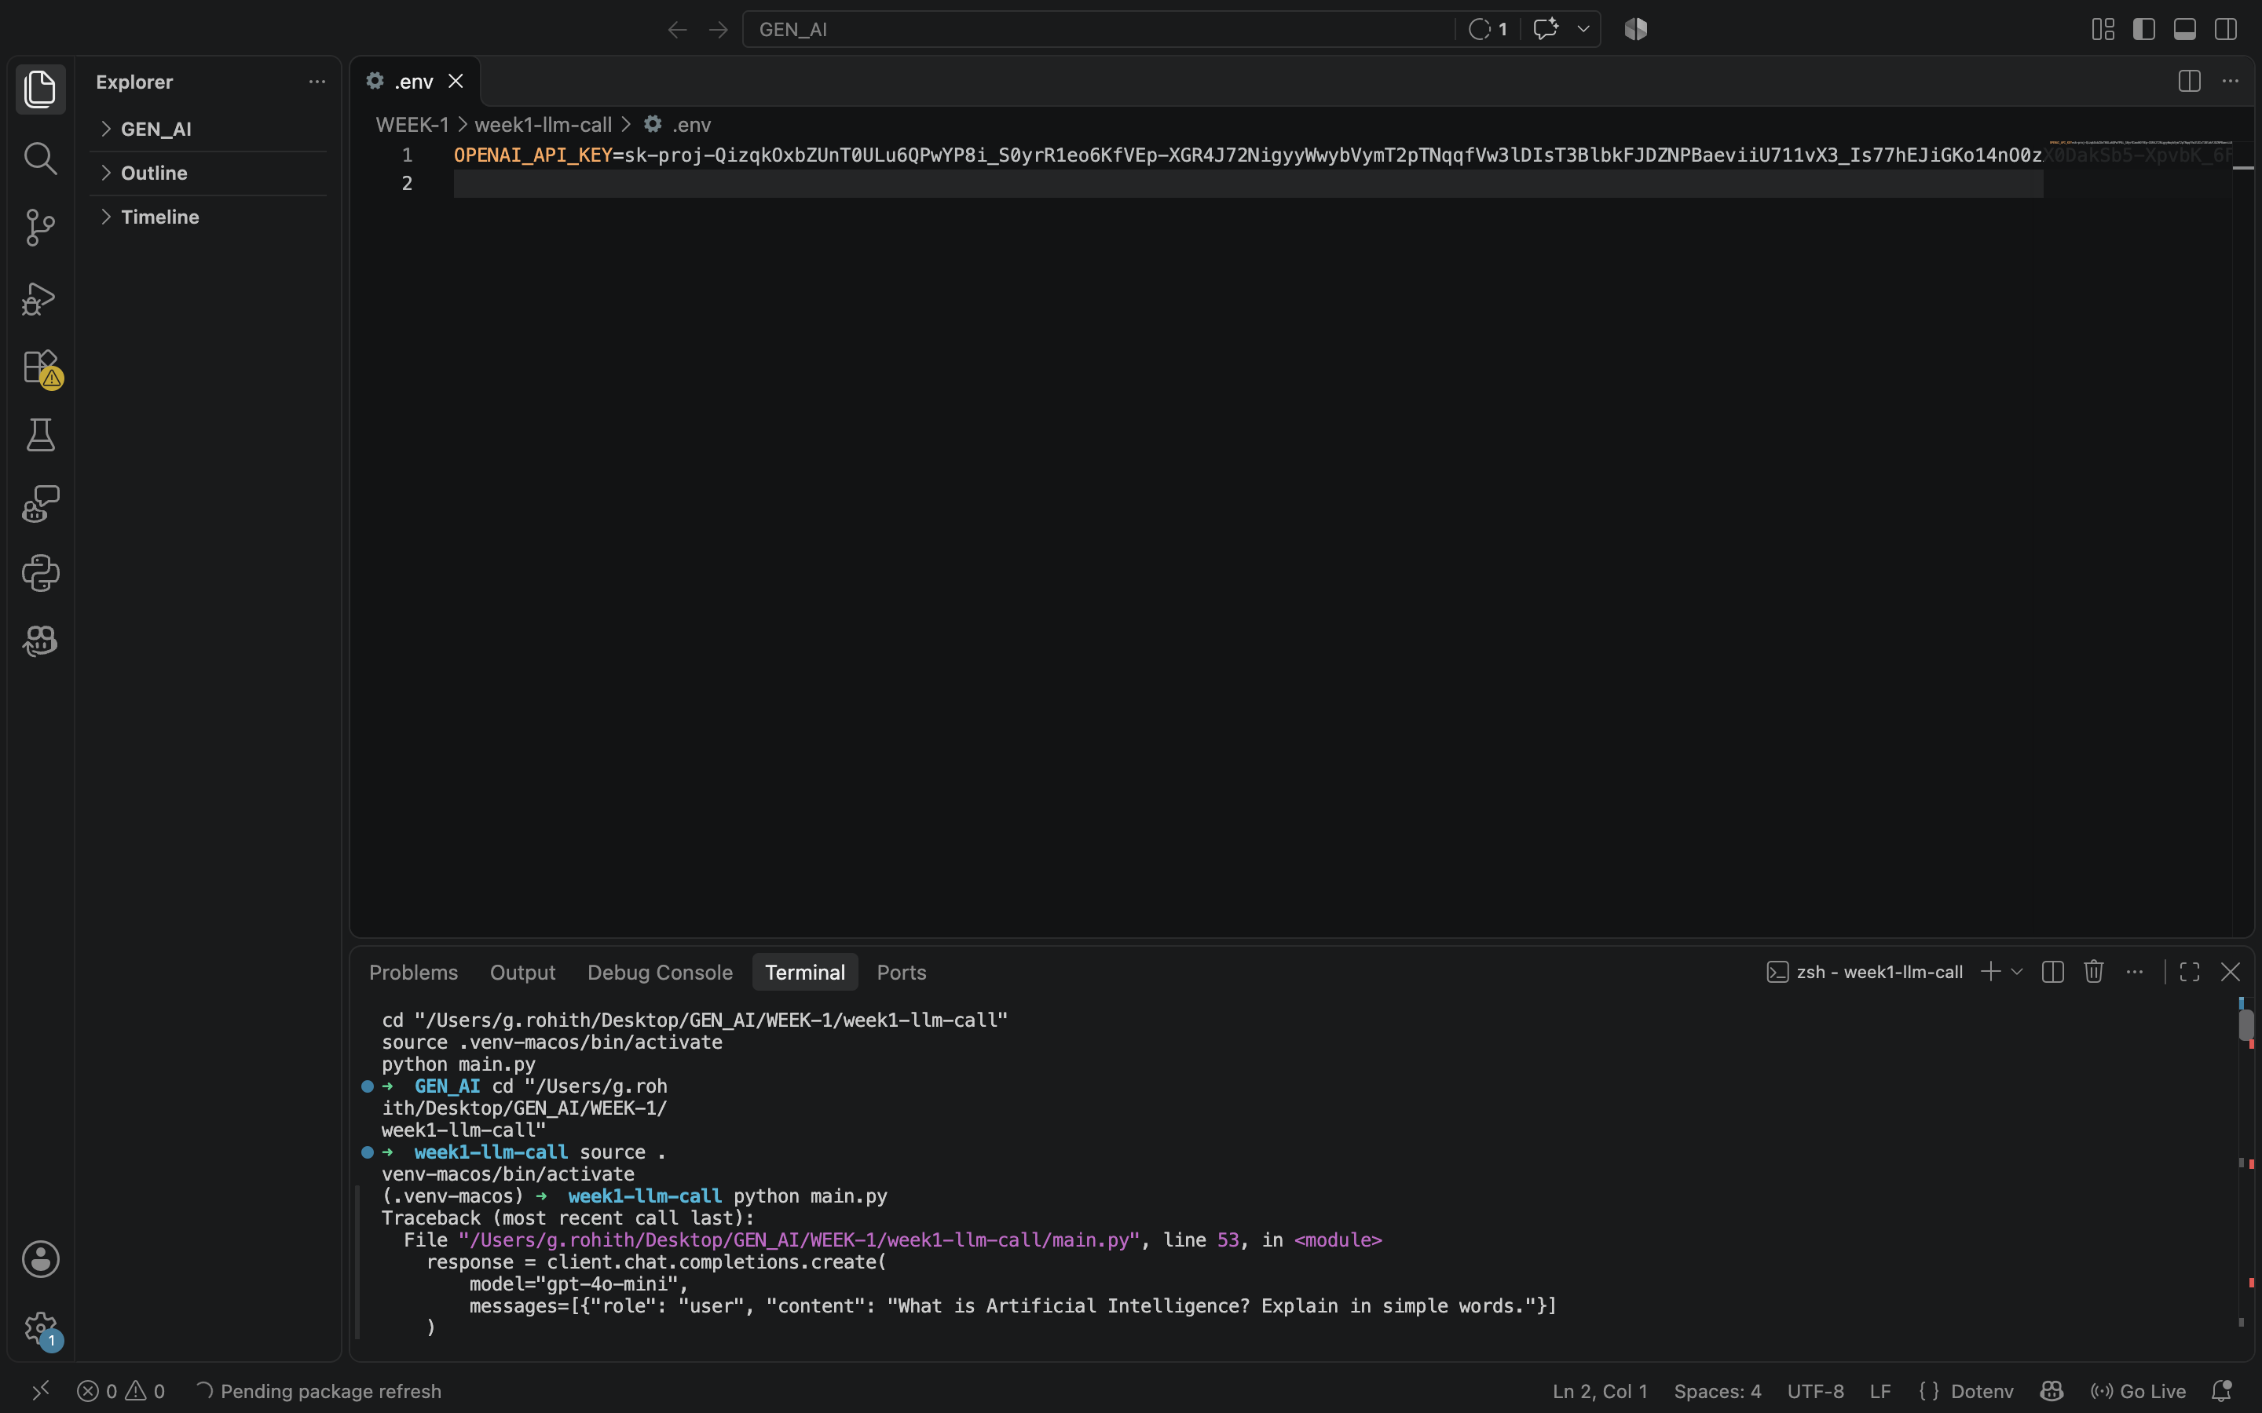

Output
Expected output: the terminal displays “LLM Response:” followed by a simple explanation of Artificial Intelligence. The exact wording depends on the model and prompt.
Actual output observed: __________________________________________________________
____________________________________________________________________________

Result
After running the program, record whether the API call worked and whether the answer appeared in the terminal.
Result recorded by me: Yes, the API call worked and answered correctly in the terminal

What I learned
I learned how to keep an API key in a separate .env file, connect Python to an LLM service, and check the response through the terminal. I also understood why .env should not be uploaded to GitHub.

