GENERATIVE AI LAB – WEEK 2
Experiment: Provider-Agnostic LLM Client (Gemini and Ollama)
Name: G.ROHITH Roll No.: 2520030220
Date: 11/11/2026 Tool used: Visual Studio Code

Aim
To use one Python client interface for two LLM providers: a hosted Gemini API and a locally running Ollama model.

Software used
VS Code, Python, Ollama, llama3.2, google-genai, requests, python-dotenv, and unittest.

Procedure
1. Downloaded and installed Ollama, then opened a terminal to check whether it was available.
2. Used ollama --version to check the installation and ollama pull llama3.2 to download the local model.
3. Created a Week 2 folder in VS Code with llm_client.py, main.py, test_client.py, .env, requirements.txt, and .gitignore.
4. In llm_client.py, created a common LLMProvider interface with a generate(prompt) method.
5. Added GeminiProvider to send prompts through the hosted Gemini API and OllamaProvider to send prompts to the local Ollama endpoint.
6. Added LLMClient to call generate(prompt) on whichever provider was selected.
7. In main.py, loaded the .env file, asked the user to choose gemini or ollama, accepted a question, and printed the answer.
8. In test_client.py, used a fake provider to check that LLMClient returned the provider response correctly.
9. Installed dependencies, ran main.py, tested the provider choices, and ran the unit test.

Commands used
ollama --version
ollama pull llama3.2
python -m pip install -r requirements.txt
python main.py
python -m unittest test_client.py
The requirements.txt file contains python-dotenv, pytest, google-genai, and requests. The Week 2 guide uses a Gemini model name as an example; use a model available to your account if necessary.

Program flow
Start main.py → choose Gemini or Ollama → enter a prompt → LLMClient calls the selected provider → response is printed in the terminal.

Sample interaction (format only)
Choose provider (gemini/ollama): ollama
Enter your question: Explain AI in simple words.

LLM Response:
[The selected model generates its answer here]
Screenshot: Ollama installation/version and model download
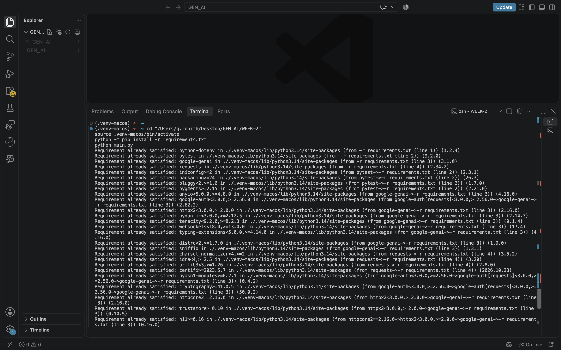

Screenshot: VS Code Week 2 files and provider code
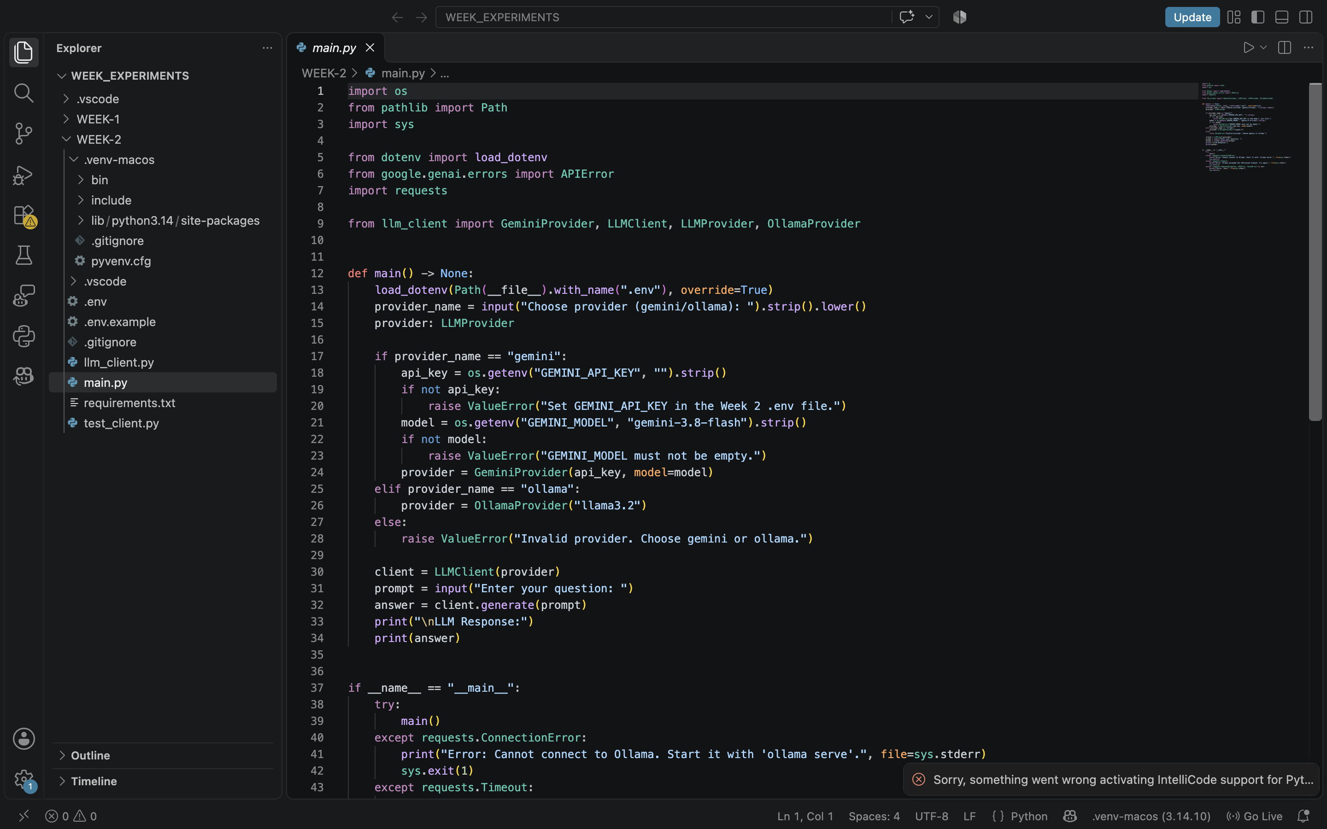

Screenshot: Ollama output in terminal
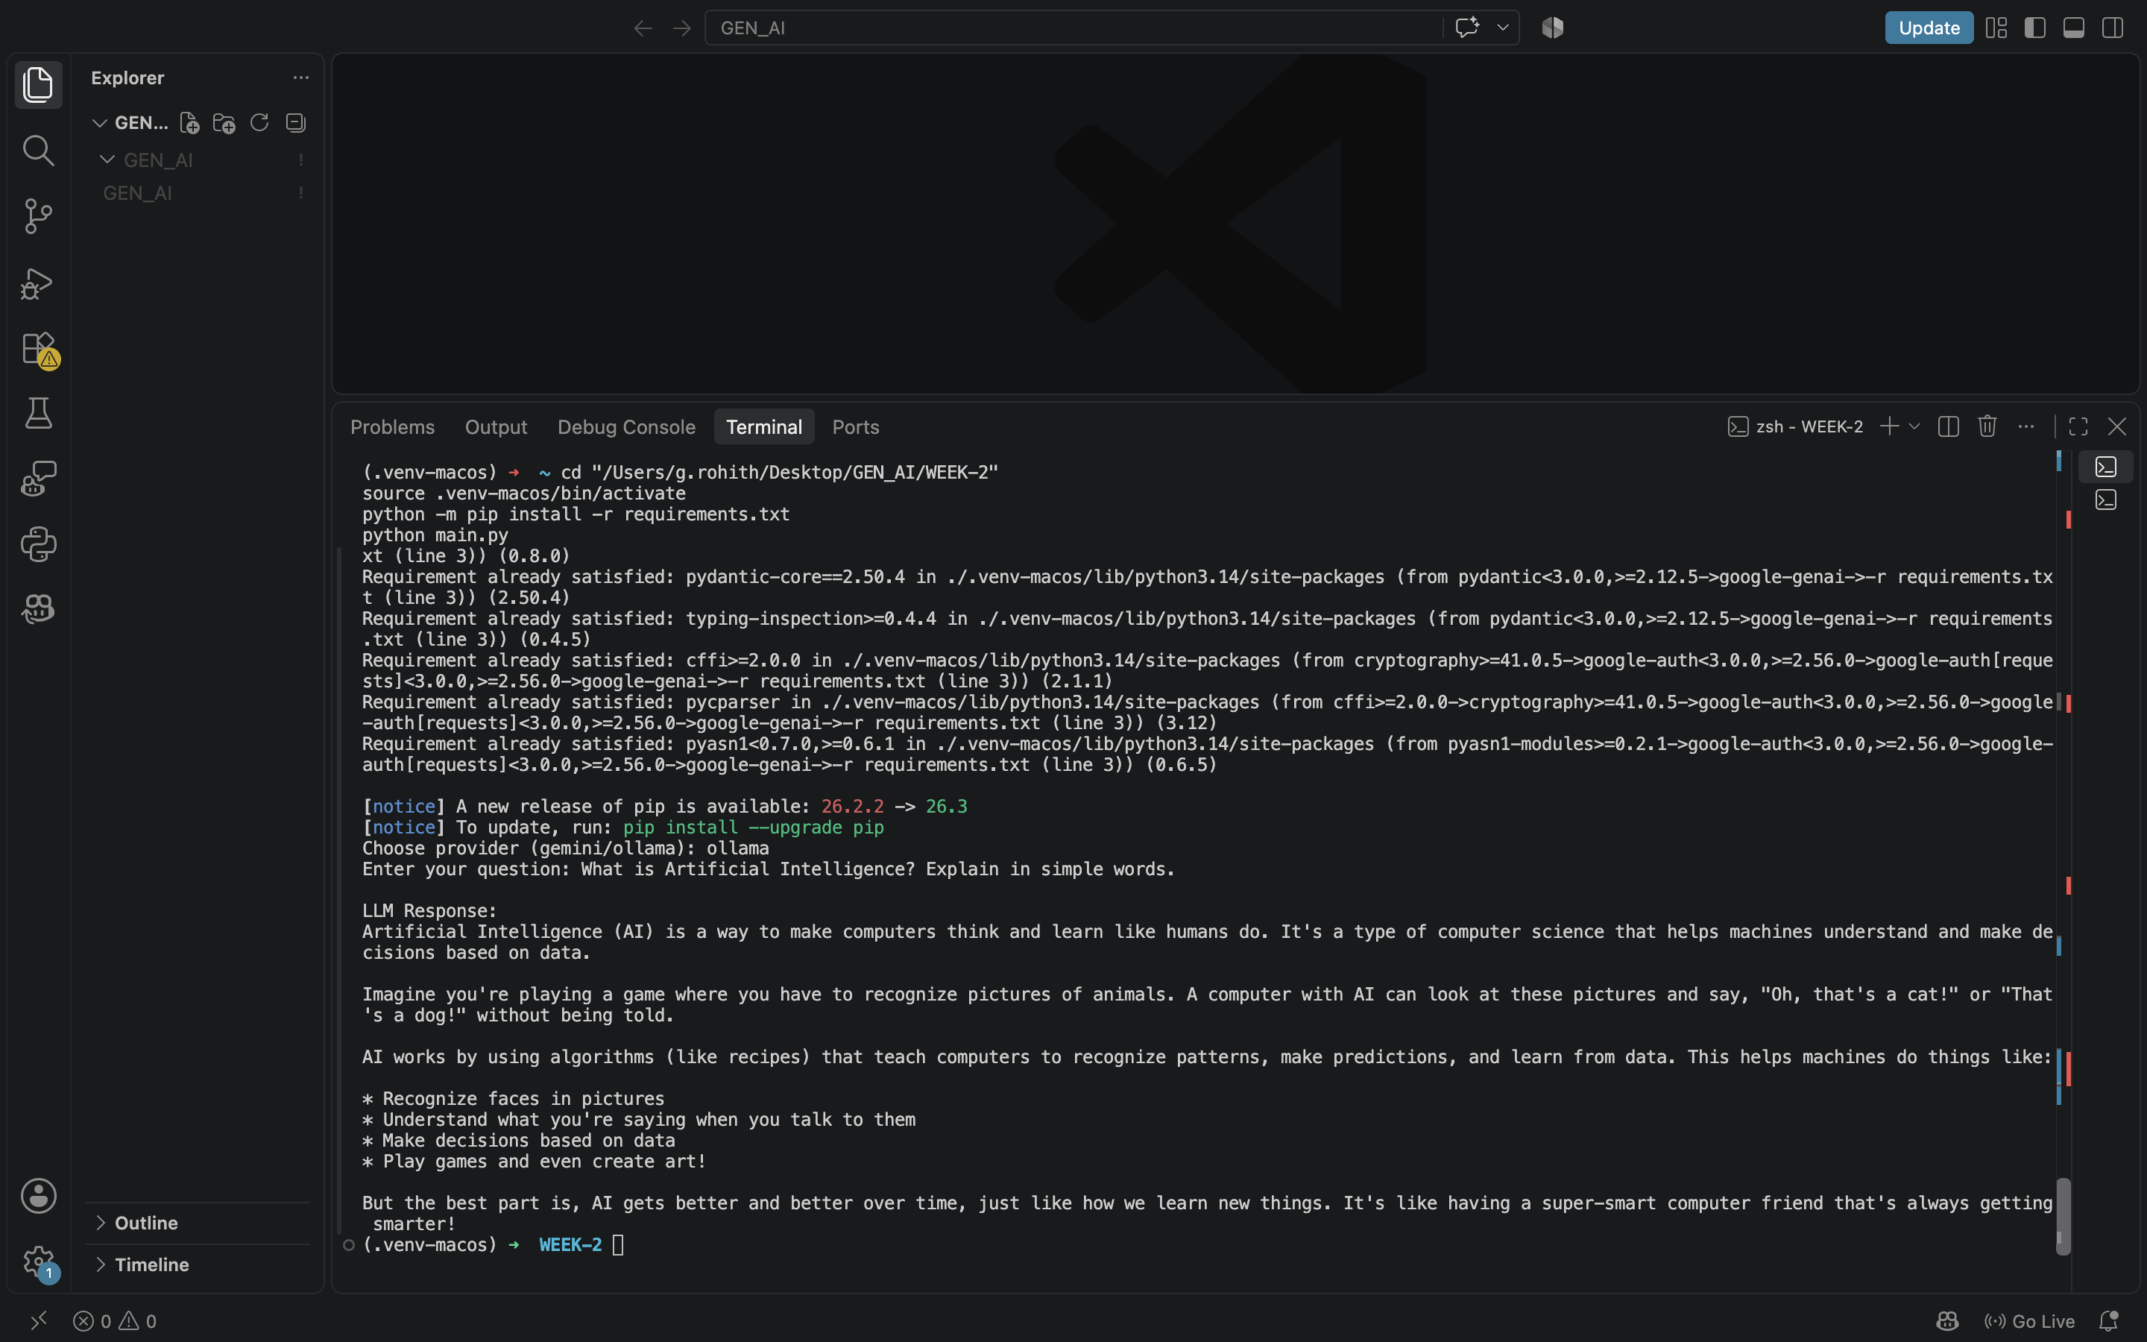

Output
Expected output: after choosing a provider and entering a prompt, the program prints “LLM Response:” followed by text from that provider. The unit test should pass if the common client correctly returns the fake provider response.

Result
The experiment is intended to show that the same client method can be used with a hosted model or a local model without changing the way main.py requests a response.
Result recorded by me: __________________________________________________________

What I learned
I understood the difference between calling an online model and running a local model. I also learned why a common interface makes it easier to switch providers and how a small unit test checks the client logic.

