GENERATIVE AI LAB – WEEK 4
Experiment: Comparison of BPE, WordPiece and SentencePiece Tokenizers
Name: G.ROHITH Roll No.: 2520030220
Date: 14/11/2026 Tool used: Visual Studio Code

Aim
To implement and compare Byte Pair Encoding (BPE), WordPiece and SentencePiece tokenizers using English, Telugu and Hindi text, and observe token pieces, token IDs and token counts.

Software used
Visual Studio Code, Python 3.15, Python virtual environment (.venv), transformers, sentencepiece, and pretrained GPT-2, multilingual BERT and XLM-R tokenizers.

Procedure
1. Opened the Week-4 project folder in Visual Studio Code and created a Python virtual environment (.venv).
2. Created requirements.txt with the transformers and sentencepiece libraries and installed the required dependencies.
3. Created tokenizer_comparison.py to compare three pretrained tokenizers on the same input text.
4. Loaded GPT-2 for byte-level BPE, bert-base-multilingual-cased for WordPiece and xlm-roberta-base for SentencePiece.
5. Added sample sentences in English, Telugu and Hindi to compare tokenization across languages.
6. For each tokenizer, converted the text into token pieces and token IDs and counted the generated tokens.
7. Executed tokenizer_comparison.py from the VS Code terminal and observed the token lists, token IDs and counts for each language.
8. Compared the outputs to understand how tokenizer vocabulary and multilingual training affect token counts.

Commands used
cd /Users/g.rohith/Desktop/GEN_AI/Week-4
python3 -m venv .venv
source .venv/bin/activate
python3 -m pip install -r requirements.txt
python tokenizer_comparison.py
The requirements.txt file contains transformers and sentencepiece. The first run may download pretrained tokenizer files. The screenshots show a warning that PyTorch was not found; tokenizer comparison still ran.

Program flow
Start tokenizer_comparison.py → load GPT-2, multilingual BERT and XLM-R tokenizers → process English, Telugu and Hindi sentences → display tokens, token IDs and token counts → compare results.

Sample interaction (observed output)
LANGUAGE: English
INPUT TEXT: Artificial intelligence is changing the world.
BPE - GPT-2: Token count 8
WordPiece - Multilingual BERT: Token count 10
SentencePiece - XLM-R: Token count 10
LANGUAGE: Telugu
BPE - GPT-2: Token count 112
WordPiece - Multilingual BERT: Token count 18
SentencePiece - XLM-R: Token count 14
LANGUAGE: Hindi
BPE - GPT-2: Token count 68
WordPiece - Multilingual BERT: Token count 17
SentencePiece - XLM-R: Token count 14
Screenshot: Week 4 project setup and installed dependencies
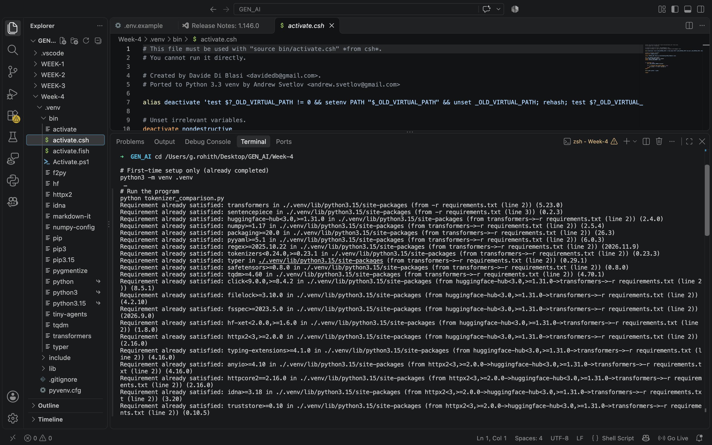
Screenshot: English tokenization output
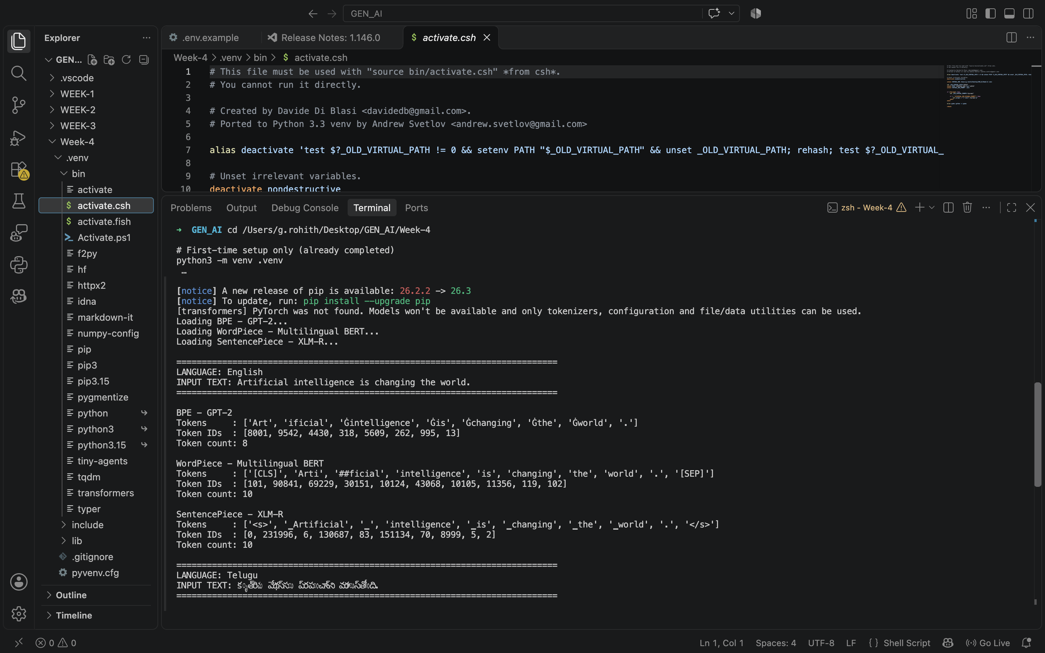
Screenshot: Telugu tokenization output
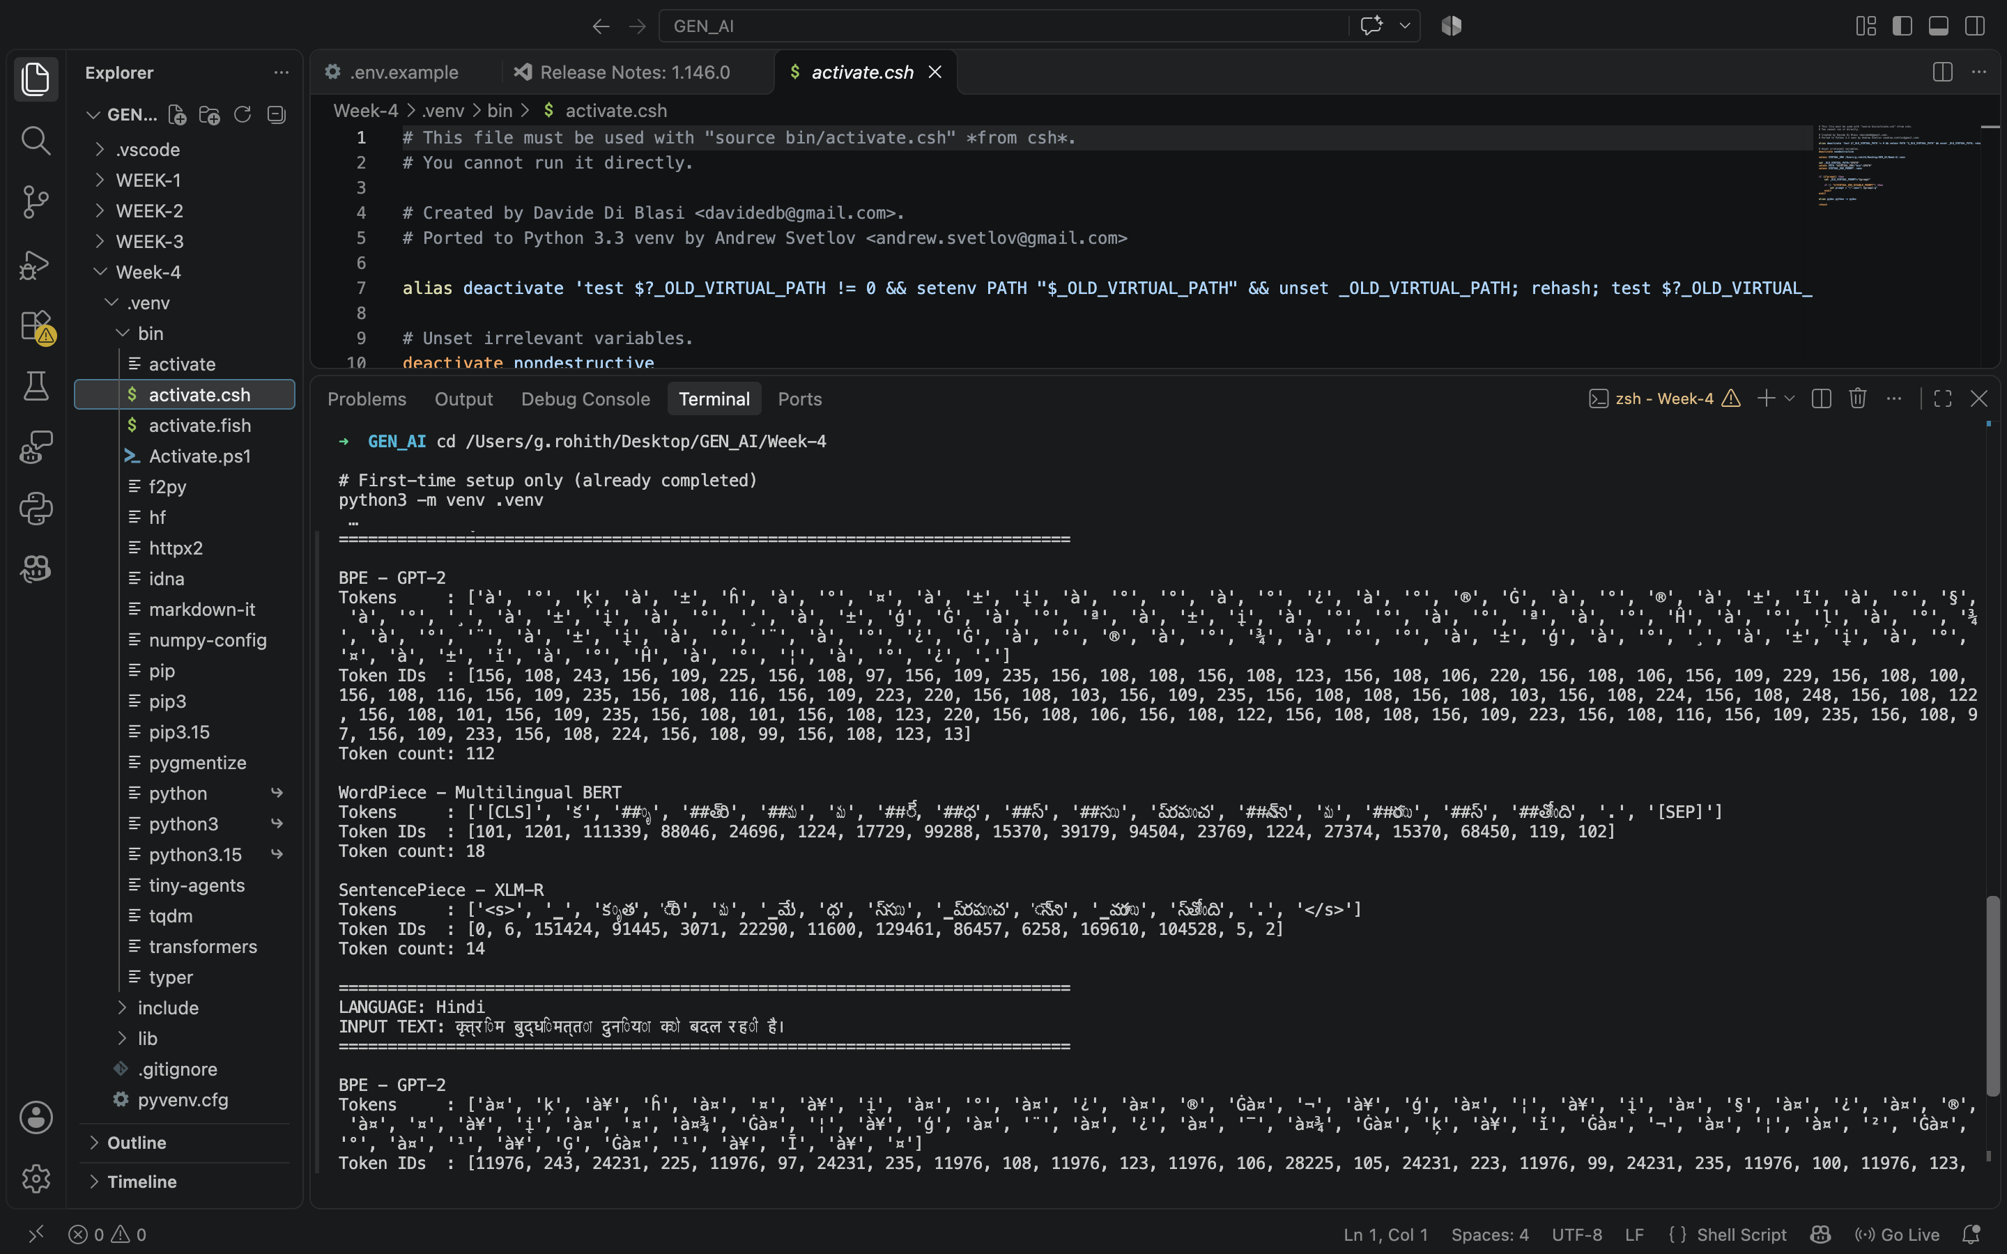
Screenshot: Hindi tokenization output
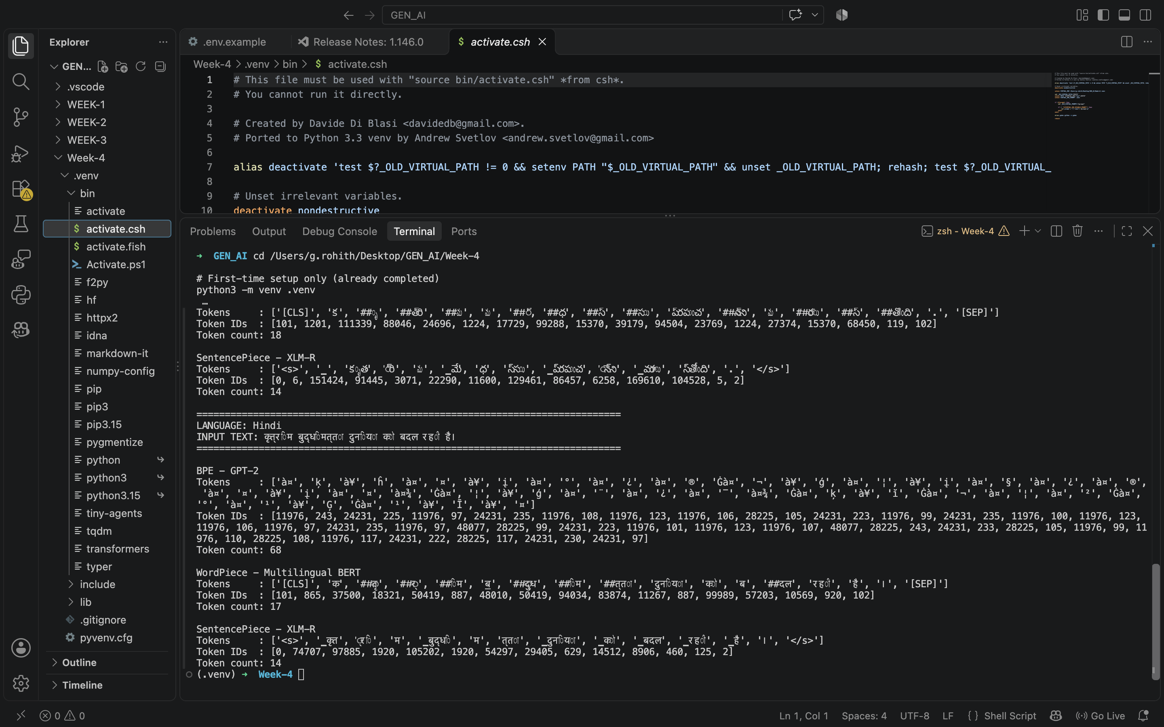

Output
The program successfully displayed token pieces, token IDs and token counts for all three languages. For English, the counts were 8 (GPT-2), 10 (multilingual BERT) and 10 (XLM-R). For Telugu, they were 112, 18 and 14. For Hindi, they were 68, 17 and 14, respectively.

Result
Successfully executed and compared BPE, WordPiece and SentencePiece tokenizers on English, Telugu and Hindi text. The multilingual tokenizers produced fewer tokens than GPT-2 for the Telugu and Hindi sentences in this experiment.
Result recorded by me: Successfully completed the tokenizer comparison.

What I learned
I learned how tokenizers split text into subword units and map them to token IDs. I observed that token counts differ across languages and pretrained vocabularies, and that SentencePiece is a tokenization framework while XLM-R uses a SentencePiece BPE model.

