Executive Summary - Coalition Warehouse Database Project:
http://classwork.engr.oregonstate.edu:30905/

Team Members: Gunnar Larsen | Daniel Slay

Step 1 – Project Proposal, Outline, ERD:

Feedback – Redundant attributes within Customers and Vendors table. Naming convention ambiguity for productCost vs vendorCost. Inconsistent naming conventions in regards to PascalCase vs camelCase. Insufficient outline distinction between entities and intersection tables.

Changes – Removed vendorNumber and customerNumber attributes from their respective tables. Renamed productCost to listPrice within the Products table. Aligned all tables to use PascalCase and all attributes to use camelCase. Better organized the outline to distinguish between entities and transaction/intersection tables. Added a purpose section to clarify the use/role of each entity. Lastly, renamed productCost to listPrice in Products table and itemPrice to unitPrice in PurchaseOrderItems table.

Step 2 – Normalized Schema + DDL with Sample Data

Feedback – Missing ON DELETE CASCADE on Inventory and VendorProducts. Inconsistency between outline and DDL with definition of purchaseDate attribute. Inconsistency of plural and singular table names.

Changes – Added ON DELETE CASCADE to Inventory and VendorProducts tables. Aligned all time stamps to be CURRENT_TIMESTAMP. Fixed naming inconsistency of table names to be all plural.

Step 3 – Design UI Interface + DML SQL:

Feedback – Non-functional UPDATE/CREATE/DELETE buttons. Low contrast of navigational bar.

Changes – Button functionality added at a later step. Nav bar made larger and increased its contrast to align with the rest of the page. Added direct links to all other pages on the homepage.

Step 4 – Stored Procedures and SELECTs for all entities:

Feedback – Routing bug allowing for old JSON data to be displayed after CRUD operations. Discrepancy between DB and Sales page for Total Cost column. SP naming convention inconsistencies.

Changes – Fixed routing issue displaying JSON. Fixed DB and Sales page discrepancy. Added window.confirm to avoid accidental deletions. Renamed Sps to start with sp_ and triggers with tr_.

Project Outline

Overview:
The owner of Coalition Warehouse LLC has been in business for over a decade. In that time, he has seen record growth and expansion of his business. He has been running this business solely with the use of Excel spreadsheets to keep track of vendor orders, warehouse inventory, products, customers, and customer orders. Due to this expansion to multiple locations, he has been plagued with inventory stocking issues, such as too much inventory or too little inventory.

Coalition Warehouse LLC sees ~40,000 transactions yearly, encompassing 500 products with 50 international vendors and 10,000 customers. A database-driven website will allow for tracking records of inventory of products within his warehouses. Additionally, tracking records of purchases from vendors and sales to customers. Lastly, allow Coalition Warehouse to make informed decisions on ordering trends for the future.

Database Outline:

Entities:
- Products:
  - Purpose: Records the product information stocked by Coalition Warehouse LLC
  - productID: int(11), auto_increment, unique, not NULL, PK
  - productName: varchar(255), not NULL
  - listCost: decimal(10,2), not NULL
  - Relationship:
    - 1:M - VendorProducts (M:N with Vendors)
    - 1:M - Inventory
    - 1:M - SalesOrderItems (M:N with Sales_Orders)
    - 1:M - PurchaseOrderItems (M:N with Purchase_Orders)

- Vendors:
  - Purpose: Records the details of vendors Coalition Warehouse LLC gets products from.
  - vendorID: int(11), auto_increment, unique, not NULL, PK
  - vendorName: varchar(255), not NULL
  - vendorAddr: varchar(255)
  - vendorEmail: varchar(255)
  - Relationship:
    - 1:M - VendorProducts (M:N with Products)
    - 1:M - PurchaseOrders
- Warehouses:
  - Purpose: Records the warehouses owned by Coalition Warehouse LLC
  - warehouseID: int(11), auto_increment, unique, not NULL, PK
  - warehouseName: varchar(255), not NULL
  - warehouseAddr: varchar(255)
  - Relationship:
    - 1:M - Inventory
    - 1:M - PurchaseOrders
    - 1:M - SalesOrders

- Customers:
  - Purpose: Records the personal and contact information of customers of Coalition Warehouse LLC
  - customerID: int(11), auto_increment, unique, not NULL, PK
  - customerLN: varchar(255), not NULL
  - customerFN: varchar(255), not NULL
  - customerAddr: varchar(255), not NULL
  - customerEmail: varchar(255)
  - Relationship:
    - 1:M Sales_Orders

Transaction Tables:
- SalesOrders:
  - Purpose: Records individual sales by Coalition Warehouse LLC to customers
  - saleOrderID: int(11), auto_increment, unique, not NULL, PK
  - customerID: int(11), NOT NULL, FK
  - warehouseID: int(11), NULL, FK
  - saleDate: DATETIME, default CURRENT_TIMESTAMP, not NULL
  - Relationship:
    - M:1 - Customers
    - M:1 - Warehouses
    - 1:M - SalesOrderItems (M:N with Products)
- PurchaseOrders:
  - Purpose: Records purchases from vendors by Coalition Warehouse LLC to restock inventory
  - purchaseOrderID: int(11), auto_increment, unique, not NULL, PK
  - vendorID: int(11), NULL, FK
  - warehouseID: int(11), NULL, FK
  - purchaseDate: DATETIME, default CURRENT_TIMESTAMP, not NULL
  - Relationship:
    - M:1 - Vendors
    - M:1 - Warehouses
    - 1:M - PurchaseOrderItems (M:N with Products)

Intersection Tables:
- Inventory:
  - Purpose: Records the quantity of a specific product stored at a specific warehouse.
  - inventoryID: int(11), auto_increment, unique, not NULL, PK
  - productID int(11), not NULL, FK
  - warehouseID int(11), not NULL, FK
    - The combination of productID and warehouseID should be unique
  - quantity: int(11), not NULL
  - Relationship:
    - M:1 - Products
    - M:1 – Warehouses

- VendorProducts:
  - Purpose: Records which products are supplied by which vendors and the associated wholesale cost catalog.
  - vendorProductID: int(11), auto_increment, unique, not NULL, PK
  - vendorID: int(11), not NULL, FK
  - productID: int(11), not NULL, FK
  - costFromVendor: decimal(10,2), not NULL
  - Relationship:
    - M:1 - Vendors
    - M:1 - Products
- PurchaseOrderItems:
  - Purpose: Records the specific items and quantities included in a restocking order.
  - purchaseOrderItemID:int(11), auto_increment, unique, not NULL, PK
  - purchaseOrderID: int(11), not NULL, FK
  - productID: int(11), NULL, FK
  - quantity: int(11), not NULL
  - purchasePrice: decimal(10,2), not NULL
  - Relationship:
    - M:1 - PurchaseOrders
    - M:1 - Products

- SalesOrderItems:
  - Purpose: Records the specific items and quantities included in a specific sales order.
  - saleOrderItemID: int(11), auto_increment, unique, not NULL, PK
  - saleOrderID: int(11), not NULL, FK
  - productID: int(11), NULL, FK
  - quantity: int(11), not NULL
  - salePrice: decimal(10,2), not NULL
  - Relationship:
    - M:1 - SalesOrders
    - M:1 – Products

Entity-Relationship Diagram:
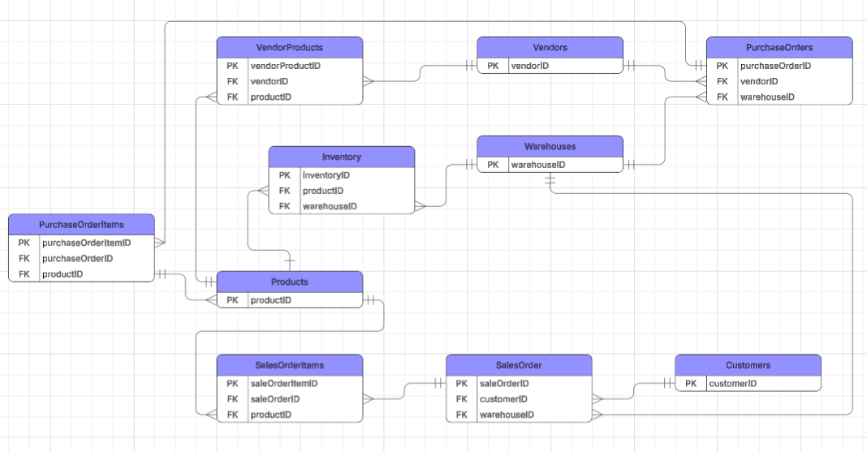
Schema Diagram:
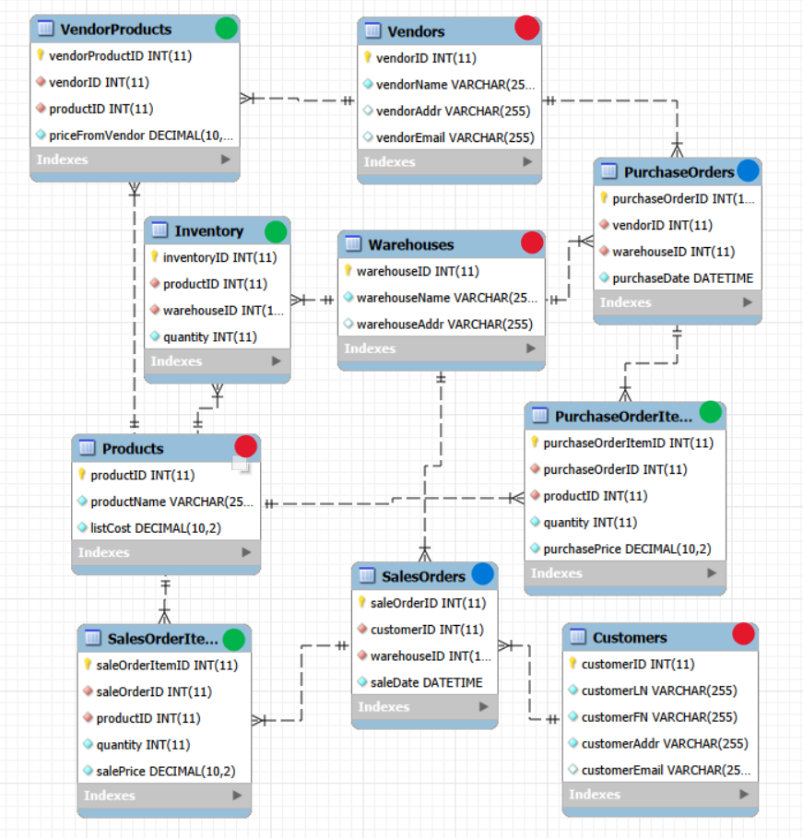

Sample Data:

PRODUCTS VENDORS
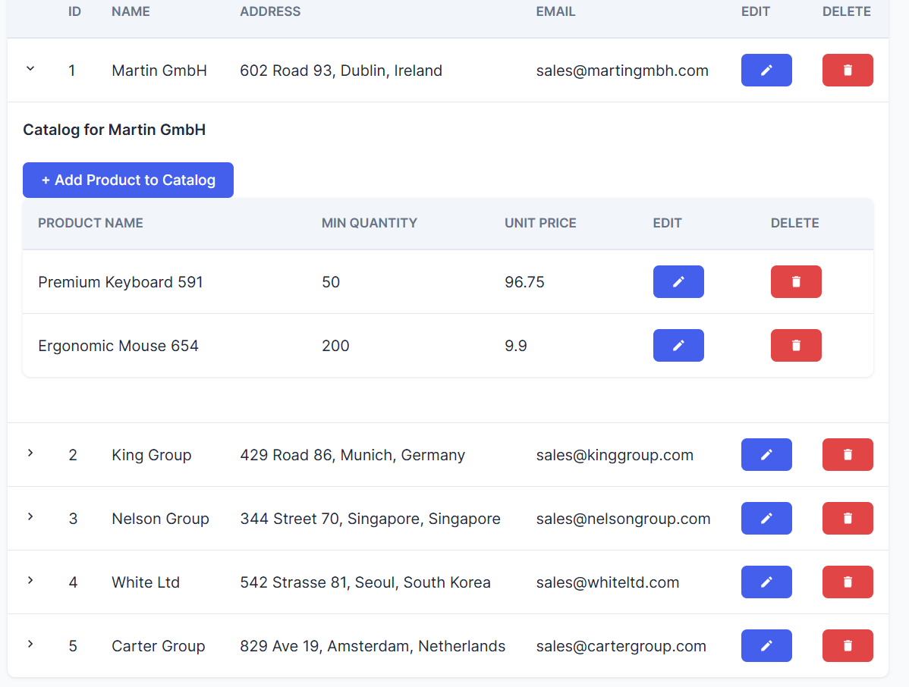
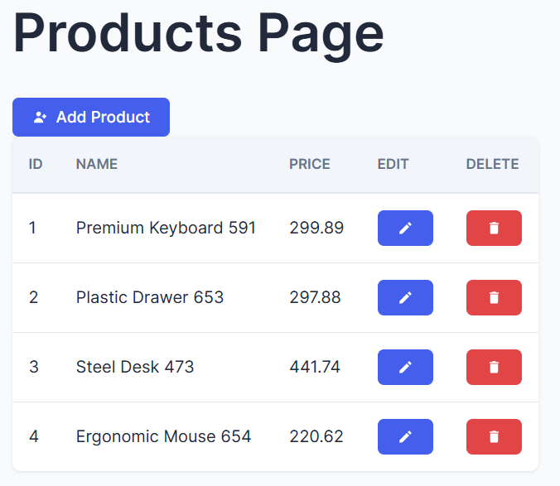

CUSTOMERS WAREHOUSES
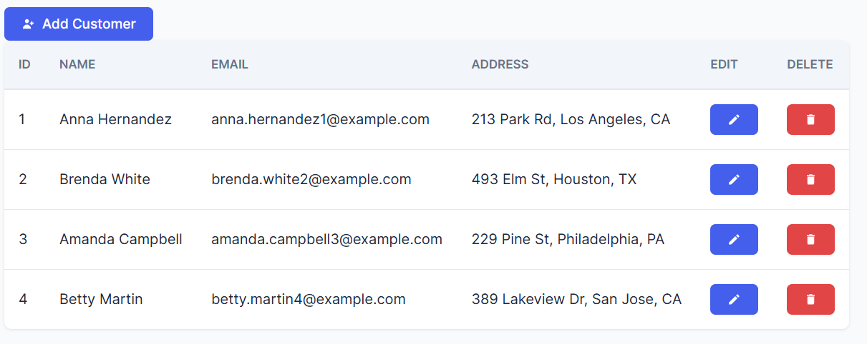
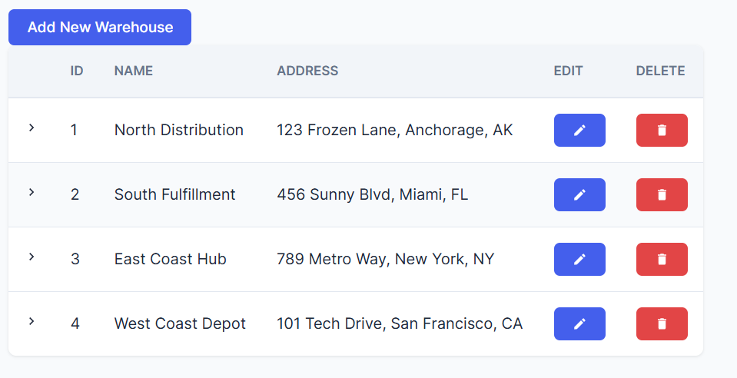

INVENTORY SALESORDERS/SALESORDERITEMS
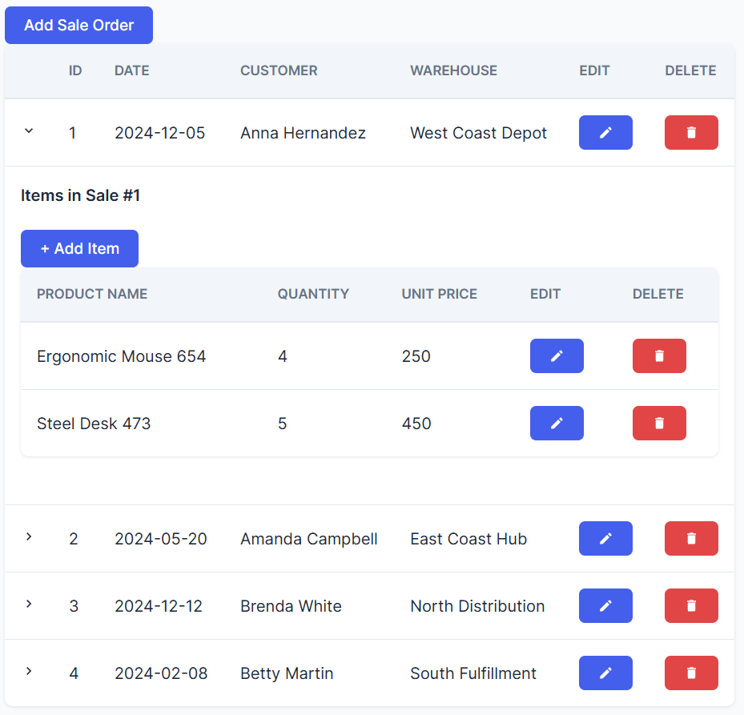
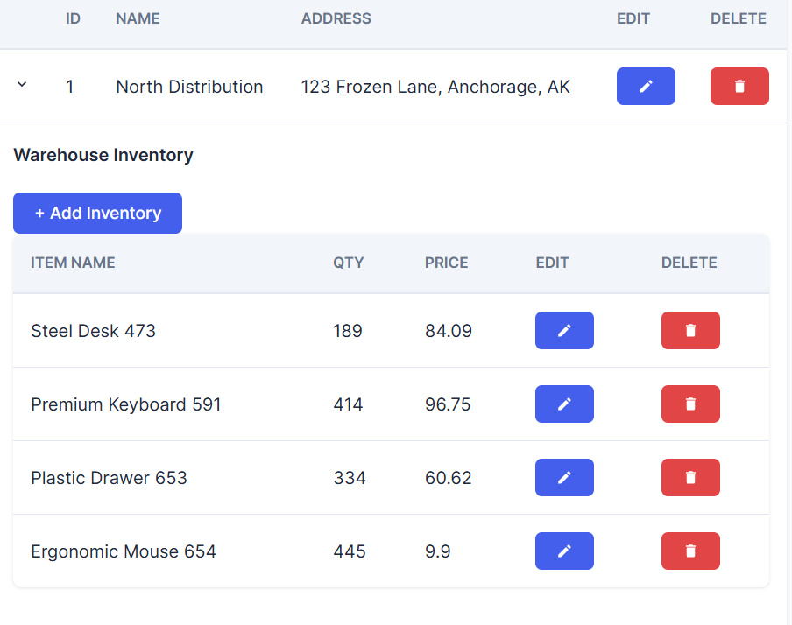

PURCHASEORDERS PURCHASEORDERITEMS
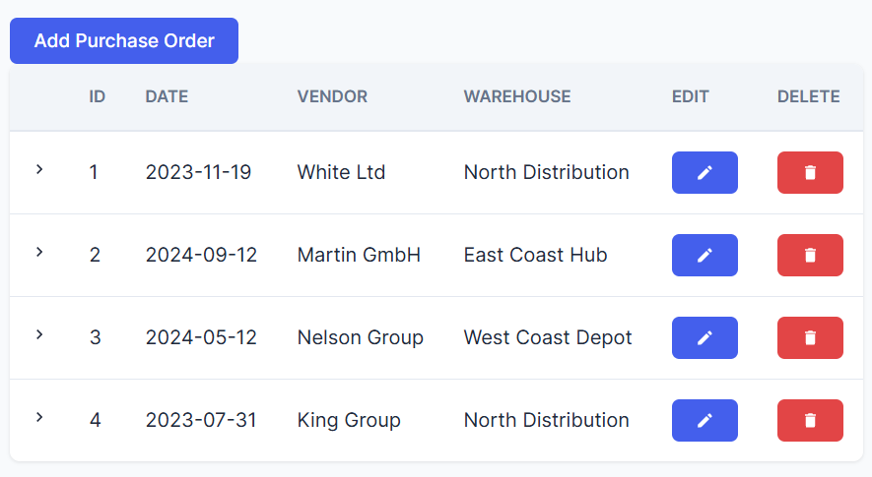
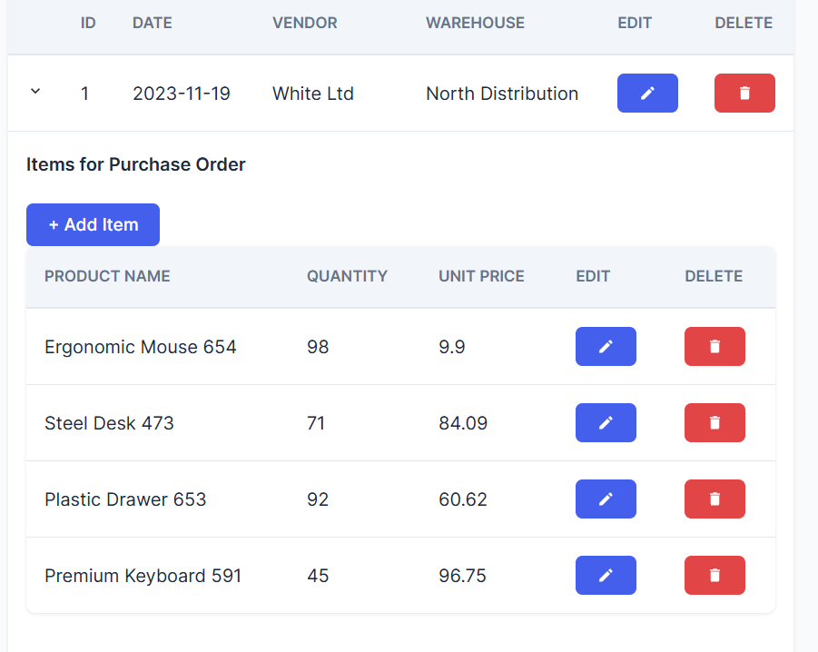

UI PAGES
Homepage (RESET Database):
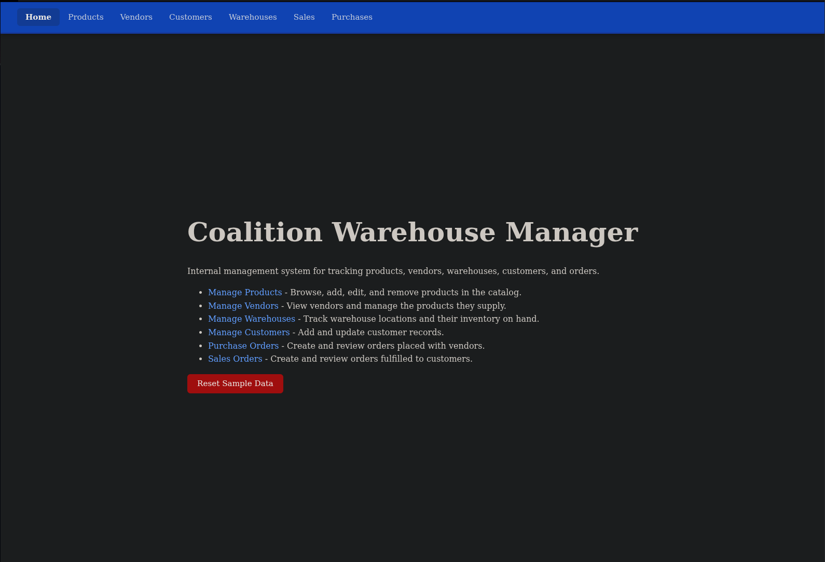
Products (CREATE/READ/UPDATE/DELETE Products):
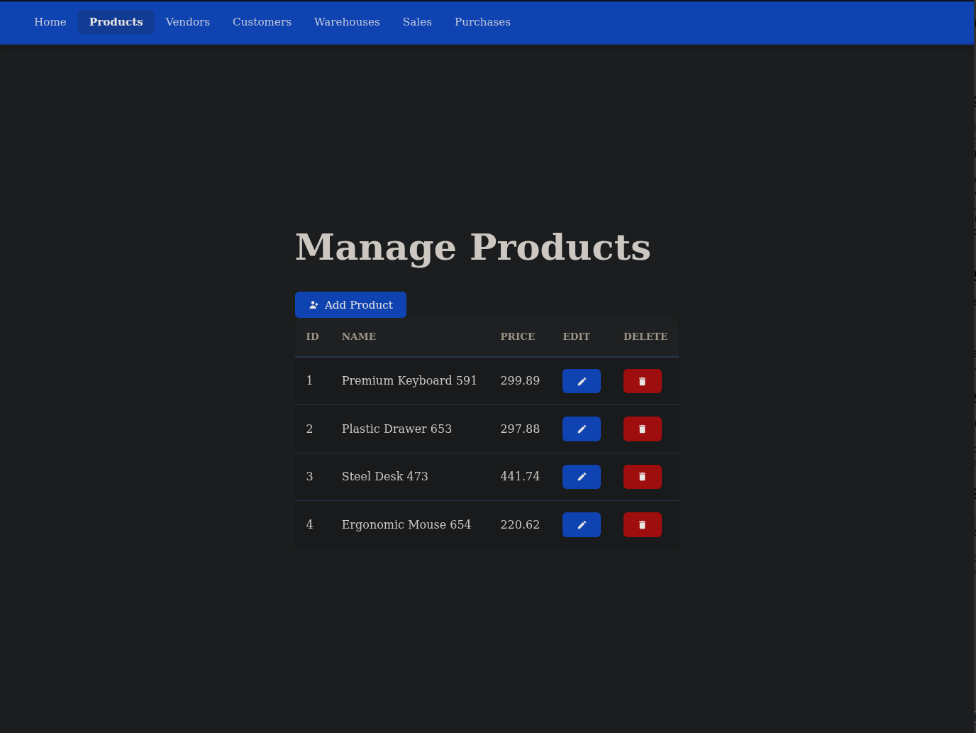
Vendors (CREATE/READ/UPDATE/DELETE Vendors):
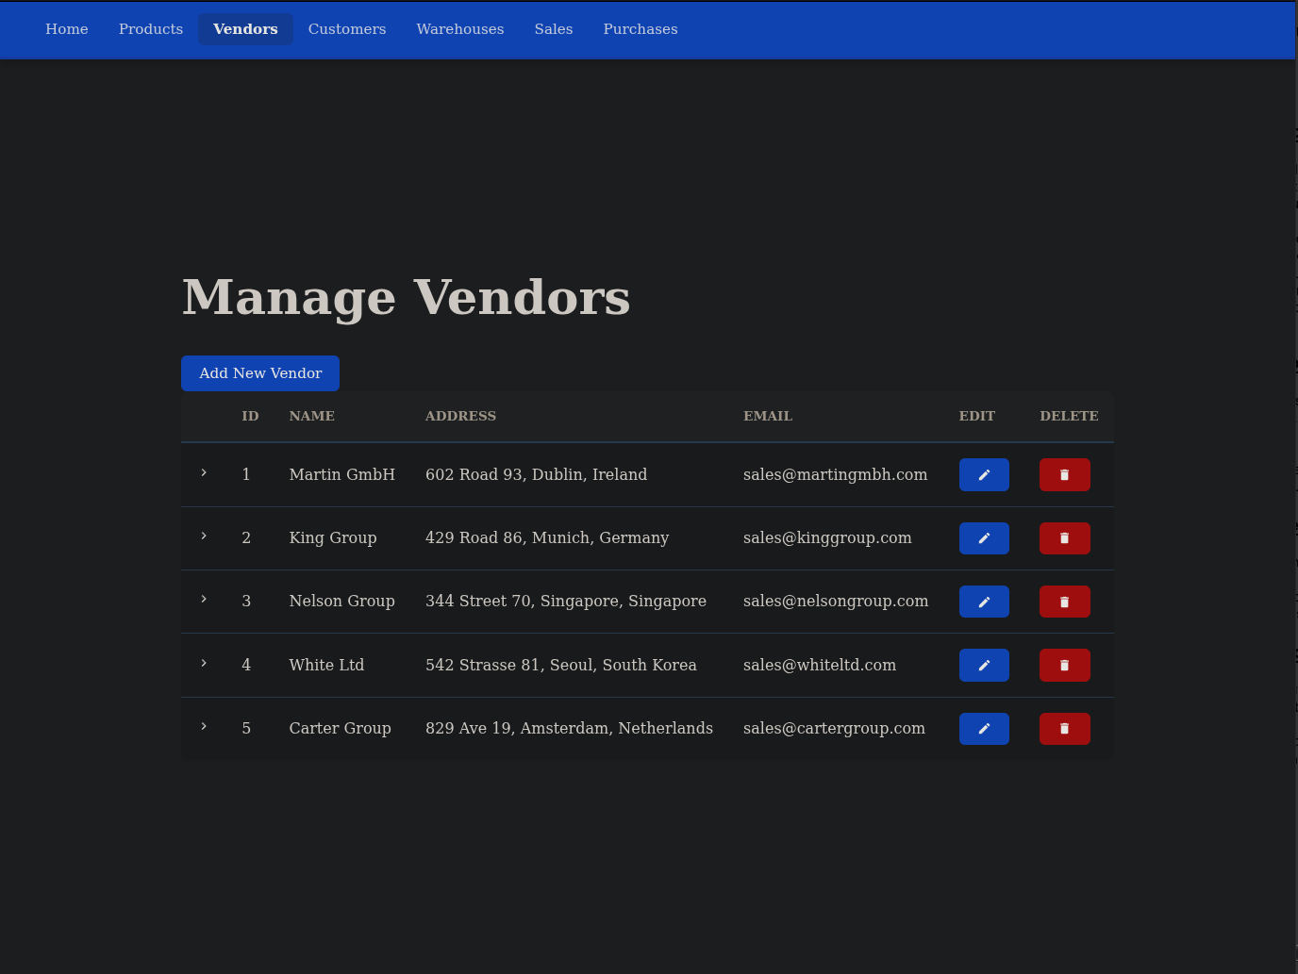
Customers (CREATE/READ/UPDATE/DELETE Customers):
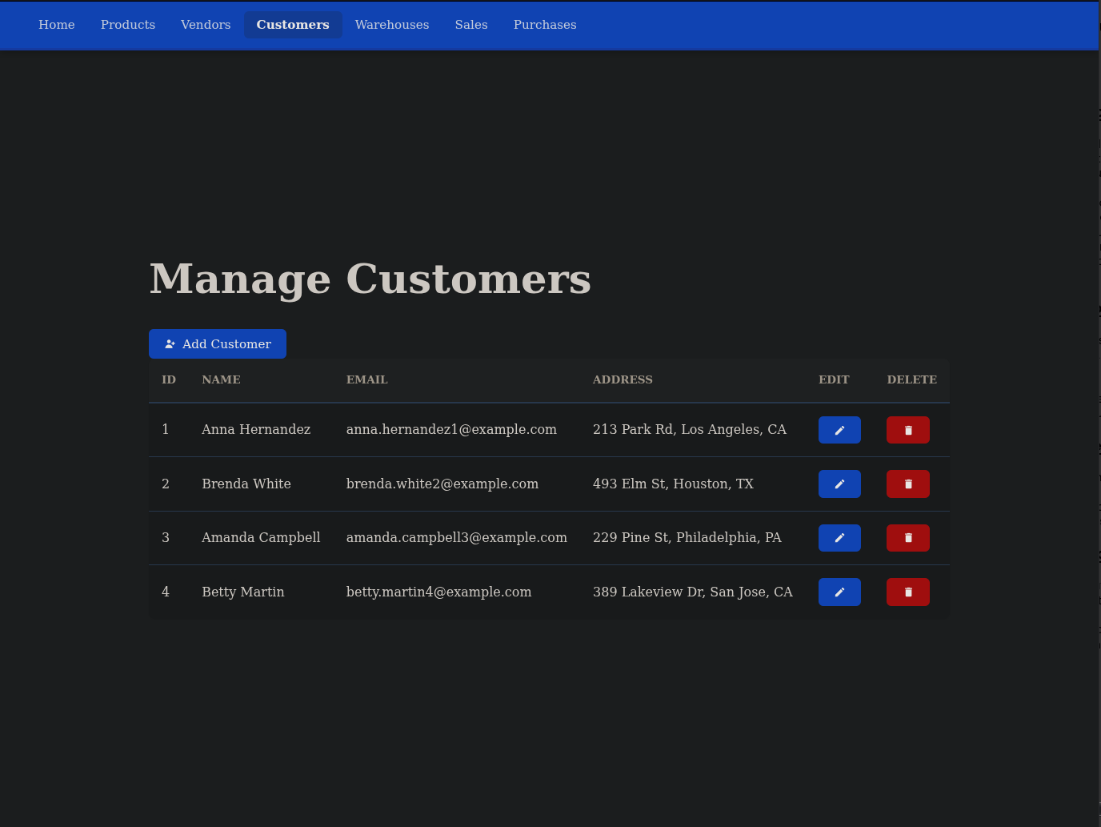
Warehouses (CREATE/READ/UPDATE/DELETE Warehouses):
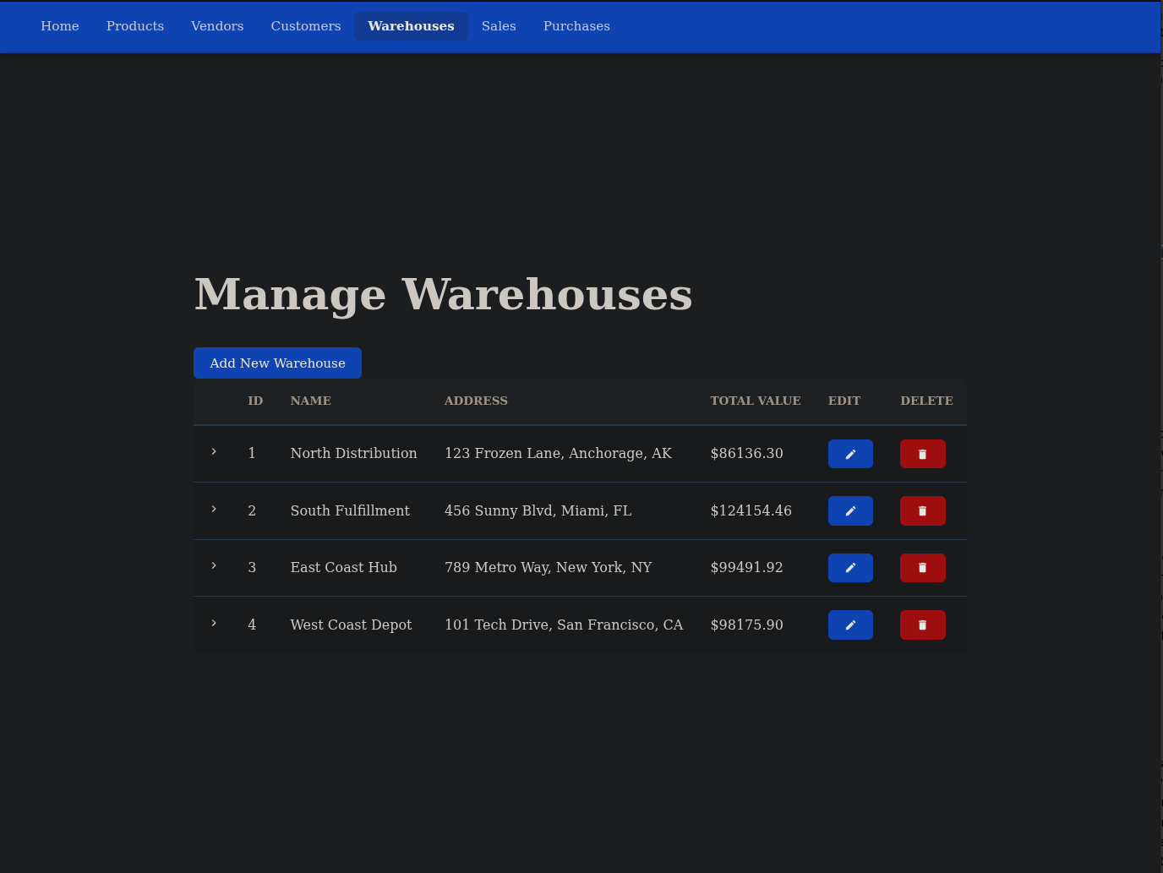
Sales (CREATE/READ/UPDATE/DELETE Sales Records):
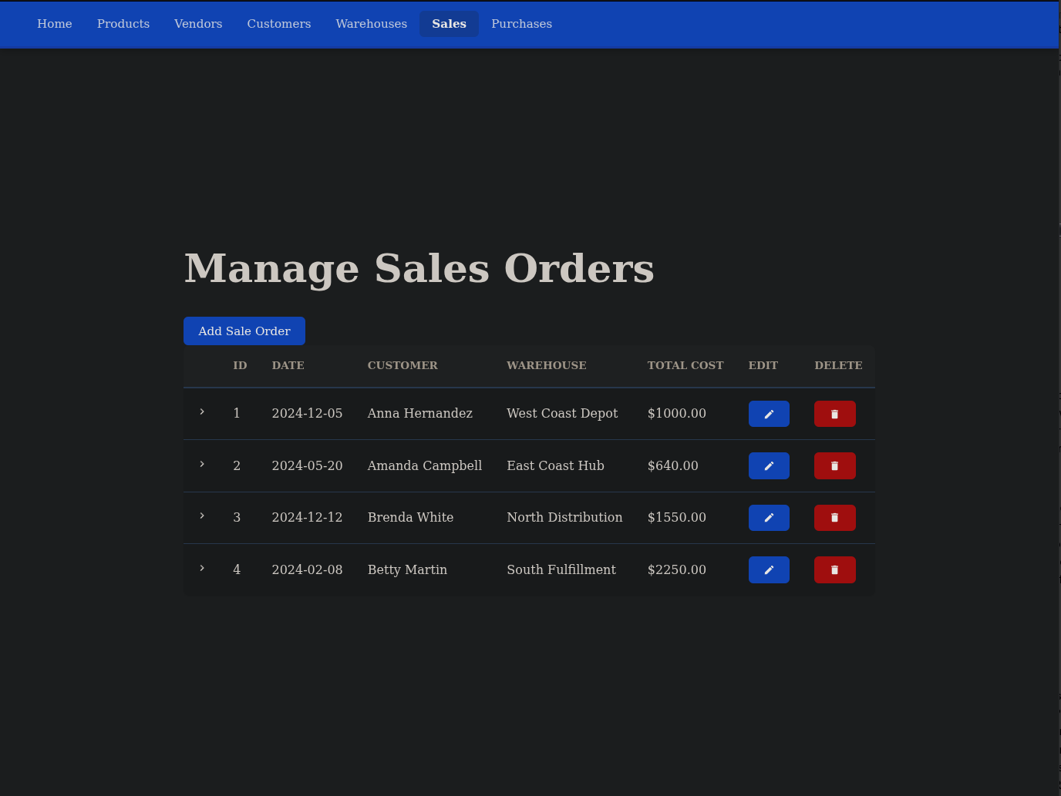
Purchases (CREATE/READ/UPDATE/DELETE Purchase Records):
