ZSERVICE_CONSUME

|  |
| --- |
| *\*&---------------------------------------------------------------------\** *\*& Report ZSERVICE_CONSUME* *\*&---------------------------------------------------------------------\** *\*&* *\*&---------------------------------------------------------------------\** REPORT zservice_consume.  INCLUDE zservice_consume_top. INCLUDE zservice_consume_pbo. INCLUDE zservice_consume_pai. INCLUDE zservice_consume_f01.  START-OF-SELECTION.   CALL SCREEN 0100. |

|  |
| --- |
| *\*&---------------------------------------------------------------------\** *\*& Include          ZSERVICE_CONSUME_TOP* *\*&---------------------------------------------------------------------\**  TABLES : zservice_consume. |

|  |
| --- |
| *\*----------------------------------------------------------------------\** *\*\*\*INCLUDE ZSERVICE_CONSUME_PBO.* *\*----------------------------------------------------------------------\** *\*&---------------------------------------------------------------------\** *\*& Module STATUS_0100 OUTPUT* *\*&---------------------------------------------------------------------\** *\*&* *\*&---------------------------------------------------------------------\** MODULE status_0100 OUTPUT.  SET PF-STATUS 'GS_0100'. *\* SET TITLEBAR 'xxx'.*  *\* zservice_consume-id = '1234'.*  ENDMODULE. |

|  |
| --- |
| *\*----------------------------------------------------------------------\** *\*\*\*INCLUDE ZSERVICE_CONSUME_PAI.* *\*----------------------------------------------------------------------\** *\*&---------------------------------------------------------------------\** *\*&      Module  USER_COMMAND_0100  INPUT* *\*&---------------------------------------------------------------------\** *\*       text* *\*----------------------------------------------------------------------\** MODULE user_command_0100 INPUT.    CASE sy-ucomm.     WHEN 'QUERY'.       PERFORM call_service.  *\*      MESSAGE 'Query butonuna bastınız' TYPE 'I'.* *\*      LEAVE TO SCREEN 0.* *\*  WHEN 'EXIT'.* *\*    LEAVE TO SCREEN 0.* *\*  WHEN 'CANC'.* *\*    LEAVE TO SCREEN 0.* *\*    WHEN OTHERS.*   ENDCASE.  ENDMODULE. *\*&---------------------------------------------------------------------\** *\*&      Module  EXIT_COMMAND  INPUT* *\*&---------------------------------------------------------------------\** *\*       text* *\*----------------------------------------------------------------------\** MODULE exit_command INPUT.   LEAVE TO SCREEN 0. ENDMODULE. |

|  |
| --- |
| *\*&---------------------------------------------------------------------\** *\*& Include          ZSERVICE_CONSUME_F01* *\*&---------------------------------------------------------------------\**  FORM call_service.  *\*  TYPES : BEGIN OF ty_data,* *\*            id        TYPE string,* *\*            vergino   TYPE string,* *\*            telefonno TYPE string,* *\*            faksno    TYPE string,* *\*            adres     TYPE string,* *\*          END   OF ty_data.*    DATA : lo_http_client TYPE REF TO if_http_client.    DATA : l_data TYPE zservice_consume. *\*       t_data TYPE STANDARD TABLE OF ty_data.*  *\*Data variables for storing response in xstring and string*   DATA  : lv_string    TYPE string.  *\*Pass the URL to get Data*   lv_string = 'http://10.1.4.21:50000/zcxp_vendor_srv/VENDOR'.    lv_string = lv_string && '?ID=' && zservice_consume-id.  *\*Creation of New IF_lo_http_client Object*   cl_http_client=>create_by_url(     EXPORTING       url                = lv_string     IMPORTING       client             = lo_http_client     EXCEPTIONS       argument_not_found = 1       plugin_not_active  = 2       internal_error     = 3   ).    IF sy-subrc IS NOT INITIAL. *\* Handle errors*   ENDIF.    CALL METHOD lo_http_client->send     EXCEPTIONS       http_communication_failure = 1       http_invalid_state         = 2       http_processing_failed     = 3       OTHERS                     = 4.    CALL METHOD lo_http_client->receive     EXCEPTIONS       http_communication_failure = 1       http_invalid_state         = 2       http_processing_failed     = 3       OTHERS                     = 4.    IF sy-subrc NE 0.      DATA subrc TYPE sysubrc.     DATA errortext TYPE string.      CALL METHOD lo_http_client->get_last_error       IMPORTING         code    = subrc         message = errortext.  *\*  WRITE: / 'communication_error( receive )',* *\*         / 'code: ', subrc, 'message: ', errortext.*     EXIT.    ENDIF.   *\*Return the HTTP body of this entity as string data*   DATA(lv_string2) = lo_http_client->response->get_cdata( ).    /ui2/cl_json=>deserialize(     EXPORTING       json        = lv_string2       pretty_name = /ui2/cl_json=>pretty_mode-camel_case     CHANGING       data        = l_data *\*     data        = t_data*   ).  *\*  zservice_consume-adres = l_data-adres.*    MOVE-CORRESPONDING l_data TO zservice_consume.    SELECT SINGLE name1 AS vendor_name FROM lfa1 INTO CORRESPONDING FIELDS OF zservice_consume WHERE lifnr EQ zservice_consume-id.    BREAK-POINT.  ENDFORM. |

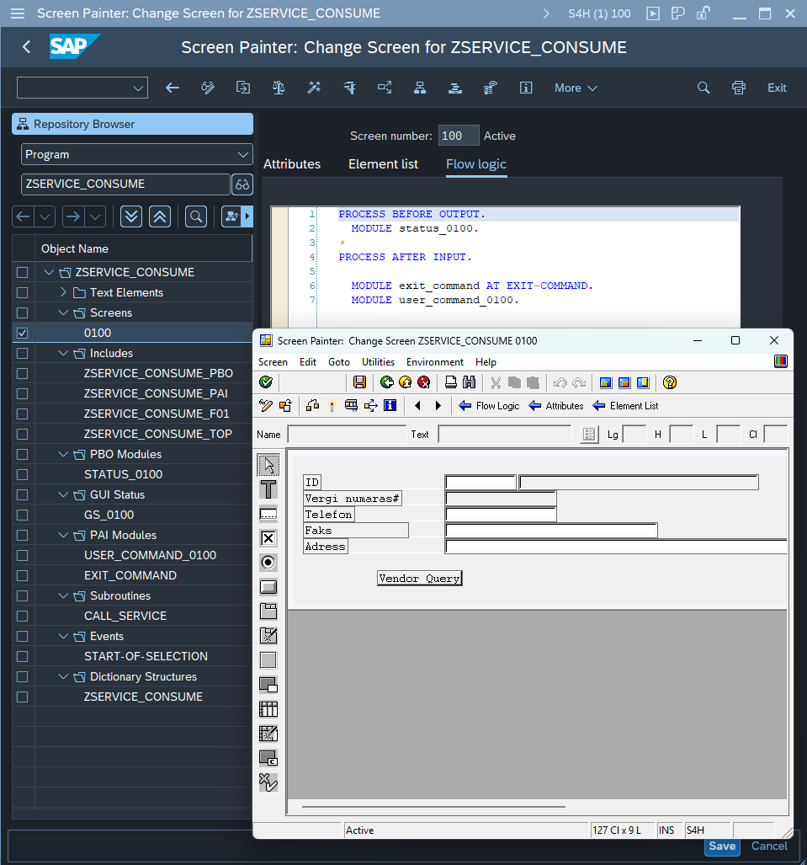

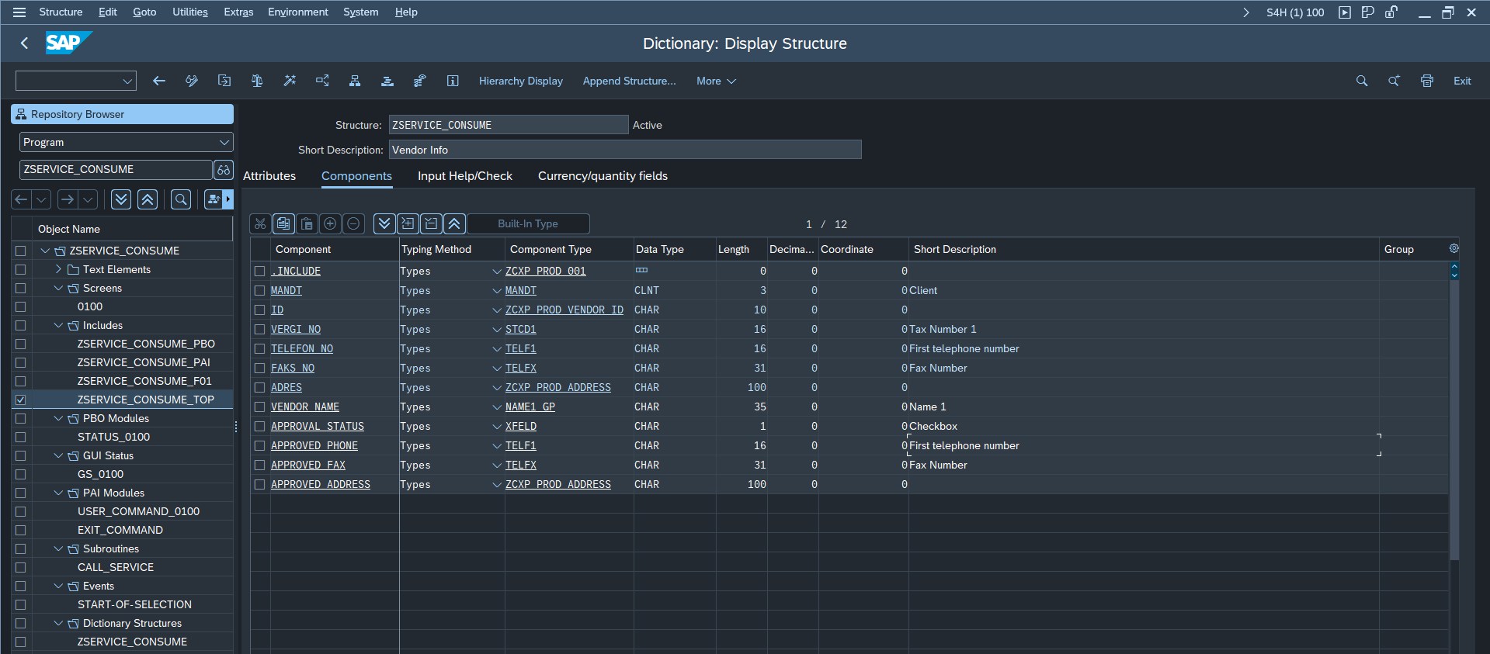

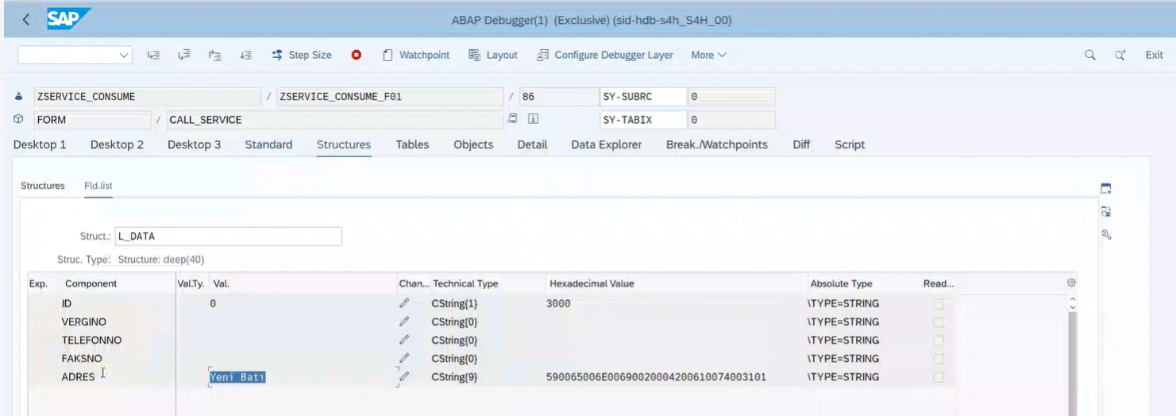

ZTR_RGC_VENDOR_APPROVAL Programı (ZTR_IGC_VENDOR_APPROVAL_C01)

|  |
| --- |
| *&---------------------------------------------------------------------* *& Report ZSERVICE_CONSUME *&---------------------------------------------------------------------* *& *&---------------------------------------------------------------------* REPORT ztr_rgc_vendor_approval.  INCLUDE ZTR_IGC_VENDOR_APPROVAL_TOP. INCLUDE ZTR_IGC_VENDOR_APPROVAL_PBO. INCLUDE ZTR_IGC_VENDOR_APPROVAL_PAI. INCLUDE ZTR_IGC_VENDOR_APPROVAL_C01. INITIALIZATION.    CREATE OBJECT go_main.  START-OF-SELECTION.    CALL SCREEN 0100. |

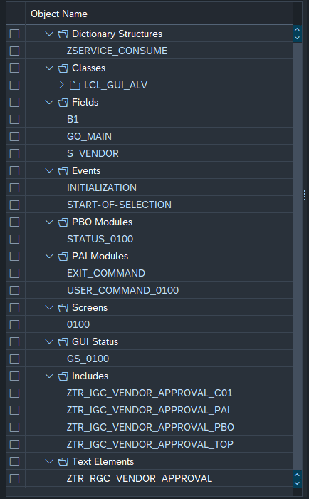

|  |
| --- |
| *&---------------------------------------------------------------------* *& Include          ZTR_I_VENDOR_QUERY_C01 *&---------------------------------------------------------------------* CLASS lcl_gui_alv IMPLEMENTATION.    METHOD user_command .      CASE sy-ucomm.       WHEN gc_user_command_approve.         CALL METHOD approve.     ENDCASE.   ENDMETHOD.    METHOD init_0100.      SET PF-STATUS 'GS_0100'.      build_data( ).      init_grid( ).      display( ).    ENDMETHOD.    METHOD approve .      mo_grid->get_selected_rows(       IMPORTING         et_index_rows = DATA(lt_index)         et_row_no     = DATA(lt_row)     ).      BREAK-POINT.      LOOP AT lt_index INTO DATA(ls_index).        READ TABLE mt_out ASSIGNING FIELD-SYMBOL(<lfs_out>) INDEX ls_index-index.        IF sy-subrc EQ 0.          <lfs_out>-approval_status = abap_true.        ENDIF.      ENDLOOP.      mo_grid->refresh_table_display( *      EXPORTING *        is_stable      = *        i_soft_refresh =       EXCEPTIONS         finished = 1         OTHERS   = 2     ).    ENDMETHOD.    METHOD build_data .      SELECT * FROM zcxp_prod_002 INTO CORRESPONDING FIELDS OF TABLE mt_out WHERE id IN s_vendor.      LOOP AT mt_out ASSIGNING FIELD-SYMBOL(<lfs_out>).        SELECT SINGLE name1 FROM lfa1 INTO <lfs_out>-vendor_name WHERE lifnr EQ <lfs_out>-id.      ENDLOOP.      APPEND LINES OF mt_out TO mt_out.     APPEND LINES OF mt_out TO mt_out.    ENDMETHOD.    METHOD set_title.      READ TABLE mt_field_catalog ASSIGNING FIELD-SYMBOL(<lfs_field_catalog>) WITH KEY fieldname = im_field_name.      IF sy-subrc EQ 0.       <lfs_field_catalog>-reptext =       <lfs_field_catalog>-scrtext_s =       <lfs_field_catalog>-scrtext_m =       <lfs_field_catalog>-scrtext_l = im_title.     ENDIF.    ENDMETHOD.    METHOD build_field_catalog.   * Filling the fieldcatalog table     CALL FUNCTION 'LVC_FIELDCATALOG_MERGE'       EXPORTING         i_structure_name       = gc_structure_name       CHANGING         ct_fieldcat            = mt_field_catalog       EXCEPTIONS         inconsistent_interface = 1         program_error          = 2         OTHERS                 = 3.      LOOP AT mt_field_catalog ASSIGNING FIELD-SYMBOL(<lfs_fcat>).        <lfs_fcat>-colddictxt = 'L'.        IF <lfs_fcat>-fieldname EQ 'APPROVAL_STATUS'.         <lfs_fcat>-checkbox = abap_true.       ENDIF.      ENDLOOP.      set_title(       im_field_name = 'ID'       im_title      = TEXT-h01     ).      set_title(       im_field_name = 'ADRES'       im_title      = TEXT-h02     ).      set_title(       im_field_name = 'VENDOR_NAME'       im_title      = TEXT-h03     ).      set_title(       im_field_name = 'APPROVAL_STATUS'       im_title      = TEXT-h04     ).    ENDMETHOD.    METHOD get_container.      DATA : lo_docking_container TYPE REF TO cl_gui_docking_container.      IF lo_docking_container IS INITIAL.        CREATE OBJECT lo_docking_container         EXPORTING           side                        = cl_gui_docking_container=>dock_at_top           extension                   = 1000 *         ratio                       = 95           caption                     = 'ALV List '         EXCEPTIONS           cntl_error                  = 1           cntl_system_error           = 2           create_error                = 3           lifetime_error              = 4           lifetime_dynpro_dynpro_link = 5           OTHERS                      = 6.     ENDIF.      re_container_object = lo_docking_container.    ENDMETHOD.    METHOD display.      DATA : ls_variant TYPE disvariant,            ls_layout  TYPE lvc_s_layo.      ls_variant-report = sy-repid.      ls_layout-zebra      = abap_on.     ls_layout-cwidth_opt = abap_on.     ls_layout-sel_mode   = 'A'.      CALL METHOD mo_grid->set_table_for_first_display       EXPORTING         is_variant      = ls_variant         i_save          = 'A'         is_layout       = ls_layout       CHANGING         it_outtab       = mt_out         it_fieldcatalog = mt_field_catalog.    ENDMETHOD.    METHOD init_grid.      CALL METHOD build_field_catalog.      CALL METHOD get_container       RECEIVING         re_container_object = DATA(lo_container).      " Create grid object     CREATE OBJECT mo_grid       EXPORTING         i_parent = lo_container.    ENDMETHOD.  ENDCLASS. |

|  |
| --- |
| *----------------------------------------------------------------------* ***INCLUDE ZTR_I_VENDOR_QUERY_PAI *----------------------------------------------------------------------* *&---------------------------------------------------------------------* *&      Module  USER_COMMAND_0100  INPUT *&---------------------------------------------------------------------* *       text *----------------------------------------------------------------------* MODULE user_command_0100 INPUT.    CALL METHOD go_main->user_command.  ENDMODULE. *&---------------------------------------------------------------------* *&      Module  EXIT_COMMAND  INPUT *&---------------------------------------------------------------------* *       text *----------------------------------------------------------------------* MODULE exit_command INPUT.   LEAVE TO SCREEN 0. ENDMODULE. |

|  |
| --- |
| *----------------------------------------------------------------------* ***INCLUDE ZTR_I_VENDOR_QUERY_PBO. *----------------------------------------------------------------------* *&---------------------------------------------------------------------* *& Module STATUS_0100 OUTPUT *&---------------------------------------------------------------------* *& *&---------------------------------------------------------------------* MODULE status_0100 OUTPUT.   go_main->init_0100( ). ENDMODULE. |

|  |
| --- |
| *&---------------------------------------------------------------------* *& Include          ZTR_I_VENDOR_APPROVAL_TOP *&---------------------------------------------------------------------*  ************************************************************************ * GLOBAL DATA DEFINITIONS                                              * ************************************************************************ *----------------------------------------------------------------------* * INCLUDE - definitions                                                * *----------------------------------------------------------------------* *----------------------------------------------------------------------* * CONSTANT - definitions                                               * *----------------------------------------------------------------------*  *----------------------------------------------------------------------* * TYPE - definitions                                                   * *----------------------------------------------------------------------* *----------------------------------------------------------------------* * DDIC - TABLE / STRUCTURE / VIEW definitions                          * *----------------------------------------------------------------------* TABLES : zservice_consume. *----------------------------------------------------------------------* * RANGE definitions                                                    * *----------------------------------------------------------------------* *----------------------------------------------------------------------* * REFERENCE definitions                                                * *----------------------------------------------------------------------*  CLASS lcl_gui_alv DEFINITION.    PUBLIC SECTION.      CONSTANTS : gc_user_command_approve TYPE sy-ucomm VALUE 'APPROVE',                 gc_structure_name       TYPE typename VALUE 'ZSERVICE_CONSUME'.      DATA : mo_grid TYPE REF TO cl_gui_alv_grid.      DATA : mt_out           TYPE TABLE OF zservice_consume,            mt_field_catalog TYPE lvc_t_fcat.      METHODS :       build_data,       build_field_catalog,       init_0100,       user_command,       get_container RETURNING VALUE(re_container_object) TYPE REF TO cl_gui_docking_container,       init_grid,       display,       set_title IMPORTING im_field_name TYPE lvc_fname im_title TYPE reptext,       approve.  ENDCLASS.  DATA : go_main TYPE REF TO lcl_gui_alv.  *----------------------------------------------------------------------* * INTERNAL TABLE / STRUCTURE definitions *----------------------------------------------------------------------* *----------------------------------------------------------------------* * OTHER GLOBAL DATA definitions                                        * *----------------------------------------------------------------------* ************************************************************************ * GLOBAL DATA DEFINITIONS - END                                        * ************************************************************************ ************************************************************************ * SELECTION SCREENS                                                    * ************************************************************************  SELECTION-SCREEN BEGIN OF BLOCK b1 WITH FRAME.    SELECT-OPTIONS : s_vendor FOR zservice_consume-id.  SELECTION-SCREEN END OF BLOCK b1.  ************************************************************************ * SELECTION SCREENS - END                                              * ************************************************************************ |

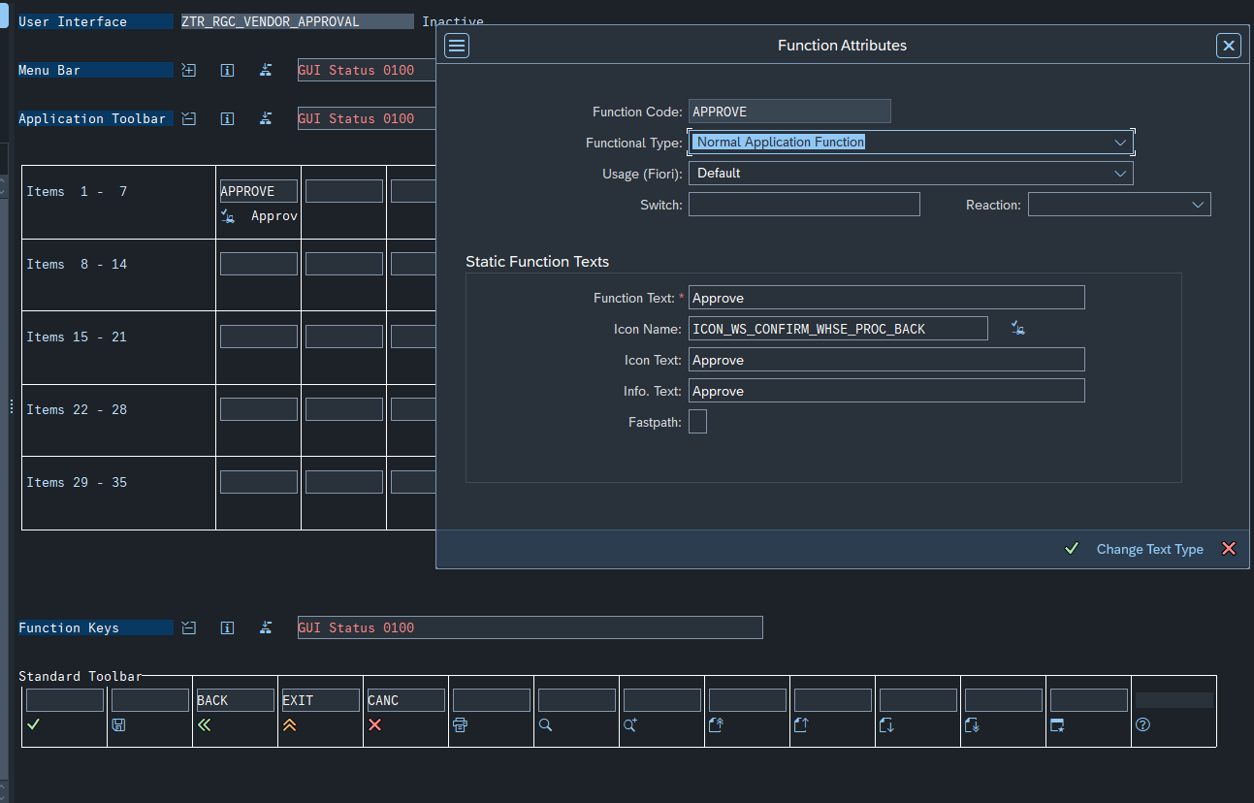

|  |
| --- |
| PROCESS BEFORE OUTPUT.    MODULE status_0100. * PROCESS AFTER INPUT.    MODULE exit_command AT EXIT-COMMAND.    MODULE user_command_0100. |



-

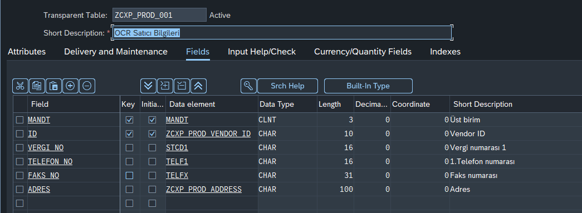

ZTR_P_VENDOR_QUERY Programı

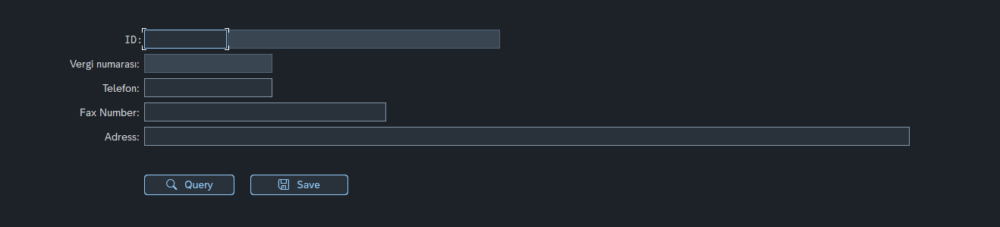

|  |
| --- |
| *\*&---------------------------------------------------------------------\** *\*& Report ZSERVICE_CONSUME* *\*&---------------------------------------------------------------------\** *\*&* *\*&---------------------------------------------------------------------\** REPORT ztr_pgc_vendor_query.  INCLUDE ZTR_IGC_VENDOR_QUERY_TOP. INCLUDE ZTR_IGC_VENDOR_QUERY_PBO. INCLUDE ZTR_IGC_VENDOR_QUERY_PAI. INCLUDE ZTR_IGC_VENDOR_QUERY_C01.  INITIALIZATION.    CREATE OBJECT go_main.  START-OF-SELECTION.    CALL SCREEN 0100. |

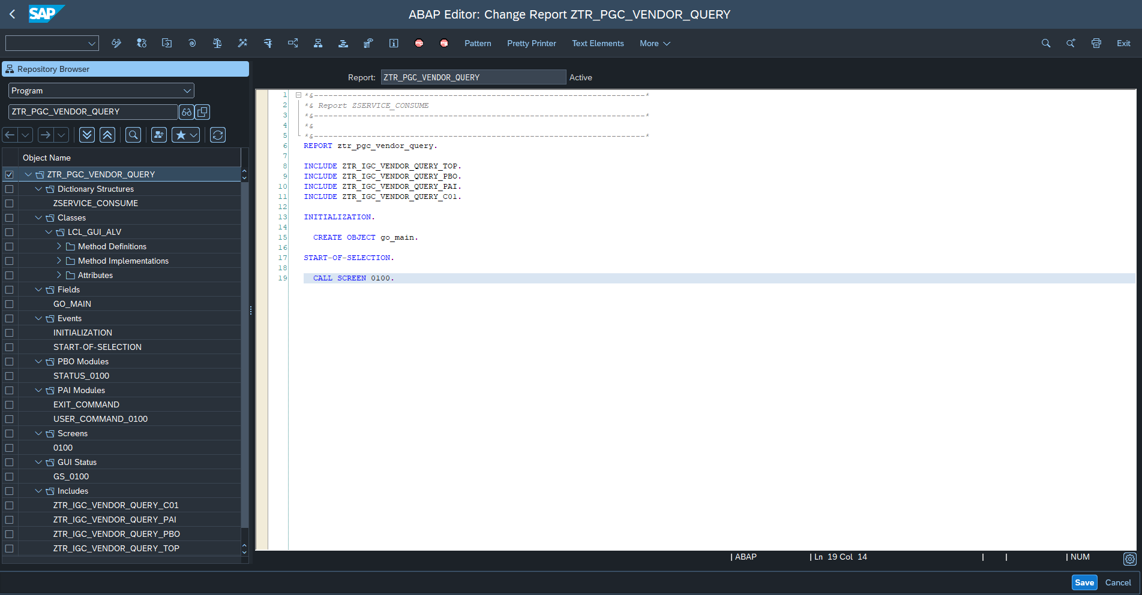

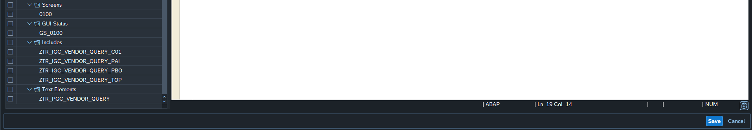

|  |
| --- |
| *\*&---------------------------------------------------------------------\** *\*& Include          ZTR_I_VENDOR_QUERY_TOP* *\*&---------------------------------------------------------------------\**  *\*\*\*\*\*\*\*\*\*\*\*\*\*\*\*\*\*\*\*\*\*\*\*\*\*\*\*\*\*\*\*\*\*\*\*\*\*\*\*\*\*\*\*\*\*\*\*\*\*\*\*\*\*\*\*\*\*\*\*\*\*\*\*\*\*\*\*\*\*\*\*\** *\* GLOBAL DATA DEFINITIONS                                              \** *\*\*\*\*\*\*\*\*\*\*\*\*\*\*\*\*\*\*\*\*\*\*\*\*\*\*\*\*\*\*\*\*\*\*\*\*\*\*\*\*\*\*\*\*\*\*\*\*\*\*\*\*\*\*\*\*\*\*\*\*\*\*\*\*\*\*\*\*\*\*\*\** *\*----------------------------------------------------------------------\** *\* INCLUDE - definitions                                                \** *\*----------------------------------------------------------------------\** *\*----------------------------------------------------------------------\** *\* CONSTANT - definitions                                               \** *\*----------------------------------------------------------------------\**  *\*CONSTANTS : gc_user_command_query TYPE sy-ucomm VALUE 'QUERY'.* *\*CONSTANTS : gc_structure_name TYPE typename VALUE 'ZHR_S_ALV'.*  *\*----------------------------------------------------------------------\** *\* TYPE - definitions                                                   \** *\*----------------------------------------------------------------------\** *\*----------------------------------------------------------------------\** *\* DDIC - TABLE / STRUCTURE / VIEW definitions                          \** *\*----------------------------------------------------------------------\** TABLES : zservice_consume. *\*----------------------------------------------------------------------\** *\* RANGE definitions                                                    \** *\*----------------------------------------------------------------------\** *\*----------------------------------------------------------------------\** *\* REFERENCE definitions                                                \** *\*----------------------------------------------------------------------\**  CLASS lcl_gui_alv DEFINITION.    PUBLIC SECTION.      CONSTANTS : gc_user_command_query TYPE sy-ucomm VALUE 'QUERY',                 gc_user_command_save  TYPE sy-ucomm VALUE 'SAVE',                 gc_endpoint           TYPE string VALUE 'http://10.1.4.21:50000/zcxp_vendor_srv/VENDOR'.  *\*    DATA : mt_out           TYPE TABLE OF zhr_s_alv.*      METHODS : *\*      build_data,* *\*      build_alv_data IMPORTING im_pernr_tab TYPE hrahq_pernr_table,* *\*      build_data IMPORTING im_pernr_tab TYPE hrahq_pernr_table,* *\*      set_text_data CHANGING ch_item TYPE zhr_s_alv,*       init_0100,       user_command,       vendor_query,       save. *\*      insert_log IMPORTING im_personnel_no TYPE zhr_01-personel_no im_request TYPE zhr... im_response TYPE zhr... im_exception_text TYPE string.*  ENDCLASS.  DATA : go_main TYPE REF TO lcl_gui_alv.  *\*----------------------------------------------------------------------\** *\* INTERNAL TABLE / STRUCTURE definitions* *\*----------------------------------------------------------------------\** *\*----------------------------------------------------------------------\** *\* OTHER GLOBAL DATA definitions                                        \** *\*----------------------------------------------------------------------\** *\*\*\*\*\*\*\*\*\*\*\*\*\*\*\*\*\*\*\*\*\*\*\*\*\*\*\*\*\*\*\*\*\*\*\*\*\*\*\*\*\*\*\*\*\*\*\*\*\*\*\*\*\*\*\*\*\*\*\*\*\*\*\*\*\*\*\*\*\*\*\*\** *\* GLOBAL DATA DEFINITIONS - END                                        \** *\*\*\*\*\*\*\*\*\*\*\*\*\*\*\*\*\*\*\*\*\*\*\*\*\*\*\*\*\*\*\*\*\*\*\*\*\*\*\*\*\*\*\*\*\*\*\*\*\*\*\*\*\*\*\*\*\*\*\*\*\*\*\*\*\*\*\*\*\*\*\*\** *\*\*\*\*\*\*\*\*\*\*\*\*\*\*\*\*\*\*\*\*\*\*\*\*\*\*\*\*\*\*\*\*\*\*\*\*\*\*\*\*\*\*\*\*\*\*\*\*\*\*\*\*\*\*\*\*\*\*\*\*\*\*\*\*\*\*\*\*\*\*\*\** *\* SELECTION SCREENS                                                    \** *\*\*\*\*\*\*\*\*\*\*\*\*\*\*\*\*\*\*\*\*\*\*\*\*\*\*\*\*\*\*\*\*\*\*\*\*\*\*\*\*\*\*\*\*\*\*\*\*\*\*\*\*\*\*\*\*\*\*\*\*\*\*\*\*\*\*\*\*\*\*\*\** |

|  |
| --- |
| *\*----------------------------------------------------------------------\** *\*\*\*INCLUDE ZTR_I_VENDOR_QUERY_PBO.* *\*----------------------------------------------------------------------\** *\*&---------------------------------------------------------------------\** *\*& Module STATUS_0100 OUTPUT* *\*&---------------------------------------------------------------------\** *\*&* *\*&---------------------------------------------------------------------\** MODULE status_0100 OUTPUT.   go_main->init_0100( ). ENDMODULE. |

|  |
| --- |
| *\*----------------------------------------------------------------------\** *\*\*\*INCLUDE ZTR_I_VENDOR_QUERY_PAI* *\*----------------------------------------------------------------------\** *\*&---------------------------------------------------------------------\** *\*&      Module  USER_COMMAND_0100  INPUT* *\*&---------------------------------------------------------------------\** *\*       text* *\*----------------------------------------------------------------------\** MODULE user_command_0100 INPUT.    CALL METHOD go_main->user_command.  ENDMODULE. *\*&---------------------------------------------------------------------\** *\*&      Module  EXIT_COMMAND  INPUT* *\*&---------------------------------------------------------------------\** *\*       text* *\*----------------------------------------------------------------------\** MODULE exit_command INPUT.   LEAVE TO SCREEN 0. ENDMODULE. |

|  |
| --- |
| *\*&---------------------------------------------------------------------\** *\*& Include          ZTR_I_VENDOR_QUERY_C01* *\*&---------------------------------------------------------------------\** CLASS lcl_gui_alv IMPLEMENTATION.    METHOD user_command .      CASE sy-ucomm.       WHEN gc_user_command_query.         CALL METHOD vendor_query.       WHEN gc_user_command_save.         CALL METHOD save.     ENDCASE.   ENDMETHOD.    METHOD init_0100.      SET PF-STATUS 'GS_0100'.    ENDMETHOD.    METHOD vendor_query .      DATA : lo_http_client TYPE REF TO if_http_client.      DATA : ls_response_data TYPE zservice_consume.      DATA : lv_endpoint   TYPE string,            lv_subrc      TYPE sysubrc,            lv_error_text TYPE string.  *\*Pass the URL to get Data*     lv_endpoint = gc_endpoint && '?ID=' && zservice_consume-id.  *\*Creation of New IF_lo_http_client Object*     cl_http_client=>create_by_url(       EXPORTING         url                = lv_endpoint       IMPORTING         client             = lo_http_client       EXCEPTIONS         argument_not_found = 1         plugin_not_active  = 2         internal_error     = 3     ).      CALL METHOD lo_http_client->send       EXCEPTIONS         http_communication_failure = 1         http_invalid_state         = 2         http_processing_failed     = 3         OTHERS                     = 4.      CALL METHOD lo_http_client->receive       EXCEPTIONS         http_communication_failure = 1         http_invalid_state         = 2         http_processing_failed     = 3         OTHERS                     = 4.      *"""""""""""""*     *" Verinin HTTP cevabında mevcut olup olmadığını kontrol et*     IF ls_response_data IS INITIAL.       MESSAGE 'Vendor ID ' && zservice_consume-id && ' not found. Please check.' TYPE 'I'.       RETURN.     ENDIF.     *""""""""""""""""""*      IF sy-subrc NE 0.        CALL METHOD lo_http_client->get_last_error         IMPORTING           code    = lv_subrc           message = lv_error_text.        DATA(lv_error) = 'communication_error( receive )' && ` ` &&                        'code:' && ` ` &&                        lv_subrc && ` ` &&                        'message:' && ` ` &&                        lv_error_text.        MESSAGE lv_error TYPE 'I'.        EXIT.      ENDIF.  *\*Return the HTTP body of this entity as string data*     DATA(lv_json) = lo_http_client->response->get_cdata( ).      /ui2/cl_json=>deserialize(       EXPORTING         json        = lv_json         pretty_name = /ui2/cl_json=>pretty_mode-camel_case       CHANGING         data        = ls_response_data     ).      MOVE-CORRESPONDING ls_response_data TO zservice_consume.      SELECT SINGLE name1 *\*    SELECT SINGLE name1 AS vendor_name*       FROM lfa1       INTO zservice_consume-vendor_name *\*      INTO CORRESPONDING FIELDS OF zservice_consume*      WHERE lifnr EQ zservice_consume-id.    ENDMETHOD.    METHOD save.      DATA : ls_db TYPE zcxp_prod_002.      MOVE-CORRESPONDING zservice_consume TO ls_db.      MODIFY zcxp_prod_002 FROM ls_db.      IF sy-subrc EQ 0.       MESSAGE TEXT-s01 TYPE 'I'.     ENDIF.    ENDMETHOD. ENDCLASS. |

