# Energy Tracker testing and Development

## [energy tracker API - Swagger UI](https://energytrackerapi20211206093928.azurewebsites.net/swagger/index.html)

## Questions for Matt

* there is no data already in the database?
  + is it possible to add the old data?
* generally, it would be useful to add references for definitions (ideally in the schema) of terms (e.g. in /SectorsAndTypologies/AddSectorsAndTypesToProject):
  + use:
  + category:
  + sector:
  + type:
  + ^ ideally the above would all have accompanying references from literature
  + (i’m currently not sure how to add Sectors / Types to my project)
* is UTC time used generally (current working assumption). required for expiry response for auth.
  + if yes, add to description in schema.
* when project is initiated with POST /Projects/Project, in the sample request: {"yourReferenceKey": "MyKey"}, it should be {"referenceKey": "MyKey"}
* ProjectCreationShell –> accessType: is there an enum of allowed values?
* “isFinalDesign” within Sessions
  + can’t see how to set “isFinalDesign” (its not in the PUT or POST commands within Sessions)
  + within a Session, we should define the convention within the schema for how “isFinalDesign” can be used. suggest that:
    - for a given “methodology”, there can only be 1no “isFinalDesign”
    - can this be enforced by validation within the schema?

## Workflow of Tool

* JG is in the process of making a tool for extracting data from an IES model and inputting into EnergyTracker
* it is intentionally limited in scope as a way to:
  + experiment with the API on a small project
  + embed the eTracker into other best-practice modelling workflows to increase likelihood of Engineers inputting the data

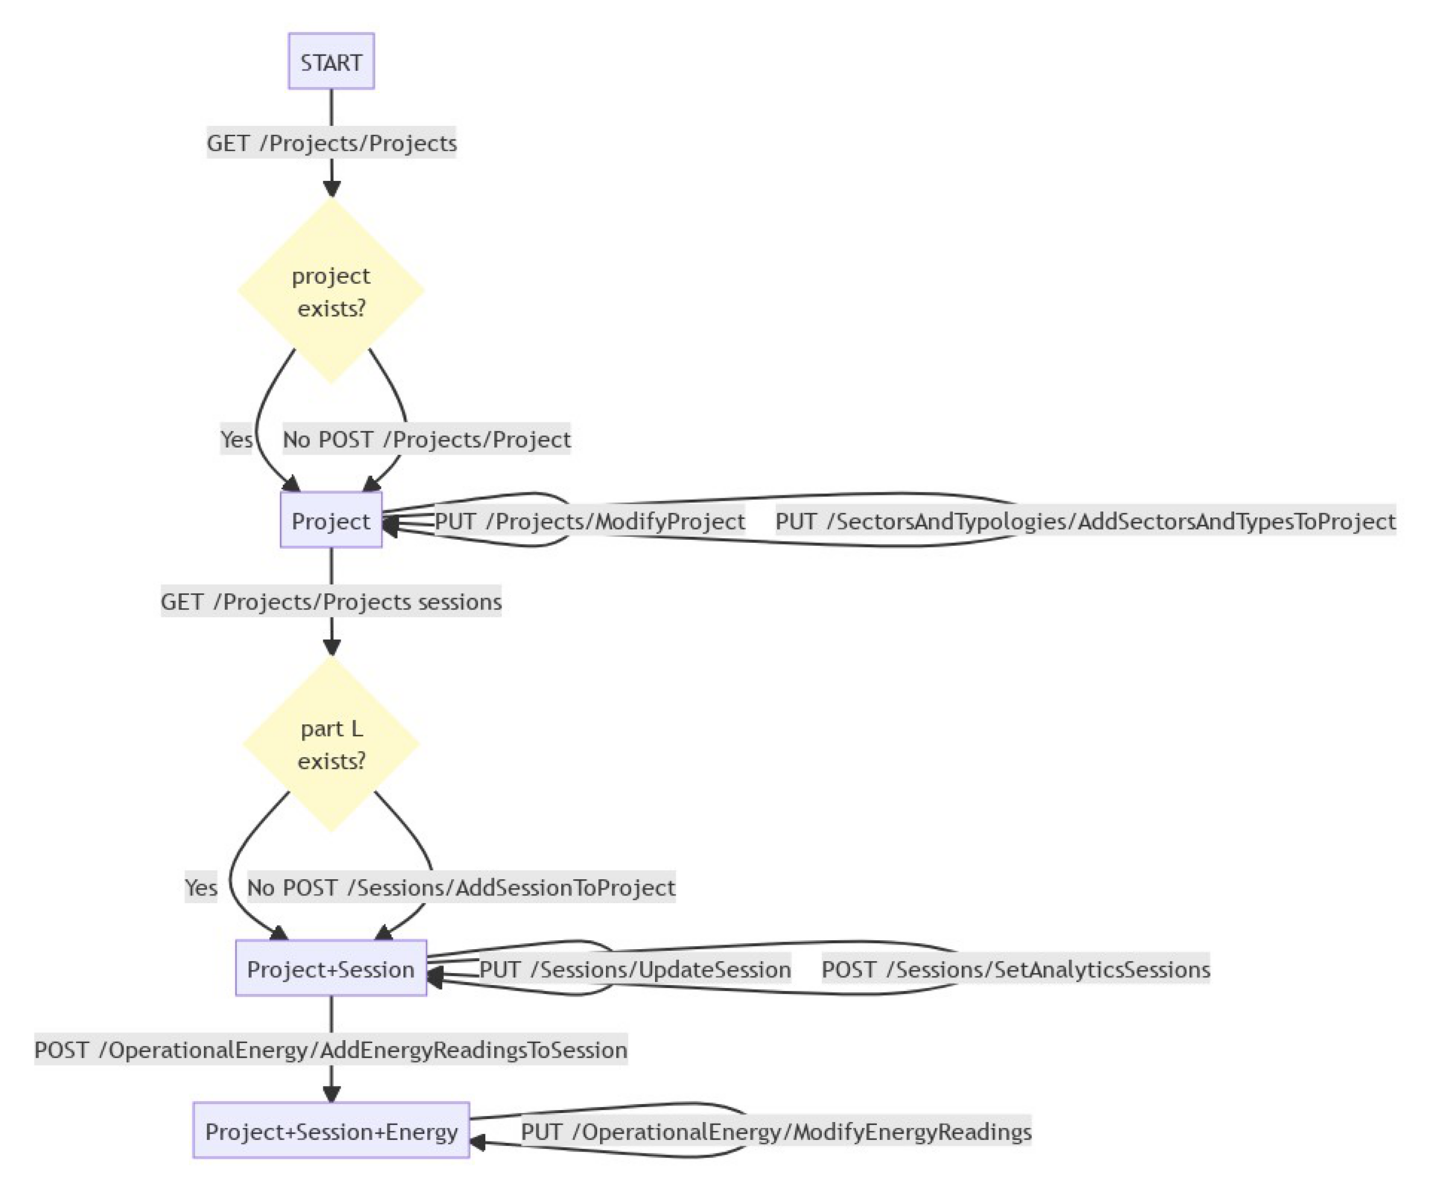

## Other Notes

* because the swagger.json file is built to the openapi standard it has been possible to convert the swagger.json files into python [pydantic](https://pydantic-docs.helpmanual.io/) models [datamodel-code-generator](https://koxudaxi.github.io/datamodel-code-generator/)
  + this makes development using python much more streamlined!
* [vuetify-jsonschema-form](https://github.com/koumoul-dev/vuetify-jsonschema-form) can be used to generate out-the-box UI forms from the schema