

**Edexcel GCSE Business**

**Homework Booklet 1.3**

**Name:______________________________**

**1.3.1 Aims and Objectives**

If you need help on any key terms, scan the link to take you to the key terms on Quizlet

What is the difference between an aim and objectives?

___________________________________________________________________________________________________________________________________________________________________________________________________________________________

What are financial objectives? Give some examples

___________________________________________________________________________________________________________________________________________________________________________________________________________________________

A business can also set non-financial objectives. List three non-financial:

1.

2.

3.

SMART targets

|  |  |  |
| --- | --- | --- |
|  | Stands for….. | Explain/Example |
| S |  |  |
| M |  |  |
| A |  |  |
| R |  |  |
| T |  |  |

* + 1. **Revenue, Cost and Profit**

What is revenue? How is it calculated?

______________________________________________________________________

______________________________________________________________________

**Revenue Calculations-** Complete the following table by calculating revenue

|  |  |  |
| --- | --- | --- |
| 1. | 40 Apple Air Pods are sold at £129.99 each |  |
| 2. | 160 revision guides sold at £3.75 |  |
| 3. | 95 tickets sold at £15.99 |  |
| 4. | 2000 chocolate bars sold at 55p |  |

A baker sells 125 cakes a day at £2.29 each

|  |  |  |
| --- | --- | --- |
| 5. | What’s their daily revenue? |  |
| 6. | What’s their weekly revenue? They open Monday to Saturday (closed Sunday). |  |

**Cost Calculations** use the information to calculate costs

A market stall buys cakes for £1.00 (variable costs) and sells them on for more. Their rent on the stall is £150 per week.

|  |  |  |
| --- | --- | --- |
| 1. | If they sell 200 cakes per week what will their total costs be? |  |
| 2. | If they sell 400 cakes per week what will their total costs be? |  |

A coffee shop has variable costs of 25p per coffee and weekly fixed costs of £1200

|  |  |  |
| --- | --- | --- |
| 3. | What are the total costs a week if they sell 800 cups of coffee a week? |  |
| 4. | What are the total costs a week if sales double to 1,600 cups a week? |  |
| 5. | Outline why the costs haven’t just doubled as production doubled |  |

What is profit and how is it calculated?

_________________________________________________________________________________________________________________________________________________________________________________________________________

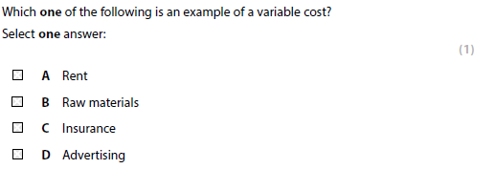

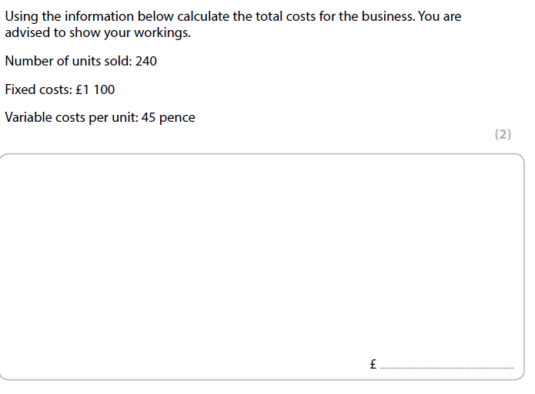

**1.3.3 Cash and Cashflow**

**Importance of cash - To pay suppliers**

Suppliers – those businesses which supply the company with _____ ______________ or even finished goods that another business may sell on for more. If a supplier is not paid on time they may ______________________ to deal with the company in the future. Therefore, cash is important to ensure that you can build good relationships with suppliers.

**Importance of cash - To prevent business failure (insolvency)**

What does it mean if a business becomes insolvent?

**________________________________________________________________________**

**Importance of cash - To pay employees**

What could happen if a business does not pay its employees:

___________________________________________________________________________________________________________________________________________________________________________________________________________________________

What is the difference between cash and profit?

Cash:

_________________________________________________________________________________________________________________________________________________

Profit: __________________________________________________________________________________________________________________________________________________

What is the difference between cash flow forecast and a cash flow statement?

___________________________________________________________________________________________________________________________________________________________________________________________________________________________

**Complete the cash flow documents**

|  |  |  |  |  |
| --- | --- | --- | --- | --- |
| Cash flow forecast for XYZ Garage Ltd | | | | |
|  | Jan | Feb | Mar | April |
|  | £ | £ | £ | £ |
| Balance brought forward | 25000 |  |  |  |
|  |  |  |  |  |
| INCOME | | | | |
| Sale of goods | 100000 | 80000 | 60000 | 70000 |
| Rental income | 10000 | 10000 | 10000 | 10000 |
| TOTAL INCOME |  |  |  |  |
|  |  |  |  |  |
| EXPENDITURE | | | | |
| materials | 50000 | 80000 | 60000 | 40000 |
| energy costs | 5000 | 20000 | 5000 | 5000 |
| wages | 10000 | 20000 | 20000 | 10000 |
| transport | 10000 | 15000 | 10000 | 5000 |
| TOTAL EXPENDITURE |  |  |  |  |
|  |  |  |  |  |
| balance carried forward |  |  |  |  |

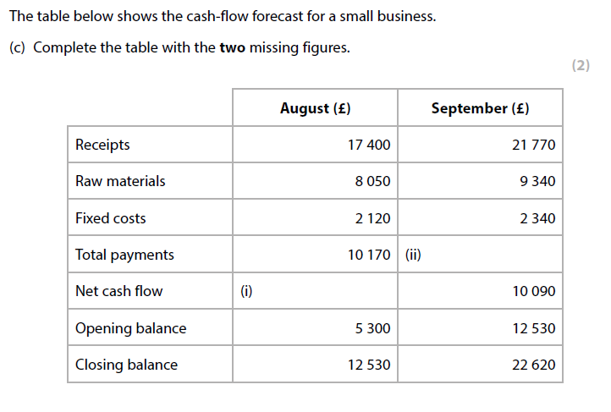

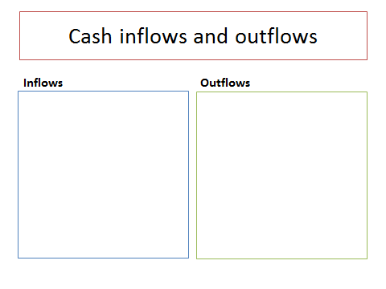**How many inflows and outflows can you think of?**

* + 1. **Breakeven**

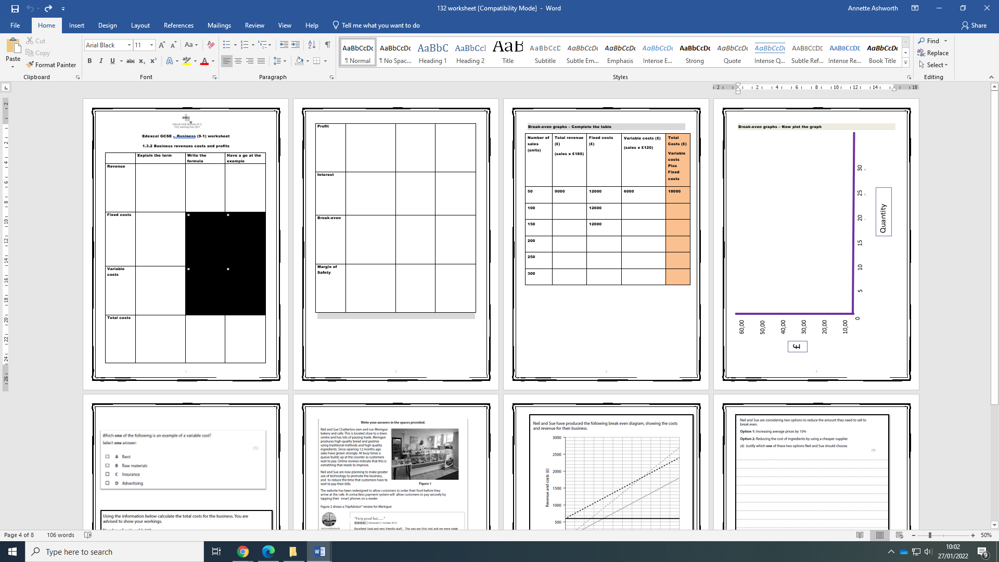**Complete the table to create the data to plot a graph.**

|  |  |  |  |  |
| --- | --- | --- | --- | --- |
| **Number of sales (units)** | **Total revenue (£)**  **(sales x £180)** | **Fixed costs (£)** | **Variable costs (£)**  **(sales x £120)** | **Total Costs (£)**  **Variable costs Plus Fixed costs** |
| **50** | 9000 | 12000 | 6000 | 18000 |
| **100** |  | 12000 |  |  |
| **150** |  | 12000 |  |  |
| **200** |  |  |  |  |
| **250** |  |  |  |  |
| **300** |  |  |  |  |

**1.3.5 Sources of business finance**

**Short-term sources of finance**

An overdraft is __________________________________________________________________________________________________________________________________________________

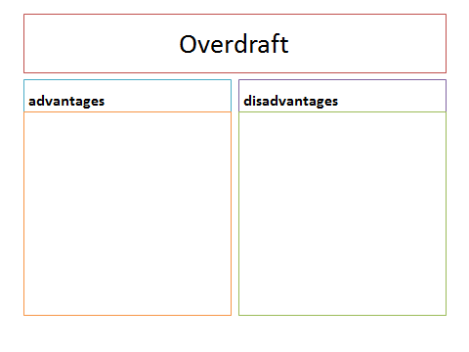

Trade credit is __________________________________________________________________________________________________________________________________________________

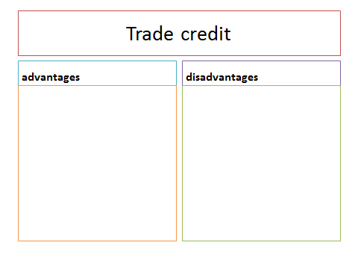

**Long-term sources of finance**

Personal savings are __________________________________________________________________________________________________________________________________________________

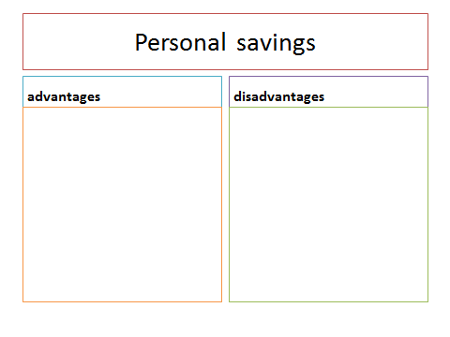

Loans are __________________________________________________________________________________________________________________________________________________

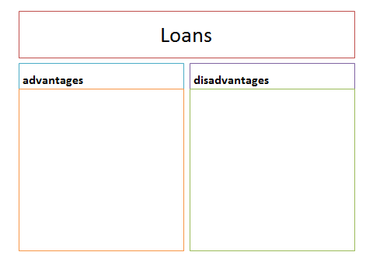

Venture Capital is __________________________________________________________________________________________________________________________________________________

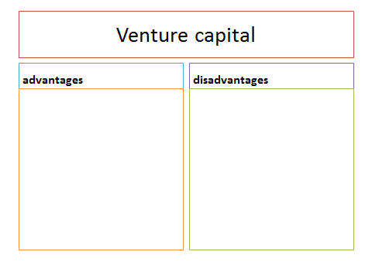

Crowd funding is __________________________________________________________________________________________________________________________________________________

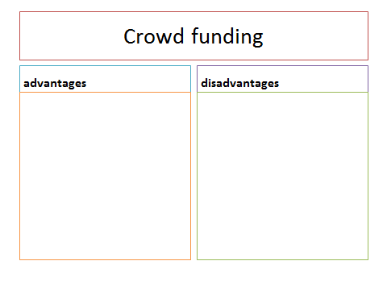

Share Capital is __________________________________________________________________________________________________________________________________________________

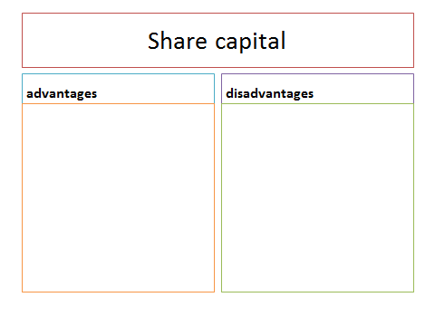

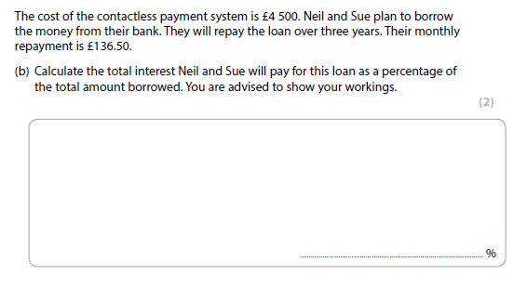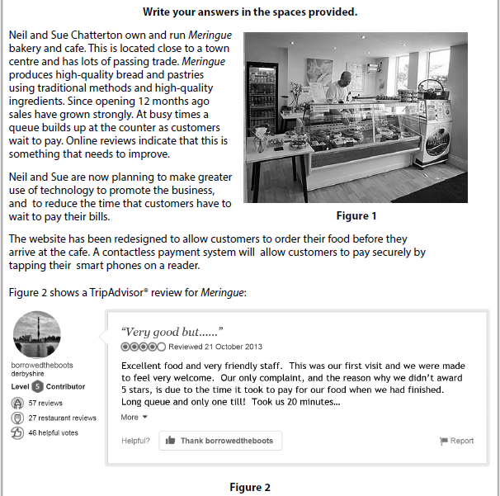**Writing in context practice**

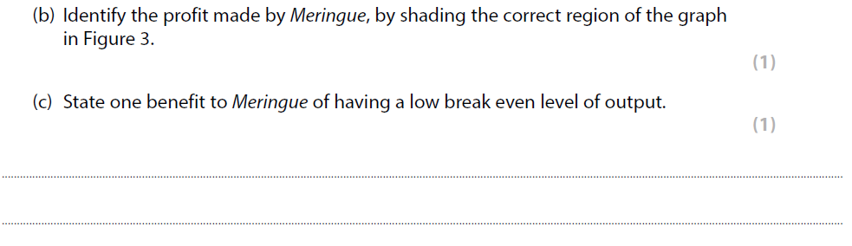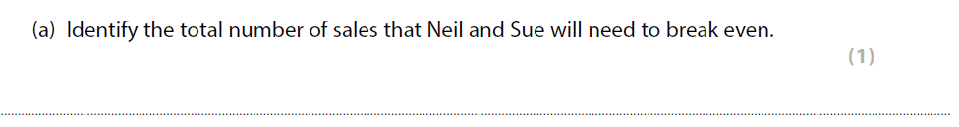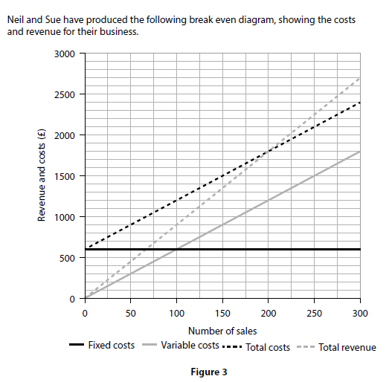

1.3 Putting a Business Idea into Practice Tier 3 vocab

|  |  |
| --- | --- |
| Key term | Definition |
| Aims |  |
| Objectives |  |
| Financial Objectives |  |
| Non-financial Objectives |  |
| Survival |  |
| Market Share |  |
| Profit |  |
| Social Objectives |  |
| Personal Satisfaction |  |
| Independence |  |
| Public sector |  |
| Private sector |  |
| Not for Profit |  |
| Revenue |  |
| Fixed Costs |  |
| Variable Costs |  |
| Total Costs |  |
| Loan |  |
| Repayments |  |
| Interest rates |  |
| Breakeven Point |  |
| Margin of Safety |  |
| Cashflow Forecast |  |
| Cashflow Statement |  |
| Cash Inflows |  |
| Cash Outflows |  |
| Net Cashflow |  |
| Opening Balance |  |
| Closing Balance |  |
| Insolvency |  |
| Overdraft |  |
| Trade Credit |  |
| Savings |  |
| Retained Profit |  |
| Loans |  |
| Venture Capital |  |
| Share Capital |  |
| Crowd Funding |  |
| Short term Sources |  |
| Long term Sources |  |



**Building Business Brains Bonus**

Try these extra credit tasks to really boost your business knowledge and gain some extra award points.

Business Research

1. What is the **interest rate** on a personal loan from the Halifax today?
2. How much revenue did **Amazon** make last year?
3. Who was YouTube’s biggest earner last year, and how much did they earn?

Business Documentaries

1. Go to <https://www.channel5.com> and search for **How do they do it?**. Select a documentary, watch it and write a summary of what you learned below.
2. Go to <https://www.channel5.com> and search for the **Wonderful World of Chocolate**. Watch an episode and summarise what it covered below.

Business Revision

Go to [www.Quizlet.com](http://www.Quizlet.com) (use the QR code on the front page), revise the 1.3 topic and show evidence to your teacher of your revision.