The solar wind is the stream of charged particles that flow from the Sun into space. The wind itself consists of high energy protons and electrons, as well as heavier ions like carbon, nitrogen and oxygen from the Sun’s plasma. Solar wind is also responsible for dragging part of the Sun’s magnetic field, called the heliospheric magnetic field, away from the Sun and into the Solar System. The solar wind exists because the particles in it come from the Sun’s corona, the outermost layer of plasma in the Sun, and it has a high enough temperature that allows for the particles to escape the Sun’s gravity. The crucial parts of the corona are the coronal holes and coronal loops. Coronal holes are colder, lower density areas of the corona with practically no magnetic radiation. Coronal loops are loops of magnetic field that carry plasma on the surface of the Sun. The magnetic field itself has two types of loops, called open and closed field lines. Closed field lines are loops that stay close to the Sun, whereas open field lines stray very far away from the Sun so that at close distances they appear more like two open ended lines of magnetic field than a loop.

The solar wind has been divided into two categories, called the fast wind and the slow wind. The fast wind typically has speeds greater than 500 km/sec, and slow wind has speeds less than this. A more important distinction is the compositional properties of the winds. Specifically, the ratio of elements with low first ionization potential to those with higher first ionization potential is observed. This ratio in the corona is about four times higher than it is in the photosphere. The fast wind has been observed to have a ratio more like that of the photosphere, while the slow wind is more similar to the corona. The two winds also have different ion ratios and freeze-in temperatures. These differences in data have led to the idea that the two winds come from different places, the fast wind from coronal holes and the slow wind from the corona.

A current issue for solar winds is the manner in which they are accelerated. Thermal energy from particle collisions in the corona only achieve speeds of about 150 km/sec, which is well below the speed necessary for the solar wind. Clearly, the energy must come from some other mechanism. There are two different theories for how this occurs. One is that the energy comes from the dissipation of Alfvén waves. The other argues that plasma is released through the reconnection of open and closed magnetic field lines. An open field corridor connects two coronal holes, and the locations of the corridors can change from changes in the photosphere. This is from field lines opening and closing, which releases the closed field plasma. In magnetic reconnection, field lines travelling in opposite directions connect as they get closer and closer to each other. This forms quasi-separatrix layers. The QSL allows for slow winds to be located far from the heliospheric current sheet, which matches observed data.

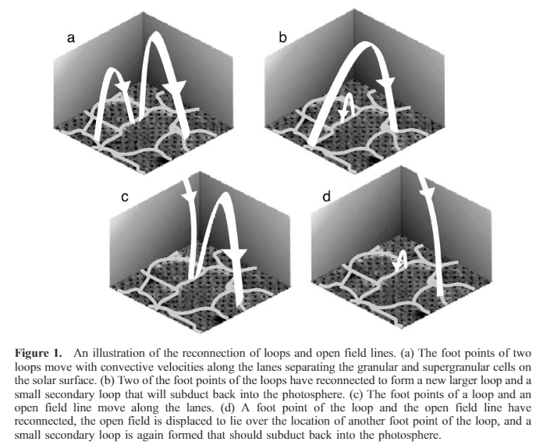 Figure 1

In Fisk et al, 2003, they pose a theory for how the energy for solar winds are created. Figure 1 above shows the process by which loops and field lines connect. Each loop has two foot points, and when the foot points of two different loops have opposite polarity, these foot points connect to form one big loop, as seen in figures 1a and 1b. A smaller loop is also formed where the loops connect, and the flux in this loop goes back into the photosphere. As the primary loop grows bigger, it can encounter an open field line, and if they have opposite polarity, they can also connect with each other, as seen in 1c and 1d. Then the material that was originally in the closed field loop is transported into the open field lines. The open line is displaced by all this reconnecting, which alters the magnetic field, allowing more energy to enter the corona.

Take an area *d***s**, with an open field line and a loop’s foot point that have the same polarity. They won’t reconnect, and *d***s** has the flux from one open field line passing through it. The other end of the loop can connect with a different open field line, creating a new open field line that will align with the first open field line. This doubles the amount of flux through *d***s**. The strength of the magnetic field along the line will also double, from **B**open to 2**B**open. The equation for the energy is Emagnetic=**.** As the volume increases, the flux stays constant, so 2 $∫B⋅ⅆh$ goes to $∫B⋅ⅆh$**.** This releases energy into the corona and serves to accelerate the solar wind.

Fisk et al, 1999 describes that as the field lines keep changing and moving around, the amount of flux in some areas will increase by $δB$ and decrease by $δB$ elsewhere, so the total magnetic flux doesn’t change, but the density does, by $\frac{δB^{2}}{8π}$. The changes in one area will propagate elsewhere, but the propagation can’t go on forever, so the energy does work on the plasma, heating the corona and allowing for the acceleration of the solar wind.