**Object Oriented Programming Assignment Report**



**Professor: 이혁준**

**Computer Information Engineering**

**2017202008**

**Nam Gun U**

1. **Assignment Explanation**

This assignment has 5 questions which make source code and operate the source code with Visual Studio. I have to solve it with programming language “c++” that I learned it Object Orient Programming lecture.

First of 5 problems is the “Collatz conjecture” that Regardless of any input number, the number becomes ‘1’. This mathematic conjecture has specific form. If I assume that $A_{i}$ is even number, we calculate $A_{i+1}$ which has the value $A_{i}$/2. However, if I suppose that $A_{i+1}$ is odd number, $A_{i+2}$ becomes $3A_{i+1}$ +1. I have to determine one number that is used for initial number, and then find the Maximum number and Minimum number. And also, I have to calculate sum of total numbers and Average by Dividing.

Second question is Drawing stars with input mark. By inputting mark and the number of side mark, Output the rational big star which satisfied input information.

Third problem is about perfect number. Perfect number means that sum of all aliquot numbers is equal to the number. If I input Maximum range of output number, the numbers which are perfect numbers that smaller than Maximum number, appear in the cmd. And all of aliquots have to appear in the cmd with regular form.

Fourth question is making a function which has specific function. Prior to explain the function, this problem requires 3 input information such as ‘Main string’, ‘Sub string’, and ’N’. It is really related to function and 3 things are required to the function. Its function’s name is ‘InsertString’. Its returning form is ‘bool’ which returns the value 1 or 0. It remakes the ‘Main string ‘with ‘Sub string’. ’N’ decide that where ‘sub string’ is inserted.

Last question is about birthday. ‘Messi’ who is having birthday has the number of candles that its amount is equal to his year. And he can blow out his longest candles. Therefore, Output information has to appear how many candles that ‘Messi’ can blow out.

1. **Result Information**

<1>

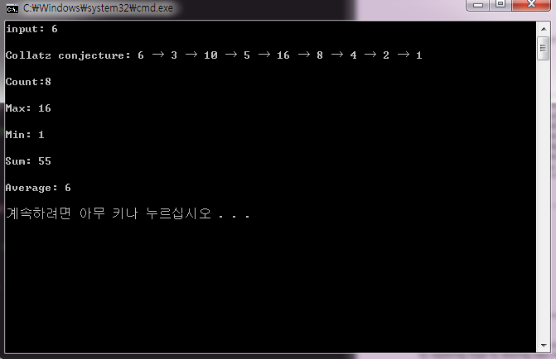

When I input 6 for initial number, It output 6 information such as Collatz conjecture, Count( the number of numbers), Maximum number, Minimum number, Sum and Average. Picture shows that what it is general and main output.

**Exception Handling**

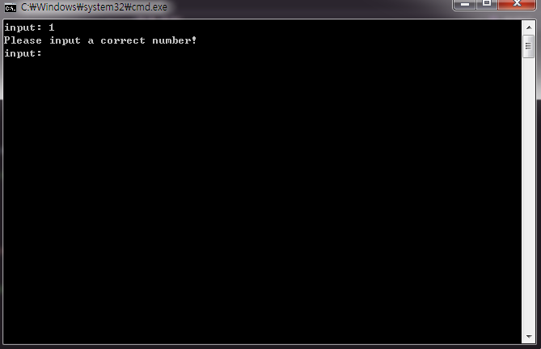

If I input number 1, it output “Please input a correct number!”. And then the program restart that can input a new information. The reason that I make this function is the last the number of Collatz conjecture have to be 1, but the start number 1 is not rational number by this form.

Therefore, I have to make this Exception Handling.

<2>

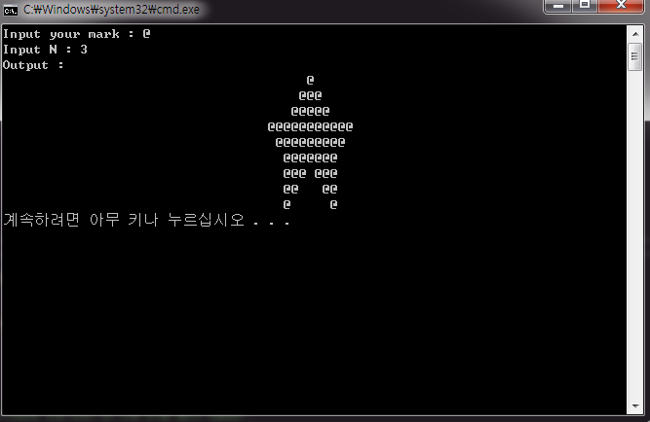

When I input mark ‘@’ and N ’3’, a big star which has the 3 marks ’@’ in one side of the star.

Like this form, we can make a star which has the 5 marks ‘@’. This star is in the pdf file that Assistance upload it in Kwangwoon Ucampus web site.

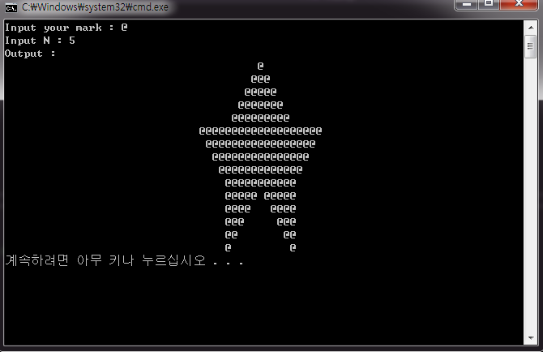

This is a star that has input information that mark ‘@’ and N ‘5’. Like this, we can make any kind of the stars with regular form.

<3>

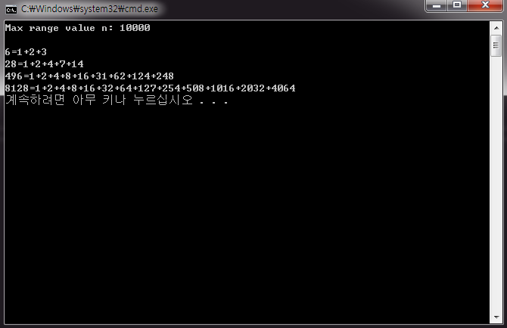

When we input Maximum range value, a number which is the perfect number appear in cmd. Like this picture, perfect number and aliquot are appear in cmd with the regular form, “perfect number = Sum of aliquot”.

<4>

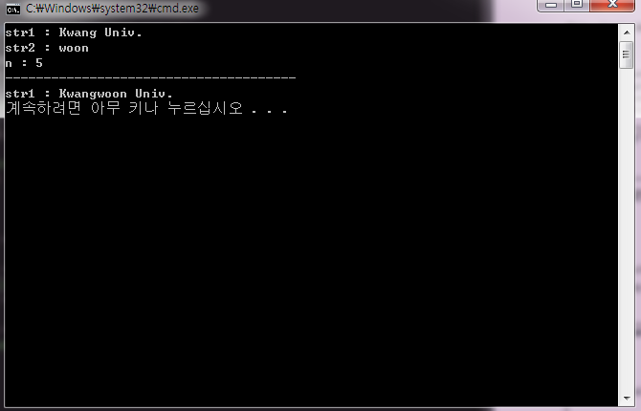

When I input str1 (Main string), str2 (Sub string), and n, this program reorganize the letters’ places. In the picture, this program is editing str1 with str2. This form is regular form. Next picture, it is Exception Handling for this question.

**Exception Handling**

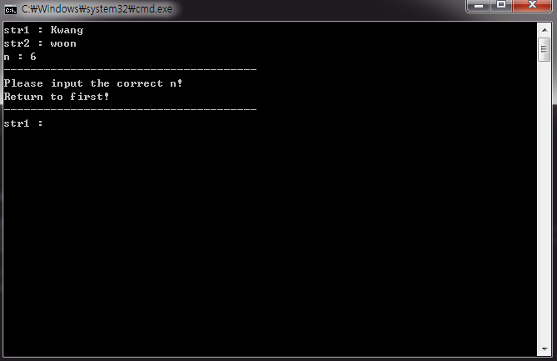

If the number of str1 letters are shorter than n, the program outputs “Please input the correct n!” and restart. The reason that why this program back to first is str2 have to be inserted in str1 between n and (n+1)th. However, in str1, (n+1)th does not exist. Therefore, I have to make this Exception Handling.

<5>

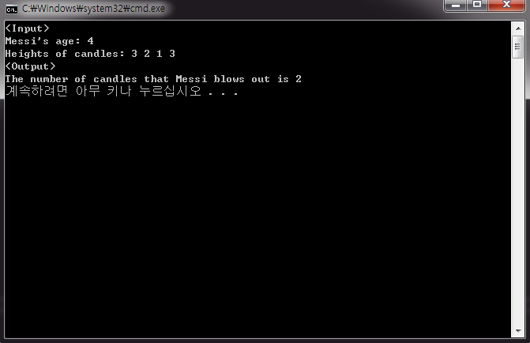

We input the Messi’s age and Heights of candles. Messi’s age is equal to the number of candles. If we input these information, cmd shows that the number of longest candles that Messi can blows out. This form is general and original form that cmd shows.

1. **Consideration**

When I was solving the first problem, I thinked that I had to use array that can save many variable such as numbers. However, it is so complicated that I have to determine array’s size. However, I didn’t use it so I use temporary operation. When I input a new one, it operates immediately with other variable. In such way, I can solve this first question.

Next question makes me feel embarrassed because I think it is hard to solve. This question is making a huge star with someone’s inputs like mark and length of star. It is hard because I have to know this star’s geometric characteristics and patterns, And then I make its operation code with these information. Although I realized this star’s geometric pattern and form, I can’t make the code correctly in first time because it is so complicated and there are many variables. Through many tries and challanges, I can make the source code rationally and it operates correctly.

Third question was also hard. At the first time of solving this problem, I don’t know meaning about perfect number. I can know its meaning through internet searching. Perfect number is number that sum of numbers’ aliquot which is equal to the number. After I know that meaning, I start making a logic code. I have to find standard that what is even number and what is odd number. I solve this question with rest of division. Through many thinking and tries, I can find that rest of the division is the way to solve this problem. If rest number of the division is zero, origin number is even number. However, If rest number of the division is one, origin number is odd number.

Next problem makes me embarrassed. I have no idea about bool function because I have never seen this returning form. Therefore, I was very careful to use this because it can makes error because of my fault or mistakes. This function returns 0 when str1 is bigger than n but it returns 1 vice versa. Principal of this function is that str1 moves the letters from n. And then str2 is inserted in str1 from n. Therefore, str1 is edited by this function. Like this way, I can solve this problem. I realized that logical and rational thinking is very important to make source code and computerize thinking.

Last question is easier than other things. By using loop and if, program is operated. By logical system flow, Input the Heights of candles. And this question has two Exception Handling. If Heights of Messi’s candles is out of range, retype the new input. And if also someone who input the Messi’s age input input the age that out of range, input the new input. Like this way, I make the source code and operate the system correctly and logically.