# **Hybrid App Development**

# Practical 1

## Ionic 4-Create and build first project or application (Android and iOS)

Ionic is open source framework used for developing mobile applications. It provides tools and services for building Mobile UI with native look and feel. Ionic framework needs native wrapper to be able to run on mobile devices. This is an introductory tutorial, which covers the basics of the Ionic Open Source Framework and explains how to deal with its various components and sub-components.

Steps to install Ionic and build your first project.

Step1: Go to command prompt and check if npm is installed or not by using the following command:

npm – v

This shows the version of npm, if it is not installed then install npm.

You can also check the node version by typing the command

node

Step 2: npm install -g ionic cordova.

Step 3: ionic start hello_world blank

Here, we have chosen blank as a template.

This command will create a folder name hello_world.

Step 4: cd hello_world

Now open new command prompt and type command cd hello_world.This command will take you to your hello world directory.

Step 5: ionic serve

It will give you the link of your localhost and you will get the following output.

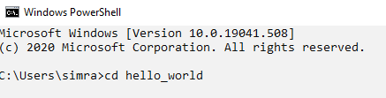

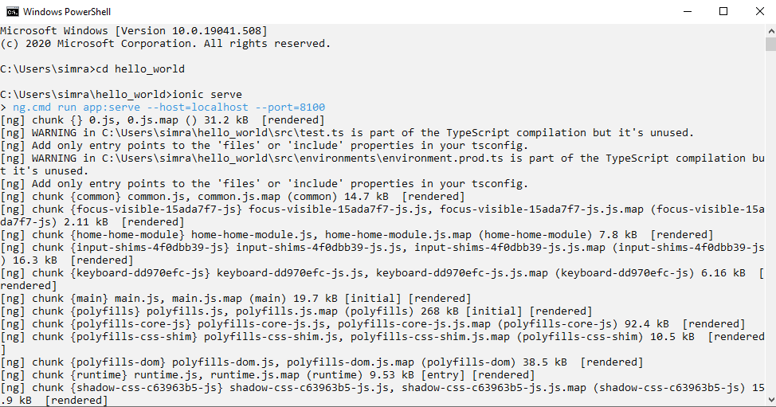

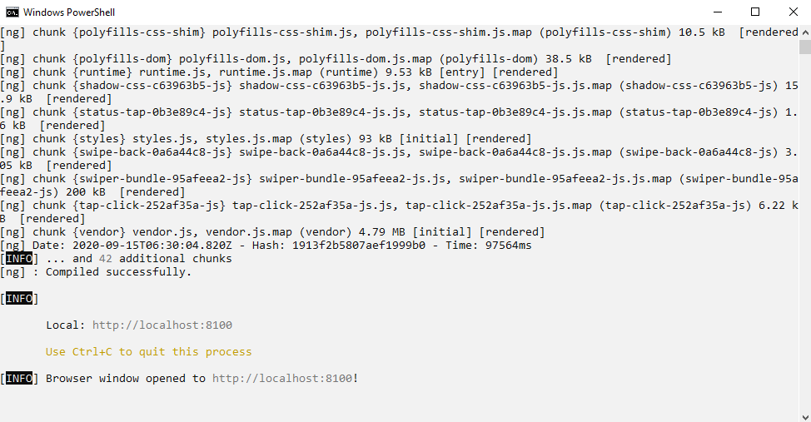

Now, open the text editor and open the project hello_world.

**Write the code as shown below:**

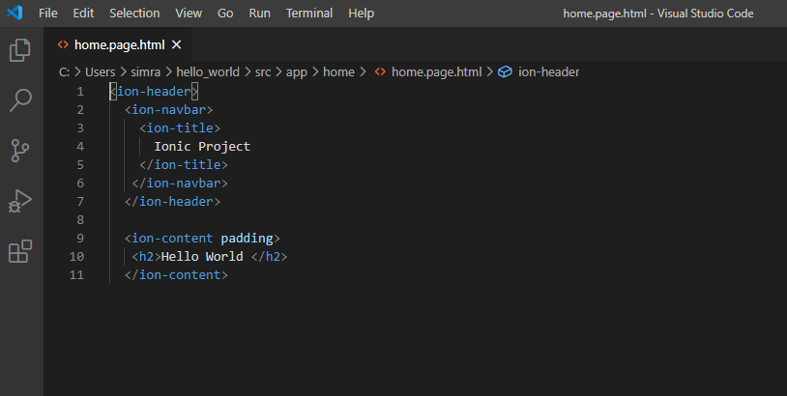

**OUTPUT:**

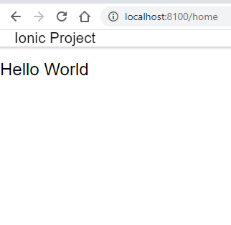

**Build android:**

Pre-requisites:

1. Java jdk installation and JAVA_HOME
2. ANDROID_HOME
3. Android SDK build Tools
4. Android SDK platforms Tools.

Type the following commands in the prompt to build android apk.

Step 6: ionic cordova build android

Step7: Now to run the ionic Cordova app on android, we type

Ionic Cordova run android

If we have our phone connected to the machine, then we need to turn on the USB debugging under the Developer settings. This will export the app and will be viewable in your phone. Another way is to run by setting up an emulator in the Android Studio.

