NAME;KHAN ABDUL FAROOQUE WASEEM
PRN:202501080023
SUB:PRACTICAL2

QNO1: Select the number from the entered list and find its position in Python (use Linear Search).
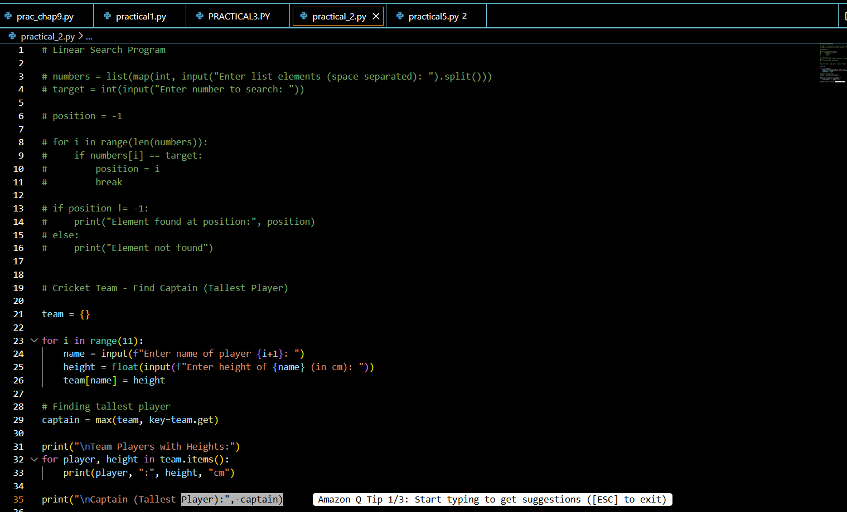

2. Choose cricket team of eleven players find the captain of the team (consider tallest person as a captain) using dictionary.



