MQTT Supplemental Publication Version 1.0 Part 1: NIST Cybersecurity Framework
Working Draft 03
15 January 2014
Technical Committee:
OASIS Message Queuing Telemetry Transport (MQTT) TC
Chairs:
Raphael Cohn (raphael.cohn@stormmq.com), Individual
Richard J Coppen (coppen@uk.ibm.com), IBM
Editors:
Geoff Brown (geoff.brown@m2mi.com), Machine-to-Machine Intelligence (M2MI) Corporation
Louis-Philippe Lamoureux (louis.lamoureux@m2mi.com), Machine-to-Machine Intelligence (M2MI) Corporation
Related work:
This specification is related to:
- Message Queuing Telemetry Transport Version 3.1.1 Latest version. http://docs.oasis-open.org/mqtt/mqtt/v3.1.1/csprd01/mqtt-v3.1.1-csprd01.html.
Abstract:
The purpose of this document is to assist MQTT implementors into applying the NIST Cybersecurity Framework focused on MQTT security targeted to the regulatory requirements of their organization.
Status:
This Working Draft (WD) has been produced by one or more TC Members; it has not yet been voted on by the TC or approved as a Committee Draft (Committee Specification Draft or a Committee Note Draft). The OASIS document Approval Process begins officially with a TC vote to approve a WD as a Committee Draft. A TC may approve a Working Draft, revise it, and re-approve it any number of times as a Committee Draft.
Initial URI pattern:
http://docs.oasis-open.org/mqtt/mqtt-security-sp/v1.0/csd01/part1-nist/mqtt-security-sp-v1.0-csd01-part1-nist.doc
(Managed by OASIS TC Administration; please don’t modify.)

Copyright © OASIS Open 2013. All Rights Reserved.
All capitalized terms in the following text have the meanings assigned to them in the OASIS Intellectual Property Rights Policy (the "OASIS IPR Policy"). The full Policy may be found at the OASIS website.
This document and translations of it may be copied and furnished to others, and derivative works that comment on or otherwise explain it or assist in its implementation may be prepared, copied, published, and distributed, in whole or in part, without restriction of any kind, provided that the above copyright notice and this section are included on all such copies and derivative works. However, this document itself may not be modified in any way, including by removing the copyright notice or references to OASIS, except as needed for the purpose of developing any document or deliverable produced by an OASIS Technical Committee (in which case the rules applicable to copyrights, as set forth in the OASIS IPR Policy, must be followed) or as required to translate it into languages other than English.
The limited permissions granted above are perpetual and will not be revoked by OASIS or its successors or assigns.
This document and the information contained herein is provided on an "AS IS" basis and OASIS DISCLAIMS ALL WARRANTIES, EXPRESS OR IMPLIED, INCLUDING BUT NOT LIMITED TO ANY WARRANTY THAT THE USE OF THE INFORMATION HEREIN WILL NOT INFRINGE ANY OWNERSHIP RIGHTS OR ANY IMPLIED WARRANTIES OF MERCHANTABILITY OR FITNESS FOR A PARTICULAR PURPOSE.

Table of Contents
1 Introduction 4
1.1 Terminology 4
1.2 Normative References 4
1.3 Overview of the Framework 4
1.3.1 MQTT Cybersecurity Framework Core 4
1.3.2 MQTT Cybersecurity Framework Implementation Tiers 4
1.3.3 MQTT Cybersecurity Framework Profile 4
1.4 Document Overview 5
2 MQTT Cybersecurity Management Functions 6
2.1 Identify 6
2.2 Protect 7
2.3 Detect 8
2.4 Respond 9
2.5 Recover 9
3 MQTT Cybersecurity Framework Implementation Tiers 11
3.1 Tier 0: Partial 11
3.2 Tier 1: Risk-Informed 11
3.3 Tier 2: Repeatable 11
3.4 Tier 3: Adaptive 11
3.5 Conclusion 11
4 MQTT Cybersecurity Framework Profile 12
5 Example Implementation 13
5.1 USA Energy Provider MQTT Bus Architecture 13
5.1.1 Context 13
5.1.2 Test Lab Scenario 13
5.1.3 Framework Core 15
5.1.4 Framework Profile 16
6 # Conformance 18
Appendix A. Acknowledgments 19
Appendix B. Example Title 20
B.1 Subsidiary section 20
B.1.1 Sub-subsidiary section 20
Appendix C. Revision History 21

Introduction
The purpose of this supplemental publication is to introduce implementors and senior executives to the NIST Cybersecurity Framework and its relationship with the MQTT security recommendations. The NIST Cybersecurity Framework provides a common language and mechanism for organizations to: 1) describe current Cybersecurity posture; 2) describe their target state for Cybersecurity; 3) identify and prioritize opportunities for improvement within the context of risk management; 4) assess progress toward the target state; 5) foster communications among internal and external stakeholders.
The NIST Cybersecurity Framework complements, and does not replace, an organization’s existing business or Cybersecurity risk management process and Cybersecurity program. Rather, the organization can use its current processes and leverage the NIST Cybersecurity Framework to identify opportunities to improve an organization’s Cybersecurity risk management.
This supplemental document focuses solely on the MQTT protocol’s integration within the NIST Cybersecurity Framework. Keep in mind that a complete Cybersecurity management framework can include a wide variety of topics that must be tailored for specific needs according to the organization's missions, environments of operation, and technologies used. Please refer to the NIST Cybersecurity Framework for more information: http://www.nist.gov/cyberframework/

Terminology

Normative References

Overview of the Framework
The NIST Cybersecurity Framework is composed of three components: the Framework Core, the Framework Implementation Tiers, and the Framework Profile. In the context of the MQTT protocol, each component has been reduced to solely reflect security considerations of the protocol and are renamed accordingly: MQTT Cybersecurity Framework Core, MQTT Cybersecurity Framework Implementation Tiers, and MQTT Cybersecurity Framework Profile.

MQTT Cybersecurity Framework Core
The MQTT Cybersecurity Framework Core consists of five Functions - Identify, Protect, Detect, Respond, Recover - which can provide a high-level, strategic view of an organization’s management of MQTT related Cybersecurity risk. The MQTT Cybersecurity Framework Core then identifies underlying key Categories and Subcategories for each of these Functions, and matches them with Informative References such as existing standards, guidelines, and practices.

MQTT Cybersecurity Framework Implementation Tiers
The MQTT Cybersecurity Framework Implementation Tiers demonstrate the implementation of the MQTT Cybersecurity Framework Core Functions and Categories and indicate how Cybersecurity risk is managed. These Tiers range from Partial (Tier 0) to Adaptive (Tier 3), with each Tier building on the previous Tier.

MQTT Cybersecurity Framework Profile
The MQTT Cybersecurity Framework Profile conveys how an organization manages MQTT Cybersecurity risk in each of the MQTT Cybersecurity Framework Core Functions and Categories by identifying the Subcategories that are implemented or planned for implementation. Profiles are also used to identify the appropriate goals for an organization or for a critical infrastructure sector and to assess progress against meeting those goals.

Document Overview
The remainder of this supplemental document contains the following sections:
- Section 2 describes the MQTT Cybersecurity Framework Core along with the five Functions and their associated Categories, Subcategories, and Informative References.
- Section 3 describes the 4 MQTT Cybersecurity Framework Implementation Tiers.
- Section 4 describes the MQTT Cybersecurity Framework Profile.
- Section 5 provides an example implementation of how the MQTT Cybersecurity Framework can be used.

MQTT Cybersecurity Management Functions
This section describes the 5 Cybersecurity management functions and how they can be used to assess an organization’s Cybersecurity level where the MQTT protocol is prevalent. The list of components associated with each function presented here is non-exhaustive and merely provides a starting point for a Cybersecurity Management Framework. Implementors should modify Categories, Subcategories, and Informative References as they see fit such as to tailor the MQTT Cybersecurity Framework functions for their organization.

Identify
The purpose of this function is to:
- Develop the institutional understanding of which MQTT related organizational systems, assets, data, and capabilities need to be protected;
- determine priority in light of organizational mission;
- establish processes to achieve risk management goals.
Function | Category | Subcategory | Informative References
Identify | Asset Management | List of hardware devices | ISO/IEC 27001  HITRUST  COBIT  FFIEC  National Infrastructure Protection Plan  HIPAA  NIST SP 800-18  NIST SP 800-53 Rev. 4
Identify | Asset Management | Software inventory
Identify | Asset Management | Network mapping
Identify | Asset Management | Lifecycle tracking
Identify | Risk Management | Defining Risk Tolerance
Identify | Risk Management | Risk Identification
Identify | Risk Management | Risk Assessment
Identify | Risk Management | Authentication of the Server by the Clients
Identify | Risk Management | Analysis of Alternatives
Identify | Compliance | Business Requirements
Identify | Compliance | Legislative and Regulatory
Identify | Compliance | Contractual Requirements
Identify | Compliance | Technology Certification
Identify | Information Sharing and Communications | Understand Data Flows
Identify | Information Sharing and Communications | Internal Communications
Identify | Information Sharing and Communications | External Communications
Identify | Information Sharing and Communications | Cryptographic suites versioning and implementation how-to
Identify | Environmental Awareness | Location of (client-side) end-devices
Identify | Environmental Awareness | Location of end-to-end communication infrastructures
Identify | Environmental Awareness | Location of (server-side) brokers and vicinity

Protect
The purpose of this function is to develop and implement the appropriate MQTT safeguards, prioritized through the organization’s risk management process, to ensure delivery of critical infrastructure services.
Function | Category | Subcategory | Informative References
Protect | Security Awareness | User Awareness Training | MQTT Specification  ISO 29192  NIST Interagency Report 7628  NERC CIP
Protect | Security Awareness | Formal Training
Protect | Security Awareness | Exercise and Evaluation
Protect | Identity, Credential and Access Management | Use of PKI (e.g. TLS, VPN)
Protect | Identity, Credential and Access Management | Choose a well-known Certificate Authority
Protect | Identity, Credential and Access Management | Authentication of Clients by the Server
Protect | Identity, Credential and Access Management | Authentication of the Server by the Clients
Protect | Identity, Credential and Access Management | Authorization of Clients by the Server
Protect | Information Protection | Use of cryptographic suites (e.g. TLS, VPN)
Protect | Information Protection | Integrity of Application Messages and Control Packets
Protect | Information Protection | Privacy of Application Messages and Control Packets
Protect | Information Protection | Non-repudiation of message transmission
Protect | Information Protection | Secure Random Number Generation for all involved devices
Protect | Server-side Protection | Compliance with MQTT specification
Protect | Server-side Protection | Automatic Client disconnect mechanisms
Protect | Server-side Protection | Suspicious behavior detection
Protect | Server-side Protection | Dynamic Access Control Listing (e.g. IP address or Client ID)
Protect | Server-side Protection | Rate limiting and/or blocking (e.g. IP address)
Protect | Server-side Protection | Data-at-rest encryption
Protect | Server-side Protection | Frequent session renegotiation to establish new cryptographic parameters (e.g. replace session keys or change cipher suites)
Protect | Client-side Protection | Tamper proof end-devices
Protect | Client-side Protection | Proper storage of the client certificate (key management considerations)
Protect | Client-side Protection | Two-factor authentication

Detect
The purpose of this function is to develop and implement the appropriate activities to identify the occurrence of an MQTT related Cybersecurity event.
Function | Category | Subcategory | Informative References
Detect | Network Monitoring | Repeated connection attempts | SANS Top 20 Controls  NIST 800-12  NIST SP 800-83  NIST SP 800-94
Detect | Network Monitoring | Abnormal termination of connections
Detect | Physical Monitoring | Client availability verification
Detect | Physical Monitoring | End-devices and their vicinity physical inspection
Detect | Intrusion Detection | Repeated authentication attempts
Detect | Intrusion Detection | Topic scanning (attempts to send or subscribe to many topics)
Detect | Intrusion Detection | Sending undeliverable messages (no subscribers to the topics)
Detect | Intrusion Detection | Clients that connect but do not send data

Respond
The purpose of this function is to develop and implement the appropriate activities, prioritized through the organization’s risk management process, to take action regarding a detected Cybersecurity event.
Function | Category | Subcategory | Informative References
Respond | Response Planning | Revoke lost and/or compromised certificates | NIST SP 800-53 Rev. 4  NIST SP 800-61  NIST SP 800-83  NIST 800-86
Respond | Response Planning | Revoke lost and/or compromised Client or Server authentication credentials
Respond | Response Planning | Disconnect suspicious or compromised end-devices
Respond | Response Planning | Block compromised telemetry channels
Respond | Response Planning | Increase Firewall policies
Respond | Response Planning | Shutdown compromised brokers and servers

Recover
The purpose of this function is to develop and implement the appropriate activities, prioritized through the organization’s risk management process, to restore the appropriate capabilities that were impaired through a Cybersecurity event.

Function | Category | Subcategory | Informative References
Recover | Recover Planning | Perform information system recovery (e.g. restart broker, create new telemetry channels, etc.) | NIST SP 800-34  NIST SP 800-53 Rev. 4  SANS Top 20 Controls
Recover | Recover Planning | Perform reconstitution activities
Recover | Recover Planning | Provide alternate work site to recover work activities
Recover | Recover Planning | Review Firewall policies
Recover | Recover Planning | Reissue certificates and authentication credentials
Recover | Recover Planning | Inspect end-devices
Recover | Recover Planning | Review Key Management and cryptographic deployments
Recover | Recover Planning | Backup systems
Recover | Recover Planning | Updated contingency plan

MQTT Cybersecurity Framework Implementation Tiers
The MQTT Cybersecurity Framework Implementation Tiers reflect how an organization implements the MQTT Cybersecurity Framework Core functions and categories and manages its risk. The Tiers are progressive, ranging from Partial (Tier 0) to Adaptive (Tier 3), with each Tier building on the previous Tier. A Tier represents the stage of the implementation of the Framework Profile and the organization’s Cybersecurity risk management process. These characteristics are applied to the MQTT Cybersecurity Framework Core to determine how a category is implemented. The Tier definitions follow:

Tier 0: Partial
The organization has not yet implemented a formal, threat-aware MQTT risk management process to determine a prioritized list of Cybersecurity activities. The organization may implement some portions of the Framework on an irregular, case-by-case basis due to varied experience or information gained from outside sources.

Tier 1: Risk-Informed
The organization uses a formal, threat-aware MQTT risk management process to develop an MQTT Profile of the Framework. In addition, risk-informed, management approved processes and procedures are defined and implemented and staff has adequate resources to perform their Cybersecurity duties.

Tier 2: Repeatable
The organization updates its Profile based on regular application of its MQTT risk management process to respond to a changing Cybersecurity landscape. Risk informed policies, processes, and procedures are defined, implemented as intended, and validated. The organization will also have consistent methods in place to provide updates when a risk change occurs.

Tier 3: Adaptive
The organization updates its Profile based on predictive indicators derived from previous and anticipated Cybersecurity activities. These updates to the Profile enable the organization to actively adapt to a changing Cybersecurity landscape and emerging/evolving threats. Risk-informed policies, processes, and procedures are part of the organizational culture and evolve from previous activities (and from information shared by other sources) to predict and address potential Cybersecurity events.

Conclusion
Organizations should determine the desired Tiers at the Category level, ensuring that the selected levels meet the organizational goals, reduce Cybersecurity risk, and are feasible to implement. External guidance will be helpful, such as information that could be obtained from OASIS Security Assertion Markup Language (SAML), the Federal Information Processing Standards (FIPS), and Payment Card Industry Data Security Standard (PCI DSS).

MQTT Cybersecurity Framework Profile
An MQTT Cybersecurity Framework Profile enables organizations to establish a roadmap for reducing MQTT related Cybersecurity risk that is well-aligned with organization and sector goals, considers legal/regulatory requirements, and reflects risk management priorities. An MQTT Cybersecurity Framework Profile can be used to describe both the current state and the desired target state of specific MQTT Cybersecurity activities, thus revealing gaps that should be addressed to meet MQTT Cybersecurity risk management objectives. Figure 1 shows the two types of Profiles: Target and Current. The Target Profile indicates the MQTT Cybersecurity goal state, and the Current Profile indicates the current state.

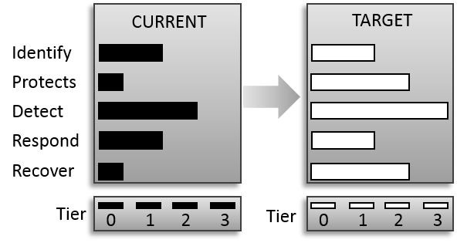
Figure 1: Profile Comparison
The Profile is the selection of the Functions, Categories, and Subcategories that are aligned with the business requirements, risk tolerance, and resources of the organization. The Target Profile should support business/mission requirements and aid in the communication of risk within and between organizations. Identifying the gaps between the Current Profile and the Target Profile allows the creation of a roadmap that organizations should implement to reduce MQTT related Cybersecurity risk.

Example Implementation

USA Energy Provider MQTT Bus Architecture
This section illustrates puts the Framework in practice by applying the different components in a concrete use case. An American energy provider intends to implement an open-source, broker-agnostic, and distributed field message bus architecture based on the MQTT protocol. Protecting the bus architecture is essential because the energy provider is a critical infrastructure.
The energy provider has implemented the Framework Core thus establishing the required categories, sub-categories and references for each functions. It has also implemented a Framework Profile with current and targeted states the energy provider wishes to reach.

Context
To leverage the capacity and augment the capability of an energy provider standards-based, modular communication platform (e.g. a “communications node”), the company is executing a pilot project to define, test, and implement an open-source, broker-agnostic, and distributed field message bus architecture. Its primary role is to facilitate interoperability between the various operational technologies deployed (i.e. SCADA, EMS, DMS, OMS, MDM, etc.) and also augment these technologies by using the MQTT protocol for the efficient sharing and processing of data closer to the asset(s) required for the rapid, reliable, and safe execution of operational functions of all priorities on the electric grid.
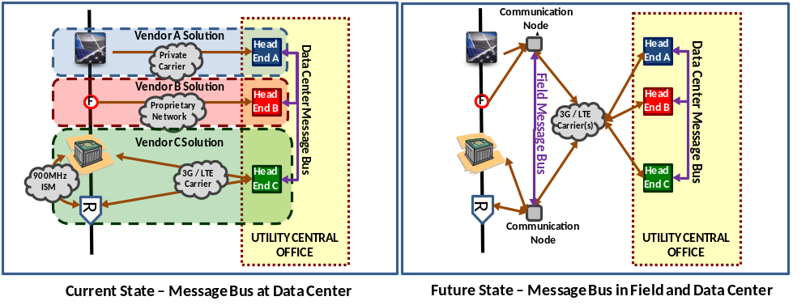
Consequently, using the MQTT protocol will not only improve the simplicity and the integrity of the information exchanges between disparate assets in the field, but also inherently filter a significant amount of unused data overhead and, more importantly, will eliminate the need to backhaul all raw data to a central data center. Fundamentally, these benefits will translate into vast savings in the cost of operating the IT systems and telecommunication networks, but can also achieve further value by enabling deployed control schemes that are not presently feasible without distributed decision-making closer to the electric grid assets.

Test Lab Scenario
The energy provider is running the following Field Message Bus scenario, based on MQTT. The initial and final state of the system is shown in picture form. The intermediate publish and subscribe steps are described the following paragraph.
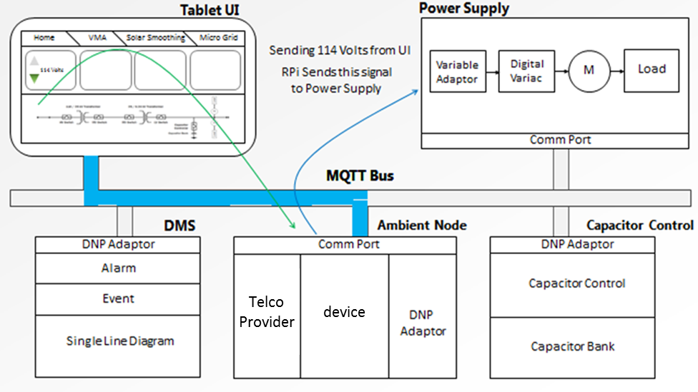
Initial State: Scenario starts when the Tablet UI publishes low voltage – 114V.
A Tablet PC is used to control the voltage of a power supply that feeds input voltage to a smart meter. The scenario starts when the Tablet UI publishes low voltage – 114V. The smart meter sees the low voltage and publishes its voltage status change to the distribution management system (DMS). The DMS subscribes and updates its status. The DMS publishes a control command to the cap bank controller to close the cap bank, thus raising the voltage. The cap bank controller publishes its status change – closed – back to the DMS. The DMS subscribes to the cap bank controller status change; it updates its single-line diagram and publishes a raise voltage volt-120 command to the Power Supply who subscribes and makes the change. The meter publishes its voltage status change – 120V. The DMS publishes an updated single-line diagram to the Tablet UI showing the closed cap bank. This scenario is complete when the Tablet UI subscribes to and displays the updated single-line diagram from the DMS.
This simple test scenario reveals the richness, flexibility, and ease of use of publish and subscribe Field Message Bus, MQTT technology. Future plans for the Field Message Bus is to include the necessary security layers: authentication, authorization, encryption, intrusion detection, and quality of trust behavior analytics to the distributed enterprise.
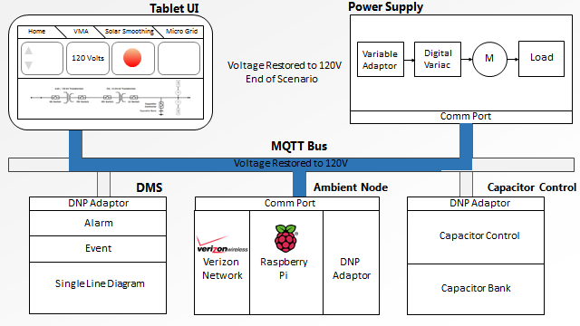
Device
Telco
Provider

Final State: Scenario ends when the Tablet UI subscribes to raised voltage -
120V and a new single-line diagram from the DMS.

Framework Core
The energy provider follows several recommendation publications such as NIST Special publication 800-26 (Security Self-Assessment Guide for Information Technology Systems" for advice on how to manage IT security and ISO 15408 (Evaluation criteria for IT security) to test the security of the bus architecture. The energy provider has also a list of standards it must comply with imposed by the US government. The Framework Core established for the current MQTT bus architecture is defined below.
Function | Category | Subcategory | Informative References
Identify | Asset Management | List of hardware devices | ISO/IEC 27001
Identify | Asset Management | Software inventory | HITRUST  COBIT
Identify | Asset Management | Network mapping | ISO/IEC 27033
Identify | Risk Management | Defining Risk Tolerance | National Infrastructure Protection Plan
Identify | Risk Management | Risk Identification | National Infrastructure Protection Plan
Identify | Risk Management | Risk Assessment | National Infrastructure Protection Plan
Identify | Risk Management | Analysis of Alternatives | National Infrastructure Protection Plan
Identify | Information Sharing and Communications | Understand Data Flows | NIST SP 800-18  NIST SP 800-53 Rev. 4
Identify | Information Sharing and Communications | Internal Communications | NIST SP 800-18  NIST SP 800-53 Rev. 4
Identify | Information Sharing and Communications | External Communications | NIST SP 800-18  NIST SP 800-53 Rev. 4
Identify | Information Sharing and Communications | Cryptographic suites versioning and implementation how-to | NIST SP 800-18  NIST SP 800-53 Rev. 4
Identify | Environmental Awareness | Location of (client-side) end-devices | National Infrastructure Protection Plan
Identify | Environmental Awareness | Location of end-to-end communication infrastructures | National Infrastructure Protection Plan
Identify | Environmental Awareness | Location of (server-side) brokers and vicinity | National Infrastructure Protection Plan
Protect | Information Protection | User Awareness Training | MQTT Specification  ISO 29192  NIST Interagency Report 7628  NERC CIP
Protect | Information Protection | Identity, Credential and Access Management
Detect | Monitoring | Network | SANS Top 20 Controls  NIST 800-12  NIST SP 800-83  NIST SP 800-94
Detect | Monitoring | Physical
Detect | Monitoring | Intrusion
Respond | Response Planning | Revoke lost and/or compromised certificates | NIST SP 800-61  NIST SP 800-83
Respond | Response Planning | Revoke lost and/or compromised Client or Server authentication credentials | NIST SP 800-61  NIST SP 800-83
Respond | Response Planning | Disconnect suspicious or compromised end-devices | NIST SP 800-61  NIST SP 800-83
Respond | Response Planning | Block compromised telemetry channels | NIST SP 800-61  NIST SP 800-83
Respond | Response Planning | Increase Firewall policies | NIST SP 800-61  NIST SP 800-83
Respond | Response Planning | Shutdown compromised brokers and servers | NIST SP 800-61  NIST SP 800-83
Recover | Recover Planning | Perform information system recovery (e.g. restart broker, create new telemetry channels, etc.) | NIST SP 800-34  NIST SP 800-53 Rev. 4
Recover | Post Recovery | Perform reconstitution activities | SANS Top 20 Controls
Recover | Post Recovery | Provide alternate work site to recover work activities | SANS Top 20 Controls
Recover | Post Recovery | Review Firewall policies | SANS Top 20 Controls
Recover | Post Recovery | Backup systems | SANS Top 20 Controls

Framework Profile
The energy provider constitutes a Framework Profile that establishes how the organization currently meets each regulation and standard defined in the functions of the Framework Core. This task is performed internally by the implementors in an objective pattern using the Framework Implementation Tiers scoring system. The result is the current state of specific Cybersecurity activities. The implementors subsequently establish a targeted state of Cybersecurity activities thus revealing gaps that should be addressed to meet Cybersecurity risk management objectives.
As we can see in the figure below, the Current Profile indicates the Cybersecurity outcomes that are currently being achieved. The Target Profile indicates the outcomes needed to achieve the desired Cybersecurity risk management goals.
The gap between the two states indicates actions the energy provider must undertake to achieve the target state. Here, the gap is essentially defined by the “Protect” and “Recover” functions as they bear the largest discrepancies.
The energy provider is conscious it requires more efforts to comply with the current version of the Smart Grid Cybersecurity (NISTIR 7628) and NIST SP 800-34 for the reconstitution efforts plan.

# Conformance
The last numbered section in the specification must be the Conformance section. Conformance Statements/Clauses go here. [Remove # marker]
- Acknowledgments
The following individuals have participated in the creation of this specification and are gratefully acknowledged:
Participants:
Louis-P. Lamoureux, Machine-To-Machine Intelligence Corporation
Geoff Brown, Machine-To-Machine Intelligence Corporation
Allan Stockdill-Mander, IBM

- Example Title
text
  - Subsidiary section
text
    - Sub-subsidiary section
text
- Revision History

Revision | Date | Editor | Changes Made
WD02 | Dec 2nd 2013 | Louis-P. Lamoureux | Added use case  modified functions formatting

