12、Linux常用服务类相关命令

课堂重点：

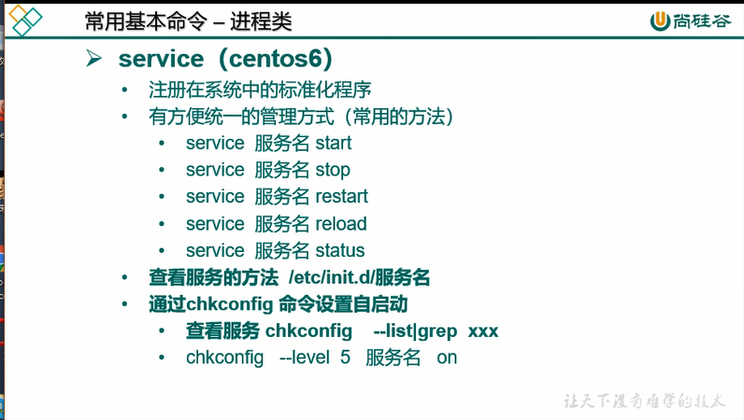

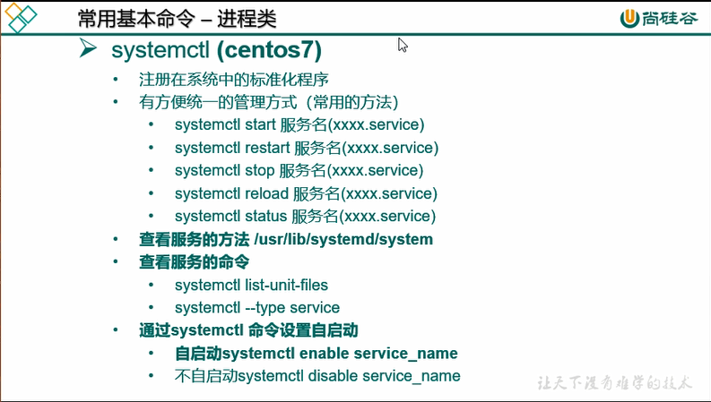

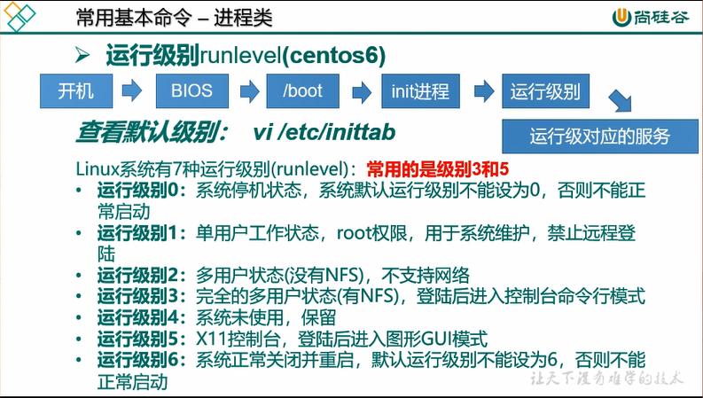

(centos 6)

service network status

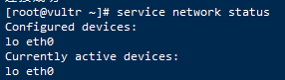

chkconfig --list

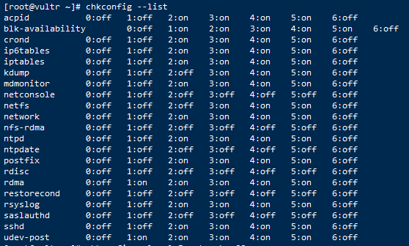

chkconfig --level 5 network off

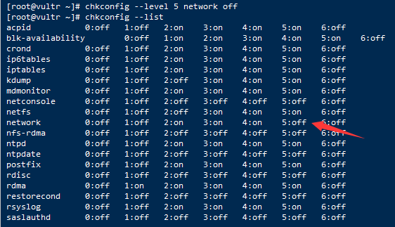

(centos7)

systemctl status firewalld

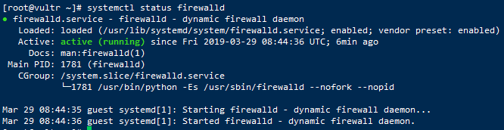

systemctl stop firewalld

systemctl status firewalld

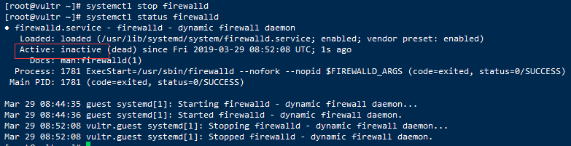

systemctl list-unit-files

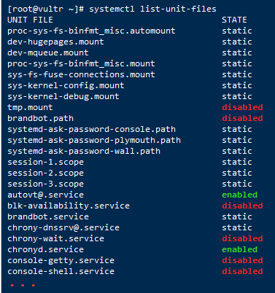

systemctl list-unit-files |grep firewalld



systemctl disable firewalld

systemctl list-unit-files |grep firewalld

