CS380-Assignment 3
Guocheng Qian

1. Texture Mapping
- read different textures from the folder "data/textures", use the bmpreader or any library you like. you can also add new textures.
- render a box with a texture assigned to it.
- load multiple textures and add a keyboard shortcut to switch between them.

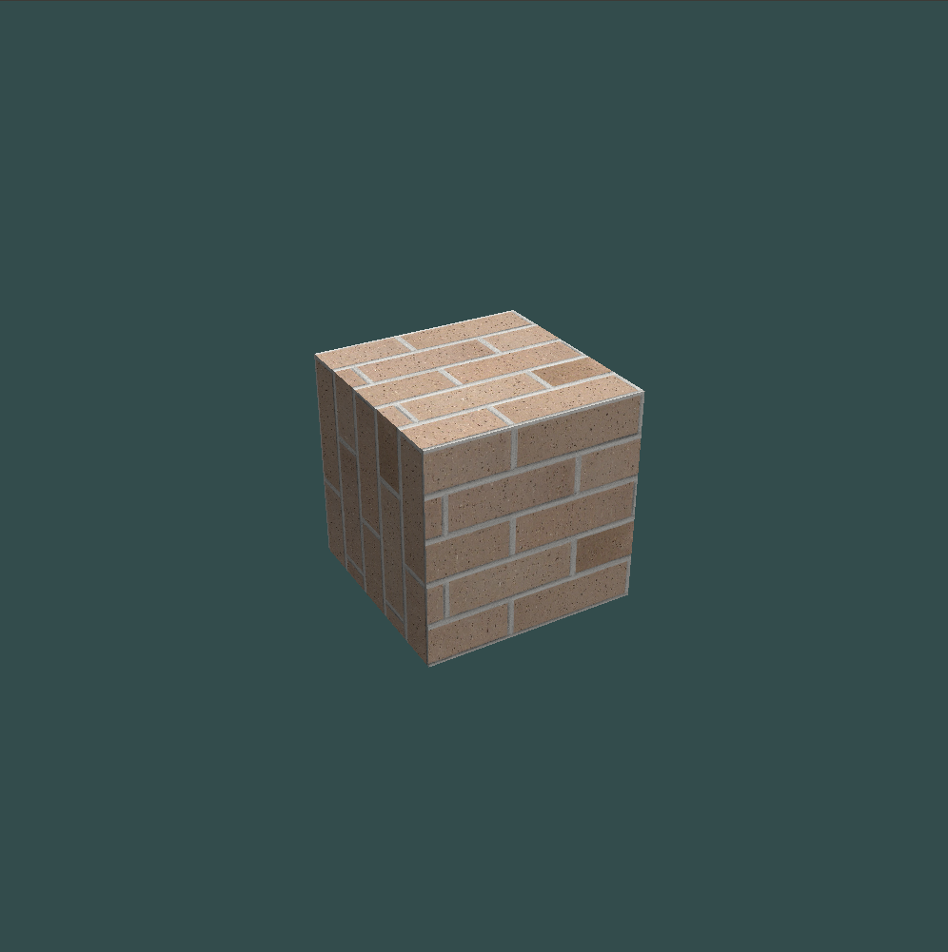
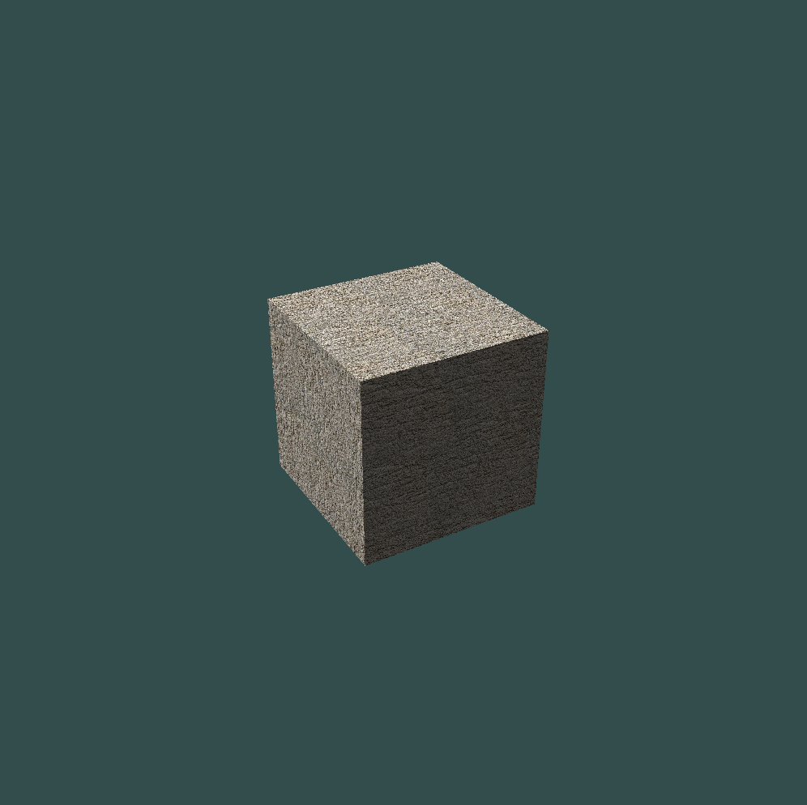

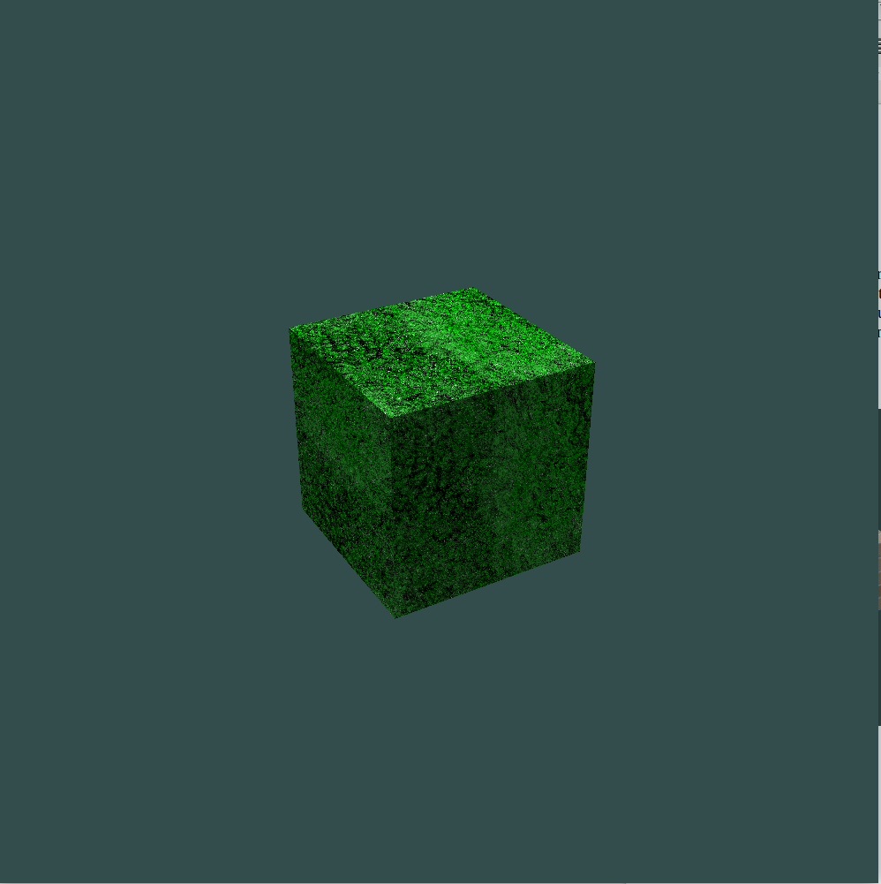

- Per-pixel operations: implement operations to adjust a) brightness, b) contrast, and c) saturation of the texture (Chapter 19.5. [1]).

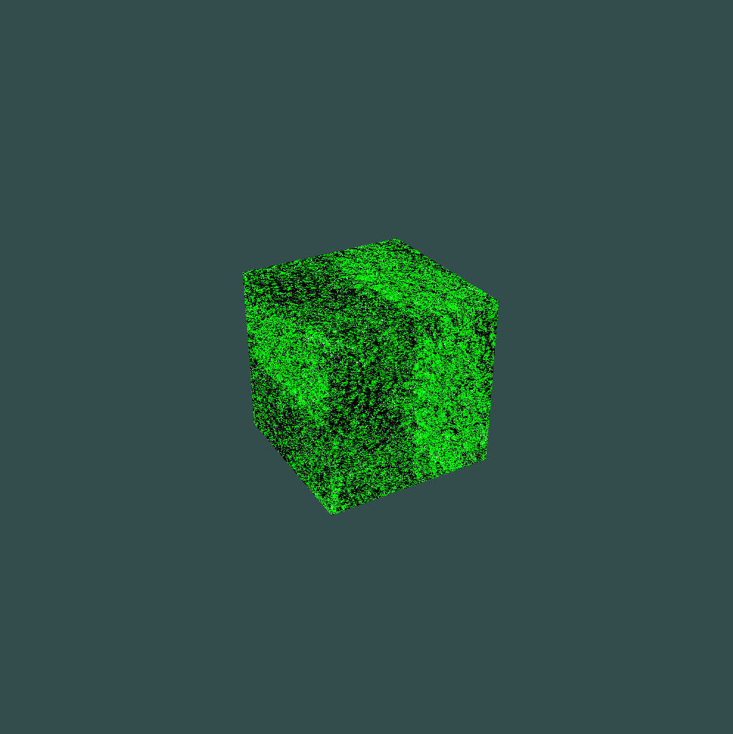
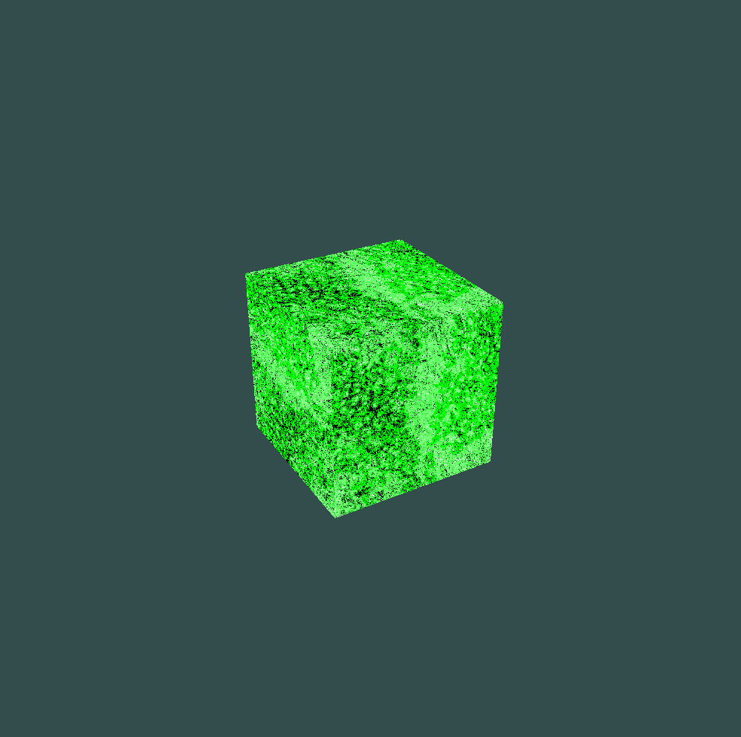
\

(a) (b)

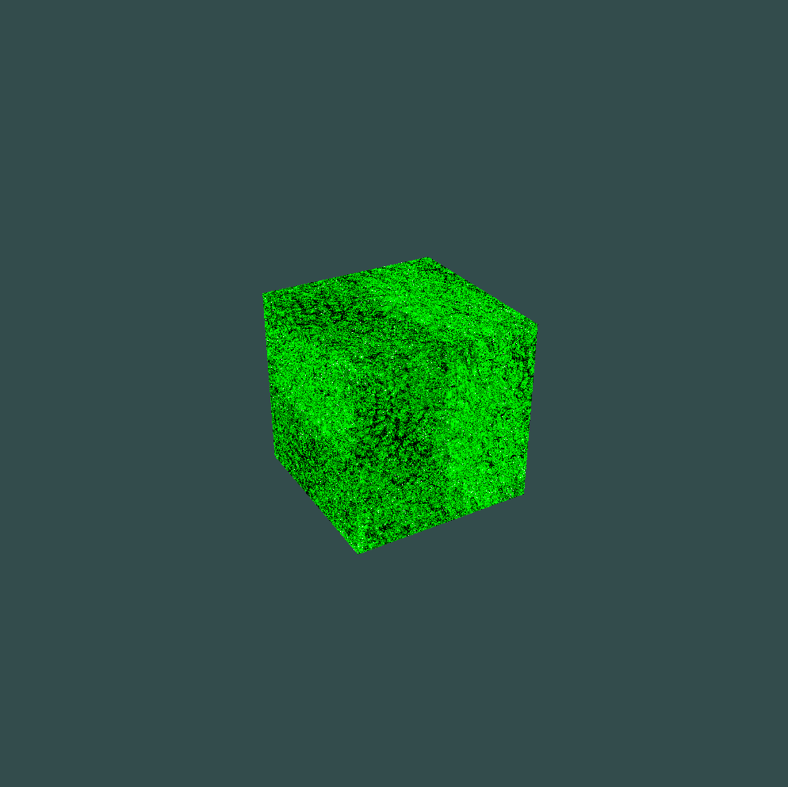

(c)

- Filter operations: Implement filters for d) smoothing, e) edge detection, and f) sharpening (Chapter 19.7. [1])

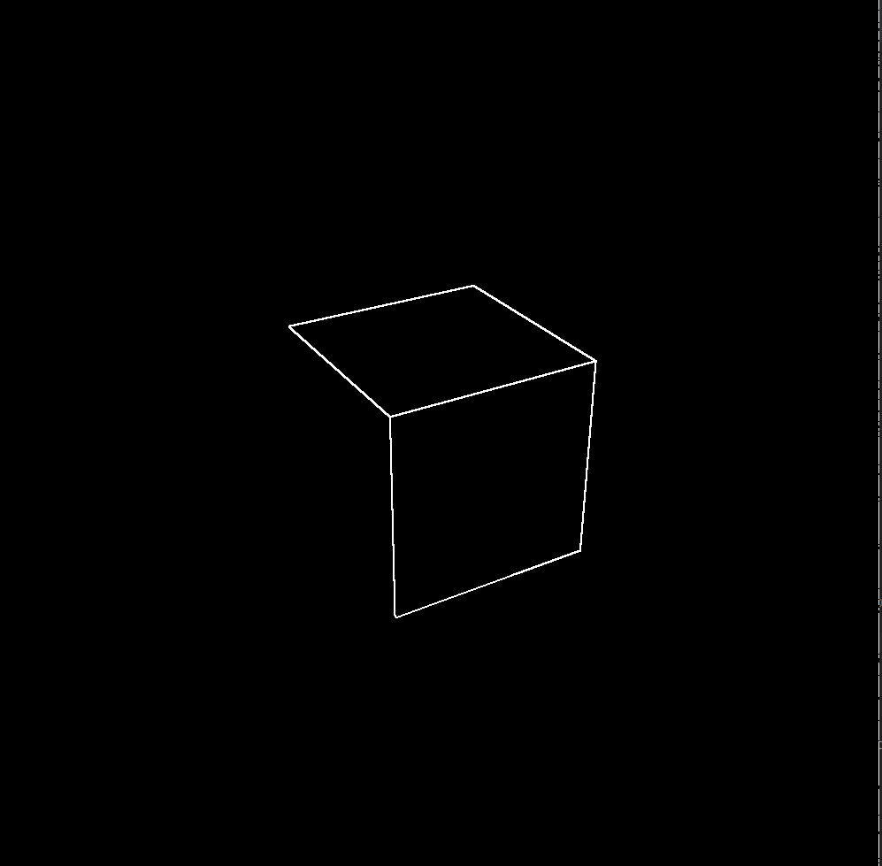
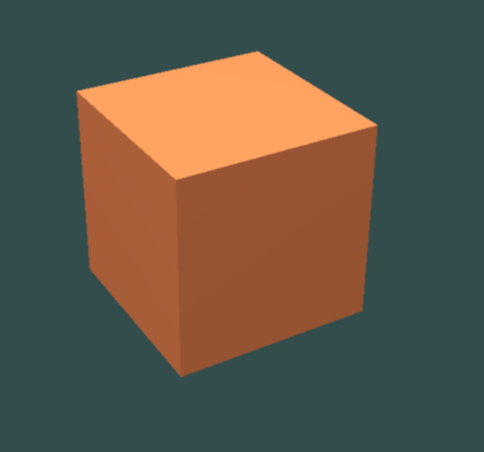

(a) (b)
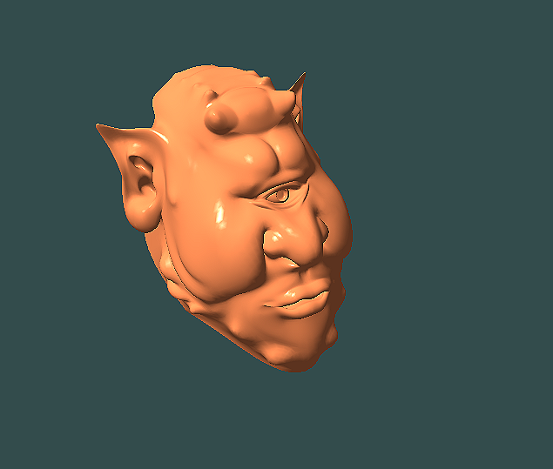

Key control the parameters (eg. the alpha in brightness)

alpha = 2.5
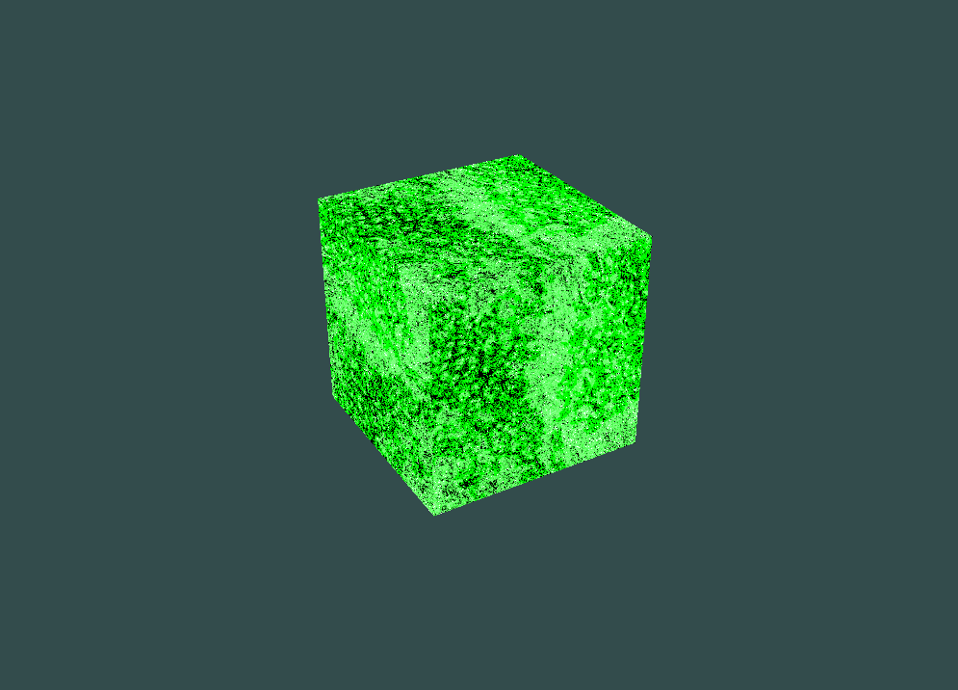
alpha = 7.5
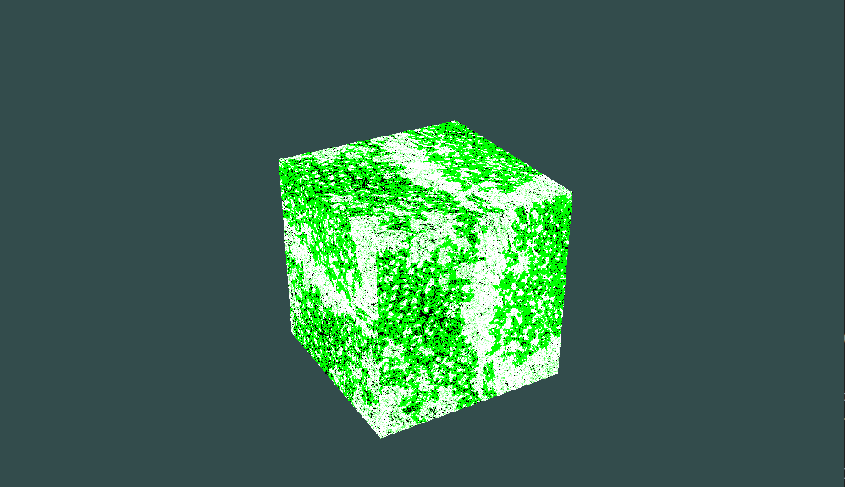

alpha= 0.5
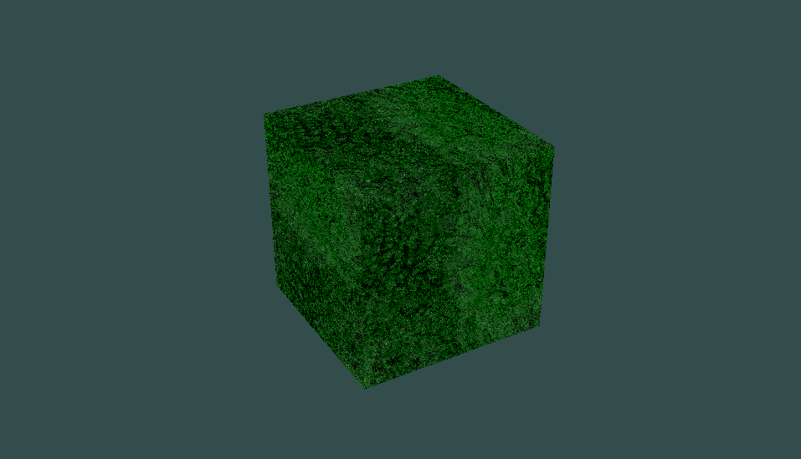
3 Key mapping

void printUsage(){
fprintf(stdout, "================================ usage ================================\n");
fprintf(stdout, "Q/E button: switch model\n");
fprintf(stdout, "U/O/I/K/J/L button to rotate and translate models\n");
fprintf(stdout, "AWSD button to translate camera\n");
fprintf(stdout, "R button: turn on/off rotation light\n");
fprintf(stdout, "1,2,3,4,5: switch shading mode\n");
fprintf(stdout, "1: Phong+Gouraud.\n" );
fprintf(stdout, "2: Phong+Phong.\n" );
fprintf(stdout, "3: Phong+Phong, Stripes.\n" );
fprintf(stdout, "4: Phong+Phong, Lattice.\n" );
fprintf(stdout, "5: Texture mapping, brick.\n" );
fprintf(stdout, "6: Texture mapping, cement.\n" );
fprintf(stdout, "7: Texture mapping, moss.\n" );
fprintf(stdout, "Y button: turn on/off multi-pass and image processing\n");
fprintf(stdout, "F10: Multi-pass image processing, None.\n" );
fprintf(stdout, "F1: Multi-pass image processing, brightness.\n" );
fprintf(stdout, "F2: Multi-pass image processing, contrast.\n" );
fprintf(stdout, "F3: Multi-pass image processing, saturation.\n" );
fprintf(stdout, "F4: Multi-pass image processing, blur.\n" );
fprintf(stdout, "F5: Multi-pass image processing, edge.\n" );
fprintf(stdout, "F6: Multi-pass image processing, sharpening.\n" );
fprintf(stdout, "H: Help.\n" );
fprintf(stdout, "P: Restart.\n" );
fprintf(stdout, "=======================================================================\n");
}
void keyCallback(GLFWwindow *window, int key, int scancode, int action, int mods) {
if (glfwGetKey(window, GLFW_KEY_ESCAPE) == GLFW_PRESS)
glfwSetWindowShouldClose(window, true);

if (glfwGetKey(window, GLFW_KEY_W) == GLFW_PRESS)
camera.ProcessKeyboard(FORWARD, deltaTime);
if (glfwGetKey(window, GLFW_KEY_S) == GLFW_PRESS)
camera.ProcessKeyboard(BACKWARD, deltaTime);
if (glfwGetKey(window, GLFW_KEY_A) == GLFW_PRESS)
camera.ProcessKeyboard(LEFT, deltaTime);
if (glfwGetKey(window, GLFW_KEY_D) == GLFW_PRESS)
camera.ProcessKeyboard(RIGHT, deltaTime);

// translate model
if (glfwGetKey(window, GLFW_KEY_UP) == GLFW_PRESS)
shadermodel.ProcessKeyboard(Model_FORWARD, deltaTime);
if (glfwGetKey(window, GLFW_KEY_DOWN) == GLFW_PRESS)
shadermodel.ProcessKeyboard(Model_BACKWARD, deltaTime);
if (glfwGetKey(window, GLFW_KEY_LEFT) == GLFW_PRESS)
shadermodel.ProcessKeyboard(Model_LEFT, deltaTime);
if (glfwGetKey(window, GLFW_KEY_RIGHT) == GLFW_PRESS)
shadermodel.ProcessKeyboard(Model_RIGHT, deltaTime);

// rotate model
if (glfwGetKey(window, GLFW_KEY_J) == GLFW_PRESS)
shadermodel.ProcessKeyboard(Model_ROT_X_PLUS, deltaTime);
if (glfwGetKey(window, GLFW_KEY_L) == GLFW_PRESS)
shadermodel.ProcessKeyboard(Model_ROT_X_MINUS, deltaTime);
if (glfwGetKey(window, GLFW_KEY_I) == GLFW_PRESS)
shadermodel.ProcessKeyboard(Model_ROT_Z_PLUS, deltaTime);
if (glfwGetKey(window, GLFW_KEY_K) == GLFW_PRESS)
shadermodel.ProcessKeyboard(Model_ROT_Z_MINUS, deltaTime);
if (glfwGetKey(window, GLFW_KEY_U) == GLFW_PRESS)
shadermodel.ProcessKeyboard(Model_ROT_Y_PLUS, deltaTime);
if (glfwGetKey(window, GLFW_KEY_O) == GLFW_PRESS)
shadermodel.ProcessKeyboard(Model_ROT_Y_MINUS, deltaTime);

// Switch shading
if (glfwGetKey(window, GLFW_KEY_1) == GLFW_PRESS) {
g_iShaderOption = 1;
printf("Switched to Phong+Gouraud.\n");
} else if (key == GLFW_KEY_2 && action == GLFW_PRESS) {
g_iShaderOption = 2;
printf("Switched to Phong+Phong.\n");
} else if (key == GLFW_KEY_3 && action == GLFW_PRESS) {
g_iShaderOption = 3;
printf("Switched to Phong+Phong, Stripes.\n");
} else if (key == GLFW_KEY_4 && action == GLFW_PRESS) {
g_iShaderOption = 4;
printf("Switched to Phong+Phong, Lattice.\n");
} else if (key == GLFW_KEY_5 && action == GLFW_PRESS) {
g_iShaderOption = 5;
g_iRenderOption = 1;
printf("Switched to texture mapping, brick1\n");
} else if (key == GLFW_KEY_6 && action == GLFW_PRESS) {
g_iShaderOption = 5;
g_iRenderOption = 2;
printf("Switched to texture mapping, cement.\n");
} else if (key == GLFW_KEY_7 && action == GLFW_PRESS) {
g_iShaderOption = 5;
g_iRenderOption = 3;
printf("Switched to texture mapping, moss.\n");
}else if (key == GLFW_KEY_F10 && action == GLFW_PRESS) {
g_iImgOption=0;
printf("Switched to image processing, None.\n");
}else if (key == GLFW_KEY_F1 && action == GLFW_PRESS) {
g_iImgOption=1;
printf("Switched to image processing, brightness.\n");
} else if (key == GLFW_KEY_F2 && action == GLFW_PRESS) {
g_iImgOption=2;
printf("Switched to image processing, contrast.\n");
} else if (key == GLFW_KEY_F3 && action == GLFW_PRESS) {
g_iImgOption=3;
printf("Switched to image processing, saturation.\n");
}else if (key == GLFW_KEY_F4 && action == GLFW_PRESS) {
g_iImgOption = 4;
printf("Switched to image processing, blur.\n");
} else if (key == GLFW_KEY_F5 && action == GLFW_PRESS) {
g_iImgOption = 5;
printf("Switched to image processing, edge.\n");
} else if (key == GLFW_KEY_F6 && action == GLFW_PRESS) {
g_iImgOption = 6;
printf("Switched to image processing, syharpening.\n");
}else if (key == GLFW_KEY_H && action == GLFW_PRESS) {
printUsage();
}else if (key == GLFW_KEY_P && action == GLFW_PRESS) {
// default initialization
glClearColor(0.2f, 0.3f, 0.3f, 1.0f);;
glEnable(GL_DEPTH_TEST); // Enable !!!

// viewport
glViewport(0, 0, gWindowWidth, gWindowHeight);
printf("Restart.\n");

setupScene();
}

// for Changing the loaded model
else if (key == GLFW_KEY_Q && action == GLFW_PRESS) {
g_uMeshOption++;
if (g_uMeshOption>2) {
g_uMeshOption = 0;
}
} else if (key == GLFW_KEY_E && action == GLFW_PRESS) {
if (g_uMeshOption == 0) {
g_uMeshOption = 2;
} else {
g_uMeshOption--;
}
}

// for turn on/off the rotating light.
else if (key == GLFW_KEY_R && action == GLFW_PRESS) {
rotateLight = !rotateLight;
}

// for turn on/off the multi pass and image processing
else if (key == GLFW_KEY_Y && action == GLFW_PRESS) {
multiPass = !multiPass;
printf("use multi pass?: %d \n ", multiPass);
}
}

