**Selenium**

Selenium is an open source tool which is used for automating the tests carried out on web browsers.

It can be tested through different browsers and platforms. Can be integrated with tools like TestEngine, GUnit. Also Jenkins, Maven.

* Selenium is easy to automate testing across web applications.
* Has a variety of language supports (c#, c++, JavaScript, Python).
* Easy to implement test cases.
* Supports various OS (Operating System). Mac, Windows, etc.

Features of Selenium:

* Cloud-based testing platform (ability to record their actions and export as reusable script)
* Test scripts are written in Java, Python, C#, Ruby
* Supports parallel execution
* Requires fewer resources
* Does not require server installation

Components of Selenium:

* Selenium IDE (Integrated Development Environment)
* Selenium RC (Remote Control)
* Selenium WebDriver
* Selenium Grid

Selenium RC and WebDriver are merged into one framework – Selenium 2.

Same Origin Policy – prohibits JavaScript code from accessing elements from a domain that is different from where it was launched. (Google uses a JavaScript program randomscript.js, which will allow access pages within google.com, but not yahoo or other sites).

**Selenium RC (Selenium 1)**

Engineer Paul Hammant created a server that acts as an http proxy to “trick” the browser into believing that selenium core and the web application being tested come from the same domain.

**Selenium Grid**

Was developed by Patrick Lightbody to address the need of minimizing test execution times as much as possible. He called the system “Hosted QA”.

It was capable of capturing browser’s screenshots during significant test stages and also sending out selenium commands to different machines simultaneously.

**Selenium IDE:**

Shinya Kasatani created Selenium IDE, a Firefox extension that can automate the browser through a record and playback feature.

Created to further increase the test speed in creating test cases.

**WebDriver:**

First cross-platform testing framework that could control the browser from the OS level.

**Selenium 2:**

Webdriver and Selenium RC merged to create a more powerful tool, with WebDriver being the core.

**Selenium IDE:**

1. Create new project and select name
2. Press REC button on top right. 
3. Write base URL (include **http://** at the start!) and click confirm
4. Search for something, and once you find what you need – click stop to stop the test (square top right).

To see each step step-by-step, click .

Three parts in IDE:

* **Command** – an action
* **Target** – what are you doing the action upon
* **Value** – supplementary parameter which is optional for some of the commands, mandatory for others.

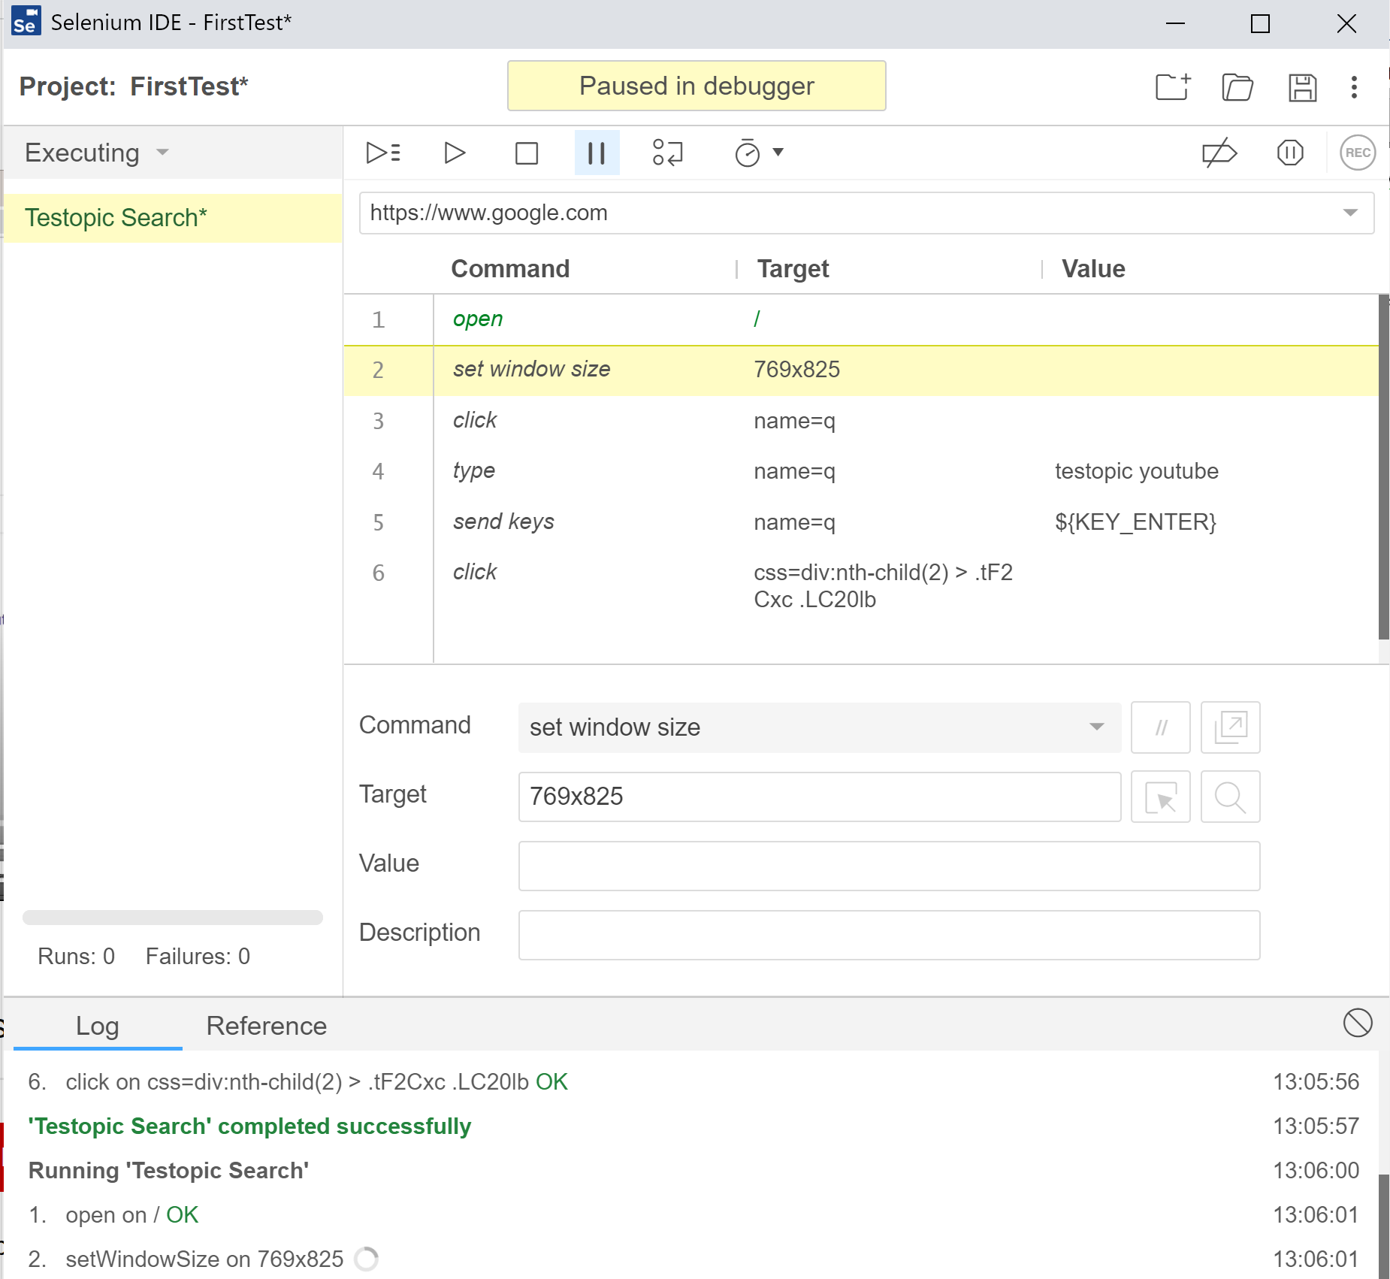

1. Target, **/** - the google link (<http://google.com>)
2. Set window size is a step that isn’t as important, but the IDE still recorded it.
3. Type (action), **name=q** (target element) – where we are sending the command. It’s the search bar.



The 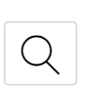button shows where the target element is on the web page.

**Command** *type* types the **value** (in this case *testopic youtube*) into the **target** (element/identifier *name=q*) – search bar.

1. Send keys, name=q, $(KEY_ENTER)

Command *send keys* send the ENTER key *($(KEY_ENTER))* to the same element *name=q* (search bar).

*Send keys* is like typing with your keyboard for Selenium IDE.

**BASICALLY, Command -> Value -> Target**

1. Click, css.(…)

Command *click* (similar to send keys, but instead of keyboard using mouse) clicks on the webpage (css.(…))

You can make this a test by adding a verification or you can just use Selenium IDE for any repetitive job that you have to do, filling out forms, doing a proof of concept of a test.

1. Extra Command: Verification of title (continuing the test)

Verification in automated testing are called **asserts.**

Create a new command by clicking an empty line -> Select *assert title* for command -> write the title we are expecting in target (*Testopic – YouTube).*

We can run the command without running the whole test by double clicking it. Or run it as a whole with the 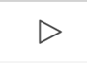 button.

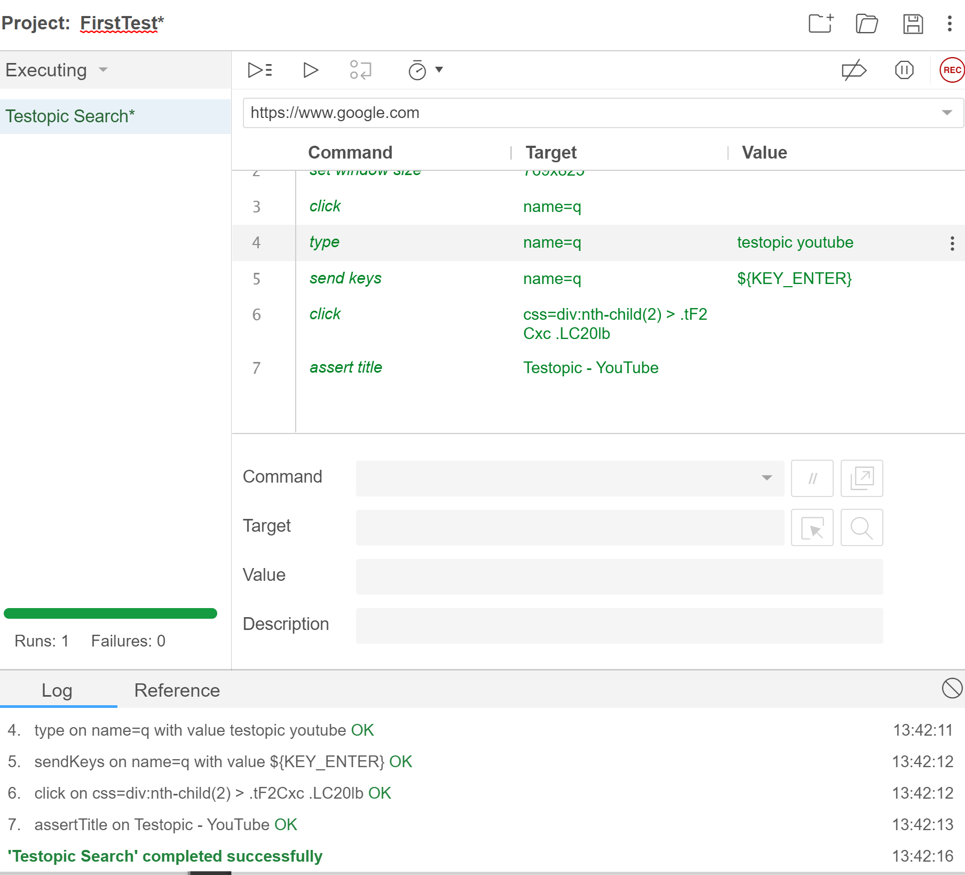

Reference video: <https://www.youtube.com/watch?v=pQPUs9uaKUM&ab_channel=Testopic>