# 1. Install Cypress, testing library and Typescript

npm install --save-dev cypress @testing-library/cypress typescript

2. open the project with VS Code

3. npx cypress open

Let cypress generate its files

Follow instructions of cypress app 🡪 E2E 🡪 generate empty spec

4. add tsconfig.json to the cypress folder

Contents from Cypress website

5. add this to commands.ts

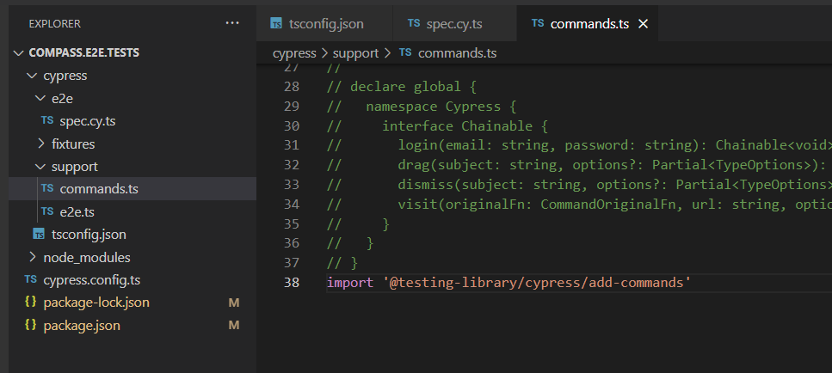

To run one specific test/feature:

Use .only() after describe or it:

