<http://blog.csdn.net/flow_snow/article/details/42738605>

版权声明：本文为博主原创文章，未经博主允许不得转载。

目录[(?)[+]](http://blog.csdn.net/flow_snow/article/details/42738605)

### 版本说明

Eclipse:Eclipse [**Java**](http://lib.csdn.net/base/java)EE IDE for Web Developers

Version:Luna Release(4.4.0)

Tomcat:apache-tomcat-7.0.56

SpringMVC:3.2.3.RELEASE

### 文件结构

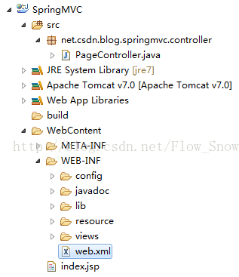

### SpringMVC所需JAR

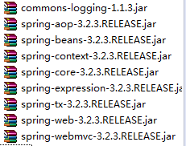

### 步骤

#### 1、建立web项目

运用eclipse建立Dynamic Web Project.具体过程略。

#### 2、修改web.xml文件

**[html]** [view plain](http://blog.csdn.net/flow_snow/article/details/42738605) [copy](http://blog.csdn.net/flow_snow/article/details/42738605)

[print?](http://blog.csdn.net/flow_snow/article/details/42738605)

1. **<?xml** version="1.0" encoding="UTF-8"**?>**
2. **<web-app** xmlns:xsi="http://www.w3.org/2001/XMLSchema-instance"
3. xmlns="http://java.sun.com/xml/ns/javaee"
4. xsi:schemaLocation="http://java.sun.com/xml/ns/javaee http://java.sun.com/xml/ns/javaee/web-app_3_0.xsd"
5. id="WebApp_ID" version="3.0"**>**
7. **<display-name>**SpringMVC**</display-name>**
8. **<welcome-file-list>**
9. **<welcome-file>**index.jsp**</welcome-file>**
10. **</welcome-file-list>**
12. <!-- Spring MVC -->
13. **<servlet>**
14. **<servlet-name>**SpringMVC**</servlet-name>**
15. **<servlet-class>**org.springframework.web.servlet.DispatcherServlet**</servlet-class>**
16. <!-- 自定义servlet.xml配置文件的位置和名称，默认WEB-INF目录下，名称为[<servlet-name>]-servlet.xml -->
17. **<init-param>**
18. **<param-name>**contextConfigLocation**</param-name>**
19. **<param-value>**/WEB-INF/config/springMVC-servlet.xml**</param-value>**
20. **</init-param>**
21. **<load-on-startup>**1**</load-on-startup>**
22. **</servlet>**
23. **<servlet-mapping>**
24. **<servlet-name>**SpringMVC**</servlet-name>**
25. **<url-pattern>**/**</url-pattern>**
26. **</servlet-mapping>**
28. **</web-app>**

拦截所有请求中含有‘/’的url，类似SpringMVC/**/* 这类的url

#### 3、建立springMVC-servlet.xml文件

**[html]** [view plain](http://blog.csdn.net/flow_snow/article/details/42738605) [copy](http://blog.csdn.net/flow_snow/article/details/42738605)

[print?](http://blog.csdn.net/flow_snow/article/details/42738605)

1. **<?xml** version="1.0" encoding="UTF-8"**?>**
2. **<beans** xmlns="http://www.springframework.org/schema/beans"
3. xmlns:xsi="http://www.w3.org/2001/XMLSchema-instance" xmlns:p="http://www.springframework.org/schema/p"
4. xmlns:context="http://www.springframework.org/schema/context"
5. xmlns:mvc="http://www.springframework.org/schema/mvc"
6. xsi:schemaLocation="
7. http://www.springframework.org/schema/beans
8. http://www.springframework.org/schema/beans/spring-beans-3.0.xsd
9. http://www.springframework.org/schema/context
10. http://www.springframework.org/schema/context/spring-context-3.0.xsd
11. http://www.springframework.org/schema/mvc
12. http://www.springframework.org/schema/mvc/spring-mvc-3.0.xsd
13. "**>**
14. <!-- 默认扫描的包路径 -->
15. **<context:component-scan** base-package="*" **/>**
17. <!-- 添加注解驱动 -->
18. **<mvc:annotation-driven** **/>**
20. <!-- 定义跳转的文件的前后缀 -->
21. **<bean** id="viewResolver"
22. class="org.springframework.web.servlet.view.InternalResourceViewResolver"**>**
23. **<property** name="prefix" value="/WEB-INF/views/" **/>**
24. **<property** name="suffix" value=".jsp" **/>**
25. **</bean>**
26. **</beans>**

将controller中返回的String字符串加上前缀与后缀，并去项目中找到相应的位置

#### 4、建立controller

**[java]** [view plain](http://blog.csdn.net/flow_snow/article/details/42738605) [copy](http://blog.csdn.net/flow_snow/article/details/42738605)

[print?](http://blog.csdn.net/flow_snow/article/details/42738605)

1. **package** net.csdn.blog.springmvc.controller;
3. **import** org.springframework.stereotype.Controller;
4. **import** org.springframework.ui.Model;
5. **import** org.springframework.web.bind.annotation.RequestMapping;
7. @Controller
8. **public** **class** PageController {
10. @RequestMapping("/login")
11. **public** String login(Model model) {
12. model.addAttribute("msg", "controller --> login");
13. **return** "login";
14. }
16. }

将键值放入model中，在前台可以直接用el、jstl表达式取出

#### 5、建立login.jsp

**[plain]** [view plain](http://blog.csdn.net/flow_snow/article/details/42738605) [copy](http://blog.csdn.net/flow_snow/article/details/42738605)

[print?](http://blog.csdn.net/flow_snow/article/details/42738605)

1. <%@ page language="java" contentType="text/html; charset=UTF-8"
2. pageEncoding="UTF-8"%>
3. <!DOCTYPE html PUBLIC "-//W3C//DTD HTML 4.01 Transitional//EN" "http://www.w3.org/TR/html4/loose.dtd">
4. <html>
5. <head>
6. <meta http-equiv="Content-Type" content="text/html; charset=UTF-8">
7. <title>登录界面</title>
8. </head>
9. <body>
10. <h3>${msg}</h3>
11. </body>
12. </html>

#### 6、验证结果

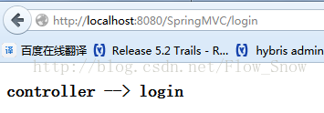

此文仅为记录从无到有的过程，以备以后查看。

未完待续...