# 准备

Keepalive源码下载地址：<http://www.keepalived.org/download.html>

两台CentOS6的虚拟机，master的ip：192.168.220.129，backup的ip：192.168.220.128，虚拟IP：192.168.220.120

# 2.安装ipvsadm（master+backup）

yum install ipvsadm

[root@localhost src]# ipvsadm #说明成功

IP Virtual Server version 1.2.1 (size=4096)

Prot LocalAddress:Port Scheduler Flags

-> RemoteAddress:Port Forward Weight ActiveConn InActConn

可能发生的异常：

[root@localhost src]# yum install ipvsadm

已加载插件：fastestmirror

base | 3.6 kB 00:00

extras | 3.4 kB 00:00

updates | 3.4 kB 00:00:00

Traceback (most recent call last):

File "/usr/libexec/urlgrabber-ext-down", line 75, in <module>

main()

File "/usr/libexec/urlgrabber-ext-down", line 61, in main

fo = PyCurlFileObject(opts.url, opts.filename, opts)

File "/usr/lib/python2.7/site-packages/urlgrabber/grabber.py", line 1258, in __init__

self._do_open()

File "/usr/lib/python2.7/site-packages/urlgrabber/grabber.py", line 1589, in _do_open

self._do_grab()

File "/usr/lib/python2.7/site-packages/urlgrabber/grabber.py", line 1723, in _do_grab

self._do_perform()

File "/usr/lib/python2.7/site-packages/urlgrabber/grabber.py", line 1517, in _do_perform

raise KeyboardInterrupt

KeyboardInterrupt

由于用户取消而退出

解决办法：

Vi /usr/lib/python2.7/site-packages/urlgrabber/grabber.py

跳转到1517行，

elif errcode in (42, 57, **):

改成：

elif errcode == 42:

# 3.安装keepalived（master+backup）

## 3.1 安装

tar -zvxf keepalived-1.2.7.tar.gz

cd keepalived-1.2.7

./configure --prefix=/usr --sysconf=/etc

make

make install

实际会报错：

**configure: error:**

**!!! OpenSSL is not properly installed on your system. !!!**

**!!! Can not include OpenSSL headers files. !!!**

## 3.2 安装openssl

yum install openssl-devel

再次执行，报错：

checking for poptGetContext in -lpopt... no

configure: error: Popt libraries is required

## 3.3 安装Popt

yum install popt-devel

出现下面表示安装成功：

Keepalived configuration

------------------------

Keepalived version : 1.2.7

Compiler : gcc

Compiler flags : -g -O2

Extra Lib : -lpopt -lssl -lcrypto

Use IPVS Framework : Yes

IPVS sync daemon support : Yes

IPVS use libnl : No

Use VRRP Framework : Yes

Use VRRP VMAC : Yes

SNMP support : No

Use Debug flags : No

# 4. 配置keepalived

## 4.1 配置master（192.168.220.129）

global_defs {

notification_email {

xjs250@163.com

}

notification_email_from eyun@163.com

smtp_server 220.181.12.11

smtp_connect_timeout 30

router_id LVS_DEVEL

}

vrrp_instance VI_1 {

state MASTER

interface eth0

virtual_router_id 51

priority 100

advert_int 1

authentication {

auth_type PASS

auth_pass 1111

}

virtual_ipaddress {

192.168.220.120

}

}

virtual_server 192.168.220.120 80 {

delay_loop 6

lb_algo wlc

lb_kind DR

nat_mask 255.255.255.0

persistence_timeout 50

protocol TCP

real_server 192.168.220.129 80 {

weight 1

TCP_CHECK {

connect_timeout 10

nb_get_retry 3

connect_port 80

}

}

real_server 192.168.220.128 80 {

weight 1

TCP_CHECK {

connect_timeout 10

nb_get_retry 3

connect_port 80

}

}

}

## 4.2 配置backup（192.168.220.128）

global_defs {

notification_email {

xjs250@163.com

}

notification_email_from eyun@163.com

smtp_server 220.181.12.11

smtp_connect_timeout 30

router_id LVS_DEVEL

}

vrrp_instance VI_1 {

state BACKUP

interface eth0

virtual_router_id 51

priority 80

advert_int 1

authentication {

auth_type PASS

auth_pass 1111

}

virtual_ipaddress {

192.168.220.120

}

}

virtual_server 192.168.220.120 80 {

delay_loop 6

lb_algo wlc

lb_kind DR

nat_mask 255.255.255.0

persistence_timeout 50

protocol TCP

real_server 192.168.220.129 80 {

weight 1

TCP_CHECK {

connect_timeout 10

nb_get_retry 3

connect_port 80

}

}

real_server 192.168.220.128 80 {

weight 1

TCP_CHECK {

connect_timeout 10

nb_get_retry 3

connect_port 80

}

}

}

# 5. 启动keepalive

## 5.1修改系统参数：

Vi /etc/sysctl.conf

net.ipv4.ip_forward = 1

[root@localhost ~]# sysctl -p

fs.aio-max-nr = 1048576

fs.file-max = 6815744

kernel.shmall = 2097152

kernel.shmmax = 536870912

kernel.shmmni = 4096

kernel.sem = 250 32000 100 128

net.ipv4.ip_local_port_range = 9000 65500

net.core.rmem_default = 262144

net.core.rmem_max = 4194304

net.core.wmem_default = 262144

net.core.wmem_max = 1048576

net.ipv4.ip_forward = 1

## 5.2 启动keepalive

/etc/rc.d/init.d/keepalived start

ip a :可以看到所有的ip信息

ipvsadm：可以看到虚拟路由信息和虚拟ip对应的真实ip

在master上执行：ip a

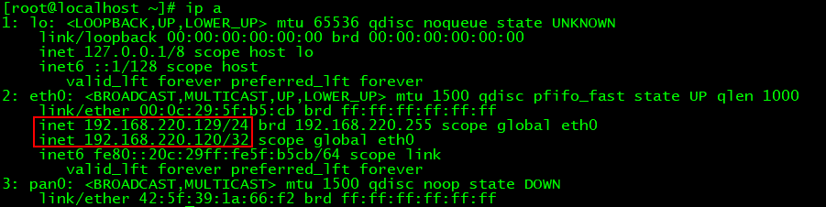

执行：ipvsadm，可以看到120对应的两个真实ip

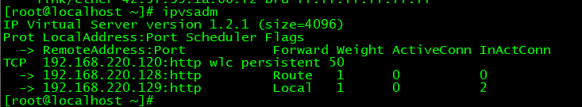

在backu上执行：ip a

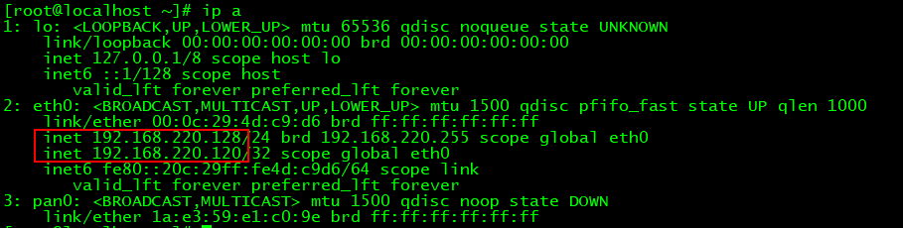

执行：ipvsadm

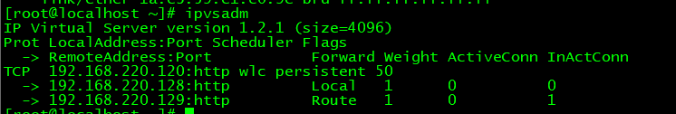

在master和backup上启动两个web应用，客户端浏览器访问：<http://192.168.220.120/>进行演示。

参考：

<https://www.iyunv.com/thread-155645-1-1.html>

<http://pmghong.blog.51cto.com/3221425/1201533>