**Git 基础知识**

**1、教学视频：**

https://ke.qq.com/course/472543?taid=4133996217185759



**2、Git下载：**

windows

<http://git-scm.com/download/win>

linux

yum install git -y

**3、实战：git init、git config、git add 、git staus 、git commi**t

86188@DESKTOP-VLS5H3G MINGW64 ~

$ cd /c/Users/86188/Desktop/myapp #新建文件夹myapp并进入

86188@DESKTOP-VLS5H3G MINGW64 ~/Desktop/myapp

$ touch index.html #新建index.html

86188@DESKTOP-VLS5H3G MINGW64 ~/Desktop/myapp

$ touch app.js #新建 app.js

86188@DESKTOP-VLS5H3G MINGW64 ~/Desktop/myapp

$ ls

app.js index.html

86188@DESKTOP-VLS5H3G MINGW64 ~/Desktop/myapp

$ git init #初始化本地仓库

Initialized empty Git repository in C:/Users/86188/Desktop/myapp/.git/

86188@DESKTOP-VLS5H3G MINGW64 ~/Desktop/myapp (master)

$ git config --global user.name 'guoguogewangzi' #配置用户名

86188@DESKTOP-VLS5H3G MINGW64 ~/Desktop/myapp (master)

$ git config --global user.email '879086359@qq.com' #配置email

86188@DESKTOP-VLS5H3G MINGW64 ~/Desktop/myapp (master)

$ git add index.html #添加index.html到队列

86188@DESKTOP-VLS5H3G MINGW64 ~/Desktop/myapp (master)

$ git status #查看队列状态

On branch master

No commits yet

Changes to be committed:

(use "git rm --cached <file>..." to unstage)

new file: index.html #可以发现index.html添加到了队列

Untracked files:

(use "git add <file>..." to include in what will be committed)

app.js #app.js处于未添加到队列状态

86188@DESKTOP-VLS5H3G MINGW64 ~/Desktop/myapp (master)

$ git rm --cached index.html #从队列删除index.html文件

rm 'index.html'

86188@DESKTOP-VLS5H3G MINGW64 ~/Desktop/myapp (master)

$ git status #查看队列状态

On branch master

No commits yet

Untracked files:

(use "git add <file>..." to include in what will be committed)

app.js

index.html #可以看到index.html被移除了队列

nothing added to commit but untracked files present (use "git add" to track)

86188@DESKTOP-VLS5H3G MINGW64 ~/Desktop/myapp (master)

$ git add *.html #添加指定类型文件到队列

86188@DESKTOP-VLS5H3G MINGW64 ~/Desktop/myapp (master)

$ git status #查看状态

On branch master

No commits yet

Changes to be committed:

(use "git rm --cached <file>..." to unstage)

new file: index.html #可以看到.html类型文件被添加到了队列

Untracked files:

(use "git add <file>..." to include in what will be committed)

app.js #.js类型文件仍处于不在队列状态

86188@DESKTOP-VLS5H3G MINGW64 ~/Desktop/myapp (master)

$ git rm --cache index.html #从队列删除index.html文件

rm 'index.html'

86188@DESKTOP-VLS5H3G MINGW64 ~/Desktop/myapp (master)

$ git status

On branch master

No commits yet

Untracked files:

(use "git add <file>..." to include in what will be committed)

app.js

index.html

nothing added to commit but untracked files present (use "git add" to track)

86188@DESKTOP-VLS5H3G MINGW64 ~/Desktop/myapp (master)

$ git add . #添加所有文件到队列

86188@DESKTOP-VLS5H3G MINGW64 ~/Desktop/myapp (master)

$ git status #查看队列状态

On branch master

first commit

No commits yet

Changes to be committed:

(use "git rm --cached <file>..." to unstage)

new file: app.js #可以看到app.js被添加到了队列

new file: index.html #index.html被添加到了队列

86188@DESKTOP-VLS5H3G MINGW64 ~/Desktop/myapp (master)

$ git status #修改index.html文件，并查看队列状态

On branch master

No commits yet

Changes to be committed:

(use "git rm --cached <file>..." to unstage)

new file: app.js

new file: index.html

Changes not staged for commit:

(use "git add <file>..." to update what will be committed)

(use "git restore <file>..." to discard changes in working directory)

modified: index.html #可以看到提示index.html文件被修改

86188@DESKTOP-VLS5H3G MINGW64 ~/Desktop/myapp (master)

$ git add . #所有提交所有文件到队列

86188@DESKTOP-VLS5H3G MINGW64 ~/Desktop/myapp (master)

$ git status

On branch master

No commits yet

Changes to be committed:

(use "git rm --cached <file>..." to unstage)

new file: app.js

new file: index.html #可以看到index.html在队列里，并没有修改提示了

86188@DESKTOP-VLS5H3G MINGW64 ~/Desktop/myapp (master)

$ git commit #提交到本地仓库，会弹出文本，在第一行添加说明并保存退出

[master (root-commit) 9b8de4e] first commit

2 files changed, 15 insertions(+)

create mode 100644 app.js create mode 100644 index.

tml

86188@DESKTOP-VLS5H3G MINGW64 ~/Desktop/myapp (master)

$ git status #查看队列状态

On branch master

nothing to commit, working tree clean #可以看到没有可提交的队列

86188@DESKTOP-VLS5H3G MINGW64 ~/Desktop/myapp (master)

$ git status #修改app.js文件，并查看队列状态

On branch master

Changes not staged for commit:

(use "git add <file>..." to update what will be committed)

(use "git restore <file>..." to discard changes in working directory)

modified: app.js #可以看到提示app.js被修改

no changes added to commit (use "git add" and/or "git commit -a")

86188@DESKTOP-VLS5H3G MINGW64 ~/Desktop/myapp (master)

$ git add . #所以添加所有文件到队列

86188@DESKTOP-VLS5H3G MINGW64 ~/Desktop/myapp (master)

$ git status #查看队列状态

On branch master

Changes to be committed:

(use "git restore --staged <file>..." to unstage)

modified: app.js #可以看到app.js文件被添加到了队列

86188@DESKTOP-VLS5H3G MINGW64 ~/Desktop/myapp (master)

$ git commit -m 'modify app.js' #提交到本地仓库,-m参数：添加说明

[master 8b44711] modify app.js

1 file changed, 1 insertion(+) #可以看到提示一个文件有变化

**4、忽略文件和文件夹：创建.gitignore文件添加需要忽略的文件或文件夹即可**

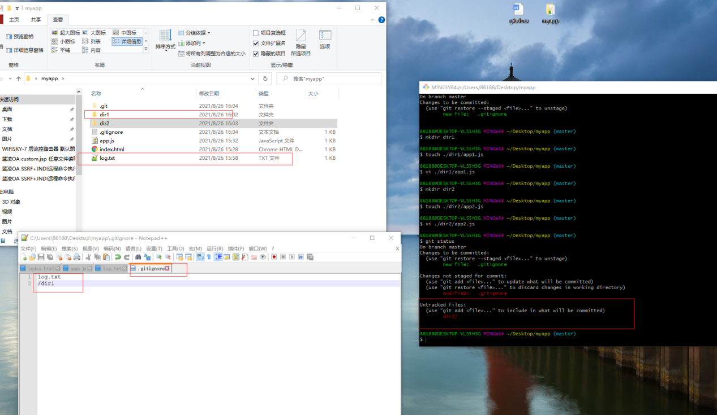

86188@DESKTOP-VLS5H3G MINGW64 ~/Desktop/myapp (master)

$ touch log.txt #创建log.txt文件

86188@DESKTOP-VLS5H3G MINGW64 ~/Desktop/myapp (master)

$ ls #查看文件列表

app.js index.html log.txt

86188@DESKTOP-VLS5H3G MINGW64 ~/Desktop/myapp (master)

$ git status #查看队列状态

On branch master

Untracked files:

(use "git add <file>..." to include in what will be committed)

log.txt #可以看到log.txt待添加到队列

nothing added to commit but untracked files present (use "git add" to track)

86188@DESKTOP-VLS5H3G MINGW64 ~/Desktop/myapp (master)

$ touch .gitignore #创建.gitignore文件,并添加一行：log.txt

86188@DESKTOP-VLS5H3G MINGW64 ~/Desktop/myapp (master)

$ git status #查看队列状态

On branch master

Untracked files:

(use "git add <file>..." to include in what will be committed)

.gitignore #可以看到只有.gitignore待添加状态，log.txt忽略了

nothing added to commit but untracked files present (use "git add" to track)

86188@DESKTOP-VLS5H3G MINGW64 ~/Desktop/myapp (master)

$ git add . #添加所有文件到队列

86188@DESKTOP-VLS5H3G MINGW64 ~/Desktop/myapp (master)

$ git status #查看状态

On branch master

Changes to be committed:

(use "git restore --staged <file>..." to unstage)

new file: .gitignore #可以看到只有.gitignore文件添加到了队列

86188@DESKTOP-VLS5H3G MINGW64 ~/Desktop/myapp (master)

$ mkdir dir1 #新建dir1文件夹

86188@DESKTOP-VLS5H3G MINGW64 ~/Desktop/myapp (master)

$ touch ./dir1/app1.js #往dir1文件夹里添加app1.js文件

86188@DESKTOP-VLS5H3G MINGW64 ~/Desktop/myapp (master)

$ vi ./dir1/app1.js #编辑内容

86188@DESKTOP-VLS5H3G MINGW64 ~/Desktop/myapp (master)

$ mkdir dir2 #新建dir2文件夹

86188@DESKTOP-VLS5H3G MINGW64 ~/Desktop/myapp (master)

$ touch ./dir2/app2.js #往dir2文件夹里添加app2.js文件

86188@DESKTOP-VLS5H3G MINGW64 ~/Desktop/myapp (master)

$ vi ./dir2/app2.js #编辑内容

86188@DESKTOP-VLS5H3G MINGW64 ~/Desktop/myapp (master)

$ vi .gitignore #往.gitignore文件增加一行：/dir1，表明要忽略dir1文件夹

86188@DESKTOP-VLS5H3G MINGW64 ~/Desktop/myapp (master)

$ git status #查看队列状态

On branch master

Changes to be committed:

(use "git restore --staged <file>..." to unstage)

new file: .gitignore

Changes not staged for commit:

(use "git add <file>..." to update what will be committed)

(use "git restore <file>..." to discard changes in working directory)

modified: .gitignore #可以看到提示修改了.gitignore文件

Untracked files:

(use "git add <file>..." to include in what will be committed)

dir2/ #可以看到只有dir2文件夹处于待添加队列状态，dir1文件夹被忽略了

86188@DESKTOP-VLS5H3G MINGW64 ~/Desktop/myapp (master)

$ git add . #添加所有文件到队列

warning: LF will be replaced by CRLF in dir2/app2.js.

The file will have its original line endings in your working directory

86188@DESKTOP-VLS5H3G MINGW64 ~/Desktop/myapp (master)

$ git status #查看队列状态

On branch master

Changes to be committed:

(use "git restore --staged <file>..." to unstage)

new file: .gitignore

new file: dir2/app2.js #可以看到dir2文件夹被添加到了队列，dir1文件夹忽略了

86188@DESKTOP-VLS5H3G MINGW64 ~/Desktop/myapp (master)

$ git commit -m 'another change' #提交到本地仓库

[master 1b14e72] another change

2 files changed, 3 insertions(+)

create mode 100644 .gitignore

create mode 100644 dir2/app2.js

**5、git分支：**git branch login、 git checkout、、git merge、 git remote、git push、git clone

86188@DESKTOP-VLS5H3G MINGW64 ~/Desktop/myapp (master)

$ git branch login #创建分支名为login分支

86188@DESKTOP-VLS5H3G MINGW64 ~/Desktop/myapp (master)

$ git status #查看主线的队列状态

On branch master

nothing to commit, working tree clean

86188@DESKTOP-VLS5H3G MINGW64 ~/Desktop/myapp (master)

$ git checkout login #切换到login分支

Switched to branch 'login'

86188@DESKTOP-VLS5H3G MINGW64 ~/Desktop/myapp (login)

$ touch login.html #创建login.html文件

86188@DESKTOP-VLS5H3G MINGW64 ~/Desktop/myapp (login)

$ vi index.html #修改index.html文件

86188@DESKTOP-VLS5H3G MINGW64 ~/Desktop/myapp (login)

$ git status #查看login分支下的队列状态

On branch login

Changes not staged for commit:

(use "git add <file>..." to update what will be committed)

(use "git restore <file>..." to discard changes in working directory)

modified: index.html #可以看到提示index.html被修改

Untracked files:

(use "git add <file>..." to include in what will be committed)

login.html #可以看到login.html待添加状态

no changes added to commit (use "git add" and/or "git commit -a")

86188@DESKTOP-VLS5H3G MINGW64 ~/Desktop/myapp (login)

$ git add . #添加所有文件到队列

86188@DESKTOP-VLS5H3G MINGW64 ~/Desktop/myapp (login)

$ git commit -m 'login form' #提交到本地仓库

[login bb9b7fa] login form

2 files changed, 17 insertions(+)

create mode 100644 login.html

86188@DESKTOP-VLS5H3G MINGW64 ~/Desktop/myapp (login)

$ git status #查看login分支的队列状态

On branch login

nothing to commit, working tree clean #可以看到为空

86188@DESKTOP-VLS5H3G MINGW64 ~/Desktop/myapp (login)

$ git checkout master #切换到主线，

Switched to branch 'master'

86188@DESKTOP-VLS5H3G MINGW64 ~/Desktop/myapp (master)

$ ls #主线下查看文件列表，并没有多出login.html,以及index.html还是原来样子

app.js dir1/ dir2/ index.html log.txt

86188@DESKTOP-VLS5H3G MINGW64 ~/Desktop/myapp (master)

$ git checkout login #切换到login分支

Switched to branch 'login'

86188@DESKTOP-VLS5H3G MINGW64 ~/Desktop/myapp (login)

$ ls #login分支下查看文件列表，刚刚创建的login.html存在，以及index.html修改了

app.js dir1/ dir2/ index.html log.txt login.html

86188@DESKTOP-VLS5H3G MINGW64 ~/Desktop/myapp (login)

$ git checkout master #切换到主线

Switched to branch 'master'

86188@DESKTOP-VLS5H3G MINGW64 ~/Desktop/myapp (master)

$ git merge login #在主线下合并login分支

Updating 1b14e72..bb9b7fa

Fast-forward

index.html | 2 ++

login.html | 15 +++++++++++++++

2 files changed, 17 insertions(+) #可以看到有两个文件有变化

create mode 100644 login.html

86188@DESKTOP-VLS5H3G MINGW64 ~/Desktop/myapp (master)

$ git remote #查看远程仓库地址

86188@DESKTOP-VLS5H3G MINGW64 ~/Desktop/myapp (master)

$ git remote add origin git@github.com:guoguogewangzi/homework.git#添加仓库地址

86188@DESKTOP-VLS5H3G MINGW64 ~/Desktop/myapp (master)

$ git remote -v #查看远程仓库地址信息

origin git@github.com:guoguogewangzi/homework.git (fetch)

origin git@github.com:guoguogewangzi/homework.git (push)

#修改远程仓库地址

86188@DESKTOP-VLS5H3G MINGW64 ~/Desktop/myapp (master)

$ git remote set-url origin https://github.com/guoguogewangzi/homework.git

86188@DESKTOP-VLS5H3G MINGW64 ~/Desktop/myapp (master)

$ git remote -v #查看远程仓库地址信息，可以看到修改成功

origin https://github.com/guoguogewangzi/homework.git (fetch)

origin https://github.com/guoguogewangzi/homework.git (push)

86188@DESKTOP-VLS5H3G MINGW64 ~/Desktop/myapp (master)

$ vi .gitignore #先清空.gitignore文件内容

86188@DESKTOP-VLS5H3G MINGW64 ~/Desktop/myapp (master)

$ git push -u origin master #将主线push到远程仓库，会弹出对话框并身份验证

info: please complete authentication in your browser...

Enumerating objects: 16, done.

Counting objects: 100% (16/16), done.

Delta compression using up to 12 threads

Compressing objects: 100% (11/11), done.

Writing objects: 100% (16/16), 1.39 KiB | 711.00 KiB/s, done.

Total 16 (delta 2), reused 0 (delta 0), pack-reused 0

remote: Resolving deltas: 100% (2/2), done.

To https://github.com/guoguogewangzi/homework.git

* [new branch] master -> master

Branch 'master' set up to track remote branch 'master' from 'origin'.

86188@DESKTOP-VLS5H3G MINGW64 ~/Desktop/myapp (master)

$ touch README.md #主线下创建README.md 文件

86188@DESKTOP-VLS5H3G MINGW64 ~/Desktop/myapp (master)

$ vi README.md #编辑README.md文件

86188@DESKTOP-VLS5H3G MINGW64 ~/Desktop/myapp (master)

$ git status #查看主线的队列状态

On branch master

Your branch is up to date with 'origin/master'.

Untracked files:

(use "git add <file>..." to include in what will be committed)

README.md #可以看到README.md处于待添加状态

nothing added to commit but untracked files present (use "git add" to track)

86188@DESKTOP-VLS5H3G MINGW64 ~/Desktop/myapp (master)

$ git add . #添加所有文件到队列

warning: LF will be replaced by CRLF in README.md.

The file will have its original line endings in your working directory

86188@DESKTOP-VLS5H3G MINGW64 ~/Desktop/myapp (master)

$ git commit -m 'README.md' #将队列提交到本地仓库

[master fc33789] README.md

1 file changed, 3 insertions(+)

create mode 100644 README.md

86188@DESKTOP-VLS5H3G MINGW64 ~/Desktop/myapp (master)

$ git push #push到远程仓库，此时不需要再-u指定仓库地址

Enumerating objects: 4, done.

Counting objects: 100% (4/4), done.

Delta compression using up to 12 threads

Compressing objects: 100% (2/2), done.

Writing objects: 100% (3/3), 300 bytes | 300.00 KiB/s, done.

Total 3 (delta 1), reused 0 (delta 0), pack-reused 0

remote: Resolving deltas: 100% (1/1), completed with 1 local object.

To https://github.com/guoguogewangzi/homework.git

bb9b7fa..fc33789 master -> master

86188@DESKTOP-VLS5H3G MINGW64 ~/Desktop/myapp (master)

$ cd ..

86188@DESKTOP-VLS5H3G MINGW64 ~/Desktop

$ mkdir myapp2 #创建myapp2文件夹，准备在此文件夹下克隆项目

86188@DESKTOP-VLS5H3G MINGW64 ~/Desktop

$ cd myapp2 #进入myapp2文件夹下

86188@DESKTOP-VLS5H3G MINGW64 ~/Desktop/myapp2

$ git clone https://hub.fastgit.org/guoguogewangzi/homework.git#复制镜像地址克隆

Cloning into 'homework'...

remote: Enumerating objects: 25, done.

remote: Counting objects: 100% (25/25), done.

remote: Compressing objects: 100% (12/12), done.

remote: Total 25 (delta 4), reused 24 (delta 3), pack-reused 0

Receiving objects: 100% (25/25), done.

Resolving deltas: 100% (4/4), done.

86188@DESKTOP-VLS5H3G MINGW64 ~/Desktop/myapp2

$ ls -l ./homework/ #可以看到克隆成功

total 5

-rw-r--r-- 1 86188 197121 34 Aug 26 17:26 README.md

-rw-r--r-- 1 86188 197121 27 Aug 26 17:26 app.js

drwxr-xr-x 1 86188 197121 0 Aug 26 17:26 dir1/

drwxr-xr-x 1 86188 197121 0 Aug 26 17:26 dir2/

-rw-r--r-- 1 86188 197121 173 Aug 26 17:26 index.html

-rw-r--r-- 1 86188 197121 13 Aug 26 17:26 log.txt

-rw-r--r-- 1 86188 197121 148 Aug 26 17:26 login.html

86188@DESKTOP-VLS5H3G MINGW64 ~/Desktop/myapp2

**6、安装github客户端**

http://desktop.github.com

**7、新建guoguogewangzi.github.io特殊项目，可以作为服务器给别人访问**

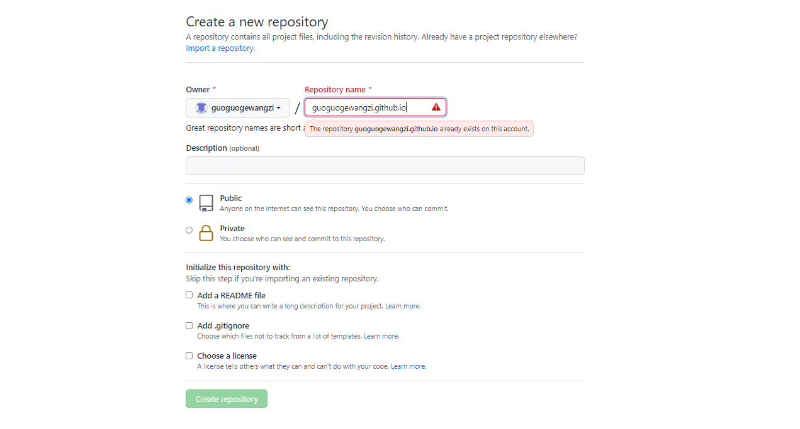

(1)克隆guoguogewangzi.github.io项目

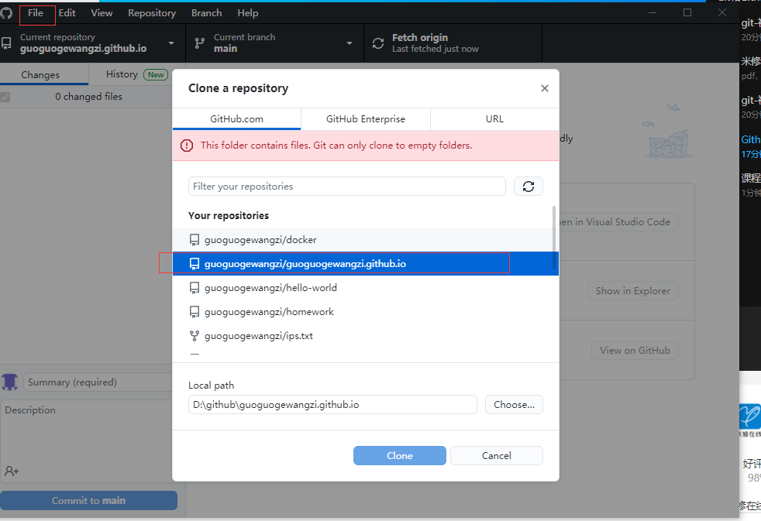

(2)将index.html拖拽至guoguogewangzi.github.io文件夹，此时Github客户端自动显示更改了那些内容，这相当于命令行的git add

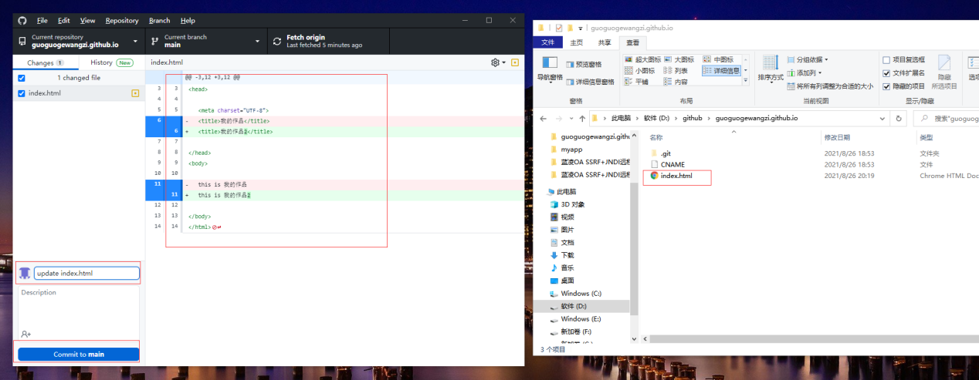

(3)点击Commit to main后如图，这相当于命令行的git commit -m “update index.html”

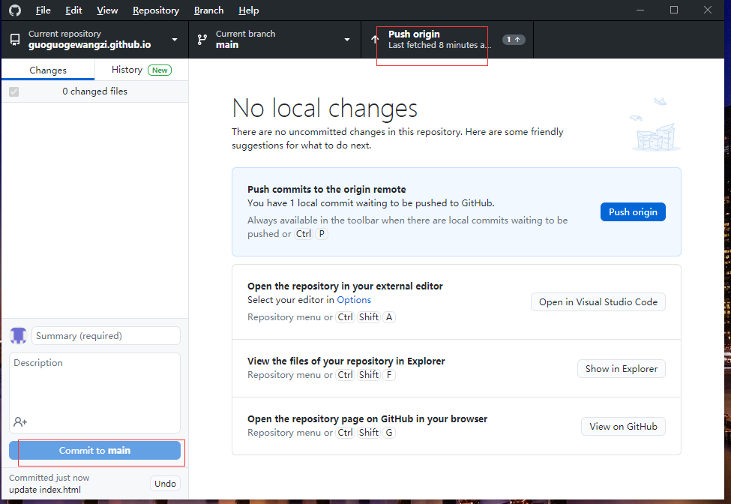

(4)推送成功，点击Puch origin后如图，这相当于命令行的git push

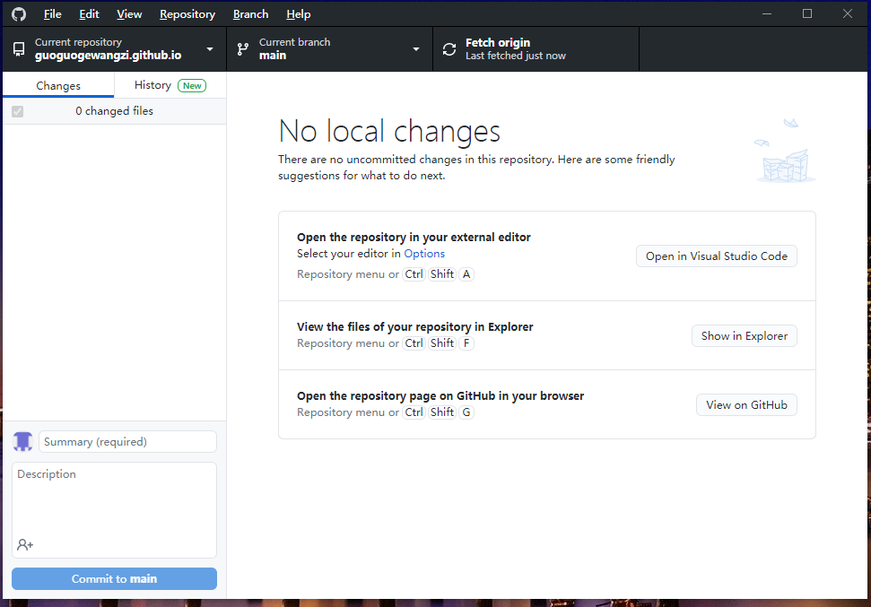

(5)注册域名：点击立即结算

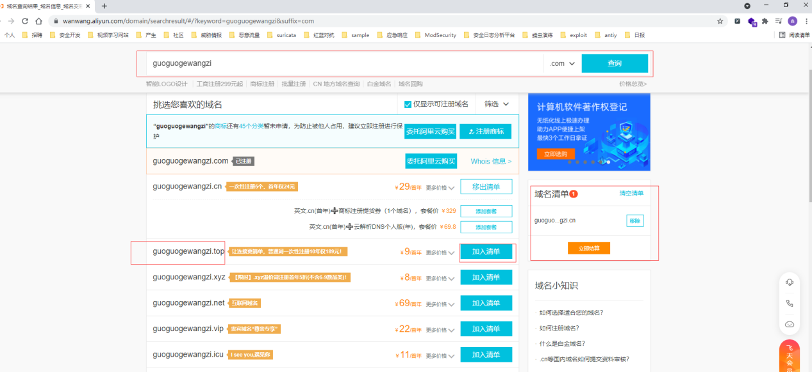

(6)进入控制台：

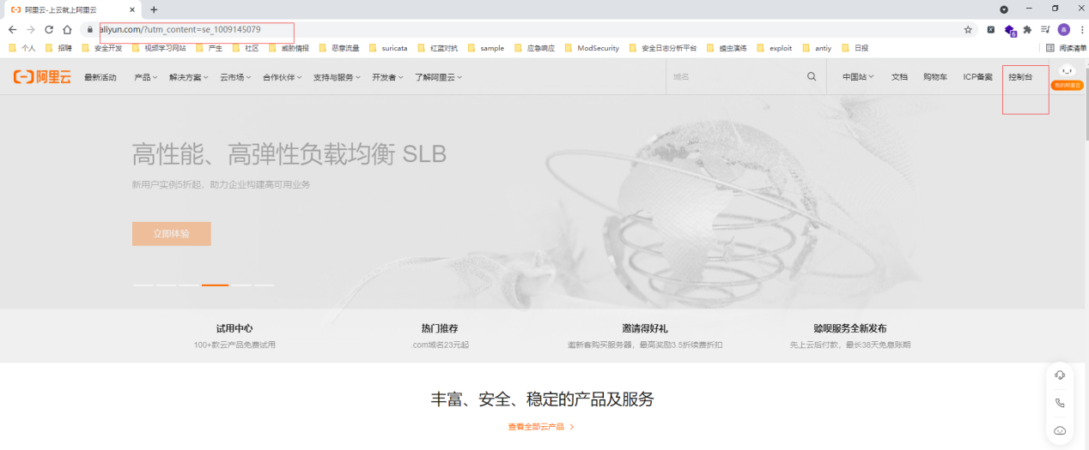

(7)点击域名

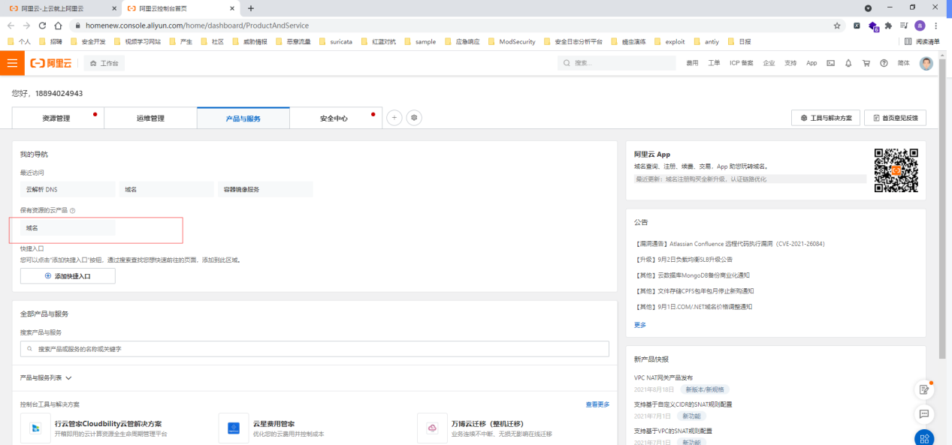

(8)可以看到域名列表，点击解析，添加域名记录

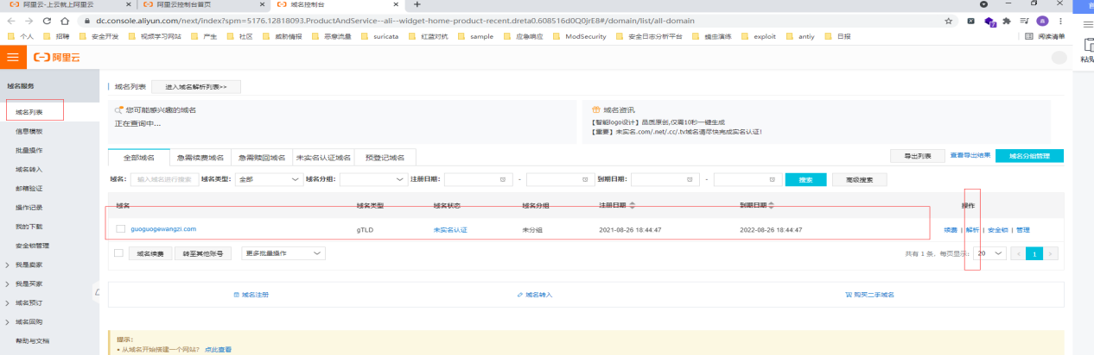

(9)添加两条CNAME记录，一条WWW记录，另一条为：没有WWW用@代替

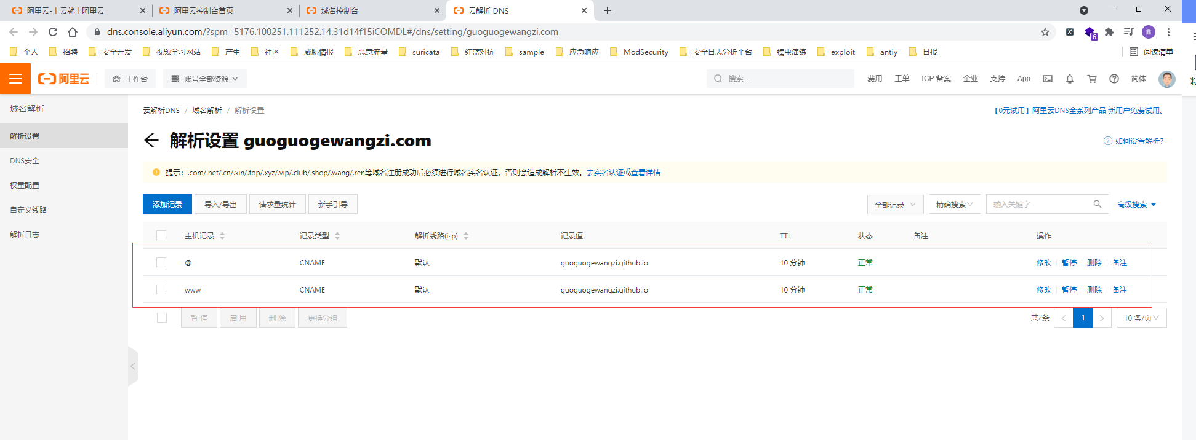

(10)给项目添加名为CNAME文件：内容为：www.guoguogewangzi.com

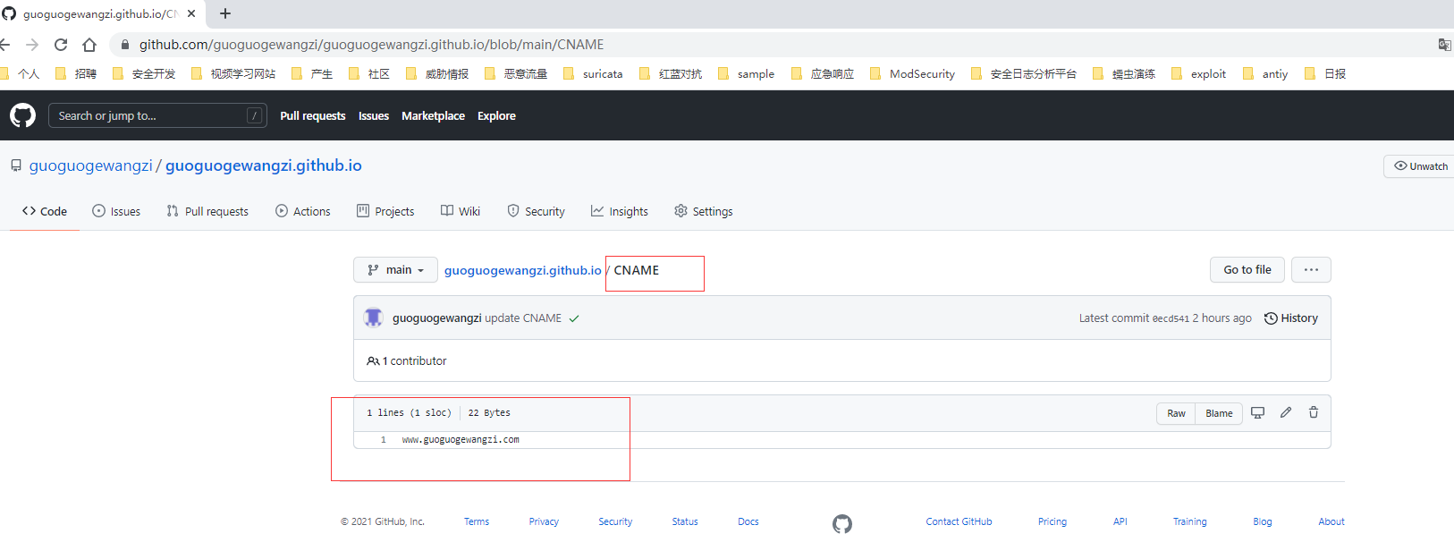

(11)成功访问：www.guoguogewangzi.com，新买的域名需要等一会儿生效

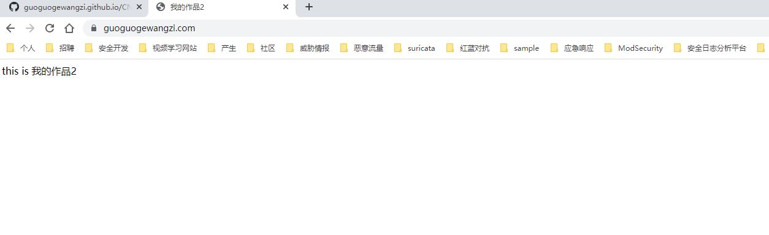

**一、项目实战：**

**1、初始化git仓库**

86188@DESKTOP-VLS5H3G MINGW64 /d/github/git_study

$ git init #新建git_study文件夹，并初始化

Initialized empty Git repository in D:/github/git_study/.git/

**2、添加项目**

86188@DESKTOP-VLS5H3G MINGW64 /d/github/git_study (master)

$ git status #将项目复制到git_study文件夹下，并查看状态

starting fsmonitor-daemon in 'D:/github/git_study'

On branch master

No commits yet

Untracked files:

(use "git add <file>..." to include in what will be committed)

git.docx

nothing added to commit but untracked files present (use "git add" to track)

**3、git add:添加到队列**

86188@DESKTOP-VLS5H3G MINGW64 /d/github/git_study (master)

$ git add . #add 到队列

86188@DESKTOP-VLS5H3G MINGW64 /d/github/git_study (master)

$ git status #查看队列状态

On branch master

No commits yet

Changes to be committed:

(use "git rm --cached <file>..." to unstage)

new file: git.docx

**4、git commit:提交仓库(添加了ssh公钥的可以直接跳到第8步)**

86188@DESKTOP-VLS5H3G MINGW64 /d/github/git_study (master)

$ git commit -m "add git.docx" #提交到本地仓库

[master (root-commit) 70d71f3] add git.docx

1 file changed, 0 insertions(+), 0 deletions(-)

create mode 100644 git.docx

86188@DESKTOP-VLS5H3G MINGW64 /d/github/git_study (master)

$ git status #查看队列状态

On branch master

nothing to commit, working tree clean

**5、额外，ssh-keygen:生成公钥和私钥**

86188@DESKTOP-VLS5H3G MINGW64 /d

$ ssh-keygen -o #生成ssh公钥和私钥，默认回车即可

Generating public/private rsa key pair.

Enter file in which to save the key (/c/Users/86188/.ssh/id_rsa):

Enter passphrase (empty for no passphrase):

Enter same passphrase again:

Your identification has been saved in /c/Users/86188/.ssh/id_rsa

Your public key has been saved in /c/Users/86188/.ssh/id_rsa.pub

The key fingerprint is:

SHA256:ePqavMparARkYs2dmlcJf936tseSgfEglWO+4p0t+gI 86188@DESKTOP-VLS5H3G

The key's randomart image is:

+---[RSA 3072]----+

| . . |

| o . + . .=. |

|.+ o o + .+... |

|= o .... +. |

|. o .. S ..* |

| . .. E . o.o |

| . o . o o oo+ |

| . + . o o +.+.o |

| o.o.=o..+...o |

+----[SHA256]-----+

**6、额外，复制公钥信息**

86188@DESKTOP-VLS5H3G MINGW64 /d

$ cat /c/Users/86188/.ssh/id_rsa.pub #复制公钥信息

ssh-rsa  86188@DESKTOP-VLS5H3G

查看C:\Users\86188\.ssh路径下的文件，生成了id_rsa私钥和id_rsa.pub公钥，linux服务器路径为：/root/.ssh

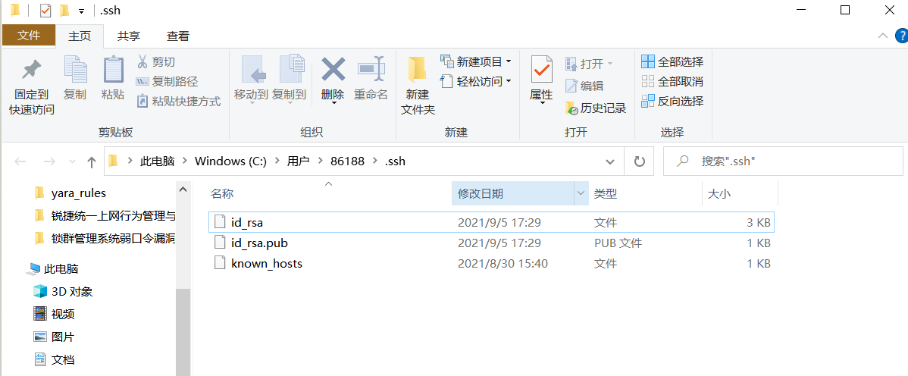

**7、额外，添加公钥到github**

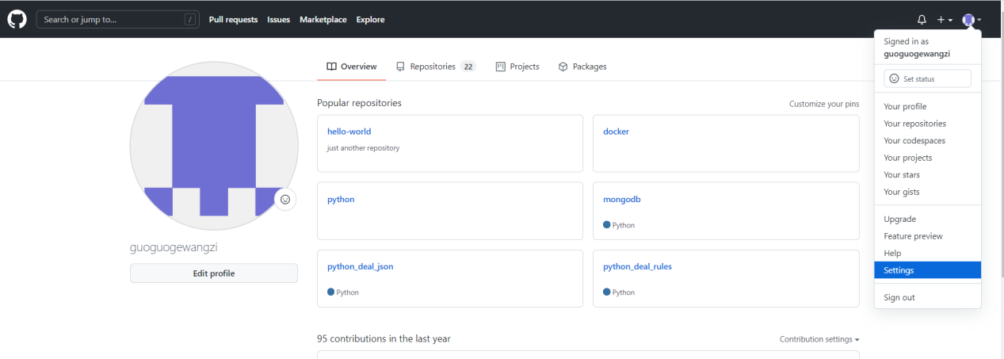

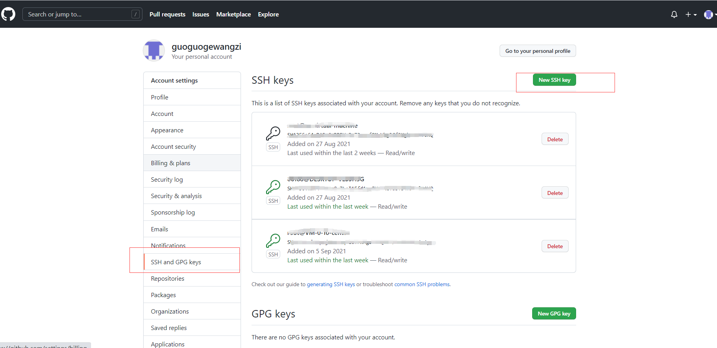

**8、新建仓库，并复制仓库的ssh远程地址(再次之前确保本地机器的ssh公钥添加到了github)**

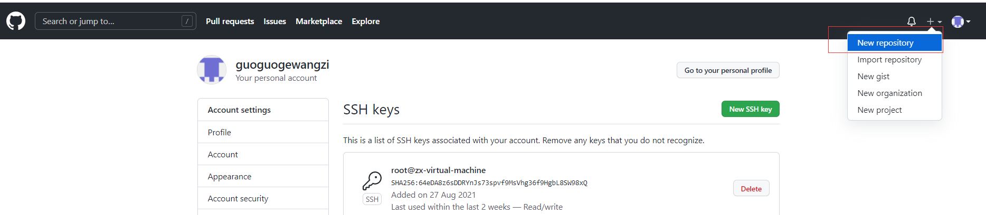

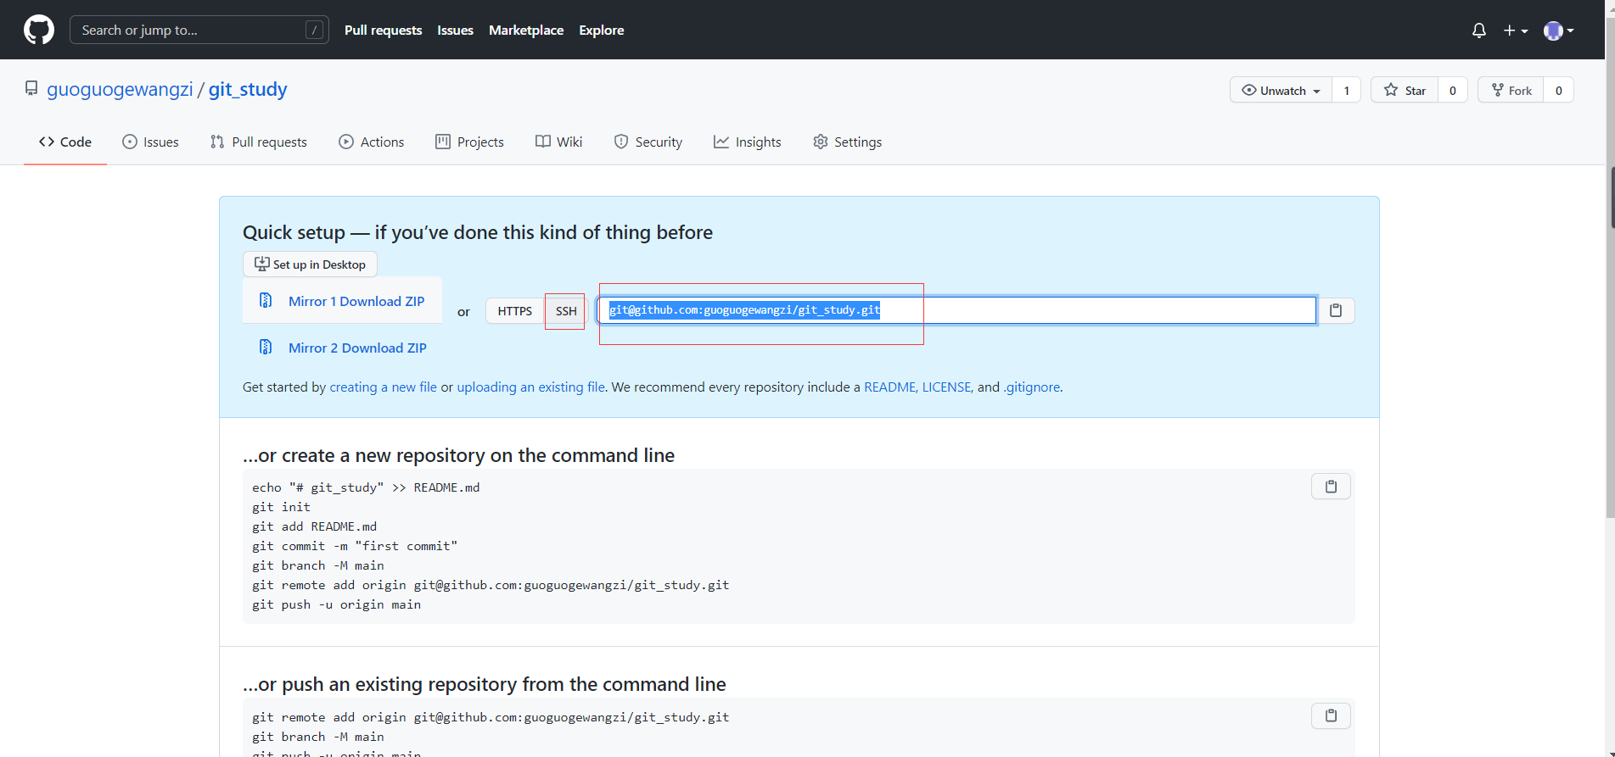

**9、git remote:添加远程仓库地址**

86188@DESKTOP-VLS5H3G MINGW64 /d/github/git_study (master)

$ git remote add origin git@github.com:guoguogewangzi/git_study.git

86188@DESKTOP-VLS5H3G MINGW64 /d/github/git_study (master)

$ git remote -v #查看远程仓库地址

origin git@github.com:guoguogewangzi/git_study.git (fetch)

origin git@github.com:guoguogewangzi/git_study.git (push)

**10、git push -u origin master 上传到远程仓库**

86188@DESKTOP-VLS5H3G MINGW64 /d/github/git_study (master)

$ git push -u origin master #push到远程仓库

Enumerating objects: 3, done.

Counting objects: 100% (3/3), done.

Delta compression using up to 12 threads

Compressing objects: 100% (2/2), done.

Writing objects: 100% (3/3), 1.71 MiB | 669.00 KiB/s, done.

Total 3 (delta 0), reused 0 (delta 0), pack-reused 0

To github.com:guoguogewangzi/git_study.git

* [new branch] master -> master

Branch 'master' set up to track remote branch 'master' from 'origin'.

**二、后期更新维护：**

**1、git status:查看队列状态,进入项目文件夹下**

86188@DESKTOP-VLS5H3G MINGW64 /d/github/git_study (master)

$ git status #查看队列状态

On branch master

Your branch is up to date with 'origin/master'.

Changes not staged for commit:

(use "git add <file>..." to update what will be committed)

(use "git restore <file>..." to discard changes in working directory)

modified: git.docx

no changes added to commit (use "git add" and/or "git commit -a")

**2、git add：提交到队列**

86188@DESKTOP-VLS5H3G MINGW64 /d/github/git_study (master)

$ git add . #添加到队列

**3、git commit:提交到本地仓库**

86188@DESKTOP-VLS5H3G MINGW64 /d/github/git_study (master)

$ git commit -m "update git.docx" #提交到本地仓库

[master a871c1d] update git.docx

1 file changed, 0 insertions(+), 0 deletions(-)

86188@DESKTOP-VLS5H3G MINGW64 /d/github/git_study (master)

$ git status #查看队列状态

On branch master

Your branch is ahead of 'origin/master' by 1 commit.

(use "git push" to publish your local commits)

nothing to commit, working tree clean

**4、git push :上传到远程仓库**

86188@DESKTOP-VLS5H3G MINGW64 /d/github/git_study (master)

$ git push #上传到远程仓库

Enumerating objects: 5, done.

Counting objects: 100% (5/5), done.

Delta compression using up to 12 threads

Compressing objects: 100% (2/2), done.

Writing objects: 100% (3/3), 400.59 KiB | 2.05 MiB/s, done.

Total 3 (delta 1), reused 0 (delta 0), pack-reused 0

remote: Resolving deltas: 100% (1/1), completed with 1 local object.

To github.com:guoguogewangzi/git_study.git

0fa3bfd..a871c1d master -> master

86188@DESKTOP-VLS5H3G MINGW64 /d/github/git_study (master)

$

**结束！**

**1、Git设置http/https代理**

git config --global http.proxy http://127.0.0.1:41091  
git config --global https.proxy https://127.0.0.1:41091

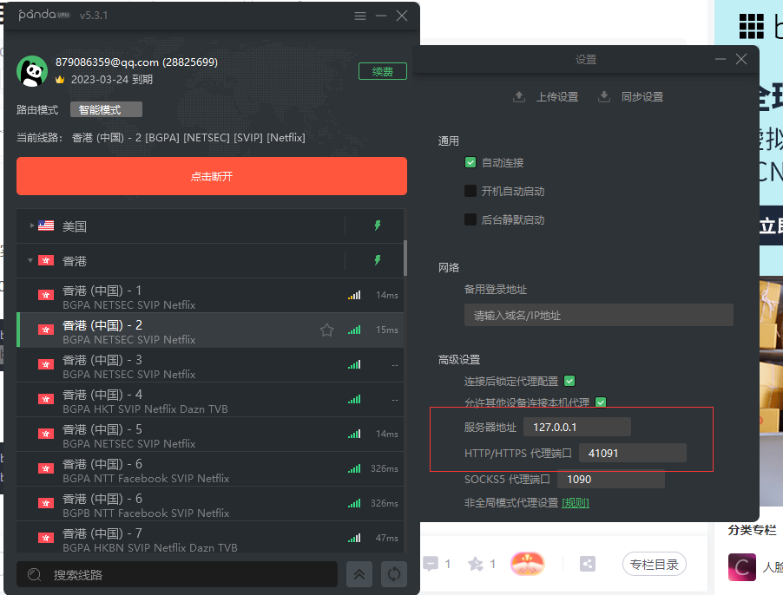

**2、git config --list：查看全局配置信息**

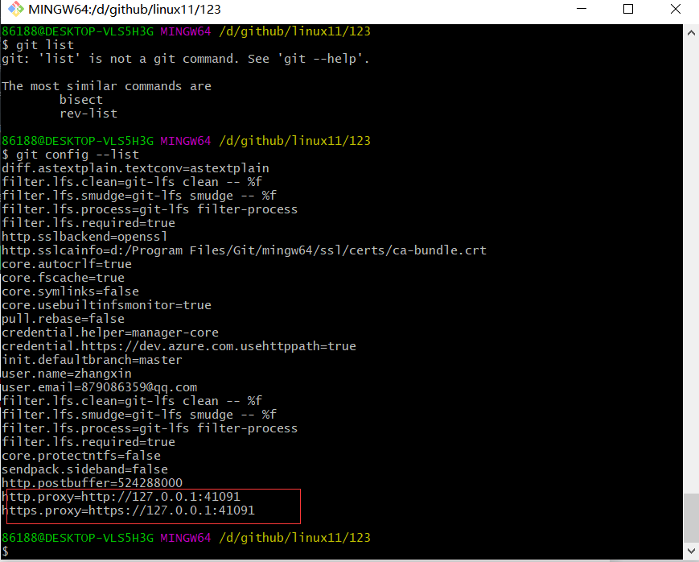

**3、取消代理**

git config --global --unset http.proxy

git config --global --unset https.proxy

**4、设置ssh代理，修改config配置文件**

Linux: vi ~/.ssh/config

Windows: C:\Users\86188\.ssh\config (没有自行创建)

**5、确保connect.exe存在git bash里面，需要用到connect.exe**

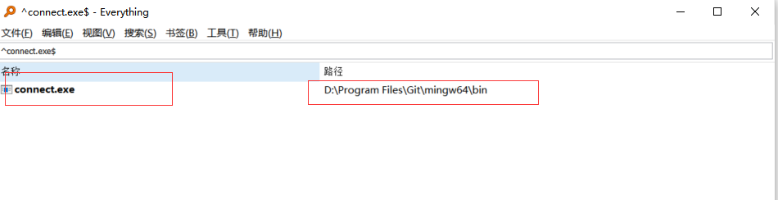

**6、查看SOCKS5监听端口：1090**

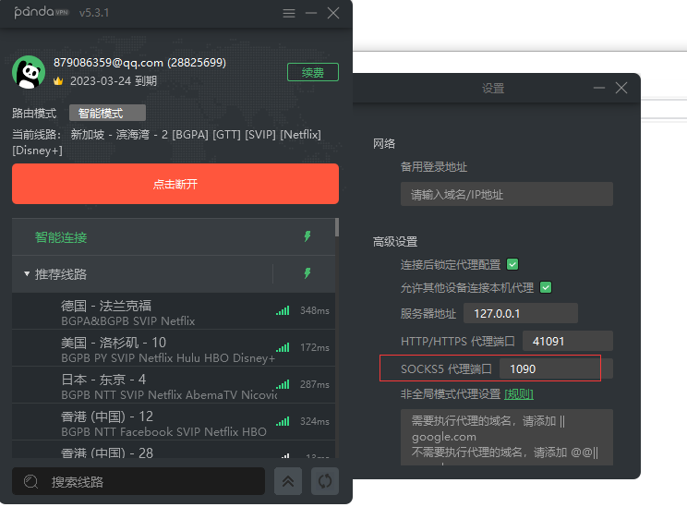

**7、添加以下内容：**

#注意：端口改为自己代理软件SOCKS5监听的端口

ProxyCommand connect -S 127.0.0.1:1090 -a none %h %p

Host github.com

User git

Port 22

Hostname github.com

# 注意修改路径为你的私钥文件路径

IdentityFile "C:\Users\86188\.ssh\id_rsa"

TCPKeepAlive yes

Host ssh.github.com

User git

Port 443

Hostname ssh.github.com

# 注意修改路径为你的私钥文件路径

IdentityFile "C:\Users\86188\.ssh\id_rsa"

TCPKeepAlive yes

如图：

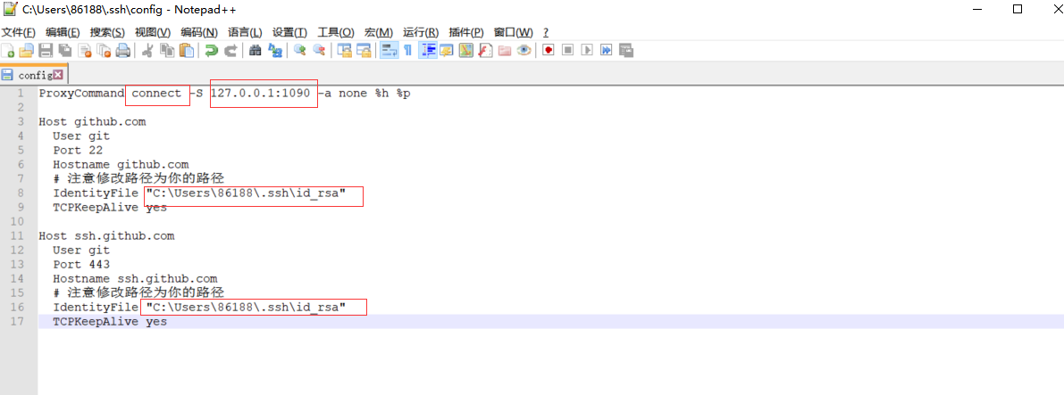

另一种更快的方法，设置如下：

Host 42.194.233.78

HostName 42.194.233.78

User root

Host 42.194.233.78

HostName 42.194.233.78

User root

ForwardAgent yes

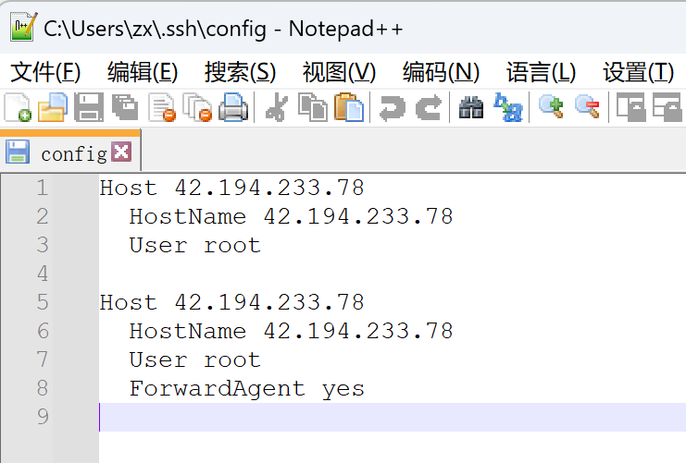

**8、执行：ssh -T git@github.com,返回successfully，则监听成功**

86188@DESKTOP-VLS5H3G MINGW64 /d/github/linux11/123

$ ssh -T git@github.com

Hi guoguogewangzi! You've successfully authenticated, but GitHub does not provide shell access

.

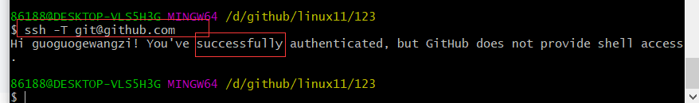

**常见错误：**

**一. 大文件的错误**

**错误信息：**

fatal: sha1 file '<stdout>' write error: Broken pipe

fatal: The remote end hung up unexpectedly

**解决方案：**

设置 ；将Git缓冲区大小增加到repo的最大单个文件大小：

git config --global http.postBuffer 157286400

**二. 回退到上一次commit的状态**

方法一：

$ git status

On branch master

Your branch is ahead of 'origin/master' by 2 commits.

(use "git push" to publish your local commits)

nothing to commit, working tree clean

**解决方案：**

git reset HEAD^ --soft

**三、回滚到指定状态**

整个过程其实就三步。  
1、找到提交记录的[hash](https://so.csdn.net/so/search?q=hash" \t "https://blog.csdn.net/weixin_44075200/article/details/_blank)值。  
2、回滚到相应的提交状态。  
3、上传到github。

**1、找到提交记录的hash值，点击复制hash**

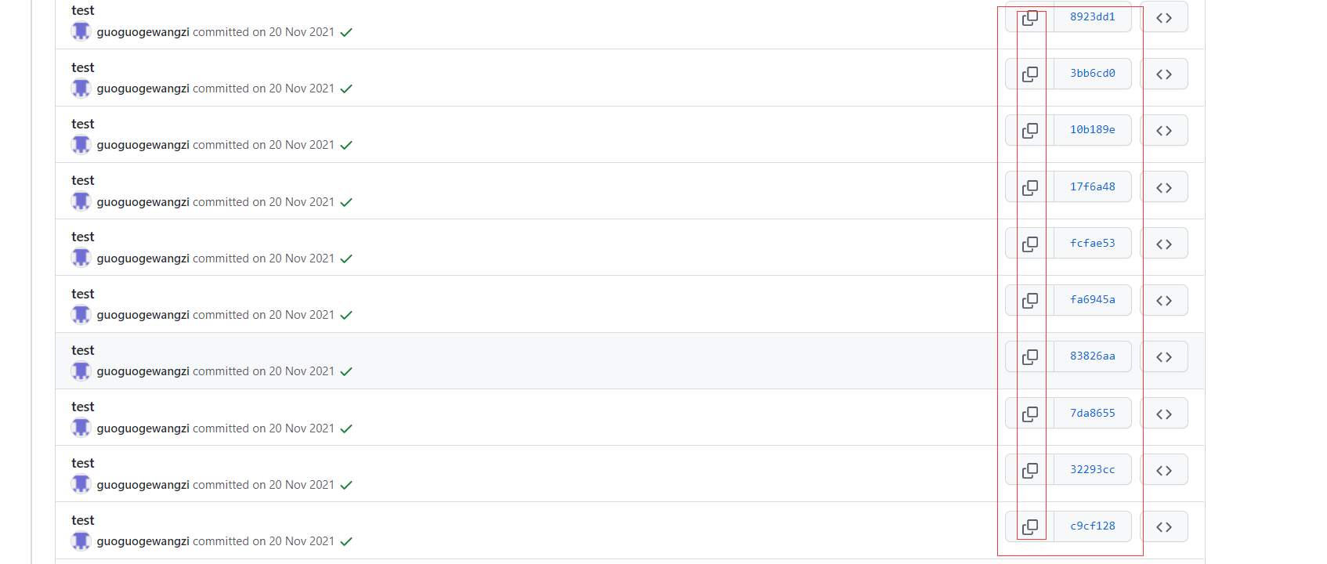

或：git log命令查看

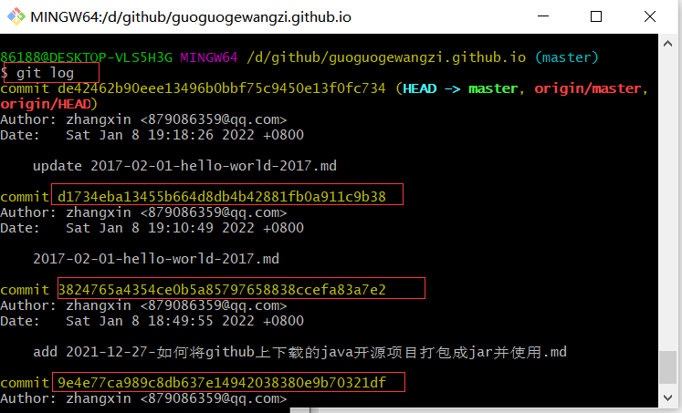

**2、回滚到相应的提交状态**

git reset --hard 644ce...

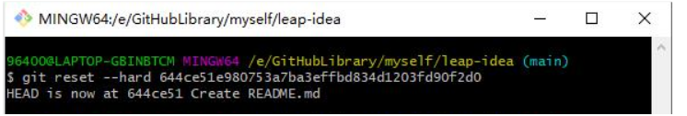

**3、上传到github**

git push origin HEAD --force

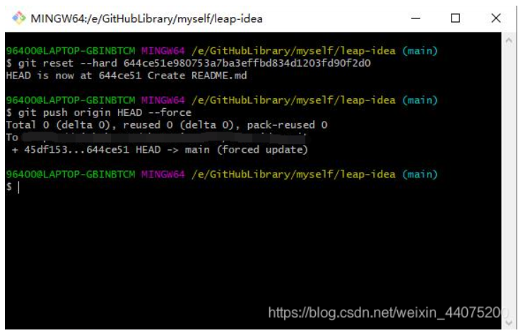

到此，回到github项目再看一下提交记录，如果成功删除，那这次的回滚就结束了。