log4j:WARN No appenders could be found for logger (org.apache.hadoop.metrics2.lib.MutableMetricsFactory).
log4j:WARN Please initialize the log4j system properly.
log4j:WARN See http://logging.apache.org/log4j/1.2/faq.html#noconfig for more info.
Exception in thread "main" org.apache.hadoop.hbase.client.RetriesExhaustedException: Failed after attempts=35, exceptions:
Fri Jul 08 15:57:41 GMT+08:00 2016, org.apache.hadoop.hbase.client.RpcRetryingCaller@49de7857, java.io.IOException: Could not set up IO Streams
Fri Jul 08 15:57:42 GMT+08:00 2016, org.apache.hadoop.hbase.client.RpcRetryingCaller@49de7857, org.apache.hadoop.hbase.ipc.RpcClient$FailedServerException: This server is in the failed servers list: kit-b4/172.16.19.154:60020
Fri Jul 08 15:57:42 GMT+08:00 2016, org.apache.hadoop.hbase.client.RpcRetryingCaller@49de7857, org.apache.hadoop.hbase.ipc.RpcClient$FailedServerException: This server is in the failed servers list: kit-b4/172.16.19.154:60020
Fri Jul 08 15:57:43 GMT+08:00 2016, org.apache.hadoop.hbase.client.RpcRetryingCaller@49de7857, org.apache.hadoop.hbase.ipc.RpcClient$FailedServerException: This server is in the failed servers list: kit-b4/172.16.19.154:60020
Fri Jul 08 15:57:45 GMT+08:00 2016, org.apache.hadoop.hbase.client.RpcRetryingCaller@49de7857, java.io.IOException: Could not set up IO Streams
Fri Jul 08 15:57:49 GMT+08:00 2016, org.apache.hadoop.hbase.client.RpcRetryingCaller@49de7857, java.io.IOException: Could not set up IO Streams
Fri Jul 08 15:57:59 GMT+08:00 2016, org.apache.hadoop.hbase.client.RpcRetryingCaller@49de7857, java.io.IOException: Could not set up IO Streams
Fri Jul 08 15:58:09 GMT+08:00 2016, org.apache.hadoop.hbase.client.RpcRetryingCaller@49de7857, java.io.IOException: Could not set up IO Streams
Fri Jul 08 15:58:19 GMT+08:00 2016, org.apache.hadoop.hbase.client.RpcRetryingCaller@49de7857, java.io.IOException: Could not set up IO Streams
Fri Jul 08 15:58:30 GMT+08:00 2016, org.apache.hadoop.hbase.client.RpcRetryingCaller@49de7857, java.io.IOException: Could not set up IO Streams
Fri Jul 08 15:58:50 GMT+08:00 2016, org.apache.hadoop.hbase.client.RpcRetryingCaller@49de7857, java.io.IOException: Could not set up IO Streams
Fri Jul 08 15:59:10 GMT+08:00 2016, org.apache.hadoop.hbase.client.RpcRetryingCaller@49de7857, java.io.IOException: Could not set up IO Streams
Fri Jul 08 15:59:30 GMT+08:00 2016, org.apache.hadoop.hbase.client.RpcRetryingCaller@49de7857, java.io.IOException: Could not set up IO Streams
Fri Jul 08 15:59:50 GMT+08:00 2016, org.apache.hadoop.hbase.client.RpcRetryingCaller@49de7857, java.io.IOException: Could not set up IO Streams
Fri Jul 08 16:00:10 GMT+08:00 2016, org.apache.hadoop.hbase.client.RpcRetryingCaller@49de7857, java.io.IOException: Could not set up IO Streams
Fri Jul 08 16:00:30 GMT+08:00 2016, org.apache.hadoop.hbase.client.RpcRetryingCaller@49de7857, java.io.IOException: Could not set up IO Streams
Fri Jul 08 16:00:50 GMT+08:00 2016, org.apache.hadoop.hbase.client.RpcRetryingCaller@49de7857, java.io.IOException: Could not set up IO Streams
Fri Jul 08 16:01:10 GMT+08:00 2016, org.apache.hadoop.hbase.client.RpcRetryingCaller@49de7857, java.io.IOException: Could not set up IO Streams
Fri Jul 08 16:01:30 GMT+08:00 2016, org.apache.hadoop.hbase.client.RpcRetryingCaller@49de7857, java.io.IOException: Could not set up IO Streams
Fri Jul 08 16:01:51 GMT+08:00 2016, org.apache.hadoop.hbase.client.RpcRetryingCaller@49de7857, java.io.IOException: Could not set up IO Streams
Fri Jul 08 16:02:11 GMT+08:00 2016, org.apache.hadoop.hbase.client.RpcRetryingCaller@49de7857, java.io.IOException: Could not set up IO Streams
Fri Jul 08 16:02:31 GMT+08:00 2016, org.apache.hadoop.hbase.client.RpcRetryingCaller@49de7857, java.io.IOException: Could not set up IO Streams
Fri Jul 08 16:02:51 GMT+08:00 2016, org.apache.hadoop.hbase.client.RpcRetryingCaller@49de7857, java.io.IOException: Could not set up IO Streams
Fri Jul 08 16:03:11 GMT+08:00 2016, org.apache.hadoop.hbase.client.RpcRetryingCaller@49de7857, java.io.IOException: Could not set up IO Streams
Fri Jul 08 16:03:31 GMT+08:00 2016, org.apache.hadoop.hbase.client.RpcRetryingCaller@49de7857, java.io.IOException: Could not set up IO Streams
Fri Jul 08 16:03:51 GMT+08:00 2016, org.apache.hadoop.hbase.client.RpcRetryingCaller@49de7857, java.io.IOException: Could not set up IO Streams
Fri Jul 08 16:04:11 GMT+08:00 2016, org.apache.hadoop.hbase.client.RpcRetryingCaller@49de7857, java.io.IOException: Could not set up IO Streams
Fri Jul 08 16:04:31 GMT+08:00 2016, org.apache.hadoop.hbase.client.RpcRetryingCaller@49de7857, java.io.IOException: Could not set up IO Streams
Fri Jul 08 16:04:51 GMT+08:00 2016, org.apache.hadoop.hbase.client.RpcRetryingCaller@49de7857, java.io.IOException: Could not set up IO Streams
Fri Jul 08 16:05:12 GMT+08:00 2016, org.apache.hadoop.hbase.client.RpcRetryingCaller@49de7857, java.io.IOException: Could not set up IO Streams
Fri Jul 08 16:05:32 GMT+08:00 2016, org.apache.hadoop.hbase.client.RpcRetryingCaller@49de7857, java.io.IOException: Could not set up IO Streams
Fri Jul 08 16:05:52 GMT+08:00 2016, org.apache.hadoop.hbase.client.RpcRetryingCaller@49de7857, java.io.IOException: Could not set up IO Streams
Fri Jul 08 16:06:12 GMT+08:00 2016, org.apache.hadoop.hbase.client.RpcRetryingCaller@49de7857, java.io.IOException: Could not set up IO Streams
Fri Jul 08 16:06:32 GMT+08:00 2016, org.apache.hadoop.hbase.client.RpcRetryingCaller@49de7857, java.io.IOException: Could not set up IO Streams
Fri Jul 08 16:06:52 GMT+08:00 2016, org.apache.hadoop.hbase.client.RpcRetryingCaller@49de7857, java.io.IOException: Could not set up IO Streams

at org.apache.hadoop.hbase.client.RpcRetryingCaller.callWithRetries(RpcRetryingCaller.java:131)
at org.apache.hadoop.hbase.client.ClientScanner.nextScanner(ClientScanner.java:283)
at org.apache.hadoop.hbase.client.ClientScanner.initializeScannerInConstruction(ClientScanner.java:188)
at org.apache.hadoop.hbase.client.ClientScanner.<init>(ClientScanner.java:183)
at org.apache.hadoop.hbase.client.ClientScanner.<init>(ClientScanner.java:110)
at org.apache.hadoop.hbase.client.HTable.getScanner(HTable.java:737)
at org.apache.hadoop.hbase.catalog.MetaReader.fullScan(MetaReader.java:543)
at org.apache.hadoop.hbase.catalog.MetaReader.tableExists(MetaReader.java:311)
at org.apache.hadoop.hbase.client.HBaseAdmin.tableExists(HBaseAdmin.java:259)
at org.apache.hadoop.hbase.client.HBaseAdmin.tableExists(HBaseAdmin.java:273)
at com.yibao.hbase.demo.HbaseUtil.open(HbaseUtil.java:49)
at com.yibao.hbase.demo.HbaseUtil.main(HbaseUtil.java:157)
Caused by: java.io.IOException: Could not set up IO Streams
at org.apache.hadoop.hbase.ipc.RpcClient$Connection.setupIOstreams(RpcClient.java:934)
at org.apache.hadoop.hbase.ipc.RpcClient.getConnection(RpcClient.java:1543)
at org.apache.hadoop.hbase.ipc.RpcClient.call(RpcClient.java:1442)
at org.apache.hadoop.hbase.ipc.RpcClient.callBlockingMethod(RpcClient.java:1661)
at org.apache.hadoop.hbase.ipc.RpcClient$BlockingRpcChannelImplementation.callBlockingMethod(RpcClient.java:1719)
at org.apache.hadoop.hbase.protobuf.generated.ClientProtos$ClientService$BlockingStub.scan(ClientProtos.java:31548)
at org.apache.hadoop.hbase.client.ScannerCallable.openScanner(ScannerCallable.java:308)
at org.apache.hadoop.hbase.client.ScannerCallable.call(ScannerCallable.java:164)
at org.apache.hadoop.hbase.client.ScannerCallable.call(ScannerCallable.java:59)
at org.apache.hadoop.hbase.client.RpcRetryingCaller.callWithRetries(RpcRetryingCaller.java:115)
... 11 more
Caused by: java.lang.RuntimeException: SASL authentication failed. The most likely cause is missing or invalid credentials. Consider 'kinit'.
at org.apache.hadoop.hbase.ipc.RpcClient$Connection$1.run(RpcClient.java:835)
at java.security.AccessController.doPrivileged(Native Method)
at javax.security.auth.Subject.doAs(Subject.java:415)
at org.apache.hadoop.security.UserGroupInformation.doAs(UserGroupInformation.java:1614)
at org.apache.hadoop.hbase.ipc.RpcClient$Connection.handleSaslConnectionFailure(RpcClient.java:796)
at org.apache.hadoop.hbase.ipc.RpcClient$Connection.setupIOstreams(RpcClient.java:898)
... 20 more
Caused by: javax.security.sasl.SaslException: GSS initiate failed [Caused by GSSException: No valid credentials provided (Mechanism level: Failed to find any Kerberos tgt)]
at com.sun.security.sasl.gsskerb.GssKrb5Client.evaluateChallenge(GssKrb5Client.java:212)
at org.apache.hadoop.hbase.security.HBaseSaslRpcClient.saslConnect(HBaseSaslRpcClient.java:179)
at org.apache.hadoop.hbase.ipc.RpcClient$Connection.setupSaslConnection(RpcClient.java:770)
at org.apache.hadoop.hbase.ipc.RpcClient$Connection.access$600(RpcClient.java:357)
at org.apache.hadoop.hbase.ipc.RpcClient$Connection$2.run(RpcClient.java:891)
at org.apache.hadoop.hbase.ipc.RpcClient$Connection$2.run(RpcClient.java:888)
at java.security.AccessController.doPrivileged(Native Method)
at javax.security.auth.Subject.doAs(Subject.java:415)
at org.apache.hadoop.security.UserGroupInformation.doAs(UserGroupInformation.java:1614)
at org.apache.hadoop.hbase.ipc.RpcClient$Connection.setupIOstreams(RpcClient.java:888)
... 20 more
Caused by: GSSException: No valid credentials provided (Mechanism level: Failed to find any Kerberos tgt)
at sun.security.jgss.krb5.Krb5InitCredential.getInstance(Krb5InitCredential.java:147)
at sun.security.jgss.krb5.Krb5MechFactory.getCredentialElement(Krb5MechFactory.java:121)
at sun.security.jgss.krb5.Krb5MechFactory.getMechanismContext(Krb5MechFactory.java:187)
at sun.security.jgss.GSSManagerImpl.getMechanismContext(GSSManagerImpl.java:223)
at sun.security.jgss.GSSContextImpl.initSecContext(GSSContextImpl.java:212)
at sun.security.jgss.GSSContextImpl.initSecContext(GSSContextImpl.java:179)
at com.sun.security.sasl.gsskerb.GssKrb5Client.evaluateChallenge(GssKrb5Client.java:193)
... 29 more

条用api，java代码去连接hbase报zk节点的相关错误：
http://osdir.com/ml/general/2013-07/msg22843.html
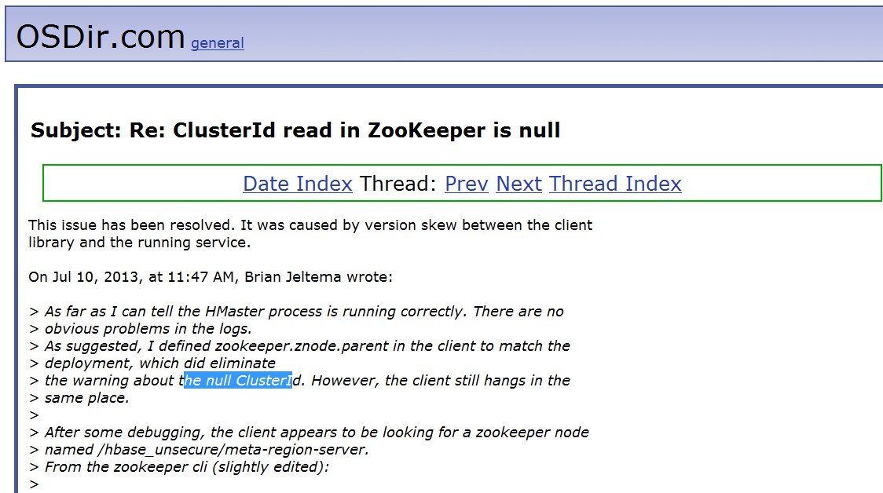

hbase相关命令：
klist 查看用户权限认证
kinit -kt /etc/hyperbase1/hbase.keytab hbase/kit-b2@TDH 添加用户认证
list 获取所有表名
scan table 查看表

--创建表
create 'kit0607','kit1','kit2','kit3'
add data:
put ‘kit0607’,’0001’,’kit1:nm’,’guohan’

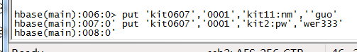
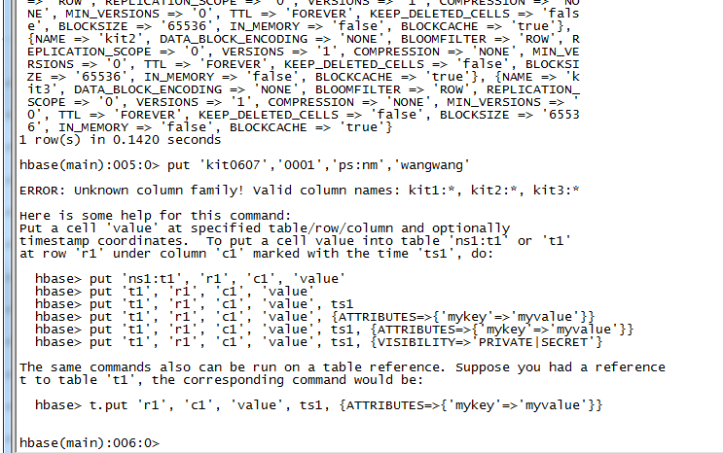

删除表的列：
alter 'kit0607', 'delete'=>'kit3'

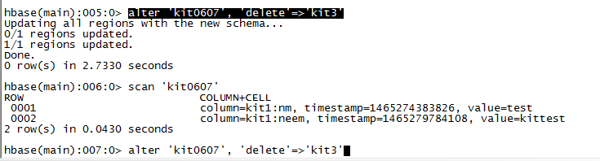
添加列：
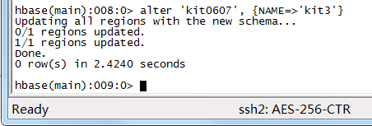

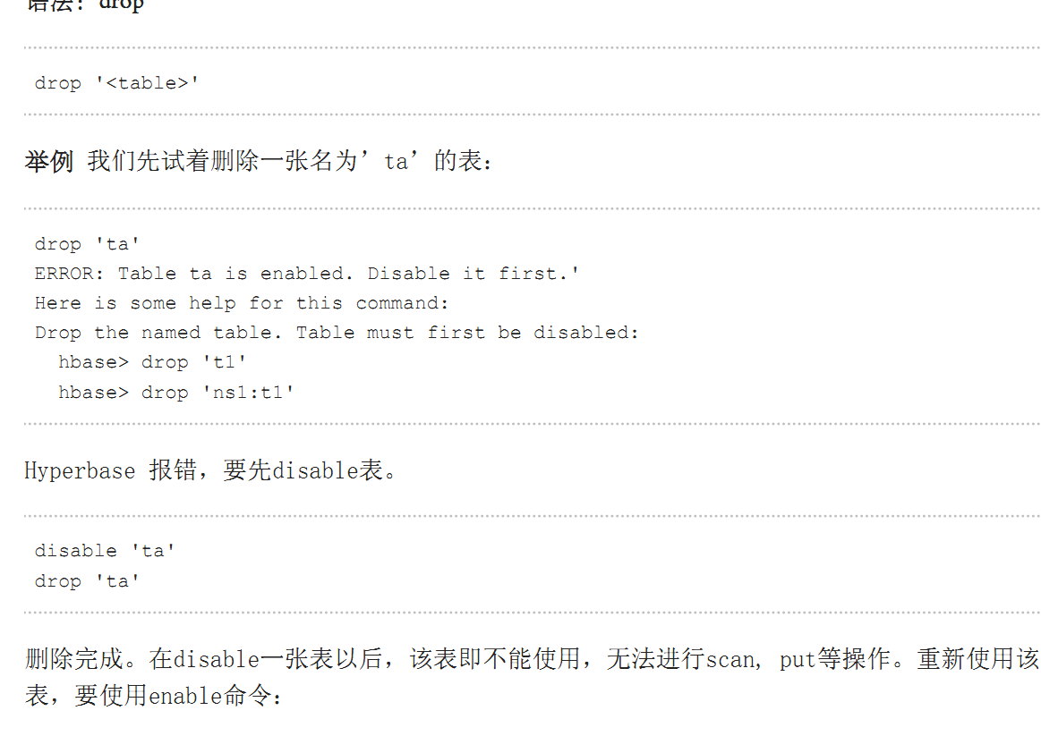

HelP:

hbase(main):020:0> help 'dml'
Command: append
Appends a cell 'value' at specified table/row/column coordinates.

hbase> append 't1', 'r1', 'c1', 'value', ATTRIBUTES=>{'mykey'=>'myvalue'}
hbase> append 't1', 'r1', 'c1', 'value', {VISIBILITY=>'PRIVATE|SECRET'}

The same commands also can be run on a table reference. Suppose you had a reference
t to table 't1', the corresponding command would be:

hbase> t.append 'r1', 'c1', 'value', ATTRIBUTES=>{'mykey'=>'myvalue'}
hbase> t.append 'r1', 'c1', 'value', {VISIBILITY=>'PRIVATE|SECRET'}

Command: count
Count the number of rows in a table. Return value is the number of rows.
This operation may take a LONG time (Run '$HADOOP_HOME/bin/hadoop jar
hbase.jar rowcount' to run a counting mapreduce job). Current count is shown
every 1000 rows by default. Count interval may be optionally specified. Scan
caching is enabled on count scans by default. Default cache size is 10 rows.
If your rows are small in size, you may want to increase this
parameter. Examples:

hbase> count 'ns1:t1'
hbase> count 't1'
hbase> count 't1', INTERVAL => 100000
hbase> count 't1', CACHE => 1000
hbase> count 't1', INTERVAL => 10, CACHE => 1000

The same commands also can be run on a table reference. Suppose you had a reference
t to table 't1', the corresponding commands would be:

hbase> t.count
hbase> t.count INTERVAL => 100000
hbase> t.count CACHE => 1000
hbase> t.count INTERVAL => 10, CACHE => 1000

Command: delete
Put a delete cell value at specified table/row/column and optionally
timestamp coordinates. Deletes must match the deleted cell's
coordinates exactly. When scanning, a delete cell suppresses older
versions. To delete a cell from 't1' at row 'r1' under column 'c1'
marked with the time 'ts1', do:

hbase> delete 'ns1:t1', 'r1', 'c1', ts1
hbase> delete 't1', 'r1', 'c1', ts1
hbase> delete 't1', 'r1', 'c1', ts1, {VISIBILITY=>'PRIVATE|SECRET'}

The same command can also be run on a table reference. Suppose you had a reference
t to table 't1', the corresponding command would be:

hbase> t.delete 'r1', 'c1', ts1
hbase> t.delete 'r1', 'c1', ts1, {VISIBILITY=>'PRIVATE|SECRET'}

Command: deleteall
Delete all cells in a given row; pass a table name, row, and optionally
a column and timestamp. Examples:

hbase> deleteall 'ns1:t1', 'r1'
hbase> deleteall 't1', 'r1'
hbase> deleteall 't1', 'r1', 'c1'
hbase> deleteall 't1', 'r1', 'c1', ts1
hbase> deleteall 't1', 'r1', 'c1', ts1, {VISIBILITY=>'PRIVATE|SECRET'}

The same commands also can be run on a table reference. Suppose you had a reference
t to table 't1', the corresponding command would be:

hbase> t.deleteall 'r1'
hbase> t.deleteall 'r1', 'c1'
hbase> t.deleteall 'r1', 'c1', ts1
hbase> t.deleteall 'r1', 'c1', ts1, {VISIBILITY=>'PRIVATE|SECRET'}

Command: get
Get row or cell contents; pass table name, row, and optionally
a dictionary of column(s), timestamp, timerange and versions. Examples:

hbase> get 'ns1:t1', 'r1'
hbase> get 't1', 'r1'
hbase> get 't1', 'r1', {TIMERANGE => [ts1, ts2]}
hbase> get 't1', 'r1', {COLUMN => 'c1'}
hbase> get 't1', 'r1', {COLUMN => ['c1', 'c2', 'c3']}
hbase> get 't1', 'r1', {COLUMN => 'c1', TIMESTAMP => ts1}
hbase> get 't1', 'r1', {COLUMN => 'c1', TIMERANGE => [ts1, ts2], VERSIONS => 4}
hbase> get 't1', 'r1', {COLUMN => 'c1', TIMESTAMP => ts1, VERSIONS => 4}
hbase> get 't1', 'r1', {FILTER => "ValueFilter(=, 'binary:abc')"}
hbase> get 't1', 'r1', 'c1'
hbase> get 't1', 'r1', 'c1', 'c2'
hbase> get 't1', 'r1', ['c1', 'c2']
hbase> get 't1','r1', {COLUMN => 'c1', ATTRIBUTES => {'mykey'=>'myvalue'}}
hbase> get 't1','r1', {COLUMN => 'c1', AUTHORIZATIONS => ['PRIVATE','SECRET']}

Besides the default 'toStringBinary' format, 'get' also supports custom formatting by
column. A user can define a FORMATTER by adding it to the column name in the get
specification. The FORMATTER can be stipulated:

1. either as a org.apache.hadoop.hbase.util.Bytes method name (e.g, toInt, toString)
2. or as a custom class followed by method name: e.g. 'c(MyFormatterClass).format'.

Example formatting cf:qualifier1 and cf:qualifier2 both as Integers:
hbase> get 't1', 'r1' {COLUMN => ['cf:qualifier1:toInt',
'cf:qualifier2:c(org.apache.hadoop.hbase.util.Bytes).toInt'] }

Note that you can specify a FORMATTER by column only (cf:qualifer). You cannot specify
a FORMATTER for all columns of a column family.

The same commands also can be run on a reference to a table (obtained via get_table or
create_table). Suppose you had a reference t to table 't1', the corresponding commands
would be:

hbase> t.get 'r1'
hbase> t.get 'r1', {TIMERANGE => [ts1, ts2]}
hbase> t.get 'r1', {COLUMN => 'c1'}
hbase> t.get 'r1', {COLUMN => ['c1', 'c2', 'c3']}
hbase> t.get 'r1', {COLUMN => 'c1', TIMESTAMP => ts1}
hbase> t.get 'r1', {COLUMN => 'c1', TIMERANGE => [ts1, ts2], VERSIONS => 4}
hbase> t.get 'r1', {COLUMN => 'c1', TIMESTAMP => ts1, VERSIONS => 4}
hbase> t.get 'r1', {FILTER => "ValueFilter(=, 'binary:abc')"}
hbase> t.get 'r1', 'c1'
hbase> t.get 'r1', 'c1', 'c2'
hbase> t.get 'r1', ['c1', 'c2']

Command: get_counter
Return a counter cell value at specified table/row/column coordinates.
A cell cell should be managed with atomic increment function oh HBase
and the data should be binary encoded. Example:

hbase> get_counter 'ns1:t1', 'r1', 'c1'
hbase> get_counter 't1', 'r1', 'c1'

The same commands also can be run on a table reference. Suppose you had a reference
t to table 't1', the corresponding command would be:

hbase> t.get_counter 'r1', 'c1'

Command: hdelete
Put a delete cell value at specified table/row/column and optionally
timestamp coordinates. Deletes must match the deleted cell's
coordinates exactly. When scanning, a delete cell suppresses older
versions. To delete a cell from 't1' at row 'r1' under column 'c1'
marked with the time 'ts1', do:

hbase> hdelete 'ns1:t1', 'r1', 'c1', ts1
hbase> hdelete 't1', 'r1', 'c1', ts1
hbase> hdelete 't1', 'r1', 'c1', ts1, {VISIBILITY=>'PRIVATE|SECRET'}

Command: hget
Get row or cell contents; pass table name, row, and optionally
a dictionary of column(s), timestamp, timerange and versions. Examples:

hbase> hget 'ns1:t1', 'r1'
hbase> hget 't1', 'r1'
hbase> hget 't1', 'r1', {TIMERANGE => [ts1, ts2]}
hbase> hget 't1', 'r1', {COLUMN => 'c1'}
hbase> hget 't1', 'r1', {COLUMN => ['c1', 'c2', 'c3']}
hbase> hget 't1', 'r1', {COLUMN => 'c1', TIMESTAMP => ts1}
hbase> hget 't1', 'r1', {COLUMN => 'c1', TIMERANGE => [ts1, ts2], VERSIONS => 4}
hbase> hget 't1', 'r1', {COLUMN => 'c1', TIMESTAMP => ts1, VERSIONS => 4}
hbase> hget 't1', 'r1', {FILTER => "ValueFilter(=, 'binary:abc')"}
hbase> hget 't1', 'r1', 'c1'
hbase> hget 't1', 'r1', 'c1', 'c2'
hbase> hget 't1', 'r1', ['c1', 'c2']
hbase> hget 't1','r1', {COLUMN => 'c1', ATTRIBUTES => {'mykey'=>'myvalue'}}
hbase> hget 't1','r1', {COLUMN => 'c1', AUTHORIZATIONS => ['PRIVATE','SECRET']}

Besides the default 'toStringBinary' format, 'get' also supports custom formatting by
column. A user can define a FORMATTER by adding it to the column name in the get
specification. The FORMATTER can be stipulated:

1. either as a org.apache.hadoop.hbase.util.Bytes method name (e.g, toInt, toString)
2. or as a custom class followed by method name: e.g. 'c(MyFormatterClass).format'.

Example formatting cf:qualifier1 and cf:qualifier2 both as Integers:
hbase> hget 't1', 'r1' {COLUMN => ['cf:qualifier1:toInt',
'cf:qualifier2:c(org.apache.hadoop.hbase.util.Bytes).toInt'] }

Note that you can specify a FORMATTER by column only (cf:qualifer). You cannot specify
a FORMATTER for all columns of a column family.

Command: hput
Put a cell 'value' at specified table/row/column and optionally
timestamp coordinates. To put a cell value into table 'ns1:t1' or 't1'
at row 'r1' under column 'c1' marked with the time 'ts1', do:

hbase> hput 'ns1:t1', 'r1', 'c1', 'value'
hbase> hput 't1', 'r1', 'c1', 'value'
hbase> hput 't1', 'r1', 'c1', 'value', ts1
hbase> hput 't1', 'r1', 'c1', 'value', {ATTRIBUTES=>{'mykey'=>'myvalue'}}
hbase> hput 't1', 'r1', 'c1', 'value', ts1, {ATTRIBUTES=>{'mykey'=>'myvalue'}}
hbase> hput 't1', 'r1', 'c1', 'value', ts1, {VISIBILITY=>'PRIVATE|SECRET'}

Command: hscan
Scan a table; pass table name and optionally a dictionary of scanner
specifications. Scanner specifications may include one or more of:
TIMERANGE, FILTER, LIMIT, STARTROW, STOPROW, TIMESTAMP, MAXLENGTH,
or COLUMNS, CACHE

If no columns are specified, all columns will be scanned.
To scan all members of a column family, leave the qualifier empty as in
'col_family:'.

The filter can be specified in two ways:
1. Using a filterString - more information on this is available in the
Filter Language document attached to the HBASE-4176 JIRA
2. Using the entire package name of the filter.

Some examples:

hbase> hscan 'hbase:meta'
hbase> hscan 'hbase:meta', {COLUMNS => 'info:regioninfo'}
hbase> hscan 'ns1:t1', {COLUMNS => ['c1', 'c2'], LIMIT => 10, STARTROW => 'xyz'}
hbase> hscan 't1', {COLUMNS => ['c1', 'c2'], LIMIT => 10, STARTROW => 'xyz'}
hbase> hscan 't1', {COLUMNS => 'c1', TIMERANGE => [1303668804, 1303668904]}
hbase> hscan 't1', {REVERSED => true}
hbase> hscan 't1', {FILTER => "(PrefixFilter ('row2') AND
(QualifierFilter (>=, 'binary:xyz'))) AND (TimestampsFilter ( 123, 456))"}
hbase> scan 't1', {FILTER =>
org.apache.hadoop.hbase.filter.ColumnPaginationFilter.new(1, 0)}
For setting the Operation Attributes
hbase> hscan 't1', { COLUMNS => ['c1', 'c2'], ATTRIBUTES => {'mykey' => 'myvalue'}}
hbase> hscan 't1', { COLUMNS => ['c1', 'c2'], AUTHORIZATIONS => ['PRIVATE','SECRET']}
For experts, there is an additional option -- CACHE_BLOCKS -- which
switches block caching for the scanner on (true) or off (false). By
default it is enabled. Examples:

hbase> hscan 't1', {COLUMNS => ['c1', 'c2'], CACHE_BLOCKS => false}

Also for experts, there is an advanced option -- RAW -- which instructs the
scanner to return all cells (including delete markers and uncollected deleted
cells). This option cannot be combined with requesting specific COLUMNS.
Disabled by default. Example:

hbase> hscan 't1', {RAW => true, VERSIONS => 10}

Besides the default 'toStringBinary' format, 'scan' supports custom formatting
by column. A user can define a FORMATTER by adding it to the column name in
the scan specification. The FORMATTER can be stipulated:

1. either as a org.apache.hadoop.hbase.util.Bytes method name (e.g, toInt, toString)
2. or as a custom class followed by method name: e.g. 'c(MyFormatterClass).format'.

Example formatting cf:qualifier1 and cf:qualifier2 both as Integers:
hbase> hscan 't1', {COLUMNS => ['cf:qualifier1:toInt',
'cf:qualifier2:c(org.apache.hadoop.hbase.util.Bytes).toInt'] }

Note that you can specify a FORMATTER by column only (cf:qualifer). You cannot
specify a FORMATTER for all columns of a column family.

Command: incr
Increments a cell 'value' at specified table/row/column coordinates.
To increment a cell value in table 'ns1:t1' or 't1' at row 'r1' under column
'c1' by 1 (can be omitted) or 10 do:

hbase> incr 'ns1:t1', 'r1', 'c1'
hbase> incr 't1', 'r1', 'c1'
hbase> incr 't1', 'r1', 'c1', 1
hbase> incr 't1', 'r1', 'c1', 10
hbase> incr 't1', 'r1', 'c1', 10, {ATTRIBUTES=>{'mykey'=>'myvalue'}}
hbase> incr 't1', 'r1', 'c1', {ATTRIBUTES=>{'mykey'=>'myvalue'}}
hbase> incr 't1', 'r1', 'c1', 10, {VISIBILITY=>'PRIVATE|SECRET'}

The same commands also can be run on a table reference. Suppose you had a reference
t to table 't1', the corresponding command would be:

hbase> t.incr 'r1', 'c1'
hbase> t.incr 'r1', 'c1', 1
hbase> t.incr 'r1', 'c1', 10, {ATTRIBUTES=>{'mykey'=>'myvalue'}}
hbase> t.incr 'r1', 'c1', 10, {VISIBILITY=>'PRIVATE|SECRET'}

Command: put
Put a cell 'value' at specified table/row/column and optionally
timestamp coordinates. To put a cell value into table 'ns1:t1' or 't1'
at row 'r1' under column 'c1' marked with the time 'ts1', do:

hbase> put 'ns1:t1', 'r1', 'c1', 'value'
hbase> put 't1', 'r1', 'c1', 'value'
hbase> put 't1', 'r1', 'c1', 'value', ts1
hbase> put 't1', 'r1', 'c1', 'value', {ATTRIBUTES=>{'mykey'=>'myvalue'}}
hbase> put 't1', 'r1', 'c1', 'value', ts1, {ATTRIBUTES=>{'mykey'=>'myvalue'}}
hbase> put 't1', 'r1', 'c1', 'value', ts1, {VISIBILITY=>'PRIVATE|SECRET'}

The same commands also can be run on a table reference. Suppose you had a reference
t to table 't1', the corresponding command would be:

hbase> t.put 'r1', 'c1', 'value', ts1, {ATTRIBUTES=>{'mykey'=>'myvalue'}}

Command: scan
Scan a table; pass table name and optionally a dictionary of scanner
specifications. Scanner specifications may include one or more of:
TIMERANGE, FILTER, LIMIT, STARTROW, STOPROW, TIMESTAMP, MAXLENGTH,
or COLUMNS, CACHE

If no columns are specified, all columns will be scanned.
To scan all members of a column family, leave the qualifier empty as in
'col_family:'.

The filter can be specified in two ways:
1. Using a filterString - more information on this is available in the
Filter Language document attached to the HBASE-4176 JIRA
2. Using the entire package name of the filter.

Some examples:

hbase> scan 'hbase:meta'
hbase> scan 'hbase:meta', {COLUMNS => 'info:regioninfo'}
hbase> scan 'ns1:t1', {COLUMNS => ['c1', 'c2'], LIMIT => 10, STARTROW => 'xyz'}
hbase> scan 't1', {COLUMNS => ['c1', 'c2'], LIMIT => 10, STARTROW => 'xyz'}
hbase> scan 't1', {COLUMNS => 'c1', TIMERANGE => [1303668804, 1303668904]}
hbase> scan 't1', {REVERSED => true}
hbase> scan 't1', {FILTER => "(PrefixFilter ('row2') AND
(QualifierFilter (>=, 'binary:xyz'))) AND (TimestampsFilter ( 123, 456))"}
hbase> scan 't1', {FILTER =>
org.apache.hadoop.hbase.filter.ColumnPaginationFilter.new(1, 0)}
For setting the Operation Attributes
hbase> scan 't1', { COLUMNS => ['c1', 'c2'], ATTRIBUTES => {'mykey' => 'myvalue'}}
hbase> scan 't1', { COLUMNS => ['c1', 'c2'], AUTHORIZATIONS => ['PRIVATE','SECRET']}
For experts, there is an additional option -- CACHE_BLOCKS -- which
switches block caching for the scanner on (true) or off (false). By
default it is enabled. Examples:

hbase> scan 't1', {COLUMNS => ['c1', 'c2'], CACHE_BLOCKS => false}

Also for experts, there is an advanced option -- RAW -- which instructs the
scanner to return all cells (including delete markers and uncollected deleted
cells). This option cannot be combined with requesting specific COLUMNS.
Disabled by default. Example:

hbase> scan 't1', {RAW => true, VERSIONS => 10}

Besides the default 'toStringBinary' format, 'scan' supports custom formatting
by column. A user can define a FORMATTER by adding it to the column name in
the scan specification. The FORMATTER can be stipulated:

1. either as a org.apache.hadoop.hbase.util.Bytes method name (e.g, toInt, toString)
2. or as a custom class followed by method name: e.g. 'c(MyFormatterClass).format'.

Example formatting cf:qualifier1 and cf:qualifier2 both as Integers:
hbase> scan 't1', {COLUMNS => ['cf:qualifier1:toInt',
'cf:qualifier2:c(org.apache.hadoop.hbase.util.Bytes).toInt'] }

Note that you can specify a FORMATTER by column only (cf:qualifer). You cannot
specify a FORMATTER for all columns of a column family.

Scan can also be used directly from a table, by first getting a reference to a
table, like such:

hbase> t = get_table 't'
hbase> t.scan

Note in the above situation, you can still provide all the filtering, columns,
options, etc as described above.

Command: scan_local_index
Scan a table; pass table name and optionally a dictionary of scanner
specifications. Scanner specifications may include one or more of:
TIMERANGE, FILTER, LIMIT, STARTROW, STOPROW, TIMESTAMP, MAXLENGTH,
or COLUMNS, CACHE

If no columns are specified, all columns will be scanned.
To scan all members of a column family, leave the qualifier empty as in
'col_family:'.

The filter can be specified in two ways:
1. Using a filterString - more information on this is available in the
Filter Language document attached to the HBASE-4176 JIRA
2. Using the entire package name of the filter.

Some examples:

hbase> scan_local_index 'ns1:t1', {COLUMNS => ['c1', 'c2'], LIMIT => 10, STARTROW => 'xyz'}
hbase> scan_local_index 't1', {COLUMNS => ['c1', 'c2'], LIMIT => 10, STARTROW => 'xyz'}
hbase> scan_local_index 't1', {COLUMNS => 'c1', TIMERANGE => [1303668804, 1303668904]}
hbase> scan_local_index 't1', {REVERSED => true}
hbase> scan_local_index 't1', {FILTER => "(PrefixFilter ('row2') AND
(QualifierFilter (>=, 'binary:xyz'))) AND (TimestampsFilter ( 123, 456))"}
hbase> scan 't1', {FILTER =>
org.apache.hadoop.hbase.filter.ColumnPaginationFilter.new(1, 0)}
For setting the Operation Attributes
hbase> scan 't1', { COLUMNS => ['c1', 'c2'], ATTRIBUTES => {'mykey' => 'myvalue'}}
hbase> scan 't1', { COLUMNS => ['c1', 'c2'], AUTHORIZATIONS => ['PRIVATE','SECRET']}
For experts, there is an additional option -- CACHE_BLOCKS -- which
switches block caching for the scanner on (true) or off (false). By
default it is enabled. Examples:

hbase> scan_local_index 't1', {COLUMNS => ['c1', 'c2'], CACHE_BLOCKS => false}

Also for experts, there is an advanced option -- RAW -- which instructs the
scanner to return all cells (including delete markers and uncollected deleted
cells). This option cannot be combined with requesting specific COLUMNS.
Disabled by default. Example:

hbase> scan_local_index 't1', {RAW => true, VERSIONS => 10}

Besides the default 'toStringBinary' format, 'scan' supports custom formatting
by column. A user can define a FORMATTER by adding it to the column name in
the scan specification. The FORMATTER can be stipulated:

1. either as a org.apache.hadoop.hbase.util.Bytes method name (e.g, toInt, toString)
2. or as a custom class followed by method name: e.g. 'c(MyFormatterClass).format'.

Example formatting cf:qualifier1 and cf:qualifier2 both as Integers:
hbase> scan 't1', {COLUMNS => ['cf:qualifier1:toInt',
'cf:qualifier2:c(org.apache.hadoop.hbase.util.Bytes).toInt'] }

Note that you can specify a FORMATTER by column only (cf:qualifer). You cannot
specify a FORMATTER for all columns of a column family.

Scan can also be used directly from a table, by first getting a reference to a
table, like such:

hbase> t = get_table 't'
hbase> t.scan

Note in the above situation, you can still provide all the filtering, columns,
options, etc as described above.

Command: truncate
Disables, drops and recreates the specified table.

Command: truncate_all
Disables, drops and recreates the specified table and table's lob|global|local|themisindex|fulltextIndex etc.
hbase> truncate_all 't1'
hbase> truncate_all 'ns1:t1'

Command: truncate_preserve
Disables, drops and recreates the specified table while still maintaing the previous region boundaries.

hbase(main):021:0>

hbase(main):002:0> help 'ddl'
Command: add_index
Add a global index for an exist table. Deprecated,please use add_global_index instead.
Examples:

hbase> add_index 't1', 'index_name, 'COMBINE_INDEX|INDEXED=f1:q1:9|rowKey:rowKey:10,UPDATE=true'

Command: alter
Alter a table. Depending on the HBase setting ("hbase.online.schema.update.enable"),
the table must be disabled or not to be altered (see help 'disable').
You can add/modify/delete column families, as well as change table
configuration. Column families work similarly to create; column family
spec can either be a name string, or a dictionary with NAME attribute.
Dictionaries are described on the main help command output.

For example, to change or add the 'f1' column family in table 't1' from
current value to keep a maximum of 5 cell VERSIONS, do:

hbase> alter 't1', NAME => 'f1', VERSIONS => 5

You can operate on several column families:

hbase> alter 't1', 'f1', {NAME => 'f2', IN_MEMORY => true}, {NAME => 'f3', VERSIONS => 5}

To delete the 'f1' column family in table 'ns1:t1', use one of:

hbase> alter 'ns1:t1', NAME => 'f1', METHOD => 'delete'
hbase> alter 'ns1:t1', 'delete' => 'f1'

You can also change table-scope attributes like MAX_FILESIZE, READONLY,
MEMSTORE_FLUSHSIZE, DEFERRED_LOG_FLUSH, etc. These can be put at the end;
for example, to change the max size of a region to 128MB, do:

hbase> alter 't1', MAX_FILESIZE => '134217728'

You can add a table coprocessor by setting a table coprocessor attribute:

hbase> alter 't1',
'coprocessor'=>'hdfs:///foo.jar|com.foo.FooRegionObserver|1001|arg1=1,arg2=2'

Since you can have multiple coprocessors configured for a table, a
sequence number will be automatically appended to the attribute name
to uniquely identify it.

The coprocessor attribute must match the pattern below in order for
the framework to understand how to load the coprocessor classes:

[coprocessor jar file location] | class name | [priority] | [arguments]

You can also set configuration settings specific to this table or column family:

hbase> alter 't1', CONFIGURATION => {'hbase.hregion.scan.loadColumnFamiliesOnDemand' => 'true'}
hbase> alter 't1', {NAME => 'f2', CONFIGURATION => {'hbase.hstore.blockingStoreFiles' => '10'}}

You can also remove a table-scope attribute:

hbase> alter 't1', METHOD => 'table_att_unset', NAME => 'MAX_FILESIZE'

hbase> alter 't1', METHOD => 'table_att_unset', NAME => 'coprocessor$1'

You can also alert a columnFamily-scope attribute, for example:

columnFamily-scope add a metadata attribute
hbase> alter 't1', {NAME => 'f',METADATA=>{'flushsize','67108864'}}
columnFamily-scope remove a metadata attribute
hbase> alter 't1', {NAME => 'f',METADATA=>{'flushsize',''}}

You can also add a locl index, for example:
hbase> alter 't1', {NAME => 'if1',LOCAL_INDEX=>'COMBINE_INDEX|INDEXED=f1:q1:8|rowKey:rowKey:10,UPDATE=true'}

There could be more than one alteration in one command:

hbase> alter 't1', { NAME => 'f1', VERSIONS => 3 },
{ MAX_FILESIZE => '134217728' }, { METHOD => 'delete', NAME => 'f2' },
OWNER => 'johndoe', METADATA => { 'mykey' => 'myvalue' }

Command: alterUseJson
Alter a table using json description.
Examples:
hbase> alterUseJson 't2', '{"tableName":"t2","base":{"f":{"DATA_BLOCK_ENCODING":"NONE","BLOOMFILTER":"ROW","REPLICATION_SCOPE":0,"VERSIONS":1,"COMPRESSION":"NONE","MIN_VERSIONS":0,"TTL":2147483647,"BLOCKSIZE":65536,"IN_MEMORY":false,"BLOCKCACHE":true}}'

hbase> alterUseJson 't2', '{"tableName":"t2","base":{"f":{"DATA_BLOCK_ENCODING":"NONE","BLOOMFILTER":"ROW","REPLICATION_SCOPE":0,"VERSIONS":1,"COMPRESSION":"NONE","MIN_VERSIONS":0,"TTL":2147483647,"BLOCKSIZE":65536,"IN_MEMORY":false,"BLOCKCACHE":true}}','whetherUseHexInSplitKey'
hbase> alterUseJson 't2','/tmp/json.txt'
hbase> alterUseJson 't2','/tmp/json.txt','whetherUseHexInSplitKey'

Command: alter_async
Alter column family schema, does not wait for all regions to receive the
schema changes. Pass table name and a dictionary specifying new column
family schema. Dictionaries are described on the main help command output.
Dictionary must include name of column family to alter. For example,

To change or add the 'f1' column family in table 't1' from defaults
to instead keep a maximum of 5 cell VERSIONS, do:

hbase> alter_async 't1', NAME => 'f1', VERSIONS => 5

To delete the 'f1' column family in table 'ns1:t1', do:

hbase> alter_async 'ns1:t1', NAME => 'f1', METHOD => 'delete'

or a shorter version:

hbase> alter_async 'ns1:t1', 'delete' => 'f1'

You can also change table-scope attributes like MAX_FILESIZE
MEMSTORE_FLUSHSIZE, READONLY, and DEFERRED_LOG_FLUSH.

For example, to change the max size of a family to 128MB, do:

hbase> alter 't1', METHOD => 'table_att', MAX_FILESIZE => '134217728'

There could be more than one alteration in one command:

hbase> alter 't1', {NAME => 'f1'}, {NAME => 'f2', METHOD => 'delete'}

To check if all the regions have been updated, use alter_status <table_name>

Command: alter_status
Get the status of the alter command. Indicates the number of regions of the
table that have received the updated schema
Pass table name.

hbase> alter_status 't1'
hbase> alter_status 'ns1:t1'

Command: create
Creates a table. Pass a table name, and a set of column family
specifications (at least one), and, optionally, table configuration.
Column specification can be a simple string (name), or a dictionary
(dictionaries are described below in main help output), necessarily
including NAME attribute.
Examples:

Create a table with namespace=ns1 and table qualifier=t1
hbase> create 'ns1:t1', {NAME => 'f1', VERSIONS => 5}

Create a table with namespace=default and table qualifier=t1
hbase> create 't1', {NAME => 'f1'}, {NAME => 'f2'}, {NAME => 'f3'}
hbase> # The above in shorthand would be the following:
hbase> create 't1', 'f1', 'f2', 'f3'
hbase> create 't1', {NAME => 'f1', VERSIONS => 1, TTL => 2592000, BLOCKCACHE => true}
hbase> create 't1', {NAME => 'f1', CONFIGURATION => {'hbase.hstore.blockingStoreFiles' => '10'}}

Table configuration options can be put at the end.
Examples:

hbase> create 'ns1:t1', 'f1', SPLITS => ['10', '20', '30', '40']
hbase> create 't1', 'f1', SPLITS => ['10', '20', '30', '40']
hbase> create 't1', 'f1', SPLITS_FILE => 'splits.txt', OWNER => 'johndoe'
hbase> create 't1', {NAME => 'f1', VERSIONS => 5}, METADATA => { 'mykey' => 'myvalue' }
hbase> # Optionally pre-split the table into NUMREGIONS, using
hbase> # SPLITALGO ("HexStringSplit", "UniformSplit" or classname)
hbase> create 't1', 'f1', {NUMREGIONS => 15, SPLITALGO => 'HexStringSplit'}
hbase> create 't1', 'f1', {NUMREGIONS => 15, SPLITALGO => 'HexStringSplit', CONFIGURATION => {'hbase.hregion.scan.loadColumnFamiliesOnDemand' => 'true'}}
hbase> create 't1', {NAME => 'f1'}, {NAME => 'if1', LOCAL_INDEX=>'COMBINE_INDEX|INDEXED=f1:q1:8|rowKey:rowKey:10,UPDATE=true'}

You can also keep around a reference to the created table:

hbase> t1 = create 't1', 'f1'

Which gives you a reference to the table named 't1', on which you can then
call methods.

Command: create_table
Creates a table. Pass a table name, and a set of column family
specifications (at least one), and, optionally, table configuration.
Column specification can be a simple string (name), or a dictionary
(dictionaries are described below in main help output), necessarily
including NAME attribute.
Examples:

Create a table with namespace=default and table qualifier=t1
hbase> # The above in shorthand would be the following:
hbase> create_table 't1', ':key:string,f:c1:int,f:c3:struct<int,varchar(10), decimal(9,33), float, double, bigint>', 'f2', 'f3'

Table configuration options can be put at the end.
Examples:
':key:string,f:c1:int,f:c2:double,f:c3:varchar(10), f:c4:struct<int,varchar(10), decimal(9,33), string, float, double, bigint>'
hbase> create_table 't1', ':key:string,f:c1:int,f:c3:struct<int,varchar(10), decimal(9,33), float, double, bigint>', SPLITS => ['10', '20', '30', '40']
hbase> create_table 't1', ':key:string,f:c1:int,f:c3:struct<int,varchar(10), decimal(9,33), float, double, bigint>', SPLITS_FILE => 'splits.txt', OWNER => 'johndoe'
hbase> # Optionally pre-split the table into NUMREGIONS, using
hbase> # SPLITALGO ("HexStringSplit", "UniformSplit" or classname)
hbase> create_table 't1', ':key:string,f:c1:int,f:c3:struct<int,varchar(10), decimal(9,33), float, double, bigint>', {NUMREGIONS => 15, SPLITALGO => 'HexStringSplit'}
hbase> create_table 't1', ':key:string,f:c1:int,f:c3:struct<int,varchar(10), decimal(9,33), float, double, bigint>', {NUMREGIONS => 15, SPLITALGO => 'HexStringSplit', CONFIGURATION => {'hbase.hregion.scan.loadColumnFamiliesOnDemand' => 'true'}}

Which gives you a reference to the table named 't1', on which you can then
call methods.

Command: delete_fulltext_index
Delete fulltext index for an exist table.
Examples:

hbase> delete_fulltext_index 't1'

Command: delete_global_index
Delete a global index from exist table.
Examples:

hbase> delete_global_index 't1', 'index_name'

Command: delete_index
Delete a global index from exist table.Deprecated,please use delete_global_index instead.
Examples:

hbase> delete_index 't1', 'index_name'

Command: delete_local_index
Delete a local index from exist table.
Examples:

hbase> delete_local_index 't1', 'index_name'

Command: delete_table
Delete an exist table.
Examples:

hbase> delete_table 't1'

Command: describe
Describe the named table. For example:
hbase> describe 't1'
hbase> describe 'ns1:t1'

Alternatively, you can use the abbreviated 'desc' for the same thing.
hbase> desc 't1'
hbase> desc 'nds1:t1'

Command: describeInJson
Describe the named table. For example:

Useage: describeInJson 'tableName','useFormat','outputJsonFile','wetherUseHexInSplitKeys'
hbase> describeInJson 't1'
hbase> describeInJson 'ns1:t1'
hbase> describeInJson 't1','true'
hbase> describeInJson 't1','true','/tmp/json.txt'
hbase> describeInJson 't1','true','/tmp/json.txt','true'

Command: disable
Start disable of named table:
hbase> disable 't1'
hbase> disable 'ns1:t1'

Command: disable_all
Disable all of tables matching the given regex:

hbase> disable_all 't.*'
hbase> disable_all 'ns:t.*'
hbase> disable_all 'ns:.*'

Command: drop
Drop the named table. Table must first be disabled:
hbase> drop 't1'
hbase> drop 'ns1:t1'

Command: drop_all
Drop all of the tables matching the given regex:

hbase> drop_all 't.*'
hbase> drop_all 'ns:t.*'
hbase> drop_all 'ns:.*'

Command: enable
Start enable of named table:
hbase> enable 't1'
hbase> enable 'ns1:t1'

Command: enable_all
Enable all of the tables matching the given regex:

hbase> enable_all 't.*'
hbase> enable_all 'ns:t.*'
hbase> enable_all 'ns:.*'

Command: exists
Does the named table exist?
hbase> exists 't1'
hbase> exists 'ns1:t1'

Command: get_table
Get the given table name and return it as an actual object to
be manipulated by the user. See table.help for more information
on how to use the table.
Eg.

hbase> t1 = get_table 't1'
hbase> t1 = get_table 'ns1:t1'

returns the table named 't1' as a table object. You can then do

hbase> t1.help

which will then print the help for that table.

Command: is_disabled
Is named table disabled? For example:
hbase> is_disabled 't1'
hbase> is_disabled 'ns1:t1'

Command: is_enabled
Is named table enabled? For example:
hbase> is_enabled 't1'
hbase> is_enabled 'ns1:t1'

Command: list
List all tables in hbase. Optional regular expression parameter could
be used to filter the output. Examples:

hbase> list
hbase> list 'abc.*'
hbase> list 'ns:abc.*'
hbase> list 'ns:.*'

Command: rebuild_fulltext_index
Rebuild an exist fulltext index.
Examples:

hbase> rebuild_fulltext_index 't1'

Command: rebuild_fulltext_index_with_range
Rebuild an exist fulltext index.
Examples:

hbase> rebuild_fulltext_index_with_range 't1', 'start_key', 'stop_key'

Command: rebuild_global_index
Rebuild an exist global index.
Examples:

hbase> rebuild_global_index 't1', 'index_name'

Command: rebuild_global_index_with_range
Rebuild an exist global index.
Examples:

hbase> rebuild_global_index_with_range 't1', 'index_name', 'start_key', 'end_key'

Command: rebuild_index
Rebuild an exist global index.Deprecated,please use rebuild_global_index instead.
Examples:

hbase> rebuild_index 't1', 'index_name'

Command: rebuild_local_index
Rebuild an exist local index.
Examples:

hbase> rebuild_local_index 't1','index_family'

Command: rebuild_local_index_with_range
Rebuild an exist local index.
Examples:

hbase> rebuild_local_index_with_range 't1','index_family','startKey','endKey'

Command: show_filters
Show all the filters in hbase. Example:
hbase> show_filters

Documentation on filters mentioned below can be found at: https://our.intern.facebook.com/intern/wiki/index.php/HBase/Filter_Language
ColumnPrefixFilter
TimestampsFilter
PageFilter
.....
KeyOnlyFilter

Command: split_fulltext_index_partition
Split fulltext index partition for an exist table, index must be partition index
Examples:

hbase> split_fulltext_index_partition 't1', 'true'/'false'

hbase(main):003:0>

