组件选型，优化点评审！

Kafka持久化至Hive，目前搜到大致有如下几种方案：

1、HiveKa : Apache Hive's storage handler that adds support in Apache Hive to query data from Apache Kafka

https://github.com/HiveKa/HiveKa

2、Confluent Platform - HDFS Connector

http://kaimingwan.com/post/kafka/kafkachi-jiu-hua-shu-ju-dao-hdfsde-fang-fa

http://docs.confluent.io/2.0.0/connect/connect-hdfs/docs/index.html

3、camus或gobblin

http://www.aboutyun.com/thread-20701-1-1.html

oracle数据库字段配置:

user table_ name column_name primary_key

ood table1 c1,c2,c3,c4…… c1,c2,c3,c4……

场景概要：goldengate监控oracle数据数据库，数据发生变化时，发送信息到kafka，用spark streaming消费kafka数据后，入库hive或者hbase！

Kafka消息示列：

DEBUG:partition : 0, offset : 210 mess : {"table":"BDTEST.TEST_KPI_SCORE","op_type":"I","op_ts":"2016-11-09 07:16:57.385885","current_ts":"2016-11-10T17:29:12.479000","pos":"00000000-10000001391","after":{"SCORE_ID":0,"KPI_CYCLE":"4","EVALUATE_ID":"MM_20_04_03","DEPT_CODE":"0302","P_ORGANIZATION_CODE":null,"YM":"200912","NUMERATOR":"0","DENOMINATOR":"0","SCORE":"0","SUM_SCORE":null,"STATUS":null,"ETL_DT":"20120814151900"}}

解析数据与入库流程：

1 解析kafka数据

获取table（表名称）op_type（增删改查的操作类型） after （具体的字段）op_ts(操作时间)

业务涵盖点：增加和修改需匹配oracle数据库中的字段名称 进行入库和修改操作

删除 与查询不需匹配相关信息

代码点：解析这串json信息 获取oracle表中的数据

2 对数据字段进行匹配后，做数据库入库hive操作

代码点：做入库操作

测试表：

DIM_LCAM_PROJECT_TYPE,SM_PRIV_MENU_USER

+--------+--------------------+--------------------+--------------------+

| OWNER| TABLE_NAME| TABLE_COLS| TABLE_PK|

+--------+--------------------+--------------------+--------------------+

| KIT_DEV|DIM_LCAM_PROJECT_...|PROJECT_TYPE_ID,P...|PROJECT_TYPE_ID,P...|

| KIT_DEV| SM_PRIV_MENU_USER|ID,EIPID,MENU_ID,...| ID|

|KIT_DEV1| test| id,pwd,name| id|

+--------+--------------------+--------------------+--------------------+

|  |  |  |  |
| --- | --- | --- | --- |
| OWNER | TABLE_NAME | TABLE_COLS | TABLE_PK |
| KIT_DEV | DIM_LCAM_PROJECT_TYPE | PROJECT_TYPE_ID,PROJECT_TYPE_NAME,UNIFIED_CODE,SORT | PROJECT_TYPE_ID,PROJECT_TYPE_NAME,UNIFIED_CODE,SORT |
| KIT_DEV | SM_PRIV_MENU_USER | ID,EIPID,MENU_ID,UPD_USER,UPD_DATE,CRT_USER,CRT_DATE | ID |

Hive 语句建表: DIM_LCAM_PROJECT_TYPE 表

drop table if exists DIM_LCAM_PROJECT_TYPE;

create table DIM_LCAM_PROJECT_TYPE (PROJECT_TYPE_ID varchar(100), PROJECT_TYPE_NAME varchar(100), UNIFIED_CODE varchar(100), SORT varchar(100)) clustered by (PROJECT_TYPE_ID) into 10 buckets stored as orc TBLProperties(\"transactional\"=\"true\");

Hive 语句建表: SM_PRIV_MENU_USER 表

drop table if exists SM_PRIV_MENU_USER;

create table SM_PRIV_MENU_USER (ID varchar(100), EIPID varchar(100), MENU_ID varchar(100), UPD_USER varchar(100),

UPD_DATE varchar(100), CRT_USER varchar(100), CRT_DATE varchar(100)) clustered by (ID) into 10 buckets stored as orc TBLProperties(\"transactional\"=\"true\")

测试脚本：

INSERT INTO "KIT_DEV"."SM_PRIV_MENU_USER" (ID, EIPID, MENU_ID, UPD_USER, UPD_DATE, CRT_USER, CRT_DATE) VALUES

('201701162519501', 'zhangwenfeng@gsbb.gpgc1', '23', 'admin', TO_DATE('17-4月 -12', 'DD-MON-RR'), 'admin', TO_DATE('17-4月 -12', 'DD-MON-RR'));

INSERT INTO "KIT_DEV"."SM_PRIV_MENU_USER" (ID, EIPID, MENU_ID, UPD_USER, UPD_DATE, CRT_USER, CRT_DATE) VALUES

('201701162519502', 'zhangwenfeng@gsbb.gpgc1', '23', 'admin', TO_DATE('17-4月 -12', 'DD-MON-RR'), 'admin', TO_DATE('17-4月 -12', 'DD-MON-RR'));

INSERT INTO "KIT_DEV"."SM_PRIV_MENU_USER" (ID, EIPID, MENU_ID, UPD_USER, UPD_DATE, CRT_USER, CRT_DATE) VALUES

('201701162519503', 'zhangwenfeng@gsbb.gpgc1', '23', 'admin', TO_DATE('17-4月 -12', 'DD-MON-RR'), 'admin', TO_DATE('17-4月 -12', 'DD-MON-RR'));

INSERT INTO "KIT_DEV"."SM_PRIV_MENU_USER" (ID, EIPID, MENU_ID, UPD_USER, UPD_DATE, CRT_USER, CRT_DATE) VALUES

('201701162519504', 'zhangwenfeng@gsbb.gpgc1', '23', 'admin', TO_DATE('17-4月 -12', 'DD-MON-RR'), 'admin', TO_DATE('17-4月 -12', 'DD-MON-RR'));

INSERT INTO "KIT_DEV"."SM_PRIV_MENU_USER" (ID, EIPID, MENU_ID, UPD_USER, UPD_DATE, CRT_USER, CRT_DATE) VALUES

('201701162519505', 'zhangwenfeng@gsbb.gpgc1', '23', 'admin', TO_DATE('17-4月 -12', 'DD-MON-RR'), 'admin', TO_DATE('17-4月 -12', 'DD-MON-RR'));

INSERT INTO "KIT_DEV"."SM_PRIV_MENU_USER" (ID, EIPID, MENU_ID, UPD_USER, UPD_DATE, CRT_USER, CRT_DATE) VALUES

('201701162519506', 'zhangwenfeng@gsbb.gpgc1', '23', 'admin', TO_DATE('17-4月 -12', 'DD-MON-RR'), 'admin', TO_DATE('17-4月 -12', 'DD-MON-RR'));

commit;

update SM_PRIV_MENU_USER set UPD_USER='admin123' where id='201701162519501';

update SM_PRIV_MENU_USER set UPD_USER='admin1213' where id='201701162519502';

commit;

delete SM_PRIV_MENU_USER where id='201701162519501';

delete SM_PRIV_MENU_USER where id='201701162519502';

delete SM_PRIV_MENU_USER where id='201701162519503';

delete SM_PRIV_MENU_USER where id='201701162519504';

delete SM_PRIV_MENU_USER where id='201701162519505';

delete SM_PRIV_MENU_USER where id='201701162519506';

commit;

hive表操作：truncate table SM_PRIV_MENU_USER;

Q:

Hive下的重复数据如何分辨识别

单引号下的注入式攻击

关于分桶字段不可更改的问题:

String sql5 = "create table DIM_LCAM_PROJECT_TYPE (PROJECT_TYPE_ID varchar(100), PROJECT_TYPE_NAME varchar(100), UNIFIED_CODE varchar(100), SORT varchar(100)) clustered by (PROJECT_TYPE_ID) into 10 buckets stored as orc TBLProperties(\"transactional\"=\"true\")";

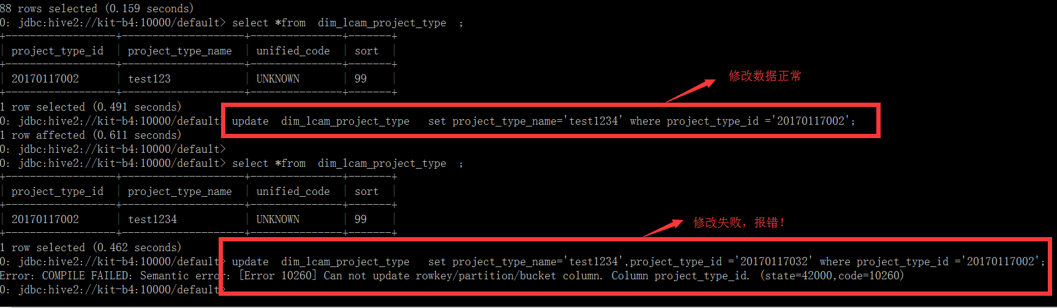

Kafka的消费入库hive先告一段落,接下来测试关联查询！

遍历kafka消息后入库不同的表：

设计思路：

目前已实现了表的增删改查操作，目前在入库之前需要做关联对比操作！

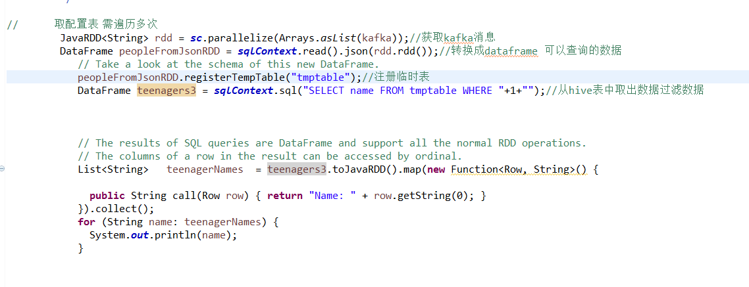

步骤1： 根据表名 取出需过滤的条件

步骤2： 封装json为rdd

步骤3：注册临时表

步骤4： 获取集合数据

步骤5 遍历数据

步骤6 如果匹配相关规则 则入库 没有数据则过滤掉

Rule :

select *from kitdev.rule_cfg

rule_id | rule_name | rule_desc | rule_type | rule_sql | system_name | table_name | column_name | rule_status

过滤sql：

select rule_sql from kitdev.rule_cfg where table_name=’’;

get the result:

Row[] lengths = jdbcDF.collect();

**for** (Row row : lengths) {

System.***out***.println(row.get(0));

}

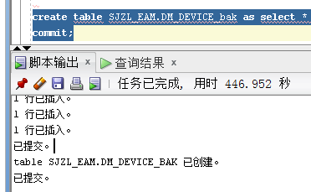

-----------------------------------------------------------------------------------+

| CREATE TABLE kitdev.rule_cfg( |

| rule_id string DEFAULT NULL COMMENT ' ', |

| rule_code string DEFAULT NULL COMMENT ' ', |

| rule_name string DEFAULT NULL COMMENT ' ', |

| rule_desc string DEFAULT NULL COMMENT ' ', |

| rule_type string DEFAULT NULL COMMENT ' ', |

| rule_range_col_name string DEFAULT NULL COMMENT ' ', |

| rule_range_col_value string DEFAULT NULL COMMENT ' ', |

| rule_status string DEFAULT NULL COMMENT ' ', |

| src_sys_code string DEFAULT NULL COMMENT ' ', |

| table_name string DEFAULT NULL COMMENT ' ', |

| col_name string DEFAULT NULL COMMENT ' ', |

| rule_sql string DEFAULT NULL COMMENT ' ' |

| )

修改后的代码为：

1. 根据表名获取cols字段
2. 根据cols字段获取kafka过来的值
3. 根据表名以及步骤2获取的kafka的值 获取rule sql 进行

--------------------------------------------------------------------------------------------------+

| CREATE TABLE RULE_CHECK_RESULT_TODAY( |

| rule_id string DEFAULT NULL COMMENT ' ', |

| table_name string DEFAULT NULL COMMENT ' ', |

| table_pk_value string DEFAULT NULL COMMENT ' ', |

| rule_check_time string DEFAULT NULL COMMENT ' ', |

| check_result string DEFAULT NULL COMMENT ' ' |

| )

DM_A_TRANSFORMER

SJZL_EAM.DM_A_BREAKER;

Q1:

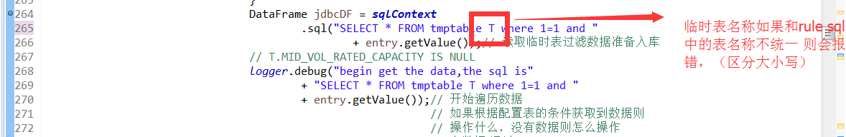

org.apache.spark.sql.AnalysisException: cannot resolve 'T.MID_VOL_RATED_CAPACITY' given input columns INDUSTRIAL_CAPACITY, HIGH_VOLTAGE_BOX_GAS, RATED_PRESSURE, HIGH_VOL_RATED_CAPACITY, ENVELOP_MODE, UPPER_OIL_BOX_WEIGHT, PROVINCE_CODE, MID_LOW_IMPEDANCE_VL, EQUIPMENT_TYPE, LINE_NAME, RESIDENTIAL_CAPACITY, TAP_AREA, CUSTOMER_NO, IMPEDANCE_VOLTAGE, DYRCP, TRANSFORMER_NO, HIGN_LOW_IMPE_VL_RATED, OIL_BOX_AIRPROOF_MODE, BURIED_DIMENSIONS, WIDING_COUNT, LATITUDE, ADJUST_TYPE, WINDING_TEMP_ALARM_VALUE, HIGN_VOL_RATED_LITTLE_SCC, NATURE_OF_ELE_CONSUMED, COMMERCIAL_CAPACITY, HIGN_MID_IMPE_VL_MIN, LONGITUDE, HIGHT_MID_LOAD_WASTAGE, BUREAU_CODE, MID_VOL_RATED_LITTLE_SCC, MACHINE_WEIGHT, LOW_VOL_RATED_LITTLE_SCC, PHASES, BULK_GAS, HIGN_MID_IMPE_VL_RATED, OIL_MANUFACTURER, MID_LOW_LOAD_WASTAGE, WINDING_MATERIAL, NON_INDUSTRIAL_CAPACITY, OLTC_GAS, NO_LOAD_WASTAGE, IS_STANDBY_PHASE, RATED_VOLTAGE, NEUTRAL_GROUN_MODE, MID_VOL_RATED_CAPACITY, HIGH_VOL_RATED_CURRENT, RATED_CAPACITY, FARMLAND_CAPACITY, LINE_NO, LOAD_LOSS, IRON_CORE_MODE, NO_LOAD_CURRENT, DATA_FROM, TRAFFIC_WEIGHT, COOLING_SYSTEM_GAS, HIGHT_LOW_LOAD_WASTAGE, ID, UPDATE_TIME, STANDARD_CODE, LOW_VOL_RATED_CURRENT, RATED_VOLTAGE_RATIO, OPTIMISTIC_LOCK_VERSION, CUSTOMER_NAME, HIGN_LOW_IMPE_VL_MAX, TAP_POSITION, INSTALLATION_TYPE, TIE_LINE_GROUP, OIL_TEMP_ALARM_VALUE, INSULATION_LEVEL, TYPE, OIL_MARK, OIL_WEIGHT, INSULATION_CORROSION_LEVEL, YAWP_VALUE, LOW_VOL_RATED_CAPACITY, HIGN_MID_IMPE_VL_MAX, HIGN_LOW_IMPE_VL_MIN, MID_VOL_RATED_CURRENT, ZERO_SEQ_IMPEDANCE, COOLING_MODE, TOTAL_WEIGHT;

Q2:

在做数据过滤的时候，做规则匹配的时候 ，发现有些函数在spark中识别不了，会报错：

自定义函数：

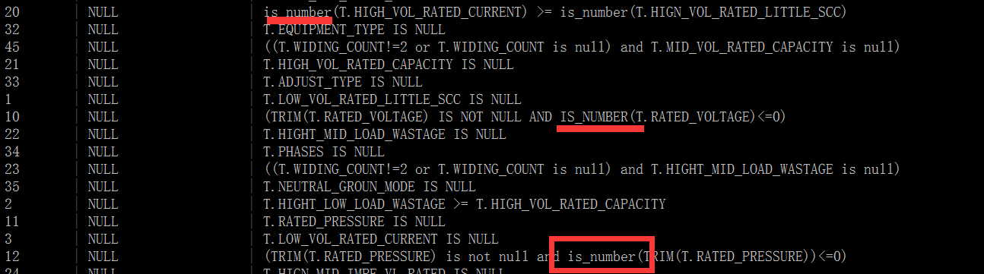

org.apache.spark.sql.AnalysisException: undefined function IS_NUMBER;

结果表：RULE_CHECK_RESULT_TODAY

// sqlContext.sql(sql);

// jdbcDF.toDF().insertInto("tableName");这两种都是数据入库的操作方式 年后回来进行测试 部署到集群

Todolist： 1 反馈自定义函数问题给辉哥 以及临时表的大小写问题

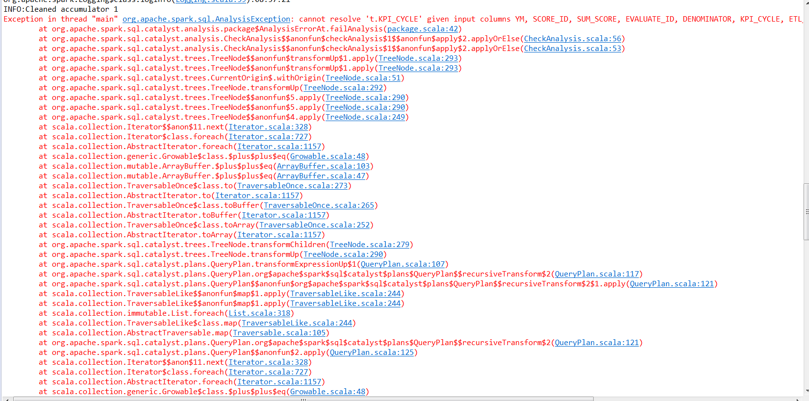

2 测试spark sql方式 而不是重复的连接hive数据库

验证临时表的rdd对象与真正的的hive表 是否需要与字段匹配

worldBankDf.toDF().~~insertInto~~("tableName");

批量测试语句：

declare

begin

for i in 1 .. 5 loop

insert into SM_PRIV_MENU_USER

(ID, EIPID, MENU_ID, UPD_USER, UPD_DATE, CRT_USER, CRT_DATE)

select to_number('99998'||i), EIPID, MENU_ID, UPD_USER, UPD_DATE, CRT_USER, CRT_DATE from SM_PRIV_MENU_USER t where rownum = 1;

commit;

end loop;

end;

规则表相关：批量添加

declare

begin

for i in 1 .. 50 loop

insert into DM_A_TRANSFORMER

(ID,BUREAU_CODE,TYPE,HIGN_LOW_IMPE_VL_MAX,HIGN_LOW_IMPE_VL_RATED,HIGN_LOW_IMPE_VL_MIN,HIGN_MID_IMPE_VL_MAX,HIGN_MID_IMPE_VL_RATED,HIGN_MID_IMPE_VL_MIN,MID_LOW_IMPEDANCE_VL,NO_LOAD_WASTAGE,NO_LOAD_CURRENT,ZERO_SEQ_IMPEDANCE,MID_VOL_RATED_LITTLE_SCC,LOW_VOL_RATED_LITTLE_SCC,OIL_WEIGHT,OIL_MARK,TRAFFIC_WEIGHT,UPPER_OIL_BOX_WEIGHT,MACHINE_WEIGHT,TOTAL_WEIGHT,OIL_MANUFACTURER,OIL_TEMP_ALARM_VALUE,WINDING_TEMP_ALARM_VALUE,RATED_VOLTAGE,ADJUST_TYPE,RATED_VOLTAGE_RATIO,COOLING_MODE,HIGH_VOL_RATED_CAPACITY,HIGH_VOL_RATED_CURRENT,MID_VOL_RATED_CAPACITY,MID_VOL_RATED_CURRENT,LOW_VOL_RATED_CAPACITY,LOW_VOL_RATED_CURRENT,TIE_LINE_GROUP,INSULATION_LEVEL,STANDARD_CODE,HIGHT_LOW_LOAD_WASTAGE,HIGHT_MID_LOAD_WASTAGE,MID_LOW_LOAD_WASTAGE,PHASES,DYRCP,WIDING_COUNT,IRON_CORE_MODE,WINDING_MATERIAL,INSULATION_CORROSION_LEVEL,OIL_BOX_AIRPROOF_MODE,YAWP_VALUE,ENVELOP_MODE,INSTALLATION_TYPE,TAP_POSITION,TAP_AREA,HIGN_VOL_RATED_LITTLE_SCC,CUSTOMER_NO,CUSTOMER_NAME,TRANSFORMER_NO,LINE_NO,LINE_NAME,LATITUDE,LONGITUDE,BURIED_DIMENSIONS,NATURE_OF_ELE_CONSUMED,RESIDENTIAL_CAPACITY,COMMERCIAL_CAPACITY,INDUSTRIAL_CAPACITY,NON_INDUSTRIAL_CAPACITY,FARMLAND_CAPACITY,BULK_GAS,RATED_PRESSURE,RATED_CAPACITY,LOAD_LOSS,HIGH_VOLTAGE_BOX_GAS,COOLING_SYSTEM_GAS,EQUIPMENT_TYPE,IS_STANDBY_PHASE,OLTC_GAS,NEUTRAL_GROUN_MODE,IMPEDANCE_VOLTAGE,OPTIMISTIC_LOCK_VERSION,UPDATE_TIME,DATA_FROM,PROVINCE_CODE)

select to_number('20170208002'||i), BUREAU_CODE,TYPE,HIGN_LOW_IMPE_VL_MAX,HIGN_LOW_IMPE_VL_RATED,HIGN_LOW_IMPE_VL_MIN,HIGN_MID_IMPE_VL_MAX,HIGN_MID_IMPE_VL_RATED,HIGN_MID_IMPE_VL_MIN,MID_LOW_IMPEDANCE_VL,NO_LOAD_WASTAGE,NO_LOAD_CURRENT,ZERO_SEQ_IMPEDANCE,MID_VOL_RATED_LITTLE_SCC,LOW_VOL_RATED_LITTLE_SCC,OIL_WEIGHT,OIL_MARK,TRAFFIC_WEIGHT,UPPER_OIL_BOX_WEIGHT,MACHINE_WEIGHT,TOTAL_WEIGHT,OIL_MANUFACTURER,OIL_TEMP_ALARM_VALUE,WINDING_TEMP_ALARM_VALUE,RATED_VOLTAGE,ADJUST_TYPE,RATED_VOLTAGE_RATIO,COOLING_MODE,HIGH_VOL_RATED_CAPACITY,HIGH_VOL_RATED_CURRENT,MID_VOL_RATED_CAPACITY,MID_VOL_RATED_CURRENT,LOW_VOL_RATED_CAPACITY,LOW_VOL_RATED_CURRENT,TIE_LINE_GROUP,INSULATION_LEVEL,STANDARD_CODE,HIGHT_LOW_LOAD_WASTAGE,HIGHT_MID_LOAD_WASTAGE,MID_LOW_LOAD_WASTAGE,PHASES,DYRCP,WIDING_COUNT,IRON_CORE_MODE,WINDING_MATERIAL,INSULATION_CORROSION_LEVEL,OIL_BOX_AIRPROOF_MODE,YAWP_VALUE,ENVELOP_MODE,INSTALLATION_TYPE,TAP_POSITION,TAP_AREA,HIGN_VOL_RATED_LITTLE_SCC,CUSTOMER_NO,CUSTOMER_NAME,TRANSFORMER_NO,LINE_NO,LINE_NAME,LATITUDE,LONGITUDE,BURIED_DIMENSIONS,NATURE_OF_ELE_CONSUMED,RESIDENTIAL_CAPACITY,COMMERCIAL_CAPACITY,INDUSTRIAL_CAPACITY,NON_INDUSTRIAL_CAPACITY,FARMLAND_CAPACITY,BULK_GAS,RATED_PRESSURE,RATED_CAPACITY,LOAD_LOSS,HIGH_VOLTAGE_BOX_GAS,COOLING_SYSTEM_GAS,EQUIPMENT_TYPE,IS_STANDBY_PHASE,OLTC_GAS,NEUTRAL_GROUN_MODE,IMPEDANCE_VOLTAGE,OPTIMISTIC_LOCK_VERSION,UPDATE_TIME,DATA_FROM,PROVINCE_CODE from DM_A_TRANSFORMER t where rownum = 1;

commit;

end loop;

end;

2017-02-09 报错日志:

ERROR:Error opening session

org.apache.thrift.TApplicationException: Required field 'client_protocol' is unset! Struct:TOpenSessionReq(client_protocol:null, configuration:{use:database=default})

at org.apache.thrift.TApplicationException.read(TApplicationException.java:111)

at org.apache.thrift.TServiceClient.receiveBase(TServiceClient.java:71)

at org.apache.hive.service.cli.thrift.TCLIService$Client.recv_OpenSession(TCLIService.java:156)

at org.apache.hive.service.cli.thrift.TCLIService$Client.OpenSession(TCLIService.java:143)

at org.apache.hive.jdbc.HiveConnection.openSession(HiveConnection.java:583)

at org.apache.hive.jdbc.HiveConnection.<init>(HiveConnection.java:192)

at org.apache.hive.jdbc.HiveDriver.connect(HiveDriver.java:105)

at java.sql.DriverManager.getConnection(DriverManager.java:664)

at java.sql.DriverManager.getConnection(DriverManager.java:247)

at com.kit.JDBCUtils.getConnection(JDBCUtils.java:50)

at com.kit.KfkToHiveFilter.getRULE_RANGE_COL_NAME_Set(KfkToHiveFilter.java:915)

at com.kit.KfkToHiveFilter.checkData(KfkToHiveFilter.java:217)

at com.kit.KfkToHiveFilter.access$2(KfkToHiveFilter.java:148)

at com.kit.KfkToHiveFilter$1$1.call(KfkToHiveFilter.java:135)

at com.kit.KfkToHiveFilter$1$1.call(KfkToHiveFilter.java:1)

at org.apache.spark.api.java.JavaRDDLike$$anonfun$foreach$1.apply(JavaRDDLike.scala:330)

at org.apache.spark.api.java.JavaRDDLike$$anonfun$foreach$1.apply(JavaRDDLike.scala:330)

at scala.collection.Iterator$class.foreach(Iterator.scala:727)

at org.apache.spark.util.NextIterator.foreach(NextIterator.scala:21)

at org.apache.spark.rdd.RDD$$anonfun$foreach$1$$anonfun$apply$28.apply(RDD.scala:890)

at org.apache.spark.rdd.RDD$$anonfun$foreach$1$$anonfun$apply$28.apply(RDD.scala:890)

at org.apache.spark.SparkContext$$anonfun$runJob$5.apply(SparkContext.scala:1850)

at org.apache.spark.SparkContext$$anonfun$runJob$5.apply(SparkContext.scala:1850)

at org.apache.spark.scheduler.ResultTask.runTask(ResultTask.scala:66)

at org.apache.spark.scheduler.Task.run(Task.scala:88)

at org.apache.spark.executor.Executor$TaskRunner.run(Executor.scala:214)

at java.util.concurrent.ThreadPoolExecutor.runWorker(ThreadPoolExecutor.java:1142)

at java.util.concurrent.ThreadPoolExecutor$Worker.run(ThreadPoolExecutor.java:617)

at java.lang.Thread.run(Thread.java:745)

java.sql.SQLException: Could not establish connection to jdbc:hive2://172.16.19.154:10000/default: Required field 'client_protocol' is unset! Struct:TOpenSessionReq(client_protocol:null, configuration:{use:database=default})

at org.apache.hive.jdbc.HiveConnection.openSession(HiveConnection.java:594)

at org.apache.hive.jdbc.HiveConnection.<init>(HiveConnection.java:192)

at org.apache.hive.jdbc.HiveDriver.connect(HiveDriver.java:105)

at java.sql.DriverManager.getConnection(DriverManager.java:664)

at java.sql.DriverManager.getConnection(DriverManager.java:247)

at com.kit.JDBCUtils.getConnection(JDBCUtils.java:50)

at com.kit.KfkToHiveFilter.getRULE_RANGE_COL_NAME_Set(KfkToHiveFilter.java:915)

at com.kit.KfkToHiveFilter.checkData(KfkToHiveFilter.java:217)

at com.kit.KfkToHiveFilter.access$2(KfkToHiveFilter.java:148)

at com.kit.KfkToHiveFilter$1$1.call(KfkToHiveFilter.java:135)

at com.kit.KfkToHiveFilter$1$1.call(KfkToHiveFilter.java:1)

at org.apache.spark.api.java.JavaRDDLike$$anonfun$foreach$1.apply(JavaRDDLike.scala:330)

at org.apache.spark.api.java.JavaRDDLike$$anonfun$foreach$1.apply(JavaRDDLike.scala:330)

at scala.collection.Iterator$class.foreach(Iterator.scala:727)

at org.apache.spark.util.NextIterator.foreach(NextIterator.scala:21)

at org.apache.spark.rdd.RDD$$anonfun$foreach$1$$anonfun$apply$28.apply(RDD.scala:890)

at org.apache.spark.rdd.RDD$$anonfun$foreach$1$$anonfun$apply$28.apply(RDD.scala:890)

at org.apache.spark.SparkContext$$anonfun$runJob$5.apply(SparkContext.scala:1850)

at org.apache.spark.SparkContext$$anonfun$runJob$5.apply(SparkContext.scala:1850)

at org.apache.spark.scheduler.ResultTask.runTask(ResultTask.scala:66)

at org.apache.spark.scheduler.Task.run(Task.scala:88)

at org.apache.spark.executor.Executor$TaskRunner.run(Executor.scala:214)

at java.util.concurrent.ThreadPoolExecutor.runWorker(ThreadPoolExecutor.java:1142)

at java.util.concurrent.ThreadPoolExecutor$Worker.run(ThreadPoolExecutor.java:617)

at java.lang.Thread.run(Thread.java:745)

Caused by: org.apache.thrift.TApplicationException: Required field 'client_protocol' is unset! Struct:TOpenSessionReq(client_protocol:null, configuration:{use:database=default})

at org.apache.thrift.TApplicationException.read(TApplicationException.java:111)

at org.apache.thrift.TServiceClient.receiveBase(TServiceClient.java:71)

at org.apache.hive.service.cli.thrift.TCLIService$Client.recv_OpenSession(TCLIService.java:156)

at org.apache.hive.service.cli.thrift.TCLIService$Client.OpenSession(TCLIService.java:143)

at org.apache.hive.jdbc.HiveConnection.openSession(HiveConnection.java:583)

... 24 more

org.apache.spark.Logging$class.logError(Logging.scala:96):10:07:42

ERROR:Exception in task 5.0 in stage 317.0 (TID 2858)

java.lang.NullPointerException

at com.kit.KfkToHiveFilter.getRULE_RANGE_COL_NAME_Set(KfkToHiveFilter.java:917)

at com.kit.KfkToHiveFilter.checkData(KfkToHiveFilter.java:217)

at com.kit.KfkToHiveFilter.access$2(KfkToHiveFilter.java:148)

at com.kit.KfkToHiveFilter$1$1.call(KfkToHiveFilter.java:135)

at com.kit.KfkToHiveFilter$1$1.call(KfkToHiveFilter.java:1)

at org.apache.spark.api.java.JavaRDDLike$$anonfun$foreach$1.apply(JavaRDDLike.scala:330)

at org.apache.spark.api.java.JavaRDDLike$$anonfun$foreach$1.apply(JavaRDDLike.scala:330)

at scala.collection.Iterator$class.foreach(Iterator.scala:727)

at org.apache.spark.util.NextIterator.foreach(NextIterator.scala:21)

at org.apache.spark.rdd.RDD$$anonfun$foreach$1$$anonfun$apply$28.apply(RDD.scala:890)

at org.apache.spark.rdd.RDD$$anonfun$foreach$1$$anonfun$apply$28.apply(RDD.scala:890)

at org.apache.spark.SparkContext$$anonfun$runJob$5.apply(SparkContext.scala:1850)

at org.apache.spark.SparkContext$$anonfun$runJob$5.apply(SparkContext.scala:1850)

at org.apache.spark.scheduler.ResultTask.runTask(ResultTask.scala:66)

at org.apache.spark.scheduler.Task.run(Task.scala:88)

at org.apache.spark.executor.Executor$TaskRunner.run(Executor.scala:214)

at java.util.concurrent.ThreadPoolExecutor.runWorker(ThreadPoolExecutor.java:1142)

at java.util.concurrent.ThreadPoolExecutor$Worker.run(ThreadPoolExecutor.java:617)

at java.lang.Thread.run(Thread.java:745)

org.apache.spark.Logging$class.logWarning(Logging.scala:71):10:07:42

WARN:Lost task 5.0 in stage 317.0 (TID 2858, localhost): java.lang.NullPointerException

at com.kit.KfkToHiveFilter.getRULE_RANGE_COL_NAME_Set(KfkToHiveFilter.java:917)

at com.kit.KfkToHiveFilter.checkData(KfkToHiveFilter.java:217)

at com.kit.KfkToHiveFilter.access$2(KfkToHiveFilter.java:148)

at com.kit.KfkToHiveFilter$1$1.call(KfkToHiveFilter.java:135)

at com.kit.KfkToHiveFilter$1$1.call(KfkToHiveFilter.java:1)

at org.apache.spark.api.java.JavaRDDLike$$anonfun$foreach$1.apply(JavaRDDLike.scala:330)

at org.apache.spark.api.java.JavaRDDLike$$anonfun$foreach$1.apply(JavaRDDLike.scala:330)

at scala.collection.Iterator$class.foreach(Iterator.scala:727)

at org.apache.spark.util.NextIterator.foreach(NextIterator.scala:21)

at org.apache.spark.rdd.RDD$$anonfun$foreach$1$$anonfun$apply$28.apply(RDD.scala:890)

at org.apache.spark.rdd.RDD$$anonfun$foreach$1$$anonfun$apply$28.apply(RDD.scala:890)

at org.apache.spark.SparkContext$$anonfun$runJob$5.apply(SparkContext.scala:1850)

at org.apache.spark.SparkContext$$anonfun$runJob$5.apply(SparkContext.scala:1850)

at org.apache.spark.scheduler.ResultTask.runTask(ResultTask.scala:66)

at org.apache.spark.scheduler.Task.run(Task.scala:88)

at org.apache.spark.executor.Executor$TaskRunner.run(Executor.scala:214)

at java.util.concurrent.ThreadPoolExecutor.runWorker(ThreadPoolExecutor.java:1142)

at java.util.concurrent.ThreadPoolExecutor$Worker.run(ThreadPoolExecutor.java:617)

at java.lang.Thread.run(Thread.java:745)

org.apache.spark.Logging$class.logError(Logging.scala:75):10:07:42

G_DM_FUNCTION_LOCATION

备份：

create table G_DM_FUNCTION_LOCATION_bak as select * from G_DM_FUNCTION_LOCATION ;

commit;

insert into G_DM_FUNCTION_LOCATION

(ID,CLASSIFY_ID,FL_NAME,FL_TYPE,RUNNING_STATE,BASE_VOLTAGE_ID,OWNER_STATION,SITE_ID,SITE_NAME,FEEDER_ID,ASSETS_PROPERTY,LINE_FUNCTION,AREA_FEATURE,XFMR_TYPE,LATITUDE,LONGITUDE,POWER_GRID_FLAG,IS_DEDICATEDLINE,DISPATCH_NO,RUN_DATE,POLE_ID,SRC_ID,OH_LENGTH,CABLE_LENGTH,LINE_CATEGORY_CODE,USER_CODE,PARENT_ID,MAIN_LINE,P_CODE,C_CODE,B_CODE,D_CODE,FULL_PATH)

select to_number('20170215003'||2),CLASSIFY_ID,FL_NAME,FL_TYPE,RUNNING_STATE,BASE_VOLTAGE_ID,OWNER_STATION,SITE_ID,SITE_NAME,FEEDER_ID,ASSETS_PROPERTY,LINE_FUNCTION,AREA_FEATURE,XFMR_TYPE,LATITUDE,LONGITUDE,POWER_GRID_FLAG,IS_DEDICATEDLINE,DISPATCH_NO,RUN_DATE,POLE_ID,SRC_ID,OH_LENGTH,CABLE_LENGTH,LINE_CATEGORY_CODE,USER_CODE,PARENT_ID,MAIN_LINE,P_CODE,C_CODE,B_CODE,D_CODE,FULL_PATH

from G_DM_FUNCTION_LOCATION t where rownum = 1;

commit;

错误异常：

java.lang.RuntimeException: [2.10] failure: ``)'' expected but 1 found

(select 1

^