# 一：Mapreduce测试场景：

管理界面已添加kitdev与kittest9用户,kit-b1(建立了kitdev账户) kit-b4(建立了kitdev kittest9账户)

## 执行脚本：打印pi值

hadoop jar /usr/lib/hadoop-mapreduce/hadoop-mapreduce-examples-2.5.2-transwarp-tdh460.jar pi 10 100

## 测试场景1：kit-b1,Kdestroy 后，执行异常

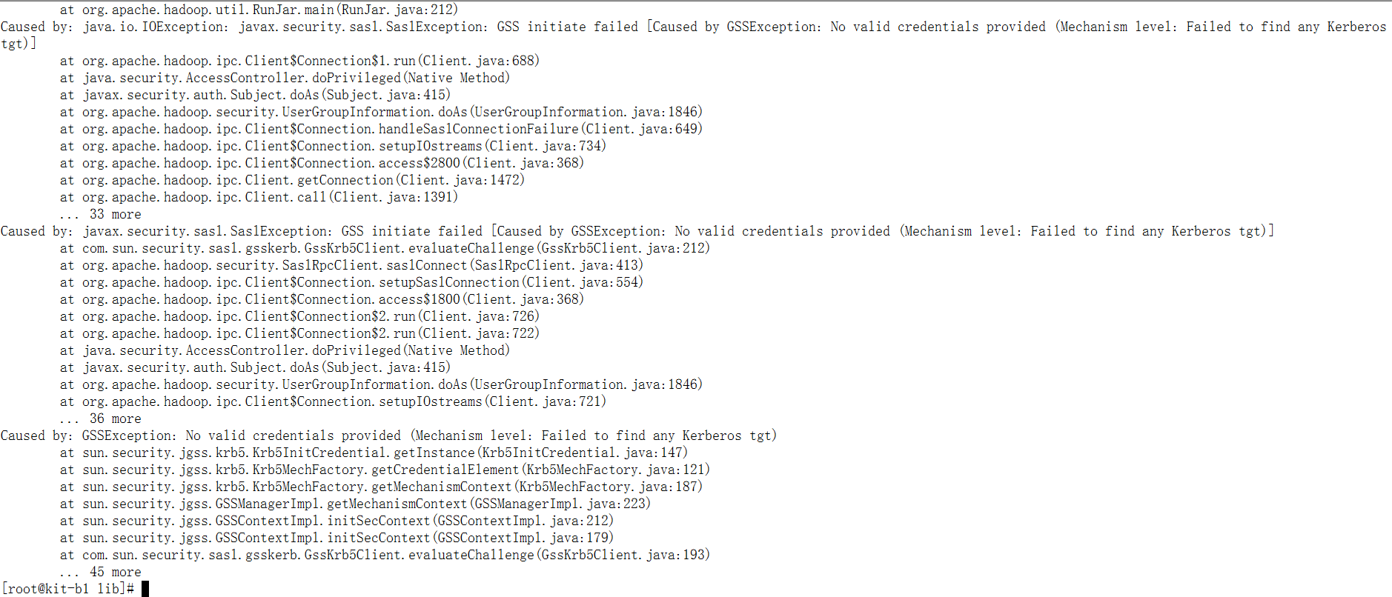

## 测试场景2：kit-b1,Kinit kitdev后，正常执行

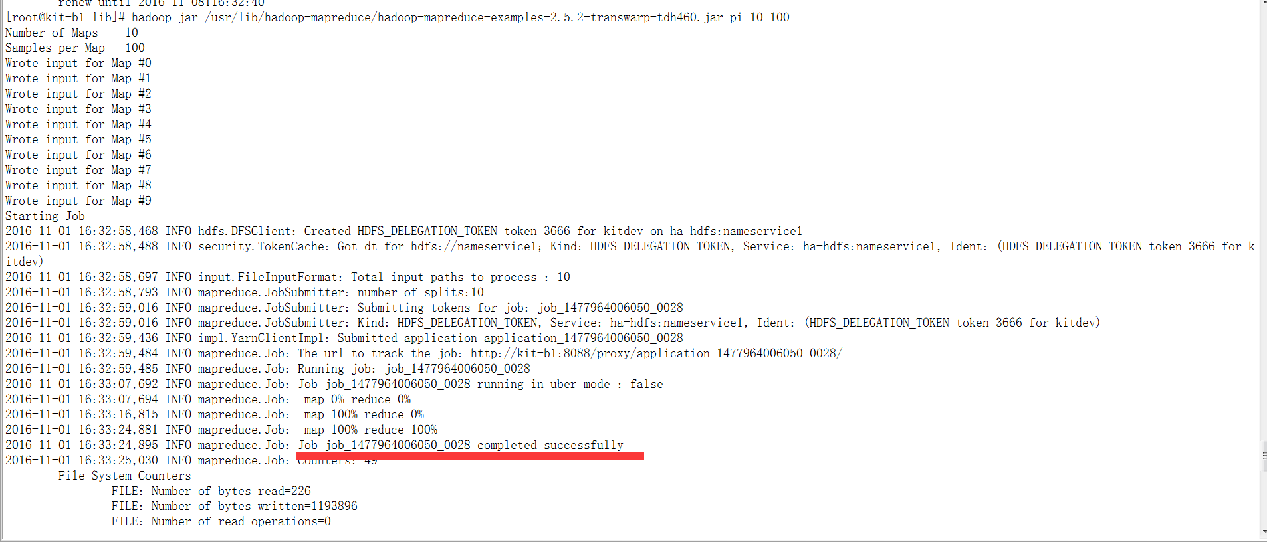

## 测试场景3：kit-b1,Kinit kittest9后,执行异常

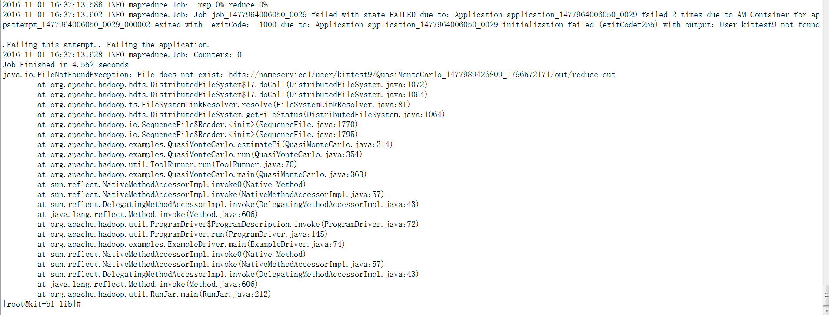

## 测试场景4：Kit-b4,Kdestroy后，执行异常

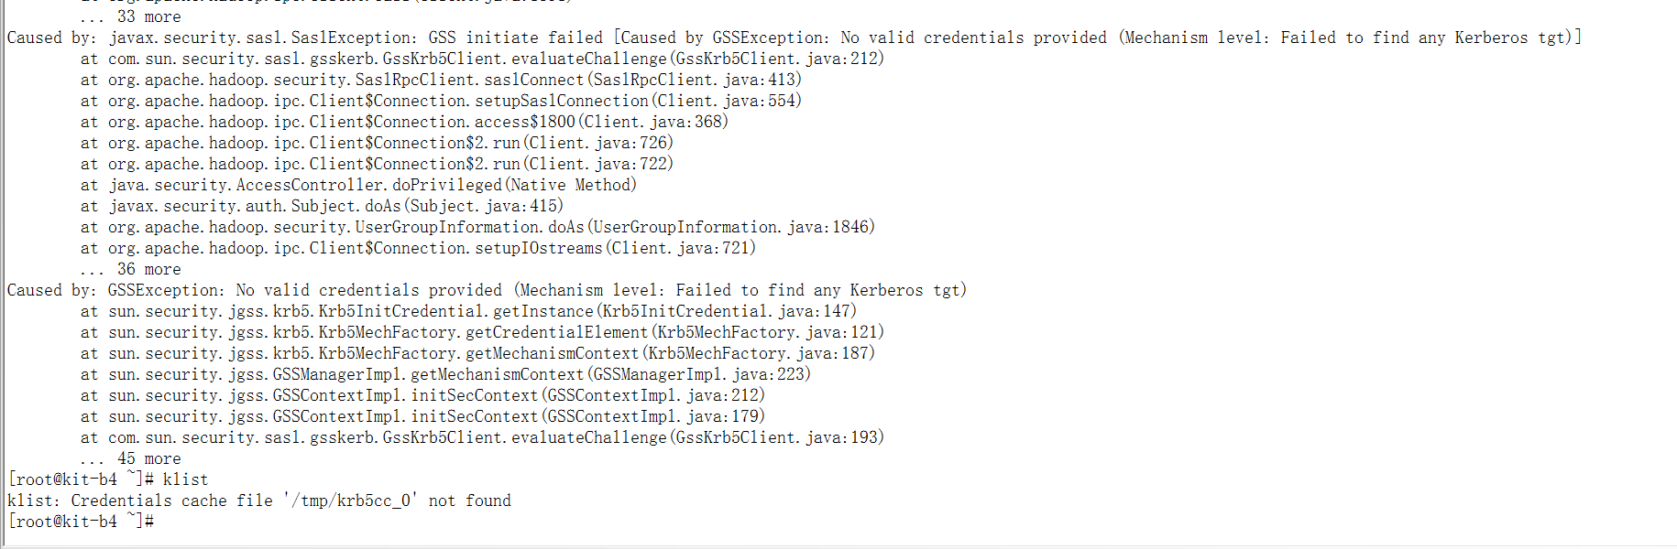

## 测试场景5：Kit-b4,Kinit kitdev后，执行正常

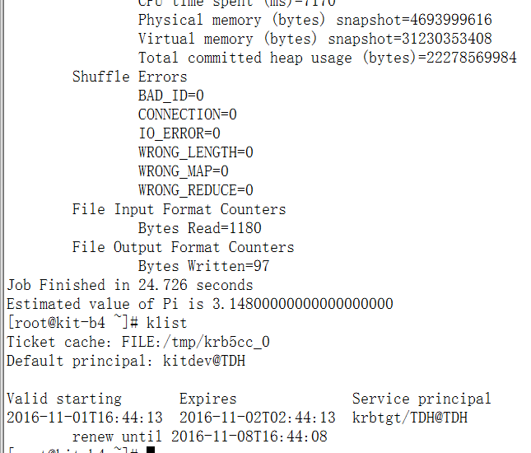

## 测试场景6：Kit-b4,Kinit kittest9后，执行异常:

[root@kit-b4 ~]# hadoop jar /usr/lib/hadoop-mapreduce/hadoop-mapreduce-examples-2.5.2-transwarp-tdh460.jar pi 10 100

Number of Maps = 10

Samples per Map = 100

Wrote input for Map #0

Wrote input for Map #1

Wrote input for Map #2

Wrote input for Map #3

Wrote input for Map #4

Wrote input for Map #5

Wrote input for Map #6

Wrote input for Map #7

Wrote input for Map #8

Wrote input for Map #9

Starting Job

2016-11-01 16:47:50,391 INFO hdfs.DFSClient: Created HDFS_DELEGATION_TOKEN token 3670 for kittest9 on ha-hdfs:nameservice1

2016-11-01 16:47:50,412 INFO security.TokenCache: Got dt for hdfs://nameservice1; Kind: HDFS_DELEGATION_TOKEN, Service: ha-hdfs:nameservice1, Ident: (HDFS_DELEGATION_TOKEN token 3670 for kittest9)

2016-11-01 16:47:50,659 INFO input.FileInputFormat: Total input paths to process : 10

2016-11-01 16:47:50,759 INFO mapreduce.JobSubmitter: number of splits:10

2016-11-01 16:47:50,994 INFO mapreduce.JobSubmitter: Submitting tokens for job: job_1477964006050_0032

2016-11-01 16:47:50,994 INFO mapreduce.JobSubmitter: Kind: HDFS_DELEGATION_TOKEN, Service: ha-hdfs:nameservice1, Ident: (HDFS_DELEGATION_TOKEN token 3670 for kittest9)

2016-11-01 16:47:51,476 INFO impl.YarnClientImpl: Submitted application application_1477964006050_0032

2016-11-01 16:47:51,522 INFO mapreduce.Job: The url to track the job: http://kit-b1:8088/proxy/application_1477964006050_0032/

2016-11-01 16:47:51,523 INFO mapreduce.Job: Running job: job_1477964006050_0032

2016-11-01 16:47:59,758 INFO mapreduce.Job: Job job_1477964006050_0032 running in uber mode : false

2016-11-01 16:47:59,761 INFO mapreduce.Job: map 0% reduce 0%

2016-11-01 16:48:02,821 INFO mapreduce.Job: Task Id : attempt_1477964006050_0032_m_000004_0, Status : FAILED

Application application_1477964006050_0032 initialization failed (exitCode=255) with output: User kittest9 not found

2016-11-01 16:48:02,842 INFO mapreduce.Job: Task Id : attempt_1477964006050_0032_m_000005_0, Status : FAILED

Application application_1477964006050_0032 initialization failed (exitCode=255) with output: User kittest9 not found

2016-11-01 16:48:02,844 INFO mapreduce.Job: Task Id : attempt_1477964006050_0032_m_000001_0, Status : FAILED

Application application_1477964006050_0032 initialization failed (exitCode=255) with output: User kittest9 not found

2016-11-01 16:48:02,846 INFO mapreduce.Job: Task Id : attempt_1477964006050_0032_m_000000_0, Status : FAILED

Application application_1477964006050_0032 initialization failed (exitCode=255) with output: User kittest9 not found

2016-11-01 16:48:02,848 INFO mapreduce.Job: Task Id : attempt_1477964006050_0032_m_000002_0, Status : FAILED

Application application_1477964006050_0032 initialization failed (exitCode=255) with output: User kittest9 not found

2016-11-01 16:48:02,850 INFO mapreduce.Job: Task Id : attempt_1477964006050_0032_m_000008_0, Status : FAILED

Application application_1477964006050_0032 initialization failed (exitCode=255) with output: User kittest9 not found

2016-11-01 16:48:02,852 INFO mapreduce.Job: Task Id : attempt_1477964006050_0032_m_000009_0, Status : FAILED

Application application_1477964006050_0032 initialization failed (exitCode=255) with output: User kittest9 not found

2016-11-01 16:48:02,854 INFO mapreduce.Job: Task Id : attempt_1477964006050_0032_m_000007_0, Status : FAILED

Application application_1477964006050_0032 initialization failed (exitCode=255) with output: User kittest9 not found

2016-11-01 16:48:02,856 INFO mapreduce.Job: Task Id : attempt_1477964006050_0032_m_000003_0, Status : FAILED

Application application_1477964006050_0032 initialization failed (exitCode=255) with output: User kittest9 not found

2016-11-01 16:48:02,858 INFO mapreduce.Job: Task Id : attempt_1477964006050_0032_m_000006_0, Status : FAILED

Application application_1477964006050_0032 initialization failed (exitCode=255) with output: User kittest9 not found

2016-11-01 16:48:05,886 INFO mapreduce.Job: Task Id : attempt_1477964006050_0032_m_000005_1, Status : FAILED

Application application_1477964006050_0032 initialization failed (exitCode=255) with output: User kittest9 not found

2016-11-01 16:48:05,887 INFO mapreduce.Job: Task Id : attempt_1477964006050_0032_m_000001_1, Status : FAILED

Application application_1477964006050_0032 initialization failed (exitCode=255) with output: User kittest9 not found

2016-11-01 16:48:06,897 INFO mapreduce.Job: Task Id : attempt_1477964006050_0032_m_000002_1, Status : FAILED

Application application_1477964006050_0032 initialization failed (exitCode=255) with output: User kittest9 not found

2016-11-01 16:48:06,898 INFO mapreduce.Job: Task Id : attempt_1477964006050_0032_m_000008_1, Status : FAILED

Application application_1477964006050_0032 initialization failed (exitCode=255) with output: User kittest9 not found

2016-11-01 16:48:07,907 INFO mapreduce.Job: Task Id : attempt_1477964006050_0032_m_000007_1, Status : FAILED

Application application_1477964006050_0032 initialization failed (exitCode=255) with output: User kittest9 not found

2016-11-01 16:48:07,909 INFO mapreduce.Job: Task Id : attempt_1477964006050_0032_m_000003_1, Status : FAILED

Application application_1477964006050_0032 initialization failed (exitCode=255) with output: User kittest9 not found

2016-11-01 16:48:08,919 INFO mapreduce.Job: Task Id : attempt_1477964006050_0032_m_000005_2, Status : FAILED

Application application_1477964006050_0032 initialization failed (exitCode=255) with output: User kittest9 not found

2016-11-01 16:48:08,921 INFO mapreduce.Job: Task Id : attempt_1477964006050_0032_m_000001_2, Status : FAILED

Application application_1477964006050_0032 initialization failed (exitCode=255) with output: User kittest9 not found

2016-11-01 16:48:09,929 INFO mapreduce.Job: Task Id : attempt_1477964006050_0032_m_000008_2, Status : FAILED

Application application_1477964006050_0032 initialization failed (exitCode=255) with output: User kittest9 not found

2016-11-01 16:48:09,931 INFO mapreduce.Job: Task Id : attempt_1477964006050_0032_m_000007_2, Status : FAILED

Application application_1477964006050_0032 initialization failed (exitCode=255) with output: User kittest9 not found

2016-11-01 16:48:12,955 INFO mapreduce.Job: map 100% reduce 100%

2016-11-01 16:48:12,970 INFO mapreduce.Job: Job job_1477964006050_0032 failed with state FAILED due to: Task failed task_1477964006050_0032_m_000001

Job failed as tasks failed. failedMaps:1 failedReduces:0

2016-11-01 16:48:13,090 INFO mapreduce.Job: Counters: 36

File System Counters

FILE: Number of bytes read=0

FILE: Number of bytes written=433184

FILE: Number of read operations=0

FILE: Number of large read operations=0

FILE: Number of write operations=0

HDFS: Number of bytes read=1060

HDFS: Number of bytes written=0

HDFS: Number of read operations=16

HDFS: Number of large read operations=0

HDFS: Number of write operations=0

Job Counters

Failed map tasks=22

Killed map tasks=4

Launched map tasks=30

Other local map tasks=20

Data-local map tasks=6

Rack-local map tasks=4

Total time spent by all maps in occupied slots (ms)=58650

Total time spent by all reduces in occupied slots (ms)=0

Total time spent by all map tasks (ms)=58650

Total vcore-seconds taken by all map tasks=58650

Total megabyte-seconds taken by all map tasks=60057600

Map-Reduce Framework

Map input records=4

Map output records=8

Map output bytes=72

Map output materialized bytes=112

Input split bytes=588

Combine input records=0

Spilled Records=8

Failed Shuffles=0

Merged Map outputs=0

GC time elapsed (ms)=0

CPU time spent (ms)=2560

Physical memory (bytes) snapshot=1738051584

Virtual memory (bytes) snapshot=11337773056

Total committed heap usage (bytes)=8101298176

File Input Format Counters

Bytes Read=472

Job Finished in 22.946 seconds

java.io.FileNotFoundException: File does not exist: hdfs://nameservice1/user/kittest9/QuasiMonteCarlo_1477990067921_928907711/out/reduce-out

at org.apache.hadoop.hdfs.DistributedFileSystem$17.doCall(DistributedFileSystem.java:1072)

at org.apache.hadoop.hdfs.DistributedFileSystem$17.doCall(DistributedFileSystem.java:1064)

at org.apache.hadoop.fs.FileSystemLinkResolver.resolve(FileSystemLinkResolver.java:81)

at org.apache.hadoop.hdfs.DistributedFileSystem.getFileStatus(DistributedFileSystem.java:1064)

at org.apache.hadoop.io.SequenceFile$Reader.<init>(SequenceFile.java:1770)

at org.apache.hadoop.io.SequenceFile$Reader.<init>(SequenceFile.java:1795)

at org.apache.hadoop.examples.QuasiMonteCarlo.estimatePi(QuasiMonteCarlo.java:314)

at org.apache.hadoop.examples.QuasiMonteCarlo.run(QuasiMonteCarlo.java:354)

at org.apache.hadoop.util.ToolRunner.run(ToolRunner.java:70)

at org.apache.hadoop.examples.QuasiMonteCarlo.main(QuasiMonteCarlo.java:363)

at sun.reflect.NativeMethodAccessorImpl.invoke0(Native Method)

at sun.reflect.NativeMethodAccessorImpl.invoke(NativeMethodAccessorImpl.java:57)

at sun.reflect.DelegatingMethodAccessorImpl.invoke(DelegatingMethodAccessorImpl.java:43)

at java.lang.reflect.Method.invoke(Method.java:606)

at org.apache.hadoop.util.ProgramDriver$ProgramDescription.invoke(ProgramDriver.java:72)

at org.apache.hadoop.util.ProgramDriver.run(ProgramDriver.java:145)

at org.apache.hadoop.examples.ExampleDriver.main(ExampleDriver.java:74)

at sun.reflect.NativeMethodAccessorImpl.invoke0(Native Method)

at sun.reflect.NativeMethodAccessorImpl.invoke(NativeMethodAccessorImpl.java:57)

at sun.reflect.DelegatingMethodAccessorImpl.invoke(DelegatingMethodAccessorImpl.java:43)

at java.lang.reflect.Method.invoke(Method.java:606)

at org.apache.hadoop.util.RunJar.main(RunJar.java:212)

## 测试场景7：Kit-b4,root账户切换到kittest9, Kinit kittest9后,执行异常

[kittest9@kit-b4 root]$ cd /usr/lib/discover/lib

[kittest9@kit-b4 lib]$ hadoop jar /usr/lib/hadoop-mapreduce/hadoop-mapreduce-examples-2.5.2-transwarp-tdh460.jar pi 10 100^C

[kittest9@kit-b4 lib]$ klist

Ticket cache: FILE:/tmp/krb5cc_505

Default principal: kittest9@TDH

Valid starting Expires Service principal

2016-11-01T15:48:10 2016-11-02T01:48:10 krbtgt/TDH@TDH

renew until 2016-11-08T15:48:06

[kittest9@kit-b4 lib]$ hadoop jar /usr/lib/hadoop-mapreduce/hadoop-mapreduce-examples-2.5.2-transwarp-tdh460.jar pi 10 100

Number of Maps = 10

Samples per Map = 100

Wrote input for Map #0

Wrote input for Map #1

Wrote input for Map #2

Wrote input for Map #3

Wrote input for Map #4

Wrote input for Map #5

Wrote input for Map #6

Wrote input for Map #7

Wrote input for Map #8

Wrote input for Map #9

Starting Job

2016-11-01 16:52:15,010 INFO hdfs.DFSClient: Created HDFS_DELEGATION_TOKEN token 3671 for kittest9 on ha-hdfs:nameservice1

2016-11-01 16:52:15,037 INFO security.TokenCache: Got dt for hdfs://nameservice1; Kind: HDFS_DELEGATION_TOKEN, Service: ha-hdfs:nameservice1, Ident: (HDFS_DELEGATION_TOKEN token 3671 for kittest9)

2016-11-01 16:52:15,304 INFO input.FileInputFormat: Total input paths to process : 10

2016-11-01 16:52:15,410 INFO mapreduce.JobSubmitter: number of splits:10

2016-11-01 16:52:15,643 INFO mapreduce.JobSubmitter: Submitting tokens for job: job_1477964006050_0033

2016-11-01 16:52:15,643 INFO mapreduce.JobSubmitter: Kind: HDFS_DELEGATION_TOKEN, Service: ha-hdfs:nameservice1, Ident: (HDFS_DELEGATION_TOKEN token 3671 for kittest9)

2016-11-01 16:52:16,129 INFO impl.YarnClientImpl: Submitted application application_1477964006050_0033

2016-11-01 16:52:16,173 INFO mapreduce.Job: The url to track the job: http://kit-b1:8088/proxy/application_1477964006050_0033/

2016-11-01 16:52:16,174 INFO mapreduce.Job: Running job: job_1477964006050_0033

2016-11-01 16:52:19,197 INFO mapreduce.Job: Job job_1477964006050_0033 running in uber mode : false

2016-11-01 16:52:19,198 INFO mapreduce.Job: map 0% reduce 0%

2016-11-01 16:52:19,214 INFO mapreduce.Job: Job job_1477964006050_0033 failed with state FAILED due to: Application application_1477964006050_0033 failed 2 times due to AM Container for appattempt_1477964006050_0033_000002 exited with exitCode: -1000 due to: Application application_1477964006050_0033 initialization failed (exitCode=255) with output: User kittest9 not found

.Failing this attempt.. Failing the application.

2016-11-01 16:52:19,239 INFO mapreduce.Job: Counters: 0

Job Finished in 4.493 seconds

java.io.FileNotFoundException: File does not exist: hdfs://nameservice1/user/kittest9/QuasiMonteCarlo_1477990332538_265455517/out/reduce-out

at org.apache.hadoop.hdfs.DistributedFileSystem$17.doCall(DistributedFileSystem.java:1072)

at org.apache.hadoop.hdfs.DistributedFileSystem$17.doCall(DistributedFileSystem.java:1064)

at org.apache.hadoop.fs.FileSystemLinkResolver.resolve(FileSystemLinkResolver.java:81)

at org.apache.hadoop.hdfs.DistributedFileSystem.getFileStatus(DistributedFileSystem.java:1064)

at org.apache.hadoop.io.SequenceFile$Reader.<init>(SequenceFile.java:1770)

at org.apache.hadoop.io.SequenceFile$Reader.<init>(SequenceFile.java:1795)

at org.apache.hadoop.examples.QuasiMonteCarlo.estimatePi(QuasiMonteCarlo.java:314)

at org.apache.hadoop.examples.QuasiMonteCarlo.run(QuasiMonteCarlo.java:354)

at org.apache.hadoop.util.ToolRunner.run(ToolRunner.java:70)

at org.apache.hadoop.examples.QuasiMonteCarlo.main(QuasiMonteCarlo.java:363)

at sun.reflect.NativeMethodAccessorImpl.invoke0(Native Method)

at sun.reflect.NativeMethodAccessorImpl.invoke(NativeMethodAccessorImpl.java:57)

at sun.reflect.DelegatingMethodAccessorImpl.invoke(DelegatingMethodAccessorImpl.java:43)

at java.lang.reflect.Method.invoke(Method.java:606)

at org.apache.hadoop.util.ProgramDriver$ProgramDescription.invoke(ProgramDriver.java:72)

at org.apache.hadoop.util.ProgramDriver.run(ProgramDriver.java:145)

at org.apache.hadoop.examples.ExampleDriver.main(ExampleDriver.java:74)

at sun.reflect.NativeMethodAccessorImpl.invoke0(Native Method)

at sun.reflect.NativeMethodAccessorImpl.invoke(NativeMethodAccessorImpl.java:57)

at sun.reflect.DelegatingMethodAccessorImpl.invoke(DelegatingMethodAccessorImpl.java:43)

at java.lang.reflect.Method.invoke(Method.java:606)

at org.apache.hadoop.util.RunJar.main(RunJar.java:212)

kinit kitdev后再次执行:

[kittest9@kit-b4 lib]$ kdestroy

[kittest9@kit-b4 lib]$ kinit kitdev

Password for kitdev@TDH:

[kittest9@kit-b4 lib]$ klist

Ticket cache: FILE:/tmp/krb5cc_505

Default principal: kitdev@TDH

Valid starting Expires Service principal

2016-11-01T16:53:29 2016-11-02T02:53:29 krbtgt/TDH@TDH

renew until 2016-11-08T16:53:23

[kittest9@kit-b4 lib]$ hadoop jar /usr/lib/hadoop-mapreduce/hadoop-mapreduce-examples-2.5.2-transwarp-tdh460.jar pi 10 100

Number of Maps = 10

Samples per Map = 100

Wrote input for Map #0

Wrote input for Map #1

Wrote input for Map #2

Wrote input for Map #3

Wrote input for Map #4

Wrote input for Map #5

Wrote input for Map #6

Wrote input for Map #7

Wrote input for Map #8

Wrote input for Map #9

Starting Job

2016-11-01 16:53:38,689 INFO hdfs.DFSClient: Created HDFS_DELEGATION_TOKEN token 3672 for kitdev on ha-hdfs:nameservice1

2016-11-01 16:53:38,711 INFO security.TokenCache: Got dt for hdfs://nameservice1; Kind: HDFS_DELEGATION_TOKEN, Service: ha-hdfs:nameservice1, Ident: (HDFS_DELEGATION_TOKEN token 3672 for kitdev)

2016-11-01 16:53:38,906 INFO input.FileInputFormat: Total input paths to process : 10

2016-11-01 16:53:38,990 INFO mapreduce.JobSubmitter: number of splits:10

2016-11-01 16:53:39,214 INFO mapreduce.JobSubmitter: Submitting tokens for job: job_1477964006050_0034

2016-11-01 16:53:39,214 INFO mapreduce.JobSubmitter: Kind: HDFS_DELEGATION_TOKEN, Service: ha-hdfs:nameservice1, Ident: (HDFS_DELEGATION_TOKEN token 3672 for kitdev)

2016-11-01 16:53:39,642 INFO impl.YarnClientImpl: Submitted application application_1477964006050_0034

2016-11-01 16:53:39,690 INFO mapreduce.Job: The url to track the job: http://kit-b1:8088/proxy/application_1477964006050_0034/

2016-11-01 16:53:39,691 INFO mapreduce.Job: Running job: job_1477964006050_0034

2016-11-01 16:53:47,893 INFO mapreduce.Job: Job job_1477964006050_0034 running in uber mode : false

2016-11-01 16:53:47,895 INFO mapreduce.Job: map 0% reduce 0%

2016-11-01 16:53:55,995 INFO mapreduce.Job: map 60% reduce 0%

2016-11-01 16:53:57,005 INFO mapreduce.Job: map 100% reduce 0%

2016-11-01 16:54:05,069 INFO mapreduce.Job: map 100% reduce 100%

2016-11-01 16:54:06,088 INFO mapreduce.Job: Job job_1477964006050_0034 completed successfully

2016-11-01 16:54:06,220 INFO mapreduce.Job: Counters: 50

File System Counters

FILE: Number of bytes read=226

FILE: Number of bytes written=1193122

FILE: Number of read operations=0

FILE: Number of large read operations=0

FILE: Number of write operations=0

HDFS: Number of bytes read=2640

HDFS: Number of bytes written=215

HDFS: Number of read operations=43

HDFS: Number of large read operations=0

HDFS: Number of write operations=3

Job Counters

Launched map tasks=10

Launched reduce tasks=1

Data-local map tasks=8

Rack-local map tasks=2

Total time spent by all maps in occupied slots (ms)=64108

Total time spent by all reduces in occupied slots (ms)=6536

Total time spent by all map tasks (ms)=64108

Total time spent by all reduce tasks (ms)=6536

Total vcore-seconds taken by all map tasks=64108

Total vcore-seconds taken by all reduce tasks=6536

Total megabyte-seconds taken by all map tasks=65646592

Total megabyte-seconds taken by all reduce tasks=6692864

Map-Reduce Framework

Map input records=10

Map output records=20

Map output bytes=180

Map output materialized bytes=280

Input split bytes=1460

Combine input records=0

Combine output records=0

Reduce input groups=2

Reduce shuffle bytes=280

Reduce input records=20

Reduce output records=0

Spilled Records=40

Shuffled Maps =10

Failed Shuffles=0

Merged Map outputs=10

GC time elapsed (ms)=0

CPU time spent (ms)=8050

Physical memory (bytes) snapshot=4702588928

Virtual memory (bytes) snapshot=31235399680

Total committed heap usage (bytes)=22278569984

Shuffle Errors

BAD_ID=0

CONNECTION=0

IO_ERROR=0

WRONG_LENGTH=0

WRONG_MAP=0

WRONG_REDUCE=0

File Input Format Counters

Bytes Read=1180

File Output Format Counters

Bytes Written=97

Job Finished in 27.797 seconds

Estimated value of Pi is 3.14800000000000000000

[kittest9@kit-b4 lib]$

## 问题：在开启kerberos认证后，用户的权限授权问题。

# 二：Spark测试场景:

管理界面已添加kitdev用户，kit-b1——kit-b4都已添加kitdev账户

## 执行脚本: (获取hdfs文件后，进行wordcount计算，打印计算结果)

spark-submit --class com.spark.sparktrans.JavaWordCount2 ../lib/sparktrans-0.0.10.27-SNAPSHOT.jar 100

## 测试场景1：kit-b2 kit-b3 kit-b4 直接执行命令，打印结果正常

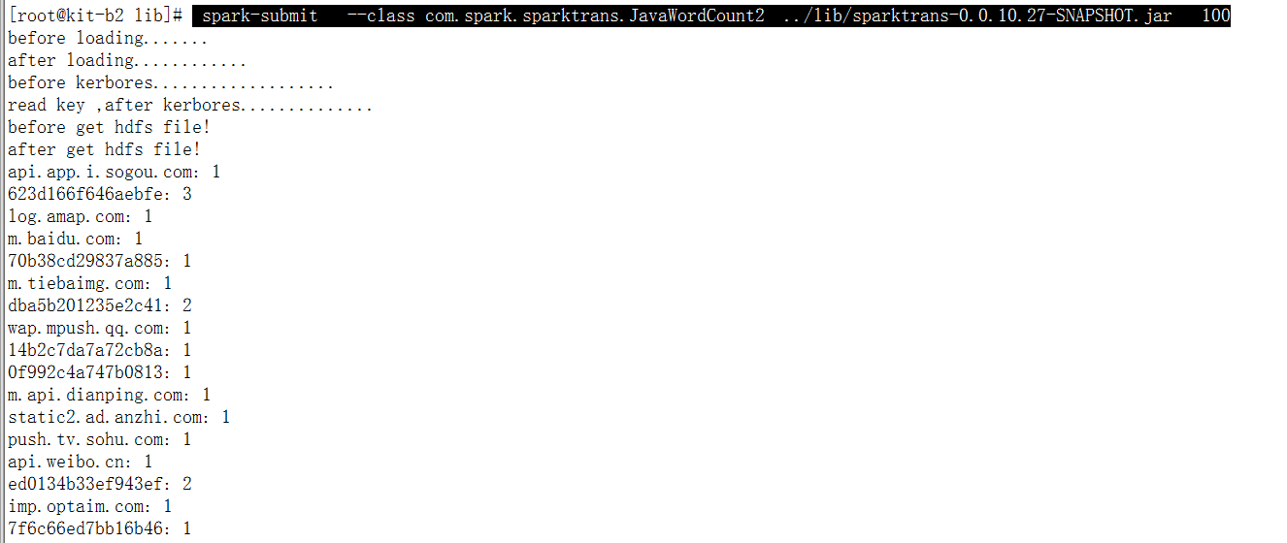

## 测试场景2：kit-b1,直接执行命令，执行异常

[root@kit-b1 lib]# spark-submit --class com.spark.sparktrans.JavaWordCount2 ../lib/sparktrans-0.0.10.27-SNAPSHOT.jar 100

before loading.......

after loading............

before kerbores...................

read key ,after kerbores..............

before get hdfs file!

after get hdfs file!

Exception in thread "main" org.apache.spark.SparkException: Job aborted due to stage failure: Task 0 in stage 0.0 failed 4 times, most recent failure: Lost task 0.3 in stage 0.0 (TID 3, 172.16.19.152): java.io.IOException: Failed on local exception: java.io.IOException: org.apache.hadoop.security.AccessControlException: Client cannot authenticate via:[TOKEN, KERBEROS]; Host Details : local host is: "kit-b2/172.16.19.152"; destination host is: "kit-b1":8020;

at org.apache.hadoop.net.NetUtils.wrapException(NetUtils.java:760)

at org.apache.hadoop.ipc.Client.call(Client.java:1424)

at org.apache.hadoop.ipc.Client.call(Client.java:1373)

at org.apache.hadoop.ipc.ProtobufRpcEngine$Invoker.invoke(ProtobufRpcEngine.java:206)

at com.sun.proxy.$Proxy13.getBlockLocations(Unknown Source)

at sun.reflect.NativeMethodAccessorImpl.invoke0(Native Method)

at sun.reflect.NativeMethodAccessorImpl.invoke(NativeMethodAccessorImpl.java:57)

at sun.reflect.DelegatingMethodAccessorImpl.invoke(DelegatingMethodAccessorImpl.java:43)

at java.lang.reflect.Method.invoke(Method.java:606)

at org.apache.hadoop.io.retry.RetryInvocationHandler.invokeMethod(RetryInvocationHandler.java:187)

at org.apache.hadoop.io.retry.RetryInvocationHandler.invoke(RetryInvocationHandler.java:102)

at com.sun.proxy.$Proxy13.getBlockLocations(Unknown Source)

at org.apache.hadoop.hdfs.protocolPB.ClientNamenodeProtocolTranslatorPB.getBlockLocations(ClientNamenodeProtocolTranslatorPB.java:225)

at org.apache.hadoop.hdfs.DFSClient.callGetBlockLocations(DFSClient.java:1109)

at org.apache.hadoop.hdfs.DFSClient.getLocatedBlocks(DFSClient.java:1099)

at org.apache.hadoop.hdfs.DFSClient.getLocatedBlocks(DFSClient.java:1089)

at org.apache.hadoop.hdfs.DFSInputStream.fetchLocatedBlocksAndGetLastBlockLength(DFSInputStream.java:286)

at org.apache.hadoop.hdfs.DFSInputStream.openInfo(DFSInputStream.java:252)

at org.apache.hadoop.hdfs.DFSInputStream.<init>(DFSInputStream.java:244)

at org.apache.hadoop.hdfs.DFSClient.open(DFSClient.java:1262)

at org.apache.hadoop.hdfs.DistributedFileSystem$3.doCall(DistributedFileSystem.java:293)

at org.apache.hadoop.hdfs.DistributedFileSystem$3.doCall(DistributedFileSystem.java:289)

at org.apache.hadoop.fs.FileSystemLinkResolver.resolve(FileSystemLinkResolver.java:81)

at org.apache.hadoop.hdfs.DistributedFileSystem.open(DistributedFileSystem.java:289)

at org.apache.hadoop.fs.FileSystem.open(FileSystem.java:764)

at org.apache.hadoop.mapred.LineRecordReader.<init>(LineRecordReader.java:108)

at org.apache.hadoop.mapred.TextInputFormat.getRecordReader(TextInputFormat.java:67)

at org.apache.spark.rdd.HadoopRDD$$anon$1.<init>(HadoopRDD.scala:239)

at org.apache.spark.rdd.HadoopRDD.compute(HadoopRDD.scala:216)

at org.apache.spark.rdd.HadoopRDD.compute(HadoopRDD.scala:101)

at org.apache.spark.rdd.RDD.computeOrReadCheckpoint(RDD.scala:297)

at org.apache.spark.rdd.RDD.iterator(RDD.scala:264)

at org.apache.spark.rdd.MapPartitionsRDD.compute(MapPartitionsRDD.scala:38)

at org.apache.spark.rdd.RDD.computeOrReadCheckpoint(RDD.scala:297)

at org.apache.spark.rdd.RDD.iterator(RDD.scala:264)

at org.apache.spark.rdd.MapPartitionsRDD.compute(MapPartitionsRDD.scala:38)

at org.apache.spark.rdd.RDD.computeOrReadCheckpoint(RDD.scala:297)

at org.apache.spark.rdd.RDD.iterator(RDD.scala:264)

at org.apache.spark.rdd.MapPartitionsRDD.compute(MapPartitionsRDD.scala:38)

at org.apache.spark.rdd.RDD.computeOrReadCheckpoint(RDD.scala:297)

at org.apache.spark.rdd.RDD.iterator(RDD.scala:264)

at org.apache.spark.scheduler.ShuffleMapTask.runTask(ShuffleMapTask.scala:73)

at org.apache.spark.scheduler.ShuffleMapTask.runTask(ShuffleMapTask.scala:41)

at org.apache.spark.scheduler.Task.run(Task.scala:88)

at org.apache.spark.executor.Executor$TaskRunner.run(Executor.scala:214)

at java.util.concurrent.ThreadPoolExecutor.runWorker(ThreadPoolExecutor.java:1145)

at java.util.concurrent.ThreadPoolExecutor$Worker.run(ThreadPoolExecutor.java:615)

at java.lang.Thread.run(Thread.java:745)

Caused by: java.io.IOException: org.apache.hadoop.security.AccessControlException: Client cannot authenticate via:[TOKEN, KERBEROS]

at org.apache.hadoop.ipc.Client$Connection$1.run(Client.java:688)

at java.security.AccessController.doPrivileged(Native Method)

at javax.security.auth.Subject.doAs(Subject.java:415)

at org.apache.hadoop.security.UserGroupInformation.doAs(UserGroupInformation.java:1846)

at org.apache.hadoop.ipc.Client$Connection.handleSaslConnectionFailure(Client.java:649)

at org.apache.hadoop.ipc.Client$Connection.setupIOstreams(Client.java:734)

at org.apache.hadoop.ipc.Client$Connection.access$2800(Client.java:368)

at org.apache.hadoop.ipc.Client.getConnection(Client.java:1472)

at org.apache.hadoop.ipc.Client.call(Client.java:1391)

... 46 more

Caused by: org.apache.hadoop.security.AccessControlException: Client cannot authenticate via:[TOKEN, KERBEROS]

at org.apache.hadoop.security.SaslRpcClient.selectSaslClient(SaslRpcClient.java:172)

at org.apache.hadoop.security.SaslRpcClient.saslConnect(SaslRpcClient.java:396)

at org.apache.hadoop.ipc.Client$Connection.setupSaslConnection(Client.java:554)

at org.apache.hadoop.ipc.Client$Connection.access$1800(Client.java:368)

at org.apache.hadoop.ipc.Client$Connection$2.run(Client.java:726)

at org.apache.hadoop.ipc.Client$Connection$2.run(Client.java:722)

at java.security.AccessController.doPrivileged(Native Method)

at javax.security.auth.Subject.doAs(Subject.java:415)

at org.apache.hadoop.security.UserGroupInformation.doAs(UserGroupInformation.java:1846)

at org.apache.hadoop.ipc.Client$Connection.setupIOstreams(Client.java:721)

... 49 more

Driver stacktrace:

at org.apache.spark.scheduler.DAGScheduler.org$apache$spark$scheduler$DAGScheduler$$failJobAndIndependentStages(DAGScheduler.scala:1283)

at org.apache.spark.scheduler.DAGScheduler$$anonfun$abortStage$1.apply(DAGScheduler.scala:1271)

at org.apache.spark.scheduler.DAGScheduler$$anonfun$abortStage$1.apply(DAGScheduler.scala:1270)

at scala.collection.mutable.ResizableArray$class.foreach(ResizableArray.scala:59)

at scala.collection.mutable.ArrayBuffer.foreach(ArrayBuffer.scala:47)

at org.apache.spark.scheduler.DAGScheduler.abortStage(DAGScheduler.scala:1270)

at org.apache.spark.scheduler.DAGScheduler$$anonfun$handleTaskSetFailed$1.apply(DAGScheduler.scala:697)

at org.apache.spark.scheduler.DAGScheduler$$anonfun$handleTaskSetFailed$1.apply(DAGScheduler.scala:697)

at scala.Option.foreach(Option.scala:236)

at org.apache.spark.scheduler.DAGScheduler.handleTaskSetFailed(DAGScheduler.scala:697)

at org.apache.spark.scheduler.DAGSchedulerEventProcessLoop.doOnReceive(DAGScheduler.scala:1496)

at org.apache.spark.scheduler.DAGSchedulerEventProcessLoop.onReceive(DAGScheduler.scala:1458)

at org.apache.spark.scheduler.DAGSchedulerEventProcessLoop.onReceive(DAGScheduler.scala:1447)

at org.apache.spark.util.EventLoop$$anon$1.run(EventLoop.scala:48)

at org.apache.spark.scheduler.DAGScheduler.runJob(DAGScheduler.scala:567)

at org.apache.spark.SparkContext.runJob(SparkContext.scala:1824)

at org.apache.spark.SparkContext.runJob(SparkContext.scala:1837)

at org.apache.spark.SparkContext.runJob(SparkContext.scala:1850)

at org.apache.spark.SparkContext.runJob(SparkContext.scala:1921)

at org.apache.spark.rdd.RDD$$anonfun$collect$1.apply(RDD.scala:905)

at org.apache.spark.rdd.RDDOperationScope$.withScope(RDDOperationScope.scala:147)

at org.apache.spark.rdd.RDDOperationScope$.withScope(RDDOperationScope.scala:108)

at org.apache.spark.rdd.RDD.withScope(RDD.scala:306)

at org.apache.spark.rdd.RDD.collect(RDD.scala:904)

at org.apache.spark.api.java.JavaRDDLike$class.collect(JavaRDDLike.scala:338)

at org.apache.spark.api.java.AbstractJavaRDDLike.collect(JavaRDDLike.scala:47)

at com.spark.sparktrans.JavaWordCount2.main(JavaWordCount2.java:99)

at sun.reflect.NativeMethodAccessorImpl.invoke0(Native Method)

at sun.reflect.NativeMethodAccessorImpl.invoke(NativeMethodAccessorImpl.java:57)

at sun.reflect.DelegatingMethodAccessorImpl.invoke(DelegatingMethodAccessorImpl.java:43)

at java.lang.reflect.Method.invoke(Method.java:606)

at org.apache.spark.deploy.SparkSubmit$.org$apache$spark$deploy$SparkSubmit$$runMain(SparkSubmit.scala:672)

at org.apache.spark.deploy.SparkSubmit$.doRunMain$1(SparkSubmit.scala:180)

at org.apache.spark.deploy.SparkSubmit$.submit(SparkSubmit.scala:205)

at org.apache.spark.deploy.SparkSubmit$.main(SparkSubmit.scala:120)

at org.apache.spark.deploy.SparkSubmit.main(SparkSubmit.scala)

Caused by: java.io.IOException: Failed on local exception: java.io.IOException: org.apache.hadoop.security.AccessControlException: Client cannot authenticate via:[TOKEN, KERBEROS]; Host Details : local host is: "kit-b2/172.16.19.152"; destination host is: "kit-b1":8020;

at org.apache.hadoop.net.NetUtils.wrapException(NetUtils.java:760)

at org.apache.hadoop.ipc.Client.call(Client.java:1424)

at org.apache.hadoop.ipc.Client.call(Client.java:1373)

at org.apache.hadoop.ipc.ProtobufRpcEngine$Invoker.invoke(ProtobufRpcEngine.java:206)

at com.sun.proxy.$Proxy13.getBlockLocations(Unknown Source)

at sun.reflect.NativeMethodAccessorImpl.invoke0(Native Method)

at sun.reflect.NativeMethodAccessorImpl.invoke(NativeMethodAccessorImpl.java:57)

at sun.reflect.DelegatingMethodAccessorImpl.invoke(DelegatingMethodAccessorImpl.java:43)

at java.lang.reflect.Method.invoke(Method.java:606)

at org.apache.hadoop.io.retry.RetryInvocationHandler.invokeMethod(RetryInvocationHandler.java:187)

at org.apache.hadoop.io.retry.RetryInvocationHandler.invoke(RetryInvocationHandler.java:102)

at com.sun.proxy.$Proxy13.getBlockLocations(Unknown Source)

at org.apache.hadoop.hdfs.protocolPB.ClientNamenodeProtocolTranslatorPB.getBlockLocations(ClientNamenodeProtocolTranslatorPB.java:225)

at org.apache.hadoop.hdfs.DFSClient.callGetBlockLocations(DFSClient.java:1109)

at org.apache.hadoop.hdfs.DFSClient.getLocatedBlocks(DFSClient.java:1099)

at org.apache.hadoop.hdfs.DFSClient.getLocatedBlocks(DFSClient.java:1089)

at org.apache.hadoop.hdfs.DFSInputStream.fetchLocatedBlocksAndGetLastBlockLength(DFSInputStream.java:286)

at org.apache.hadoop.hdfs.DFSInputStream.openInfo(DFSInputStream.java:252)

at org.apache.hadoop.hdfs.DFSInputStream.<init>(DFSInputStream.java:244)

at org.apache.hadoop.hdfs.DFSClient.open(DFSClient.java:1262)

at org.apache.hadoop.hdfs.DistributedFileSystem$3.doCall(DistributedFileSystem.java:293)

at org.apache.hadoop.hdfs.DistributedFileSystem$3.doCall(DistributedFileSystem.java:289)

at org.apache.hadoop.fs.FileSystemLinkResolver.resolve(FileSystemLinkResolver.java:81)

at org.apache.hadoop.hdfs.DistributedFileSystem.open(DistributedFileSystem.java:289)

at org.apache.hadoop.fs.FileSystem.open(FileSystem.java:764)

at org.apache.hadoop.mapred.LineRecordReader.<init>(LineRecordReader.java:108)

at org.apache.hadoop.mapred.TextInputFormat.getRecordReader(TextInputFormat.java:67)

at org.apache.spark.rdd.HadoopRDD$$anon$1.<init>(HadoopRDD.scala:239)

at org.apache.spark.rdd.HadoopRDD.compute(HadoopRDD.scala:216)

at org.apache.spark.rdd.HadoopRDD.compute(HadoopRDD.scala:101)

at org.apache.spark.rdd.RDD.computeOrReadCheckpoint(RDD.scala:297)

at org.apache.spark.rdd.RDD.iterator(RDD.scala:264)

at org.apache.spark.rdd.MapPartitionsRDD.compute(MapPartitionsRDD.scala:38)

at org.apache.spark.rdd.RDD.computeOrReadCheckpoint(RDD.scala:297)

at org.apache.spark.rdd.RDD.iterator(RDD.scala:264)

at org.apache.spark.rdd.MapPartitionsRDD.compute(MapPartitionsRDD.scala:38)

at org.apache.spark.rdd.RDD.computeOrReadCheckpoint(RDD.scala:297)

at org.apache.spark.rdd.RDD.iterator(RDD.scala:264)

at org.apache.spark.rdd.MapPartitionsRDD.compute(MapPartitionsRDD.scala:38)

at org.apache.spark.rdd.RDD.computeOrReadCheckpoint(RDD.scala:297)

at org.apache.spark.rdd.RDD.iterator(RDD.scala:264)

at org.apache.spark.scheduler.ShuffleMapTask.runTask(ShuffleMapTask.scala:73)

at org.apache.spark.scheduler.ShuffleMapTask.runTask(ShuffleMapTask.scala:41)

at org.apache.spark.scheduler.Task.run(Task.scala:88)

at org.apache.spark.executor.Executor$TaskRunner.run(Executor.scala:214)

at java.util.concurrent.ThreadPoolExecutor.runWorker(ThreadPoolExecutor.java:1145)

at java.util.concurrent.ThreadPoolExecutor$Worker.run(ThreadPoolExecutor.java:615)

at java.lang.Thread.run(Thread.java:745)

Caused by: java.io.IOException: org.apache.hadoop.security.AccessControlException: Client cannot authenticate via:[TOKEN, KERBEROS]

at org.apache.hadoop.ipc.Client$Connection$1.run(Client.java:688)

at java.security.AccessController.doPrivileged(Native Method)

at javax.security.auth.Subject.doAs(Subject.java:415)

at org.apache.hadoop.security.UserGroupInformation.doAs(UserGroupInformation.java:1846)

at org.apache.hadoop.ipc.Client$Connection.handleSaslConnectionFailure(Client.java:649)

at org.apache.hadoop.ipc.Client$Connection.setupIOstreams(Client.java:734)

at org.apache.hadoop.ipc.Client$Connection.access$2800(Client.java:368)

at org.apache.hadoop.ipc.Client.getConnection(Client.java:1472)

at org.apache.hadoop.ipc.Client.call(Client.java:1391)

... 46 more

Caused by: org.apache.hadoop.security.AccessControlException: Client cannot authenticate via:[TOKEN, KERBEROS]

at org.apache.hadoop.security.SaslRpcClient.selectSaslClient(SaslRpcClient.java:172)

at org.apache.hadoop.security.SaslRpcClient.saslConnect(SaslRpcClient.java:396)

at org.apache.hadoop.ipc.Client$Connection.setupSaslConnection(Client.java:554)

at org.apache.hadoop.ipc.Client$Connection.access$1800(Client.java:368)

at org.apache.hadoop.ipc.Client$Connection$2.run(Client.java:726)

at org.apache.hadoop.ipc.Client$Connection$2.run(Client.java:722)

at java.security.AccessController.doPrivileged(Native Method)

at javax.security.auth.Subject.doAs(Subject.java:415)

at org.apache.hadoop.security.UserGroupInformation.doAs(UserGroupInformation.java:1846)

at org.apache.hadoop.ipc.Client$Connection.setupIOstreams(Client.java:721)

... 49 more

## 测试场景3：kit-b1,kit-b2,kit-b3,kit-b4在原有脚本上加上—master yarn-client参数后，执行正常，成功提交作业

命令: spark-submit --class com.spark.sparktrans.JavaWordCount2 --master yarn-client ../lib/sparktrans-0.0.10.27-SNAPSHOT.jar 100

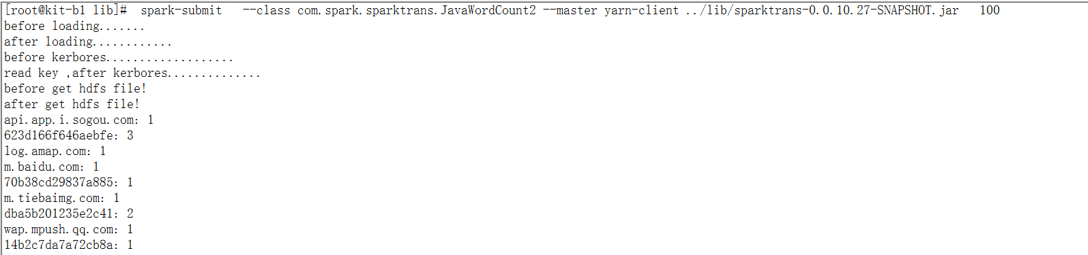

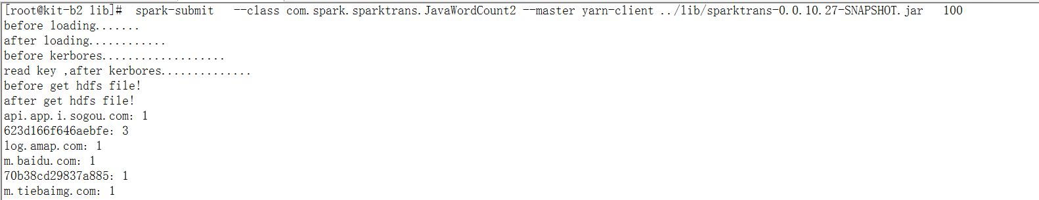

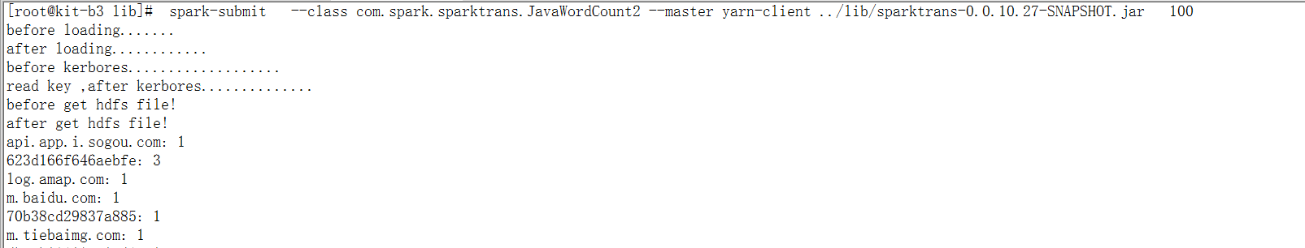

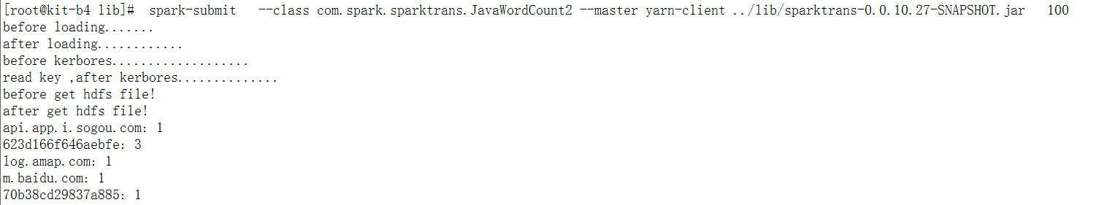

## 问题：

为何在kit-b1上执行脚本

spark-submit --class com.spark.sparktrans.JavaWordCount2 ../lib/sparktrans-0.0.10.27-SNAPSHOT.jar 100

异常，另外三台机器执行同样的命令却是正常的，是否与集群配置或者权限设置有关?