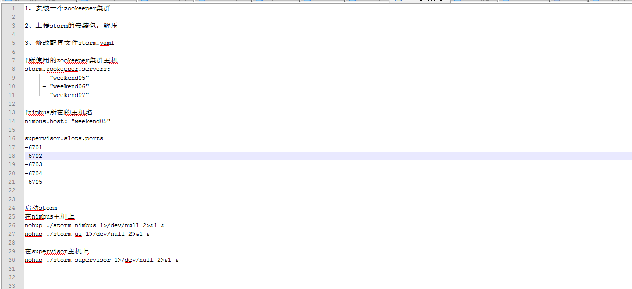

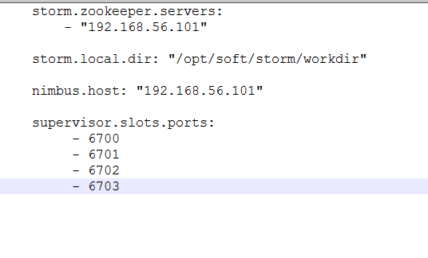

node01启动nimbus：bin/storm nimbus >/dev/null 2>&1 &

node02、node03启动supervisor：bin/storm supervisor >/dev/null 2>&1 &

node01启动ui： bin/storm ui >/dev/null 2>&1 &

http://192.168.56.101:8080/index.html