Daas部署

1 拷贝daas工程到linux服务器

下载jdk1.8

编写dockerfile文件：

Dockerfile：



FROM 172.16.1.41:5000/jenkins/transwarp-docker:live

ADD jdk-8u161-linux-x64.tar.gz /usr/lib

ENV JAVA_HOME=/usr/lib/jdk1.8.0_161

ENV JRE_HOME=${JAVA_HOME}/jre

ENV CLASSPATH=.:${JAVA_HOME}/lib:${JRE_HOME}/lib

ENV PATH=${JAVA_HOME}/bin:$PATH

ENV LD_LIBRARY_PATH=/usr/lib/jdk1.8.0_161/jre/lib/amd64:/usr/lib/jdk1.8.0_161/jre/lib/amd64/server:/usr/lib/jdk1.8.0_161/jre/lib/amd64/libjsig.so:/usr/lib/jdk1.8.0_161/jre/lib/amd64/server/libjvm.so

ADD uba /usr/lib/uba

ADD start.sh /usr/bin

CMD /usr/bin/start.sh

修改uba文件：



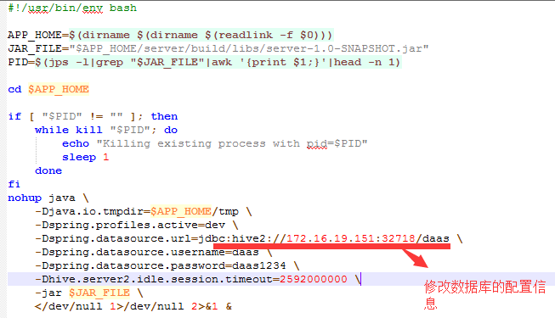

编写start.sh:

sh /usr/lib/uba/bin/uba.sh

while true

do

echo "daas is running"

sleep 600

done

构建镜像：

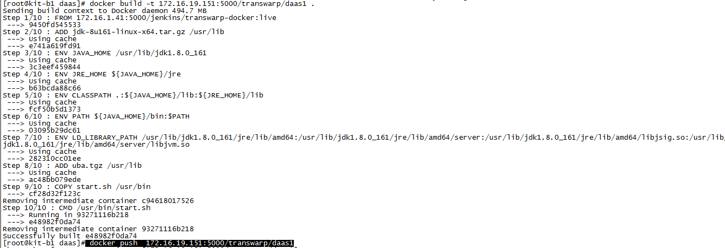

运行镜像:



Push对象：

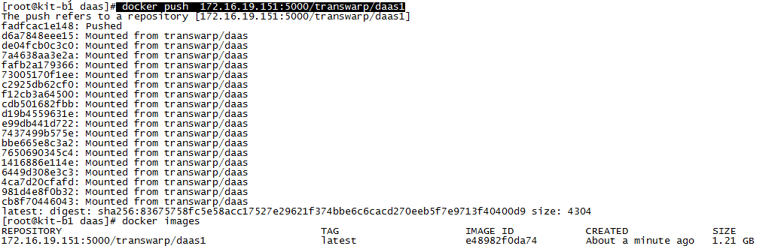

在tos管理界面添加应用：

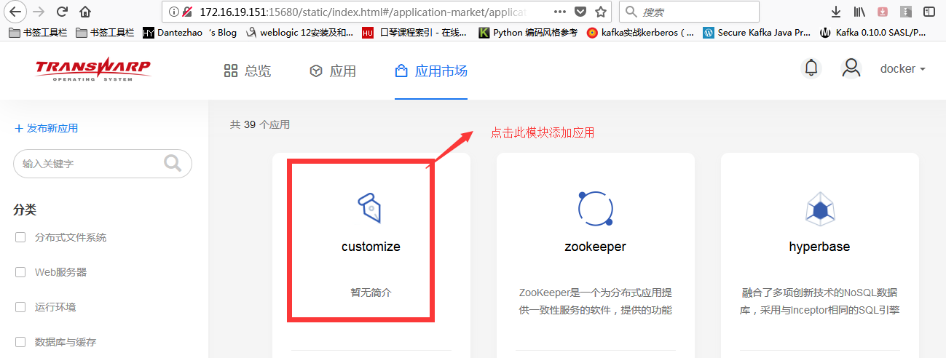

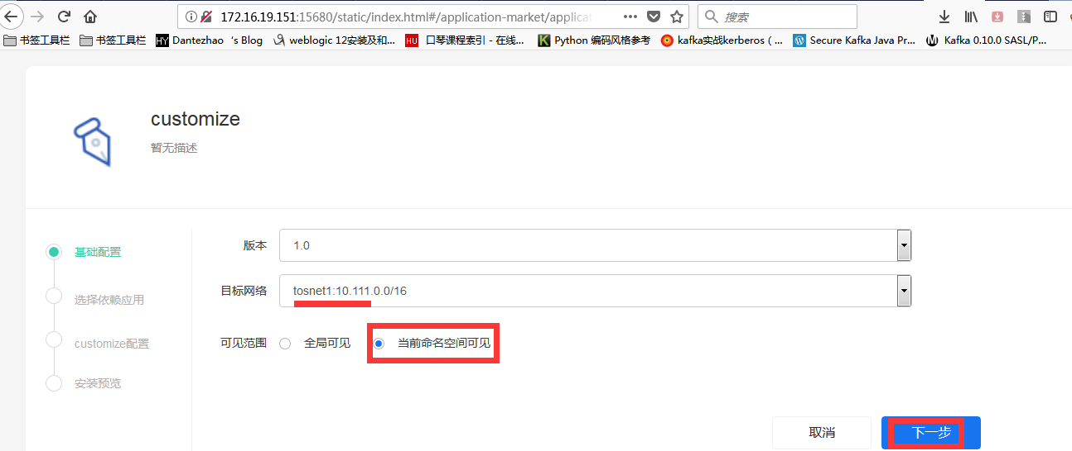

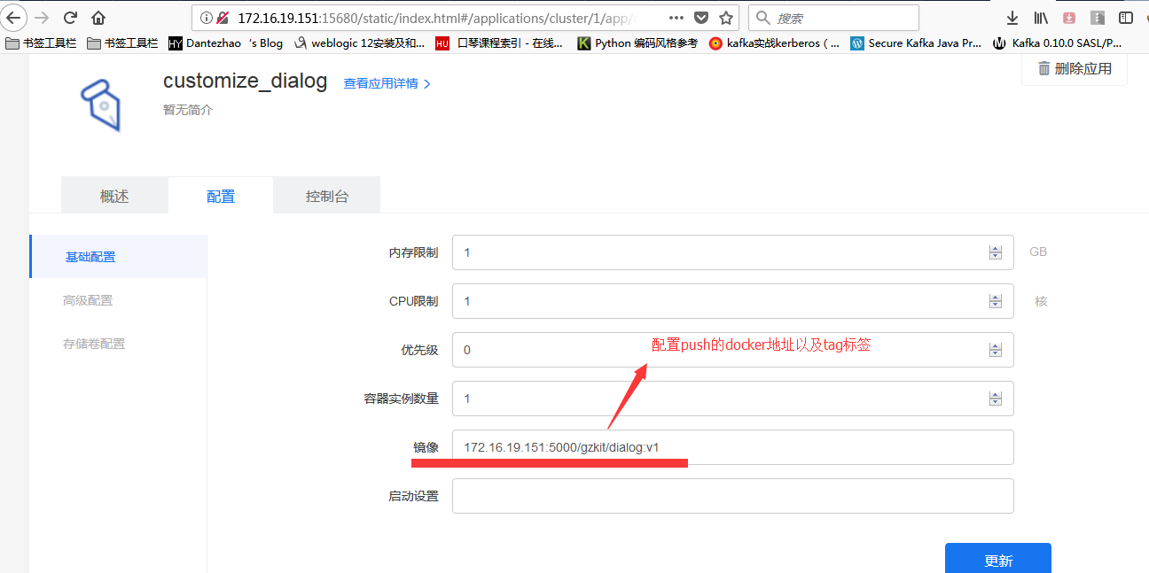

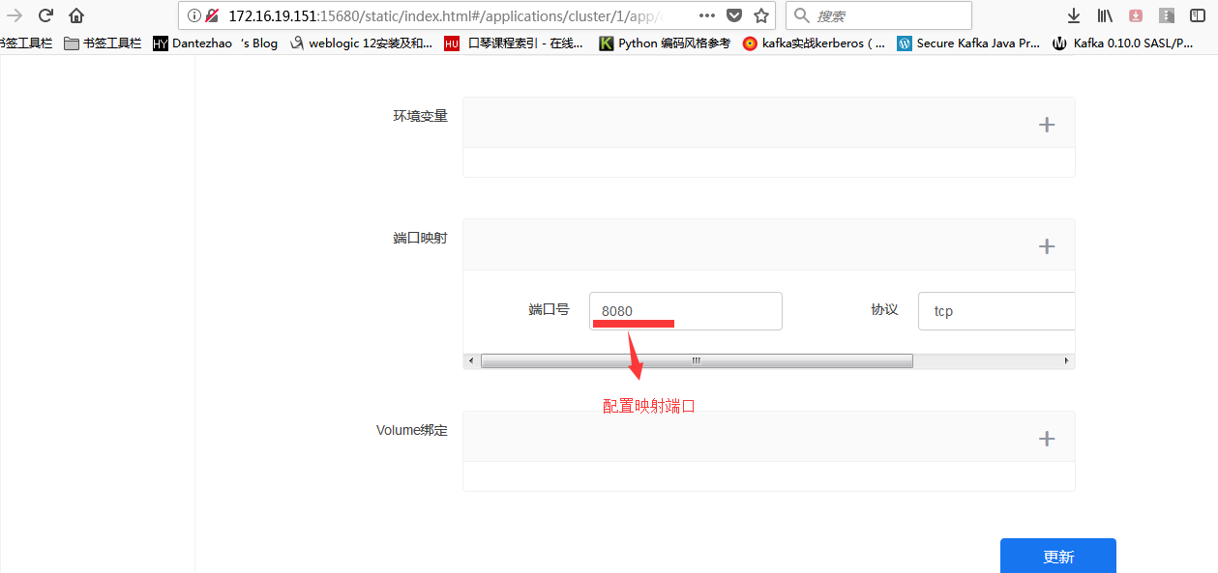

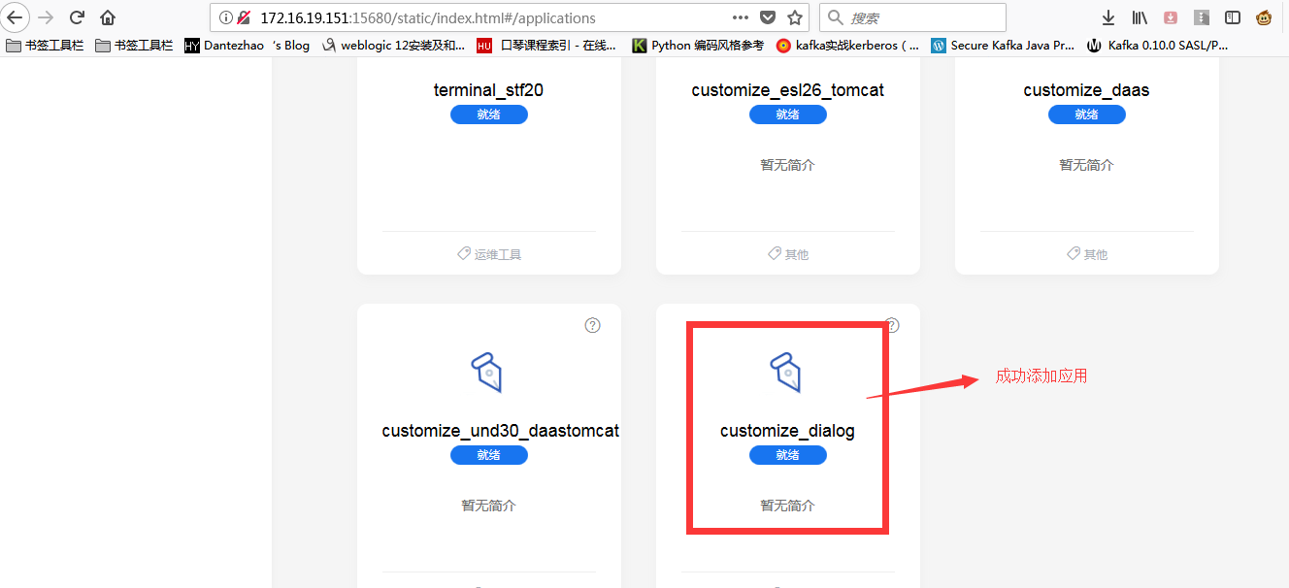

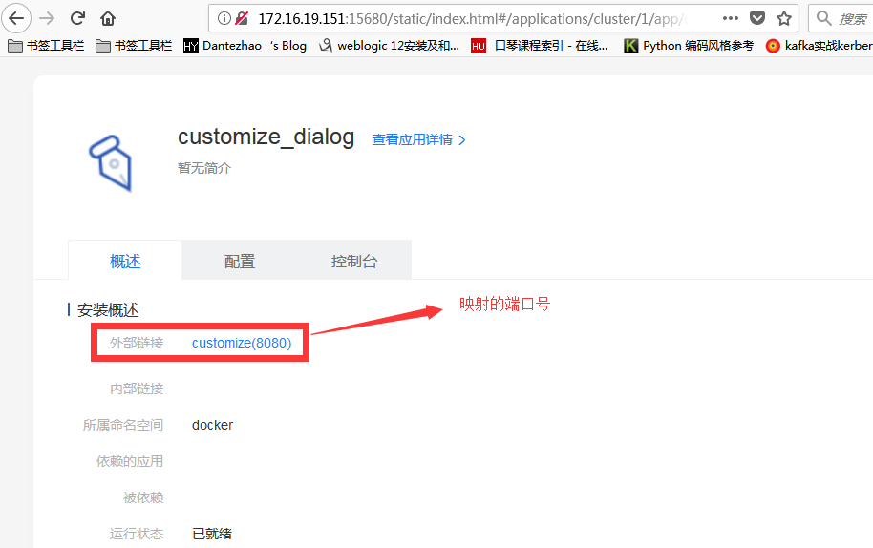

验证应用：

<https://172.16.19.151:32508/userActions/get_with_description>

<http://172.16.19.151:30547/dialog/WebRoot/index.jsp>

