Dictionary: 1600 patches randomly selected from 50000 random patches
encoding: soft threshold (Ours_soft), sparse coding (Ours_SC)
- AR (all data, 13 training/test samples with each of 100 classes)
SRC | CRC | LRC | Ours_soft | Ours_SC
86.46% | 84.54% | 66.3% | 95.31% | 98.15%

- AR_clean (only clean data without sunglass/scarf, 7 training/test samples with each of 100 classes)
SRC | CRC | LRC | Ours_soft | Ours_SC
92.86% | 88.43% | 76.14% | 98.29% | 98.71%

- Extended YaleB (32 training/test samples with each of 38 classes)
SRC | CRC | LRC | Ours_soft | Ours_SC
97.08% | 98.41% | 95.15% | 99.67% | 96.41%

Results of our method with different dictionary and encoding methods
- AR: (AR for dictionary training)
Dictionary\encoding | Soft threshold(average pool) | Soft threshold(max pool) | Sparse coding  (average) | LLC (average pool) | LLC (max pool)
Random patches | 95.31% | 94.77% | 98.15% | 94.46% | 95.23%
K-means | 95.57% | 94.31% | 96.62% | 91.08% | 91.31%
- AR: (CIFAR-10 for dictionary training)
Dictionary\encoding | Soft threshold(average) | Soft threshold(max) | Sparse coding(average) | Sparse coding (max) | LLC (average) | LLC (max)
Random patches | 95.38% | 93.46% | 97.38% | 97.23% | 94.15% | 94.38%
K-means | 95.61% | 93.69% | 97.15% | 97.69% | 91.23% | 92.61%

- Extended Yale B (Extended Yale B for dictionary training)
Dictionary\encoding | Soft (average) | Soft (max) | Sparse coding | LLC (average) | LLC (max pool)
Random patches | 99.67% | 96.99% | 96.41% | 99.00% | 98.83%
K-means | 99.75% | 97.33% | 95.49% | 98.25% | 97.99%
- Extended Yale B (CIFAR-10 for dictionary training)
Dictionary\encoding | Soft threshold(average) | Soft threshold(max) | Sparse coding(average) | Sparse coding (max) | LLC (average) | LLC (max)
Random patches | 99.75% | 97.83% | 92.98% |  | 99.16% | 99.16%
K-means | 99.67% | 97.58% | 94.07% |  | 98.66% | 98.08%

- AR clean(CIFAR-10 for dictionary training)
Dictionary\encoding | Soft threshold(average pool) | Soft threshold(max pool) | Sparse coding(average pool) | Sparse coding (max) | LLC (average pool) | LLC (max pool)
Random patches | 97.85% | 96.85% | % | 98.86% | 97.48% | 97.57%
K-means | 97.86% | 96.57% | % | 99% | 95.29% | 96.14%

Observations:
- On both datasets, K-means leads to inferior accuracies. This is reasonable for face recognition. (WHY IS THAT? I DON’T UNDERSTAND. CS Maybe this is heuristic: image patches generated by averaging (K-means) are actually not face patches. The dimension of a face subspace for one class is very low (normally 5--9). Averaging actually increases the dimension. Fumin)
This doesn’t make sense. If this is the case, then k-median (instead of k-means) should perform better.

- Max pooling does not always show better results. (WHAT ABOUT NO POOLING? CS Without pooling, the dimension of learned features obtained by encoding will be too large, since for each image there maybe thousands of patches. Fumin)
We can increase the size of patches, e.g. 60 x 60, instead of 6 x 6. So the number of patches will be reduced considerably. Then run this experiment. We should compare different image patch size anyway. Also later we need to run experiments using dense SIFT, see if SIFT improves raw patch. For generic object recognition, SIFT does better than raw patch almost always. Normally the dimension used in FR paper is less than 100 x 100, usually around 32 x 32 or 64 x 64. Yes, dense SIFT may improves the results. However the improvement will not be large on the mostly used AR and Yale B, since the accuracies are already over 98% and 99%. I will try that on other databases not aligned well.

CS: POOLING. I am not sure how you apply pooling. But pooling should not pool all the patches in the whole image (ie., only one level). You should try that CVPR paper “Spatial Pyramid Kernel……”. I.e., multiple level pooling. Maybe you already did that. I used a simplified SPM pooling: split each image to four bins, pool over each bin, and then for each image I get a 4 x (dictionary size) vector. As in the Ng ICML paper, in order to get all entries of the code > 0, for each bin I split the positive and negative components using operation max {0, s} and max {0,−s}. This makes the final code length for each image 4 x 2 x (dictionary size). In the following experiments, I will try SPM.

CS: Have a look at the paper “An analysis of Single-layer networks in Unsupervised feature learning.” Maybe we should run these experiments first. Note that in that paper, normalization and PCA whitening are very important to achieve good results. This may be the reason why in your experiments Random even works better than k-means. Need to verify I have already performed normalization and ZCA whitening.

26 MAY Fumin
Observations:
- From Table 1 and 2, Table 3 and 4, we can see It IS NOT IMPORTANT whether the dictionary is trained on the same datasets (as the test one) or on the datasets of faces or not.
- Sparse coding and small training size. There is gap between sparse coding and soft threshold on AR dataset. See Table 1 and 2. The reason may be AR has a large number of classes and relatively small number of samples (14) each class. This is contrast to Extended Yale B, 38 classes with 32 samples each class. This phenomenon is also analyzed in section 5.1 of the Ng ICML'11 paper.
- Increasing Dictionary size (from 100 to 1200) improves accuracy significantly
AR / Dictionary: random patch/ Encoding: soft threshold
Dictionary Size | 100 | 400 | 800 | 1200 | 1600 | 2000 | 4000
random patches | 79.15 | 91.46 | 93.92 | 95.62 | 95.31 | 95.77 | 95.92
kmeans | 78.77 | 90.92 | 94.69 | 95.31 | 95.46 | 95.85 | 95.92

- Average pooling obtains better results. In the BMVC 11 paper by Andrew Zisserman "The devil is in the details", average pooling is used except for LLC (Max pooling). Also note we are not using BOV model, i.e. without histograms feature.
- In most cases, random patches and kmeans get very similar results.

- Yes, we can train a linear SVM using just one sample per class.
Results with increasing training size per class. Dictionary are trained on a additional database, CIFAR-10 here.

AR clean: Training size from 1 to 7
Extended Yale B: Training size from 1 to 32

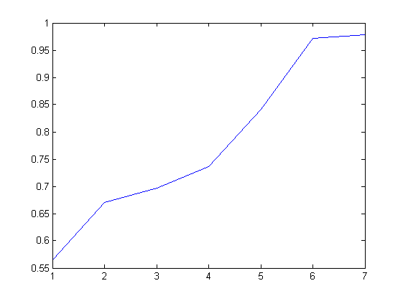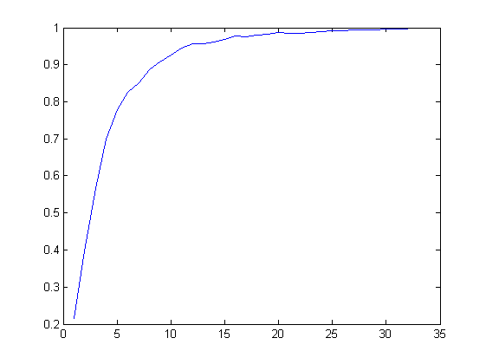
AR Extended Yale B

- The impact of patch size. Image size is 32 x 32
Patch size | 4 x 4 | 6 x 6 | 8 x 8 | 10 x 10 | 15 x 15
AR | 95.46% | 96.00% | 95.62% | 94.31 | 93.31
ExYaleB | 99.50% | 99.83% | 99.75% | 99.75% | 99.16%

No pooling, use holistic image (1 patch 32 x 32 per image)
AR 76.77%
Extended Yale B 97.24%
This result is not good enough.
- SSPP
Following Hinton's NIPS'12 work of deep learning on ImageNet, I augmented the training data by extracting 60x60 patches from the original 64x64 image. So we have 25 training samples per class. I also extract 5 samples for every test image. I classify every test image by the voting strategy.
Unfortunately, this does not improve the results.

